Ratified
PICO Confirmation
Application 1660:
Diagnostic testing for MET Exon 14 skipping alterations in non-small cell lung cancer to help determine PBS eligibility for tepotinib treatment

Summary of PICO/PPICO criteria to define the question(s) to be addressed in an Assessment Report to the Medical Services Advisory Committee (MSAC)
Component | Description
Patients | Test: Adults (18 years or older) with histologically or cytologically confirmed non-small cell lung cancer (NSCLC), shown to have non-squamous histology or histology not otherwise specified, without EGFR gene alterations.  Drug: Adults (18 years or older) with histologically or cytologically confirmed locally advanced or metastatic NSCLC, shown to have non-squamous histology or histology not otherwise specified, with a METex14 skipping alteration, who are either treatment naïve or pretreated with no more than 2 lines of prior therapy.
Prior tests | Routine imaging such as contrast-enhanced chest computed tomography scan or chest X-ray, cytology or histology procedures to confirm diagnosis of non-squamous or histology not otherwise specified NSCLC. Testing for activating mutations of the EGFR gene. Immunohistochemistry (IHC) testing for ROS-1 and ALK expression.
Intervention | Test: Genetic testing for METex14 skipping alterations. Testing may utilise RNA/DNA in tumour tissue using commercially available platforms or laboratory accredited in-house tests (e.g. PCR or NGS).  Drug: Tepotinib (TEPMETKO®) orally administered tyrosine kinase inhibitor in those with a METex14 skipping alteration. Comparator treatment in those without a METex14 skipping alteration.
Evidentiary standard | The methodology of testing for METex14 skipping alterations in the key clinical study (VISION) (Paik, PK et al. 2020): cfDNA obtained from plasma (liquid biopsy) with the use of NGS panel or by evaluating RNA obtained from fresh or archival FFPE tumour-biopsy tissue.
Comparator | Test: No testing for METex14 skipping alterations.  Drug:  Immunotherapy (pembrolizumab) and/or platinum doublet chemotherapy (e.g. carboplatin plus gemcitabine)  or  Immunotherapy or mono-chemotherapy (e.g. pemetrexed or docetaxel) after failure of first line treatment.
Outcomes | Test outcomes:  Analytical performance compared to the evidentiary standard:  - Positive percent agreement  - Negative percent agreement.  Clinical validity of the test:  - Comparative prognosis of patients with advanced NSCLC between those whose tumours do and do not have METex14 skipping alterations.  Clinical utility of the test:  - Treatment effect modification of METex14 skipping alterations on response to tepotinib in patients with advanced NSCLC.  Other test-related considerations:  - Re-biopsy rates (including test failure and inadequate sample rate [e.g. from an inadequate cytological specimen])  - Test turn-around time  - Estimated number of patients being tested  - Number needed to test  - Cost of testing per patient.  Drug outcomes:  - Safety and tolerability (AEs, physical examinations, laboratory findings, vital signs)  - Objective response rate  - Overall survival  - Progression-free survival  - Partial response  - Complete response  - Health-related quality of life.
Abbreviations: AEs=adverse events; ALK = anaplastic lymphoma kinase, cfDNA=circulating free DNA; FFPE= formalin fixed-paraffin-embedded; EGFR= epidermal growth factor receptor; MET= mesenchymal-epithelial transition; METex14=MET exon 14; NGS=next generation sequencing; NSCLC=non-small cell lung cancer; PCR=polymerase chain reaction; ROS-1 receptor tyrosine kinase

PICO or PPICO rationale for therapeutic and investigative medical services only

Questions
What is the safety, effectiveness, and cost-effectiveness of mesenchymal-epithelial transition (MET) exon 14 skipping alteration testing for determining access to tepotinib, in patients with non-small cell lung cancer (NSCLC), shown to have non-squamous histology or histology not otherwise specified, who have tested negative to epidermal growth factor receptor (EGFR) gene alteration, compared with no testing and standard of care (immunotherapy or platinum doublet chemotherapy)?
Do results from MET exon 14 skipping alteration testing predict a treatment effect modification with tepotinib?
How will the range of testing options likely to be used in Australian pathology practices compare (in regards to the extent of positive and negative discordance) to the evidentiary standard?
Is the proposed MET exon 14 skipping alteration test safe in the test-eligible population compared with no testing?

Population
Test:
The applicant proposes the population for MET exon 14 (METex14) skipping alteration testing, to be patients with locally advanced or metastatic NSCLC, shown to have non-squamous histology or histology not otherwise specified, to determine their PBS eligibility for tepotinib treatment, who do not have EGFR gene alterations.
PASC noted that the test population was for patients with non-squamous NSCLC histology or histology not otherwise specified, without activating mutations of the EGFR gene (i.e. a narrower population than the key VISION study).
Existing MBS items for ALK and ROS-1 testing with fluorescence in-situ hybridisation (FISH) have been restricted to patients with locally advanced or metastatic NSCLC. For ALK, MSAC requested that early diagnosis be justified (MSAC 1250 PSD). For ROS-1, the Evaluation Sub Committee considered that additional analyses related to the cost of testing for ROS-1 gene status at initial diagnosis would be informative (MSAC 1454 PSD). It is therefore suggested that the applicants justify the timing in the ADAR and present the alternative testing scenario as well. That is, PASC recommended assessing METex14 testing any time after diagnosis of NSCLC, and thus not be limited to those with locally advanced or metastatic disease. PASC also recommended an assessment of the alternative strategy of only testing METex14 patients with locally advanced or metastatic disease.
Drug:
The population that will be eligible for tepotinib treatment will be patients with confirmed advanced (locally advanced or metastatic) NSCLC, shown to have non-squamous histology or histology not otherwise specified who have METex14 skipping alterations and are either treatment naive or pretreated with no more than 2 lines of prior therapy. This population is narrower than the population included in the VISION clinical study (NCT02864992). The VISION clinical study included a broader population of all types of advanced NSCLC (including squamous and sarcomatoid). A subgroup analysis using patients with non-squamous NSCLC from the intent-to-treat (ITT) population of the VISION study will provide the key evidence used in the MSAC/Pharmaceutical Benefits Advisory Committee (PBAC) submission. This population would also include patients with locally advanced or metastatic NSCLC who are unsuitable for conservative management or surgical resection or recurrence after surgical resection.
PASC advised that if the applicant uses the intent-to-treat (ITT) population from the VISION clinical study, which used the broader population of all histologic subtypes of advanced NSCLC (i.e. squamous and non-squamous), it should also evaluate whether the ITT population provides the best estimate for the requested subgroup, or whether a subgroup analysis provides a sufficiently different and robust estimate.

Incidence of lung cancer
Lung cancer is the leading cause of cancer-related deaths worldwide (Kim, EK et al. 2019; Pasquini & Giaccone 2018; Pruis et al. 2020; Wang et al. 2019). In 2020, lung cancer accounted for an estimated 1.8 million deaths worldwide, equating to 18% of all cancer related deaths (excluding non-melanoma skin cancer) (Sung et al. 2021). In 2020, 3,258 new cases of lung cancer were diagnosed in Australia making it the fifth most common cancer diagnosed in this country, excluding non-melanoma cancers¹. Lung cancer is responsible for almost one in five Australian cancer deaths. The risk of lung cancer diagnosis in men and women by age 85 is 1 in 13 and 1 in 21 respectively¹. The five year survival rate is estimated to be 19%¹.
There are two main types of lung cancer; NSCLC and small cell lung cancer (SCLC) ¹. NSCLC is the most common type of lung cancer, and accounts for around 85% to 90% (Kim, EK et al. 2019). The most common NSCLC sub-types¹ are:
- Adenocarcinoma - begins in mucus-producing cells and makes up about 40% of lung cancers. This type of cancer is commonly diagnosed in both smokers (current and former) and non-smokers¹.
- Squamous cell (epidermoid) carcinoma - commonly develops in the larger airways of the lungs¹.
- Large cell undifferentiated carcinoma - can appear in any part of the lung but does not clearly present as squamous cell or adenocarcinoma¹.
The other type of lung cancer, SCLC accounts for approximately 15% of all lung cancers, and tends to develop centrally in the lungs and spreads more quickly than NSCLC¹.
Most patients who have NSCLC present with advanced or incurable disease, and chemotherapy generally results in modest improvement of survival (Kim, JH, Kim & Kim 2017; Pasquini & Giaccone 2018).

Biological rationale
In the last decade, many of the subtypes of NSCLC (mainly adenocarcinomas), have been characterised by a single oncogenic event, which drives the tumour growth (Pasquini & Giaccone 2018). Molecular analysis to detect activating alterations in oncogenic driver genes prior to treatment has become part of the standard diagnostic approach in advanced lung cancer (Pruis et al. 2020). These alterations have been found to be sensitive to specific targeted therapies (Pasquini & Giaccone 2018). Currently, the most prevalent targetable oncogenic driver activating alterations are in the epidermal growth factor receptor (EGFR) and anaplastic lymphoma kinase (ALK)/c-ros oncogene 1 (ROS1) genes (Pasquini & Giaccone 2018; Pruis et al. 2020).
More recently, another proto-oncogene MET, has emerged as an NSCLC-associated oncogenic driver (Onozato et al. 2009; Pruis et al. 2020). The MET gene is located on chromosome 7 on bands 7q21-31 (Drilon et al. 2017; Pasquini & Giaccone 2018; Wang et al. 2019), and is approximately 125 kilobases long, with 21 exons (Drilon et al. 2017). The MET gene encodes for a protein receptor tyrosine kinase, which belongs to the hepatocyte growth factor (HGF) receptor family (Frampton et al. 2015; Pasquini & Giaccone 2018). This receptor tyrosine kinase is a critical regulator of cell growth and development (Schrock et al. 2016).
The protein encoded by the MET gene is referenced by several different names in the literature including ‘MET’, ‘c-MET receptor’, ‘tyrosine-protein kinase met’ and ‘hepatocyte growth factor receptor’(Bladt et al. 2013). Throughout this document, the protein will be referred to as c-MET.
In NSCLC, abnormal activation of the c-MET pathway may occur through a variety of mechanisms (Schrock et al. 2016). Activating MET alterations, over-expression of the c-MET protein or HGF and MET gene amplification are well-documented mechanisms that induce abnormal activation of the c-MET pathway (Huang et al. 2020; Pasquini & Giaccone 2018; Salgia et al. 2020). More recently, the literature describes MET exon 14 alteration at RNA splice acceptor or donor sites leading to alternative splicing, which results in exon 14 skipping in the subsequent mRNA (Pruis et al. 2020; Schrock et al. 2016). These resultant METex14 skipping alterations produce a shortened c-MET receptor that lacks a juxtamembrane domain (Drilon et al. 2017; Huang et al. 2020; Kim, EK et al. 2019), but retains affinity for HGF (Salgia et al. 2020). The elimination of the juxtamembrane domain, results in decreased ubiquitination, due to inefficient recruitment of the ubiquitin protein ligase CBL (Casitas B-cell lymphoma), which targets c-MET for ubiquitin-mediated degradation (Davies et al. 2019; Drilon et al. 2017; Huang et al. 2020; Kim, EK et al. 2019). This results in increased c-MET stability and prolonged signalling upon HGF stimulation, and consequently induction of cell proliferation and tumour growth (Davies et al. 2019; Drilon et al. 2017; Pruis et al. 2020). MET abnormalities are associated with rapid tumour growth, aggressively invasive disease and a poor prognosis (Salgia et al. 2020).
Most literature reports that METex14 skipping alterations drive between 3% to 4% of NSCLC (Davies et al. 2019; Drilon et al. 2017; Frampton et al. 2015; Huang et al. 2020; Kim, EK et al. 2019; Paik, P et al. 2019; Paik, PK et al. 2020; Pasquini & Giaccone 2018). One paper, however, reported a broader estimation of between 1.3% and 5.7% (Pruis et al. 2020). Other papers more specifically reported that METex14 skipping alterations occurred at a prevalence of around 3% in adenocarcinomas and around 2% in other lung neoplasms (Huang et al. 2020; Ma 2015; Reungwetwattana et al. 2017). METex14 skipping alterations occur more frequently in Caucasians than in Asians (3%-4.9% vs 0.9%-2.8%), as well as in the elderly, women and those who have never smoked (Huang et al. 2020; Kim, EK et al. 2019).
In the context of NSCLC, METex14 skipping alterations have demonstrated mutual exclusivity with other oncogenic driver gene alterations (e.g. EGFR and ALK) (Frampton et al. 2015; Kim, EK et al. 2019; Pruis et al. 2020), suggesting that METex14 skipping alterations are an oncogenic driver (Frampton et al. 2015; Kim, EK et al. 2019). The METex14 skipping alteration biomarker is reported to predict response to MET-targeting therapies (Kim, EK et al. 2019). However, METex14 skipping alterations are highly diverse, and this diversity may prove to be challenging for diagnostic testing in clinics (Frampton et al. 2015; Kim, EK et al. 2019).
Available data on the overlap between METex14 skipping alterations, MET amplification and MET point alterations are sparse, but concurrent MET amplification has been reported in 15-21% of METex14 skipping alteration NSCLC (Reungwetwattana et al. 2017). Based on 28 patients, those with Stage IV METex14 skipping alteration NSCLC were significantly more likely to have concurrent MET genomic amplification and strong MET immunohistochemical expression than stage 1A to IIIB METex14 skipping alteration NSCLC (Reungwetwattana et al. 2017). However, a much larger series of 298 METex14 skipping alteration patients did not show the correlation between MET amplification and advanced stage (Reungwetwattana et al. 2017).

Incidence of METex14 skipping alterations in NSCLC
The applicant estimates that approximately 150 patients per year will have a METex14 skipping alteration, based on its estimation that METex14 skipping alterations drive approximately 3%-5% of NSCLC.
The applicant did not provide details on how these figures were estimated, but a number of references including the key study for this application (NCT02864992) (Paik, PK et al. 2020) estimate that METex14 skipping alteration drive a slightly smaller percentage of approximately 3%-4%.
PASC clarified that the prevalence of METex14 skipping alteration is approximately 3%-5% of NSCLC cases.
The applicant expected the testing numbers for METex14 skipping alterations to be similar to those for EGFR with potential for an increase in numbers during the first 6 months due to catch-up testing. A previous MSAC application (1516) stated that 15% of Australian patients with locally advanced or metastatic NSCLC, would present with an EGFR gene alteration. Using Medicare statistical data derived from EGFR gene testing (Item 73337), and noting that this does not capture testing for EGFR not billed to Medicare, Table 1 provides approximate figures of patients who would have been tested for METex14 skipping alterations during the past six years, and the approximate number of likely patients testing positive. A more detailed analysis of anticipated uptake of METex14 skipping alteration testing will be presented in the MSAC/PBAC submission.
Table 1 Potential patient population tested for METex14 skipping alteration in Australia between 2014 and 2020
Year | Population tested for EGFR | Population tested for METex14 skipping alterations (removing the 15% expected to be EGFR positive) | METex14 skipping alteration potential population (3-5%ª of tested population will be positive) | METex14 skipping alteration potential population (3-4%^{b} of tested population will be positive)
2014 | 1451 | 1233 | 37-62 | 37-49
2015 | 3368 | 2862 | 86-143 | 86-114
2016 | 3419 | 2906 | 87-145 | 87-116
2017 | 3863 | 3283 | 98-164 | 98-131
2018 | 4147 | 3525 | 106-176 | 106-141
2019 | 4603 | 3912 | 117-195 | 117-156
2020 | 4697 | 3992 | 120-200 | 120-160
Abbreviations: EGFR= epidermal growth factor receptor METex14= mesenchymal-epithelial transition exon 14
ª based on estimates provided by applicant
^{b} based on estimates in published literature (Paik, PK et al. 2020)
Reference: http://medicarestatistics.humanservices.gov.au/statistics/

Prior tests
Prior testing for both the intervention and the comparator would be performed to define the population. Guidelines for the management of NSCLC suggest the following procedures:
- physical examination and assessment of medical history;
- complete blood count;
- renal and liver function testing;
- pathologic evaluation of tumour biopsy specimen to determine histological subtype;
- contrast-enhanced computed tomography (CT) scan of the chest and upper abdomen;
- a potential further flurodeoxyglucose-positron emission tomography (FDG-PET) scan if the presence of metastatic disease is suspected after CT scan (equivocal CT scan result).
PASC advised that IHC testing for PD-L1, ALK and ROS-1 expression would occur at the point of diagnosis at the same time as EGFR testing, so these would be considered prior tests. This earlier testing may influence the number of patients tested for METex14 skipping alterations.
If the patient has locally advanced or metastatic disease unsuitable for conservative management or surgical resection, the use of systemic treatment is recommended. In order to determine eligibility for targeted therapies, molecular testing of the patient’s tumour tissue is performed (NCCN 2019; Planchard et al. 2020).

Intervention
Test: Genetic testing for MET exon 14 skipping alterations in tumour tissue.
The VISION clinical study (NCT02864992) used testing of either tumour tissue or blood for circulating tumour DNA. During the pre-PASC meeting, the applicant confirmed that MBS listing was being sought for METex14 skipping alteration testing either archival or fresh tumour tissue samples. MBS listing for testing of blood samples was not being sought.
The applicant anticipated METex14 skipping alteration testing would use polymerase chain reaction (PCR) or next generation sequencing (NGS).
As previously stated, in Australia the EGFR gene alterations is prevalent in 15% of locally advanced and metastatic NSCLC patients. This is up to five times more prevalent than METex14 skipping alterations (Table 2) in the Australian NSCLC population. METex14 skipping alterations and ALK gene alterations have similar prevalence and ROS-1 is the least prevalent of the four common NSCLC biomarkers.
It is reasonable to incorporate METex14 skipping alteration testing after EGFR in the existing MBS-funded flow of gene testing. In the event that parallel gene sequencing via a single panel becomes funded via the MBS, the applicant confirmed that it would not object to having this biomarker included in the panel, with the overall fee for the panel incorporating the cost of testing for this particular biomarker.
Table 2 Prevalence of common genes in the Australian NSCLC population
Gene alteration | Prevalence | Reference
EGFR activating pathological variants | 15% | (MSAC 2012)
MET exon 14 skipping alterations | 3-4% | (Paik, PK et al. 2020)
ALK rearrangements | 3% | (MSAC 2014)
ROS-1 rearrangements | 1.2% | (MSAC 2018)
Abbreviations: ALK=anaplastic lymphoma kinase; EGFR=epidermal growth factor receptor; MET=mesenchymal-epithelial transition; NSCLC=non-small cell lung cancer; ROS-1=ROS-1 receptor tyrosine kinase
As outlined by the applicant, there are three broad groups of instrumentation:
- Real-time PCR
  - Standard equipment for molecular pathology laboratories;
  - The fluorescent probes used for the AmoyDx MET alteration testing kit (FAM and VIC) are standard methods of detection;
  - Is compatible with a number of instruments including AB17500, SLAN-96S, Rotor-Gene Q, Mx3000P and Lightcycler 480 II.
- NGS (Illumina)
  - Number of different instruments and different assays can be utilised using this platform;
  - DNA based assays are standard, but there are also assays that utilise RNA for the detection of gene fusions;
  - ArcherDx MET assay and a version of Oncomine Focus Assay (OFA) can use this platform;
  - Distributed across Australia in both private and public laboratories.
- NGS (Thermo Fisher)
  - Amplicon based and includes Oncomine assays with OFA;
  - Includes both a DNA and RNA component;
  - Faster to perform than hybrid-capture based assays;
  - Less common in Australia but are distributed across some private and public laboratories.
Registration status with TGA
The intervention proposes to be ‘test agnostic’, i.e. METex14 skipping alterations are detected using commercially available platforms such as, but not limited to the Oncomine® Focus Assay (Thermo Fisher). However, it is expected that laboratories will develop in-house tests, accredited through National Association of Testing Authorities (NATA), and quality controlled through a Quality Assurance Program.
The TGA classifies in-vitro diagnostic (IVD) tests for METex14 skipping alterations as a Class III medical device, and NATA-approved in-house METex14 skipping alteration testing in a laboratory accredited to perform the testing would also be billable to the MBS. The approved purpose is for molecular genetics- genetic testing for chimerism and mosaic gene variants (Cancer and somatic mosaicism) and targeted panels for non-inherited (somatic) DNA/RNA changes, and also for validation as a companion diagnostic.
Drug: Tepotinib (TEPMETKO®)
The Food and Drug Administration (FDA) granted accelerated approval to tepotinib as treatment for adults with metastatic NSCLC with an oncogenic MET exon 14 skipping alteration in September 2019 (Takamori et al. 2021). The regulatory decision was based on data from the VISION clinical study (NCT02864992). The FDA also approved the ArcherMET test as a companion diagnostic to identify METex14 skipping alterations in tissue and liquid biopsy samples to identify patients eligible for tepotinib (Takamori et al. 2021).
Tepotinib is an orally administered, highly selective, ATP-competitive tyrosine kinase inhibitor (TKI) (Pasquini & Giaccone 2018; Pudelko et al. 2020; Takamori et al. 2021). Tepotinib is a Type 1b TKI which is highly specific for c-MET with fewer off target effects as compared with a type 1a TKI (Reungwetwattana et al. 2017). Multiple c-MET inhibitors have been tested in preclinical studies and human trials, but to date, the results of clinical studies have been overall disappointing (Pasquini & Giaccone 2018; Reungwetwattana et al. 2017). The largest categories of patients entered into clinical trials of c-MET inhibitors have been patients with MET over-expressing of MET amplified tumours (Pasquini & Giaccone 2018). These may not represent the most responsive groups of patients (Pasquini & Giaccone 2018). Case reports and case series have reported that patients with METex14 skipping alteration NSCLC respond to c-MET TKIs (Reungwetwattana et al. 2017; Schrock et al. 2016; Takamori et al. 2021). METex14 sipping alterations appear to be the most promising molecular subset that is sensitive to c-MET inhibitors (Pasquini & Giaccone 2018; Poirot et al. 2017).
Registration status with the Therapeutic Goods Administration (TGA)
Tepotinib has been granted orphan drug designation by the TGA. REDACTED
PASC noted that tepotinib has been granted orphan drug designation by the TGA. REDACTED
Health professionals
A managing clinician, most likely a medical oncologist or thoracic medicine specialist will initiate a request for METex14 skipping alteration testing in tumour tissue for NSCLC, usually in conjunction with other known biomarkers. Qualified and trained pathologists should conduct both the testing and interpretation of test results.
Testing laboratories
Laboratories conducting testing will hold NATA accreditation under an appropriate Quality Assurance Program. METex14 skipping alteration testing is not routinely performed in Australia, although several laboratories are offering METex14 skipping alteration testing (Genomics for Life, Sonic Genetics, Australian Clinical Labs, Genomic Diagnostics (Healius) and a number of public laboratories using NGS. The applicant was also aware that Roche was collaborating with the Federal Government to fund NGS testing for 1000 advanced lung cancer patients.
The applicant provided no further information. It is unknown whether the applicant is also eligible for this Federal Government funding collaboration. Any further available data on possible Federal Government funding collaboration should be included in the integrated codependent submission.
Sample material and test platform
The applicant stated that NATA accredited in-house IVD tests for METex14 skipping alterations, available in Australia, may utilise RNA/DNA formalin fixed-paraffin-embedded (FFPE) tissue, depending on the testing platform used.
The applicant further stated that IVD tests developed in-house would use single or multi-use consumables, and that the assays would be kits, which may be used for DNA/RNA extraction or any kit for PCR or NGS methods. The applicant stated that details of consumables will be confirmed with relevant pathology laboratories and presented in the full submission dossier.
Testing for METex14 skipping alterations in the key tepotinib study (NCT 02864992) (Paik, PK et al. 2020) was performed on either DNA or RNA. Testing was performed centrally on circulating free DNA (cfDNA) obtained from plasma (liquid biopsy) with the use of NGS panel Guardant 360 (included 73 genes) or by evaluating RNA obtained from fresh or archival (FFPE) tumour-biopsy tissue with the use of Oncomine Focus Assay (includes 52 genes). Dual testing by the two biopsy methods was not a requirement for study enrolment.
PASC noted that the proposed methods of testing for METex14 skipping alterations utilise RNA/DNA on tumour tissue using commercially available platforms or laboratory accredited in-house tests (e.g. RT-PCR or NGS). PASC noted there were variations in the detection rates for DNA versus RNA testing regimens, but that this was a consideration for National Association of Testing Authorities (NATA) to ensure that the most appropriate test was used for the intended purpose. PASC noted that, consistent with existing MBS items testing for NSCLC biomarkers, the proposed testing was restricted to using tumour tissue rather than circulating DNA, despite circulating DNA being used in the key trial. PASC confirmed that MET amplification and MET overexpression were not being investigated in this submission.
Test frequency
The applicant stated that testing would normally be one test per patient, and it is expected that METex14 skipping alterations are stable.
PASC also noted that METex14 skipping alterations will persist within the tumour.
Proposed as a pathologist-determinable test, the testing of tissue for METex14 skipping alterations could commence immediately upon the receipt of an EGFR negative test, using the same tissue for both tests. No further specialist referral would be required. The applicant believed this to be less expensive with reduced repeat biopsy rates and improved tissue utilisation. The METex14 skipping alteration test is expected to take 5-10 days to perform in a laboratory, which is the same turnaround time for EGFR alteration testing.
Rebiopsy may be required if there is insufficient tissue and/or quality of the tumour sample.
The applicant did not provide any further information on rates of retesting. As this will have an impact on METex14 skipping alteration testing costs, any further available data on rates of retesting should be included in the integrated codependent submission.

Comparator
The proposed comparators reflect the current treatment pathways for locally advanced and metastatic NSCLC.
Test:
The comparator for METex14 skipping alteration testing is ‘no METex14 skipping alteration testing’. In the vast majority of cases, METex14 skipping alteration testing is likely to be an add-on test. In the event that a patient is positive on IHC testing for ALK or ROS-1 and positive for a METex14 skipping alteration, then the METex14 skipping alteration testing would replace FISH testing for ALK or ROS-1.
PASC confirmed that the test comparator was no testing for METex14 skipping alterations.
Drug:
Treatment-naive patients with metastatic NSCLC with no evidence of an activating EGFR gene mutation or rearrangements in either an ALK gene or a ROS-1 gene would receive an immunotherapy first line (pembrolizumab) or platinum doublet chemotherapy (e.g. carboplatin plus gemcitabine). The applicant‘s current and proposed testing and treatment algorithms are displayed in Figure 1 and Figure 2, respectively. In the second line, patients may be offered treatment with an immunotherapy after failure of platinum-based chemotherapy or mono-chemotherapy (e.g. pemetrexed or docetaxel).
PASC noted that the proposed drug comparators were immunotherapy (pembrolizumab) and/or platinum doublet chemotherapy or immunotherapy or mono-chemotherapy after failure of first line treatment.

Outcomes
The applicant considered the following outcome measures relevant for assessment of the clinical claim proposed for METex14 skipping alteration testing and tepotinib treatment in the management of NSCLC (noting some updates were made to outcomes Post-PASC):
Safety outcomes:
Safety and tolerability of tepotinib treatment assessed by adverse events, physical examinations, laboratory findings and vital signs

Test (for METex14 skipping alterations only, ie other MET variants detected should not be considered test positive results in these analyses)
Analytical performance compared to evidentiary standard:
Positive percent agreement
Negative percent agreement

Clinical validity:
Comparative prognosis of patients with advanced NSCLC between those whose tumours do and do not have METex14 skipping alterations

Clinical utility:
Treatment effect modification of METex14 skipping alterations on response to tepotinib in patients with advanced NSCLC

Other test-related considerations:
Re-biopsy rates (also include test failure and inadequate sample rate [e.g. from an inadequate cytological specimen]) as a proxy for re-biopsy rate)
Test turn-around time
Estimated number of patients being tested
Number needed to test
Cost of testing per patient

Drug
Clinical effectiveness outcomes:
Objective response rate (ORR)
Overall survival (OS)
Progression-free survival (PFS)
Partial response (PR)
Complete response (CR)
Health-related quality of life (HRQoL)

METex14 = mesenchymal-epithelial transition exon 14; NSCLC=non-small cell lung cancer
Test
PASC confirmed that test outcomes would be analytical performance compared to evidentiary standard, clinical validity of the test and clinical utility of the test. PASC advised that, because MET variants other than METex14 skipping alterations were not part of the evidentiary standard, the detection of other MET variants should not be considered test positive results in these analyses.
PASC confirmed other test-related considerations were re-biopsy rates (including test failure and inadequate sample rate), test turn-around time, estimated number of patients being tested, number needed to test and cost of testing per patient.
Drug
PASC confirmed drug-related outcomes would be safety and tolerability (adverse events, physical examination, laboratory findings, vital signs), objective response rate, overall survival, progression-free survival, partial response, complete response and health-related quality of life.

Current clinical management algorithm for identified population
The applicant provided an algorithm, which was consistent with previous PICO confirmations, showing the IHC triage testing for ALK and ROS-1 occur after the results of EGFR testing are known. However, PASC advised that IHC triage testing for ALK and ROS-1 would occur at essentially the same time at initial diagnosis. Testing for ALK or ROS-1 rearrangements using FISH is only available under current MBS items when patients have locally advanced or metastatic NSCLC.
The revised current treatment algorithm for patients with NSCLC is in Figure 1, below.
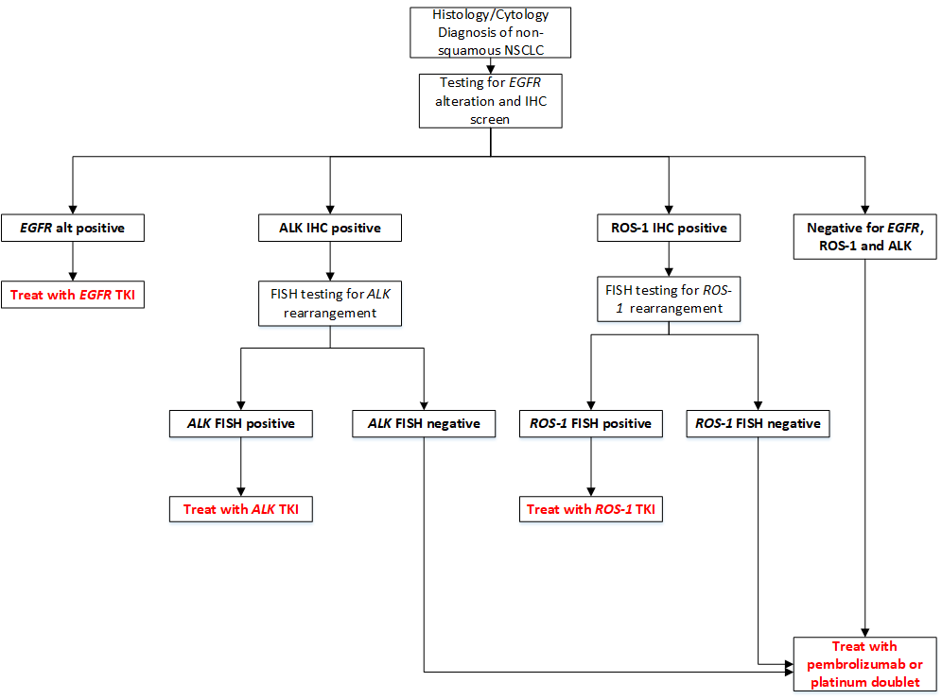
Figure 1 A clinical management algorithm for current testing and treatment for advanced NSCLC
Abbreviations: ALK=anaplastic lymphoma kinase; alt=alteration; EGFR=epidermal growth factor receptor; FISH=fluorescence in situ hybridisation; IHC=immunohistochemistry; NSCLC=non-small cell lung cancer; ROS-1=ROS-1 receptor tyrosine kinase; TKI=tyrosine kinase inhibitor
Pembrolizumab is listed on the PBS for treatment naïve patients with metastatic NSCLC, who have no evidence of EGFR gene, ALK gene rearrangement or a ROS-1 gene rearrangement

Proposed clinical management algorithms for identified population
The future testing and treatment algorithms for patients with NSCLC, after inclusion of testing for METex14 skipping alterations are in Figure 2 and, Figure 3 below. Figure 2 depicts the clinical management algorithm for testing of patients at diagnosis of NSCLC (where METex14 skipping alterations may occur prior to testing for ALK or ROS-1 using FISH) and Figure 3 represents the clinical management algorithm for patients who are tested for METex14 skipping alterations at the point of having locally advanced or metastatic NSCLC (where ALK and ROS-1 testing would occur first in any patients who were positive on IHC).
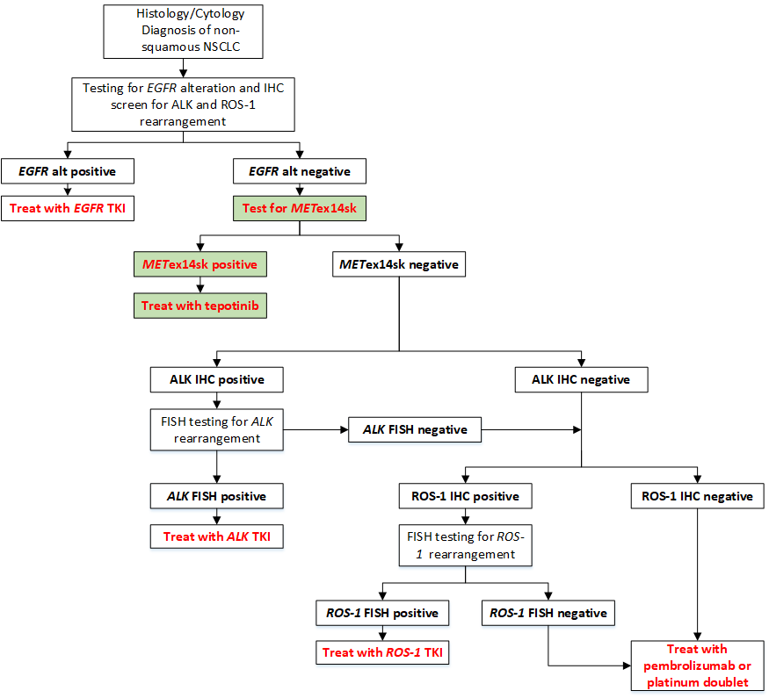
Figure 2 A proposed clinical management algorithm for NSCLC at time of diagnosis after inclusion of METexon14 skipping alteration test
Abbreviations: ALK=anaplastic lymphoma kinase; alt=alteration; EGFR=epidermal growth factor receptor; FISH=fluorescence in situ hybridisation; IHC=immunohistochemistry; METex14sk=mesenchymal-epithelial transition exon 14 skipping alteration; NSCLC=non-small cell lung cancer; ROS-1=ROS-1 receptor tyrosine kinase; TKI=tyrosine kinase inhibitor
Pembrolizumab is listed on the PBS for treatment naïve patients with metastatic NSCLC, who have no evidence of EGFR gene, ALK gene rearrangement or a ROS-1 gene rearrangement

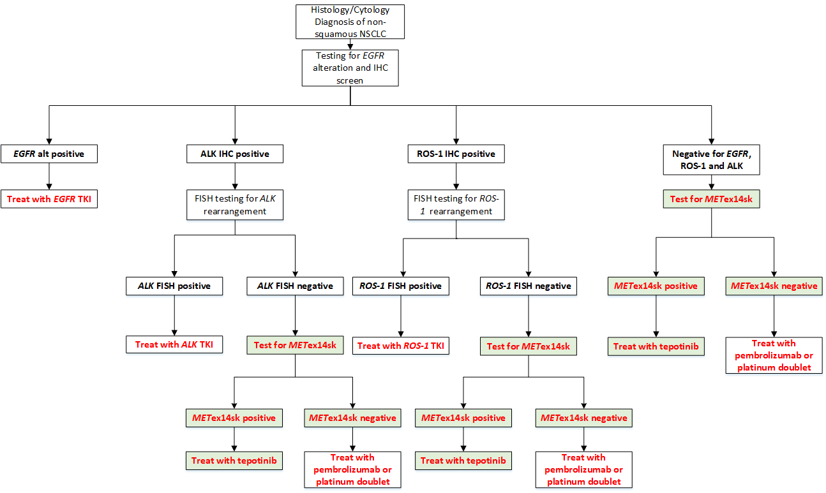
Figure 3 A proposed clinical management algorithm for advanced NSCLC after inclusion of METexon14 skipping alteration test
Abbreviations: ALK=anaplastic lymphoma kinase; alt=alteration; EGFR=epidermal growth factor receptor; FISH=fluorescence in situ hybridisation; IHC=immunohistochemistry; METex14sk=mesenchymal-epithelial transition exon 14 skipping alteration; NSCLC=non-small cell lung cancer; ROS-1=ROS-1 receptor tyrosine kinase; TKI=tyrosine kinase inhibitor
Pembrolizumab is listed on the PBS for treatment naïve patients with metastatic NSCLC, who have no evidence of EGFR gene, ALK gene rearrangement or a ROS-1 gene rearrangement

In the event that the parallel application for comprehensive genomic profiling for patients with NSCLC (MSAC application 1634) receives funding approval, the applicant has no objection for METex14 skipping alteration testing to be carried out as part of the genetic profiling panel.
PASC advised that the current treatment algorithm is not consistent with current practice whereby IHC for ALK and ROS1 is conducted at initial diagnosis as needed alongside EGFR testing.
PASC advised that the current and proposed treatment algorithms be revised to reflect current clinical practice.

Proposed economic evaluation
The applicant proposed that METex14 skipping alteration testing and treatment with tepotinib is non-inferior in terms of comparative effectiveness, versus the main comparator (no testing and current standard care) in patients with NSCLC. This claim is based on:
- Non-inferior effectiveness and safety of treating METex14 skipping alteration positive patients with tepotinib relative to standard of care without testing.
The applicant stated that this claim may change to superiority once more data are analysed.
PASC requested clarification around the comparative effectiveness outcome claim of non-inferior given the applicant is claiming superior health effects. PASC recommended changing the comparative effectiveness outcome claim of non-inferior to superior, but noted that the economic model may be a cost-minimisation analysis.
If the evidence presented demonstrates non-inferior effectiveness and safety, the appropriate economic evaluation is to take a cost-minimisation approach (Table 3). If on the other hand, the evidence identifies that safety and/or effectiveness is superior, then a cost -effectiveness or cost-utility analysis is recommended (Table 3).
Table 3 Classification of the comparative effectiveness and safety of the proposed intervention compared with its main comparator and guide to the suitable type of economic evaluation
Comparative safety |  | Comparative effectiveness
- | Inferior | Uncertainª | Non-inferior^{b} | Superior
Inferior | Health forgone: need other supportive factors | Health forgone possible: need other supportive factors | Health forgone: need other supportive factors | ? Likely CUA
Uncertainª | Health forgone possible: need other supportive factors | ? | ? | ? Likely CEA/CUA
Non-inferior^{b} | Health forgone: need other supportive factors | ? | CMA | CEA/CUA
Superior | ? Likely CUA | ? Likely CEA/CUA | CEA/CUA | CEA/CUA
CEA=cost-effectiveness analysis; CMA=cost-minimisation analysis; CUA=cost-utility analysis
? = reflect uncertainties and any identified health trade-offs in the economic evaluation, as a minimum in a cost-consequences analysis
ª ‘Uncertainty’ covers concepts such as inadequate minimisation of important sources of bias, lack of statistical significance in an underpowered trial, detecting clinically unimportant therapeutic differences, inconsistent results across trials, and trade-offs within the comparative effectiveness and/or the comparative safety considerations
^{b} An adequate assessment of ‘non-inferiority’ is the preferred basis for demonstrating equivalence

Proposed item descriptor
The applicant proposed the following descriptor:
Category 6 or 7 – Pathology or genetics service
Proposed item descriptor: A test of tumour tissue from a patient diagnosed with non-small cell lung cancer, shown to have non-squamous histology or histology not otherwise specified, and with documented absence of activating mutations of the epidermal growth factor receptor (EGFR) gene, requested by or on behalf of, a specialist or consultant physician or determinable by a pathologist, to determine:
If the requirements relating to MET exon 14 skipping gene status (including deletion mutations) for access to tepotinib are fulfilled under the Pharmaceutical Benefits Scheme (PBS)
Fee: $397.35 Benefit: 85% = $337.75
Testing for METex14 skipping alterations to be conducted sequentially to the EGFR gene test, if the EGFR result is negative and prior to any treatment.
During the pre-PASC meeting, clarification was provided that testing of ‘tumour tissue’ was acceptable in the proposed item descriptor.
The applicant clarified that a specific test descriptor (e.g. RNA vs DNA) was not needed as testing was considered method-agonistic with reliance on NATA accreditation to consider which test would be appropriate.
PASC noted currently MBS items are listed for targeting EGFR, ALK and ROS-1 for patients with non-squamous or not other otherwise specified NSCLC to determine eligibility for PBS-listed therapies, including tyrosine kinase inhibitors. Eligibility for treatment of metastatic NSCLC with pembrolizumab also requires confirmation of the absence of EGFR, ALK and ROS-1 alterations. PASC queried whether there should be a frequency restriction to once per lifetime (consistent with 73295) or once per primary tumour diagnosis (consistent with 73301 or 73302) in the proposed item. PASC noted that the specific criteria to be set out in the item descriptor should prevent leakage into untargeted populations.
The item descriptor proposed does not restrict use of the test to those with locally advanced or metastatic disease. If the proposal is for testing to occur only in those with locally advanced or metastatic disease, then the item could be amended to include the italicised words in the box below.
Category 6 or 7 – Pathology or genetics service
Proposed item descriptor: A test of tumour tissue from a patient diagnosed with locally advanced or metastatic non-small cell lung cancer, shown to have non-squamous histology or histology not otherwise specified, and with documented absence of activating mutations of the epidermal growth factor receptor (EGFR) gene, requested by or on behalf of, a specialist or consultant physician or determinable by a pathologist, to determine:
If the requirements relating to MET exon 14 skipping gene status (including deletion mutations) for access to tepotinib are fulfilled under the Pharmaceutical Benefits Scheme (PBS)
Fee: $397.35 Benefit: 85% = $337.75

Fee
The applicant has quoted a fee of $397.35, with an 85% benefit of 337.75. This fee is the same as for EGFR gene testing (item 73337). Unlike item 73337, which quotes a benefit of 75% ($298.05) and 85% ($337.75), the applicant has quoted a benefit for METex14 skipping alteration testing of 85% ($337.75) only.
During the pre-PASC meeting, the applicant confirmed acceptability of a fee of $397.35.

Consultation feedback
Targeted consultation feedback was received from the Royal College of Pathologists of Australasia (RCPA).
PASC noted that the RCPA expressed support for parallel testing (e.g. MSAC 1634) rather than sequential testing. PASC noted that letters of support from Rare Cancers Australia and Genomics for Life have been received with the application.

Next steps
PASC noted the applicant has elected to progress its application as an integrated codependent submission encompassing an ADAR (applicant developed assessment report).

Applicant Comments on the Ratified PICO
Population
The applicant commented that testing for mutations is currently limited to patients with histology categorised as non-squamous (NSQ) or not otherwise specified (NOS) and is not performed for patients with squamous (SQ) histology. In the co-dependent submission, Merck is requesting funding for METex14 testing of patients independent of histology i.e., including SQ, NSQ, and NOS patients, to ensure alignment with the requested tepotinib listing following advice at the PASC and Pre-PBAC meetings. This is a change to the original request to only test NSQ and NOS patients which had been based on Australian expert clinical opinion borne from their use of targeted therapies in other indications.
The applicant noted that patient numbers in Table 1 (above) would increase when squamous patients are included.
Intervention
The applicant provided the following comments:
EGFR prevalence
The prevalence of EGFR is 17.9% (Erlotinib and Gefitinib: 24 month predicted versus actual analysis (March 2017 DUSC)). This is the prevalence rate used in the co-dependent submission for tepotinib.
Rebiopsy
As stated by the independent expert pathologist at the PASC meeting, the retesting rate for Metex14sk is expected to be similar to the EGFR retesting rate and is not expected to be more frequent.
The rate of retesting for EGFR is infrequent. Whilst sequential testing is proposed, generally if there is sufficient sample for EGFR testing, there is likely to be sufficient sample for METex14sk testing. It should also be noted that simultaneous DNA and RNA extraction can be performed on the same sample enabling the sample to be used for both EGFR and METex14sk testing.
Comparator
The applicant that the most likely to be replaced treatment is pembrolizumab in combination with chemotherapy in the first-line setting. However, as some patients are unsuitable or ineligible for immunotherapy, it is expected that tepotinib will be replacing some chemotherapy as well.
Proposed economic evaluation
The applicant noted that the approach for the economic evaluation has been discussed with the Department and will inform our PBAC application.
Proposed item descriptor
The applicant proposed an updated proposed item descriptor below (which includes the Squamous cell NSCLC population)
Proposed item descriptor: A test of tumour tissue from a patient diagnosed with non-small cell lung cancer with the following characteristics:
Either:
- shown to have squamous histology or;
- shown to have non-squamous histology or histology not otherwise specified, and with documented absence of activating mutations of the epidermal growth factor receptor (EGFR) gene.
The test is requested by or on behalf of, a specialist or consultant physician or determinable by a pathologist, to determine:
If the requirements relating to MET exon 14 skipping gene status (including deletion mutations) for access to tepotinib are fulfilled under the Pharmaceutical Benefits Scheme (PBS).
Fee: $397.35 Benefit: 85% = $337.75

References
Bladt, F, Faden, B, Friese-Hamim, M, Knuehl, C, Wilm, C, Fittschen, C, Grädler, U, Meyring, M, Dorsch, D, Jaehrling, F, Pehl, U, Stieber, F, Schadt, O & Blaukat, A 2013, 'EMD 1214063 and EMD 1204831 Constitute a New Class of Potent and Highly Selective c-Met Inhibitors', Clinical Cancer Research, vol. 19, no. 11, p. 2941.
Davies, KD, Lomboy, A, Lawrence, CA, Yourshaw, M, Bocsi, GT, Camidge, DR & Aisner, DL 2019, 'DNA-Based versus RNA-Based Detection of MET Exon 14 Skipping Events in Lung Cancer', Journal of Thoracic Oncology, vol. 14, no. 4, 2019/04/01/, pp. 737-741.
Drilon, A, Cappuzzo, F, Ou, S-HI & Camidge, DR 2017, 'Targeting MET in Lung Cancer: Will Expectations Finally Be MET?', Journal of Thoracic Oncology, vol. 12, no. 1, 2017/01/01/, pp. 15-26.
Frampton, G, Ali, S, Rosenzweig, M, Chmielecki, J, Lu, X, Bauer, T, Akimov, M, Bufill, J & Lee, C 2015, 'Activation of MET via Diverse Exon 14 Splicing Alterations occurs in multiple tumor types and confers clinical sensitivity to MET inhibitors', Cancer Discovery, vol. 5, no. 8, pp. 850-859.
Huang, C, Zou, Q, Liu, H, Qiu, B, Li, Q, Lin, Y & Liang, Y 2020, 'Management of Non-small Cell Lung Cancer Patients with MET Exon 14 Skipping Mutations', Current Treatment Options in Oncology, vol. 21, no. 4, 2020/04/18, p. 33.
Kim, EK, Kim, KA, Lee, CY, Kim, S, Chang, S, Cho, BC & Shim, HS 2019, 'Molecular Diagnostic Assays and Clinicopathologic Implications of MET Exon 14 Skipping Mutation in Non–small-cell Lung Cancer', Clinical Lung Cancer, vol. 20, no. 1, 2019/01/01/, pp. e123-e132.
Kim, JH, Kim, HS & Kim, BJ 2017, 'MET inhibitors in advanced non-small-cell lung cancer: a meta-analysis and review', Oncotarget, vol. 8, no. 43, pp. 75500-75508.
Ma, P 2015, 'MET Receptor Juxtamembrane Exon 14 Alternative Spliced Variant: Novel Cancer Genomic Predictive Biomarker', Cancer Discovery, vol. 5, no. 8, pp. 802-805.
NCCN 2019, 'NCCN Clinical Practice Guidelines in Oncology (NCCN Guidelines), Non-Small Cell Lung Cancer', Department of Health.
Onozato, R, Kosaka, T, Kuwano, H, Sekido, Y, Yatabe, Y & Mitsudomi, T 2009, 'Activation of MET by Gene Amplification or by Splice Mutations Deleting the Juxtamembrane Domain in Primary Resected Lung Cancers', Journal of Thoracic Oncology, vol. 4, no. 1, 2009/01/01/, pp. 5-11.
Paik, P, Cortot, A, Felip, E, Sakai, H, Mazieres, J, Horn, L, Griesinger, F, Bruns, R, Scheele, J, Straub, J & Veillon, R 2019, '182TiP - A phase II trial of tepotinib in patients with non-small cell lung cancer (NSCLC) harboring MET alterations: The VISION study', Annals of Oncology, vol. 30, 2019/04/01/, p. ii66.
Paik, PK, Felip, E, Veillon, R, Sakai, H, Cortot, AB, Garassino, MC, Mazieres, J, Viteri, S, Senellart, H, Van Meerbeeck, J, Raskin, J, Reinmuth, N, Conte, P, Kowalski, D, Cho, BC, Patel, JD, Horn, L, Griesinger, F, Han, J-Y, Kim, Y-C, Chang, G-C, Tsai, C-L, Yang, JCH, Chen, Y-M, Smit, EF, van der Wekken, AJ, Kato, T, Juraeva, D, Stroh, C, Bruns, R, Straub, J, Johne, A, Scheele, J, Heymach, JV & Le, X 2020, 'Tepotinib in Non–Small-Cell Lung Cancer with MET Exon 14 Skipping Mutations', New England Journal of Medicine, vol. 383, no. 10, 2020/09/03, pp. 931-943.
Pasquini, G & Giaccone, G 2018, 'C-MET inhibitors for advanced non-small cell lung cancer', Expert Opinion on Investigational Drugs, vol. 27, no. 4, 2018/04/03, pp. 363-375.

Planchard, D, Popat, S, Kerr, K, Novello, S, Smit, E, Faivre-Finn, C, Mok, T, Reck, M, Van Schil, P, Hellman, M & Peters, S 2020, 'Metastatic non-small cell lung cancer: ESMO Clinical Practice Guidelines for diagnosis, treatment and follow-up', Ann Oncol, vol. 29, pp. iv192-iv237.
Poirot, B, Doucet, L, Benhenda, S, Champ, J, Meignin, V & Lehmann-Che, J 2017, 'MET Exon 14 Alterations and New Resistance Mutations to Tyrosine Kinase Inhibitors: Risk of Inadequate Detection with Current Amplicon-Based NGS Panels', Journal of Thoracic Oncology, vol. 12, no. 10, 2017/10/01/, pp. 1582-1587.
Pruis, M, Geurts-Giele, W, Von der, T, Meijssen, I, Dinjens, W, Aerts, J, Dingemans, A, Loikema, M, Paats, M & Dubbink, H 2020, 'Highly accurate DNA-based detection and treatment results of MET exon 14 skipping mutations in lung cancer', Lung Cancer, vol. 140, pp. 46-54.
Pudelko, L, Jaehrling, F, Reusch, C, Vitri, S, Stroh, C, Linde, N, Sanderson, M, Musch, D, Lebrun, C, Keil, M, Esdar, C, Blaukat, A, Rosell, R, Schumacher, K & Karachaliou, N 2020, 'SHP2 Inhibition influences therapeutic response to tepotinib in tumors with MET Alterations', iScience, vol. 23, no. 12, pp. 1-15.
Reungwetwattana, T, Liang, Y, Zhu, V & Ou, S-HI 2017, 'The race to target MET exon 14 skipping alterations in non-small cell lung cancer: The Why, the How, the Who, the Unknown, and the Inevitable', Lung Cancer, vol. 103, 2017/01/01/, pp. 27-37.
Salgia, R, Sattler, M, Scheele, J, Stroh, C & Felip, E 2020, 'The promise of selective MET inhibitors in non-small cell lung cancer with MET exon 14 skipping', Cancer Treatment Reviews 87, pp. 1-12.
Schrock, AB, Frampton, GM, Suh, J, Chalmers, ZR, Rosenzweig, M, Erlich, RL, Halmos, B, Goldman, J, Forde, P, Leuenberger, K, Peled, N, Kalemkerian, GP, Ross, JS, Stephens, PJ, Miller, VA, Ali, SM & Ou, S-HI 2016, 'Characterization of 298 Patients with Lung Cancer Harboring MET Exon 14 Skipping Alterations', Journal of Thoracic Oncology, vol. 11, no. 9, 2016/09/01/, pp. 1493-1502.
Sung, H, Ferlay, J, Siegel, RL, Laversanne, M, Soerjomataram, I, Jemal, A & Bray, F 2021, 'Global cancer statistics 2020: GLOBOCAN estimates of incidence and mortality worldwide for 36 cancers in 185 countries', CA: A Cancer Journal for Clinicians, vol. n/a, no. n/a, 2021/02/04.
Takamori, S, Matsubara, T, Fujishita, T, Ito, K, Toyozawa, R, Seto, T, Yamaguchi, M & Okamoto, T 2021, 'Dramatic intracranial response to tepotinib in a patient with lung adenocarcinoma harboring MET exon 14 skipping mutation', Thoracic Cancer, pp. 1-3.
Wang, Q, Yang, S, Wang, K & Sun, S 2019, 'MET inhibitors for targeted therapy of EGFR TKI-resistant lung cancer', J Hematol Oncol, vol. 12, no. 1, pp. 1-11.

Cancer Council https://www.cancer.org.au/cancer-information/types-of-cancer/lung-cancer Accessed 9th February 2021
1516 - Testing for epidermal growth factor receptor (EGFR) status in patients with locally advanced or metastatic non-small cell lung cancer (NSCLC) to determine eligibility for osimertinib. Available at http://www.msac.gov.au/internet/msac/publishing.nsf/Content/1516-public Accessed 22nd February 2021
OncLive website https://www.onclive.com/view/fda-approves-tepotinib-for-metex14-altered-metastatic-nsclc Accessed 17th February 2021

