MSAC Application 1771
Axicabtagene ciloleucel for patients with relapsed/refractory follicular lymphoma
PICO Set

Population

Describe the population in which the proposed health technology is intended to be used:
Adult patients with Grade 1, Grade 2 or Grade 3a follicular lymphoma and relapsed or refractory disease after two or more lines of therapy.

Specify any characteristics of patients with the medical condition, or suspected of, who are proposed to be eligible for the proposed health technology, describing how a patient would be investigated, managed and referred within the Australian health care system in the lead up to being considered eligible for the technology:
Investigations and management within the Australian health care system
Follicular lymphoma is a haematological malignancy involving B-cell lymphocytes which often impacts the lymph nodes (glands) and lymphatic system.
The diagnosis of FL is based on: physical examination; pathological assessments of blood sample; consideration of viral serology testing (hepatitis B and C and HIV); and excisional (preferred) or core (if excisional not possible) lymph node biopsy, followed by histopathological assessment of the biopsy specimen (Trotman et al. 2019).
Patients with a confirmed diagnosis of FL should receive investigations supporting disease staging. Work-up includes bone marrow aspirate and trephine biopsy, complemented by contrast-enhanced computed tomography (CT) or positron emission tomography (PET) imaging (Trotman et al. 2019, Dreyling et al. 2021).
Follicular lymphoma is indolent in nature for many patients. These patients may be asymptomatic or only have mild symptoms. Patients with indolent FL have a favourable prognosis, with a median overall survival of more than 15 years (Carbone et al. 2019). On this basis, patients with a diagnosis of FL who are asymptomatic and have low tumour burden do not require active treatment and are recommended to be managed with an observation/watch-and-wait approach (Trotman et al. 2019, Dreyling et al. 2021).
Previously indolent forms of FL may develop into a more aggressive form of disease. The increased rate of cellular proliferation in more aggressive forms of FL is associated with an increase in tumour burden and development of symptomatic disease. Local and international clinical management guidelines recommend that patients with symptomatic and/or high tumour burden FL receive systemic treatment.
In Australia the established first line (1L) treatment for patients with symptomatic and/or high tumour burden FL is chemoimmunotherapy, often followed by anti-CD20 antibody maintenance (Trotman et al. 2019). Recommended 1L regimens are outlined in Table 1.
Table 1: First line chemoimmunotherapy regimens for follicular lymphoma
Induction regimen | Maintenance regimen
Obinutuzumab-CHOP | Obinutuzumab
Rituximab-CHOP | Rituximab
Obinutuzumab-CVP | Obinutuzumab
Rituximab-CVP | Rituximab
Obinutuzumab-B | Obinutuzumab
Rituximab-B | -
Abbreviations: B=bendamustine; CHOP=cyclophosphamide, vincristine, doxorubicin and prednisone; CVP= cyclophosphamide, vincristine, doxorubicin and prednisone
Patients treated with 1L chemoimmunotherapy would be examined every 3-6 months to assess response to treatment. Investigations relevant to monitoring patients include physical examination and pathological assessments of blood samples, with and CT imaging performed if clinically indicated. Patients assessed as responding and tolerating to 1L chemoimmunotherapy would continue to receive their induction or maintenance regimen until the completion of the course of treatment.
Despite recent advanced in 1L treatments, the majority of patients will experience disease progression on or after 1L therapy (Carbone et al. 2019). The Lugano criteria (Cheson et al. 2014) is a widely adopted framework to assess patient response to treatment.
Patients assessed as no longer achieving disease control are classified as being:
- Relapsed, typically defined as patients who progress ≥6 months from completion of the most recent prior treatment, or:
- Refractory, typically defined as patients who progress <6 months from completion of the most recent prior treatment
Patients with R/R FL with symptomatic disease and/or high tumour burden should be considered for second line (2L) treatment (Freedman et al. 2020, Dreyling et al. 2021). Patients with asymptomatic disease and low tumour burden may be managed with an observation/watch-and-wait approach (Dreyling et al. 2021).
The selection of 2L treatment is based on the efficacy and duration of response of the prior treatment regimen. Australian clinical management guidelines do not discuss the management of R/R FL in detail. However, a summary of 2L regimens recommended in international clinical management guidelines (Freedman et al. 2020, Dreyling et al. 2021) is outlined in Table 2.
Table 2: Second line treatment regimens for follicular lymphoma
Regimen | Note
Obinutuzumab+B | Consider in rituximab-refractory cases or remissions lasting <6 months
Bendamustine | Consider for early systemic relapses (<12-24 months) after CHOP
Rituximab-B | -
Fludarabine-based chemotherapy | -
Platinum-based chemotherapy | -
Alkylating agent-based chemotherapy | -
Add rituximab to previously used chemoimmunotherapy regimen | Consider if previous regimen achieved >6-12 month remission
Idelalisib | PBS listed for patients refractory to rituximab and/or alkylating agent within 6 months of completion of treatment
Lenalidomide+rituximab | Lenalidomide not PBS listed for treatment of FL
Abbreviations: B=bendamustine; CHOP=cyclophosphamide, vincristine, doxorubicin and prednisone; FL=follicular lymphoma
Patients receiving 2L treatment would be monitored for response to treatment in a way consistent with monitoring patients receiving 1L treatment.
Patients that develop R/R FL after 2L treatment have limited treatment options that have demonstrated clinical efficacy in clinical trials. For this reason, patients indicated for third line and beyond (3L+) treatment often ‘cycle through’ recommended 2L treatment regimens.
Analysis of a cohort of R/R FL patients initiating 3L+ treatment demonstrates that survival outcomes for patients in the 3L+ setting are poor (Ghione et al. 2023) and that outcome become progressively worse for patients initiating each subsequent line of treatment (Figure 1).
Figure 1: Overall survival for relapsed or refractory follicular lymphoma patients by line of therapy
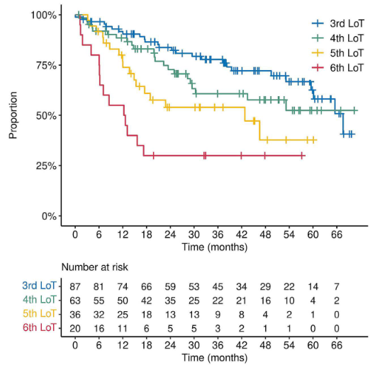
Source: Figure 4 (Panel A), p. 829 of (Ghione et al. 2023)
Abbreviation: Lot=line of therapy
This application proposes that Yescarta is funded as a treatment for adult patients with Grade 1, Grade 2 or Grade 3a FL with relapsed or refractory disease after 2 or more lines of therapy. That is, Yescarta would be used in a 3L+ setting.
Referral pathway to be considered by treatment with Yescarta
Patients with FL would typically be managed by a clinician specialising in haematological malignancies. Upon an assessment of a patient being R/R to 2L treatment and a potential candidate for Yescarta, the clinician would refer the patient to a tertiary hospital that has been approved to provide Yescarta infusion for the treatment of FL.

Provide a rationale for the specifics of the eligible population:
The patient population proposed to be eligible for treatment with Yescarta is consistent with the TGA-approved indication and the patient population enrolled in the pivotal study assessing the safety and efficacy of Yescarta as a treatment for FL (the ZUMA-5 study).
The TGA-approved indication for Yescarta as a treatment for patients with FL is outlined below.
YESCARTA is a genetically modified autologous immunocellular therapy for the treatment of patients with relapsed or refractory follicular lymphoma (FL) after two or more lines of systemic therapy
Key eligibility criteria applied in the recruiting patients into the ZUMA-5 trial were: adult patients (≥18 years), grade 1-3a follicular lymphoma, relapsed or refractory disease after 2 or more lines of therapy.

Intervention

Name of the proposed health technology:
Yescarta™ (axicabtagene ciloleucel)

Describe the key components and clinical steps involved in delivering the proposed health technology:
The key steps involved in delivering Yescarta for the treatment of patients with R/R FL is consistent with the use of Yescarta for other indications considered by MSAC. A summary of the procedures involved in delivering treatment with Yescarta is provided below.
Step 1: Leukapheresis
Leukocytes (white blood cells) are collected from the patient at their clinical centre. This is done by leukapheresis, whereby whole blood is withdrawn from the patient, leukocytes are extracted and then the remainder of the blood is transfused back into the patient.
Step 2: Procurement of Yescarta
REDACTED
The manufacturing process involves isolation and activation of T-cells obtained from the patient sample collected as part of the leukapheresis step. The patients T-cells the engineered to express the CAR gene, followed by steps to expand the population of engineered T-cells. The final product is washed, cryopreserved and tested for identity, potency, and adventitious agents. After meeting acceptance criteria, the product is transported back to the patient’s clinical centre in Australia using a validated cryo-shipper.
Step 3: Lymphodepleting chemotherapy
Prior to infusion, patients are treated with low dose lymphodepleting chemotherapy to eliminate the patient’s lymphocytes and allow space for the T-cells to expand. Lymphodepleting chemotherapy consists of fludarabine (30 mg/m2/day) plus cyclophosphamide (500 mg/m2/day) for 3 days (on the fifth, fourth, and third day before the infusion of Yescarta at Day 0).
Step 4: Treatment infusion
Yescarta is a single infusion product. Each bag contains a suspension of anti-CD19 CAR-T- cells at a target dose of 2x10⁶ cells/kg in approximately 68 mL. Yescarta is delivered via an intravenous infusion.
A diagram representing the steps involved in the delivery of treatment with Yescarta is provided below.
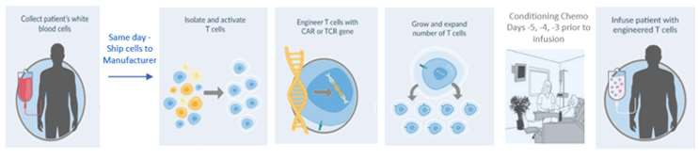

Identify how the proposed technology achieves the intended patient outcomes:
Yescarta binds to CD19, an antigen expressed on the cell surface of the target lymphoma B cells. Following engagement with CD19-expressing target cells, the CD3ζ domain activates the downstream signalling cascade that leads to T-cell activation, proliferation, and acquisition of effector functions, such as cytotoxicity. The intracellular signalling domain of CD28 provides a co-stimulatory signal that works in concert with the primary CD3ζ signal to augment T-cell function, including interleukin-2 (IL-2) production (Finney et al. 1998). Together, these signals act in concert resulting in proliferation of the Yescarta CAR T-cells and direct killing of target cells. In addition, activated T-cells secrete cytokines and other molecules that can recruit and activate additional anti-tumour immune cells (Restifo et al. 2012).

Does the proposed health technology include a registered trademark component with characteristics that distinguishes it from other similar health components?
Yes, Yescarta is a registered trademark (YESCARTA®)

Explain whether it is essential to have this trademark component or whether there would be other components that would be suitable:
The process of manufacture for Yescarta is distinct from other CAR-T therapies available in Australia such as Kymriah (tisagenlecleucel) and Tecartus (brexucabtagene autoeucel). As such, CAR-T treatments are not considered to be interchangeable with each other.
The inclusion of the trademarked (Yescarta) component is important to avoid confusion with other CAR-T therapies which are not within the scope of this application.

Are there any proposed limitations on the provision of the proposed health technology delivered to the patient (For example: accessibility, dosage, quantity, duration or frequency):
Yes

Provide details and explain:
Yescarta will be administered at tertiary public hospitals that have successfully completed Gilead’s rigorous site qualification process to ensure all quality and safety requirements can be satisfied.
Patients will require daily monitoring for at least 7 days at the qualified clinical facility following infusion for possible adverse events, such as cytokine release syndrome or neurologic events.
Patients are then instructed to remain within proximity of the qualified clinical facility for at least 4 weeks following infusion with Yescarta.

If applicable, advise which health professionals will be needed to provide the proposed health technology:
Haematologists and clinicians specialising in haematological malignancies.

If applicable, advise whether delivery of the proposed health technology can be delegated to another health professional:
Not applicable

If applicable, advise if there are any limitations on which health professionals might provide a referral for the proposed health technology:
Not applicable

Is there specific training or qualifications required to provide or deliver the proposed service, and/or any accreditation requirements to support delivery of the health technology?
Yes

Provide details and explain:
Yescarta would be prescribed by clinicians with qualifications allowing them to practice in Australia and manage patients with haematological malignancies.
The administration of Yescarta would take place in tertiary hospitals that have been accredited to provide Yescarta after completion of Gilead’s rigorous site qualification process.

Indicate the proposed setting(s) in which the proposed health technology will be delivered:
Consulting rooms
Day surgery centre
Emergency Department
Inpatient private hospital
Inpatient public hospital
Laboratory
Outpatient clinic
Patient’s home
Point of care testing
Residential aged care facility
Other
A patient’s T-cells will be collected at an outpatient clinic via leukapheresis. Extracted apheresis material is then couriered to an offsite manufacturing facility and returned to Australia to the healthcare/clinical facility.
Lymphodepleting chemotherapy with fludarabine and cyclophosphamide will be infused at an outpatient clinic.
Yescarta will be administered by intravenous infusion at the qualified clinical facility. Patients will require monitoring daily for at least 7 days at the qualified healthcare/clinical facility following infusion for possible adverse events such as cytokine release syndrome.

Is the proposed health technology intended to be entirely rendered inside Australia?
No

Provide additional details on the proposed health technology to be rendered outside of Australia:
The manufacturing of Yescarta is undertaken at a manufacturing facility outside of Australia.
All other steps (leukapheresis, administration and post-administration monitoring) are rendered in Australia.

Comparator

Nominate the appropriate comparator(s) for the proposed medical service (i.e. how is the proposed population currently managed in the absence of the proposed medical service being available in the Australian health care system). This includes identifying health care resources that are needed to be delivered at the same time as the comparator service:
Provide a name for your comparator:
Standard of Care (SoC), represented by a ‘basket’ of anti CD20 monotherapy, anti CD20 therapy in combination with chemotherapy and chemotherapy regimens.
Provide an identifying number for your comparator (if applicable):
Not applicable
Provide a rationale for why this is a comparator:
As discussed above, there is no uniformly recommended systemic treatment for patients with FL that are R/R to at least 2 prior lines of therapy. Instead, treatments are chosen based on individual patient circumstances such as the mechanism of action and duration of response to prior treatments.
REDACTED Regimens recorded as 3L treatment were:
- Rituximab+bendamustine (anti CD20 therapy in combination with chemotherapy)
- Dexamethasone+cytarabine+carboplatin (chemotherapy)
- Ifosfamide+carboplatin+etoposide (chemotherapy)
REDACTED Therefore, it is plausible that additional therapeutic combinations would be used in Australian clinical practice.
Given the range of treatment regimens likely used as 3L treatment for patients with FL, nomination of SoC represented by a ‘basket’ of anti CD20 monotherapy, anti CD20 therapy in combination with chemotherapy and chemotherapy regimens reasonably captures how patients with R/R FL after at least 2 prior lines of treatment are managed in Australia.
Pattern of substitution – Will the proposed health technology wholly replace the proposed comparator, partially replace the proposed comparator, displace the proposed comparator or be used in combination with the proposed comparator?
None (used with the comparator)
Displaced (comparator will likely be used following the proposed technology in some patients)
Partial (in some cases, the proposed technology will replace the use of the comparator, but not all)
Full (subjects who receive the proposed intervention will not receive the comparator)

Outline and explain the extent to which the current comparator is expected to be substituted:
Clinical contraindications for Yescarta include active infection and inflammatory disorders. Further, treatment with Yescarta involves hospital visits and admission for leukapheresis, treatment administration and monitoring. As such, some patients are anticipated to elect to not undergo treatment with Yescarta on the basis that treatment requires prolonged periods away from home.
Gilead is engaging with local clinicians to better understand the extent to which Yescarta is expected to be used as a substitute for SoC. However, for the reasons outlined above it is expected that there will be less than 100% substitution in Australian clinical practice.

Outcomes

List the key health outcomes (major and minor – prioritising major key health outcomes first) that will need to be measured in assessing the clinical claim for the proposed medical service/technology (versus the comparator):
Health benefits
Health harms
Resources
Health benefits:
Key outcomes applicable to assessing the health benefits (efficacy) of Yescarta are:
- Objective response rate (ORR)
- Complete response rate (CR)
- Progression-fee survival (PFS)
- Overall survival (OS)
- Time-to-next treatment (TTNT)
Health harms:
Outcomes applicable to assessing the health harms (safety) associated with Yescarta are:
- Incidence of adverse events (AEs) and serious adverse events (SAEs)
- Incidence of AEs of special interest, specifically:
  - Cytokine release syndrome
  - Neurological events
  - Infections
  - Cytopenias
Resources:
Healthcare resources applicable to assessing the cost-effectiveness and budget impact associated with funding Yescarta are:
- Percentage of patients undergoing leukapheresis that go on to have Yescarta administered
- Cost of pre-infusion lymphodepleting chemotherapy
- Cost of hospitalisation for Yescarta administration and monitoring
- Cost of patient consultations and investigations for post-treatment monitoring

Outcome description – include information about whether a change in patient management, or prognosis, occurs as a result of the test information:
Not applicable. Yescarta is not a test used for diagnostic or risk assessment purposes.

Claims

In terms of health outcomes (comparative benefits and harms), is the proposed technology claimed to be superior, non-inferior or inferior to the comparator(s)?
Superior
Non-inferior
Inferior

State what the overall claim is, and provide a rationale:
The clinical claim is that Yescarta has superior efficacy and non-inferior safety compared with SoC, represented by a ‘basket’ of anti CD20 monotherapy, anti CD20 therapy in combination with chemotherapy and chemotherapy regimens.

Why would the requestor seek to use the proposed investigative technology rather than the comparator(s)?
Yescarta is associated with improvements in treatment response, progression free survival and overall survival compared with the comparator.

Identify how the proposed technology achieves the intended patient outcomes:
This question is duplicated from the ‘Intervention’ section above. Please refer to the response provided previously.

For some people, compared with the comparator(s), does the test information result in:

A change in clinical management?

A change in health outcome?

Other benefits?
Not applicable. Yescarta is not a test used for diagnostic or risk assessment purposes.

Provide a rationale, and information on other benefits if relevant:
Not applicable

In terms of the immediate costs of the proposed technology (and immediate cost consequences, such as procedural costs, testing costs etc.), is the proposed technology claimed to be more costly, the same cost or less costly than the comparator?
More costly
Same cost
Less costly

Provide a brief rationale for the claim:
Treatment acquisition, administration and monitoring costs are higher for Yescarta compared with SoC. represented by a ‘basket’ of anti CD20 monotherapy, anti CD20 therapy in combination with chemotherapy and chemotherapy regimens.

Algorithms

PREPARATION FOR USING THE HEALTH TECHNOLOGY

Define and summarise the clinical management algorithm, including any required tests or healthcare resources, before patients would be eligible for the proposed health technology:
As outlined previously, Yescarta would be considered as a treatment for patients with R/R FL after 2 or more lines of therapy.
Tests required before patients would be eligible for Yescarta are not materially different to those currently performed as part of routine management of R/R FL, notably physical examination and pathological assessments of blood samples, with and CT imaging performed if clinically indicated.

Is there any expectation that the clinical management algorithm before the health technology is used will change due to the introduction of the proposed health technology?
No

Describe and explain any differences in the clinical management algorithm prior to the use of the proposed health technology vs. the comparator health technology:
Not applicable

USE OF THE HEALTH TECHNOLOGY

Explain what other healthcare resources are used in conjunction with delivering the proposed health technology:
Patients are treated with low dose lymphodepleting chemotherapy prior to infusion with Yescarta,. This regimen consists of fludarabine (30 mg/m2/day) plus cyclophosphamide (500 mg/m2/day) for 3 days (on the fifth, fourth, and third day before the infusion of Yescarta at Day 0).
Patients would remain hospitalised for observation for a minimum of 7 days after infusion with Yescarta.

Explain what other healthcare resources are used in conjunction with the comparator health technology:
SoC requires administration by intravenous infusion. This would take place in outpatient clinics and is funded through MBS item 13950.

Describe and explain any differences in the healthcare resources used in conjunction with the proposed health technology vs. the comparator health technology:
The objective of administering lymphodepleting chemotherapy is to create and optimal environment for the in vivo expansion of anti-CD19 CAR-T cells.
CAR-T therapies (including Yescarta) are associated with increased risk of patients developing cytokine release syndrome and neurological events. These typically manifest themselves 3-6 days following CAR-T cell infusion {Penack, 2020 #1212}. This is the basis the minimum 7 day period of hospital administration following administration with Yescarta.
The difference in the mechanism of action between Yescarta (CAR-T therapy) and comparator treatment (systemic therapies with non-CAR-T mechanisms of action) is the reason why for the difference in healthcare resources using in conjunction with Yescarta vs the comparator.

CLINICAL MANAGEMENT AFTER THE USE OF HEALTH TECHNOLOGY

Define and summarise the clinical management algorithm, including any required tests or healthcare resources, after the use of the proposed health technology:
Following the administration of Yescarta and completion of the minimum 7-day period of hospitalisation for observation, patients would be discharged and followed-up in an outpatient setting.
Follow-up investigations include physical examination and pathological assessments of blood samples, with and CT imaging performed if clinically indicated.
Define and summarise the clinical management algorithm, including any required tests or healthcare resources, after the use of the comparator health technology:
The management and healthcare resource use for patients being followed-up after treatment with the comparator is not materially different to those used after treatment with Yescarta. That is, follow-up investigations are physical examination and pathological assessments of blood samples, with and CT imaging performed if clinically indicated.

Describe and explain any differences in the healthcare resources used after the proposed health technology vs. the comparator health technology:
No material differences

Insert diagrams demonstrating the clinical management algorithm with and without the proposed health technology:
Figure 2: Clinical management algorithm without Yescarta
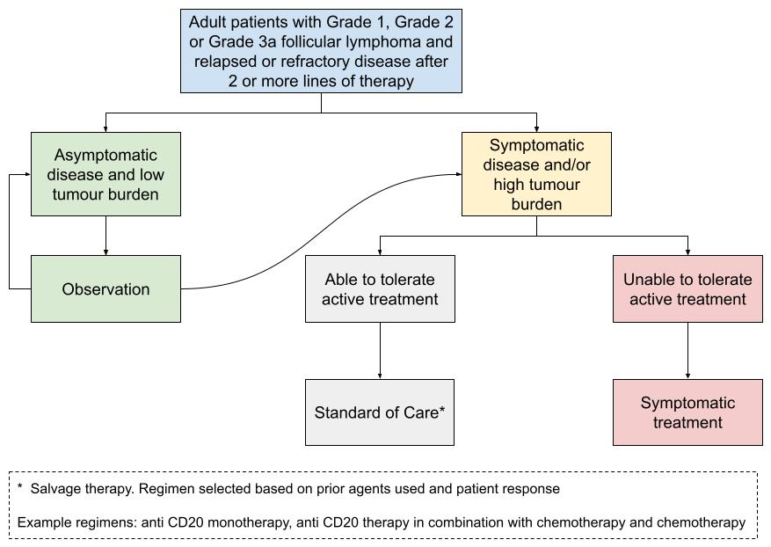
Figure 3: Clinical management algorithm with Yescarta
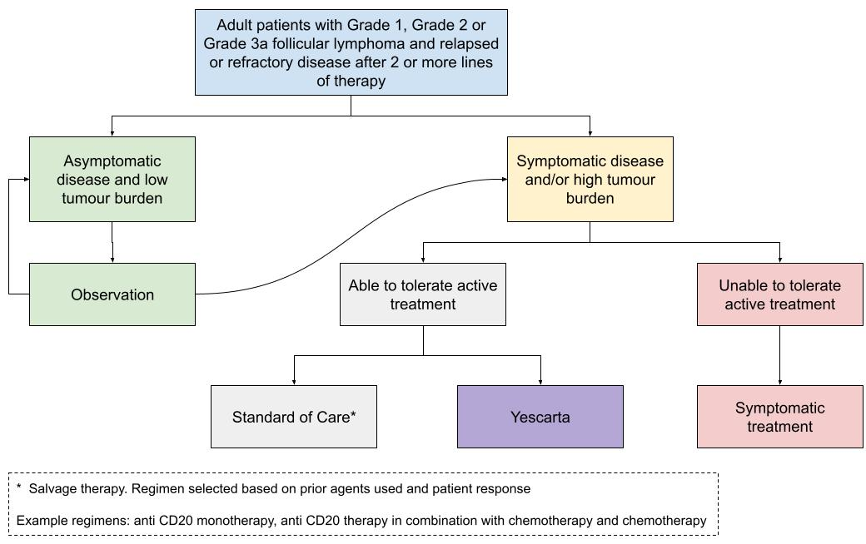

Summary of Evidence

Provide one or more recent (published) high quality clinical studies that support use of the proposed health service/technology
 | Type of study design | Title of journal article or research project | Short description of research | Website link to journal article or research | Date of publication
1. | Pivotal study: ZUMA-5  Non-randomised, single-arm, multicentre, Phase 2 trial | Axicabtagene ciloleucel in relapsed or refractory indolent non-Hodgkin lymphoma (ZUMA-5): a single-arm, multicentre, phase 2 trial  NCT03105336 | This trial assessed the safety and efficacy of Yescarta as a treatment of indolent non-Hodgkin lymphoma R/R to at least 2 prior lines of therapy (population requested in this application).  This article reports on the primary analysis of the ZUMA-5 trial with a minimum follow-up of 12 months.  The primary endpoint was overall response rate assessed by an independent review committee per Lugano criteria. In the subgroup of N=84 FL patients 96% had objective response and 79% had a complete response. | https://doi.org/10.1016/S1470-2045(21)00591-X | 2022: (Jacobson et al. 2022)
2. | Pivotal study: ZUMA-5  Non-randomised, single-arm, multicentre, Phase 2 trial | Three-year follow-up analysis of axicabtagene ciloleucel in relapsed/refractory indolent non-hodgkin lymphoma (ZUMA-5)  NCT03105336 | This article reports on the outcomes of the ZUMA-5 trial with minimum follow-up of 36 months.  At this updated analysis of patients in the subgroup 94% (96% at 12-month analysis) had objective response and 79% (79% at 12 months analysis) had a complete response  Median PFS was 40.2 months (95% C: 28.9, NE).  At 36 months following administration of Yescarta, 76% of patients remained alive. | https://doi.org/10.1182/blood.2023021243 | 2023: (Neelapu et al. 2023)  3-year follow-up to the primary analysis with minimum of 12-months follow-up reported by (Jacobson et al. 2022)
3. | Supplementary study.  Simulated randomised controlled trail | Comparative effectiveness of ZUMA-5 (axi-cel) vs SCHOLAR-5 external control in relapsed/refractory follicular lymphoma | Outcomes from the ZUMA-5 trial were compared with international SCHOLAR-5 cohort.  Patient characteristics were balanced through propensity scoring on prespecified prognostic factors prior to analysis.  Objective response in SCHOLAR-5 vs ZUMA-5 was 50% vs 94% respectively: OR 16.2 (95% CI: 5.6, 46.9)  Hazard ratios for PFS and OS were 0.42 (95% CI: 0.21, 0.83) and 0.30 (95%: 0.18, 0.49) respectively. | https://doi.org/10.1182/blood.2021014375 | 2022: (Ghione et al. 2022)

Identify yet-to-be-published research that may have results available in the near future (that could be relevant to your application)
 | Type of study design | Title of journal article or research project | Short description of research | Website link to journal article or research | Date of publication
1. | Supplementary study.  Simulated randomised controlled trail | Comparative effectiveness of axicabtagene ciloleucel vs historical standard-of-care in patients with relapsed or refractory follicular lymphoma: an analysis of CIBMTR and SCHOLAR-5 data | Outcomes from patients receiving Yescarta in a real-world setting were compared with the SCHOLAR-5 cohort.  Objective response in SCHOLAR-5 vs real-world Yescarta was 67% vs 92% respectively: OR 4.9 (95% CI: 2.4, 10.3)  Hazard ratios for PFS and OS at 6-months were 0.41 (95% CI: 0.22, 0.77) and 0.15 (95%: 0.06, 0.34) respectively | https://ash.confex.com/ash/2023/webprogram/Paper178629.html | 2023

References
Carbone, A, Roulland, S, et al. (2019). "Follicular lymphoma." Nature reviews Disease primers 5(1): 83.
Cheson, BD, Fisher, RI, et al. (2014). "Recommendations for initial evaluation, staging, and response assessment of Hodgkin and non-Hodgkin lymphoma: the Lugano classification." Journal of clinical oncology 32(27): 3059.
Dreyling, M, Ghielmini, M, et al. (2021). "Newly diagnosed and relapsed follicular lymphoma: ESMO Clinical Practice Guidelines for diagnosis, treatment and follow-up†☆." Annals of Oncology 32(3): 298-308.
Finney, HM, Lawson, AD, et al. (1998). "Chimeric receptors providing both primary and costimulatory signaling in T cells from a single gene product." The Journal of Immunology 161(6): 2791-2797.
Freedman, A and Jacobsen, E (2020). "Follicular lymphoma: 2020 update on diagnosis and management." American Journal of Hematology 95(3): 316-327.
Ghione, P, Palomba, ML, et al. (2023). "Treatment patterns and outcomes in relapsed/refractory follicular lymphoma: results from the international SCHOLAR-5 study." Haematologica 108(3): 822.
Ghione, P, Palomba, ML, et al. (2022). "Comparative effectiveness of ZUMA-5 (axi-cel) vs SCHOLAR-5 external control in relapsed/refractory follicular lymphoma." Blood, The Journal of the American Society of Hematology 140(8): 851-860.
Jacobson, CA, Chavez, JC, et al. (2022). "Axicabtagene ciloleucel in relapsed or refractory indolent non-Hodgkin lymphoma (ZUMA-5): a single-arm, multicentre, phase 2 trial." The lancet oncology 23(1): 91-103.
Neelapu, SS, Chavez, JC, et al. (2023). "Three-Year Follow-Up Analysis of Axicabtagene Ciloleucel in Relapsed/Refractory Indolent Non-Hodgkin Lymphoma (ZUMA-5)." Blood Journal: blood. 2023021243.
Restifo, NP, Dudley, ME, et al. (2012). "Adoptive immunotherapy for cancer: harnessing the T cell response." Nature Reviews Immunology 12(4): 269-281.
Trotman, J, Cheah, CY, et al. (2019). "Front‐line management of non‐Hodgkin lymphoma in Australia. Part 1: follicular lymphoma." Internal Medicine Journal 49(4): 422-433.

