

Application Form

(New and Amended Requests for Public Funding)

(Version 2.5)

This application form is to be completed for new and amended requests for public funding (including but not limited to the Medicare Benefits Schedule (MBS)). It describes the detailed information that the Australian Government Department of Health requires in order to determine whether a proposed medical service is P

Please use this template, along with the associated Application Form Guidelines to prepare your application. Please complete all questions that are applicable to the proposed service, providing relevant information only. Applications not completed in full will not be accepted.

The application form will be disseminated to professional bodies / organisations and consumer organisations that have will be identified in Part 5, and any additional groups that the Department deem should be consulted with. The application form, with relevant material can be redacted if requested by the Applicant.

Should you require any further assistance, departmental staff are available through the contact numbers and email below to discuss the application form, or any other component of the Medical Services Advisory Committee process.

Phone: +61 2 6289 7550

Fax: +61 2 6289 5540

Email: [hta@health.gov.au](mailto:hta@health.gov.au)

Website: [www.msac.gov.au](http://www.msac.gov.au/)

# PART 1 – APPLICANT DETAILS

## Applicant details (primary and alternative contacts)

Corporation / partnership details (where relevant):

Redacted

Corporation name: Redacted

ABN: Redacted

Business trading name: Redacted

**Primary contact name:** Redacted

Primary contact numbers

Business: Redacted

Mobile: Redacted

Email: Redacted

**Alternative contact name:** Redacted

Alternative contact numbers

Business: Redacted

Phone: Redacted

Email: Redacted

## (a) Are you a consultant acting on behalf of an Applicant?

Yes

No

**(b) If yes, what is the Applicant(s) name that you are acting on behalf of?**

Redacted

## (a) Are you a lobbyist acting on behalf of an Applicant?

Yes

No

## If yes, are you listed on the Register of Lobbyists?

Yes

No

# PART 2 – INFORMATION ABOUT THE PROPOSED MEDICAL SERVICE

## Application title

Micro-bypass stenting for open-angle glaucoma (external to Schlemm’s canal)

## Provide a succinct description of the medical condition relevant to the proposed service (no more than 150 words – further information will be requested at Part F of the Application Form)

Glaucoma is a chronic degenerative optic neuropathy in which the neuro-retinal rim of the optic nerve becomes progressively thinner, caused by an acquired loss of retinal ganglion cell axons and atrophy of the optic nerve. The lens and cornea of the eye both lack direct blood supply. Therefore, these anterior structures are nourished by a separate circulatory system. The aqueous humour, produced by the ciliary body, circulates throughout the anterior chamber and drains through the uveoscleral outflow in the iridocorneal angle. Its primary role is to maintain intraocular pressure (IOP), and provide nutrients to the structures of the anterior and posterior chambers of the eye. In open-angle glaucoma aqueous outflow is diminished, leading to an elevation of IOP. Patients with glaucoma typically lose peripheral vision, and may suffer complete vison loss if not treated.

## Provide a succinct description of the proposed medical service (no more than 150 words – further information will be requested at Part 6 of the Application Form)

Micro-Stent implantation involves a minimally invasive glaucoma surgery (MIGS) device, and is a ab interno, bleb-less, conjunctiva-sparing procedure. The device improves aqueous outflow through the natural physiologic uveoscleral outflow pathway, thereby lowering IOP and dependence on pressure-lowering topical medication. The procedure is generally performed as a day surgery procedure in an ophthalmology surgical setting, in conjunction with cataract surgery or as a stand-alone treatment.

## ****(a) Is this a request for MBS funding?****

Yes

No

## ****If yes, is the medical service(s) proposed to be covered under an existing MBS item number(s) or is a new MBS item(s) being sought altogether?****

Amendment to existing MBS item(s)

New MBS item(s)

## ****If an amendment to an existing item(s) is being sought, please list the relevant MBS item number(s) that are to be amended to include the proposed medical service:****

Not applicable

## ****If an amendment to an existing item(s) is being sought, what is the nature of the amendment(s)?****

Not applicable

1. **An amendment to the way the service is clinically delivered under the existing item(s)**
2. **An amendment to the patient population under the existing item(s)**
3. **An amendment to the schedule fee of the existing item(s)**
4. **An amendment to the time and complexity of an existing item(s)**
5. **Access to an existing item(s) by a different health practitioner group**
6. **Minor amendments to the item descriptor that does not affect how the service is delivered**
7. **An amendment to an existing specific single consultation item**
8. **An amendment to an existing global consultation item(s)**
9. **Other (please describe below):**

## ****If a new item(s) is being requested, what is the nature of the change to the MBS being sought?****

1. **A new item which also seeks to allow access to the MBS for a specific health practitioner group**
2. **A new item that is proposing a way of clinically delivering a service that is new to the MBS (in terms of new technology and / or population)**
3. **A new item for a specific single consultation item**
4. **A new item for a global consultation item(s)**

**An MSAC review of MBS item number 42758 (goniotomy) determined that the current criteria does not extend to the implantation of MIGS devices. An amendment to the current MBS item for goniotomy, effective 1 May 2017, will explicitly exclude implantation of MIGS device being claimed under this service.** Thus, MIGS devices are not novel to Australian clinical practice; but its safety, effectiveness and cost-effectiveness in the proposed patient population have not previously been evaluated by MSAC, nor is there an MBS item (current or former) that specifically describes the proposed service. In this way, the service and therapeutic intervention it describes is new to the MSAC.

## ****Is the proposed service seeking public funding other than the MBS?****

Yes

No

**At the time of submitting this application form (20 March 2017), the CyPass Micro-Stent is listed on the Prostheses List.** **The identified MBS item number was 42758.**

What is the type of service:

Therapeutic medical service

Investigative medical service

Single consultation medical service

Global consultation medical service

Allied health service

Co-dependent technology

Hybrid health technology

## For investigative services, advise the specific purpose of performing the service *(which could be one or more of the following)*:

Not applicable

1. To be used as a screening tool in asymptomatic populations
2. Assists in establishing a diagnosis in symptomatic patients
3. Provides information about prognosis
4. Identifies a patient as suitable for therapy by predicting a variation in the effect of the therapy
5. Monitors a patient over time to assess treatment response and guide subsequent treatment decisions
6. Is for genetic testing for heritable mutations in clinically affected individuals and, when also appropriate, in family members of those individuals who test positive for one or more relevant mutations (and thus for which the Clinical Utility Card proforma might apply)

## Does your service rely on another medical product to achieve or to enhance its intended effect?

Pharmaceutical / Biological

Prosthesis or device

No

## (a) If the proposed service has a pharmaceutical component to it, is it already covered under an existing Pharmaceutical Benefits Scheme (PBS) listing?

Not applicable

Yes

No

## If yes, please list the relevant PBS item code(s):

Not applicable

## If no, is an application (submission) in the process of being considered by the Pharmaceutical Benefits Advisory Committee (PBAC)?

Not applicable

Yes (please provide PBAC submission item number below)

No

## If you are seeking both MBS and PBS listing, what is the trade name and generic name of the pharmaceutical?

Not applicable

## (a) If the proposed service is dependent on the use of a prosthesis, is it already included on the Prostheses List?

Yes

No

**At the time of submitting this application form (20 March 2017), the CyPass Micro-Stent is listed on the Prostheses List. The identified MBS item number was 42758.**

## If yes, please provide the following information (where relevant):

Billing code(s): AL042

Trade name of prostheses: CyPass System

Clinical name of prostheses: glaucoma drainage micro-stent device

Other device components delivered as part of the service: CyPass System also consists of a ‘loader’ and ‘applier’ for implantation of the micro-stent.

## If no, is an application in the process of being considered by a Clinical Advisory Group or the Prostheses List Advisory Committee (PLAC)?

Not applicable

Yes

No

## Are there any other sponsor(s) and / or manufacturer(s) that have a similar prosthesis or device component in the Australian market place which this application is relevant to?

Yes

No

The following manufacturers produce similar MIGS devices to treat patients with mild-moderate POAG – these devices are also implanted by the ab interno approach, but the anatomical placement of the device is in the trabecular meshwork.

* Sponsor: Glaukos Device: iStent
* Sponsor Ivantis Device: Hydrus

## If yes, please provide the name(s) of the sponsor(s) and / or manufacturer(s):

Not applicable

## Please identify any single and / or multi-use consumables delivered as part of the service?

Single use consumables:

An injector system, pre-loaded with the MIGS device is provided and included in the total cost of the MIGS device system. The cost of the injector and the micro-bypass stent prosthesis are not included as part of the MBS service

Multi-use consumables: None

# PART 3 – INFORMATION ABOUT REGULATORY REQUIREMENTS

## (a) If the proposed medical service involves the use of a medical device, in-vitro diagnostic test, pharmaceutical product, radioactive tracer or any other type of therapeutic good, please provide the following details:

Type of therapeutic good: Drain, internal, eye.

Manufacturer’s name: Redacted

Sponsor’s name: Redacted

## Is the medical device classified by the TGA as either a Class III or Active Implantable Medical Device (AIMD) against the TGA regulatory scheme for devices?

Class III

AIMD

N/A

## (a) Is the therapeutic good to be used in the service exempt from the regulatory requirements of the *Therapeutic Goods Act 1989*?

Yes (If yes, please provide supporting documentation as an attachment to this application form)

No

## If no, has it been listed or registered or included in the Australian Register of Therapeutic Goods (ARTG) by the Therapeutic Goods Administration (TGA)?

Yes (if yes, please provide details below)

No

ARTG listing, registration or inclusion number: 163624.

TGA approved purpose(s), if applicable: To be implanted in the eye to relieve elevated intraocular pressure due to glaucoma.

## If the therapeutic good has not been listed, registered or included in the ARTG, is the therapeutic good in the process of being considered for inclusion by the TGA?

Not applicable

Yes (please provide details below)

No

## If the therapeutic good is not in the process of being considered for listing, registration or inclusion by the TGA, is an application to the TGA being prepared?

Not applicable

Yes (please provide details below)

No

# PART 4 – SUMMARY OF EVIDENCE

## Provide an overview of all key journal articles or research published in the public domain related to the proposed service that is for your application (limiting these to the English language only). *Please do not attach full text articles, this is just intended to be a summary.*

A formal systematic literature review will be undertaken as part of the SBA.

|  | Type of study design | Title of journal article or research project (including any trial identifier or study lead if relevant) | Short description of research (max 50 words) | Website link to journal article or research | Date of publication |
| --- | --- | --- | --- | --- | --- |
| 1. | COMPASS trial: randomised, controlled, multicentre study comparing the safety and efficacy of supraciliary micro-stenting (CyPass) with cataract surgery vs. cataract surgery alone. | Two-Year COMPASS trial results: supraciliary microstenting with phacoemulsification in patients with open-angle glaucoma and cataracts. Vold S, Ahmed II, Craven ER et al 2016. Ophthalmology 2016;123(10):2103-12.(NCT01085357) | Patients with POAG randomised to CyPass with phacoemulsification (n = 374), or control (phacoemulsification only; n = 131).  Primary outcome:  Proportion with unmedicated diurnal IOP reduction ≥20% at 24 months vs. unmedicated baseline IOP.  Results: 73% CyPass vs. 58% control (ITT analysis), p=0.002. | http://www.aaojournal.org/article/S0161-6420(16)30500-0/pdf | Redacted |
| 2. | CyCLE study: TMI-09-02  multicentre, open-label, efficacy and safety registry of glaucoma patients implanted with CyPass (in conjunction with cataract surgery or stand-alone) and in real-world clinical practice. | A Multicenter Registry Study to Capture Data With Respect to CyPass Clinical Experience  (NCT01097174) | Prospective and retrospective enrolment of subjects who underwent implantation with the CyPass Micro-Stent (n = 212 in conjunction with cataract surgery and n=178 stand-alone).  Primary outcome:  Mean change in IOP and mean change in required glaucoma medications.  Results: Consistent with prior experience with CyPass and similar MIGS. | https://clinicaltrials.gov/ct2/show/NCT01097174 | Redacted |
| 3. | DUETTE study: TMI-10-03  Prospective, randomised, comparative, multicenter trial of CyPass implantation as a stand-alone therapy for lowering IOP in patients with POAG who have failed at least one class of topical medical therapy. | Study of CyPass Implantation In Patients With Open-Angle Glaucoma Refractory to Single or Multi-agent Topical Therapy  (NCT01166659) | Subjects received the CyPass Micro-Stent as a stand-alone therapy (n=48)  Primary outcome:  Proportion of Eyes With IOP Reduction of ≥ 20% at 12 Months.  Results:  60.4% patients had IOP reduction of ≥ 20% at 12 months postoperatively. | <https://clinicaltrials.gov/ct2/show/results/NCT01166659> | TBC |

## Identify yet to be published research that may have results available in the near future that could be relevant in the consideration of your application by MSAC (limiting these to the English language only). *Please do not attach full text articles, this is just intended to be a summary.*

Not applicable

|  | Type of study design* | Title of research (including any trial identifier if relevant) | Short description of research (max 50 words)** | Website link to research (if available) | Date*** |
| --- | --- | --- | --- | --- | --- |
| NA | NA | NA | NA | NA | NA |

# PART 5 – CLINICAL ENDORSEMENT AND CONSUMER INFORMATION

## List all appropriate professional bodies / organisations representing the group(s) of health professionals who provide the service (please attach a statement of clinical relevance from each group nominated):

### Royal Australian and New Zealand College of Ophthalmologists (RANZCO)

## List any professional bodies / organisations that may be impacted by this medical service (i.e. those who provide the comparator service):

### Royal Australian and New Zealand College of Ophthalmologists (RANZCO)

## List the relevant consumer organisations relevant to the proposed medical service (please attach a letter of support for each consumer organisation nominated):

Glaucoma Australia  
Ophthalmology Network  
Consumer Health Forum

## List the relevant sponsor(s) and / or manufacturer(s) who produce similar products relevant to the proposed medical service:

The following manufacturers produce similar MIGS devices to treat patients with mild-moderate POAG – these devices are also implanted by the ab interno approach, but the anatomical placement of the device is or associated with the trabecular meshwork.

* Sponsor: Glaukos Device: iStent
* Sponsor Ivantis Device: Hydrus

## Nominate two experts who could be approached about the proposed medical service and the current clinical management of the service(s):

TBC

*Please note that the Department may also consult with other referrers, proceduralists and disease specialists to obtain their insight.*

# PART 6 – POPULATION (AND PRIOR TESTS), INDICATION, COMPARATOR, OUTCOME (PICO)

PART 6a – INFORMATION ABOUT THE PROPOSED POPULATION

## Define the medical condition, including providing information on the natural history of the condition and a high level summary of associated burden of disease in terms of both morbidity and mortality:

Natural history of glaucoma

Glaucoma is a chronic, degenerative optic neuropathy characterised by progressive vision loss due to the loss of retinal ganglion cells and optic nerve damage (Kwon 2009; Quigley 2011). Glaucoma is referred to as open-angle (OAG) or closed-angle (CAG) depending on whether the drainage channels for aqueous humour in the front of the eye appear open or closed (Boland 2012). OAG is the most common form, and is usually characterised by optic neuropathy combined with ocular hypertension (OHT, generally defined as IOP > 21 mmHg) (Quigley 2011). Usually bilateral but often asymmetric, OAG painlessly and slowly causes blindness. Unfortunately, in many cases optic nerve damage occurs before functional vision losses are detected via visual field measurements.

There is no universally accepted method for staging the progression of OAG, and a number of staging systems have been published. The 2015 American Academy of Ophthalmology (AAO) Preferred Practice Patterns Guidelines report on primary OAG (POAG) states that the severity of glaucoma damage can be estimated using the following stages or categories (AAO, 2015).

* Mild: Optic disk or retinal nerve fibre layer abnormalities consistent with glaucoma and a normal visual field as tested with standard automated perimetry.
* Moderate: Optic disk or retinal nerve fibre layer abnormalities consistent with glaucoma and visual field abnormalities in one hemifield that are not within 5 degrees of fixation as tested with standard automated perimetry.
* Severe: Optic disk or retinal nerve fibre layer abnormalities consistent with glaucoma as and visual field abnormalities in both hemifields and/or loss within 5 degrees of fixation in at least one hemifield as tested with standard automated perimetry.
* Indeterminate: Optic disk or retinal nerve fibre layer abnormalities consistent with glaucoma as detailed above, inability of patient to perform visual field testing, unreliable/uninterpretable visual field test results.

Many clinical trials have demonstrated elevated IOP as a strong, modifiable risk factor for the development and progression of open-angle glaucoma. It is estimated that between 60% and 85% of patients with open-angle glaucoma exhibit ocular hypertension (Maier et al 2005). As noted above, in OAG, the iridocorneal angle is unobstructed but aqueous outflow is diminished, leading to an elevation of IOP (Maier et al 2005).

The objective of glaucoma management is to provide a significant and sustained decrease in lOP that minimises the risk of progression (i.e. visual field loss) and impact on the patient's quality of life (QoL). Normal lOP is generally considered to be between 10 mmHg and 21 mmHg. As noted, ocular hypertension is generally defined as an IOP > 21 mmHg. Management follows a treat-to-target strategy, which is individualised for each patient, based on their baseline IOP and other risk factors.

For the majority of OAG patients, topical hypotensive medication represents the first-line therapy. These treatments are used as initial therapy as they represent the least invasive treatment option. Patients will initiate a single topical mediation, and increase the dosing frequency and number of therapies, as required, in order to maintain a target IOP. There are four main classes of pharmacotherapy used to treat glaucoma in Australia, which are available through the Pharmaceutical Benefits Scheme (PBS). These are described below:

* Prostaglandin analogues: This class are the most commonly prescribed hypotensive medications for glaucoma, and are the first choice for most newly diagnosed patients
* Beta-blockers: The second most commonly prescribed class of topical glaucoma medications and are still used as first-line therapy for some patients
* Alpha agonists and carbonic anhydrase inhibitors: Commonly used as adjunctive therapy when IOP is inadequately controlled with one medication
* Fixed combination agents of the above classes also may be used

As the condition progresses, hypotensive medication may become less efficacious, or patients may have trouble adhering to pharmacotherapy (due to cost, complexity, or physical difficulty in administering eye drops). For such patients, surgical treatment options are considered.

Laser trabeculoplasty uses a laser to initiate cellular and biochemical changes to the trabecular meshwork in order to increase aqueous humour flow and lower IOP. The procedure has been shown to provide clinically significant improvements in IOP, and is usually considered in patients where IOP cannot be adequately managed with medication alone. Following laser trabeculoplasty, more invasive surgical treatment options, known broadly as ‘filtering’ surgeries, may be considered. This category of procedure includes trabeculectomy, aqueous shunt/filtration device implantation, sclerectomy, viscocanalostomy, canaloplasty, ab interno excimer laser trabeculostomy, and ab interno microelectrocautery of the trabecular meshwork. Such procedures can be effective in lowering and maintaining IOP, but carry a significant risk of complication, including: procedural failure, endophthalmitis, blebitis, bleb leak, or hypotony. Due to these risk factors, filtering surgeries are generally reserved for patients with advanced disease who can no longer maintain IOP with a combination of medication and laser trabeculoplasty.

The current clinical management pathway for patients with mild-to-moderate OAG is summarised under Question 26 and 27 below. The proposed pathways are adapted from the Guidelines for the screening, prognosis, diagnosis, management and prevention of glaucoma (NHMRC, 2010). The pathway for a patient with suspected open-angle glaucoma described in these guidelines is provided in Figure 1.

Figure 1 Open-angle glaucoma pathway (NHMRC 2010)

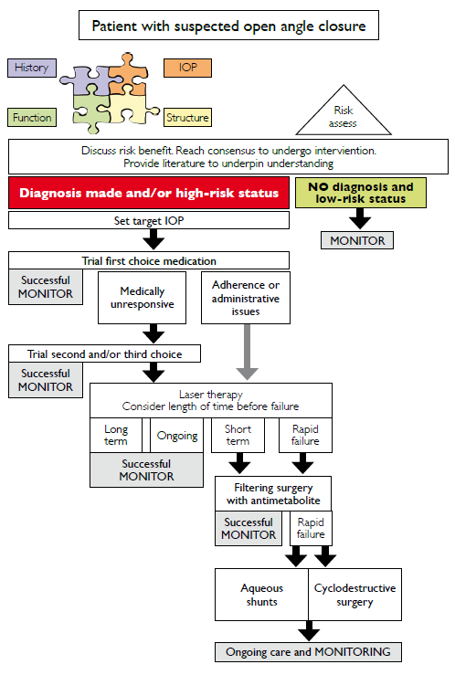

Burden of illness

Patients with mild glaucoma may be asymptomatic, but as the disease progresses, difficulties may occur with peripheral vision, contrast sensitivity, glare, and light-to-dark and dark-to-light adaptation. In its most severe form, glaucoma results in irreversible blindness (Boland 2012). Visual impairment may affect activities of daily living (eg, driving, walking, and reading), and may decrease QoL and health-related quality of life (HRQoL). Vision loss may also impose a psychological burden on patients due to fear of blindness, social withdrawal, and depression. The impact of glaucoma on HRQoL can be significant in both undiagnosed as well as diagnosed patients, even in the early stages of disease (Varma 2011).

Treatment of OAG incurs substantial annual costs that usually increase over time as the disease progresses. Direct medical costs include ocular hypotensive medication(s), physician and hospital visits, and glaucoma-related procedures; direct nonmedical costs include transportation, government purchase programs, guide dogs, and nursing home care (Varma 2011). Indirect costs reflect lost productivity, such as days missed from work, and the productivity costs borne by caregivers such as family members and friends. In Australia, one in eight persons over 80 years of age will develop glaucoma, placing a substantial clinical and financial burden on the Australian healthcare system. By 2025, the total annual cost of glaucoma is expected to reach AU$4.3b (Centre for Eye Research 2008; NHMRC 2010).

## Specify any characteristics of patients with the medical condition, or suspected of, who are proposed to be eligible for the proposed medical service, including any details of how a patient would be investigated, managed and referred within the Australian health care system in the lead up to being considered eligible for the service:

The patient population who will be eligible for the proposed service are those with a confirmed diagnosis of open-angle glaucoma. Guidelines for the screening, prognosis, diagnosis, management and prevention of glaucoma in Australia (NHMRC, 2010) state that diagnosis of glaucoma should be made on the basis of multiple sources of information. An initial consultation would ascertain relevant risk factors, such as age, family history, ethnicity, smoking and diabetes status. In addition, a comprehensive clinical examination would be undertaken including slit lamp examination, tonometry (assessment of IOP), fundus and optic nerve head examination, gonioscopy, corneal thickness, and visual field examination. A confirmatory diagnosis may require more than one consultation with a health care provider, including the involvement of an ophthalmologist.

The sub-set of glaucoma patients expected to access CyPass Micro-Stent MIGS device implantation through the MBS can be broadly divided into two groups;

* those who will undergo implantation in conjunction with cataract surgery, and;
* those who receive the intervention as a stand-alone procedure.

## Define and summarise the current clinical management pathway *before* patients would be eligible for the proposed medical service (supplement this summary with an easy to follow flowchart [as an attachment to the Application Form] depicting the current clinical management pathway up to this point):

The current clinical management algorithm for patients diagnosed with open-angle glaucoma prior to CyPass Micro-Stent MIGS implantation is depicted in Figure 2. As noted above, eligible OAG glaucoma patients can be categorised into two populations, according to their cataract status.

Figure 2 Current treatment management algorithm for patients with OAG

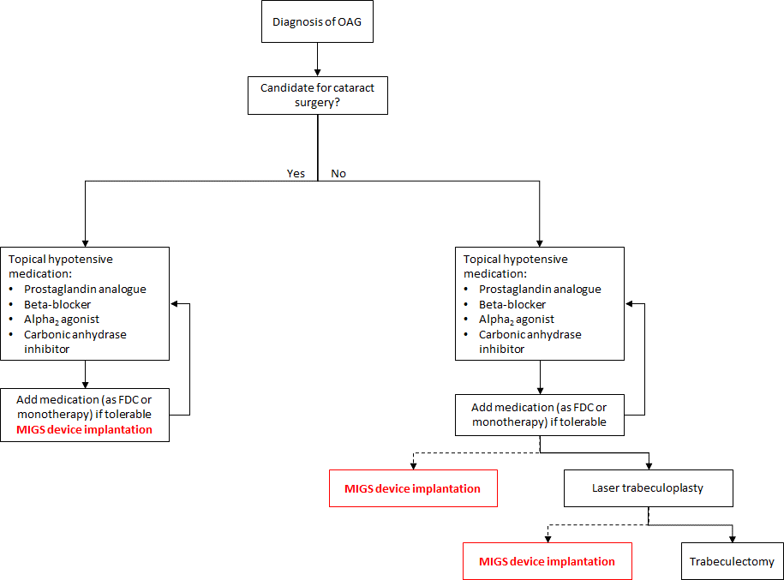

PART 6b – INFORMATION ABOUT THE INTERVENTION

## Describe the key components and clinical steps involved in delivering the proposed medical service:

The CyPass System consists of the CyPass Micro-Stent, which is contained in a loading device (Loader), and the CyPass Applier. The CyPass Micro-Stent( Figure 2) is a polyimide tube with a fenestrated lumen. The stent has a single piece design and is 0.25” (6.35 mm) long. The inner diameter of the stent is 0.012” (0.30 mm) and the outer diameter is 0.017” (0.43 mm). The CyPass Micro-Stent is designed for placement in the angle of the eye, with the proximal end extending from the angle into the anterior chamber (AC) and the distal end residing in the supraciliary space. When properly implanted, the CyPass® Micro-Stent is intended to allow outflow of aqueous fluid from the AC, where the device proximal end resides, through and around the fenestrated lumen and distal end of the tube into the supraciliary and suprachoroidal space via the uveoscleral pathway.

Figure 3 CyPass® Micro-Stent



The CyPass Applier (Figure 3) is the hand-held surgical instrument used to implant the CyPass Micro-Stent. The Applier consists of a medical-grade polymer handpiece with a guidewire assembly. The guidewire assembly includes a nitinol implant delivery guidewire extending from inside the handpiece through and beyond the distal end of a stainless steel tube (guidewire tube) that supports the guidewire. The guidewire is 0.011” (0.28 mm) in diameter and formed with a 0.48” (12 mm) radius of distal curvature and a blunt distal tip to facilitate location and blunt dissection of the plane between the ciliary body and sclera. The CyPass Applier delivers the CyPass Micro-Stent to the desired location within the eye.

Figure 4 CyPass Applier with guidewire extended



The CyPass® Micro-Stent is loaded onto the guidewire Figure 4before insertion into the eye. Once the guidewire has positioned the CyPass® Micro-Stent at the desired location within the eye, the implant is released from the guidewire using the front button on the CyPass Applier. This action withdraws the guidewire back into the guidewire tube, leaving the CyPass® Micro-Stent in position in the eye.

Figure 5 CyPass Micro-Stent loaded onto the CyPass Applier guidewire



The key steps in delivering the proposed service are: preparing the patient for eye surgery; anaesthetising the affected eye; if necessary, performing cataract surgery using standard microsurgical techniques and instrumentation; instilling a miotic drug to constrict the pupil; assembling the CyPass System according to instructions; under gonioscopy, implanting the CyPass stent; confirming wound seal; managing the risk of postoperative IOP increase by applying topical hypotensive agents.

## Does the proposed medical service include a registered trademark component with characteristics that distinguishes it from other similar health components?

The CyPass Micro-Stent device system is the registered trademark component with a distinguishing characteristic: similar to other MIGS stents it is implanted by the ab interno approach, but its anatomical placement is in the supraciliary space (‘outside Schlemm’), for aqueous drainage through the uveoscleral pathway into the supraciliary and suprachoroidal spaces.

## If the proposed medical service has a prosthesis or device component to it, does it involve a new approach towards managing a particular sub-group of the population with the specific medical condition?

The CyPass System Micro-Stent prosthesis is applicable to all patients for whom tube drainage is indicated (i.e., patients with glaucoma refractory to topical drug therapy, or who cannot tolerate or comply with topical treatment).

## If applicable, are there any limitations on the provision of the proposed medical service delivered to the patient (i.e. accessibility, dosage, quantity, duration or frequency):

Not applicable.

## If applicable, identify any healthcare resources or other medical services that would need to be delivered at the same time as the proposed medical service:

Cataract extraction immediately prior to CyPass implantation may be indicated in some patients.

## If applicable, advise which health professionals will primarily deliver the proposed service:

Ophthalmologist, Cataract Surgical Specialist.

## If applicable, advise whether the proposed medical service could be delegated or referred to another professional for delivery:

Not applicable.

## If applicable, specify any proposed limitations on who might deliver the proposed medical service, or who might provide a referral for it:

Delivery of the service should be restricted to ophthalmologists specialising in glaucoma or cataract surgical intervention. Referral may come from optometrists or general practitioners.

## If applicable, advise what type of training or qualifications would be required to perform the proposed service as well as any accreditation requirements to support service delivery:

Surgeon would be a Fellow of the Royal Australian and New Zealand College of Ophthalmology (RANZCO) or in the RANZCO training program under supervision of the RANZCO Fellow. Ophthalmologists delivering the proposed service would require specific training in implantation technique - as would also be the case for other ocular micro-surgery and implantation procedures and devices.

## (a) Indicate the proposed setting(s) in which the proposed medical service will be delivered (select all relevant settings):

Inpatient private hospital

Inpatient public hospital

Outpatient clinic

Emergency Department

Consulting rooms

Day surgery centre

Residential aged care facility

Patient’s home

Laboratory

Other – please specify below

1. **Where the proposed medical service is provided in more than one setting, please describe the rationale related to each:**

The proposed service is delivered under local anaesthesia and is not a prolonged procedure, therefore patients would usually be able to be discharged the same day. However, since some patients might be elderly, an overnight admission for observation purposes may be the better management option.

## Is the proposed medical service intended to be entirely rendered in Australia?

Yes

No – please specify below

PART 6c – INFORMATION ABOUT THE COMPARATOR(S)

## Nominate the appropriate comparator(s) for the proposed medical service, i.e. how is the proposed population currently managed in the absence of the proposed medical service being available in the Australian health care system (including identifying health care resources that are needed to be delivered at the same time as the comparator service):

The appropriate comparator for CyPass Micro-Stent MIGS implantation is dependent on the medical history of the patient. Primarily, this is determined by the presence or absence of a cataract co-morbidity.

Population 1: Implantation of MIGS device in conjunction with cataract surgery

Glaucoma patients undergoing surgery for a cataract co-morbidity represent a unique opportunity to treat both conditions in a single operation, thus minimising the risk of surgery-related complications. For this population, MIGS implantation would be considered early in the management algorithm of such patients, as an adjunctive to topical hypotensive medication. Laser therapy would not be considered as a treatment option in conjunction with cataract surgery as the treatments cannot be performed concomitantly. Thus, the appropriate comparator for OAG patients with a cataract co-morbidity is continued, escalating ocular hypotensive medication.

Population 2: Implantation of MIGS device as a stand-alone procedure

The appropriate comparator for CyPass Micro-Stent MIGS implantation as a stand-alone procedure is dependent on whether the patient has had previous cataract surgery or not.

The anticipated clinical place for CyPass Micro-Stent MIGS implantation in OAG patients with *prior cataract surgery* is in those patients experiencing inadequate IOP control with maximal-tolerated topical hypotensive medication (i.e. through natural disease progression or unmanageable medication burden leading to poor medication compliance, or other treatment-related adverse events). In the current clinical management pathway, such patients would be considered candidates for laser trabeculoplasty.

In patients who retain their natural lens (also known as ‘phakic’ patients), the benefits of invasive incisional surgery must be weighed against the risk of such complications. Patients with *no history of cataract* would likely be considered candidates for CyPass Micro-Stent MIGS implantation when target IOP is not being achieved with maximal-tolerated medication, or adherence is problematic, and when laser has failed or is not likely to succeed. This places MIGS implantation in line with alternative incisional surgical approaches, the most common of which is trabeculectomy.

Population 1 and 2

There are currently two types of MIGS devices to treat patients with mild-moderate POAG which both work to achieve reduction in IOP, and differ only in the location of the implantation device. Both devices are implanted by the ab interno approach, but the anatomical placement of the device differs. i.e. for CyPass, the MIGS device is placed into the supraciliary space, whereas in iStent and Hydrus, the device is inserted into the trabecular meshwork. Therefore, the SBA may warrant a comparison between the two different types of MIGS devices, in order to inform clinician and patient choice and/or preference.

## Does the medical service that has been nominated as the comparator have an existing MBS item number(s)?

Yes (please provide all relevant MBS item numbers below)

No

Laser trabeculoplasty – MBS item 42782, 42783

Incisional filtration surgery, including trabeculectomy – MBS item 42746 (first surgery), 42749 (subsequent surgeries)

Other glaucoma surgical intervention (insertion of a drainage device) – MBS item 42752 (insertion), 42755 (removal)

## Define and summarise the current clinical management pathways that patients may follow *after* they receive the medical service that has been nominated as the comparator (supplement this summary with an easy to follow flowchart [as an attachment to the Application Form] depicting the current clinical management pathway that patients may follow from the point of receiving the comparator onwards including health care resources):

The current clinical management pathway a glaucoma patient would follow after implantation with a CyPass Micro-Stent MIGS device is summarised in Figure 6. The addition of MIGS implantation to the clinical management pathway for patients with OAG will not alter the downstream treatment options available to patients – however, it is expected to alter the extent to which these options will be required (e.g. less reliance on medication to achieve the same IOP target; and/or better IOP control leading to lower rates of progression to more invasive procedures). Thus, the treatment options available to POAG patients following MIGS implantation will be determined by the clinical place of MIGS in the treatment pathway. The clinical place of the proposed service is discussed in detail in Question 26 and 27 above.

Figure 6 Current treatment management algorithm for patients with OAG after MIGS device implantation

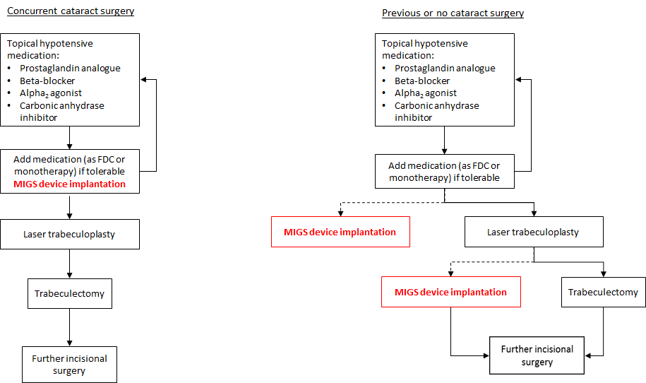

## (a) Will the proposed medical service be used in addition to, or instead of, the nominated comparator(s)?

Yes

No

## If yes, please outline the extent of which the current service/comparator is expected to be substituted:

Each step in the glaucoma management pathway may avoid the need for further intervention. Nonetheless, the condition is progressive in nature, and therefore for most patients, the proposed service will represent an additional treatment in their glaucoma management pathway, rather than a replacement. Utilisation of current MBS services for the treatment of glaucoma (laser trabeculoplasty, trabeculotomy) may be reduced in the short-term. The long-term avoidance rates for these interventions will be explored in the modelled economic evaluation presented in the SBA. Based on the 2-year COMPASS trial, it is expected that about 70% of patients will not require topical antihypertensive medication for at least the first two years post-implantation.

## Define and summarise how current clinical management pathways (from the point of service delivery onwards) are expected to change as a consequence of introducing the proposed medical service including variation in health care resources (Refer to Question 39 as baseline):

The clinical management algorithm of glaucoma from the point of service delivery onwards is not expected to change as a result of MIGS implantation. The implantation of a MIGS device does not impact the subsequent treatment options available to glaucoma patients. This suggests patients may progress slower through the management pathway. As a result, patients may utilise fewer healthcare resources over the course of their lifetime. This effect may manifest on the population level as a mean reduction in incisional surgeries per patient, or a reduction in ocular hypotensive medication dispensed through the PBS. The long-term effects on healthcare resource utilisation will be explored in the SBA.

PART 6d – INFORMATION ABOUT THE CLINICAL OUTCOME

## Summarise the clinical claims for the proposed medical service against the appropriate comparator(s), in terms of consequences for health outcomes (comparative benefits and harms):

Population 1: Implantation of MIGS device in conjunction with cataract surgery

Implantation of a CyPass Micro-Stent MIGS device in conjunction with cataract surgery (and background standard of care) is superior in terms of comparative clinical effectiveness and safety compared to patients treated for cataract surgery alone (plus background standard of care).

Population 2: Implantation of MIGS device as a stand-alone procedure

Implantation of a CyPass Micro-Stent MIGS device is at least non-inferior in terms of comparative clinical effectiveness and safety compared to patients treated with laser trabeculoplasty and/or trabeculotomy.

## Please advise if the overall clinical claim is for:

Superiority

Non-inferiority

## Below, list the key health outcomes (major and minor – prioritising major key health outcomes first) that will need to be specifically measured in assessing the clinical claim of the proposed medical service versus the comparator:

**Safety Outcomes:**

Worsening ocular symptoms

Intraoperative complications

Postoperative ocular complications

**Clinical Effectiveness Outcomes:**

Mean IOP reduction from baseline

Proportion of subjections with IOP reduction ≥ 20%

Proportion of subjections with IOP ≤ 18 mmHg

Absolute IOP reduction

Change in the number of ocular hypotensive medications

Proportion of subjects on medication

# PART 7 – INFORMATION ABOUT ESTIMATED UTILISATION

## Estimate the prevalence and/or incidence of the proposed population:

It is estimated that, approximately 2.7% of Australians aged 55 or more suffer from OAG (Blue Mountains Eye Study, 1996). Among the same sub-group of the Australian population, aged 55 years or older, the prevalence rate for cataract is estimated to be approximately 31% (AIHW 2005). Age-specific rates for cataract increase with age for men and women and are well over 70% for men and women aged 80 or more. Prevalence rates are higher among women than men (AIHW 2005).

Based on current population estimates (ABS, June 2016), these prevalence rates translate to 174,839 persons aged 55 years and older diagnosed with OAG in Australia. Of these glaucoma patients (assuming the prevalence of cataract is independent of glaucoma status), 54,200 would be expected to have a cataract co-morbidity.

## Estimate the number of times the proposed medical service(s) would be delivered to a patient per year:

The proposed service is a one-off procedure and it is likely that for most patients a single implantation will be sufficient for several years. In rare circumstances, a patient may require repositioning or replacement of their CyPass Micro-Stent MIGS device. The applicants are willing to take the Department’s advice as to whether separate MBS item numbers are required for these procedures.

## How many years would the proposed medical service(s) be required for the patient?

It is likely that for most patients a single implantation will be sufficient for several years, and the prospect of a repeat procedure slim.

## Estimate the projected number of patients who will utilise the proposed medical service(s) for the first full year:

In 2016, 2,650 MBS services were claimed for the implantation of a MIGS device (using the MBS item for goniotomy – 42758). It is expected that utilisation of the proposed MBS service would continue to grow but at a reduced rate of the first four years of MBS listing. The total number of services would be naturally limited by the availability of resources able to deliver the service (i.e. ophthalmologist time, day surgery room availability etc.). It is estimated between 3,000 and 3,500 patients would access the proposed MBS service in the first full year of MBS listing.

## Estimate the anticipated uptake of the proposed medical service over the next three years factoring in any constraints in the health system in meeting the needs of the proposed population (such as supply and demand factors) as well as provide commentary on risk of ‘leakage’ to populations not targeted by the service:

As noted, ophthalmologist are familiar with the proposed service. In 2016, 2,650 services were delivered under the MBS item code 42758. Utilisation would be expected to return to similar levels once MBS funding for the proposed service is restored. It is also anticipated that growth will continue, but at a reduced rate relative to that observed between 2014 and 2016, for the first four years of MBS listing.

A treatment pathway is tailored to each patient based on their individual risk profile (age, health status, ethnicity etc.), and well established clinical guidelines. Leakage into earlier or later lines of therapy would be considered against clinical practice and is considered unlikely to occur. Further, the interventions are specifically designed to address the pathophysiology of OAG. As such, leakage into other forms of glaucoma (i.e. normal tension glaucoma, angle closure glaucoma) is also not expected.

# PART 8 – COST INFORMATION

## Indicate the likely cost of providing the proposed medical service. Where possible, please provide overall cost and breakdown:

Advice from the Royal Australian and New Zealand College of Ophthalmologists (RANZCO) suggest the fee for this service ($699.45) is a reasonable representation of the true cost of delivering the proposed service. A comprehensive cost analysis of the proposed service will be undertaken during development of the SBA. The MBS fee for MIGS device implantation would be expected to be similar to the current fee for MBS item 42758.

## Specify how long the proposed medical service typically takes to perform:

The procedure requires approximately 30-60 minutes of operating and preparation time.

## If public funding is sought through the MBS, please draft a proposed MBS item descriptor to define the population and medical service usage characteristics that would define eligibility for MBS funding.

Category 3 – THERAPEUTIC PROCEDURES

Proposed item descriptor:

GLAUCOMA, implantation, repositioning, or removal of, a micro-invasive glaucoma surgery stent system placed into the supraciliary space, in patients diagnosed with primary open-angle glaucoma currently treated with ocular hypotensive medication.

Can be delivered as a stand-alone procedure or in conjunction with cataract surgery.

When delivered as a stand-alone procedure, the patient must have inadequate IOP control with maximally-tolerated ocular hypotensive medication

Multiple Services Rule

Fee: $699.45 [approximate fee based on MBS item 42758 – to be determined]

Category 3 – THERAPEUTIC PROCEDURES

Proposed item descriptor:

GLAUCOMA, repositioning or removal of, a micro-invasive glaucoma surgery stent system from the placed into the supraciliary space

Multiple Services Rule

Fee: $699.45 [approximate fee based on MBS item 42758 – to be determined]

# PART 9 – FEEDBACK

The Department is interested in your feedback.

## How long did it take to complete the Application Form?

Insert approximate duration here

## (a) Was the Application Form clear and easy to complete?

Yes

No

## If no, provide areas of concern:

Describe areas of concern here

## (a) Are the associated Guidelines to the Application Form useful?

Yes

No

## If no, what areas did you find not to be useful?

Insert feedback here

## (a) Is there any information that the Department should consider in the future relating to the questions within the Application Form that is not contained in the Application Form?

Yes

No

## If yes, please advise:

Insert feedback here