Public Summary Document

Report to the Medical Services Advisory Committee on utilisation of Medicare Benefits Schedule (MBS) items 32523 and 32526 following MSAC Application 1166: Radiofrequency ablation (RFA) for the treatment of varicose veins due to chronic venous insufficiency
MBS items considered: 32523 and 32526
Date of MSAC consideration: 26-27 July 2018
Context for decision: MSAC makes its advice in accordance with its Terms of Reference, see the MSAC Website

Purpose
The purpose of the report presented to the Medical Services Advisory Committee (MSAC) was to inform MSAC of the real world impacts of the utilisation of MBS items 32523 and 32526 following MSAC Application 1166. MSAC then uses this information to ensure that the new items resulting from this application are being used as intended.
The report is not intended to be a review of the clinical information covered during the application process.

MSAC’s advice
After consideration of the actual utilisation data for RFA for the treatment of varicose veins due to chronic venous insufficiency (MBS items 32523 and 32526; MSAC Application 1166), MSAC recommended amendment of item descriptors for all three varicose vein services – RFA, ELT and surgery – to restrict usage to complicated (non-cosmetic) cases.
MSAC was concerned that the utilisation for both RFA items (32523 and 32526) was far greater than expected. This was combined with an overall growth in utilisation for all three varicose vein services.
MSAC recommended these services be reviewed by the Department in consultation with relevant professional groups, to align the items with the intended patient population originally supported by MSAC in 2012. MSAC recommended that any amendments to the RFA item descriptors may also need to apply to other comparable MBS listed treatments (e.g. ELT and surgical stripping).
Amended descriptors could be shared with the MSAC Executive for ratification prior to progressing to implementation. MSAC recommended continued monitoring of the revised item descriptors with a further review of their use in 2 years. If agreement cannot be reached on amended descriptors, MSAC recommended a formal review of the clinical and economic evidence.

Summary of consideration and rationale for MSAC’s advice
MSAC considered the impacts of the outcome of MSAC Application 1166 for RFA for the treatment of varicose veins due to chronic venous insufficiency (MBS items 32523 and 32526) by examining the actual utilisation data up to December 2017 (with some data up to January 2018). The items were MBS listed in May 2013.
RFA is a minimally invasive process that can be performed both in-hospital and in an outpatient setting. The procedure is similar to ELT for varicose veins – MSAC Application 1113 (MBS items 32520 and 32522). RFA was proposed as a direct alternative to ELT as well as surgical vein ligation/stripping (MBS items 32508 and 32511).
MSAC recalled advice from ESC at the time of the initial application in August 2012 that the introduction of another minimally invasive procedure may result in more patients seeking treatment and an overall increase in demand above what was predicted in the application. MSAC recalled that because of high variability in fees charged for equivalent ELT procedures, an Extended Medicare Safety Net cap was put in place for RFA, consistent with that already in place for ELT. MSAC also recalled that the long-term costs of treatment were uncertain due to a lack of data on long-term treatment failure and re-treatment rates.
MSAC recalled that it was predicted that both services would increase slightly in years 1 to 3 of listing before plateauing around years 4–5. MSAC was concerned that the utilisation for both RFA items (32523 and 32526) was far greater than expected (Figures 1 and 2). This was combined with an overall growth in utilisation for all three varicose vein services.
MSAC noted that item 32523 constituted 87% of all RFA therapies. Of these services, 80% were performed in hospital. MSAC noted that the higher hospital theatre banding allocation for RFA compared with ELT may be a contributing reason for this, and also that there are significant costs associated with outpatient establishment and management of this therapy. The highest utilisation of item 32523 was in Queensland. MSAC noted that item 32526 constituted 13% of all RFA therapies. Of these services, between 22% and 65% were performed in hospital. The highest utilisation of item 32526 was in Victoria.
MSAC recalled that it was predicted that RFA would directly replace ELT and surgery items; however, this has not eventuated. MSAC recalled that utilisation of ELT items (32520 and 32522) was predicted to increase slightly over the 5-year period. MSAC noted that actual utilisation has gradually increased in line with expected trends, but the overall volume for these items is much higher than anticipated. MSAC recalled that utilisation of surgery items (32508 and 32511) was predicted to decrease due to listing and availability of the less invasive ELT and RFA procedures. MSAC noted that actual utilisation has declined as expected, but the overall utilisation values are much higher than anticipated.
The overall high utilisation values for all three services (RFA, ELT and surgery) indicates that the introduction of RFA as an additional non-invasive therapy has resulted in growth in the overall market, rather than RFA taking a proportion of the market share from ELT and surgery as predicted.
MSAC recalled that the 75% benefit for item 32523 is $400.20. MSAC noted that the average fee charged for item 32523 was $1,337 in 2016–17, a small overall decrease from $1,670 in 2012–13. This was between the fees for ELT (approximately $1,000) and surgery (approximately $2,000). The highest average fee ($2,714) was in Western Australia. Services were bulk billed at low rates.
MSAC recalled that the 75% benefit for item 32526 is $595. MSAC noted that the average fee charged for item 32526 was $1,720 in 2016–17, which decreased from $4,018 in
2012–13. This was between the fees for ELT (approximately $1,500) and surgery (approximately $2,200). The highest average fee ($2,499) was in Western Australia. Rates of bulk billing were highly variable between states, between 0.7% and 47%.
MSAC noted that very little surgical treatment for varicose veins is done in public hospitals, which contributes to driving varicose vein treatment into the private sector. It is likely that private health insurance and ‘no gap’ or ‘known gap’ arrangements may be utilised for RFA services.
MSAC noted that items 32523 and 32526 were both predominantly claimed by female patients aged 35 to 74. MSAC noted that, for item 32523, a total of around 14,500 services were performed on about 11,300 patients in the 5-year period, and for item 32526, around 2,100 services were performed on about 1,700 patients. Between 70% and 80% of patients received one service and about 20% received two services; it was very unusual for a patient to receive three or more services. A small percentage of services were performed on sequential days.
MSAC recalled that there are no restrictions on the type of medical practitioner able to perform RFA, though it is recommended that they have successfully completed a recognised course of study or training. MSAC noted that 123 practitioners provided a service under item 32523 in 2016–17 (up from 51 in 2013–14). Around 74% of these services were provided by vascular surgeons. MSAC noted that 70 practitioners provided a service under item 32526 in 2016–17 (up from 23 in 2013–14). Around 87% of these services were provided by vascular surgeons and 7% by general surgeons.
MSAC noted that item 32523 is co-claimed in 84% of episodes, most frequently with specialist consultation item 105 and ultrasound item 55054. MSAC noted that item 32526 is co-claimed in 75% of episodes, most frequently with specialist consultation item 105, ultrasound item 55054, and RFA item 32523 (for RFA in both legs in the same episode – both great saphenous vein [GSV] and small saphenous vein [SSV] in one leg, and GSV or SSV in the other leg). MSAC noted that the majority of vascular trainees/surgeons use ultrasound guidance as a safety measure. MSAC noted that co-claiming with item 105 is expected to cease in upcoming years due to changes that block co-claiming of ‘subsequent attendance items’ with items in Group T8 that have a schedule fee of equal to or greater than $300.
MSAC considered that minor disease may be driving patient demand for, and resultant provision of, treatment for cosmetic purposes. Treatment is effective in preventing disease progression and complications, but most patients have minor symptoms and will not progress to severe ulceration or complications.
MSAC queried whether the services may no longer be cost-effective based on the fees being charged, and noted that the clinical evidence that these items were approved on related to a population that is different to the population receiving the treatments now. MSAC noted that it would be desirable to amend the item descriptors to reflect what happens in the public sector where only complicated (non-cosmetic) cases are treated.
MSAC queried whether there should be a clear indication that the items are subject to compliance activities, and noted the role of the Department’s compliance group to educate providers. MSAC queried what effect changing the descriptor might have on the prices being charged and on patient out-of-pocket costs.
MSAC recommended these services be reviewed by the Department in consultation with relevant professional groups, to align the items with the intended patient population originally supported by MSAC in 2012. MSAC recommended that any amendments to the RFA item descriptors may also need to apply to other comparable MBS listed treatments (e.g. ELT and surgical stripping).
Amended descriptors could be shared with the MSAC Executive for ratification prior to progressing to implementation. MSAC recommended continued monitoring of the revised item descriptors with further review of their use in 2 years. If agreement cannot be reached on amended descriptors, MSAC recommended a formal review of the clinical and economic evidence.

Methodology
An application is selected for consideration if the resulting new item(s) or item amendment(s) have been on the MBS for approximately 24 months or longer or if there were particular concerns about utilisation such that MSAC requested to consider it earlier. The specific applications for each MSAC meeting are selected by the MSAC Executive which is composed of the Chairs of MSAC and its sub-committees.
A report on the utilisation is developed by the Department of Health (the department) with information on a number of metrics including state variation, patient demographics, services per patient, practitioner’s providing the service, data on fees and co-claiming of services. The number of metrics included in a report is dependent on the annual service volume for the MBS item(s) under consideration i.e. an item with very low utilisation will have less data to analyse. Where service volumes are too low, information is suppressed to protect patient privacy.
Where possible the report compares data on real world utilisation to the assumptions made during the MSAC assessment. Most of these assumptions are drawn from the assessment report.
Relevant stakeholders are provided an opportunity to comment on the findings in the report before it is presented to the MSAC. It is intended that stakeholders are given at least three weeks to consider the reports.
The stakeholder version of the report does not contain information on assumptions from the MSAC consideration if this information is not already publicly available. This is to protect the commercial in confidence of the original applicants. The same principle is applied to this document.
Once MSAC has considered the report its advice is made available online at the MSAC Website.

Results

Utilisation

Item 32523
The utilisation of item 32523 was initially lower than predicted, however has steadily increased and is now above that estimated, with 3,373 services in 2015-16 and 4,518 services in 2016-17 (Figure 1). From 1 May 2012 to 31 December 2017, Queensland had the highest utilisation with 5,561 services (38% of total services billed to the item). There were 3,960 services in Victoria and 3,415 services in New South Wales in the same period (Table 1). Since listing, item 32523 has constituted approximately 87% of all RFA services.
From 1 May 2012 to 31 December 2017, item 32523 was mostly performed in-hospital, with a national average rate of 84.1% (ranging around 80% across all years). This is contrary to the prediction that RFA would be chiefly performed in an out-patient setting. The reasons for this are unclear, but a contributing factor may be the higher hospital theatre banding allocation for RFA. As consumables tend to depreciate over time, the cost of consumables (such as the catheter) is likely now lower than at the time of listing. Therefore, theatre banding levels may no longer reflect the actual market price, resulting in both services yielding higher profit margins. However, the higher banding allocation for RFA likely means there is a greater incentive for RFA to be performed in-hospital. It should be noted that consumables are not covered by private health funds when performed in the out-of-hospital setting. However, there may also be clinical or other considerations for performing the service in-hospital, such as more stringent rules regarding laser registration, training and ownership (for ELT).

Figure 1: Services for item 32523 from 1 May 2013 to 31 December 2017.
* 2017-18 financial year not included as predictions were only until 2016-1
Table 1: Service volume of MBS item 32523 between 2012-13 and 2017-18 by State and Territory
FY | NSW | VIC | QLD | SA | WA | TAS | NT | ACT | Total
2012-13 | 39 | 19 | 50 | np | np | - | - | - | 112
2013-14 | 312 | 261 | 647 | np | np | - | - | - | 1,306
2014-15 | 426 | 539 | 1,333 | 24 | 56 | 136 | - | - | 2,514
2015-16 | 675 | 969 | 1,337 | 29 | 142 | 212 | 9 | - | 3,373
2016-17 | 1,215 | 1,295 | 1,428 | 62 | 145 | 303 | 27 | 43 | 4,518
2017-18 | 748 | 877 | 766 | 41 | 70 | 155 | 19 | 29 | 2,707
All years | 3,415 | 3,960 | 5,561 | 180 | 479 | 806 | 55 | 72 | 14,530
Source: Department of Health, File: Q21109B item 32523 and 32526 utilisation
* 2017-18 financial year includes data to 31 December 2017 (processed to 31 Jan 2018) and does not constitute a full financial year
NP = not published

Item 32526
The actual utilisation of item 32526 was initially lower than predicted, however has steadily increased and is now above that estimated, with 609 services in 2015-16 and 707 services in 2016-17 (Figure 2). From 1 May 2012 to 31 December 2017, Victoria had the highest utilisation with 762 services (35% of total services billed to the item). There were 514 services in Queensland and 455 services in Western Australia in the same period (Table 2). Since listing, item 32526 has constituted approximately 13% of all RFA services.
From 1 May 2012 to 31 December 2017, in-hospital rates for item 32526 increased with the average in-hospital rate increasing from 22.2% in 2012-13 to 64.9% in 2016-17 (the average across all years was 58.4%). Initial rates were close to the predicted in-hospital rate, however are now much higher than predicted. As per item 32523, this may be due to the higher hospital theatre banding allocation for RFA compared to ELT.
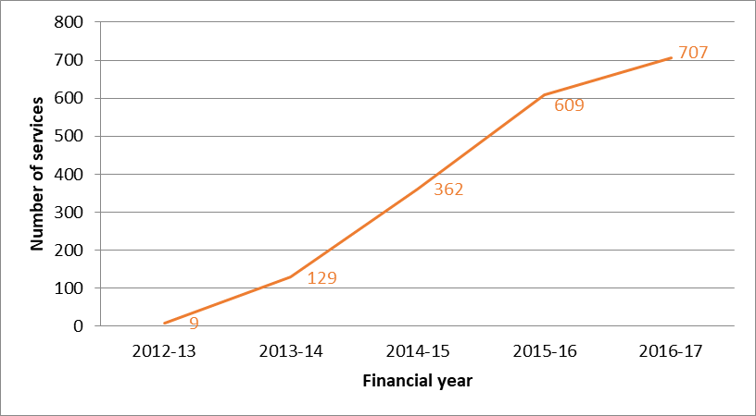

Figure 2: Services under MBS item 32526 from 1 May 2013 to 31 December 2017 by date of service.
* 2017-18 financial year not included as predictions were only until 2016-17

Table 2: Service volume of MBS item 32526 between 2012-13 and 2017-18 by State and Territory
FY | NSW | VIC | QLD | SA | WA | TAS | ACT | Total
2012-13 | np | np | np | - | np | - | - | 9
2013-14 | 34 | np | 43 | np | 41 | - | - | 129
2014-15 | np | 94 | 110 | np | 116 | np | - | 362
2015-16 | 76 | 232 | 144 | 9 | 138 | 10 | - | 609
2016-17 | 120 | 289 | 146 | 14 | 125 | np | np | 707
2017-18 | 93 | 138 | 70 | np | 34 | 9 | np | 361
All years | 361 | 762 | 514 | 37 | 455 | 37 | 10 | 2,177
Source: Department of Health, File: Q21109B Item 32523 and 32526 utilisation
* 2017-18 financial year includes data to 31 December 2017 (processed to 31 Jan 2018)
NP = not published

Items 32520 and 32522 (ELT items)
The actual utilisation of item 32520 is above that predicted, with 6,136 services in 2015-16 and 5,744 services in 2016-17 (Figure 3). The actual utilisation of item 32522 is also above that estimated, with 1,220 services in 2015-16 and 1,034 services in 2016-17 (Figure 4). It was predicted that utilisation of items 32520 and 32522 would increase slightly over the five year period. Actual utilisation has shown a gradual increase in line with expected trends, however overall volume for these items is much higher than anticipated.
It was predicted that RFA would take a proportion of the market share for ELT and surgery items, and the slight decrease seen in ELT utilisation in 2016-17 (Figures 3-4) may indicate that this is beginning to occur. However, the overall high utilisation values for all three services (RFA, ELT and surgery) indicate that the introduction of RFA has grown the overall market, rather than only taking up a share of the established market. This is somewhat in line with advice provided to MSAC that the introduction of an additional non-invasive treatment option via RFA may increase overall demand for varicose vein treatments by 20%, however the increase in overall demand is still higher than anticipated.

Figure 3: Services under MBS item 32520 from 1 May 2013 to 31 December 2017 by date of service

Figure 4: Services under MBS item 32522 from 1 May 2013 to 31 December 2017 by date of service.

Items 32508 and 32511 (surgery items)
The actual utilisation of item 32508 is above that estimated, with 5,333 services in 2015-16 and 4,322 services in 2016-17 (Figure 5). The actual utilisation of item 32511 is also above that estimated, with 521 services in 2015-16 and 495 services in 2016-17 (Figure 6). It was predicted that utilisation of these surgery items would decrease due to listing and availability of the less invasive ELT and RFA procedures. Actual utilisation data has shown a decline as expected, however overall utilisation is once again higher than anticipated.
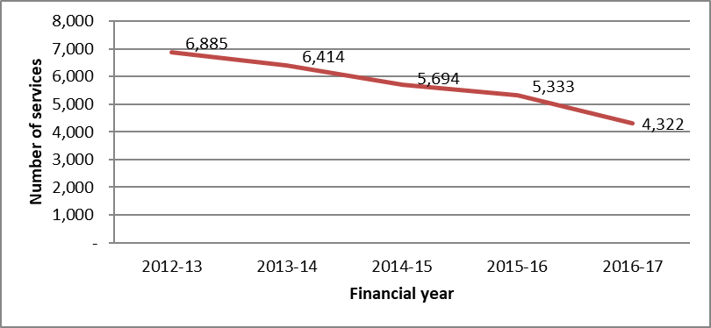

Figure 5: Services under MBS item 32508 from 1 May 2013 to 31 December 2017 by date of service.
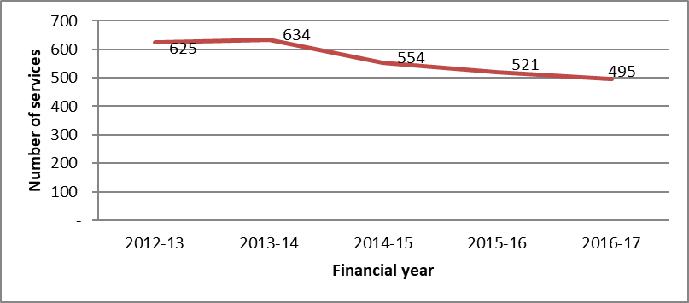

Figure 6: Services under MBS item 32511 from 1 May 2013 to 31 December 2017 by date of service.
Source for Figures 3-6: Department of Health, File: Q21158 items 32508, 32511, 32514, 32517, 32520, 32522 utilisation

Data on fee charged
The information provided below on fees is a snapshot of how the items are being claimed in practice. Data has not been printed for states and territories with low service volumes.

Item 32523
The 75% benefit for item 32523 is $400.20.
The average fee charged for item 32523 has decreased from $1,670 in 2012-13 to $1,361 in 2017-18 (Table 3, Figure 7). The average fees charged in Western Australia are significantly higher than other states (Figure 8), with the average fee from 2012-13 to
2017-18 amounting to $2,733. Total average fees over this period in other states ranged from $747 to $1,561, and the national average was $1,357.
Services are bulk billed at low rates in most states, although there was a 15.8% bulk billing rate in Victoria in 2014-15, which decreased to 0.5% in 2017-18 (Table 3). It is likely that Private Health Insurance and “no gap” or “known gap” arrangements may be utilised for this service.
In 2017-18, the average fees charged for equivalent items 32508 (surgery) and 32520 (ELT) were $1,003 and $1,994, respectively. The average fee for RFA in 2017-18 fell between these values at $1,361.
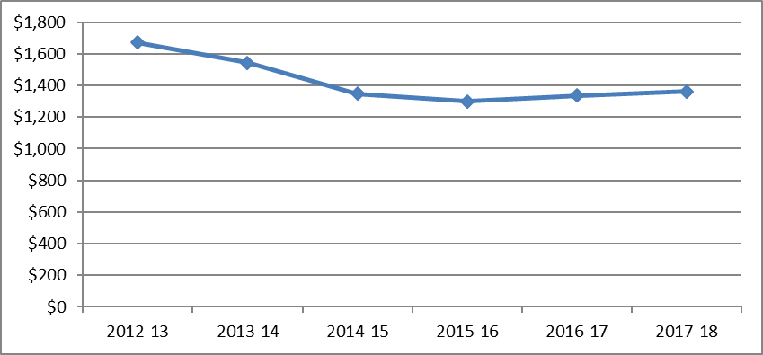

Figure 7: Average fee charged across Australia for MBS item 32523 between 2012-13 and 2017-18

Figure 8: Average fee charged and the variation in fees charged from the 25th to the 95th percentiles by state for MBS item 32523 between 2012-13 and 2017-18

Table 3: Statistics on fees charged for MBS item 32523 - 2012-13 to 2017-18 by Sate and Territory
 |  | NSW | VIC | QLD | SA | WA | TAS | NT | ACT | AUS
2012-13 | Average fee charged | 1,979.16 | 2,680.44 | 1,119.1 | 533.6 | 2,669.45 | - | - | - | 1,670.36
 | Standard deviation | 1,357.78 | 788.91 | 591.78 | - | - | - | - | - | 1,104.4
 | Median | 1,828.15 | n/a (4) | 1,013.85 | n/a (4) | n/a (4) | - | - | - | 1,520.8
 | 75th percentile | 2,403.6 | n/a (4) | 1,520.8 | n/a (4) | n/a (4) | - | - | - | 2,300
 | 95th percentile | 4,500 | n/a (4) | 2,000 | n/a (4) | n/a (4) | - | - | - | 3,500
 | Bulk billed rate | 2.6% | 15.8% | - | - | - | - | - | - | 3.6%
2013-14 | Average fee charged | 1,785.41 | 1,756.2 | 1,190.18 | 742.61 | 3,358.67 | - | - | - | 1,544.67
 | Standard deviation | 1,266.87 | 1,191.36 | 897.68 | 163.98 | 1,260.67 | - | - | - | 1,184.27
 | Median | 1,283.6 | 1,170.08 | 791.4 | n/a (4) | 3,500 | - | - | - | 1,040.55
 | 75th percentile | 2,403.6 | 3,000 | 1,520.8 | n/a (4) | 3,500 | - | - | - | 2,100
 | 95th percentile | 4,500 | 3,500 | 3200 | n/a (4) | 5,500 | - | - | - | 3,608.95
 | Bulk billed rate | 1.0% | 2.3% | 0.8% | 4.3% | - | - | - | - | 1.1%
2014-15 | Average fee charged | 1,716.17 | 1,489.79 | 1,124.36 | 795.9 | 3,047.94 | 1,211.71 | - | - | 1,347.57
 | Standard deviation | 1,272.32 | 1,046.02 | 664.61 | 287.78 | 1,012.8 | 317.75 | - | - | 945.22
 | Median | 1,193.29 | 1,141.8 | 799 | n/a (4) | 3,000 | 1,280.05 | - | - | 1,040.55
 | 75th percentile | 2,403.6 | 1,670.08 | 1,400 | n/a (4) | 3,800 | 1,352.4 | - | - | 1,600
 | 95th percentile | 5,100 | 3,000 | 3,000 | n/a (4) | 4,200 | 1,671.83 | - | - | 3,200
 | Bulk billed rate | 4.0% | 2.8% | 1.8% | - | - | 5.1% | - | - | 2.5%
2015-16 | Average fee charged | 1,427.84 | 1,271.86 | 1,142.54 | 752.59 | 2,453.85 | 1,312.85 | 566.95 | - | 1,298.64
 | Standard deviation | 959.41 | 884.02 | 693 | 239.11 | 1,716.24 | 361.1 | 222.65 | - | 899.39
 | Median | 1,000 | 1,109.7 | 805.7 | 799.9 | 2,725 | 1,336.3 | n/a (4) | - | 1,030.75
 | 75th percentile | 2,350 | 1,406.85 | 1,400 | 913.25 | 3,680 | 1,387.84 | n/a (4) | - | 1,500
 | 95th percentile | 3,000 | 3,000 | 3,000 | 980.05 | 6,360 | 1,783.4 | n/a (4) | - | 3,000
 | Bulk billed rate | 1.9% | 1.9% | 2.8% | - | - | 1.9% | - | - | 2.2%
2016-17 | Average fee charged | 1,490.16 | 1,230.24 | 1,194.4 | 1,042.52 | 2,714.78 | 1,261.89 | 758.49 | 1,313.24 | 1,337.1
 | Standard deviation | 1,146.25 | 779.28 | 752.88 | 318.82 | 1,660.7 | 325.66 | 90.24 | 608.78 | 948.5
 | Median | 1,000 | 1,098.23 | 891.9 | 913.25 | 2,500 | 1,279.06 | 780.05 | 1,520 | 1,096.43
 | 75th percentile | 2,450 | 1,394.7 | 1,443.73 | 1,369.88 | 3,680 | 1,355.6 | 797.65 | 1,520 | 1,500
 | 95th percentile | 3,950 | 3,000 | 3,000 | 1,499 | 6,360 | 1,783.4 | 797.65 | 2,320 | 3,000
 | Bulk billed rate | 1.6% | 1.8% | 2.1% | - | - | 0.7% | - | - | 1.7%
2017-18 | Average fee charged | 1,602.69 | 1,197.22 | 1,279.35 | 804.58 | 2,433.33 | 1,192.89 | 808.93 | 1,187.62 | 1,361.12
(to) 31 | Standard deviation | 1,109.79 | 785.36 | 852.81 | 270.16 | 1,397.6 | 371.74 | 91.23 | 480.38 | 940.85
Dec 2017 | Median | 999 | 1,081.5 | 952.36 | 806.1 | 2,500 | 1,272.15 | n/a (4) | 1,320 | 1,031.83
 | 75th percentile | 2,700 | 1,280.05 | 1,500 | 999 | 3,500 | 1,362.05 | n/a (4) | 1,520 | 1,500
 | 95th percentile | 3,500 | 3,000 | 3,200 | 1,170.08 | 5,000 | 1,793.08 | n/a (4) | 1,600 | 3,250
 | Bulk billed rate | 3.5% | 0.5% | 1.6% | - | 1.4% | 2.6% | - | - | 1.7%
*The 95th percentile fee charged represents that 95% of the time the fee is below this amount but in 5% of cases, the fee is higher than this.

Item 32526
The 75% benefit for item 32526 is $595.
The average fee charged for item 32526 has decreased from $4,018 in 2012-13 to $1,645 in 2017-18 (Table 4, Figure 9). The high average fee in 2012-13 was likely related to the average fee charged in NSW, which was $5,967, significantly higher than other states which ranged from $1,507 to $2,700. In recent years, the average fees charged in Western Australia have been higher than other states, with the average fee in 2017-18 amounting to $3,045 (Table 4, Figure 10). Average fees in other states over this period ranged from $1,135 to $1,685. Bulk billing rates varied across states and years, with the highest rate at 92.2% in WA in 2014-15. In 2017-18, bulk billing rates varied between 0.7% in Victoria and 47.1% in WA. It is likely that Private Health Insurance and “no gap” or “known gap” arrangements may be utilised for this service.
In 2017-18, the average fees charged for equivalent items 32511 (surgery) and 32522 (ELT) were $1,523 and $2,173, respectively. The average fee for RFA in 2017-18 fell between these values at $1,645.

Figure 9: Average fee charged across Australia for MBS item 32526 between 2012-13 and 2017-18.

Figure 10: Average fee charged and the variation in fees charged from the 25th to the 95th percentiles by state for MBS item 32526 between 2012-13 and 2017-18.

Table 4: Statistics on fees charged for MBS item 32526 between 2012-13 and 2017-18 by State and Territory
 |  | NSW |  | VIC | QLD | SA | WA | TAS | ACT | AUS
2012-13 | Average fee charged | $5,966.67 | $2,699.90 |  | $1,507.30 | - | $2,000.00 | - | - | $4,017.87
 | Standard deviation | $1,703.18 | - |  | - | - | - | - | - | $2,421.03
 | Median | n/a (4) | n/a (4) |  | n/a (4) | - | n/a (4) | - | - | n/a (4)
 | 75th percentile | n/a (4) | n/a (4) |  | n/a (4) | - | n/a (4) | - | - | n/a (4)
 | 95th percentile* | n/a (4) | n/a (4) |  | n/a (4) | - | n/a (4) | - | - | n/a (4)
 | Bulk billed rate | 16.7% | - |  | - | - | - | - | - | 11.1%
2013-14 | Average fee charged | $2,620.82 | $2,154.02 |  | $1,354.75 | $1,009.28 | $2,512.75 | - | - | $2,000.03
 | Standard deviation | $1,085.11 | $1,079.55 |  | $519.83 | $190.53 | $795.13 | - | - | $996.80
 | Median | $2,563.80 | n/a (4) |  | $1,176.60 | n/a (4) | n/a (4) | - | - | $1,898.23
 | 75th percentile | $3,000.00 | n/a (4) |  | $1,659.60 | n/a (4) | n/a (4) | - | - | $2,531.90
 | 95th percentile | $4,859.85 | n/a (4) |  | $2,224.60 | n/a (4) | n/a (4) | - | - | $4,000.00
 | Bulk billed rate | - | - |  | - | - | 41.5% | - | - | 13.2%
2014-15 | Average fee charged | $2,072.89 | $2,319.12 |  | $1,638.81 | $1,214.25 | $2,757.68 | $1,498.00 | - | $1,932.93
 | Standard deviation | $1,140.40 | $1,031.60 |  | $783.39 | $126.86 | $1,004.08 | $295.76 | - | $969.10
 | Median | $1,814.05 | $2,000.00 |  | $1,462.45 | n/a (4) | n/a (4) | n/a (4) | - | $1,725.00
 | 75th percentile | $2,584.25 | $3,500.00 |  | $2,030.00 | n/a (4) | n/a (4) | n/a (4) | - | $2,618.85
 | 95th percentile | $4,317.65 | $3,500.00 |  | $3,074.00 | n/a (4) | n/a (4) | n/a (4) | - | $3,500.00
 | Bulk billed rate | 9.4% | 4.3% |  | - | - | 92.2% | - | - | 31.5%
2015-16 | Average fee charged | $1,501.78 | $1,736.38 |  | $1,579.26 | $1,459.53 | $1,641.97 | $1,594.96 | - | $1,635.43
 | Standard deviation | $887.49 | $720.15 |  | $845.99 | $308.83 | $1,133.92 | $275.44 | - | $799.20
 | Median | $1,188.20 | $1,601.30 |  | $1,197.80 | n/a (4) | n/a (4) | n/a (4) | - | $1,400.25
 | 75th percentile | $1,990.00 | $2,000.00 |  | $2,067.45 | n/a (4) | n/a (4) | n/a (4) | - | $2,000.00
 | 95th percentile | $3,236.10 | $3,500.00 |  | $3,074.00 | n/a (4) | n/a (4) | n/a (4) | - | $3,500.00
 | Bulk billed rate | 2.6% | 1.3% |  | 0.7% | - | 89.9% | - | - | 21.3%
2016-17 | Average fee charged | $1,703.87 | $1,724.81 |  | $1,553.06 | $1,351.50 | $2,499.44 | $1,443.17 | $1,889.90 | $1,720.38
 | Standard deviation | $923.19 | $824.25 |  | $714.08 | $486.34 | $877.11 | $265.03 | - | $841.98
 | Median | $1,194.70 | $1,493.23 |  | $1,285.80 | n/a (4) | $2,040.00 | n/a (4) | n/a (4) | $1,499.00
 | 75th percentile | $1,803.05 | $2,000.00 |  | $1,900.00 | n/a (4) | $3,000.00 | n/a (4) | n/a (4) | $2,036.48
 | 95th percentile | $3,294.15 | $3,500.00 |  | $3,074.00 | n/a (4) | $4,190.00 | n/a (4) | n/a (4) | $3,500.00
 | Bulk billed rate | 0.8% | 2.4% |  | 2.1% | - | 64.8% | - | - | 13.0%
2017-18 | Average fee charged | $1,685.08 | $1,620.55 |  | $1,430.33 | $1,247.08 | $3,045.17 | $1,476.27 | $1,134.67 | $1,645.36
 | Standard deviation | $1,190.36 | $728.37 |  | $726.92 | $196.16 | $1,192.66 | $392.87 | $274.82 | $951.51
 | Median | $1,192.23 | $1,400.25 |  | $1,207.20 | n/a (4) | n/a (4) | n/a (4) | n/a (4) | $1,400.25
 | 75th percentile | $1,673.90 | $1,909.60 |  | $1,739.40 | n/a (4) | n/a (4) | n/a (4) | n/a (4) | $1,900.00
 | 95th percentile | $3,850.35 | $3,500.00 |  | $2,750.00 | n/a (4) | n/a (4) | n/a (4) | n/a (4) | $3,500.00
 | Bulk billed rate | 6.5% | 0.7% |  | 1.4% | - | 47.1% | 11.1% | - | 6.9%
Source for Figures 7-10 and Tables 5-6: Department of Health, File: Q21109B Item 32523 and 32526 utilisation.xls
*The 95th percentile fee charged represents that 95% of the time the fee is below this amount but in 5% of cases, the fee is higher than this.

Patient breakdown
There were 3,566 patients who claimed item 32523 in 2016-17. Of these, 3,501 were new patients and 65 were continuing from the previous financial year (Table 5).
There were 584 patients who claimed item 32526 in 2016-17. Of these, 572 were new patients and 12 were continuing from the previous financial year (Table 5).
In 2016-17, 26% of patients received two or more services under item 32523, and 21% of patients received two or more services under item 32526 (Table 6).
Less than 1% of patients have received three or more services under item 32523 and approximately 1% of patients have received three or more services under item 32526 since the listing of the items (Table 7). Across all years, most patients (73% and 79%) received one service under items 32523 and 32526 (Table 7).
Continued and/or multiple services for one patient may represent repeat operations due to failure, or may represent operations on both legs for the same patient. However, as the data cannot differentiate between these, error rates cannot be estimated using these values.
Item 32523 and 32526 are both predominantly claimed by female patients aged 35-74. In 2016-17, about 48 services under item 32523 and about seven services under item 32526 were provided to adults aged 24 or below (Figure 11, Figure 12).

Table 5: Number of new and continuing patients who received MBS items 32523 or 32526
Item number | Financial year | Total Patients | Total Services | New Patients | New Services | Continuing Patients | Continuing Services
32523 | 2012-13 | 94 | 112 | 94 | 112 | - | -
 | 2013-14 | 1,077 | 1,306 | 1,075 | 1,304 | np | np
 | 2014-15 | 2,017 | 2,514 | 1,987 | 2,484 | 30 | 30
 | 2015-16 | 2,669 | 3,373 | 2,627 | 3,328 | 42 | 45
 | 2016-17 | 3,566 | 4,518 | 3,501 | 4,446 | 65 | 72
 | 2017-18* | 2,151 | 2,707 | 2,084 | 2,637 | 67 | 70
 | Total | 11,368 | 14,530 | - | - | - | -
32526 | 2012-13 | 7 | 9 | 7 | 9 | - | -
 | 2013-14 | 114 | 129 | 114 | 129 | - | -
 | 2014-15 | 287 | 362 | 285 | 358 | np | np
 | 2015-16 | 497 | 609 | 486 | 594 | 11 | 15
 | 2016-17 | 584 | 707 | 572 | 695 | 12 | 12
 | 2017-18* | 316 | 361 | 309 | 354 | 7 | 7
 | Total | 1,773 | 2,177 | - | - | - | -
*2017-18 data until 31 December 2017, and does not constitute a complete financial year
NP = not published

Table 6: Number of services per patient from 2012-13 to 2017-18* for items 32523 and 32526
Financial year | Services per patient | 32523 Count | 32523 Percent | 32526 Count | 32526 Percent
2012-13 | 1 | 76 | 81 | np | 71
 | 2 | 18 | 19 | np | 29
2013-14 | 1 | 854 | 79 | 99 | 87
 | 2+ | 223 | 21 | 15 | 13
2014-15 | 1 | 1,523 | 76 | 216 | 75
 | 2+ | 494 | 24 | 71 | 25
2015-16 | 1 | 1,968 | 74 | 391 | 79
 | 2+ | 701 | 26 | 106 | 21
2016-17 | 1 | 2,624 | 74 | 466 | 80
 | 2+ | 942 | 26 | 114 | 20
2017-18 | 1 | 1,601 | 74 | 273 | 86
 | 2+ | 550 | 26 | 43 | 13
*2017-18 data until 31 December 2017, and does not constitute a complete financial year
NP = not published

Table 7: Number of services per patient since service listed 1 November 2012 to 31 December 2017
Services per patient | 32523 Count | 32523 Percent | 32526 Count | 32526 Percent
1 | 8,272 | 73 | 1,398 | 79
2 | 3,040 | 27 | 356 | 20
3+ | 56 | - | 19 | 1
Source for tables 7-9: Department of Health, File: Q21109B Item 32523 and 32526 utilisation.xlsx
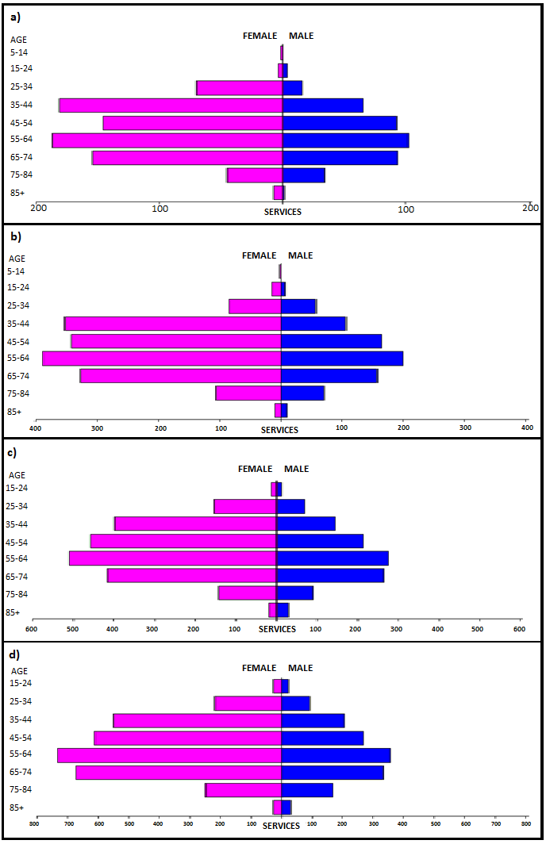Figure 11: Demographic profile for MBS item 32523 for (a) 2013-14, (b) 2014-15, (c) 2015-16 and (d) 2016-17.
Source: Medicare Statistics Online
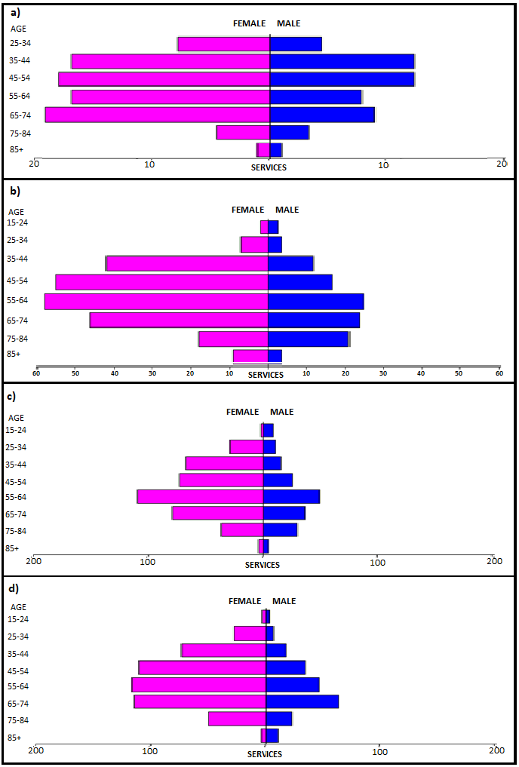Figure 12: Demographic profile for MBS item 32526 for (a) 2013-14, (b) 2014-15, (c) 2015-16 and (d) 2016-17
Source: Medicare Statistics Online

Provider breakdown
There has been an increase in the number of practitioners providing services under item 32523. There were 51 practitioners in 2013-14, increasing to 123 practitioners in 2016-17. Similarly, the number of practitioners providing services under item 32526 has increased from 23 in 2013-14 to 70 in 2016-17 (Table 8).
Around 25% of practitioners have provided close to 76% of all services for item 32523 (Table 9). Approximately 25% of practitioners have provided about 84% of all services for item 32526 (Table 10).
Around 74% of services under item 32523 were provided by Vascular Surgeons, and 21% by General Surgeons (Table 11). Similarly, around 87% of services under item 32526 were provided by Vascular Surgeons, and 7% by General Surgeons (Table 12). In contrast, Vascular and General Surgeons only provide around half (49% and 46% respectively) of services for ELT items 32520 and 32522. The greater representation of Vascular and General Surgeons in the RFA provider data may be another reason why RFA is more often performed in-hospital (compared to ELT (as discussed in ‘Utilisation’, pages 6-9). This may be because Vascular and General Surgeons already have admitting rights to hospitals to perform RFA services as opposed to
VR GPs.
The data is based on provider billing behaviour (i.e. derived specialty as opposed to registered specialty). There are no restrictions on the type of medical practitioner able to perform RFA, though it is recommended that they have successfully completed a recognised course of study/training in the management of venous disease.

Table 8: Number of practitioners providing items 32523 and 32526 from 2012-13 to 2017-18
Financial Year | 32523 Providers | 32523 Services | 32523 Average | 32526 Providers | 32526 Services | 32526 Average
2012-13 | 19 | 112 | 5.9 | 6 | 9 | 1.5
2013-14 | 51 | 1,306 | 25.6 | 23 | 129 | 5.6
2014-15 | 86 | 2,514 | 29.2 | 45 | 362 | 8.0
2015-16 | 103 | 3,373 | 32.7 | 54 | 609 | 11.3
2016-17 | 123 | 4,518 | 36.7 | 70 | 707 | 10.1
2017-18 | 123 | 2,707 | 22.0 | 64 | 361 | 5.6
All Years | 159 | 14,530 | 91.4 | 100 | 2,177 | 21.8

Table 9: Cumulative percentage of medical practitioners providing item 32523; and how many services each percentile accounts for from 2012-13 to 2017-18
Provider Cumulative % | 2012- 13 | 2013-14 | 2014-15 | 2015-16 | 2016-17 | 2017-18 | All Years
5% | - | 21.8 | 23.9 | 22.5 | 25.5 | 23.4 | 29.0
10% | 26.5 | 37.2 | 40.9 | 37.3 | 40.9 | 37.5 | 46.3
20% | 45.4 | 57.4 | 64.0 | 58.9 | 61.3 | 58.8 | 68.9
25% | 54.0 | 65.6 | 72.2 | 66.9 | 68.8 | 65.7 | 75.9
30% | 61.3 | 73.2 | 78.6 | 72.9 | 75.0 | 71.1 | 81.9
40% | 74.3 | 84.7 | 86.8 | 82.9 | 84.8 | 80.5 | 90.2
50% | 83.9 | 91.1 | 92.7 | 90.2 | 91.8 | 87.8 | 95.1
60% | 89.5 | 95.4 | 96.6 | 94.8 | 96.1 | 93.4 | 97.7
70% | 94.3 | 97.4 | 98.5 | 97.6 | 98.4 | 96.8 | 99.2
75% | 95.8 | 98.1 | 98.9 | 98.4 | 98.9 | 97.9 | 99.5
80% | 96.6 | 98.7 | 99.2 | 99.1 | 99.3 | 98.7 | 99.7
90% | 98.3 | 99.5 | 99.7 | 99.7 | 99.7 | 99.5 | 99.9
95% | 99.2 | 99.8 | 99.8 | 99.8 | 99.9 | 99.8 | 99.9
99% | 99.8 | 100.0 | 100.0 | 100.0 | 100.0 | 100.0 | 100.0

Table 10: Cumulative percentage of medical practitioners providing item 32526; and how many services each percentile accounts for from 2012-13 to 2017-18
Provider Cumulative % | 2012-13 | 2013-14 | 2014-15 | 2015-16 | 2016-17 | 2017-18 | All Years
5% | - | 32.9 | 49.2 | 38.3 | 38.5 | 33.2 | 47.1
10% | - | 41.9 | 58.0 | 54.2 | 60.5 | 52.1 | 64.4
20% | 46.7 | 58.3 | 69.9 | 70.4 | 75.8 | 68.6 | 79.3
25% | 50.0 | 64.5 | 74.9 | 75.5 | 80.8 | 74.0 | 84.0
30% | 53.3 | 69.4 | 79.4 | 79.7 | 84.4 | 78.3 | 87.6
40% | 60.0 | 78.3 | 85.4 | 86.0 | 88.7 | 85.0 | 92.0
50% | 66.7 | 84.9 | 89.6 | 90.5 | 91.8 | 89.5 | 94.8
60% | 73.3 | 89.6 | 92.8 | 94.0 | 94.6 | 92.9 | 96.7
70% | 80.0 | 93.2 | 95.3 | 96.7 | 96.6 | 94.7 | 98.1
75% | 83.3 | 95.0 | 96.5 | 97.5 | 97.5 | 95.6 | 98.6
80% | 86.7 | 96.4 | 97.5 | 98.2 | 98.0 | 96.5 | 99.0
90% | 93.3 | 98.2 | 98.8 | 99.1 | 99.0 | 98.2 | 99.5
95% | 96.7 | 99.1 | 99.4 | 99.6 | 99.5 | 99.1 | 99.8
99% | 99.3 | 99.8 | 99.9 | 99.9 | 99.9 | 99.8 | 100.0
Source for tables 10-12: Department of Health, File: Q21109B Item 32523 and 32526 provider concentration.xlsx

Table 11: Number of services by provider specialty under item 32523 between 2012-13 and
2016-17 (to 31 December 17)
Derived Major Specialty | Number of services | Percentage
GP - VRGP - Non-referred Attendances | 123 | 0.85%
GP - VRGP - Procedural | 565 | 3.89%
GP - NONVRGP - Non-referred Attendances | 4 | 0.03%
GP - NONVRGP - Procedural | 24 | 0.17%
GP - NONVRGP - Diagnostic Imaging | 2 | 0.01%
Specialist - Intensive Care | 1 | 0.01%
Specialist - Pathology | 1 | 0.01%
Specialist - Surgery - General Surgery | 3,002 | 20.66%
Specialist - Surgery - Vascular Surgery | 10,768 | 74.11%
Specialist - Diagnostic Radiology | 35 | 0.24%
Specialist - Anaesthetics | 1 | 0.01%
Specialist - Dermatology | 1 | 0.01%
Specialist - Obstetrics and Gynaecology | 1 | 0.01%
Specialist - Ophthalmology | 2 | 0.01%

Table 12: Number of services by provider specialty under item 32526 between 2012-13 and
2016-17 (to 31 December 17)
Derived Major Specialty | Number of services | Percentage
GP - VRGP - Procedural | 107 | 4.92%
GP - NONVRGP - Procedural | 8 | 0.37%
Specialist - Surgery - General Surgery | 159 | 7.30%
Specialist - Surgery - Vascular Surgery | 1,885 | 86.59%
Specialist - Diagnostic Radiology | 15 | 0.69%
Specialist - Obstetrics and Gynaecology | 1 | 0.05%
GP - GP Trainee | 1 | 0.05%
Specialist - Cardiology | 1 | 0.05%
Source for tables 13 and 14: Department of Health, File: Q21109B Item 32523 and 32526 utilisation.xlsx

Co-claiming
Item 32523 is somewhat frequently claimed (approximately 43% of episodes from 2013-14 to 2016-17) with specialist consultation item 105 and ultrasound item 55054. In approximately 16% of cases (from 2013-14 to 2016-17), item 32523 was not claimed with another item (Tables 13-15).
Item 32526 is similarly somewhat frequently claimed (approximately 31% of episodes from 2013-14 to 2016-17) with specialist consultation item 105, ultrasound item 55054 and RFA item 32523. In approximately 28% of cases from 2013-14 to
2016-17, item 32526 was not claimed with another item (Tables 16-18). Co-claiming with item 32523 was appropriate as it likely reflects operations on both legs in the same instance – on both the great AND small saphenous vein in one leg, and on one of the great OR small saphenous veins in the other.
As both items are in Group T8 and have schedule fees of greater than $300, they are affected by the 1 November 2017 changes to co-claiming arrangements. These changes block claiming of ‘subsequent attendance items’ (such as item 105) with items in Group T8 that have a schedule fee of equal to or greater than $300 on the same day. Therefore, co-claiming with item 105 is expected to cease over upcoming financial years.
Item 32526 was co-claimed with item 32504 in two instances in 2013-14 (Table 19). This is prohibited by the item descriptor, however is unlikely to be of concern, due to the very small volume of cases and lack of further occurrences in subsequent years.

Table 13: Top 10 instances of co-claiming with MBS item 32523 in 2014-15
# | Items | Episodes | Services | Schedule Fee for combination | Number of providers | Number of patients | % of episodes
1 | 32523, 00105, 55054. | 507 | 1,600 | $348,216 | 13 | 480 | 24.24%
2 | 32523, 55054. | 399 | 869 | $273,264 | 39 | 392 | 19.07%
3 | 32523 | 331 | 407 | $196,898 | 41 | 322 | 15.82%
4 | 32523, 00105. | 122 | 263 | $75,414 | 11 | 115 | 5.83%
5 | 32523, 55246. | 79 | 178 | $59,345 | 7 | 76 | 3.78%
6 | 32523, 18272, 55246. | 75 | 291 | $67,281 | np | 74 | 3.59%
7 | 32523, 55296. | 56 | 132 | $41,161 | np | 56 | 2.68%
8 | 32523, 55054, 55296. | 54 | 189 | $45,995 | np | 54 | 2.58%
9 | 32523, 00105, 55246. | 41 | 138 | $31,964 | 7 | 41 | 1.96%
10 | 32523, 55054, 60048. | 28 | 93 | $35,909 | np | 28 | 1.34%

Table 14: Top 10 instances of co-claiming with MBS item 32523 in 2015-16
# | Items | Episodes | Services | Schedule Fee for combination | Number of providers | Number of patients | % of episodes
1 | 32523, 00105, 55054. | 584 | 1,869 | $408,312 | 17 | 554 | 21.12%
2 | 32523, 55054. | 533 | 1,173 | $367,988 | 42 | 516 | 19.28%
3 | 32523. | 376 | 458 | $222,778 | 51 | 370 | 13.60%
4 | 32523, 55246. | 134 | 358 | $110,597 | np | 133 | 4.85%
5 | 32523, 18272, 55246. | 87 | 351 | $79,102 | np | 87 | 3.15%
6 | 32523, 00105. | 76 | 175 | $49,958 | 11 | 76 | 2.75%
7 | 32523, 55296. | 74 | 190 | $57,505 | np | 74 | 2.68%
8 | 32523, 00105, 55246. | 52 | 174 | $40,199 | np | 51 | 1.88%
9 | 32523, 00105, 18262, 18270, 18272. | 47 | 372 | $53,922 | np | 47 | 1.70%
10 | 32523, 11602, 18272. | 40 | 120 | $26,154 | np | 32 | 1.45%

Table 15: Top 10 instances of co-claiming with MBS item 32523 in 2016-17
# | Items | Episodes | Services | Schedule Fee for combination | Number of providers | Number of patients | % of episodes
1 | 32523, 55054. | 797 | 1,735 | $545,839 | 54 | 764 | 21.49%
2 | 32523, 00105, 55054. | 578 | 1,888 | $413,190 | 21 | 558 | 15.58%
3 | 32523. | 451 | 553 | $268,668 | 59 | 442 | 12.16%
4 | 32523, 55246. | 242 | 652 | $200,386 | 8 | 237 | 6.52%
5 | 32523, 11602, 18272. | 178 | 534 | $116,385 | np | 160 | 4.80%
6 | 32523, 55296. | 173 | 456 | $131,925 | 8 | 172 | 4.66%
7 | 32523, 00105. | 110 | 245 | $70,096 | 15 | 110 | 2.97%
8 | 32523, 00105, 18272, 55054. | 109 | 462 | $84,131 | np | 107 | 2.94%
9 | 32523, 00105, 18272, 55246. | 81 | 436 | $78,235 | np | 81 | 2.18%
10 | 32523, 00105, 18262, 18270, 18272. | 69 | 551 | $79,360 | np | 69 | 1.86%

Table 16: Top 10 instances of co-claiming with MBS item 32526 in 2014-15
# | Items | Episodes | Services | Schedule Fee for combination | Number of providers | Number of patients | % of episodes
1 | 32526. | 103 | 130 | $92,419 | np | 94 | 34.33%
2 | 32526, 55054. | 60 | 145 | $63,755 | np | 60 | 20.00%
3 | 32526, 00105, 55054. | 36 | 112 | $34,184 | np | 35 | 12.00%
4 | 32526, 55246. | 12 | 27 | $12,094 | np | 11 | 4.00%
5 | 32526, 00105, 32523, 55054. | 10 | 40 | $11,722 | np | 10 | 3.33%
6 | 32526, 00105. | 8 | 16 | $6,690 | np | 8 | 2.67%
7 | 32526, 32523. | 7 | 14 | $7,421 | np | 7 | 2.33%
8 | 32526, 55054, 55296. | 6 | 18 | $6,021 | np | np | 2.00%
9 | 32526, 18262, 18270, 18272, 55054. | np | 29 | $5,393 | np | np | 1.33%
10 | 32526, 32523, 55054, 55296. | np | 17 | $5,148 | np | np | 1.33%

Table 17: Top 10 instances of co-claiming with MBS item 32526 in 2015-16
# | Items | Episodes | Services | Schedule Fee for combination | Number of providers | Number of patients | % of episodes
1 | 32526. | 127 | 158 | $113,045 | np | 120 | 24.28%
2 | 32526, 55054. | 93 | 204 | $90,603 | np | 93 | 17.78%
3 | 32526, 00105, 55054. | 30 | 95 | $29,153 | np | 29 | 5.74%
4 | 32526, 18262, 18270, 18272, 55054. | 25 | 173 | $35,100 | np | 25 | 4.78%
5 | 32526, 18262, 18270, 18272, 32523, 55054. | 17 | 150 | $26,842 | np | 17 | 3.25%
6 | 32526, 00105, 32523, 55054. | 15 | 60 | $17,850 | np | 15 | 2.87%
7 | 32526, 32508. | 13 | 27 | $14,045 | np | 11 | 2.49%
8 | 32526, 00105, 18262, 18270, 18272. | 11 | 91 | $17,042 | np | 11 | 2.10%
9 | 32526, 00105, 55054, 60057, 60078. | 9 | 45 | $21,839 | np | 8 | 1.72%
10 | 32526, 11602, 18270. | 9 | 27 | $8,457 | np | 9 | 1.72%

Table 18: Top 10 instances of co-claiming with MBS item 32526 in 2016-17
# | Items | Episodes | Services | Schedule Fee for combination | Number of providers | Number of patients | % of episodes
1 | 32526. | 98 | 116 | $84,487 | np | 91 | 16.28%
2 | 32526, 55054. | 88 | 202 | $89,284 | np | 88 | 14.62%
3 | 32526, 00105, 55054. | 32 | 97 | $29,369 | np | 30 | 5.32%
4 | 32526, 32523, 55296. | 28 | 105 | $34,052 | np | 28 | 4.65%
5 | 32526, 18262, 18270, 18272, 55054. | 24 | 192 | $37,651 | np | 24 | 3.99%
6 | 32526, 11602, 18272. | 20 | 60 | $18,271 | np | 20 | 3.32%
7 | 32526, 55296. | 20 | 51 | $20,700 | np | 20 | 3.32%
8 | 32526, 00105, 18262, 18270, 18272. | 19 | 139 | $26,662 | np | 19 | 3.16%
9 | 32526, 18262, 18270, 18272, 32523, 55054. | 18 | 161 | $28,558 | np | 18 | 2.99%
10 | 32526, 55246. | 18 | 41 | $18,344 | np | 17 | 2.99%
Source for Tables 15-20: Department of Health, File: Q21109B Item 32523 and 32526 item combination.xlsx
NP = not published

Background
In February 2011, an application was received from Covidien Pty Ltd, requesting MBS listing of RFA for the treatment of varicose veins due to chronic venous insufficiency.
The intervention involves the abolition of varicose veins, through endovenous thermal ablation (destruction) by a radiofrequency catheter. The procedure is minimally invasive and involves conveying sufficient thermal energy to the wall of an incompetent vein segment to produce irreversible occlusion, fibrosis and eventually resorption of the vein. It is indicated for patients with documented venous reflux (by duplex ultrasound) who have exhausted conservative treatment measures, and where sclerotherapy alone is unlikely to be successful.
RFA is similar to ELT for varicose veins (MSAC Application 1113). This service was MBS listed under items 32520 and 32522 on 1 November 2011 following a positive recommendation by MSAC in December 2009.
At the time of application, three devices were approved by the Therapeutic Goods Administration for use in treating varicose veins with RFA.
MSAC’s role was to assess the safety, efficacy, effectiveness and cost-effectiveness of RFA for the treatment of varicose veins due to chronic venous insufficiency. MSAC also considered the wording of the MBS item descriptors, the MBS fees and the financial implications of publicly funding the surgical procedures.
On 2 August 2012, MSAC supported the listing of two new MBS items: an item for the use of RFA in the treatment of either the great (long) OR small (short) saphenous veins (item 32523); and an item for use of RFA in the treatment of both the great (long) AND small (short) saphenous veins (item 32526). The two new items are comparable to and intended as a direct alternative to MBS items 32520 and 32522 for ELT.
There are no restrictions on the type of medical practitioner able to perform RFA. However, in line with existing ELT items, it is recommended that medical practitioners performing ELT or RFA have successfully completed a substantial, endorsed course of study and training in the management of venous disease.
In the Public Summary Document (PSD), MSAC noted advice that the introduction of another minimally invasive procedure with potential for reductions in pain, bleeding and complication rates, may result in more patients seeking treatment than previously, and thus an overall increase in demand for varicose vein treatment services.
MSAC further noted that although a cost minimisation approach was appropriate for the economic evaluation, this analysis focused on the MBS fee and did not reflect out-of-pocket consequences for patients. This was particularly relevant in the context of the highly variable fees (from $800 to $6,000) charged for equivalent ELT procedures, resulting in a median out-of-pocket cost of approximately $1,600 per patient. In view of this, MSAC advised that RFA should have an Extended Medicare Safety Net cap, consistent with that already in place for ELT. MSAC also noted that the long-term costs of treatment are uncertain given that long-term treatment failure and re-treatment rates are unknown.

Item descriptors
32523 | Varicose veins, abolition of venous reflux by occlusion of a primary or recurrent great (long) or small (short) saphenous vein of one leg (and major tributaries of saphenous veins as necessary), using a radiofrequency catheter introduced by an endovenous catheter, where it is documented by duplex ultrasound that the great or small saphenous vein (whichever is to be treated) demonstrates reflux of 0.5 seconds or longer, including all preparation and immediate clinical aftercare (including excision or injection of either tributaries or incompetent perforating veins, or both), but not including endovenous laser therapy, and not provided on the same occasion as a service described in any of items 32500, 32501, 32504 or 32507  Multiple Services Rule  (Anaes.)  Fee: $533.60 Benefit: 75% = $400.20 85% = $453.60  (See para TN.8.33 of explanatory notes to this Category)  Extended Medicare Safety Net Cap: $80.05

32526 | Varicose veins, abolition of venous reflux by occlusion of a primary or recurrent great (long) and small (short) saphenous vein of one leg (and major tributaries of saphenous veins as necessary), using a radiofrequency catheter introduced by an endovenous catheter, where it is documented by duplex ultrasound that the great and small saphenous veins demonstrate reflux of 0.5 seconds or longer, including all preparation and immediate clinical aftercare (including excision or injection of either tributaries or incompetent perforating veins, or both), but not including endovenous laser therapy, and not provided on the same occasion as a service described in any of items 32500, 32501, 32504 or 32507  Multiple Services Rule  (Anaes.)  Fee: $793.30 Benefit: 75% = $595.00 85% = $711.60  Extended Medicare Safety Net Cap: $79.35

Further information on MSAC
MSAC Terms of Reference and other information are available on the MSAC Website.

