Public Summary Document
Application No. 1555 – Endoscopic Sleeve Gastroplasty (ESG) for the treatment of patients with Class I and Class II obesity with comorbidities who have failed first-time treatments
Applicant: Apollo Endosurgery Australia Pty Ltd
Date of MSAC consideration: MSAC 77th Meeting, 28-29 November 2019
Context for decision: MSAC makes its advice in accordance with its Terms of Reference, visit the MSAC website

Purpose of application
An application requesting a new Medicare Benefits Schedule (MBS) item number for endoscopic sleeve gastroplasty (ESG) for the treatment of patients with Class I (body mass index [BMI]:30.0-34.9) and Class II obesity (BMI: 35.0-39.9) with comorbidities who have failed first-line treatments was received from Apollo Endosurgery Australia by the Department of Health.

MSAC’s advice to the Minister
After considering the strength of the available evidence in relation to comparative safety, clinical effectiveness and cost-effectiveness, MSAC did not support public funding for endoscopic sleeve gastroplasty (ESG) for the treatment of patients with Class I and Class II obesity with comorbidities, who have failed first-line treatments. MSAC considered the evidence base for ESG was weak, and the clinical effectiveness and safety of ESG (relative to first- and second-line interventions and bariatric surgery) was highly uncertain, particularly over the longer term. In addition, MSAC considered that the current evidence base had limited applicability to the proposed population, the impact of ESG on comorbidities was largely unknown, and these uncertainties flowed into the modelled economic evaluation.
MSAC noted that within the next three years a substantive body of evidence, including two randomised controlled trials evaluating the safety and effectiveness of ESG in the appropriate population and comparators, is anticipated to be published, which could address the uncertainties in the current clinical evidence.
Consumer summary
Apollo Endosurgery Australia Pty Ltd applied for public funding through the Medicare Benefits Schedule (MBS) for endoscopic sleeve gastroplasty (ESG) for people with low-risk (Class I) or moderate-risk (Class II) obesity. The application is for people with a body mass index (BMI) of 30.0 to 39.9 – a BMI of 30 and above is considered to indicate obesity. The application stated that to be eligible for the procedure, a person would also need to have other health problems such as heart disease or diabetes (known as comorbidities), and have failed to lose 5% of their weight within 3 months using other treatments.
In ESG, the shape of the stomach is changed into a sleeve using a type of ‘stitching’ device. The smaller stomach size means that the person cannot eat as much food, making it easier for them to lose weight.
MSAC could not find good enough evidence that ESG would be safe or effective in the years following the surgery. Also, the groups of patients used in clinical studies were different from the population in Australia who would use the procedure. This makes it hard to know how safe and effective the procedure would be when used in Australia. Without more evidence, it is also difficult to work out how this item would affect the MBS budget.
There are some clinical studies happening now that may provide more useful information once they have been completed and their findings published.
MSAC’s advice to the Commonwealth Minister for Health
MSAC did not support public funding for ESG to treat patients with Class I and Class II obesity with comorbidities who have failed other treatments because of the lack of evidence of safety and effectiveness and uncertainties about cost.

Summary of consideration and rationale for MSAC’s advice
This application sought public funding of ESG for the treatment of patients with Class I and Class II obesity with comorbidities, who have failed first-line treatments.
MSAC noted that evidence for the safety and effectiveness of ESG, particularly in the longer term, is of low quality due to significant risk of bias.
In addition, the population included in the ESG and comparator evidence bases generally did not align with the population proposed in the PICO confirmation, having higher baseline BMIs compared to the proposed population. MSAC noted that people with higher baseline BMIs have a higher capacity to lose weight, so clinical effectiveness may be overestimated. In addition, MSAC noted the comorbidity- and treatment failure- status of patients in the evidence base was often unclear; these applicability concerns had flow on effects to the economics.
MSAC noted that the safety profile of ESG is inferior compared to standard care (Comparator 1) and non-inferior compared to other bariatric surgeries (Comparator 2). MSAC noted advice from gastrointestinal surgeons that the procedure is not reversible, but it is highly likely to fail and therefore needs a revision item.
MSAC noted the evidence on comparative effectiveness is limited to case series and two retrospective comparative studies with significant risk of biases across included studies from open label designs, short durations of follow-up, high attrition rates and indirect comparisons (note there are currently two ongoing RCTs). MSAC noted that the applicant pre-MSAC response provided results from an observational study providing five-year follow-up of the efficacy of ESG (n=203). However, MSAC considered that the long-term clinical effectiveness of ESG is uncertain (relative to main comparator) and noted the clinicians concerns regarding the durability of the sleeve.
MSAC noted a number of problems with the economic modelling. For the comparison with standard care (i.e. lifestyle interventions ± pharmacotherapy), MSAC noted the very high incremental cost-effectiveness ratio (at two years), but the lifetime (base case) cost-utility model indicated that ESG was modelled to be cost-effective after eight years. However, there were uncertain applicability issues, highly uncertain model inputs, highly uncertain structural assumptions and uncertain impact of revision/repair. MSAC considered the base-case model would need considerable revision in any future resubmission.
For the comparison with other bariatric surgeries (Comparator 2), MSAC noted that a cost-minimisation approach is only appropriate if the clinical claim of non-inferior safety and efficacy is accepted. However, MSAC considered that there is not enough evidence to accept these claims at this time.
MSAC noted that the financial estimates were uncertain for a number of reasons:
The net cost may be overestimated because it is assumed that 100% of patients eligible for ESG will take it up, and the number of people with obesity class I who are eligible for ESG is likely overestimated as comorbidities were derived from a population with a BMI >35.
The cost of ESG revision/repair was not included in the financial impact.
There is potential for leakage (particularly in patients without comorbidities). MSAC was also concerned about the risk that ESG could become a bridge to laparoscopic sleeve gastrectomy (most commonly performed bariatric surgery on MBS).
ESG will be open to many more clinicians (those who can use an endoscope), which could significantly increase the number of procedures that might be claimed under Medicare.
MSAC noted that the application was not supported by the General Surgeons of Australia or the Australian and New Zealand Metabolic and Obesity Surgery Society, based on the currently available evidence.

Other discussion
MSAC noted that for private health insurers to be mandated to pay benefits for a device on the Prostheses List, there must be a Medicare benefit payable for the professional service. MSAC agreed to write to the Prostheses List Advisory Committee and the Department and ask them to review the circumstances under which these devices are reimbursed under the Prostheses List arrangements (billing codes ER279 and ER280).

Background
This is the first submission of ESG for the treatment of patients with Class I and Class II obesity with comorbidities who have failed first-line treatments. MSAC has not previously considered this application.

Prerequisites to implementation of any funding advice
Items on the Australian Register of Therapeutic Goods (ARTG) that are relevant to this application are shown in Table 1. One system that could be used to perform the ESG procedure, the OverStitch™ Endoscopic Suturing System is listed on the ARTG.
A new version of the device, the Overstitch SX™ has been developed which can be used with single-channel endoscopes. Apollo Endosurgery Inc. state that this latest version of the device is compatible with over 20 single-channel flexible endoscopes. However, the redacted is not currently listed on the ARTG.
Table 1 Items relevant to ESG listed on the Australian Register of Therapeutic Goods
ARTG no. | Product description | Product category | Sponsor
237773 | Endotherapy forceps, grasping, flexible | Medical Device Class IIa | Emergo Asia Pacific Pty Ltd T/a Emergo Australia
237774 | Endoscopic suturing unit, single-use | Medical Device Class IIa | Emergo Asia Pacific Pty Ltd T/a Emergo Australia
236906 | Suture retention device | Medical Device Class IIb | Emergo Asia Pacific Pty Ltd T/a Emergo Australia
245894 | Suture, polypropylene monofilament | Medical Device Class IIb | Ebos Group Australia Pty Ltd
Abbreviations: ESG = endoscopic sleeve gastroplasty
Source: Therapeutic Goods Administration, accessed 30/01/2019 Link to TGA.gov.au
In addition to the four ARTG listings relevant to ESG, the OverStitch™ Endoscopic Suturing System and the OverStitch™ Endoscopic Suturing System 2.0 Sutures are listed on the Prostheses List (billing codes: ER279 and ER280 respectively). The description provided for the OverStitch™ Endoscopic Suturing System is “Needle Driver, Anchor Exchange and Tissue Helix Device” while the description for the OverStitch™ Endoscopic Suturing System 2.0 Sutures is “Endoscopic Polypropylene Suture with Cinch”.

Proposal for public funding
The population considered in this application (contracted assessment) includes patients aged 18 years or over with a BMI of 30.0 to 39.9 kg/m² (Class 1, Class2 obesity) who have one or more major medical comorbidities and have failed first- and second-line treatment options. Failure of first- and second- line interventions is defined as an inability to achieve a minimum five per cent weight loss within three months.
The proposed MBS item descriptor, as defined in the PICO is summarised in Table 2.
Table 2 Proposed MBS item descriptor for ESG
Category 3 – Therapeutic Procedures
xxxxx
Endoscopic Sleeve Gastroplasty for patients 18 years of age or over with a BMI 30.0–39.9 kg/m² and comorbidities.
Multiple Services Rule
(Anaes.) (Assist)
Fee: $redacted Benefit: 75% = $redacted (See para TN.8.29 of explanatory notes for this Category)
Abbreviations: BMI = body mass index; ESG = endoscopic sleeve gastroplasty; MBS = Medical Benefits Schedule

Summary of public consultation feedback/consumer Issues
Consultation feedback was provided from seven professional groups and three individuals.
Some of the consultation feedback was supportive of ESG and noted that it represents an acceptable non-surgical therapeutic option for patients who may not otherwise access existing surgical bariatric interventions. The feedback considered that ESG is an effective, minimally invasive, lower risk option that can be performed safely in an outpatient setting.
Some of the consultation feedback noted the short-term benefit of weight loss with ESG. However, considered that the durability and response to ESG is uncertain (in terms of effectiveness), with further research and longer-term follow-up required before any recommendation for public funding should be supported. One group considered that the comparator should be sleeve gastrectomy (SG) instead of the laparoscopic band.
In regards to safety, some of the consultation feedback noted that ESG is broadly equivalent in terms of safety to other bariatric procedures, however the benefit to Class I or II obese individuals is more marginal; and, for Class I obese individuals the procedure is likely cosmetic in nature. It was recommended that the procedure should undergo post-market surveillance if listed.
Some of the consultation feedback noted that increasing the number of clinicians treating obesity may reduce patients’ progression from overweight to morbid obesity.
The majority of consultation feedback noted that multidisciplinary care with allied health professionals (e.g. dietitians, exercise physiologists, psychologists/counsellors etc) is important to ensure long term weight loss and should be provided to the patient prior to and after any weight loss intervention.

Proposed intervention’s place in clinical management
The current and proposed clinical management algorithms are presented in Figure 1 and Figure 2, respectively. Based on feedback from the Applicant and PASC, the clinical management algorithm is designed to reflect a single population (patients who have a BMI between 30.0 to 39.9 kg/m² plus one or more comorbidities).
In the current clinical management algorithm (Figure 1); patients with a BMI of 30.0 to 34.9 kg/m² who fail to achieve their weight loss goals following first- and second-line treatment continue to cycle through these treatments. Patients with a BMI of 35 kg/m² or greater who fail first- and second-line treatment are eligible to undergo bariatric procedures, including gastric bypass by Roux-en-Y, adjustable gastric banding (AGB), sleeve gastrectomy (SG), gastroplasty or gastric bypass by biliopancreatic diversion according to current MBS criteria.
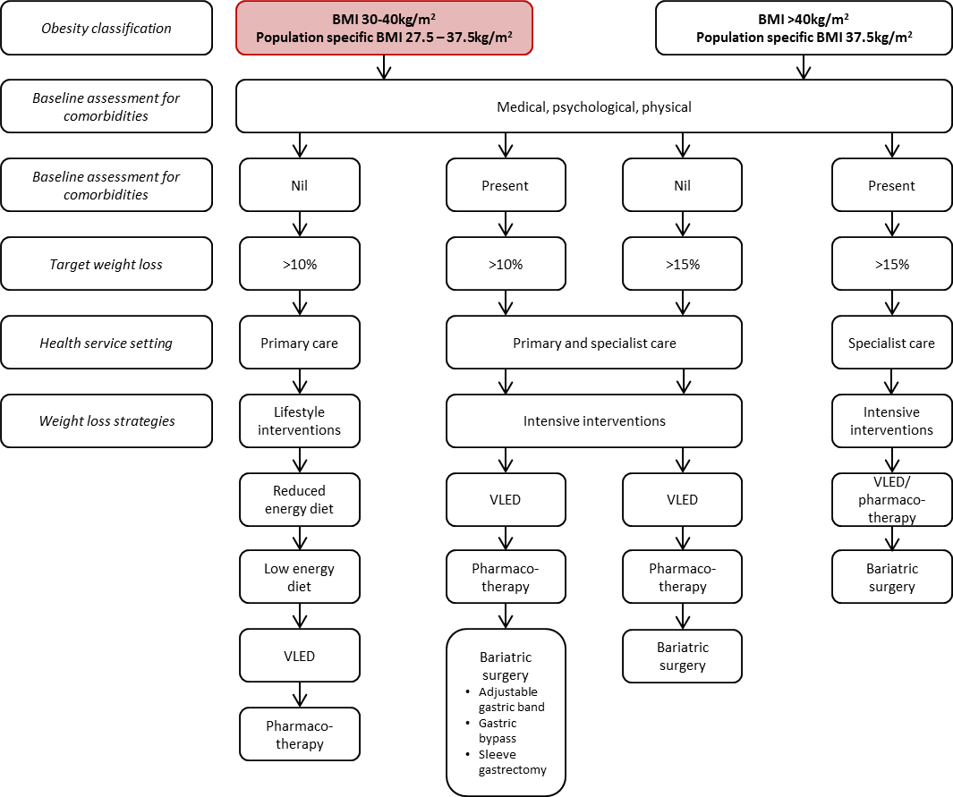
Figure 1 The current clinical management algorithm for patients aged 18 years and over with a BMI between 30 to 40 kg/m2 plus one or more comorbidities
Notes:
Comorbidities may include type 2 diabetes mellitus, cardiovascular disease, hypertension, dyslipidaemia, kidney disease, sleep apnoea or osteoarthritis. Diet may include reduced, low and very low energy diets.
Drugs currently registered in the Therapeutic Goods Administration for the treatment of obesity are Phentermine (Duromine® and Metermine®), Orlistat (Xenical®) and Liraglutide (Saxenda®). Only Orlistat (Xenical®) is supported by the Pharmaceutical Benefits Scheme.
Dieticians, Clinical Psychologists, General Practitioners, Physiotherapists, Surgeons, Gastroenterologists, Endocrinologists and Nurses play an essential role as a multidisciplinary team.
Highlighted red box = proposed population.
Population specific BMI 27.5–32.4 kg/m2 recommended for Asian populations.
Source: Australian and New Zealand Obesity Society and Australian Diabetes Society (2016).
In the proposed clinical management algorithm (Figure 2), ESG will be a new intervention for individuals 18 years in age or over with a BMI of 30.0 to 34.9 kg/m² with one or more comorbidities who have failed first- and second-line treatments. For patients with a BMI of 35.0 to 39.9 kg/m² who are eligible to undergo bariatric procedures listed on the MBS following failure of first- and second-line treatments, ESG is a substitute procedure they can undergo prior to other forms of bariatric surgery. The proposed algorithm is based on the current Australian and New Zealand Obesity Society and the Australian Diabetes Society.
The Critique of the contracted assessment stated that the algorithm appears appropriate; however, progression from ESG to bariatric surgery in the algorithm was unclear. Specifically, the Critique noted that there is an arrow from ESG to bariatric surgery, implying bariatric surgery may be considered should ESG fail. The evidence for reversal or conversion to surgical intervention is unclear, particularly seeing as ESG is proposed as a permanent therapy. It may be considered that ESG be placed among other bariatric surgery options as a ‘less-invasive’ alternative in the treatment algorithm.
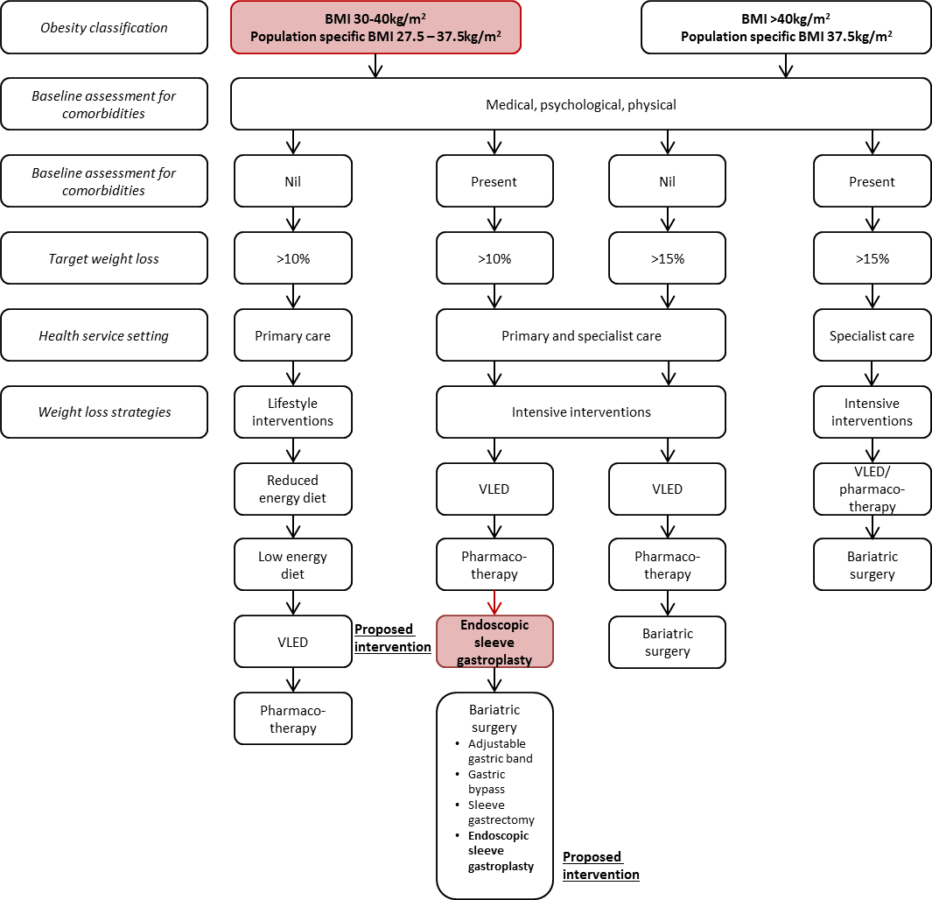
Figure 2 Proposed clinical management algorithm for patients aged 18 years or over with a BMI between 30 to 40 kg/m2 plus one or more comorbidities relative to current clinical practice
Notes:
Comorbidities may include type 2 diabetes mellitus, cardiovascular disease, hypertension, dyslipidaemia, kidney disease, sleep apnoea or osteoarthritis. Diet may include reduced, low and very low energy diets.
Drugs currently registered in the Therapeutic Goods Administration for the treatment of obesity are Phentermine (Duromine® and Metermine®), Orlistat (Xenical®) and Liraglutide (Saxenda®). Only Orlistat (Xenical®) is supported by the Pharmaceutical Benefits Scheme.
Dieticians, Clinical Psychologists, General Practitioners, Physiotherapists, Surgeons, Gastroenterologists, Endocrinologists and Nurses play an essential role as a multidisciplinary team.
Highlighted red box = proposed population or intervention.
Population specific BMI 27.5–32.4 kg/m² recommended for Asian populations.
Source: Australian and New Zealand Obesity Society and Australian Diabetes Society (2016).

Comparator
In Australia, Class I and II obese patients have different treatment options. Thus, the application nominated two comparators:
- Comparator 1: Continued lifestyle interventions (behavioural therapy, diet and exercise) with or without pharmacotherapy (i.e. standard care).
- Comparator 2: AGB or SG plus lifestyle interventions with or without pharmacotherapy.

Comparative safety
In total, two non-randomised retrospective comparative studies (Fayad et al. 2018, Novikov et al. 2017) and six case series studies (Abu et al. 2017, Alqahtani et al. 2019, Graus Morales et al. 2018, Lopez-Nava et al. 2017a, Saumoy et al. 2018, Thompson et al. 2017) were identified as pivotal evidence for the assessment of safety and effectiveness of ESG. The application stated that all studies were at serious risk of bias as judged using the Cochrane ROBINS-I tool (comparative studies) and the Institute of Health Economics (IHE) tool (case series studies). Key limitations of the evidence base included: retrospective design, failure to adjust for BMI and comorbidity differences between cohorts, limited follow-up duration, notable losses to follow-up and financial conflicts of interest to redacted.
All case series studies (excluding Thompson et al. 2017) and one RCT (Fayad et al 2018) were included in the application’s meta-analysis of ESG.
Eight systematic reviews were included for the assessment of the safety and effectiveness of the comparators. These reviews were considered acceptable or high-quality, as assessed using the Assessing the Methodological Quality of Systematic Reviews (AMSTAR) tool.
The application stated that patients included in the studies evaluating ESG and the comparators had higher BMIs, fewer comorbidities and unclear treatment failure histories than those specified in the PICO Confirmation. Given baseline weight and comorbidity status likely influence the safety and effectiveness of the procedure, it is unclear whether the population and the results in the studies are applicable to the population outlined by the PICO Confirmation.
The application stated that based on the available evidence, ESG was not associated with any serious safety concerns over the reported follow-up duration. However, the safety data obtained were limited and relatively short-term, (up to 5 years). Further, there are no RCTs comparing ESG to first- and second-line interventions or to AGB or SG, only matched cohort comparisons. . It was claimed that the safety profile of ESG is inferior compared to standard care and non-inferior to other bariatric surgeries. Although these clinical claims seem reasonable from the evidence currently available, the long-term comparative safety of ESG to its comparators remain unclear. A summary of the indirect comparison of safety is presented in Table 3.
Table 3 Summary of representative safety outcomes across the comparator and intervention arms
 | Proposed intervention | First-line intervention | Second-line interventions |  | Bariatric surgeries
Safety outcome | ESGª  Range | Diet, exercise, therapy | Very low energy diet  Range of means | Pharmaco-therapy  Range of means | AGB  Range of means | SG  Range of means
Any AE | 0.7 – 92.4%^{4, 5, 9} | NR | 0.0 – 42.9%¹⁰ | 80.0 – 96.0%^{11, 12} | 3.9 – 13.0%^{13, 14} | 7.7 – 26.3%^{14, 15}
SAE | 0.0 – 4.0%^{3, 7, 8} | None¹⁶ | 0.76%¹⁰ | 0.0 – 15.0%¹¹ | NR | 0.2 – 4.2%¹⁵
Mortality | 0.0%^{4, 5, 9} | None^{b11, 16} | NR¹⁶ | None^{b11} | 0.07 – 0.21%¹³ | 0.29 – 6.0%¹³
Abbreviation: AE = adverse event; AGB = adjustable gastric band; ESG = endoscopic sleeve gastroplasty; SAE = severe adverse event; SG = sleeve gastrectomy
Notes: The severity of adverse events differs between first- and second-line intervention and bariatric surgery. Thus, while a higher proportion reported adverse events following pharmacotherapy, the severity is likely lower than those following bariatric surgery.
a = maximum length of follow-up was 18 months, b = there were deaths in these groups; however, they were not attributed to the intervention.

Comparative effectiveness
The application’s results from the meta-analysis and the comparative studies indicated that ESG was associated with meaningful short-term weight loss (reduction in BMI by approximately 6 kg/m² at 12 months). However, the generalisability of these results to the proposed population is uncertain; data is likely enriched with patients who responded to treatment. No data on long-term weight loss maintenance is available. A summary of representative effectiveness outcomes from the indirect comparison are shown in Table 4.
Table 4 Typical effectiveness outcomes following ESG, first- and second-line treatments and bariatric surgery at 12 months
 | Proposed intervention | First-line interventions | Second-line interventions |  | Bariatric Surgeries
Outcome | Meta-analysis of ESG studies  MD (95% CI) ³⁻⁷ | Diet, exercise and therapyª  Range of means^{11, 12, 16} | Very low energy dietª  WMD  (95% CI)¹⁰ | Pharmaco-therapyª  WMD  (95% CI)¹⁶ | SG  Range of means^{2, 13 18} | AGB  Range of means^{2, 13, 13}
TWL, kg | -18.44  (-15.28,  -21.59) | -2.39 to -4.0 | -3.90  (-6.69, -1.11) | -3.01  (-3.48, -2.54) | NR | NR
Change in BMI, kg/m² | -5.82  (-5.18, -6.45) | Unlikely^{b} | Unlikely^{b} | Unlikely^{b} | -7.1 to -16.20^{b} | -6.79^{c} to -10.48^{d}
Diabetes Remission (%) | 76.5%^{e} | Unlikely^{f} | Unlikely^{f} | Unlikely^{f} | 81.5 to 85.53% | 67.58 to 73.88%
Hypertension  Remission (%) | 100%^{e} | Unlikely^{f} | Unlikely^{f} | Unlikely^{f} | 63.7 to 82.23% | 53.55 to 63.73%
Dyslipidaemia  Remission (%) | 56.3%^{e} | Unlikely^{f} | Unlikely^{f} | Unlikely^{f} | 65.4 to 82.86% | 39.95 to 60.91%
Abbreviations: AGB = adjustable gastric banding; BMI = body mass index; CI = confidence interval; ESG = endoscopic sleeve gastroplasty; kg = kilogram; MD = mean difference; NR = not reported; SG = sleeve gastrectomy; TWL = total weight lost; WMD = weighted mean difference.
Notes: a = the changes from these interventions are unlikely to result in remission of comorbidities; b = changes in kg are unlikely to result in clinically meaningful changes in BMI; c = Novikov et al. (2017)²; d = results from meta-analyses; e = results from a single study Alqahtani et al. (2018)⁴; f = the change in biochemical parameters are unlikely to result in the remission of comorbidities.
The overall summary of findings and an indication of the quality of information that informed these findings is reported in Table 5.
Table 5 Balance of clinical benefits and harms of endoscopic sleeve gastroplasty as measured by the critical patient-relevant outcomes in the key studies
Outcomes (units) | Participants (k)  Studies (n) | Quality of evidence (GRADE)ª | Relative effect (95%CI)
Weight change (BMI, kg/m²) | n = 498  k = 5 | ⨁⨀⨀⨀ | 5.82 (5.18, 6.45)
Weight change (% EWL) | n = 438  k = 4 | ⨁⨀⨀⨀ | 63.12 (52.23, 74.02)
Serious adverse events | n = 318  k = 5 | ⨁⨁⨀⨀ | Range: 0 to 4%
Mortality | n = 1148  k = 2 | ⨁⨁⨀⨀ | Range: 0%
Abbreviations: BMI = body mass index; CI = confidence interval; % EWL = percentage of excess weight loss.
Notes: ª GRADE Working Group grades of evidence (Guyatt et al. 2013).
⨁⨁⨀⨀ Low quality: Confidence in the effect estimate is limited: The true effect may be substantially different from the estimate of the effect. ⨁⨀⨀⨀ Very low quality: Very little confidence in the effect estimate: The true effect is likely to be substantially different from the estimate of effect.
Clinical claim
On the basis of the evidence profile (summarised above), the application proposed that relative to Comparator 1 (first- and second-line interventions), ESG has inferior safety and unclear short-term and unknown long-term effectiveness. Relative to Comparator 2 (SG and AGB), ESG has non-inferior safety and is likely to have non-inferior short-term and unknown long-term effectiveness. The Critique said this conclusion was reasonable.
This conclusion is predicated on the understanding that: there is limited direct comparative evidence evaluating the safety and effectiveness of ESG in the appropriate populations with sufficient follow-up time; the impact of ESG on comorbidities and long-term risks is unclear; and there are significant biases across the included studies.
Searches for ongoing clinical trials suggest that within the next three years a substantive body of evidence evaluating the safety and effectiveness of ESG in the appropriate population and comparators is anticipated to be published. It is possible that these trials will address many areas of concern within the current evidence base.

Pre-MSAC response

Vs Comparator 1
The applicant included new data from a recently published case-matched study of ESG (n=105) vs. low-intensity diet and lifestyle therapy [LIDLT] (n=281), which used Australian trial data. In the study, scenario analysis was performed to handle the loss to follow-up, using last-observation carried forward methodology (Cheskin, Hill et al. 2019).

Long-term effectiveness and durability of ESG in BMI 30-40kg/m²
The applicant included five-year long term follow-up of the effectiveness of ESG from a large observational study with a very high (89%) follow-up rate at five years (n=203) [Hajifathalian, Ang et al. 2019]. The applicant stated patients had minimal weight gain after reaching their post-ESG minimum weight, with an average gain of only 2.4 kg (95% CI 1.8-3.0, p<0.0001). The Applicant stated this level (five years with a follow-up of 89%) meets the McMaster Evidence-based Criteria for High Quality Studies (≥80% of patients at 12 months) [Table 6].
Table 6 Weight loss and percentage of total body weight loss (% TBWL) during follow-up after ESG (N=203)
Follow-up time | Follow-up rate | Weight loss, kg (95% CI) | p-value | % TBWL (95% CI) | p-value | % patients with ≥10% TBWL
1 year | 73% | 18.1 (15.8, 20.5) | <0.0001 | 15.2% (13.5, 16.8) | <0.0001 | 74%
2 years | 80% | 17.3 (14.3, 20.4) | <0.0001 | 14.5% (12.1, 16.8) | <0.0001 | 67%
3 years | 64% | 20.8 (13.3, 28.2) | <0.0001 | 15.7% (11.1, 20.3) | <0.0001 | 37%
5 years | 89% | 18.7 (10.0, 27.3) | 0.0003 | 14.5% (8.2, 20.9) | 0.0002 | 69%
Source: Table 3 of the pre-MSAC response
Bold = statistically significant
The applicant also provided data from case series (n=1,000), that there were eight patients (0.8%) who had their ESG converted to laparoscopic sleeve gastrectomy and five patients (0.5%) who had a revision (i.e. extra stitches added) [Algahtani, Al-Darwish et al. 2019]. In Sarkar, Tawadros et al. 2019 only 0.2% patient had a revision procedure. Thus, the applicant stated both durable long-term weight loss as well as sleeve durability have been demonstrated by 5-year study data with very high follow-up and by the low revision rates seen with ESG in practice.

Upcoming clinical evidence for ESG
The applicant stated that the multicentre ESG trial (MERIT0 [NCT03406975 interim analysis estimated to be in mid-2020 reporting on the 12 month period; with a further 12 month follow-up data to follow] will mainly address issues relating to patients with a BMI 30-35 with co-morbidities, given that it examines use of ESG vs. lifestyle therapy in obese patients (BMI>30) who have a history of failure with non-surgical weight-loss methods and have comorbidities of hypertension and/or diabetes. However, there is no comparator arm with bariatric surgery, and therefore this study will provide no further comparative data for BMI 35-40 with comorbidities.

Economic evaluation
Different economic evaluations were performed depending on the specific clinical claim of ESG and each comparator:
- A cost-utility analysis (CUA) was performed for the comparison between ESG and continued lifestyle modification (with or without pharmacotherapy) for patients with obesity Class I on the basis of inferior safety and superior effectiveness (Table 7).
- A cost-minimisation analysis (CMA) was performed for the comparison of ESG to AGB and SG for patients with obesity Class II on the basis of non-inferior safety and effectiveness.
Table 7 Summary of the economic evaluation
Perspective | Health system
Comparator | Lifestyle intervention with or without pharmacological therapy
Type of economic evaluation | Cost-utility analysis
Sources of evidence | Data synthesised from case series in Section B and pre-modelling results from Section C
Time horizon | 40 years, starting from age 30
Outcomes | QALYs
Methods used to generate results | Cohort expected Markov model
Health states | Normal weight, Overweight, Obesity category I, II, III, and death (6 states)
Cycle length | Annual
Discount rate | 5%
Software packages used | Excel 365
Abbreviations: QALY = quality-adjusted life year.
There are several key assumptions made by the application for the economic model:
- In the model, costs and utilities are attached to the obesity classes as health states. This is justified by correction of the potential overestimation of ESG effectiveness due to the population mismatch (applicability translation issue), the lack of comorbidity information in the evidence base (extrapolation translation issue) and previous examples of a number of published models.
- The model assumed that patients’ weight stabilises after two years, and they will maintain that weight lifelong. Any weight fluctuations or changes of comorbidity status are negligible if these changes are not significant enough for the patient to be re-classified into a different obesity class. As the result, both utilities and costs will also remain constant.
- While different obesity management regimens are used around the intervention and comparator, the model assumed that distinct care bundles are applied to the intervention and the comparator, and these care bundles are only relevant for the first two years. Ongoing costs for obesity were captured via a universal cost specific to different obesity classes. These costs are inclusive of general weight management and comorbidity related items, which is reflective of an average cost for patients with obesity. A similar assumption was also applied to utilities. Obesity class-specific utility values were sourced and derived for the model to be attached at each cycle.
Where uncertainties associated with these assumptions were identified, a list of sensitivity analyses were proposed to investigate their impact.
For the CUA on the ESG versus Comparator 1, the model adopted a stepped approach where incremental cost-effectiveness ratios (ICERs) were produced first over the initial two years, then over the entire 40-year time horizon (Table 8). The Critique stated that the base case assumes weight loss is sustained over the lifetime of the patient (40 years). The long-term clinical effectiveness of ESG is uncertain and concerns regarding the durability of the sleeve have been raised by clinicians. It may not be reasonable to assume a base case scenario of no weight regain over a 40-year time horizon.
Table 8 Incremental costs, QALYs and ICERs for the initial two years and over the 40-year time horizon
Model base-case | Cost | Effectiveness (QALYs) | ICER
First two years
ESG | $redacted | redacted
Critique’s values | $redacted ª
Standard of care | $redacted | redacted | $redacted
Incremental values | $redacted | redacted
Critique’s values | $redacted |  | $redacted
Life-time (40 years extrapolation)
ESG | $redacted | redacted
Critique’s values | $redacted
Standard of care | $redacted | redacted | redacted
Incremental values | $redacted | redacted
Critique’s values | $redacted |  | redacted
Abbreviations: ESG = endoscopic sleeve gastroplasty; QALY = quality-adjusted life year; ICER = incremental cost-effectiveness ratio.
ª Revised post-operative cost of $redacted rather than $redacted used in analysis
For the cost-minimisation analysis (Table 9) comparing ESG to Comparator 2, only the costs associated with each surgery plus two years of post-surgery outpatient care costs are included. The cost of the comparator surgeries is weighted between SG and AGB via MBS usage data. The Critique stated the CMA is only appropriate if the claim of non-inferior effectiveness and safety compared with Comparator 2 is accepted.
Table 9 Result of cost-minimisation analysis comparing ESG to other bariatric surgery
Model-base-case | Intervention |  | Comparator
 | ESG | SG | AGB | SG and AGB weighted total
Weight |  | redacted% | redacted% | redacted%
Subtotal cost | $redacted | $redacted | $redacted | $redacted
Critique’s values | $redacted
Incremental (ESG vs. comparator) |  | $redacted | $redacted | $redacted
Critique’s values |  | $redacted | $redacted | $redacted
Abbreviations: AGB = adjustable gastric band; ESG = endoscopic sleeve gastroplasty; SG = sleeve gastrectomy.
Notes: Weighting for SG and AGB has been derived from 2017-18 Medical Benefits Schedule claims data for items 31575 and 31569.
Sensitivity analyses was performed on key model uncertainties (ESG benefit in comorbidity subgroups, various weight regain assumptions and costs of interventions; Table 10). The application stated the cost-effectiveness profile of ESG appears relatively stable.
Table 10 Sensitivity analyses summary table
Sensitivity analyses | Method/Value | Effect of DSA | Outcome interpretation
Base-Case |  | redacted | redacted
DSA 1: Comorbidity subgroups
Diabetes | All patients begin diabetic. 50% in ESG arm go into remission | redacted | redacted
Increased CVD risk | All patients begin with increased risk. 56% in ESG arm go into remission | redacted | redacted
DSA 2: Weight regainª
Worst-case-scenario in weight regain | 60% of patients regain their weight 2 years after the surgery | redacted | redacted
Significant regain at early stage | 20% of patients regain their weight 2 years after the surgery | redacted | redacted
DSA 2: Other uncertain inputs for CUA model
Costs | 7 variables are tested, the model is most sensitive to obesity state cost | redacted | redacted
Utilities | 2 variables are tested | redacted
DSA 3: Cost-minimisation analysis
Surgical intervention related costs | Cost variations including hospital, prosthesis (SG only) and post-surgical care | redacted | redacted
Cost of reoperations | Equating rate of ESG to SG | redacted | redacted
Abbreviations: CUA = cost utility analysis; CVD = cardiovascular disease; DSA = deterministic sensitivity analysis; ESG = endoscopic sleeve gastroplasty; ICER = incremental cost-effectiveness ratio; SG= sleeve gastrectomy.
Notes: ªTwenty weight regain scenarios were undertaken as part of this Assessment. A summary of only two are presented here. Please refer to Table 81 for the full results.

Financial/budgetary impacts
An epidemiological approach has been used to estimate the financial implications of the introduction of ESG to the MBS. Table 11 outlines the data sources used to estimate the number of Australian adults who may seek ESG to assist with their weight loss.
Table 11 Total costs to the MBS associated with ESG
Year | 2020 | 2021 | 2022 | 2023 | 2024
Patients receiving ESG
OBI | redacted | redacted | redacted | redacted | redacted
OBII | redacted | redacted | redacted | redacted | redacted
Overall no. treated | redacted | redacted | redacted | redacted | redacted
Cost of proposed ESG item
OBI | $redacted | $redacted | $redacted | $redacted | $redacted
OBII | $redacted | $redacted | $redacted | $redacted | $redacted
Overall cost of proposed item | $redacted | $redacted | $redacted | $redacted | $redacted
ESG and associated services
OBI | $redacted | $redacted | $redacted | $redacted | $redacted
OBII | $redacted | $redacted | $redacted | $redacted | $redacted
Overall cost of ESG and associated services | $redacted | $redacted | $redacted | $redacted | $redacted
Net cost implications
OBI | $redacted | $redacted | $redacted | $redacted | $redacted
OBII | $redacted | $redacted | $redacted | $redacted | $redacted
Overall net cost to the MBS | $redacted | $redacted | $redacted | $redacted | $redacted
Abbreviations: ESG = endoscopic sleeve gastroplasty; MBS = Medicare Benefits Schedule; OBI = obese class one (BMI of 30-34.99 kg/m²); OBII = obese class two (BMI of 35-39.99 kg/m²).
Sensitivity analyses performed in the application suggested that the overall net cost to the MBS is between $redacted to $redacted in year 1, assuming that there is no constraint on supply. An initial year supply constraint of 50% restricts this cost impact to $redacted. Overall, the Critique stated there is considerable uncertainty in the financial impact estimates which reflects the uncertain efficacy and safety of ESG, the eligibility and uptake of ESG in both subpopulations, and the potential constrain of supply relating to the number of physicians able to perform the procedure.
In the pre-MSAC response, the applicant stated that the eligible population has likely been overestimated, suggesting the financial impact will be substantially lower than that estimated in the application.

Key issues from ESC for MSAC
ESC key issue | ESC advice to MSAC
Efficacy of ESG | Relative to Comparator 1 (first- and second-line interventions), ESG has unclear short-term and unknown long-term effectiveness.  Relative to Comparator 2 (SG and AGB), ESG is likely to have non-inferior short-term and unknown long-term effectiveness.
Safety of ESG | ESG was not associated with any serious safety concerns over the reported follow-up duration. However, the safety data obtained were limited and relatively short-term. The safety profile of ESG is inferior compared to standard care and non-inferior to other bariatric surgeries.
MBS item descriptor | Clinical evidence provided is limited to ESG performed with theOverStitch™. MSAC may want to consider whether it would list an item number for OverStitch™ only, or consider a more generic item.
Low quality clinical evidence | Evidence on comparative effectiveness is limited to case series and 2 retrospective comparative studies with significant risk of biases across included studies from open label designs, short durations of follow-up, high attrition rates and indirect comparisons (note there are currently 2 ongoing RCTs).
Uncertain applicability issues | The population included in the ESG and comparator evidence bases generally did not align with the PICO Confirmation proposed population: study populations had higher baseline BMIs vs. proposed MBS population. As patients with higher baseline BMIs have a higher capacity to lose weight, the clinical effectiveness results (e.g. BMI reductions) may be subject to overestimation. In addition, the comorbidity- and treatment failure- status of patients in the evidence base was often unclear; these uncertainties had flow on effects to the economics.
Cost implications and possible offsets | The base case of the cost-utility analysis assumes weight loss is sustained over the lifetime of the patient (40 years). The long-term clinical effectiveness of ESG is uncertain and concerns regarding the durability of the sleeve have been raised by clinicians.
Highly uncertain model-based economic evaluation (vs. Comparator 1) | There is a high level of uncertainty in model-based CUA arising from:  - uncertain applicability issues (patient characteristics and baseline BMI)  - highly uncertain model inputs (baseline and treatment effect-BMI trajectory component), informed from low quality clinical evidence  - highly uncertain structural assumptions including oversimplifications, and duration of treatment effect (continuing effect) given short duration of follow-up and the model time horizon (lifetime)  - uncertain impact of revision/repair (which is highly likely to be needed).
Uncertain financial impact | Potential for net cost to be overestimated due to:  - overestimated eligible population (uptake rate, comorbidities derived from population with BMI>35kg/m²⁾  In addition, the cost of ESG revision/repair was not included and potential leakage may be possible (particularly in patients without comorbidities).

ESC discussion
ESC noted that the clinical evidence in the Contracted Assessment (CA) is for endoscopic sleeve gastroplasty (ESG) performed using the OverStitch™ endoscopic suturing device because this is the only device currently listed on the Australian Register of Therapeutic Goods (ARTG). ESC noted that there is an redacted which is not listed by the ARTG. There is also evidence for similar endoscopic gastric plication devices and methods, with seven listed in a recent meta-analysis. Therefore, ESC suggested that MSAC may want to consider whether it would list an item number for OverStitch™ only, or a more generic item.
ESC noted that the population in the MBS item descriptor does not align with that of the PICO and that MSAC may wish to amend the descriptor to include a definition of comorbidities, stipulate that the procedure is only applicable to patients who have failed first- and second-line treatments, and stipulate that ESG is to be used in conjunction with continued postoperative lifestyle interventions.
ESC noted that in the algorithm there is an arrow from ESG to bariatric surgery, implying bariatric surgery may be considered should ESG fail. There was concern that, for patients with a body mass index (BMI) of 30–34.9 kg/m², there could be leakage to other bariatric procedures.
ESC noted that the procedure is likely to be a type A procedure with hospitalisation required. ESC questioned how feasible it is to reverse the procedure. It was noted advice from gastrointestinal surgeons that the procedure is not reversible, but it is highly likely to fail and therefore needs a revision item. ESC noted that although an alternative item descriptor has been suggested for revision, this is somewhat premature and needs to be considered only in the light of further studies. ESC considered that the impact of including revision/repair on the economic evaluation g is unclear.
ESC noted that currently surgeons undertake the surgical interventions associated with comparator 2 (adjustable gastric banding [AGB] or sleeve gastrectomy [SG]). However, ESG will be open to many more clinicians (those who can use an endoscope), which could significantly increase the number of cases that might be claimed under Medicare. ESC considered that there may also be safety concerns regarding the adequate training of such interventionalists performing this complex procedure.
ESC noted that the population included in the ESG and comparator evidence bases generally did not align with the PICO confirmation proposed population: patients included in the evidence base had higher baseline BMIs compared to the proposed population for ESG. Therefore, ESC considered that the clinical effectiveness results (e.g. BMI reductions) may be subject to overestimation.
For Comparator 1, ESC noted the very high ICER (at two years), which is mainly due to the minimal incremental QALYs gained and the cost of the intervention. ESC noted that the CAs base case model indicated that ESG appears to be cost-effective after 8 years.
However, ESC noted a number of uncertainties in the economic modelling:
- A cohort starting from Class I obesity transitions to either death or overweight (for ESG) or death only (for the comparator). That is, only three health states were included in the model. There are no transitions between different obesity classes or normal weight. ESC considered this to be an oversimplification and not represent real world practices.
- The benefits of comorbidity resolutions/remissions were not directly modelled; instead, they were indirectly modelled through obesity class changes. However, BMI may not be the best risk factor for predicting some important comorbidities such as stroke or coronary heart disease. ESC noted that a model structure that includes comorbidities as health states might capture the benefits of weight loss. ESC noted the effect of comorbidities (diabetes and cardiovascular risk) were not included in the base-case model but rather investigated in subgroup analyses, due to lack of data on the prevalence of comorbidities in the proposed MBS population.
- The uncertainty with the model assumption that everyone in the ESG arm (if alive) will benefit from ESG to the same degree, which means it does not rely on patient characteristics. This favours the intervention. ESC considered that, while evidence related to BMI is important, there are applicability issues because data are from a meta-analysis of case series. The high attrition rate in the included studies increases the risk of bias.
- The high level of uncertainty about the duration of treatment effects, due to the lack of long-term data beyond 18 months. The submission’s base-case model assumes weight loss is sustained over the lifetime of the patient (40 years). However, the long-term clinical effectiveness of ESG is uncertain and concerns regarding the durability of the sleeve have been raised by clinicians. ESC considered it may not be reasonable to assume a base case scenario of no weight regain over a 40-year time horizon.
For comparator 2, ESC noted that the cost-minimisation approach (CMA) is only appropriate if the clinical claim of non-inferior safety and efficacy (compared with bariatric surgery: AGB or SG) is accepted. ESC noted the Critique amended the weighted cost of bariatric surgery to reflect a 50% split between patients requiring overnight stay and day cases. However, ESC noted that the evidence base supporting the comparison with bariatric surgery is weak, comprising two non-randomised retrospective comparative studies with significant risk of biases across included studies from open label designs, short durations of follow-up, high attrition rates and indirect comparisons.
ESC noted that within the next three years a substantive body of evidence (e.g. 2 randomised controlled trials [RCTs]) evaluating the safety and effectiveness of ESG in the appropriate population and comparators is anticipated to be published.
ESC noted that many centres performing these endoscopic procedures order additional routine post-procedure investigations to evaluate the intervention and exclude certain complications, and that these additional costs also need to be considered.
ESC noted the estimated net cost to the MBS of $redacted in year 1 and $redacted in year 5. However, ESC considered these estimates were uncertain and that the net cost may be overestimated because it is assumed that 100% of patients eligible for ESG will take it up; and the number of people with obesity class I who are eligible for ESG is likely overestimated as comorbidities were derived from a population with a BMI >35. ESC also noted the cost of ESG revision/repair was not included in the financial impact and potential leakage may be possible (particularly in patients without comorbidities).
ESC noted that studies with longer-term follow-up are required before any recommendation for public funding can be supported.

Other significant factors
Nil.

Applicant’s comments on MSAC’s Public Summary Document
The applicant would like to thank the MSAC, the Secretariat, and the Contracted HTA group for all their work and the consideration of our application. We are naturally disappointed with the outcome and believe that ESG is an attractive minimally invasive endoscopic alternative to surgery that expands the therapeutic benefits of effective obesity interventions targeting the GI tract to patients who do not qualify for or wish to pursue bariatric surgery. The evidence in this field is maturing, and we will take MSAC’s advice under consideration and will plan a resubmission at a later date.

Further information on MSAC
MSAC Terms of Reference and other information are available on the MSAC Website:
www.msac.gov.au

