Public Summary Document

Application No. 1194 – Single Dose Stereotactic Radiosurgery for Single and Multiple Brain Metastases (Gamma Knife)

Applicant: Medical Intelligence on behalf of Macquarie University Hospital

Date of MSAC consideration: MSAC 64th MSAC Meeting, 30-31 July 2015

Context for decision: MSAC makes its advice in accordance with its Terms of Reference, see at www.msac.gov.au

Purpose of application and links to other applications

An application requesting Medicare Benefits Scheme (MBS) listing of Single Dose Stereotactic Radiosurgery (SRS) for patients with single or multiple brain metastases (Gamma Knife) was received from Macquarie University Hospital. The evidence for assessment of this application was submitted in February 2014.

The application presented a range of fee structures for the proposed intervention.

MSAC’s advice to the Minister

After considering the available evidence presented in relation to safety, clinical effectiveness and cost-effectiveness of single dose stereotactic radiosurgery (SRS) for single and multiple brain metastases (Gamma Knife), MSAC did not support a change to public funding for the existing MBS item 15600 based on uncertain incremental clinical benefit of the Gamma Knife unit over other SRS units or compared to whole brain radiation therapy (WBRT), as well as uncertain cost-effectiveness.

Summary of consideration and rationale for MSAC’s advice

MSAC noted that two other applications for stereotactic surgery by Gamma Knife had previously been considered in November 2000 and March 2006. SRS is an established treatment for brain metastases currently performed by either Gamma Knife or Linac SRS systems, MSAC noted that these services are currently available and publicly funded under MBS item 15600.

MSAC noted that this application requested a review of the schedule fee and funding structure of the existing MBS item 15600 which currently provides public funding for single dose stereotactic radiosurgery including all oncology consultation, planning, simulation, dosimetry and treatment. This application was specifically for a change in fee structure for the existing MBS item from $1,702.30 to $7,230. MSAC considered the claim for a fee increase was difficult to assess based on the evidence presented regarding the suitability (or not) of the current MBS fee for item 15600.

MSAC considered the evidence presented on the comparative safety, efficacy and cost-effectiveness of SRS with WBRT. MSAC noted that the studies for SRS were not limited to Gamma Knife and although the application assumed a similar effect of single session Linac SRS and Gamma Knife SRS, MSAC considered that a comparison of Linac SRS versus Gamma Knife would have been informative.

In March 2006, MSAC concluded that Gamma Knife radiosurgery was safe when compared with Linac SRS. MSAC agreed that the evidence presented in this application was consistent with this conclusion for comparative safety of SRS with WBRT.

MSAC noted that the evidence presented for clinical effectiveness suggested that SRS has an equivalent overall post-treatment survival time for patients compared to WBRT or WBRT plus SRS. However, the studies also indicated that combined therapy with WBRT plus SRS improved local tumour control and improved distal tumour control. MSAC noted the applicant pre-MSAC response stated that the traditional fractionated WBRT can no longer be considered safe and effective in the treatment of brain metastases. However, MSAC noted advice from ESC that WBRT is now largely applied with hippocampal-sparing which is intended to alleviate some of the side effects for WBRT without this adjustment. Overall, MSAC considered that there was no strong evidence to support the claim that SRS was better than WBRT with hippocampal-sparing and no clear evidence regarding whether Gamma Knife was better than using a modified Linac.

MSAC noted that the base case presented for the cost comparison analysis had included the proposed new fee for Linac based SRS, and considered that it would have been more informative if the base case had included the current fee for 15600 instead. MSAC also noted that the cost comparison analysis for the proposed increase in fee for MBS item 15600 was highly volume dependent predominantly to recover capital costs. MSAC was uncertain what the impact that a throughput of 125 or 250 patients per year, which was proposed by the applicant, would be due to the current limited availability of medical physicists in Australia. In addition, comparisons to the modified Linac may be misleading because while the Gamma Knife is limited to radiosurgery of the brain only, the Linac can be used for a greater range of services.

Overall, MSAC was unconvinced by the evidence presented that the requested increase in fee was justified. MSAC noted that MBS item 15600 is likely to be considered as part of the recently announced MBS Review Taskforce, and may be more appropriately considered as part of a broader review of funding structure for SRS in general.

Background

The applicant noted that two prior applications had been considered by MSAC for review of stereotactic surgery by Gamma Knife:

In November 2000, MSAC considered Application 1028 and determined that there was insufficient evidence on comparative safety, effectiveness and cost-effectiveness pertaining to Gamma Knife radiosurgery, and that additional public funding for this procedure should not be supported.

In February/March 2006, MSAC concluded that Gamma Knife radiosurgery was safe and appeared to be effective, but was not cost-effective when compared with linear accelerator (Linac) SRS. A partial economic costing indicated that an adapted Linac unit would provide the least costly method of SRS treatment in Australia. The review stated that further evidence about the effectiveness of Gamma Knife radiosurgery vs. alternatives, such as adapted Linac systems, is required in order to undertake a full economic analysis. MSAC recommended that the funding arrangements not be changed.

Prerequisites to implementation of any funding advice

Gamma Knife was approved by the Therapeutic Goods Administration (TGA) for stereotactic irradiation of head structures ranging from very small target sizes of a few millimetres to several centimetres. Examples include metastatic tumours, arteriovenous malformations, trigeminal neuralgia, meningiomas and vestibular schwannomas.

The applicant noted that the requested indications for SRS using Gamma Knife are consistent with the TGA registered indications and there are no prerequisites required to provide the intervention.

Proposal for public funding

The applicant has requested a review of the schedule fee and funding structure for the existing MBS item 15600 (SRS, including all radiation oncology consultations, planning, simulation, dosimetry and treatment).

Category 3 - THERAPEUTIC PROCEDURES
15600

STEREOTACTIC RADIOSURGERY, including all radiation oncology consultations, planning, simulation, dosimetry and treatment
Fee: $1,702.30 Benefit: 75% = $1,276.75 85% = $1,623.90

MBS item 15600 includes all planning, consultation and treatment for this radiation oncology service. This differs from other radiation oncology services where the separate components of service delivery are claimed through separate items.
The MBS item descriptor and fee proposed in the pre-MSAC response (based on an annual throughput of 250) was:

Single dose stereotactic radiosurgery for benign or malignant intracranial tumours, vascular malformations and functional disorders, including all radiation oncology consultations, planning, simulation, dosimetry and treatment

Fee: $7,230.00 Benefit: 75% = $5,422.50 85% = $6,145.50.
The proposed intervention is SRS for the treatment of single or multiple brain metastases.

SRS is an established treatment for brain metastases. In Australia, SRS can be performed by either Gamma Knife or linear accelerator (Linac) systems and is claimable under MBS item 15600. The delivery of SRS under item 15600 is not predicated on any one specific technology and services can be, and are, provided by both Gamma Knife and Linac systems. These services are currently available and do not address an unmet clinical need as treatment for single or multiple brain metastases can be achieved by SRS, delivered using adapted Linac systems, whole brain radiotherapy (WBRT) or surgery. SRS is classified as a non-invasive procedure.

The applicant noted that stereotactic radiosurgery would be delivered by a team headed up by a radiation oncologist and/or a neurosurgeon. The team would comprise a radiation oncologist, neurosurgeon, a medical physicist, a radiation therapist and a nurse.

Summary of Public Consultation Feedback/Consumer Issues

Consumers noted that there was a lack of comparative efficacy and clinical uncertainty around the proposed intervention with no evidence of unmet clinical need. Consumers also considered the treatment expensive with no co-payment and wealthier patients predominately supporting the intervention.

Proposed intervention’s place in clinical management

SRS is defined by the use of a physical frame or fiducial markers to provide an external three-dimensional frame of reference to target lesions for treatment by ionising radiation. Gamma Knife is designed specifically for intracranial and pericranial lesions and treatment is typically effected by a single large fraction of radiation. Multiple collimated beams are focused on the target lesions with a dosimetry designed to ensure rapid drop-off of dose intensity at the target boundary.

Stereotactic radiosurgery is intended to treat malignant and benign intracranial lesions (including pericranial lesions from the base of the skull to C2). Malignant and benign intracranial lesions include the following specific indications (as specified by the DAP):
    - Cerebral metastases, arteriovenous malformations (AVMs) unsuitable for surgery or interventional radiology.
    - Benign intracranial tumours including acoustic neuroma, arteriovenous malformation, trigeminal neuralgia,meningioma, pituitary adenomas, where patients are ineligible for or are refractory to medical or surgical treatment.
    - Residual intracranial and pericranial tumours following surgical treatment.
    - Focally recurrent gliobastoma multiforme (GBM).
The applicant provided the following clinical management algorithm for the treatment of single or multiple brain metastases.

Clinical Management Algorithm for Treatment of Single or Multiple Brain Metastases

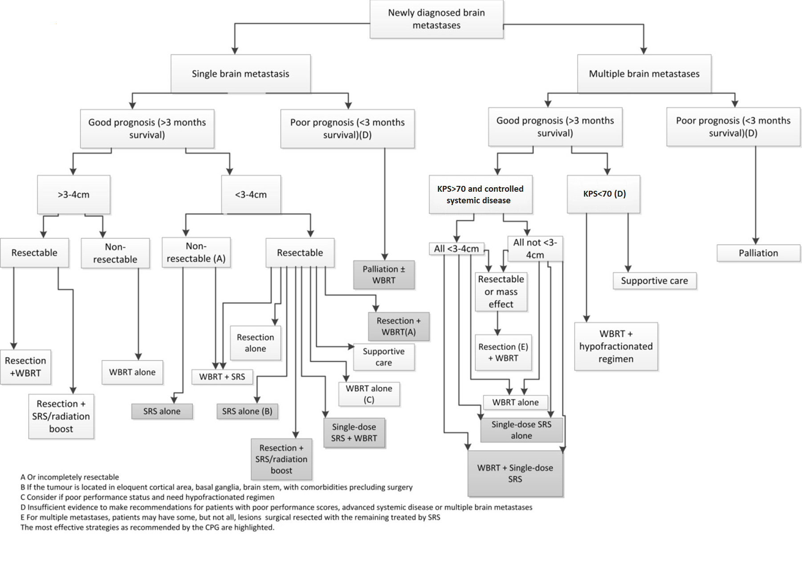

Comparator

The applicant indicated that the main comparator for SRS was whole brain radiotherapy (WBRT). More specifically, the comparators were:

- WBRT plus SRS vs. WBRT only
- WBRT plus SRS vs. SRS only
- SRS vs. surgery
- the applicant included an additional comparison to assess the safety and efficacy of a SRS only treatment for patients with 2 to 4 metastases compared with patients that have 5 to 10 metastases.

In its pre-ESC response, the applicant noted the following:

Treatment Alternatives for Brain Metastases (Comparators)
Currently brain metastases are alternatively treated with open surgical resection combined with fractionated whole brain radiotherapy or by WBRT alone or by stereotactic radiosurgery.

Metastases: Treatment Alternative: Open Surgery (Comparators)
The surgical resection of brain metastases is an important treatment of a small group of patients, but is inadequate for the majority since surgery of brain metastases is rarely carried out when there is more than one metastasis and surgery requires a good general condition of the cancer patient. The rates for side effects and complications, surgical mortality, recurrences rates and the inherent need for longer hospitalisation and rehabilitation, are important issues in the selection of cancer patients. Hence, surgery is needed for a small group of patients with larger or symptomatic brain metastases, but, due to inherent clinical restrictions, in the majority of patients with brain metastases surgery cannot be applied. It was recently assumed that approximately one-third of patients with surgically resected brain metastasis would be suitable for SRS.

Comparative safety

The critique noted the following key outcomes for the comparative safety of SRS and WBRT were:
- Adverse events related to treatment toxicity were variably reported.
- Two of the RCTs reported no significant difference between treatments with respect to cause of death (Andrews et al. 2004; Aoyama et al. 2006) while one reported a significantly greater hazard ratio for patients assigned to the SRS plus WBRT treatment compared with SRS alone (Chang et al. 2009).

The critique stated that comparative safety of SRS performed using Gamma Knife as compared with a Linac system was not addressed. It the pre-ESC response the applicant stated that other modalities were 180–290% higher than Gamma Knife when comparing the volumes of normal brain receiving radiation of 12 Gy.

In its pre-ESC response, the applicant advised that WBRT has been applied for decades as standard therapy in the treatment of brain metastases. Recent scientific evidence including multiple randomised studies have now demonstrated a low and insufficient response rate of brain metastases after WBRT which is reflected by randomised data showing no life extending effect of WBRT. New metastases develop despite previous WBRT in 23%- 50% and WBRT cannot be repeated. Randomised studies have shown that WBRT has a negative impact on cognition, verbal memory and quality of life. Based on these data showing that WBRT is not sufficiently locally effective, does not prolong the life of cancer patients and is potentially harmful for cognitive functions and quality of life, WBRT can no longer be considered as safe and effective to provide a reliable and reproducible treatment of brain metastases in patients in good clinical and mental condition.

MSAC noted that WBRT is now largely applied with hippocampal sparing which is intended to alleviate some of the side effects of WBRT without this adjustment.

In its pre-MSAC response the applicant stated that Gamma knife provides the highest accuracy of radiation, the lowest radiation exposure of the surrounding brain and rest of the body.

Comparative effectiveness

The critique considered that the conclusions presented in the submission based assessment report have a high degree of uncertainty and high likelihood of bias. The critique stated that the key outcomes for comparative efficacy of SRS and WBRT are as follows:

- Overall survival time post-treatment is equivalent for patients receiving any one of the following treatment regimens: SRS, WBRT or WBRT plus SRS. Only one study, Chang (2009), found a difference in median survival between treatment arms, favouring SRS plus WBRT over SRS alone.
- Local tumour control was improved in patients treated with a combination of SRS plus WBRT as compared to either SRS alone or WBRT alone.
  - Two RCTs compared WBRT against WBRT plus SRS. Local tumour control was improved in both trials for the combined treatment; however, the trial by Andrews et al. (2004) indicated that the difference between treatments was not statistically significant.
  - Two RCTs compared SRS against WBRT plus SRS. The combined therapy resulted in a statistically significant improvement in local tumour control.
  - Distal tumour control was reported in three of the four RCTs that compared WBRT or SRS to the combined therapy of WBRT plus SRS. The combined therapy resulted in a statistically significant improvement in distal tumour control.
  - None of the included RCTs directly compared SRS with WBRT as the sole intervention.
- Patients who received SRS plus WBRT as compared to WBRT alone may have better functionally independent survival (Andrews et al. 2004).
- A statistically significant difference in neurological function between SRS alone compared to WBRT and SRS was not identified.

The critique stated that the comparative effectiveness of SRS performed using Gamma Knife as compared with a Linac system was not addressed. In the pre-ESC response, the applicant noted that most published series after single session Linac SRS report mixed patient cohorts with various primary cancer types that do not allow conclusions to be drawn concerning specific tumour types. In addition, the current evidence after hypofractionated Linac SRT was insufficient for a comparison with single session Gamma Knife radiosurgery due to low rates of follow‐up, limited local control and number of adverse effects. Therefore, for the purpose of this application, a similar effect of single session Linac SRS and Gamma Knife SRS was assumed.

In its pre-ESC response, the applicant also noted that:
- A total of 1,821 articles have been published dealing with radiosurgery of brain metastases. The applicant marked prospective randomised studies to allow a differentiation from retrospective studies;
- 158 studies published outcome data after Gamma Knife radiosurgery of brain metastases, studies with specific clinical results were selected and cited;
- 76 articles published outcome data after Linac radiosurgery of brain metastases;
- Studies were cited specifically with respect to local control after Gamma Knife treatment, comprising 6,069 scientifically studied, peer reviewed and published patients. The reported criterion was local tumour control; and
- Studies may analyse various aspects, which were cited separately in chapters that focused on specific issues.

Economic evaluation

The applicant presented a cost analysis, based on two comparisons, specifically:
- Gamma Knife vs. a modified Linac system; and
- SRS vs. WBRT with hippocampal-sparing.
In addition, the applicant provided surgery costs for comparison.

The table below summarises the results of the economic evaluation of the proposed intervention. Table redacted.

Summary of the incremental costs of SRS vs. WBRT (Gamma Knife vs. WBRT with hippocampal-sparing)
Table redacted

The critique stated that the results are uncertain due to:
- The uncertainty of the estimated capital cost. In particular, the capital cost for modified Linac was highly uncertain. Additionally, the stated figures are almost double the estimate presented in the 2006 MSAC Gamma Knife assessment report. Also, the ROHPG was not considered for partial capital cost recovery.
- The appropriateness of selecting WBRT with hippocampal-sparing as the comparator in the economic analysis, while the comparator used in the DAP and submission based assessment report is WBRT with or without hippocampal-sparing
- The uncertainty of the cost components for Gamma Knife.

The applicant pre-ESC response included updated costing.

Financial/budgetary impacts

The submission based assessment report stated that the total cost per patient, based on a patient throughput of 250 per year, covering all the costs of treatment incurred on the day of service using Gamma Knife is $redacted. The equivalent cost using a modified linac is estimated to be $redacted.

Based on an annual patient throughput of 250, the annual increased costs to the MBS and extended medicare safety net (EMSN) was estimated in the submission based assessment report.

The below table was constructed during the critique to calculate the incremental annual cost of Gamma Knife, compared to Modified Linac or WBRT. Table redacted

Overall, the critique considered that the cost estimates provided by the applicant for MBS-listing Gamma Knife are subject to uncertainty with the magnitude unknown. Whether it is an over- or underestimate is unknown, particularly the potentially overestimated capital cost for the comparators, plus the uncertainty of the annual throughput and omission of treatments for adverse events.

Key issues from ESC for MSAC

ESC considered that under current rules and current fees as reported through the MBS, the predicted out-of-pocket cost of $200 was likely an underestimate. ESC also noted that the application is being considered ahead of changes to the Medicare Extended Safety Net, and reviews likely to impact radiation oncology health program grants which will significantly impact the comparison.

ESC noted that the submission based assessment report deviated from the PASC ratified protocol in a number of areas, including:
- Restricting the patient population;
- Restricting the comparator; and
- Restricting the economic analysis to a comparison of direct costs of SRS to the current MBS and EMSN coverage of WBRT.

ESC acknowledged the 154 additional references in the applicant’s pre-ESC Response, but considered the studies of limited relevance to the comparative analysis, noting that there were almost no RCTs or relevant comparisons, and that the studies were of SRS and not limited to Gamma Knife.
ESC advised that there was not strong evidence to support the claim that Stereotactic Radiosurgery was better than WBRT with hippocampal sparing. ESC also advised that there was no clear evidence regarding whether Gamma Knife was better than using a modified Linac.

ESC noted that the cost comparison was highly volume dependent as a major component was the need to recover large capital costs, and noted that the cost comparison provided by the applicant was based on 250 or 125 patients. This was not limited to cerebral metastases.

ESC also considered that MSAC should be aware that the cost comparison with modified Linac may be misleading as Gamma Knife is limited to providing radiosurgery for the brain while a modified Linac, although less convenient, can be used to provide a greater range of services.

ESC noted that additional Medical Physicist time is required for Gamma Knife, which has implications due to the limited availability of medical physicists needs to be included.

ESC also noted that the since the Gamma Knife is already claimable under item 15600, if MSAC were to support the higher fee as requested it would be necessary to adjust the MBS items in one of the following ways:
- Create a new item for some Gamma Knife services at the higher fee;
- Create a new item for the identified services for all SRS modalities;
- Increase the fee for MBS item 15600

Other significant factors

Nil.

Applicant’s comments on MSAC’s Public Summary Document

The Applicant appreciates MSAC consideration of its Application 1194 for a change to public funding of existing MBS item 15600, in line with cost of stereotactic radiosurgery (SRS) delivery in 2015. The Applicant is very disappointed with MSAC failure to support the Application and its rationale, in spite of the overwhelming international evidence presented (including evidence presented in the Applicant’s Response to Critique of the Assessment
Report May 2015 and Response to ESC Report July 2015).

The MBS 15600 fee was established in 1997 and is outdated. The Applicant is hopeful that, as stated in Section 3 of this Public Summary Document, ‘MBS item 15600 is likely to be considered as part of the recently announced MBS Review Taskforce, and may be more appropriately considered as part of a broader review of funding structure for SRS in general’.

Further information on MSAC

MSAC Terms of Reference and other information are available on the MSAC Website at: www.msac.gov.au.

