1364

Final Protocol to guide the assessment of partially implantable middle ear implants for conductive and mixed hearing loss

April 2015

Table of contents
List of Figures 4
List of Tables 4
MSAC and PASC 5
Purpose of this document 5
Purpose of Application 5
Previous Assessment 6
Current Application 7
Hearing and Hearing Loss 7
Hearing Loss Thresholds 8
Air-conduction vs bone-conduction thresholds 8
Types of Hearing Loss 9
Current Treatment Options for Hearing Loss 9
Prevalence of Hearing Loss in Australia 10
Projected Uptake of Proposed Service 12
Population 12
Intervention (proposed) 14
Partially implantable Middle Ear Device 14
Medical Service 15
Delivery of the medical service 15
Co-administered and associated interventions 16
Current arrangements for public reimbursement 16
Comparator 16
Percutaneous Bone-Anchored Hearing Implant 18
Transcutaneous Bone Conduction Hearing Implant 19
Passive Bone Conduction implants (PT-BCI) 20
Active Bone Conduction implants (AT-BCI) 21
Fully Implantable MEIs 21
Partially Implantable MEIs 21
Current MBS Services for the Comparator 22
Regulatory status 23
Proposed Listing and Options for MSAC Consideration 23
Clinical place for proposed intervention 25
Clinical claim 25
Outcomes and health care resources affected by proposed intervention 26
Outcomes 26
Health care resources 27
Proposed structure of economic evaluation (decision-analytic) 28
Clinical Question 29
Attachment A 30
Attachment B 36
References 38

List of Figures

Figure 1: External, middle and inner ear 8
Figure 2: CHL/MHL indication range (bone conduction) (VSB) 14
Figure 3: Partially implantable Middle ear implant - placement for CHL and MHL 14
Figure 4: shows a comparison of bone conduction hearing devices (source: Med-El). 19
Figure 5: Clinical algorithm – Partially implantable MEI for CHL and MHL 24

List of Tables

Table 1: Comparator for MEI relative to type and severity of hearing loss 7
Table 2: Types of Hearing loss 9
Table 3: Causes of hearing loss 10
Table 4: Treatment options for hearing loss 10
Table 5: Prevalence of hearing impairment² 12
Table 6: Bone conduction threshold levels for C/MHL indication for VSB 14
Table 7: Comparator relative to type and severity of hearing loss 16
Table 8: Bone conduction devices 17
Table 9: Osseointegration medical service to implant BCI 21
Table 10: MBS Services for the Comparator 23
Table 11: MEI components listed on the ARTG 24
Table 12: Proposed MBS item descriptor 24
Table 13: Proposed MBS item descriptor for or explantation surgery 25
Table 14: Classification of an intervention for determination of economic evaluation to be
presented 27
Table 15: List of resources to be considered in the economic analysis 28
Table 16: Summary of extended PICO to define research question that assessment will investigate 31

MSAC and PASC
The Medical Services Advisory Committee (MSAC) is an independent expert committee appointed by the Australian Government Health Minister to strengthen the role of evidence in health financing decisions in Australia. MSAC advises the Commonwealth Minister for Health on the evidence relating to the safety, effectiveness, and cost-effectiveness of new and existing medical technologies and services and under what circumstances public funding should be supported.

The Protocol Advisory Sub-Committee (PASC) is a standing sub-committee of MSAC. Its primary objective is the determination of protocols to guide clinical and economic assessments of medical interventions proposed for public funding.

Purpose of this document
This document is intended to provide a draft decision analytic protocol that will be used to guide the assessment of an intervention for a particular population of patients. The draft protocol will be finalised after inviting relevant stakeholders to provide input to the protocol. The final protocol will provide the basis for the assessment of the intervention.

The protocol guiding the assessment of the health intervention has been developed using the widely accepted “PICO” approach. The PICO approach involves a clear articulation of the following aspects of the research question that the assessment is intended to answer:
Patients – specification of the characteristics of the patients in whom the intervention is to be considered for use;
Intervention – specification of the proposed intervention
Comparator – specification of the therapy most likely to be replaced by the proposed intervention
Outcomes – specification of the health outcomes and the healthcare resources likely to be affected by the introduction of the proposed intervention

Purpose of Application
An application requesting Medicare Benefits Schedule (MBS) listing of a medical service for the implantation of partially implantable middle ear implants (MEI) for the treatment of conductive hearing loss (CHL) and mixed hearing loss (MHL) was received from MED-EL Implant Systems Australia Pty Ltd (the Applicant) by the Department of Health in September 2013. The proposal is a resubmission for a new MBS service.

Previous Assessment
In November 2010, MSAC considered Application 1137 which sought a new MBS service for implantation of middle ear implants for the treatment of CHL, MHL and sensorineural hearing loss (SNHL). The assessment of MEI for SNHL is not discussed here as it is the subject of separate Application 1365.

The assessment had the following parameters:

Patients: adults with mild to severe CHL and MHL who could not achieve success or adequate benefit from established therapy.

Intervention: implantation of a generic MEI (evidence included partially and fully implantable devices).

Comparator: bone conduction implants (BCI) and cochlear implants (CI) relative to type and severity of hearing loss (Table 1).

Table 1: Comparator for MEI relative to type and severity of hearing loss
 | Severity of Hearing Loss
Indication | Mild | Moderate | Severe
Mixed hearing loss | MEI vs. BCI |  | MEI vs. CI
Conductive hearing loss | MEI vs. BCI

Clinical claim: superior effectiveness and non-inferior safety.

Outcomes: MSAC expressed concern about the lack of data on long term safety and clinical outcomes for the MEIs. In addition, MSAC :
- agreed that the population for the MEI should be patients who could not tolerate occlusion of the ear canal.
- noted that some patients may opt for the MEI out of convenience.
- agreed that the MEI was more expensive than the BCI, but less expensive than the CI.
- concluded that substituting the MEI:
- for the CI would lead to a cost saving but the outcome may be less effective.
- for the BCI would lead to a cost increase but with no increase in effectiveness.
- for the CI and the BCI would lead to an overall saving to the MBS.

MSAC rejected public funding for the implantation of the MEI.

Current Application

Hearing and Hearing Loss
The function of the ear is to convert sound waves occurring in the environment into electrical impulses that can be interpreted by the brain (American Hearing Research Foundation, 2014). The ear comprises three parts:
- the outer ear comprises the pinna, the external auditory canal and the tympanic membrane. The pinnae funnel sound waves into the external auditory canal resulting in pressure waves impacting the tympanic membrane which separates the outer and middle ear.
- the middle ear is an air-filled cavity containing the auditory ossicles (malleus, incus and stapes). The pressure waves are converted into mechanical vibration by the tympanic membrane and passed to the malleus then via the incus to the stapes. The footplate of the stapes sits against the oval window which is at the front of the inner ear.
- the inner ear is filled with fluid and comprises the oval window and the bony labyrinth (the vestibule, the semicircular canals and the cochlea). The movement of the stapes footplate against the oval window places pressure on the fluid of the inner ear. The vibrating fluid stimulates the hair cells in the organ of Corti (part of the cochlea) and results in the transmission of electrical impulses to the brain via the cochlear nerve.

Volume is determined by the rate at which the electrical impulses reach the auditory cortex.

Figure 1: External, middle and inner ear
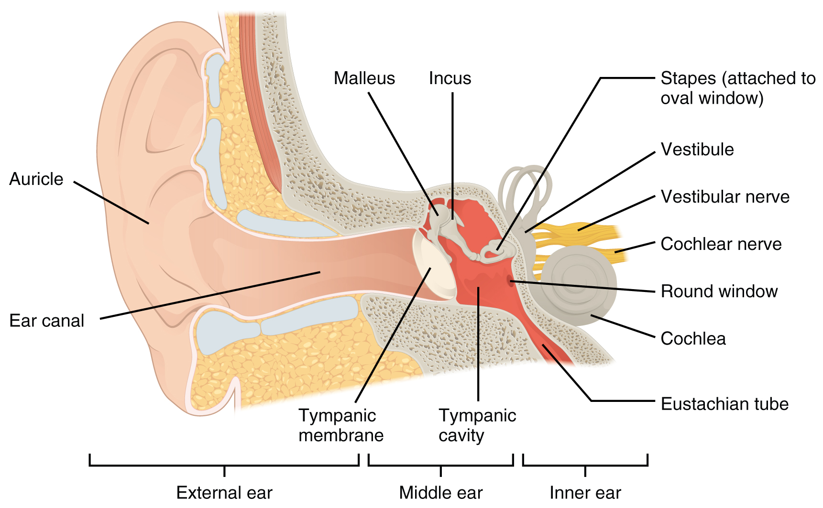
Source: http://museummonger.com/human-anatomy-ear/human-anatomy-ear/, (2014).

Hearing Loss Thresholds
Sound intensity is measured using the decibel (dB) scale. The threshold of hearing is defined as the minimum effective sound pressure of a signal that is capable of provoking an auditory sensation (Keith 2002). Normal hearing thresholds are between 0 and 19 dB. The severity of hearing loss is measured using variable thresholds. Hearing thresholds are recorded across specified frequencies, using air conduction pure tone signals. The Applicant advises that the more conservative and commonly used procedures are defined by the British Society of Audiology (BSA). In particular, this Application references the BSA recommendation that the pure-tone average (PTA4) should be calculated as the average of hearing sensitivity at 500, 1000, 2000, and 4000Hz. Hearing loss thresholds defined by the BSA calculated at PTA4 are classified as 0-19dB normal hearing; 20-40dB mild hearing loss; 41-70dB moderate hearing loss; 71-95dB severe hearing loss; and >95dB profound hearing loss. Australian Hearing, the largest provider of Government funded hearing services in Australia, refers to the thresholds described in Table 2. In December 2014, the Protocol Advisory Committee (PASC) noted that the differences between the two definitions’ thresholds for mild and moderate hearing loss were insignificant and within margins of error. Accordingly, this application relies on the BSA hearing thresholds.

Table 2: Types of Hearing loss
Interpretation | Hearing threshold (dB) Source: British Society of Audiology (BSA)
Normal hearing | 0-19
Mild hearing loss | 20-40
Moderate hearing loss | 41-70
Severe hearing loss | 71-95
Profound hearing loss | >95

Air-conduction vs bone-conduction thresholds

In air-conduction testing, a pure tone is presented via an earphone (or a loudspeaker). The signal travels through the air in the outer ear to the middle ear and then to the cochlea in the inner ear. In bone-conduction testing, instead of using an earphone, an electromechanical earphone is placed on the skull. This allows for stimulation of the cochlea via mechanical vibration of the skull with almost no stimulation of the outer and middle ear.
Normal hearing individuals typically have a hearing threshold level close to 0 dB for both air and bone conduction. Individuals with a hearing disorder of any part of the auditory pathway have poor air-conduction thresholds. Poor air-conduction threshold is the primary indication of conductive hearing loss, since abnormalities of the conduction mechanism have relatively little effect on bone-conduction measurements.
In conductive hearing loss the thresholds for both air conduction and bone conduction are affected such that the air-bone gap (air conduction minus bone conduction) should be at least 10 dB. The presence of an air-bone gap signifies conductive hearing loss. In sensorineural hearing loss, the air-bone gap is close to zero.

Types of Hearing Loss
The three types of hearing loss (CHL, MHL, SNHL) are caused by damage to the ear (Table 3; note SNHL is included for references purposes only).
Table 3: Causes of hearing loss
Hearing loss | Location of damage | Outer ear  cause | Middle ear  cause | Inner ear  cause
CHL | Sound conduction in outer ear, tympanic membrane or middle ear disrupted | Exostoses  Otitis externa  Stenosis  Wax impaction  Malformations (esp. Atresia) | Choleasteatoma or glomus tumour  Eustachian tube dysfunction  Ossicular chain discontinuity  Otitis media  Otosclerosis  Tympanic membrane perforation  Tympanosclerosis  Malformations (esp. Atresia) | NA
MHL | Damage as for both CHL and SNHL |  |  | Aging  Birth defects  Disease  Hereditary factors  Loud noise  Meniere’s disease  Otosclerosis Pharmaceuticals  Trauma  Tumors
SNHL | Damage to sensory cells or neural pathway disrupts conduct of sound to brain | NA | NA

Current Treatment Options for Hearing Loss
A range of interventions are used to address hearing loss (Table 4; SNHL included for reference purposes only):
- medical: such as pharmaceuticals to treat infection.
- surgical: such as ossicular chain reconstruction or use of typanostomy tubes.
- amplification: such as hearing aids or implanted devices.

Table 4: Treatment options for hearing loss
Hearing loss | Medical | Surgical | Amplification
 |  |  | Hearing aid | Hearing implant
CHL and MHL | Antibiotic eardrops  Oral antibiotics  Antifungal meds | Ossicular chain reconstruction  Mastoidectomy  Stapedectomy  Tympanostomy tubes | Hearing aid  Assistive devices | Bone conduction implant  Middle ear implant
SNHL |  | NA |  | Middle ear implant  Cochlear implant
(American Hearing Research Foundation, 2014)

Eligible Australians may obtain hearing aids through Australian Hearing. Surgical intervention is usually refractory to medical treatment. Amplification options depend upon the severity of hearing loss and whether the person has outer, middle and/or inner ear disease or malformations. Interventions and implant services are currently available on the MBS (Attachment A).
The proposed medical service is for individuals with a hearing loss, for whom further surgical intervention will not restore the hearing to a normal level and/or for whom hearing aid use is contraindicated by their ENT surgeon because of anatomy or chronic middle ear pathology. However, these individuals can still benefit from the amplification of sounds. These patients may have already had previous failed surgical intervention and be ineligible for alternative implants, thus MEI represents the last and only alternative for restoring hearing. These patients need to be aided but their hearing is not at a level which requires a cochlear implant.
The Applicant indicates that MEI implantation has been recognised as a new rehabilitation alternative for children and adolescents in a recent international consensus (Cremers 2010). Children are referred for hearing intervention as soon as possible, ideally right after birth. As of November 2008, the VSB has been implanted in more than 60 children and adolescents throughout the world with favourable results. This number is estimated for 2014 for more than 200 VSB implants in Children in 50 clinics. In June 2009, the VSB received approval for patients younger than 18 years of age in the European Union and all other countries accepting the CE marking.

Prevalence of Hearing Loss in Australia
The prevalence of hearing loss in Australia, solely based on audiograms, is approximately 22.2%. In adults, the most common type of hearing loss is SNHL at 20.2%. The prevalence of CHL is 0.4% and MHL is 1.6% (Table 5). More adult males than adult females have hearing loss (26% versus 18.4%) and males also have a higher prevalence of moderate and severe impairment. The prevalence of common outer ear conditions preventing the use of hearing aids, namely chronic otitis externa, ear canal stenosis/exostosis and cerumen removal was estimated to be 2.95% of the Australian population (687,922).

Table 5: Prevalence of hearing impairment²
- | ≧ 25dBHTL
Age yr | SNHL | CHL | MHL
15-50 | 4.0 (0.0-8.3) | 0.5 (0.2-0.7) | 0.8 (0.0-2.0)
51-60 | 25.5 (10.8-40.3) | 0.4 (0.0-1.1) | 2.4 (0.6-4.1)
61-70 | 55.5 (37.4-73.6) | 0.5 (0.0-1.2) | 2.7 (1.2-4.3)
>70 | 68.5 (41.3-95.7) | 0.0 | 5.0 (0.0-11.8)
Total | 20.2 (14.9-25.4) | 0.4 (0.1-0.7) | 1.6 (0.7-2.5)
Source: Wilson et al 1998
The Australian Hearing data for children suggest a prevalence of pre-lingual (0-4 years) hearing loss of 1.2/1,000 live births and of child acquired loss (4-14 years) as 3.2/1,000 live births (Burns, 2013). Children may be developing noise-induced hearing loss at increasing rates, possibly due to increased exposure to audio equipment and other noise making technology.
Conductive hearing loss in children may be caused by congenital conditions or chronic ear infections. One European study estimated that the incidence of conductive hearing loss caused by congenital atresia (narrowing or closure of the ear canal) is approximately one in 10,000 live births. Of individuals with congenital atresia, about 25% have this condition in both ears. It is recognised that in Aboriginal and Torres Strait Islander communities, children aged 0-14 experience a higher prevalence of:
- OM 4% compared to 2% for non-Indigenous children;
- complete or partial hearing loss or deafness (5%) compared to 1% for non-Indigenous children).

In children, the overall prevalence of hearing loss is around 0.25%. Around 37% of children have mild hearing loss, 38% have moderate hearing loss and 25% have severe to profound hearing loss (Access Economics, 2006). Congenital hearing loss accounts for around half of childhood hearing impairment. Congenital factors may include genetic causes such as Down Syndrome or Treacher Collins Syndrome or non-genetic causes such as maternal infections, premature birth or anoxia. Acquired hearing loss, which is caused by conditions such as ear infections, measles and meningitis, accounts for the other half.
Hearing loss in the Aboriginal community is very common. A systematic review of evidence commissioned by the Office of Aboriginal and Torres Strait Islander Health (OATSIH) reported that ear disease (particularly OM) and subsequent hearing loss were significant problems among Aboriginal communities. Data quality problems and differing prevalence rates across regions limit the extent to which the problem can be credibly reported. The prevalence of otitis media in children was reported to vary between 10% and 54%. By United Nations criteria, a prevalence exceeding 4% is considered to be a significant public health problem. Subsequent perforated ear drums were reported to be between 9% and 35% and as high as 95% in some studies. Otitis media was occurring in newborn children with two thirds of babies having one ear drum affected by six months of age. Rates of hearing loss were reported between 10%-41%. Hearing loss in comparative western populations was reported at between 5% and 7% (Access Economics, 2006).

Projected Uptake of Proposed Service
Based on data from Australia, the United Kingdom and Germany, the Applicant has calculated that 70-94 new patients each year with either CHL or MHL will also have a medical indication that prevents the use of a hearing aid. Of this group, approximately 57 will be patients with MHL and 37 will be patients with CHL.

Population
The Applicant has identified a specific population for whom the MEI is suitable. One cohort of this population is people with CHL who are unable to wear a hearing aid due to blockage or damage in the outer and/or middle ear. Patients with middle ear issues may be often considered for a surgical intervention. However for certain patients, middle ear reconstruction surgery fails or there is insufficient benefit achieved.

The population comprises people with CHL or MHL thresholds in the mild to moderate range, who cannot wear conventional hearing aids due to anatomical or medical reasons who meet the following criteria:

- unsuitable or unsuccessful alternative treatments (e.g. middle ear surgery, ear reconstruction surgery, anatomical anomalies, chronic pathologies, previous repeated failed middle ear surgeries etc.).
- mild to moderate hearing impairment as indicated by BSA AC thresholds (Table 2).
- pure-tone bone-conduction threshold levels at or within the levels depicted in Table 6 and Figure2.
- stable (less than 10 dB variations over two years for adults) bone conduction thresholds within the shaded area in Figure 2.
- speech audiometry curve adequate to the respective PTA.
- accessible round window or oval window and middle ear anatomy that allows the transducer to be placed on a suitable vibratory structure.
- absence of active middle ear infections.
- absence of retro-cochlear or central auditory disorders.
- speech perception discrimination of ≧65% correct with appropriately amplified sound.

Table 6: Bone conduction threshold levels for C/MHL indication for VSB
Frequency (kHz) | 0.5 | 1 | 1.5 | 2 | 3
Lower Limit (dB HL) | 0 | 0 | 0 | 0 | 0
Upper Limit (dB HL) | 45 | 50 | 55 | 65 | 65

Figure 2: CHL/MHL indication range (bone conduction) (VSB)
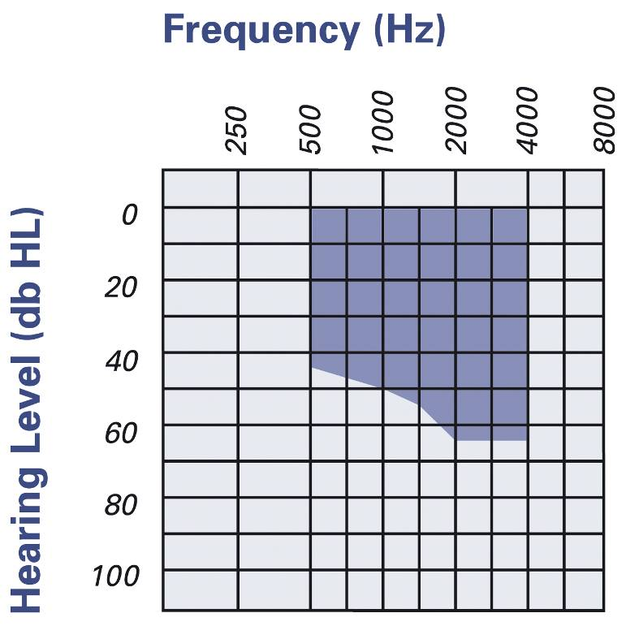

Intervention (proposed)

Partially implantable Middle Ear Device
This is a generic application. However, information relating to the operation of the MEI device is based on the Vibrant Soundbridge, as it is the only device available in Australia. The partially implantable MEI device comprises two components:
- an internal component that includes a magnet, an electronic housing and a transducer.
- an external audio processor containing the battery, microphone and digital signal processor.

Figure 3: Partially implantable Middle ear implant - placement for CHL and MHL
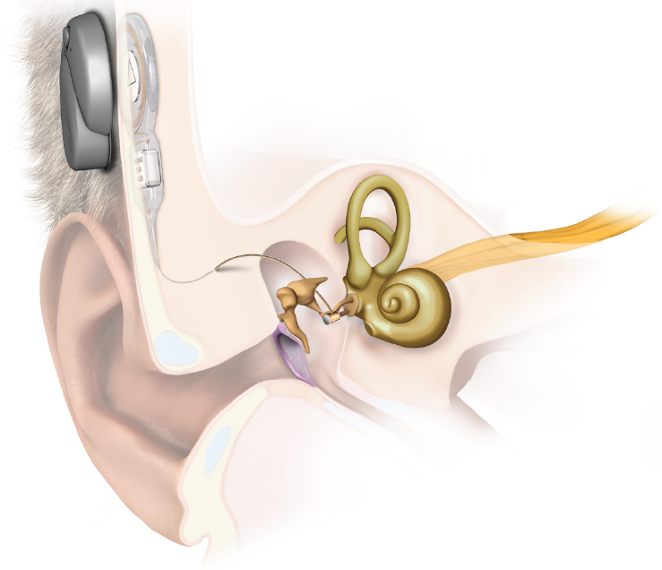
(Medel, 2014)
The signal from the audio processor is transmitted to the internal component and transformed into vibrations. The transducer which is called the Floating Mass Transducer (FMT) is attached to the round window membrane. Unless patients present with abnormal middle ear anatomy, in which devices will be placed on other middle ear structures. The amplified vibrations can be adjusted via an external auditory processor (AP) to suit different degrees of hearing losses. Battery life of the AP is 6 days. Patients can place new batteries in, or charge their existing batteries.

Medical Service
The MEI device is implanted in the middle ear during a vibroplasty (Med-EL, 28275 5.0). In a conventional approach to treat CHL and MHL the transducer is attached to the round window membrane (round window vibroplasty). However, if malformations of the external ear canal and/or middle ear are present, a modified approach may be employed using couplers. In the modified approach, the transducer is placed on the stapes footplate or oval window using a coupler for those with CHL or MHL where the stapes superstructure is absent (stapes or third window vibroplasty).

The surgery involves:
- an incision behind the ear in a posterior-superior direction.
- a full or partial mastoidectomy via the facial recess or the transmeatal route (depends on the medical status of the patient`s ear and surgeon preference).
- drilling a bone bed and tie-down holes for placing the implant, the transition to the transducer and the demodulator.
- accessing and visualising the middle ear by either posterior tympanotomy through the facial recess, or by lifting the tympanomeatal flap of the outer ear canal (depends on surgical approach used).
- fixing the implant, transducer and demodulator into the previously drilled bone-bed.
- placing the transducer on to the round window membrane (or other middle ear structures instead if patient has abnormal middle ear anatomy).
- placing the conductor link in the excavated mastoid.
- Closing the wound

Delivery of the medical service
The vibroplasty procedure used to insert the partially implanted MEI device is carried out by an otolaryngologist under general anaesthesia. It takes 1 to 2.5 hours not including preparation of the admitted patient. This anaesthetic and intravenous antibiotic is administered 30 minutes before surgery; at the same time the incision site is marked and the hair on the site is shaved. A facial nerve monitoring system may be used to prevent nerve trauma (Medtronic, 2013). The general anaesthetic is administered by an anaesthetist. Patients usually require an overnight stay. In exceptional circumstances, where a general anaesthetic cannot be tolerated, the service may be performed under a local anaesthetic. However, it is not the recommended approach for the majority of patients. Training in implanting the device is delivered by an expert otolaryngologist and supported by the device manufacturer. The implantation of the MEI device is a one-off intervention. The Applicant indicates a rare possibility of complications, which may include device failure and explantation of the device due to insufficient gain. The overall rate of revision surgery reported in the literature is 7 %. Only a small amount of these surgeries actually involve device explantation and re-implantation.

Co-administered and associated interventions
Prior to surgery, candidates for MEI implantation are assessed by an audiologist and have a consultation with the otolaryngologist, that includes a CT scan of the middle ear. Six to eight weeks after surgery, the audiologist will fit the speech processor, undertake initial programming and activate the device (outpatient consultation 45 minutes). The audiologist will conduct follow-ups (30 minutes) to adjust or re-program the audio processor about a month later and then as necessary. Adjustment or re-programming may require several follow up consultations to complete.

Current arrangements for public reimbursement
The cost of the device and implant procedure is not currently subsidised by the Commonwealth. However Australian Hearing may provide eligible clients with financial assistance for batteries, speech processor repairs and replacement parts. Private health insurers may make ex gratia payments to privately insured patients seeking assistance with the cost of the device. The device may also be funded under some state government programs to assist people with the cost of aids and appliances.

Comparator
In patients with mild to moderate CHL or MHL that cannot be corrected with hearing aids, surgical options may include implantable devices, such as bone conduction devices (BCI) with percutaneous or transcutaneous components, and MEI. The proposed intervention’s comparator relative to type and severity of hearing loss is described in Table 7 (Application).

Table 7: Comparator relative to type and severity of hearing loss
- | Severity of Hearing Loss
Indication | Mild | Moderate
Conductive hearing loss | MEI vs. Bone Conduction Implant (BCI)
Mixed hearing loss

Bone conduction implantable devices are approved for CHL, MHL and single-sided deafness (SSD) in cases where a conventional hearing aid is contraindicated. All current devices are semi-implantable and transmit sound to the cochlea via bone conduction, bypassing the impaired outer or middle ear. Traditionally, these systems took advantage of direct osseointegration using a titanium bone fixture and percutaneous abutment connected to an external sound processor. Several methods of transcutaneous transmission with the use of magnetic coupling between the processor and scalp have been more recently introduced.

There are a range of BCI devices on the market such as:
- Percutaneous BCIs: abutment connection - Cochlear BAHA 4 Connect, BAHA cordell II, BAHA divino, BAHA intenso, BAHA BP100, BAHA BP110, Oticon Ponto Pro, Oticon Ponto, Ponto Pro Power
- Transcutaneous BCIs: passive: Cochlear BAHA 4 Attract, Sophono Alpha 2
- Transcutaneous BCIs: active Med-El Bonebridge.

Table 8: Bone conduction devices
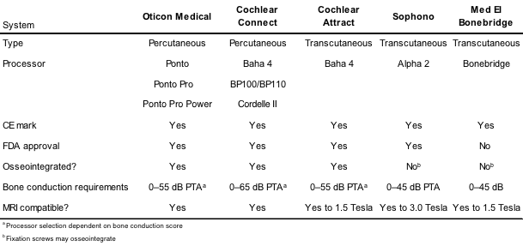

Attachment B lists the BCI devices registered on the Australian Register of Therapeutic Goods (ARTG) for use in Australia. These devices are also listed on the Prostheses List (PL). The minimum benefit available for each device/component is provided in the Attachment.

The indications for the treatment of CHL and MHL are (information from manufacturer’s websites):
- ≧ 5 years of age and bone conduction threshold PTA ≤45 dBHL or better for indicated ear measured at 500Hz, 1KHz, 2KHz, and 3 or 4KHz (Med-El Bonebridge, Oticon Ponto Systems (Ponto and Ponto Pro), Sophono Alpha 1, Cochlear BAHA 4 Attract and BAHA 4 Connect, BAHA BP100, BAHA Divino).
- ≧ 5 years of age and bone conduction threshold PTA ≤55 dBHL or better for indicated ear measured at 500Hz, 1KHz, 2KHz, and 4KHz (Oticon Ponto Pro Power, BAHA Intenso, BAHA Cordell).
- ≧ 5 years of age and Bone conduction threshold PTA ≤65 dBHL or better for indicated ear measured at 500Hz, 1KHz, 2KHz, and 4KHz (BAHA Cordell II).
- ≧ 18 years of age with moderate to severe HL, and who are candidates for stapes surgery (etiopathology of Otosclerosis) (Former DACS device (Direct Acoustic Cochlear Stimulation), Codacs or DACI device from Cochlear)
- and indicated middle ear implants

Percutaneous Bone-Anchored Hearing Implant
Percutaneous Bone-Anchored Hearing Implant systems (PBCI) are approved for SSD, CHL and MHL in cases where a conventional hearing aid is not appropriate. Air-bone gaps of ≥30 dB are recommended. The sensorineural component of the MHL can be up to 45–65 dB HL, depending on the manufacturer’s speech processor. Single-sided deafness applications require a normal contralateral ear boneline with Oticon specifying a hearing level of better than 20 dB HL. Contraindications include thin bone or poor bone quality, conditions that increase the likelihood of skin infections, or the inability to clean and maintain the abutment site. Currently, both Oticon Medical and Cochlear Ltd. produce PBCI called the Ponto and Baha, respectively. Percutaneous systems rely on osseointegration of the titanium implant with the skull to provide a clear signal to the cochlea.

Both PBCI systems consist of the following components:
- a titanium implant.
- an external/percutaneous abutment (or coupling) which at one end attaches to the titanium implant and at the other end protrudes through the skin.
- an external sound processor which attaches to the abutment.

The medical service to implant the PBCI involves:
- A linear or curved incision to expose pericranium (55-60 mm from the external canal at a 45 degree angle above horizontal). Newer abutments may use a dermal punch rather than an incision. Scalp thinning is minimised.
- A 3–4-mm-deep guide hole is drilled using a countersink burr to create a shallow lip to enable a flange to sit flush with the surrounding bone.
- A flange is screwed into the cranium and the abutment is secured to the flange.
- The wound is closed around the abutment (linear incision) or punch hole (off-axis incision).
- Gauze is placed around the abutment.
- A healing cap is attached to the abutment to prevent oedema which may lead to skin over-growing the abutment.
- The gauze pressure dressing is changed weekly for 2–3 weeks.
- The external processor is typically attached at 8–10 weeks to 3 months, depending on manufacturer.
In children, implantation is typically staged:
- For stage one, the flange is put into place with an internal cover screw, and the skin is closed for 3–6 months to allow osseointegration to occur. If a child has a thin calvarium or prior issues with osseointegration, a second ‘sleeper’ fixture may be implanted to allow for the possibility of a complication with the main implant.
- For stage two, the cover screw is removed and the permanent abutment affixed. Intraoperative fluoroscopy may be used to locate the internal fixture and can reduce the size of the incision required.

Complications associated with the PBCI device include skin reactions, infections, inflammation, skin growth over the abutment, failure to osseointegrate, shifting or extrusion of the implant or persistent pain Complications associated with the surgery to implant the device include: problems in securing the implant, CSF or blood leak, subdural hematoma, skin flap necrosis, wound dehiscence and pain from the implant

The area around the abutment where the implant attaches to the sound processor requires daily maintenance to reduce the risk of inflammation or infection.

Transcutaneous Bone Conduction Hearing Implant
Transcutaneous bone conduction systems can be divided into those that directly/active stimulate the bone versus those where the vibration is applied to the skin (passive stimulation). In active systems (Bonebridge, Med-EL) the implant generates vibrational stimulation that is directly applied to the bone (“direct drive bone conduction stimulation”). In passive systems (Cochlear BAHA 4 Attract, Sophono Alpha 2) the sound processor generates stimulation that is applied from outside onto the skin (like hearing glasses or BC-head-bands). Skin attenuates the sound before it reaches the bone.
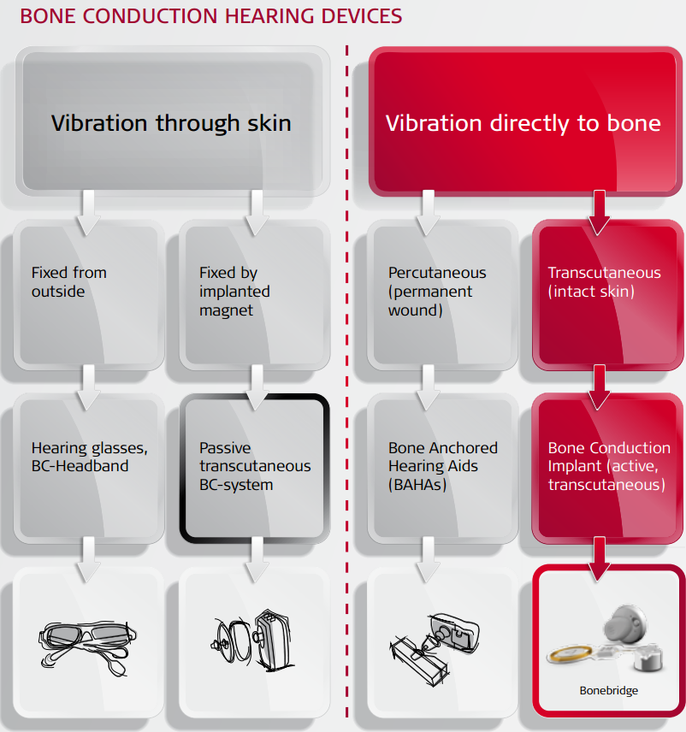
Figure 4: shows a comparison of bone conduction hearing devices (source: Med-El).

Passive Bone Conduction implants (PT-BCI)
The PT-BCI are indicated for adults and children >5 years who have CHL or MHL with bone conduction thresholds of ≥45 dBHL, and adults with SSD. These systems are available from two manufacturers, Sophono and Cochlear Ltd. With PT-BCIs the auditory signal is transmitted through the scalp via bone conduction but without percutaneous abutment. The Sophono system consists of an internal twin magnet fixed to the skull with standard plating screws and the Alpha 2 speech processor. The Cochlear Attract system consists of:
- An osseointegrating titanium flange fixture.
- A magnetic plate, coupled with a fixture under the skin.
- An external speech processor (Cochlear Baha 4 or Baha 3 Power) connected to an external spacer magnet (various strengths). The magnet is lined with a foam pad that distributes pressure evenly over the skin to avoid pressure sores).

The medical service to implant a PT-BCI involves:
- a linear (Sophono) or curvilinear incision (Sophono or Cochlear), including thinning of subcutaneous tissue if more than 6 mm thick.
- Placement of the device proximal to the percutaneous abutment, positioning it to sit flat to reduce postoperative pain.
- For the Sophono device, two vertically aligned wells are drilled for the magnets using device as a template (2 mm deep, 1 cm in diameter). Fix magnet into position with plating screws. Close and allow 6 weeks for reduction of oedema before fitting.
- For the Cochlear Attract device, a flange fixture is placed as described above. Assess clearance from the underlying bone to ensure the internal magnet will lie flat, preventing a pressure point at one edge. Attach the internal magnet and close.
- Patients with good bone quality may complete the surgery in one step. However, a two step procedure is required if a patient has compromised, soft or irradiated bone, bone thickness of <3 mm (children) or if other surgery, such as acoustic neuroma removal, is also performed (Oticon Medical M52058).

Table 9: Osseointegration medical service to implant BCI
One step procedure | Timing | Two step procedure | Timing
surgical procedure to place implant and abutment or magnet | - | surgical procedure to place implant and cover screw | -
aftercare (wound and remove sutures) | 1-2 week | aftercare (wound and remove sutures) | 1-2 weeks
fit sound processor (subject to soft tissue healing) | 4-12 weeks | osseointegration period | 3-6 months
audiologist assessment |  | surgical procedure to remove cover screw and place abutment or magnet
maintenance checks | 6-12 months | aftercare (wound) | 1-2 weeks
- | - | fit sound processor (subject to soft tissue healing) | 4 weeks
- | - | audiologist assessment
- | - | maintenance checks | 6-12 months

A one-stage procedure may be converted to a two-stage procedure intraoperatively if required.

Complications associated with the surgery to implant the PT-BCI device include:
- minor skin infections
- skin irritation/complications (may occur if magnet is too strong)
- Tinnitus
- headache
- vertigo

Active Bone Conduction implants (AT-BCI)
The Bonebridge (MED-EL) is the only AT-BCI available. It does not require osseointegration may be used to treat SSD, CHL or MHL where bone conduction thresholds are better than or equal to 45 dB. Patients must be assessed to ensure that their bone thickness and consistency will accommodate the internal device. This is determined by a preoperative CT scan. The Bonebridge is semi-implantable and consists of:
- an external audio processor (microphones, signal processor, battery, magnet).
- an internal device (internal receiver coil, magnet, Bone Conduction Floating Mass Transducer (BC-FMT)).

The medical service utilises components supplied by the manufacturer such as fixation screws, tools to measure the drilling depth, and to position the coil and BC-FMT. The BC-FMT is connected to the internal coil by means of a flexible component that can be bent up to 90° horizontally and 30° vertically depending on placement of the FMT. Placement is determined following the preoperative CT scan. Multiple surgical approaches are available; the decision on surgical approach is dependent on placement of the device which may be close to the mastoid or retrosigmoid. Providers are warned to avoid the dura mater or sigmoid sinuses. Complications associated with the surgery to implant the device include tinnutis, headache, vertigo and minor skin reactions

Fully Implantable MEIs
The Envoy Esteem (Envoy Medical) is indicated for adults ages 18 or over who have a stable bilateral moderate to severe SNHL. The surgical procedure for the placement of the battery and sound processor is similar to that for a cochlear implant. However, positioning the transducers is a more complex, multi-step process. As the indications for the Envoy Esteem are outside the patient parameters, this device is not an appropriate comparator for this application.
The Otologics Carina is indicated for adults with moderate to severe SNHL and is available in Europe for CHL and MHL (CE Mark). The surgical procedure to implant the Carina device begins in a manner similar to that of a cochlear implant procedure in that the approach is usually through the mastoid. However, the transducer is electromagnetic so the approach to placing it correctly may vary. In addition, the microphone and battery must be implanted behind the ear and secured to reduce movement (Flint teal, 2010). Given these differences the Otologics Carina may not be an appropriate comparator.

Partially Implantable MEIs

Direct Acoustic Cochlear Stimulator Partial Implant: Codacs/DACI
The Cochlear Ltd. Codacs/DACI (formerly DACS by Phonak Acoustic Implants) is a partially implantable device for people with moderate to severe MHL, who are candidates for stapes surgery (Otosclerosis). The DACS are no longer in production. Codacs has recently received the CE Mark for use in Europe. The Applicant advises that only one study including the device has been identified. The Codacs/DACI device consists of:
- external components including a modified Cochlear Nucleus Freedom sound processor and an RF coil
- internal components comprising a receiver coil, transducer, electronics and fixation system.

Surgical times for the implantation ranges from 0.5 to 2.5 hours, depending on surgical experience. The transducer is surgically placed behind the ear and the actuator is placed near the incus. The footplate of the stapes is removed, and a conventional prosthetic stapes is crimped onto the actuator with a ball joint, which is intended to improve device placement options. The surgeon has the option to include a second prostheses attached to the patients incus parallel to the first prosthetic. Complications include strange sound sensations, inferior sound quality, nausea, tinnitus, sensation at receiver site, deterioration of bone conduction thresholds facial palsy and feedback from the device.

Current MBS Services for the Comparator
The medical service associated with the implantation of BCI devices is an osseointegration procedure. There are currently two MBS items for osseointegration available for use with BCI devices (Table 10). MBS item 41603 may be claimed for the procedure to place the titanium implant. If the BCI device requires an abutment then MBS item 41604 may also be claimed, subject to the multiple operations rule. There are also a number of items for middle ear surgery. The number of services provided, and the total expenditure, is low.

Table 10: MBS Services for the Comparator
- |  | - | 2013-14
MBS Service and description |  | Schedule Fee | Services | MBS Benefits
41603 - 41604 | Osseointegration procedure—fixation of abutment or implantation of titanium fixture for use with implantable bone conduction hearing system device, in a specified patient group. | $186.50 to $503.85 | 375 | $72,217
41539-41542 | Ossicular chain reconstruction | $1089.90 to $1194.25 | 241 | $191,618
41545 to 41564 | Mastoidectomy | $521.25 to $1876.95 depends on complexity | 1013 | $953,267
45794 to 45797 | Osseointegration procedure – placement of TORP/PORP for ossicular reconstruction surgery. | $186.50 to $503.85 | 67 | $9066
(Commonwealth of Australia, 2014)

Regulatory status
The VSB is the sole partially implantable MEI available for the treatment of CHL or MHL that is listed on the Australian Register of Therapeutic Goods (ARTG).

Table 11: MEI components listed on the ARTG
ARTG | Product | Indication
170179 | Amade audio processor | External sound processor
161702 | Vibrating ossicular prosthesis 502X | Internal, crimped to vibratory structure of middle ear
185533 | Vibroplasty coupler | Internal, couples transducer to vibratory structure of middle ear.
(Commonwealth of Australia, 2014)

Proposed Listing and Options for MSAC Consideration
Table 12 shows the proposed MBS listing. It should be noted that the proposed MBS Scheduled fee for the vibroplasty required to position the MEI is considerable higher than the fee for the osseointegration procedure required to position the BCI.

Table 12: Proposed MBS item descriptor
Category 3 – Therapeutic Procedures
MBS [item number]
Middle ear implant, partially implantable, insertion of, including mastoidectomy, for patients with conductive or mixed hearing loss who meet all the criteria listed below:
- ear pathology that prevents the use of a conventional hearing aid
- unsuited or unsuccessful to alternative treatments (e.g. middle ear surgery, ear reconstruction surgery, or due to anatomical anomalies, chronic pathologies, or previous repeated failed middle ear surgeries etc.).
- mild to moderate hearing impairment as indicated by BSA air-conduction thresholds
- stable (less than 10 dB variations over two years for adults), pure-tone bone-conduction threshold levels
- speech audiometry curve adequate to the respective PTA
- accessible round window or oval window and anatomy that allows the transducer to be placed on a suitable vibratory structure
- absence of active middle ear infections
- absence of retro-cochlear or central auditory disorders
- speech perception discrimination of ≧65% correct with appropriately amplified sound
- Adequate motivation and expectations
(Anaes)
Fee: $1,876.59 (based on mastoidectomy item)

A separate listing is proposed for explantation and revision surgery for MEI. This is the same revision item proposed for Application 1365.

Table 13: Proposed MBS item descriptor for or explantation surgery
Category 3 – Therapeutic Procedures
MBS [item number]
Middle ear implant, partially implantable, revision or explantation of. (Anaes)
Fee: $TBA.

Clinical place for proposed intervention
The clinical management algorithm proposed by the applicant is shown in Figure 5.

Figure 5: Clinical algorithm – Partially implantable MEI for CHL and MHL

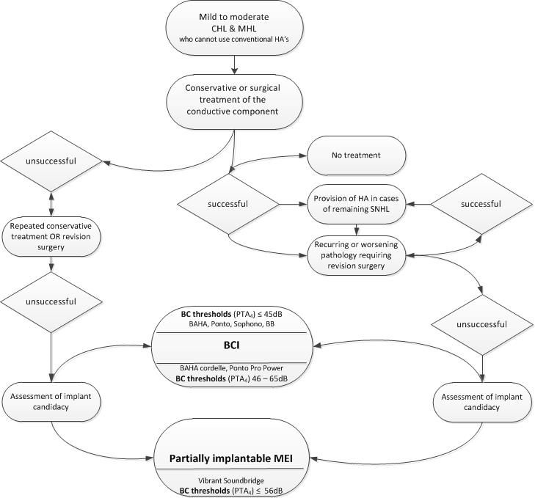

Clinical claim
The clinical claim is superior effectiveness, specifically in sound localization/binaural hearing performance (compared to BCI) and non-inferior safety (compared to BCI), but MEI may be easier to maintain as it does not require permanent daily care of the implant site. The Applicant has indicated that the MEI is superior in terms of cosmetics, comfort, safety and performance.

In terms of effectiveness compared to the BCI, the Applicant claims that the potential amplification range of the MEI is significantly greater and provides better directionality, localization of sound and spatial hearing outcomes. Unlike BCI, the device only stimulates the ear that is implanted which allows for true binaural hearing. The single point attachment of the MEI means it can function independent from skull growth making it more suitable for implantation in children.

For patients who have undergone previous middle surgeries, the Applicant asserts that MEI provides the best hearing solution as it stimulates the cochlea directly and outperforms acoustic devices in cases with an air bone gap >30dB. The hearing benefit provided by the MEI can be achieved even where a middle ear condition exists. Performance is not influenced by reoccurring pathologies such as otitis media or cholesteatoma. The Applicant claims that the MEI can significantly enhance hearing and provide better quality of life to patients for whom other treatments have been unsuccessful.

The Applicant claims that the MEI does not result in greater medical or surgical complication rates compared to other types of routine middle ear surgery. Compared to the BCI, the MEI avoids safety issues such as osseointegration failure in children and complications such as skin infections, regrowth, abutment losses and revision surgeries. The MEI may be easier to maintain as it does not require permanent daily care of the implant site.

Table 14: Classification of an intervention for determination of economic evaluation to be presented
- |  | Comparative effectiveness versus comparator
 |  | Superior |  | Non-inferior | Inferior
Comparative safety versus comparator | Superior | CEA/CUA |  | CEA/CUA | Net clinical benefit | CEA/CUA
 |  |  |  |  | Neutral benefit | CEA/CUA*
 |  |  |  |  | Net harms | None^
 | Non-inferior | CEA/CUA |  | CEA/CUA* | None^
 | Inferior | Net clinical benefit | CEA/CUA | None^ | None^
 |  | Neutral benefit | CEA/CUA*
 |  | Net harms | None^
Abbreviations: CEA = cost-effectiveness analysis; CUA = cost-utility analysis
* May be reduced to cost-minimisation analysis. Cost-minimisation analysis should only be presented when the proposed service has been indisputably demonstrated to be no worse than its main comparator(s) in terms of both effectiveness and safety, so the difference between the service and the appropriate comparator can be reduced to a comparison of costs. In most cases, there will be some uncertainty around such a conclusion (i.e., the conclusion is often not indisputable). Therefore, when an assessment concludes that an intervention was no worse than a comparator, an assessment of the uncertainty around this conclusion should be provided by presentation of cost-effectiveness and/or cost-utility analyses.
^ No economic evaluation needs to be presented; MSAC is unlikely to recommend government subsidy of this intervention

Outcomes and health care resources affected by proposed intervention

Outcomes
The proposed outcome measures for MEI versus the comparator for effectiveness are:
- Abbreviated Profile of Hearing Aid Benefit
- Client-orientated scale of improvement
- Functional gain
- Speech recognition
- Sound-field assessment
- Sound localization testing
- Speech comprehension scores
- Self-assessment scales
- Patient preference
- Absence of clinical management, maintenance and replacement costs associated with external abutments

The proposed outcome measures for MEI versus the comparator for safety are:
- Complication rate and adverse events
- Infection
- Taste disturbance
- Fibrosis
- Aural fullness
- Acoustic trauma
- Dizziness
- Damage to the middle ear
- Revision surgery, explant rate, device failure
- Mortality

Health care resources
The health care resources required for MEI, as proposed by the applicant, are shown in Table 15.

Table 15: List of resources to be considered in the economic analysis
- | Provider of resource | Setting in which resource is provided | Proportion of patients receiving resource | Number of units of resource per relevant time horizon per patient receiving resource | Disaggregated unit cost
 |  |  |  |  | MBS | Safety nets* | Other govt budget | Private health insurer | Patient | Total cost
Resources provided to identify eligible population
Resources provided to deliver proposed intervention
Prosthesis | Public/  PHI fund | Hospital |  | 1.0 |  |  |  | 13,970 |  | 13,970
Pre-assessment audiogram  MBS 82315 (11327) | Audiologist  (ENT) | Outpatient |  | 1.0 | 33.45 (41.85)
Impedance audiogram  MBS 82327 (11327) | Audiologist  (ENT) | Outpatient |  | 1.0 | 13.45 (16.80)
CT scanning  MBS 56016 | MBS | Outpatient |  | 1.0 | 246.50
ENT consultation  MBS 104 | MBS | Outpatient |  | 1.0 | 72.75
Anaesthesia prep  MBS17610 | Anaesthetist | Hospital |  | 1.0 | 32.25
Anaesthesia  MBS 20120 | Anaesthetist | Hospital |  | 1.0 | 74.25
Facial stem monitoring  MBS 11015 | ENT | Hospital |  | 1.0 | 112.45
Implant procedure Proposed fee based on mastoidectomy item | ENT | Hospital |  | 1.0 | 1876.59
Surgical assistant  MBS 51303 |  |  |  |  | 375.92
Hospital stay |  | Hospital |  |  |  |  |  |  |  | TBA
Post-op audiometry  MBS 82300 (11300) | Audiologist  / ENT | Outpatient |  | 1.0 | 130.90  (163.60)
Resources provided in association with proposed intervention
Follow-up ENT consult  MBS 105 | ENT | Outpatient |  |  | 36.55
Fitting of processor  MBS 10952 | Audiologist | Outpatient |  | 1.0 | 52.95
Follow-up audiometry  MBS 82300 (11300) | Audiologist  (ENT) | Outpatient |  | 1.0 | 130.90  (163.60)
Battery cost |  | Outpatient
* Include costs relating to both the standard and extended safety net.

Proposed structure of economic evaluation (decision-analytic)
The PICO for comparison of MEI versus the comparators is shown in Table 15.

Table 16: Summary of extended PICO to define research question that assessment will investigate
Population | Intervention | Comparator | Outcomes to be assessed
People with CHL or MHL thresholds in the mild to moderate range, who meet all of the following criteria:  - outer ear pathology that prevents the use of conventional hearing aids.  - unsuited for, or has failed, alternative treatments such as ear reconstruction surgery.  - speech audiometry curve adequate to the respective PTA.  - anatomy that allows the transducer to be placed on a suitable vibratory structure.  - accessible round window or oval window.  - absence of active middle ear infections.  - absence of retro-cochlear or central auditory disorders.  - speech perception discrimination of ≧65% correct with appropriately amplified sound. | Partially implantable middle ear implant | Bone conduction implant | Effectiveness  Abbreviated Profile of Hearing Aid Benefit  Client-orientated scale of  improvement  Functional gain  Speech recognition  Sound-field assessment  Sound localization testing  Speech comprehension scores  Self-assessment scales  Patient preference  Absence of clinical management, maintenance and replacement costs associated with external abutments  Safety  Complication rate  Adverse events  Infection  Taste disturbance  Fibrosis  Aural fullness  Acoustic trauma  Dizziness  Damage to the middle ear  Revision surgery  Explant rate  Device failure  Mortality

Clinical Question
Is vibroplasty to implant an MEI safe, effective and cost effective for patients with CHL and MHL who meet all the criteria set out in Table 16?

Attachment A
Current MBS Items by Medical Service, Hearing Loss Type and Hearing Loss Cause
MBS item | Descriptor | Medical Service | Hearing loss type | Hearing loss cause
41527 | Myringoplasty, trans-canal approach (Rosen incision) | Procedure using a skin graft to repair a perforated in tympanic membrane (eardrum). May include drain fluid from middle ear and insertion of typanostomy tube. | CHL | Severe ear infection or otitis media Perforation of tympanic membrane and intermittent discharge.
41539 | Ossicular chain reconstruction | Ossiculoplasty to repair or reconstruct middle ear and restore function. May include:  - total ossicular replacement prosthesis (TORP)  - partial ossicular replacement prosthesis (PORP)  - tympanoplasty (repair of tympanic membrane)  - stapedectomy or stapedotomy (partial or full replacement of stapes, for patients with otosclerosis or congenital malformation). | CHL (moderate to severe) | Trauma, neoplasms, inflammatory processes and/or cholesteatoma. Discontinuity of ossicular chain caused by eroded incudostapedial joint, absent incus, or absent incus and stapes superstructure. Fixation of ossicular chain caused by malleus head ankylosis or ossicular tympanosclerosis.
41542 | Ossicular chain reconstruction and myringoplasty
41545 | Mastoidectomy (cortical) | The mastoidectomy procedure varies according to extent of infection:  - simple: mastoid bone is exposed, infected air cells removed, incision in eardrum to drain middle ear.  - radical: tympanic membrane and most middle ear structures are removed, Eustachian tube is closed. Stapes usually retained.  - modified radical: retains ossicles. Tympanic membrane is reconstructed by tympanoplasty.  - complete (canal wall up): removal of mastoid air cells, tegmen, sigmoid sinus, presigmoid dural plate, posterior wall of external auditory canal. Posterior wall of external auditory canal is retained.  - canal wall down: complete mastoidectomy plus removal of posterior and superior osseous external auditory canal. Tympanic membrane reconstructed to separate the middle ear and mastoid cavity and ear canal.  With or without myringoplasty and/or ossiculoplasty. | CHL (moderate to severe) | Ear infections such as otitis media (chronic or acute) or mastoiditis.  Cholesteatoma.  Complications such as intra-temporal or intracranial suppuration, abscess formation, lateral venous sinus thrombosis.  Failure to respond to IV antibiotics.  Lateral skull base neoplasms.
41548 | Obliteration of the mastoid cavity
41551 | Mastoidectomy, intact wall technique, with myringoplasty
41554 | Mastoidectomy, intact wall technique, with myringoplasty and ossicular chain reconstruction
41557 | Mastoidectomy (radical or modified radical)
41560 | Mastoidectomy (radical or modified radical) and myringoplasty
41563 | Mastoidectomy (radical or modified radical), myringoplasty and ossicular chain reconstruction
41564 | Mastoidectomy (radical or modified radical), obliterate mastoid cavity, blind sac closure of external auditory canal and obliterate Eustachian tube
41566 | Revision of mastoidectomy (radical, modified radical or intact wall), including myringoplasty
41603 | Osseo-integration procedure, implantation of titanium fixture for use with implantable bone conduction hearing system device, in patients: with permanent or long term hearing loss; and unable to use conventional air or bone conduction hearing aid for medical or audiological reasons; and with bone conduction thresholds that accord to recognised criteria for the hearing device being inserted. Not associated with items 41554, 45794 or 45797 | Procedure for implantation of bone conduction implants (BCI). A titanium plate is anchored to the skull and attached to an external hearing aid. External device captures sound and transforms it into vibratory signals which are transmitted to the implanted plate and associated bone and conveyed to the brain. | CHL (with ≧ moderate hearing in better ear)  MHL with bone conduction thresholds ≦45 dB  Single sided deafness (severe to profound unilateral SNHL) with bone conduction threshold ≦45dB | Canal or middle ear malformation  Infection resulting in chronic draining ears  Chronic otitis media  Congenital atresia  Cholesteatoma  Middle ear dysfunction or disease  Sudden hearing loss  Acoustic neuroma  Meniere’s disease
41604 | Osseo-integration procedure, fixation of transcutaneous abutment implantation of titanium fixture for use with implantable bone conduction hearing system device, in patients (as for 41603).
41608 | Stapedectomy | Procedure to partially or fully replace stapes. Diseased part of stapes footplate is removed and replaced with a prosthesis which is attached to incus restoring continuity of ossicular movement. This enables sound to be transmitted from eardrum to inner ear. May be part of ossiculoplasty (repair or reconstruction of middle ear). | CHL with air bone gap of ≧30dB | Otosclerosis  Congenital malformation of stapes  Severe middle ear infections  Previous middle ear surgery
41611 | Stapes mobilisation | Procedure to remobilise stapes footplate.
41614 | Round window surgery including repair of cochleotomy | Procedures may be used to:  - correct a defect in round or oval window (or both) to prevent perilymph fistula (PLF) from leaking from inner ear to middle ear. Using trans-canal approach, small soft tissue grafts are used to patch fistula.  - correct superior canal dehiscence syndrome by reinforcing the round and oval windows fascia from a post-auricular incision. | CHL  MHL  SNHL | Otosclerosis  Trauma (head or ear)  Perforated eardrum  Ear block (plane descent or scuba diving)  Rapid increase in cranial pressure  Superior canal dehiscence syndrome
41615 | Oval window surgery including repair of fistula, not being a service associated with a service to which any other item in this Group applies.
41617 | Cochlear implant, insertion of, including mastoidectomy | Procedure to implant CI device which bypasses damaged inner ear and directly stimulates the auditory nerve. External component captures sound and transforms it into electromagnetic signal. Signal is conveyed to implant located behind auricle and changed into vibration which is conveyed to cochlea stimulating auditory nerve. | Adult – bilateral severe-profound SNHL  Children:  2-17 yr: severe-profound SNHL  12-24 mth: profound SNHL | Damaged hair cells in the cochlear (inner ear) and/or nerve to brain
41632 | Middle ear, insertion of tube for DRAINAGE OF (including myringotomy) | Procedure to insert a tube to drain fluid from middle ear in peoples with severe ear infection or otitis media with effusion. With or without myringotomy to enable release of fluid from middle ear. | CHL | Otitis media with effusion.  Cholesteatomas from severe infection, perforated eardrum, chronic middle ear problems or congenital issues.
41635 | Clearance of middle ear for granuloma, cholesteatoma and polyp, 1 or more, with or without myringoplasty | Procedure to remove granuloma, cholesteatomas and polyps from middle ear. May be performed with:  - myringoplasty (skin graft to repair perforated tympanic membrane).  - insertion of typanostomy tube.  - ossiculoplasty (41638).
41638 | Clearance of middle ear for granuloma, cholesteatoma and polyp, 1 or more, with or without myringoplasty with ossicular chain reconstruction
45794 | Osseo-integration procedure - extra-oral, implantation of titanium fixture, not for implantable bone conduction hearing system device | Placement of titanium prostheses as part of a TORP or PORP procedure to repair or reconstruct the middle ear (ossicular chain reconstruction).  Reconstruction of the external ear with osseo-integrated prostheses. Auricular deficit or absence may or may not be associated with hearing loss. | CHL (moderate-severe)  severe MHL | Discontinuity or fixation of ossicular chain, trauma, neoplasm, inflammatory processes, cholesteatoma.  Auricular deficit due to aplasia, auricle avulsion or amputation injuries, blunt trauma, burns, composite defect, frost bite, lacerations, superficial defects.
45797 | Osseo-integration procedure, fixation of transcutaneous abutment, not for implantable bone conduction hearing system device

Attachment B
ARTG Listing for Comparator Devices
 |  |  |  | Prostheses List
Sponsor | ARTG | Product Name | Description | Bill Code | Min Benefit
Cochlear | 123987 | Baha Cordelle sound processor | Sound processor (body worn) | CO033 | $6,000
 |  | Baha Divino sound processor | HW digital sound processor | CO040 | $6,000
 |  | Baha Intenso sound processor | HW digital sound processor | CO041 | $6,000
 |  | Baha BP100 sound processor | FPHW sound processor | CO047 | $6,500
 |  | Baha BP110 sound processor | FPHW sound processor | CO056 | $6,500
 |  | Baha 4 sound processor | FPHW digital sound processor, wireless | CO073 | $6,500
 | 123984 | Baha Abutment Snap Coupling | Titanium abutment, screw & holder | CO025 | $895
 |  | Baha BA210 abutment | Titanium abutments | CO050 | $895
 |  | Baha BIA400 Implant with abutment | Titanium implant & abutment | CO063 | $2,197
 |  | Baha BA300 abutment | Titanium abutment. | CO052 | $936
 |  | Baha BIA300 implant with abutment | Implant & premounted abutment | CO053 | $2,017
 |  | Baha BI300 Implant | Titanium implant | CO051 | $1,082
 |  | Baha BA400 DermaLock abutment | Titanium abutment | CO062 | $1,115
 |  | Baha BIM400 Implant Magnet | Implantable magnet | CO068 | $895
 |  | BAHA Cover screw unigrip | Titanium cover screws | CO028 | $142
 |  | Baha Cover Screw conical | Titanium cover screw | CO054 | $142
 |  | Flange fixture with abutment | Flange with premounted abutment | CO032 | $1,930
Fusion Healthcare | 191931 | Sophono Alpha Bone Conduction Hearing System, Sound Processor | Sound Processor | FH001 | $6,500
 |  | Sophono Alpha Bone Conduction Hearing System, Implant | Implant | FH002 | $1,930
Med-El Implant Systems Aust | 203302 | Bonebridge Amadé BB audio processor | Sound processor (magnetic) | US002 | $6,500
 | 203243 | Bonebridge Bone Conduction Implant Kit | Magnet, receiver coil, demodulator bendable transition to FMT & FMT | US001 | $1,930
 | 203243, 203280 | Bonebridge Cortical screws (Bonebridge Surgical Tool Kit) | Titanium cortex screws | US003 | $142.00
Oticon Australia | 198759 | Ponto Implant | Bone anchored implant | OI024 | $1,035
 | 198860 | Ponto Sound Processor | FPHW sound processor | OI023 | $6,500
 |  | Ponto Pro Sound Processor | FPHW sound processor | OI029 | $6 ,500
 | 198759 | Ponto Abutment | Abutment and connection screw | OI025 | $895.00
 |  | Ponto Abutment and Implant | Implant, abutment and connection screw | OI026 | $1,930
 |  | Ponto Cover Screw | Cover screw | OI028 | $142.00
 | 198868 | Ponto Healing Cap | Cover screw | OI027 | $142.00

References

Access Economics (2006). Listen Hear! The economic impact and cost of hearing loss in Australia.

American Hearing Research Foundation, http://americanhearing.org, accessed October 2014.

asha.com, accessed 30 September 2014.

Australian Bureau of Statistics. 4829.0.55.001 - Health of Children in Australia: A Snapshot, 2004-05

Australian Hearing, http://www.hearing.com.au, accessed July 2014.

Australian Institute of Health and Welfare (2011). The health and welfare of Australia’s Aboriginal and Torres Strait Islander people, an overview 2011. Cat. no. IHW 42. Canberra: AIHW.

British Society of Audiology

Burns J, Thomson N (2013) Review of ear health and hearing among Indigenous Australians. Retrieved [access date] from http://www.healthinfonet.ecu.edu.au/other-health-conditions/ear/reviews/our-review

Cochlear Australia (2014). http://www.cochlear.com/wps/wcm/connect/au/home, accessed September 2014.

Cremers CWRJ, et al., 'International consensus on Vibrant Soundbridge implantation in children and adolescents', Int. J. Pediatr. Otorhinolaryngol. (2010), doi:10.1016/j.ijporl.2010.07.028

Flint PW, Haughey BH, Lund VJ, Niparko JK, Richardson MA., (eds). (2010). Cummings Otolaryngology-Head and Neck Surgery. 5th ed., Mosby Inc. URL: /books/linkTo?type=bookPage&isbn=978-0-323-05283-2&eid=4-u1.0-B978-0-323-05283-2..00220-2 Accessed online 29 November 2014.

http://museummonger.com/human-anatomy-ear/human-anatomy-ear/, 2014.

Keith RW; Clinical Tests. In: Seiden AM et al (eds) (2002). Otolaryngology: The Essentials. New York: Thieme, 2002, pp. 13-27.

Kesser BW and Friedman RA; Functional disorders. In: Seiden AM et al (eds). (2002). Otolaryngology: The Essentials. New York: Thieme, pp. 33-38.

Kozlowski, K, Friedland DR, 'Implantable Hearing Devices', Curr Surg Rep, 2(59), 2014

Kulkarni K and Hartley DEH, 2008. ‘Recent advances in hearing restoration’, Journal of the Royal Society of Medicine, 2008: 101, 116-124.

Med-EL 28275 5.0 Information for Surgeons for Incus and Round Window Vibroplasty, accessed October 2014.

NIM Response-2 (2013). Medtronic Xomed Inc., Jacksonville, Fla., USA accessed December 2014.

Oticon Medical. Surgical Manual M52058. http://www.oticon.com, accessed October 2014.

Perera C, Thavaneswaran P, Lee I, Church J (2010) Middle ear implant for sensorineural, conductive and mixed hearing losses Assessment Report for Medical Services Advisory Committee Application 1137. Commonwealth of Australia.
Seiden AM et al (eds) (2002). Otolaryngology: The Essentials. New York: Thieme.
Wilson D, Walsh PG, Sanchez L, Read P. Hearing impairment in an Australian population. 1998 Centre for Population Studies in Epidemiology, South Australian Department of Human Services.

www.medel.com/image-gallery/?versioncode=755452a54b&, accessed October 2014.

Hearing threshold is ≧25dBHTL in the worse ear. The worse ear is generally used to measure prevalence, while the better ear is used to measure disability.

