Application 1453:
PD-L1 (Programmed Death-1 Ligand) immunohistochemistry testing for access to pembrolizumab for patients with unresectable metastatic mesothelioma.

PICO Confirmation
(to guide a new application to MSAC)

December 2016

Summary of PICO/PPICO criteria to define the question(s) to be addressed in an Assessment Report to the Medical Services Advisory Committee (MSAC)
The PICO criteria have been outlined separately for first and subsequent-line treatments. The outcomes assessed would be the same, and have not been duplicated. Suggestions made by the Health Technology Assessment Group, which are not based on the application have been italicised. Although the additional intervention (no testing and non-selective treatment with pembrolizumab) does not include a testing component and therefore does not need to be assessed by the MSAC, it has been added here, as it can strengthen the argument regarding the optimal combination of testing and treatment.
Table 1 Summary of the population, prior tests, intervention and comparator components of the PICO
Component | Description of population 1 | Description of population 2
Patients | Patients diagnosed with unresectable mesothelioma who have failed prior therapyª (second or subsequent-line therapy) | Patients diagnosed with unresectable mesothelioma in whom standard of care is not appropriate (first-line)
Prior tests | Confirmation of unresectable mesothelioma diagnosis through biopsy and subsequent histology, cytology and IHC testing for standard markers. | Confirmation of unresectable mesothelioma diagnosis through biopsy and subsequent histology, cytology and IHC testing for standard markers.
Intervention | a. PD-L1 (programmed cell death – ligand 1) testing and targeted treatment with pembrolizumab in those who express PD-L1, and vinorelbine, pemetrexed monotherapy, platinum doublet or best supportive care in those who do not express PD-L1.  b. No testing. Non-selective treatment with pembrolizumab. | a. PD-L1 (programmed cell death – ligand 1) testing and targeted treatment with pembrolizumab in those who express PD-L1, and second-line therapy options of vinorelbine, pemetrexed monotherapy, platinum doublet or best supportive care in those who do not express PD-L1.  b. No testing. Non-selective treatment with pembrolizumab.
Comparator | No testing and vinorelbine, pemetrexed monotherapy, platinum doublet or best supportive care. | No testing and second-line options of vinorelbine, pemetrexed monotherapy or platinum doublet or best supportive care.
Reference standard | None available | None available
ª Prior therapies excludes surgery or radiation, but includes cistplatin (or carboplatin) + pemetrexed, and should be likely to be beneficial (may be more clearly defined by the inclusion criteria of the relevant clinical trials); failure of therapy refers to failure of response or development of intolerance to therapy
Table 2 Summary of the outcomes component of the PICO
Component | Description
Outcomes | Outcomes relevant to the assessment include:  Safety  - Physical harms from testing  - Adverse events related to a change in treatment associated with testing  Clinical effectiveness associated with the test  Direct evidence  - Primary outcomes – progression-free survival, overall survival, quality of life  - Secondary outcomes – overall response rate, duration of response  Linked evidence  - Analytic validity, reproducibility (note that there is no reference standard so diagnostic accuracy cannot be measured)  - Prognostic value of PD-L1 testing  - Predictive value of PD-L1 testing  - Change in management  - Impact of change in management (treatment effectiveness in the identified population – health outcomes as per direct evidence of effectiveness)  Cost-effectiveness
ECOG PS = European Cooperative Oncology Group; IHC = immunohistochemistry; PD-L1 = programmed cell death ligand 1
Research questions for safety, direct effectiveness and cost-effectiveness
- What is the safety, effectiveness and cost-effectiveness of PD-L1 testing for access to pembrolizumab compared to no PD-L1 testing treatment with vinorelbine, pemetrexed monotherapy, platinum doublet or best supportive care, for patients with unresectable mesothelioma, in whom first-line standard of care treatment has failed?
- What is the safety, effectiveness and cost-effectiveness of non-selective pembrolizumab treatment compared to vinorelbine, pemetrexed monotherapy, platinum doublet or no treatment, for patients with unresectable mesothelioma, in whom first-line standard of care treatment has failed?
- What is the safety, effectiveness and cost-effectiveness of PD-L1 testing for access to pembrolizumab compared to no PD-L1 testing and best supportive care or second-line treatment options for patients with unresectable mesothelioma, in whom first-line standard of care treatment is not appropriate?
- What is the safety, effectiveness and cost-effectiveness of non-selective pembrolizumab treatment compared to best supportive care or second-line treatment options for patients with unresectable mesothelioma, in whom first-line standard of care treatment is not appropriate?

Research questions for linked evidence
- What is the analytical validity and reproducibility of PD-L1 testing in patients with unresectable mesothelioma in whom treatment with first-line standard of care is not appropriate or has failed?
- Is PD-L1 testing able to predict the prognosis of patients with unresectable mesothelioma in whom treatment with first-line standard of care is not appropriate or has failed, irrespective of treatment received? (i.e. does it have prognostic value?).
- Does PD-L1 expression predict which patients are going to respond to pembrolizumab, compared to best supportive care or treatment with vinorelbine, pemetrexed monotherapy, platinum doublet, in whom treatment with first-line standard of care is not appropriate or has failed? (i.e. does it have predictive value?)
  - Is there a treatment effect modification (i.e. interaction) as a consequence of biomarker status?
- Does expression of PD-L1 impact the treatment which patients receive, in those with unresectable mesothelioma, in whom first-line standard of care treatment is not appropriate or has failed? (i.e. does it change management?)
- Does treatment with pembrolizumab lead to better health outcomes in patients with unresectable mesothelioma in whom treatment with first-line standard of care is not appropriate or has failed, who express PD-L1 compared with and best supportive care, or treatment with vinorelbine, pemetrexed monotherapy, platinum doublet?

PICO rationale

Population
Mesothelioma is a rare but aggressive cancer that is usually evident 20 to 40 years after exposure. It is caused by exposure to asbestos fibre and has been diagnosed in increasing numbers since 1982, when national data first became available, until its peak in 2011 when 690 new cases were diagnosed. The majority of patients have the pleural form of the disease (93% of cases since 1982) and the peritoneal form accounts for 6% of cases (AIHW 2015). Patients are usually diagnosed with the disease in its advanced forms and there is little effective treatment available, once surgery is not an option.
Recent discovery of the over-expression of the programmed death (PD) ligands (PD-L1 and L2) on the surface of tumour cells has led to the analysis of these markers in mesothelioma tissue. PD-1 is a transmembrane receptor protein expressed on T cells which binds to the paired ligand on the surface of tumour cells, triggering a process whereby T cells are inactivated, and preventing the normal pathway of apoptosis in the tumour cell.
PD-L1 has been found expressed in varying proportion of FFPE malignant pleural mesothelioma (MPM) tissue samples, reported between 20.7% to 45% ((Cedres et al. 2015) and (Alley et al. 2015) respectively)) and as high as 63% in a mixed population of pleural and peritoneal mesothelioma samples (Khanna et al. 2016). These data have led to the trialling of the monoclonal anti PD-1 drug pembrolizumab in advanced mesothelioma patients. Pembrolizumab has the potential to block binding via the PD-L1 ligand and thus enable the normal process of immune response and tumour cell destruction via the T-cells.
The latest figures from the Australian Mesothelioma Registry (AMR) reported 641 new cases diagnosed in 2014 (AMR 2015). Mesothelioma is nearly always fatal hence the number of deaths annually mirror the number of new cases diagnosed. Data from Safe Work Australia indicate a peak in the number of deaths in 2012 when there were 638 deaths due to mesothelioma (AIHW 2015). The majority of mesothelioma cases occur in males, however data indicate an increase in the proportion of female cases from 12% in 1982-1986 to 18% in 2007-2011 of all new cases. This skew towards occurrence in males is likely to reflect the higher proportion of men working in industries using asbestos products, thereby increasing their exposure. Due to the time lag between exposure and diagnosis, mesothelioma tends to be diagnosed in older people. In 2011 the highest age-specific incidence rate occurred in men aged 85 years or older (49.9 cases per 100,000) (AIHW 2015). The AIHW report that the number of cases reported for a given year is likely to increase into the following year due to delays in notifications. Table 3 reports the number of new cases notified to the AMR for 2012 to 2014 (AIHW 2015).
Table 3 Number of new mesothelioma cases notified to the AMR by sex, 2012 to 2014
Year | Male | Female | Total
2012 | 591 | 122 | 713
2013 | 547 | 129 | 676
2014ª | 518 | 123 | 641
ª Notified to the AMR at 31 May 2015
Source: AMR 2015 (AMR 2015)
PD-L1 testing is proposed as a means of determining which patients would be eligible for receiving the co-dependent drug pembrolizumab. The application proposed that access to pembrolizumab would be for those with unresectable mesothelioma, either pleural or peritoneal, who express PD-L1. The key trials are only in patients who cannot tolerate, are not eligible for, or have failed standard first-line therapies. It is proposed that PD-L1 testing should occur only in those who meet these criteria.
For the purpose of Medicare subsidy, failed prior therapies include only those that are given which are likely to be of benefit to the patient. They do not include surgical resection or radiotherapy. Failure of therapy may be defined as progression of disease following therapy, loss of response to or development of intolerance therapy.
Table 4 gives an estimate of the number of patients likely to be eligible for pembrolizumab, based on the number of new cases of mesothelioma diagnosed and the proportion of patients testing positive for PD-L1 in the KEYNOTE-028 trial (45%). No adjustment in the eligible number has been made for patients with comorbidities, those who refuse treatment or have other circumstances that render them unsuitable for treatment.
Table 4 Estimate of newly diagnosed advanced mesothelioma patients eligible for pembrolizumab
Year | New advanced cases/number of PD-L1 tests (n)ª | Newly diagnosed patients eligible for pembrolizumab^{b} (n)
2012 | 713 | 293
2013 | 676 | 259
2014 | 641 | 288
ª Based on AMR 2015 data (Table 1), and assuming that patients are diagnosed in the advanced state
^{b} Based on a positive PD-L1 test in which ≥1% of cells in the tumour sample test positive and using KEYNOTE-028 trial data in which 45% of patients with malignant pleural mesothelioma tested positive
This is likely to be an over-estimate, if access to pembrolizumab is restricted to those with unresectable mesothelioma in whom standard treatment is inappropriate or has failed, to be consistent with the trial populations.
Rationale
Two trials, one with preliminary results (KEYNOTE-028) (Alley et al. 2015) and one currently underway (KEYNOTE-158) (Merck Sharp & Dohme Corp 2015) have treated PD-L1 positive mesothelioma patients with pembrolizumab under different inclusion criteria.
The KEYNOTE trial-028 tested pembrolizumab in patients with MPM who were unable to receive standard therapy and those who no longer responded to it. (Further eligibility criteria included PD-L1 expression in ≥1% of cells in tumour nests or PD-L1 positive bands in stroma as determined by a prototype IHC assay at a central laboratory, failure of standard therapy, ECOG PS 0-1, adequate organ function, and no autoimmune disease or interstitial lung disease).
The KEYNOTE-158 trial did not specify pleural or peritoneal mesothelioma for eligibility. Patients with advanced solid tumour where there was progression or intolerance to other therapies were eligible (no limit to the number of therapies).
The criteria for population eligibility may be dependent on the trial outcomes. It should be noted that as both the KEYNOTE trials included patients who were intolerant to other therapies, the proportion of patients testing positive for PD-L1 may be higher in the trials than the newly diagnosed or general mesothelioma population in Australia.
Prior test (if prior tests are to be included)
Prior to PD-L1 testing all patients suspected of mesothelioma would undergo a biopsy followed by histology and cytology assessment, and IHC analysis of standard markers to confirm the diagnosis and sup-type of the disease (Baas et al. 2015). Those patients who are considered unresectable, and for whom first-line standard therapies have failed or inappropriate, would be eligible to then undergo PD-L1 testing.

Intervention
The proposed co-dependent intervention is PD-L1 testing for patients with unresectable mesothelioma, who have failed or are ineligible for first-line standard care, and selective treatment with pembrolizumab in those who express PD-L1, and no treatment and best supportive care or treatment with vinorelbine, pemetrexed monotherapy, or platinum doublet for those without PD-L1 expression.
An alternative intervention is no PD-L1 testing and pembrolizumab.
PD-L1 testing
Testing would be performed once for all patients diagnosed with mesothelioma, and would be performed in accredited laboratories. Immunohistochemistry (IHC) is a technique commonly performed for numerous tests. The Applicant therefore claims that hardware or equipment other than the kit associated with this application, should not be required.
Patients suspected of mesothelioma would have their tumour tissue biopsied, on which histology and cytology would be performed, to confirm diagnosis. The tumour specimen would be preserved as a formalin fixed paraffin embedded (FFPE) sample. PD-L1 IHC assay would be performed fresh or FFPE tumour biopsy material retrieved when required. The assay assesses the level of expression of the PD-L1 ligand through staining and visualisation mediated by a labelled antibody which specifically binds to the ligand. The specific antibody is the major component supplied in the commercial test kit (PD-L1 22C3 PharmDx™ kit). The kit can be used for 50 single tests.
The level of expression of PD-L1 in a tumour sample is determined by the proportion of cells that appear stained at visualisation. There is some variation in the cut-off point between positive and negative in the literature on PD-L1 testing, however the trials cited in this application use a cut-off of ≥1% of cells stained. In this case patients who have ≥1% staining in their biopsy tissue would be eligible for pembrolizumab. Patients who have <1% staining would be classed as negative for PD-L1 expression and would be offered supportive care or second-line treatment options.
If other cut-offs are used in the literature, these should also be examined in the submission.
Pembrolizumab as an alternative first or second-line therapy
Pembrolizumab is a monoclonal antibody treatment targeted at the PD-1 receptor found on the T-cells elicited in a normal immune response against the tumour cells. By interfering with T-cell binding to the tumour cell PD-L1 ligand (this bond results in destruction of the T-cell), pembrolizumab enables the T-cell to perform its usual surveillance and invasive cell destruction. The restoration of normal T-cell function results in tumour reduction in some patients. Patients who test positive for PD-L1 would be offered pembrolizumab as a first line therapy if first-line standard therapy is not appropriate or as a second-line treatment if first-line therapies have failed.
Rationale
Pembrolizumab as a second-line (or subsequent) therapy
Pebrolizumab may be effective as a second-line or subsequent therapy. Participants included in both the KEYNOTE-028 and KEYNOTE-158 had undergone previous therapies.
Patients who have not undergone PD-L1 testing would be offered the standard first-line therapies of cisplatin (or carboplatin) and pemetrexed. Should a patient’s disease progress following this therapy they may be offered PD-L1 testing on their original FFPE tumour sample retrieved from pathology storage. If found positive, they could be offered pembrolizumab as a second-line therapy. If found negative, there are no standard therapies but a patient would be offered available treatments such as vinorelbine or pemetrexed monotherapy.
Patients who have undergone first and second-line therapies and have progressed disease may also be offered PD-L1 testing followed by pembrolizumab if found to be positive. If they are found not to express PD-L1, alternative treatment would be offered.
Pembrolizumab as a first-line therapy
In KEYNOTE-028 PD-L1 pembrolizumab is also being trialled as a first-line therapy in those for whom standard therapies were not appropriate (and who test positive for PD-L1).
Quality assurance issues
The proposed MBS item will not specify a particular brand of kit, rather the item would be based on a specific monoclonal antibody test. The intensity of staining can be assessed as weak through to strong, although a positive result is based on any amount of staining visualised, for the listed KEYNOTE trials. Laboratories would need to participate in quality assurance measures to ensure the visualisation and measurement of degree of staining are consistent between different branded kits and between laboratories. In addition, there should be quality assurance measures in place to ensure that all kits or manufacturers of the antibody provide a consistently performing product that would produce the same results.
The integrity of the FFPE tumour sample taken at diagnosis should be considered, and in particular the status of PD-L1 expression, as this may change with the progression of the disease. Additional tumour biopsy material may be required for testing. The rate of rebiopsy should be considered as an additional safety outcome.
Heterogeneity of the tumour tissue may lead to inaccurate results, in addition to PD-L1 testing being performed across multiple laboratories. A quality assurance program would be required to ensure diagnostic laboratories maintain a high level of accuracy and reproducibility of results.

Comparator
PD-L1 testing
The comparator for PD-L1 testing component would be ‘no testing’.
Pembrolizumab as a second-line (or subsequent) therapy
There is no standard second-line therapy for mesothelioma patients, however they may be offered various treatment options such as vinorelbine, pemetrexed monotherapy or platinum doublet. No treatment with best supportive care is also an option in advanced cases.
Pembrolizumab as a first-line therapy
When standard first-line care is not appropriate, patients may be offered no treatment and best supportive care, or second-line treatment options such as vinorelbine, pemetrexed monotherapy or platinum doublet.

Outcomes
Patient relevant
Direct safety and effectiveness outcomes relevant to the proposed population are listed.
Safety:
- physical and psychological harms associated with testing
- harms associated with treatment change as a result of testing
- harms associated with rebiopsy
- rate of rebiopsy
Clinical effectiveness:
Primary outcomes
- progression-free survival
- overall survival
- quality of life
Secondary outcomes
- overall response rate
- duration of response
Linked evidence (if required):
- analytic validity, reproducibility (including analytic comparison of available PD-L1 IHC tests)
- predictive value of PD-L1 testing
- change in management
- impact of change in management (treatment effectiveness in the identified population – health outcomes as per direct evidence of effectiveness)
Healthcare system
Should the proposed co-dependent test be approved there will be financial implications for the healthcare system. The following outcomes should be assessed:
- Number of patients tested
- Number of patients tested per PD-L1 positive result
- Number of patients tested per PD-L1 positive result treated with pembrolizumab
- Cost of testing per PD-L1 positive case detected
- Cost of testing per PD-L1 positive case detected and treated with pembrolizumab

Current clinical management algorithm for patients suspected of mesothelioma
The current clinical management of patients with mesothelioma is described in Figure 1. When suspected with mesothelioma, a patient will undergo biopsy on request of the consultant physician. The biopsy sample would be sent to pathology where it would undergo standard laboratory investigations such as histology and cytology, and IHC testing for confirmation of diagnosis and sub-type analysis of mesothelioma. Most patients are diagnosed with the disease at a relatively advanced stage, and that being confirmed, patients would be offered the standard first-line therapy of cisplatin (or carboplatin) plus pemetrexed. Once the patient’s disease progresses there is no standard care for second-line therapy. Options available to the patient would be vinorelbine, pemetrexed monotherapy, platinum doublet or no treatment.

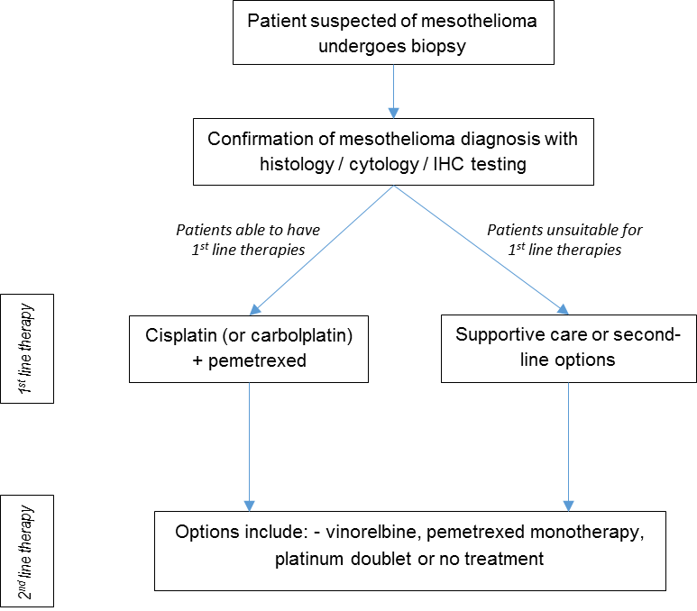

Figure 1 Algorithm describing the current clinical pathway for patients diagnosed with mesothelioma
IHC = immunohistochemistry

Proposed clinical management pathway for treatment patients who have undergone prior therapy
In the proposed clinical pathway (Figure 2), patients suspected with mesothelioma would undergo biopsy as in the current pathway. The biopsy sample would be sent to pathology where for histology and cytology, and IHC testing for confirmation of diagnosis and sub-type analysis of mesothelioma. Patients with unresectable disease and able to tolerate standard first-line therapy will be offered cistplatin (or carbolplatin) plus pemetrexed. Once their disease no longer respondes to therapy and progresses, patients could undergo PD-L1 testing on a FFPE biopsy sample retrieved from store, or alternatively undergo rebiopsy. If a patient tests positive for the PD-L1 ligand (that is ≥1% TPS) they would be eligible for pembrolizumab as a second-line therapy. Patients testing negative for PD-L1 would not be offered pembrolizumab and may be offered the one of various options for second-line therapy such as vinorelbine, pemetrexed monotherapy, or platinum doublet therapy. No treatment may also be an option. Patients whose disease progressed after undergoing pembrolizumab treatment may be offered cisplatin plus pemetrexed as second-line therapy.
Patients who have undergone current first and second-line therapies may undergo PD-L1 testing for access to pembrolizumab. Those who test positive would be eligible for pembrolizumab, and those who test negative may be offered an additional second-line therapy options.

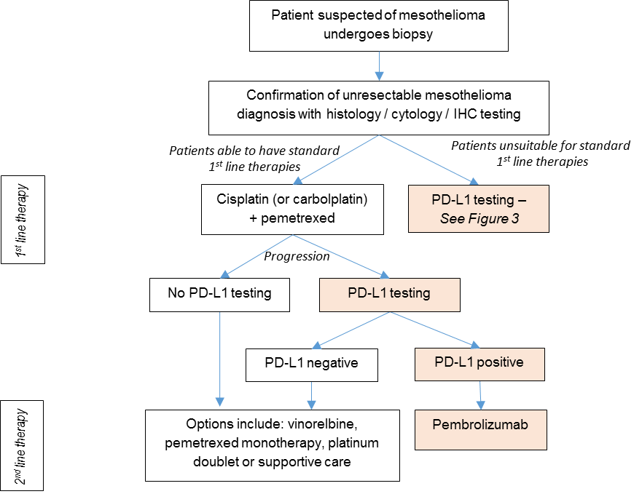

Figure 2 Algorithm describing the proposed treatment pathway for patients who have failed prior therapies
IHC = immunohistochemistry; PD-L1 = programmed cell death ligand 1

Proposed clinical management pathway for patients unsuitable for standard first-line therapies
In the proposed clinical pathway (Figure 3), patients suspected of having mesothelioma (and treatment naïve) would undergo biopsy as in the current pathway. The usual histology, cytology and IHC testing conducted on the biopsy sample, and all patients will be assessed for their suitability for tumour resection. Patients considered unresectable, and who are able to tolerate standard first-line therapies will continue in the current pathway, and be offered cisplatin (or carboplatin) and pemetrexed. Patients who are unresectable and also unsuitable for standard first-line therapies would be eligible for PD-L1 IHC testing. If a patient tests positive for the PD-L1 ligand (≥1% TPS) they would be eligible for pembrolizumab treatment. For patients testing negative for PD-L1, there are no other standard therapies available. They may be offered no treatment and best supportive care or second-line therapy options.
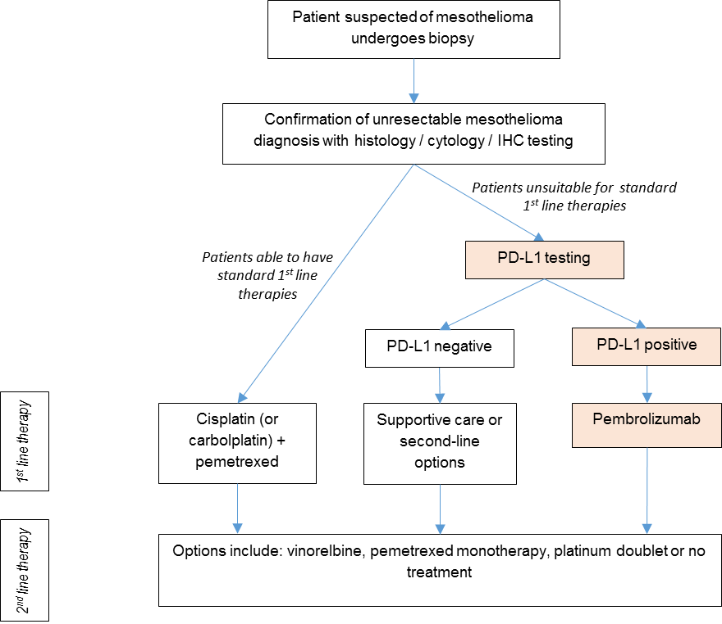
Figure 3 Algorithm describing the proposed treatment pathway for patients unsuitable for first-line standard therapy
IHC = immunohistochemistry; PD-L1 = programmed cell death ligand 1

Proposed economic evaluation
The Applicant claims superiority for the proposed co-dependent service. This claim is based on
- Acceptable safety and analytical performance of the PD-L1 test (to be assessed by MSAC) and
- Superior effectiveness with acceptable safety of treating PD-L1 positive patients with pembrolizumab relative to standard of care without testing (to be assessed by PBAC).
The appropriate economic evaluation for a claim of superiority would be a cost-utility analysis.
Comparative evidence of PD-L1 testing or pembrolizumab treatment is not included in the preliminary supporting evidence identified in Part 4 of the Application Form. Additional evidence will need to be presented in order to substantiate these claims.

Proposed item descriptor
The Applicant has proposed the following item descriptor (Table 5).

Table 5 Item descriptor for the proposed new MBS service
Category 6 – PATHOLOGY SERVICES
Item XXXXX

Immunohistochemical examination of biopsy material by immunoperoxidase or other labelled antibody
techniques using the PD-L1 antibody to determine if the requirements relating to programmed cell death
ligand 1 (PD-L1) status for access pembrolizumab under the Pharmaceutical Benefits Scheme (PBS) are fulfilled.

Fee: $(proposed fee) To be determined

PASC may wish to consider whether the proposed item descriptor should specify the proposed population eligible for PD-L1 testing (i.e. patients with locally advanced or metastatic mesothelioma who are ineligible for or have failed standard therapy) in order to prevent utilisation in other indications.

References
AIHW 2015, Mesothelioma io Australia: Incidence (1982 to 2013) and Mortality (1997 to 2012), Australian Institute of Health and Welfare, Safe Work Australia.
Alley, EW, Molife, LR, Santoro, A, Beckey, K, Yuan, S, Cheng, JD, Piperdi, B & Schellens, JHM 2015, 'Abstract CT103: Clinical safety and efficacy of pembrolizumab (MK-3475) in patients with malignant pleural mesothelioma: Preliminary results from KEYNOTE-028', Cancer Research, vol. 75, no. 15 Supplement, pp. CT103-CT103.
AMR 2015, Mesothelioma in Australia 2014, 4th annual report.
Baas, P, Fennell, D, Kerr, KM, Van Schil, PE, Haas, RL, Peters, S & Committee, EG 2015, 'Malignant pleural mesothelioma: ESMO Clinical Practice Guidelines for diagnosis, treatment and follow-up', Ann Oncol, vol. 26 Suppl 5, Sep, pp. v31-39.
Cedres, S, Ponce-Aix, S, Zugazagoitia, J, Sansano, I, Enguita, A, Navarro-Mendivil, A, Martinez-Marti, A, Martinez, P & Felip, E 2015, 'Analysis of expression of programmed cell death 1 ligand 1 (PD-L1) in malignant pleural mesothelioma (MPM)', PLoS One, vol. 10, no. 3, p. e0121071.
Khanna, S, Thomas, A, Abate-Daga, D, Zhang, J, Morrow, B, Steinberg, SM, Orlandi, A, Ferroni, P, Schlom, J, Guadagni, F & Hassan, R 2016, 'Malignant mesothelioma effusions are infiltrated by CD3+ T cells highly expressing PD-L1 and the PD-L1+ tumor cells within these effusions are susceptible to ADCC by the anti-PD-L1 antibody avelumab', J Thorac Oncol, Aug 17.
Merck Sharp & Dohme Corp 2015, 'KEYNOTE-158 - Study of pembrolizumab (MK-3475) in participants with advanced solide tumours', last verified August 2016 edn, US National Institutes of Health, ClinicalTrials.gov, p. NCT02628067<https://clinicaltrials.gov/ct2/show/study/NCT02628067?term=Keynote+158&rank=1>.

Eastern Cooperative Oncology group performance status: a scale of 0 to 5 which measures a patient’s performance status based on their ability to care for themselves, daily activity and physical activity. At Level 0 a patient is fully active and at Level 5 a patients is dead.

