MSAC Application 1665:
Ultrasound radiofrequency echographic multi spectrometry (REMS) for evaluation of bone mineral density (BMD) at the lumbar vertebrae and femoral neck for the diagnosis of osteoporosis

Ratified
PICO Confirmation
Summary of PICO/PPICO criteria to define question(s) to be addressed in an Assessment Report to the Medical Services Advisory Committee (MSAC)
Table 1 PICO for REMS for use in the diagnosis of osteoporosis: PICO Set 1
Component | Description
Population | Patients currently eligible for dual energy x-pray absorptiometry (DXA) scanning (MBS items 12306, 12312, 12315, 12320, 12321, 12322)
Prior tests | None
Intervention | Ultrasound device for bone characterisation and micro-architecture assessment for the diagnosis of osteoporosis through scanning of central reference sites (lumbar vertebrae L1-L4 and the femoral neck) based on radiofrequency echographic multi spectrometry (REMS)
Comparator/s | Dual energy x-ray absorptiometry (DXA)
Reference standard | Dual energy x-ray absorptiometry (DXA)
Outcomes | Safety:  - potential harm due to incorrect diagnosis  - reduction in longer-term, cumulative harms due to the avoidance of ionising radiation  Effectiveness:  - correlation between REMS and DXA in terms of bone mineral density (BMD), T-scores and Z-scores at all sites assed by REMS  - diagnostic and prognostic accuracy of REMS vs. DXA based on categorisation of patients at each of lumbar spine and both proximal femoral (femoral neck and total proximal femur) sites  - rate of unsuccessful scans  - rate of repeat scans  Total Australian Government healthcare costs:  - Total cost to the Medicare Benefits Schedule (MBS)
Assessment questions | What is the safety, effectiveness, and cost-effectiveness of REMS versus DXA in patients being diagnosed for osteoporosis?  What is the level of concordance for results based on REMS and DXA in the proposed population?  Is there an inference that similar results from REMS and DXA will result in the same management decisions, and noninferior health outcomes?

Purpose of application
An application requesting Medicare Benefits Schedule (MBS) listing of radiofrequency echographic multi spectrometry (REMS) for the diagnosis of osteoporosis was received from Cortex Health Pty Ltd by the Department of Health.
The clinical claim is that REMS is non-inferior to dual energy X-ray absorptiometry (DXA). The application stated (p31) that use of REMS instead of DXA provides a similar level of effectiveness (i.e. diagnostic accuracy). There is a similar level of safety during the procedure, with a potential for reduction in longer-term, cumulative harms due to the avoidance of ionising radiation as part of the process.

PICO criteria

Population
Background
Osteoporosis is a condition that causes bones to become thin, weak and fragile, resulting in a broken bone from even a minor bump or accident (AIHW 2020). Any bone can be affected by osteoporosis, with the most common sites where broken bones occur being the hip, wrist and spine. Other sites include the ankle, leg, forearm, upper arm and ribs (Healthy Bones Australia). Broken bones may occur in patients with either osteoporosis or osteopenia, which is a condition when bone mineral density (BMD) is lower than normal but not low enough to be classified as osteoporosis. Fractures due to osteoporosis can result in chronic pain, disability, loss of independence and premature death.
The application stated (p22) that individuals aged 45 and over with osteoporosis had considerable adverse impacts from osteoporosis based on self-reported data from the Australian Bureau of Statistics (ABS) 2017–18 National Health Survey (NHS), including:
- lower self-assessed health status than people without the condition - people with osteoporosis were 2.7 times as likely to describe their health as poor (15%) compared with those without the condition (5.4%)
- more than half of people with osteoporosis (57%) experienced ‘moderate’ to ‘very severe’ pain in the last 4 weeks. People with osteoporosis were 2.3 times as likely to experience severe or very severe bodily pain in the last 4 weeks (23%) compared with those without the condition (10%)
- individuals were 2.9 times as likely to experience very high levels of psychological distress (12%) compared with those without the condition (4.1%).
Diagnosis of osteoporosis requires an assessment of BMD. The most commonly used technique is dual-energy X-ray absorptiometry (DXA) to determine BMD in the hips and spine. Scan results are expressed as T-scores, with normal being a T-score of 1 to -1, osteopenia being a T-score of -1 to -2.5 and osteoporosis being a T-score of -2.5 or lower. As described further below, the proposed intervention is a non-invasive ultrasound device for bone characterisation and micro-architecture assessment through scanning of central reference sites.
Eligible population
The application indicated (p22) that osteoporosis is under-diagnosed and it is difficult to determine the true prevalence of osteoporosis because it has no overt symptoms and it is often not diagnosed until a fracture occurs (AIHW 2020). The application added that based on self-reported data from the ABS in 2017-2018, an estimated 924,000 Australians have osteoporosis, and 20% of people aged 75 and over have osteoporosis or osteopenia.
The application proposes that patients currently eligible for DXA scanning (MBS items 12306, 12312, 12315, 12320, 12321, 12322) would also be eligible for REMS.
PASC confirmed that the proposed population is the same as that currently eligible for an MBS funded DXA. Prior to being considered eligible for REMS, patients would be investigated, managed and referred in the same way as they currently are for DXA scanning (see ‘Clinical management algorithms’ for further detail). The application noted that use would be restricted to specific adult populations, and criteria on the frequency of use would be applied, i.e. usually requiring a minimum 24 month period between the service , except for the ≥70 years monitoring disease progression population where frequency would be ≥2 years or ≥5 years, depending on which range the T-score fell into. There are also some populations where the minimum frequency is 12 months, i.e. after proven low BMD diagnosis or for the monitoring of prolonged glucocorticoid therapy, excess glucocorticoid secretion, male hypogonadism or the specified female hypogonadism indication. The proposed populations are as follows:
- previously identified low BMD diagnosed based on fractures following minimal trauma or monitoring of low BMD proven by densitometry at least 12 months previously (analogous to MBS item 12306)
- bone loss associated with prolonged glucocorticoid therapy, any condition associated excess glucocorticoid secretion, male hypogonadism, female hypogonadism lasting more than 6 months before the age of 45 (MBS item 12312)
- bone loss associated with primary hyperparathyroidism, chronic liver disease, chronic renal disease, any proven malabsorptive disorder, rheumatoid arthritis, any condition associated with thyroxine excess (MBS item 12315)
- patient aged 70 years of age or over who has not previously had bone densitometry or the t-score for the patient’s BMD is -1.5 or more (MBS item 12320)
- established low BMD or confirming a presumptive diagnosis of BMD made on the basis of 1 or more fractures occurring after minimal trauma (MBS item 12321)
- patient is over 70 years of age and the t-score is less than -1.5 but more than -2.5 (MBS item 12322).
PASC discussed concerns raised about the limited data on REMS in obese patients and considered that the rates of unsuccessful scans due to obesity or technical difficulties should be addressed in the applicant developed assessment report (ADAR). Other concerns raised included rates of unsuccessful scans in certain patients including those with bowel gas, presence of metal prosthesis/internal fixation devices, presence of osteophytes, presence of compression fractures; and inability to perform forearm scans in patients with hyperparathyroidism. The applicant advised that every time a REMS service is conducted, it is immediately known whether the scan can generate a valid BMD measurement or not, and in the case where the REMS device indicates a valid BMD measurement could not be generated the scan can be reattempted on the spot which should cause minimal inconvenience to the patient and clinician. PASC considered that these concerns, including where a scan is unsuccessful in patients following reattempts, should still be further addressed in the ADAR (applicant developed assessment report).
PASC noted concerns raised in relation to the use of REMS for monitoring in subgroups such as in males, younger populations and in different racial populations where evidence is currently lacking. The applicant responded that evidence in men and other subgroups is available and will be reported in the ADAR.
The application also noted REMS could be used for monitoring disease progression, in populations previously diagnosed with low BMD via either DXA or REMS, but this would only be allowed at appropriate defined intervals. The application indicated that patients who need to be monitored for their response to anti-osteoporosis medication could also be conducted by REMS. The application indicated this would be for patients who had a significant change in osteoporosis therapy more than 12 months prior. The pre-PASC response indicated that monitoring would be consistent with that which currently applies to DXA, with the option to obtain the T-score via REMS. The pre-PASC response also noted that all available clinical trial evidence to support the use of REMS for monitoring response to therapy will be provided in the assessment report.
Finally, the application indicated that as the REMS device can be portable, this may provide improved access to some high risk or ‘hard to reach’ populations who might present difficulties for a DXA scan. These include:
1. regional and remote communities
2. aboriginal and Torres Strait Islander populations and communities
3. elderly and frail who have reduced mobility
4. those with bone deformity / difficulty who cannot lie perfectly supine
5. patients with surgical intervention such as hip fracture surgery using rods and nails.
In the information provided for the pre-PASC meeting, the applicant also indicated that not all patients are suitable for DXA but will be suitable for REMS and these include the patients listed above, along with those not suitable or desirable for radiation exposure. However, currently the device is only available in limited metropolitan areas and has not been introduced to the wider community or demonstrated to improve access for the above populations. Any potential to improve access in regional/remote communities is more likely to occur through porting the device as part of outreach programs rather than availability of the device at health facilities in regional/rural communities.
In regard to the elderly and frail or those with bone deformity or unable to lie flat, the applicant indicated for the pre-PASC meeting that the devices are able to scan a patient who is not completely lying flat as the operator has the ability to manoeuvre the probe to find the correct position before initiating the scan. Thus, it is possible to scan patients by adjusting the position of the probe in relation to their orientation. The applicant stated they have scanned patients who were lying with their head and torso elevated (both femoral neck and lumbar spine) as well as a quadriplegic patient in a wheelchair (femoral neck only).
When it was stated to the applicant that ultrasound has known challenges in producing results in larger body habitus in patients who cannot remain still, the applicant responded that the limitations of the device in scanning relate to physical distance between the probe and the respective bone region of interest (ROI). The maximum depth of the scan is 210 mm. In some patients with a high body mass index (BMI) this may prove to be a problem in reaching the lumbar spine but is not a complication to record femoral neck BMD. In the applicant’s experience, the largest individual scanned successfully in Australia with REMS was 156 kg. The applicant concluded that the technology is designed to recognise the relevant ROI and if the scan does not have sufficient quality signals within that ROI, it will reject the scan and give a null result or ‘invalid scan’. Therefore, the clinic/operator can feel confident that when they get a result, it is a valid BMD measurement and not an artifact or reading distorted by physical position or body mass composition or movement.

Intervention
Investigative technology
The intervention for the proposed investigative service is a non-invasive ultrasound device for bone characterisation and micro-architecture assessment for the diagnosis of osteoporosis through scanning of central reference sites, with lumbar vertebrae L1-L4 and the femoral neck nominated as the pivotal sites.
The intervention is based on the use of the REMS method. This method uses all the spectral features of the radiofrequency signals acquired during an echographic scan of the target anatomical site to determine the status of internal bone architecture. Use of the intervention does not require radiological protection.
The application is for one brand, Echolight, which through its software provides all the standard parameters for the diagnosis of osteoporosis, including BMD, T-score and Z-score.
The proposed service is expected to substitute for the comparator, which is also the reference standard, DXA. The applicant indicated that patients will have either REMS or DXA, and will not have both. Both REMS and DXA can perform diagnostic scans on lumbar vertebrae L1-L4 (spine, individual vertebrae and total score) and proximal femur (hip, femoral neck, trochanter and total).
PASC noted that in the pre-PASC response, the applicant claimed that REMS scans at all sites will provide 11 individual results. PASC considered the reference to 11 individual results should not be misrepresented and concluded that REMS at best would provide a score for a total of three sites: lumbar spine and two proximal femurs. PASC noted concerns raised that REMS is not able to provide a BMD measurement for the total proximal femur and agreed that this is an important measurement that REMS is unable to provide.
In the pre-PASC response, the applicant advised that the total preparation, scanning and report generation time (including the 3 to 5 minutes required for a patient to get into position) is on average 20 minutes for two sites and approximately 25 minutes for three sites. This includes data entry of the patient’s details, application of ultrasound gel, probe placement and refinement, the scans (90 seconds for femoral neck; 120 seconds for lumbar vertebrae L1-L4), analysis of the scanned data by the device (1 to 2 minutes) and report generation by the device. In a failed scan where no result is given, the failure of the scan is identified within 30 seconds and the operator will be aware the scan must be repeated and will repeat the scan, which may involve re-positioning the patient.
The pre-PASC response indicated that REMS is not an ultrasound imaging device. Such devices, which fall within diagnostic imaging, and the sonographers who use them, are designed so the user is qualified to make an assessment/diagnosis based on the ultrasound image. That is not the case with REMS, which is a different technology. The health professional conducting the scan uses the image as a guide only to find the ROI and nothing more. The software and technology are fully automated and complete the calculations for determination of BMD and subsequent diagnosis. Therefore, the applicant believes that REMS should not be considered equivalent to an ultrasound imaging service. The pre-PASC response indicated the applicant is willing to work with the government on any requirement for registering the device with the Diagnostic Imaging Accreditation Scheme (DIAS) and other credentialing arrangements, if deemed clinically appropriate.
PASC considered that REMS is not an ultrasound imaging service and therefore appropriate to consider inclusion in the Health Insurance (General Medical Services Table) Regulations.
Device technology
The ultrasound scans are performed by an echographic device equipped with a convex transducer operating at 3.5 MHz, allowing the simultaneous acquisition of conventional B mode images and corresponding unprocessed radiofrequency signals. The REMS approach is based on the idea that radiofrequency signals, acquired during an echographic scan of a target bone district, can be used to determine the health status of the considered bone through advanced comparisons with previously derived reference spectral models of the possible pathological or normal conditions. This method is natively integrated with ultrasound imaging, combining:
- the regions of interest (for diagnostic calculations within the investigated bone are automatically identified exploiting both morphologic details and radiofrequency spectral features)
- the simultaneous acquisition of several radiofrequency scan lines for each image frame provides a solid and reliable statistical basis for subsequent spectral processing.
Further detail on the device technology is available in Conversano (2015), which stated (p284) that analogue radiofrequency signals were passed to a custom-developed signal pre-processing chain that performed the following steps: 1-kHz high-pass filtering to can low-frequency noise; 18-dB amplification to improve signal dynamics and analogue to digital conversion (40MS/s, 16 bits). The patients underwent a sagittal scan of the lumbar spine, with the probe being moved back and forth from the xiphoid process. The scan generated 100 frames of radiofrequency data (frame rate ~1.5 fps) that were acquired and stored in a PC hard disk for subsequent off-line analysis. Transducer focus was set at 5 cm, and the probe was coupled with the abdomen to keep vertebral interfaces in the ultrasound focal region (i.e. thickness of soft tissue between skin and vertebrae was approximately constant). Other echograph parameters were the same for all the acquisitions: power = 45%, mechanical index (MI) = 0.4, scan depth = 12 m, gain = 0 dB, linear time gain compensation.
The Conversano (2015) publication also noted that in the typical situation, vertebral interfaces were actually located in the focal region, being 1–2 mm below the focus reference line on the screen: L3 and L4 required almost no pressure on the probe to be placed at such a distance, whereas slight abdominal compression was necessary to reach the same placement for lumbar vertebrae L1 and L2. During data acquisition, the operator oriented the ultrasound transducer to place the interface of the insonated vertebra in the horizontal position (aligned with the focus reference line).
The pre-PASC response stated that the depth of the scan can be adjusted by the operator to accommodate patient variables and ensure that the ROI is at, or just below, the focal point of the scan. The maximum depth is 210 mm, which is sufficient for a femoral neck scan for any BMI size, and is also sufficient for very high BMI lumbar spine scans.
Data analysis, based on the correlation between frequency spectra of acquired radiofrequency signals and the appropriate reference models, is then able to calculate BMD, T-score and Z-score. The reference dataset is the National Health and Nutrition Examination Survey (NHANES) III United States (US) data set, which is a standardised worldwide dataset and is used by the majority of DXA scans as well. The device reference models are derived from a database including more than 10,000 subjects, covering all typical BMI values, from under-weight to obese individuals. The pre-PASC response noted that while NHANES III is the most commonly referenced dataset, several Australian experts have referenced the Geelong Osteoporosis Study reference dataset (Henry 2004), and have used the BMD value to calculate T-score and Z-scores derived from this dataset. The applicant advised that the dataset used for automatic analysis by REMS currently does not include the Geelong Osteoporosis Study reference dataset for the Australian population, but if other more relevant datasets become available, the applicant will look to try and incorporate these into the software platform in collaboration with Echolight Italy.
The applicant did note that it is anticipated the reference models will be updated every 6 to 12 months.
The figure below outlines the data processing steps used to calculate reference model spectra in Conversano 2015.
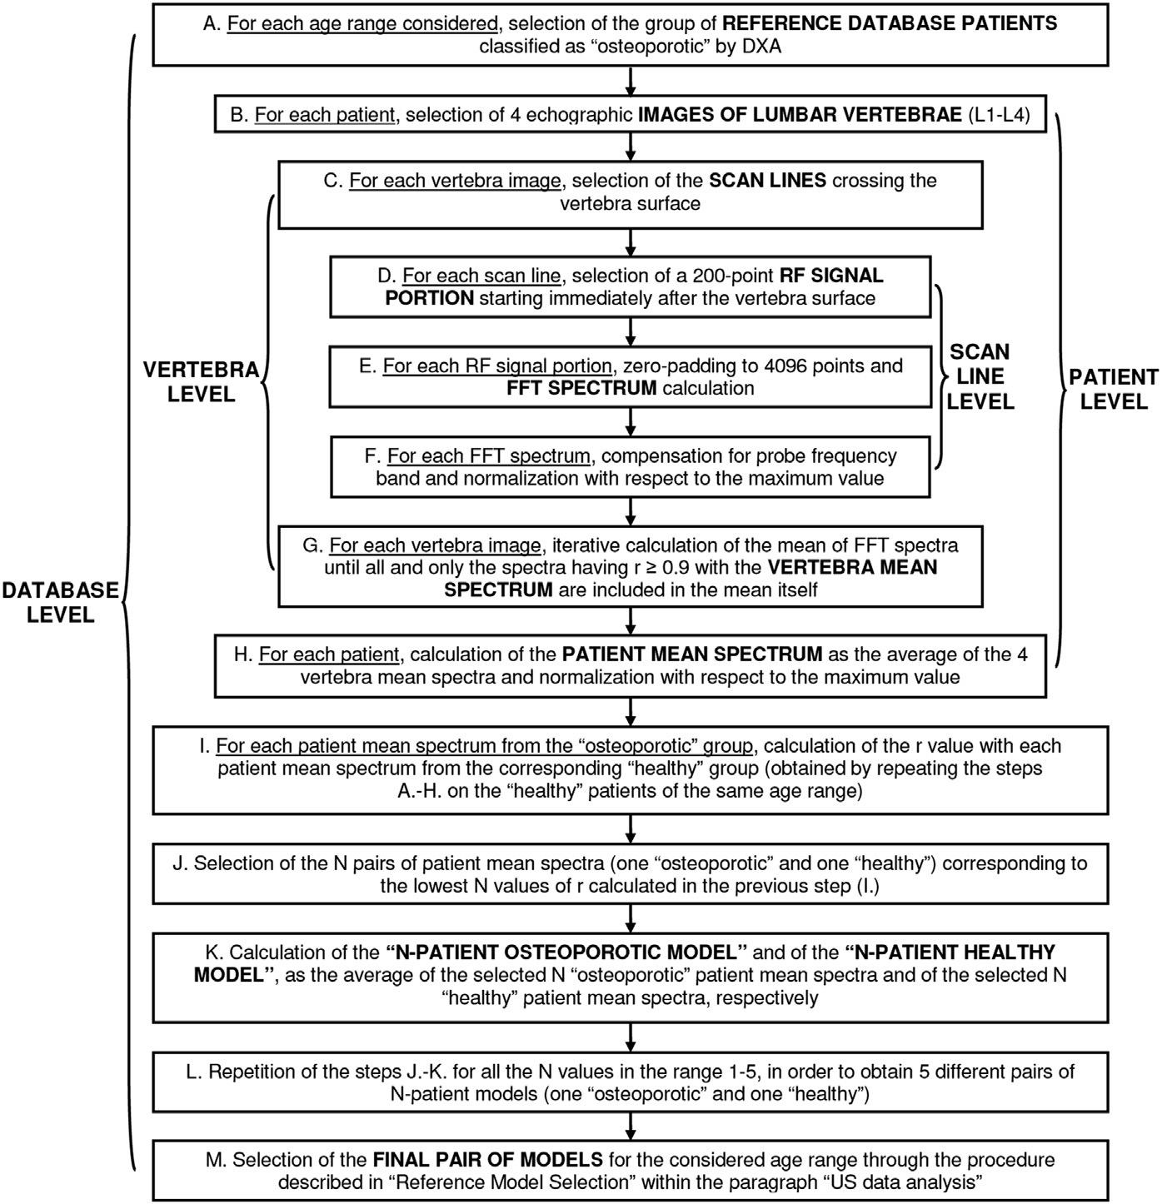
Figure 1 Illustration of the data processing steps used to calculate reference model spectra for 5-year age ranges for REMS in Conversano 2015
Source: Figure 1, p287 of Conversano 2015.
DXA=dual X-ray absorptiometry; FFT=fast Fourier transform; RF=radiofrequency.
Device operation
The application stated (p27) to perform the diagnostic investigation, the operator should preliminarily visualise the first target interface (i.e. vertebra L1 for lumbar acquisitions or femoral neck for hip scans) and set image depth and focal position to have the target interface in the central part of the image and in correspondence of the focus.
The software-assisted ultrasound acquisition then begins. During the scan, the algorithm automatically detects the bone interfaces (red lines) and calculates the ROIs for data analysis (green areas). The automatic data processing is then started, including RF (radiofrequency) signal analysis and spectral comparison with reference models for calculation of diagnostic parameters and generation of the final medical report. REMS method provides two new numerical parameters:
- osteoporosis score (OS) which directly correlates with BMD measurements (in g/cm²) and consequently with DXA diagnostic evaluations (BMD, T-score, Z-score). The OS value measures the degree of similarity between radiofrequency spectra obtained from the considered patient and reference spectral models previously derived from anthropometrically-matched subjects having either a low BMD (T-score ≤ -2.5, osteoporotic model) or a normal BMD (T-score >-1, healthy model) (Conversano 2015)
- fragility score (FS; which is under development) which provides an independent estimate of bone fragility and fracture risk. The FS evaluates an analogous spectral similarity with reference to spectral models previously derived from anthropometrically-matched subjects that either had reported a recent fragility fracture (fragility model) or had no fracture history (healthy model) (Pisani 2017).
PASC queried the applicant regarding the fragility score provided by REMS and noted that the fragility score is not yet validated.
In the information provided for the pre-PASC meeting, the applicant indicated that the REMS technology does not make the diagnosis from the image. The operator must find the region of interest and activate the scanning sequence and the software/technology will complete the scans, compare with the reference dataset and make a diagnosis, independent of the operator.
The application cited a video which demonstrates how to use the device (see Echolight in the References).
The applicant’s pre-PASC response indicated that the device must only be used by healthcare professionals who have undergone the REMS training. Referrals from GPs or specialists to a trained and established group with REMS expertise is the preferred path to ensure the best quality outcome and results. It is proposed by the applicant that the clinical interpretation of the results would be done by either a specialist or consultant physician. The results can be used by a specialist or consultant physician, in conjunction with other risk factors, as an aid in the diagnosis of osteoporosis and medical conditions leading to bone fragility, and ultimately in the assessment of fracture risk.
Device training
Information provided for the pre-PASC meeting indicates that the applicant has devised a 3-day training program for healthcare professionals to provide information on:
- bone architecture / normal BMD vs. osteopenia and osteoporosis
- REMS technology
- use of the device
- sufficient practice to ensure confidence and competence
- regular follow-up with clinics and training as required.

The outline of the training program is available in Attachment 1.
PASC considered that the applicant should work with the relevant professional societies to seek their endorsement of an accredited training program for REMS.
Device output
The applicant advised that the medical report generated by the REMS device contains all the common parameters for osteoporosis diagnosis through bone density assessment, including BMD (g/cm²), T-score and Z-score.
The application added that the fragility score evaluates the quality of internal bone micro-architecture and the 10-year risks of osteoporotic fractures.
Device types and cost
The REMS device is available in four different units and these are listed below, along with the expected cost of the device and software.
Table 2 Device and software approximate purchase priceª (October 2021)
Device | Description | Price (AUD)
EchoS | Portable unit with essential BMD report only. | $62,500
EchoStation | Clinic unit with panel PC to provide expanded BMD reporting. | $72,500
EchoHybrid | Same as EchoStation plus travel case and laptop. Hence both in clinic and portable functionality. | $81,250
EchoHybrid Plus | Same as EchoHybrid but with a more powerful panel PC incorporated into the travel case. Full functionality in the portable unit. | $86,500
Source: Table 1, p9 of the information provided by the applicant prior to the pre-PASC meeting.
AUD=Australian; BMD=bone mineral density; PC=personal computer
ª Prices are excluding GST and may vary depending on the exchange rate and requested modifications. The software (EchoStudio) is included as part of the purchase price.
As outlined in the table above, three of the four devices are portable (EchoS, EchoHybrid and EchoHybrid Plus).
The applicant anticipated that clinics will seek to fund the device through external government funding grants, research proposals/funding, privately (patient pays), MBS fee income or cost recovery from tax incentives/rebates for equipment purchases. The pre-PASC response added that the annual operating costs for the REMS device are determined by: amortisation of the principal cost of the device over a standard time period; salary of the trained health care professional (part of their daily/weekly duties and not the sole reason for employment); 6-month calibration/quality check and software update by the sponsor ($1,000 to $2,000 per service); ultrasound gel (approximately $120 for 5 litres which should last one month); allowance for consulting/examination space and associated clinic running costs. The pre-PASC response indicated that in comparison, a DXA device ranges upward from $80,000 for the device only. The pre-PASC response stated the full cost of providing the service will be itemised and presented in detail in the assessment report.
The REMS devices are depicted below.
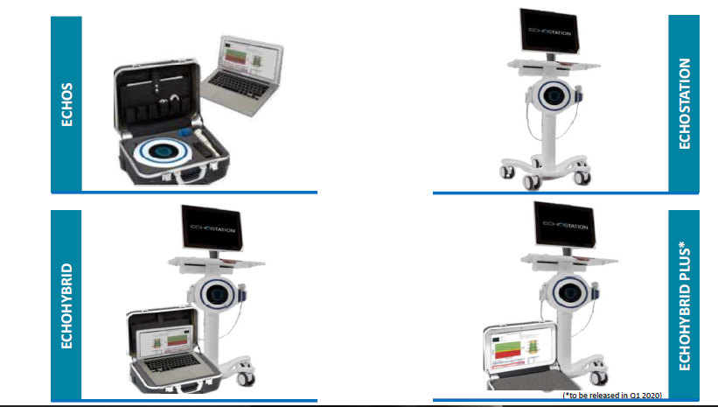
Figure 2 Devices available to clinics in Australia
Source: Appendix 1, p17 of the information provided by the applicant prior to the pre-PASC meeting.
Claimed advantages
While the clinical claim for REMS is non-inferiority to DXA, the pre-PASC response indicated that the advantages of REMS over DXA scanning include:
- does not use ionising radiation
- portability within a hospital or clinic as it is able to be moved easily and does not require a dedicated room
- portable/transportable to regional, rural and even remote clinics through the travel case (12 kg and 20 kg depending on device)
- a health care professional can be trained to use the device and use does not need to be limited to diagnostic imaging professionals
- the REMS device is cheaper compared to DXA to purchase without considering clinic room allocation cost
- the device does not require daily calibration as DXA does (REMs calibration is every 6 months)
- the reproducibility and coefficient of variation (T-score, Z-score, BMD values) is lower than those published for DXA, hence small changes in BMD (degradation or improvement) are more likely to be detected by sequential REMS examinations before DXA. The pre-PASC response did not indicate if the applicant intends to provide evidence to support this claim in the assessment report.
PASC noted the limited number of REMS devices currently available in Australia may initially limit access to this service.
While the ultrasound device does not use ionising radiation, it is relevant to note that the literature states that the amount of radiation used in DXA scans is extremely low (Lewis 1994; Blake 1997; Njeh 1999), as do other sources including Healthy Bones Australia. For example, the amount of ionising radiation from an 8-minute lumbar spine DXA scan is 0.5 microsievert units (µSv) (Lewis 1994). The amount of radiation is generally compared to natural background radiation to put the value into context. To compare the 0.5 µSv received from a lumbar spine DXA scan, the International Atomic Energy Agency (IAEA) reports that the effective dose received from natural background radiation in one day is about 10 µSv. The pre-PASC response acknowledged that the radiation exposure of DXA is low.

Comparator(s)
The comparator identified by the application is DXA. PASC confirmed that DXA was the appropriate comparator.
DXA was introduced in the 1980’s (Blake 1997) and is a way of measuring BMD using spectral imaging. In a DXA scan, two x-ray beams, with different energy levels are aimed at a patient’s bones. The hip and spine are scanned, and Healthy Bones Australia reports that a scan takes approximately 10 to 15 minutes. When soft tissue absorption is subtracted out, the BMD can be determined from the absorption of each beam by bone. DXA is the most widely used and thoroughly studied bone density measurement technology (Royal Osteoporosis Society).
Bone densities are given to patients as a T-score or a Z-score with DXA. The applicant claims that the same outcomes are provided with REMS. A T-score is the number of standard deviations at which the individual’s BMD lies above or below the mean BMD of young adults of the same gender. A Z-score is the number of standard deviations at which the individual’s BMD lies above or below the mean BMD of age- and gender-matched controls. The World Health Organization (WHO) has defined categories based on bone density, and a normal T-score is -1.0 and above, low bone density is between -1.0 and -2.5, and severe (established) osteoporosis is a T-score more than -2.5 standard deviations below the young adult female reference mean in the presence of one or more fragility fractures (WHO 2004).
DXA scans are subsidised under the MBS for eligible patients. The MBS items that can be claimed for DXA services are: 12306, 12312, 12315, 12320, 12321 and 12322. A patient can be referred for a DXA scan by a medical practitioner (e.g. their GP) and are to be provided by a specialist or consultant physician. DXA scans may also be provided by a person who holds a radiation licence under a law of a State or Territory and performs the service under the supervision of a specialist or consultant physician and the specialist or consultant physician performs the interpretation and reporting for the service.
PASC noted that while DXA is not portable, it is currently delivered in rural and remote areas, including via mobile units. PASC noted that different DXA devices (e.g., Lunar vs. Hologic vs. Norland) do not give identical values and that it is not evident from the publications which DXA devices were used to derive the correlations between REMS & DXA. PASC advised that when comparing REMS with DXA in the assessment report, it would be pertinent to identify the DXA device(s) used in the comparison.
The current MBS items for DXA scans, including additional wording for REMS, are available below under ‘Proposal for public funding’.

Reference standard (for investigative technologies only)
The application indicated that DXA is considered the reference standard.
Both the AIHW report (2020) and the International Osteoporosis Foundation (IOF) webpage indicate that the diagnosis of osteoporosis requires an assessment of BMD and the most commonly used and recommended method for obtaining a measurement of BMD is DXA. Other earlier publications (e.g. Blake 2007; Kanis 2007; WHO 2004) describe the use of DXA in the diagnosis of osteoporosis, and the Kanis 2007 paper suggests that BMD of the neck be considered the gold standard, and the 2004 WHO meeting report notes that other central sites such as the spine and hip can be used.
PASC noted that DXA was nominated as the reference standard. PASC agreed that DXA is well accepted and the recommended standard for assessing BMD for diagnosing osteoporosis.
PASC raised some points around accuracy in predicting fracture risk, and noted that DXA can also provide false negative results, for example in the presence of osteoarthritis in the lumbar spine. PASC queried whether accuracy in predicting fracture risk is the true ‘gold standard’, that is whether REMS is as accurate as DXA at predicting fracture risk. PASC also noted that BMD is not the sole determinant of fracture risk. However, PASC concluded that comparison of BMD measurement with DXA as the reference standard was appropriate but should take into consideration the limitations of DXA.

Outcomes
The application claimed that REMS is non-inferior to DXA in regard to diagnostic accuracy for osteoporosis. The application nominated the following outcomes.
Safety outcomes
The application stated (p32) that safety outcomes are not reported in the comparative trials and the application did not identify any safety outcomes.
PASC considered that adverse outcomes of an incorrect diagnosis with REMS (i.e. failure to treat appropriately or inappropriate treatment) is an appropriate safety outcome. However, PASC also considered that any adverse outcomes of incorrect diagnosis for DXA would also be a relevant outcome. PASC queried whether the rates of unsuccessful scans for REMS should be included in an analysis and compared to DXA. PASC advised that the need for any repeat scanning, i.e. when a physician determines there is not sufficient information for diagnosis, or in the case of DXA, when a quantitative computerised tomography scan is required (e.g. in the case of implants), would be informative, including to advise on the appropriateness of using REMS and compare the rate of repeat scans for both technologies.
PASC noted that while REMs may be non-ionising and therefore present less risk compared to DXA regarding radiation risk, DXA is associated with a very low radiation dose which is not a significant safety risk.
Effectiveness outcomes
Correlation/agreement between REMS and DXA in terms of BMD (g/cm²),T-scores and Z-scores at each of lumbar spine and both proximal femoral (femoral neck and total proximal femur) sites:
- correlation between REMS and DXA determined by calculating the slope of the regression line, Pearson’s correlation coefficient (r), the coefficient of determination (r²) and the standard error of the estimate (SEE)
- some studies also reported these values for patient sub-populations with previous fracture history and those without previous fracture history (e.g. Adami 2020).
Diagnostic accuracy/concordance of REMS vs. DXA based on categorisation of patients at each of lumbar spine and both femoral neck sites:
- categorisation as percentage of patients with osteoporosis (T-score ≤-2.5) or osteopenia (-2.5< T-score <-1.0) or healthy patients (T-score >-1.0)
- sensitivity (%)
- specificity (%)
- positive/negative predictive value (NPV/PPV) (%).
T-score and Z-score based analysis for REMS vs. DXA:
- T-score distributions for each treatment with statistical treatment difference (p value)
- sensitivity in discriminating patients with and without previous osteoporotic fractures (%)
- specificity in discriminating patients with and without previous osteoporotic fractures (%).
The pre-PASC response noted that the implications of downstream management decisions for any discordant results for the presence/absence of osteoporosis will be presented, based on the available evidence.
PASC noted that the concordance between DXA and REMS will need to be assessed for all available sites, not just lumbar spine and femoral neck, and that the effects of age, gender and BMI also need to be considered in the assessment for concordance.
PASC agreed that BMD correlation is a relevant outcome, noting that BMD may contribute up to 70% of an individual’s fracture risk. However, as fracture prediction (for example, after 5 years’ follow-up based on one or more of lumbar spine, left proximal femur or right proximal femur results) would be the final outcome, PASC indicated there should also be consideration of the ability of REMs to predict future fracture risk or correlate with the existing rate of low trauma fractures.
Australian Government healthcare costs
PASC noted that while the proposed fee is the same as that for DXA, it should be considered there could be an increase in Government costs due to the potential for over-servicing. PASC also noted consultation feedback raised concerns that REMS may lead to higher costs or out-of-pocket costs compared to DXA. PASC advised the proposed MBS fees (and all other relevant costs associated with the delivery of the service) should be further justified, including a detailed breakdown of the cost components, in the assessment report.

Assessment framework (for investigative technologies)
The assessment framework proposed by the applicant (presented in the figure below) is a linked evidence approach truncated at test accuracy.
The relevant assessment questions are as follows:
- What is the safety, effectiveness, and cost-effectiveness of REMS versus DXA in patients being diagnosed for osteoporosis?
- What is the level of concordance for results based on REMS and DXA in the proposed population?
- Is there an inference that similar results from REMS and DXA will result in the same management decisions, and noninferior health outcomes?
The applicant indicated that it is expected the rate of discordant results will be very low and there is no clinical justification to perform both a REMS and DXA scan.

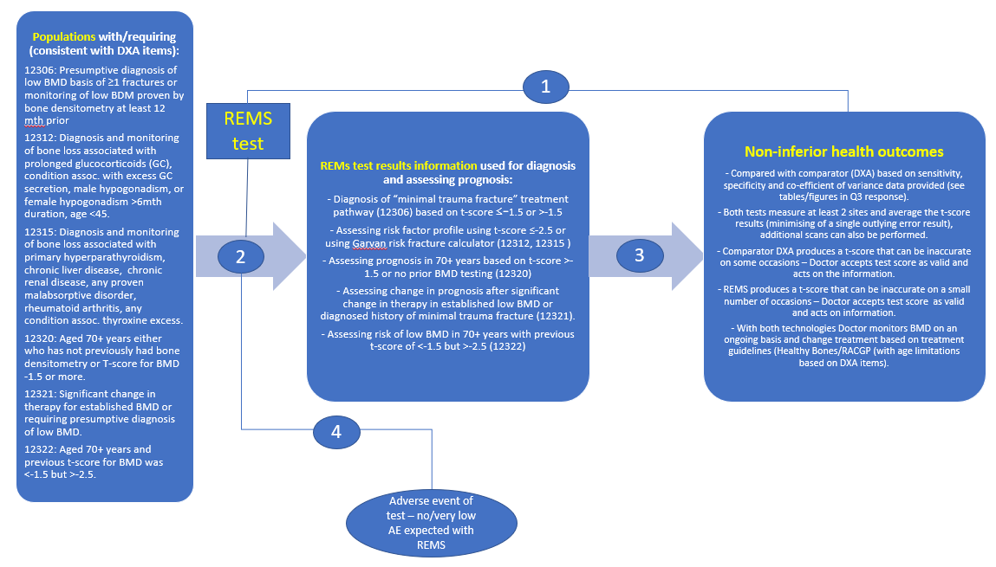
Figure 3 Proposed assessment framework
Source: Supplementary Figure 1, p4 of the information provided by the applicant following the pre-PASC meeting.

Clinical management algorithms
The applicant provided additional information that indicated that the clinical management pathway is sourced from the Healthy Bones Australia (formerly Osteoporosis Australia) position statement on the management of osteoporosis (February 2021).
PASC noted the clinical management algorithm and advised the only change to the algorithm will be the inclusion of REMS as an alternative to DXA.
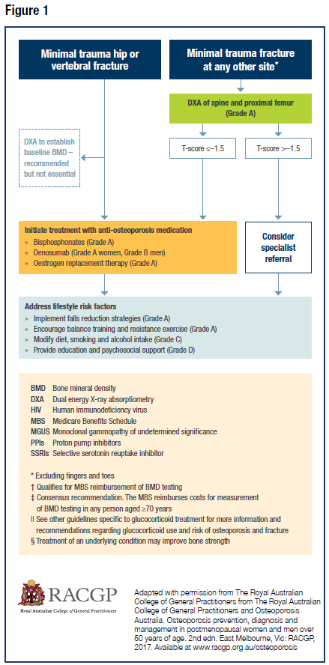
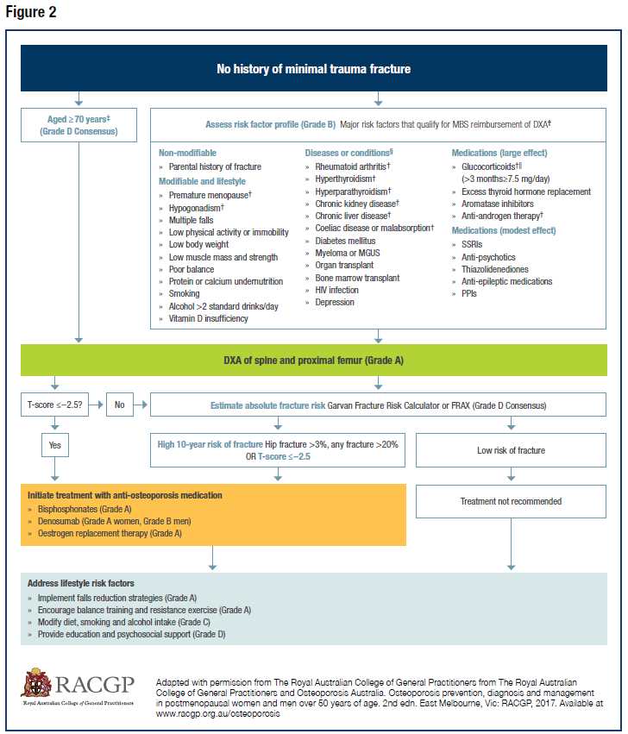
Figure 4 Proposed clinical management algorithm for osteoporosis risk assessment, diagnosis and management: for DXA and for REMS
Source: Figure 1 and Figure 2, p3 of the information provided for the pre-PASC meeting, sourced from February 2021 Healthy Bones Position Statement on the Management of Osteoporosis.
The application stated (p24) that all steps in the management pathway prior to the use of DXA scans would apply prior to use of REMS scans, as would the steps following a DXA scan. The application stated (p30) that patient management following use of a REMS scan is expected to be the same as following a DXA scan, as the same outputs used to determine treatment pathways are provided to clinicians. For example, following receipt of the T-score, clinicians may either monitor a patient, refer for specialist review or initiate treatment, depending on the clinical presentation (i.e. with or without minimal trauma fracture) and the T-score obtained.

Proposed economic evaluation
The application claimed REMS has non-inferior safety and effectiveness compared to DXA.
PASC noted that the applicant’s clinical claim is that REMS has non-inferior safety and effectiveness compared to DXA and on this basis considered the applicant’s proposal to undertake a cost-minimisation analysis to be appropriate.
Table 3 Classification of comparative effectiveness and safety of the proposed intervention, compared with its main comparator, and guide to the suitable type of economic evaluation
Comparative safety- |  | Comparative effectiveness
 | Inferior | Uncertainª | Noninferior^{b} | Superior
Inferior | Health forgone: need other supportive factors | Health forgone possible: need other supportive factors | Health forgone: need other supportive factors | ? Likely CUA
Uncertainª | Health forgone possible: need other supportive factors | ? | ? | ? Likely CEA/CUA
Noninferior^{b} | Health forgone: need other supportive factors | ? | CMA | CEA/CUA
Superior | ? Likely CUA | ? Likely CEA/CUA | CEA/CUA | CEA/CUA
CEA=cost-effectiveness analysis; CMA=cost-minimisation analysis; CUA=cost-utility analysis
? = reflect uncertainties and any identified health trade-offs in the economic evaluation, as a minimum in a cost-consequences analysis
ª ‘Uncertainty’ covers concepts such as inadequate minimisation of important sources of bias, lack of statistical significance in an underpowered trial, detecting clinically unimportant therapeutic differences, inconsistent results across trials, and trade-offs within the comparative effectiveness and/or the comparative safety considerations
^{b} An adequate assessment of ‘noninferiority’ is the preferred basis for demonstrating equivalence

Proposal for public funding
The application provided proposed items, which correspond to the current MBS items for DXA (MBS items 12306, 12312, 12315, 12320, 12321, 12322). The proposed item descriptors have been amended to include “or” and for “either DXA or REMS” when referring to monitoring in item 12306.
The information provided by the applicant following the pre-PASC meeting also stated that the re-scanning time period limitations (e.g. 12 months, 24 months or 5 years) should also be amended to apply to either technology. Thus, patients would be eligible for repeat scanning with either technology after the specified timeframe, not both technologies.
PASC indicated that the explanatory note DN1.18 may need alteration to accommodate REMS. PASC noted that for DXA, interpretation and reporting must be provided by a specialist or consultant physician in the practice of his or her specialty. PASC noted that the applicant claims any healthcare provider can be trained in REMS but it was unclear as to what requirement for quality assurance there will be for the operator’s qualifications for use of REMS. PASC also noted that when patients are unable to have a DXA, patients may be referred for a quantitative computed tomography scan. PASC queried whether this should this change to REMS being used instead.
PASC questioned whether there is a need for a new separate “failure to scan” item when either procedure fails due to patient or technical factors. PASC noted Departmental advice that separate items were preferred for DXA and REMS over a “failure to scan” item, with the item descriptors appropriately restricting the claiming of REMS with DEXA items and vice versa.
Category 2: Diagnostic Procedures and Investigations
MBS item 12306
Bone densitometry, using dual energy x-ray absorptiometry or radiofrequency echographic multi spectrometry, involving the measurement of 2 or more sites (including interpretation and reporting), for:
(a) confirmation of a presumptive diagnosis of low bone mineral density made on the basis of one or more fractures occurring after minimal trauma; or
(b) monitoring of low bone mineral density proven by bone densitometry at least 12 months previously by either dual energy x-ray absorptiometry or radiofrequency echographic multi spectrometry;
other than a service associated with a service to which item 12312, 12315, 12321 or tbc applies
For any particular patient, once only in a 24 month period by either dual energy x-ray absorptiometry or radiofrequency echographic multi spectrometry
Fee: $106.55 Benefit: 75% = $79.95 85% = $90.60
MBS item 12312
Bone densitometry, using dual energy x-ray absorptiometry or radiofrequency echographic multi spectrometry, involving the measurement of 2 or more sites (including interpretation and reporting) for diagnosis and monitoring of bone loss associated with one or more of the following:
(a) prolonged glucocorticoid therapy;
(b) any condition associated with excess glucocorticoid secretion;
(c) male hypogonadism;
(d) female hypogonadism lasting more than 6 months before the age of 45;
other than a service associated with a service to which item 12306, 12315, 12321 or tbc applies
For any particular patient, once only in a 12 month period by either dual energy x-ray absorptiometry or radiofrequency echographic multi spectrometry
Fee: $106.55 Benefit: 75% = $79.95 85% = $90.60
MBS item 12315
Bone densitometry, using dual energy x-ray absorptiometry or radiofrequency echographic multi spectrometry, involving the measurement of 2 or more sites (including interpretation and reporting) for diagnosis and monitoring of bone loss associated with one or more of the following conditions:
(a) primary hyperparathyroidism;
(b) chronic liver disease;
(c) chronic renal disease;
(d) any proven malabsorptive disorder;
(e) rheumatoid arthritis;
(f) any condition associated with thyroxine excess;
other than a service associated with a service to which item 12306, 12312, 12321 or tbc applies
For any particular patient, once only in a 24 month period by either dual energy x-ray absorptiometry or radiofrequency echographic multi spectrometry
Fee: $106.55 Benefit: 75% = $79.95 85% = $90.60
MBS item 12320
Bone densitometry, using dual energy x-ray absorptiometry or radiofrequency echographic multi spectrometry or quantitative computed tomography, involving the measurement of 2 or more sites (including interpretation and reporting) for measurement of bone mineral density, if:
(a) the patient is 70 years of age or over, and
(b) either:
(i) the patient has not previously had bone densitometry; or
(ii) the t-score for the patient's bone mineral density is -1.5 or more;
other than a service associated with a service to which item 12306, 12312, 12315, 12321, 12322 or tbc applies
For any particular patient, once only in a 5 year period by either dual energy x-ray absorptiometry or radiofrequency echographic multi spectrometry or quantitative computed tomography
Fee: $106.55 Benefit: 75% = $79.95 85% = $90.60
MBS item 12321
Bone densitometry, using dual energy x-ray absorptiometry or radiofrequency echographic multi spectrometry, involving the measurement of 2 or more sites at least 12 months after a significant change in therapy
(including interpretation and reporting), for:
(a) established low bone mineral density; or
(b) confirming a presumptive diagnosis of low bone mineral density made on the basis of one or more fractures occurring after minimal trauma;
other than a service associated with a service to which item 12306, 12312, 12315 or tbc applies
For any particular patient, once only in a 12 month period by either dual energy x-ray absorptiometry or radiofrequency echographic multi spectrometry
Fee: $106.55 Benefit: 75% = $79.95 85% = $90.60
MBS item: 12322
Bone densitometry, using dual energy x-ray absorptiometry or radiofrequency echographic multi spectrometry or quantitative computed tomography, involving the measurement of 2 or more sites (including interpretation and reporting) for measurement of bone mineral density, if:
(a) the patient is 70 years of age or over; and
(b) the t-score for the patient's bone mineral density is less than -1.5 but more than -2.5;
other than a service associated with a service to which item 12306, 12312, 12315, 12320, 12321 or tbc applies
For any particular patient, once only in a 2 year period by either dual energy x-ray absorptiometry or radiofrequency echographic multi spectrometry or quantitative computed tomography
Fee: $106.55 Benefit: 75% = $79.95 85% = $90.60
Source: MBS online with amendments to include REMS in blue text
tbc = to be confirmed
The pre-PASC response provided the following breakdown and justification of the proposed service fee:
- REMS technology available
- trained health care professional to conduct the service (20-25 minutes)
- a determination of BMD, T-score and Z-score at a minimum of two reference sites
- consulting/examination room within a clinic
- ultrasound gel
- generated report including confirmation of diagnosis
- confirmation and assessment by a trained medical practitioner (i.e. clinician experienced or has advanced training in bone disease) for interpretation.
The fee proposed by the applicant is the same as the fees for the current MBS items for DXA.

Summary of public consultation input
Consultation input was received from one (1) individual and seven (7) organisations:
- Australian and New Zealand Bone and Mineral Society (ANZBMS)
- Australian Diagnostic Imaging Association (ADIA)
- Australian Society of Medical Imaging and Radiation Therapy (ASMIRT)
- Australasian Association of Nuclear Medicine Specialists (AANMS)
- Australasian Sonographers Association
- Healthy Bones Australia (HBA)
- Royal Australian and New Zealand College of Radiologists (RANZCR).
Most organisations were not supportive of the application; however, the Australasian Sonographers Association and the individual supported the application. Organisations not supportive of the application however noted that REMS measurement of BMD may have potential use in settings where patients would not be able to easily access DXA.
Benefits
Most responses noted that the portability of the REMS device would allow easier access to BMD scans, such as for patients in nursing home or rural and remote communities. It was also noted that REMS is radiation free, but levels of radiation associated with a DXA scan are low.
The individual, a nurse educator, noted that REMS could offer greater flexibility for patients who are unable to lie completely supine for DXA scans, and would also provide greater consumer choice. It was also noted that test accuracy is important for consumer confidence when taking osteoporosis treatment is dictated by the BMD result. REMS would also have the potential for greater accuracy, as stated in trials.
Disadvantages
Organisations considered DXA the gold standard for BMD assessment and did not consider that the REMS technology had the same functionality as DXA. They noted the following disadvantages for the REMS technology, including:
- Discordant results between REMS and DXA scans in lumbar spine and femoral neck had been found in a significant percentage of patients.
- ANZMBS raised concerns that REMS may not obtain an adequate scan at the spine or hip in a significant number of subjects, especially in overweight patients, and the rate of unsuccessful scans may exceed 15% based on published studies.
- REMS scans are limited to two regions, being lumbar vertebrae L1-L4 and the femoral neck. ANZBMS considered a major limitation of REMS is the inability to estimate BMD for the Total Proximal Femur (TPF) region of interest, one of the main sites used in DXA, and the recommended ‘Gold standard’ site for monitoring the proximal femur. ANZBMS also queried the validity of the diagnostic claims for REMS given the studies have excluded TPF.
- REMS is not currently able to estimate BMD for the forearm (e.g. distal radius), a site commonly scanned using DXA to estimate BMD in patients with hyperparathyroidism.
- There is limited data on REMS to support its utility for men, for monitoring response to therapy and fracture risk, and for many of the conditions indicated, such as glucocorticoid induced osteoporosis and male hypogonadism.
- There is limited data for the REMS method on reference ranges used to calculate T- and Z-scores with no ability to change reference ranges in different racial populations with potential limitations in a multiracial society.
- DXA scans can be reviewed and retrospectively reanalysed, while REMS scans have no mechanism for retrospective review and cannot assess the accuracy of the scan after its acquisition.
- REMS scans may be less acceptable to patients, requiring the use of ultrasound gel on the abdomen and groin, with subsequent clean-up required at scan completion.
- In addition, concerns were raised that may take longer to perform a REMS scan than a DXA scan, and there may be a higher operator cost for REMS scans due to proposed staff and reduced patient throughput.
- ADIA noted that REMS is not performed in a radiology clinic and therefore the multimodality follow-ups which are often required for these cases, such as thoracic spine X-Rays for vertebral height loss, are not immediately available.
- RANZCR also considered that the model of service delivery (point of care) would lead to over-servicing of multiple patients at the same health care facility.
- The Australasian Sonographers Association noted that while DXA is undertaken by radiographers, sonographers may have a role in performing REMS.
- ADIA indicated that ultrasound investigations are very user dependent, noting challenges with repeatability and operator dependence, and expressed concern whether the training was sufficient.
- ADIA raised that there is insufficient information on which practitioner takes responsibility for the service and which clinician will be able to bill the service.
- ADIA raised that DXA currently forms part of comprehensive diagnostic imaging service with establish follow-up pathways and was concerned that the same has not been described for REMS creating a risk that REMS will be done in isolation leading to patients being missed or not followed up.
PASC noted the concerns raised in the consultation responses. PASC considered that the risk of over-servicing was an important point raised, particularly in aged care facilities. PASC suggested that consideration of the addition of appropriate use criteria for aged care could be included. PASC also queried how the risk of over-servicing due to portability of REMS will be considered by the applicant.

Next steps
PASC noted that the applicant intends to progress the application as an ADAR (applicant developed assessment report).

Applicant Comment on Ratified PICO Confirmation
Intervention
The applicant notes the inability of REMS to provide a BMD measurement for the total proximal femur. However, the applicant considers that the REMS total femur score ( a composite of the femoral neck and upper trochanter) can be considered equivalent to the total proximal femur measurement from DXA and will provide evidence to support this claim in the ADAR.
Outcomes / Summary of public consultation
Potential for over-servicing (under Australian Government Healthcare costs below):
This application is not seeking to expand the population for assessment of BMD, the target population is the same high-risk group that currently qualifies and are included within the MBS item numbers. The note regarding over-servicing may be more appropriately viewed as an under-diagnosed gap within the broader population that is not currently fully reached.
Furthermore, the reimbursed item number, 12306, is restricted to 1 referral claim within a 24 month time-period. That is, the same patient cannot receive multiple reimbursed scans within 24 months unless their indication changes. Regardless of venue of assessment, the item number can only be used once and cannot be claimed again. Therefore the notion that over-servicing will occur due to portability is unfounded.
Over-servicing was raised as a matter of particular interest in the aged care setting. The portability of the REMS device will lead to the appropriate assessment of a high-risk patient population. If a resident of the aged care facility does not qualify for reimbursement, the item number should not be claimed. However if there are patients that qualify but have not been able to access DXA for bone densitometry assessment then then use of the REMS device is appropriate and warranted.
Fixed associated costs with REMS are anticipated to be lower than DXA. In particular, DXA requires a dedicated room within a building and appropriate screening for operator protection and with structural reinforcement to allow for the provision of a hoist. These significant costs are not required for REMS. In addition, any operator or consumable costs would be similar or lower than DXA. Full costing details will be provided in the ADAR.

References
AIHW 2020. Report on osteoporosis; available at: https://www.aihw.gov.au/reports/chronic-musculoskeletal-conditions/osteoporosis/contents/what-is-osteoporosis.
Australian Bureau of Statistics (ABS) Microdata: National Health Survey, 2017-18, detailed microdata, DataLab. ABS cat no. 4324.0.55.001. Canberra: ABS.
Australian Bureau of Statistics (ABS) 2017–18 National Health Survey (NHS). Available at: https://www.abs.gov.au/statistics/health/health-conditions-and-risks/national-health-survey-first-results/latest-release
Better Health. Victoria State Government Department of Health. Available at: https://www.betterhealth.vic.gov.au/health/conditionsandtreatments/osteoporosis
Blake GM and Fogelman I. Technical principles of dual energy x-ray absorptiometry. Semin Nucl Med 1997; 27(3): 210-228.
Blake GM and Fogelman I. The role of DXA bone density scans in the diagnosis and treatment of osteoporosis. Postgrad Med J 2007; 83: 509-517.
Conversano F, Franchini R, Greco A et al. A novel ultrasound methodology for estimating spine mineral density, Ultrasound Med Biol 2015; 41(1): 281–300.
Echolight. See https://www.echolightmedical.com/technology/ and click on ‘Watch the demo’
Henry MJ, Pasco JA, Pocock NA, Nicholson GC, Kotowicz. Reference ranges for bone densitometers adopted Australia-wide: Geelong osteoporosis study. Australas Radiol 2004; 48(4): 473-475.
Healthy Bones Australia. Information on osteoporosis available at: https://healthybonesaustralia.org.au/your-bone-health/about-bones/. Information on DXA scans available at: https://healthybonesaustralia.org.au/osteoporosis-you/diagnosis/
International Atomic Energy Agency. Information available at: https://www.iaea.org/resources/rpop/health-professionals/other-specialities-and-imaging-modalities/dxa-bone-mineral-densitometry/patients.
Kanis JA, McCloskey EV, Johansson H, Oden A et al. A reference standard for the description of osteoporosis. Bone 2008; 42(3): 467-475.
Lewis MK, Blake GM and Fogelman I. Patient dose in dual x-ray absorptiometry. Osteoporos Int 1994: 4: 11-15.
Njeh CF, Fuerst T, Hans D, Blake GM, Genant HK. Radiation exposure in bone mineral density assessment. Appl Radiat Isot 1999; 50(1): 215-236.
Pisani P, Greco A, Conversano F, Renna MD et al. A quantitative ultrasound approach to estimate bone fragility: A first comparison with dual x-ray absorptiometry. Measurement 2017; 101: 243-249.
Royal Osteoporosis Society (ROS). Physical principles and measurement accuracy of bone densitometry. Available at: https://nos.org.uk/media/1725/02_physical_principles.pdf.
WHO Scientific Group On the Assessment of Osteoporosis at Primary Health Care Level. Summary meeting report, May 2004, Belgium. Available at: https://www.who.int/chp/topics/Osteoporosis.pdf

Attachment 1
The proposed training plan is outlined below. The applicant indicated that to ensure the correct and appropriate use of the equipment, the purchaser must ensure staff are trained in the use of the equipment. The training may be performed by the applicant or by the purchaser (‘train the trainer’ model).
- Pre-reading. A pack of materials, literature, slides and videos are provided for staff who are to be trained in the use of the equipment.
- Onsite training – Day 1
  - Bone architecture
  - What is osteoporosis and what is its impact on Australian society
    - Causes of osteoporosis
    - Treatments for osteoporosis
  - Current Australian guidelines
  - Common assessment of bone mineral density
    - DXA
    - Qualitative US
    - REMS technology
  - What is REMS
  - Understanding of T-Score, Z-Score, BMD (g/cm²)
    - Use of reference data sets to convert BMD to a T-score
    - Impact of age, BMI on T-scores
  - Fragility scoring – what is it, FRAX questionnaire
  - Having discussions with patients
    - Why should they have bone densitometry
    - When to manage within general practice and when to refer
    - Comorbidities which (may) complicate osteoporosis
- Onsite training – Day 2
  - Review the pre-reading pack, technology, and key features of the equipment
  - Software tuition
    - Logging in
    - Entering new patient details
    - Scan activation
    - Report review
    - Downloading reports
    - Report search functionality
  - Practice scanning – using phantom models
  - Demonstration scanning and practice on individuals
- Onsite training - Day 3
  - Recap of Day 1
  - Demonstration scanning and practice on individuals
  - Patient (or additional staff) scanning / practice
  - Troubleshooting
  - Key support contacts
  - Final observations and sign-off of clinic as competent and confident
- Echolight User Certification
  - A Cortex representative will assess the competence of the staff member. The format of this assessment will be advised at the commencement of Day 1 of Onsite Training. It may include verbal questions and the Cortex representative may observe the staff member using the Equipment. The assessment can occur face-to-face or via video.
  - The Cortex representative will immediately advise of the outcome of the assessment.
  - Cortex will email the staff member with their Echolight User Certification within 7 days of the date of the assessment.
- Remote follow-up training
  - If the training is conducted by Cortex, then follow-up / refresher training of up to 8 hours will be performed by Cortex upon request of the purchaser, such request to be made within 6 months of the commencement of the Cortex-led training.
Notes:
The training plan is subject to change.

Available at: https://www.osteoporosis.foundation/patients/diagnosis

