MSAC Application 1775
Newborn bloodspot screening for mucopolysaccharidosis, Type 1 (MPS I)
PICO Set 2

Population

Describe the population in which the proposed health technology is intended to be used:
MPS I is autosomal recessive, therefore, both parents of an affected newborn with two pathogenic variants can be assumed to be carriers, with a one in four chance that other offspring would also be affected. If the carrier status of one or both of the parents was confirmed, carrier testing of their direct relatives (e.g., siblings) may also be appropriate.
When a newborn is diagnosed with MPS I, it is proposed that cascade testing is offered to parents to allow for future reproductive planning.
Older siblings of the affected newborn may also be affected but, if born prior to the implementation of screening for MPS I as part of NBS, may not have yet presented with symptoms and remain undetected. It is proposed that these individuals would receive biochemical testing (urine GAG analysis). If this test is positive for MPS I, the sibling would be offered genetic testing. If the analysis returned a negative result, genetic testing to determine carrier status would not be offered.

Specify any characteristics of patients with the medical condition, or suspected of, who are proposed to be eligible for the proposed health technology, describing how a patient would be investigated, managed and referred within the Australian health care system in the lead up to being considered eligible for the technology:
Biological parents and older sibling(s) (born prior to the implementation of NBS for MPS I) of a newborn diagnosed with MPS I are eligible for the proposed health technology.

Provide a rationale for the specifics of the eligible population:
As an autosomal recessive condition, both parents of an affected newborn with two pathogenic variants can be assumed to be carriers, with a one in four chance that other offspring would also be affected.

Intervention

Name of the proposed health technology:
The proposed intervention is cascade testing for the biological parents (and where relevant, older sibling(s)) of babies diagnosed with MPS I as a result of NBS.

Describe the key components and clinical steps involved in delivering the proposed health technology:
The intervention for the parents of a newborn diagnosed with MPS I through NBS is cascade testing (for the specific familial pathogenic variants identified in the newborn) and genetic counselling for family planning. Siblings would only be offered biochemical testing (initially urine GAG analysis) if considered at risk of having MPS I. Cascade testing would only occur if the biochemical tests were positive for MPS I.
Cascade testing to determine the presence of specific pathogenic variants is usually conducted using targeted sequencing methods.
The number of parents tested may increase slightly if MPS I is currently underdiagnosed. Additionally, there may be some initial shift towards earlier cascade testing for some families if screening for MPS I is added to the NBS program.

Identify how the proposed technology achieves the intended patient outcomes:
Cascade testing of parents provides the value of knowing and helps to inform reproductive decision-making.
It may also support earlier diagnosis and management of affected siblings, who have not been screened for the condition as part of NBS.

Does the proposed health technology include a registered trademark component with characteristics that distinguishes it from other similar health components?
Yes
No

Explain whether it is essential to have this trademark component or whether there would be other components that would be suitable:
N/A

Are there any proposed limitations on the provision of the proposed health technology delivered to the patient (For example: accessibility, dosage, quantity, duration or frequency):
Yes
No

Provide details and explain:
N/A

If applicable, advise which health professionals will be needed to provide the proposed health technology:
Health professionals that would provide cascade testing are the same as per current practice, including genetic counsellors, clinical geneticists and laboratory scientists / geneticists.
Affected siblings would require referral to clinical services (see PICO set 1).

If applicable, advise whether delivery of the proposed health technology can be delegated to another health professional:
N/A

If applicable, advise if there are any limitations on which health professionals might provide a referral for the proposed health technology:
Cascade testing would require referral from a clinician following diagnosis of the affected newborn.

Is there specific training or qualifications required to provide or deliver the proposed service, and/or any accreditation requirements to support delivery of the health technology?
Yes
No

Provide details and explain:
Training and qualifications required to deliver cascade testing would be the same as current practice.

Indicate the proposed setting(s) in which the proposed health technology will be delivered:
Consulting rooms
Day surgery centre
Emergency Department
Inpatient private hospital
Inpatient public hospital
Laboratory
Outpatient clinic
Patient’s home
Point of care testing
Residential aged care facility
Other (please specify)
Cascade testing requires oversight by relevant health professionals.

Is the proposed health technology intended to be entirely rendered inside Australia?
Yes
No

Please provide additional details on the proposed health technology to be rendered outside of Australia:
N/A

Comparator

Nominate the appropriate comparator(s) for the proposed medical service (i.e., how is the proposed population currently managed in the absence of the proposed medical service being available in the Australian health care system). This includes identifying health care resources that are needed to be delivered at the same time as the comparator service:

Please provide a name for your comparator:
Cascade testing offered to the family members of presenting individuals diagnosed with MPS I.

Please provide an identifying number for your comparator (if applicable):
N/A

Please provide a rationale for why this is a comparator:
Currently, cascade testing is offered to parents after diagnosis of a symptomatic child within the hospital system.

Pattern of substitution – Will the proposed health technology wholly replace the proposed comparator, partially replace the proposed comparator, displace the proposed comparator or be used in combination with the proposed comparator?
None – used with the comparator
Displaced – comparator will likely be used following the proposed technology in some patients
Partial – in some cases, the proposed technology will replace the use of the comparator, but not all
Full – subjects who receive the proposed intervention will not receive the comparator

Please outline and explain the extent to which the current comparator is expected to be substituted:
Parents of an affected child would be offered cascade testing following diagnosis as a result of NBS, rather than at the point of symptomatic presentation.

Outcomes

List the key health outcomes (major and minor – prioritising major key health outcomes first) that will need to be measured in assessing the clinical claim for the proposed medical service/technology (versus the comparator):
Health benefits
- Improvement in clinical outcomes from an earlier diagnosis and intervention (for affected siblings)
Health harms
- Impact of diagnosing siblings with mild or benign forms of the condition that may not become symptomatic (overdiagnosis)
Resources
- Financial impact of cascade testing
  - Health care resources involved in testing and counselling
  - Diagnosis and management for an affected sibling
  - Total costs to health care system, including cost effectiveness
Other relevant considerations
- Value of knowing (for parents, siblings and broader family members, emotional benefits/harms to family, social benefits/harms to family)
- Accuracy of the test
- Ethical considerations (equity of access, notification of carrier status)

Outcome description – please include information about whether a change in patient management, or prognosis, occurs as a result of the test information
Cascade testing enables the parents to undertake informed reproductive planning and may support identification of affected but undiagnosed siblings.

Claims

In terms of health outcomes (comparative benefits and harms), is the proposed technology claimed to be superior, non-inferior or inferior to the comparator(s)?
Superior
Non-inferior
Inferior

Please state what the overall claim is, and provide a rationale:
Cascade testing may support improved outcomes if an affected sibling is identified through cascade testing, but this would be limited to a small number of cases. It also supports reproductive planning for parents, who are unaffected by the condition.

Why would the requestor seek to use the proposed investigative technology rather than the comparator(s)?
See rationale above.

Identify how the proposed technology achieves the intended patient outcomes:
Cascade testing of parents provides the value of knowing and helps to inform reproductive decision-making.
It may also support earlier diagnosis and management of affected siblings, who have not been screened for the condition as part of NBS.
For some people, compared with the comparator(s), does the test information result in:
A change in clinical management? Yes No
Affected siblings identified earlier would be able to receive clinical care before diagnosed clinically as a result of presenting with symptoms.
A change in health outcome? Yes No
Affected siblings identified earlier may receive earlier access to intervention, supporting improved health outcomes.
Other benefits? Yes No

Please provide a rationale, and information on other benefits if relevant:
The family can access support services such as genetic counselling and reproductive technologies for family planning. It may also shorten the diagnostic odyssey for affected siblings, who have not been screened for the condition as part of NBS.

In terms of the immediate costs of the proposed technology (and immediate cost consequences, such as procedural costs, testing costs etc.), is the proposed technology claimed to be more costly, the same cost or less costly than the comparator?
More costly
Same cost
Less costly

Provide a brief rationale for the claim:
Newborns with mild or benign cases who may have never been diagnosed clinically with MPS I in the absence of NBS may potentially be identified, meaning that their parents and siblings may receive cascade testing that would not have otherwise been offered.

Summary of Evidence
Provide one or more recent (published) high quality clinical studies that support use of the proposed health service/technology.
 | Type of study design | Title of journal article or research project | Short description of research | Website link to journal article or research | Date of publication
1. | Review | Cascade health service use in family members following genetic testing in children: a scoping literature review | Summarises published research on the patterns and costs of cascade health service use by relatives of children with any condition diagnosed through genetic testing. Cascade testing uptake was found to vary across diseases; from 37% in cystic fibrosis to 90% for rare monogenic conditions. Limited studies (n=2) evaluated costs. | https://www.nature.com/  articles/s41431-021-00952-4 | August 2021
2. | Review | Barriers and facilitators for cascade testing in genetic conditions: a systematic review | Provides the outcomes of a systematic review on the barriers and facilitators for the uptake of cascade testing by at-risk relatives, and categorised at the:  - individual level  - interpersonal level  - environmental level. | https://www.ncbi.nlm.nih.gov/  pmc/articles/PMC7784694/ | December 2020

Identify yet-to-be-published research that may have results available in the near future (that could be relevant to your application)
None identified

Algorithms
Preparation for using the health technology

Define and summarise the clinical management algorithm, including any required tests or healthcare resources, before patients would be eligible for the proposed health technology:
Diagnosis of MPS I in a child is required for the parents and siblings to access cascade testing (see PICO set 1).

Is there any expectation that the clinical management algorithm before the health technology is used will change due to the introduction of the proposed health technology?
Yes
No

Describe and explain any differences in the clinical management algorithm prior to the use of the proposed health technology vs. the comparator health technology:
N/A
Use of the health technology

Explain what other healthcare resources are used in conjunction with delivering the proposed health technology:
Health professionals that would provide cascade testing are the same as per current practice, including genetic counsellors, clinical geneticists and laboratory scientists / geneticists.
Affected siblings would require referral to clinical services (see PICO set 1).

Explain what other healthcare resources are used in conjunction with the comparator health technology:
Health professionals that provide cascade testing include genetic counsellors, clinical geneticists and laboratory scientists / geneticists.

Describe and explain any differences in the healthcare resources used in conjunction with the proposed health technology vs. the comparator health technology:
There may be an increase in healthcare resource use associated with the earlier diagnosis of affected siblings, and possible increase where cascade testing is offered to parents of newborns with mild / benign forms of the condition that would otherwise not be detected.
Clinical management after the use of health technology

Define and summarise the clinical management algorithm, including any required tests or healthcare resources, after the use of the proposed health technology:
Parents would access any services associated with counselling and family planning following the provision of cascade testing.
Siblings identified as being affected by MPS I would receive clinical care, as per the services outlined in PICO set 1.

Define and summarise the clinical management algorithm, including any required tests or healthcare resources, after the use of the comparator health technology:
Parents would access any services associated with counselling and family planning following the provision of cascade testing.

Describe and explain any differences in the healthcare resources used after the proposed health technology vs. the comparator health technology:
Resource use may be associated with the diagnosis and surveillance of siblings with mild / benign forms of MPS I identified as a result of cascade testing, who may not otherwise have been detected.
Algorithms

Insert diagrams demonstrating the clinical management algorithm with and without the proposed health technology:
Please see PICO set 1 for further details on these algorithms. Cascade testing components are indicated in the green boxes.

Current clinical management algorithm

Figure 1 Current clinical management algorithm
ART = assisted reproductive technology; CSF= cerebrospinal fluid; ERT = enzyme replacement therapy; DQ = developmental quotient; GAG = glycosaminoglycan; HSCT = hematopoietic stem cell transplantation; IDUA = α-L-iduronidase; LSD = lysosomal storage disorder; MPS I = mucopolysaccharidosis type I; uGAG = glycosaminoglycans detected in urine; VUS = variants of unknown significance.
Source: modified from Bay et al (2021), Fuller (2020), Muenzer et al (2009), Stapleton et al (2019)

Proposed clinical management algorithm
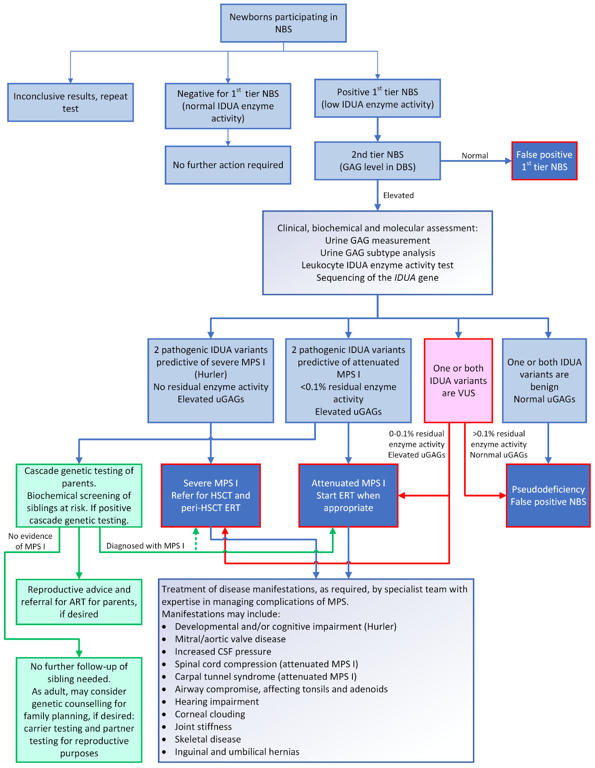
Figure 2 Proposed clinical treatment algorithm
ART = assisted reproductive technology; CSF= cerebrospinal fluid; DBS = dried blood spot; ERT = enzyme replacement therapy; GAG = glycosaminoglycan; HSCT = hematopoietic stem cell transplantation; IDUA = α-L-iduronidase; NBS = newborn bloodspot screening; MPS I = mucopolysaccharidosis type I; uGAG = glycosaminoglycans detected in urine; VUS = variants of unknown significance.
Source: modified from Costello Medical (2019), Bay et al (2021), Fuller (2020), Muenzer et al (2009), Stapleton et al (2019)

