RATIFIED PICO
MSAC Application 1629:

Defensive Antibacterial Coating (DAC) 5ml Kit

Summary of PICO criteria to define the question(s) to be addressed in an Assessment Report to the Medical Services Advisory Committee (MSAC)
Component | Description
Patients | Patients at risk of periprosthetic deep surgical site infection (SSI) when undergoing surgery with orthopaedic implant procedure(s). The applicant nominated 4 surgical populations for the prevention (primary, secondary) of deep periprosthetic SSI, categorised by the type and indication of the surgical arthroplasty procedure(s):  - Patients undergoing an elective primary joint implant at increased risk of infection due to the presence of comorbidities (ASA score ≥3; and BMI > 30; and Cementless Components)  - Patients undergoing elective megaprosthesis implantation or elective major revision of joint implants for indications other than periprosthetic infection, including total joint revision, tumour removal and reconstruction  - Patients undergoing surgery for periprosthetic infection with implant replacement  - Patients undergoing open reduction and internal fixation:  Subgroup 1: Closed fracture with comorbidities (ASA score ≥3; and BMI > 30)  Subgroup 2: Open fracture
Intervention | Total joint arthroplasty (TJA) with one or two kits of Defensive Antibacterial Coating (DAC®) 5 ml hydrogel applied to the surface of the implanted device.
Comparator | Standard surgery: TJA without DAC
Outcomes | Safety  - Adverse events attributed to DAC; Procedural complications; Post-operative complications (e.g. amputation); Allergies associated with DAC  Clinical/therapeutic effectiveness outcomes  Clinical outcomes  - Incidence of surgical site infection (SSI); Recurrence of SSI; Incidence of mortality due to SSI and all causes; incidence of bacteraemia, septicaemia and septic shock; Incidence of early and late post-operative infection-related morbidity; Wound healingª; Clinical scores^{b}. Implant revision or permanent removal. Long-term antibiotic administration (potentially requires a central line)  Imaging outcomes  - Osteolysis or progressive (>2mm) radiolucent lines around the implant  - Implant loosening or subsidence  Health-related quality of life  - Quality of life measures (e.g. standardised tools such as EQ-5D or SF-36)  Healthcare system  - Cost of treatment, revision surgery, extended antibiotic courses and cost of treating adverse events  - Total cost to Medicare Benefits Schedule due to hospital treatment for complications of infections; Total cost to Australian Government budgets  Cost-effectiveness  - Cost per life-year gained; cost per quality-adjusted life year (QALY) gained; incremental cost-effectiveness ratio (ICER)
ª As detailed in Malizos et al. (2017), wound healing could be assessed at 7 and 14 days using the ASEPSIS score, described by Wilson
et al. [1]. The delayed wound could be assessed based on whether there is incomplete healing of the wound after 4 weeks from surgery, including the presence of wound dehiscence, necrosis or serum leakage. The presence of these conditions may need further medication but may not require any additional surgical treatment.
^{b} Clinical scores could be obtained using several outcome measures, including Charnley Hip Score, Oxford Hip and Knee Scores, Harris Hip Score, Hospital for Special Surgery Knee Score, Knee Society Score, Oxford shoulder scores, Disabilities of the Arm Shoulder and Hand questionnaire as appropriate.
Abbreviations: ASA: American Society of Anaesthesiologists; BMI: body mass index; EQ-5D: EuroQol-5 Dimension scale; SF-36: Short Form 36 health survey; TJA: total joint arthroplasty
PICO rationale for therapeutic medical services only

Population
The population for whom the proposed medical service is intended includes patients who are at risk of periprosthetic deep surgical site infection (SSI) when undergoing orthopaedic implant procedure(s). The Application seeks listing of Defensive Antibacterial Coating (DAC) 5ml Kit on the Prostheses List.
The applicant nominated 4 surgical populations (which were amended during preparation of the PICO) for the prevention (primary, secondary) of deep periprosthetic SSI, categorised by the type and indication of the surgical arthroplasty procedure(s):
- Patients undergoing an elective primary joint implant at increased risk of infection due to the presence of comorbidities
- Patients undergoing elective megaprosthesis implantation or elective major revision of joint implants for indications other than periprosthetic infection, including total joint revision, tumour removal and reconstruction
- Patients undergoing surgery for periprosthetic infection with implant replacement
- Patients undergoing open reduction and internal fixation.
PASC considered that, for population 4, open reduction and internal fixation (ORIF) is generally not elective, so populations 4a and 4b should be combined into a single population. PASC also advised that the application should specify appropriate subgroups, joints or surgical procedures that would benefit, to help narrow this population.
Subsequently, the applicant suggested the following subgroups for population 4. Patients with:
- any open fracture and;
- the same co-morbidity stratification as population 1.
The World Health Organisation (WHO) 2016 Guidelines define SSIs as an infection that occurs within 30 days after the operation and involves the skin and subcutaneous tissue of the incision (superficial incisional) and/or the deep soft tissue (for example fascia, muscle) of the incision (deep incisional) and/or any part of the anatomy (for example, organs and spaces) other than the incision that was opened or manipulated during an operation (organ/space) [2]. SSIs remain the most common healthcare associated infection, with an incidence of up to 2.5% after primary hip and knee arthroplasty and 10% following revision surgery [3]. PASC noted that deep SSIs are serious adverse event of arthroplasty and that interventions are needed to reduce SSI rates.
Periprosthetic joint SSIs are complications after arthroplasty, most commonly occurring during implantation and are attributed to endogenous skin flora or exogenous sources from the operation site [4]. They are typically caused by microorganisms that thrive in biofilms, within which microorganisms form a complex and organised structure, resembling multicellular organisms [5]. The Application noted the following risk factors for such infections: obesity, diabetes mellitus, use of disease-modifying antirheumatic drugs, rheumatoid arthritis, immunosuppressed state, malignancy, American Society of Anaesthesiologists (ASA) score ≥3 (severe systemic disease), colonisation with Staphylococcus aureus, previous arthroplasty or other surgery of the same joint, history of prior prosthetic joint infection, arthroplasty for management of fracture, prolonged procedure duration, and contaminated or dirty surgical site (p14 of the Application).
Periprosthetic joint SSIs could manifest either early (mostly within the first four weeks after implantation) or with a delay (typically between three months and three years) [6]. Early infections are identified with local and systemic signs of inflammation and are generally caused by high-virulent pathogens, such as Staphylococcus aureus, enterococci and streptococci). Delayed infections are manifested with more chronic symptoms, such as joint pain and early loosening and are mostly caused by low-virulent organisms, such as coagulase-negative staphylococci or species related to Cutibacterium.
A staging system, which was defined in McPherson et al. (2002) [7], can be used to stage periprosthetic joint infections using three categories to stage the infection in the host:
- Infection type: I (early post-operative infection; < 4 weeks post-operative), II (haematogenous infection; < 4 duration) or III (late chronic infection; >4 weeks duration)
- Systemic host grade (medical and immune status): A (uncompromised), B (compromised), or C (significant compromise)
- Local wound or extremity grade: 1 (uncompromised), 2 (compromised), or 3 (significant compromise) (see Table 1 in Appendix).
The pivotal RCTs by Romano et al. (2016) and Malizos et al. (2018) report the systemic host grade (medical and immune status) in patients at baseline [3, 8].
MSIS criteria can be used to confirm the presence of periprosthetic joint infection among patients undergoing surgery [9]:
- Major criteria: 2 positive periprosthetic cultures with phenotypically identified organisms or a sinus tract communicating with joint, or
- Minor criteria (having 3 of 5 criteria below):
  - Elevated serum C-reactive protein (CRP) AND erythrocyte sedimentation rate (ESR)
  - Elevated synovial White Blood Cell (WBC) count OR ++ change on leukocyte esterase test strip
  - Elevated synovial fluid polymorphonuclear neutrophil percentage (PMN%)
  - Positive histological analysis of periprosthetic tissue
  - A single positive culture.
Two case control studies by Capuano et al. (2018) [10] and Zagra et al. (2019) [11] and an upcoming RCT (NCT04251377) used MSIS criteria to define the patients having periprosthetic joint infection (see Table 2).
Periprosthetic joint SSIs are associated with increased perioperative morbidity, mortality, length of stay, cost of hospital care and the requirement for additional procedures to address the infection [12]. They could also lead to the need for revision surgery and extended antibiotic courses [4]. The implications of periprosthetic joint SSIs can be broadly categorised under two sets of factors: clinical factors, characterised by high risks of morbidity and mortality, and economic factors, characterised by the substantial costs to the healthcare system [13] (p14 of the Application).
A systematic review by Lum et al. (2018) reported that patients undergoing total knee replacement had an SSI-related post-operative one-year mortality rate of 4.33%, which rose to 21.64% at five years [14]. The odds of death after total knee periprosthetic joint infections was 3.05, adjusting for age. Patients surviving SSIs may often be debilitated by infection-related morbidity, leading to decreased quality of life. An Australian study by Cahill et al. (2008) showed that patients with SSIs after total joint replacement experienced significantly poorer satisfaction in both outcome and diminished quality of life, mainly in terms of pain, stiffness, ability to live independently and their mental health [15]. These results were robust even after controlling for age, sex, and follow-up period using multiple regression analysis [15].
Clinical and quality of life consequences of periprosthetic joint SSIs are particularly pronounced in already compromised patients, such as those having a tumour that requires major revision arthroplasty and a megaprosthesis [16]. There is a chance of high reinfection rate among these patients, which could result in the loss of the limb or even death [16].
The cost implications of remediating of periprosthetic joint SSIs could be substantial, given the high clinical and disease burden. An Australian study by Peel et al. (2013) estimated the median cost of treating prosthetic joint infection to be Australian $34,800 per patient. Costs would further increase substantially if the initial surgery is not successful, resulting in further surgical (revision) and/or lengthy treatment procedures [17].
As life expectancy continues to grow in Australia and elsewhere, the incidence of periprosthetic joint SSIs could increase further with the rise in the number of joint surgeries, particularly those related to hip and knee [18, 19]. This could have considerable economic implications on the healthcare system.
Incidence
In 2018, around 122,500 joint replacement procedures were conducted in Australia [20]. Between 2013-2018, a total of 2,073 patients (i.e. 0.9% out of 299,699 procedures) received revisions of primary total knee replacement in Australia as a result of infection, while 1,093 revisions (i.e. 0.7% of 180,722 procedures) took place for total hip replacement [20].
The Application noted that overall periprosthetic joint SSI is a relatively rare adverse outcome with an incidence rate of around 2% (p19 of the Application). This percentage is comparable to the overall incidence rate of 1.7% in the Australian population, as reported in the literature [21]. However, the incidence rate for periprosthetic deep joint SSI only could be much lower than 2%. A systematic review by Urquhart et al. (2010) reported that the incidence of deep SSI following primary total hip arthroplasty ranged from 0.2% before discharge to 1.1% for the period up to and including five years post-surgery [22].
Utilisation estimates
The Application estimated that less than 100 patients would utilise DAC 5ml kit in the first year (p19 of the Application). The Application also mentioned that less than 500 patients were anticipated to utilise it over the next three years (p19 of the Application). There is uncertainty regarding which population among the 4 applicant nominated surgical populations would be the largest. During the preparation of the PICO, the applicant indicated that the estimated number of patients utilising DAC 5ml kit (initial and three years following the initial year) in Australia was based on the rates of uptake of DAC in the European Union. The applicant also indicated that the utilisation pattern in Australia would be similar to the one in European Union. The applicant should provide relevant references to support these claims.
PASC considered that the applicant’s estimate of the size of the proposed population and sizes of subpopulations was uncertain and needed to be clarified in the assessment phase. This uncertainty in part was related to the broadly defined patient populations, in particular population 1, which could have a potentially large eligible population given the large numbers (~80%) of total knee joint replacements and total hip replacements performed on the MBS (see Table 1). PASC noted the applicant’s advice indicating that the infection rate for population 1 would be approximately 1% for all comers.
In its response, the applicant considered the primary population size could be further defined by the Australian Orthopaedic Association National Joint Replacement Registry (AOANJRR). The applicant noted that in the primary joint population, DAC is only compatible with cementless or hybrid fixation components. The applicant considered this was relevant as over 70% of primary knee replacements are fully cemented and therefore would not be indicated for DAC. Additionally, The AOANJRR reported approximately 36% and 38% of primary total hip and total knee implant patients have an ASA score of 3 or higher. Similarly the BMI > 30 segment of the total hip and total knee population is only 39% and 58% respectively. This would be relevant to the estimates, if as proposed by the applicant (see page 10), eligibility for DAC was limited to patients with an ASA score of 3 or above and Obese Class 1. The applicant noted that if all three criteria would need to be met for DAC to be used, the eligible primary joint population is likely to be 10% of the overall population.
Since the Application did not present an epidemiological approach estimating the expected utilisation of the DAC 5ml kit over the next three years, the size of the eligible patient population between 2016 and 2019 was investigated using MBS items provided in the Application year (Table 1). The Application provided the following 19 MBS item numbers: 49318, 49319, 49324, 49327, 49330, 49333, 49336, 49346, 49509, 49512, 49517, 49518, 49527, 49530, 49533, 50215, 50218, 50224, 50227 (p17 of the Application). The eligible patients for DAC could be considered to be those who access one of the 19 MBS-subsidised services for orthopaedic surgical procedures (hip, knee arthroplasty procedures, and orthopaedic procedures for tumour indications), and at risk of developing deep SSI.
Table 1: MBS Utilisation of 19 MBS items provided in the application form over 2016-19
MBS item | Description | Number of services used in each financial year
 |  | 2016/  2017 | 2017/  2018 | 2018/2019
49318 | Hip, total replacement arthroplasty of, including minor bone grafting (anaes.) (assist.) | 18,289 | 19,040 | 19,270
49319 | Hip, total replacement arthroplasty of, including associated minor grafting, if performed - bilateral (anaes.) (assist.) | 304 | 344 | 342
49324 | Hip, total replacement arthroplasty of, revision procedure including removal of prosthesis (anaes.) (assist.) | 1,112 | 1,071 | 1,158
49327 | Hip, total replacement arthroplasty of, revision procedure requiring bone grafting to acetabulum, including obtaining of graft (anaes.) (assist.) | 473 | 476 | 493
49330 | Hip, total replacement arthroplasty of, revision procedure requiring bone grafting to femur, including obtaining of graft (anaes.) (assist.) | 232 | 266 | 224
49333 | Hip, total replacement arthroplasty of, revision procedure requiring bone grafting to both acetabulum and femur, including obtaining of graft (anaes.) (assist.) | 297 | 334 | 336
49336 | Hip, treatment of a fracture of the femur where revision total hip replacement is required as part of the treatment of the fracture (not including intra-operative fracture), being a service associated with a service to which items 49324 to 49333 apply (anaes.) (assist.) | 237 | 178 | 242
49346 | Hip, revision arthroplasty with replacement of acetabular liner or ceramic head, not requiring removal of femoral component or acetabular shell (anaes.) (assist.) | 196 | 175 | 168
49509 | Knee, total synovectomy or arthrodesis with synovectomy if performed (anaes.) (assist.) | 2,817 | 3,216 | 3,418
49512 | Knee, arthrodesis of, with synovectomy if performed, with removal of prosthesis (anaes.) (assist.) | 9 | 17 | 22
49517 | Knee, hemiarthroplasty of (anaes.) (assist.) | 2,321 | 2,731 | 2,688
49518 | Knee, total replacement arthroplasty of (anaes.) (assist.) | 25,886 | 26,131 | 26,545
49527 | Knee, total replacement arthroplasty of, revision procedure, including removal of prosthesis (anaes.) (assist.) | 1,824 | 1,949 | 2,057
49530 | Knee, total replacement arthroplasty of, revision procedure, requiring bone grafting to femur or tibia, including obtaining of graft and including removal of prosthesis (anaes.) (assist.) | 351 | 297 | 330
49533 | Knee, total replacement arthroplasty of, revision procedure, requiring bone grafting to both femur and tibia, including obtaining of graft and including removal of prosthesis (anaes.) (assist.) | 445 | 516 | 600
50215 | Malignant or aggressive soft tissue tumour affecting the long bones of leg or arm, enbloc resection of, with compartmental or wide excision of soft tissue, with intercalary reconstruction (prosthesis, allograft or autograft) (anaes.) (assist.) | 21 | 27 | 19
MBS item | Description | Number of services used in each financial year
 |  | 2016/  2017 | 2017/  2018 | 2018/2019
50218 | Malignant tumour of long bone, enbloc resection of, with replacement or arthrodesis of adjacent joint, with synovectomy if performed (anaes.) (assist.) | 87 | 87 | 101
50224 | Malignant or aggressive soft tissue tumour of pelvis, sacrum or spine; or scapula and shoulder, enbloc resection of, with reconstruction by prosthesis, allograft or autograft (anaes.) (assist.) | 60 | 52 | 50
50227 | Malignant bone tumour, enbloc resection of, with massive anatomic specific allograft or autograft, with or without prosthetic replacement (anaes.) (assist.) | 14 | 20 | 14
Total MBS services |  | 54,975 | 56,927 | 58,077
Source: Compiled during the preparation of the PICO for the MSAC Application 1629 based on Medicare data [23].
MBS items in the table were based on the Application (p17 of the Application)
Abbreviations: MBS: Medicare Benefits Schedule; MSAC: Medical Services Advisory Committee
For the utilisation to remain within 500 in the first three years using the MBS utilisation data from 2016-19, the incidence rate of periprosthetic joint deep SSI would have to be around 0.30%, which is within the incidence rate reported in the systematic review by Urquhart et al. (2010). It could be that the proportion of patients fulfilling the Applicant-listed conditions would be around 0.30% of overall services as provided in Table 1. However, this is uncertain, owing to the lack of relevant data. Thus, this estimate will need to be refined and validated in the assessment report. Table 1 could provide useful information to help estimate the size of the eligible patient population.
The Application mentioned that the risk of leakage, i.e. use of DAC in patients outside the target population, was anticipated to be close to zero, given the relatively rare incidence of deep SSIs (p19 of the Application). The four groups proposed in the Application are patients with increased risk of developing deep SSIs. The at-risk population could be larger than the population who develop disease. Leakage is possible through the definition of eligible at-risk patients.

Rationale
The patient populations which have been included in published studies in periprosthetic joint SSI prevention and treatment are summarised in Table 2. During preparation of the PICO, these studies were grouped according to the predominant proposed patient populations in this application, noting that there were multiple populations included in some of the studies. For example, it was noted that the predominant population in Romano et al. (2016) was patients receiving primary surgery (71.1%) and with compromised immune status (65.5%), which would align to population 1 [3]. Regarding the definition of comorbidities in Romano et al. (2016), it was considered that compromised immune status might relate to comorbidities, either due to inherited disorders of immunity (small proportion of all patients); or acquired causes, e.g. diabetes, smoking cancer long-term steroids, immunosuppressants etc.); however, comorbidities were not reported as baseline characteristics in the trial, but were reported for those who had complications.
PASC considered that the comorbidities for increased infection risk would be relevant for all proposed populations, not just population 1. The applicant considered it would be inappropriate to limit the use of DAC in populations 2 and 3, noting that they are much smaller and well-defined populations, with significantly high infection rates regardless of comorbidities and high risk of infection.
PASC noted that the rate of infection would be approximately 1% of all knee/hip replacements. Given that infection is often unpredictable, PASC advised that the application should include evidence-based information to define which patients are at increased risk of infection in population 1, including the strength of association between defined comorbidities and infection risk. PASC noted the applicant’s advice indicating there are many publications reporting on this association, which would be important for inclusion in the assessment phase.
Romano et al. (2016) also recruited those who were undergoing revision surgery for infection, which would align with population 3. PASC noted for population 3, the applicant’s response to the draft PICO considered that most patients receiving an implant replacement with DAC for infection would be with a one-stage revision procedure which is generally semi-elective and planned. Thus, PASC agreed to remove ‘elective’ from the definition of population 3.
Patients in Zoccali et al. (2019) received a megaprosthetic implant coated with DAC and would align with population 2 [24]. PASC confirmed for population 2, DAC would be used for all patients receiving a megaprosthesis or revision, not just patients at higher risk of infection. PASC noted the applicant’s advice indicating that population 2 would have the highest infection rate of up to 25% (relative to other proposed populations), but would be the smallest subpopulation. Surgical procedures for malignancy represented approximately 0.3% of surgical procedures provided on MBS in 2018/19 (see Table 1).
Patients included in Capuano et al. (2018) [10], Zagra et al. (2019) [11] and an upcoming RCT (NCT04251377) received two-stage revision surgeries with implant replacement and would thus align with population 3. Malizos et al. (2017) recruited patients with a fresh (<7 days) closed fracture requiring surgical reduction and internal fixation with either a metal plate and/or screws or with an intramedullary nail, which would align with population 4 [8]. Malizos et al. (2017) also assessed treatment and control population at baseline for imbalance in terms of morbidities. Additionally, the study recorded morbidities among patients with SSI, including nicotine and alcohol abuse, diabetes, old age, peripheral vasculopathy, severe rheumatoid arthritis, and corticosteroid therapy. Thus, patients in Malizos et al. (2017) would also align with population 1.
PASC noted that the patient populations were complex, and that as defined, populations 1 and 4 were large and diverse. PASC advised that “comorbidities” in population 1 (e.g. obesity, diabetes mellitus, immunosuppression and malignancy) should be further defined, including a condition-specific scoring measure, if possible, to help define the population. PASC noted the applicant’s advice indicating that the AOANJRR only collected ASA, BMI and height; functional outcomes were not collected. However subsequent to this, it was established that publications on infections are available through the AOANJRR’s website.
The applicant proposed a scoring method that utilises the AOANJRR data for defining population 1. The applicant proposed that eligibility for DAC usage in the setting of primary de novo joint arthroplasty should be limited to patients with an ASA score of 3 or above and Obese Class 1 or above and cementless components. They considered this criterion was supported by large systematic reviews (Kunutsor et al (2016)).
Table 2: Descriptions of patient populations for DAC in periprosthetic joint SSI prevention in published studies
Study type | Study identifier | Patient population
Population 1 |  | (also includes some patients in population 3)
Prospective, multicentre, randomised control trial | Romano et al. (2016) | 380 patients undergoing Primary or revision surgery randomised to DAC or No DAC –  Treated group: N=189; male 42.9%; mean age (SD)=69yr (12.6); McPherson host class B 65.6% (compromised immune status), class C 10.6%; undergoing revision surgery for infection 28.2% (26.6% by 2-stage procedure).  Control group: N=184; male 40.2%; mean age (SD)=71yr (10.6); McPherson host class B 69.0%, class C 7.6%; undergoing revision surgery for infection 28.3% (26.1% by 2-stage procedure).  Inclusion criteria: need for a cementless or hybrid (partially cemented) total hip or knee prosthesis and age>18 years.  Exclusion criteria: pregnancy, breast-feeding or planning to become pregnant during the study period, the presence of an active infection at the site of surgery, severe malignancies with a life expectancy of less than 3 months, previous diagnosis of immune depression or immunosuppressive treatment for organ  transplantation, known allergy to the antibiotics or the DAC hydrogel constituents, unwillingness or inability to present for follow-up examinations or refusal to sign the informed consent documents or inability to do so.  Note, comorbidities were reported in patients who had complications.

Population 2
Consecutive Case Series* | Zoccali et al. (2019) | Forty-seven consecutive patients in three Centres received a megaprosthetic implant coated with Antibacterial-Loaded Hyaluronan Based Gel following tumour resection and limb salvage surgical procedure. Sites were Distal Femur (n=17) and Proximal Femur (n=19).
Population 3
Case-control study. | Capuano et al. (2018) | 22 cases undergoing 1-stage exchange hip or knee procedures, using cementless (hip) or partially cemented (knee) implants coated with DAC, matched for age, sex, infection site and host type with 22 controls undergoing 2-stage exchange hip or knee procedures, using cementless (hip) or partially cemented (knee) implants without DAC. Cases: 9 male, 13 female; mean age 71.3 ± 13.6yr; McPherson host class B+C 86.4%; revision for septic hip 22.7%, for septic knee 77.3%; 1st-stage MRSA population 52.1%.  Controls: 9 male, 13 female; mean age 71.9 ± 8.3yr; McPherson host class B+C 81.8%; revision for septic hip 22.7%, for septic knee 77.3%; 1st-stage MRSA population 30.4%.  Inclusion criteria cases: one stage revision for delayed or late prosthetic knee or hip infection as defined by MSIS criteria.  Exclusion criteria cases: lack of pre-operative identification of pathogen, large-soft tissue defects preventing skin closure or patient refusal to undergo a 1-stage approach.  Inclusion criteria controls: peri-prosthetic knee or hip infection as defined by MSIS criteria treated with 2-stage procedure, using a preformed antibiotic-loaded spacer and a cementless or hybrid revision implant without DAC.
Case-control study. | Zagra et al. (2019) | 27 cases undergoing 2-stage exchange hip procedure using cementless implants coated with DAC matched for age and host type with 27 controls without DAC operated on in the same time period.  Inclusion criteria: delayed or late peri-prosthetic hip infection as defined by MSIS criteria, treated with 2-stage procedure and a cementless revision implant.  Exclusion criteria: large soft-tissue defects; previous failed revision for infection.  Cases: 11male, 16 female; mean age 63.9 ± 11.7yr; McPherson host class B 70.4%, class C 25.9%; 1st-stage explant MRSA population 18.5%.  Controls: 14 male, 13 female; mean age 64.8 ± 10.1yr; McPherson host class B 81.5%, class C 14.8%; 1st-stage explant MRSA population 18.5%.
NCT04251377 | Primary completion date: 2022  Final completion date: 2024 | Selected inclusion criteria: aged >18 years chronic periprosthetic hip joint infection as defined by MSIS criteria; 2 positive periprosthetic cultures with phenotypically identified organisms or a sinus tract communicating with joint, or having 3 of 5 minor criteria: elevated CRP and ESR, elevated synovial WBC count or change of ++ on leukocyte esterase test strip; elevated synovial fluid PMN (%); positive histological analysis of periprosthetic tissue; a single positive culture.  Selected exclusion criteria: hypersensitivity to hydrogel components, pregnancy or positive pregnancy test, life expectancy <3 months, expected use of a cemented implant by the surgical team.
Population 4
Prospective, multicentre, randomised control trial | Malizos et al. (2017) | Randomised 256 patients over 18yr with a fresh (<7 days) closed fracture requiring surgical reduction and internal fixation with either a metal plate and/or screws, or with an intramedullary nail to DAC or No DAC.  Treated group: N=126; male 42.1%; mean age (SD)=62.5yr (12.6); McPherson host class B 48.4%, class C 4.0%; major fracture sites=femur 37.3%, ankle/foot 25.4%, forearm/wrist 11.1%.  Control group: N=127; male 44.9%; mean age (SD)=58.6yr (17.6); McPherson host class B 41.7%, class C 3.1%; major fracture sites=femur 25.2%, ankle/foot 22.8%, forearm/wrist 22.8%.  Inclusion criteria: presence of a fresh (<7 days) closed fracture requiring ORIF with either a metal plate and/or screws in patients aged>18 years.  Selected exclusion criteria: pregnancy, breastfeeding or planning pregnancy, presence of previous or active infection at site of fracture, severe malignancies with life expectancy< 3 months, previous diagnosis of immune depression (including HIV) or immune suppressive treatment for organ transplantation, known allergy to antibiotics or DAC.
Source: Compiled from Table provided on pp6-10 of the Application and additional information extracted from publications
*Zoccali et al. (2019) is not a peer-reviewed paper but a conference abstract. The full text was not available.
Abbreviations: CRP: C-reactive protein; DAC: Defensive Antibacterial Coating; ESR: Erythrocyte Sedimentation Rate; MRSA: Methicillin-resistant Staphylococcus aureus; MSIS: Musculoskeletal Infection Society Criteria; PMN: Polymorphonuclear; SD: Standard deviation; WBC: White Blood Cell
Two randomised controlled trial (RCTs) by Romano et al. (2016) and Malizos et al. (2017) restricted the use of DAC in periprosthetic joint SSI to patients over 18 years (at the date of study inclusion) [3, 8]. Further, Romano et al. (2016) included patients with “the need for a cementless or hybrid (partially cemented) total hip or knee prosthesis” [3]. The Application did not explicitly mention these conditions for a patient to be eligible to receive DAC. Thus, the restrictions based on age and the extent of cement needed for the prosthesis is not clear. Additionally, the use of DAC in Romano et al. (2016) is limited to hip or knee prosthesis. Compared to this, the Application proposed the use of DAC in all possible joint prostheses associated with 19 MBS items, provided they are at risk of periprosthetic joint SSIs (p17 of the Application).
The Application did not mention conditions when DAC would not be applicable. Romano et al. (2016) and Malizos et al. (2017) excluded patients with: pregnancy, breastfeeding or planning to become pregnant during the study period, the presence of an active infection at the site of surgery, severe malignancies with a life expectancy of fewer than 3 months, previous diagnosis of immune depression or immunosuppressive treatment for organ transplantation, known allergy to the antibiotics or DAC hydrogel constituents, unwillingness or inability to present for follow-up examinations or refusal to sign the informed consent documents or inability to do so [3, 8]. Information regarding the eligibility of the patient population for DAC should be presented in the assessment report.
Patient management, including diagnostic workup
The diagnostic workup of the proposed population might include the following tests:
- Laboratory investigations: Serum tests (to detect Erythrocyte sedimentation rate (ESR),
C-reactive protein, full blood count, blood clotting, and liver and kidney function markers) and synovial fluid microscopy
- Histopathological testing to detect acute inflammation in the periprosthetic tissue
- Microbiological testing of blood, skin or deep tissue, including the culture of synovial fluid
- Radiological testing, including magnetic resonance imaging (MRI), positron emission tomography (PET) scans.
It was noted in one of the pivotal RCT (Romano et al. (2016)) all patients underwent pre-operative clinical, radiographic and laboratory test examinations [3].
The applicant indicated that currently, prophylaxis against joint infection is provided by the use of systemic antibiotics (p.15 of application form).

Intervention
Defensive Antibacterial Coating (DAC®) 5 ml kit is a sterile, single-use, Class III medical device designed for the preparation and application of a bioresorbable hydrogel coating to prevent peri-implant infection due to both Gram-positive and -negative genera of aerobic and anaerobic bacteria during and after total joint arthroplasty (TJA). This co-dependent Application is also being considered by the Prostheses List Advisory Committee (PLAC). The applicant for this MSAC Application is Novagenit® Australia Pty Ltd, a distributor for Novagenit® Italy.
DAC is composed of two bioresorbable polymers: hyaluronic acid (HA) and polylactic acid. HA is a natural polysaccharide that exists in all living organisms and is the main constituent of the extracellular matrix in human connective tissue. Surfaces coated with HA have less bacterial adherence and growth [25]. Polylactic acid is a synthetic polymer made from renewable sources (e.g. corn) and is entirely biodegradable.
DAC hydrogel is supplied as a dry powder, to be reconstituted into a hydrogel at the time of surgery and applied immediately to the surface of the implanted device. Sterile water is to be used but not saline solutions. When coated to an implant surface, DAC hydrogel acts as a temporary physical barrier against bacterial adhesion and colonisation of the surface [26]. The applicant reported that complete absorption of the hydrogel would occur within 72 hours after application and therefore would not adversely impact on osseointegration or the bone healing process [27]. PASC queried whether DAC should be used only for cementless prostheses; however, this was considered to be difficult to classify and had uncertain relevance to the outcomes.
The applicant confirmed that they recommend limiting DAC to cementless and hybrid primary implants, which have available surfaces for loading DAC for surgeons who have chosen this fixation. The applicant noted that megaprostheses have large exposed surface areas available for DAC loading, regardless of the stem fixation method, making DAC appropriate for use in both a cemented or cementless megaprostheses.
Infection prophylaxis may be further reinforced by rehydrating DAC hydrogel powder with a solution of water for injectable preparations containing antibiotics; provided it is deemed appropriate by the treating surgeon. It is not clear whether further training and quality assurance programs are required to be developed to assist in the application of DAC. PASC noted the applicant’s response to the draft PICO stating that no training is required to use DAC.
The applicant reported that antibiotics (not included in DAC kit) and DAC are compatible [28]. Several potential antibiotics, including gentamicin, vancomycin, daptomycin, meropenem, rifampicin, and ciprofloxacin were suggested in the literature [29]. Among them, daptomycin and meropenem are not PBS-listed, but rather restricted to hospital use only. However, it is not clear what antibiotics would be appropriate to use with DAC. During the preparation of the PICO, the applicant indicated that the choice of antibiotics depends on hospital settings and cause of infection. The applicant also noted that vancomycin, gentamicin and cefazolin were among three of the most used antibiotics in the Australian context. It was noted that in the pivotal RCT by Romano et al. (2016), the predominant systemic prophylaxis was cefazolin (48.2%), and the predominant loading of DAC with antibiotic was with vancomycin (52.9%) and gentamicin (37.0%) [3].
DAC is currently being evaluated for registration by the Therapeutic Goods Administration (TGA). The following information was provided by the applicant regarding the registration process on the Australian Register of Therapeutic Goods (ARTG) by the TGA (p5 of the Application):
Date of submission to TGA: 31/10/2019
Estimated date by which TGA approval can be expected: July 2020
TGA Application ID: DV-2019-CA-17985-1
TGA approved purpose(s): The product is especially indicated in orthopaedic and traumatology as a preventive measure against bacterial adhesion, colonisation and biofilm formation (which is a cause of bacterial infections) on implant surface in the very early time window after implantation.
However, the actual proposed TGA indication is not clear. The intended purpose for DAC as mentioned in the TGA website under the “Medical devices (including IVDs) designation notices” topic was as follows: “Indicated in orthopaedy, traumatology and dentistry as a preventative measure against bacterial adhesion, colonisation and biofilm formation” [30]. The intended purpose mentioned on the TGA website and the TGA indication suggested by the Application slightly differ, given that dentistry is specified on the TGA website only. The applicant should clarify whether dentistry is a part of the proposed TGA indication.
A DAC 5 ml kit is for the preparation of 5 ml hydrogel DAC. It includes the following sterile components: a) a syringe containing 300 mg of dry product, (b) a complete set of DAC parts (connector, backstop and spreader) and (c) an empty graduated 10 ml syringe. Kits to make other quantities of hydrogel DAC are also available: 2, 5, 10 or 15 ml for orthopaedic purposes; or 1 or 2 ml for dentistry purposes. The current Application is for the 5 ml kit only. The applicant stated that DAC would be applied at the time of surgery, and an average patient is unlikely to receive it more than once (p19 of the Application). PASC noted that DAC could be used more than once over time (e.g. for revisions) but considered it was appropriate to limit use to once per procedure. PASC noted advice from the applicant that the predominant use would be a single DAC 5 mL kit, but that megaprostheses (population 2) would typically require two kits. PASC advised that the costs for using two kits for megaprostheses should be included in the application. PASC noted the applicant’s advice that the AOANJRR would be an informative source to estimate DAC utilisation for megaprostheses.
The applicant estimated that one third of all patients would require a single DAC 5mL kit and two thirds would require two kits.
During the preparation of the PICO, the applicant stated that the DAC 5 ml kit has been approved in the European Union. However, no documentation or reference was suggested in this regard.
In addition to the information provided in the application form, guidelines relating to SSI prevention from World Health Organisation [2], National Institute for Health and Care Excellence (NICE) [31, 32] and Asia Pacific Society of Infection Control (APSIC) [33], as well as proceedings of international consensus [34, 35], were reviewed for information relevant to this PICO. The current guidelines and consensus reports deal mostly with antibiotic prophylaxis, wound irrigation and intracavity lavage, and antiseptics and antibiotics usage and not necessarily with the application of antibacterial coatings on the surface of implants, such as DAC.

Rationale
The description of the proposed intervention as provided in the included peer-reviewed studies noted that DAC hydrogel was prepared intra-operatively according to the manufacturer’s indications. Additionally, there was no major difference across studies regarding the procedure of hydrogel administration on implants prior to implantation. A common procedure was followed by directly spreading hydrogel onto the implant, which was then inserted into the body by the surgeons. There was some variation to how DAC was used with surgery, noting in population 3, DAC was used in a 1-stage approach (1-stage exchange hip or knee procedure) in Capuano et al. (2018) [10], and DAC was used in a 2-stage approach (2-stage exchange hip procedure) in Zagra et al. (2018) [11].
PASC noted that the benefits of DAC could be different depending on the type of revision surgery (1 or 2-stage revision surgery). The applicant advised that one-stage revision can only be performed if causative organism for infection is identified, and no bone loss or sinus; the minority would have a two-stage revision surgery. PASC also noted DAC would be used for primary prevention of deep SSIs for all populations except population 3, which would be for secondary prevention.
Subsequently, the applicant advised that they do not have evidence to suggest two stage procedures are the minority and their clinical expert reported that he almost exclusively uses two stage procedures.
There was also some variation across the studies regarding the type of antibiotics used with DAC. For example, in Romano et al. (2016) and Malizos et al. (2017), the randomised studies, the surgeons could choose the antibiotic from among a list of antibacterials previously tested as being compatible with the hydrogel, including gentamicin, vancomycin, daptomycin, meropenem, rifampicin, and ciprofloxacin [3, 8]. In the case-control study by Capuano et al. (2018), DAC hydrogel was loaded with vancomycin 5% in 14 patients (63.3%) and with a combination of vancomycin 5% and meropenem 5% in 8 patients (27.4%) [10]. Similarly, Zagra et al. (2019) included vancomycin and meropenem as the antibiotics of choice, although teicoplanin, ceftazidime and rifampicin were also used [11]. In comparison, the Application noted that “… DAC powder may also be reconstituted with an aqueous solution of an appropriate antibiotic …” (p2 of the Application). During the preparation of the PICO, the applicant noted that vancomycin, gentamicin and cefazolin were among three of the most used antibiotics in the Australian context. The applicant should refine the list of antibiotics that would be more applicable in the Australian context, given that not all antibiotics used in studies above, including daptomycin and meropenem, are PBS-listed. PASC also advised that the application should clarify which antibiotics are compatible with DAC.
The applicant advised that vancomycin and gentamicin have been the most commonly used antibiotics in Australia to date. The applicant further noted that teicoplanin, meropenem and daptomycin are not applicable in the Australian setting.

Comparator
The applicant nominated standard surgery (i.e. TJA without DAC), as the comparator. Thus, the use of DAC would be in addition (or adjunct) to standard surgery. It was noted that the choice of surgical intervention (including perioperative management) will be individualised for each patient within the proposed populations. PASC accepted the proposed comparator of surgery without DAC.
The application provided a list of 19 surgical items that could be claimed for surgical procedures performed without DAC, within the nominated patient populations (see Table 1).
The applicant considered that the use of DAC is likely to reduce periprosthetic deep joint SSIs, which would result in a reduced need for post-infection management procedures, including the treatment of acute and chronic infections. This will have implications in the current management procedures and resources required to manage periprosthetic deep joint SSIs.

Rationale
Both randomised studies (Romano et al. (2016) and Malizos et al. (2017)) as well as case control studies (Capuano et al. (2018) and Zagra et al. (2019)) included ‘surgery without DAC’ as the comparator [3, 8, 10, 11]. Thus, the comparator considered in these studies was consistent with the one suggested in the Application.
The economic evaluation by Trentinaglia et al. (2018) compared the cost-effectiveness of three antibacterial technologies applied to joint arthroplasty: [(COPAL gentamicin(G) + clindamycin(C)], DAC, and a silver coating (Agluna)] [36]. Only COPAL G + C has been registered by the TGA. Agluna has not yet been considered in the Australian context as it is not yet TGA registered nor included on the Prostheses List.

Outcomes
The applicant nominated outcomes related to safety and clinical effectiveness only (p18 of the Application). However, the list of outcomes could be expanded to include a range of outcomes associated with the use of DAC to prevent periprosthetic deep SSI. PASC accepted the proposed outcomes.

Patient relevant
Safety outcomes
The Application suggested that the safety outcomes with DAC are due to the abolition of, or reduction in, the risk of SSI and the sequelae associated with the post-infection management procedures necessary (p18 of the Application). However, these are most appropriately classified as clinical effectiveness outcomes. The applicant did not list any particular safety outcomes. During the preparation of the PICO, the applicant indicated that no apparent DAC-related safety outcomes were observed in practice to date. However, the following safety outcomes could be considered:
- Adverse events attributed to DAC
- Procedural complications related to the application of DAC hydrogel during surgery
- Post-operative complications (e.g. amputation)
- Incidence of SSI
- Recurrence of SSI
- Incidence of mortality due to SSI and all causes
- Incidence of bacteraemia, septicaemia and septic shock
- Incidence of early and late post-operative infection-related morbidity
- Wound healing; Clinical scores
- Implant revision or permanent removal
- Long-term antibiotic administration (potentially requires a central line).
PASC agreed with the applicant who did not consider that the incidence of drug resistance or multidrug-resistance should be an outcome in the application, because this is often the result of prolonged use, whereas DAC provides a high, short-lived minimum inhibitory concentration.
In addition to clinical outcomes, the following imaging outcomes assessed on radiographic examination in pivotal RCT by (Romano et al. (2016)) could also be required to understand the full benefit of the intervention [3]:
- Osteolysis or progressive (>2mm) radiolucent lines around the implant (as a rule of thumb, periprosthetic lucencies >2 mm and/or progressive lucencies signal abnormality) [37]
- Implant loosening or subsidence.
However, noting the potential limitations associated with whether imaging outcomes are valid surrogate outcomes for assessing patient-relevant outcomes. PASC noted that although imaging may identify potential infection during the acute period, over time similar radiographic changes can also been seen due to aseptic loosening.

Healthcare system
Healthcare system-related outcomes have not explicitly been discussed in the Application. However, the introduction of a new intervention will certainly have an impact on the Australian healthcare system and should, therefore, be investigated. Thus, the following financial outcomes should be included: cost of treatment, cost of treating adverse events, costs of revision surgery and extended antibiotic courses. Additionally, total cost of MBS due to hospital treatment of complications of infections and total cost of Australian Government budget should also be incorporated.

Rationale
Health-related quality of life should be included as an outcome but has not explicitly been discussed in the Application. Quality of life measures could include standardised tools such as EuroQoL-5 dimension (EQ-5D) or Short Form-36 (SF-36).
The inclusion of health-related quality of life outcomes would aid in conducting cost-effectiveness analyses of DAC. Among the studies provided by the Applicant, Malizos et al. (2017) and Capuano et al. (2018) measured health-related quality of life using the SF-12 questionnaire [8, 10]. SF-12 can be mapped to EQ-5D, which can be used to provide estimations of quality‐adjusted life years (QALY) gained [38]. Cost-effectiveness could be expressed in terms of the following: Cost per life-year gained, cost per QALY gained, incremental cost-effectiveness ratio (ICER).

Current and proposed clinical management algorithms
PASC advised that further clinical input was required to refine the clinical management algorithms. PASC noted this would be performed by the Department and verified with the applicant and assessment group post PASC. Figure 1 and 2 below were updated post-PASC accordingly.
Post-PASC, the applicant provided current (without DAC) and proposed (with DAC) management algorithms for each proposed population. For population 1 (Figure 1) and population 2 (Figure 2) the management pathways are the same; for population 3 (Figure 3) the management pathways are largely the same as for populations 1-2, with the exception that no infection would not be an option following surgery without/with DAC, given the population was those with pre-existing infection; and for Population 4 (Figure 4) the management pathways were more unique.
The Application noted that the current clinical management of joint infection is prophylaxis through the use of systemic antibiotics (p15 of the Application). For each population, the flowchart begins with patients undergoing surgery without or with DAC (green box or yellow box). Following surgery without or with DAC, post-surgery deep SSI may occur which could be either acute or chronic, or no infection could be present (not an option for population 3 with pre-existing infection). PASC noted the applicant’s comment on the draft pre-PASC PICO that in the algorithm for patients without pre-existing infection, that ‘no infection’ should be included as an outcome after surgery.
For populations 1-3, acute infection can be bacteraemia, septicaemia or septic shock. Acute infection can be treated using a debridement and systemic antibiotics with implant retention of fixed components and replacement of exchangeable components (DAIR). DAIR patients receive post-operative antibiotics “for a number of days” (p17 of the Application). Unsuccessful DAIR patients (i.e. persistent post-op infection) or chronic infections could be treated with antibiotic suppression therapy (e.g. if unsuitable to undergo a revision surgery due to high surgical risk) or with either a two-stage or one-stage revision (without or with DAC).
As per the algorithms, DAC can be used more than once over time (e.g. for revisions after failure of surgery with DAC). A two-stage revision involves the removal of all infected tissue, washouts utilising antibacterial agents, followed by the reimplantation of an antibiotic-loaded cement spacer device. These procedures are accompanied by six weeks of systemic antibiotics (i.e. post-operative management) until infection markers are acceptable to re-enter the joint and implant a new medical device (p17 of the Application). If two-stage revision fails this could lead to further 2-stage revision; if further 2-stage revision fails this could lead to additional surgery, including amputation. A one-stage revision involves the removal of all components, debridement, pulse lavage and antibacterial washes with systemic antibiotic loading before implantation. Given that the process could lead to the removal of the infected devices, the use of new devices will be required. If one-stage revision fails, this could lead to two-stage revision.
The treatment algorithms also incorporates health outcomes including possible morbidity and death at different stages of treatment.
The definitions of “failure” after one-stage and two-stage revisions are not clear. The applicant should also refine the list and dosing of systemic antibiotics used to treat deep SSIs in the Australian context.
For population 4, if the fracture is healed the metal work is removed and antibiotics are given; if the fracture does not heal antibiotic suppression therapy might be required which if successful will result in the removal of the metal work and antibiotics are given; if antibiotic suppression therapy is unsuccessful than a 2-stage procedure might be done involving debridement removal of metal, possible external fixation, possible antibiotics spacer and intravenous antibiotics. If the infection is successfully treated following 2-stage procedure, the fracture may heal resulting in no further treatment or may not heal and result in repeat ORIF and bone graft with or without DAC. Amputation is performed if there is unsuccessful treatment or recurrent infection following 2-stage procedure.
Proportions related to acute and chronic infections will need to be quantified for the economic evaluation, given that chronic infections could lead to additional costs and deterioration in patient health-related quality of life. Similarly, proportions of patients moving from one-stage revision to further one-stage revision or two-stage revision and from two-stage to further surgery, including amputations need to be estimated for the economic analysis.
For the full assessment, potential downstream services that are currently required during the management of both acute and chronic deep SSIs should be considered, as they could be associated with high costs.
The Application stated that the use of DAC “will abolish, or very least reduce, the need for current management procedures and resources required to manage surgical site infection” (p17 of the Application). Thus, the only difference between the current and the proposed clinical management algorithm would be surgery with DAC (green or yellow boxes) in the algorithms. The Application claimed that the proportion of patients with deep SSIs after surgery with DAC will be very low, given the ability of DAC to prevent infections. It also indicated that patients would receive post-operative treatment of infections using systemic antibiotics (usual care) if patients develop deep SSI.
The Application indicated that an average patient would receive DAC only once. However, in conditions where the use of DAC has failed to prevent infection in the first attempt, it is not clear whether the procedure involving DAC will be implemented during the reimplantation of prostheses. The applicant estimated that one third of all patients would require a single DAC 5mL kit and two thirds would require two kits.

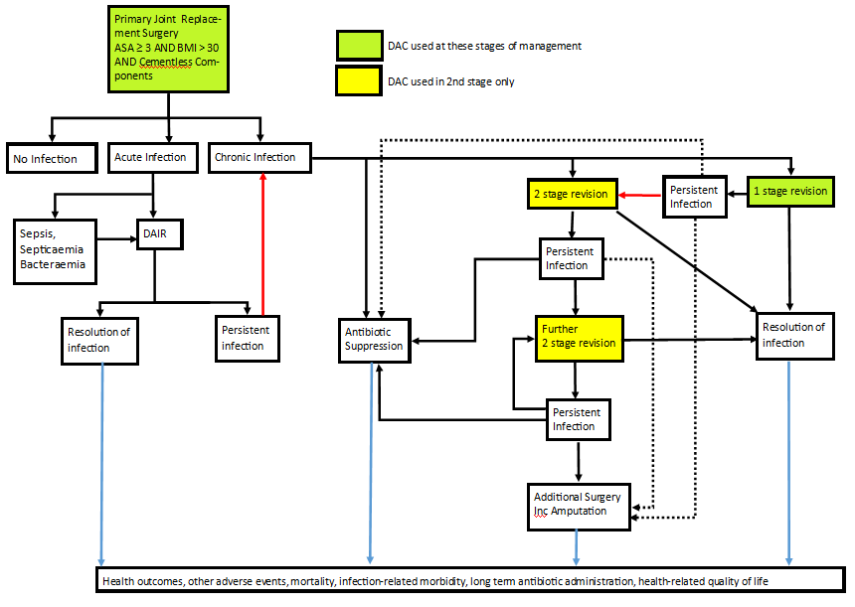
Figure 1: Current and proposed clinical management pathway of primary prevention of periprosthetic deep surgical site infection: Population 1
Source: Prepared by the applicant Post PASC in response to draft Pre-PASC PICO algorithms drafted by Department in consultation with AG. It incorporates the description provided in the Application (p17 of the Application)
Acronyms: DAC: Defensive Antibacterial Coating; DAIR: Debridement and Implant Retention; SSI: Surgical Site Infection
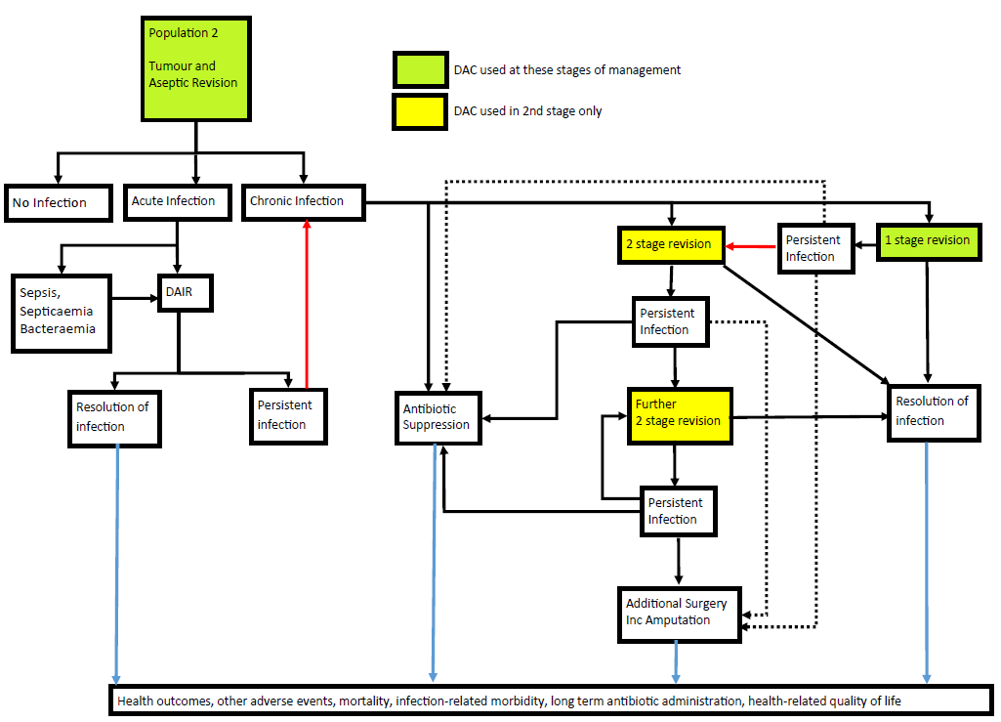
Figure 2: Current and proposed clinical management pathway of primary prevention of periprosthetic deep surgical site infection: Population 2
Source: Prepared by the applicant Post PASC in response to draft Pre-PASC PICO algorithms drafted by Department in consultation with AG. It incorporates the description provided in the Application (p17 of the Application)
Acronyms: DAC: Defensive Antibacterial Coating; DAIR: Debridement and Implant Retention; SSI: Surgical Site Infection
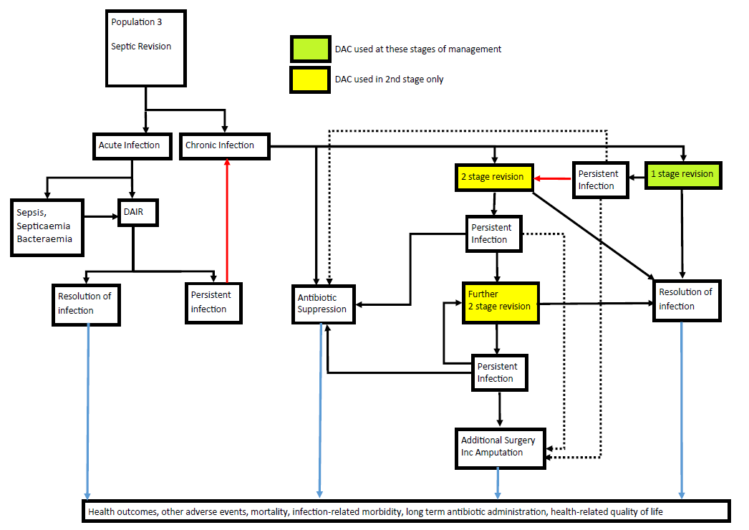
Figure 3 Current and proposed clinical management pathway of primary prevention of periprosthetic deep surgical site infection: Population 3
Source: Prepared by the applicant Post PASC in in response to draft Pre-PASC PICO algorithms drafted by Department in consultation with AG. It incorporates the description provided in the Application (p17 of the Application)
Acronyms: DAC: Defensive Antibacterial Coating; DAIR: Debridement and Implant Retention; SSI: Surgical Site Infection
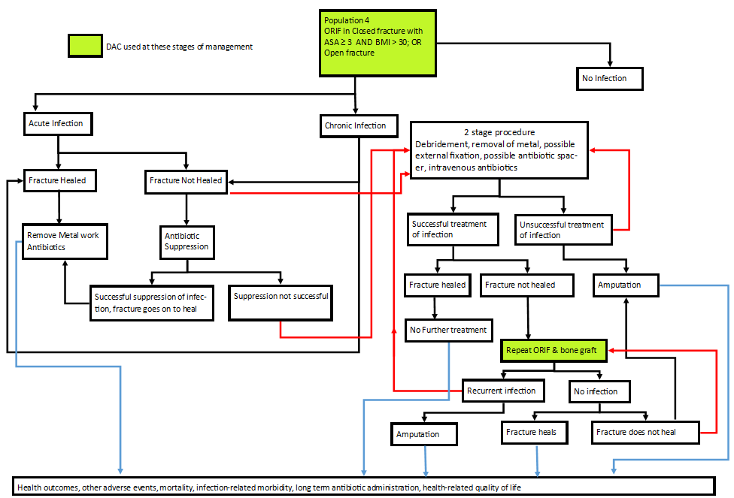
Figure 4: Current and proposed clinical management pathway of primary prevention of periprosthetic deep surgical site infection: Population 4
Source: Prepared by the applicant Post-PASC in response to draft Pre-PASC PICO algorithms drafted by Department in consultation with AG.
Acronyms: DAC: Defensive Antibacterial Coating; DAIR: Debridement and Implant Retention; SSI: Surgical Site Infection

Proposed economic evaluation
During the preparation of the PICO, the applicant indicated that the use of DAC to reduce periprosthetic deep SSI is likely to be superior compared with the current standard of care, i.e. standard surgery without DAC. Studies included by the applicant to substantiate their clinical claims are summarised in Table 3, which will be assessed in the assessment phase.
Table 3: Summary of current clinical evidence for periprosthetic joint infection with DAC
 | Study type | Study identifier | Key outcomes results
1. | Prospective, multicentre, randomised control trial, N=380 | Romano et al. (2016) | - Patients in the DAC group had 1 early SSI compared with 11 in the control group  (0.6% vs. 6%; p=0.003)  - No local or systemic side effects related to DAC hydrogel coating  - No detectable interference with implant osteointegration noted
2. | Prospective, multicentre, randomised control trial, N=253 | Malizos et al. (2017) | - Patients in the DAC group had 0 SSIs compared with 6 in the control group (0% vs. 4.6%, p<0.03)  - No local or systemic side effects related to DAC hydrogel coating  - No detectable interference with bone healing noted
3. | Case-control study, (N=22 retrospective matched cases and controls) | Capuano et al. (2018) | - Patients in the DAC group had two infection recurrence (9.1%) compared with three in the control group (13.6%) [two-stage results]
4. | Case-control study (N=27 retrospective matched cases and controls) | Zagra et al. (2019) | - Patients in the DAC group did not result in infection, implant loosening, AEs  - Four cases of infection recurrence in the control group
5. | Consecutive Case Series (N was not clear) | Zoccali et al. (2019) | - No deep or organ space infections were seen in the post-operative follow-up following the use of DAC  - No intraoperative complications related to the use of DAC
Source: Compiled during the preparation of the PICO based on studies suggested by the Application.
Acronyms: AE: Adverse Event; DAC: Defensive Antibacterial Coating; SSI: Surgical Site Infection
No economic evaluations assessing the use of DAC to reduce periprosthetic deep SSI reduction versus standard practice were provided in the Application. A study by Trentinaglia et al. (2018) evaluated the potential overall annual healthcare cost savings of 3 different antibacterial technologies applied to joint arthroplasty in the European healthcare context: a dual-antibiotic-loaded bone cement [COPAL G+C, DAC, and Agluna] [36]. When considering a relatively high-risk population of patients with 5% expected post-surgical infection rate, COPAL G + C and DAC hydrogel would provide annual direct cost savings of approximately €48,800,000 and €43,200,000, while the use of silver coating would lead to an economic loss of €136,000,000.
While the cost results in Trentinaglia et al. (2018) tend to show that the use of antibacterial coatings, including DAC, might be cost-saving, the results do not reflect the actual cost-effectiveness of those interventions, due to the incremental health outcomes have not been captured together with the incremental costs. More robust economic outcomes, such as those expressed in terms of incremental cost per QALY gained may be required to conclude that surgery with DAC is considered cost-effective compared with standard surgery (without DAC).
Since the applicant indicated that the comparative clinical claim is likely to be superior effectiveness for functional outcomes, cost-effectiveness or cost-utility analysis would be appropriate.
PASC confirmed that a cost-effectiveness or cost-utility analysis would be appropriate.

Proposed item descriptor
The Application is for a listing of DAC 5ml kit on the Prostheses List, to be used in conjunction with existing MBS items. Public funding is not sought for DAC. As such, no new MBS items were proposed. PASC confirmed that no new MBS item is proposed.

Consultation feedback
PASC noted the supportive consultation feedback received from one specialist society and one patient advocacy group:
1. The Specialist Society highlighted the burden of infection in patients receiving megaprostheses in immunosuppressed populations, noting infection rates have been stable over time despite modern improvements. This feedback also considered lower infection rates could thereby reduce overall health costs.
2. The patient advocacy group highlighted the high consumer distress associated with joint replacement procedures. This feedback also considered the potential benefits was a reduced risk of infection (such as deep SSIs) for patients having major joint replacement surgery which would be particularly relevant for those with other comorbidities. This feedback also highlighted the potential disadvantage was the high cost of the product.
The applicant welcomed the consultation feedback.

Next steps
PASC advised that, upon ratification of the post-PASC PICO, the application can proceed to the Evaluation Sub-Committee (ESC) stage of the MSAC process.
PASC noted the applicant has elected to progress its application as a DCAR (Department-contracted assessment report).

References
1. Wilson, A., et al., A scoring method (ASEPSIS) for postoperative wound infections for use in clinical trials of antibiotic prophylaxis. The Lancet, 1986. 327(8476): p. 311-312.
2. Organization, W.H., Global guidelines for the prevention of surgical site infection. 2016: World Health Organization.
3. Romanò, C.L., et al., Does an antibiotic-loaded hydrogel coating reduce early post-surgical infection after joint arthroplasty? Journal of bone and joint infection, 2016. 1: p. 34.
4. Kapadia, B.H., et al., Periprosthetic joint infection. The Lancet, 2016. 387(10016): p. 386-394.
5. Costerton, J.W., P.S. Stewart, and E.P. Greenberg, Bacterial biofilms: a common cause of persistent infections. Science, 1999. 284(5418): p. 1318-1322.
6. Zimmerli, W., A. Trampuz, and P.E. Ochsner, Prosthetic-joint infections. New England Journal of Medicine, 2004. 351(16): p. 1645-1654.
7. McPherson, E.J., et al., Periprosthetic total hip infection: outcomes using a staging system. Clinical Orthopaedics and Related Research®, 2002. 403: p. 8-15.
8. Malizos, K., et al., Fast-resorbable antibiotic-loaded hydrogel coating to reduce post-surgical infection after internal osteosynthesis: a multicenter randomized controlled trial. Journal of Orthopaedics and Traumatology, 2017. 18(2): p. 159-169.
9. Kunutsor, SK., et al., Patient-Related Risk Factors for Periprosthetic Joint Infection after Total Joint Arthroplasty: A Systematic Review and Meta-Analysis. PLoS ONE, 2016. 11(3): p 11-14
10. Parvizi, J. and T. Gehrke, Definition of periprosthetic joint infection. The Journal of arthroplasty, 2014. 29(7): p. 1331.
11. Capuano, N., et al., One-stage exchange with antibacterial hydrogel coated implants provides similar results to two-stage revision, without the coating, for the treatment of peri-prosthetic infection. Knee Surgery, Sports Traumatology, Arthroscopy, 2018. 26(11): p. 3362-3367.
12. Zagra, L., et al., Two-stage cementless hip revision for peri-prosthetic infection with an antibacterial hydrogel coating: results of a comparative series. International Orthopaedics, 2019. 43(1): p. 111-115.
13. Poultsides, L.A., et al., In-hospital surgical site infections after primary hip and knee arthroplasty—incidence and risk factors. The Journal of arthroplasty, 2013. 28(3): p. 385-389.
14. Adeyemi, A. and P. Trueman, Economic burden of surgical site infections within the episode of care following joint replacement. Journal of Orthopaedic Surgery and Research, 2019. 14(1): p. 196.
15. Lum, Z.C., et al., Mortality during total knee periprosthetic joint infection. The Journal of Arthroplasty, 2018. 33(12): p. 3783-3788.
16. Cahill, J.L., et al., Quality of life after infection in total joint replacement. Journal of orthopaedic surgery, 2008. 16(1): p. 58-65.
17. Sigmund, I.K., et al., Efficacy of different revision procedures for infected megaprostheses in musculoskeletal tumour surgery of the lower limb. PloS one, 2018. 13(7): p. e0200304.
18. Peel, T., et al., Factors influencing the cost of prosthetic joint infection treatment. Journal of Hospital Infection, 2013. 85(3): p. 213-219.
19. Kurtz, S., et al., Projections of primary and revision hip and knee arthroplasty in the United States from 2005 to 2030. Jbjs, 2007. 89(4): p. 780-785.
20. Kurtz, S.M., et al., Economic burden of periprosthetic joint infection in the United States. The Journal of arthroplasty, 2012. 27(8): p. 61-65. e1.
21. Australian Orthopaedic Association National Joint Replacement Registry (AOANJRR), Hip, Knee & Shoulder Arthroplasty: 2019 Annual Report. 2019: Adelaide: AOA.
22. Marang-Van de Mheen, P.J., et al., Variation in Prosthetic Joint Infection and treatment strategies during 4.5 years of follow-up after primary joint arthroplasty using administrative data of 41397 patients across Australian, European and United States hospitals. BMC musculoskeletal disorders, 2017. 18(1): p. 207.
23. Urquhart, D.M., et al., Incidence and risk factors for deep surgical site infection after primary total hip arthroplasty: a systematic review. The Journal of arthroplasty, 2010. 25(8): p. 1216-1222. e3.
24. Medicare Australia Statistics. Requested Medicare items processed from July 2016 to June 2019. 2020 [cited 2020 June 1]; Available from: http://medicarestatistics.humanservices.gov.au/statistics/do.jsp?_PROGRAM=%2Fstatistics%2Fmbs_item_standard_report&DRILL=ag&group=49318%2C+49319%2C+49324%2C+49327%2C+49330%2C+49333%2C+49336%2C+49346%2C+49509%2C+49512%2C+49517%2C+49518%2C+49527%2C+49530%2C+49533%2C+50215%2C+50218%2C+50224%2C+50227&VAR=services&STAT=count&RPT_FMT=by+time+period+and+state&PTYPE=finyear&START_DT=201607&END_DT=201906.
25. Zoccali, C., et al., Antibacterial hydrogel coating in the prevention of periprosthetic joint infection after bone reconstruction with megaprosthesis: a consecutive case series. 2019.
26. Novagenit. What is DAC. 22 June 2020; Available from: http://www.dac-coating.com/dac/what-is-dac/.
27. Novagenit. Technical Data Sheet. 18 June 2020; Available from: http://www.novagenit.com/page_contents/media/pdf/ST-NG002_KIT_DAC_DACXXNNNY_EN_rev05.pdf.
28. Davidson, D.J., D. Spratt, and A.D. Liddle, Implant materials and prosthetic joint infection: the battle with the biofilm. EFORT open reviews, 2019. 4(11): p. 633-639.
29. Novagenit. DAC barrier effect. 28 June 2020; Available from: http://www.dac-coating.com/dac/dac-barrier-effect/.
30. Drago, L., et al., Does implant coating with antibacterial-loaded hydrogel reduce bacterial colonization and biofilm formation in vitro? Clinical Orthopaedics and Related Research®, 2014. 472(11): p. 3311-3323.
31. The Therapeutic Goods Administration. Medical devices (including IVDs) designation notices. 27 June 2020]; Available from: https://www.tga.gov.au/ws-md-designation-notices-index.
32. National Institute for Health and Care Excellence, Surgical site infections: prevention and treatment. 2019.
33. National Institute for Health and Care Excellence. Joint replacement (primary): hip, knee and shoulder NICE guideline [NG157]. 2020 June 20 2020]; Available from: https://www.nice.org.uk/guidance/ng157/documents/html-content-2.
34. Ling, M.L., et al., APSIC guidelines for the prevention of surgical site infections. Antimicrobial Resistance & Infection Control, 2019. 8(1): p. 1-8.
35. Cats-Baril, W., et al., International consensus on periprosthetic joint infection: description of the consensus process. Clinical Orthopaedics and Related Research®, 2013. 471(12): p. 4065-4075.
36. Fillingham, Y., et al., Hip and knee section, prevention, local antimicrobials: proceedings of international consensus on orthopedic infections. The Journal of Arthroplasty, 2019. 34(2): p. S289-S292.
37. Trentinaglia, M.T., et al., Economic evaluation of antibacterial coatings on healthcare costs in first year following total joint arthroplasty. The Journal of arthroplasty, 2018. 33(6): p. 1656-1662.
38. Vanrusselt, J., et al., Postoperative radiograph of the hip arthroplasty: what the radiologist should know. Insights into imaging, 2015. 6(6): p. 591-600.
39. Le, Q.A., Probabilistic mapping of the health status measure SF-12 onto the health utility measure EQ-5D using the US-population-based scoring models. Quality of Life Research, 2014. 23(2): p. 459-466.

Appendix
Table 4: Staging System for Prosthetic Joint Infection
Category | Grading | Description
Infection type | I | Early post-operative infection (<4 weeks post-operative)
 | II | Hematogenous infection (<4 duration)
 | III | Late chronic infection (>4 weeks duration)
Systemic host grade (medical and immune status) | A | Uncompromised (no compromising factors)
 | B | Compromised (1-2 compromising factors)
 | C | Significant compromise (>2 compromising factors) or one of te following:  Absolute neutrophil count <1000  CD4 cell count <100  Intravenous drug abuse  Chronic active infection other site  Dysplasia or neoplasm of immune system
Local extremity grade | 1 | Uncompromised (no compromising factors)
 | 2 | Compromised (1-2 compromising factors)
 | 3 | Significant compromise (>2 compromising factors)
Source: Based on Table 1 from McPherson et al. (2002) [7]

In addition to major and minor MSIS criteria, periprosthetic joint infection could be present without meeting those criteria, specifically in relation to less virulent organisms, such as Propionibacterium acnes. In such instances, clinicians may have to use their own judgement and clinical acumen in concluding the diagnosis of the infection.
https://clinicaltrials.gov/ct2/show/study/NCT04251377
The definition of prosthetic joint infection was based on the Centers for Disease Control and Prevention/National Healthcare Safety Network definition of deep and organ/space SSI. The focus of this MSAC Application is deep SSI only.
i.e., inclusive of superficial, deep and organ/space SSIs.
- The applicant nominated 4 surgical populations (which were amended during preparation of the PICO) for the prevention (primary, secondary) of deep periprosthetic SSI, categorised by the type and indication of the surgical arthroplasty procedure(s): Patients undergoing an elective primary joint implant at increased risk of infection due to the presence of comorbidities - Patients undergoing elective megaprosthesis implantation or elective major revision of joint implants for indications other than periprosthetic infection, including total joint revision, tumour removal and reconstruction - Patients undergoing non-elective surgery for periprosthetic infection with implant replacement - a) Patients undergoing open reduction and internal fixation (elective) - b) Patients undergoing open reduction and internal fixation (non-elective).
including hip prosthesis dislocation, knee stiffness, and deep vein thrombosis after knee replacement in the control group; and hip revision prosthesis dislocation, deep vein thrombosis after hip revision surgery and stiff knee after revision in the treatment group
Cefazolin was the most often used antibiotic for short-term prophylaxis. In both groups combined systemic short-term prophylaxis was administered in approximately half of patients in Romano et al. (2016).
As detailed in Malizos et al. (2017), wound healing could be assessed at 7 and 14 days using the ASEPSIS score, described by Wilson et al (1986). The delayed wound could be assessed based on whether there is incomplete healing of the wound after 4 weeks from surgery, including the presence of wound dehiscence, necrosis or serum leakage. The presence of these conditions may need further medication but may not require any additional surgical treatment.
Clinical scores could be obtained using several outcome measures, including Charnley Hip Score, Oxford Hip and Knee Scores, Harris Hip Score, Hospital for Special Surgery Knee Score, Knee Society Score, Oxford shoulder scores, Disabilities of the Arm Shoulder and Hand questionnaire as appropriate.
Osteolysis or ‘aseptic loosening’ is a biological process caused by phagocytosis of particulate debris. As a result, the implant is separated from the bone. This separation is evident as a periprosthetic zone of radiolucency around the bone-cement or bone-prosthesis interface.

