Application 1533:
Genome-wide microarray testing for prenatal abnormalities

Ratified PICO Confirmation

Summary of PICO/PPICO criteria to define the question(s) to be addressed in an Assessment Report to the Medical Services Advisory Committee (MSAC)
Component | Description
Patients | - Prenatal patients with major fetal structural abnormalities detected on ultrasound
Prior tests | - Ultrasound (screening test)
Intervention | - Genome-wide microarray testing performed on a sample obtained through amniocentesis or chorionic villus sampling (CVS), that can detect copy number variants (CNVs) that are too small to be detected by traditional karyotyping techniques (diagnostic test)
Comparator | - Karyotype analysis on samples obtained through invasive CVS or amniocentesis (diagnostic test)
Outcomes | Efficacy:  - Greater detection of chromosome abnormalities  - Unexpected diagnosis beneficial for patients to know  Safety:  - Spontaneous abortion due to amniocenteses or CVS  - Anxiety due to variants of unknown significance (VUS)  Analytical validity:  - Analytical sensitivity and specificity  - Likelihood ratios  Clinical validity:  - Clinical sensitivity and specificity  - Positive and negative predictor values  Healthcare resources:  - Cost of genome-wide microarray  - Hospitalisation for amniocentesis or CVS  - Specialist visit  - Cost of termination  - Cost of genetic counselling  Cost-effectiveness:  - Cost per quality-adjusted life year  Total Australian Government healthcare costs:  - Cost of genome-wide microarray andcost offset by avoiding karyotyping

PICO or PPICO rationale for therapeutic and investigative medical services only

Population
The proposed patient population are prenatal pregnancies with major fetal structural abnormalities detected on ultrasound. This population undergoes invasive testing to obtain material for analysis of chromosomes. This application seeks MBS listing for chromosome analysis by genome-wide microarray to be performed in lieu of karyotyping.
The Human Genetics Society of Australasia (HGSA) and The Royal Australian and New Zealand College of Obstetricians and Gynaecologists (RANZCOG) estimate that major structural conditions occur in 2-3.5% of pregnancies.^{1, 2} A total of 311,104 births was registered in Australia in 2016.³ By applying the estimated annual incidence of structural abnormalities, this would be equivalent to 6,222 (i.e. 2%) to 10,889 (3.5%) tests in 2016.^{1, 3} This estimate can fluctuate due to increases or decreases in fertility rates.
The RANZCOG recommends ultrasound screening assessment.¹ If fetal abnormality is detected on ultrasound, prenatal diagnostic testing is used to determine the presence of a chromosomal abnormality. The most common types of prenatal diagnostic sample tests available are chorionic villus sampling (CVS) and amniocentesis. The sample is then examined for chromosome abnormalities.
Chromosome abnormalities detected on a CVS or amniocentesis cell sample include trisomies, missing chromosomes, deletion of portions of chromosomes, or re-arrangement of chromosomes. Abnormal results cause anxiety and require further management options and counselling. Most abnormal test results lead to termination of pregnancy (TOP). Other outcomes include intrauterine death (IUD); miscarriage (~< 20 weeks); still birth (~> 20 weeks) or live birth.⁴
Rationale
When structural fetal conditions are detected on ultrasound scan, invasive techniques including CVS or amniocentesis are performed to obtain material to examine chromosome abnormalities. Currently chromosome analysis by karyotyping is reimbursed in Australia. The proposed MBS listing, genome-wide microarray, detects more clinically significant pathogenic chromosome abnormalities than conventional karyotype.^{5, 6} Genome-wide microarray is recommended as the first chromosome test in the presence of a structural fetal condition and replaces the need for karyotype.^{6, 7}
In prenatal samples with a normal karyotype, genome-wide microarray analysis revealed clinically relevant deletions or duplications in 6.0% with a structural anomaly and in 1.7% of patients whose indications were advanced maternal age or positive screening results.⁵ In a literature review by De Wit (2014), 3.1–7.9% of fetuses with a normal karyotype and structural ultrasound anomaly restricted to one anatomical system will show sub-microscopic copy number variants (CNVs) that explain phenotype and provide information for fetal prognosis. Thus, genome-wide microarray has considerable diagnostic and prognostic value in these pregnancies.⁸
Genome-wide microarray facilitates more accurate and definitive prenatal diagnosis including reassurance of fetal normality where soft ultrasound signs of possible abnormality require articulation⁹. A common example of this is a fetal cleft lip or unilateral multi-cystic dysplastic kidney⁹, where the chance of no genetic abnormality approaches 95%, and where genome-wide microarray is of immense value in excluding associated genetic pathology.
The proposed number of the population suitable for genome-wide microarray has been determined from analysis of the claims of MBS services: MBS items 73287 and 73293 (Table 1).
Table 1 Description and cost of MBS services 73287 and 73293 for karyotyping in CVS/amniocentesis, blood and products of conception, reimbursed in the prenatal population
MBS Item Number | Description | Cost
73287 | The study of the whole of every chromosome by cytogenetic or other techniques, performed on 1 or more of any tissue or fluid except blood (including a service mentioned in item 73293, if performed) - 1 or more tests | Fee: $394.55  Benefit: 75% = $295.95 85% = $335.40
73293 | Analysis of one or more regions on all chromosomes for specific constitutional genetic abnormalities of fresh tissue in diagnostic studies of the products of conception, including exclusion of maternal cell contamination. | Fee: $230.95  Benefit: 75% = $173.25 85% = $196.35
Medicare statistics indicate that from July 2016 to June 2018, the number of services for karyotyping increased by 29%. However, the MBS item is not exclusive to the prenatal population, so this is likely to be an overestimate. The use of analysis of products of conception, exclusive to the prenatal population, increased by 4.3% in the same time period (Table 2).
Table 2 Number of karyotyping services provided July 2016 to June 2018
MBS Item Number | Number of Services Jul 2016 to Jun 2017 | Number of Services Jul 2017 to Jun 2018
73287 | 11,203 | 14,456
73293 | 230 | 240
Total | 11,433 | 14,696
Source: Medicare online statistics¹⁰ (accessed 10th October 2018)
Prior test (investigative services only - if prior tests are to be included)
Prior tests are ultrasound-based structural fetal screening, CVS and amniocentesis. When a structural fetal abnormality is detected on ultrasound invasive chorionic villus sampling (CVS) or amniocentesis is performed to obtain a sample for genetic testing.
Australian Guidelines for the Performance of First Trimester Ultrasound are published by the Australian Society for Ultrasound in Medicine (ASUM).¹¹ This guideline provides a list of gestational ages at which various fetal structures may be visualised. The International Society of Ultrasound in Obstetrics and Gynaecology (ISUOG)¹² first trimester fetal ultrasound guidelines provide detailed information about the structures to be identified. Briefly, it is important to identify the fetal head, chest, abdomen and the four limbs. In referral centres, detection rates for major and lethal conditions are reported to be between 40% and 75%.^{13, 14} Ultrasound screening can be performed in second and third trimester.¹⁵ Not all conditions can be detected antenatally.² Detection rates of major structural conditions prenatally are reported to be approximately 60% in unselected series, dependant on the anatomical system involved and on the expertise of the ultrasound operator.^{16, 17} Approximately 25% of fetal conditions manifest only in the second and third trimesters.¹³
CVS involves obtaining a small amount of placental tissue (chorionic villi) from the developing pregnancy. Chromosomes in these cells are then studied. CVS is typically performed between 11 and 12 weeks of pregnancy.¹⁸ Amniocentesis involves passing a fine needle through the maternal abdomen into the amniotic sac to obtain a small amount of amniotic fluid. The specimen is cultured and chromosomes examined. Amniocentesis is typically carried out under ultrasound control, between 15 and 17 weeks of pregnancy. ¹⁸

Intervention
Genome-wide microarray analysis is a method of measuring gains and losses of DNA throughout the human genome.¹⁹ Prenatal genome-wide microarray analysis is recommended for a patient with a fetus with one or more major structural abnormalities identified on ultra-sonographic examination and who is undergoing invasive prenatal diagnosis. Genome-wide microarray detects two basic groups, numerical and structural chromosome abnormalities. Numerical disorders detect an abnormal number of chromosomes, such as trisomies. Structural abnormalities detect alterations such as deletions and duplications.²⁰
Comprehensive patient pre-test and post-test genetic counselling is essential. An obstetrician–gynaecologist or geneticist with expertise regarding the benefits, limitations, and results of genome-wide microarray analysis is crucial.¹⁵
The probability of finding a pathogenic CNV, using genome-wide microarray to analyse chromosomes of prenatal patients with major fetal abnormalities detected on ultrasound, is highly correlated with the presence of structural fetal abnormalities. However, CNVs do not always imply clinical significance. CNVs are qualified as pathogenic or benign to clarify clinical relevance. ²¹ Genome-wide microarray qualifies as a medium complexity (or resolution) test.²²
Genome-wide microarrays have limitations. One limitation is the detection of CNVs of uncertain significance (VUS). As the use of databases to link clinical findings with CNVs becomes more robust, the number of VUS should decrease.¹⁹ Genome-wide microarray analysis will not detect certain chromosome rearrangements, such as balanced translocations (reciprocal and Robertsonian translocations) and inversions because, although there has been an exchange of DNA, there is no net gain or loss of DNA detectable by microarray.²³ Also a negative genome-wide microarray does not unequivocally rule out a genetic or developmental disorder.²⁴
Australian patients of prenatal pregnancies with major fetal structural abnormalities wishing to access genome-wide microarray can currently do so on a user pays basis.
Rationale
The use of genome-wide microarray following genetic counselling is well established in Australia. The RANZCOG recommend genome-wide microarray as the “first tier” chromosome test in the presence of a structural fetal condition detected on ultrasound and replace the need for conventional karyotype.²⁵
In the prenatal setting, chromosome microarrays have been found to have a superior diagnostic yield over karyotyping, without increasing unexpected diagnoses.^{5, 6} Many clinical societies recommend incorporating guidelines on the use of chromosome microarrays.^{6, 19, 26, 27}
Additionally, genome-wide microarray use for diagnostic assessment of the fetus with structural abnormalities has been the standard practice in Australian for several years. In 2015, all surveyed RANZCOG subspecialists performing amniocenteses and CVS ordered a genome-wide microarray if a fetal structural abnormality was present. Half were ordering genome-wide microarray for any indication of structural abnormality. In 2016, over 80% of all prenatal diagnostic samples (all indications combined) were analysed with genome-wide microarray in Victoria.²⁵

Comparator
The main comparator is karyotyping. Karyotyping is to be replaced by genome-wide microarray testing in pregnancies with major fetal structural abnormalities detected on ultrasound.
Karyotyping primarily detects genetic abnormalities resulting from large changes in the number or structure of chromosomes while genome-wide microarray provides additional information at the sub microscopic level throughout the human genome.²⁸ Genome-wide microarray provides additional clinically relevant information for prenatal diagnosis.
The karyotyping test reimbursed in the prenatal population is MBS item 73287. This is the analysis of chromosomes from a CVS or amniocentesis fluid sample. The total fee for karyotyping in a CVS or amniocentesis fluid sample is $394.55.²⁹ Karyotyping can take up to two weeks and qualifies as a low complexity test.^{22 ,30}
Rationale
Karyotyping has limitations in prenatal diagnosis testing. Karyotyping detects large abnormities by length and position of chromosomes, and is less efficacious than genome-wide microarray that uses relative quantitation rather than position. Karyotyping requires cultured cells, with a slower turnaround time then genome-wide microarray testing.²⁴

Outcomes
Patient relevant
From a patient perspective, genome-wide microarray analysis offers increased resolution compared to traditional karyotyping, allowing for diagnosis of sub-microscopic, clinically important chromosomal deletions and duplications in those undergoing prenatal diagnosis for a structural fetal abnormality.⁵
There are other benefits of genome-wide microarray utilisation, including a faster turnaround time compared to conventional karyotype (because cultured cells are not required). This benefit is especially apparent in clinical situations with high rates of non-dividing cells (i.e. intrauterine fetal demise, spontaneous miscarriage, and third-trimester amniocentesis). Genome-wide microarray analysis is beneficial when ultrasound abnormalities are detected that are known to be associated with microdeletion or microduplication syndromes, or in investigating de novo balanced rearrangements and marker chromosomes.²⁴
Genome-wide microarray is currently more expensive than standard karyotype. However, it may be more cost-effective in the prenatal population because of greater sensitivity to detect chromosomal abnormalities.
The following outcomes are considered relevant to the assessment of the comparative effectiveness and safety for prenatal patients with major fetal structural abnormality detected on ultrasound.
Effectiveness:
- Greater detection of chromosome abnormalities
- Unexpected diagnosis beneficial for patients to know
Safety:
- Spontaneous abortion due to amniocenteses or CVS
- Anxiety due to VUS
Analytical validity:
- Analytical sensitivity and specificity
- Likelihood ratios
Clinical validity:
- Clinical sensitivity and specificity
- Positive and negative predictive values
Healthcare system
The availability of genome-wide microarray for prenatal patients with major fetal abnormality detected on ultrasound will have implications for the Australian health care system.
Genome-wide microarray is currently more expensive than standard karyotype. Table 3 presents the current MBS item number, description, fee and associated in or out-of-hospital rebate for genome-wide microarray. This is not currently reimbursed in the prenatal population. However, it is considered cost-effective with supporting evidence showing 6% greater detection of chromosome abnormalities than karyotyping in fetuses with ultrasound abnormalities.⁵
Table 3 Description and fee of MBS service 73292 Genome-wide microarray test
MBS Item | Description | Cost
73292 | Analysis of chromosomes by genome-wide microarray including targeted assessment of specific regions for constitutional genetic abnormalities in diagnostic studies of a person with developmental delay, intellectual disability, autism, or at least two congenital abnormalities (including a service in items 73287, 73289 or 73291, if performed)  - 1 or more tests. | Fee: $589.90  Benefit: 75% = $442.45  85% = $508.20
Source: Medicare Benefits Schedule online search (accessed May 28 2018) ³¹
Abbreviations: MBS, Medicare benefits schedule
It is important to note that standard karyotyping will most likely be replaced by non-invasive prenatal testing (NIPT) for common trisomies (MSAC application 1461). The total numbers of prenatal diagnostic procedures (amniocenteses and CVS) have declined substantially in Australia over the past decade due to fewer false positive trisomy 21 screening results.³² Therefore, the increased per-sample costs of CMA are offset by the reduction in total numbers of invasive prenatal tests, brought about by independent developments in NIPT for trisomy 21 with cell-free DNA. Further cost offsets in genome-wide microarray testing will be brought about by an increase in non-invasive prenatal screening for trisomy 13, 18 and 21. This application has also requested testing for monosomy X.³³
Despite significantly improved detection of chromosomal imbalance in pregnancies with structural anomalies, no current data exist on the cost-effectiveness of prenatal genome-wide microarray. The increase in cost is expected to be similar to that reported in the paediatric setting, but the value of detecting a higher proportion of chromosomal abnormalities has not been compared with the risk of detecting CNVs of unknown or uncertain clinical significance. More research is needed in this area as this data will be important to prenatal providers, payers, and patients considering what to test for when undergoing an invasive diagnostic procedure such as CVS and amniocentesis. Compromising on genomic coverage, content, or resolution by using traditional methods such as karyotyping, FISH, and low-resolution arrays leads to significant aberrations being missed, which necessitates further analysis, delaying results and increasing costs.
Pre-test and post-test genetic counselling with a genetic counsellor or geneticist regarding the risks and benefits of the test, review and interpret the results is required. Pre-test counselling with CMA discusses with patients the objective of testing, methodology, options of obtaining samples (amniocentesis, CVS, serum, and tissue), unpredictable nature of incomplete penetrance and variable expressivity, and limitations of testing including the potential for results of unclear significance. There is a risk of detecting VUS as high as 1.5% to 3%. This rate may decrease with time, experience, and as chromosomal abnormalities are better classified.²⁴
Healthcare resource use:
- Cost of genome-wide microarray
- Hospitalisation for amniocentesis or CVS*
- Specialist visit*
- Cost of termination*
- Cost of genetic counselling*
- Cost effectiveness or cost utility (cost, quality of life)
- Total Australian Government healthcare costs
*Note: These costs are common to both genome-wide microarray and karyotyping

Current clinical management algorithm for identified population
Under the current clinical management pathway, prenatal patients (with major fetal abnormalities detected on ultrasound) undergo invasive prenatal collection of a testing sample by amniocentesis or CVS. The sample is then karyotyped. Chromosomes are counted and examined for structural and numerical abnormalities.
Figure 1 presents the current clinical management algorithm for prenatal patients with major fetal abnormalities detected on ultrasound.
Figure 1 Current clinical management algorithm
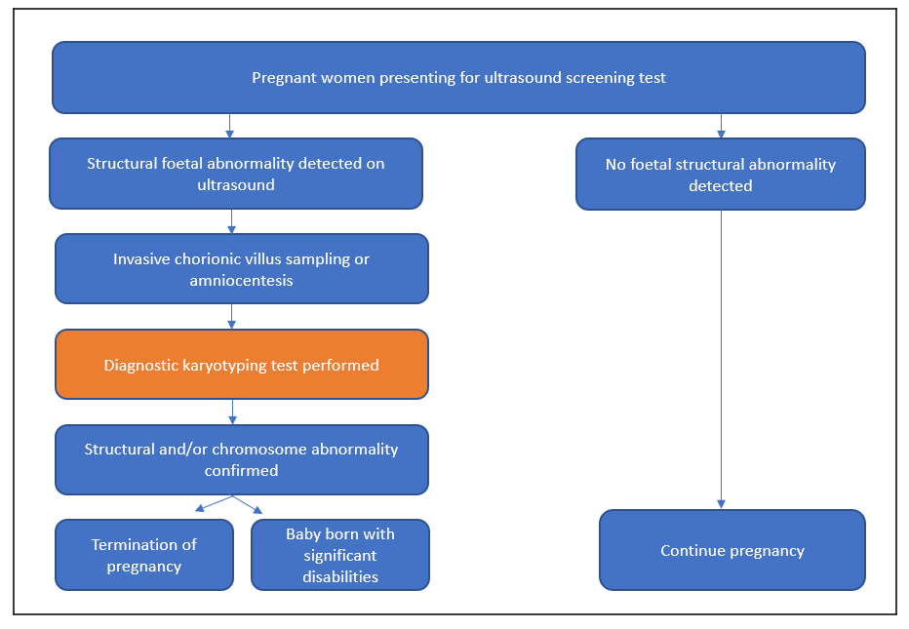
Notes: a. Ultrasound screening is predominantly performed in the first trimester as part of combined first trimester screening (CFTS). Combined first trimester screening (CFTS) is performed at 11+0 to 13+6 weeks by incorporating maternal age, ultrasound measurement of the fetal nuchal translucency, and maternal serum markers levels to generate an overall figure for the likelihood of trisomy disorders.³⁴ 2nd and 3rd trimester ultrasound is also recommended. ¹
b. Pre-post-test prenatal/genetic counselling is offered when a structural abnormality is detected. ^{1, 34}

Proposed clinical management algorithm for identified population
The proposed clinical management pathway, for prenatal patients with major fetal anomaly detected on ultrasound is to undergo invasive prenatal collection of testing sample by amniocenteses or CVS. The sample is then tested by genome-wide microarray. Microarray analysis can detect sub microscopic deletions and duplications of genetic material across all chromosomes.
Figure 2 presents the proposed clinical management algorithm for prenatal patients with major fetal anomaly detected on ultrasound.

Figure 2 Proposed clinical management algorithm
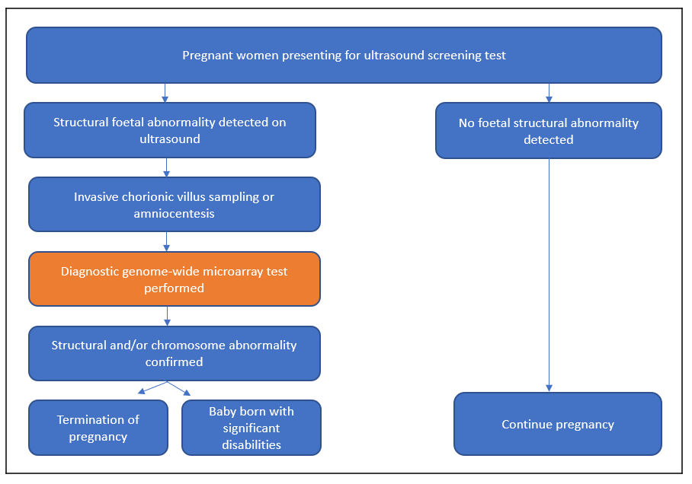
Notes: a. Ultrasound screening is predominantly performed in the first trimester as part of combined first trimester screening (CFTS). Combined first trimester screening (CFTS) is performed at 11+0 to 13+6 weeks by incorporating maternal age, ultrasound measurement of the fetal nuchal translucency, and maternal serum markers levels to generate an overall figure for the likelihood of trisomy disorders. ³⁴ 2nd and 3rd trimester ultrasound is also recommended. ¹
b. Pre-post-test prenatal/genetic counselling is offered when a structural abnormality is detected. ^{1, 34}

Proposed economic evaluation
The clinical claim is that genome-wide microarray in prenatal pregnancies with major fetal structural abnormalities detected on ultrasound is non-inferior in terms of safety, and superior in terms of clinical effectiveness, compared to karyotyping.
According to the Technical Guidelines for preparing assessment reports for the Medical Services Advisory Committee: Investigative, the required economic analysis is therefore a cost‐effectiveness and/or cost-utility analysis. This type of analysis will enable the determination of the incremental cost per extra unit of health outcome achieved, expressed in quality-adjusted life years (QALYs) as a result of a reduction in the number of babies born with structural/chromosomal abnormalities.
Figure 3 shows the basic structure of the decision analysis that would be the basis for a cost-effectiveness analysis of genome-wide microarray testing. The cost effectiveness analysis would generate an incremental cost effectiveness ratio (ICER) for the specific population of the difference in the costs between karyotyping and genome-wide microarray, divided by the difference in the outcomes between karyotyping and genome-wide microarray.
For the economic evaluation, QALYs should be calculated for karyotyping and genome-wide microarray. If QALYs cannot be calculated, then the measure of effectiveness can be expressed in life years or outcomes.
Figure 3 Basic structure of the economic evaluation
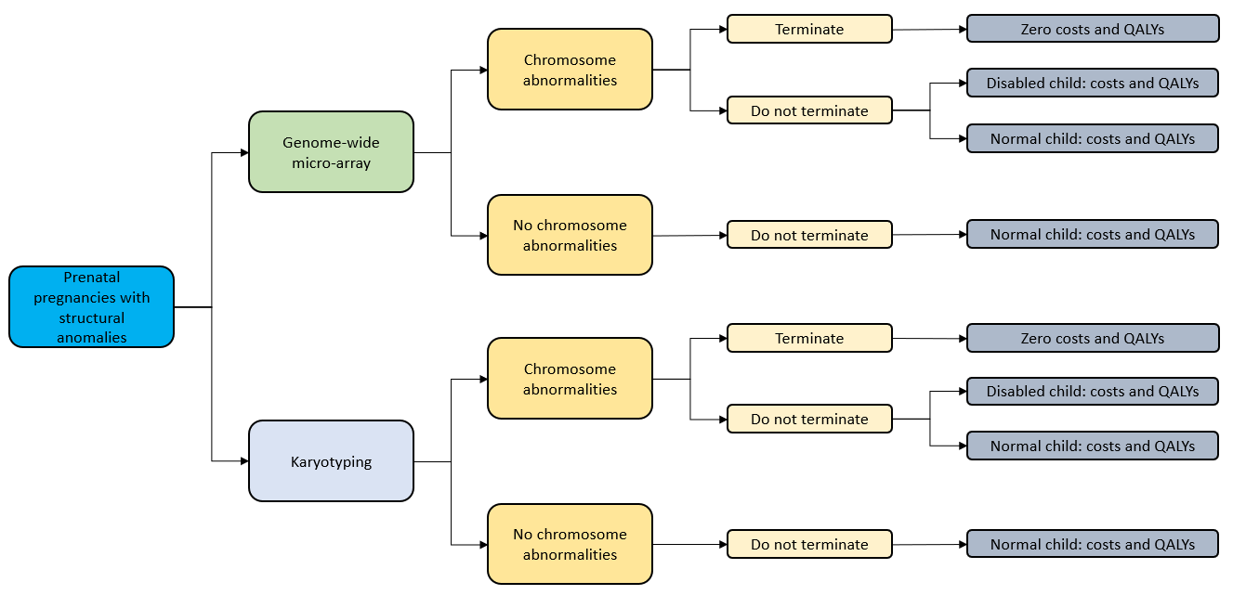
Abbreviations: QALY, quality adjusted life year

Proposed item descriptor – a new item, distinct from existing item 73292
Category 6 – PATHOLOGY SERVICES
Item xxxxx
Group P7 - Genetics
Analysis of chromosomes by genome-wide microarray, including targeted assessment of specific regions for constitutional genetic abnormalities in diagnostic studies of prenatal patients with major fetal anomaly detected on ultrasound (including a service in items 73287, 73289 or 73291, if performed)
- 1 or more tests.
MBS Fee: $589.90 Benefit: 75% = $442.45 85% = $508.20
The MBS fee proposed by the Applicant includes the DNA and RNA extraction and quantification, kit, sequencing and labour (medical and scientific), and bioinformatics for interpretation. It also includes the development, validation, maintenance, quality control and overhead costs of the laboratories providing the clinical testing.
Several assay technologies are available for genome-wide microarray and all require single use consumables. The Applicant does not endorse any one specific commercial product/brand of consumables or genetic test.

Reference List
1 Royal Australian and New Zealand College of Obstrtricians and Gynaecologists and Human Genetics Society of Australasia Prenatal assessment of fetal structural conditions 2015.
2 Gagnon, A. Evaluation of prenatally diagnosed structural congenital anomalies. J Obstet Gynaecol Can 2009; 31(9): 875-881
3 Australian Bureau of Statistics (ABS). Births, Australia, 2016 2017;
4 Da Silva, F.T., Gonik, B., McMillan, M., Keech, C., Dellicour, S., Bhange, S., Tila, M., Harper, D.M., Woods, C., and Kawai, A.T. Stillbirth: case definition and guidelines for data collection, analysis, and presentation of maternal immunization safety data. Vaccine 2016; 34(49): 6057
5 Wapner, R.J., Martin, C.L., Levy, B., Ballif, B.C., Eng, C.M., Zachary, J.M., Savage, M., Platt, L.D., Saltzman, D., and Grobman, W.A. Chromosomal microarray versus karyotyping for prenatal diagnosis. New England Journal of Medicine 2012; 367(23): 2175-2184
6 Australasia, T.R.A.a.N.Z.C.o.O.a.G.a.H.G.S.o. Prenatal screening and diagnostic testing for fetal chromosomal and genetic conditions. HGSA and RANZCOG; Updated July 2018;
7 Shaffer, L.G., Rosenfeld, J.A., Dabell, M.P., Coppinger, J., Bandholz, A.M., Ellison, J.W., Ravnan, J.B., Torchia, B.S., Ballif, B.C., and Fisher, A.J. Detection rates of clinically significant genomic alterations by microarray analysis for specific anomalies detected by ultrasound. Prenatal diagnosis 2012; 32(10): 986-995
8 De Wit, M., Srebniak, M., Govaerts, L., Van Opstal, D., Galjaard, R., and Go, A. Additional value of prenatal genomic array testing in fetuses with isolated structural ultrasound abnormalities and a normal karyotype: a systematic review of the literature. Ultrasound in Obstetrics & Gynecology 2014; 43(2): 139-146
9 Fu, F., Chen, F., Li, R., Zhang, Y., Pan, M., Li, D., and Liao, C.J.N.D.T. Prenatal diagnosis of fetal multicystic dysplastic kidney via high-resolution whole-genome array. 2016; 31(10): 1693-1698
10 Australian Government. Requested Medicare items processed from July 2016 to June 2018 Accessed October 10 2018;
11 Australisian Society for Ultrasound in Medicine. Guidelines, Policies and Statements 2014;
12 International Society of Ultrasound in Obstetrics and Gynecology (ISUOG). ISUOG Practice Guidelines: performance of first‐trimester fetal ultrasound scan 2012; 41(Issue): 102-113
13 Syngelaki, A., Chelemen, T., Dagklis, T., Allan, L., and Nicolaides, K.H. Challenges in the diagnosis of fetal non-chromosomal abnormalities at 11-13 weeks. Prenat Diagn 2011; 31(1): 90-102
14 Grande, M., Arigita, M., Borobio, V., Jimenez, J.M., Fernandez, S., and Borrell, A. First-trimester detection of structural abnormalities and the role of aneuploidy markers. Ultrasound Obstet Gynecol 2012; 39(2): 157-63
15 Verrotti, C., Caforio, E., and Gramellini, D. Ultrasound screening in second and third trimester of pregnancy: an update. Acta Bio Medica Atenei Parmensis 2007; 78(3): 229-232
16 Gagnon, A., Wilson, R.D., Allen, V.M., Audibert, F., Blight, C., Brock, J.-A., Désilets, V.A., Johnson, J.-A., Langlois, S., and Murphy-Kaulbeck, L. Evaluation of prenatally diagnosed structural congenital anomalies. Journal of Obstetrics and Gynaecology Canada 2009; 31(9): 875-881
17 Grandjean, H., Larroque, D., and Levi, S. Sensitivity of routine ultrasound screening of pregnancies in the Eurofetus database. The Eurofetus Team. Ann N Y Acad Sci 1998; 847(118-24
18 Wieacker, P. and Steinhard, J. The prenatal diagnosis of genetic diseases. Deutsches Aerzteblatt International 2010; 107(48): 857
19 American College of Obstetricians Gynecologists Microarrays and next-generation sequencing technology: the use of advanced genetic diagnostic tools in obstetrics and gynecology. ACOG Committee opinion no. 682. American College of Obstetricians and Gynecologists. Obstetricians and Gynecologists, 2016. 128, 262-268.
20 Shaffer, L.G., Dabell, M.P., Fisher, A.J., Coppinger, J., Bandholz, A.M., Ellison, J.W., Ravnan, J.B., Torchia, B.S., Ballif, B.C., and Rosenfeld, J.A. Experience with microarray‐based comparative genomic hybridization for prenatal diagnosis in over 5000 pregnancies. Prenatal diagnosis 2012; 32(10): 976-985
21 Vissers, L.E., Veltman, J.A., van Kessel, A.G., and Brunner, H.G. Identification of disease genes by whole genome CGH arrays. Hum Mol Genet 2005; 14 Spec No. 2(R215-23
22 Government, A. Genetic Testing. Australian Law Reform Commission Accessed July 2018; https://www.alrc.gov.au/publications/10-genetic-testing/access-genetic-testing ].
23 Shaffer, L.G. and Rosenfeld, J.A. Microarray-based prenatal diagnosis for the identification of fetal chromosome abnormalities. Expert review of molecular diagnostics 2013; 13(6): 601-611
24 Lo, J.O., Shaffer, B.L., Feist, C.D., and Caughey, A.B. Chromosomal microarray analysis and prenatal diagnosis. Obstetrical & gynecological survey 2014; 69(10): 613-621
25 Australasia, T.R.A.a.N.Z.C.o.O.a.G.a.H.G.S.o. Medical Services Advisory COmmittee Application 1533 - Genome wide microarray testing for prenatal abnormalities. Journal 2018;
26 Buchanan, J.A., Chitayat, D., Kolomietz, E., Lee, H.C., Scherer, S.W., Speevak, M.D., Sroka, H., and Stavropoulos, D.J. Prenatal genomic microarray and sequencing in Canadian medical practice: towards consensus. Journal of medical genetics 2015; 52(9): 585-586
27 Armour, C.M., Dougan, S.D., Brock, J.-A., Chari, R., Chodirker, B.N., DeBie, I., Evans, J.A., Gibson, W.T., Kolomietz, E., and Nelson, T.N. Practice guideline: joint CCMG-SOGC recommendations for the use of chromosomal microarray analysis for prenatal diagnosis and assessment of fetal loss in Canada. Journal of medical genetics 2018; 55(4): 215-221
28 Kearney, H.M., Thorland, E.C., Brown, K.K., Quintero-Rivera, F., and South, S.T. American College of Medical Genetics standards and guidelines for interpretation and reporting of postnatal constitutional copy number variants. Genet Med 2011; 13(7): 680-5
29 Government, T.A. MBS online Medicare Benefits Schedule Accessed June 2018; Advanced search [Available from: http://www9.health.gov.au/mbs/search.cfm.
30 Ogilvie, C.M., Lashwood, A., Chitty, L., Waters, J.J., Scriven, P.N., and Flinter, F. The future of prenatal diagnosis: rapid testing or full karyotype? An audit of chromosome abnormalities and pregnancy outcomes for women referred for Down's Syndrome testing. BJOG: An International Journal of Obstetrics & Gynaecology 2005; 112(10): 1369-1375
31 Australian Government. MBS Online Accessed 29 May 2018;
32 Hui, L., Hutchinson, B., Poulton, A., and Halliday, J.J.G.i.M. Population-based impact of noninvasive prenatal screening on screening and diagnostic testing for fetal aneuploidy. 2017; 19(12): 1338
33 Medical Services Advisory Committee. 1461 Non-invasive prenatal testing for common trisomies (21, 18 and 13). 2016 10 October 2018]; Available from: http://www.msac.gov.au/internet/msac/publishing.nsf/Content/1461-Public.
34 Australasia, T.R.A.a.N.Z.C.o.O.a.G.a.H.G.S.o. Prenatal screening and diagnosis of chromosomal and genetic conditions in the fetus in pregnancy 2016.

Efficacy: measures the test’s ability to predict the presence or absence of disease, that is, the sensitivity, specificity and positive and negative predictive values, in this case, to accurately predict the risk of fetus with structural abnormality/chromosome abnormality
This risk is the same as karyotyping, as both are preceded by CVS or amniocentesis.
Analytical validity: the reproducibility and repeatability of the test, the ability of the test to accurately and reliably measure gene expression
Clinical validity: measures the tests ability to predict the presence or absence of disease, that is, the sensitivity, specificity and positive and negative predictive values
This risk is the same as karyotyping, as both are preceded by CVS or amniocentesis.
Analytical validity: the reproducibility and repeatability of the test, the ability of the test to accurately and reliably measure gene expression
Clinical validity: measures the tests ability to predict the presence or absence of disease, that is, the sensitivity, specificity and positive and negative predictive values

