Application 1559:
Endoscopic Mucosal Resection (EMR) as a therapeutic modality for large sessile colorectal polyps

Ratified PICO Confirmation
(To guide a new application to MSAC)
(Version 1.0)

Summary of PICO/PPICO criteria to define the question(s) to be addressed in an Assessment Report to the Medical Services Advisory Committee (MSAC)
Component | Description
Patients | Patients with non-invasive sessile or flat superficial colorectal lesions which are at least 25 mm in diameter.
Intervention | Endoscopic mucosal resection (EMR) is a procedure used for removal of colorectal lesions unsuitable for resection using standard endoscopic polypectomy. Lesions may be removed in a single piece (en-bloc resection) or in several pieces (piecemeal resection). EMR is performed under anaesthesia/sedation, typically as a day procedure in an outpatient clinic.  Endoscopic mucosal resection is available in the public health sector and is already offered to patients in the private health sector (in the absence of specific MBS rebates for larger polyps).
Comparator | Removal of colorectal lesions by surgical resection.
Outcomes | Patient relevant efficacy and safety outcomes are summarised below  Efficacy outcomes Safety outcomes  Technical success rate (defined as “absence of neoplastic tissue at completion of the procedure after careful inspection of the post-EMR mucosal defect and margin.”) Intraprocedural complications  Uptake of surgical resection in unsuccessful EMR cases (EMR only) Postprocedural complications  Lesion recurrence rate (short-term and long-term recurrence) Bleeding-related adverse events (including delayed polypectomy bleeding)  Rate of long-term colorectal cancer development Deep mural injury rate (EMR only)  Time to perform procedure Perforation rate (EMR only)  Length of hospital stay Hospital presentations/admissions reported following procedure  Procedure-related mortality rate  Key outcomes impacting the broader healthcare system are: a potential increase in the number of patients undergoing EMR as a result of Medicare Benefits Schedule (MBS) funding; the potential for a transfer in the source of funding for EMR from State/Territory healthcare budgets to the MBS; and a potential decrease in the number of surgical resection procedures funded through the MBS as a result of substitution with EMR.

PICO or PPICO rationale for therapeutic and investigative medical services only
Population
The population for whom the applicant is requesting MBS funding are patients with non-invasive sessile or flat superficial colorectal lesions which are at least 25 mm in diameter. Colorectal lesions are growths occurring on the lining of the colon which, if left untreated, may develop into colorectal cancer.
Colorectal cancer (also referred to as bowel cancer) develops in a multistage process in which a series of cellular mutations occurs over time. Most colorectal cancers start in the epithelial cells forming the inner lining of the large bowel (intestinal mucosa layer). Early states of cellular mutations are associated with benign polyps (adenoma/adenomatous polyp). These polyps may mutate further and develop into a malignant cancer (Figure 1).
Figure 1: Development of colorectal cancer
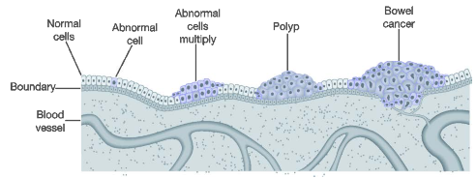
Source: Figure 1.1 (p. 11) of (AIHW 2018)
Symptoms associated with colorectal cancers are visible rectal bleeding, change in bowel habit, bowel obstruction, and anaemia. Due to the slowly progressing nature of colorectal cancer these symptoms may not be seen until the cancer has reached a relatively advanced stage. The slowly developing nature of colorectal means that pre-cancerous and early stage cancers can be screened for and treated prior to developing into malignant disease.
In Australia, a government funded population-based screening program is available to eligible Australians through the National Bowel Cancer Screening Program (NBCSP). From 2019, all eligible Australians aged between 50 and 74 years will be invited to undergo screening every two years. The NBCSP uses an immunohistochemical faecal occult blood test (iFOBT) kit to detect microscopic amounts of blood in a bowel movement. A positive screening result per the detection of blood in a bowel movement by iFOBT may indicate the presence of polyps or cancer (or other non-colorectal cancer condition such as haemorrhoids or bowel inflammation). A positive iFOBT test result should be discussed with the patient’s General Practitioner in order to determine if further tests are required in order to determine the cause of the bleeding. The Australian clinical practice guidelines for the management of colorectal cancer outline that a positive iFOBT test is associated with a Category 1 colonoscopy triage category (recommended in <30 days) and that patients with a positive iFOBT result be considered for a colonoscopy (Cancer Council Australia 2019).
Colonoscopies are an endoscopic examination of the colon undertaken with the aim of visually diagnosing polyps or other colorectal abnormalities. During a routine colonoscopy any polyp <20 mm is recommended to be removed by the gastroenterologist/surgical endoscopist. Resected tissue is sent for histopathological examination to assess the nature and extent of abnormal cells.
Clinical guidelines published by the European Society of Gastrointestinal Endoscopy (ESGE) recommend that “all polyps be resected except for diminutive (≤5 mm) rectal and rectosigmoid polyps that are predicted with high confidence to be hyperplastic” (Ferlitsch et al. 2017). The removal of polyps 5-20 mm via polypectomy is routinely managed by gastroenterologist/surgical endoscopist as part of the same colonoscopy procedure where visual inspection of the colon is undertaken as it does not pose considerable technical difficulty (Kandel et al. 2017).
This application relates to the use of an endoscopic technique to resect larger flat or laterally spreading colorectal lesions. The technique, endoscopic mucosal resection (EMR), is suitable for the removal of lesions which are not amenable for resection via endoscopic polypectomy. The primary basis to remove a lesion using EMR instead of endoscopic polypectomy is the size of the lesion, with EMR recommended in non-invasive lesions ≥20 mm-40 mm (Ferlitsch et al. 2017). The location of a lesion within haustral folds or regions involving the ileocecal valve (separating the small and large intestine) or close to the dentate line may also be indicated for resection using the EMR technique (Kandel et al. 2017).
The applicant has estimated that 5% of patients receiving a colonoscopy would be candidates for EMR as the appropriate technique for the removal of colorectal lesions. Case series reported in various clinical settings report a frequency of colonic polyps ≥20 mm of 0.8%-1.4% of patients in a Japanese series and 5.2% in a Polish series (Gallegos-Orozco et al. 2010). Therefore, the estimate of 5% of patient receiving a colonoscopy being candidates for EMR is consistent with the broader literature.
The applicant has estimated that 900,000 colonoscopies are performed nationally each year, corresponding to 45,000 (900,000*0.05) patients being candidates for EMR each year. This estimate is based on a review being undertaken as part of the preparation of the Australian Council of Healthcare Standards (ACHS) Gastrointestinal Endoscopy Clinical Indicators report (Version 3) and includes colonoscopies undertaken in the private and public health sector.
Based on MBS claims data, a total of 639,935 colonoscopy-related items (see Table 1) were processed in 2017 (last full calendar year with data available). Using an alternate estimate of the number of colonoscopies performed each year based on MBS items processed, a total of 31,997 (639,935*0.05) patients receiving colonoscopies funded through the MBS may be candidates for EMR each year, with the funding through the MBS being most applicable to procedures undertaken in the private health sector.
Table 1: Items processed for MBS items relating to colonoscopy: January 2017-December 2017
MBS item | Item Descriptor at Medicare Benefits Schedule Book Operation from 1 March 2019 | Services
32084 | Flexible fibreoptic sigmoidoscopy or fibreoptic colonoscopy up to the hepatic flexure, with or without biopsy, other than a service associated with a service to which item 32090 or 32093 applies. (Anaes.)  (See para TN.8.17, TN.8.134 of explanatory notes to this Category)  Fee: $111.35 Benefit: 75% = $83.55 85% = $94.65 | 20,025
32087 | Endoscopic examination of the colon up to the hepatic flexure by flexible fibreoptic sigmoidoscopy or fibreoptic colonoscopy for the removal of 1 or more polyps or the treatment of radiation proctitis, angiodysplasia or post-polypectomy bleeding by argon plasma coagulation, one or more of, other than a service associated with a service to which item 32090 or 32093 applies (Anaes.)  (See para TN.8.17, TN.8.134 of explanatory notes to this Category)  Fee: $204.70 Benefit: 75% = $153.55 85% = $174.00 | 3,625
32088 | FIBREOPTIC COLONOSCOPY examination of the colon beyond the hepatic flexure WITH or WITHOUT BIOPSY, following a positive faecal occult blood test for a participant registered on the National Bowel Cancer Screening Program. (Anaes.)  (See para TN.8.17 of explanatory notes to this Category)  Fee: $334.35 Benefit: 75% = $250.80 85% = $284.20 | 4,215
32089 | Endoscopic examination of the colon beyond the hepatic flexure by FIBREOPTIC COLONOSCOPY for the REMOVAL OF 1 OR MORE POLYPS, following a positive faecal occult blood test for a participant registered on the National Bowel Cancer Screening Program. (Anaes.)  (See para TN.8.17 of explanatory notes to this Category)  Fee: $469.20 Benefit: 75% = $351.90 85% = $398.85 | 6,169
32090 | FIBREOPTIC COLONOSCOPY examination of colon beyond the hepatic flexure WITH or WITHOUT BIOPSY (Anaes.)  (See para TN.8.17, TN.8.134 of explanatory notes to this Category)  Fee: $334.35 Benefit: 75% = $250.80 85% = $284.20 | 321,377
32093 | Endoscopic examination of the colon beyond the hepatic flexure by FIBREOPTIC COLONOSCOPY for the REMOVAL OF 1 OR MORE POLYPS, or the treatment of radiation proctitis, angiodysplasia or post-polypectomy bleeding by ARGON PLASMA COAGULATION, 1 or more of (Anaes.)  (See para TN.8.17, TN.8.134 of explanatory notes to this Category)  Fee: $469.20 Benefit: 75% = $351.90 85% = $398.85 | 284,524
Total |  | 639,935
Source: Medicare items processed data: http://medicarestatistics.humanservices.gov.au/statistics/mbs_item.jsp

Rationale
The applicant has proposed that the use of EMR funded through the MBS would be limited to patients with large (>25 mm) colorectal lesions. A notable difference in the patient population proposed as being eligible to access EMR funded through the MBS and the use of EMR outlined in clinical management guidelines is the size of the lesion considered suitable for EMR. Specifically, the applicant has proposed that EMR funded through the MBS be restricted to patients with lesions >25 mm whereas clinical management guidelines recommend that EMR considered in patients with lesions ≥20 mm (Ferlitsch et al. 2017).
A rapid review of the literature undertaken during the preparation of the PICO Confirmation identified a study assessing the use of EMR for the removal of colorectal lesions undertaken in Australia, the Australian Multicentre Colonic endoscopic Mucosal Resection (ACE/EMR) Study. This study enrolled consecutive patients referred to eight Australian academic hospitals for the management of large sessile and flat colorectal polyps ≥20 mm. A summary of key clinical characteristics reported as part of the ACE/EMR study is provided in Table 2. A further Australian study reporting the outcome of EMR undertaken in 174 patients with difficult to treat polyps was identified (Swan et al. 2009). This study reports a mean lesion diameter of 30mm (range 10-80 mm) range of polyp size of 10-80 mm.
Table 2: Baseline clinical characteristics of 1,748 lesions from the ACE/EMR study
Variable | Adenoma ≥20 mm  Patients: 1,425 | SSA/P ≥20 mm  Patients: 246
Age (years), Mean ±SD | 68.2±10.6 | 65.6±12.7
Size (largest lesion), Mean ±SD | 38.0±16.4 | 29.6±10.0
Size group
≤25 mm | 28.7% | 49.5%
26-35 mm | 27.1% | 30.0%
>35 mm | 44.2% | 20.5%
Piecemeal resection (not en-bloc) | 85.5% | 76.7%
Abbreviation: sessile serrated adenoma/polyp
Source: Adapted from Table 1 (p. 649) of (Pellise et al 2017)
PASC agreed that a minimum in situ lesion size of >25 mm is reasonable as it addresses the issue of potential leakage of EMR use in smaller lesions. PASC outlined that data from studies of EMR enrolling patients with lesions <25 mm would be applicable to an assessment of EMR in patients with lesions >25 mm.
Prior test (investigative services only - if prior tests are to be included)
Endoscopic mucosal resection is a therapeutic service. However, prior investigative services undertaken as part of identifying patients suitable for having colorectal lesions removed using EMR may include:
- iFOBT to detect blood in a bowel movement. The detection of blood in a bowel movement may indicate the presence of polyps or colorectal cancer.
  - iFOBT is supported by MBS items 66764, 66767, and 66770.
- A colonoscopy to visually diagnose the presence of lesions which are not amenable for removal via polypectomy during a routine colonoscopy procedure.
  - Colonoscopies not including the removal of polyps are supported by MBS items 32084, 32088, and 32090.
  - Note that if the clinician performing the colonoscopy was experienced in the conduct of EMR then the removal of lesions using EMR may take as part of the initial colonoscopy following a positive iFOBT test and not require referral to a specialty centre specifically for the conduct of EMR.
  - Patients who have had previous polypectomy/EMR are likely to receive follow-up colonoscopies without prior iFOBT testing in order to assess for recurrence.
Intervention
An overview of the key steps involved in the removal of colorectal lesions using EMR follows:
Pre-procedure stage:
The patient follows the bowel preparation protocol recommended by the treating clinician in order to clear the digestive tract prior to the procedure. This is done at the patient’s home, usually commencing the evening prior to the procedure.
On the day of the procedure patients are given intravenous anaesthesia/sedation prior to the commencement of the EMR. Endoscopic mucosal resection is typically performed under conscious sedation.
Colonic insufflation with CO₂ (preferred) or air is undertaken prior to the procedure.
Procedural stage:
A colonoscope is inserted into the patient’s anus and the lesion to be removed is located. Following the location and assessment of the lesion a solution is injected in the submucosal space to separate the mucosal lesion from the underlying muscularis propria. The submucosal injection fluid is typically comprised of 3 elements: saline or a viscous solution providing a cushion to reduce the risk of thermal or mechanical injury to the underlying muscularis propria during the procedure; diluted adrenaline to reduce intra-procedural bleeding; and a dye (indigo carmine or methylene blue) to aid in the delineation of lesion margins.
Upon successful separation from the underlying muscularis propria the lesion is resected by snare electrosurgery. Where possible resection of the entire lesion including a normal mucosal margin of 2-3 mm should be removed in a single piece (en-bloc resection). Where en-bloc resection is not feasible or safe, resection of the lesion in several pieces can be pursued (Piecemeal resection). Tissue collected via en-bloc or piecemeal resection should be retrieved for histological assessment.
Post-procedure stage:
Patients should be observed in clinic for a period of approximately 4 hours after undergoing EMR. If no immediate complications develop during the observation period the patient may be discharged and return home. Patients should follow a clear fluid diet overnight and follow the post-procedural instructions from their clinician.
How the proposed medical service is expected to be used
Endoscopic mucosal resection is currently available to patients being treated in the public health sector funded by State/Territory health budgets. As an outpatient procedure without an MBS item number this limits the ability for patients electing to be treated in the private health sector in being able to access EMR.
With the MBS listing of EMR as requested there would be expanded access to EMR as a result of patients being able to access subsidised treatment outside of the public health sector. It may also be expected that some patients who would have otherwise received EMR as a public patient would receive treatment as a private patient, thus having EMR funded through the MBS instead of State/Territory health budgets.
The applicant outlines that the providers of EMR funded through the MBS would be gastroenterologists or endoscopic surgeons. This is consistent with the providers undertaking EMR in the public health sector.
As outlined in the Final report from the Gastroenterology Clinical Committee of the Medicare Benefits Schedule Review Taskforce it is outlined that:
“The Committee noted the range of EMR complexity, time and expertise required to perform the procedure and considered if the service should be restricted to specialist to specialist referrals and or if specifying the size of the resected specimen is required. The Committee agreed that it should not be restricted to tertiary referral as this would prevent experienced specialists from completing the procedure if found during a normal colonoscopy.” (p. 58)
Based on the recommendation of the Gastroenterology Clinical Committee of the Medicare Benefits Schedule Review Taskforce, the applicant has not requested that EMR funded through the MBS be restricted a tertiary referral centre, meaning that any suitably qualified and experienced proceduralist would be eligible to claim for the conduct of EMR.
The applicant has outlined that a maximum of one EMR procedure would be required for a patient in a given year. Due to the potential for recurrent lesions to develop over time patients may require additional polypectomy/EMR procedures to remove further lesions on an ‘as needed’ basis.
Comparator
The applicant has nominated surgery as the comparator for the removal of colorectal lesions which may otherwise be removed using EMR. It is proposed that for the majority of patients with a colorectal lesion suitable for removal using EMR that the use of EMR would be as an alternative to surgical resection, noting that a small number of patients may have an unsuccessful EMR and subsequently require removal of the lesion with surgical resection. The use of surgery for the removal of colorectal lesions which may otherwise be removed using EMR may be considered a historical comparator as EMR is considered the standard of care for the endoscopic removal of non-invasive colorectal lesions ≥20 mm.
PASC confirmed that surgical resection is the appropriate comparator.
The removal of colorectal lesions through surgical resection may be performed using a laparoscopic or open approach, although the laparoscopic approach is recommended as it is associated with an overall reduction in post-operative pain, a shortened time to return of normal bowel function and a shorter hospital stay (Cancer Council Australia 2019).
Laparoscopic resection of colorectal tumours is performed as part of an inpatient episode of hospital care. Results of a randomised controlled trial comparing laparoscopic (n=294 analysed) and open surgeries (n=298 analysed) in patients with colorectal cancer reported a mean post-operative length of stay of 9.5 days (SD ±7.4) for patients undergoing laparoscopic surgery (Hewett et al. 2008).
Surgical resection of colorectal tumours is facilitated by MBS items 32000 through 32006 depending on the location of lesions and nature of the procedure undertaken (see MBS item descriptors below). Additional MBS items associated with anaesthesia, surgical assistants and diagnostic imaging performed as part of the surgical resection may be claimed at the same item as the MBS items for surgical resection.
Table 3: MBS items associated with surgical resection of colorectal lesions
MBS item | MBS Item Descriptor
32000 | LARGE INTESTINE, resection of, without anastomosis, including right hemicolectomy (including formation of stoma) (Anaes.) (Assist.)  Fee: $1,031.35 Benefit: 75% = $773.55
32003 | LARGE INTESTINE, resection of, with anastomosis, including right hemicolectomy (Anaes.) (Assist.)  Fee: $1,078.80 Benefit: 75% = $809.10
32004 | LARGE INTESTINE, subtotal colectomy (resection of right colon, transverse colon and splenic flexure)without anastomosis, not being a service associated with a service to which item 32000, 32003, 32005 or32006 applies (Anaes.) (Assist.)  Fee: $1,150.35 Benefit: 75% = $862.80
32005 | LARGE INTESTINE, subtotal colectomy (resection of right colon, transverse colon and splenic flexure)with anastomosis, not being a service associated with a service to which item 32000, 32003, 32004 or 32006 applies (Anaes.) (Assist.)  Fee: $1,299.55 Benefit: 75% = $974.70
32006 | LEFT HEMICOLECTOMY, including the descending and sigmoid colon (including formation of stoma) (Anaes.) (Assist.)  Fee: $1,150.35 Benefit: 75% = $862.80

Rationale
The use of EMR is considered as standard of care for the removal of non-invasive colorectal lesions ≥20 mm (Lee et al. 2016, Ferlitsch et al. 2017) and is available to patients treated in the public health sector. Based on a Non-admitted price weight code of 10.06 (Endoscopy – gastrointestinal) and the pricing inputs established in the Nation Efficient Price Determination 2018-19 (IHPA 2018) the pricing for gastrointestinal endoscopic procedures in the public sector is $1,919.
Searches undertaken during the preparation of the PICO Confirmation revealed that many practitioners are offering EMR to patients electing to be treated in the private health sector. The applicant has advised that the existing MBS items for colonoscopy with polypectomy may be used to fund EMR in some patients treated in the private health sector. The applicant further advised that the existing MBS items for colonoscopy with polypectomy do not adequately reflect the additional time, complexity and training required to perform EMR compared with colonoscopy with polypectomy.
PASC noted that EMR requires significant training, and the procedure should only be performed by clinicians experienced in the technique. PASC confirmed that, if possible, some reference to skill or training could be included in the item descriptor (or explanatory notes if skill or training verification cannot be inserted into the item descriptor, because it could not be enforced by the Department of Human Services). Criteria detailed in item descriptor wording must be able to be verified and legally enforced by the Department of Human Services.
Outcomes
Patient-relevant outcomes
Patient relevant efficacy and safety outcomes applicable to the assessment of EMR vs. surgical resection are outlined in Table 4.
Table 4: Patient relevant outcomes applicable to the assessment of EMR vs. surgical resection
Efficacy outcomes | Safety outcomes
Technical success rate (defined as “absence of neoplastic tissue at completion of the procedure after careful inspection of the post-EMR mucosal defect and margin.”)  Uptake of surgical resection in unsuccessful EMR cases (EMR only)  Lesion recurrence rate (short-term and long-term recurrence)  Rate of long-term colorectal cancer development  Time to perform procedure  Length of hospital stay | Intraprocedural complications  Postprocedural complications  Bleeding-related adverse events (including delayed polypectomy bleeding)  Deep mural injury rate (EMR only)  Perforation rate (EMR only)  Hospital presentations/admissions reported following procedure  Procedure-related mortality rate

Healthcare system
With the potential availability of EMR funded through the MBS the following changes in patterns of healthcare resource use may be foreseen:
- An overall increase in the number of patients undergoing EMR as a result of expanded access to EMR in the private healthcare sector.
- A potential transfer in the source of funding of EMR procedures from State/Territory healthcare budgets to the MBS for patients electing to be treated in the private healthcare sector which may otherwise have been treated in the public healthcare sector.
- A potential decrease in the number of surgical resection procedures funded through the MBS as a result of substitution with EMR.

Current clinical management algorithm for identified population
The applicant provided an overview of the place of EMR in the management of patients with colorectal lesions as established in clinical management guidelines (Figure 2). The place of EMR was highlighted in the red boxes during the preparation of the PICO Confirmation for ease of identification.
Figure 2: Algorithm for selection of suitable resection technique for colorectal lesions
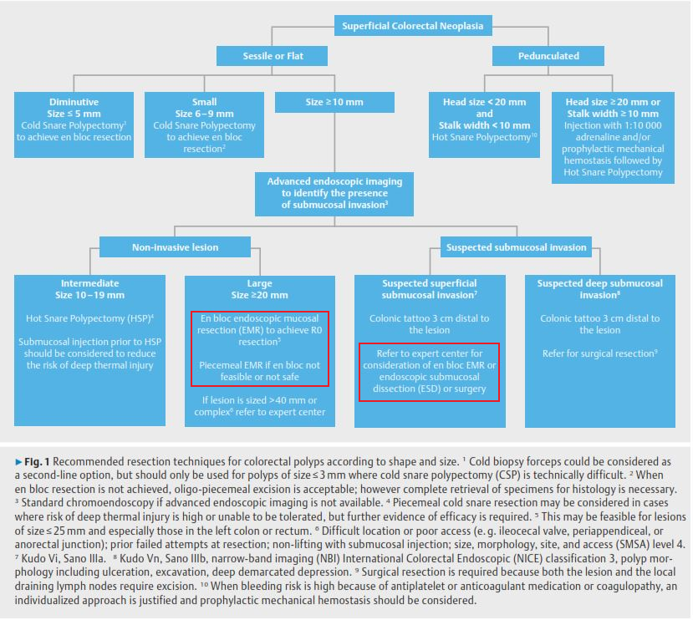
Source: Figure 1 (p. 272) of (Ferlitsch et al. 2017)

Proposed clinical management algorithm for identified population
The key difference between the current and proposed algorithm applied for the selection of the suitable resection technique for colorectal lesions with EMR funded through the MBS is the restriction of the use of EMR to patients with lesions >25 mm (EMR funded through the MBS) compared with lesions ≥20 mm (current recommended use). No other differences in the management of patients are proposed, including the type and frequency of use of upstream services to identify patients with suspected colorectal lesions or the downstream services required for post-resection surveillance.
An algorithm representing patient management pathways with the availability of EMR on the MBS as requested is presented in Figure 3.
Figure 3: Proposed clinical management algorithm for patients using EMR
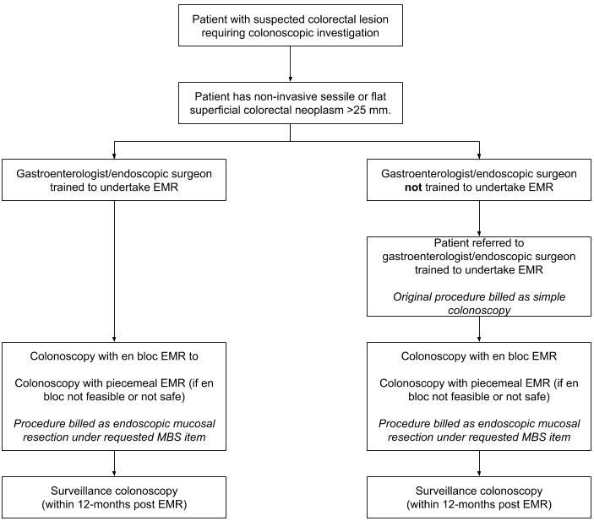

Proposed economic evaluation
The evidence reporting efficacy and safety outcomes of EMR and surgical resection is largely represented by prospective single-arm studies or retrospective cohort studies. Thus, an assessment of the comparative efficacy and safety of EMR vs. surgical resection is likely to be based on an indirect comparison of outcomes.
The applicant has outlined that EMR is superior to surgical resection in terms of clinical safety and efficacy. This clinical claim may be reasonable based on a preliminary assessment of the supporting evidence provided within the Application Form or identified during a rapid review of the literature undertaken during the development of the PICO Confirmation. A summary of key outcomes relevant to an assessment of the clinical efficacy of EMR as well as the cost of EMR vs. surgical resection based on the results of Australian studies are provided in Table 5 and Table 6. It should be noted that these results are not intended to be representative of the totality of the evidence for EMR presented in the final MSAC Assessment Report.
Table 5: Summary of EMR efficacy
Variable | Patients: 1134
Age (years), Mean | 67
Lesion size, Mean ±SD | 36.4 mm ±17 mm
EMR attempted, N | 96.6% (1095/1134 patients enrolled)
Technical success rate | 91.3% (1000/1095 patients with EMR attempted)
Patients with outcome data from surveillance colonoscopy at 4-6 months (SC1) | 79.9% (799/1000 patients with successful EMR)
Patients with no residual/recurrent adenoma present at SC1 | 83.9% (670/799 patients with SC1 outcome data)
Patients with outcome data from surveillance colonoscopy at 16 months (SC2) | 69.5% (510/799 patients with outcome data from SC1)
Patients with no residual/recurrent adenoma present at SC2 | 93.3% (476/510 patients with SC1 and SC2 outcome data)
Source: Moss et al 2015
Table 6: Summary of costs of EMR vs. surgical resection
Variable | EMR | Surgical Resection | Increment (EMR-Surgical Resection)
Total cost per patient, Mean | $5428 | $14268 | -$8840
Inpatient length of stay (days), mean±SD | 0.87±2.02 | 3.69±1.21 | -2.82
Source: p. 274 of Jayanna et al (2016)

Any claim of superiority of EMR vs. surgical resection is likely to be more robustly supported by shorter-term outcomes such as length of hospital stay rather than longer-term outcomes such as recurrence rate, lifetime cases of colorectal cancer avoided, or reduction in colorectal cancer mortality.
In consideration that the assessment of longer-term outcomes for EMR vs. surgical resection would be based on an indirect comparison of evidence from single-arm studies or retrospective cohort studies which were not designed to capture long-term recurrence rates, the number of cases of colorectal cancer avoided, or a reduction in colorectal cancer mortality it may be reasonable to claim that EMR is at least non-inferior to surgical resection with regards to longer-term clinical outcomes.
Based on the potential clinical claims of EMR being superior (shorter-term outcomes) and at least non-inferior (longer-term outcomes) compared with surgical resection, a cost-minimisation (CMA), cost-effectiveness analysis (CEA) or cost-utility analysis (CUA) would be an appropriate form of economic evaluation (Table 7).
PASC confirmed that a cost-utility analysis would be the appropriate form of economic evaluation.
Table 7: Classification of the clinical claims and guide to the suitable type of economic evaluation for MSAC assessment reports
Comparative safety | Comparative effectiveness
 | Inferior | Uncertainª | Non-inferior^{b} | Superior
Inferior | Health forgone: need other supportive factors | Health foregone possible: need other supportive factors | Health foregone: need other supportive factors | ? Likely CUA
Uncertainª | Health foregone possible: need other supportive factors | ? | ? | ? Likely CEA/CUA
Non-inferior^{b} | Health forgone: need other supportive factors | ? | CMA | CEA/CUA
Superior | ? Likely CUA | ? Likely CUA | ? Likely CEA/CUA | CEA/CUA
CEA = cost-effectiveness analysis; CMA = cost-minimisation analysis; CUA = cost-utility analysis
? = reflects uncertainties and any identified health trade-offs in the economic evaluation, as a minimum in a cost-consequences analysis
a ‘Uncertainty’ covers concepts such as inadequate minimisation of important sources of bias, lack of statistical significance in an underpowered trial, detecting clinically unimportant therapeutic differences, inconsistent results across trials, and trade-offs within the comparative effectiveness and/or the comparative safety considerations (e.g. where the safety profiles of the compared medical services differ, with some aspects worse for the proposed medical service and some aspects better for the proposed medical service).
b An adequate assessment on ‘non-inferiority’ is the preferred basis for demonstrating equivalence.

Proposed item descriptor and MBS fee
The MBS item descriptor proposed to apply to EMR is outlined below.
Category 3 – Therapeutic procedure
Endoscopic mucosal resection of a non-invasive sessile or flat superficial colorectal neoplasm which is at least 25mm in diameter by a specialist gastroenterologist or surgical endoscopist, supported by photographic evidence to confirm the size of the polyp in situ. (Anaes)

MBS Fee: $1,750

PASC noted that the applicant has proposed a fee of $1,750 for EMR; however, it was not clear how that figure was derived. PASC confirmed that the fee must be justified, and a detailed costing prepared by the applicant (and provided to the assessment group) during the assessment phase, with guidance from the Department.

Other issues
PASC noted that most colonoscopies are billed to the MBS, and the procedure can be done as an inpatient (admitted patient) or outpatient (non-admitted patient) service, depending on the patient’s insurance status. If patients who choose to be treated in a private hospital/clinic do not have private health insurance, they would be more likely to be treated as outpatients in that hospital/clinic (i.e. not admitted). This may have Extended Medicare Safety Net consequences for this more complex procedure. However, non-insured patients may be more likely to choose public hospital treatment. If the public hospital treats the patient as a private patient, the hospital would bulk-bill the service to the MBS. PASC requested that Extended Medicare Safety Net risk should be examined (associated with out-of-pocket costs of non-admitted, uninsured patients).

References
AIHW (2018). National Bowel Cancer Screening Program: monitoring report 2018 Australian Institute of Health and Welfare. Canberra.
Cancer Council Australia. (2019). "Clinical practice guidelines for the prevention, early detection and management of colorectal cancer." Retrieved 25/02/2019, from https://wiki.cancer.org.au/australia/Guidelines:Colorectal_cancer.
DoH (2016). Medicare Benefits Schedule Review Taskforce: Final report from the Gastroenterology Clinical Committee. Department of Health. Canberra
Ferlitsch, M, Moss, A, et al. (2017). "Colorectal polypectomy and endoscopic mucosal resection (EMR): European Society of Gastrointestinal Endoscopy (ESGE) clinical guideline." Endoscopy 49(03): 270-297.
Gallegos-Orozco, JF and Gurudu, SR (2010). "Complex colon polypectomy." Gastroenterology & hepatology 6(6): 375.
Hewett, PJ, Allardyce, RA, et al. (2008). "Short-term outcomes of the Australasian randomized clinical study comparing laparoscopic and conventional open surgical treatments for colon cancer: the ALCCaS trial." Annals of surgery 248(5): 728-738.
IHPA (2018). National Efficient Price Determination 2018-19, Independent Hospital Pricing Authority.
Jayanna, M., Burgess, N.G., Singh, R. et al 2016. Cost analysis of endoscopic mucosal resection vs surgery for large laterally spreading colorectal lesions. Clinical Gastroenterology and Hepatology, 14(2), pp.271-278
Kandel, P and Wallace, MB (2017). "Colorectal endoscopic mucosal resection (EMR)." Best Practice & Research Clinical Gastroenterology 31(4): 455-471.
Lee, EY and Bourke, MJ (2016). "EMR should be the first-line treatment for large laterally spreading colorectal lesions." Gastrointestinal endoscopy 84(2): 326-328.
Moss, A., Williams, S.J., Hourigan, L.F et al, 2015. Long-term adenoma recurrence following wide-field endoscopic mucosal resection (WF-EMR) for advanced colonic mucosal neoplasia is infrequent: results and risk factors in 1000 cases from the Australian Colonic EMR (ACE) study. Gut, 64(1), pp.57-65.
Swan, MP, Bourke, MJ, et al. (2009). "Large refractory colonic polyps: is it time to change our practice? A prospective study of the clinical and economic impact of a tertiary referral colonic mucosal resection and polypectomy service (with videos)." Gastrointestinal endoscopy 70(6): 1128-1136.

A colorectal lesion is considered non-invasive if it has not invaded into the submucosa of the colorectum.
https://clinicaltrials.gov/ct2/show/NCT01368289?term=ACE%2FEMR&rank=1
Reported for code 10.06 (Endoscopy – gastrointestinal) by Non-Admitted Outpatient Service 2018-19 NWAU calculator available at: https://www.ihpa.gov.au/what-we-do/pricing/national-weighted-activity-unit-nwau-calculators/nwau-calculators-2018-19

