Public Summary Document

Report to the Medical Services Advisory Committee on utilisation of MBS items associated with Application 1153: Genetic Testing for Hereditary Mutation of the von Hippel -Lindau (VHL) Gene
Medicare Benefits Schedule (MBS) item considered: 73333, 73334, 73335
Date of MSAC consideration: 23 November 2017
Context for decision: MSAC makes its advice in accordance with its Terms of Reference, see the MSAC Website.

Purpose
The purpose of the report presented to the Medical Services Advisory Committee (MSAC) was to inform MSAC of the real world impacts on the outcomes of Application 1153. The MSAC uses this information to ensure that the new item/s resulting from this application/s is being used as intended.
The report is not intended to be a review of the clinical information covered during the application process.

MSAC’s advice
MSAC considered actual utilisation data and compared it with the utilisation predicted prior to listing of genetic testing for hereditary mutations of the Von Hippel-Lindau gene. MSAC noted that there was lower than expected utilisation of this service but recommended no change to the MBS items 73333, 73334 and 73335. MSAC recommended utilisation be reviewed again in five years.

Summary of consideration and rationale for MSAC’s advice
MSAC considered the real world impacts of the outcome of Application 1153 on genetic testing for hereditary mutation of the Von Hippel-Lindau (VHL) gene by examining available data on the utilisation of MBS items 73333, 73334 and 73335.
Mutation of the VHL gene causes a rare familial cancer syndrome that can manifest as phaeochromocytoma, haemangioblastoma and/or renal cell carcinoma. MBS item 73333 is used for diagnostic germline detection of the VHL gene in patients who show symptoms of VHL syndrome, whereas MBS item 73334 is a predictive test (through germline testing of the VHL gene mutation) for biological relatives of a patient with a known mutation in the VHL gene. MBS item 73335 is used for diagnostic detection of somatic VHL gene mutations.
MSAC noted that the VHL gene can occur either as a somatic mutation or inherited from germ line cells. Since the origin of the VHL gene is uncertain upon presentation of cancer in individuals, somatic testing of the tumour is conducted first. MSAC also noted that the VHL gene is amongst 15 or more genes that can cause phaeochromocytoma and that tests for VHL now can be a part of a panel test of multiple genes.
MSAC recalled that there was a lack of data on the prevalence of VHL genes in the Australian population and so epidemiological data from Denmark was used to draw estimates.
MSAC recalled that it was predicted there would be 80 diagnostic tests (MBS items 73333 and 73335) for VHL per year in the first year and anticipated that this would gradually increase to 160 tests per year after five years. It was also assumed that VHL predictive tests would not increase, remaining at 30 tests per year (MBS item 73334).
MSAC noted that test volumes were lower than expected in the period 2016–17 with 47 services for MBS items 73333 and 73334, which represents approximately 34% of predicted usage. However MSAC noted that there has been a spike in the total number of diagnostic services for the 2017 financial year which does not reflect a backlog of tests or biological pathology.
MSAC noted that the spike in utilisation of MBS services for the 2017 financial year was only observed in New South Wales and considered the possibility that it is the result of a policy change in public hospital laboratories to claim these services from the MBS. MSAC noted that there was wide variation in utilisation between States. MSAC noted that Western Australia and South Australia had no reportable statistics, possibly as a result of privacy preservation due to the very low uptake in utilisation of MBS items 73333, 73334, 73335 or not claiming services through the MBS. MSAC also noted that the low utilisation rates in the Australian Capital Territory, Queensland and Victoria could be attributed to laboratories not claiming services through the MBS. MSAC noted that MBS data may not be a reliable reflection of testing practices for this mutation as MBS claiming of the items is not consistent and in some cases testing is funded by the States.
MSAC noted that the age distribution of the disease does not match the age distribution of services claimed. It is estimated that 80% of those who carry the VHL gene will have manifested symptoms by age 60 years but the majority of services have been in those aged 60 years or over. MSAC considered the possibility that this age discrepancy could be a result of testing in patients with phaeochromocytoma (a disorder of older patients) while younger patients were being tested through clinical genetics services and public labs.
MSAC recalled that the impetus for listing was to increase momentum for awareness of the field of genetic testing. MSAC also highlighted the need for a national audit of genetic tests funded by state governments, Medicare and patients to aid in planning of future genetic testing. This could be assisted by the development of a national policy and program for genetic testing.
MSAC noted that VHL testing is needed for rare familial cancer despite the low volume in uptake. MSAC also noted the emerging availability of panel tests for simultaneous testing of various genetic mutations as opposed to single gene tests which may change the way these items are used in the future.
MSAC recommended no change to the MBS items 73333, 73334 and 73335 but recommended they be reviewed again in five years in light of emerging panel tests.

Methodology
An application is selected for consideration if the resulting new item(s) and/or item amendment(s) have been on the MBS for approximately 24 months or longer or if there were particular concerns about utilisation such that MSAC requested to consider it earlier. The specific applications for each MSAC meeting are selected by the MSAC Executive which is composed of the chairs of MSAC and its sub-committees.
A report on the utilisation is developed by the department with information on a number of metrics including; state variation, patient demographics, services per patient, practitioner’s providing the service, data on fees and co-claiming of services. The number of metrics included in a report is dependent on the annual service volume for the MBS item(s) under consideration i.e. an item with very low utilisation will have less data to analyse. Where service volumes are too low, information is suppressed to protect patient privacy.
Where possible the report compares data on real world utilisation to the assumptions made during the MSAC assessment. Most of these assumptions are drawn from the assessment report.
Relevant stakeholders are provided an opportunity to comment on the findings in the report before it is presented to the MSAC. It is intended that stakeholders are given at least three weeks to consider the reports.
The stakeholder version of the report does not contain information on assumptions from the MSAC consideration if this information is not already publicly available. This is to protect the commercial in confidence of the original applicants. The same principle is applied to this document.
Once MSAC has considered the report, its advice is made available online at the MSAC Website.

Results

Utilisation
Overall, the three items have had very limited use and also show state-based variation.
The actual utilisation of MBS item 73333 and 73334 used for VHL diagnostic purposes is significantly lower than volumes estimated. There have been a total of 104 services for 73333 and 73334 since implementation (Table 1). Figure 1 shows an initial increase in utilisation of the two items but in the most recent calendar year item 73334 has essentially not been used.
From 1 November 2012 to 31 March 2017, New South Wales had the highest utilisation with 83 services (approximately 80 percent of total services billed to the item). There were a small number of services provided in South Australia, Victoria and Queensland in the same period. This most likely reflects the distribution of medical specialists able to treat patients who present with features consistent with VHL. In addition, the frequency of testing is reducing, as all prevalent cases are likely to have now been tested.

Table 1: Predicted vs actual utilisation of MBS item 73333 and 73334 (diagnostic)
Financial Year | 2012-2013 | 2013-2014 | 2014-2015 | 2015-2016 | 2016-17
Actual number of Services | 10 | 14 | 31 | 47 | np
Total services projected (public and private) | 80 | 100 | 120 | 140 | 160
% of actual services to total services projected | 12.5% | 14.0% | 25.8% | 33.6% | np
Source: MBS Analytics Section – December 2017
NOTE: Item was listed 1 November 2012 and 2016-2017 only reported until 31 March 2017
np = not printed to protect privacy
Figure 1: Number of services for MBS item 73333 and 73334 for 2012-13 to 2015-16.

Source: MBS Analytics Section – December 2017
NOTE: Item was listed 1 November 2012 and 2016-2017 only reported until 31 March 2017
Such a low utilisation of a test raises some pathology quality concerns. In particular, can the quality of a service be maintained when only two tests per year are performed. If a laboratory is only doing a few tests per month then NATA guidance recommends the laboratory should refer the testing to a larger facility.
The policy area considers that this sort of very low volume pathology testing could be more efficiently dealt with by a small annual grant to a single testing laboratory to perform all this MBS testing for Australia. This would provide an opportunity to capture MBS utilisation in a single database to inform policy and decision-making.
Item 73335 used for monitoring of VHL mutations is also significantly lower than predicted (Figure 2).

Figure 2: Number of services for MBS item 73335 for 2012-13 to 2015-16.

Source: MBS Analytics Section – December 2017
NOTE: Item was listed 1 November 2012 and 2016-2017 only reported until 31 March 2017

Data on fee charged
For privacy reasons, data cannot be printed for states and territories with very low service volumes (less than seven services). Due to the low measured utilisation, fee information is limited but indicates approximately 100% increase in the fee charged for item 73333 from $315.40 in 2012-2013 to $605.02 in 2015-16. Bulk billing rates for item 73333 have also decreased from 100% in 2013-14 and 2014-15 to 20.5% in 2015-16.
Fees charged for item 73334 have remained constant at $340.00 but bulk billing rates have decreased from 100% in 2012-13 and 2013-14 to 66.7% in 2015-16.
Fees charged nationally for item 73335 on average are $485.73, with a $75.84 standard deviation, and a bulk billed rate of 66.7%.

Patient Breakdown
There were 95 patients who claimed 104 services for MBS item 73333 and 73334 used for VHL diagnostic purposes. All patients have been new patients with no continuing services. Approximately 9% of patients received 2 or more services for item 73333 in 2015-16.
MBS item 73333 is predominantly claimed by patients aged 55-84 (Figure 3). MBS item 73334 is predominantly claimed by patients aged 0-44 years (Figure 4). A small number of services for item 73335 have been provided exclusively to female patients aged 25-74 (Figure 5).
Figure 3: Demographic profile for MBS item 73333 (a), 73334 (b), and 73335 (c)
MBS item 73333; Nov 2012 – June 2017
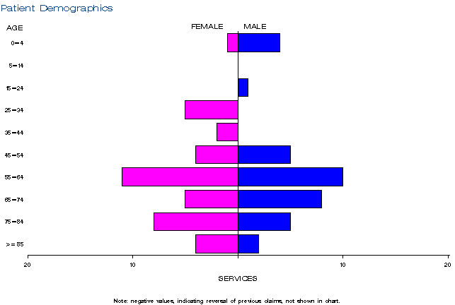
Source: Medicare Statistics Online
Figure 4: Demographic profile for MBS item 73333 (a), 73334 (b), and 73335 (c)
MBS item 73334; Nov 2012 – June 2017

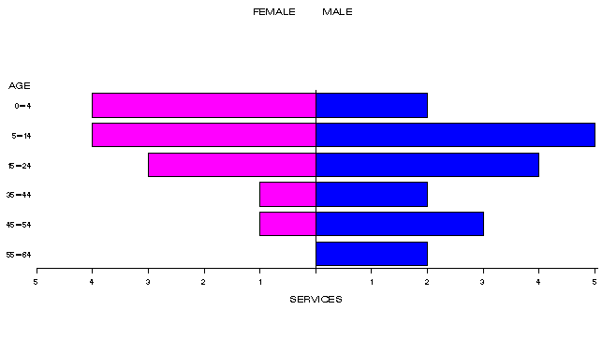
Source: Medicare Statistics Online

Figure 5: Demographic profile for MBS item 73333 (a), 73334 (b), and 73335 (c)
MBS item 73335; Nov 2012 – June 2017

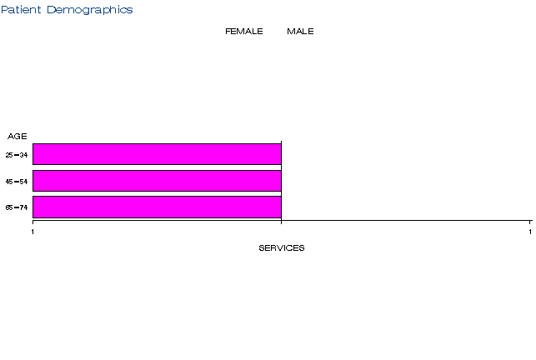

Source: Medicare Statistics Online

In and out of hospital
It was assumed that the majority of services would be provided by a specialist pathology laboratory. Actual utilisation shows the services are predominantly claimed in-hospital. In-hospital MBS pathology services are limited to private patients in private hospitals and private patients in public hospitals. ( Reference: G.1.2.a and G1.2.b.(iii) and (iv) and G.10.1 (a) Medicare Benefits Schedule Book – available on MBS Online).
The service provision setting is likely the main factor driving the low overall utilisation of these three items – the anticipated testing across the three VHL items may still be occurring but largely within the state-based public hospital system.

Co-claiming
The ten most common items co-claimed with the three VHL items are described in the following tables. These items cover blood tests, microbiology, standard tests of organ function (cardiac, respiratory, liver, kidney, thyroid) and inflammatory markers. Overall, the co-claimed items are unremarkable in the context of an initial diagnostic work-up. Many of the co-claimed items would also be consistent with testing to monitor the status of a patient and their organ function if they have already been diagnosed with VHL and have tumours previously identified in specific organs. Some of the less commonly claimed items not included in these tables are for example, tissue pathology of biopsy samples (72823), which one would expect for a patient with a recent tumour diagnosis or resection, as would be the case for patient with VHL.
It is interesting to note that VHL testing is sometimes co-claimed with a different genetic test for multiple endocrine neoplasia (73339). This suggests that patients suffering from the two conditions may present with similar clinical features and that specialists ordering the two tests together are working through a differential diagnosis.
The data do not reveal whether the result of each VHL test rendered was mutation positive or not. Without such information it is not possible to explore whether testing is being ordered for patients who are highly likely to test positive or whether testing is purely speculative for patients presenting with a tumour but no other features or risk factors suggesting VHL.

Table 2: Instances of co-claiming with MBS item 73333 in 2014-15
# | Items | Episodes | Number of Services | Schedule Fee for Combination | % of total episodes | Cumulative %
1 | 73333 | np | np | $1,800 | 20% | 20%
2 | 73333, 73339, 73939 | np | np | $3,007 | 20% | 40%
3 | 73333, 73939 | np | np | $1,807 | 20% | 60%
4 | 73333, 73939, 73940 | np | np | $2,021 | 13.33% | 73.33%
5 | 73333, 73940 | np | np | $1,221 | 13.33% | 86.66%
6 | 73333, 66716, 73939 | np | np | $627 | 6.67% | 93.33%
7 | 73333, 73339 | np | np | $1,000 | 6.67% | 100%
Source: MBS Analytics Section – December 2017

Table 3: Top 10 instances of co-claiming with MBS item 73333 in 2015-16
# | Items | Episodes | Number of Services | Schedule Fee for Combination | % of total episodes | Cumulative %
1 | 73333, 73939 | 15 | 30 | $9,036 | 34.09% | 34.09%
2 | 73333 | np | np | $2,400 | 9.09% | 43.18%
3 | 73333, 65070, 66512, 73939 | np | 18 | $1,985 | 6.82% | 50%
4 | 73333, 73940 | np | np | $1,831 | 6.82% | 56.82%
5 | 73333, 66512, 73931 | np | np | $1,240 | 4.55% | 61.37%
6 | 73333, 73339 | np | np | $2,000 | 4.55% | 65.92%
7 | 73333, 65070, 65120, 65123, 66512, 66518, 69354, 69363, 73939 | np | 12 | $788 | 2.27% | 68.19%
8 | 73333, 65070, 65123, 66512, 66569, 73339, 73939 | np | 7 | $1,100 | 2.27% | 70.46%
9 | 73333, 65070, 66503, 66512, 73931 | np | np | $651 | 2.27% | 72.73%
10 | 73333, 65070, 66509, 73931 | np | np | $635 | 2.27% | 75%
Source: MBS Analytics Section – December 2017

Background
MBS items 73333, 73334, 73335 for the Genetic Testing for Hereditary Mutation of the von Hippel -Lindau (VHL) Gene was listed onto the MBS on 1 November 2012.
MSAC considered the real world impacts of the outcome of Application 1153 for the Genetic Testing for Hereditary Mutation of the von Hippel -Lindau (VHL) Gene (MBS item 73333, 73334, 73335) by examining the available data for this item number.
On November 2010, the Pathology Services Table Committee (PSTC) requested that the Medical Services Advisory Committee (MSAC) undertake an assessment of genetic testing for hereditary mutations in the VHL gene that cause von Hippel-Lindau (VHL) syndrome for (i) patients with symptoms of VHL syndrome, and (ii) family members of a patient with a confirmed diagnosis of VHL syndrome.
VHL syndrome is a relatively rare clinical diagnosis of what is largely an inherited disorder that affects approximately 1 in 91,000 people worldwide. It is characterised by both benign and malignant tumours in specific organs of the body, including the central nervous system, eye, inner ear, kidney, pancreas, adrenal gland, and epididymis in the male and broad ligament in the female.
It was expected that the MBS item for the testing of relatives would primarily be used for first- and second-degree relatives, but the proposed listing was kept broad to allow for exceptional circumstances where wider use may be required. The comparator used for assessing the performance of VHL testing was patients with diagnosed VHL syndrome.
MSAC suggested that diagnostic testing for heritable mutation in affected patients and diagnostic testing for somatic mutations in patients with VHL syndrome and normal germline study be made available to specialists involved in the management of patients with VHL syndrome, but that predictive test for heritable mutation in relative of person with a heritable mutation be restricted to clinical geneticists.
MSAC noted that most current testing is done outside the Medicare system and 16% of laboratories performed less than 100 genotype tests in one year, with many laboratories performing very few diagnostic tests falling outside the scope of NATA volume threshold criteria. MSAC suggested that all testing should be ordered by a clinical geneticist or through a family cancer clinic or general genetics clinic – whose roles would include interpretation of unclassified variants and negative tests. MSAC also noted that MBS listing of this test would be contingent on an accredited quality assurance program to support the delivery of the test.
MSAC noted that laboratories offering the test in-house must have National Association of Testing Authorities accreditation, with demonstrated compliance with the suite of standards on the validation of in-house IVDs, as published by the National Pathology Accreditation Advisory Committee, for each test manufactured.

Item descriptor
MBS  Item # | Descriptor
65070 | Erythrocyte count, haematocrit, haemoglobin, calculation or measurement of red cell index or indices, platelet count, leucocyte count and manual or instrument generated differential count - not being a service where haemoglobin only is requested - one or more instrument generated set of results from a single sample; and (if performed)  (a) a morphological assessment of a blood film;  (b) any service in item 65060 or 65072  Fee: $16.95 Benefit: 75% = $12.75 85% = $14.45
65120 | Prothrombin time (including INR where appropriate), activated partial thromboplastin time, thrombin time (including test for the presence of heparin), test for factor XIII deficiency (qualitative), Echis test, Stypven test, reptilase time, fibrinogen, or 1 of fibrinogen degradation products, fibrin monomer or D-dimer - 1 test  Fee: $13.70 Benefit: 75% = $10.30 85% = $11.65
65123 | 2 tests described in item 65120  Fee: $20.35 Benefit: 75% = $15.30 85% = $17.30
66500 | Quantitation in serum, plasma, urine or other body fluid (except amniotic fluid), by any method except reagent tablet or reagent strip (with or without reflectance meter) of: acid phosphatase, alanine aminotransferase, albumin, alkaline phosphatase, ammonia, amylase, aspartate aminotransferase, bicarbonate, bilirubin (total), bilirubin (any fractions), C-reactive protein, calcium (total or corrected for albumin), chloride, creatine kinase, creatinine, gamma glutamyl transferase, globulin, glucose, lactate dehydrogenase, lipase, magnesium, phosphate, potassium, sodium, total protein, total cholesterol, triglycerides, urate or urea - 1 test  Fee: $9.70 Benefit: 75% = $7.30 85% = $8.25
66503 | 2 tests described in item 66500  Fee: $11.65 Benefit: 75% = $8.75 85% = $9.95
66509 | 4 tests described in item 66500  Fee: $15.65 Benefit: 75% = $11.75 85% = $13.35
66512 | 5 or more tests described in item 66500  Fee: $17.70 Benefit: 75% = $13.30 85% = $15.05
66518 | Investigation of cardiac or skeletal muscle damage by quantitative measurement of creatine kinase isoenzymes, troponin or myoglobin in blood - testing on 1 specimen in a 24 hour period  Fee: $20.05 Benefit: 75% = $15.05 85% = $17.05
66569 | Quantitation of blood gases, bicarbonate and pH as described in item 66566 on 2 specimens performed within any 1 day  Fee: $42.60 Benefit: 75% = $31.95 85% = $36.25
66716 | TSH quantitation  Fee: $25.05 Benefit: 75% = $18.80 85% = $21.30
69354 | Blood culture for pathogenic micro-organisms (other than viruses), including sub-cultures and (if performed):  (a) identification of any cultured pathogen; and  (b) necessary antibiotic susceptibility testing;  to a maximum of 3 sets of cultures - 1 set of cultures  Fee: $30.75 Benefit: 75% = $23.10 85% = $26.15
69363 | Detection of Clostridium difficile or Clostridium difficile toxin (except if a service described in item 69345 has been performed) - one or more tests  Fee: $28.65 Benefit: 75% = $21.50 85% = $24.40
73339 | Detection of germline mutations in the RET gene in patients with a suspected clinical diagnosis of multiple endocrine neoplasia type 2 (MEN2) requested by a specialist or consultant physician who manages the treatment of the patient.  One test. (Item is subject to rule 25)  Fee: $400.00 Benefit: 75% = $300.00 85% = $340.00
73931 | Initiation of a patient episode by collection of a specimen for 1 or more services (other than those services described in items 73922, 73924 or 73926) if:  (a) the specimen is collected by an approved pathology practitioner for a prescribed laboratory or by an employee of an approved pathology authority, who conducts a prescribed laboratory, from a person who is a private patient in a hospital or;  (b) the person is a private patient in a recognised hospital and the specimen is collected by an approved pathology practitioner or an employee of an approved pathology authority  Fee: $2.40 Benefit: 75% = $1.80 85% = $2.05
73939 | Initiation of a patient episode by collection of a specimen for 1 or more services (other than those services described in items 73922, 73924 or 73926), if the specimen is collected by or on behalf of the treating practitioner and if:  - the service is performed in a prescribed laboratory or  - the person is a private patient in a recognised hospital  Fee: $2.40 Benefit: 75% = $1.80 85% = $2.05
73940 | Receipt of a specimen by an approved pathology practitioner of an approved pathology authority from another approved pathology practitioner of a different approved pathology authority or another approved pathology authority  (Item is subject to rules 14, 15 and 16)  Fee: $10.25 Benefit: 75% = $7.70 85% = $8.75

Applicant’s comments on MSAC’s public summary document
The applicant had no comment.

Further information on MSAC
MSAC Terms of Reference and other information are available on the MSAC Website at: www.msac.gov.au.

