MSAC Application 1772
Single chamber leadless pacing with atrio-ventricular synchronous pacing in patients with bradycardia
PICO Set Document

Intended purpose
This submission to MSAC is lodged to facilitate the listing of the leadless pacemaker (LPM) Micra AV device on the Prescribed List of Medical Devices and Human Tissue Products (“Prescribed List”, PL), which provides pacing to the ventricle and senses the atrium, eg, providing atrio-ventricular (AV) synchronous pacing.
The procedural component (fee for service) of the proposed intervention is already funded via MBS items 38372 (insertion), 38373 (retrieval and replacement) 38374 (retrieval at least 4 weeks after insertion) and 38375 (explantation).
The purpose of the MSAC submission is to facilitate the listing of the Micra AV device on the Prescribed List (Part A) via the Tier 3 Full HTA pathway (Draft PL guide). A Tier 3 Full HTA pathway is nominated because, as outlined in this PICO set, the proposed device is superior and more costly than the comparator device, hence an economic model will be required to assess the longer-term costs and benefits of patients beyond the trial period. In addition, the PICO differs from the previous MSAC submission for single chamber ventricular pacing (MSAC application 1672).

Population
Describe the population in which the proposed health technology is intended to be used:
Bradycardia
Bradycardia, or cardiac bradyarrhythmia, is defined as abnormally slow heart rhythm, as a consequence of the disturbance of the generation or conduction of cardiac electrical activity. A resting heart rate less than 60 beat per minutes in adults other than well trained athletes is considered bradycardia by the National Institutes of Health (NIH) (NIH 2017). However, studies frequently apply a lower cut-off of 50 beats per minutes (Kusomoto 2019).
Within the heart there is a natural pacemaker, the sinoatrial (SA) node, located within the right atrium. The SA node sets the heart rate by spontaneously generating electrical activity which initiates depolarisation and contraction of the right atrium. The electrical signal is then propagated through the right atrium to the ventricles through the atrioventricular (AV) junction. The AV junction consists of the AV node and the bundle of His and is located at the base of the intra-atrial septum extending into the interventricular septum. In a typical functioning heart this is the only electrical connection between the atrium and the ventricles. Following electrical conduction through this system, there is resulting depolarisation and contraction of the ventricles (Sovari 2018).1
There are several conditions that can cause disruption in this pathway. Such disruptions result in arrythmias of which bradycardia is the most common. Depending on the location of the conduction abnormality, or the presence of symptomatic bradycardia, the treatment of these conditions is usually permanent cardiac pacing. Bradycardia can be broadly categorised as stemming from sinus node dysfunction (SND) or AV block, with the clinical presentation, ranging from insidious symptoms to episodes of syncope, explained by the underlying electrophysiologic issue.
Irrespective of whether the bradycardia is caused by SND or AV block, the term “symptomatic bradycardia” is used by the 2018 American College of Cardiology / American Heart Association/ Heart Rhythm Society (ACC/AHA/HRS) bradycardia guidelines and is defined as a “documented bradyarrhythmia that is directly responsible for development of the clinical manifestations of syncope or presyncope, transient dizziness or light headedness, heart failure symptoms, or confusional states resulting from cerebral hypoperfusion attributable to slow heart rate” (Kusumoto 2019 Bradycardia Guideline pg e391).
Bradycardia due to AV block
There are multiple aetiologies of bradycardia attributable to AV block, including both congenital and acquired forms. The acquired forms are more prevalent and include infectious, inflammatory, degenerative, ischaemic and iatrogenic causes as shown in Table 1.
Table 1 Aetiology of AV block
Congenital/genetic | Congenital AV block (associated with maternal systemic lupus
 | Congenital heart defects (eg, L-TGA)
 | Genetic (eg, SCN5A mutations)
Infectious | Lyme carditis
 | Bacterial endocarditis with perivalvar abscess
 | Acute rheumatic fever
 | Chagas disease
 | Toxoplasmosis
Inflammatory/infiltrative | Myocarditis
 | Amyloidosis
 | Cardiac sarcoidosis
 | Rheumatologic disease: Systemic sclerosis, SLE, RA, reactive arthritis (Reiter’s syndrome)
 | Other cardiomyopathy—idiopathic, valvular
Ischaemic | Acute MI
 | Coronary ischemia without infarction—unstable angina, variant angina
 | Chronic ischaemic cardiomyopathy
Degenerative | Lev’s and Lenegre’s diseases
Vagotonic-associated with increased vagal tone | Sleep, obstructive sleep apnoea
 | High-level athletic conditioning
 | Neurocardiogenic
Metabolic/endocrine | Acid-base disorders
 | Poisoning/overdose (eg, mercury, cyanide, carbon monoxide, mad honey)
 | Thyroid disease (both hypothyroidism and hyperthyroidism)
 | Adrenal disease (eg, pheochromocytoma, hypoaldosteronism)
Other diseases | Neuromuscular diseases (eg, myotonic dystrophy, Kearns-Sayre syndrome, Erb’s dystrophy)
 | Lymphoma
Iatrogenic | Medication related
 | Beta blockers, verapamil, diltiazem, digoxin
 | Antiarrhythmic drugs
 | Neutraceuticals
 | Catheter ablation
 | Cardiac surgery, especially valve surgery
 | TAVR, alcohol septal ablation
RA, rheumatoid arthritis; MI, myocardial infarction; SLE, systemic lupus erythematosus; TAVR, transcatheter aortic valve replacement.
Source: Kusumoto (2019), table 9

Table 2 provides the ACC/AHA/HRS (2019) definitions of AV block. The symptoms of AV block are varied and dependent on the degree of AV block, the ventricular rate and how often it occurs (Kusomoto 2019). In higher grade, first degree AV block when the PR interval is long enough for loss of AV synchrony to occur with consequent reduction in cardiac output and increase in pulmonary wedge pressure, patients may present with what is referred to as pseudo pacemaker syndrome (Kusomoto 2019). Symptoms may include dyspnea, malaise, light-headedness, chest pain, or even syncope due to poor synchronisation of atrial and ventricular contractions (Oldroy 2023). Patients with third degree AV block (complete heart block) are rarely asymptomatic, and typically present with fatigue, tiredness, chest pain, shortness of breath, presyncope or syncope (Knabben 2023).
Table 2 Definitions or descriptions of AV block
Term | Definition or description
AV block | First-degree atrioventricular block: P waves associated with 1:1 atrioventricular conduction and a PR interval >200 ms (this is more accurately defined as atrioventricular delay because no P waves are blocked)
 | Second-degree atrioventricular block: P waves with a constant rate (<100 bpm) where atrioventricular conduction is present but not 1:1
 | Mobitz type I: P waves with a constant rate (<100 bpm) with a periodic single nonconducted P wave associated with P waves before and after the nonconducted P wave with inconstant PR intervals
 | Mobitz type II: P waves with a constant rate (< 100 bpm) with a periodic single nonconducted P wave associated with other P waves before and after the nonconducted P wave with constant PR intervals (excluding 2:1 atrioventricular block)
 | 2:1 atrioventricular block: P waves with a constant rate (or near constant rate because of ventriculophasic sinus arrhythmia) rate (<100 bpm) where every other P wave conducts to the ventricles
 | Advanced, high-grade or high-degree atrioventricular block: ≥2 consecutive P waves at a constant physiologic rate that do not conduct to the ventricles with evidence for some atrioventricular conduction
 | Third-degree atrioventricular block (complete heart block): No evidence of atrioventricular conduction
 | Vagally mediated atrioventricular block: Any type of atrioventricular block mediated by heightened parasympathetic tone
 | Infranodal block: atrioventricular conduction block where clinical evidence or electrophysiologic evidence suggests that the conduction block occurs distal to the atrioventricular node
Source: Kusumoto (2019) table 3 pg d390.
Permanent pacing
Permanent pacing works by preventing the heart from beating slower than a predefined rate, by delivering an electrical stimulus to the myocardium when required. In conventional pacing this occurs via transvenous lead(s) which are in contact with the myocardium either in the atrium or ventricle or both depending on the lead configuration. The electrical impulse triggers localised depolarisation which is then propagated causing either atrial or ventricular contraction. This electrical impulse needs to deliver enough energy to cause depolarisation. The minimum energy required to “capture” the myocardium of the heart is known as the output threshold. The efficacy of pacemaker therapy is therefore measured by the ability of a pacemaker to deliver electrical impulse successfully. The efficacy of therapy is monitored regularly by clinicians, with device check-ups at regular intervals or if a patient presents with symptomatic bradycardia (Pacemaker Learning package 2016).
There are two main types of pacemaker systems that exists– conventional transvenous system and a leadless system. Currently available transvenous permanent pacemakers are available in two main types: single-chamber (atrial or ventricular pacing only) or dual-chamber (paces both the atrium and ventricles). In addition, these pacemakers are available in various pacing modes. There are two types of leadless pacemaker systems available in Australia- one providing ventricular pacing (VVI pacing), and one that provides AV synchronous pacing (VDD pacing).
Selection of ideal pacing mode involves consideration of the patient’s overall physical condition, comorbidities, exercise capacity, left ventricular function, and chronotropic response to exercise in addition to the underlying rhythm disturbance (Link 2023). Patient preference must also be taken into account. Table 3 outlines cardiac pacing nomenclature as used in pacing mode descriptors.
Table 3 Cardiac pacing nomenclature: five position code¹
Position | Function described | Code | Code meaning
I | Chamber(s) paced | A | Atrium
 |  | V | Ventricle
 |  | D | Dual chamber²
II | Chamber(s) sensed | A | Atrium
 |  | V | Ventricle
 |  | D | Dual chamber²
 |  | O | Sensing absent
III | Response to a sensed event | I | Sensed event inhibits the output pulse and causes the pacemaker to recycle for one or more timing cycles
 |  | T | Sensed event triggers an output pulse
 |  | D | Dual modes of response³, an event sensed in the atrium inhibits the atrial output but triggers a ventricular output⁴
 |  | O | No response to sensed input
IV | Rate modulation⁵ | R | Rate modulation present with a sensor to adjust the programmed paced heart rate in response to patient activity
 |  | O | Rate modulation is either unavailable or disabled
V | Multisite pacing⁶ | O | No multisite pacing
 |  | A | Multisite pacing in the atrium or atria
 |  | V | Multisite pacing in the ventricle or ventricles
 |  | D | Dual multisite pacing in both atrium and ventricle
Source: adapted from Hayes 2018
1. Note that this code is generic and does not describe specific or unique functional characteristics for each pacing device. When a code includes only three or four characters it can be assumed that the positions not mentioned are “O” or absent
2. Both atrium and ventricle
3. Restricted to dual-chamber systems
4. There is a programmable delay between the sensed atrial event and the triggered ventricular output to mimic the normal PR interval. If the ventricular lead senses a native ventricular signal during the programmed delay, it will inhibit the ventricular output
5. Also referred to as rate-responsive or rate adaptive pacing
6. Defined as stimulation sites in both atria, both ventricles, more than one stimulation site in any single-chamber, or a combination of these (this position is rarely used)

AV block and permanent pacing
Patients with AV block are indicated for permanent pacing (Kusumoto 2019; Glikson 2021). Permanent pacing in these patients can be via a conventional transvenous pacemaker (TVPM) or via a leadless pacemaker (Glikson 2021).
Conventional dual-chamber TVPM have a long history of use and have essentially remained unchanged over time with reliance on a pulse generator (the battery component of the pacemaker) which is implanted in a subcutaneous pocket (created at time of insertion) in the infraclavicular region of the anterior chest wall. The pulse generator produces the electrical activity required to be transmitted to the myocardium, via the electrodes (leads). In DDD mode, two leads are inserted percutaneously either via subclavian, cephalic or axillary veins, and guided transvenously via the tricuspid valve into the ventricle and atrium. The position of the wire is checked using fluoroscopy. The lead can either be attached passively with tines (spikes at the end of the wire), which become fixed via granulation tissue formation, or can be actively fixed to the myocardium using a screw. For VDD pacing, a ventricular single-lead VDD pacemaker with two floating atrial electrodes for atrial sensing and the ventricular bipolar pacing/sensing electrodes is used (Mehmood 2022).
According to local experts, the most commonly used mode in dual-chamber TVPM for the proposed population is DDD (Table 3). In this mode the ventricle and atrium is sensed and paced. There is also a rate responsiveness function which allows the programmed rate to increase with increased physical activity, such as strenuous exercise, to allow for a compensatory increase in cardiac output.
The LPM is 90% smaller than a TVPM, and is a self-contained generator and electrode system that is implanted directly into the right ventricle via a femoral vein transcatheter approach. The procedure does not require chest incision or a subcutaneous generator pocket and eliminates the need for leads. The main benefit of the LPM relative to a TVPM is the elimination of several complications associated with TVPMs and leads such as pocket infections, hematoma, lead dislodgement, and lead fracture. Furthermore, the LPM has no chest incision or visible pacemaker pocket (Groner & Grippe 2019).
Currently two single-chamber LPM systems exist, Medtronic’s Micra VR, which provides pacing and sensing of the ventricle (VVI pacing mode), and Micra AV, which provides pacing to the right ventricle and senses the electrical signals in the atrium to allow for synchronised AV pacing of the ventricle (VDD pacing mode). Medtronic’s leadless single chamber ventricular pacemaker has recently undergone an MSAC assessment (MSAC application 1672) and will be listed on the Prescribed List (from 1st November 2023). This current application is specific to the next generation Micra LPM device, Micra AV, which is the LPM of choice in the proposed patient population with AV block and in sinus rhythm.
Whilst an effective intervention, conventional TVPM expose the patients to risk of lead and pocket complications. Furthermore, the subcutaneous device placement is cumbersome to some patients, leaving an unsightly scar, which may in turn compromise a patients quality of life. Given the limitations of the conventional TV-PM with respect to device and lead complications, there is a clinical need for an alternate treatment option in these patients, overcoming the safety concerns with the TVPM.

Specify any characteristics of patients with the medical condition, or suspected of, who are proposed to be eligible for the proposed health technology, describing how a patient would be investigated, managed and referred within the Australian health care system in the lead up to being considered eligible for the technology:
The proposed patient population for the insertion of a LPM for pacing of the ventricle and sensing of the atrium (Micra AV) include patients who are indicated for permanent pacing because of bradycardia due to AV block and who are in sinus rhythm.
AV block, also referred to as heart block, occurs when there is partial or complete interruption of impulse transmission from the atrium to the ventricle. Sinus rhythm refers to the normal rhythm of the heart, whereby the electrical impulse is initiated in the sinoatrial (SA) node and describes the characteristic rhythm of the healthy human heart.
The service is performed by an interventional cardiologist, electrophysiologist or cardiac surgeon. Patients may initially present to the hospital or to a general practitioner, with subsequent referral to a specialist cardiologist. In the lead up to being considered eligible for the service, evaluation of the patient’s history and physical examination constitutes a pivotal component of the medical evaluation (Kusumoto 2019).
Further non-invasive testing may include resting electrocardiography (ECG) monitoring to document rhythm, rate, and conduction as well as screening for structural heart disease or systemic illness; exercise ECG testing, ambulatory ECG, imaging, lab tests to investigate potential underlying causes (including thyroid function tests, Lyme titre, potassium, pH); genetic testing and sleep apnoea testing. Invasive testing may be required in some patients where non-invasive tests do not result in a diagnosis, such as implantable cardiac monitors and electrophysiology studies (Kusumoto 2019).
The ACC/AHA/HRS 2019 guidelines provides the work up algorithms that show the investigations performed on patients with bradycardia of the initial evaluation of suspected AV block (Figure 1).
Importantly, the work up and lead up to diagnosis of patients will not change as a consequence of the introduction of the proposed intervention.

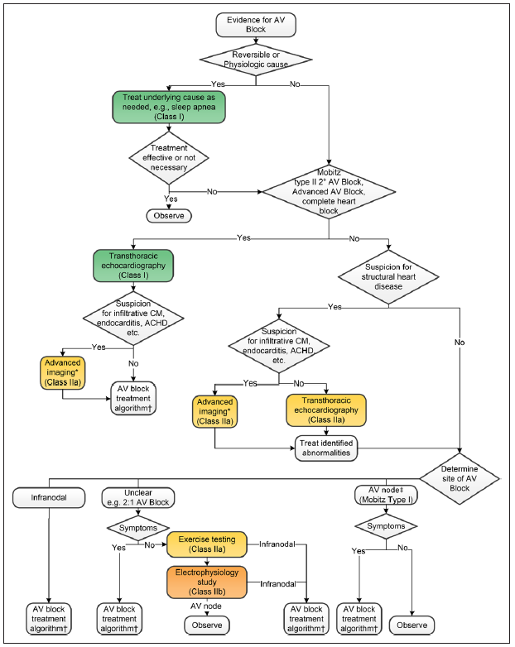
Figure 1 Initial evaluation of suspected AV block algorithm
Source: Kusumoto (2019) Figure 3 pg e395.
Colours correspond to Class of Recommendation in Kusumoto (2019). *Targeted Advanced Imaging—Magnetic Resonance Imaging (MRI): Amyloidosis, myocarditis, hemochromatosis, sarcoidosis, CHD, sinus of Valsalva aneurysm, aortic dissection, arrhythmogenic right ventricular cardiomyopathy; fluoro-deoxy-glucose (fludeoxyglucose)-positron emission tomography (FDG PET): sarcoidosis; 99m technetium pyrophosphate (Tc PYP) or 99m technetium 3,3-diphosphono-1,2-propanodicarboxylic acid (TC-DPD): Transthyretin (TTR) amyloidosis; cardiac computed tomography (CT): CHD, sinus of Valsalva aneurysm, aortic dissection, arrhythmogenic right ventricular cardiomyopathy; echo longitudinal strain: Amyloidosis; transesophageal echocardiogram (TEE): Endocarditis, sinus of Valsalva aneurysm, aortic dissection, CHD. ‡The atrioventricular node is more likely the site of block with second-degree Mobitz type I atrioventricular block and a narrow QRS complex or severe first-degree atrioventricular block (>0.30 s) with a narrow QRS complex.
AV, atrioventricular; ACHD, adult congenital heart disease; CHD, congenital heart disease; and CM, cardiomyopathy.

Provide a rationale for the specifics of the eligible population:
The proposed population is consistent with the approved indications included on the Australian Register of Therapeutic Goods (ARTG) where Micra AV Model MC1AVR1 (Micra AV) is indicated for patients with AV block who are in sinus rhythm. Given the Micra AV pacemaker paces the ventricle and senses the atrium, to ensure synchronicity between the atrium and the ventricle, it is necessary for the electrical impulses sent from the sinus node to function properly, meaning patients must be in sinus rhythm.
The proposed eligible population for Micra AV is also consistent with the clinical position as advised by seven leading experts in the management of these patients consulted to inform this Application. The experts are interventional cardiologists from Victoria (VIC), New South Wales (NSW), Australian Capital Territory (ACT) and Queensland (QLD).

Are there any prerequisite tests?
No

Are the prerequisite tests MBS funded?
Not applicable (NA)

Please provide details to fund the prerequisite tests:
N/A

Intervention

Name of the proposed health technology:
Insertion of a single chamber, leadless pacemaker providing atrio-ventricular (AV) synchronous pacing

Describe the key components and clinical steps involved in delivering the proposed health technology:
The key componentss of the Micra AV system containes one implantable transcatheter pacing system which includes the implantable device and the delivery cathter systeim (Figure 2).
- Implantable device – The Micra AV Model MC1AVR1 is a single chamber transcatheter pacing system that provides AV synchronous pacing and bipolar sensing and pacing in the right ventricle. The device has an active fixation mechanism consisting of four electrically inactive tines designed to anchor the device in the cardiac tissue at the implant location in the right ventricle.
- Device delivery catheter system – The Micra AV delivery catheter system consists of the following parts:
  - A delivery catheter designed to carry, deliver, and position the device for implant in the right ventricle by accessing this chamber through the femoral vein. The delivery catheter has a steerable, flexible shaft with a rigid distal end that contains a device cup to hold the device and a recapture cone to retrieve it. The delivery catheter is compatible with a 7.8 mm (23 Fr) introducer sheath that is 56 cm (22 in) long or longer, such as the Medtronic Micra Introducer.
  - A handle with controls to navigate the delivery catheter and deploy the device. The handle also provides a tether designed as an aid to test the device fixation and to recapture and reposition the device for proper fixation during the implant procedure.

The Medtronic programmer and software are used to program the device for implant testing and patient follow-up sessions. The use of a Medtronic programming head is required for communication between the device and the programmer. [Programmers from other manufacturers are not compatible with Medtronic devices but will not damage Medtronic devices].
The MRI SureScan feature permits a mode of operation that allows a patient with a SureScan system to be safely scanned by an MRI machine whilst the device continues to provide appropriate pacing. When programmed to “On”, MRI SureScan operation disables all user-defined diagnostics.

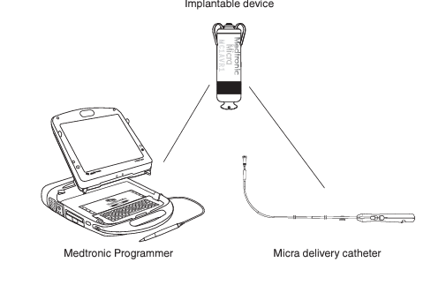
Figure 2 Micra AV system components
The Micra AV is a type of leadless pacemaker, that is a single-chamber implantable transcatheter pacemaker inserted via the femoral vein and implanted directly into the right ventricular myocardium negating the need for transvenous wires. The Micra AV provides VDD pacing.
The device implant steps are as follows:
- The implant procedure:
- Preparing the delivery system and device for implant
- Inserting a percutaneous introducer into the patient’s femoral vein
- Navigating the delivery system and deploying the device in the right ventricle
- Assessment of device fixation
- Performing the pull and hold test
- Taking the initial electrical measurements
- Repositioning the device if necessary for proper fixation
- Completion of the implant procedure
- Completing the device programming

- Assessment of device performance
(Micra AV instructions for use: https://wwwp.medtronic.com/crs-upload/letters/401/401_Micra_AV_Implant_Manual_with_Medical_Procedure_and_EMI_Precautions.pdf)

Identify how the proposed technology achieves the intended patient outcomes:
The Medtronic Micra AV Model MC1AVR1 MR single chamber (‘Micra AV’), transcatheter pacing system with SureScan technology is a programmable cardiac device that monitors and regulates the patient’s heart rate by providing rate-responsive bradycardia pacing to the right ventricle and AV synchrony based on the mechanical sensing of atrial activity.
The device senses both the electrical activity and the mechanical activity of the patient’s heart using sensing and pacing electrodes and an accelerometer enclosed in a miniature titanium capsule. It monitors the heart for bradycardia and AV synchrony. It also provides the following features for patients:
- The device responds to bradycardia by providing pacing therapy based on programmed pacing parameters.
- The device provides AV synchrony based on sensed mechanical activity in the atrium.
- The device provides diagnostic and monitoring information to evaluate device performance and to provide the best possible patient care.

Does the proposed health technology include a registered trademark component with characteristics that distinguishes it from other similar health components?
Yes – Micra™ AV MC1AVR1

Explain whether it is essential to have this trademark component or whether there would be other components that would be suitable:
It is not essential to have this trademark component in the MBS item descriptor (as per the resultant MBS item descriptor for the Micra VR LPM).

Are there any proposed limitations on the provision of the proposed health technology delivered to the patient (For example: accessibility, dosage, quantity, duration or frequency):
No
Provide details and explain:
NA

If applicable, advise which health professionals will be needed to provide the proposed health technology:
The health professionals that will primarily deliver the proposed service include specialist cardiologists (interventional cardiologist, cardiac electrophysiologist) or cardiac surgeons.

If applicable, advise whether delivery of the proposed health technology can be delegated to another health professional:
NA

If applicable, advise if there are any limitations on which health professionals might provide a referral for the proposed health technology:
The delivery of the service, as addressed above, is limited to interventional cardiologist, cardiac electrophysiologist or cardiac surgeon. The referring physicians are general practitioner or a non-interventional cardiologist.

Is there specific training or qualifications required to provide or deliver the proposed service, and/or any accreditation requirements to support delivery of the health technology?
Yes

Provide details and explain:
Cardiologists who intend to perform insertion of a LPM device undergo a comprehensive training program, which is provided by Medtronic. This robust program includes online as well as hands-on education designed to provide a performance-based, interactive procedural training to prepare physicians to start implanting Micra.
Prerequisites
The Micra system is placed in the heart via a 23 Fr Introducer after access is gained through the femoral vein. Proficiency in femoral venous access and large bore catheter manipulation are, therefore, recommended.
Upon satisfaction of the prerequisites, physicians are invited to complete the required Micra Academy educational components (see Implanter Training Pathway below).
Implanter Training Pathway
Physicians must complete two Micra procedural training components: online modules via Medtronic Academy and attend a Medtronic sponsored in-person training course. This in-person training includes didactic learning and hands-on procedural training (e.g.: implant simulator, cadaver and animal model, videos, and demonstration models).
Micra Technical Support
It is recommended that a minimum of the first 10 implants be supported by a Medtronic Micra Technical Expert representative. Additional support beyond the first 10 cases will be made available.
Indicate the proposed setting(s) in which the proposed health technology will be delivered:
Consulting rooms
Day surgery centre
Emergency Department
Inpatient private hospital
Inpatient public hospital
Laboratory
Outpatient clinic
Patient’s home
Point of care testing
Residential aged care facility
Other (please specify)

The procedure is performed as an inpatient service, either in the public or private hospital setting. The first 24 hours after the procedure is critical in terms of monitoring the patient for adverse events and complications.

Is the proposed health technology intended to be entirely rendered inside Australia?
Yes

Please provide additional details on the proposed health technology to be rendered outside of Australia:
N/A

Comparator

Nominate the appropriate comparator(s) for the proposed medical service (i.e., how is the proposed population currently managed in the absence of the proposed medical service being available in the Australian health care system). This includes identifying health care resources that are needed to be delivered at the same time as the comparator service:
The nominated comparator to the insertion of a LPM in the proposed patient population is the insertion of a conventional, dual chamber transvenous pacemaker (TVPM).
The health care resources that are needed to be delivered at the same time as the comparator service are similar to those delivered at the same time as the proposed intervention, and includes anaesthesia, the professional service itself and hospitalisation. The duration of stay is the same for both procedures with patients admitted overnight.

List any existing MBS item numbers that are relevant for the nominated comparators:
There are two item numbers listed on the MBS that are used to claim the dual-chamber TVPM procedure; one item relevant to the insertion of the PM generator device itself (MBS item 35353) and one item for the component of the service that relate to the insertion of the dual-chamber TV leads (MBS item 38356; Table 4). It should be noted that whilst item 38356 is specific to the insertion of the leads for a dual-chamber PM, item 38353 can be used for the insertion of either a dual or single-chamber PM generator.
Table 4 MBS items used for the comparator service, implantation of a dual-chamber TVPM
MBS item number | Description | Fee and benefit
38353 | PERMANENT CARDIAC PACEMAKER, insertion, removal or replacement of, not for cardiac resynchronisation therapy, including cardiac electrophysiological services, where used for pacemaker implantation.  Multiple operation Rule  (See para TN.8.60 of explanatory notes to this Category) ª | Fee: $279.75 Benefit: 75% = $209.85
38356 | DUAL CHAMBER PERMANENT TRANSVENOUS ELECTRODES, insertion, removal or replacement of, including cardiac electrophysiological services, where used for pacemaker implantation.  Multiple Operation Rule  (Anaes.)  (See para TN.8.60 of explanatory notes to this Category) ª | Fee: $917.05 Benefit: 75% = $687.80
a TN.8.60: The fees for the insertion of a pacemaker (Items 38350, 38353 and 38356) cover the testing of cardiac conduction or conduction threshold, etc related to the pacemaker and pacemaker function. Accordingly, additional benefits are not payable for such routine testing under Item 38209 or 38212 (Cardiac electrophysiological studies).
Source: MBS online, accessed 6 October 2023.

Please provide a rationale for why this is a comparator:
According to advice from seven Australian specialist cardiologists that are experts in the management of these patients, the current management of patients with AV block who are in sinus rhythm consist of implantation of a DC-TVPM with DDD mode (two leads). DDD mode provides pacing and sensing to the atrium and ventricle.
Whilst a TVPM with VDD pacing mode exists (one lead) which paces the ventricle and senses the atrium, these models are no longer sold in Australia (Mond 2019). This was corroborated by seven local experts, who advised that these devices are not used in current practice, and are not listed on the Prescribed List (PL) as they are becoming obsolete. Hence the TVPM with VDD pacing is not a comparator to LPM with Micra AV in the proposed population. The experts confirmed that patients with AV block and who are in sinus rhythm and who are indicated for permanent pacing receive a DC-TVPM with two leads and DDD mode, even in patients where right ventricular pacing alone would be sufficient. This confirms that DC-TVPM with DDD mode is the comparator to LPM in the proposed population, as it reflects the “technology most likely to be replaced” consistent with the definition of a comparator as per the MSAC guidelines (TG 2.3 pg 35).
The experts advised that leadless VDD pacing would be used in patients that do not require pacing to the atrium, and in patients who do not require close to100% AV synchronicity – typically these are older patients who have co-morbidities and with restricted physical activity. In these patients, the risk of infections and lead complications could be catastrophic.
The current management of these patients using a DC-TVPM pacemaker with DDD mode means these patients receive ‘more pacing’ than required for the condition and are implanted with more hardware than necessary. The benefits of LPM using Micra AV over a DC-TVPM DDD pacemaker is the lack of leads and generator in the subcutaneous pocket that can cause infections and lead complications, which is particularly important in this typically frail patient population.

Pattern of substitution – Will the proposed health technology wholly replace the proposed comparator, partially replace the proposed comparator, displace the proposed comparator or be used in combination with the proposed comparator?
None – used with the comparator
Displaced – comparator will likely be used following the proposed technology in some patients
Partial – in some cases, the proposed technology will replace the use of the comparator, but not all
Full – subjects who receive the proposed intervention will not receive the comparator

Please outline and explain the extent to which the current comparator is expected to be substituted:
Refer to UTILISATION ESTIMATES attachment.

Outcomes

List the key health outcomes (major and minor – prioritising major key health outcomes first) that will need to be measured in assessing the clinical claim for the proposed medical service/technology (versus the comparator):
Health benefits
Health harms
Resources
Value of knowing
Outcome | Health benefit/harms
Procedural complications (acute) | Superior vs TVPM
Device related complications \ | Superior vs TVPM
Reinterventions | Superior vs TVPM
Quality of life | Superior vs TVPM
Deaths | Similar vs TVPM

The key outcomes are as follows:
Technical performance
- pacing performance (sensing, impedance, pacing threshold, AV synchronicity)
- battery life
- adaptability (rate response)
Patient-relevant effectiveness outcomes
- Mortality (all-cause and cardiovascular)
- Exercise capacity
- Health-related quality of life
- Patient satisfaction
Safety outcomes
- Major procedure-related complications (infection, pericardial effusion, cardiac tamponade/perforation, thromboembolism, vascular complications [bleeding, arteriovenous/atrioventricular fistula, pseudoaneurysm, haematoma])
- Pacemaker syndrome
- Major device-related complications (device dislodgement, device malfunction, battery failure, device infection, pacemaker-induced arrhythmia)
- Device revision, retrieval, replacement, explantation
- Any serious adverse event

Outcome description – please include information about whether a change in patient management, or prognosis, occurs as a result of the test information:
N/A

Proposed MBS items

How is the technology/service funded at present? (for example: research funding; State-based funding; self-funded by patients; no funding or payments):
The procedural component (fee for service) of the proposed intervention is already funded via MBS items 38372 (insertion), 38373 (retrieval and replacement) 38374 (retrieval at least 4 weeks after insertion) and 38375 (explantation).
As described below, the current wordings of these MBS items would allow for insertion of the Micra AV pacemaker for the proposed population, hence no changes to existing MBS items are proposed.
As discussed previously, the purpose of this MSAC submission is to facilitate a Tier 3 Full HTA for the listing of the Micra AV device on the Prescribed List (Part A) (Draft PL guide).
Please provide at least one proposed item with their descriptor and associated costs, for each population/Intervention: (please copy the below questions and complete for each proposed item)
Proposed item details
No changes to existing MBS items are proposed. Below the MBS item for insertion (38372) (is presented, noting that the following MBS items are also relevant: 38373 (retrieval and replacement) 38374 (retrieval at least 4 weeks after insertion) and 38375 (explantation). No changes to any of the MBS items are sought.
MBS item number | 38372
Category number | 3
Category description | THERAPEUTIC PROCEDURES
Proposed item descriptor | Leadless permanent cardiac pacemaker, single-chamber ventricular, percutaneous insertion of, for the treatment of bradycardia, including cardiac electrophysiological services (other than a service associated with a service to which item 38350 applies) (H)  Multiple Operation Rule  (Anaes.)
Proposed MBS fee | Fee: $830.30 Benefit: 75% = $622.75
Indicate the overall cost per patient of providing the proposed health technology | Refer to Cost-breakdown attachment
Please specify any anticipated out of pocket expenses | $0
Provide any further details and explain | If Micra AV is listed on the PL at an acceptable benefit the out-of-pocket cost for the device is expected to be $0.  [In the event the patients’ health fund does not cover the cost of the procedure, the out of pocket costs for patients may reflect 25% of the MBS item fee for the service ($207.58)]

Algorithms
Preparation for using the health technology

Define and summarise the clinical management algorithm, including any required tests or healthcare resources, before patients would be eligible for the proposed health technology:
The proposed clinical management algorithm for the eligible population including the Micra AV LPM is provided in Figure 3. This reflects the adapted algorithm by the 2018 ACC/AHA/HRS guideline on the evaluation and management of patients with bradycardia and cardiac conduction delay (Kusomoto 2019).
The Micra AV device is indicated for use in those with AV block and a normal sinus rhythm, and when a right ventricular pacing system is acceptable (eg, in whom an atrial lead is not necessary). Consistent with the indication for use of the Micra AV LPM, the clinical placement in the algorithm of Micra AV is as an alternative to dual chamber pacing with a right ventricular pacing lead. That is, in patients with AV block who are in sinus rhythm (eg, these patients do not have permanent atrial fibrillation) [The algorithm also indicates where the Micra VR device is used, eg in those with atrial fibrillation].
The work up of patients including test and assessments before patients would be eligible for the proposed health technology or the comparator is outlined in Figure 1.

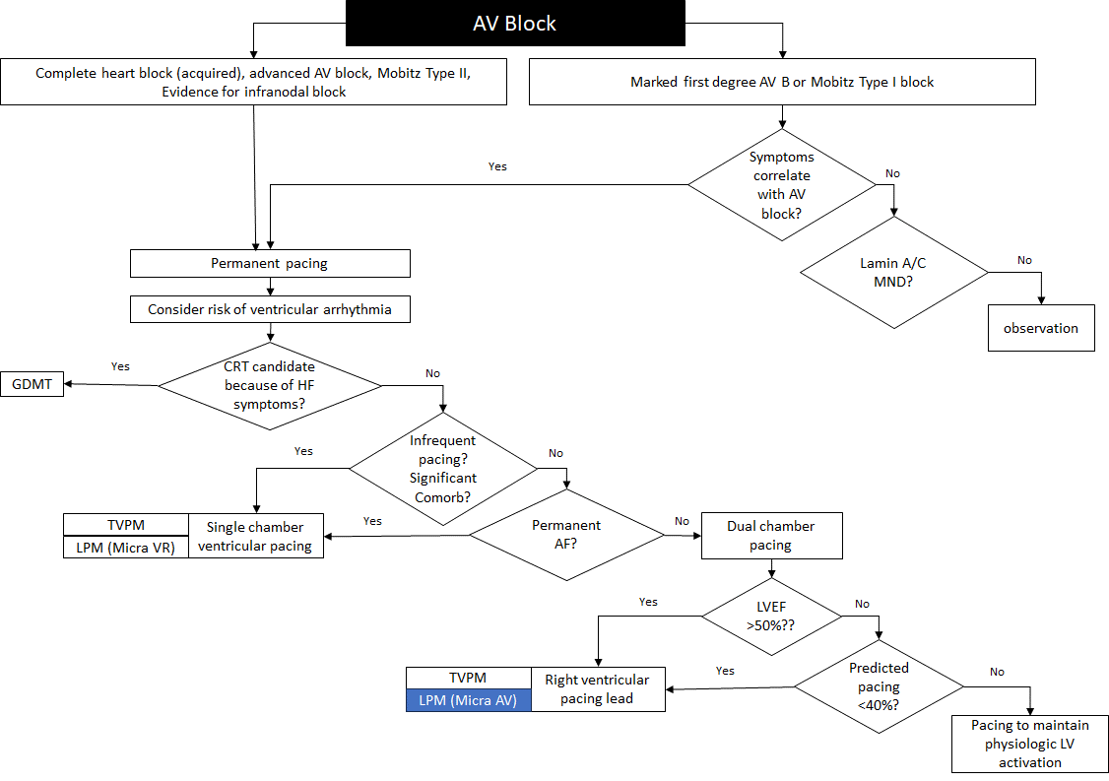
Figure 3 Proposed algorithm with the introduction of Micra AV LPM

Is there any expectation that the clinical management algorithm before the health technology is used will change due to the introduction of the proposed health technology?
No

Describe and explain any differences in the clinical management algorithm prior to the use of the proposed health technology vs. the comparator health technology:
No difference.
Use of the health technology

Explain what other healthcare resources are used in conjunction with delivering the proposed health technology:
The health care resources that are needed to be delivered at the same time as the proposed intervention includes anaesthesia, fluoroscopy, the professional service itself and hospitalisation. The duration of stay is the same for both procedures, with patients generally admitted overnight.

Explain what other healthcare resources are used in conjunction with the comparator health technology:
The health care resources that are needed to be delivered at the same time as the comparator service are similar to those delivered at the same time as the proposed intervention as described above.

Describe and explain any differences in the healthcare resources used in conjunction with the proposed health technology vs. the comparator health technology:
No difference.
Clinical management after the use of health technology

Define and summarise the clinical management algorithm, including any required tests or healthcare resources, after the use of the proposed health technology:
The clinical management pathway after the use of the proposed health technology and the comparator procedure is provided in Figure 4. The main difference in the current clinical management from the point of service delivery, that is, the insertion of a LPM, is the reduction in procedure and device related complications compared with the insertion of a TVPM. In particular, given the lack of leads in the LPM procedure, LPM patients will not experience lead complications such as infections.
A proportion of TVPM patients will experience lead and/or pocket infections. This complication typically results in the pacing system (device and leads) needing to be removed. The patient is admitted (or remains in hospital if occurring within 24 hours) and treated with antibiotic therapy to clear the infection. Temporary cardiac pacing will be required during this time if the patient is pacing dependent. Temporary cardiac pacing is achieved by the insertion of a temporary lead/s which is connected to an external pacing generator. After the infection has resolved a completely new system will be inserted including the PM generator and lead. The patient is hospitalised for the duration of the episode, which according to local experts typically lasts two weeks.
LPM patients may experience device or procedure related complications related to the LPM procedure.
All other monitoring requirements post the LPM procedure is the same as per the comparator procedure.

The frequency of monitoring of patients after the procedure may vary by treatment centres; however, patients who received a TVPM or a LPM are generally followed up at 1 week, 3 months, 6 months and then every 6–12 months by a specialist cardiologist or general practitioner.

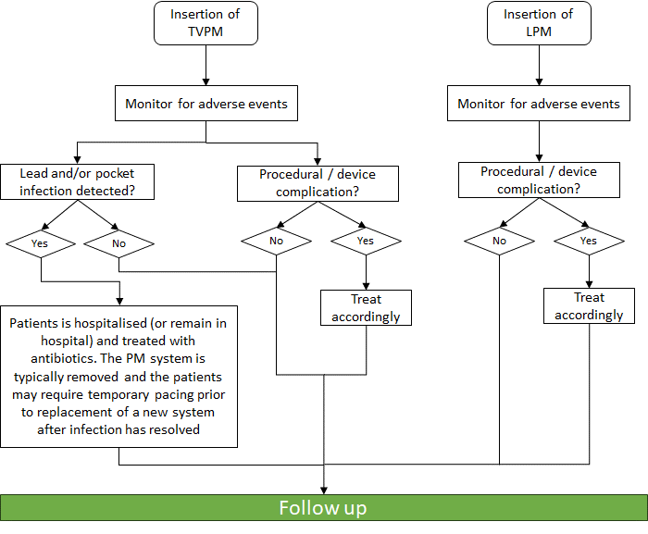
Figure 4 The clinical management pathway that patients may follow after they receive the proposed health technology

Define and summarise the clinical management algorithm, including any required tests or healthcare resources, after the use of the comparator health technology:
Discussed above

Describe and explain any differences in the healthcare resources used after the proposed health technology vs. the comparator health technology:
As discussed above, TVPM patients may have a lead and/or pocket infection detected which requires treatment, as described above. Given the Micra AV does not have any lead or generator in a subcutaneous pocket, these events do not occur with LPM.
Algorithms

Insert diagrams demonstrating the clinical management algorithm with and without the proposed health technology:
Inserted above.

Claims
In terms of health outcomes (comparative benefits and harms), is the proposed technology claimed to be superior, non-inferior or inferior to the comparator(s)?
Superior
Non-inferior
Inferior

Please state what the overall claim is, and provide a rationale:
The expected clinical claim is that relative to standard DC-TVPM, the transcatheter LPM with Micra AV is:
- Superior with respect to safety (complications over the longer term and reinterventions)
- Superior with respect to quality of life
- Non-inferior with respect to efficacy (including mortality)
- Inferior with respect to technical performance (AV synchronicity, all other parameters are expected to be non-inferior)
The rationale for the claim is provided below.

Why would the requestor seek to use the proposed investigative technology rather than the comparator(s)?
N/A

Identify how the proposed technology achieves the intended patient outcomes:
Given the Micra AV LPM is implanted directly into the myocardium of the right ventricle and does not have leads or a generator implanted in a subcutaneous pocket, lead and pocket related infections and complications do not occur with LPM and consequently a lower rate of reinterventions are required relative to the DC-TVPM. These results were observed in the Micra AV CED study (Crossley 2023).
Insertion of LPM with Micra AV is likely to result in improved quality of life of patients relative to those receiving DC-TVPM. A shorter period of restricted activities is required following LPM vs TVPM technologies (~24 hours vs 4–6 weeks, respectively). The earlier return to activities of daily living and hence independence as well as the omission of pain, discomfort and aesthetic issues pertaining to the subcutaneous pocket required for the TVPM procedure further contribute to improved quality of life of patients implanted with a LPM technology.
In terms of pacing performance including AV synchronicity, because the Micra AV device paces the ventricle and senses the atrium, whereas the DC-TVPM paces and senses the ventricle and atrium, LPM with Micra AV will not provide close to 100% AV synchronicity as is the case for the DC-TVPM. The MARVEL and MARVEL 2 studies indicated a modest reduction in AV synchrony during posture test and hall walks with Micra AV. In MARVEL, AV synchrony ranged from 81.5% during sitting to 62.7% during fast walking (Chinitz 2018). In MARVEL 2, AV synchrony ranged from 89.2% at rest to 69.8% whilst standing in high-degree AV block patients; average AV synchrony remained ≥ 70% for all maneuvers (Steinwender 2020).
LPM with Micra AV therefore provides an alternative to DC-TVPM in patients where the potential benefits of leadless pacing, in terms of reduced risk for complication as well as increased quality of life, outweigh the potential benefit of close to 100% AV synchrony and atrial pacing. It is anticipated that Micra AV will only be used in a patient population that does not require close to 100% AV synchronicity, consistent with those that do not perform high levels of activity (eg, elderly, frail, comorbid population).
For some people, compared with the comparator(s), does the test information result in:
A change in clinical management? N/A
A change in health outcome? N/A
Other benefits? N/A

Please provide a rationale, and information on other benefits if relevant:
N/A – the device is not a test.
In terms of the immediate costs of the proposed technology (and immediate cost consequences, such as procedural costs, testing costs etc.), is the proposed technology claimed to be more costly, the same cost or less costly than the comparator?
More costly
Same cost
Less costly

Provide a brief rationale for the claim:
The LPM (Micra AV) is safer, with reduced complications, and provides superior quality of life to patients compared with the DC-TVPM. This is consistent with the benefits of the Micra VR device, relative to transvenous single-chamber pacemakers (see MSAC Application 1672).

Summary of Evidence
Provide one or more recent (published) high quality clinical studies that support use of the proposed health service/technology. At ‘Application Form lodgement’, please do not attach full text articles; just provide a summary (repeat columns as required).
 | Type of study design* | Title of journal article or research project | Short description of research | Website link to journal article or research | Date of publication
1. | Observational study, longitudinal, prospective matched cohort study  Ongoing, post-market surveillance study# | MICRA AV CED  Outcomes of Patients Implanted with an Atrioventricular Synchronous Leadless Ventricular Pacemaker in the Medicare Population  Crossley 2023 | The Micra AV cohort had higher comorbidity burden at baseline than DC-TVPM cohort. Micra AV patients had a significantly lower rate of acute complications than DC-TCPM, including device related complications. No difference in rates of acute complications (30 days) were detected. At 6 months, Micra AV patients had statistically significantly lower rates of complications and reinterventions than DC-TVMP. Whilst Micra AV patients had higher rates of all-cause mortality, this is most likely explained by differences in underlying mortality risks at baseline.  REDACTED TEXT REDACTED TEXT REDACTED TEXT REDACTED TEXT REDACTED TEXT | https://pubmed.ncbi.nlm.nih.gov/37742991/  NCT04235491 | 2023
2 | Prospective, single arm, multicentre | AccelAV  Ambulatory atrioventricular synchronous pacing over time using a leadless ventricular pacemaker: Primary results from the AccelAV study  Chinitz 2023 | The objective was to characterise AVS in patients implanted with a Micra AV, which uses the device accelerometer to mechanically detect atrial contractions and promote VDD pacing. A total of 152 patients were implanted with LPM Micra AV. At 1 month post implant, mean resting AVS was 85.4% and ambulatory AVS was 74.8% among patients with normal sinus function and complete AVB (n=54). AVS remained stable through 3 months, and there were no system upgrades to DC-TVPM. | https://pubmed.ncbi.nlm.nih.gov/36075532/  NCT04245345 | 2023
 | Prospective, single arm, multicentre | Micra AV post-approval registry  Safety and effectiveness of the Micra AV system in the real-world setting, ongoing  Clementy 2023 (interim analyses compared to a historical control of 2,667 DC-TVPM patients) | Micra AV was successfully implanted in 797 of 802 patients (99.4%) at 99 centres. Mean age was 74.1±15.1 years and 42.3% were female. Micra AV patients were on average older (74.1 vs. 71.1 yrs, p<0.0001) and had a significantly higher incidence of renal disease (22.3% vs. 9.8%, P<0.0001) than the historical cohort of DC-TVPM patients. Major complications occurred in 2.6% of Micra AV patients and in 7.1% DC-TVPM patients (p<0.001). The reduction in major complications was largely driven by the absence of pneumothoraces and lead dislodgements among Micra AV patients. Of the 309 patients programmed to VDD mode with at least 30 days of device follow-up, the median AVS index was 86.0% (IQR: 69.2%– 97.2%). | https://academic.oup.com/europace/article/25/Supplement_1/euad122.392/7176582 | 2023
 | Prospective, single arm multi centre | MARVEL  Accelerometer-based atrioventricular synchronous pacing with a ventricular leadless pacemaker: Results from the Micra atrioventricular feasibility studies  Chinitz 2018 | The objective was to characterise the closed-loop performance of an AVS algorithm downloaded into previously implanted Micra VR devices (n=64). The average AVS at rest was 80% in AV block patients (n=33), with a modest reduction with increasing activity, to 62.7% AVS at a fast walk. | https://pubmed.ncbi.nlm.nih.gov/29758405/ | 2018
3 | Prospective, single arm | MARVEL 2  Atrioventricular Synchronous Pacing Using a Leadless Ventricular Pacemaker  Steinwender 2022 | The objective was to report on the performance of an automated, enhanced accelerometer-based algorithm (MARVEL 2) that provides AV synchronous pacing downloaded into Micra VR devices (n = 75). Median AVS at rest in patients with complete AV block and normal sinus rhythm was 94.3% (n = 40). Stroke volume increased by 1.7 cm (p = 0.2) or 8.8 + 15.4% during VDD pacing in patients with complete AV block and normal sinus rhythm. There were no pauses or episodes of oversensing-induced tachycardia. | https://www.jacc.org/doi/10.1016/j.jacep.2019.10.017 | 2022
AVS, atrioventricular synchrony; DC-TVPM, dual-chamber transvenous pacemaker; IQR, interquartile range.
# The Medtronic Micra is approved for funding in the US with a Coverage with Evidence Development [CED] requirement in the form of this US Claims data study

Identify yet-to-be-published research that may have results available in the near future (that could be relevant to your application). Do not attach full text articles; this is just a summary (repeat columns as required).
 | Type of study design | Title of journal article or research project | Short description of research | Website link to journal article or research | Status; Estimated completion
1. | RCT | The Leadless AV Versus DDD Pacing Study (LEAVE DDD)  The Leadless AV Versus DDD Pacing Study: A Randomised Controlled Single-centre Trial on Leadless Versus Conventional Cardiac Dual-chamber Pacing | The aim of this trial is to compare the therapeutic efficacy of the Micra AV™ LPM and DC-TVPM systems in patients with intermittent or permanent AV block and a PM indication according to the latest European guidelines. Thus, patients will be randomised to either a DC-TVPM implantation or the Micra AV LPM implantation and patients will be stratified for gender (female/male) and a priori estimated physical exercise capacity ("fit"/"unfit"). The primary outcome will be the physical exercise capacity of the patients. Estimated N=100. | NCT05498376 | Recruiting  2026-02-28
2 | RCT, cross-over | Danish Randomised Trial on Leadless vs Transvenous Pacing (DANVERS)  Danish Randomised Trial on VDD Leadless Atrial Tracking With MicraTM AV Transcatheter Pacing System vs Transvenous DDD Pacing in Elderly Patients With AV-block | The aim of this study is to assess the quality of life, patient acceptance and exercise capacity with the Micra AV LPM compared to DC-TVPM in elderly patients with new-onset high-grade atrioventricular block and preserved sinus node function and indication for permanent pacemaker implantation according to the latest European guidelines. Estimated N=80 | NCT05856799 | Recruiting  2025-08
AVS, atrioventricular synchrony; DC-TVPM, dual-chamber transvenous pacemaker; RCT, randomised controlled trial; LPM, leadless pacemaker.

Hayes DL (2018) Modes of cardiac pacing: Nomenclature and selection [internet]. Cited 5th September 2018. URL: www.uptodate.com/

