Application 1452:
Pembrolizumab (MK-3475) in Mismatch Repair Deficient Stage IV Colorectal Carcinoma

PICO Confirmation
(to guide a new application to MSAC)

December 2016

Summary of PICO/PPICO criteria to define the question(s) to be addressed in an Assessment Report to the Medical Services Advisory Committee (MSAC)
If direct evidence is available, direct effectiveness of the intervention can be determined using the following PICO criteria.
Component | Description
Patients | Patients diagnosed with colorectal cancer (CRC; stage IV at time of treatment with pembrolizumab)
Prior tests | Routine histology, cytology and immunohistochemical (IHC) tests to confirm diagnosis and stage of CRC
Intervention | - IHC mismatch repair (MMR) deficiency testing using antibodies directed against the four MMR proteins to detect a deficiency for eligibility for treatment with pembrolizumab on progression to stage IV CRC, and standard of care in those with proficient MMR  - Current testing regimenª plus pembrolizumab
Comparator | Current testing regimenª plus standard of care (chemotherapy with a combination of two drugs)
Outcomes | Safety : harms from testing (including rates of re-biopsy required for testing); treatment-associated adverse events and tolerability  Effectiveness: Critical outcomes^{b}: Overall survival, progression-free survival, overall response rate; Important outcomes^{b}: Quality of life  Cost-effectiveness: Cost, cost per life year gained, cost per quality adjusted life year or disability adjusted life year, incremental cost-effectiveness ratio, cost per case identified  Total Australian Government healthcare costs
Direct research question | What is the safety, effectiveness, and cost-effectiveness of IHC MMR deficiency testing for determining access to pembrolizumab in patients with stage IV CRC, compared with no testing and standard of care chemotherapy?  What is the safety, effectiveness, and cost-effectiveness of current testing regimen plus pembrolizumab, compared to the current testing regimen plus standard of care?
ª Current testing regimen may or may not include MMR testing for purposes other than determining eligibility for pembrolizumab
^{b}Outcomes ranked as recommended by GRADE

If direct effectiveness of the intervention cannot be determined, a linked approach may be used. A summary of the PICO criteria to address these are provided below.
Component | Description
Patients | Patients diagnosed with colorectal cancer (CRC)
Prior tests | Routine histology, cytology and immunohistochemical (IHC) tests to confirm diagnosis and stage of CRC
Intervention | IHC mismatch repair (MMR) deficiency testing using antibodies directed against the four MMR proteins to detect a deficiency for eligibility for treatment with pembrolizumab on progression to Stage IV CRC
Reference standard | Genomic sequencing of the four MMR genes
Comparator | Diagnostic accuracy: polymerase chain reaction-based microsatellite instability testing  Therapeutic effectiveness: current testing regimenª plus standard of care (chemotherapy with a combination of two drugs)
Outcomes | Diagnostic accuracy: Sensitivity, specificity, concordance, test-retest reliability, positive and negative likelihood ratios, positive and negative predictive values.  Prognosis: prognostic effect of biomarker  Change in management: % change in management plan (e.g. changes in treatment)  Therapeutic effectiveness: Critical outcomes^{b}: Overall survival, progression-free survival, overall response rate; Important outcomes^{b}: Quality of life  Predictive validity: treatment effect modification
Linked evidence research questions | What is the diagnostic accuracy of IHC MMR deficiency testing compared with the reference standard for determining access to pembrolizumab in patients with stage IV CRC?  Will the extra information generated as a result of IHC MMR deficiency testing be of additional prognostic value in patients with CRC?  Is there a change in management in patients in whom an MMR deficiency is diagnosed?  Does treatment with pembrolizumab lead to better health outcomes in patients with MMR deficient CRC compared with standard of care chemotherapy?  Is MMR status a treatment effect modifier?
ªCurrent testing regimen may or may not include MMR testing for purposes other than determining eligibility for pembrolizumab
^{; b}Outcomes ranked as recommended by GRADE

PICO rationale

2.1 Population
The proposed population are those patients diagnosed with colorectal cancer (CRC). Patients would receive immunohistochemical (IHC) DNA mismatch repair (MMR) deficiency testing using antibodies directed against the four mismatch repair proteins to detect a deficiency for eligibility for treatment with pembrolizumab on progression to Stage IV disease.
CRC can occur in any part of the large bowel (colon or rectum) and if untreated, can spread to the lymph nodes (glands) and eventually metastasize. Stage IV CRC is defined as cancer that has spread to distant organs or tissues.
In 2016, it is estimated that the age-standardised incidence rate will be 62 cases per 100,000 persons (74 for males and 51 for females) and CRC will be the second most common cause of death from cancer in Australia with an estimated age-standardised mortality rate of 14 deaths per 100,000 persons (16 for males and 12 for females) . This translates into an estimated 17,520 Australian cases of CRC, 10% of whom will be diagnosed with stage IV disease, and a 1 in 52 (1 in 45 for males and 1 in 62 for females) chance of an individual dying from bowel cancer by their 85th birthday.
The MMR system is mainly composed of four proteins (MLH1, MSH2, MSH6 and PMS2) interacting together to recognize DNA mismatches that may occur during DNA replication and excising them (Buecher et al. 2013). Microsatellites are short tandem DNA repeat sequences of 1–6 bases distributed throughout the coding and non-coding regions of the genome and are especially prone to replication errors that are normally repaired by the MMR system. An MMR deficiency results in a cancer with a 10- to 100-fold increase in the mutation rate and leads to the accumulation of frameshift mutations in microsatellites, which results in a genetic instability (Buecher et al. 2013; Dudley et al. 2016). Microsatellite Instability (MSI) also arises from either a germline (hereditary) mutation in one copy of any of the genes that encode the MMR proteins (Lynch syndrome) or from sporadic somatic hyper-methylation of the MLH1 promoter (Dudley et al. 2016). Homozygous or compound heterozygous mutation in these genes leads to childhood cancer syndromes such as constitutional mismatch repair deficiency syndrome and Turcot syndrome.
MMR deficient CRCs account for 12–17% of CRCs, of which only 2–3% are hereditary (Ashktorab et al. 2016; Dunne et al. 2016). MMR deficiency is more frequent in stage II CRC (almost 20%) compared to stage III (12%) and is relatively uncommon among metastatic tumours (4%) (Kawakami, Zaanan & Sinicrope 2015). The reduced level of MMR deficiency among stage IV CRC probably reflects the improved prognosis of MMR deficient stage II CRC (i.e. these patients do not progress to stage IV disease). Data to support the prevalence of MMR deficient CRC should be provided in the report.
Biological plausibility
MMR deficient CRC tumours commonly have increased numbers of tumour infiltrating lymphocytes, and patients have a greater inflammatory state as evidenced by higher C-reactive protein, neutrophil, and platelet counts than MMR-proficient CRC patients (Buecher et al. 2013; Quiroga, Lyerly & Morse 2016). This is most likely due to the increased mutation rate resulting in neo-epitopes recognised as foreign by the immune system (Llosa et al. 2015). MMR deficient tumours are associated with a good prognosis, and the presence of this immune response may partially explain their better clinical outcome (Buecher et al. 2013).
Llosa et al. (2015) found that MMR deficient tumours had significant gene upregulation of immune checkpoint proteins, including PD-L1, enabling them to survive the immune response. Rosenbaum et al. (2016) was able to detect PD-L1 expression by IHC (using the anti-PD-L1 monoclonal antibody E1L3N) in 12/54 (22%) MMR deficient CRC tumours (primary and metastatic), and found that PD-L1 positivity was associated with a lower survival within this MMR deficient CRC patient cohort. Thus, immune checkpoint inhibitors, such as the PD-1 inhibitor pembrolizumab, may provide a clinical benefit in treating MMR deficient CRC.
A more detailed analysis of the biological plausibility for the use of IHC MMR deficiency testing to identify CRC tumours susceptible to immune checkpoint inhibitors, such as the PD-1 inhibitor pembrolizumab, should be provided in the report. Furthermore, evidence of MMR deficiency being an effect modifier for treatment with pembrolizumab, above and beyond its prognostic effect should be provided.
Rationale
Three trials that are listed in the summary of evidence include patient populations that are broader than stage IV CRC indicated for treatment in this application. While all three trials enrolled patients with metastatic CRC, the KEYNOTE-164 single-arm phase II pembrolizumab trial and the single-arm phase II trial to evaluate the efficacy of MEDI4736 (durvalumab) also enrolled patients with locally-advanced disease whereas the third CheckMate 142 single-arm phase II nivolumab trial also enrolled patients with recurrent CRC. This approach will increase the number of patients with MMR deficient CRC eligible for the MEDI4736 trial, and the proportion of patients with MMR deficient disease in the KEYNOTE-164 and CheckMate 142 trials as a greater proportion of patients with stage III CRC will be MMR deficient (12%) than those with stage IV disease (4%). This will have little impact on IHC MMR deficiency testing as most patients are tested at diagnosis, regardless of disease stage. However, as MMR deficiency is a strong prognostic marker in earlier stages of disease, its role as a treatment effect modifier must be clearly demonstrated in these patients.

2.2 Prior test
Routine histology, cytology and IHC tests to confirm diagnosis and stage of CRC.

2.3 Intervention
The intervention to be assessed is IHC MMR deficiency testing plus pembrolizumab in those who are MMR deficient, and standard of care (chemotherapy with a combination of two drugs) in those who are MMR proficient.
An alternative intervention would be the current IHC MMR deficiency testing regimen plus pembrolizumab administered to all patients. This may be of use in clarifying the benefit of the testing component.
IHC MMR deficiency testing uses antibodies directed against each MMR protein (MLH1, MSH2, MSH6 and PMS2) and IHC staining to detect the expression of these proteins in the tumour cells to determine eligibility for treatment with pembrolizumab. The test uses formalin-fixed paraffin-embedded (FFPE) tumour tissue from either a surgical resection or a biopsy (if unresectable). Evidence of the stability of these proteins in FFPE tissue blocks should be provided if archival tissue is likely to be retrieved for testing.
The proteins form heterodimers (either MLH1/PMS2 or MSH2/MSH6), as the loss of one protein usually affects the expression of its partner, most MMR deficient CRCs show loss of expression of both proteins in the affected heterodimer. Loss of protein expression should be complete, with the absence of nuclear staining of all cancer cells and unequivocal positive staining of the nuclei of surrounding non-cancer cells and intratumoral lymphocytes. The loss of expression of MSH2/MSH6 is highly suggestive of a MSH2 germline mutation, and loss of expression of MLH1/PMS2 may result either from a MLH1 germline mutation or from acquired somatic hyper-methylation of the MLH1 gene promoter. Patients whose tumours showed a lack of expression of any of these proteins would be classed as MMR deficient and would be eligible for treatment with pembrolizumab at diagnosis of or progression to stage IV disease.
The applicant indicated that IHC MMR deficiency testing for access to pembrolizumab should be requested by the treating clinician. Patients are expected to receive one test throughout the course of their disease. The test is a Class II in vitro diagnostic test and must be performed in an accredited laboratory by a certified pathologist. It should be noted that most laboratories already perform the IHC MMR deficiency test, either routinely or based on either clinician request or red flag criteria. If found to be MMR deficient, treatment with pembrolizumab would be managed by medical oncologists.
The IHC MMR test is a simple, fast and inexpensive and most patients already receive IHC MMR deficiency testing as part of their initial diagnostic work-up at initial diagnosis. A survey found that currently, 54% of pathology laboratories conduct routine IHC MMR deficiency testing and an additional 40% conduct IHC MMR deficiency testing on either clinician request or red flag criteria for Lynch syndrome. Red flag criteria include: aged <50 years at diagnosis (3% of patients), medullary, micro-glandular, mucinous or signet ring cell morphology (up to 20% of patients), and increased tumour infiltrating lymphocytes (approximately 30% of patients) (Deschoolmeester et al. 2010).
IHC MMR deficiency testing is billed to the MBS via item number 72847 (Table 1). This item is for general IHC testing with 4-6 antibodies and is not limited to either anti-MMR antibodies or a specific patient population. The purpose of current IHC MMR deficiency testing is to improve outcomes for all CRC patients by providing prognostic information and guiding the use of fluorouracil-based chemotherapy, as well diagnosing Lynch syndrome, so that patients and family members with an increased risk of cancer can be monitored.
Table 1 Current MBS item number for IHC MMR deficiency testing
Category 6– Pathology Services
Group: P5 - TISSUE PATHOLOGY
72847
Immunohistochemical examination of biopsy material by immunofluorescence, immunoperoxidase or other labelled antibody techniques with multiple antigenic specificities per specimen - 4-6 antibodies
(Item is subject to rule 13)
Fee: $89.40 Benefit: 75% = $67.05 85% = $76.00
Rationale
The RCPA currently recommends that “IHC tests should be performed to test MMR deficiency status and the results recorded in the pathology report.” It recommends that for the purposes of diagnosing Lynch syndrome, at a minimum all cases of CRC arising in individuals less than 50 years of age should be tested. In addition, all cases meeting the revised Bethesda guidelines (Umar et al. 2004), which consider age, family history and histology of CRC, for being at risk of having hereditary nonpolyposis CRC should be tested. The RCPA also notes that the prognosis of mucinous carcinomas is dependent on their MMR deficiency status. Whereas the MMR deficient phenotype confers a favourable prognosis, mucinous CRCs that are MMR proficient tend to have an overall poorer prognosis.
Additionally, IHC MMR deficiency testing is used to predict of efficacy of fluorouracil-based adjuvant chemotherapy. This is especially useful for stage II CRC; in these patients MMR deficiency is associated with an excellent prognosis and a lack of benefit from fluorouracil-based chemotherapy in sporadic MMR deficiency CRC cases (Buecher et al. 2013). The test is not currently used to determine eligibility for treatment with immune checkpoint inhibitors, such as pembrolizumab in Australia.
If pembrolizumab is listed by the PBS, IHC MMR deficiency testing would also be used to direct treatment to pembrolizumab; patients with MMR-deficient stage IV CRC receiving their first line of therapy would be eligible.
As most patients already have IHC MMR deficiency testing, the changes to current practice will be minimal. The applicant suggests that the test would only need to be performed once, regardless of stage of disease when tested. Data to support the stability of the biomarker over the course of the disease should be included in the report. Additionally, the heterogeneity of MMR deficiency both within the tumour and between the primary tumour and metastases should also be explored.

2.4 Comparator
The suggested comparator for direct evidence of effectiveness, safety and cost-effectiveness of MMR testing and targeted pembrolizumab is the current testing regimen plus standard of care (chemotherapy with a combination of two drugs).
The KEYNOTE-177 trial will provide the main clinical evidence. In this trial the standard of care is one of six standard chemotherapy regimens per investigator choice: FOLFOX, FOLFOX plus bevacizumab, FOLFOX plus cetuximab, FOLFIRI, FOLFIRI plus bevacizumab, or FOLFIRI plus cetuximab. These combinations are commonly used in Australia and are included as treatment options in the clinical management algorithms (Figures 1 and 2).
As the National Comprehensive Cancer Network Guidelines for Genetic/Familial High-Risk Assessment: Colorectal recommend either MMR deficiency testing or PCR-based MSI testing and both tests were used to determine eligibility for the KEYNOTE-177 trial, the concordance between the two tests should be included in the report.
PCR amplification of specific microsatellite markers, usually by multiplex PCR, can be performed on fresh, frozen or FFPE tumour material (Buecher et al. 2013). A MSI phenotype is defined by the presence of at least two unstable markers (identified as having insertions or deletions) among five (or ≥30% of unstable markers if a larger panel is used). All other tumours, with 0–30% unstable markers, are considered as tumours without MSI owing to their clinical, histological and outcome similarities.
It should be noted that rare cases of MSI cannot be detected by IHC. Apparent intact expression of all four proteins by IHC cannot entirely exclude MSI and Lynch syndrome as missense mutations can lead to a non-functional protein with retained antigenicity (Buecher et al. 2013).
Rationale
The applicant suggested that the comparator would be no testing plus standard of care. However, given that many patients receive MMR testing under the current scenario, the comparator was amended to reflect this.
In this setting, IHC MMR deficiency testing to determine eligibility for pembrolizumab will be an additional test in those patients who do not receive an IHC MMR deficiency test for diagnostic or prognostic purposes at initial diagnosis. For patients who receive IHC MMR deficiency testing at initial diagnosis, there will be no change to the current diagnostic/prognostic testing regime.
The applicant suggested that a second comparator would be no testing plus pembrolizumab. This was modified to ‘current IHC MMR deficiency testing regimen plus pembrolizumab administered to all patients’, and is included as an alternative intervention because it may clarify the benefit of the testing component.
As the KEYNOTE-177 trial is estimated to enrol 270 stage IV CRC patients who are MMR deficient or have microsatellite instability, the concordance between the IHC MMR test and the MSI-PCR test must be demonstrated to validate the inclusion of patients enrolled on the basis of their MSI-PCR result. As MSI develops as a consequence of being MMR deficient it is reasonable to assume that the two tests should identify similar populations.
Reference standard
The gold standard for diagnosis of Lynch syndrome is genomic sequencing of the four MMR genes. To date over 3,100 unique DNA variants have been described with 57% classed as pathogenic or likely pathogenic, 32% as uncertain, 4% as likely not pathogenic and 7% as not pathogenic (Da Silva et al. 2016).

2.5 Outcomes
Evidence summary provided in application
The evidence base identified by the Applicant consists of three single-arm phase II trials in which stage IV CRC patients with or without MMR deficiency were treated with pembrolizumab or nivolumab, one phase II trial where patients with MMR deficient CRC were treated with durvalumab, and one phase III trial randomising patients with MMR deficient CRC to treatment with either pembrolizumab or standard chemotherapy. The results for some of these trials will not be available until mid to late 2017 or 2018.
These trials do not provide direct evidence for a co-dependent technology as defined below;
Level 1 direct evidence: Double-randomised controlled trial (randomised to test and to drug)
Level 2 direct evidence: Single-randomised controlled trial (randomised to test plus drug versus no test plus usual care)
Level 3 direct evidence: Prospective bio-marker stratified randomised controlled trial of drug (population with and without biomarker randomised to drug or usual care)
Level 4 direct evidence: Retrospective bio-marker stratified randomised controlled trial of drug (randomised to drug or usual care and then biomarker status determined)
Thus, a linked evidence approach will need to be undertaken.
Linked Evidence
Patient relevant outcomes
Safety Harms from testing (including rates of re-biopsy required for testing), treatment-associated adverse events and tolerability
Diagnostic accuracy Sensitivity, specificity, concordance, test-retest reliability, positive and negative likelihood ratios, positive and negative predictive values.
Prognosis Prognostic effect of MMR deficiency in CRC patients treated with standard of care.
Change in management % change in management plan (e.g. changes in treatment as a result of IHC MMR deficiency testing). It should be noted that the majority of patients are already tested and there may be no change in management outcomes to assess other than access to pembrolizumab
Therapeutic effectiveness (ranked as recommended by GRADE)
Critical outcomes: overall survival, progression-free survival, overall response rate; Important outcomes: quality of life
Predictive validity Treatment effect modification

Healthcare system
Cost-effectiveness Cost, cost per life year gained, cost per quality adjusted life year or disability adjusted life year, incremental cost-effectiveness ratio, cost per case identified
Financial implications Number of patients tested, number of patients tested per MMR deficient result, number of patients tested per MMR deficient result treated with pembrolizumab
As most CRC patients already receive IHC MMR deficiency testing, the impact of additional testing across the healthcare system if introduced is likely to be small. Most pathology laboratories already conduct IHC MMR testing; therefore, changes in patterns of healthcare resource provision will be minimal and there are unlikely to be any access issues. The proportion of patients currently receiving an IHC MMR test should be determined by the applicant in consultation with the RCPA.
Rationale
As a co-dependent technology, any treatment effect modification and/or prognostic effect operating in the relationship between IHC MMR deficiency testing and pembrolizumab needs to be elucidated.

Current clinical management algorithm for identified population
The current management of CRC (shown in Figure 1) includes IHC MMR deficiency testing as part of the initial work-up, with most patients having the test at initial diagnosis of CRC for diagnostic (Lynch syndrome) and/or prognostic/predictive purposes. The treatment options have been modified compared to that in the application to reflect current PBS restrictions on the use of cetuximab and panitumumab in first-line treatment of stage IV CRC, and alternative treatments for patients who have only resectable or hepatic metastases. However, current treatment options available to patients with MMR deficient stage IV CRC do not include any targeted treatment options.
Stage 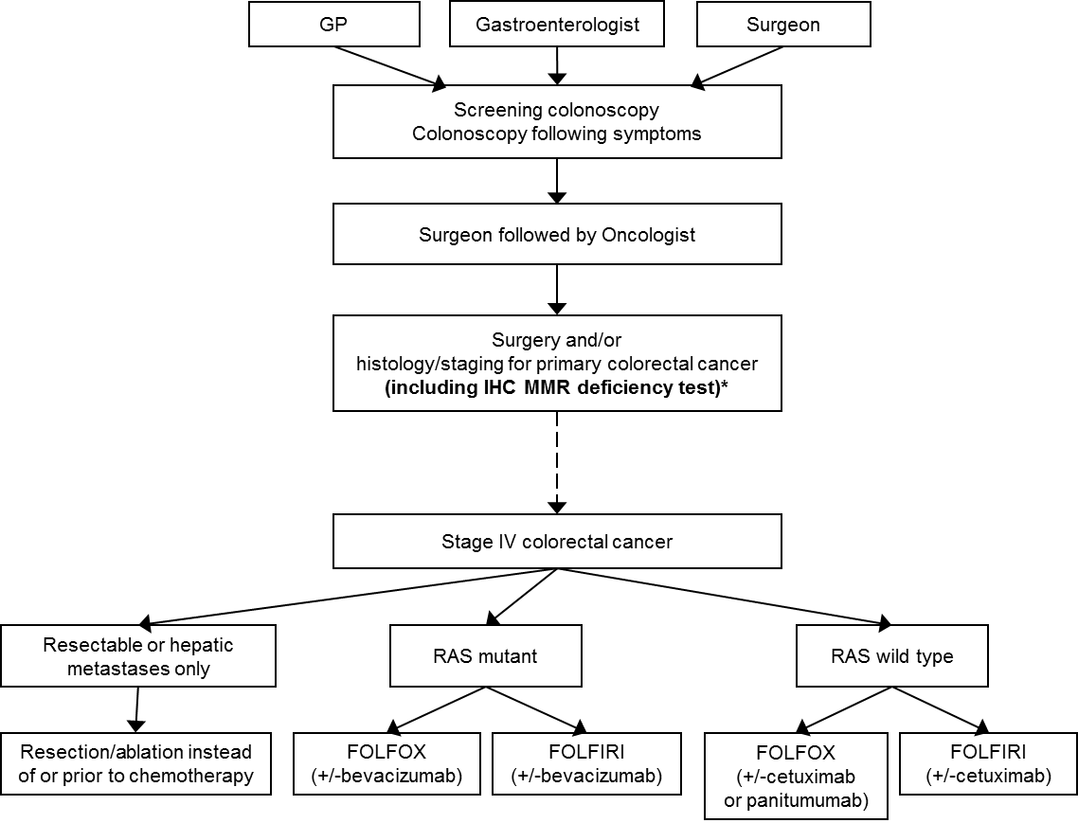
Figure 1 Current clinical management algorithm for stage IV CRC
*Not routinely conducted in all centres (see 2.2 above for details) although most patients are tested
IHC = immunohistochemistry; MMR = mismatch repair; RAS = rat sarcoma; FOLFOX = combination folinic acid, fluorouracil and oxaliplatin; FOLFIRI = combination of folinic acid, fluorouracil and irinotecan.

Proposed clinical management algorithm for identified population
The clinical management algorithm proposed by the applicant (Figure 4 in Appendix 1) lacked clarity. It indicated that patients with stage IV CRC should receive IHC MMR deficiency testing at initial work-up and did not appear to allow for testing of patients who are diagnosed with a lower stage disease and then progress to stage IV. It also seemed to preclude IHC MMR deficiency testing for diagnostic and/or prognostic/predictive purposes although that was not likely their intention.
After clarification during the teleconference between the Department, the applicant and the HTA group on 31 October 2016, the timing of the IHC MMR deficiency test would still occur at initial diagnosis of CRC, but all patients would be tested. This enables clinicians to use this information for diagnostic and/or prognostic/predictive purposes in early stages of disease. When, or if, patients are diagnosed with or progress to stage IV CRC, pembrolizumab treatment can commence in those patients who are eligible without requiring further testing.
For PASC consideration: also discussed at the tele conference was the stability of the MMR biomarker. It is unknown how stable MMR deficiency is over time and disease progression in sporadic cases. Thus, it was recommended that PASC consider whether or not to allow for repeat testing of patients who were diagnosed with early disease on progression to stage IV disease.
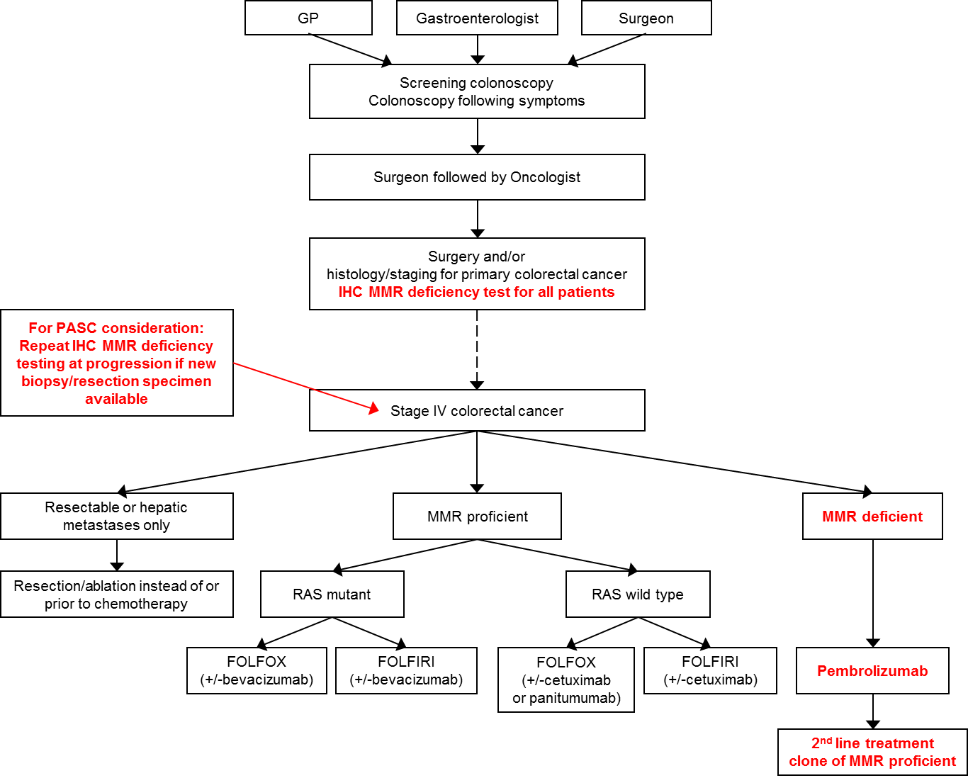
Figure 2 Proposed clinical management algorithm for stage IV CRC
IHC = immunohistochemistry; MMR = mismatch repair; RAS = rat sarcoma; FOLFOX = combination folinic acid, fluorouracil and oxaliplatin; FOLFIRI = combination of folinic acid, fluorouracil and irinotecan.
It is estimated that there will be 17,520 Australian cases of CRC in 2016, and 10% of these cases will be diagnosed with stage IV disease. According to the current clinical management algorithm, most of these 17,520 patients will have an IHC MMR deficiency test, including all patients with stage IV disease.

Proposed economic evaluation
The applicant predicts a claim of superiority in patients who are MMR deficient with pembrolizumab relative to standard of care, but the final clinical claims will be related to the hypotheses of the phase III KEYNOTE 177 trial (enrolling only MMR deficient CRC patients) and are dependent upon the results of the interim/final analyses, which will be available at the end of 2018.
The four hypotheses of the KEYNOTE 177 trial are:
1: Pembrolizumab prolongs progression-free survival per RECIST 1.1 by central imaging vendor compared with standard of care chemotherapies;
2: Pembrolizumab improves overall response rate compared with standard of care chemotherapies;
3: Pembrolizumab prolongs overall survival compared with standard of care chemotherapies;
4: Pembrolizumab has a non-inferior safety and tolerability profile compared with standard of care chemotherapies.
On the basis of these claims, the appropriate type of economic evaluation would be a cost-utility analysis. However, comparative evidence of IHC MMR deficiency testing or pembrolizumab treatment in both MMR deficient and proficient populations is not included in the preliminary supporting evidence identified in Part 4 of the Application Form. Additional evidence will need to be presented in order to substantiate these claims.

Proposed item descriptor
The IHC MMR deficiency test is currently billed to MBS item 72847 (IHC with 4-6 antibodies; Table 1). This item number is generic and is used for testing other biomarkers using other antibodies in a variety of diseases. In fact, in the last financial year (July 2015 to June 2016) 54,968 tests were billed to this item number whereas there were only approximately 17,000 new cases of CRC during this time.
MBS item number 72847 currently enables IHC MMR deficiency testing of any CRC patient, and most patients are already being tested, primarily for diagnosis of Lynch syndrome and/or for prognostic/predictive purposes. The applicant is seeking an amendment to the existing MBS item to augment IHC MMR deficiency testing for access to pembrolizumab.
The applicant expects that patients would require only 1 test throughout the course of their disease and the Medicare fee for MBS item 72847 of $89.40 is not expected to change. However, the Department has asked PASC to consider whether retesting of new biopsy specimens should be allowed on progression to stage IV disease.
If the current MBS item descriptor was amended, the proposed changes (Table 2) would restrict IHC MMR deficiency testing to determining eligibility for access to pembrolizumab, excluding the current usage for diagnostic and/or for prognostic/predictive purposes. The loss of reimbursement for use of the IHC MMR test for diagnostic purposes would have repercussions for family members of patients with Lynch syndrome who remain undiagnosed. At risk family members may be unaware of their increased susceptibility to developing cancer and may not undergo early and/or regular screening to detect early signs of disease. The proposed changes would also preclude reimbursement for other tests conducted under this item number. Thus, the proposed item number, as currently worded, cannot directly replace the existing item number if current usage is deemed appropriate by PASC. It is suggested that the current item descriptor would be sufficient for the purposes of IHC MMR testing proposed in this application and should remain the same. If PASC disagrees, an additional item number should be added as shown in Table 2.

Table 2 Proposed MBS item descriptor for IHC MMR deficiency testing
Category 6– Pathology Services
Proposed changes to item descriptor / new item descriptor:

Immunohistochemical examination of biopsy material by immunofluorescence, immunoperoxidase or other labelled antibody techniques with multiple antigenic specificities per specimen (4-6 antibodies) to determine if the requirements relating to mismatch repair deficiency status for access to pembrolizumab under the Pharmaceutical Benefits Scheme (PBS) are fulfilled
Fee: $89.40 Benefit: 75% = $67.05 85% = $76.00
Type in boldface shows the proposed changes to the wording of MBS item number 72847

References
Ashktorab, H, Ahuja, S, Kannan, L, Llor, X, Ellis, NA, Xicola, RM, Laiyemo, AO, Carethers, JM, Brim, H & Nouraie, M 2016, 'A meta-analysis of MSI frequency and race in colorectal cancer', Oncotarget, vol. 7, no. 23, Apr 23, pp. 34546-34557.
Buecher, B, Cacheux, W, Rouleau, E, Dieumegard, B, Mitry, E & Lievre, A 2013, 'Role of microsatellite instability in the management of colorectal cancers', Dig Liver Dis, vol. 45, no. 6, Jun, pp. 441-449.
Da Silva, F, Wernhoff, P, Dominguez-Barrera, C & Dominguez-Valentin, M 2016, 'Update on Hereditary Colorectal Cancer', Anticancer Res, vol. 36, no. 9, Sep, pp. 4399-4405.
Deschoolmeester, V, Baay, M, Van Marck, E, Weyler, J, Vermeulen, P, Lardon, F & Vermorken, JB 2010, 'Tumor infiltrating lymphocytes: an intriguing player in the survival of colorectal cancer patients', BMC Immunology, vol. 11, pp. 19-19.
Dudley, JC, Lin, MT, Le, DT & Eshleman, JR 2016, 'Microsatellite Instability as a Biomarker for PD-1 Blockade', Clin Cancer Res, vol. 22, no. 4, Feb 15, pp. 813-820.
Dunne, PD, McArt, DG, O'Reilly, PG, Coleman, HG, Allen, WL, Loughrey, M, Van Schaeybroeck, S, McDade, S, Salto-Tellez, M, Longley, DB, Lawler, M & Johnston, PG 2016, 'Immune-Derived PD-L1 Gene Expression Defines a Subgroup of Stage II/III Colorectal Cancer Patients with Favorable Prognosis Who May Be Harmed by Adjuvant Chemotherapy', Cancer Immunol Res, vol. 4, no. 7, Jul, pp. 582-591.
Kawakami, H, Zaanan, A & Sinicrope, FA 2015, 'Microsatellite instability testing and its role in the management of colorectal cancer', Curr Treat Options Oncol, vol. 16, no. 7, Jul, p. 30.
Llosa, NJ, Cruise, M, Tam, A, Wicks, EC, Hechenbleikner, EM, Taube, JM, Blosser, RL, Fan, H, Wang, H, Luber, BS, Zhang, M, Papadopoulos, N, Kinzler, KW, Vogelstein, B, Sears, CL, Anders, RA, Pardoll, DM & Housseau, F 2015, 'The Vigorous Immune Microenvironment of Microsatellite Instable Colon Cancer Is Balanced by Multiple Counter-Inhibitory Checkpoints', Cancer Discovery, vol. 5, no. 1, January 1, 2015, pp. 43-51.
Quiroga, D, Lyerly, HK & Morse, MA 2016, 'Deficient Mismatch Repair and the Role of Immunotherapy in Metastatic Colorectal Cancer', Curr Treat Options Oncol, vol. 17, no. 8, Aug, p. 41.
Rosenbaum, MW, Bledsoe, JR, Morales-Oyarvide, V, Huynh, TG & Mino-Kenudson, M 2016, 'PD-L1 expression in colorectal cancer is associated with microsatellite instability, BRAF mutation, medullary morphology and cytotoxic tumor-infiltrating lymphocytes', Mod Pathol, May 20.
Umar, A, Boland, CR, Terdiman, JP, Syngal, S, de la Chapelle, A, Rüschoff, J, Fishel, R, Lindor, NM, Burgart, LJ, Hamelin, R, Hamilton, SR, Hiatt, RA, Jass, J, Lindblom, A, Lynch, HT, Peltomaki, P, Ramsey, SD, Rodriguez-Bigas, MA, Vasen, HFA, Hawk, ET, Barrett, JC, Freedman, AN & Srivastava, S 2004, 'Revised Bethesda Guidelines for Hereditary Nonpolyposis Colorectal Cancer (Lynch Syndrome) and Microsatellite Instability', Journal of the National Cancer Institute, vol. 96, no. 4, pp. 261-268.

Appendix 1 Applicant presented proposed clinical management algorithm

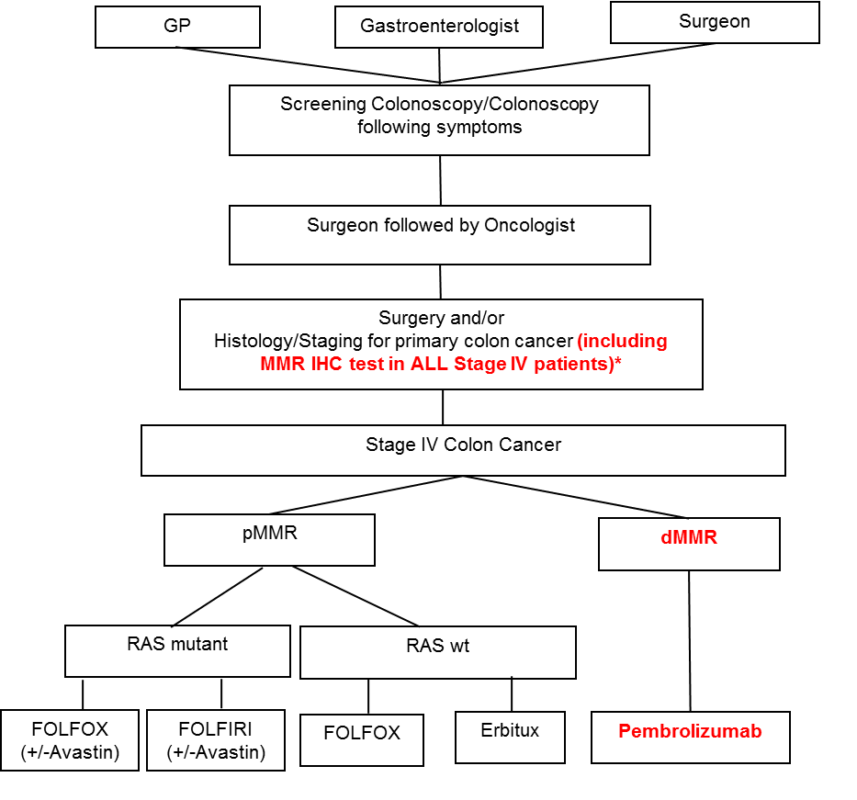
Figure 3 Proposed clinical management algorithm for stage IV CRC presented by the applicant
*If the test was not previously undertaken during earlier stages of disease
dMMR = mismatch repair deficient; IHC = immunohistochemistry; MMR = mismatch repair; pMMR = mismatch repair proficient; RAS = rat sarcoma; wt = wildtype; ; FOLFOX = combination folinic acid, fluorouracil and oxaliplatin; FOLFIRI = combination of folinic acid, fluorouracil and irinotecan

Available from URL <http://www.aihw.gov.au/cancer/bowel/>, Accessed 24 August 2016.
Available from URL <http://www.aihw.gov.au/cancer/bowel/>, Accessed 24 August 2016.
“Colorectal Cancer Structured Reporting Protocol” (3rd Edition 2016). Available from URL < http://www.rcpa.edu.au/Library/Practising-Pathology/Structured-Pathology-Reporting-of-Cancer/Cancer-Protocols> accessed 22 August 2016.
“Colorectal Cancer Structured Reporting Protocol” (3rd Edition 2016). Available from URL < http://www.rcpa.edu.au/Library/Practising-Pathology/Structured-Pathology-Reporting-of-Cancer/Cancer-Protocols> accessed 22 August 2016.
See section 2d of the ‘Guidelines for preparing a submission to the PBAC’ for Product Type 4 – Co-dependent technologies for further details
Available from URL <http://www.aihw.gov.au/cancer/bowel/>, Accessed 24 August 2016.

