MSAC Application 1680:
Genetic testing for childhood hearing impairment

Ratified

PICO Confirmation

Summary of PICO/PPICO criteria to define the questions to be addressed in an Assessment Report to the Medical Services Advisory Committee (MSAC)
Table 1 PICO for whole exome/genome analysis in childhood hearing loss
Component | Description
Population | Children (<18 years) with permanent bilateral moderate, severe or, profound (>40dB in the worst ear over three frequencies) sensorineural, auditory neuropathy or mixed isolated hearing loss and a non-diagnostic GJB2/GJB6 gene test result.  Child should not meet the criteria for testing under MBS item 73358 or 73359.
Prior tests | Clinical assessment and family history including audiology testing, GJB2/GJB6 (connexin 26/30) gene testing
Intervention | Singleton virtual gene panel-based analysis of whole exome or genome data (WEA), including copy number variant (CNV) analysis, of germline gene variants known to cause hearing loss.
Comparator/s | No virtual gene panel-based analysis of whole exome/genome data including CNV analysis (prior tests alone, i.e. Clinical assessment and family history including audiology testing)
Outcomes | Safety  - Adverse events from genetic testing or no genetic testing  - Psychological effects of genetic testing (with the result being positive, negative or a variant of unknown significance (VUS)) or no genetic testing  Effectiveness  - Time to diagnosis  - Impact on clinical management (investigations, treatment, and surveillance)  - Health-related quality of life  - Impact on reproductive decisions/number of couples with information (reproductive confidence)  Cross-sectional test outcomes  - Diagnostic yield (including proportion of those tested whose results provide prognostic/predictive information)  Longitudinal accuracy  - Prognostic value  - Predictive value  Healthcare resources  - Cost per proband identified  - Total Australian Government healthcare costs  Other relevant considerations  - Value of knowing (personal and family utility)  - Ethical considerations
Research questions | Overarching question: What is the safety, effectiveness, and cost-effectiveness of the addition of WEA including CNV analysis for hearing loss (HL)-associated germline gene variants in children (<18 years) with permanent bilateral moderate, severe, or profound isolated hearing loss who do not have a genetic cause for their deafness identified from prior GJB2/GJB6 gene variant analysis?  Questions to be addressed in the assessment:  Test information/accuracy: What is the diagnostic yield of WEA for identifying HL-associated germline gene variants in children (<18 years) with permanent bilateral isolated HL in comparison to diagnosis using standard clinical investigations? In what proportion of patients does this provide incremental prognostic information? In what proportion of patients does this provide incremental predictive information? Does trio testing rather than singleton testing increase the diagnostic yield or reduce the time to diagnosis?  What is the prognostic and predictive value of pathogenic HL-associated germline gene variants in children (<18 years) with permanent bilateral isolated HL identified using WEA?  Safety of testing: What harms (including psychological harms) might occur due to WEA or WEA test results (with the result being a positive, negative, or a variant of unknown significance) in a child (<18 years) with permanent bilateral isolated HL? (psychological harms could be to the child or their parents/caregivers)  Change in management: Does the identification of a pathogenic HL-associated germline gene variants in children (<18 years) with permanent bilateral isolated HL change their clinical management? Impact on management includes further investigations, surveillance, and treatment.  Effectiveness of change in management (if required): Are there any health outcomes associated with change in management due to identification of pathogenic HL-associated germline gene variants in children (<18 years) with permanent bilateral isolated HL?  Are there any adverse events associated with change in management due to identification of pathogenic HL-associated germline gene variants in children (<18 years) with permanent bilateral isolated HL?  Value of knowing: Are there benefits/harms that result from the incremental diagnostic/prognostic information provided by WEA, which are outside of the health sector? (e.g. for language attainment, educational outcomes, reproductive decisions)
Abbreviations: CNV = copy number variant, dB = decibels, GJB2/GJB6 = genes for connexin 26 and connexin 30 proteins, HL = Hearing Loss, MBS = Medical Benefits Schedule, WEA = whole exome analysis.
Table 2 PICO for trio testing (biological parents concurrently with the child) using gene panel-based analysis of whole exome or genome sequencing data in childhood hearing loss to aid diagnosis
Component | Description
Population | A child (<18 years) and biological parents of a child with permanent bilateral moderate, severe or, profound (>40dB in the worst ear over three frequencies) sensorineural, auditory neuropathy or mixed isolated HL and a non-diagnostic GJB2/GJB6 gene test result. The child should not meet the criteria for testing under MBS item 73358 or 73359.
Prior tests | Clinical assessment and family history including audiology testing.  GJB2/GJB6 (connexin 26/30) gene testing (for affected child only).
Intervention | Trio virtual gene panel-based analysis of whole exome or genome data including CNV analysis of germline gene variants known to cause hearing loss. Testing to be performed concurrently using samples from both biological parents and child (trio testing), where possible, for gene variant segregation purposes.
Comparator/s | No virtual gene panel-based analysis of whole exome/genome data including CNV analysis (prior tests alone, i.e. Clinical assessment and family history including audiology testing; GJB2/GJB6 (connexin 26/30) gene testing for affected child only)
Outcomes | As in Table 1
Research questions | As in Table 1
Abbreviations: dB = decibels, GJB2/GJB6 = genes for connexin 26 and connexin 30 proteins, HL, hearing loss, MBS = Medical Benefits Schedule, WEA = whole exome analysis.

Table 3 Re-analysis of whole exome or genome sequencing data for previously unreported germline gene variants for childhood hearing loss
Component | Description
Population | A child (<18 years) and biological parents of a child with permanent bilateral moderate, severe or, profound (>40 dB in the worst ear over three frequencies) sensorineural, auditory neuropathy or mixed isolated HL and a non-diagnostic GJB2/GJB6 gene test result. The result of the initial germline gene variant analysis should be at least 18 months prior and should be non-diagnostic for a pathogenic or likely pathogenic gene variant of hearing loss for the individual.  Child should not meet the criteria for testing under MBS item 73358 or 73359.
Prior tests | Comprehensive clinical assessment (audiology testing, CMV saliva test within 3 weeks of birth, where appropriate, MRI of the brain, ophthalmology assessment), family history including audiology testing of first-degree family members, GJB2/GJB6 (connexin 26/30) gene variant testing, WEA including CNV analysis.
Intervention | Re-analysis of WES or WGS data (including CNV analysis) for previously unreported germline gene variants for isolated hearing loss, and reassessment of VUS identified previously.
Comparator/s | No re-analysis of WES or WGS data
Outcomes | As in Table 1
Research questions | As in Table 1
Abbreviations: CMV = cytomegalovirus, CNV = copy number variant, MBS = Medical Benefits Schedule, MRI = magnetic resonance imaging, WES = whole exome sequencing, WGS = whole genome sequencing
Table 4 Cascade testing of a biological relative of an individual with a confirmed pathogenic gene variant for hearing loss
Component | Description
Population | Biological relativeª of an individual with a confirmed pathogenic or likely pathogenic variant for hearing loss.
Prior tests | Comprehensive clinical assessment and family history including audiology testing for the biological relative
Intervention | Sequencing of pathogenic gene variant(s) identified in the proband
Comparator/s | No cascade genetic testing
Outcomes | Safety  - Adverse events from genetic testing or no genetic testing  - Psychological effects of genetic testing (positive or negative) or no genetic testing  Effectiveness  - Diagnostic yield  - Time to definitive diagnosis  - At-risk couples identified, or couples whose risk status is identified  Healthcare resources  - Cost per at-risk individual/couple identified  - Cost per couple provided with information  - Cost effectiveness analysis  - Total Australian Government healthcare costs  Other relevant considerations  - Value of knowing (personal and family utility)  - Ethical considerations
Research questions | Overarching question: What is the safety, effectiveness, and cost-effectiveness of cascade testing of family members of an individual with a confirmed pathogenic variant for hearing loss versus no cascade genetic testing?  Questions to be addressed in the assessment:  What are the benefits and potential harms, including psychological harms, associated with cascade testing of relatives for a pathogenic variant for hearing loss?  What is the diagnostic yield of cascade testing of relatives for a pathogenic variant for hearing loss?  What is the value of knowing for relatives with a positive or negative test result from cascade testing? Are there any harms associated with this knowledge?
ª The intention is that it will predominantly be first-degree relatives tested, but has not been restricted, so that if a first-degree relative is not available or refuses testing, another biological relative may be tested at the clinician’s discretion.
Table 5 Testing of the reproductive partner of an individual with a confirmed recessive pathogenic variant for hearing loss for reproductive decision-making
Component | Description
Population | Reproductive partner of an individual with a confirmed recessive pathogenic variant for hearing loss.
Prior tests | Clinical assessment and family history of partner including audiology testing
Intervention | Gene sequencing in the reproductive partner to identify any variant(s) in the recessive gene(s) in which a HL-related variant(s) was found in their partner.
Comparator/s | No reproductive partner genetic testing
Outcomes | Safety  - Adverse events from genetic testing or no genetic testing  - Psychological effects of genetic testing (positive or negative) or no genetic testing  Effectiveness  - Diagnostic yield  - Time to definitive diagnosis  - At-risk couples identified, or couples whose risk status is identified  Healthcare resources  - Cost per at-risk couple identified  - Cost per couple provided with information  - Cost effectiveness analysis  - Total Australian Government healthcare costs  Other relevant considerations  - Value of knowing (personal and family utility)  - Ethical considerations
Research question | Overarching question: What is the safety, effectiveness, and cost-effectiveness of testing of the reproductive partner of an individual with a confirmed pathogenic variant for hearing loss versus no genetic testing of reproductive partners?  Questions to be addressed in the assessment:  What are the benefits and potential harms, including psychological harms, associated with testing of reproductive partners for all variants in the recessive gene(s) in which a HL-related variant was found in their partner?  What is the diagnostic yield of testing of reproductive partners for a HL-associated variant?  What is the value of knowing for reproductive partners with a positive or negative test result from testing? Are there any harms associated with this knowledge?

Table 6 PICO criteria for GJB2/GJB6 genetic testing
Component | Description
Population | Individual with congenital or childhood-onset permanent bilateral hearing loss confirmed by audiology testing
Prior tests | Clinical and family history, audiology testing
Intervention | Testing for common GJB2/GJB6 gene variants (connexin 26/30) using an MBS item
Comparator/s | Testing for common GJB2/GJB6 gene variants (connexin 26/30) without using an MBS item (state/territory funding only)
Outcomes | Effectiveness  - Diagnostic yield  Healthcare resources  - Cost of GJB2/GJB6 gene variant analysis to the MBS  - Total Australian Government healthcare costs
Research questions | What is the diagnostic yield of GJB2/GJB6 testing in children (<18 years) with bilateral isolated HL?  What is the anticipated cost to the MBS/Australian Government of GJB2/GJB6 genetic testing for an individual with congenital or childhood-onset permanent hearing loss?

Purpose of application
An application requesting Medicare Benefits Schedule (MBS) listing of virtual gene panel-based whole exome analysis (WEA) and copy number variant (CNV) analysis for the diagnosis of a genetic cause of hearing loss (HL) in children (<18 years old) was received from the Australian Genomics Health Alliance by the Department of Health.
The abbreviation WEA (whole exome analysis) used throughout this document refers to computer-based analysis of whole exome DNA sequence data using a virtual panel of HL-related genes. Whole exome DNA sequence data can be obtained by either whole exome sequencing (WES) or whole genome sequencing (WGS), typically using massively parallel next generation sequencing (NGS) methodology. The process used by the laboratory should include a method of identifying copy number variants (CNVs) for HL genes. In this document, the term “pathogenic variants for HL” refers to both pathogenic and likely pathogenic variants for HL.
PASC noted that WGS is considered the gold standard but is not currently widely available. The request for funding is therefore method agnostic and allows for use of either a WES or WGS approach and subsequent analysis of the sequence data using a virtual hearing loss gene panel, including CNV analysis.
The Applicant is also requesting six related MBS items:
- Singleton WEA for a child with HL
- Concurrent WEA of a child with HL and their biological parents to enable segregation analysis of variants (trio testing), which increases the probability of diagnosis
- Re-analysis of WES/WGS data for new HL gene variants in children and their biological parents without a confirmed diagnosis after their initial WEA (either singleton or trio testing)
- Cascade testing of first-degree relatives (or other biological relative at the physician’s discretion) of an individual with a pathogenic variant(s) for HL by sequencing of the pathogenic gene variant(s)
- Testing of a reproductive partner of an individual with a confirmed recessive pathogenic variant for HL to determine if they also have a pathogenic variant in the same gene (carrier status)
- GJB2/GJB6 genetic testing for a child with HL.
The clinical claim is that use of WEA to identify pathogenic variants for HL in addition to current standard care for the proposed population is superior to current standard care alone. Only children <18 years meeting the eligibility requirements, including a non-diagnostic GJB2/GJB6 test result, would be eligible for WEA. The biological parents of this child are also eligible for concurrent WEA to aid segregation analysis (trio testing).
The proposed benefits of WEA for the child and their biological parents include:
- a genetic diagnosis for their HL
- decreased time to diagnosis for some individuals
- avoidance of adverse events due to investigations no longer required, e.g. general anaesthetic for MRI in infants.
- avoids ongoing clinical review and inappropriate investigations (diagnostic odyssey)
- targeted investigations, surveillance, or treatment of potential complications or symptoms if a syndromic cause for HL is confirmed
- earlier intervention leading to better outcomes e.g. speech and language development
- aids informed reproductive decision-making by provision of accurate reproductive advice on risk of genetic HL
- value of knowing (empowerment, reassurance, and support)
The applicant considers that the risk of harms due to WEA are low. Psychological harms due to unintended findings are minimised by restricting the virtual panel to genes responsible for HL. However, it is possible that variants of uncertain significance (VUS) are identified within the virtual panel genes and no confirmed diagnosis for HL following WEA can lead to uncertainty and have a negative psychological impact on both the child and family members.

PICO criteria

Population
Five populations are proposed:
Population 1: Child <18 years of age with congenital or childhood-onset isolated HL
The population of interest are children (<18 years) with congenital or childhood-onset permanent bilateral moderate, severe, or profound (>40 dB in the worst ear over three frequencies) sensorineural, auditory neuropathy or mixed isolated HL and a non-diagnostic GJB2/GJB6 genetic test result (connexin test).
Isolated HL means that HL is the only symptom observed at the time of testing. The child should not meet the testing criteria for MBS items 73358 or 73359 for childhood monogenic syndromes. These MBS items are for WES or WGS and analysis of germline variants of any child (≤10 years of age) with a monogenic disorder characterised as either (i) a dysmorphic facial appearance and one or more major structural congenital anomalies, or (ii) intellectual disability or global developmental delay of at least moderate severity.
For children in Population 1, WEA including CNV analysis for germline HL variants can be carried out either in isolation (singleton testing; PICO Table 1) or concurrently with both biological parents (trio testing; PICO Table 2) for the purpose of variant segregation analysis. PICO Table 2 includes the biological parents of a child in addition to Population 1 as the population of interest.
PASC noted that hearing impairment is relatively frequent, yet problematic to identify in neonates despite extensive newborn hearing screening programs, as approximately 100 children with HL are missed each year by this screening. PASC noted that milder hearing impairment can be harder to detect, and is often detected later in childhood, for example as a developmental delay. PASC considered that while hearing aids are available, genetic diagnosis of HL offers the potential for more targeted treatments.
PASC noted that the population of interest is children under 18 years of age with sensorineural, auditory neuropathy or mixed isolated moderate to severe permanent hearing loss in both ears who are not eligible for genetic testing under the MBS items for childhood monogenic syndromes (MBS item 73358 or 73359). Biological relatives (first-degree relatives and other biological relatives at the physician’s discretion) and reproductive partners are also included in the application as additional populations.
Population 2: Patients from Population 1 with a non-diagnostic WEA test result
The population of interest are children from Population 1 with a negative or uninformative test result after their initial WEA via singleton or trio testing (
Table 3). Re-analysis of their WES/WGS data would be considered by a specialist at their clinical review. Re-analysis may occur at least 18 months after the initial analysis. Re-analysis would not be automatically triggered based on time alone. A second re-analysis of the WES/WGS data would be possible at least 18 months after the first re-analysis.
Re-analysis of unreported variants may be required if new genes for HL are added to the virtual gene panel, if changes in the child’s condition suggest that analysis of other candidate genes for HL may be more relevant, or if the pathogenicity of the variant has been re-classified in the interim. The applicant confirmed that the option to re-analyse WES/WGS data is a significant advantage over testing using amplicon-specific gene panel methods. The re-analysis is restricted to twice per lifetime and can include re-analysis of the WES/WGS data from the biological parents generated during trio testing.
Population 3: Biological relatives of an individual with a pathogenic HL variant
The population of interest are biological relatives of an individual with a pathogenic variant for HL. The proposed MBS item descriptor has been broadened to allow testing of a “biological relative” rather than “first-degree relative” to allow for cases where first-degree relatives decline testing or are not available for testing. The applicant has recommended that testing of biological relatives would be at the requester’s discretion as this encompasses any individual who is at risk of having the pathogenic variant when the family relationships are determined.
The population includes the following:
- biological relatives (at the physician’s discretion) of a child from Population 1 with a pathogenic variant for HL confirmed after initial WEA or upon re-analysis of the sequence data
- biological relatives (at the physician’s discretion) of an individual with a pathogenic variant for HL identified during cascade testing using single variant testing
- biological relatives (at the physician’s discretion) of an individual with pathogenic GJB2/GJB6 variant identified by GJB2/GJB6 gene testing (connexin testing).
PASC noted that currently first-degree relatives have access to cascade testing for GJB2/GJB6 only through state/territory-funded healthcare and considered that extending cascade testing to biological relatives (at the physician’s discretion) extends the cascade population and therefore the potential cost of MBS listing.
When trio testing using WEA is not possible (e.g. when samples are not available from both biological parents of a child), singleton WEA for the child is used in conjunction with cascade testing of biological relatives (at the physicians discretion) using single variant testing for the putatively pathogenic HL variant. This may aid diagnosis for VUS using segregation analysis. Cascade testing may also provide important genetic information that impact on future reproductive options, such as the need for preimplantation testing during in vitro fertilization, and the likelihood of HL recurring in other children born to the reproductive couple.
PASC noted that many in the deaf community do not regard hearing loss as a disease and accepted that the aim of this application is to ensure testing is available for those who wish to use it. PASC noted that hearing loss genes were not included in Mackenzie’s Mission genetic testing. PASC has taken into consideration this view that hearing loss is not a disease and confirmed that fetal genetic testing in pregnant individuals who are carriers of a pathogenic or likely pathogenic variant for HL is likely to be out of scope for this application. The applicant noted that its aim is to ensure this testing be made available for those who want to use it.
Population 4: Reproductive partner of an individual with a recessive pathogenic HL variant
The reproductive partner of an individual with a confirmed pathogenic HL variant in a gene with recessive mode of inheritance (identified via WEA, cascade testing, or GJB2/GJB6 genetic testing) would be eligible for whole gene sequencing for reproductive decision-making purposes. The whole gene sequence of the reproductive partner is analysed for all relevant variants (rather than just the pathogenic variant identified in the individual), therefore note that the GJB2/GJB6 test (DDDDD) would likely not be suitable for reproductive partner testing as it does not encompass all variants within either gene. Reproductive partner testing increases available information and reproductive choice for couples where one individual has a pathogenic HL variant or is a confirmed genetic carrier.
PASC noted that states and territories funding is not available for GJB2/GJB6 genetic testing of reproductive partners.
Population 5: Individual with congenital or childhood-onset permanent bilateral hearing loss confirmed by audiology testing
The population of interest for GJB2/GJB6 genetic testing are individuals with congenital or childhood-onset permanent bilateral hearing loss confirmed by audiology testing.
PASC noted that the request for MBS funding of GJB2/GJB6 genetic testing is to streamline the administration and provision of GJB2/GJB6 genetic testing, as this test is required to determine eligibility for whole exome analysis (WEA) using a virtual HL gene panel. PASC confirmed that safety and effectiveness of GJB2/GJB6 testing can be assumed, and that the analysis of this test in the assessment report should focus on the degree and wider impact of projected cost-shifting from states/territories funding to MBS funding – though as it is a prior test, establishing its diagnostic yield will also remain part of the assessment.

Rationale
The proposed singleton testing population for WEA are children (<18 years) with permanent congenital bilateral isolated HL of suspected genetic cause not attributable to a GJB2/GJB6 gene variant identified by a prior GJB2/GJB6 genetic test (connexin test).
Around 1–3 per 1000 children in Australia have permanent HL (Ching, TY, Oong & Wanrooy 2006). The incidence of HL is age dependent, increasing within this range during childhood and adolescence due to identification of progressive, acquired, or late-onset HL and delayed diagnosis due to inconclusive results from neonatal hearing screening.
Hearing loss may be congenital or acquired, unilateral or bilateral, and range in severity from mild to profound. It may be stable or progressive, gradually increasing in severity over time. Types of HL included in this application include sensorineural HL, auditory neuropathy spectrum disorder, and mixed HL.
Sensorineural HL (SNHL) is caused by abnormalities of the cochlea and/or auditory nerve. This interferes with conversion of sound into electrical signals or signal transmission along the auditory nerve to the brain. Auditory neuropathy spectrum disorder (ANSD) is considered a subtype of SNHL. It may be caused by a primary lesion located in the inner hair cells, in the auditory nerve of intervening synapse and may also include damage to neuronal populations in the auditory pathway. Mixed HL is attributed to both conductive HL and SNHL. Conductive HL may be temporary or permanent and occurs when there is injury, obstruction, or disease of the outer or middle ear, which interferes with sound transmission to the inner ear. Permanent conductive loss may be caused by microtia, other outer ear malformations, tumours (cholesteatoma) or otosclerosis; temporary conductive loss may be caused by otitis media with or without effusion, impacted earwax, foreign bodies, or tympanic membrane perforation (Sung et al. 2019).
Interventions in the application are GJB2/GJB6 testing, WEA for diagnosis of isolated HL of suspected genetic cause, single variant cascade testing of biological relatives, and single gene testing of reproductive partners. The genetic causes of HL are highly heterogeneous with more than 160 genes currently identified. It is estimated that at least 50% of congenital or childhood onset HL has a genetic cause, and most HL is monogenic. Different types of variants have been identified including missense mutations, deletions, truncations, and larger rearrangements associated with changes in gene copy number. Copy number variants (CNV) are of interest as they account for around 15% of all pathogenic variants identified for HL.
Hearing loss is described as “isolated” when HL is the only symptom evident at the point of testing. Around 70% of isolated HL is non-syndromic (NSHL) as only a child’s hearing is affected. Development of effective communication and normal neurodevelopment is associated with prelingual detection and early intervention. For genetic causes of non-syndromic HL, 80% are autosomal recessive, 15% autosomal dominant, and 1–2% mitochondrial or X-linked. A further 20% of children have HL detected through newborn hearing screening that is associated with a more complex genetic disorder (syndromic HL: SHL). This can present as isolated HL during screening with other symptoms attributable to the syndrome emerging over time. Currently, the only effective way to detect syndromic HL in children with a non-diagnostic GJB2/GJB6 genetic test is through regular screening or surveillance for other symptoms or health problems associated with the syndromic cause of the HL. This “diagnostic odyssey” is both costly and burdensome for families.

Prior investigations and tests for congenital or childhood-onset HL in Australia
International guidelines and recommendations for the diagnosis and management of childhood HL have been developed by the British Association of Audiovestibular Physicians (https://www.baap.org.uk) and International Paediatric Otolaryngology Group (Liming et al. 2016). For Australia, consensus recommendations for the diagnosis and medical management of children with SNHL, including ANSD, were published in 2019 and are intended for use by general practitioners, paediatricians, otolaryngologists, and genetic services (Sung et al. 2019). These recommendations include comprehensive genetic testing using next generation sequencing (NGS) technologies but recognise that availability is affected by current funding limitations and equity of access.
In Australia, a universal neonatal hearing screening programme covers 98% of all births. This facilitates early diagnosis, intervention, and management of HL and identifies suspected HL in around 250–300 infants per year (Ching, TY, Oong & Wanrooy 2006; Ching, TYC et al. 2017). Hearing loss may also be identified later in childhood due to delayed acquisition of developmental milestones or changes in behaviour that are suggestive of HL. Children with suspected HL are referred by a specialist paediatrician for comprehensive evaluation by audiologists experienced in paediatric hearing assessment. If the child is confirmed to have HL, they are referred to a specialist paediatrician or otolaryngologist in an outpatient setting where testing to investigate the underlying aetiology is performed.
Children with confirmed HL should also have a comprehensive medical assessment, including three-generation family history, and physical examination carried out by a specialist paediatrician in line with Australian consensus guidelines recommendations. These investigations may include cytomegalovirus salivary testing within 21 days of birth, magnetic resonance imaging (MRI) of the brain including the internal acoustic canal, audiology testing of first-degree family members, and an ophthalmology assessment. At this point, all children with bilateral HL would be offered genetic testing for GJB2/GJB6 variants (connexin testing) by an otolaryngologist or paediatrician, as these variants are the most common genetic cause of HL. GJB genes encode connexins, major components of gap junctions in the cochlea and GJB2/GJB6 variants cause around 20% of isolated HL. Consequently, around 80% of children with isolated HL will not have a confirmed genetic diagnosis after GJB2/GJB6 genetic testing.
PASC noted that some investigations, such as MRI and ophthalmology assessment, may no longer be required if WEA for HL gene variants is carried out after audiology and non-diagnostic GJB2/GJB6 testing.
Children with a definitive diagnosis following these first-line investigations, including GJB2/GJB6 genetic testing, do not require additional investigative tests. However, further clinical assessment to aid decisions about HL management may be considered beneficial. If the GJB2/GJB6 genetic test result is negative, further investigations and clinical review are required particularly when symptoms consistent with a syndromic phenotype in addition to HL become apparent.
Cascade testing of biological relatives includes a clinical assessment, detailed family history and audiology testing if the child’s HL is confirmed. Biological relatives of an individual with a positive GJB2/GJB6 genetic test result may be referred for cascade testing to aid reproductive decision-making and confirm their carrier status.
Most biological relatives tested during cascade testing are likely to be first-degree relatives of an affected individual. However, it may be relevant to test other biological relatives (at the physician’s discretion) to aid segregation analysis of variants if first-degree relatives are not available or are unwilling to be tested.

Estimated size of the testing population
The applicant has estimated that the incidence of congenital and childhood HL that would meet eligibility criteria for WEA is 1 in 1000 live births.
Based on numbers provided by each newborn hearing screening service in Australia, 300 children would be eligible for WEA per year and, of these, 180–200 patients (60%) would be expected to consent to WEA per year based on data from Downie et al (2020). The applicants estimated that approximately 107 children per year have a diagnosis of HL not identified during neonatal hearing loss screening. Some of these may have unilateral or mild HL and would not eligible for WEA or may choose to decline testing.
The applicant has estimated that there are currently an additional 3000 children under 18 years who are eligible for testing if WEA becomes available. Based on information in the application, the projected number of children nationally receiving WEA would be ~3500 over the first three years. This would address the additional children <18 years that require testing.
MBS claim data for WEA of childhood monogenic syndromes for the financial year 2020/2021 showed that 46 claims were for MBS item 73358 (singleton testing) and 358 claims were for MBS item 73359 (trio testing). Based on this data, approximately 400 children in total received WEA of childhood syndromes in the financial year 2020/2021.
There was no information in the application about the number of biological relatives and reproductive partners likely to receive single gene cascade testing. Additionally, biological parents are eligible for WEA via trio testing. If a similar proportion of biological parents participated in trio testing as provided in the example above for MBS item 73359, it is anticipated that the number of parents receiving WEA over three years could be ~6000.
PASC noted that the applicant is able to provide utilisation data from each state/territory neonatal hearing screening service to facilitate estimation of the potential utilisation of WEA for the assessment report.

Intervention
Five interventions are proposed:
- Virtual gene panel-based exome/genome analysis for germline HL variants, including analysis of CNVs
This is a targeted approach to genetic testing. The proposed process (WEA) is either whole genome or whole exome sequencing using NGS technologies followed by computer-based analysis of exome sequence data using a virtual gene panel to identify known pathogenic variants, including CNVs, for either non-syndromic or syndromic HL in the proposed population (Population 1). The proposed test (WEA) can be repeated once at an interval of at least 5 years after the initial WEA.
PASC confirmed that the prior test is GJB2/GJB6 testing, and the intervention is WES/WGS with analysis of the sequence data using a virtual gene panel of genes with known association with hearing loss, including copy number variant (CNV) analysis. PASC agreed this is the appropriate intervention for affected individuals.
PASC noted the applicant’s advice that re-analysis decreases over time in its ability to provide genetic diagnosis answers, and that a re-test may be warranted after that point. PASC noted that to date all comparable test items for heritable disease have been proposed as once per lifetime tests (i.e., no re-testing) but with re-analysis permitted. PASC considered that while there may be rapid advances in WGS methodology, in addition to likely increased availability and associated reduction in costs over the proposed 18-year eligibility period, this did not justify permitting re-testing for germline genetic testing for hearing loss where it has not previously been supported for genetic testing for other diseases.
- Re-analysis of exome/genome sequence data for newly identified germline gene variants for HL, including CNVs
Re-analysis of existing WES/WGS data at least 18 months after the initial WEA and a second re-analyses would be permitted after a further 18 months. The re-analysis is computer-based and does not require the generation of new DNA sequence through WES or WGS. This is for re-analysis of any previously unreported HL variants, including where the pathogenicity of a variant has been re-classified (as per MSAC’s advice for example for the scope of the re-analysis item in Application 1585). Re-analysis would be considered in children where a pathogenic HL variant was not identified during the initial WEA.
PASC noted that re-analysis was for previously unreported variants, which includes newly identified variants for HL plus assessment of previously identified VUS that have been re-classified as pathogenic/likely pathogenic variants in the interim.
PASC noted that the proposed minimum 18-month interval for re-analysis of the WES or WGS data for previously unreported variants was the same re-analysis period previously supported by MSAC (e.g. 73360, 1599 DDDD, 1600 BBBB). PASC advised that re-analysis should not be automatic (i.e. based on time alone) but would be considered following a clinical review of the patient. PASC advised that the proposed minimum re-analysis period of 18 months was appropriate, and that subsequent or concurrent re-analysis of trio testing sequence data from the biological parents to aid segregation analysis of previously unreported VUSs was appropriate at the same minimum time interval.
PASC noted that re-analysis was also proposed to be restricted to twice per lifetime. PASC noted that previous MSAC-supported re-analysis items have specified maximum of two re-analyses per lifetime (e.g., 73360, 1599 DDDD, 1600 BBBB, 1585 FFFF). PASC considered it likely that novel HL-associations will continue to be discovered over multiple decades, however retained the restriction to two re-analyses per lifetime in line with previous similar items.
- Cascade testing for a single pathogenic HL variant
Sequencing of a single pathogenic HL variant as identified in the proband. This would apply to biological relatives. Biological relatives (first-degree relatives and other biological relatives at the physician’s discretion) of an individual identified with the pathogenic HL variant by cascade testing would also become eligible for cascade testing.
PASC noted that for cascade testing only the pathogenic HL variant would be analysed for segregation purposes and to determine carrier status.
- Testing for all pathogenic variants in a recessive gene(s)
Cascade testing for reproductive partners would analyse all variants in the gene(s) in which a recessive pathogenic variant was identified in their reproductive partner. Analysis is not restricted to the same pathogenic variant identified in the proband but is limited to the same gene(s).
PASC noted that sequencing the whole gene containing an autosomal recessive variant for HL is required for a reproductive partner in order to determine whether they have any pathogenic variants in the gene of interest.
PASC noted that MSAC’s advice in recent germline testing applications has been that reproductive partner testing must examine all variants within the relevant gene/s. However, based on the applicant’s advice that while the GJB2/6 test does not detect all currently understood variants it does detect all relevant pathogenic or likely pathogenic variants, PASC considered that it may be justifiable to permit the GJB2/6 test also to be used for reproductive partner testing. PASC advised that a scenario analysis should be included in the assessment to examine the use of the GJB2/6 test in reproductive partner testing where the relevant gene is GJB2 or GJB6. PASC noted the exclusion of GJB2/6 from reproductive partner gene sequencing may have implications for the exclusion of GJB2/6 in a generic reproductive partner item if this is supported by MSAC in the future.
- GJB2/GJB6 testing
Testing for common variants within the GJB2 and GJB6 genes: sequencing of exon 2 of the GJB2 gene, and detection of the two common large deletions of the GJB6 gene by capillary electrophoresis. A non-diagnostic result from testing these genes (whether through this MBS item or testing funded in other ways) would be required for access to WEA with virtual panel-based testing.
PASC noted that having monoallelic GJB2/GJB6 variants does not typically cause HL as the vast majority of variants in these genes have a recessive mode of inheritance, so typically biallelic pathogenic variants affecting both copies are required for a positive test outcome. However, PASC noted that a small proportion of variants within these genes do have dominant mode of inheritance (e.g. 2% of GJB2 variants, DeMille et al., 2020)

Rationale

Whole exome analysis
The amount of sequence data available for subsequent analysis differs substantially between WGS and WES. Whole genome sequencing (WGS) has the highest yield of sequence data as it encompasses the entire genome including exons, introns, and intergenic regions, and includes the mitochondrial DNA. Whole exome sequencing (WES) has a lower yield of sequence data for analysis as it represents about 2.8% of the genome and includes only the exons (protein coding regions of the genome) and immediately adjacent intronic and control region sequences. Both WGS and WES have an advantage over the use of amplicon-specific gene panel testing as re-analysis of WES or WGS data can be carried out when additional HL genes and variants are identified. Whole genome sequencing data has some advantages in comparison to WES. These include identification of pathogenic intronic variants, accurate copy number variant analysis, and identification of HL variants in the mitochondrial genome. However, WGS is currently more expensive than WES and the sequence data available is more complex and extensive increasing the time required for subsequent analysis of genetic variants.
The proposed intervention is NGS and analysis of exons (coding regions) only in clinically affected individuals. Therefore, both WGS and WES approaches can be used, and the process does not require use of a particular platform for NGS. There are multiple computer software packages available for analysis of gene variants. The number of HL genes to be included in the virtual panel for analysis was specified by the applicant to be those on the “isolated deafness” panel in PanelApp Australia (107 “green” genes). For the similar MSAC application 1585, MSAC considered that the number of genes to be assessed on the virtual panel did not need to be stated in the item descriptor, but that the panel should, at a minimum, include the “green” genes from PanelApp UK or PanelApp Australia (Public Summary Document, MSAC application 1585).
The applicant has recommended that the HL genes included in the virtual gene panel used for WEA should be clinically valid (i.e. already curated genes with confirmed gene-disease associations) and regularly reviewed through an open-source platform, such as PanelApp Australia (https://panelapp.agha.umccr.org/), or similar. There are currently two panels for HL genes included in PanelApp Australia, both submitted by the applicant.
- The Deafness_Isolated panel includes 131 genes (107 “green” genes) and contains genes for conditions that present with isolated deafness in childhood and early adulthood. This panel is maintained by Victorian Clinical Genetics Services, and is the virtual panel proposed for analysis in this application.
- The Deafness_IsolatedAndComplex panel is larger at 228 genes (170 “green” genes) as it contains genes that cause isolated HL, as well as genes that cause HL as part of syndromic and other multi system disorders. This panel was originally designed for the Melbourne Genomics Congenital Deafness Flagship. The panel incorporates the ClinGen Hearing Loss gene-validity assessments.
PASC noted the applicant proposed the PanelApp Australia “isolated deafness” virtual panel be that used for the proposed testing. PASC considered that the appropriate set of HL genes to be included in the proposed virtual gene panel are those clinically validated as having confirmed gene-disease associations (“green genes”) on PanelApp Australia or PanelApp UK, and advised that this should be the minimum gene list used for virtual panel testing.
The study by Downie et al (2020) used 144 HL genes for their WEA (Downie et al. 2020). Variants were classified according to the principles outlined in the American College of Medical Genetics and Genomics (ACMG) and Association for Molecular Pathology standards for interpretation of sequence variants (Richards et al. 2015). Variant classification was reviewed by a multidisciplinary team. Variants of uncertain significance (VUS) were sub-classified according to the available evidence toward pathogenicity or otherwise.
Analysis of CNVs is included in the intervention as CNVs account for around 15% of pathogenic variants responsible for congenital HL. CNV detection tools are becoming available for both WGS and WES analyses but their use in clinical practice is currently limited. Downie et al (2020) used chromosome microarray analysis in their study of exome sequencing for congenital HL in infants. In this study, microarray for CNVs contributed to a positive genetic diagnosis in 11% of the infants. This rate is consistent with other published studies (Shearer & Smith 2015).
The applicant has indicated that NATA-accredited laboratories across Australia use a variety of methods for CNV analysis. Victorian Clinical Genetics Services (VCGS) uses multiplex-ligation dependent probe amplification (MLPA) to analyse copy number variants of the OTOA, STRC and CATSPER2 genes for SNHL. Copy number variants of these genes account for the majority of CNVs for SNHL. The applicant considers that microarray is not suitable for use in the proposed population due to highly homologous pseudogenes.
WEA will be carried out after and in addition to current investigative tests, which include GJB2/GJB6 genetic testing. A non-diagnostic GJB2/GJB6 test result is a required for WEA eligibility. Genetic testing for GJB2/GJB6 is currently funded by the Australian states/territories through public hospitals. It is not currently funded via the MBS. Confirmation of a non-diagnostic GJB2/GJB6 test result would be required prior to a specialist paediatrician or clinical geneticist requesting WEA. Risk of leakage is low due to targeted testing of a well-defined population, and restriction of test requests to paediatricians with appropriate training in genetics or clinical geneticists.
Singleton or trio testing using WEA can be carried out. Both singleton and trio testing (MBS items 73358 and 73359, respectively) were implemented for whole exome or genome analysis of germline variants associated with monogenic syndromic disorders in children ≤10 years old. Children with isolated HL are not eligible for testing using these MBS items. Trio testing of the biological parents concurrently with the affected child is recommended as it enhances the analysis of variants and aids identification of de novo gene variants and classification of the pathogenicity of VUSs. In trio testing WEA of samples from the biological parents is used to triage inherited variants of interest in the sequencing data, improving laboratory reporting efficiency and may increase diagnostic yield (Clark et al. 2018; Kingsmore et al. 2019; Tan et al. 2019). Segregation analysis during trio testing results in fewer VUS being reported than for singleton testing. Trio testing is not available if only one biological parent is available for genetic testing, or when the parents decline WGS or WES. In this case, cascade testing of samples from other biological relatives can use single variant testing for the pathogenic variant only.
PASC noted the applicant’s advice that re-analysis decreases over time in its ability to provide genetic diagnosis answers, and that a re-test may be warranted after that point. PASC considered that WEA should potentially not be limited to once per lifetime but noted that to date all comparable test items for heritable disease have been proposed as once per lifetime tests but with earlier re-analysis permitted. WEA for HL gene variants can be repeated once after a minimum period of 5 years from the initial WEA with a limit of two re-analyses per lifetime. This applies to both singleton and trio testing. This is because of rapid advances in WGS methodology, in addition to likely increased availability and associated reduction in costs over the proposed 18-year eligibility period.

Re-analysis of exome sequence data
Re-analysis of sequence data would be available up to twice per lifetime for a child who did not have a pathogenic HL variant identified during the initial WEA. Re-analysis of sequence data would be intended for variants not previously reported, including genes that were not included on the original virtual panel, and where the pathogenicity of relevant variants has been re-classified. A re-analysis period of at least 18 months is suggested in line with MBS item 73360 for childhood syndromic disorders, and only as clinically indicated. For example, if relevant new genes have been identified or new symptoms arise in the child that suggests a genetic condition associated with hearing impairment not included in the initial WEA. The child may develop symptoms or signs that would make other investigative tests more appropriate than re-analysis of the whole exome data. This re-analysis of existing sequencing data may increase the diagnostic yield. Stark et al (2019) found that re-analysis of existing WES data was a highly effective diagnostic strategy in patients with uninformative results but ongoing suspicion of a monogenic condition (Stark et al. 2019). The diagnostic yield of 14% for re-analysis was consistent with other studies (10–21%) at 20–36 months after initial analysis (Nambot et al. 2018; Wenger et al. 2017; Wright et al. 2018).

Cascade testing of biological relatives
Cascade testing of biological relatives of an individual with a pathogenic HL variant identified by WEA or GJB2/GJB6 genetic testing will utilise single variant testing, or an equivalent technique, to confirm the presence of the pathogenic HL variant(s) originally identified in the proband. Biological parents of a child with HL may be tested using WEA during trio testing, as described previously. When singleton WEA has been used for the child with HL, the biological parents or other biological relatives are tested for the putatively pathogenic variant identified in the child.
Cascade testing has numerous benefits. These include segregation analysis to aid variant interpretation which can increase the diagnostic yield, determining whether a pathogenic variant is de novo, establishing carrier status, clarifying the risk of recurrence in future children, and has the potential to enable informed reproductive decision-making. Families with a definitive diagnosis for their child’s HL are likely to benefit from the value of knowing.

Reproductive partner testing
Reproductive partner testing must assess all variants within a gene containing the pathogenic recessive HL variant in an individual. Therefore, single gene sequencing rather than single variant testing must be used. The benefits for the partner are based on the ability to make informed decisions about future reproduction options and access to reproductive technologies.

Accessing and delivering WEA, cascade testing of biological relatives and reproductive partner testing
A specialist paediatrician with expertise in genetics or a clinical genetics service will request WEA. Per NPAAC guidelines, informed consent is required for testing the affected individual (and does not specifically have to be written). Written informed consent and counselling is required for testing for other purposes where “DNA testing for which specialised knowledge is needed for the DNA test to be requested, and for which professional genetic counselling should precede and accompany the test. Predictive or pre-symptomatic DNA testing, for conditions for which there is no simple treatment would usually be included in this grouping”.
PASC noted that an ENT specialist (otolaryngologist) was able to request GJB2/GJB6 testing but not able to request WEA. The applicant advised that this was because greater knowledge and training in clinical genetics is required to discuss potential test outcomes when requesting whole exome analysis due to the broader implications of testing (e.g., diagnosis of a potentially life-threatening syndrome; issues around paternity etc). The applicant also advised that ENT specialists being able to request GJB2/GJB6 testing but not the other testing proposed in this application reflects current requesting practice for HL testing in the public setting. PASC requested the Department further investigate appropriate requestors.
A blood sample from the child would be use for singleton or trio testing using WEA. A saliva or buccal sample may also be suitable for testing when a blood sample is not available. Blood samples are also required from both biological parents when trio testing is requested for WEA.
Whole exome analysis will be carried out by NATA-accredited diagnostic laboratories in Australia. The 2017 Health Genomics Survey by the Royal College of Pathologists of Australasia (RCPA) on behalf of the Commonwealth to support the National Health Genomics Policy Framework 2018–2021 reported that 59/72 NATA-accredited laboratories surveyed were accredited for genetic/genomic testing. Of these 59 laboratories, just over half were accredited to provide the massively parallel sequencing required for WGS or WES (RCPA 2019). It is anticipated that increased demand for genetic/genomic testing would lead to more diagnostic laboratories seeking accreditation. The applicant has stated that apart from Victorian Clinical Genetics Services there are currently no other Australian laboratories offering specific genetic analysis for HL. Several Australian laboratories (Queensland Health, Canberra Clinical Genomics, SEALS NSW) offer assessment of clinician-provided gene lists with or without CNV analysis. Other laboratories may set up this service and/or improve their capability for accredited copy number variant detection, if there is demand for it.
An appropriately qualified laboratory geneticist would be responsible for supervising WEA in the diagnostic laboratory and providing the clinical report include interpretation of the WEA results. Genetic counselling should be provided to all patients and their parents at the time of results delivery. A clinical geneticist may be required for cases with complex results. Test reporting times for WEA vary widely according to the survey from a couple of weeks to a few months (RCPA 2019). The applicant has indicated that the current turnaround time for WEA is about 16 weeks.
PASC noted that the applicants were in the process of developing supportive educational and training materials for genetic testing of congenital and childhood-onset hearing loss for requesting specialists and physicians. This is important because there is limited access to clinical geneticists and genetic counselling in some regions of Australia.
Re-analysis of WES/WGS data may be considered following a child’s clinical review with a specialist paediatrician. The proposed interval for re-analysis is at least 18 months after WEA. Re-analysis does not require new WES/WGS data as analysis of new HL variants is computer-based using specialist software. Additional CNV analysis may also be required. Whole exome analysis can be repeated once at least 5 years after the initial WEA. This applies to both singleton and trio testing. This requires preparation of new WES or WGS from the original or new blood samples and a computer-based analysis of the sequence DNA for a virtual HL gene panel. Further, re-analysis of the sequence data for new variants may be appropriate at 18-month intervals after the second WEA, although currently it is proposed that re-analysis is limited to twice per lifetime.
Cascade testing for biological relatives and reproductive partner testing will be carried out at NATA-accredited laboratories following a consultation with a clinical geneticist or specialist physician in consultation with a clinical geneticist.

Comparator
Comparator for WEA (Population 1)
The comparator for WEA of a child with isolated HL is current standard of care, i.e. clinical investigations without WEA. Genetic testing for GJB2/GJB6 variants is currently part of standard care and is a prerequisite test for WEA eligibility in children with isolated HL. Patients with a non-diagnostic GJB2/GJB6 genetic test may undergo further investigations (e.g., magnetic resonance imaging (MRI) or computerized tomography (CT) scanning). Ongoing review by specialists is required to determine whether the HL progresses during childhood and adolescence or is associated with symptoms indicating a syndromic cause (e.g., adolescent-onset vision impairment in Usher syndrome, long QT in Jervell and Lange-Nielsen syndrome, renal abnormalities in branchio-oto-renal syndrome, or thyroid abnormalities in Pendred syndrome). Where additional symptoms emerge during childhood or adolescence, a diagnosis may be possible without genetic confirmation following further clinical investigations.
PASC confirmed that the comparator was current standard of care, i.e. clinical investigations without WEA.
Comparator for re-analysis (Population 2)
The comparator for re-analysis is no re-analysis of the sequence data. Children without a diagnosis for their HL after WEA would receive standard care with further investigations and ongoing clinical reviews, as discussed above.
Comparator for cascade testing (Population 3)
The appropriate comparator for cascade testing using either trio testing (biological parents only) or single variant sequencing (biological relatives) is no genetic testing and standard care (clinical investigations and comprehensive family history). Clinical investigations and comprehensive family history of biological relatives may be used to determine the likelihood of carrier status.
Comparator for reproductive partner testing (Population 4)
The appropriate comparator for reproductive partner testing using gene sequencing of the gene(s) in which their reproductive partner has a recessive variant is no genetic testing and standard care (clinical investigations and comprehensive family history).
Comparator for GJB2/GJB6 genetic testing (Population 5)
The appropriate comparator for GJB2/GJB6 testing is no GJB2/GJB6 genetic testing (comprehensive clinical assessment and family history only).

Reference standard (for investigative technologies only)
MSAC has advised that analytical validity does not need to be assessed for applications for expanded indications for genomic tests (including large panels, WES and WGS) because NGS is used extensively by laboratories and is not inferior to Sanger sequencing (Public summary document MSAC 1585). Similarly, for cascade testing of family members, assessment of analytical validity is not required, as the methods used will be targeted specifically to identifying the known variant.
PASC noted there was no nominated reference standard because MSAC’s reforms to the approach to be used for the assessment of genomic tests (as used for application 1585) had established that assessment of analytical validity is not required for NGS testing.
PASC considered that assessment of analytical validity is also not required for cascade testing, because the methods used will be targeted specifically to identifying the known familial variant.

Outcomes

Outcomes for WEA (singleton and trio testing) and data re-analysis (Populations 1 and 2)
Safety
- Adverse events from genetic testing or no genetic testing
- Psychological effects of genetic testing (positive, negative or variants of unknown significance) or no genetic testing
Effectiveness
- Time to diagnosis
- Impact on clinical management (investigations, treatment, and surveillance)
- Health-related quality of life
- At-risk couples identified, or couples whose risk status is identified
Cross-sectional test outcomes
- Diagnostic yield
Longitudinal accuracy
- Prognostic value
- Predictive value
Healthcare resources
- Cost per proband identified
- Cost effectiveness analysis
- Total Australian Government healthcare costs
Other relevant considerations
- Value of knowing (personal and family utility)
- Ethical considerations
PASC noted the safety issues for genetic testing relate less to the physical collection of a blood sample, and more to issues that could arise such as family disagreements.
As childhood hearing loss is an etiologically heterogeneous condition it may be difficult to demonstrate overall clinical utility through a linked-evidence approach. The key outcomes for inclusion in the assessment are highlighted below.

Diagnostic yield
WEA including CNV analysis is proposed as an additional test to standard care including GJB2/GJB6 testing for diagnosing the aetiology of HL. The application provided clinical evidence that WEA and CNV analysis had a diagnostic yield of 56% and that the increase in diagnostic yield was ~35% in infants <2 years (Downie et al. 2020). The increased number of children receiving a confirmed diagnosis will reduce the diagnostic odyssey for many children. In the study by Downie et al. (2020) of infants with congenital HL, 21% had pathogenic GJB2/GJB6 variants and 15% had another non-syndromic gene variant. These children receiving a non-syndromic diagnosis were discharged from further testing or surveillance. A syndromic cause for HL was identified in 20% of children that required a tailored management and testing approach (Downie et al. 2020).
The diagnostic yield reported by other observational studies included in the application ranged from 30–56%, which was comparable with a diagnostic yield of 41% reported by a systematic review of 30 studies (Bademci et al. 2016; Likar et al. 2018; Retterer et al. 2016; Shearer & Smith 2015; Sheppard et al. 2018; Sloan-Heggen et al. 2016; Zazo Seco et al. 2017). However, it should be noted that some of the studies included adults in the study population or assessed populations from a single geographical location and so were not representative of the Australian population. Overall diagnostic yield is dependent upon many factors including WEA methodology used, severity of the HL, aetiology of the HL, number of HL genes included in WEA, age and ethnicity of the patient cohort, and gene variant classification method.
PASC noted diagnostic yield estimates that approximately 60% of childhood HL has a genetic basis (of which approximately 15% are CNVs).

Proportion of identified variants providing prognostic/predictive information
The pathogenic variants identified during WEA may have prognostic or predictive value. These may provide information about HL progression, development of additional symptoms, and identify the most appropriate investigations, treatment, and support at an earlier stage. Intervention at an earlier age can maximise a child’s communication and developmental potential.
WEA may also provide certainty and reassurance when a diagnosis is excluded leading to a reduction in further clinical investigations (diagnostic odyssey) and inappropriate treatment. Unnecessary harms or risks associated with some investigational tests, e.g., receiving a general anaesthetic during MRI or radiation exposure from CT scanning, may be avoided.
Testing of the biological parents can provide more accurate information about HL recurrence in the future, which may increase reproductive confidence and assist with reproductive planning. According to the applicant, recurrence risk was determined in all families who received a diagnosis in the study by Downie et al. (2020). The use of WEA in this cohort reduced the burden of the diagnostic odyssey for the 56% of families who received a diagnosis and decreased the overall utilisation of health care resources that would have been used for ongoing investigation in these families (Downie et al. 2020).

Cost per identified proband
The cost of WEA per proband will be dependent on the cumulative incidence of the conditions in the test population, the diagnostic yield of testing, and any subsequent cost-offset from the change in the patient’s management. Patients may also utilize additional services such as reproductive planning and genetic counselling. When a pathogenic variant is confirmed, additional costs associated with targeted management may be offset by costs associated with ending the diagnostic odyssey of potentially inappropriate investigations and treatment. When a proband receives WEA there may be additional costs associated with cascade testing of biological relatives and testing of reproductive partners, where appropriate.

Value of knowing
Children and their relatives can benefit from the value of knowing (personal utility). Early intervention and rehabilitation are essential in children with HL to prevent them falling behind in reading skills, cognition and, socio-emotional development. This can have an impact on education and employment later in life. Effective prelingual interventions in children with HL, such as hearing aids, leads to better outcomes. Receiving an early diagnosis enables a parent to make choices about their child’s treatment and seek additional support at an early stage. This can have a long-term impact on the child’s quality of life and educational attainment.
Parents of a child receiving a confirmed diagnosis reported regaining a sense control over their child's future health and their own family planning (Tutty et al. 2021). Parents may benefit from reassurance obtained from prognostic information associated with diagnosis of the underlying HL cause. Parents whose child has a diagnosis of syndromic HL that is associated with worsening symptoms may have an opportunity to obtain additional support. Many parents reported valuing the offer of WEA and considered they were promoting their child’s best interests by agreeing to genetic testing (Tutty et al. 2021). However, an uncertain diagnosis, such as identification of VUS, can lead to psychological harms for both the child and family members. Cascade testing allows family members and their partners to seek reassurance about their own genetic status.
PASC noted that diagnostic yield, number of individuals identified with prognostic and predictive information, and value of knowing were important test outcomes. PASC noted that non-medical outcomes (such as speech and language development, effect on cognition, educational attainment, access to support networks) were important but may be difficult to quantify.
PASC noted that change in management following WEA is likely to be limited for non-syndromic HL because available treatment options are not determined by HL aetiology (hearing aid and cochlear implant). However, children with non-syndromic HL do not require further diagnostic tests, so the value of genetic testing is in ending their diagnostic odyssey and reducing medicalisation of their HL. Children diagnosed with a syndromic cause for their HL can benefit from more targeted clinical management and earlier clinical intervention prior to the development of syndrome-associated symptoms. This can end their diagnostic odyssey.
PASC noted that both children and their families benefit from personal utility following a confirmed diagnosis for their HL (value of knowing). It may allow children and their families to access emotional and physical support networks, if required. Children and their families require appropriate advice and counselling when considering WEA as participation in testing and the test outcome may have an impact on coverage by health and life insurance.
PASC noted the unique ethical issues with genetic testing for hearing loss, as it is not a severe disorder. PASC noted the potential ethical implications of genetic testing, including potential implications for insurance (despite the current moratorium on genetic tests in life insurance in Australia) and access to NDIS funding.
Outcomes for cascade testing and reproductive partner testing (Populations 3 and 4)
Safety
- Adverse events from genetic testing or no genetic testing
- Psychological effects of genetic testing (positive or negative) or no genetic testing
Effectiveness
- Diagnostic yield
- Time to definitive diagnosis
- At-risk couples identified, or couples whose risk status is identified

Healthcare resources
- Cost per at-risk individual/couple identified
- Cost per couple provided with information
- Cost effectiveness analysis
- Total Australian Government healthcare costs
Other relevant considerations
- Value of knowing (personal and family utility)
- Ethical considerations

PASC noted that biological relatives and reproductive partners may benefit from a reduction in uncertainty about their status and information about reproductive options when planning future pregnancies. This can lead to increased reproductive confidence.

Outcomes for GJB2/GJB6 testing (Population 5)
Effectiveness
- Diagnostic yield
Healthcare resources
- Cost of GJB2/GJB6 gene testing to the MBS
- Total Australian Government healthcare costs
PASC noted that the GJB2/6 test had a firmly established basis in existing clinical practice, and considered its safety and effectiveness can be assumed, and therefore advised that only an assessment of costs and the wider impact of cost-shifting from the states/territories to the MBS would be required. PASC noted an assessment of the diagnostic yield of GJB2/GJB6 testing would remain a required part of the assessment as this prior test determines access to WEA.

Assessment framework (for investigative technologies)
PASC noted that the proposed assessment framework utilised a linked evidence approach. PASC agreed that the linked evidence approach was appropriate.
A linked evidence approach is the most appropriate for WEA in children with HL (Figure 1) as there is unlikely to be direct evidence of the impact of WEA on health outcomes. Scoping searches indicate that evidence is available to support the following elements of a linked-evidence approach: (2) testing results information including diagnostic yield and prognostic/predictive information, (3) change in management, (6) adverse events associated with change in management, (7) value of knowing and (8) adverse events from knowledge of test results. These questions are also relevant to information obtained following re-analysis of exome data.
Question relevant to this assessment framework are as follows:
- What is the diagnostic yield of WEA for identifying HL-associated germline gene variants in children (<18 years) with permanent bilateral HL in comparison to diagnosis using standard clinical investigations? In what proportion of patients does this provide incremental prognostic information? In what proportion of patients does this provide incremental predictive information? Does trio testing rather than singleton testing increase the diagnostic yield or reduce the time to diagnosis?
- What is the prognostic and predictive value of pathogenic HL-associated germline gene variants in children (<18 years) with permanent bilateral HL identified using WEA?
- Does the identification of a pathogenic HL-associated germline gene variants in children (<18 years) with permanent bilateral HL change their clinical management? Impact on management includes further investigations, surveillance, and treatment.
- Are there any health outcomes associated with change in management due to identification of pathogenic HL-associated germline gene variants in children (<18 years) with permanent bilateral HL?
- Are there any adverse events associated with change in management due to identification of pathogenic HL-associated germline gene variants in children (<18 years) with permanent bilateral HL?
- What harms (including psychological harms) might occur due to WEA or WEA test results (positive, negative or variant of unknown significance, either true or false) in a child (<18 years) with permanent bilateral HL (psychological harms could be to the child or their parents/caregivers)?
- Are there benefits/harms that result from the incremental diagnostic/prognostic information provided by WEA, which are outside of the health sector? (i.e. for language attainment, educational outcomes, reproductive decisions)
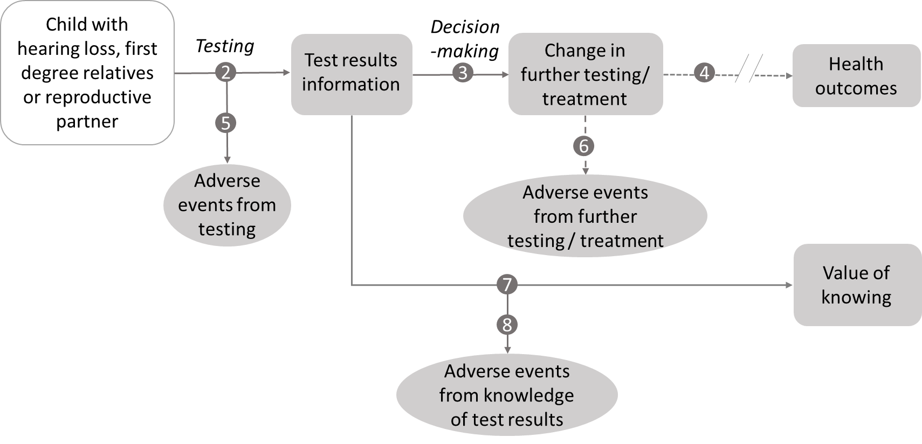
Figure 1 Assessment framework for WEA showing the links to health outcomes
Figure notes: 2: test outcomes; 3: change in diagnosis/treatment/management; 4: influence of the change in management on health outcomes; 5: adverse events due to testing; 6: adverse events from further testing/treatment; 7: value of knowing; 8: adverse events due to knowledge of test results.

The same linked-evidence approach will also be the most appropriate assessment framework for cascade testing of biological relatives and reproductive partner testing (Figure 1). Questions relevant to the assessment framework for cascade testing or reproductive partner testing are as follows:
- What are the benefits and potential harms, including psychological harms, associated with cascade testing of biological relatives or reproductive partner testing?
- What is the diagnostic yield and prognostic/predictive value of cascade testing of biological relatives for the putative pathogenic HL variant identified in the proband?
- What is the diagnostic yield and prognostic/predictive value of reproductive partner testing for HL variant(s) in the gene(s) in which their reproductive partner has a recessive pathogenic variant for HL?
- Does the identification of a pathogenic germline gene variant for HL by cascade testing of biological relatives or testing of a reproductive partner change their clinical management? What are the outcomes of the change in management?
- What is the value of knowing for biological relatives with a positive or negative test result from cascade testing? Are there any harms associated with this knowledge?
- What is the value of knowing for reproductive partners with a positive, negative or, uncertain result from testing? Are there any harms associated with this knowledge?

Clinical management algorithms
PASC noted that clinical management algorithms were provided for all proposed populations.

Current clinical management algorithm
The current clinical management algorithm for children (<18 years) with permanent bilateral moderate, severe, or profound (>40 dB in the worst ear over three frequencies) sensorineural, auditory neuropathy or mixed isolated hearing loss is shown in
Figure 2 and is in line with the recommendations in the Australian guidelines (Sung et al. 2019).
Genetic assessment is currently limited to GJB2/GJB6 testing as funding for comprehensive genetic testing is not currently available. GJB2/GJB6 testing utilises sequencing of exon 2 of the GJB2 gene and capillary electrophoresis to detect two common large deletions of the GJB6 gene. Children with a diagnostic GJB2/GJB6 test result require no further genetic diagnostic testing but may receive some further clinical investigations to determine whether they are suitable for HL interventions such as cochlear implant or hearing aid.
The family of a child with a diagnostic GJB2/GJB6 test result may receive genetic counselling and further information about cascade testing of first-degree relatives and reproductive planning. Cascade GJB2/GJB6 testing is currently states/territories funded for first-degree relatives only. There is no MBS funding.
Children with a non-diagnostic GJB2/GJB6 test result require further clinical investigations, diagnostic tests, and ongoing clinical review to obtain a diagnosis for their HL (diagnostic odyssey). These investigations may be guided by any additional symptoms that become apparent during childhood or adolescence attributed to a syndromic cause.
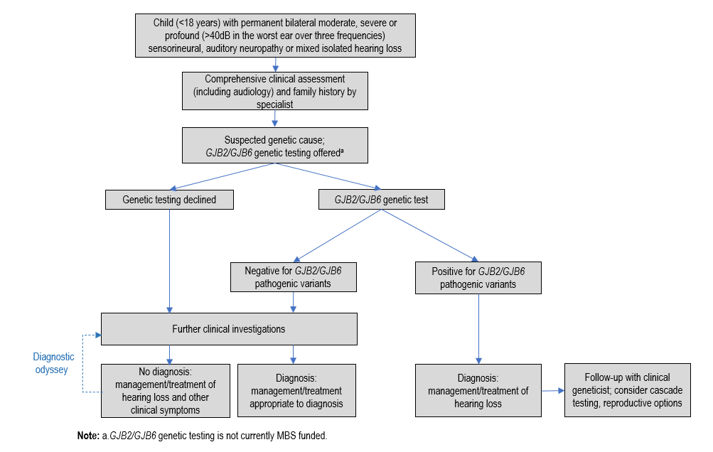
Figure 2 Current clinical management algorithm for children with congenital or childhood onset isolated HL

Proposed clinical management algorithm for children with isolated hearing loss
The proposed clinical management algorithm is shown in Figure 3. The green boxes represent the proposed intervention. The current investigations and standard care which includes GJB2/GJB6 genetic testing are represented by the grey boxes.
The addition of comprehensive genetic testing in the form of WES/WGS and WEA using a virtual gene panel for isolated HL is in line with international and Australian guidance for diagnosis of HL with a suspected genetic cause in children. WEA offers the opportunity to analyse all known non-syndromic or syndromic HL variants in the exons of HL-associated genes included in the virtual gene panel for isolated HL. Syndromic HL may initially present as isolated, for example in patients with Usher Syndrome or Jervell and Lange-Nielsen syndrome, the genes for which are included in the isolated HL virtual panel – therefore virtual panel analysis for isolated HL may result in the detection of a syndromic or non-syndromic HL variant. Trio testing including samples from the biological parents increases the efficiency of WEA for the child with HL and may increase the likelihood of a positive diagnosis in addition to decreasing the time to diagnosis.
Children with a confirmed diagnosis due to the presence of a pathogenic variant in a gene associated with HL will receive clinical management and treatment for their HL and any additional symptoms that become apparent over time. Further targeted investigations and treatment may be required when syndromic HL is identified by WEA. Children with a non-syndromic HL require no further diagnostic testing but may require further investigations to aid management of their HL, such as use of cochlear implants or hearing aids.
Children without a confirmed diagnosis following WEA require further investigations, diagnostic tests, and on-going clinical review, as they continue their diagnostic odyssey. Re-analysis of their sequence data for new HL genes and variants if clinically indicated, or re-evaluation of any VUS has the potential to provide a confirmed genetic diagnosis in the future. Re-testing (as distinct from re-analysis of existing data) using WGS/WES with the virtual HL gene panel after a period of at least 5 years has been proposed by PASC.
The affected child, biological relatives and reproductive partners may receive genetic counselling when the results of genetic testing are shared with the family. Information about cascade testing for biological relatives and testing for reproductive partners to aid reproductive decision-making is available if the child has a confirmed genetic diagnosis following GJB2/GJB6 testing or WEA.
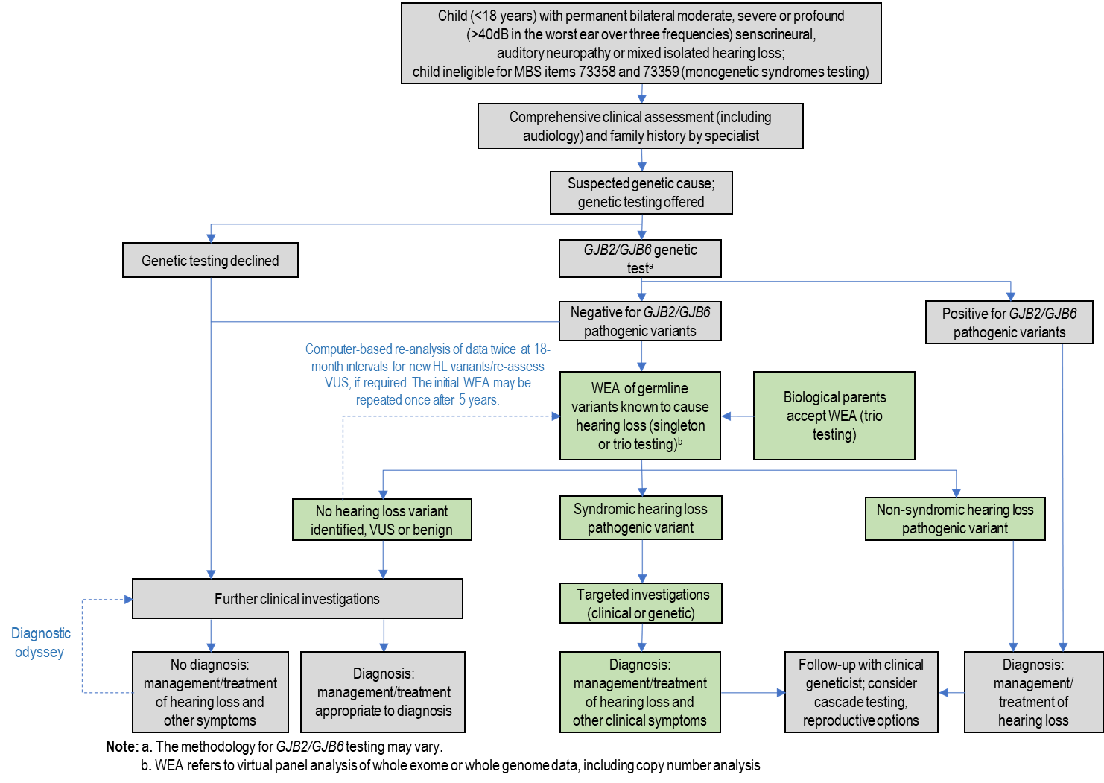
Figure 3 Proposed clinical management algorithm for children with congenital or childhood onset presumed isolated HL

Current and proposed clinical management algorithms for a biological relative of an individual with a confirmed pathogenic HL variant(s)
Current and proposed clinical management algorithms for cascade testing are shown in Figure 4 and Figure 5, respectively.
In the current algorithm, first-degree relatives of a child with a diagnostic GJB2/GJB6 genetic test result do not receive cascade testing funded by the MBS. Cascade testing of first-degree relatives is state/territory funded but equitable access is uncertain. Monitoring and assessment of their children for HL may be required.
Under the proposed management algorithm, biological relatives will be offered cascade testing by individual variant sequencing for the pathogenic variant(s) identified in the proband. This would include pathogenic GJB2/GJB6 variants identified during GJB2/GJB6 testing of the proband (child with HL). Cascade testing is also available for biological relatives of an individual identified as having a pathogenic variant for HL during their cascade testing. When a pathogenic variant is identified in a biological relative, genetic counselling and further advice about reproductive options will be provided. If the biological parents were tested via trio testing, then cascade testing of their other offspring (siblings of the proband) for the familial pathogenic HL variant may be beneficial to determine their carrier status.
Biological relatives of a child with a non-diagnostic GJB2/GJB6 test or no pathogenic variant identified during WEA would not receive cascade genetic testing unless a genetic cause for the child’s HL was established in the future either be by re-analysis of WES/WGS data for new HL genes and variants including re-assessment of VUS, or re-testing using WGS/WES with the virtual HL gene panel after a minimum period of 5 years.
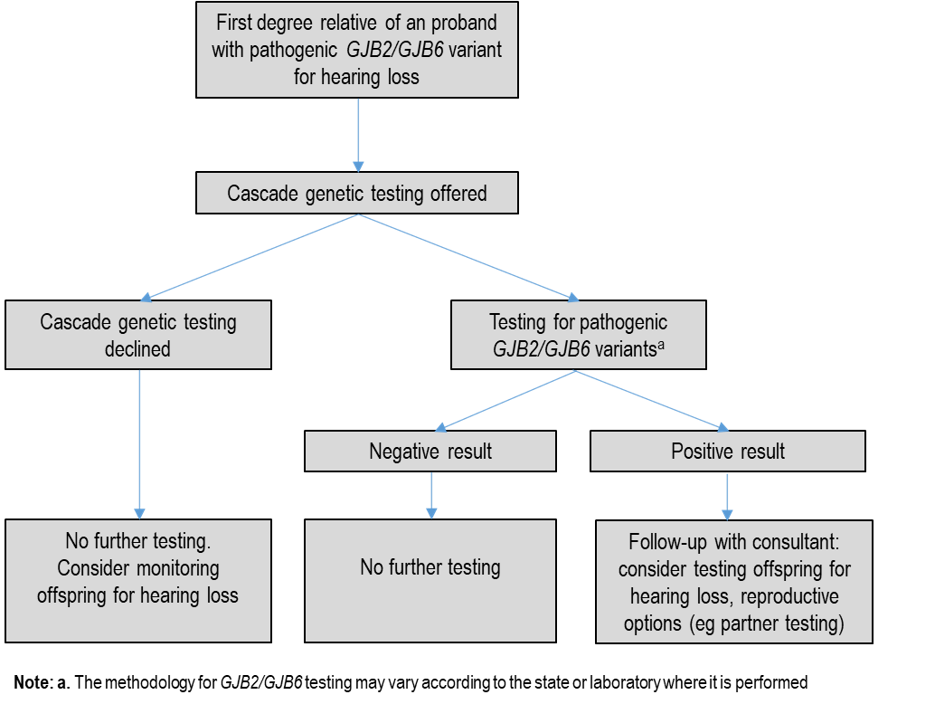
Figure 4 Current clinical management algorithm for a first-degree relative of an individual with a confirmed pathogenic GJB2/GJB6 variant
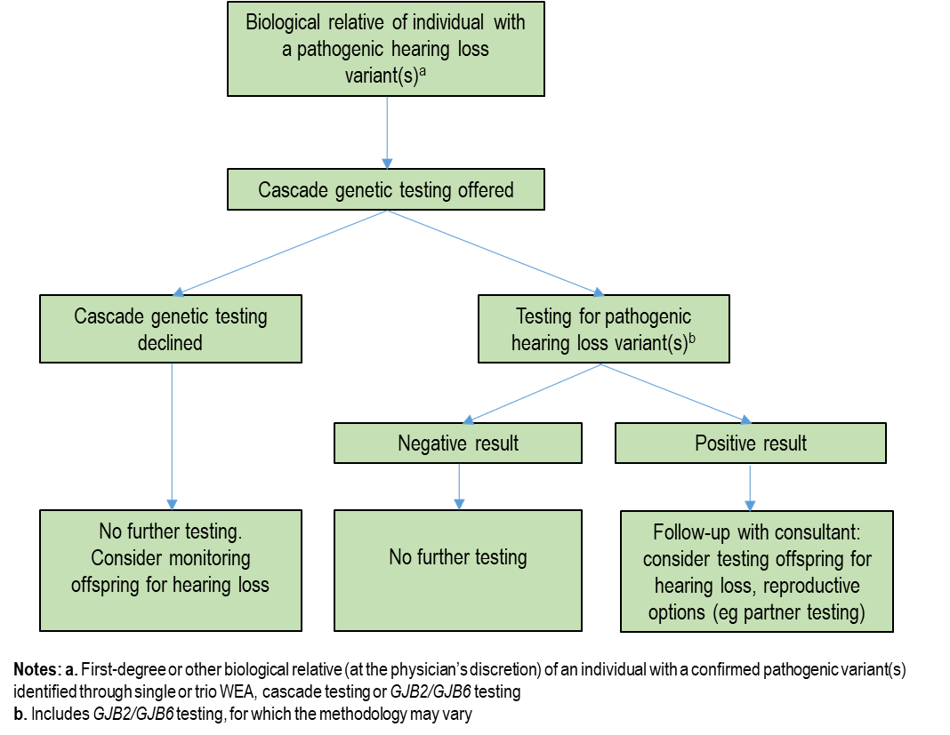
Figure 5 Proposed clinical management algorithm for a biological relative of an individual with a confirmed pathogenic HL variant(s)

Current and proposed clinical management algorithms for reproductive partner of an individual with a confirmed pathogenic HL variant(s)
Current and proposed clinical management algorithms for reproductive partner testing are shown below (Figure 6).
Currently, reproductive partners of probands with a recessive pathogenic GJB2/GJB6 variant would not receive cascade testing.
In the proposed algorithm, reproductive partners of probands with a recessive pathogenic HL variant would receive testing via whole gene sequencing and identification of all potential pathogenic variants in the HL gene(s) of interest.

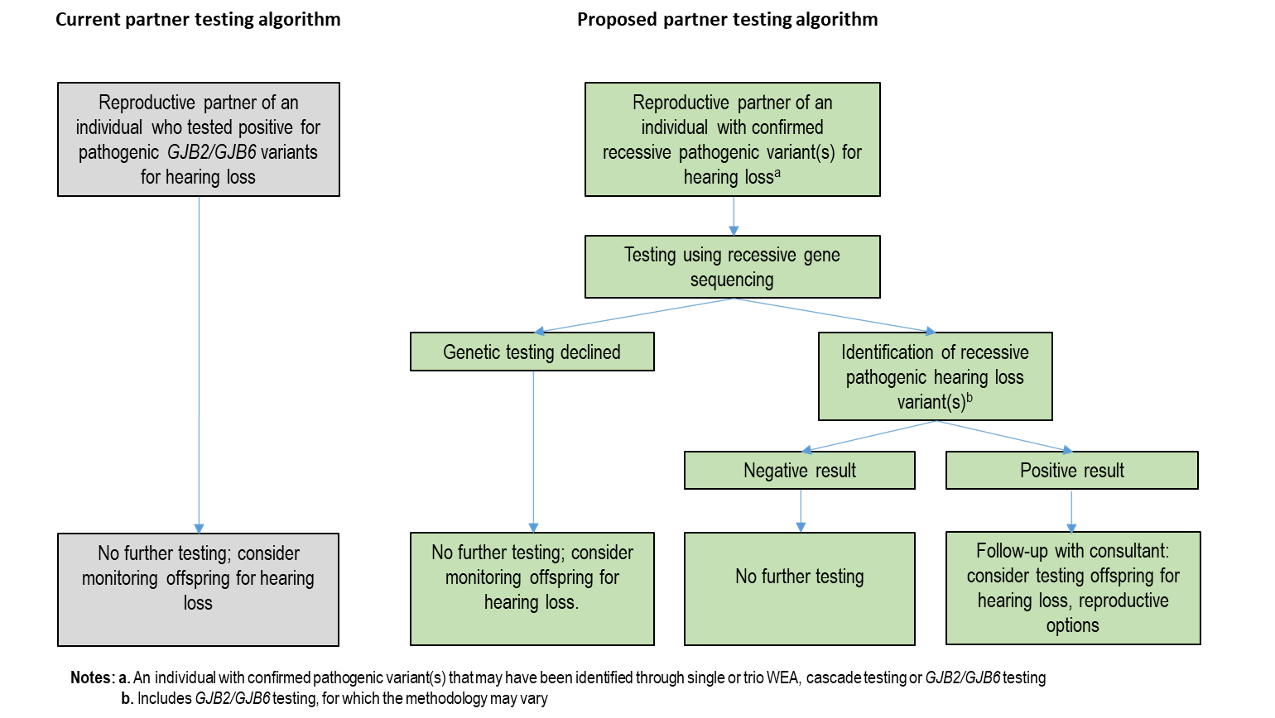
Figure 6 Current and proposed clinical management algorithm for testing of reproductive partners

Proposed economic evaluation
The application claims that WEA for pathogenic germline gene variants for HL in children (<18 years) with permanent bilateral moderate, severe, or profound HL and cascade testing of their first-degree relatives and reproductive partners is superior in effectiveness and superior in safety to standard care in the absence of WEA.
The table below (Table 7) classifies the type of economic evaluation that should be presented, based on the assessed evidence profile. As the claim is for superior comparative effectiveness and comparative safety, a CEA or CUA can be used.
The applicant has conducted a study assessing the relative cost-effectiveness of exome sequencing for isolated congenital HL compared with standard care (Downie et al. 2021). Incremental cost-effectiveness and cost-benefit analyses were undertaken from an Australian healthcare system perspective using an 18-year time horizon. Costs and outcomes associated with exome sequencing and standard care for infants (<2 years) presenting with isolated congenital deafness were modelled using a decision tree. A clinical study published by Downie et al (2020) was used to inform model inputs. The study population is aligned with the proposed population for WEA in this application, but the study population were between 4 weeks and 1 year of age at the time of recruitment and participants received their results prior to age 2 years. Older children up to 18 years were not included in the study population and therefore were not represented in the CEA. The WEA was based on assessment of 141 HL genes from PanelApp Australia and CNV analysis was included in the model. Costs presented in Australian dollars (AUD) were obtained from the MBS, Victorian Clinical Genetics Service genomics price list (vcgs.org.au), and the Royal Children’s Hospital costing centre. Patient management after WEA followed standard clinical practice and was based on the diagnosis obtained. Direct health outcomes from testing were not included in the model.
The authors of the CEA study confirmed that there are acknowledged difficulties in producing health-economic evidence for exome sequencing (Downie et al. 2021). These include lack of long-term health impact data, difficulty in obtaining quality adjusted life years (QALYs) for infant populations, limited data for personal utility of exome sequencing (e.g., avoiding the diagnostic odyssey), and difficulty defining the cost and performance of exome sequencing due to ongoing technological improvements (Downie et al. 2021).
The economic assessment used in the assessment report will be a cost effectiveness analysis (cost per proband identified, cost per person with prognostic information identified, cost per person with predictive information identified). A refined assessment (without providing data on the health impact of changing management due to the results of WEA) is considered appropriate particularly given the heterogeneous nature of HL.
PASC acknowledged difficulties associated with obtaining health outcome data as outlined by Downie et al (2021) and supported the use of a simpler cost-effectiveness analysis including integrated cost-effectiveness measures supported by MSAC under its recent reforms to the approach for the assessment of genomic tests, such as ‘cost per additional proband identified’.
PASC noted the GJB2/GJB6 prior test and considered that this test had a firmly established basis in existing clinical practice. PASC considered that while it is a prior test, it is one that would shift from state/territory funding to Commonwealth as a consequence of this application, and therefore advised that an assessment of costs and the wider impact of cost-shifting from the states/territories to the MBS would be required. PASC noted an assessment of the diagnostic yield of GJB2/GJB6 testing would be part of the assessment as this determines access to WEA.
Table 7 Classification of comparative effectiveness and safety of the proposed intervention, compared with its main comparator, and guide to the suitable type of economic evaluation
Comparative safety- |  | Comparative effectiveness
 | Inferior | Uncertainª | Noninferior^{b} | Superior
Inferior | Health forgone: need other supportive factors | Health forgone possible: need other supportive factors | Health forgone: need other supportive factors | ? Likely CUA
Uncertainª | Health forgone possible: need other supportive factors | ? | ? | ? Likely CEA/CUA
Noninferior^{b} | Health forgone: need other supportive factors | ? | CMA | CEA/CUA
Superior | ? Likely CUA | ? Likely CEA/CUA | CEA/CUA | CEA/CUA
CEA=cost-effectiveness analysis; CMA=cost-minimisation analysis; CUA=cost-utility analysis
? = reflect uncertainties and any identified health trade-offs in the economic evaluation, as a minimum in a cost-consequences analysis
ª ‘Uncertainty’ covers concepts such as inadequate minimisation of important sources of bias, lack of statistical significance in an underpowered trial, detecting clinically unimportant therapeutic differences, inconsistent results across trials, and trade-offs within the comparative effectiveness and/or the comparative safety considerations
^{b} An adequate assessment of ‘noninferiority’ is the preferred basis for demonstrating equivalence

Proposal for public funding
The applicant had proposed three items for MBS funding (singleton testing; re-analysis; cascade testing of biological relatives). Following discussions at the pre-PASC meeting, two additional items have been added (trio testing; reproductive partner testing).
The MBS items proposed are comparable with MBS items implemented for MSAC Application 1476 (Genetic testing for monogenic childhood syndromes using WEA) except that, in contrast to MSAC Application 1476, the cascade testing item proposed under this application includes all biological relatives and separate items for segregation analysis are not provided. The cascade testing items include biological relatives of an individual with a positive GJB2/GJB6 genetic test, which leads on from the proposed MBS item DDDDD for GJB2/GJB6 genetic testing discussed in the question to PASC previously. An MBS item for testing a reproductive partner was not included in MSAC Application 1476 (Genetic testing for childhood syndromes).
PASC noted that six MBS items are associated with this application.
Both WEA and cascade testing should be requested by either a clinical geneticist, a paediatrician in consultation with a clinical geneticist or a specialist paediatrician with expertise in genetics. Reproductive partner testing can be requested by a clinical geneticist or a specialist physician in consultation with a clinical geneticist.
GJB2/GJB6 genetic testing is currently requested by either an ENT specialist (otolaryngologist) or a specialist paediatrician at the time that HL is confirmed, as proposed in the MBS item DDDDD. It is currently states/territories funded. The MBS item has been proposed to remove the need for patients to move between public (states/territories funded) and private (MBS funded) streams, as a non-diagnostic GJB2/GJB6 genetic test is a prerequisite for WEA eligibility. The listing of this proposed MBS item and its potential impacts on the balance of services provided under public health services (non-MBS) and private services will be assessed as part of the assessment report. GJB2/GJB6 gene variants can be identified during WEA if included in the requested analysis. These genes are included in most virtual HL gene panel lists and the decision to exclude their analysis in WEA, so that a non-diagnostic GJB2/GJB6 genetic test is a prerequisite for WEA, is mainly based on the higher proposed cost of WEA versus GJB2/GJB6 genetic test if all HL patients were tested.
PASC noted that the proposed MBS item fees were based on equivalent MBS items supported by MSAC for testing of childhood monogenic syndromes (MSAC Application 1476), which uses a similar methodological approach (i.e. WES/WGS virtual panel only, with amplicon-specific panel methods not being proposed). PASC noted that the MSAC Executive had recently advised virtual panel testing fees should be aligned, and considered that it should advise how fees should be set rather than to set the fees, and advised that the proposed fees should be justified in the assessment and consistent with comparable services previously supported by MSAC.
The cost of singleton WEA for HL (Item AAAAA1) proposed by the applicant is slightly higher ($2195) than fee supported by MSAC for item 73358 ($2100) for Application 1476 (Genetic testing for childhood syndromes). The proposed fee for trio WEA for HL (AAAAA2) is $2900. This is comparable with item 73359 for Application 1476, as suggested by the Department at the pre-PASC meeting.
PASC noted that virtual panel testing is at present MBS-funded under both gene panel testing ($1200) and WES or WGS data ($2100) and noted that the MSAC Executive had recently advised the fees for similar testing should be aligned. PASC noted the virtual gene panel for HL is likely to contain >100 genes, and that the applicant had proposed a slightly higher fee of $2195 for singleton testing in the application. The applicant considered that the $2100 fee proposed by the Department was appropriate because of the work involved in analysis of the virtual gene panel.
PASC noted that the proposed fee for trio testing was $2900, based on the supported fee for trio WES/WGS testing in MBS item 73359.
The fee proposed by the applicant for re-analysis of WES/WGS data (Item BBBBB) is lower ($425) than the supported fee for the re-analysis item 73360 from Application 1476 ($500). The applicant indicated in the application that this fee was comparable with the current charge by Victorian Clinical Genetics Services of $425 for re-analysis of whole exome data.
PASC noted the proposed re-analysis fee of $425 is lower than that for item 73360 ($500).
The MBS item for cascade testing (including for segregation analysis) (Item CCCCC1) restricts analysis to a familial gene variant(s) in a HL gene as identified in the proband. The proposed cost is comparable with other variant cascade testing items on the MBS. PASC noted the proposed cascade testing item was for first-degree relatives, and considered that expanding cascade testing to second-degree (or more distant) relatives at the clinician’s discretion would enable cascade testing where first-degree relatives are either not available for testing or unwilling to be tested. PASC noted the applicant agreed that “biological relatives” be allowed to access cascade testing, rather than “first-degree relatives”. PASC advised that broadening cascade testing to “biological relatives” would be appropriate, and that this should be examined in the assessment report, as should the potential financial impact on the MBS. PASC noted previous assessments had estimated three first-degree relatives tested per proband (e.g. MSAC Applications 1476, 1598).
The MBS item for partner testing for reproductive partner testing (Item CCCCC2) includes analysis of all variants in the HL gene containing the recessive pathogenic variant in the other individual. For MSAC Application 1599 (Genomic testing for the diagnosis of heritable cardiomyopathies) MSAC considered that reproductive partner testing is generally considered important by families who are known to carry a recessive variant. MSAC advised that, consistent with previously supported reproductive partner testing items, this testing needs to sequence the whole gene(s) because unrelated partners are unlikely to have the same variant. MSAC advised that the fee for reproductive partner testing should be $1,200, in line with affected individual panel testing” as stated in the Public summary document of MSAC Application 1599. Therefore, a fee of $1200 is proposed for reproductive partner testing (Item CCCCC2) in line with proposed MBS item for MSAC Application 1599.
PASC noted that previous similar MBS items for reproductive partner whole gene sequencing supported under MSAC Applications 1599, 1600 and 1585 were also $1200.
Table 8 Proposed MBS items
Proposed MBS items
MBS item number: AAAAA1
Characterisation, via whole exome or genome sequencing and copy number variant analysis, of germline variants known to cause childhood hearing loss, if:
(a) the characterisations is
(i) requested by a consultant physician practising as a clinical geneticist; or
(ii) requested by a consultant physician practising as a specialist paediatrician with expertise in genetics; or
(iii) requested by a consultant physician practising as a specialist paediatrician, following consultation with a clinical geneticist; and
(b) the patient is aged 17 years or younger with congenital or childhood onset hearing loss that is permanent bilateral moderate, severe, or profound (>40 dB in the worst ear over three frequencies) and classified as non-syndromic sensorineural, auditory neuropathy or mixed; and
(c) the characterisation is performed following completion of a service described in item DDDDD, for which the results were non-informative; and
(d) the patient is not eligible for a service to which items 73358 or 73359 apply;
(e) the characterisation is not performed in conjunction with or following a service to which MBS item AAAA2 applies

Applicable twice once per lifetime with the second test at least 5 years after the initial test.

MBS Fee: $2195 (Note – fee for singleton testing in Item 73358 from Application 1476 is $2100)
Benefit: 75% = $1646.00 85% = $1866.00

Practice Notes
Appropriate genetic counselling should be provided to the patient either by the specialist
treating practitioner, a genetic counselling service or a clinical geneticist

MBS item number: AAAAA2
Characterisation, via whole exome or genome sequencing and copy number variant analysis, of germline variants known to cause childhood hearing loss, if:
(a) the characterisations is
(i) requested by a consultant physician practising as a clinical geneticist; or
(ii) requested by a consultant physician practising as a specialist paediatrician with expertise in genetics; or
(iii) requested by a consultant physician practising as a specialist paediatrician, following consultation with a clinical geneticist; and a specialist paediatrician; and
(b) the patient is aged younger than 17 years or younger with congenital or childhood onset non-syndromic hearing loss that is permanent bilateral moderate, severe, or profound (>40 dB in the worst ear over three frequencies) and classified as sensorineural, auditory neuropathy or mixed; and .
(c) the characterisation is performed following completion of a service described in item DDDDD, for which the results were non-informative; and
(d) the characterisation is performed using a sample from the patient and a sample from each of the patient’s biological parents; and
(e) the patient is not eligible for a service to which items 73358 or 73359 apply;
(f) the characterisation is not performed in conjunction with or following a service to which MBS item AAAA1 applies.

Applicable twice once per lifetime with the second test at least 5 years after the initial test.

MBS Fee: $2900 (Note - fee for trio testing in item 73359 from Application 1476)
Benefit: 75% = $2,175.00 85% = $2,465.00

Practice Notes
Appropriate genetic counselling should be provided to the biological parents and child either by the specialist treating practitioner, a genetic counselling service or a clinical geneticist

MBS item number: BBBBB
Re-analysis of whole exome or genome data obtained under a service to which item AAAAA1 and AAAAA2 apply, for characterisation of previously unreported germline gene variants for childhood hearing loss, if
(a) the re-analysis is
(i) requested by a consultant physician practising as a clinical geneticist; or
(ii) requested by a consultant physician practising as a specialist paediatrician with expertise in genetics; or
(iii) requested by a consultant physician practising as a specialist paediatrician, following consultation with a clinical geneticist; and
(b) The re-analysis is performed at least 18 months after
(i) a service to which items AAAAA1 or AAAAA2 applies; or
(ii) a service to which this item applies

Applicable twice per lifetime.after use of MBS item AAAAA1 or AAAAA2

MBS Fee: $425 (Note – fee proposed by applicant. Note fee for item 73360 from Application 1476 is $500)
Benefit: 75% = $319.00 85% = $361.00
MBS item number: CCCCC1
Characterisation of one or more familial pathogenic or likely pathogenic germline gene variants known to cause childhood hearing loss, if:
(a)The characterisation is
(i) requested by a consultant physician practising as a clinical geneticist; or
(ii) requested by a consultant physician practising as a specialist paediatrician with expertise in genetics; or
(iii) requested by a consultant physician practising as a specialist paediatrician, following consultation with a clinical geneticist; and
(b) the person tested is a biological relative of a patient with a pathogenic or likely pathogenic germline gene variant(s) known to cause hearing loss confirmed by laboratory findings; and
(c) the result of the previous proband testing is made available to the laboratory.
Applicable only once per variant per lifetime.

MBS Fee: $400 (Ref – fee proposed was comparable to item 73362 from Application 1476)
Benefit: 75% = $300 85% = $340
MBS item number: CCCCC2
Characterisation of all germline variants in one or more genes known to cause hearing loss for the reproductive partner of an individual with a causative pathogenic or likely pathogenic variant for hearing loss identified in the same recessive gene(s), if:
(a)The characterisation is
(i) requested by a consultant physician practising as a clinical geneticist; or
(ii) requested by a consultant physician practising as a specialist paediatrician, following consultation with a clinical geneticist; and
(b) the characterisation is for a reproductive partner of a patient with a pathogenic or likely pathogenic germline recessive gene variant(s) known to cause hearing loss confirmed by laboratory finding, and
(c) the result of the previous proband testing is made available to the laboratory.

Applicable only once per gene per lifetime.

MBS Fee: $1,200 (Note – based on fee supported by MSAC for partner testing in Application 1599)
Benefit: 75% = $900 85% = $1020

GJB2/GJB6 genetic testing
The proposed MBS item for GJB2/GJB6 testing (to precede panel testing under items AAAAA1 and AAAAA2) are in Table 9.
PASC noted that a fee was not proposed for GJB2/GJB6 testing. PASC noted the applicant considered the fee charged by the VCGS ($520) was appropriate. There was no information available to PASC on the current cost of GJB2/GJB6 testing to the states and territories.
Table 9 Proposed MBS item for GJB2/GJB6 testing
Proposed MBS items
MBS item: DDDDD
Characterisation of germline gene variants in the GJB2 and GJB6 genes, if:
a) The characterisation is
(i) requested by a consultant physician practising as a clinical geneticist; or
(ii) requested by a consultant physician practising as a specialist paediatrician with expertise in genetics; or
(iii) requested by a consultant physician practising as a specialist paediatrician, following consultation with a clinical geneticist; or
(iv) requested by a consultant physician practising as an otolaryngologist;

b) the patient is aged 17 years or younger with congenital or childhood onset bilateral hearing loss.
Applicable only once per lifetime.
MBS Fee: $XXX (Ref: GJB2/GJB6 diagnostic testing by VCGS is $520 for non-Victorian residents)
Benefit: 75% = $XXX 85% = $XXX

Summary of public consultation input
Ten (10) organisations provided responses to the consultation process:
- Australasian Newborn Hearing Screening Committee (ANHSC)
- Australian Genomics (AG)
- Australian Pathology (AP)
- Aurora School (AS)
- Centre for Genetics Education (CGE)
- Deafness Foundation (DF)
- Human Genetics Society of Australasia (HGSA)
- Neurodevelopmental and Behavioural Paediatric Society of Australasia (NBPSA)
- Public Pathology Australia (PPA)
- Usher Kids Australia (UKA)
All organisations were supportive of the application. Any disadvantages identified in the feedback were predominantly related to the implications for the family of affected children once a diagnosis is made.
PASC noted that ten organisations had participated in consultation about the Application, and all were supportive.
PASC noted that the deaf community does not consider hearing loss as a life-limiting disability. It is therefore important to use positive language in the assessment report.
Benefits
All organisations noted that the proposed test has good diagnostic yield compared to current standard of care, allows for more tailored care, and can provide families with a diagnosis and an understanding of the genetic cause for hearing loss.
CGE added that in some cases, knowing which variant the child has will assist doctors to predict the severity of the hearing loss and other symptoms which may occur.
AG suggested that test could be combined with the newborn hearing screening test, which already reaches up to 98% of newborns in Australia, and thus, it could further improve outcomes of the hearing test across the full cohort for which hearing loss is detected.
Organisations considered that the proposed investigational service facilitates earlier and more targeted interventions for infants. DF noted that it would also prognostic information about progression of hearing or other health conditions. Earlier and targeted treatment would lead to better quality of life and a reduced financial and social impact on society. Organisations also noted that knowledge of the cause of deafness may reduce parental anxiety and be relevant for further family planning in the wider family.
HGSA considered that public funding would ensure equity of access to the test. AG considered that it would expect more that 60% of families take up the opportunity to would undertake the proposed test to find a genetic diagnosis for hearing impairment outside of a research setting.
Genetic counselling following testing is a further service identified by the Deafness Foundation. It was also stated that GJB2/6 testing prior to WEA testing would reduce overall number of WEA tests.
HGSA recommended that genetic counselling should be provided following a positive test result.
Disadvantages
CGE stated that when hearing impairment in a child is thought to have a genetic basis, there may be no positive result for the family from this particular test, as there are many genetic causes possible.
DF advised that parents may receive information they did not want to know, but that this could be addressed with appropriate informed consent processes.
AP thought that the cost of WEA would be high unless larger volumes of testing occur, with economies of scale facilitating the broader provision of genomic tests in general, to make genomics more accessible.
AP considered that the nominated comparator is incorrect, and considered ‘no genetic testing’ more appropriate, rather than GJB2/GJB6 testing, as GJB testing is not currently listed on the MBS.

Next steps
PASC noted that the applicants have elected to progress their application as a DCAR (Department -contracted assessment report).
PASC noted the Department had raised queries around matters such as genomic data storage, national security, and privacy risks. PASC considered that these issues are not unique to this application. The Department advised that other areas of the Department are working to address these broader issues.

Applicant Comment on PICO Confirmation
Nil.

References
Bademci, G, Foster, J, 2nd, Mahdieh, N, Bonyadi, M, Duman, D, Cengiz, FB, Menendez, I, Diaz-Horta, O, Shirkavand, A, Zeinali, S, Subasioglu, A, Tokgoz-Yilmaz, S, Huesca-Hernandez, F, de la Luz Arenas-Sordo, M, Dominguez-Aburto, J, Hernandez-Zamora, E, Montenegro, P, Paredes, R, Moreta, G, Vinueza, R, Villegas, F, Mendoza-Benitez, S, Guo, S, Bozan, N, Tos, T, Incesulu, A, Sennaroglu, G, Blanton, SH, Ozturkmen-Akay, H, Yildirim-Baylan, M & Tekin, M 2016, 'Comprehensive analysis via exome sequencing uncovers genetic etiology in autosomal recessive nonsyndromic deafness in a large multiethnic cohort', Genet Med, vol. 18, no. 4, Apr, pp. 364-371.

Ching, TY, Oong, R & Wanrooy, Ev 2006, The Ages of Intervention in Regions with and without Universal Newborn Hearing Screening and Prevalence of Childhood Hearing Impairment in Australia, vol. 28, Australian Academic Press.

Ching, TYC, Dillon, H, Button, L, Seeto, M, Van Buynder, P, Marnane, V, Cupples, L & Leigh, G 2017, 'Age at Intervention for Permanent Hearing Loss and 5-Year Language Outcomes', Pediatrics, vol. 140, no. 3, Sep.

Clark, MM, Stark, Z, Farnaes, L, Tan, TY, White, SM, Dimmock, D & Kingsmore, SF 2018, 'Meta-analysis of the diagnostic and clinical utility of genome and exome sequencing and chromosomal microarray in children with suspected genetic diseases', NPJ Genom Med, vol. 3, p. 16.

DeMille, D, Carlston, CM, Tam, OH, Palumbos, JC, Stalker, HJ, Mao, R, Zori, RT, Viskochil, DH, Park, AH & Carey, JC 2018, 'Three novel GJB2 (connexin 26) variants associated with autosomal dominant syndromic and nonsyndromic hearing loss', Am J Med Genet A, vol. 176, no. 4, Apr, pp. 945-950.
Downie, L, Amor, DJ, Halliday, J, Lewis, S, Martyn, M & Goranitis, I 2021, 'Exome Sequencing for Isolated Congenital Hearing Loss: A Cost-Effectiveness Analysis', Laryngoscope, vol. 131, no. 7, Jul, pp. E2371-e2377.

Downie, L, Halliday, J, Burt, R, Lunke, S, Lynch, E, Martyn, M, Poulakis, Z, Gaff, C, Sung, V, Wake, M, Hunter, MF, Saunders, K, Rose, E, Lewis, S, Jarmolowicz, A, Phelan, D, Rehm, HL & Amor, DJ 2020, 'Exome sequencing in infants with congenital hearing impairment: a population-based cohort study', Eur J Hum Genet, vol. 28, no. 5, May, pp. 587-596.

Kingsmore, SF, Cakici, JA, Clark, MM, Gaughran, M, Feddock, M, Batalov, S, Bainbridge, MN, Carroll, J, Caylor, SA, Clarke, C, Ding, Y, Ellsworth, K, Farnaes, L, Hildreth, A, Hobbs, C, James, K, Kint, CI, Lenberg, J, Nahas, S, Prince, L, Reyes, I, Salz, L, Sanford, E, Schols, P, Sweeney, N, Tokita, M, Veeraraghavan, N, Watkins, K, Wigby, K, Wong, T, Chowdhury, S, Wright, MS & Dimmock, D 2019, 'A Randomized, Controlled Trial of the Analytic and Diagnostic Performance of Singleton and Trio, Rapid Genome and Exome Sequencing in Ill Infants', Am J Hum Genet, vol. 105, no. 4, Oct 3, pp. 719-733.

Likar, T, Hasanhodžić, M, Teran, N, Maver, A, Peterlin, B & Writzl, K 2018, 'Diagnostic outcomes of exome sequencing in patients with syndromic or non-syndromic hearing loss', PLoS One, vol. 13, no. 1, p. e0188578.

Liming, BJ, Carter, J, Cheng, A, Choo, D, Curotta, J, Carvalho, D, Germiller, JA, Hone, S, Kenna, MA, Loundon, N, Preciado, D, Schilder, A, Reilly, BJ, Roman, S, Strychowsky, J, Triglia, JM, Young, N & Smith, RJ 2016, 'International Pediatric Otolaryngology Group (IPOG) consensus recommendations: Hearing loss in the pediatric patient', Int J Pediatr Otorhinolaryngol, vol. 90, Nov, pp. 251-258.

Nambot, S, Thevenon, J, Kuentz, P, Duffourd, Y, Tisserant, E, Bruel, AL, Mosca-Boidron, AL, Masurel-Paulet, A, Lehalle, D, Jean-Marçais, N, Lefebvre, M, Vabres, P, El Chehadeh-Djebbar, S, Philippe, C, Tran Mau-Them, F, St-Onge, J, Jouan, T, Chevarin, M, Poé, C, Carmignac, V, Vitobello, A, Callier, P, Rivière, JB, Faivre, L & Thauvin-Robinet, C 2018, 'Clinical whole-exome sequencing for the diagnosis of rare disorders with congenital anomalies and/or intellectual disability: substantial interest of prospective annual reanalysis', Genet Med, vol. 20, no. 6, Jun, pp. 645-654.

RCPA 2019, 'Australian Health Genetics/ Genomics Survey 2017 Report of Key Findings to: Department of Health'.

Retterer, K, Juusola, J, Cho, MT, Vitazka, P, Millan, F, Gibellini, F, Vertino-Bell, A, Smaoui, N, Neidich, J, Monaghan, KG, McKnight, D, Bai, R, Suchy, S, Friedman, B, Tahiliani, J, Pineda-Alvarez, D, Richard, G, Brandt, T, Haverfield, E, Chung, WK & Bale, S 2016, 'Clinical application of whole-exome sequencing across clinical indications', Genet Med, vol. 18, no. 7, Jul, pp. 696-704.

Richards, S, Aziz, N, Bale, S, Bick, D, Das, S, Gastier-Foster, J, Grody, WW, Hegde, M, Lyon, E, Spector, E, Voelkerding, K & Rehm, HL 2015, 'Standards and guidelines for the interpretation of sequence variants: a joint consensus recommendation of the American College of Medical Genetics and Genomics and the Association for Molecular Pathology', Genet Med, vol. 17, no. 5, May, pp. 405-424.

Shearer, AE & Smith, RJ 2015, 'Massively Parallel Sequencing for Genetic Diagnosis of Hearing Loss: The New Standard of Care', Otolaryngol Head Neck Surg, vol. 153, no. 2, Aug, pp. 175-182.

Sheppard, S, Biswas, S, Li, MH, Jayaraman, V, Slack, I, Romasko, EJ, Sasson, A, Brunton, J, Rajagopalan, R, Sarmady, M, Abrudan, JL, Jairam, S, DeChene, ET, Ying, X, Choi, J, Wilkens, A, Raible, SE, Scarano, MI, Santani, A, Pennington, JW, Luo, M, Conlin, LK, Devkota, B, Dulik, MC, Spinner, NB & Krantz, ID 2018, 'Utility and limitations of exome sequencing as a genetic diagnostic tool for children with hearing loss', Genet Med, vol. 20, no. 12, Dec, pp. 1663-1676.

Sloan-Heggen, CM, Bierer, AO, Shearer, AE, Kolbe, DL, Nishimura, CJ, Frees, KL, Ephraim, SS, Shibata, SB, Booth, KT, Campbell, CA, Ranum, PT, Weaver, AE, Black-Ziegelbein, EA, Wang, D, Azaiez, H & Smith, RJH 2016, 'Comprehensive genetic testing in the clinical evaluation of 1119 patients with hearing loss', Hum Genet, vol. 135, no. 4, Apr, pp. 441-450.

Stark, Z, Schofield, D, Martyn, M, Rynehart, L, Shrestha, R, Alam, K, Lunke, S, Tan, TY, Gaff, CL & White, SM 2019, 'Does genomic sequencing early in the diagnostic trajectory make a difference? A follow-up study of clinical outcomes and cost-effectiveness', Genet Med, vol. 21, no. 1, Jan, pp. 173-180.

Sung, V, Downie, L, Paxton, GA, Liddle, K, Birman, CS, Chan, WW, Cottier, C, Harris, A, Hunter, M, Peadon, E, Peacock, K, Roddick, L, Rose, E, Saunders, K & Amor, DJ 2019, 'Childhood Hearing Australasian Medical Professionals network: Consensus guidelines on investigation and clinical management of childhood hearing loss', J Paediatr Child Health, vol. 55, no. 9, Sep, pp. 1013-1022.

Tan, TY, Lunke, S, Chong, B, Phelan, D, Fanjul-Fernandez, M, Marum, JE, Kumar, VS, Stark, Z, Yeung, A, Brown, NJ, Stutterd, C, Delatycki, MB, Sadedin, S, Martyn, M, Goranitis, I, Thorne, N, Gaff, CL & White, SM 2019, 'A head-to-head evaluation of the diagnostic efficacy and costs of trio versus singleton exome sequencing analysis', Eur J Hum Genet, vol. 27, no. 12, Dec, pp. 1791-1799.

Tutty, E, Amor, DJ, Jarmolowicz, A, Paton, K & Downie, L 2021, 'Personal utility of genomic sequencing for infants with congenital deafness', Am J Med Genet A, Jun 29.

Wenger, AM, Guturu, H, Bernstein, JA & Bejerano, G 2017, 'Systematic reanalysis of clinical exome data yields additional diagnoses: implications for providers', Genet Med, vol. 19, no. 2, Feb, pp. 209-214.

Wright, CF, McRae, JF, Clayton, S, Gallone, G, Aitken, S, FitzGerald, TW, Jones, P, Prigmore, E, Rajan, D, Lord, J, Sifrim, A, Kelsell, R, Parker, MJ, Barrett, JC, Hurles, ME, FitzPatrick, DR & Firth, HV 2018, 'Making new genetic diagnoses with old data: iterative reanalysis and reporting from genome-wide data in 1,133 families with developmental disorders', Genet Med, vol. 20, no. 10, Oct, pp. 1216-1223.

Zazo Seco, C, Wesdorp, M, Feenstra, I, Pfundt, R, Hehir-Kwa, JY, Lelieveld, SH, Castelein, S, Gilissen, C, de Wijs, IJ, Admiraal, RJ, Pennings, RJ, Kunst, HP, van de Kamp, JM, Tamminga, S, Houweling, AC, Plomp, AS, Maas, SM, de Koning Gans, PA, Kant, SG, de Geus, CM, Frints, SG, Vanhoutte, EK, van Dooren, MF, van den Boogaard, MH, Scheffer, H, Nelen, M, Kremer, H, Hoefsloot, L, Schraders, M & Yntema, HG 2017, 'The diagnostic yield of whole-exome sequencing targeting a gene panel for hearing impairment in The Netherlands', Eur J Hum Genet, vol. 25, no. 3, Feb, pp. 308-314.

