1170

Final Decision Analytic Protocol (DAP) to guide the assessment of intensive care medicine professional attendance items

June 2012

Table of Contents
MSAC and PASC 2
Purpose of this document 2
Summary of key matters for consideration by the applicant 3
Purpose of application 4
Background 5
Current arrangements for public reimbursement 5
Intervention 10
Description 10
Prerequisites 10
Co-administered and associated interventions 11
Listing proposed and options for MSAC consideration 12
Proposed MBS listing 12
Clinical place for proposed intervention 14
Other relevant considerations 14
Clinical claim 15
Economic analysis 15

MSAC and PASC

The Medical Services Advisory Committee (MSAC) is an independent expert committee appointed by the Minister for Health and Ageing (the Minister) to strengthen the role of evidence in health financing decisions in Australia. MSAC advises the Minister on the evidence relating to the safety, effectiveness, and cost-effectiveness of new and existing medical technologies and procedures and under what circumstances public funding should be supported.

The Protocol Advisory Sub-Committee (PASC) is a standing sub-committee of MSAC. Its primary objective is the determination of protocols to guide clinical and economic assessments of medical interventions proposed for public funding.

Purpose of this document

This document is intended to provide a decision analytic protocol that will be used to guide the assessment of an intervention for a particular population of patients.

The protocol guiding the assessment of the health intervention are typically developed using the widely accepted “PICO” approach. The PICO approach involves a clear articulation of the following aspects of the question for public funding that the assessment is intended to answer:

Patients – specification of the characteristics of the patients in whom the intervention is to be considered for use

Intervention – specification of the proposed intervention and how it is delivered

Comparator – specification of the therapy most likely to be replaced by the proposed intervention

Outcomes – specification of the health outcomes and the healthcare resources likely to be affected by the introduction of the proposed intervention

However, as discussed on p.4 below, in the case of intensive care medicine (ICM) professional attendance items, PASC resolved that the adoption of the standard PICO approach was not appropriate as an assessment focussed on such an approach may be so narrow that it would not be informative to MSAC.

Summary of key matters for consideration by the applicant

The PASC requests that the applicant note the following issues and address these issues in its assessment:
• An assessment report is sought that presents the overall body of evidence that could inform a judgement as to the overall comparative effectiveness, safety and cost-effectiveness of a model of care involving ICM specialists outside the ICU compared with alternative models of care (e.g., assessment of patients by consultant physicians).
• On the basis of the likely claims of potential clinical equivalence or superiority for the model of care involving intensive care medicine (ICM) specialists outside the ICU compared with alternative models of care, PASC considered that the assessment report would present either a cost- minimisation or cost-effectiveness analysis, respectively.
• In addition to a comparison of models of care involving ICM specialists with alternative models of care that are available to patients outside an ICU, PASC recommended that any assessment presented to MSAC should address a wider set of claims including:
o What evidence is available to demonstrate that there is unmet need for ICM specialists outside the ICU?
o What evidence is available in relation to the consequences of unmet need?

o To what extent is the failure to access ICM services due to shortage of ICM specialists (i.e., due to workforce shortage)? To what extent is the failure to access ICM services due to other factors (e.g., requirement for a referral, fees)?
o What evidence is available with respect to the effects of different approaches to funding for the various models of care that are possible?
o Are there differences in clinical need for services provided by intensive care specialists outside the ICU in public compared with private hospitals?

Purpose of application

The listing of four time-tiered professional attendance (consultation) on the Medicare Benefits Schedule (MBS) to be provided by ICM specialists has been progressed by the Department of Health and Ageing (DoHA) in consultation with the Australian and New Zealand Intensive Care Society (ANZICS), the peak professional body for the professional service.

ICM is an area of specialty practice that provides care for critically ill patients, usually with unstable and life threatening illnesses. In general, services provided by ICM specialists are provided in an intensive care unit (ICU) in a hospital. However ICM specialists can be called upon to deliver specialist services outside the ICU e.g., providing specialist consultation on a general ward or as part of Medical Emergency Teams (METs), previously known as cardiac response teams, that are designed to recognise and treat patients experiencing life-threatening situations throughout a hospital. It is reported that 72% of public hospitals and 75% of private hospitals have a MET. According to the application, few MET-call patients require ICU admission meaning that the ICM specialist may spend considerable time on the general wards assessing and managing patients and counselling families and relatives.

Services rendered by ICM specialists outside the ICU may be reimbursed using professional attendance items in Group A3, specifically MBS items 104 and 105. The application claims that the reimbursement under these items is inadequate as the items do not allow for complex treatment and prolonged consultations that may be necessary when delivering services as part of a MET, or for other services outside the ICU.

It is also claimed that the costs of complex treatment and prolonged consultations are being absorbed by the profession and is therefore proposed that the listing of four time-tiered professional attendance (consultation) items on the MBS will provide a more appropriate item structure in line with current practice. The applicant is seeking a funding model that is flexible enough to cover their MET and prolonged services.

PASC noted that a traditional MSAC HTA assessment may derive estimates of comparative effectiveness, safety and cost-effectiveness of MBS of the proposed scenario (where four time-tiered professional attendance items would be available and claimed) versus the current scenario (where currently available specific MBS professional attendance and case-conferencing items are claimed) using the standard MSAC PICO plus economic evaluation approach. PASC considered that such an approach was not appropriate in this case for two reasons: (i) the approach was too narrow to permit assessment of various claims made by ANZICS; and (ii) the approach may not best inform MSAC of the value of services provided by ICM specialists as data and evidence to inform such a specific approach were unlikely to be available.

PASC considered, that there are unlikely to be data covering health outcomes with the proposed funding mechanism compared with the current funding mechanism.

PASC discussed that there may be evidence in alternative models of care (e.g., provision of services by consultant physicians) for MSAC to provide advice to the Minister on comparative effectiveness, safety and cost-effectiveness of services as delivered by ICM specialists.

PASC agreed that the final DAP should reflect this approach.

Background

Current arrangements for public reimbursement

ICM is practiced in both the public and private setting. According to ANZICS Intensive Care Resources
& Activity: Australia and New Zealand 2007/2008, there are currently 103 public ICUs and 50 private
ICUs. According to the Medical Training Review Panel’s 13th Report (April 2010), there are currently
642 ICM specialists.

Patients undergoing intensive care treatment in a private hospital may be able to claim rebates for services through private health insurance depending on the insurance policy purchased. Furthermore, there are seventeen MBS items that may be claimed with respect to services delivered to a patient in an ICU. These are summarised in Table 1.

Table 1: Current MBS item descriptors for items used to reimburse intensive care medicine specialists for services rendered in an intensive care unit
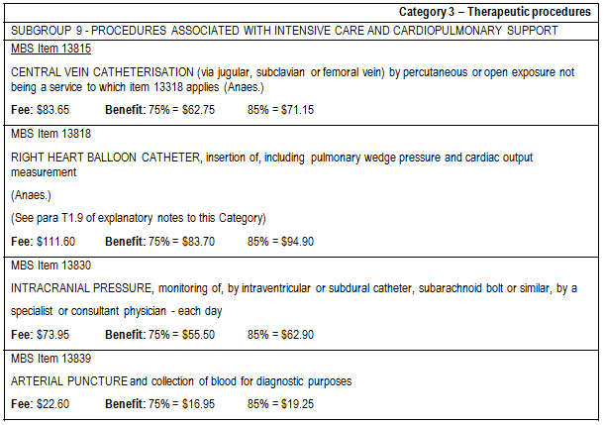

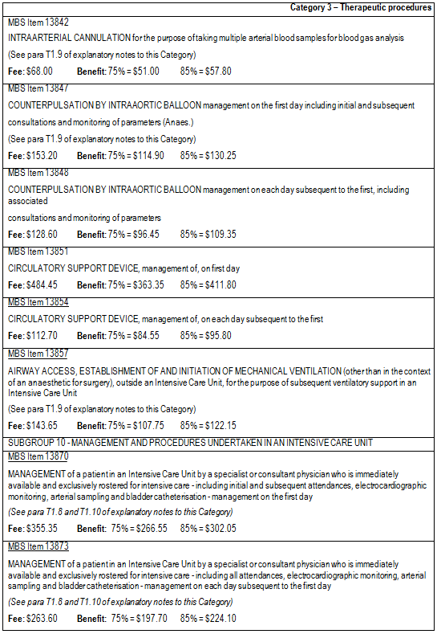

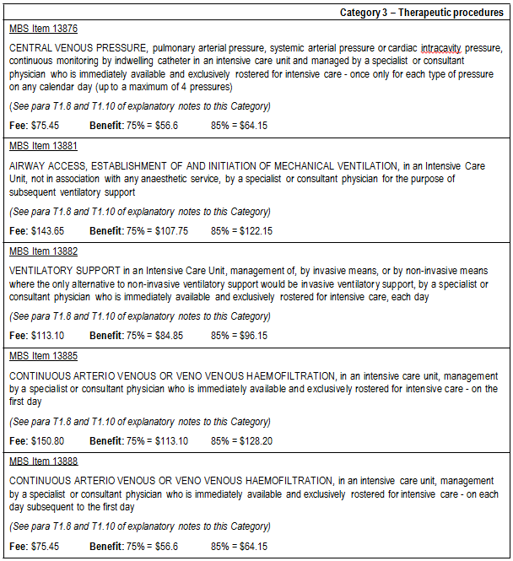
Although there are MBS items that relate to provision of specific services in an ICU, there are currently no professional attendance items specifically intended for ICM specialists available on the MBS for provision of services outside the ICU.

Access to MBS items is not consistent across ICM specialists because members have varying qualifications. Some have qualifications in addition to those in ICM e.g. some are consultant physicians, which allows them to claim for services under a wider range of MBS items. Others are limited in their options to access reimbursement of services under the MBS. For services rendered outside an ICU in a hospital, intensive care specialists who are not fellows of the Royal Australian College of Physicians (FRACPs) can currently claim reimbursement using the MBS items 104 and 105

as detailed in Table 2. Intensive care specialists who are also FRACPs are able to claim items in Group A4 of professional attendance items such as MBS items 110, 116, 132 and 133 listed in Table 3, which provide for complex assessments of patients.
Table 2: Current MBS item descriptors for professional attendance items used to reimburse intensive care medicine specialist (who are not FRACPs) for services rendered outside an intensive care unit

Table 3: Current MBS item descriptors for items available for complex assessment and management of patients in surgery or hospital settings

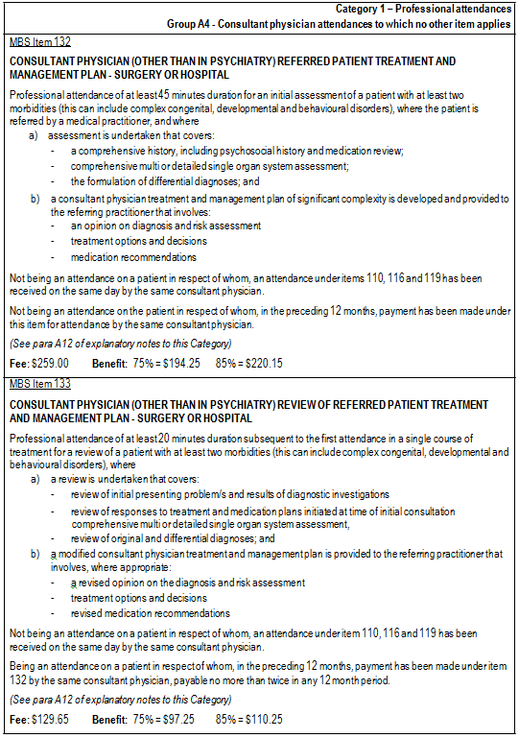

Intervention

Description

In relation to the professional attendance items, it was anticipated that a consultation with an ICM specialist outside the ICU could range from a routine service to a more complex and prolonged service. Examples of routine services include the insertion of lines and referral for specialised care, such as total parenteral nutrition. Examples of complex services, such as those provided by METs, involve the evaluation of a patient including taking a detailed history, performing a thorough and multi-system physical examination, the organisation and review of investigations, exploring treatment options, discussion of care plans with the patient and family members, or discussion with a multi- disciplinary team. The consultation is not used to manage a specific condition. The proposed services are described as being largely consultative or cognitive in nature, although there may be elements of physical intervention.

The purpose of the proposed service is to provide early expert advice on the best course of treatment to a patient who is seriously ill.

Advice was received by PASC that indicated that only one specialist should be able to claim the item in relation to a single patient on any calendar day. In the case of MET teams, for example, it would not be normal practice for more than one ICM specialist to be involved with the team at the same time and only the specialist could claim the item.

It is anticipated that the proposed services will be delivered either in general wards or in emergency departments of hospitals.

Prerequisites

REFERRAL

The proposed item descriptors (provided in Table 4) indicate that it is proposed that the patient must be referred for the intervention by a medical practitioner. The application states that the referral will be from the patient’s primary specialist, or in the case of an emergency department, the emergency physician duty doctor and that the referral process will be in accordance with the requirements of MBS G6.1 Referral of Patients to Specialist or Consultant Physician.

In relation to the need for referral, the Department has accepted that the requirement for a referral in an emergency situation may not be practical (especially for referral to a MET) and this is provided for under MBS Explanatory Note G.6.1. However, the provision is limited to the initial attendance only and further policy consideration would be required to determine whether waiver of the referral requirements in other circumstances would be appropriate. The Department indicates that the wording and structure of the proposed items remain to be finalised.

TRAINING

Historically, training of ICM specialists was coordinated by the Joint Faculty of Intensive Care Medicine (JFICM), which became the College of Intensive Care Medicine (CICM) in January 2010. Many trainees are dual trainees, usually in anaesthesia or general medicine.

The training requirements of the CICM training program in General Intensive Care includes 12 months General Hospital Experience post-graduation plus 36 months of basic training and 36 months of advanced training.

A six year training program comprising three years of basic training and three years of advanced training, which must include:
• 36 months of intensive care training. 12 months may be undertaken in Basic Training in units approved for training. 24 months of core intensive care training must be undertaken in Advanced Training in an ICU approved for core training. One core year of intensive care training must be continuous. The second core year of intensive care training may be spent discontinuously in two periods of six months each. At least 12 months must be undertaken in a unit or units accredited as C24, and only one rotation to a unit classified as C6 is permitted without prior approval of the Censor. In-Training Assessments for this period of training are required. At least 6 months of intensive care training must be undertaken as a Senior Registrar. A maximum of 24 months of intensive care training, whether basic or core, can be completed in the same unit.

A separate pathway is available in Paediatric Intensive Care, based on the above training program.

Co-administered and associated interventions

No other specific services are required to be administered prior to, with or following the requested medical services. However, follow-up services may need to be rendered following a consultation with an ICM specialist. An ICM specialist may order various pathology tests, diagnostic imaging services and therapeutic services (including medications) during a consultation for assessment of a patient’s status.

Listing proposed and options for MSAC consideration

Proposed MBS listing

The proposed MBS item descriptors are provided in Table 4.

Table 4: Proposed MBS item descriptor for proposed intensive care medicine services
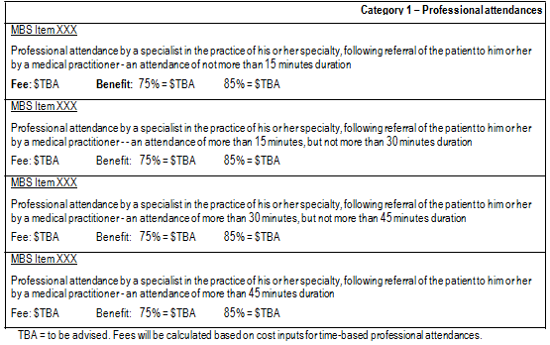

PASC noted that specific requirements to be met (and/or assessments to be completed) during the consultation will be incorporated into the item descriptors provided in Table 4 . The following issues would need to be addressed:
• the item descriptors are to include the definition of the patient population, that patients were (i) admitted to hospital or undergoing assessment and treatment in an Emergency Department; and (ii) not in an ICU as defined in the MBS.
• PASC agreed that there should be a limit on the number of times the item may be claimed per patient, such as a limiting by episode of care or by separation. The application suggests that the intervention will likely be a once only event, unless the patient deteriorates within the same episode of care, or subsequently presents to hospital suffering a life-threatening condition and requires further evaluation by an ICM specialist.
• PASC resolved that the item should be only claimable if the patient is NOT admitted to the ICU. PASC did not accept ANZIC’s claim that items should be payable except where patient is admitted to ICU on the same calendar day (not within 24 hours as suggested in the Consultation DAP) as management of a patient for the first day in ICU MBS item 13870 includes all consultations on that calendar day. However, if admission to ICU is by a different specialist, the activities would need to be repeated. PASC considered that it was reasonable to accept that appropriate handover would occur in practice.

As discussed in the description of the intervention above, it was suggested that proposed items could be used to reimburse ICM specialists for time spent with other specialists, or discussion with a multi- disciplinary team. In the course of the preparation of this DAP, the Department advised the ICM specialists already have access to case conferencing through their current ICU management items under the MBS.

As discussed on p.4, PASC resolved that the traditional MSAC HTA assessment approach, which would seek to derive estimates of the comparative effectiveness, safety and cost-effectiveness of MBS of the proposed scenario (where four time-tiered professional attendance items would be available and claimed) versus the current scenario (where currently available specific MBS professional attendance and case-conferencing items are claimed), was not appropriate in this case for two reasons: (i) the approach was too narrow to permit assessment of various claims made by ANZICS; and (ii) the approach was likely to be unhelpful in informing MSAC about the value of services provided by ICM specialists because data and evidence to inform such a specific approach were unlikely to be available. For example, there were unlikely to be data to answer the question as to what the health outcomes associated with a funding mechanism involving 4 time-tiered services would be compared with the funding mechanism that was currently available. Although PASC considered that MSAC would be unlikely to be able to answer a question as to whether it would be preferable to have four time-tiered professional attendance (consultation) on the MBS for ICM specialists compared with the currently available and used items, PASC considered that evidence may be available that would permit MSAC to provide advice to the Minister as to the comparative effectiveness, safety and cost-effectiveness of services as delivered by ICM specialists outside the ICU versus alternative models of care (e.g., delivery of services only by consultant physicians), i.e., evidence was likely to be available to permit MSAC to determine a response to the question as to whether availability of ICM specialists outside the ICU was worthwhile in a general sense.

Thus, PASC resolved that the “intervention” should be more broadly defined than as proposed above. PASC resolved that it would be appropriate for an assessment report to present the overall body of evidence that could inform a judgement as to the overall comparative effectiveness, safety and cost- effectiveness of a model of care involving ICM specialists outside the ICU compared with alternative models of care (e.g., assessment of patients by consultant physicians). In other words, the question could be framed as “Are ICM specialists uniquely qualified to perform the role it is suggested they perform outside the ICU and what evidence is available that demonstrates that involvement of an ICM specialist (as opposed to other providers) is associated with superior health outcomes and/or is associated with a potential for reduction in costs (e.g., by prevention of admissions to an ICU)?”

Due to the wide range of reasons patients may require consultation with an ICM specialist outside the ICU, and in recognition that the strength of evidence for some conditions requiring the services of an ICM specialist may be better than for other conditions, PASC recommended that the overall body of evidence should be presented in a systematised manner so that evidence for similar conditions is presented together. For example, although evidence for MET teams, and more specifically, the participation of an ICM specialist on a MET team, may be available and can be presented, this should be supplemented with evidence for other occasions where routine consultation with an intensive care specialist outside the ICU for complex assessment is expect to be warranted (e.g., where there are

post-surgical complications and a surgeon requires an assessment of a patient to determine whether admission to an ICU is warranted).

Clinical place for proposed intervention

Patients requiring the attendance of an ICM specialist will include people of all ages who suffer from various medical conditions. There is no specific disease or medical condition that defines the patient population. Typically, these patients will be experiencing a life threatening situation or require expert assistance with the insertion of a line or assessment of total parenteral nutrition requirements.

The application indicates that the clinical place for professional attendance by an ICM specialist occurs at the point at which a patient’s specialist or an emergency department physician makes a clinical judgement that such an attendance is necessary to determine the appropriate course of therapeutic intervention.

Other relevant considerations

In considering comments received on the Consultation DAP, PASC noted that the fundamental claim made by ICM specialists is that there is currently inadequate reimbursement of services delivered by ICM specialists outside the ICU.

PASC noted that the fundamental objective of the MBS was not to provide a remuneration system for health practitioners but, instead, the MBS is a public subsidy system intended to ensure that Australian public have equitable access to effective, safe and cost-effective medical services. However, PASC acknowledged that, if a model of care involving ICM specialists outside, provided incremental health benefits at a reasonable incremental cost compared to other models of care or provided the same health benefits at a reduced cost, then it might be desirable to broaden the MBS items for such specialists to expand the number of services provided by ICM specialists outside the ICU

In addition to a comparison of models of care involving ICM specialists with alternative models of care that are available to patients outside the ICU, PASC recommended that any assessment presented to MSAC should address a wider set of claims including:

• What evidence is available to demonstrate that there is unmet need for ICM specialists outside the
ICU?

• What evidence is available in relation to the consequences of unmet need?

• To what extent is the failure to access ICM services due to shortage of ICM specialists (i.e., due to workforce shortage)? To what extent is the failure to access ICM services due to other factors (e.g., requirement for a referral, fees)?

• What evidence is available with respect to the effects of different approaches to funding for the various models of care that are possible?

• Are there differences in clinical need for services provided by intensive care specialists outside the
ICU in public compared with private hospitals?

Clinical claim

The application proposes that the comparative effectiveness, safety and cost-effectiveness of an appropriate model of care for ICM specialists treating patients outside of an ICU is for:
• Patients managed by an ICM specialist using an appropriate model of care will experience either equivalent or superior quality-adjusted survival compared to other patients.
• Appropriate funding for services provided by ICM specialists outside the ICU may create a
financial incentive for ICM specialists to provide additional services to patients outside the ICU, minimising unnecessary cost of admissions to an ICU and in turn, have a positive impact on the Australian healthcare system.

In relation to the outcomes that should be used to judge the effectiveness of various models of care for attendances for complex assessment & review, PASC noted that, ultimately, quality-adjusted survival would be the appropriate metric to consider. PASC thus advised that studies reporting outcomes that had an impact on quality-adjusted survival would be relevant for presentation in an application.

Economic analysis

On the basis of the likely claims of potential clinical equivalence or superiority for the model of care involving ICM specialists compared with alternative models of, PASC considered that the assessment report would present either a cost-minimisation or cost-effectiveness analysis, respectively.

