Consultation Decision

Analytic Protocol (DAP)

to guide the assessment

of intensive care medicine

professional attendance items

(Application 1170)

January 2012

Table of Contents
MSAC and PASC 2
Purpose of this document 2
Summary of key matters for which PASC seeks input from stakeholders 3
Purpose of application 4
Background 4
Current arrangements for public reimbursement 4
Intervention 9
Description 9
Prerequisites 10
Co-administered and associated interventions 11
Listing proposed and options for MSAC consideration 11
Proposed MBS listing 11
Clinical place for proposed intervention 12
Comparator 14
Clinical claim 14
Outcomes and health care resources affected by introduction of proposed intervention 15
Clinical outcomes 15
Health care resources 15
Proposed structure of economic evaluation (decision- analytic) 15

MSAC and PASC

The Medical Services Advisory Committee (MSAC) is an independent expert committee appointed by the Minister for Health and Ageing (the Minister) to strengthen the role of evidence in health financing decisions in Australia. MSAC advises the Minister on the evidence relating to the safety, effectiveness, and cost-effectiveness of new and existing medical technologies and procedures and under what circumstances public funding should be supported.

The Protocol Advisory Sub-Committee (PASC) is a standing sub-committee of MSAC. Its primary objective is the determination of protocols to guide clinical and economic assessments of medical interventions proposed for public funding.

Purpose of this document

This document is intended to provide a draft decision analytic protocol that will be used to guide the assessment of an intervention for a particular population of patients. The draft protocol that will be finalised after inviting relevant stakeholders to provide input to the protocol. The final protocol will provide the basis for the assessment of the intervention.

The protocol guiding the assessment of the health intervention has been developed using the widely accepted “PICO” approach. The PICO approach involves a clear articulation of the following aspects of the question for public funding that the assessment is intended to answer:

Patients – specification of the characteristics of the patients in whom the intervention is to be considered for use

Intervention – specification of the proposed intervention and how it is delivered

Comparator – specification of the therapy most likely to be replaced by the proposed intervention

Outcomes – specification of the health outcomes and the healthcare resources likely to be affected by the introduction of the proposed intervention

Summary of key matters for which PASC seeks input from stakeholders

The PASC welcomes comments on any aspect of this draft DAP but would particularly appreciate comment from stakeholders on the following issues:
• Whether the proposed MBS items as included in Table 4 on p.11 are appropriately worded and structured. In particular, PASC seeks comment on how the following parameters could be incorporated into the item descriptors:
o that only one specialist should be able to claim the item in relation to a single patient on any calendar day;
o patients to be either inpatients or or undergoing assessment and treatment in an Emergency
Department but not scheduled for admission to an intensive care unit as defined in the MBS;
o the number of times the item should be able to be claimed for an individual patient, per admission or per specified time interval eg 1 year;
o item should not be claimable if the patient is admitted to an ICU within 24 hours of the consultation.

• potential sources of estimates for likely rates of transfer from current MBS items to proposed MBS
items

• availability of any other potentially relevant outcomes upon which an assessment of the comparative effectiveness of attendances by intensive care medicine specialists outside the ICU

• availability of any published references that might assist MSAC in understanding and quantifying the relationship between surrogate outcomes (e.g., the relationship between an unnecessary admission to ICU and the final patient-relevant outcome of quality-adjusted survival);

• whether any resources other than MBS items relating to intensive care medicine specialists and admissions to ICU and length of hospitalisation should be included in an economic evaluation.

• whether the referral from a medical practioners reflect current practice or whether referrals are usually requested by nursing staff.

Purpose of application

A proposal for an application requesting listing of four time-tiered professional attendance (consultation) on the Medicare Benefits Schedule (MBS) to be provided by intensive care medicine specialists has been progressed by the Department of Health and Ageing (DoHA) in consultation with the Australia and New Zealand Intensive Care Society (ANZICS), the peak professional body for the professional service.

Intensive care medicine (ICM) is an area of specialty practice that provides care for critically ill patients, usually with unstable and life threatening illnesses. It is a subset of a broader area of practice, critical care, which can also encompass such practice domains as emergency medicine, post anaesthesia, dialysis, coronary care and high dependency. In general, services provided by ICM specialists are provided in an intensive care unit (ICU) in a hospital however ICM specialists can be called upon to deliver specialist services outside the ICU e.g., as specialist consultant on a general ward or as part of Medical Emergency Teams (METs), traditionally known as cardiac response teams, that are designed to recognise and treat patients experiencing life-threatening situations throughout a hospital. It is reported that 72% of public hospitals and 75% of private hospitals have a MET. According to the proposal for an application, Few MET-call patients require ICU admission meaning that the intensive care medicine specialist may spend considerable time on the general wards assessing and managing patients and counselling families and relatives.

Services rendered by intensive care medicine specialists outside the ICU may be reimbursed using professional attendance items in Group A3, specifically MBS items 104 and 105. The proposal for an application claims that the reimbursement under these items is inadequate as the items do not allow for complex and prolonged consultations that may be necessary when delivering services as part of a MET, or for other services outside the ICU.

It is also claimed that the costs of prolonged consultations are being absorbed by the profession and is therefore proposed that the listing of four time-tiered professional attendance (consultation) items on the Medicare Benefits Schedule (MBS) will provide a more appropriate item structure in line with current practice.

Background

Current arrangements for public reimbursement

ICM is practiced in both the public and private setting. According to ANZICS Intensive Care Resources
& Activity: Australia and New Zealand 2007/2008, there are currently 103 public ICU’s and 50 private
ICUs. According to the Medical Training Review Panel’s 13th Report (April 2010), there are currently
642 intensive care medicine specialists.

Patients undergoing intensive care treatment in a private hospital may be able to claim rebates for services through private health insurance depending on the insurance policy purchased. Furthermore,

there are seventeen MBS items that may be claimed with respect to services delivered to a patient in an intensive care unit. These are summarised in Table 1.

Table 1: Current MBS item descriptors for items used to reimburse intensive care medicine specialists for services rendered in an intensive care unit

Category 3 – Therapeutic procedures
SUBGROUP 9 - PROCEDURES ASSOCIATED WITH INTENSIVE CARE AND CARDIOPULMONARY SUPPORT
MBS Item 13815

CENTRAL VEIN CATHETERISATION (via jugular, subclavian or femoral vein) by percutaneous or open exposure not being a service to which item 13318 applies (Anaes.)

Fee: $83.65 Benefit: 75% = $62.75 85% = $71.15
MBS Item 13818

RIGHT HEART BALLOON CATHETER, insertion of, including pulmonary wedge pressure and cardiac output measurement

(Anaes.)

(See para T1.9 of explanatory notes to this Category)

Fee: $111.60 Benefit: 75% = $83.70 85% = $94.90
MBS Item 13830

INTRACRANIAL PRESSURE, monitoring of, by intraventricular or subdural catheter, subarachnoid bolt or similar, by a specialist or consultant physician - each day
Fee: $73.95 Benefit: 75% = $55.50 85% = $62.90
MBS Item 13839

ARTERIAL PUNCTURE and collection of blood for diagnostic purposes

Fee: $22.60 Benefit: 75% = $16.95 85% = $19.25
MBS Item 13842

INTRAARTERIAL CANNULATION for the purpose of taking multiple arterial blood samples for blood gas analysis

(See para T1.9 of explanatory notes to this Category)

Fee: $68.00 Benefit: 75% = $51.00 85% = $57.80
MBS Item 13847

COUNTERPULSATION BY INTRAAORTIC BALLOON management on the first day including initial and subsequent consultations and monitoring of parameters (Anaes.)
(See para T1.9 of explanatory notes to this Category)

Fee: $153.20 Benefit: 75% = $114.90 85% = $130.25
MBS Item 13848

COUNTERPULSATION BY INTRAAORTIC BALLOON management on each day subsequent to the first, including associated

consultations and monitoring of parameters

Fee: $128.60 Benefit: 75% = $96.45 85% = $109.35
MBS Item 13851

CIRCULATORY SUPPORT DEVICE, management of, on first day

Fee: $484.45 Benefit: 75% = $363.35 85% = $411.80

Table 1: Current MBS item descriptors for items used to reimburse intensive care medicine specialists for services rendered in an intensive care unit

Category 3 – Therapeutic procedures
MBS Item 13854

CIRCULATORY SUPPORT DEVICE, management of, on each day subsequent to the first

Fee: $112.70 Benefit: 75% = $84.55 85% = $95.80
MBS Item 13857

AIRWAY ACCESS, ESTABLISHMENT OF AND INITIATION OF MECHANICAL VENTILATION (other than in the context of an anaesthetic for surgery), outside an Intensive Care Unit, for the purpose of subsequent ventilatory support in an
Intensive Care Unit

(See para T1.9 of explanatory notes to this Category)

Fee: $143.65 Benefit: 75% = $107.75 85% = $122.15
SUBGROUP 10 - MANAGEMENT AND PROCEDURES UNDERTAKEN IN AN INTENSIVE CARE UNIT
MBS Item 13870

MANAGEMENT of a patient in an Intensive Care Unit by a specialist or consultant physician who is immediately available and exclusively rostered for intensive care - including initial and subsequent attendances, electrocardiographic monitoring, arterial sampling and bladder catheterisation - management on the first day

(See para T1.8 and T1.10 of explanatory notes to this Category)

Fee: $355.35 Benefit: 75% = $266.55 85% = $302.05
MBS Item 13873

MANAGEMENT of a patient in an Intensive Care Unit by a specialist or consultant physician who is immediately available and exclusively rostered for intensive care - including all attendances, electrocardiographic monitoring, arterial sampling and bladder catheterisation - management on each day subsequent to the first day

(See para T1.8 and T1.10 of explanatory notes to this Category)

Fee: $263.60 Benefit: 75% = $197.70 85% = $224.10
MBS Item 13876

CENTRAL VENOUS PRESSURE, pulmonary arterial pressure, systemic arterial pressure or cardiac intracavity pressure, continuous monitoring by indwelling catheter in an intensive care unit and managed by a specialist or consultant physician who is immediately available and exclusively rostered for intensive care - once only for each type of pressure on any calendar day (up to a maximum of 4 pressures)

(See para T1.8 and T1.10 of explanatory notes to this Category)

Fee: $75.45 Benefit: 75% = $56.6 85% = $64.15
MBS Item 13881

AIRWAY ACCESS, ESTABLISHMENT OF AND INITIATION OF MECHANICAL VENTILATION, in an Intensive Care Unit, not in association with any anaesthetic service, by a specialist or consultant physician for the purpose of subsequent ventilatory support

(See para T1.8 and T1.10 of explanatory notes to this Category)

Fee: $143.65 Benefit: 75% = $107.75 85% = $122.15
MBS Item 13882

VENTILATORY SUPPORT in an Intensive Care Unit, management of, by invasive means, or by non-invasive means where the only alternative to non-invasive ventilatory support would be invasive ventilatory support, by a specialist or consultant physician who is immediately available and exclusively rostered for intensive care, each day

(See para T1.8 and T1.10 of explanatory notes to this Category)

Fee: $113.10 Benefit: 75% = $84.85 85% = $96.15

Table 1: Current MBS item descriptors for items used to reimburse intensive care medicine specialists for services rendered in an intensive care unit
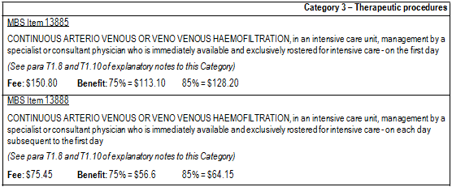
Although there are MBS items that relate to provision of specific services in an ICU, there are currently no professional attendance items specifically intended for intensive care medicine specialists available on the MBS.

Access to MBS items is not consistent across intensive care medicine specialists because members have varying qualifications. Some have qualifications in addition to those in intensive care medicine e.g. some are consultant physicians, which allows them to claim for services under a wider range of MBS items. Others are limited in their options to access reimbursement of services under the MBS. For services rendered outside an intensive care unit in a hospital, intensive care specialists who are not Fellows of the Royal Australasian College of Physicians (FRACPs) can currently claim reimbursement using the MBS items 104 and 105 as detailed in Table 2. Intensive care specialists who are also FRACPs are able to claim items in Group A4 of professional attendance items such as MBS items 110,
116, 132 and 133 listed in Table 3, which provide for complex assessments of patients.

Table 2: Current MBS item descriptors for professional attendance items used to reimburse intensive care medicine specialist (who are not FRACPs) for services rendered outside an intensive care unit

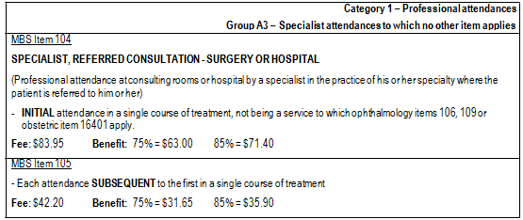
Table 3: Current MBS item descriptors for items available for complex assessment and management of patients in surgery or hospital settings

Category 1 – Professional attendances
Group A4 - Consultant physician attendances to which no other item applies
MBS Item 110

CONSULTANT PHYSICIAN (OTHER THAN IN PSYCHIATRY), REFERRED CONSULTATION - SURGERY OR HOSPITAL

(Professional attendance at consulting rooms or hospital by a consultant physician in the practice of his or her specialty
(other than in psychiatry) where the patient is referred to him or her by a referring practitioner)

- INITIAL attendance in a single course of treatment

Fee: $148.10 Benefit: 75% = $111.10 85% = $125.90
MBS Item 116

- Each attendance (other than a service to which item 119 applies) SUBSEQUENT to the first in a single course of treatment

Fee: $74.10 Benefit: 75% = $55.60 85% = $63.00
MBS Item 132

CONSULTANT PHYSICIAN (OTHER THAN IN PSYCHIATRY) REFERRED PATIENT TREATMENT AND MANAGEMENT PLAN - SURGERY OR HOSPITAL

Professional attendance of at least 45 minutes duration for an initial assessment of a patient with at least two morbidities (this can include complex congenital, developmental and behavioural disorders), where the patient is referred by a medical practitioner, and where

a) assessment is undertaken that covers:

- a comprehensive history, including psychosocial history and medication review;

- comprehensive multi or detailed single organ system assessment;

- the formulation of differential diagnoses; and

b) a consultant physician treatment and management plan of significant complexity is developed and provided to the referring practitioner that involves:

- an opinion on diagnosis and risk assessment

- treatment options and decisions

- medication recommendations

Not being an attendance on a patient in respect of whom, an attendance under items 110, 116 and 119 has been received on the same day by the same consultant physician.

Not being an attendance on the patient in respect of whom, in the preceding 12 months, payment has been made under this item for attendance by the same consultant physician.

(See para A12 of explanatory notes to this Category)

Fee: $259.00 Benefit: 75% = $194.25 85% = $220.15

Table 3: Current MBS item descriptors for items available for complex assessment and management of patients in surgery or hospital settings

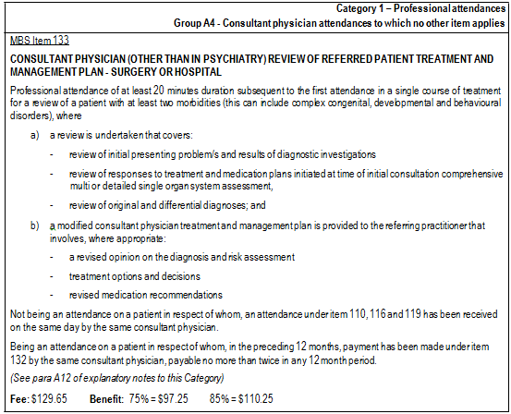

Intervention

Description
In relation to the professional attendance items, it is anticipated that a consultation with an intensive care medicine specialist could range from a routine service to a more complex and prolonged service. Unlike usual consultant physician practice, intensive care is not an “office-based” practice, with the overheads which that entails. Likewise, an attendance by an intensivist on a patient within the hospital but outside the ICU is not analogous to a hospital attendance by an otherwise office-based consultant physician. Examples of routine services include the insertion of lines and referral for specialised care, such as total parenteral nutrition. Examples of complex services, such as those provided by METs, involve the evaluation of a patient including taking a detailed history, performing a physical examination, the organisation and review of investigations, exploring treatment options, discussion of care plans with the patient and family members, or discussion with a multi-disciplinary team. The consultation is not used to manage a specific condition. The proposed services are described as being largely consultative or cognitive in nature, although there may be elements of physical intervention.

The purpose of the proposed service is to provide early expert advice on the best course of treatment to a patient who is seriously ill.

Advice was received by PASC that indicated that only one specialist should be able to claim the item in relation to a single patient on any calendar day. In the case of MET teams, for example, it would not be normal practice for more than one intensive care specialist to be involved with the team at the same time, though other non-intensivist medical practioners maybe, and only the specialist can claim the item.

It is anticipated that the proposed services will be delivered either in general wards or in emergency departments of hospitals.

Prerequisites

REFERRAL

The proposed item descriptors (provided in Table 4) indicate that it is proposed that the patient must be referred for the intervention by a medical practitioner. The proposal for an application states that the referral will be from the patient’s primary specialist, or in the case of an emergency department, the emergency physician duty doctor and that the referral process will be in accordance with the requirements of MBS G6.1 Referral of Patients to Specialist or Consultant Physician.

PASC seeks stakeholder input as to whether the referral from a medical practioners reflect current practice or whether referrals are usually requested by nursing staff.

The Department indicates that the wording and structure of the proposed items remain to be finalised.

TRAINING

Historically, training of intensive care medicine specialists was coordinated by the Joint Faculty of Intensive Care Medicine (JFICM), which became the College of Intensive Care Medicine (CICM) in January 2010. Many trainees are dual trainees, usually in anaesthesia or general medicine.

The training requirements of the CICM training program in General Intensive Care includes 12 months General Hospital Experience post-graduation plus 36 months of basic training and 36 months of advanced training.

A six year training program comprising three years of basic training and three years of advanced training, which must include:
• 36 months of intensive care training. 12 months may be undertaken in Basic Training in units approved for training. 24 months of core intensive care training must be undertaken in Advanced Training in an intensive care unit approved for core training. One core year of intensive care training must be continuous. The second core year of intensive care training may be spent discontinuously in two periods of six months each. At least 12 months must be undertaken in a unit or units accredited as C24, and only one rotation to a unit classified as C6 is permitted without prior approval of the Censor. In-Training Assessments for this period of training are required. At

least 6 months of intensive care training must be undertaken as a Senior Registrar. A maximum of
24 months of intensive care training, whether basic or core, can be completed in the same unit. A separate pathway is available in Paediatric Intensive Care, based on the above training program.

Co-administered and associated interventions

As noted above, a requirement will be that referral from a medical practitioner be required prior to a professional attendance by an intensive care medicine specialist.

No other specific services are required to be administered prior to, with or following the requested medical services. However, follow-up services that might need to be rendered following a consultation with an intensive care medicine specialist. An intensive care medicine specialist may order various pathology tests, diagnostic imaging services and therapeutic services (including medications) during a
consultation for assessment of a patient’s status.

Listing proposed and options for MSAC consideration

Proposed MBS listing

The proposed MBS item descriptors are provided in Table 4.

Table 4: Proposed MBS item descriptor for proposed intensive care medicine services

Category 1 – Professional attendances
MBS Item XXX

Professional attendance by a specialist in the practice of his or her specialty, following referral of the patient to him or her by a medical practitioner - an attendance of not more than 15 minutes duration

Fee: $TBA Benefit: 75% = $TBA 85% = $TBA
MBS Item XXX

Professional attendance by a specialist in the practice of his or her specialty, following referral of the patient to him or her by a medical practitioner - - an attendance of more than 15 minutes, but not more than 30 minutes duration

Fee: $TBA Benefit: 75% = $TBA 85% = $TBA
MBS Item XXX

Professional attendance by a specialist in the practice of his or her specialty, following referral of the patient to him or her by a medical practitioner - an attendance of more than 30 minutes, but not more than 45 minutes duration

Fee: $TBA Benefit: 75% = $TBA 85% = $TBA
MBS Item XXX

Professional attendance by a specialist in the practice of his or her specialty, following referral of the patient to him or her by a medical practitioner - an attendance of more than 45 minutes duration

Fee: $TBA Benefit: 75% = $TBA 85% = $TBA
TBA = to be advised. Fees will be calculated based on cost inputs for time-based professional attendances.

PASC noted that the Department had indicated that further detail was to be incorporated into the item descriptors provided in Table 4 with respect to specific requirements to be met (and/or assessments

to be completed) during the consultation. The following issues would need to be addressed in the revision of the item descriptors:
• Advice was given to PASC that the item descriptor could include, in the definition of the patient population, that patients were (i) admitted to hospital or undergoing assessment and treatment in an Emergency Department; and (ii) not in an intensive care unit as defined in the MBS.
• It was also agreed that there should be a limit to the number of times the item should be able to be claimed for an individual patient with a limit per episode of care or per separation. The proposal suggested that the consultation based intervention will likely be a once only event, unless the patient deteriorates within the same episode of care, or is subsequently presents to hospital suffering a life threatening condition and requires further evaluation by an intensive care medicine specialist.
• It was agreed that the item should be only claimable if the patient is NOT admitted to ICU
within 24 hours of the attendance.

As discussed in the description of the intervention above, it is suggested that proposed items could be used to reimburse intensive care specialists for time spent with other specialists, or discussion with a multi-disciplinary team. In the course of the preparation of this DAP, the Department advised the intensive care medicine specialists already have access to case conferencing through their current ICU management items under the MBS.

Clinical place for proposed intervention

Patients requiring the attendance of an intensive care medicine specialist will include people of all ages who suffer from various medical conditions. There is no specific disease or medical condition that defines the patient population. Typically, these patients will be experiencing a life threatening situation or require expert assistance with the insertion of a line or assessment of total parenteral nutrition requirements.

The proposal for an application indicates that the clinical place for professional attendance by an intensive care medicine specialist occurs at the point at which a patient’s specialist or an emergency department physician makes a clinical judgement that such an attendance is necessary to determine the appropriate course of therapeutic intervention.

The management algorithm representing current practice and the management algorithm that are anticipated would apply should the requested MBS items be listed as proposed are summarised in Figure 1 and Figure 2, respectively.

The algorithms are intended to show that there will be no change to delivery of services to patients as a consequence of change to reimbursement arrangements. As discussed, the costs of prolonged consultations are currently being absorbed by the profession.

Figure 1: Management algorithm that applies currently for intensive care medicine professional attendances

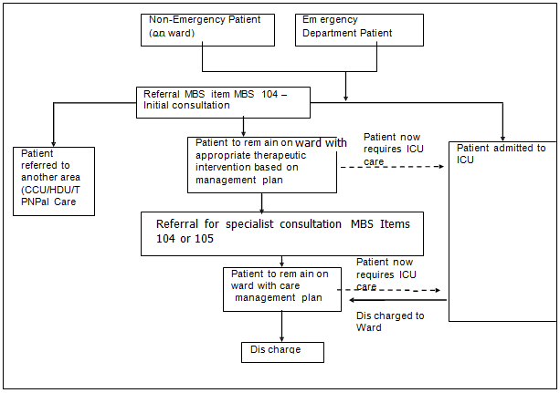
Figure 2: Management algorithm that would apply should intensive care medicine professional attendance items be included on the MBS as proposed

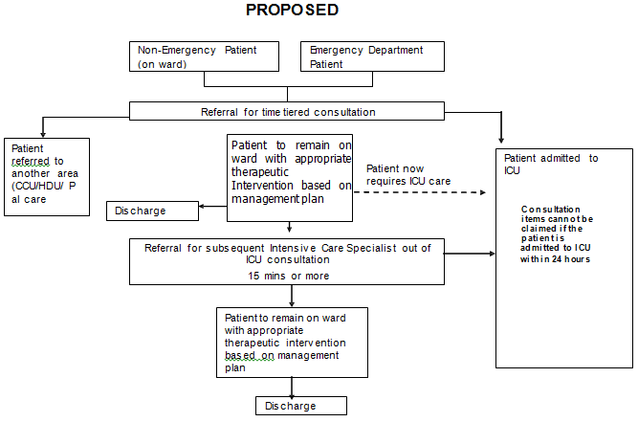

Based on Medicare data for 2010, intensive care specialists (excluding consultant physicians) provided
12,849 consultations: 5931 initial consultations reimbursed under MBS item 104 were provided at a total cost of $360,335, and 6918 subsequent consultations reimbursed under MBS item 105 were provided at a cost of $211,323. There were 258 occasions where both initial and subsequent consultation were provided by the same provider to the same patient on the same day, and 34 occasions where there was an initial and more than one subsequent consultation provided.

PASC confirmed that the appropriate clinical place for the requested items means that the requested MBS items will be used as a direct substitute for currently available MBS items (such that utilisation of the substituted items will fall as utilisation of the proposed items increases). PASC agreed that input from stakeholders on potential sources to populate the probabilities in Figure 3 would be desirable. In particular, it resolved to seek advice from stakeholders as to potential sources of estimates for likely rates of transfer from current MBS items to proposed MBS items.

Comparator

PASC recognised that the usual definition of the appropriate comparator when considering a request for inclusion of a new item on the MBS was the intervention most likely to be replaced. However, PASC recognised that the proposed application was not requesting listing of a new item but instead sought a change to the current reimbursement arrangements for services currently delivered to patients. The change to the current arrangements would be likely to be associated with an overall increase in average fees paid to specialists. Thus, in the scenario where the proposed items were direct substitutes for the current items there would be an increase in costs with no associated improvement in outcomes and a determination of dominance of the current scenario over the proposed scenario is a foregone conclusion. Thus, PASC resolved that the usual approach of comparing costs and benefits associated with the current scenario with costs and benefits associated with the proposed scenario was unlikely to be informative for MSAC.

An alternate approach of presenting a comparison of the proposed scenario with a hypothetical scenario where there is no delivery of services outside the ICU by intensive care medicine specialists (but which may include delivery of services by others) was suggested by PASC as such an approach would provide information that MSAC could use to make a decision in relation to the cost-effectiveness of the proposed listings.

Clinical claim

PASC anticipated that an application considering the comparative effectiveness, safety and cost- effectiveness of the attendance of intensive care medicine specialists outside the ICU (e.g., as part of MET calls) versus no availability of such services would claim that patients who are provided with services outside the ICU by an intensive care medicine specialist, compared with patients who are not provided with such services (but who may be provided services by others) experience superior quality- adjusted survival. The proposal for an application reports that a number of studies are available in the public domain that demonstrate that early intervention (e.g., via METs) for patients experiencing life threatening conditions can reduce morbidity, mortality and unnecessary admissions to ICU.

On the basis of the likely claims of potential clinical superiority for the proposed items compared with no availability of such items, PASC considered that the application should present a cost-effectiveness analysis.

Outcomes and health care resources affected by introduction of proposed intervention

Clinical outcomes

Rates of morbidity and mortality are nominated as appropriate outcomes upon which to assess the comparative effectiveness and safety of services delivered under the proposed MBS items versus no delivery of such services. Rates of unnecessary admissions to an ICU are also nominated as relevant outcomes. PASC confirmed that these outcomes are appropriate outcomes upon which to judge the comparative effectiveness of delivery of services by an intensive care medicine specialist outside the ICU compared with no delivery of such services. However, PASC also considered that stakeholders should be invited to nominate any other potentially relevant outcomes and also to cite any published references that might assist MSAC in understanding and quantifying the relationship between surrogate outcomes (e.g., the relationship between an unnecessary admission to ICU and the final patient-relevant outcome of quality-adjusted survival).

Health care resources

The proposal for an application notes it would be appropriate for any comparative economic analysis to include the use of resources of professional attendance by an intensive care medicine specialist and admissions to an ICU. PASC considered that other resources (e.g., time in ICU, time in hospital) besides MBS items should be included in an economic evaluation. It resolved to seek further advice from stakeholders on other resources that might be impacted by the availability of the services of an intensive care medicine specialist outside the ICU.

Proposed structure of economic evaluation (decision- analytic)

Table 5 summarises the extended PICO that it is proposed MSAC would consider.

Table 5: Summary of extended PICO to define the question for public funding that assessment will investigate

Patients | Intervention | Comparator | Outcomes to be  assessed | Healthcare resources  to be considered
Patients who have been  referred to an intensive care medicine specialist. | Time-tiered  consultations with an intensive care medicine specialist | No extra-ICU consultation items available on the MBS | Rates of morbidity, mortality, and unnecessary admissions to an ICU | MBS items relating to professional attendance items  Admissions to ICU, time in hospital  ?Other resources

The proposal for an assessment does not include a suggested structure for an economic evaluation.

PASC suggested that the fundamental structure for the overall economic evaluation of professional attendance and case-conferencing items could be summarised as shown in Figure 3.

Figure 3: Fundamental structure for the economic evaluation that might be presented in the assessment of professional attendance items for intensive care medicine specialists

