MSAC Application 1711
Review of MBS items for subacromial decompression

Ratified
PICO Confirmation

Summary of PICO/PPICO criteria to define question(s) to be addressed in an Assessment Report to the Medical Services Advisory Committee (MSAC).
Two PICO Sets define two populations who may be considered for subacromial decompression.
It should be noted that the current and proposed MBS items are not explicit on the patient population.
PASC discussed changes to simplify and clarify each PICO Set, particularly in refining the Population and Outcomes.
PASC discussed PICO Set 2 and the use of subacromial decompression as an adjunct to rotator cuff repair (e.g. 48909). PASC noted that current item numbers (e.g. 48906) are already inclusive of rotator cuff repair with or without subacromial decompression. Furthermore, the MBS Review Orthopaedic Clinical Committee Report considered different techniques of subacromial decompression including the excision of large bursa, acromioplasty and synovectomy to be inherent components of rotator cuff repair and should not be co-claimed. Thus, PASC questioned the usefulness of PICO Set 2 given that the separate clinical question of the incremental benefit of rotator cuff repair does not require further consideration. PASC advised that, subject to endorsement from the MSAC Executive, PICO Set 2 should be removed from this current assessment as the use or not of subacromial decompression as a part of rotator cuff surgery could be considered redundant in the context of an assessment of subacromial decompression.
Post PASC, the MSAC Executive at its 27 May meeting, endorsed the PASC advice to remove PICO Set 2. The MSAC Executive also advised that a review of rotator cuff repair (with/without subacromial decompression) may be endorsed when the results of the Australian Rotator Cuff trial are available (ANZCTR 2022). The PICO Set for subacromial decompression as a part of rotator cuff surgery previously included in the draft PICO confirmation can be found in Appendix D.
Table 1 PICO for patients with subacromial impingement: PICO Set 1
Component | Description
Population | Adult patients with symptomatic subacromial shoulder impingement AND:  - Symptoms unresolved despite conservative therapy for 6 months;  AND excluding:  - Patients who require rotator cuff repair AND;  - Patients with other pathologies of the shoulder e.g. glenohumeral joint osteoarthritis, acromioclavicular arthritis, labral tear including superior labral anterior-posterior (SLAP) tears, adhesive capsulitis/frozen shoulder, tendinopathy of the long head of the biceps, calcific tendinopathy, bicipital tendon disorders, neuropathy, shoulder fractures, shoulder instability/dislocation, malignancy, infection  Note, the current and proposed MBS items for subacromial decompression do not include population eligibility criteria.
Intervention | Any form of open or arthroscopic subacromial decompression of shoulder (i.e. standalone)  Inclusive of, if performed:  - Coraco-acromial ligament division (MBS items 48900, 48903, 48951, 489XX)  - Acromioplasty (48903, 48951, 489XX)  - Coplaning of the clavicle or excision of the acromioclavicular joint (48903, 489XX)  - Removal of calcium deposit (48900, 489XX)  - Excision of bursa (489XX)
Comparator/s | Continued conservative therapy (including pain relief, physiotherapy or other type of allied health or primary care)
Outcomes | - Safety  - Adverse events  - Infection  - Adhesive capsulitis  - Wasting or avulsion of the deltoid muscle  - Efficacy/effectiveness  - Shoulder function specific scores (e.g. Constant Murley, Oxford Shoulder Score etc)  - Mean pain scores improvement (e.g. visual analogue scale (VAS) etc)  - Health-related quality of life  - Failure of surgery or need for revision surgery  - Return to work or normal function  - Healthcare resources  - Consultations in primary care, specialist or surgery  - Pain management medication  - Diagnostic tests  - Physiotherapy costs  - Consumables and implants for surgery  - Rehabilitation  - Indirect costs (work days lost)  - Cost effectiveness (cost per life year gained, cost per quality-adjusted life year (QALY) gained, incremental cost-effectiveness ratio (ICER))  - Total Australian Government healthcare costs  - Patient-relevant costs (e.g. ongoing physiotherapy, pain relief, loss of time from work or other daily activities)
Assessment questions | - What is the comparative safety, effectiveness and cost effectiveness of subacromial decompression versus non-surgical therapy in patients with subacromial impingement?  - All available sub-populations should be reported.  - Which sub-populations have the greatest benefit from surgery?  - Which sub-populations have the least benefit from surgery?  - Note that the requirement for an add-on economic evaluation component to be determined subsequent to the initial results of the DCAR.  - From MBS data modelling, what is the budgetary impact of a range of scenarios?

Reason for application- purpose of the review
Advice requesting a full health technology assessment review of current and proposed MBS services for subacromial decompression and rotator cuff repair was received from the MSAC Executive.
The purpose of this assessment is to consider the safety and effectiveness of subacromial decompression surgery. Populations and sub-populations who may benefit from these services should be identified.

Background
The currently subsidised MBS items for subacromial decompression (by acromioplasty) are MBS item 48903 and MBS item 48909. Other items related to subacromial decompression include 48900 and 48906 (which include excision of the coraco-acromial ligament or removal of calcium deposit) and 48951 and 48960 (which include division of the coraco-acromial ligament, acromioplasty, and resection of the acromioclavicular joint).
Subacromial decompression surgery and rotator cuff repair are commonly performed in Australia and are currently reimbursed through a number of MBS items which include a range of procedures (Appendix A).
As part of the Medicare Benefits Schedule (MBS) Review (MBS Review), the final report on the review of Orthopaedic MBS items recommended that for shoulder surgery, existing items for subacromial decompression and rotator cuff repair should be consolidated (recommendation 74, 75) (MBS Review 2019). The proposed items are shown in Appendix A. Subsequently, an additional item has been proposed for larger rotator cuff tears.
In 2020, MSAC recommended that the MSAC Executive review the MBS item 48903 for shoulder subacromial decompression surgery (MSAC 2020). During its deliberations of this item, the MSAC Executive noted the results of two recent systematic reviews showed that the clinical benefits of these procedures compared to conservative management was uncertain and advised that a full health technology assessment (HTA) review was required prior to the implementation of recommendations 74 and 75 (Australian Government Department of Health 2021, Karjalainen et al. 2019a, Karjalainen et al. 2019b).
Guidelines are varied in their recommendations for the use of subacromial decompression (AIM 2018, AIM 2021, NICE 2018, Vandvik et al. 2019), and position statements and commentary provide insight on recent evidence (AOA 2017, Aresti and Di Mascio 2019, BESS 2017, BESS 2019).
In addition to this PICO Confirmation, the Terms of Reference for this review are, to:
- Review clinical guidelines on the management of rotator cuff disease, taking account of the clinical characteristics of the population/s recommended for subacromial decompression (with/without rotator cuff repair).
- Review the utilisation of subacromial decompression services, informed by MBS data and other data that may provide additional insight into clinical use.
- Review evidence on comparative safety and clinical effectiveness of subacromial decompression (with/without rotator cuff repair) used in the management of rotator cuff disease. The evidence review will be based on the Population, Intervention, Comparator and Outcomes (PICO) confirmation ratified by the PICO Advisory Subcommittee (PASC).
- Subject to the findings of Terms of Reference 1, 2 and 3, review and evaluate the cost effectiveness of subacromial decompression (with/without rotator cuff repair).

PICO criteria

Population
The population relevant to this assessment is: Adult patients with symptomatic subacromial shoulder impingement AND:
  - Symptoms unresolved despite conservative therapy for 6 months;
AND excluding:
  - Patients who require rotator cuff repair AND
  - patients with other pathologies of the shoulder e.g. glenohumeral joint osteoarthritis, acromioclavicular arthritis, labral tear including superior labral anterior-posterior (SLAP) tears, adhesive capsulitis/frozen shoulder, tendinopathy of the long head of the biceps, calcific tendinopathy, bicipital tendon disorders, neuropathy, shoulder fractures, shoulder instability/dislocation, malignancy, infection
A second population was considered by PASC (PICO Set 2): Adult patients with symptomatic full- or partial-thickness rotator cuff tear and subacromial shoulder impingement, AND:
  - Symptoms unresolved despite conservative therapy for 6 months AND;
  - Require concomitant subacromial decompression and rotator cuff repair;
AND excluding:
  - Patients with other pathologies of the shoulder e.g. glenohumeral joint osteoarthritis, acromioclavicular arthritis, labral tear including superior labral anterior-posterior (SLAP) tears, adhesive capsulitis/frozen shoulder, tendinopathy of the long head of the biceps, calcific tendinopathy, bicipital tendon disorders, neuropathy, shoulder fractures, shoulder instability/dislocation, malignancy, infection
Note, post PASC, PICO Set 2 was removed from the review of subacromial decompression. For information, the PICO Set for this population is shown in Appendix D.
PASC noted the physiology of the subacromial space and extrinsic and intrinsic compression that lead to impingement, pain and loss of function.
PASC discussed the populations in terms of the available evidence, consultation feedback and published guidelines, and considered the patients who may benefit from surgery. Orthopaedic Shoulder Surgeons generally consider subacromial decompression to be an option for patients in the following circumstances:
- Failure of conservative therapy and ongoing pain and loss of function for a minimum duration of four to six months
- Examination consistent with impingement along with the exclusion of other common causes of pain such as adhesive capsulitis (frozen shoulder), long head of biceps tendonitis, early osteoarthritis etc.
- Radiological evidence of pathological acromial / coraco-acromial ligament morphology, that is an extrinsic cause of subacromial impingement.
PASC considered that no additional patient-specific variables were identified that would help to identify those who may best benefit from subacromial decompression. PASC considered that consultation input could be sought from the Shoulder and Elbow Society of Australia (SESA). PASC also noted that some observational studies and clinical practice guidelines do suggest predictive factors and scoring systems that may help define patients who are more likely to benefit from surgery (Singh et al. 2014, UNSW 2013). Reported prognostic factors which may negatively influence recovery after surgery included older age, MRI tear characteristics, higher body mass index, patient comorbidities, smoking status, and duration of complaint.
PASC acknowledged that non-symptomatic partial thickness tears of the rotator cuff were common, and that over-use of imaging or radiology may lead to over-diagnosis, including of asymptomatic rotator cuff pathologies, and may lead to an over-use of surgery. PASC recognised consultation feedback that considered radiology or imaging valuable to further define the pathology, exclude other pathologies, and can be used to confirm extrinsic impingement.
PASC discussed the Australian Rotator Cuff trial that will provide high-quality evidence regarding surgical repair of non-acute rotator cuff tears of the shoulder in adults in Australia (ANZCTR 2022).
PASC recognised that the population who may best benefit from subacromial decompression is not clearly defined. The assessment phase should investigate what aspects of patient presentation best identify successful surgery, for instance severity of symptoms. Further research into what aspects of patient presentation best identify successful surgery may be useful. This may be a valuable question for the Medical Research Future Fund.

Background

Rotator cuff disease
The rotator cuff is comprised of four muscles and tendons which envelop the shoulder joint that assist in movement and stabilisation (Whittle and Buchbinder 2015) (Figure 1).
Rotator cuff disease is an umbrella term used to encapsulate all symptomatic disorders of the rotator cuff that can result in pain, weakness, instability and dysfunction in the shoulder joint regardless of pathology or anatomical location (Migliorini et al. 2021, Whittle and Buchbinder 2015). Diagnoses that are classified as rotator cuff disease include tendinopathy/tendinitis, partial- and full-thickness tears of the tendon (PTT or FTT), rotator cuff tear arthropathy, calcific tendinitis, subacromial bursitis and subacromial impingement syndrome (Coghlan et al. 2008, Karjalainen et al. 2019a).
Rotator cuff disease is thought to be the result of biological and mechanical influences including acute injury, chronic degeneration (impingement of acromial bone spurs and friction leading to oedema, inflammation and rupture), or biological factors and tendon degeneration, with risk factors including ageing, high body mass index (BMI), hypertension and smoking (Hamid and Sazlina 2021, Karjalainen et al. 2019a, Ketola et al. 2013, Whittle and Buchbinder 2015). The main external factors associated with rotator cuff disease are occupational and sporting activities due to the biomechanical demands these place on the shoulder (Whittle and Buchbinder 2015).

Rotator cuff tears
Rotator cuff tears involve one or more of the tendons of the rotator cuff (Figure 1). The tears typically occur at the supraspinatus tendon insertion under the acromion (Karjalainen et al. 2019a, Kukkonen et al. 2014, Neer 1983). Rotator cuff tears are classified according to the severity of the tendon fibre disruption including size, site, number of tendons affected, degree of tendon retraction and muscular atrophy (Longo et al. 2021, Schmucker et al. 2020). Rotator cuff tears are commonly described as full-thickness or partial-thickness, depending on whether the damage has breached both sides of the tendon (Hopman et al. 2013). FTT are commonly classified according to their size:
- small rotator cuff tear: less than 1 cm
- medium rotator cuff tear: 1–3 cm
- large rotator cuff tear: 3–5 cm
- massive rotator cuff tear: greater than 5 cm.
Rotator cuff tears typically present in older people but can also present in young patients as a result of trauma (Jacquot et al. 2014). PTT are commonly described in terms of the thickness of the remaining tendon, for example less than or greater than 50% of tendon thickness (Hohmann et al. 2020, Oliva et al. 2015).

Figure 1 Anatomy of the shoulder (reproduced with permission) (Wikimedia Commons 2022)
Shoulder impingement or subacromial impingement syndrome is a common cause of shoulder pain, where a rotator cuff tendon rubs or catches on nearby tissue and bone as the arm is lifted (NHS 2020), which presents as a set of clinical and radiological findings that pertains to tendinitis and bursitis of the rotator cuff and adjacent tissues (Nazari et al. 2019a). These pathological changes to the subacromial space can be extrinsic or intrinsic.
Shoulder impingement was originally described as a mechanical problem from an anatomical cause whereby the subacromial space is narrowed leading to contact between the acromion and soft tissues causing irritation of the subacromial tissue with consequent degeneration and rupture (Beard et al. 2018, Neer 1983). It is often considered to be caused by bony ‘spurs’ forming on the acromion leading to inflammation in the surrounding bursa and tendons (Jones et al. 2019, Longo et al. 2021). This physical contact or impingement causes pain when the arm is in certain positions. Accordingly, a hook-shaped acromion may be associated with increased risk for rotator cuff disease, and acromial spurs can be associated with FTT (Song et al. 2016).
However, others have reported that the development of the acromial bony spur is intrinsic, specifically a secondary degenerative change, implying that the majority of rotator cuff tears are initiated not by impingement but by an intrinsic degenerative tendinopathy (Shin et al. 2012).
Shoulder impingement syndrome may be associated with acromioclavicular joint arthritis and both PTT and FTT, as well as adhesive capsulitis (New York Workers Compensation Board 2021).

Prevalence in Australia
Musculoskeletal disorders have a high burden of disease across the Australian population, accounting for 653,000 disability-adjusted life years in 2019 (AIHW 2018). Shoulder pain is the third most common musculoskeletal complaint (Karjalainen et al. 2019b) and affects almost a quarter of people in the Australian community, with a significant impact on quality of life and physical functioning (Hill et al. 2010). Internationally, there is a lifetime prevalence of up to 66.7% (Brindisino et al. 2021, Jones et al. 2019, Karjalainen et al. 2019b, Thorpe et al. 2016) and an annual prevalence of seeking care for shoulder pain of 2.4% (Buchbinder et al. 2013). Shoulder pain becomes more common with increasing age (Thorpe et al. 2016).
Rotator cuff disorders, specifically rotator cuff tears or subacromial pain, is responsible for up to 65% to 85% of shoulder pain (Brindisino et al. 2021, Jones et al. 2019, Karjalainen et al. 2019b, Thorpe et al. 2016, Whittle and Buchbinder 2015) with increasing incidence with age (Sakha et al. 2021).
In the general population, the prevalence of sonographically defined, FTT is 22.1%, increasing to 28% in the population over 60 years of age and 36.6% in individuals older than 80 years (Dezaly et al. 2011, Whittle and Buchbinder 2015). Two-thirds of tears were asymptomatic (Whittle and Buchbinder 2015). Based on magnetic resonance imaging scans, over 50% of individuals older than 60 years of age have asymptomatic PTT or FTT. Half of all individuals with asymptomatic rotator cuff tears develop pain over a period of 5 years (Coghlan et al. 2008). The incidence of tears is reported at 65% in individuals above 70 years (Sayampanathan et al. 2021).
Massive rotator cuff tears are estimated to comprise approximately 20% of all initial rotator cuff tears and 80% of recurrent tears (Kovacevic et al. 2020).
As shown in Appendix B, in Australian hospitals there was a total number of 26,742 separations for symptoms related to the rotator cuff (M75.1 Rotator cuff syndrome, M75.4 Impingement syndrome of shoulder, S46.0 Injury of muscle(s) and tendon(s) of the rotator cuff of shoulder) in 2019–2020 (AIHW 2022c). There were 19,024 for rotator cuff syndrome and 4,934 for impingement syndrome. The number of these diagnoses has increased over time, although the rate has plateaued in recent years.

Clinical presentation and diagnosis
Patients present with functional loss and disability. Shoulder pain is reported particularly with overhead activities (a painful arc between 60° and 120° abduction) and is often worse when the patient is lying in bed (Karjalainen et al. 2019b).
In Australia, the management of shoulder pain by general practitioners is highly variable (Buchbinder et al. 2013). Clinical practice guidelines recommend that patient history combined with clinical and physical examination, including for muscle wasting and tenderness, are used for the initial diagnosis (Whittle and Buchbinder 2015, UNSW 2013, ACC 2003). A combination of physical tests and manoeuvres are recommended, for example: for subacromial impingement, a combination of the Hawkins-Kennedy test, the painful arc test (with pain occurring between 60° and 120°) and the infraspinatus muscle strength test; and for a rotator cuff tear, the painful arc sign, drop-arm test and the infraspinatus and supraspinatus muscle strength tests should be used (Diercks et al. 2014, Colorado Department of Labor and Employment 2015, Hopman et al. 2013). Multiple tests are commonly used in practice, and the reliability of these tests vary with experience of the examiner (Whittle and Buchbinder 2015).
Radiology and imaging studies are variously described in published guidelines (AAOS 2019, ACR 2018, Hopman et al. 2013). However, imaging tests are generally not recommended unless there is a suspected serious pathology (Whittle and Buchbinder 2015) or where the person is not responding to initial conservative management and the imaging result is expected to change clinical management decisions. According to the American College of Radiology, X-ray is usually appropriate for initial imaging of patients with shoulder pain (ACR 2018). X-rays can detect osteoarthritis, bone pathology or calcium deposits and may not be indicated in the initial few weeks in the absence of red flags (Hopman et al. 2013).
Imaging with ultrasound or magnetic resonance imaging (MRI, without contrast) can be considered where there is a suspected rotator cuff tear (ACR 2018). Imaging with MRI or ultrasound (US) is not recommended in primary care unless surgery is being considered as this can help to identify the size and location of tears (BOA 2014, Colorado Department of Labor and Employment 2015, Whittle and Buchbinder 2015). US and MRI are accurate for detection of FTT in patients for whom surgery is being considered, but they are less sensitive for detecting PTT (Lenza et al. 2013).
There are concerns that imaging findings in primary care, particularly the use of US, may be misleading and result in inappropriate management or a delay in correct diagnosis (Buchbinder et al. 2013).
Subacromial injection of a local anaesthetic or steroid can reduce the pain either directly or by reducing inflammation (Zadro et al. 2021, New York Workers Compensation Board 2021, Hohmann et al. 2020, Washington State Department of Labor and Industries 2018). Some guidelines recommend the use of these injections to help diagnosis of shoulder impingement (New York Workers Compensation Board 2021, Hohmann et al. 2020, Washington State Department of Labor and Industries 2018), although there is a paucity of high-quality studies for this method (Whittle and Buchbinder 2015).
There are existing MBS items for US of the shoulder or upper arm (55864, 55865, 55866, 55867), diagnostic radiology using X-ray of the shoulder or scapula (57700, 57703) and MRI scan of the shoulder or its supporting structures (63325) (MBS 2022a). Appropriate items for US will be confirmed as part of the assessment phase. The number of claims in 2019–2020 was 53,213 for MRI (item 63325, from 27,696 in 2010–2011), 97,381 for US (no previous years’ data available) and 462,740 for X-ray (57700 and 57703 combined, from 359,866 in 2010–2011) (MBS 2022b).

Current treatment options
While nearly half of all patients with new-onset shoulder pain consult their general practitioner only once, and most never require referral for specialist care, some patients need targeted care (Whittle and Buchbinder 2015). The primary aim of any therapy is to relieve pain and restore shoulder function (Schmucker et al. 2020).
Initial treatments of conservative therapy or non-surgical management include modification of lifting activities, simple analgesia or non-steroid anti-inflammatories (Whittle 2016). Movement, exercise and physiotherapy improve strength and stability, and are recommended in all clinical practice guidelines (AAOS 2019, Hopman et al. 2013, Vandvik et al. 2019).
The use of conservative therapy is further described under Comparator below.
According to many guidelines, patients who fail to respond to 5 - 12 weeks of conservative therapy in primary care are referred to specialist care (including surgery) according to the clinical circumstance (Whittle and Buchbinder 2015).
The use of surgical care is further described under Intervention below.

Economic impact
Musculoskeletal disorders are the second largest cause of disability globally and are estimated to have cost Australia A$55 billion in 2012. According to a cost-of-illness analysis study, the mean societal cost of healthcare and domestic support for shoulder pain in Australia in 2019 was A$7,563 annually for patients on the orthopaedic waiting list. The cost increased to A$13,885 annually when absenteeism and presenteeism were included. The mean per-patient cost to government of public hospital care was A$2,622 in the first year and A$3,835 over 2 years (Marks et al. 2018). Among employed individuals with shoulder pain, the median days of absences from work is 23 days in the United States of America and 39 days in Canada (Yu et al. 2021).

Rationale
As shown in PICO Set 1, the population for this assessment is: Patients with rotator cuff disease: subacromial shoulder impingement. This population includes patients with or without a tear of the rotator cuff. However, subacromial decompression surgery is provided as a standalone procedure with no concomitant rotator cuff repair surgery. For this population, patients with and without identified rotator cuff tears will be reported separately.
A second population was considered by PASC (PICO Set 2): Patients with rotator cuff disease: subacromial shoulder impingement and a tear of the rotator cuff. This population includes patients with a tear of the rotator cuff, with subacromial decompression provided together with repair of the rotator cuff. For this population, patients with PTT and FTT should be reported separately. In addition, patients with FTT greater than and less than 3 cm in size should be reported separately where possible. Note, post PASC, this PICO Set 2 was removed from the review of subacromial decompression. For information, the PICO Set for this population is shown in Appendix D.

MBS item descriptors
The current and proposed MBS items provide a broad definition of two populations:
- patients who require subacromial decompression but do not require concomitant rotator cuff repair
- patients who require rotator cuff repair and may require subacromial decompression. Note, post PASC, this population (PICO Set 2) was removed from the review of subacromial decompression.
The patient populations and specific pathophysiology are not defined in the current items, and the use of the various surgical services and techniques is at clinical discretion. Similarly, any physical tests and requirement for radiology, imaging or previous therapies are not described. Therefore, the population for which subacromial decompression and rotator cuff repairs is provided in Australia is uncertain.
The current and proposed MBS items are not clear on the indications for use of subacromial decompression with or without rotator cuff repair, and the evidence for the range of populations will be investigated as part of the assessment report.

Trial populations
A number of published randomised controlled trials (RCTs) are available on the use of subacromial decompression. In a recent Cochrane systematic review of subacromial decompression for rotator cuff disease, the eight included trials presented evidence for a slightly varied population (Beard et al. 2018, Brox et al. 1999, Farfaras et al. 2018, Haahr and Andersen 2006, Karjalainen et al. 2019b, Ketola et al. 2015, Paavola et al. 2021, Peters and Kohn 1997, Rahme et al. 1998). As extracted for the Cochrane review, the patient selection criteria included:
- some definition of shoulder symptoms including pain
- impingement (Brox, Haahr, Rahme, Peters, Paavola, Ketola, Faraffas) or subacromial pain (Beard), although the definition has been noted to be varied and may not always represent pathologies likely to benefit from surgery (Aresti and Di Mascio 2019)
- explicit exclusion of rotator cuff rupture in some studies (Brox, Haahr, Peters), while others included partial rupture or were not clear (Rahme, Beard, Paavola, Ketola, Farfaras)
- requirement in some studies for patients to have failed previous physiotherapy (Brox, Beard, Farfaras, Paavola, Ketola), while in other studies previous therapies were not clear (Haahr, Rahme, Peters)
- patient mean age of around 50 years of age across RCTs.
One trial recently published 10-year results that concluded improved clinical results for patients following subacromial decompression (Farfaras et al. 2018).
A number of recent systematic reviews have been published on surgery for subacromial impingement and for rotator cuff repair.
- Subacromial decompression for subacromial impingement or rotator cuff disease (Karjalainen et al. 2019b, Khan et al. 2019, Nazari et al. 2019a)
- Rotator cuff tears with or without acromioplasty (Sayampanathan et al. 2021) or surgical repair versus conservative treatment or subacromial decompression alone (Schemitsch et al. 2019)
- Surgery versus conservative management for rotator cuff tears (Brindisino et al. 2021, Garibaldi et al. 2021, Khatri et al. 2019, Longo et al. 2021, Schmucker et al. 2020).
Overall, surgical outcomes were similar to conservative therapy. However, the relevance of these analyses to this current review is uncertain. Surgery in the management of irreparable massive rotator cuff tears provided improved results compared to conservative care (Kovacevic et al. 2020).
Commentary has been provided on the design of a recent RCT, and previous trials, which questions their relevance to clinical and surgical practice (AOA 2017, Aresti and Di Mascio 2019). Specifically:
- Not all participants were selected appropriately and in line with best practice.
- Patients were not compliant to their allocated intervention.
- The high proportion of cross-over and the intent-to-treat analysis has diluted the treatment effect.
- There has been a failure to standardise surgical technique.
- There is an impact of placebo arthroscopy on the shoulder pathology.
- The morphology of the acromion is rarely considered.
Relevant trials and their populations will be evaluated during the assessment in line with the final PICO.

Excluded populations
Patients with other pathologies of the shoulder are excluded from this assessment as they will be treated with other therapies. These pathologies include glenohumeral joint osteoarthritis, acromioclavicular arthritis, labral tear including superior labral anterior-posterior (SLAP) tears, adhesive capsulitis/frozen shoulder, tendinopathy of the long head of the biceps, calcific tendinopathy, bicipital tendon disorders, neuropathy, shoulder fractures, shoulder instability/dislocation, malignancy and infection.
People with advanced damage to the rotator cuff tendons around the shoulder commonly develop a specific pattern of arthritis, termed rotator cuff tear arthropathy (Craig et al. 2020), which can be treated with a range of options including shoulder replacement surgery. Rotator cuff arthropathy is out of scope for this project.
Isolated rotator cuff calcific tendonopathy is out of scope for this project (Simpson et al. 2020).
Although rotator cuff injuries can be reported in childhood, these are rare, are normally treated with conservative management and are not within scope of this review (Oliva et al. 2015).

Intervention
The intervention for this assessment is: Open or arthroscopic subacromial decompression of shoulder (i.e. standalone)
Inclusive of, if performed:
- Coraco-acromial ligament division (MBS items 48900, 48903, 48951, 489XX)
- Acromioplasty (48903, 48951, 489XX)
- Coplaning of the clavicle or excision of the acromioclavicular joint (48903, 489XX)
- Removal of calcium deposit (48900, 489XX)
- Excision of bursa (489XX)
A second set of interventions was considered by PASC (PICO Set 2): Open, arthroscopic, arthroscopic assisted or mini open repair of rotator cuff of shoulder with decompression of subacromial space
Inclusive of, if performed:
- Acromioplasty
- Excision of coraco-acromial ligament, distal clavicle and acromioclavicular joint (MBS items 48906, 48909, 48960, 489XY, 489XY(2))
- Excision of the bursa (489XY, 489XY(2))
- Removal of calcium deposits
Note, post PASC, PICO Set 2 was removed from the review of subacromial decompression. For information, PICO Set 2 is shown in Appendix D.
The proposed place of the intervention in current clinical care is uncertain.
The objectives of surgical interventions for symptomatic rotator cuff disease are to relieve pain and restore movement and function of the shoulder by release of friction and repair of the tendon tear (Coghlan et al. 2008, Kukkonen et al. 2015). Surgical practice is varied (Lapner et al. 2021).

Subacromial decompression
Subacromial decompression describes a procedure that removes bone or soft tissue that cause the narrowing of the subacromial space. There are a range of surgical options, and often a combination of procedures is used (Coghlan et al. 2008). The purpose of this surgery is to address the mechanical impingement of the shoulder and decompress the subacromial space by removing bone spurs and soft tissue, releasing the coraco-acromial ligament (AMRC 2018, Haahr and Andersen 2006, Jones et al. 2019). The widening of the subacromial space to allow more room for tendons is believed to relieve symptoms and halt the pathological processes (Karjalainen et al. 2019b, Paavola et al. 2017, Sun et al. 2018).
Some guidelines include the option of subacromial decompression or acromioplasty as a standalone procedure for certain patients (AMRC 2018, BOA 2014, New York Workers Compensation Board 2021, Diercks et al. 2014, Washington State Department of Labor and Industries 2018, NICE 2018, Oliva et al. 2015). Other guidelines state that subacromial decompression is not medically necessary (AIM 2021, Vandvik). Where recommended, all guidelines suggest that patients should have attempted and failed various strategies of conservative therapy, and received specific physical and radiology or imaging tests as clinically indicated.
In general, the clinical practice guidelines are not explicit on individual procedures, although some mention the use of bursectomy, acromioplasty and coraco-acromial ligament release (Colorado Department of Labor and Employment 2015). Subacromial decompression can include:

Acromioplasty
The underside of the acromion is smoothed to decompress the passage of the rotator cuff tendon through the subacromial space (Paavola et al. 2018).
Acromioplasty is included in MBS items 48903, 48951, 489XX, 48909, 48960, 489XY, 489XY(2) (see Appendix A).

Bursectomy or excision of bursa
Debridement of the subacromial bursa using electrocautery (Paavola et al. 2018).
Bursectomy is included in MBS items 489XX, 489XY, 489XY(2).

Coraco-acromial ligament release
The division of the coraco-acromial ligament with a shaver releases tension to decompress the subacromial space (Moshi et al. 2021).
Coraco-acromial ligament release is included in 48900, 48903, 48951, 489XX, 48906, 48909, 489XY, 489XY(2).

Coplaning
Coplaning removes or smooths spurs or portions of the projecting surface of the acromion and/or the distal section of the clavicle to decrease injury to the rotator cuff (Barber 2001, Paavola et al. 2018). In the MBS items this technique includes excision of the clavicle and acromioclavicular joint.
Coplaning is included in MBS items 48903, 489XX, 48909, 48960, 489XY, 489XY(2).

Removal of calcium deposits
Calcium deposits have been reported in up to 42.5% of patients with subacromial pain (Loew et al. 2021, Simpson et al. 2020). The calcium deposits can in some cases resorb spontaneously, can be treated through a range of non-surgical approaches, or be removed as part of subacromial decompression (Loew et al. 2021, Surace et al. 2020).
Removal of calcium deposits is included in MBS items 48900, 489XX, 48906, 489XY, 489XY(2).
For this review, the focus is on the removal of calcium deposits as part of open or arthroscopic subacromial decompression and not as an isolated intervention.
Subacromial decompression and rotator cuff repair can be performed with an open, mini open procedure or arthroscopically, which can reduce healing time (Coghlan et al. 2008). There is reportedly no difference between open and arthroscopic surgery (Husby et al. 2003). Arthroscopy is undertaken under general anaesthesia, with posterior and lateral portals, and a 4 mm arthroscope (Paavola et al. 2018).

Repair of rotator cuff tears
The specific management of rotator cuff tears is variable, with various surgical options commonly used (Lapner et al. 2021). While the appropriate treatment selection for rotator cuff tears has been debated (Moosmayer et al. 2014, Schemitsch et al. 2019), according to international guidelines, surgical management is an option.
Rotator cuff repair can be performed with or without aspects of subacromial decompression (MacDonald et al. 2011, Shin et al. 2012). Subacromial decompression was performed in nearly 40% of rotator cuff repairs in Finland in 2011 (Song et al. 2016). However, there has been debate about the role and effectiveness of acromioplasty in the treatment of rotator cuff disorders (MacDonald et al. 2011, Milano et al. 2007, Sayampanathan et al. 2021, Shin et al. 2012, Song et al. 2016).
Most clinical guidelines describe the use of rotator cuff repair as an option for patients who have failed conservative therapy and are not explicit on pathological presentation (e.g. FTT, PTT, size of tear) (AAOS 2019, AIM 2021, BOA 2014, Colorado Department of Labor and Employment 2015, Hopman et al. 2013, New York Workers Compensation Board 2021, Washington State Department of Labor and Industries 2018). Certain guidelines include the option of subacromial decompression or acromioplasty concomitant with rotator cuff repair for certain patients (AMRC 2018, BOA 2014, New York Workers Compensation Board 2021, Diercks et al. 2014, NICE 2018, Oliva et al. 2015). Other guidelines state that subacromial decompression is not medically necessary, or do not support routine use (AAOS 2019, AIM 2021, Colorado Department of Labor and Employment 2015, Washington State Department of Labor and Industries 2018, Vandvik et al. 2019). Where recommended, all guidelines suggest that patients should have attempted and failed various strategies of conservative therapy, and received specific physical and radiology or imaging tests as clinically indicated.

Debridement of partial tears
Two guidelines recommend repair for PTT greater than 50% and debridement for PTT involving less than 50% tendon thickness (Hohmann et al. 2020, Oliva et al. 2015). Conventionally, PTT of less than 25% of the tendon thickness are treated conservatively, with tears 50% or deeper considered for surgical repair. However, PTTs may also be considered for debridement and subacromial decompression, using the techniques as described above (Schemitsch et al. 2019, Zhang et al. 2020).

Rotator cuff repair
Surgery is a commonly accepted option for younger patients with acute symptomatic PTT or FTT, while either surgical or conservative treatment can be used for managing symptoms in older patients with degenerative pathology (Longo et al. 2021, Schemitsch et al. 2019, Schmucker et al. 2020). There is a challenge in timing of surgery due to fears that the tear may become irreparable. However, systematic review evidence suggests that long-term outcomes are similar following surgery or conservative care (Khatri et al. 2019).
Large tears can be irreparable as they are retracted and cannot be reattached, so are treated with other methods (Kovacevic et al. 2020). Surgical treatment of large tears is not within the scope of this review.
In practice, decisions regarding the choice of treatment for tears are mostly guided by a variety of patient characteristics such as the patient’s age, the extent of comorbidities, the degree of functional impairment, the patient’s level of physical activity, and structural changes (Schmucker et al. 2020).
The most common method of tendon repair using an arthroscopic technique involves the use of sutures and bone anchors, either in a single row or double row configuration (Jancuska et al. 2018). Both techniques are similar in clinical outcome (Lapner et al. 2021). In instances of rotator cuff damage where the biceps tendon is also inflamed or torn, the biceps tendon can be detached from the long head of the biceps and reattached to the humerus (biceps tenodesis) (Moorthy and Tan 2020). Biceps tenotomy can provide similar relief, but in this procedure the tendon is released, but not attached (AAOS 2019, Colorado Department of Labor and Employment 2015, Moorthy and Tan 2020, Washington State Department of Labor and Industries 2018).
As for subacromial decompression, surgery for rotator cuff tears is increasingly performed mini-invasively, either through a small incision or arthroscopically. Arthroscopic repairs are considered standard of care with prevalence increasing sixfold over the past 20 years (Sakha et al. 2021). A less invasive approach can reduce post-surgical morbidity, reduce recovery time and improve cosmetic results (Migliorini et al. 2021, Nazari et al. 2019b). There is no reported difference in clinical outcomes between arthroscopic or mini open rotator cuff repair (Migliorini et al. 2021, Nazari et al. 2019b, Sakha et al. 2021).
The chances of a re-tear or failure of repair surgery are high, and range between 20% and 90% (Brindisino et al. 2021, Kovacevic et al. 2020, Lapner et al. 2021, Longo et al. 2021). Failure may occur as a result of poor-quality tendon or bone, failure of suture or fixation, lack of healing or other postoperative issues (Lapner et al. 2021).
Prognostic factors for poorer reported outcomes after surgery include older age, higher BMI, workers compensation and increased patient comorbidities including diabetes (AAOS 2019, Mall et al. 2014). Higher patient expectations before surgery is also correlated with improved patient outcomes after surgery (AAOS 2019).
The use of various factors such as platelet-rich plasma or tissue scaffolds to augment the surgery has been reported (Jancuska et al. 2018, Kim et al. 2018, Saltzman et al. 2016). An investigation of these factors is beyond the scope of this review.

Utilisation of subacromial decompression and rotator cuff services
Internationally, the reported rates of subacromial decompression range from 52 per 100,000 (England), to 115 per 100,000 in Western Australia and 131 per 100,000 in Finland (Jones et al. 2019).
Based on a Western Australian review of administrative data, there has been an increase in all surgical procedures for rotator cuff disease of 55.1% from 2001 to 2013 (Thorpe 2016). The greatest increases were for arthroscopic subacromial decompression and arthroscopic rotator cuff repair (102% and 68% respectively) (Thorpe et al. 2016). For arthroscopic subacromial decompression there was a significantly higher growth in the public hospital system (8.1% versus private 3.2%, P < 0.001). In England there has been a 91% increase in the number of subacromial decompression services over the past 10 years (Beard et al. 2018, Jones et al. 2019) with a large variability in the use of this service across the country (Jones et al. 2019).
MBS data for the current items is shown in Appendix B (MBS 2022a, MBS 2022b). In 2019–2020, the number of services provided were:
- 7,455 for the three items related to subacromial decompression (48900, 48903, 48951); the most commonly used item was 48951
- 12,436 for the three items related to rotator cuff repair (48906, 48909, 48960); the most commonly used item was 48960.
As shown in Appendix B, in 2019–2020, there were 10,709 procedures for decompression of the subacromial space in Australian hospitals (procedure codes, 48903-00, 48951-00) (AIHW 2022d). The majority of these were provided arthroscopically (10,032). In 2019–2020 there were 1,394 procedures to repair the rotator cuff and 1,533 for repair of rotator cuff with decompression of subacromial space (procedure codes, 48906-00, 48909-00). In addition, there were 19,244 procedures for 48960-00: Arthroscopic reconstruction of shoulder. While the numbers of procedures for arthroscopic subacromial decompression have increased since their introduction, the numbers have plateaued over the past five years.
A formal analysis of utilisation of subacromial decompression services will be undertaken as a part of the assessment.

Rationale
The intervention for this assessment is subacromial decompression of the shoulder, with no concomitant rotator cuff tear repair. This includes coraco-acromial ligament division, acromioplasty, coplaning of the clavicle and excision of the acromioclavicular joint, removal of calcium deposit and excision of bursa. Open and arthroscopic procedures should be reported separately where possible. The use of specific procedures should be reported where possible.
A second PICO Set was considered by PASC (PICO Set 2). For this population of patients with symptomatic rotator cuff disease: subacromial shoulder impingement with a tear of the rotator cuff, the intervention is repair of the rotator cuff of shoulder with decompression of the subacromial space. This includes decompression of the subacromial space by acromioplasty, excision of coraco-acromial ligament, distal clavicle and acromioclavicular joint, excision of the bursa and biceps tenodesis. Open, arthroscopic, arthroscopic assisted or mini open procedures should be reported separately where possible. The use of specific procedures should be reported where possible.
Note, post PASC, PICO Set 2 was removed from the review of subacromial decompression. For information, PICO Set 2 is shown in Appendix D.
Other procedures including shoulder replacement or surgery for irreparable tears are excluded. An investigation of other factors for the repair of rotator cuff injury, such as the use of platelet-rich plasma, are excluded.

Comparator(s)
For this assessment the comparator is: Continued conservative therapy (including pain relief, physiotherapy or other type of allied health or primary care).
A second PICO Set was considered by PASC (PICO Set 2). For patients in PICO Set 2 the main comparator is: Rotator cuff repair without subacromial decompression. An additional comparator is: Continued conservative therapy (including pain relief, physiotherapy or other type of allied health or primary care).
Post PASC, PICO Set 2 was removed from the review of subacromial decompression. For information, the PICO Set for this population is shown in Appendix D.
PASC agreed with the comparator for PICO Set 1.
For PICO Set 2, PASC considered that for the purposes of this assessment the main comparator would be rotator cuff repair in the absence of subacromial decompression. However, PASC recognised that for some patients, conservative therapy would be an important alternative and should therefore remain as a comparator.

Conservative therapy
The alternative to subacromial decompression for shoulder disorder is conservative therapy or non-surgical management, which is recommended by guidelines as the first line of treatment for rotator cuff disorder (Green et al. 2003). Commonly used conservative interventions include rest or no treatment, medications, injections, physiotherapy including the use of physiotherapeutic modalities, exercise and movement therapy (Green et al. 2003, Verbel et al. 2020).

Rest or no treatment
In certain cases, patients may be offered a wait-and see approach, or non-structured exercise (Washington State Department of Labor and Industries 2018). Rotator cuff disorders are initially treated with active rest of the shoulder to relieve pain and to lessen the strain on the affected area. In active rest, the patient can and should move the shoulder. Movements that might provoke the symptoms of shoulder injury, such as lifting of heavy objects or repetitive overhead movements, should be avoided (Simons and Michael Roberts 2021).

Medication for pain and inflammation
Anti-inflammatory pain relievers such as aspirin, ibuprofen and naproxen are beneficial in easing shoulder pain and inflammation (Eubank et al. 2021, Genootschap 2019, Industrial Insurance Chiropractic Advisory Committee 2014, Washington State Department of Labor and Industries 2018, Juel et al. 2019, Kassolik et al. 2018, Kauta et al. 2021). The use of nonsteroidal anti-inflammatory medication (NSAIDs) may be helpful but must be taken with caution, in particular by older patients who are vulnerable to gastrointestinal and renal complications (Tytherleigh-Strong et al. 2001).

Physiotherapy
Physiotherapy is often the first line of treatment for this shoulder disorder that is recommended by guidelines on the conservative management of shoulder pain (Cheshire and Wirral Partnerships 2013, Eubank et al. 2021, Green et al. 2003, Kassolik et al. 2018, Yu et al. 2021). If treatment with analgesics or NSAIDs is not effective, patients with persistent symptoms are often referred for physiotherapy (Eubank et al. 2021). Physiotherapeutic interventions include information/advice, exercise therapy, massage, manual joint mobilisation or manipulation, trigger point therapy, taping/bracing and posture correction or physiotherapeutic modalities such as extracorporeal shockwave therapy and transcutaneous electrical nerve stimulation (Yu et al. 2021). Physiotherapy including exercise therapy is initially recommended for 5 to 12 weeks (Eubank et al. 2021, Yu et al. 2021).
Rotator cuff disorders can cause chronic shoulder pain, which may affect the patient’s quality of life (Burbank et al. 2008). A musculoskeletal condition that has been present or is likely to be present for six months or longer is termed a chronic medical condition, and patients are eligible to have the Chronic Disease Management or CDM (formerly Enhanced Primary Care or EPC) — general practitioner (GP) services on the MBS. CDM will enable the GP to plan and coordinate a multidisciplinary team, which may include physiotherapy. Under the CDM, the patient is allocated 5sessions with a Medicare rebate for allied health services, which includes physiotherapy (MBS 10960). The patient is still required to pay the gap fee for these 5 sessions (Australian Government - Department of Health 2021). Without the CDM, the full physiotherapy cost is paid by the patient. Private health insurance can cover a portion of the cost subject to yearly cost limits and level of coverage.

Exercise and movement therapy
Movement therapy and exercise are usually administered with physiotherapy (Page et al. 2016). This includes a shoulder muscle strengthening program, motor control and functional rehabilitation, mobility/flexibility interventions and stability exercises (Dubé et al. 2020, Industrial Insurance Chiropractic Advisory Committee 2014, Washington State Department of Labor and Industries 2018, Juel et al. 2019, Kassolik et al. 2018, Simons and Michael Roberts 2021, Yu et al. 2021).
The guidelines recommend 12 weeks of home or supervised exercise therapy with the goal of alleviating pain and improving range of motion. As with physiotherapy, medical therapy or injection can be given to the patient if improvement in range of motion and pain reduction are not achieved.

Injections
The treating physician may consider subacromial injection of local anaesthetic or steroid if there is deterioration or no improvement of the patient’s condition after the initial course of treatment (Cheshire and Wirral Partnerships 2013, Genootschap 2019, Industrial Insurance Chiropractic Advisory Committee 2014, Washington State Department of Labor and Industries 2018, Juel et al. 2019, Kassolik et al. 2018, Kauta et al. 2021, Whittle and Buchbinder 2015), or to help with pain management to assist with physiotherapy. The main objective of the injection is to reduce the inflammation, thus causing alleviation of pain and continuation of the physiotherapy intervention. Subacromial injections may be image- or landmark-guided (Bloom et al. 2012).
The different types of injection include corticosteroids, hyaluronic acid and platelet-rich plasma (Genootschap 2019, Industrial Insurance Chiropractic Advisory Committee 2014). It is a common practice to limit corticosteroid injections to a maximum of three times a year to prevent further damage to the tendons and bone (Hohmann et al. 2020). Hyaluronic acid injection has an anti-inflammatory benefit and joint lubricating effect by stimulating synovial fluid production (Osti et al. 2016). The platelet-rich plasma treatment uses an extract from the patient’s blood, which has a rich concentration of platelet cells containing anti-inflammatory and growth factors. Platelet-rich plasma injection can reduce inflammation, promote pain relief and improve the patient’s function (Mundy 2017).
The number of services for US-guided injections in Australia has risen significantly since 2000 (Buchbinder et al. 2013). The service for US-guided injection is provided by MBS items 55850, 55848 and 55054. The combined number of these services has increased from 416,036 in 2010–2011 to 907,066 in 2019–2020 (MBS 2022b). However, the items are not specific to body area therefore the number of injections to the shoulder is unknown.

Surgical care
For patients in PICO Set 2: Patients with rotator cuff disease: subacromial shoulder impingement and a tear of the rotator cuff (requiring concomitant subacromial decompression and rotator cuff repair), the main comparator is rotator cuff repair without subacromial decompression.
Information on rotator cuff repair without subacromial decompression is provided under Intervention: Rotator cuff tears.

Rationale
For this assessment, the comparator is continued conservative therapy.
A second PICO Set was considered by PASC (PICO Set 2). For this population, patients with rotator cuff disease: subacromial shoulder impingement and a tear of the rotator cuff, the main comparator is rotator cuff repair without subacromial decompression. Continued conservative therapy is included as an additional comparator although the intent of this assessment is to review the safety and effectiveness of subacromial decompression and is not intended to investigate the safety and effectiveness of rotator cuff repair.
Note, post PASC, PICO Set 2 was removed from the review of subacromial decompression. For information, the PICO Set for this population is shown in Appendix D.

Outcomes
Short- and long-term outcomes will be reported where possible. Outcomes and results should be reported in line with minimal clinically important differences (MCID).
Outcomes should be reported by:
- Presentation (chronic/degenerative, acute/traumatic)
- Presence or absence of rotator cuff tear (PTT, FTT), or patients with ‘pure’ subacromial decompression (i.e. no other rotator cuff pathology)
- Size of tear (e.g. less than or greater than 3 cm)
- Previous therapies and documented failure
- Previous imaging
- Range of surgical techniques used
- Where possible, results should be stratified according to age, diabetes mellitus, hypertension, cholesterol, smoking and body mass index. Information regarding post-surgical rehabilitation should be collected where possible

Safety
- Adverse events (including short term related to surgery e.g. deep vein thrombosis, pulmonary embolism, chest infections, bleeding, haematomas etc)
- Infection
- Adhesive capsulitis/frozen shoulder
- Wasting or avulsion of the deltoid muscle

Effectiveness

Primary
- Shoulder function specific scores (e.g. Constant Murley, Oxford Shoulder Score, American Shoulder and Elbow Surgeons standardised shoulder assessment score (ASES), Shoulder Pain and Disability Index (SPADI), Western Ontario Rotator Cuff (WORC) index score etc)
- Mean pain scores improvement (e.g. visual analogue scale (VAS) etc)
- Health-related quality of life
- Failure of surgery or need for revision surgery (and time to re-operation)
- Additional surgery

Secondary
- Return to work or normal function

Healthcare resources
- Consultations (primary care, specialist or surgery)
- Pain management medication
- Diagnostic tests
- Physiotherapy costs
- Consumables and implants for surgery
- Days in hospital
- Rehabilitation
- Indirect costs (work days lost)
- Cost effectiveness
- Patient-relevant costs (e.g. ongoing physiotherapy, pain relief, loss of time from work or other daily activities)
- Total Australian Government healthcare costs

Clinical management algorithms
The clinical management algorithm for rotator cuff disease is presented below. The algorithm represents the usual steps in patient care. Although certain guidelines provide recommendations on the required duration of conservative therapy before surgical care can be considered, the type of care provided and patient compliance is likely to vary in clinical practice. In addition, the success or failure of conservative therapy based on patient pain and function is likely to be subjective and based on patient expectations. Continued conservative therapy is an option for all patients as there is uncertainty regarding the best alternative treatment to surgery (Vandvik et al. 2019).
The algorithm was informed by published clinical practice guidelines (please refer to Terms of Reference 2). The algorithm will be finalised following consultation and PASC advice.
PASC discussed a simplified algorithm. Issues included for patients to receive six months of conservative therapy, for patients to be diagnosed with extrinsic shoulder impingement, and to exclude the treatment of rotator cuff tears without adjunctive subacromial decompression.
Note, a second PICO Set was considered by PASC: PICO Set 2, Patients with rotator cuff disease: subacromial shoulder impingement and a tear of the rotator cuff. Post-PASC, PICO Set 2 was removed from the review of subacromial decompression. For information, the Clinical Management Algorithm including both PICO Set 1 and PICO Set 2 is shown in Appendix E.

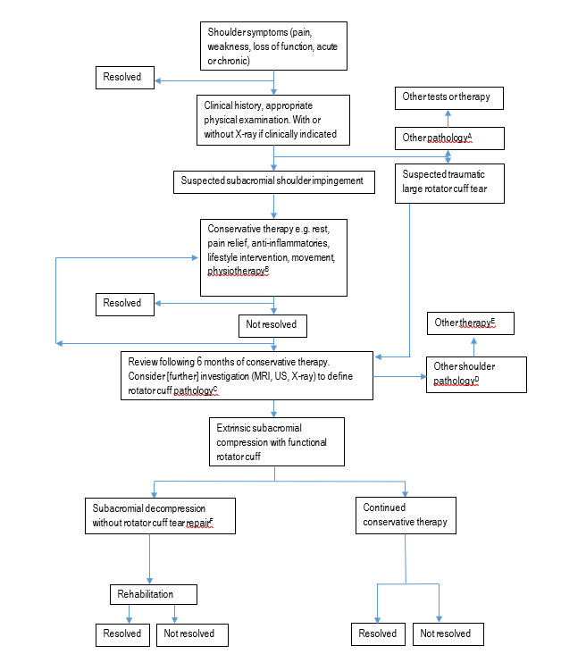
Figure 1 Current clinical management algorithm for treatment of patients with rotator cuff disease

Abbreviations
MRI = magnetic resonance imaging, US = ultrasound
Notes
A = Other pathologies may include cardiac conditions, pain in other locations, fracture, dislocation, instability, infection, inflammatory arthropathy, suspected malignancy
B = May include subacromial injections (1–3) e.g. corticosteroid or local anaesthetic for short-term pain relief, if clinically indicated
C = Rotator cuff pathology would include bursitis, tendinopathy, tear
D = Other pathologies may include rotator cuff arthropathy, SLAP lesions, bicipital tendinitis, adhesive capsulitis, glenohumeral osteoarthritis, isolated calcific tendinitis, symptomatic rotator cuff tear
E = Other therapies may include reverse shoulder arthroplasty
F = Subacromial decompression may include coraco-acromial ligament division, acromioplasty, coplaning of the clavicle, excision of the acromioclavicular joint, removal of calcium deposit and excision of bursa

Proposed economic evaluation
The requirement for an economic evaluation will be subject to the findings of the clinical guidelines review, analysis of the use of MBS items related to subacromial decompression, and the draft review of safety and effectiveness.
The final decision on the type of economic evaluation will be guided by Table 2 in line with the finding of the review of clinical evidence.
Table 2 Classification of comparative effectiveness and safety of the proposed intervention, compared with its main comparator, and guide to the suitable type of economic evaluation
Comparative safety- |  | Comparative effectiveness
 | Inferior | Uncertainª | Noninferior^{b} | Superior
Inferior | Health forgone: need other supportive factors | Health forgone possible: need other supportive factors | Health forgone: need other supportive factors | ? Likely CUA
Uncertainª | Health forgone possible: need other supportive factors | ? | ? | ? Likely CEA/CUA
Noninferior^{b} | Health forgone: need other supportive factors | ? | CMA | CEA/CUA
Superior | ? Likely CUA | ? Likely CEA/CUA | CEA/CUA | CEA/CUA
Abbreviations
CEA=cost-effectiveness analysis; CMA=cost-minimisation analysis; CUA=cost-utility analysis
Notes
? = reflect uncertainties and any identified health trade-offs in the economic evaluation, as a minimum in a cost-consequences analysis
ª ‘Uncertainty’ covers concepts such as inadequate minimisation of important sources of bias, lack of statistical significance in an underpowered trial, detecting clinically unimportant therapeutic differences, inconsistent results across trials, and trade-offs within the comparative effectiveness and/or the comparative safety considerations
^{b} An adequate assessment of ‘noninferiority’ is the preferred basis for demonstrating equivalence

Proposal for public funding
The Medicare Benefits Schedule (MBS) Review Taskforce Orthopaedics Clinical Committee and the MBS Review Shoulder and Elbow Implementation Liaison Group have proposed the following items for subacromial decompression.
Note that proposed items 489XY and 489XY(2) include the use of subacromial decompression in conjunction with rotator cuff tear repair, which is not a part of this assessment of subacromial decompression as a standalone procedure.
There are currently no proposed fees per MBS item. The out-of-pocket costs are uncertain.
PASC discussed the proposed consolidated items for subacromial decompression and rotator cuff repair. PASC noted that for PICO Set 2, further justification was required for an additional MBS item for rotator cuff repair related to more complex repair of larger tears as represented by 489XY(2). PASC advised that a review of evidence in the treatment of large rotator cuff tears should be undertaken in the assessment phase to inform discussions of an additional item. Therefore the use of subacromial decompression in the repair of rotator cuff tears of all sizes should be included in the assessment.

Category 3 – Therapeutic Procedures Group T8 – Surgical Operations Subgroup 15 – Orthopaedic Subheading 8 – Shoulder
MBS 489XX
Open or arthroscopic subacromial decompression of Shoulder
Inclusive of, if performed:
i) coraco-acromial ligament division
ii) acromioplasty
iii) excision of outer clavicle and acromioclavicular joint
iv) removal of calcium deposit
v) excision of bursa
Not being a service associated with a service to which any open or arthroscopic shoulder region procedure applies. (Anaes.) (Assist.)
Fee: not provided

Category 3 – Therapeutic Procedures Group T8 – Surgical Operations Subgroup 15 – Orthopaedic Subheading 8 – Shoulder
MBS item 489XY
Open, arthroscopic, arthroscopic assisted or mini open repair of rotator cuff of Shoulder
Inclusive of, if performed:
i) decompression of subacromial space by acromioplasty
ii) excision of coraco-acromial ligament, distal clavicle and acromioclavicular joint
iii) excision of the bursa
iv) biceps tenodesis
Not being a service associated with a service to which any open or arthroscopic shoulder region procedure applies (Anaes.) (Assist.)
Fee: Not provided

Category 3 – Therapeutic Procedures Group T8 – Surgical Operations Subgroup 15 – Orthopaedic Subheading 8 – Shoulder
MBS item 489XY(2)
Open, arthroscopic, arthroscopic assisted or mini open repair of rotator cuff of Shoulder, for a tear greater than or equal to 3 cm as assessed on ultrasound, MRI or arthroscopically measured.
Inclusive of, if performed:
i) decompression of subacromial space by acromioplasty
ii) excision of coraco-acromial ligament, distal clavicle and acromioclavicular joint
iii) excision of the bursa
iv) biceps tenodesis
Not being a service associated with a service to which any open or arthroscopic shoulder region procedure applies (Anaes.) (Assist.)
Fee: Not provided

Summary of public consultation input
The consultation questions are shown in Appendix C.
PASC noted the questions for consultation and the consultation feedback. PASC noted that there is an existing, separate MBS item for debridement, and that this service was not a part of this application.
Consultation feedback for application 1711 was received from one (1) professional organisation and two (2) individuals, both health professionals. The Shoulder and Elbow Society of Australia (SESA), and one health professional provided two responses each.
Benefits:
The SESA noted that subacromial decompression may be warranted for extrinsic causes of compression and provided either standalone or with the repair of a rotator cuff tear. Standalone subacromial decompression can be used where there is no loss of rotator cuff function. Arthroscopic acromioplasty can reduce the risk of rotator cuff disease in the future. However, acromioplasty should not be used for shoulder pain alone.
SESA recommended to retain acromioplasty as a treatment for established impingement that has not responded to appropriate conservative management, and should be available as an adjunct to rotator cuff repair when surgically indicated (that is, where there is abnormal acromial morphology and clinical impingement). The SESA President acknowledged the value of two separate PICO Sets.
Population
SESA commented that investigations such as X-ray, MRI or ultrasound are valuable as they provide information for surgical preparation and can inform surgical prognosis. The SESA President noted that the choice of imaging modality is made based on patient history and clinical presentation, and that MRI is considered to be the gold standard investigation. An individual surgeon commented that treatment for PTT is fraught and probably should be based on patient activity levels rather than MRI scan pathology, which may lead to over-diagnosis.
For patient selection SESA noted that for “chronic impingement/tendonitis that has failed a long course (4-6 months) of nonoperative treatment and is associated with extrinsic impingement, an arthroscopic acromioplasty is an excellent form of management”. Specifically, SESA recommended that patient selection for acromioplasty should be:
- A failure of nonoperative measures over 4-6 months
- Examination consistent with impingement and with the exclusion of other common causes of shoulder pain such as adhesive capsulitis, long head of biceps tendonitis, osteoarthritis etc.
- Ongoing untenable symptoms
- The demonstration of a mechanical cause for the cuff impingement(e.g. radiological evidence of abnormal acromial/subacromial morphology, impingement or abrasion)
The SESA President noted that a shorter review period and an earlier intervention may be necessary dependent on patient factors and the severity of the presentation. The SESA President advised that patients older than 70 years with a low functional demand can be managed nonoperatively. The President also noted that arthroscopic intervention for repair can minimise the need for more expensive interventions at a later time, such as shoulder arthroplasty.
SESA noted that arthroscopic acromioplasties are often performed with rotator cuff repairs, and should be restricted to repair where the tear is extrinsic in origin.
Trial design
SESA agreed that the evidence for subacromial decompression has evolved but disagree that the service should be removed entirely. Comment was provided on a recent RCT, which was considered to be poorly designed and not in line with current practice. The study was underpowered and a number of participants crossed over to the surgery group; patients were included for shoulder pain and could have had a different diagnosis, and it was unclear if patients had acromial spurs. Many patients had only 12 weeks of nonoperative treatment, and as such many of the participants were likely to have improved with ongoing conservative therapy. SESA was also critical of the Cochrane reviews which included studies on shoulder pain not impingement, and as such the arithmetic conclusions of the studies should not be taken on face value. SESA provides references in support of subacromial acromioplasty. The SESA President noted that studies with longer-term follow-up can show additional benefits to surgical decompression.
MBS items
The SESA President provide information regarding the larger or more complex services as represented by 489XY(2). In addition to large size, increased complexity included:
- Rotator cuff tear involving 2 or more tendon tears.
- Utilisation of patch grafts to augment the rotator cuff repair
- Superior capsular reconstructions to address superior instability of the shoulder
- Muscle slides to facilitate tendon mobilisation and healing
The SESA President noted issues with the wording of the MBS items. These included issues regarding the separate pathologies of acromioclavicular arthritis and biceps tendinopathy. These issues will not be investigated as part of this current assessment process. The SESA President also provided comment on the appropriateness of the exclusions applied to the proposed MBS items, and the impact on services for other pathologies of the shoulder.
The SESA President advised that arthroscopic debridement was provided by a separate MBS item (48948).
Disadvantages
One health professional provided a recent Australian article discussing a lack of benefit of number of surgical interventions compared to placebo surgery, including arthroscopy for shoulder pain (Ferreira et al. 2022).

Next steps
PASC recommended that the PICO Sets, Population and Outcomes be simplified and amended in line with its discussions.
PASC recommended that consistent with the consultation feedback, patients eligible for subacromial decompression should have tried and failed conservative therapies for a minimum of six months.
PASC requested that the MSAC Executive confirm if PICO Set 2 is required, or if it agrees with PASC that it is redundant and can be removed from this assessment. If needed, PICO Set 2 could be investigated in a separate review either before or after the results of the Australian Rotator Cuff trial. PASC acknowledged that the evidence from the Australian Rotator Cuff trial results will not be available for some years.
PASC recommended that if PICO Set 2 was to be included in the assessment, that conservative therapy should be included as a Comparator.
PASC recommended that the assessment phase should identify any studies which link patient presentation and symptoms to the outcomes of surgery. This issue may be a question of interest for the Medical Research Future Fund.

References
AAOS. 2019. Management of Rotator Cuff Injuries. Evidence-Based Clinical Practice Guideline [Online]. Available: https://www.aaos.org/quality/quality-programs/upper-extremity-programs/rotator-cuff-injuries/ [Accessed 19 January 2022].
ACC. 2003. The Diagnosis and Management of Soft Tissue Shoulder Injuries and Related Disorders: Best practice evidence-based guideline [Online]. New Zealand Accident Compensation Corporation. Available: https://cdn.ymaws.com/www.alaskachiropracticsociety.com/resource/resmgr/imported/shoulder.pdf [Accessed 20 April 2022].
ACR. 2018. American College of Radiology ACR Appropriateness Criteria Shoulder Pain–Atraumatic [Online]. American College of Radiology. Available: https://acsearch.acr.org/docs/3101482/narrative/ [Accessed 22 February 2022].
AIHW. 2018. Burden of disease [Online]. Australian Government Australian Institute of Health and Welfare. Available: https://www.aihw.gov.au/reports-data/health-conditions-disability-deaths/burden-of-disease/overview [Accessed 13 February 2022].
AIHW. 2022a. Hospitals info & downloads [Online]. Ausralian Government Australian Institute of Health and Welfare. Available: https://www.aihw.gov.au/reports-data/myhospitals/content/about-the-data [Accessed 14 February 2022].
AIHW. 2022b. METeOR Admitted patient care NMDS 2019-20 [Online]. Ausralian Government Australian Institute of Health and Welfare. Available: https://meteor.aihw.gov.au/content/index.phtml/itemId/699728 [Accessed 14 February 2022].
AIHW. 2022c. Principal diagnosis data cubes [Online]. Australian Government Australian Institute of Health and Welfare. Available: https://www.aihw.gov.au/reports/hospitals/principal-diagnosis-data-cubes/contents/data-cubes [Accessed 13 February 2022].
AIHW. 2022d. Procedures data cubes [Online]. Australian Government Australian Institute of Health and Welfare. Available: https://www.aihw.gov.au/reports/hospitals/procedures-data-cubes/contents/data-cubes [Accessed 13 February 2022].
AIM. 2018. Clinical Appropriateness Guidelines Joint Surgery [Online]. Available: https://aimspecialtyhealth.com/wp-content/uploads/2020/12/AIM_Guidelines_MSK_Joint-Surgery_Medicaid.pdf [Accessed].
AIM. 2021. Appropriate Use Criteria: Joint Surgery [Online]. Available: https://aimspecialtyhealth.com/wp-content/uploads/2021/01/AIM_Guidelines_MSK_Joint-Surgery.pdf [Accessed 19 January 2022].
AMRC. 2018. Arthroscopic shoulder decompression for subacromial pain [Online]. Available: https://www.aomrc.org.uk/ebi/clinicians/arthroscopic-shoulder-decompression-for-subacromial-pain/ [Accessed 25 January 2022].
ANZCTR. 2022. The ARC (Australian Rotator Cuff) Trial: a randomised placebo-controlled trial of surgical repair of non-acute rotator cuff tears of the shoulder in adults [Online]. Available: https://www.anzctr.org.au/Trial/Registration/TrialReview.aspx?id=379721&isReview=true [Accessed 20 April 2022].
AOA. 2017. Statement from the Shoulder and Elbow Society of Australia (an AOA subspecialty society) to the Medical Observer [Online]. Available: https://aoa.org.au/docs/default-source/advocacy/aoa-sesa-statement---subacromial-impingement-treatments-in-the-lancet-and-media-reports.pdf?sfvrsn=71dac504_8 [Accessed 19 January 2022].
Aresti NAandDi Mascio L 2019. Subacromial decompression surgery for shoulder pain. Approach with caution. BMJ, 364, 1586.
Australian Government - Department of Health. 2021. MBS Online Medicare Benefits Schedule - Item 10960 [Online]. Available: http://www9.health.gov.au/mbs/fullDisplay.cfm?q=10960&qt=ItemID&type=item [Accessed 3 February 2022].
Australian Government Department of Health. 2021. Changes to MBS Items for Orthopaedic Shoulder and Elbow Surgery [Online]. Available: http://www.mbsonline.gov.au/internet/mbsonline/publishing.nsf/Content/F3E1DA9A21343EA6CA258646007893F7/$File/Factsheet-Shoulder-Elbow.pdf [Accessed 21 January 2022].
Barber FA 2001. Coplaning of the acromioclavicular joint. Arthroscopy, 17, 913-7.
Beard DJ, Rees JL, Cook JA, Rombach I, Cooper C, Merritt N, Shirkey BA, Donovan JL, Gwilym S, Savulescu J, Moser J, Gray A, Jepson M, Tracey I, Judge A, Wartolowska K, Carr AJandGroup CS 2018. Arthroscopic subacromial decompression for subacromial shoulder pain (CSAW): a multicentre, pragmatic, parallel group, placebo-controlled, three-group, randomised surgical trial. Lancet (London, England), 391, 329-338.
BESS B. 2017. Statement in response to recent studies regarding subacromial decompression [Online]. Available: https://www.boa.ac.uk/resources/statement-in-response-to-recent-studies-regarding-subacromial-decompression-by-bess-and-boa.html [Accessed 19 January 2022].
BESS B. 2019. Response to Evidence-Based Interventions Final Document [Online]. Available: https://www.boa.ac.uk/static/77804782-e521-4019-93d149195ec26ba2/boa%20bess%20bssh%20evidence%20based%20interventions%20statement.pdf [Accessed 21 January 2022].
Bloom JE, Rischin A, Johnston RVandBuchbinder R 2012. Image-guided versus blind glucocorticoid injection for shoulder pain. Cochrane Database Syst Rev, Cd009147.
BOA. 2014. Subacromial-Shoulder-Commissioning-Guide_final.pdf [Online]. Available: https://www.boa.ac.uk/resources/subacromial-shoulder-commissioning-guide.html [Accessed 19 January 2022].
Brindisino F, Salomon M, Giagio S, Pastore CandInnocenti T 2021. Rotator cuff repair vs. nonoperative treatment: a systematic review with meta-analysis. Journal of shoulder and elbow surgery, 30, 2648-2659.
Brox JI, Gjengedal E, Uppheim G, Bøhmer AS, Brevik JI, Ljunggren AEandStaff PH 1999. Arthroscopic surgery versus supervised exercises in patients with rotator cuff disease (stage II impingement syndrome): a prospective, randomized, controlled study in 125 patients with a 2 1/2-year follow-up. J Shoulder Elbow Surg, 8, 102-11.
Buchbinder R, Staples MP, Shanahan EMandRoos JF 2013. General practitioner management of shoulder pain in comparison with rheumatologist expectation of care and best evidence: an Australian national survey. PLoS One, 8, e61243.
Burbank KM, Stevenson JH, Czarnecki GRandDorfman J 2008. Chronic shouler pain part I: Evaluation and diagnosis. American family physician, 77, 453-460.
Cheshire and Wirral Partnerships. 2013. Clinical Guideline to standardise the conservative management of shoulder impingement syndrome [Online]. NHS Foundation Trust. Available: https://www.cwp.nhs.uk/resources/policies/cc15-clinical-guideline-to-standardise-the-conservative-management-of-shoulder-impingement-syndrome/ [Accessed 10 February 2022].
Coghlan JA, Buchbinder R, Green S, Johnston RVandBell SN 2008. Surgery for rotator cuff disease. Cochrane Database Syst Rev, 2008, Cd005619.
Colorado Department of Labor and Employment. 2015. Shoulder injury medical treatment guidelines [Online]. Available: https://cdle.colorado.gov/medical-providers/medical-treatment-guidelines#collapse-accordion-5351-4 [Accessed 25 January 2022].
Craig RS, Goodier H, Singh JA, Hopewell SandRees JL 2020. Shoulder replacement surgery for osteoarthritis and rotator cuff tear arthropathy. Cochrane Database Syst Rev, 4, Cd012879.
Dezaly C, Sirveaux F, Philippe R, Wein-Remy F, Sedaghatian J, Roche OandMolé D 2011. Arthroscopic treatment of rotator cuff tear in the over-60s: repair is preferable to isolated acromioplasty-tenotomy in the short term. Orthop Traumatol Surg Res, 97, S125-30.
Diercks R, Bron C, Dorrestijn O, Meskers C, Naber R, de Ruiter T, Willems J, Winters Jandvan der Woude HJ 2014. Guideline for diagnosis and treatment of subacromial pain syndrome: a multidisciplinary review by the Dutch Orthopaedic Association. Acta Orthop, 85, 314-22.
Dubé M-O, Desmeules F, Lewis JandRoy J-S 2020. Rotator cuff-related shoulder pain: does the type of exercise influence the outcomes? Protocol of a randomised controlled trial. BMJ open, 10, e039976.
Eubank BH, Lackey SW, Slomp M, Werle JR, Kuntze CandSheps DM 2021. Consensus for a primary care clinical decision-making tool for assessing, diagnosing, and managing shoulder pain in Alberta, Canada. BMC family practice, 22, 1-20.
Farfaras S, Sernert N, Rostgard Christensen L, Hallstrom EKandKartus J-T 2018. Subacromial Decompression Yields a Better Clinical Outcome Than Therapy Alone: A Prospective Randomized Study of Patients With a Minimum 10-Year Follow-up. The American journal of sports medicine, 46, 1397-1407.
Ferreira G, Harris I, Zadro JandO'Keefe M. 2022. 3 orthopaedic surgeries that might be doing patients (and their pockets) more harm than good [Online]. the conversation. Available: https://theconversation.com/3-orthopaedic-surgeries-that-might-be-doing-patients-and-their-pockets-more-harm-than-good-179370 [Accessed 19 April 2022].
Garibaldi R, Altomare D, Sconza C, Kon E, Castagna A, Marcacci M, Monina EandDi Matteo B 2021. Conservative management vs. surgical repair in degenerative rotator cuff tears: a systematic review and meta-analysis. European review for medical and pharmacological sciences, 25, 609-619.
Genootschap NH 2019. NHG-Standaard Schouderklachten (M08).
Green S, Buchbinder RandHetrick SE 2003. Physiotherapy interventions for shoulder pain. Cochrane database of systematic reviews.
Haahr JPandAndersen JH 2006. Exercises may be as efficient as subacromial decompression in patients with subacromial stage II impingement: 4-8-years' follow-up in a prospective, randomized study. Scand J Rheumatol, 35, 224-8.
Hamid MSAandSazlina SG 2021. Platelet-rich plasma for rotator cuff tendinopathy: A systematic review and meta-analysis. PloS one, 16, e0251111.
Hill CL, Gill TK, Shanahan EMandTaylor AW 2010. Prevalence and correlates of shoulder pain and stiffness in a population-based study: the North West Adelaide Health Study. Int J Rheum Dis, 13, 215-22.
Hohmann E, Shea K, Scheiderer B, Millett PandImhoff A 2020. Indications for Arthroscopic Subacromial Decompression. A Level V Evidence Clinical Guideline. Arthroscopy - Journal of Arthroscopic and Related Surgery, 36, 913-922.
Hopman K, Krahe L, Lukersmith S, McColl AandVine K 2013. Clinical practice guidelines for the management of rotator cuff syndrome in the workplace. The University of New South Wales. wwwguidelinecentralcom/summaries/clinical-practice-guidelines-for-the-management-of-rotator-cuff-syndrome-in-the-workplace/# section-society (last accessed on 2 December 2019).
Husby T, Haugstvedt JR, Brandt M, Holm IandSteen H 2003. Open versus arthroscopic subacromial decompression: a prospective, randomized study of 34 patients followed for 8 years. Acta Orthop Scand, 74, 408-14.
IHPA. 2022. Classification of diseases and interventions [Online]. Independent Hospitals Pricing Authority. Available: https://www.ihpa.gov.au/what-we-do/classification-of-diseases-and-interventions [Accessed 14 February 2022].
Industrial Insurance Chiropractic Advisory Committee 2014. Conservative Care Options for Work-Related Mechanical Shoulder Conditions. In: WASHINGTON STATE DEPARTMENT OF LABOR AND INDUSTRIES (ed.).
Jacquot A, Dezaly C, Goetzmann T, Roche O, Sirveaux FandMolé D 2014. Is rotator cuff repair appropriate in patients older than 60 years of age? prospective, randomised trial in 103 patients with a mean four-year follow-up. Orthop Traumatol Surg Res, 100, S333-8.
Jancuska J, Matthews J, Miller T, Kluczynski MAandBisson LJ 2018. A Systematic Summary of Systematic Reviews on the Topic of the Rotator Cuff. Orthopaedic journal of sports medicine, 6, 2325967118797891.
Jones T, Carr AJ, Beard D, Linton M-J, Rooshenas L, Donovan JandHollingworth W 2019. Longitudinal study of use and cost of subacromial decompression surgery: the need for effective evaluation of surgical procedures to prevent overtreatment and wasted resources. BMJ open, 9, e030229.
Juel NG, Pedersen SJ, Engebretsen KB, Brurberg KG, Ekeberg OM, Reme SE, Brox JIandNatvig B 2019. [Non-traumatic shoulder pain in the primary health service]. Tidsskr Nor Laegeforen, 139.
Karjalainen TV, Jain NB, Heikkinen J, Johnston RV, Page CMandBuchbinder R 2019a. Surgery for rotator cuff tears. The Cochrane database of systematic reviews, 12, CD013502.
Karjalainen TV, Jain NB, Page CM, Lahdeoja TA, Johnston RV, Salamh P, Kavaja L, Ardern CL, Agarwal A, Vandvik POandBuchbinder R 2019b. Subacromial decompression surgery for rotator cuff disease. The Cochrane database of systematic reviews, 1, CD005619.
Kassolik K, Rajkowska-Labon E, Tomasik T, Gieremek K, Dobrzycka A, Andrzejewski W, Kiliański MandKurpas D 2018. Recommendations of the Polish Society of Physiotherapy, Polish Society of Family Medicine and College of Family Physicians in Poland in the scope of physiotherapy in painful shoulder syndrome in primary healthcare. Family Medicine & Primary Care Review, 277-290.
Kauta N, De Vries E, Du Plessis J-P, Grey B, Anley C, Vrettos B, Dachs RandRoche S 2021. Assessment and management of shoulder pain at primary care level. South African Family Practice, 63.
Ketola S, Lehtinen J, Rousi T, Nissinen M, Huhtala HandArnala I 2015. Which patients do not recover from shoulder impingement syndrome, either with operative treatment or with nonoperative treatment? Acta Orthop, 86, 641-6.
Ketola S, Lehtinen J, Rousi T, Nissinen M, Huhtala H, Konttinen YTandArnala I 2013. No evidence of long-term benefits of arthroscopicacromioplasty in the treatment of shoulder impingement syndrome: Five-year results of a randomised controlled trial. Bone Joint Res, 2, 132-9.
Khan M, Alolabi B, Horner N, Bedi A, Ayeni ORandBhandari M 2019. Surgery for shoulder impingement: a systematic review and meta-analysis of controlled clinical trials. CMAJ open, 7, E149-E158.
Khatri C, Ahmed I, Parsons H, Smith NA, Lawrence TM, Modi CS, Drew SJ, Bhabra G, Parsons NR, Underwood MandMetcalfe AJ 2019. The Natural History of Full-Thickness Rotator Cuff Tears in Randomized Controlled Trials: A Systematic Review and Meta-analysis. The American journal of sports medicine, 47, 1734-1743.
Kim S, Hwang J, Kim MJ, Lim J-Y, Lee WHandChoi JE 2018. SYSTEMATIC REVIEW WITH NETWORK META-ANALYSIS OF RANDOMIZED CONTROLLED TRIALS OF ROTATOR CUFF TEAR TREATMENT. International journal of technology assessment in health care, 34, 78-86.
Kovacevic D, Suriani RJ, Jr., Grawe BM, Yian EH, Gilotra MN, Hasan SA, Srikumaran U, Hasan SS, Cuomo F, Burks RT, Green AG, Nottage WM, Theja S, Kassam HF, Saad MA, Ramirez MA, Stanley RJ, Williams MD, Nadarajah V, Konja AC, Koh JL, Rokito AS, Jobin CM, Levine WN, Schmidt CC, American S, Elbow Surgeons Massive Cuff EandResearch Initiative I 2020. Management of irreparable massive rotator cuff tears: a systematic review and meta-analysis of patient-reported outcomes, reoperation rates, and treatment response. Journal of shoulder and elbow surgery, 29, 2459-2475.
Kukkonen J, Joukainen A, Lehtinen J, Mattila KT, Tuominen EK, Kauko TandAärimaa V 2014. Treatment of non-traumatic rotator cuff tears: A randomised controlled trial with one-year clinical results. Bone Joint J, 96-b, 75-81.
Kukkonen J, Joukainen A, Lehtinen J, Mattila KT, Tuominen EK, Kauko TandÄärimaa V 2015. Treatment of Nontraumatic Rotator Cuff Tears: A Randomized Controlled Trial with Two Years of Clinical and Imaging Follow-up. J Bone Joint Surg Am, 97, 1729-37.
Lapner P, Henry P, Athwal GS, Moktar J, McNeil D, MacDonald P, Canadian SandElbow S 2021. Treatment of Rotator Cuff Tears: A Systematic Review and Meta-Analysis. Journal of shoulder and elbow surgery.
Lenza M, Buchbinder R, Takwoingi Y, Johnston RV, Hanchard NCandFaloppa F 2013. Magnetic resonance imaging, magnetic resonance arthrography and ultrasonography for assessing rotator cuff tears in people with shoulder pain for whom surgery is being considered. Cochrane Database Syst Rev, 2013, Cd009020.
Loew M, Schnetzke MandLichtenberg S 2021. Current treatment concepts of calcifying tendinitis of the shoulder. A systematic review. Obere Extremität, 16, 85-93.
Longo UG, Risi Ambrogioni L, Candela V, Berton A, Carnevale A, Schena EandDenaro V 2021. Conservative versus surgical management for patients with rotator cuff tears: a systematic review and META-analysis. BMC musculoskeletal disorders, 22, 50.
MacDonald P, McRae S, Leiter J, Mascarenhas RandLapner P 2011. Arthroscopic rotator cuff repair with and without acromioplasty in the treatment of full-thickness rotator cuff tears: a multicenter, randomized controlled trial. J Bone Joint Surg Am, 93, 1953-60.
Mall NA, Tanaka MJ, Choi LSandPaletta GA, Jr. 2014. Factors affecting rotator cuff healing. J Bone Joint Surg Am, 96, 778-88.
Marks D, Comans T, Bisset L, Thomas MandScuffham PA 2018. Shoulder pain cost-of-illness in patients referred for public orthopaedic care in Australia. Australian Health Review, 43, 540-548.
MBS. 2022a. MBS Online [Online]. Australian Government Department of Health. Available: http://www.mbsonline.gov.au/internet/mbsonline/publishing.nsf/Content/Home [Accessed 13 February 2022].
MBS. 2022b. Medicare item reports [Online]. Australian Government Services Australia. Available: http://medicarestatistics.humanservices.gov.au/statistics/mbs_item.jsp [Accessed 13 February 2022].
MBS Review. 2019. Taskforce final report – Orthopaedic MBS items [Online]. Australian Government Department of Health. Available: https://www.health.gov.au/resources/publications/taskforce-final-report-orthopaedic-mbs-items [Accessed 13 February 2022].
Migliorini F, Maffulli N, Eschweiler J, Schenker H, Tingart MandBetsch M 2021. Arthroscopic versus mini-open rotator cuff repair: A meta-analysis. The surgeon : journal of the Royal Colleges of Surgeons of Edinburgh and Ireland.
Milano G, Grasso A, Salvatore M, Zarelli D, Deriu LandFabbriciani C 2007. Arthroscopic rotator cuff repair with and without subacromial decompression: a prospective randomized study. Arthroscopy, 23, 81-8.
Moorthy VandTan AHC 2020. Should long head of biceps tenodesis or tenotomy be routinely performed in arthroscopic rotator cuff repairs? J Orthop, 21, 161-165.
Moosmayer S, Lund G, Seljom US, Haldorsen B, Svege IC, Hennig T, Pripp AHandSmith HJ 2014. Tendon repair compared with physiotherapy in the treatment of rotator cuff tears: a randomized controlled study in 103 cases with a five-year follow-up. J Bone Joint Surg Am, 96, 1504-14.
Moshi M, Gaget V, McLeod RandVreugdenburg T. 2021. Subacromial decompression as a primary/isolated intervention to treat subacromial pain [Online]. Federal Office of Public Health FOPH. Available: https://www.bag.admin.ch/bag/en/home/versicherungen/krankenversicherung/krankenversicherung-leistungen-tarife/hta/hta-projekte/subakromiale_dekompression.html [Accessed 15 February 2022].
MSAC. 2020. 1593 - Bovine bioinductive collagen implant for repair of rotator cuff tear [Online]. Australian Government Department of Health. Available: http://www.msac.gov.au/internet/msac/publishing.nsf/Content/1593-public [Accessed 13 February 2022].
Mundy L 2017. Platelet-rich plasma: a case study for the identification of disinvestment opportunities using horizon scanning. Australian Health Review, 41, 33-37.
Nazari G, MacDermid JC, Bryant DandAthwal GS 2019a. The effectiveness of surgical vs conservative interventions on pain and function in patients with shoulder impingement syndrome. A systematic review and meta-analysis. PloS one, 14, e0216961.
Nazari G, MacDermid JC, Bryant D, Dewan NandAthwal GS 2019b. Effects of arthroscopic vs. mini-open rotator cuff repair on function, pain & range of motion. A systematic review and meta-analysis. PloS one, 14, e0222953.
Neer CS 1983. Impingement Lesions. Clinical Orthopaedics and Related Research, 173, 70-77.
New York Workers Compensation Board. 2021. Medical Treatment Guidelines: Shoulder Injury [Online]. Available: http://www.wcb.ny.gov/content/main/hcpp/MedicalTreatmentGuidelines/MTGOverview.jsp [Accessed 25 January 2022].
NHS. 2020. Shoulder impingment [Online]. Available: https://www.nhs.uk/conditions/shoulder-impingement-syndrome/ [Accessed 21 January 2022].
NICE. 2018. Evidence-Based Interventions: Guidance for CCGs [Online]. Available: https://445oon4dhpii7gjvs2jih81q-wpengine.netdna-ssl.com/wp-content/uploads/2018/11/EBI-Statutory-Guidance-FINAL-version.pdf [Accessed 21 January 2022].
Oliva F, Piccirilli E, Bossa M, Via AG, Colombo A, Chillemi C, Gasparre G, Pellicciari L, Franceschetti E, Rugiero C, Scialdoni A, Vittadini F, Brancaccio P, Creta D, Buono AD, Garofalo R, Franceschi F, Frizziero A, Mahmoud A, Merolla G, Nicoletti S, Spoliti M, Osti L, Padulo J, Portinaro N, Tajana G, Castagna A, Foti C, Masiero S, Porcellini G, Tarantino UandMaffulli N 2015. I.S.Mu.L.T - Rotator Cuff Tears Guidelines. Muscles Ligaments Tendons J, 5, 227-63.
Osti L, Buda M, Buono AD, Osti RandMassari L 2016. Clinical evidence in the treatment of rotator cuff tears with hyaluronic acid. Muscles, ligaments and tendons journal, 5, 270-275.
Paavola M, Kanto K, Ranstam J, Malmivaara A, Inkinen J, Kalske J, Savolainen V, Sinisaari I, Taimela S, Jarvinen TLandFinnish Shoulder Impingement Arthroscopy Controlled Trial I 2021. Subacromial decompression versus diagnostic arthroscopy for shoulder impingement: a 5-year follow-up of a randomised, placebo surgery controlled clinical trial. British journal of sports medicine, 55, 99-107.
Paavola M, Malmivaara A, Taimela S, Kanto K, Inkinen J, Kalske J, Sinisaari I, Savolainen V, Ranstam JandJärvinen TLN 2018. Subacromial decompression versus diagnostic arthroscopy for shoulder impingement: randomised, placebo surgery controlled clinical trial. Bmj, 362, k2860.
Paavola M, Malmivaara A, Taimela S, Kanto K, Jarvinen TLandInvestigators F 2017. Finnish Subacromial Impingement Arthroscopy Controlled Trial (FIMPACT): a protocol for a randomised trial comparing arthroscopic subacromial decompression and diagnostic arthroscopy (placebo control), with an exercise therapy control, in the treatment of shoulder impingement syndrome. BMJ open, 7, e014087.
Page MJ, Green S, McBain B, Surace SJ, Deitch J, Lyttle N, Mrocki MAandBuchbinder R 2016. Manual therapy and exercise for rotator cuff disease. Cochrane Database Syst Rev, 2016, Cd012224.
Peters GandKohn D 1997. Medium-term clinical results after operative and non-operative treatment of subacromial impingement. Der Unfallchirurg, 100, 623-9.
Rahme H, Solem-Bertoft E, Westerberg CE, Lundberg E, Sörensen SandHilding S 1998. The subacromial impingement syndrome. A study of results of treatment with special emphasis on predictive factors and pain-generating mechanisms. Scand J Rehabil Med, 30, 253-62.
Sakha S, Erdogan S, Shanmugaraj A, Betsch M, Leroux TandKhan M 2021. Update on all-arthroscopic vs. mini-open rotator cuff repair: A systematic review and meta-analysis. Journal of orthopaedics, 24, 254-263.
Saltzman BM, Jain A, Campbell KA, Mascarenhas R, Romeo AA, Verma NNandCole BJ 2016. Does the Use of Platelet-Rich Plasma at the Time of Surgery Improve Clinical Outcomes in Arthroscopic Rotator Cuff Repair When Compared With Control Cohorts? A Systematic Review of Meta-analyses. Arthroscopy, 32, 906-18.
Sayampanathan AA, Silva ANandHwee Chye AT 2021. Rotator Cuff Repairs With and Without Acromioplasties Yield Similar Clinical Outcomes: A Meta-analysis and Systematic Review. Arthroscopy : the journal of arthroscopic & related surgery : official publication of the Arthroscopy Association of North America and the International Arthroscopy Association, 37, 1950-1957.
Schemitsch C, Chahal J, Vicente M, Nowak L, Flurin PH, Lambers Heerspink F, Henry PandNauth A 2019. Surgical repair versus conservative treatment and subacromial decompression for the treatment of rotator cuff tears: a meta-analysis of randomized trials. The bone & joint journal, 101-B, 1100-1106.
Schmucker C, Titscher V, Braun C, Nussbaumer-Streit B, Gartlehner GandMeerpohl J 2020. Surgical and Non-Surgical Interventions in Complete Rotator Cuff Tears. Deutsches Arzteblatt international, 117, 633-640.
Shin SJ, Oh JH, Chung SWandSong MH 2012. The efficacy of acromioplasty in the arthroscopic repair of small- to medium-sized rotator cuff tears without acromial spur: prospective comparative study. Arthroscopy, 28, 628-35.
Simons SMandMichael Roberts M. 2021. Patient education: Rotator cuff tendinitis and tear (Beyond the Basics) [Online]. Up-to-Date. Available: https://www.uptodate.com/contents/rotator-cuff-tendinitis-and-tear-beyond-the-basics [Accessed 22 February 2022].
Simpson M, Pizzari T, Cook T, Wildman SandLewis J 2020. Effectiveness of non-surgical interventions for rotator cuff calcific tendinopathy: A systematic review. Journal of rehabilitation medicine.
Singh HP, Mehta SSandPandey R 2014. A preoperative scoring system to select patients for arthroscopic subacromial decompression. J Shoulder Elbow Surg, 23, 1251-6.
Song L, Miao L, Zhang PandWang WL 2016. Does concomitant acromioplasty facilitate arthroscopic repair of full-thickness rotator cuff tears? A meta-analysis with trial sequential analysis of randomized controlled trials. Springerplus, 5, 685.
Sun Z, Fu W, Tang X, Chen GandLi J 2018. Systematic review and Meta-analysis on acromioplasty in arthroscopic repair of full-thickness rotator cuff tears. Acta orthopaedica Belgica, 84, 54-61.
Surace SJ, Deitch J, Johnston RVandBuchbinder R 2020. Shock wave therapy for rotator cuff disease with or without calcification. Cochrane Database Syst Rev, 3, Cd008962.
Thorpe A, Hurworth M, O'Sullivan P, Mitchell TandSmith A 2016. Rising trends in surgery for rotator cuff disease in Western Australia. ANZ J Surg, 86, 801-804.
Tytherleigh-Strong G, Hirahara AandMiniaci A 2001. Rotator cuff disease. Current opinion in rheumatology, 13, 135-145.
UNSW. 2013. Clinical Practice Guidelines for the Management of Rotator Cuff Syndrome in the Workplace [Online]. Available: https://rcs.med.unsw.edu.au/sites/default/files/rcs/page/RotatorCuffSyndromeGuidelines.pdf [Accessed 19 January 2022].
Vandvik PO, Lähdeoja T, Ardern C, Buchbinder R, Moro J, Brox JI, Burgers J, Hao Q, Karjalainen TandVan Den Bekerom M 2019. Subacromial decompression surgery for adults with shoulder pain: a clinical practice guideline. Bmj, 364.
Verbel A, Hoving J, Bülow PAandKunz R 2020. Surgical or conservative treatment for impingement of the rotator cuff? TBV–Tijdschrift voor Bedrijfs-en Verzekeringsgeneeskunde, 28, 31-33.
Washington State Department of Labor and Industries. 2018. Medical Treatment Guideline for Shoulder: Diagnosis and Treatment [Online]. Washington State Department of Labor and Industries. Available: https://www.lni.wa.gov/patient-care/treating-patients/treatment-guidelines-and-resources/#treatment-guidelines [Accessed 25 January 2022].
Whittle SandBuchbinder R 2015. In the clinic. Rotator cuff disease. Ann Intern Med, 162, Itc1-15.
Wikimedia Commons. 2022. Anatomy of the shoulder; reproduced with permission from Wikimedia Commons, attribution National Institute Of Arthritis And Musculoskeletal And Skin Diseases (NIAMS); SVG version by Angelito7, Public domain, via Wikimedia Commons [Online]. Available: https://commons.wikimedia.org/wiki/File:Shoulder_joint.svg [Accessed 13 February 2022].
Yu H, Côté P, Wong JJ, Shearer HM, Mior S, Cancelliere C, Randhawa K, Ameis A, Carroll LJandNordin M 2021. Noninvasive management of soft tissue disorders of the shoulder: A clinical practice guideline from the Ontario Protocol for Traffic Injury Management (OPTIMa) collaboration. European journal of pain, 25, 1644-1667.
Zadro J, Rischin A, Johnston RVandBuchbinder R 2021. Image-guided glucocorticoid injection versus injection without image guidance for shoulder pain. The Cochrane database of systematic reviews, 8, CD009147.
Zhang Y, Zhai S, Qi C, Chen J, Li H, Zhao XandYu T 2020. A comparative study of arthroscopic debridement versus repair for Ellman grade II bursal-side partial-thickness rotator cuff tears. Journal of shoulder and elbow surgery, 29, 2072-2079.

Appendix A – Current and proposed MBS items
Table 3 Existing MBS items, MBS Review Taskforce recommendations and proposed new items
 | Recommendation 74 | Recommendation 75 | Subsequent addition to Taskforce recommendations
Current items, to consolidate | 48900 SHOULDER, excision of coraco-acromial ligament or removal of calcium deposit from cuff or both. (Anaes.) (Assist.)  Fee: $293.75 | 48906 SHOULDER, repair of rotator cuff, including excision of coraco-acromial ligament or removal of calcium deposit from cuff, or both – not being a service associated with a service to which item 48900 applies (Anaes.) (Assist.)  Fee: $587.75
 | 48903 SHOULDER, decompression of subacromial space by acromioplasty, excision of coraco-acromial ligament and distal clavicle, or any combination. (Anaes.) (Assist.)  Fee: $587.75 | 48909 SHOULDER, repair of rotator cuff, including decompression of subacromial space by acromioplasty, excision of coraco-acromial ligament and distal clavicle, or any combination – not being a service associated with a service to which item 48903 applies. (Anaes.) (Assist.)  Fee: $783.80
 | 48951 SHOULDER, arthroscopic division of coraco-acromial ligament including acromioplasty – not being a service associated with any other arthroscopic procedure of the shoulder region. (Anaes.) (Assist.)  Fee: $930.65 | 48960 SHOULDER, reconstruction or repair of, including repair of rotator cuff by arthroscopic, arthroscopic assisted or mini open means; arthroscopic acromioplasty; or resection of acromioclavicular joint by separate approach when performed – not being a service associated with any other procedure of the shoulder region. (Anaes.) (Assist.)  Fee: $979.60
Proposed New items | 489XX Open or arthroscopic subacromial decompression of Shoulder. Inclusive of, if performed:  i) coraco-acromial ligament division  ii) acromioplasty  iii) excision of outer clavicle and acromioclavicular joint  iv) removal of calcium deposit  v) excision of bursa  Not being a service associated with a service to which any open or arthroscopic shoulder region procedure applies. (Anaes.) (Assist.) | 489XY Open, arthroscopic, arthroscopic assisted or mini open repair of rotator cuff of Shoulder. Inclusive of, if performed:  i) decompression of subacromial space by acromioplasty  ii) excision of coraco-acromial ligament, distal clavicle and acromioclavicular joint.  iii) excision of the bursa  iv) biceps tenodesis  Not being a service associated with a service to which any open or arthroscopic shoulder region procedure applies (Anaes.) (Assist.) | 489XY(2) Open, arthroscopic, arthroscopic assisted or mini open repair of rotator cuff of Shoulder, for a tear greater than or equal to 3 cm as assessed on ultrasound, MRI or arthroscopically measured. Inclusive of, if performed:  i) decompression of subacromial space by acromioplasty  ii) excision of coraco-acromial ligament, distal clavicle and acromioclavicular joint.  iii) excision of the bursa  iv) biceps tenodesis  – not being a service associated with a service to which any open or arthroscopic shoulder region procedure applies (Anaes.) (Assist.)

Appendix B – MBS and AIHW data

MBS services data
Subacromial decompression with or without rotator cuff repair is reimbursed under a number of MBS items, as shown in Appendix A. The figures below show the utilisation of MBS items related to subacromial decompression, and for rotator cuff repair.
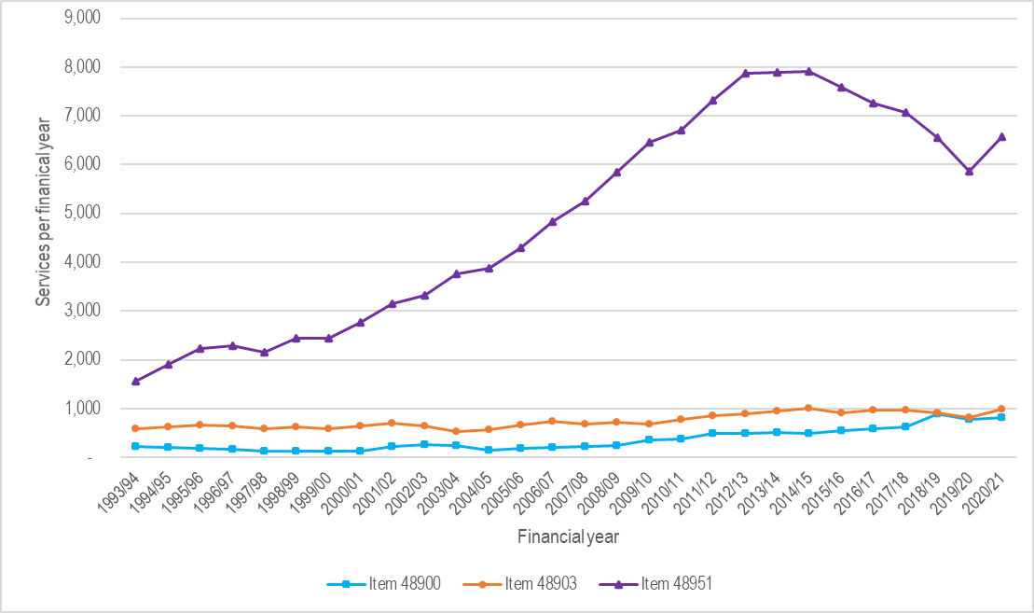
Figure 2 Utilisation of MBS items 48900, 48903 and 48951; 1993–1994 to 2020–2021
Notes
MBS item 48900 for excision of coraco-acromial ligament or removal of calcium deposit, or both; MBS item 48903 for shoulder subacromial decompression surgery; MBS item 48951 for arthroscopic division of coraco-acromial ligament, including acromioplasty.
Source
Historic MBS utilisation data is available online via Services Australia (MBS 2022b)

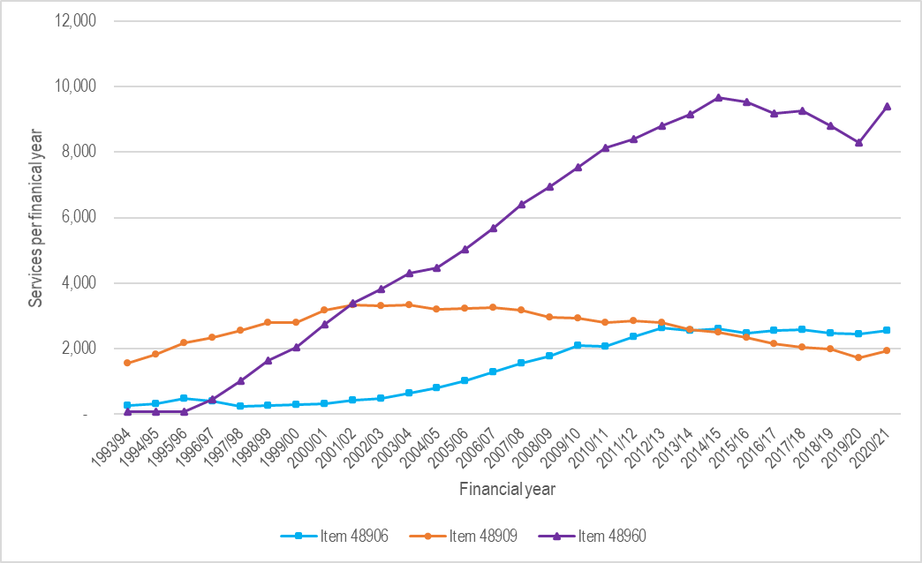
Figure 3 Utilisation of MBS items 48906, 48909 and 48960; 1993–1994 to 2020–2021
Notes
MBS item 48906 for repair of the rotator cuff including the excision of coraco-acromial ligament or calcium deposit removal; MBS item 48909 for rotator cuff repair involving subacromial decompression; MBS item 48960 for repair of the rotator cuff including arthroscopic acromioplasty or resection of acromioclavicular joint
Source
Historic MBS utilisation data is available online via Services Australia

AIHW data
The National Hospital Morbidity Database compiles episode-level records from admitted patients (AIHW 2022b, AIHW 2022a). The data are based on the Admitted Patient Care National Minimum Data Set, which captures episode-level demographic, administrative and length-of-stay data, as well as data on the diagnoses of the patients and the procedures they underwent. Data is compiled for admitted patients in Australian hospitals, including public, private and freestanding day hospital facilities.

Procedural codes
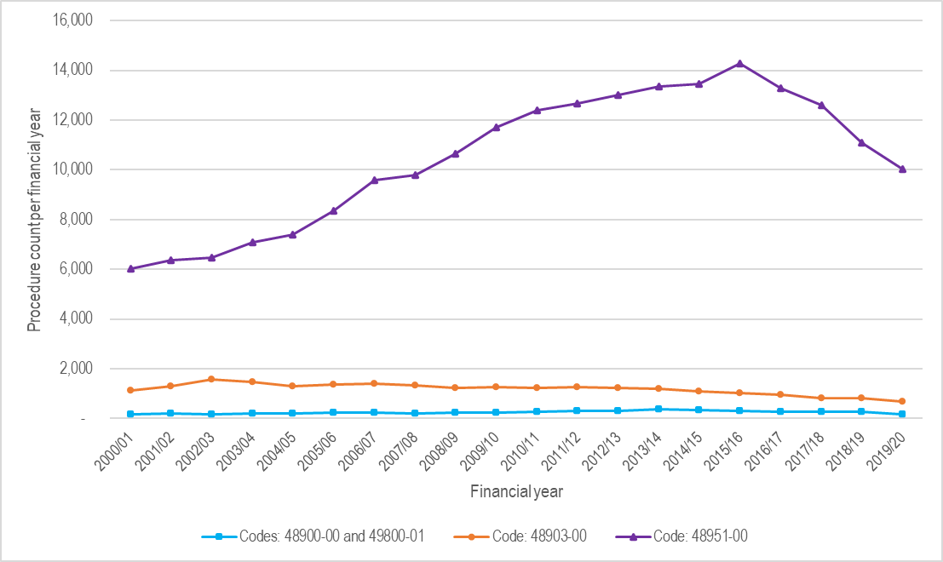
Figure 4 Number of procedures performed in Australian hospitals for the excision of the coraco-acromial ligament or calcium deposit from rotator cuff, or for decompression of the subacromial space; 2000–2001 to 2019–2020
Notes
Procedures are classified using the Australian Classification of Health Interventions (ACHI) codes (AIHW 2022d). Where a procedure has an MBS equivalent, the first five digits of its ACHI code are the MBS item number (IHPA 2022).
Code 48900-00: Excision of coraco-acromial ligament; 48900-01: Excision of calcium deposit from rotator cuff; 48903-00: Decompression of subacromial space; 48951-00: Arthroscopic decompression of subacromial space
Source
AIHW Procedures Data Cubes (AIHW 2022d).

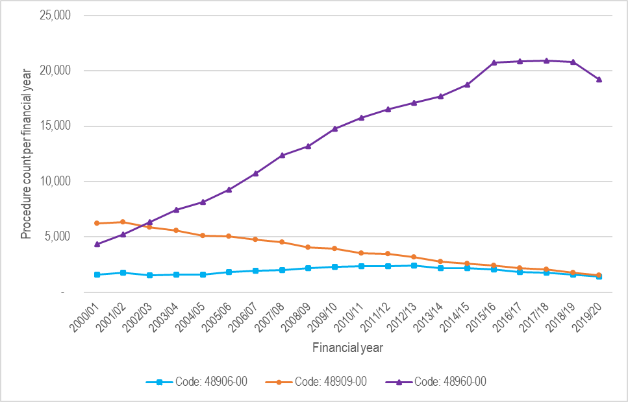
Figure 5 Number of procedures in Australian hospitals for the repair of rotator cuff, with or without decompression of the subacromial space; 2000–2001 to 2019–2020
Notes
Procedures are classified using the Australian Classification of Health Interventions (ACHI) codes. Where a procedure has an MBS equivalent, the first five digits of its ACHI code are the MBS item number.
Code 48906-00: Repair of rotator cuff; 48909-00: Repair of rotator cuff with decompression of subacromial space; 48960-00: Arthroscopic reconstruction of shoulder
Source
AIHW Procedures Data Cubes (AIHW 2022d).

Principal diagnoses
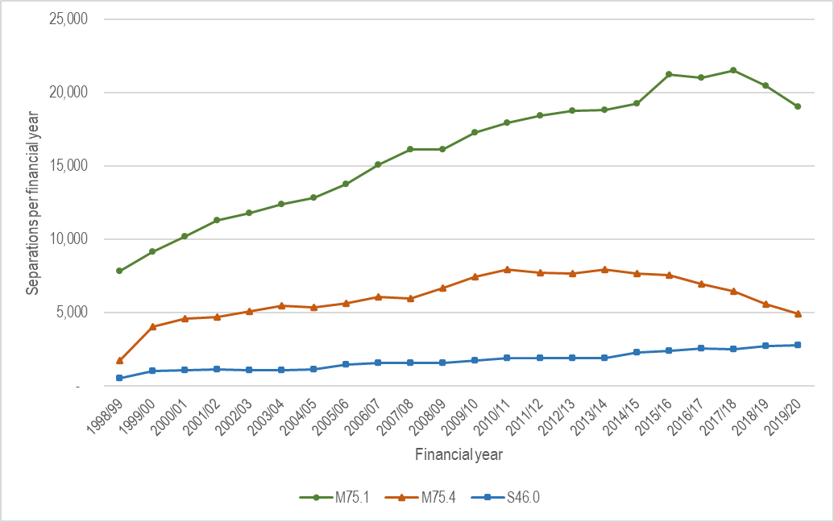
Figure 6 Number of hospital separations with a principal diagnosis of either rotator cuff syndrome, impingement syndrome of shoulder or injury of muscles and tendons of the rotator cuff; 1998–1999 to 2019–2020
Notes
Principal diagnoses codes according to ICD-10-AM classifications (various editions).
M75.1: Rotator cuff syndrome; M75.4: Impingement syndrome of shoulder; S46.0: Injury of muscle(s) and tendon(s) of the rotator cuff of shoulder.
Source
AIHW Principal Diagnosis Data Cubes (AIHW 2022c).

Appendix C – Consultation questions

The following questions were included for consultation and stakeholder input: Please also note, consultation input is not limited to these questions and can be received upon any aspect of the Draft PICO confirmation (and clinical guidelines review).
The draft PICO Confirmation includes potential populations, captured in PICO Sets 1 and 2 (pp. 2-3).
- Is the population appropriately defined in PICO Set 1, where subacromial decompression is used in the absence of rotator cuff repair? For example, should this be patients with subacromial pain syndrome, or include patients with rotator cuff disease?
- Is the population appropriately defined in PICO Set 2, where patients have subacromial shoulder impingement and a tear of the rotator cuff?
- Should all patients with suspected rotator cuff disorder have recent imaging or radiology of their shoulder prior to surgery?
- Which procedures (and MBS items) pertain to subacromial decompression performed with/without rotator cuff repair? The review has currently focused on 48903 (standalone) and 48909 (with concomitant repair) and has also considered procedures described in other items as shown in Appendix A.
- For patients with subacromial impingement how long should conservative therapy be provided prior to referral to be considered for surgery?
- For patients with (suspected) rotator cuff tears how long should conservative therapy be provided prior to referral to be considered for surgery?
- Which instruments for shoulder function are used in Australian practice? Are the shoulder-specific instruments currently included for measuring shoulder function appropriate and are there any additional instruments commonly used in Australia?
- Certain guidelines recommend debridement as an option for certain patients with PTT or FTT. Is this option reflected in the MBS items (see Appendix A)?
Additional questions for consultation are included in the Guidelines report to further investigate common clinical practice in Australia.

Appendix D –PICO for repair of rotator cuff of shoulder: PICO Set 2
Table 5 PICO for repair of rotator cuff of shoulder: PICO Set 2
Component | Description
Population | Adult patients with symptomatic full or partial thickness rotator cuff tear and subacromial shoulder impingement AND:  - Symptoms unresolved despite conservative therapy for 6 months AND;  - Require concomitant subacromial decompression and rotator cuff repair;  AND excluding:  - Patients with other pathologies of the shoulder e.g. glenohumeral joint osteoarthritis, acromioclavicular arthritis, labral tear including superior labral anterior-posterior (SLAP) tears, adhesive capsulitis/frozen shoulder, tendinopathy of the long head of the biceps, calcific tendinopathy, bicipital tendon disorders, neuropathy, shoulder fractures, shoulder instability/dislocation, malignancy, infection  Note, the current and proposed MBS items for subacromial decompression do not include population eligibility criteria.
Intervention | Open, arthroscopic, arthroscopic assisted or mini open repair of rotator cuff of shoulder with decompression of subacromial space  Inclusive of, if performed:  - Acromioplasty  - Excision of coraco-acromial ligament, distal clavicle and acromioclavicular joint (48906, 48909, 48960, 489XY, 489XY(2))  - Excision of the bursa (489XY, 489XY(2))  - Removal of calcium deposit
Comparator/s | - Comparator 1: Rotator cuff repair without subacromial decompression  - Comparator 2: Continued conservative therapy (including pain relief, physiotherapy or other type of allied health or primary care)
Outcomes | - Safety  - Adverse events  - Infection  - Adhesive capsulitis/frozen shoulder  - Wasting or avulsion of the deltoid muscle  - Efficacy/effectiveness  - Shoulder function specific scores (e.g. Constant Murley, Oxford Shoulder Scoreetc)  - Mean pain scores improvement (e.g. visual analogue scale (VAS) etc)  - Health-related quality of life  - Failure of surgery or need for revision surgery  - Return to work or normal function  - Long-term outcomes should be reported where possible  - Healthcare resources  - Consultations in primary care, specialist or surgery  - Pain management medication  - Diagnostic tests  - Physiotherapy costs  - Consumables and implants for surgery  - Rehabilitation  - Indirect costs (work days lost)  - Cost effectiveness (cost per life year gained, cost per quality-adjusted life year (QALY) gained, incremental cost-effectiveness ratio (ICER))  - Total Australian Government healthcare costs  - Patient-relevant costs (e.g. ongoing physiotherapy, pain relief, loss of time from work or other daily activities)
Assessment questions | - What is the comparative safety, effectiveness and cost effectiveness of rotator cuff surgery with subacromial decompression versus rotator cuff surgery alone in patients with rotator cuff tear with subacromial impingement?  - All available sub-populations should be reported.  - Which sub-populations have the greatest benefit from surgery?  - Which sub-populations have the least benefit from surgery?  - Note that the requirement for an add-on economic evaluation component to be determined subsequent to the initial results of the DCAR.  - From MBS data modelling, what is the budgetary impact of a range of scenarios?

Appendix E –Clinical Management Algorithm for treatment of rotator cuff disease including subacromial decompression and repair of the rotator cuff
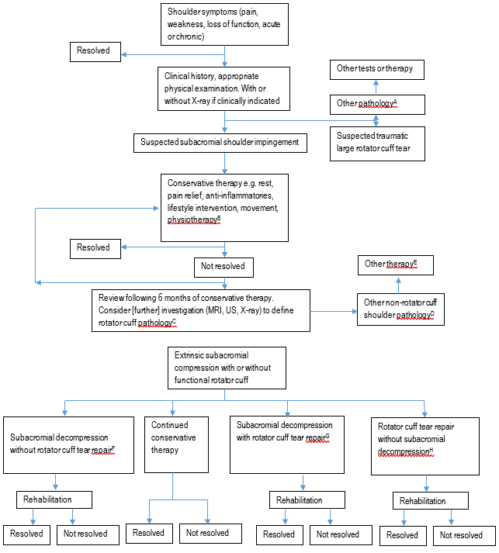
Figure 8 Current clinical management algorithm for treatment of patients with rotator cuff disease
Abbreviations: MRI = magnetic resonance imaging, US = ultrasound
Notes
A = Other pathologies may include cardiac conditions, pain in other locations, fracture, dislocation, instability, infection, inflammatory arthropathy, suspected malignancy
B = May include subacromial injections (1–3) e.g. corticosteroid or local anaesthetic for short-term pain relief, if clinically indicated
C = Rotator cuff pathology would include bursitis, tendinopathy, tear
D = Other pathologies may include rotator cuff arthropathy, SLAP lesions, bicipital tendinitis, adhesive capsulitis, glenohumeral osteoarthritis, isolated calcific tendinitis
E = Other therapies may include reverse shoulder arthroplasty
F = Subacromial decompression may include coraco-acromial ligament division, acromioplasty, coplaning of the clavicle, excision of theacromioclavicular joint, removal of calcium deposit and excision of bursa
G = Surgical repair of the rotator cuff with or without subacromial decompression may include excision of coraco-acromial ligament, distal clavicle and acromioclavicular joint, excision of bursa and biceps tendonitis
H = A review of rotator cuff repair with no subacromial decompression is not within the scope of this assessment

