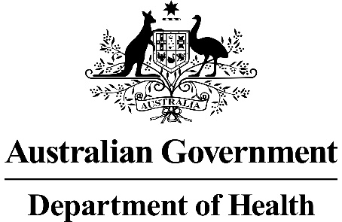

RATIFIED PICO

Application 1603:
Transcatheter aortic valve implantation (TAVI) via transfemoral delivery using the SAPIEN 3 balloon-expandable valve (BEV) system for patients at intermediate risk for surgery

Summary of PICO/PPICO criteria to define the question(s) to be addressed in an Assessment Report to the Medical Services Advisory Committee (MSAC)
Component | Description
Patients | Persons with symptomatic, severe aortic stenosis at intermediate risk for surgical aortic valve replacement, with no more than mild frailty and defined as fulfilling any one of the following criteria:  - Society of Thoracic Surgeons’ Predicted Risk Of Mortality (STS-PROM) 4%-8% OR  - One major organ system compromise not to be improved postoperatively OR  - Possible procedure-specific impediment.
Intervention | Transcatheter aortic valve implantation (TAVI) via transfemoral delivery using the SAPIEN 3 balloon-expandable valve (BEV) system.
Comparator | Surgical aortic valve replacement (SAVR) with a bioprosthesis or mechanical aortic valve.
Outcomes | - Safety, including any potential risk of harm to patient:  - Major stroke  - New onset atrial fibrillation  - Major bleeding events  - Major thrombotic events  - Acute kidney injury  - Major vascular complications  - Myocardial infarction  - Efficacy / effectiveness including, but not limited to, patient-relevant outcomes:  - Overall survival  - Health-related quality of life  - Healthcare resources  - Cost of valvular prosthesis  - Cost associated with changes in clinical management (testing required before the procedure, length of stay, post-discharge rehabilitation)  - Cost-effectiveness:  - Cost per life-year gained  - Cost per QALY gained  - Total Australian Government healthcare costs:  - Total cost to the Medical Benefits Schedule (MBS)

PICO or PPICO rationale for therapeutic and investigative medical services only
POPULATION
PASC confirmed the proposed population.
PASC noted the current TAVI MBS item is for high-risk patients only, and the applicant submitted an application (1552) to PASC in 2018 for intermediate-risk patients, which did not proceed to ESC.
PASC queried why the applicant is seeking a new MBS item, as opposed to amending the existing item to include intermediate-risk patients. The applicant explained that, when they were seeking new data for the application, the PARTNER II trial showed BEVs have different clinical and economic outcomes in intermediate-risk patients. This prompted the applicant to submit an application for a separate MBS item, specific to BEV.
PASC advised that these “different clinical & economic outcomes” should be clarified during the assessment phase, including what they were compared to. PASC highlighted that the main rationale for this application is that BEVs (specifically SAPIEN) and not self-expanding valves (SEVs, specifically CoreValve [Medtronic]) currently have TGA approval for use in intermediate-risk patient (refer to Outcome 2).
On this point, PASC highlighted that both the PARTNER2 (SAPIEN) & SURTAVI (CoreValve) trials show TAVI is non-inferior to surgery in the intermediate-risk population. However, the applicant claims registry data show lower complication rates and mortality for BEVs compared to SEVs (refer to PASC comment re: secondary comparator under ‘Comparator/s’). PASC highlighted that the PARTNER2 trial used a different version of the SAPIEN valve (XT), and the relevant trial for the SAPIEN3 valve is an observational study (P2A-S3i, Lancet 2017).
PASC advised that “intermediate risk” needs a clear definition. PASC noted there has been some leakage from the high-risk group in the current MBS item, because “high” was not defined, leaving it to clinical judgement.

Aortic stenosis (AS) is one of the most common and serious valve diseases. It is characterised by a narrowing of the aortic valve opening, which restricts blood flow from the left ventricle to the aorta and causes pressure build-up in the left ventricle and consequent hypertrophy. Furthermore, stenotic aortic valves may not close fully, resulting in regurgitation back into the left ventricle.
The most common cause of AS is age-related calcification of the tricuspid aortic valve. Less common causes are congenital bicuspid aortic valves (presenting a risk of AS in young adults) and rheumatic heart disease, particularly prevalent in the Australian Aboriginal community. Other than calcification, the pathophysiological features of AS are inflammation, lipid accumulation and subendothelial thickening (Thaden, Nkomo et al. 2014).
AS is a progressive disease that is asymptomatic until late stages. Symptomatic severe AS is classified as Stage D AS, and has the following features: symptoms (see below); calcified valve leaflets with reduced opening; jet velocity (Vmax) ≥4 m/s; and mean gradient ≥40 mm Hg. Variations in valve haemodynamics and the presence of symptoms are used to further subclassify symptomatic severe AS (Nishimura, Otto et al. 2014). Symptoms of AS include exertional dyspnoea, decreased exercise tolerance, exertional angina and exertional syncope or presyncope. Left untreated, patients will progress to heart failure.
Patients are then at high risk for sudden death. Prognosis is poor once there is a mean aortic valve gradient greater than 40mmHg. Severe AS is associated with survival of 38%, 32% and 18% at one, five years and ten years, respectively (Varadarajan, Kapoor et al. 2006). Without aortic valve replacement (AVR), survival is lower.
The prevalence of AS in tricuspid valves is age-dependent. A large population-based study from the National Health, Lung, and Blood Institute in the United States estimated the prevalence of moderate or severe AS to range from a low of 0.02% in those aged 18-44 years to a high of 2.8% in persons aged over 75 years. Similar findings are noted in other economically developed nations (Thaden, Nkomo et al. 2014). Osnabrugge, Mylotte et al. (2013) estimated that 12.4% of the population aged over 75 years have AS, and 3.4% have severe AS. Of those with severe AS, 75.6% are symptomatic. The authors further estimated that 15.8% of patients with severe symptomatic AS are at intermediate risk for surgery. Thourani, Suri et al. (2015) estimated from the Society of Thoracic Surgeons (STS) dataset that 13.9% of patients who underwent surgical aortic valve replacement (SAVR) were of intermediate risk.
Rationale
Patients with severe AS are typically elderly, although patients with congenital malformations of the aortic valve may present at younger ages. Diagnoses are made following the onset of symptoms (such as dyspnoea, angina or syncope) or incidentally. Regardless of presentation, an echocardiograph is needed to confirm a diagnosis of AS, and Doppler echocardiography is the preferred technique for assessing severity. Echocardiographic criteria for the definition of severe AS are as follows (Vahanian, Alfieri et al. 2012):
- Valve area <1.0 cm²
- Indexed valve area <0.6 cm²/m² body surface area (BSA)
- Mean gradient >40 mm Hg (in patients with normal cardiac output/transvalvular flow)
- Maximum jet velocity >4.0 m/s
- Velocity ratio <0.25.
Transthoracic echocardiography (TTE) is usually sufficient, but occasionally transoesophageal echocardiography (TOE) may be required. Other relevant investigations include cardiac magnetic resonance imaging (MRI), multi-slice computed tomography, coronary angiography and peripheral vascular assessment. Valvular regurgitation is also assessed concurrently. Functional status is assessed by the New York Heart Association (NYHA) functional class system.
At present, patients with severe symptomatic AS at intermediate risk of surgery are managed medically and/or undergo balloon valvuloplasty or SAVR. Medical management consists of pharmacological treatment to alleviate symptoms. These neither alter the disease course nor improve survival.
For patients who opt for SAVR, referral is made to a multi-disciplinary ‘heart team’ to determine their suitability for surgery. This assessment takes into account clinical information (major cardiovascular and non-cardiovascular comorbidities, risk score assessment), functional assessment (frailty, physical and cognitive function), surgical risk assessment, and shared goals of care (benefit-risk discussion with the patient and family, patient goals and expectations, likelihood of symptom relief and improved survival, possible complications, expected recovery process) (Otto, Kumbhani et al. 2017).
The present application pertains to patients who are determined to be at intermediate risk for surgery by a heart team. Patients at an intermediate risk for surgery are defined in the literature as those fulfilling any one of the following criteria (Nishimura, Otto et al. 2014, Otto, Kumbhani et al. 2017): STS-PROM 4%-8% of 30-day surgical mortality.
The population relevant to this application is defined as:
Persons with symptomatic severe AS at intermediate risk for surgical aortic valve replacement, with no more than mild frailty and fulfilling any one of the following criteria:
- STS PROM 4-8% OR
- one major organ system compromise not to be improved postoperatively OR
- possible procedure-specific impediment.
The STS-PROM score is an accepted tool to predict the 30-day risk of SAVR and serves as a starting point for risk assessment in TAVR candidates (Otto, Kumbhani et al. 2017).
Mild frailty is defined as the presence of one of the seven frailty indices of Katz Activities of Daily Living (independence in feeding, bathing, dressing, transferring, toileting, urinary continence, and independence in ambulation i.e. no walking aid required or 5-meter walk in <6 s). Other frailty scoring systems may be applied as well (Nishimura, Otto et al. 2014).
Examples of major organ system compromise include:
  - Cardiac – severe left ventricular systolic or diastolic dysfunction or right ventricular dysfunction, fixed pulmonary hypertension;
  - Chronic kidney disease stage 3 or worse;
  - Pulmonary dysfunction with forced expiratory volume (FEV1) in 1 second <50% or diffusion capacity for carbon dioxide (DLCO₂) <50% of predicted;
  - Central nervous system dysfunction (dementia, Alzheimer’s disease, Parkinson’s disease, stroke with persistent physical limitation);
  - Gastrointestinal dysfunction – Crohn’s disease, ulcerative colitis, nutritional impairment, or serum albumin <30 g/L;
  - Cancer – active malignancy; and
  - Liver – any history of cirrhosis, variceal bleeding, or elevated international normalised ratio (INR) in the absence of vitamin K antagonist therapy.
Examples of procedure-specific impediments include present tracheostomy, heavily calcified ascending aorta, chest malformation, arterial coronary graft adherent to posterior chest wall, or radiation damage.
As noted in the 2017 ACC Expert Consensus Decision Pathway for TAVR (Otto, Kumbhani et al. 2017), algorithms for TAVR assessment assume that patients are adults with calcific valvular AS, given that TAVR for congenital AS, rheumatic valve disease and isolated aortic regurgitation has not been studied in clinical trials.
INTERVENTION
PASC confirmed the intervention, as described in the Draft PICO, but advised that the reference to SAPIEN 3 should be removed. The applicant agreed the device should be referred to as ‘balloon expandable valve’.

PASC noted self-expanding valves are currently not TGA-approved for intermediate-risk patients.
The applicant confirmed a TAVI case conference is mandatory, but because the MBS fee is modest, many practitioners do not waste time claiming it. Additionally, only three people can claim the case conference item, but there may be many more involved in the case conference, with resultant uncertainty about who will claim. This means the number of claims may not reflect actual case conferences. PASC advised this issue should be raised and considered in the assessment report.
In Australia, TAVI is performed in a cardiac catheterisation or an operating room. TAVI is performed under general anaesthesia or local anaesthesia with sedation. For transfemoral delivery (relevant to this application), the latter is often sufficient. The procedure is performed without cardio-pulmonary bypass.
TAVI is usually performed under the guidance of fluoroscopy and TOE. Aortography may also be used. A percutaneous sheath is inserted into the femoral artery with a guide wire that is pushed passed the aortic valve. The aortic valve is pre-dilated via balloon valvuloplasty while the heart is rapidly paced. The TAVI BEV valve is mounted on a balloon catheter and is inserted percutaneously over the guidewire until it crosses the aortic valve. Optimum positioning is confirmed by fluoroscopy. Once the correct position is confirmed, the heart is again rapidly paced and the balloon is expanded until the device meets the native annular walls. The balloon is then deflated and the catheter and guidewire are removed.
Other TAVI devices (sponsored by St Jude Medical Australia and Medtronic Australasia) do not involve balloon-expandable valves. Rather, they involve self-expanding valves, which are currently not TGA-approved for intermediate risk patients.
Immediately following the procedure, aortography and TOE are again performed to assess the location and the degree of any aortic regurgitation, and the functioning of the coronary arteries.
Patients are then transferred for monitoring to either a coronary care, high dependency or intensive care unit.
TAVI with balloon-expandable valves (BEV) is currently included on the MBS for patients with symptomatic severe AS who are at high risk for SAVR or who would otherwise be inoperable (MBS item 38495). The present application seeks a new MBS item for the TAVI with the SAPIEN 3 BEV system, and for patients at intermediate risk for surgery.
In order to attract a Medicare benefit under MBS item 38495, the patient’s eligibility for TAVI BEV must be approved through a TAVI Case Conference, and the service must be performed by a TAVI practitioner in a hospital that is considered clinically accepted as suitable for the provision of TAVI services. The present application seeks the same conditions for the proposed new MBS item.
A TAVI practitioner is an interventional cardiologist with Fellowship of the Royal Australasian College of Physicians with specialty training in cardiology or a cardiothoracic surgeon with Fellowship of the Royal Australasian College of Surgeons with specialty training in cardiothoracic surgery, and has been accredited through Cardiac Accreditation Services Limited (CASL; http://tavi.org.au). CASL is a national body comprising representatives from the Australian and New Zealand Society of Cardiac and Thoracic Surgeons (ANZSCTS) and the Cardiac Society of Australia and New Zealand (CSANZ).
When gaining accreditation, a TAVI practitioner must also seek accreditation for a specific hospital/s. The hospital must be able to demonstrate to CASL that it meets the relevant requirements to be considered “clinically acceptable” (Department of Health 2017; Cardiac Accreditation Services Limited 2017).
At present, prior to receiving a Medicare-eligible TAVI procedure, a TAVI patient must have been assessed at a TAVI Case Conference (by a TAVI ‘Heart Team’) as having an unacceptably high risk for surgical aortic valve replacement and suitable to receive the TAVI procedure. There is an MBS item for coordination (item 6080) and participation in the conference (6081). The present application seeks to have these same ‘accompanying’ MBS items for the proposed new MBS item.
There are two main categories of transcatheter aortic valve prostheses: balloon-expandable (SAPIEN 3, Edwards Lifesciences [the applicant]) and self-expanding (Evolut R, Medtronic CoreValve and Portico, Abbott). Data directly comparing self-expanding and balloon-expandable valves are limited, especially for long-term outcomes. At present, only the balloon-expandable SAPIEN 3 prosthesis is listed in the Australian Register of Therapeutic Goods (ARTG) for use in intermediate risk patients.
COMPARATOR/S
PASC confirmed SAVR is the primary comparator. However, PASC also requested a secondary comparator: the self-expanding valve. The applicant noted there is no direct randomised trial, but there are real-world data (from registries and manufacturers) that show differences between self-expanding and balloon-expanding valves (Hermann 2019). PASC advised this needs to be clearly demonstrated in the assessment report.
For context, PASC also advised the assessment report should highlight the poor outcomes associated with intermediate-risk patients managed with best medical therapy (noting that ‘best medical therapy’ may include aortic valvotomy, which is also a transcatheter intervention). The applicant advised that, for intermediate risk patients requiring treatment due to severe aortic stenosis, the mainstay treatment is surgical AVR, and that balloon valvuloplasty has a limited role in treatment.
The comparator is SAVR, the current gold standard for treating symptomatic severe AS in patients with intermediate surgical risk. SAVR is an open-heart surgical procedure to repair or remove the narrowed aortic valve and replace it with a bioprosthestic or mechanical aortic valve. A SAVR procedure requires general anaesthetic and extracorporeal circulation, with access via a sternotomy or a less invasive transthoracic approach.
Rationale
Aortic valve replacement is the only effective therapy for patients with symptomatic severe AS who are at low or intermediate surgical risk (Varadarajan, Kapoor et al. 2006).
SAVR can only be undertaken by cardiothoracic surgeons who have completed the Cardiothoracic Surgery Program and be eligible to be a Fellow of the Royal Australasian College of Surgeons or otherwise qualified to practise cardiothoracic surgery in Australia.
OUTCOMES
PASC and the applicant noted that some outcomes (safety: renal failure, new permanent pacemaker, paravalvular leak rate, aortic valve reintervention; effectiveness: hospitalisation for aortic stenosis/chronic heart failure, symptoms of heart failure valve performance, recovery time, pain) in the original application (1552) were not included in the proposed outcomes for this application.
PASC also noted that acute kidney injury was included as an additional safety outcome (relative to application 1552). PASC confirmed (and the applicant agreed) the omitted outcomes should be reinstated. While not common, they are clinically important. In addition, PASC advised the reinstated outcomes need to be added to the algorithm.
TAVI with the SAPIEN 3 BEV is superior to SAVR in patients with symptomatic severe AS at intermediate risk for surgery, in terms of overall survival at one year.
TAVI with the SAPIEN 3 BEV also results in significantly lower incidence of disabling stroke and lower rates for new onset atrial fibrillation (AF), myocardial infarction, major bleeding events, other major vascular complications and acute kidney injury compared to SAVR.
TAVI with the SAPIEN 3 BEV would involve a shorter hospital stay, including shorter ICU/high-dependency unit time, and shorter recovery time. Patients participating in a clinical guideline panel for TAVI BEV uniquely identified recovery time and pain as critical to decision making (Siemieniuk, Agoritsas et al. 2016).
One of the major uncertainties, of particular relevance to younger patients, is the long-term durability of TAVI with the SAPIEN 3 BEV (Vandvik, Otto et al. 2016) and possible need for future revision procedures.
Safety outcomes:
- Major stroke
- New onset atrial fibrillation
- Major bleeding events
- Major thrombotic events
- Myocardial infarction
- Other major vascular complications
- Acute kidney injury
Efficacy/ effectiveness outcomes including, but not limited to, patient-relevant outcomes:
- Overall survival
- Health-related quality of life
Healthcare system outcomes
Cost-effectiveness:
- Cost per life-year gained
- Cost per QALY gained
Healthcare resources:
- Cost of valvular prosthesis
- Cost associated with changes in clinical management (testing required before the procedure, length of stay, post-discharge rehabilitation)
Total Australian Government Healthcare costs:
- Total cost to the Medicare Benefits Schedule (MBS).

The clinical pathway will be the same after TAVI as it is for SAVR.
It is possible that there will be capacity restraints if there are insufficient facilities and trained staff to meet demand. It is likely that capacity will increase in coming years.
CLINICAL MANAGEMENT ALGORITHMS
PASC advised the algorithm should clearly state the intervention is for intermediate-risk patients, with two TAVI pathways (for BEV and SEV), so they can be compared to each other.
PASC advised the reinstated outcomes need to be added to the algorithm.

Current clinical management algorithm for identified population
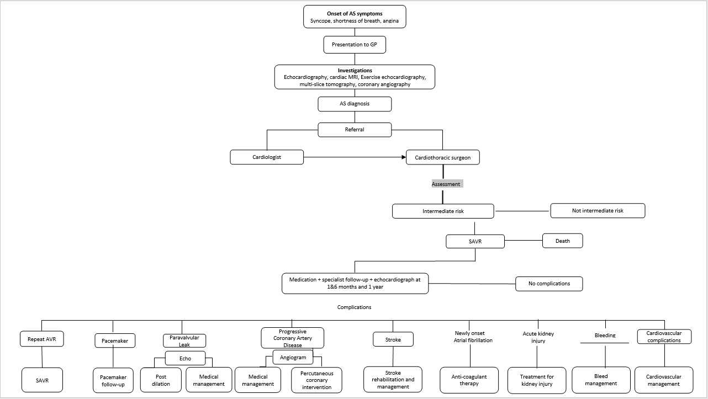

Proposed clinical management algorithm for identified population
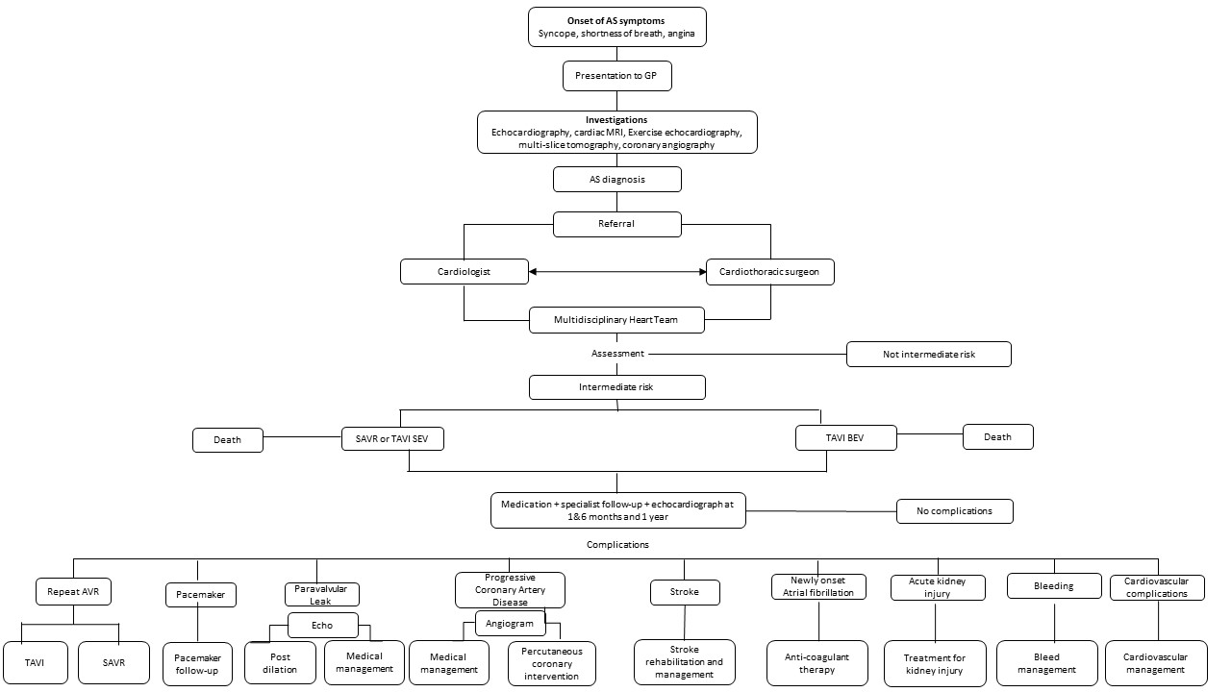

PASC advised the algorithm should clearly state the intervention is for intermediate-risk patients, with two TAVI pathways (for BEV and SEV), so they can be compared to each other.
TAVI is a new approach in Australia for treating patients who have symptomatic aortic stenosis and are at intermediate risk for SAVR. The clinical pathway after TAVI is the same as after SAVR.

PROPOSED ECONOMIC EVALUATION
PASC confirmed the economic evaluation should be a cost-effectiveness or cost-utility analysis.

PASC noted the Prostheses List benefit for ‘high-risk’ TAVI patients could be used (as a guide) to set the Prostheses List benefit for intermediate risk. The applicant advised that the current Prostheses List benefit is representative of the original proof of concept studies, indicating the lowest level of clinical and economic outcomes. The applicant believes it is not representative of the clinical and economic outcomes for a third- generation balloon expanding device.

The clinical claim is that TAVI using the SAPIEN 3 BEV system is superior to SAVR in intermediate risk patients. The appropriate economic evaluation is a cost-effectiveness or cost-utility analysis.

PROPOSED MBS ITEM DESCRIPTOR/S AND MBS FEES (if relevant)
(If the MBS is not relevant, please make that statement in this section, and provide alternative proposed funding source and price information)
PASC confirmed the MBS item descriptor and fee (as described in the Draft PICO), but agreed the “SAPIEN 3” reference should be removed. The applicant clarified this is the only BEV currently TGA approved in Australia for this indication. However, PASC acknowledged that other BEVs (and SEVs) may come onto the market in future, so a generic listing (for BEVs only in this application) would ‘future-proof’ the descriptor.
XXXXX
TAVI using a SAPIEN 3 balloon-expandable system, for treatment of symptomatic severe aortic stenosis, performed via transfemoral delivery, unless transfemoral delivery is contraindicated or not feasible, in a TAVI Hospital on a TAVI Patient by a TAVI Practitioner – includes all intraoperative diagnostic imaging that the TAVI Practitioner performs upon the TAVI Patient
(Not payable more than once per patient in a five year period.)
MBS Fee: $1,432.20 Benefit: 75% = $1,074.15 85% = $1,348.80

The Health Insurance (Section 3C General Medical Services - Transcatheter Aortic Valve Implantation) Determination 2017(Cth) (Department of Health 2017) outlines the definitions of a TAVI Patient, TAVI Hospital and TAVI Practitioner.
TAVI Patient is a patient who, as a result of a TAVI Case Conference, has been assessed as having an intermediate risk for surgical aortic valve replacement and is recommended as being suitable to receive the service described in item XXXXX.
TAVI Hospital means a hospital, as defined by subsection 121-5(5) of the Private Health Insurance Act 2007, that is clinically accepted as being a suitable hospital in which the service described in Item XXXXX may be performed.
TAVI Practitioner is either a cardiothoracic surgeon or interventional cardiologist who is accredited by the Cardiac Accreditation Services Limited.
TAVI Case Conference Items
There is an existing MBS item for coordination (item 6080) of the case conference, and an existing MBS item for participation in the conference (6081). The current application seeks to have these same ‘accompanying’ MBS items available for the proposed new MBS TAVI item.
6080 | Coordination of a TAVI Case Conference by a TAVI Practitioner where the TAVI Case Conference has a duration of 10 minutes or more  (Not payable more than once per patient in a five year period)  MBS Fee: $50.15

6081 | Attendance at a TAVI Case Conference by a specialist or consultant physician who does not also perform the service described in item 6080 for the same case conference where the TAVI Case Conference has a duration of 10 minutes or more  (Not payable more than twice per patient in a five year period)  MBS Fee: $37.40

It is not anticipated this definition of a TAVI Case Conference will require amendment.
TAVI Case Conference means a process by which:
(a) there is a team of 3 or more participants, where:
(i) the first participant is a cardiothoracic surgeon; and
(ii) the second participant is an interventional cardiologist; and
(iii) the third participant is a specialist or consultant physician who does not perform a service described in Item XXXX for the patient being assessed; and
(iv) either the first or the second participant is also a TAVI Practitioner; and
(b) the team assesses a patient’s risk and technical suitability to receive the service described in Item XXXXX, taking into account matters such as:
(i) the patient’s risk and technical suitability for a surgical aortic valve replacement; and
(ii) the patient’s cognitive function and frailty; and
(c) the result of the assessment is that the team makes a recommendation about whether or not the patient is suitable to receive the service described in Item XXXXX; and
(d) the particulars of the assessment and recommendation are recorded in writing.
CONSULTATION FEEDBACK
PASC acknowledged consultation feedback from one practitioner and two companies. All three responses were positive about use of TAVI in intermediate-risk patients, but none supported the proposal that the application be device-specific.

NEXT STEPS
Upon ratification of PICO 1603, the application can PROCEED to the pre-Evaluation Sub-Committee (ESC) stage.
PASC noted the applicant has elected to prepare its own ADAR (applicant-developed assessment report).

References
Cardiac Accreditation Services Limited (2017). Transcatheter Aortic Valve Implantation. Rules for the accreditation of TAVI practitioners. Version 1. Available at: https://tavi.org.au/wp-content/uploads/Rules-for-the-Accreditation-of-TAVI-Practitioners-1-Nov-2017.pdf. Accessed Nov 7, 2018.
Department of Health (2017). Health Insurance (Section 3C General Medical Services – Transcatheter
Aortic Valve Implantation) Determination 2017. Canberra; Department of Health. Available at: https://www.legislation.gov.au/Details/F2017L01380/Explanatory%20Statement/Text. Accessed Nov 7, 2018.
Jose, J., G. Richardt and M. Abdel-Wahab (2015). "Balloon- or Self-Expandable TAVI: Clinical Equipoise?" Interv Cardiol 10(2): 103-108.
Kodali, S., V. H. Thourani, J. White, S. C. Malaisrie, S. Lim, K. L. Greason, M. Williams, M. Guerrero, A. C. Eisenhauer, S. Kapadia, D. J. Kereiakes, H. C. Herrmann, V. Babaliaros, W. Y. Szeto, R. T. Hahn, P. Pibarot, N. J. Weissman, J. Leipsic, P. Blanke, B. K. Whisenant, R. M. Suri, R. R. Makkar, G. M. Ayele, L. G. Svensson, J. G. Webb, M. J. Mack, C. R. Smith and M. B. Leon (2016). "Early clinical and echocardiographic outcomes after SAPIEN 3 transcatheter aortic valve replacement in inoperable, high-risk and intermediate-risk patients with aortic stenosis." Eur Heart J 37(28): 2252-2262.
Nishimura, R. A., C. M. Otto, R. O. Bonow, B. A. Carabello, J. P. Erwin, 3rd, R. A. Guyton, P. T. O'Gara, C. E. Ruiz, N. J. Skubas, P. Sorajja, T. M. Sundt, 3rd and J. D. Thomas (2014). "2014 AHA/ACC guideline for the management of patients with valvular heart disease: executive summary: a report of the American College of Cardiology/American Heart Association Task Force on Practice Guidelines." J Am Coll Cardiol 63(22): 2438-2488.
Noorani, A. and V. Bapat (2014). "Differences in Outcomes and Indications between Sapien and CoreValve Transcatheter Aortic Valve Implantation Prostheses." Interv Cardiol 9(2): 121-125.
Osnabrugge, R. L., D. Mylotte, S. J. Head, N. M. Van Mieghem, V. T. Nkomo, C. M. LeReun, A. J. Bogers, N. Piazza and A. P. Kappetein (2013). "Aortic stenosis in the elderly: disease prevalence and number of candidates for transcatheter aortic valve replacement: a meta-analysis and modeling study." J Am Coll Cardiol 62(11): 1002-1012.
Otto, C. M., D. J. Kumbhani, K. P. Alexander, J. H. Calhoon, M. Y. Desai, S. Kaul, J. C. Lee, C. E. Ruiz and C. M. Vassileva (2017). "2017 ACC Expert Consensus Decision Pathway for Transcatheter Aortic Valve Replacement in the Management of Adults With Aortic Stenosis: A Report of the American College of Cardiology Task Force on Clinical Expert Consensus Documents." J Am Coll Cardiol 69(10): 1313-1346.
Siemieniuk, R. A., T. Agoritsas, V. Manja, T. Devji, Y. Chang, M. M. Bala, L. Thabane and G. H. Guyatt (2016). "Transcatheter versus surgical aortic valve replacement in patients with severe aortic stenosis at low and intermediate risk: systematic review and meta-analysis." Bmj 354: i5130.
Thaden, J. J., V. T. Nkomo and M. Enriquez-Sarano (2014). "The global burden of aortic stenosis." Prog Cardiovasc Dis 56(6): 565-571.
Thourani, V. H., R. M. Suri, R. L. Gunter, S. Sheng, S. M. O'Brien, G. Ailawadi, W. Y. Szeto, T. M. Dewey, R. A. Guyton, J. E. Bavaria, V. Babaliaros, J. S. Gammie, L. Svensson, M. Williams, V. Badhwar and M. J. Mack (2015). "Contemporary real-world outcomes of surgical aortic valve replacement in 141,905 low-risk, intermediate-risk, and high-risk patients." Ann Thorac Surg 99(1): 55-61.
Vahanian, A., O. Alfieri, F. Andreotti, M. J. Antunes, G. Baron-Esquivias, H. Baumgartner, M. A. Borger, T. P. Carrel, M. De Bonis, A. Evangelista, V. Falk, B. Iung, P. Lancellotti, L. Pierard, S. Price, H. J. Schafers, G. Schuler, J. Stepinska, K. Swedberg, J. Takkenberg, U. O. Von Oppell, S. Windecker, J. L. Zamorano and M. Zembala (2012). "Guidelines on the management of valvular heart disease (version 2012)." Eur Heart J 33(19): 2451-2496.
Vandvik, P. O., C. M. Otto, R. A. Siemieniuk, R. Bagur, G. H. Guyatt, L. Lytvyn, R. Whitlock, T. Vartdal, D. Brieger, B. Aertgeerts, S. Price, F. Foroutan, M. Shapiro, R. Mertz and F. A. Spencer (2016). "Transcatheter or surgical aortic valve replacement for patients with severe, symptomatic, aortic stenosis at low to intermediate surgical risk: a clinical practice guideline." Bmj 354: i5085.
Varadarajan, P., N. Kapoor, R. C. Bansal and R. G. Pai (2006). "Clinical profile and natural history of 453 nonsurgically managed patients with severe aortic stenosis." Ann Thorac Surg 82(6): 2111-2115.
Wijeysundera, H. C., F. Qiu, M. Koh, T. J. Prasad, W. J. Cantor, A. Cheema, M. W. Chu, A. Czarnecki, C. Feindel, S. E. Fremes, K. J. Kingsbury, M. K. Natarajan, M. Peterson, M. Ruel, B. Strauss and D. T. Ko (2017). "Comparison of Outcomes of Balloon-Expandable Versus Self-Expandable Transcatheter Heart Valves for Severe Aortic Stenosis." Am J Cardiol 119(7): 1094-1099.

