Application number 1420 to the
Medical Services Advisory Committee

For the listing of integrated, closed-system, extracorporeal photopheresis (ECP) systems

For the treatment of erythrodermic (stage T₄, M₀) cutaneous T-cell lymphoma patients, who are refractory to one or more systemic treatments

FINAL PROTOCOL
November 2016

COMMERCIAL IN CONFIDENCE

Mallinckrodt
166 Epping Rd, Lane Cove West, NSW, 2066
Table of contents
For the listing of integrated, closed-system ECP systems i
Abbreviations and terms v
1 Title of application 1
2 Purpose of application 1
3 Population and medical condition 1
3.1 Description of medical condition 1
3.2 Proposed patient population 6
3.3 Evidence for proposed patient population 7
3.4 Expected utilisation 8
4 Intervention 9
4.1 Description of proposed medical service 9
4.1.1 Integrated, closed-system ECP overview 9
4.1.2 Components of integrated, closed-system ECP 9
4.1.3 How integrated, closed-system ECP works 10
4.2 Technical specification 10
4.3 Registered trademark with distinguishing characteristics 11
4.4 Proposed setting for delivery 11
4.5 Service delivery in clinical setting 12
5 Co-dependent information 13
6 Comparator and clinical claim 16
7 Expected health outcomes 18
7.1 Expected patient relevant health outcomes 18
7.1.1 Outcomes overview 18
7.1.2 Existing clinical evidence 18
7.1.3 Clinician’s perspective 19
7.1.4 Important health outcomes within CTCL treatment 19
7.1.5 Safety endpoints 20
7.2 Potential risks to patients 21
7.3 Type of economic evaluation 21
8 Fee 21
8.1 Proposed funding type 21
8.2 Direct costs 21
8.3 Details of proposed fee 22
9 Clinical management algorithm 24
9.1 Current clinical management algorithm 24
9.2 Proposed clinical management algorithm 25
10 Regulatory information 26
11 Decision analytic 27
12 Healthcare resources 27
13 Questions for public funding 32
Refrences 33
List of tables
Table 1: ISCL/EORTC revision to the classification of mycosis fungoides and Sézary syndrome[9] 2
Table 2: ISCL/EORTC Revision to the staging of mycosis fungoides and Sézary syndrome [8, 9] 3
Table 3: Treatment options for mycosis fungoides/Sézary syndrome by disease stage [11]. 4
Table 4: Summary of recommended population to be treated using ECP in CTCL. 7
Table 5: Guideline recommendations for treatment schedule for ECP use in CTCL patients 12
Table 6: Proposed PBS restriction for methoxsalen in CTCL treatment (initial treatment) 14
Table 7: Proposed PBS restriction for methoxsalen in CTCL treatment (continuing treatment) 15
Table 8: Outcomes used within ECP monotherapy studies [36] 18
Table 9: The proposed MBS restriction for integrated, closed-system ECP use within CTCL 23
Table 10: Summary of PICO to define the research question 27
Table 11: List of resources to be considered in the economic analysis 29

List of figures
Figure 1: Actuarial disease-specific survival of 525 patients with mycosis fungoides or Sézary syndrome according to their clinical stage at diagnosis (stages IA-IV) [8]. 4
Figure 2: Current treatment algorithm for CTCL 16
Figure 3: Current clinical management algorithm in T₄ and M₀ cutaneous T-cell lymphoma patients that are refractory to initial therapy 24
Figure 4: Proposed economic model format for treatment with integrated, closed-system ECP vs usual care (basket of comparators) 27

Abbreviations and terms
Abbreviation | Term
ABS | Australian Bureau of Statistics
AIHW | Australian Institute of Health and Welfare
AR-DRG | Australian Refined Diagnostic Related Group
ARTG | Australian Register of Therapeutic Goods
CC | Complication and/or comorbidity
CCC | Catastrophic Complication and/or comorbidity
CI | Confidence interval
CSCC | Catastrophic or Severe Complication and/or comorbidity
CTCL | Cutaneous T-cell lymphoma
CTG | Cardiotocography
DPMQ | Dispensed price for Max Quantity
DRG | Diagnostic Related Group
ECP | Extracorporeal Photopheresis
ED | Emergency department
ICER | Incremental cost-effectiveness ratio
IQR | Interquartile range
ITT | Intent-to-treat
KOL | Key Opinion Leader
MBS | Medicare Benefits Schedule
MF | Mycosis Fungoides
MRI | Magnetic resonance imaging
MSAC | Medical Services Advisory Committee
N/A | Not applicable
NHMRC | National Health and Medical Research Council
N/R | Not relevant
N/S | Not stated
OR | Operating Room/ Odds ratio
PASC | Protocol Advisory Sub Committee
PBS | Pharmaceutical Benefits Scheme
PICO | Population, Intervention, Comparator and Outcomes
PP | Per protocol
Qld | Queensland
RR | Risk ratio
SCC | Severe Complication and/or comorbidity
SD | Standard deviation
SE | Standard error
SIG | Significant
SR | Systematic review
SS | Sézary Syndrome
TGA | Therapeutic Goods Administration
US(A) | United States of America
UVA | Ultraviolet A

Title of application
The use of integrated, closed-system Extracorporeal Photopheresis (ECP) with ultraviolet-A (UVA) irradiation in conjunction with a photoactive drug methoxsalen, to treat cutaneous T-cell lymphoma patients.

Purpose of application
Please indicate the rationale for the application and provide one abstract or systematic review that will provide background

Cutaneous T-cell lymphoma (CTCL) is a rare disease with a high burden of illness and an annual incidence of 0.23-0.75 per 100,000 in Australia [1]. CTCL involves malignant T-cell clones that accumulate in the skin, leading to plaques, patches, lesions, pruritus, tumours and lung and spleen damage [2, 3]. Even with treatment the disease results in eventual terminal visceral involvement or sepsis secondary to skin breakdown. There is no cure for the disease, and very few currently reimbursed treatments within Australia. Currently integrated, closed-system ECP is used within Australia to treat CTCL patients using ad hoc funding which limits treatment to a select few. It is proven within a local setting to provide effective relief for patients and has a preferable adverse event profile in comparison to other treatments (See Appendix 2). Reimbursement for treatment would lead to improvements in outcomes for patients while reducing adverse events associated with other treatment methods, some which are also used off label and with ad hoc funding (See Appendix 2).

This Protocol relates to the request for Medical Services Advisory Committee (MSAC) approval for subsidization of both integrated Extracorporeal Photopheresis devices and the active ingredient methoxsalen for use in the treatment of Cutaneous T-cell lymphoma (CTCL) patients. It is acknowledged that mycosis fungoides (MF) and Sézary syndrome (SS) are the two most common variants of CTCL, accounting for 65% of all CTCL patients (Section 3.1).. The proposed medical service is a hybrid system of both a device and a drug, and is associated with improved patient outcomes shown through extensive single arm studies. Studies ranging from 1987-2011 showed an overall mean response rate of 63% (range: 33%-100%), measured by improvement in skin scores [3], with higher response rates observed in patients with erythrodermic CTCL. Mean complete response rate for the studies that reported them was 20% (range: 0%-62%) [3]. The treatment is also known to have a better adverse event profile than observed with other treatments within the same indication (See Appendix 2).

Please refer to the JEADV guidelines by Knobler et al (2014) [3] attached within Appendix 1 for further information on ECP use within CTCL. Four other key guidelines are also attached as Appendix 1 for further reference [3-7].

Population and medical condition

Description of medical condition
CTCL is a rare heterogeneous group of diseases involving malignant T-cell clones that accumulate to the skin [2, 3]. The two most common CTCL variants are Sézary Syndrome (SS) and mycosis fungoides (MF). SS accounts for around 5% [3] of all CTCL patients and is a leukemic form of CTCL, where
T-cell’s circulate in the peripheral blood and affect internal organs such as the spleen and lungs [2, 3]. MF accounts for around 60% [3]of all CTCL patients and is characterized by clonal T-cells in the cutaneous environment that present early on as plaques and patches (which can resemble eczema or psoriasis) and eventually result in lesions, pruritus and tumours [2, 3]. Diagnosing CTCL requires clinical and pathologic symptom correlation, and consultation with an experienced pathologist is strongly recommended[8]. CTCL is most commonly found in adult males (twice as common as women) of all races, between the ages of 40-60 years [4].
When patients present with symptoms of CTCL, they are classified into stages of disease severity. A widely used set of staging criteria are the ISCL/EORTC revisions to the staging of MF and SS, as outlined in Olsen et al (2007). The tests completed that are used within the staging process usually include a complete physical exam, a skin biopsy, a blood test, a radiologic test and a lymph node biopsy [8]. The staging criteria use the test results and allow doctors to give patients a stage rating that helps determine treatment options [8]. Table 1and Table 2 below outline the complete ISCL/EORTC revision to the staging process for both MF and SS.

Table 1: ISCL/EORTC revision to the classification of mycosis fungoides and Sézary syndrome[9]
TNMB stages | Characteristics
Skin
T₁ | Limited patches*, papules, and/or plaques† covering <10% of the skin surface. May further stratify into T_{1a} (patch only) vs T_{1b} (plaque ± patch).
T₂ | Patches, papules or plaques covering ≥10% of the skin surface. May further stratify into T_{2a} (patch only) vs T_{2b} (plaque ± patch)
T₃ | One or more tumours‡ (≥ 1-cm diameter)
T₄ | Confluence of erythema covering ≥ 80% body surface area
Node
N₀ | No clinically abnormal peripheral lymph nodes§; biopsy not required
N₁ | Clinically abnormal peripheral lymph nodes; histopathology Dutch grade 1 or NCI LN₀₋₂
N_{1a} | Clone negative#
N_{1b} | Clone positive#
N₂ | Clinically abnormal peripheral lymph nodes; histopathology Dutch grade 2 or NCI LN₃
N_{2a} | Clone negative#
N_{2b} | Clone positive#
N₃ | Clinically abnormal peripheral lymph nodes; histopathology Dutch grades 3-4 or NCI LN₄; clone positive or negative
N_{X} | Clinically abnormal peripheral lymph nodes; no histologic confirmation
Visceral
M₀ | No visceral organ involvement
M₁ | Visceral involvement (must have pathology confirmation¶ and organ involved should be specified)
Blood
B₀ | Absence of significant blood involvement: ≤5% of peripheral blood lymphocytes are atypical (Sézary) cells
B_{0a} | Clone negative#
B_{0b} | Clone positive#
B₁ | Low blood tumour burden: >5% of peripheral blood lymphocytes are atypical (Sézary) cells but does not meet the criteria of B₂
B_{1a} | Clone negative#
B_{1b} | Clone positive#
B₂ | High blood tumour burden: ≥1000/µL Sézary cells with positive clone#
*For skin, patch indicates any size skin lesion without significant elevation or induration. Presence/absence of hypo- or hyperpigmentation, scale, crusting, and/or poikiloderma should be noted.
†For skin, plaque indicates any size skin lesion that is elevated or indurated. Presence or absence of scale, crusting, and/or poikiloderma should be noted. Histologic features such as folliculotropism or large-cell transformation (>25% large cells), CD30_ or CD30_, and clinical features such as ulceration are important to document.
‡For skin, tumour indicates at least one 1-cm diameter solid or nodular lesion with evidence of depth and/or vertical growth. Note total number of lesions, total volume of lesions, largest size lesion, and region of body involved. Also note if histologic evidence of large-cell transformation has occurred. Phenotyping for CD30 is encouraged.
§For node, abnormal peripheral lymph node(s) indicates any palpable peripheral node that on physical examination is firm, irregular, clustered, fixed or 1.5 cm or larger in diameter. Node groups examined on physical examination include cervical, supraclavicular, epitrochlear, axillary, and inguinal. Central nodes, which are not generally amenable to pathologic assessment, are not currently considered in the nodal classification unless used to establish N3 histopathologically.
¶For viscera, spleen and liver may be diagnosed by imaging criteria.
For blood, Sézary cells are defined as lymphocytes with hyper convoluted cerebriform nuclei. If Sézary cells are not able to be used to determine tumour burden for B2, then one of the following modified ISCL criteria along with a positive clonal rearrangement of the TCR may be used instead: (1) expanded CD4_ or CD3_ cells with CD4/CD8 ratio of 10 or more, (2) expanded CD4_ cells with abnormal immuno-phenotype including loss of CD7 or CD26.
#A T-cell clone is defined by PCR or Southern blot analysis of the T-cell receptor gene.

Table 1 shows the ISCL/EORTC revision to the classification of mycosis fungoides and Sézary syndrome. The ISCL/EORTC revision staging process for both MF and SS encompasses the various ailments CTCL presents in patients. In practice this allows practitioners to better determine treatment options suitable for patients. Table 2 below shows how the revised TNMB system is used to calculate ISCL/EORTC revised staging of disease.

Table 2: ISCL/EORTC Revision to the staging of mycosis fungoides and Sézary syndrome [8, 9]
 | T | N | M | B
Early-stage disease
IA | 1 | 0 | 0 | 0, 1
IB | 2 | 0 | 0 | 0, 1
IIA | 1, 2 | 1, 2 | 0 | 0, 1
Advanced-stage disease[8]
IIB | 3 | 0-2 | 0 | 0, 1
III | 4 | 0-2 | 0 | 0, 1
IIIA | 4 | 0-2 | 0 | 0
IIIB | 4 | 0-2 | 0 | 1
IVA₁ | 1-4 | 0-2 | 0 | 2
IVA₂ | 1-4 | 3 | 0 | 0-2
IVB | 1-4 | 0-3 | 1 | 0-2

Table 2 shows how the ISCL/EORTC revised staging system classifies the test results of patients into disease stages and defines early-stage disease and advanced-stage CTCL. While many existing therapies for CTCL focus on palliation[8], treatment options are dependent on the both the stage of disease a patient is in as well as of the number of previous treatments that patients have received. The difference between early-stage disease and advanced-stage disease is important for informing treatment decisions as patients with early stage disease often only have skin related disease, while advanced disease may have disseminated disease into lymph nodes and other organs [10]. Advanced stages can involve multiple immune derangements and require systemic therapy; however, no regimen has been proven to prolong overall survival in the advanced stages of treatment[10]. Survival by treatment stage is outlined within Figure 1 below.

Figure 1: Actuarial disease-specific survival of 525 patients with mycosis fungoides or Sézary syndrome according to their clinical stage at diagnosis (stages IA-IV) [8].
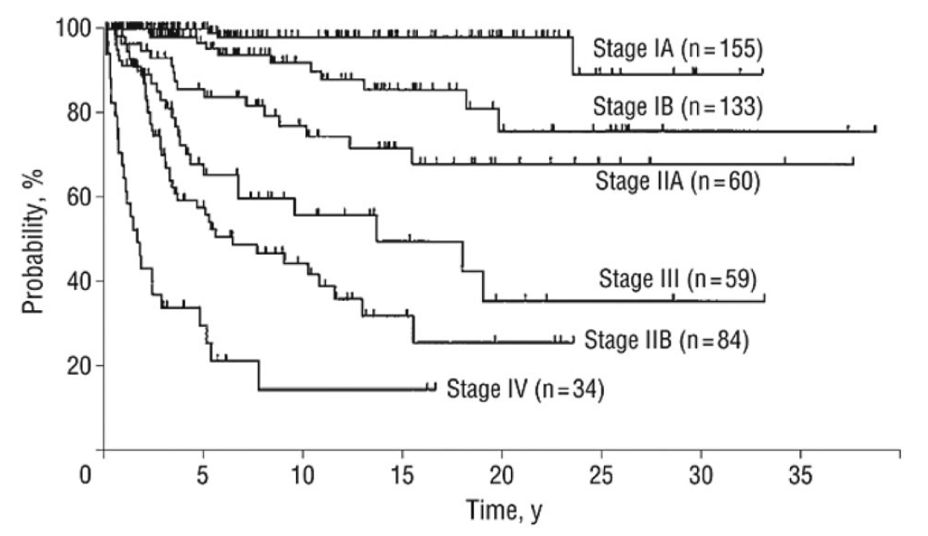
For stage IA versus IB disease, P = .007; for stage IB versus IIA disease, P = .006; for stage IIA versus IIB disease, P = .001; for stage IIA versus III disease, P = .03; for stage IIB versus III disease, P = .09; and for stage IA-III versus IV disease, P = .001.

Immuno-modulatory regimens are often used before others to reduce the need for cytotoxic therapies. The different treatment options and their effectiveness within each disease stage are outlined within Table 3 below.
Table 3: Treatment options for mycosis fungoides/Sézary syndrome by disease stage [11].
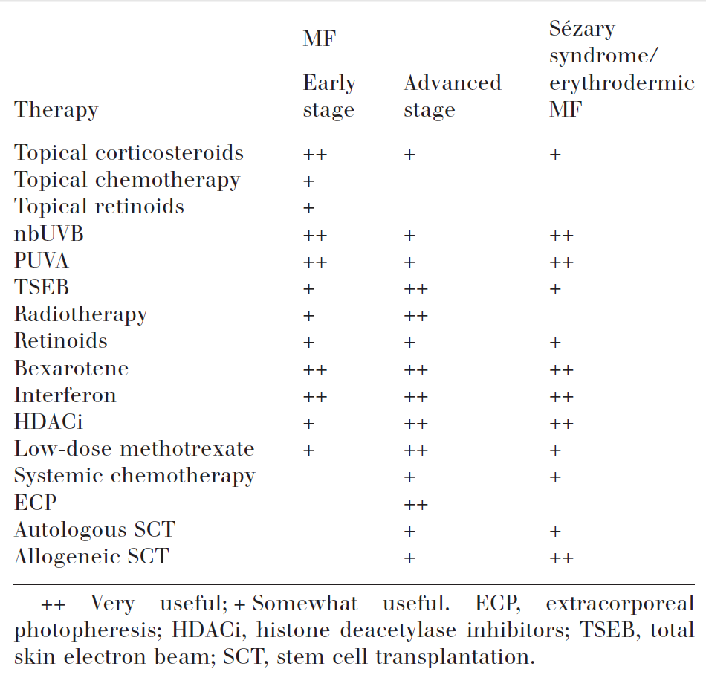
Treatment in advanced stages is where integrated, closed-system ECP has traditionally been used, although several studies have shown its effectiveness when used in ‘early-stage’ CTCL patients [12, 13]. The National Comprehensive Cancer Network (NCCN) Guidelines also recommend ECP in those patients with stage IA, IB and IIA refractory disease [3, 14]. They are, however, one of the only guidelines to do so, as shown in Table 4.
Table 4 also outlines the Australian Cancer Councils 2005 Clinical Practice Guidelines for the Diagnosis and Management of Lymphoma, which recommended ECP for first, second or third-line treatment in patients with stage IIB to IV MF, while also recommending ECP as a more effective treatment in SS patients. The number and type of previous treatments a patient is refractory to dictates future treatment options, since past treatments are not usually reused. There are a number of prognostic factors that have been shown to increase the chance of response rate to ECP [3]:
- short duration of disease, preferably <2 years;
- absence of bulky lymphadenopathy or major internal organ involvement;
- white blood cell count <20 000 mm³;
- presence of a discrete number of Sézary cells (10–20% of mononuclear cells);,
- natural killer cell activity close to normal;
- cytotoxic T lymphocytes close to normal (CD8+ > 15%);
- absence of prior intensive chemotherapy; and
- plaque stage disease not covering more than 10–15% of total skin surface [3].
Patients move from one treatment to the next based on two factors; the first is a recurrence in itch or pain, with the second being a lack of response to the given treatment. Figure 2 shows the available treatments within each successive therapy used in normal clinical practice in Australia which has been verified by Professor Miles Prince, Director for the Centre for Blood Cell Therapies at the Peter MacCallum Cancer Centre in Victoria. While Table 3 does not show that patients with SS are recommended for treatment, Professor Prince states that this indication is fitting with the clinical norm within Australia for ECP use. ECP has also been recommended for use within both MF and SS patients in the EORTC consensus for treatment of MF and SS (2006)[7], The UK Photopheresis expert group’s guidelines (2008)[6], the British Photodermatology group and UK skin lymphoma group recommendations (2006)[5], the North Derbyshire, South Yorkshire and Bassetlaw Commissioning Consortium review of ECP (2008)[4] and within the guidelines for use on ECP by the journal of the European Academy of Dermatology and Venereology (2014)[3].The applicability of ECP erythrodermic MF (stage T4) patients is also specifically recommended by 4 out of 5 of those guidelines (EORTC 2008 does not use the word both erythrodermic within its recommendation for ECP use, however it does not exclude it). Professor Miles Prince is an internationally renowned specialist haematologist who is an expert in blood-related conditions including bleeding and blood clotting disorders, anaemia, and cancers of the blood. He is on the Board of the International Society of Cutaneous Lymphoma and has co-authored numerous guidelines on the staging and treatment of CTCL. He has contemporary experience in using Extracorporeal Photopheresis to treat CTCL and has published clinical experience within the Australian patient population [8, 15]. A consultation conducted with him on the 22nd of March 2016 (for more details see Appendix 2) was carried out to ensure the wider literature and the existing international guidelines matched current clinical practice being used within Australia.

Proposed patient population
The proposed patient population is:
Erythrodermic (stage T₄, M₀) cutaneous T-cell lymphoma patients, who are refractory to one or more systemic treatments.
This proposed patient population is based on the combination of recommendations made within guidelines on ECP use for CTCL treatment and evidence from the literature [3-7], with confirmation that this restriction fits with how integrated, closed-system ECP is currently being used in Australia though expert clinical advice from consultation with Professor Miles Prince (See Appendix 2).The proposed indication includes T₄ and M₀ patients, which correspond to patients in stages III, IIIA, IIIB, IVA₁ and IVA_{2.} Given that the proposed population typically comprise of adults between 40-60 years of age [4], and that CTCL is very rare in children and adolescents and so there are unlikely to be many studies in paediatric patients, , it is proposed that the population be limited to patients aged 18 and above. While there are certain prognostic factors that increase the effectiveness of ECP usage, as this treatment is aimed as a therapy for patients with a high clinical need, and with a crippling debilitating disease, it was considered preferable to allow the clinician to determine a patients eligibility based on prognostic factors rather than limit the population to those that display those factors. This allows patients that have no other treatment options to attempt ECP to potentially gain some relief.

Evidence for proposed patient population
The proposed patient population is supported by the 5 prominent guideline recommendations outlined within Table 4 below.
Table 4: Summary of recommended population to be treated using ECP in CTCL.
Guideline | EORTC (2006)[7] | UK Photopheresis Expert Group (2008)[6] | British Photodermatology Group and UK Skin Lymphoma Group (2006) [5] | NORCOM (2008)[4] | Cancer Council Australia (2005) [16] | JEADV (2014)[3]
Recommended population | First-line treatment of MF stage III and for first-line treatment of SS (strength of recommendation of C) | Patients with CTCL with major criteria of: erythroderma and stage III or IVA CTCL and minor criteria: circulating clonal disease, evidence of circulating Sézary cells (>10% of circulating lymphocytes), CD4/CD8 ratio >10. | Erythrodermic MF/SS (stage III/IVA/B1/0), with a strength of recommendation of B.  Also recommended TSEB + ECP and IFN-α + ECP combination treatments | Erythrodermic MF/SS with the following criteria: erythroderma, biopsy-proven diagnosis of CTCL, evidence of circulating clonal disease and evidence of circulating Sézary cells (10% of lymphocytes present). | Recommended in first, second or third line therapy in stage IIB-IV MF or SS patients while noting that ECP is more effective in SS patients. | First-line therapy for Erythrodermic CTCL patients (stage IIIA or IIIB).  Early-stage disease (stage IA, IB, IIA) considered only for clinical trial purposes  • Stage IVA1 (i.e. patients with B2 score) and a T score of T1, T2 or T4.  • Stage IVA2 (i.e. patients with N3 score) and a T score of T4.

The guideline recommendations within Table 4 are broadly similar with most guidelines outlining the use of ECP within stages III CTCL [3, 5-7] to stage IVA [3, 5, 6]. It is noted that the Australian guideline refers to ECP as an effective first-, second- or third-line treatment for SS (patients with circulating clonal cells only) (Cancer Council of Australia, 2005). The guideline states that ECP is ‘more effective in SS compared to other CTCL’, although it should be acknowledged that this guideline is more than 10 years of age and may no longer reflect current evidence or best practice.
The population in these recommendations includes the proposed population of T₄ and M₀ patients with CTCL. This indicates that these patients are most suited to treatment according to the existing literature.
The restriction to usage within patients that are not responsive to other forms of systemic treatmentis reflective of the current treatment algorithm of integrated, closed-system ECP use in Australia as well as its use within the broader literature. While some studies [13, 17] suggest that integrated, closed-system ECP could be used as an initial therapy, much of the evidence on integrated, closed-system ECP usage is based on treatment of patients who are not responsive to initial treatment [18, 19]. Integrated, closed-system ECP is therefore expected to be used in patients who are refractory to one or more systemic treatments . These restrictions were also deemed to be the most appropriate patient population by Professor Prince. Professor Prince concurred with the evidence and that a restriction to T₄ and M₀ was the correct method of restricting the patient population to CTCL patients who have stages III to IVA disease due to the nature of ECP treatment (see ISCL/EORTC Revision to the staging of MF and SS in Table 2 above).
The proposed restriction allows for both of the relevant MF and SS sufferers to be included in treatment. This is important as the treatment has been shown to be affective in use within both patient populations, however more SS patients have the characteristics suited for optimal integrated, closed-system ECP use. By classifying treatment by skin and visceral staging results, the patients that receive the most benefit from the treatment are included within the patient population, and the distinction between MF and SS does not exclude patients that would benefit from use of the device.

Expected utilisation
There is a large currently unmet clinical need for CTCL patients for integrated, closed-system ECP as a reimbursed treatment. The CELLEX ECP System (both integrated and closed) was TGA approved in 2014, but the active agent (methoxsalen) is currently used off-label, with ad hoc funding used (for more details see Appendix 2). Integrated, closed-system ECP offers significant clinical benefit over the current standard of care with a preferable safety profile, and has proven to be more effective than many of its competitors within a local context (for more details see Appendix 2). Reimbursement of integrated, closed-system ECP will allow patients to have wider access to an effective treatment that provides relief from this debilitating illness. ,
An Australian publication has estimated the incidence of MF and SS to be approximately 0.3 to 1 per 100,000 annually (sourced from studies from the United States)[11]. Although SS accounts for around 5% of all CTCL patients and MF accounts for around 60%, there currently is no indication of the proportion of SS and MF patients who are erythrodermic (stage T4). However, according to expert advice (Appendix 2), most patients will have SS. Given that the proposed restriction allows for only T₄ and M₀ CTCL patients who are refractory to one or more other systemic treatment to be eligible for integrated, closed-system ECP, the total number of patients who would be eligible for ECP treatment is likely to be small.

Intervention

Description of proposed medical service

Integrated, closed-system ECP overview
Treatment with integrated, closed-system ECP is well established, with a large body of evidence showing treatment effectiveness, both in single arm studies [18-24] and in guidelines and reviews of the treatment [3-7, 12, 25]. The existing body of evidence, as well as the numerous publications made on integrated, closed-system ECP within an Australian clinical context [8, 15], will form the basis of the proposed submission.
ECP systems come in open and closed systems. The open ECP systems are characterised by separate devices for cell separation and drug photo activation, also known as two-step methods [3]. In these systems the combination of the device for separation and the device for photoactivation has not been approved either for use together or specifically approved for Photopheresis [3]. The multiple step approach also increases the potential risk of patient re-infusion error, infection and
cross-contamination [3, 26]. Open systems are also restricted for use in centres that have approval for handling blood components separately [3].
Integrated, closed-system ECP systems (also known as closed system) complete the processes of cell separation, photo activation of the drug, and reinfusion of the treated cells back into the patient within an automated and fully integrated process[3]. All components of the treatment are validated for use together.
Treatment with integrated, closed-system ECP has had a place within in CTCL patient treatment since 1987 [21], and has been described by Professor Prince as having the “least side effects” of currently available treatments. Professor Prince also stated that if patients respond to treatment, then patients are on treatment for longer before progressing in comparison to existing CTCL treatments available to Australian patients. Professor Prince stated that treatment with integrated, closed-system ECP has an important place within Australian clinical practise, and recommends the treatment for all patients with T₄, M₀ CTCL.ECP is contraindicated in patients who cannot tolerate extracorporeal volume loss (heart failure, hypotension, sepsis) or patients with coagulation disorders. In addition, methoxsalen is contraindicated in patients with idiosyncratic reactions to psoralen compounds, those with a history of light-sensitive disease (such as patients with systemic lupus erythematous with photosensitive disease, or those with aphakia).
In Australia, integrated, closed-system ECP devices are currently registered with the TGA for the following indications:
- CELLEX System (kit or system) is indicated for the administration of Photopheresis.
The indication for integrated, closed-system ECP has recently been amended to the stated indication; however the TGA website is currently displaying the previous indication.

Components of integrated, closed-system ECP
Integrated, closed-system ECP is an immune-modulatory therapy in which a patient’s leukocytes are collected and treated outside of the body with both methoxsalen and ultraviolet-A (UVA) irradiation and then returned into the patient. Integrated, closed-system ECP involves two components, the integrated, closed-system ECP device that incorporates the ultraviolet-A (UVA) irradiation system and the active agent, which is a liquid formulation of methoxsalen and the photoactive drug methoxsalen. As there is both a device and a drug used, the submission being prepared for this treatment is a hybrid co-dependent submission.
Anticoagulants, such as a heparinised saline solution, are used as part of ECP treatment in priming the system and throughout patient treatment. Volume replacement fluid and/or volume expanders (such as albumin) are considered optional; however they are another component potentially used during the procedure.

How integrated, closed-system ECP works
Integrated, closed-system ECP utilises photo immune therapy, separating white blood cells from whole blood via apheresis, combined with the photoactive drug methoxsalen (UVADEX®), and exposed to ultra violet A (UVA) light. All blood components, including the treated white blood cells are returned to the patient (simultaneously in dual needle mode and intermittently in single needle mode).
Use of integrated, closed-system ECP is thought to trigger apoptotic cascades in treated leukocytes [27]. Once re-infused into the patient, the processing of the treated cells is thought to induce a systemic immuno-modulatory response, including an increase in anti-inflammatory cytokines, a decrease in pro-inflammatory cytokines, and an increase in regulatory T cells [28, 29]. It is believed that through this process integrated, closed-system ECP induces the systemic changes within a CTCL patients’ immune system.
It should also be noted that patients receiving integrated, closed-system ECP respond normally to unrelated immune challenges, such as exposure to foreign pathogens [30]. Integrated, closed-system ECP also does not appear to change the frequency of viral reactivations and patients do not develop the infections associated with immunosuppressant treatments [26, 31-33].

Technical specification
The proposed intervention is monotherapy with integrated, closed-system ECP. The photosensitising drug, methoxsalen (8-methoxypsoralen) is integral to the technology and is used at a dose of 20 mcg/mL.
Photopheresis or extracorporeal photopheresis (ECP) is a photo immune therapy where white blood cells are separated from whole blood via apheresis, combined with a photoactive drug (8-methoxypsoralen) and then exposed to ultra violet A (UVA) light. All blood components, including the treated white blood cells are returned to the patient.
THERAKOS® Photopheresis utilizes the THERAKOS® CELLEX® Photopheresis System to combine state of-the-art cell separation and photoactivation into a single, closed and sterile circuit. The THERAKOS® CELLEX® Photopheresis System collects the buffy coat (leukocyte-enriched blood) from the patient in a continuous flow process and simultaneously (DOUBLE NEEDLE mode) or intermittently (SINGLE NEEDLE mode) returns the remaining cells to the patient. The buffy coat is passed through the Photoactivation Module where the drug is activated with a precise amount of UVA light determined by the characteristics of the individual patient’s buffy coat. After photoactivation, the buffy coat is promptly returned to the patient bloodstream
(The full system description can be found within Appendix 3, the CELLEX operator’s manual revision 6.0).

Registered trademark with distinguishing characteristics
The proposed integrated, closed-system ECP service utilises a specialised device with a registered trademark of THERAKOSTM Photopheresis system.

Proposed setting for delivery
ECP should be delivered by specially trained, experienced nursing staff and supervised by specialised haematologists in accredited medical centres. It is intended that integrated, closed-system ECP is used at public and private hospitals. Due to the small numbers of patients that are expected to require ECP treatment, it is likely that the technology will be offered in only a small number of treatment centres in major tertiary hospitals in Australia.
The integrated, closed-system ECP is administered based on the treatment schedule outlined within the 2014 Journal of the European Academy of Dermatology and Venereology (JEADV) guidelines, and input from Professor Prince (see Appendix 2)[3]. Integrated, closed-system ECP treatment should be administered for two consecutive days every two weeks for the first 3 months, then once every three or four weeks thereafter [3], although currently in Australia ECP is administered on one day every two weeks for the first 3 months. The treatment should be continued for a period of no less than 6 months, with treatment continuing until progression [3]. At maximal response, treatment should be tapered to once every 4-8 weeks for maintenance [3]. In the case of combination therapies, patients being administered ECP treatment that are not showing sufficient response to treatment are free to use other skin directed therapies (aside from TSEB) in order to provide relief from symptoms (topical steroids, creams etc.), however no systemic therapies (IFN-α2β, MTX etc.) should be used [3]. All treatment is to occur within an outpatient setting, with access to an inpatient setting for the treatment of adverse events. This treatment schedule differs slightly to those within other guidelines, and is compared in Table 5 below.

Table 5: Guideline recommendations for treatment schedule for ECP use in CTCL patients
Guideline | EORTC (2006) (not recommendation but stated within paper) | UK Photopheresis Expert Group (2008) | British Photodermatology Group and UK Skin Lymphoma Group (2006) | NORCOM (2008) | JEADV (2014)
Treatment Cycle | 2 days/4 weeks | 2 consecutive days every 2-4 weeks (more frequently to those with high tumour burden) | 2 days per month | 2 consecutive days per month | Two consecutive days every 2 weeks for the first 3 months, then once monthly or every 3 weeks.
Min/max treatment | Up to 6 months | Treatment should be tapered at maximal response or greater to one cycle every 6-12 weeks before stopping | Up to 6 months, followed by tapering or maintenance in responders | Minimum of 6 months | Treatment should be continued for a time period of not less than 6 months, and ranging between 6 and 12 months.
Other advice | Maintenance therapy tailored according to disease course and severity. |  |  |  | At maximal response, treatment should taper to one treatment every 4–8 weeks for maintenance therapy.
The 2005 Australian Cancer Councils 2005 Clinical Practice Guidelines for the Diagnosis and Management of Lymphoma [16] did not outline a treatment schedule for ECP and as such was not included within this list.
While there are slight differences between each recommendation, the overarching schedules are similar in nature of treatments. The JEADV schedule was chosen due to the inclusion of a minimum period of 6 months on treatment and the mention of the tapering of treatment. Out of the guideline recommendations, these attributes make the 2014 JEADV guidelines the most appropriate to the Australian clinical practise according to Professor Prince (see Appendix 2). The minimal treatment phase is needed to see the full benefits of integrated, closed-system ECP and the tapering of treatment is commonly used in clinical practise (see Appendix 2).

Service delivery in clinical setting
Patients are to be administered integrated, closed-system ECP after being found non-responsive to other forms of treatment, as described within Section 3. Patients within this indication would have an established relationship with a consulting haematologist given that patient with CTCL visit their haematologist between once a week to once a month depending on treatment stage and disease severity. Before initiating ECP treatment, patients would likely discuss treatment options with their haematologist and conduct appropriate blood, and skin tests to obtain baseline response markers. Once treatment begins, the schedule of treatment is based on the 2014 JEADV recommendations as described in Section 0. Two consecutive days of treatment occur for the first 3 months, then once monthly or every 3 weeks, although currently in Australia ECP is administered on one day every two weeks for the first 3 months. Treatment should be continued for a period of not less than 6 months until progression, with tapering at maximal response to one treatment every 4-8 weeks for maintenance therapy. Administration of a course of treatment would involve two attendances of a haematologist, two attendances of a nurse to aid with the administration of therapy, as well as two ECP kit packages that including lines, needles etc. It also includes the price of methoxsalen used within the procedure, and a full blood count post procedure. Adverse event and hospitalization data is outlined within Section 12.

Co-dependent information
Treatment with integrated, closed-system ECP involves both the integrated, closed-system ECP device and the drug methoxsalen. Methoxsalen is currently not reimbursed on the PBS, nor is it TGA-approved. As such methoxsalen will need to be assessed by the PBAC to determine whether integrated, closed-system ECP is effective, safe and cost-effective within this indication. Unlike other co-dependent submissions, methoxsalen use within integrated, closed-system ECP treatment is not dependent on the outcome of a diagnostic test. It should therefore be considered as a hybrid technology, with the device being inseparable from the drug. The proposed wording for the initial PBS criteria is outlined within Table 6, while the proposed wording for the PBS continuation criteria is outlined in Table 6.
Table 6: Proposed PBS restriction for methoxsalen in CTCL treatment (initial treatment)
Severity: | Advanced stage T₄ and M₀ CTCL (Stage III-IVa)
Condition: | Cutaneous T-cell lymphoma
Restriction: | Section 100 HSD  Authority Required (private hospitals)  Authority Required (STREAMLINED) (public hospitals)
Treatment Phase | Initial treatment
Clinical criteria | Patients must have advanced stage, Erythrodermic (stage T4, M0) cutaneous T-cell lymphoma, who are refractory to one or more systemic treatments.
Patient criteria | Not for use in patients with:  - Patient must not be pregnant or breastfeeding. Patients and their partners must each be using an effective form of contraception if of child-bearing age.  - history of heparin-induced thrombocytopenia  - unsatisfactory cardio-circulatory function  - Patients with known sensitivity to psoralen compounds
Treatment criteria | Must be treated in an accredited treatment centre.  Must be treated with an integrated, closed-system Extracorporeal Photopheresis (ECP) device.
Note: | Treatment centres are required to have access to the specialised haematologists for the provision of clinical consultation services for CTCL

Table 7: Proposed PBS restriction for methoxsalen in CTCL treatment (continuing treatment)
Severity: | Advanced stage T₄ and M₀ CTCL (Stage III-IVa)
Condition: | Cutaneous T-cell lymphoma
Restriction: | Section 100 HSD  Authority Required (private hospitals)  Authority Required (STREAMLINED) (public hospitals)
Treatment Phase | Continuing treatment
Clinical criteria | - Patient must have previously received PBS-subsidised treatment with methoxsalen  AND  - Patient must have shown suitable response to ECP treatment within first 6 months of treatment: defined as a response rate of less than 50%, assessed from skin score analysis
Patient criteria | Not for use in patients with:  - Patient must not be pregnant or breastfeeding. Patients and their partners must each be using an effective form of contraception if of child-bearing age.  - history of heparin-induced thrombocytopenia  - unsatisfactory cardio-circulatory function  - patients with known sensitivity to psoralen compounds  - Patients that have shown inadequate response to ECP treatment within the first 6 months.
Treatment criteria | Must be treated in an accredited treatment centre.  Must be treated with an integrated, closed-system Extracorporeal Photopheresis (ECP) device.
Note: | Treatment centres are required to have access to the specialised haematologists for the provision of clinical consultation services for CTCL

Comparator and clinical claim
Initial treatment options for Australian patients with CTCL includes expectant policy, psoralen plus ultraviolet A radiation (PUVA), methotrexate, ultraviolet B radiation (UVB), topical corticosteroids, total skin electron beam therapy (TSEB) or interferon therapy (IFN-α2β). Initial treatment aims to reduce tumour bulk and provide patients relief from debilitating symptoms. Treatment choice for initial therapy is based on disease severity, stage and patient location (TSEB and other intensive treatments are only available at selected sites). As such, the choice of initial treatment is based a number of factors, and is not well defined as in other therapeutic areas. Patients move from initial treatment to the next if they are not responsive to or becoming refractory to that treatment, as measured by an increase in itch/pain, or lack of response to the given treatment. Once a patient becomes refractory to initial treatment, patients move to another treatment. In CTCL this continues until the patient has exhausted all available treatment options, at which point the patient receives best supportive care.

As requested by PASC, a clinician survey of 20 experts with extensive experience in the treatment of CTCL was conducted in August 2016. The clinician survey indicates that in the absence of access to ECP treatment, the most commonly used second-line therapies in Australia are IFN-α2β, methotrexate and alemtuzumab. Detailed methods and results for the clinician survey will be presented in the Submission Based Assessment. The current Australian clinical algorithm is outlined within Figure 2 below, assuming an absence of access to ECP treatment in Australia. Clinical feedback suggests TSEB is used in combination with other second-line therapies.
Figure 2: Current treatment algorithm for CTCL assuming no access to ECP in Australia
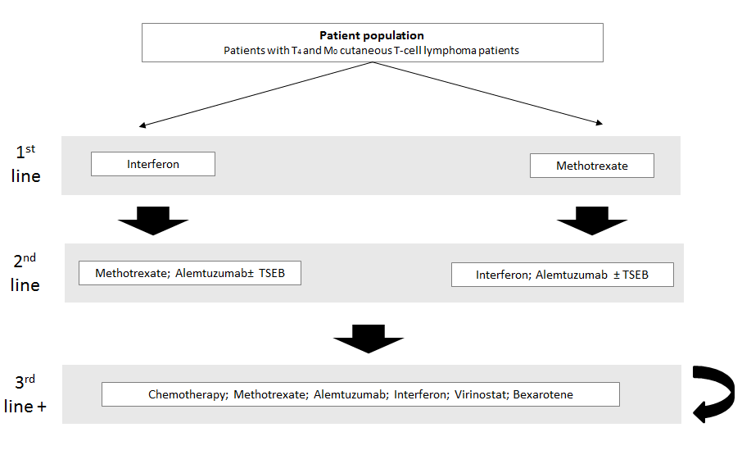
The nature of research around CTCL as a disease is shaped by the fact that no curative therapies exist, and that each successive treatment is directed towards palliation and inducing and maintaining long-term remissions [3]. There is a lack of comparative data that aligns within the proposed indication.
There are a range of treatments used in patients who are unresponsive to or refractory to initial treatment, including integrated, closed-system Extracorporeal Photopheresis (ECP), interferon (IFN-α2β), methotrexate, alemtuzumab and total skin electron beam therapy (TSEB).As integrated, closed-system ECP is currently used in Australian patients who are refractory to initial treatment, other treatments that could be used within this indication are based on previous treatments that patients were found to be unresponsive or refractory to. Second therapy treatment focuses less on removal of tumour bulk, and more on extending the duration of remission.
The three treatments with longer duration of remission used as second therapy are integrated, closed-system ECP, IFN-α2β and TSEB. Methotrexate and alemtuzumab have a shorter response than the other three therapies, and alemtuzumab is currently an experimental treatment used off label based on compassionate access. Choice of specific second treatment is also based on patient’s location as there are very few treatment centres for integrated, closed-system ECP or TSEB treatment. IFN-α2β, methotrexate and alemtuzumab are more accessible treatments for rural patients which make up around 20% of the patient population. Feedback from Professor Prince suggests methotrexate and IFN-α2β are more likely to be used in as initial systemic treatments and TSEB is restricted to MF where there is no blood involvement.
Due to the nature of CTCL, and the focus on palliation and inducing and maintaining long-term remissions [3], in the absence of access to ECP, the most commonly administered systemic therapies are IFN-α2β, methotrexate and alemtuzumab within the Australian clinical practice. Upon reimbursement of ECP, patients would be expected to use ECP as an addition to the current second-line treatment options. ECP would become an alternative in a basket of second-line treatments (including ECP, systemic and skin directed therapies) as part of the treatment paradigm due to no curative therapy available over the course of a patient lifetime. ECP provides another treatment option for patients before moving onto next line of therapy. Therefore, the most appropriate comparator to integrated, closed-system ECP is the most commonly used systemic therapies - IFN-α2β, methotrexate and alemtuzumab, assuming ECP is not available for the treatment of CTCL in the Australian clinical setting.
Upon becoming refractory to a second treatment, patients are initiated on third treatment. Treatment options in third-line therapy involve the same agents used within second treatment, excluding the treatment used within second and initial therapy.
On the basis of all of these factors,
The proposed comparators for treatment with integrated, closed-system ECP in Erythrodermic (stage T₄, M₀) cutaneous T-cell lymphoma patients, who are refractory to one or more other systemic treatments, are IFN-α2β, methotrexate and alemtuzumab.

Expected health outcomes

Expected patient relevant health outcomes

Outcomes overview
Outcomes within CTCL rarely have standardised endpoints or response criteria [35]. Therefore determining the best possible outcomes within CTCL treatment involves combining a clinician’s perspective of important outcomes with the extended evidence. As there can often be a discrepancy between clinically important outcome markers and those reported within the literature, analysing both was essential and conducted below.

Existing clinical evidence
As there are currently no curative therapies available for CTCL, treatment is directed towards palliation and inducing and maintaining long-term remissions [3]. The aim of treatment is to reduce or clear skin lesions and tumours, and reduce pruritus, thereby providing patients with symptom relief and improved quality of life. Therefore outcomes of importance include those detailing skin lesions, and tumours, time to next treatment as well as quality of life.
Table 8 below shows the different types of outcomes used within the key monotherapy studies used in Quaglino (2013) [36]. This shows that the vast majority of the literature uses reduction in erythroderma/skin score/skin response/skin examination methodology to analyse treatment response.
Table 8: Outcomes used within ECP monotherapy studies [36]
Single arm trial/observational study | Outcomes used within trial/observational study
Duvic (1996) [20] | - Complete response (CR): disappearance of all erythema and scaling. Skin score 0  - Partial response (PR): 50% to 99% reduction in skin score recorded at onset of therapy  - Minor response (MR): 25% to 49% reduction in skin score  - Progressive disease: increase of more than 25% in skin sore, appearance of new lesion or adenopathy  - No change: no change in skin score, no evidence of progressive disease  - Time to response: interval from first treatment to date of positive response (CR or PR)
Edelson (1987) [19] | - Skin response  - Minimally successful was 25% reduction in baseline overall skin-lesion score  - Skin score was the sum of the products of severity, and surface area percentage.
Heald (1989) [21] | - Skin examination  - Surface involvement was graded according to the percentage of surface involved and degree (0-4) to which the area was involved.  - Responses then graded into three categories  - 75% clear of surface involvement  - >25% involvement but ≤75% involvement  - ≤25% involvement
Jiang (1999) [22] | - Skin score for erythrodermic patients  - Single observer  - Severity (0-4) multiplied by surface area percentage (based on regions)  - Complete clinical response = disappearance of measurable disease for a month, allowing initiation of treatment taper.  - Partial clinical response = ≥50% clearance of measurable disease for 1 month  - Lack of clinical response = <50% clearance of measurable disease after 18 consecutive months of therapy.
Prinz (1995) [23] | - Skin score from Edelson (1987), i.e.: sum of severity score (0-4) multiplied by percentage of body surface within each region.  - Complete response = complete clearing of the skin, (total skin score = 0)  - Partial response = decrease in the skin score by ≥50%  - Minor response = decrease in the skin score by at least 25%  - An increase of more than 25% in skin score was judged as progression.
Stevens (2002) [24] | - Complete remission = no evidence of disease from physical examination, CT scans, blood exams for Sézary cells, abnormal immuno-phenotype  - Partial remission = ≥50% reduction in skin severity score  - Responders = achieved partial or complete remission  - Stable disease = <50% reduction in skin severity score
A consensus statement of clinical outcomes and response criteria in MF and SS published collaboratively by the International Society for Cutaneous Lymphomas, the United States Cutaneous Lymphoma Consortium, and the Cutaneous Lymphoma Task Force of EORTC [35] noted that the following additional outcomes were also of use:
- time to treatment failure(addition of another treatment or abandonment),
- time to response,
- global response (encompassing skin and blood and nodes) and
- progression free survival.

Clinician’s perspective
Within CTCL, there are 4 main health outcomes that are most relevant within CTCL according to Professor Prince. These include, in the order of clinical importance:
- Quality of life (QoL)defined by reduction in itch as measured by Pruritus score
- Actual reduction in erythroderma
- Time to next systemic treatment
- Overall survival
- Response rate

Important health outcomes within CTCL treatment
There are a broad range of clinically important outcomes, some of which are more important than others. As such each was analysed, with the following key outcomes selected based on use within guidelines, literature and verification as to their importance in local clinical practise from Professor Prince.
Quality of life/itch improvement/pruritus score is considered the most important efficacy outcome, due to its patient centric focus. This was not found within the single arm monotherapy ECP studies analysed, however may be reported within the wider literature. This outcome is also important in informing utilities for the economic model.
Reduction in erythroderma was considered to be the second most important efficacy outcome. This outcome can be difficult to measure, as it relies on patients receiving a modified Severity Weighted Assessment Tool (mSWAT) test. This involves direct assessment of the body surface area (BSA) of each type of MF/SS lesion in each 12 areas of the body, then multiplying the sum of BSA of each lesion by a weighing factor and generating a sum of the totals of each lesion subtype (patch, plaque, tumour etc.). While there is an opportunity for variability in investigators choosing a severity score [35], different studies used different methods to ensure consistency. The key similarities between the evidence base and clinically important outcomes in CTCL are that reduction in erythroderma/skin response/skin examination important in both.
Time to next (systemic) treatment is considered a more objective outcome as it incorporates both the clinician and the patient’s inputs. This does not always correlate with symptom changes in a clinical practise setting as it is common practice to add various skin directed therapies to systemic agents to improve symptoms [35].
Overall survival is the final important efficacy measure, and is relatively common in most observational trials as it is an objective measure as death is an objective outcome.
Response rates, including complete response rate, partial response rate and overall response rate, are commonly reported in clinical studies as important clinical endpoints. They also serve as part of the clinical criteria to determine the continuation or termination of the treatment.
Based on this evidence:
The proposed outcomes of interest with integrated, closed-system ECP in Erythrodermic (stage T₄, M₀) cutaneous T-cell lymphoma patients, who are refractory to one or more other systemic treatments in the order of clinical importance are:
- Quality of life/itch improvement/pruritus score
2. Reduction in erythroderma/skin response/skin examination
3. Time to next systemic treatment
4. Overall survival
5. Response rate
It is also noted that time to treatment failure (addition of another treatment or abandonment), time to response, global response (encompassing skin and blood and nodes) and progression free survival may also be used as important outcomes depending on availability of data.

Safety endpoints
According to Professor Prince, integrated, closed-system ECP has a safe adverse event profile, and this is supported within the literature [3]. The safety of integrated, closed-system ECP can be attributed to extracorporeal treatment occurring outside of the body and the majority of the components being neutralised by the radiation occurring prior to re-infusion[3]. Professor Prince considered that the safety endpoints of interest are 1) "line-related" complications (cellulitis, systemic infection and vascular complications such as thrombosis). This endpoint refers to issues relating to the occasional need (<5% of patients) to have a catheter in situ for the extraction and reinfusion of blood and 2) cardiovascular complications because of the volume changes that can occur during integrated, closed-system ECP.
The proposed safety outcomes of interest with integrated, closed-system ECP in Erythrodermic (stage T₄, M₀) cutaneous T-cell lymphoma patients, who are refractory to one or more other systemic treatments in the order of clinical importance, are:
- Line-related complications
- Cardiovascular complications

Potential risks to patients
There are no severe WHO grade III-IV side effects reported with integrated, closed-system ECP [3]. The only adverse events experienced within practice are the line-related and cardiovascular complications outlined in Section 7.1.5(See Appendix 2). As the treatment process involves using patients’ blood components, certain patient groups are not recommended for treatment. These recommendations ensure patients with poor cardiovascular health, pregnancy or sensitivity to psoralen compounds are not affected adversely.
Treatment with integrated, closed-system ECP is not recommended for use in patients that are:
• Pregnant or breastfeeding. Patients and their partners must each be using an effective form of contraception if of child-bearing age.
• have a history of heparin-induced thrombocytopenia
• have unsatisfactory cardio-circulatory function
• have a known sensitivity to psoralen compounds

Type of economic evaluation
A cost effectiveness analysis will be used to compare treatment with integrated, closed-system ECP to Best supportive care. The economic evaluation will aim to show integrated, closed-system ECP is cost-effective over BSC. The proposed economic evaluation is outlined in Section 11.

Fee

Proposed funding type
This application reflects a hybrid technology – including a medical service to be subsidised via the MBS and a drug to be subsidised via the PBS.
The integrated, closed-system ECP system incorporates integrated extracorporeal photopheresis with ultraviolet-A (UVA) irradiation in conjunction with a photoactive drug, methoxsalen, within a single device to treat erythrodermic (stage T4, M0) cutaneous T-cell lymphoma patients, who are refractory to one or more other systemic treatments. An MBS item number is sought to subsidise the delivery of the integrated, closed-system ECP service, and the PBS listing of methoxsalen is sought to reimburse the cost of drug.

Direct costs
Direct costs associated with the integrated, closed-system ECP service are listed below, with the distinction that this listing is being made for an integrated, closed-system system rather than an open system that would incur higher direct costs and have a higher risk of adverse events [3]. It is important to note that consumables associated with delivering the integrated, closed-system ECP service are the biggest driver of costs.
Direct costs associated with the integrated ECP service are listed as follows:
Procedure
- Specialist consultation
General specialist attendance is currently reimbursed under two MBS item numbers:
- MBS item 104: initial consultation (Fee: $85.55; Benefit: 75% = $64.20, 85% = $72.75); and
- MBS item 105: subsequent consultation (Fee: $43.00; Benefit: 75% = $32.35, 85% = $36.55)
MBS item 105 is likely to be used within this indication as patients would have an existing relationship with their haematologist in second treatment. The general consultation fees are likely to inform the cost for the specialist attendance requested in the management of CTCL.
- Service delivery and supervision
Indicative cost of integrated, closed-system ECP delivery and supervision is derived from the ward nursing component in the AR-DRG cost of apheresis (B62Z). The average cost of apheresis is $1,330 per DRG with an associated ward nursing cost of $164. As integrated, closed-system ECP is a more complex procedure in comparison to apheresis, the true cost is likely to be higher than $164.

Pharmaceuticals
- Photoactive drug methoxsalen: $125 per vial is currently charged to the ECP service and is proposed in the PBAC application as part of the co-dependent submission

Consumables
The consumables used for the proposed service are listed as follows. The estimated cost for an integrated, closed-system ECP tubing kit is around $1,700 per kit/treatment.
The capital cost of the ECP machine is estimated at $100,000, which is a one-off cost to the hospital or the clinical centre to provide access to the ECP service. It is noted that the capital cost has not been incorporated in the proposed MBS fee or the economic evaluation.
A summary of the resources to be considered in the economic analysis is presented in Table 12.

Details of proposed fee
Currently there is no MBS item number allocated to a clinical procedure similar to treatment with integrated, closed-system ECP. The proposed integrated, closed-system ECP service fee comprises three components:
- initial and follow-up specialist consultation
- clinical supervision of integrated, closed-system ECP service delivery
- consumables
The integrated, closed-system ECP specialist consultation fees are based on MBS items of general consultation fees (MBS item 105 for subsequent consultation). However, CTCL is a complicated disorder and is managed by highly specialised haematologists. The application of fees associated with general specialist consultation cannot fully reflect the quality of service provided in integrated, closed-system ECP specialist consultation.
The integrated, closed-system ECP service fee primarily includes three major steps: apheresis, drug administration and photoactivation. Integrated, closed-system ECP should be delivered by specially trained, experienced nursing staff and supervised by specialised haematologists in accredited medical centres. Currently there is only an AR-DRG code available for the reimbursement of apheresis (B62Z). As stated in Section 8.2, the estimated cost of an integrated, closed-system ECP procedure based on an apheresis procedure is considered an underestimate.
In general, an MBS item cannot include any consumables that would be reasonably necessary to perform the service. However, given the extremely high consumable cost incurred in the integrated, closed-system ECP service, and taking into account the underquoted specialist consultation fee and service delivery fee, it is expected that the inclusion of consumables in the proposed MBS fee would partially compensate those service components which are undervalued due to no matching MBS item numbers available. In addition, as advised by the Department of Health at the pre-PASC meeting, there were historical precedents which included consumables as part of the proposed MBS fee structure in the MSAC application process. In a recent report on the MBS expense trend, it is stated that “the Schedule fee for an item takes into account of the direct and indirect costs of providing the service (e.g., the length and complexity of the service, any consumables used, administrative costs, and rent for premises” (online 2015).
Therefore, an indicative integrated, closed-system ECP service fee is $1907.00 by including a specialist consultation ($43.00), integrated, closed-system ECP service supervision ($164) and consumables ($1700). The Sponsor remains open to further discussions with PASC and MSAC regarding this amount. $125 per vial is currently charged to the ECP service and is proposed in the PBAC application as part of the co-dependent submission.
It must be re-iterated that this MBS fee must be limited to treatment with an integrated, closed-system ECP device. As the safety profile of integrated and validated ECP systems is far better than open systems, this distinction avoids use of inferior technology with a higher rate of adverse events and higher costs for hospitals to comply with associated safety and quality standards [3]. Table 9 below outlines the proposed MBS restriction.
Table 9: The proposed MBS restriction for integrated, closed-system ECP use within CTCL
Category 3 – Therapeutic procedures
MBS 38xxx

integrated, closed-system Extracorporeal Photopheresis for the treatment of erythrodermic (Stage T4 and M0)) cutaneous T-cell lymphoma patients above 18 years of age, who are refractory to other one or more other systemic treatments. Treatment includes a specialist consultation and continuous monitoring with nurse attendance under the supervision of a consultant physician.

Fee: $1907.0 Benefit: 75% = $1430.25 85% = $1620.95

Clinical management algorithm

Current clinical management algorithm
The current clinical management involves three different treatment options, namely IFN-α2β, Methotrexate or alemtuzumab treatment. This is outlined within Figure 3 below. Treatment begins when patients become unresponsive or refractory to initial systemic or skin directed therapy. As there are no curative therapies available for CTCL, the clinical algorithm is not as straightforward as within other therapeutic areas. Movement from treatment to treatment is dependent on the treatments ability to induce and maintain long-term remissions [3], with the aim of treatment being to reduce or clear skin lesions and tumours, and reduce pruritus. These factors along with the tendency for patients to live for many years suffering from this debilitating illness mean that patients are moved from treatment to treatment in an attempt to induce symptom relief and improve quality of life. Patients respond to treatment and improve, maintain their level of disease without improvement, or move to the next therapy if a suitable response to treatment is not observed in reduction or clearing of skin lesions and tumours as well as reduction in pruritus. Depending on the specific treatment (IFN-α and alemtuzumab are administered by injection, methotrexate is used in tablet form) treatment can involve travel to a clinic/hospital for treatment procedures involving a clinician and a nurse. Regular meetings with clinicians are also used to monitor and adjust the regiment, and respond to side effects. Hospital resources are also used from side effects from treatment. Once a patient is shown to be refractory to one form of treatment, the treatment is not used again within a patient treatment paradigm.
Figure 3: Current clinical management algorithm in T₄ and M₀ cutaneous T-cell lymphoma patients in the absence of access to ECP treatment

Proposed clinical management algorithm
The proposed clinical management algorithm after the reimbursement of integrated, closed-system ECP involves the same basket of treatments as per current practise, with the only difference being the availability of integrated, closed-system ECP as a reimbursed treatment. As integrated, closed-system ECP is currently used by clinicians for CTCL off label through ad-hoc funding, there is a high unmet clinical need for integrated, closed-system ECP to be subsidised. Following the MBS and PBS listing, ECP is expected to be an addition to the current basket of immunosuppressive or immunomodulatory agents, including methotrexate, IFN-α2β and alemtuzumab, in the treatment of refractory erythrodermic (Stage T4 and M0) CTCL. The resource usage would similar to current clinical practise as the clinical tests prior to initiation of second and subsequent therapy are similar. All treatments require consultations with haematologist, a series of blood tests and skin tests in order to get baseline values prior to initiation of treatment. Treatment cost for a cycle of integrated, closed-system ECP would include the cost of two units of the MBS item proposed in Section 8.1, two specialist attendances for the haematologist, two nurse attendances, and a blood test after the procedure is complete. The resource costs to the government of patients on Methotrexate, IFN-α2β or alemtuzumab would not be expected to change by the reimbursement of integrated, closed-system ECP, since the treatments would simply be used in a different sequence, compared to that in the current scenario where ECP is not reimbursed. Adverse event costs for integrated, closed-system ECP patients are assumed to include general lymphoma hospitalisation, hospitalisation for vascular/line related complications, and skin wraps for patients when suffering from pruritus. Adverse event costs saved would include general lymphoma hospitalisation, hospitalisation for infection, and skin wraps for patients when suffering from pruritus. A logical outline of these proposed costs can be found in Table 12.
The proposed clinical management algorithm after the public reimbursement of integrated, closed-system ECP is illustrated in Figure 4.
Figure 4: Proposed clinical management algorithm in T4 and M0 cutaneous T-cell lymphoma patients that are refractory to initial therapy following ECP is reimbursed
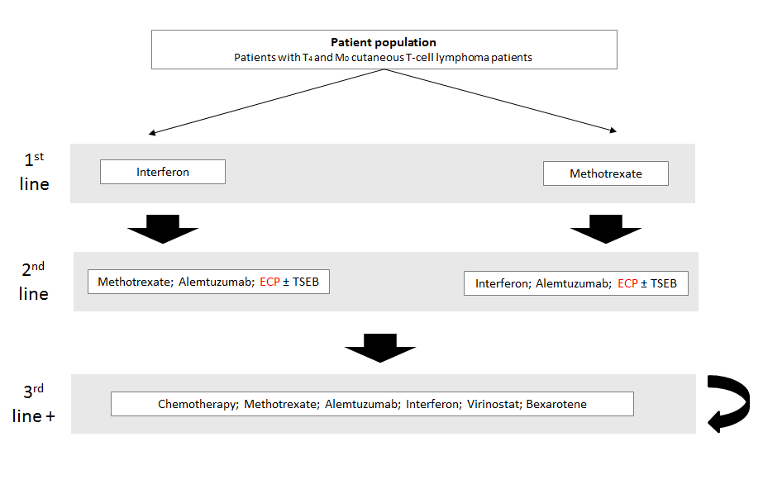

Regulatory information
- In Australia, integrated, closed-system ECP is currently registered with the TGA for the following indications:Cellex System (kit or system) is indicated for the administration of photopheresis.
Table 10 below outlines the ECP devices listed on the Australian Register of Therapeutic Goods (ARTG).
Table 10: Current ECP devices listed on the ARTG registration
ARTG number | Sponsor name | ARTG label name | Approval date | ARTG description/Intended purpose
219170 | Terumo BCT Australia Pty Ltd | Medical device class IIb – photopheresis system | 13/01/2014 | Indicated for use in the UVA irradiation in the presence of a photoactive drug, of extracoporeally circulating leukocyte-enriched blood in the palliative treatment of skin manifestations of CTCL and GVHD in persons not responsive to other forms of treatment.
219171 | Terumo BCT Australia Pty Ltd | Medical device class IIb – photopheresis system lamp assembly | 13/01/2014 | An assembly of replaceable ultraviolet. An emitting tubular strip lights inserted into a photopheresis instrument used to irradiate blood components during photoimmune therapy.
219197 | Terumo BCT Australia Pty Ltd | Medical device class IIa – photopheresis system blood set | 14/01/2014 | A single use set of devices that forms part of a photopheresis system to conduct blood from the patient to the photopheresis unit. Consists of tubing, centrifuge bowl, connectors, and clamps.
The indication for integrated, closed-system ECP has recently been amended to the stated indication; however the TGA website is currently displaying the previous indication.
The MBS item for integrated, closed-system ECP is within the TGA restriction, and is therefore appropriate within this setting.
The active ingredient of the integrated, closed-system ECP process is a 20mcg/mL methoxsalen solution which is not currently registered with TGA for the proposed indication. It was however designated orphan drug status in September 2015 for the treatment of CTCL. An application to the TGA for methoxsalen use in integrated, closed-system ECP is anticipated in 2016.

Decision analytic
Table 11 below outlines the summary of PICO that will be used to define the research question. It outlines the focus of the submission for integrated, closed-system ECP and its proposed use as a reimbursed therapy.
Table 11: Summary of PICO to define the research question
PICO | Comments
Patients | Erythrodermic (stage T₄, M₀) cutaneous T-cell lymphoma patients, who are refractory to one or more systemic treatments.
Intervention | Integrated, closed-system ECP
Comparator | Alemtuzumab  IFN-α2β  Methotrexate
Outcomes | - Quality of life/itch improvement/pruritus score  - Reduction in erythroderma/skin response/skin examination  - Time to next systemic treatment  - Overall survival  - Response rate  It is also noted that time to treatment failure (addition of another treatment or abandonment), time to response, global response (encompassing skin and blood and nodes) and progression free survival may also be used as important outcomes depending on the availability of data.
Safety outcomes | - Line-related complications  - Cardiovascular complications

Figure 5 below outlines the structure of the proposed economic model. The term ‘progression’ is used within the model to represent patients who have become unresponsive or refractory to other systemic treatments.
Figure 5: Proposed economic model format for treatment with integrated, closed-system ECP vs best supportive care.
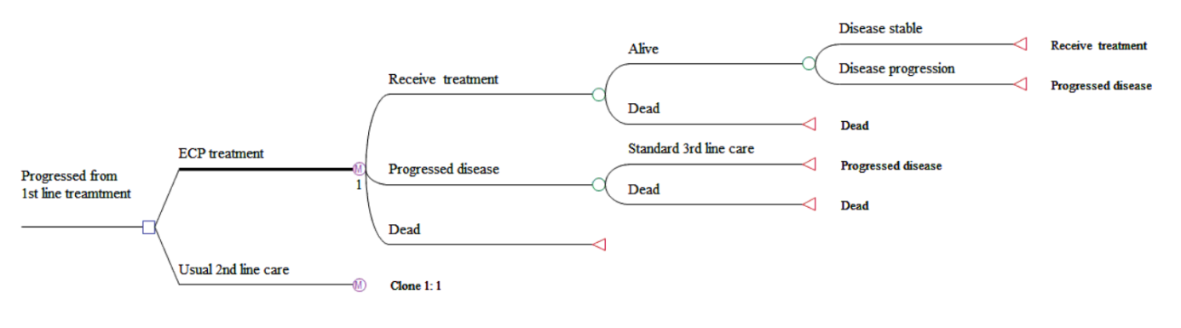

Healthcare resources
The healthcare resources involved with treatment with integrated, closed-system ECP are included within Table 12. These resources are based on the costs associated with an integrated, closed-system ECP device. As the safety profile of integrated and validated ECP systems is far better than open systems, this distinction avoids use of inferior technology that is associated with a higher rate of adverse events and higher costs for hospitals to comply with associated safety and quality standards [3].The itemised costs associated with integrated, closed-system ECP are outlined within Table 12 below and split into stages of treatment. The first section outlines the costs involved with beginning second or third treatments in CTCL. These costs are likely to be similar between integrated, closed-system ECP and best supportive care as they involve taking baseline values to allow changes in response to be observed. ‘Resources used as a result of using proposed treatment’ outlines the healthcare utilisation costs used during the treatment process, excluding the MBS fee for service. Adverse event costs refer to hospitalisations possibly associated with integrated, closed-system ECP. These are outlined within Section 9.2, and include adverse events for general lymphoma hospitalisation, vascular related adverse events, and skin related hospitalisations for full body skin wraps when patients experience pruritus. The adverse events for comparator treatments include the general lymphoma hospitalisation and skin related hospitalisations, while also incorporating the higher rates of infection associated with other CTCL treatments that reduce immune-capacity.

Table 12: List of resources to be considered in the economic analysis
 | Provider of resource | Code | Setting of service | Items included per Cost | Number of units of resource needed within relevant time horizon per patient receiving resource | AR-DRG total cost | PBS Cost (DPMQ) | MBS Cost | 75% benefit | 85% benefit | Total cost
Resources provided beginning second or third treatment (for both proposed medical service [integrated, closed-system ECP] and standard care[basket of comparators]) (OUTPATIENT TREATMENT)
Skin disease assessment | MBS | Assumption made that skin test is two hours of specialist attendance | Private | 1 | 1 | N/R | N/R | $86.00 | $64.70 | $73.10 | $86.00
Leucocyte count | MBS | 73802 | Private | 1 | 1 | N/R | N/R | $4.55 | $3.45 | $3.90 | $4.55
Blood tests | MBS | 65096 | Private | 1 | 1 | N/R | N/R | $41.00 | $30.75 | $34.85 | $41.00
Skin biopsy | MBS | 30071 | Private | 1 | 1 | N/R | N/R | $52.20 | $39.15 | $44.40 | $52.20
Initial specialist attendance | MBS | 104 | Private | 1 | 1 | N/R | N/R | $85.55 | $64.20 | $72.75 | $85.55
Subsequent specialist attendance | MBS | 105 | Private | 1 | 1 | N/R | N/R | $43.00 | $32.35 | $36.55 | $43.00
Other resources required for proposed treatment [integrated, closed-system ECP] (OUTPATIENT TREATMENT)
Subsequent specialist attendance | MBS | 105 | Private | 1 | 2 | N/R | N/R | $43.00 | $32.35 | $36.55 | $86.00
Supervising nurse attendance | AR-DRG Round 17 V6.0X Public (NURSE ATTENDANCE COMPONENT) | B62Z | Public hospital | 1 | 2 | N/R | N/R | $164.00 | N/R | N/R | $328.00
Blood tests | MBS | 65096 | Private | 1 | 1 | N/R | N/R | $41.00 | $30.75 | $34.85 | $41.00
Methoxsalen | PBS | XXXX | Private | 1 | 1 | N/R | $125.00 | N/R | N/R | N/R | $125.00/Treatment
Saline solution | PBS | 5212H | Private | 5 | 2 | N/R | $16.88 | N/R | N/R | N/R | $6.75
Heparin solution ampoules)) | PBS | 1463B | Private | 50 | 2 | N/R | $72.02 | N/R | N/R | N/R | $2.88
Adverse event costs related to proposed medical treatment [integrated, closed-system ECP] (INPATIENT TREATMENT)
Adverse event hospitalisation for lymphoma/acute leukaemia without complication | AR-DRG Round 17 V6.0X Public | R61C | Hospital | N/A | N/A | $1,212 | N/R | N/R | N/R | N/R | $1,212
Adverse event for vascular event: Stroke and other cerebral disorders without catastrophic or severe complications | AR-DRG Round 17 V6.0X Public | B70C | Hospital | N/A | N/A | $6,794 | N/R | N/R | N/R | N/R | $6,794
Adverse event for vascular event: Vascular Procedure Except Major Reconstruction without CPB Pump, without complication | AR-DRG Round 17 V6.0X Public | F14C | Hospital | N/A | N/A | $6,960 | N/R | N/R | N/R | N/R | $6,960
Hospitalisation for pruritus (Skin wraps) Other Skin, Subcutaneous Tissue and Breast Procedures | AR-DRG Round 17 V6.0X Public | J11Z | Hospital | N/A | N/A | $2,543 | N/R | N/R | N/R | N/R | $2,543
Adverse event costs related to existing medical treatment [Best supportive care] (INPATIENT TREATMENT)
Viral illness | AR-DRG Round 17 V6.0X Public | T63Z | Hospital | N/A | N/A | $3,128 | N/R | N/R | N/R | N/R | $3,128
Adverse event for infection event: Adverse event hospitalisation for lymphoma/acute leukaemia without complication | AR-DRG Round 17 V6.0X Public | R61C | Hospital | N/A | N/A | $1,212 | N/R | N/R | N/R | N/R | $1,212
Adverse event for infection event: Other Infectious and Parasitic Diseases without complications | AR-DRG Round 17 V6.0X Public | T64C | Hospital | N/A | N/A | $4,472 | N/R | N/R | N/R | N/R | $4,472
Hospitalisation for pruritus (Skin wraps) Other Skin, Subcutaneous Tissue and Breast Procedures | AR-DRG Round 17 V6.0X Public | J11Z | Hospital | N/A | N/A | $2,543 | N/R | N/R | N/R | N/R | $2,543
N/A, not available; N/R, not relevant, AR-DRG costs were obtained from Round 17 V6.0X Public list (http://www.health.gov.au/internet/ihpa/publishing.nsf/Content/CA25794400122452CA257E72007F65E1/$File/NHCDC%20Cost%20Report%202012-2013%20Round%2017.pdf) , MBS items were sourced from the MBS website (http://www.mbsonline.gov.au/internet/mbsonline/publishing.nsf/Content/Home), PBS costs are derived from the PBS website (http://www.pbs.gov.au/pbs/home)

Questions for public funding
The applicant has no questions for public funding

Refrences
See Appendix to protocol folder, “Other relevant articles used within this submission” for full text publications
1. Terumo, Prevalence of Cutaneous T-Cell Lymphomas (CTCL) in Australia. 2015.
2. Raphael, B.A., et al., High clinical response rate of s ézary syndrome to immunomodulatory therapies: Prognostic markers of response. Archives of Dermatology, 2011. 147(12): p. 1410-1415.
3. Knobler, R., et al., Guidelines on the use of extracorporeal photopheresis. Journal of the European Academy of Dermatology and Venereology, 2014. 28(SUPPL. 1): p. 1-37.
4. Clement, F.R., C; Taylor, P; Broughton, S;, A Review of Extracorporeal Photopheresis for Cancer and other diseases - Version 3, E.N.P.D. GROUP, Editor. 2008.
5. McKenna, K.E., et al., Evidence-based practice of photopheresis 1987-2001: a report of a workshop of the British Photodermatology Group and the U.K. Skin Lymphoma Group. Br J Dermatol, 2006. 154(1): p. 7-20.
6. Scarisbrick, J.J., et al., U.K. consensus statement on the use of extracorporeal photopheresis for treatment of cutaneous T-cell lymphoma and chronic graft-versus-host disease. Br J Dermatol, 2008. 158(4): p. 659-78.
7. Trautinger, F., et al., EORTC consensus recommendations for the treatment of mycosis fungoides/Sezary syndrome. Eur J Cancer, 2006. 42(8): p. 1014-30.
8. Prince, H.M., S. Whittaker, and R.T. Hoppe, How I treat mycosis fungoides and Sezary syndrome. Blood, 2009. 114(20): p. 4337-53.
9. Olsen, E., et al., Revisions to the staging and classification of mycosis fungoides and Sézary syndrome: a proposal of the International Society for Cutaneous Lymphomas (ISCL) and the cutaneous lymphoma task force of the European Organization of Research and Treatment of C…. Blood, 2007. 110(6): p. 1713-1722.
10. Li, J.Y., et al., Management of cutaneous T cell lymphoma: new and emerging targets and treatment options. Cancer Manag Res, 2012. 4: p. 75-89.
11. Hughes, C.F., et al., Mycosis fungoides and Sezary syndrome: Current challenges in assessment, management and prognostic markers. Australas J Dermatol, 2015.
12. Miller, J.D., et al., Review of extracorporeal photopheresis in early-stage (IA, IB, and IIA) cutaneous T-cell lymphoma. Photodermatology Photoimmunology and Photomedicine, 2007. 23(5): p. 163-171.
13. Talpur, R., et al., Multicenter Photopheresis Intervention Trial in Early-Stage Mycosis Fungoides. Clinical Lymphoma Myeloma and Leukemia, 2011. 11(2): p. 219-227.
14. National Comprehensive Cancer Network. NCCN clinical practice guidelines in oncology: non-Hodgkin’s lymphomas - version 3. 2013 [cited (last accessed: 30 October 2013). Available from: National Comprehensive Cancer Network.
15. Hughes, C.F.M., et al., Lack of durable disease control with chemotherapy for mycosis fungoides and Sézary syndrome: a comparative study of systemic therapy. Blood, 2015. 125(1): p. 71-81.
16. Cancer Council Australia, Clinical Practice Guidelines for the Diagnosis and Management of Lymphoma. 2005.
17. Weber, L.L., et al., Successful implementation of a rural extracorporeal photopheresis program for the treatment of cutaneous T-cell lymphoma and chronic graft-versus-host disease in a rural hospital. J Clin Apher, 2015. 30(6): p. 359-63.
18. Bouwhuis, S.A., et al., Treatment of late-stage Sézary syndrome with 2-Chlorodeoxyadenosine. International Journal Of Dermatology, 2002. 41(6): p. 352-356.
19. Edelson , R., et al., Treatment of Cutaneous T-Cell Lymphoma by Extracorporeal Photochemotherapy. New England Journal of Medicine, 1987. 316(6): p. 297-303.
20. Duvic, M., J.P. Hester, and N.A. Lemak, Photopheresis therapy for cutaneous T-cell lymphoma. Journal Of The American Academy Of Dermatology, 1996. 35(4): p. 573-579.
21. Heald, P.W., et al., Photopheresis therapy of cutaneous T-cell lymphoma: the Yale-New Haven Hospital experience. The Yale Journal Of Biology And Medicine, 1989. 62(6): p. 629-638.
22. Jiang, S.B., et al., Extracorporeal photochemotherapy for cutaneous T-cell lymphoma: a 9.7-year experience. Photodermatology, Photoimmunology & Photomedicine, 1999. 15(5): p. 161-165.
23. Prinz, B., et al., Extracorporeal photopheresis for the treatment of cutaneous T-cell lymphoma--the Düsseldorf and Munich experience. Archives Of Dermatological Research, 1995. 287(7): p. 621-626.
24. Stevens, S.R., et al., Circulating cd4+cd7− lymphocyte burden and rapidity of response: Predictors of outcome in the treatment of sézary syndrome and erythrodermic mycosis fungoides with extracorporeal photopheresis. Archives of Dermatology, 2002. 138(10): p. 1347-1350.
25. Weberschock, T., et al., Interventions for mycosis fungoides. Cochrane Database of Systematic Reviews, 2012. 9: p. CD008946.
26. Pierelli, L., et al., Extracorporeal photopheresis for the treatment of acute and chronic graft-versus-host disease in adults and children: best practice recommendations from an Italian Society of Hemapheresis and Cell Manipulation (SIdEM) and Italian Group for Bone Marrow Transplantation (GITMO) consensus process. Transfusion, 2013. 53(10): p. 2340-2352.
27. Yoo, E.K., et al., Apoptosis Induction by Ultraviolet Light A and Photochemotherapy in Cutaneous T-Cell Lymphoma: Relevance to Mechanism of Therapeutic Action. Journal of Investigative Dermatology, 1996. 107(2): p. 235-242.
28. Morelli, A.E., et al., Internalization of circulating apoptotic cells by splenic marginal zone dendritic cells: dependence on complement receptors and effect on cytokine production. Blood, 2003. 101(2): p. 611-20.
29. Lamioni, A., et al., The immunological effects of extracorporeal photopheresis unraveled: induction of tolerogenic dendritic cells in vitro and regulatory T cells in vivo. Transplantation, 2005. 79(7): p. 846-50.
30. Suchin, K.R., et al., Extracorporeal photochemotherapy does not suppress T- or B-cell responses to novel or recall antigens. Journal of the American Academy of Dermatology. 41(6): p. 980-986.
31. Dignan, F.L.A., P; Clark, A; Cornish, J; Jackson, G; Mahendra, P; Scarisbrick, J.J; Taylor, P.C; Shaw, B.E; Potter, M.N;, Diagnosis and management of chronic graft-versus-host disease. British Journal of Haematology, 2012(158).
32. Kanold, J., et al., Photopheresis in pediatric graft-versus-host disease after allogeneic marrow transplantation: clinical practice guidelines based on field experience and review of the literature. Transfusion, 2007. 47(12): p. 2276-2289.
33. Wolff, D., et al., Consensus Conference on Clinical Practice in Chronic GVHD: Second-Line Treatment of Chronic Graft-versus-Host Disease. Biol Blood Marrow Transplant, 2011. 17(1): p. 1-17.
34. Committee;, P.B.A. Public summary document: Vorinostat. 2011; Available from: P.B.A. Public summary document: Vorinostat. 2011.
35. Olsen, E.A., et al., Clinical end points and response criteria in mycosis fungoides and Sezary syndrome: a consensus statement of the International Society for Cutaneous Lymphomas, the United States Cutaneous Lymphoma Consortium, and the Cutaneous Lymphoma Task Force of the European Organisation for Research and Treatment of Cancer. J Clin Oncol, 2011. 29(18): p. 2598-607.
36. Quaglino, P., et al., Extracorporeal photopheresis for the treatment of erythrodermic cutaneous T-cell lymphoma: a single center clinical experience with long-term follow-up data and a brief overview of the literature. Int J Dermatol, 2013. 52(11): p. 1308-18.

