MSAC Application 1751

Valoctocogene roxaparvovec for Haemophilia A

PICO Set 2

PICO set 2: AAV5 test

Population
Describe the population in which the proposed health technology is intended to be used:
The population in which the AAV5 DetectCDx™ test is intended to be used is adults with severe haemophilia A) without a history of FVIII inhibitors and without active hepatitis or severe liver disease, to determine eligibility for access to valoctocogene roxaparvovec treatment*.
*As per the valoctocogene roxaparvovec PICO set, the proposed population for valoctocogene roxaparvovec includes adults with severe haemophilia A without a history of FVIII inhibitors and pre-existing antibodies to AAV5, without active hepatitis or severe liver disease (see valoctocogene roxaparvovec PICO set for further details).
Specify any characteristics of patients with the medical condition, or suspected of, who are proposed to be eligible for the proposed health technology, describing how a patient would be investigated, managed and referred within the Australian health care system in the lead up to being considered eligible for the technology:
The proposed population is adults with severe haemophilia A without a history of FVIII inhibitors and without active hepatitis or severe liver disease.
As detailed in the valoctocogene roxaparvovec PICO set, patients are managed at haemophilia treatment centres (HTCs), where diagnosis is confirmed and assessments are performed. Patients considered eligible for treatment with valoctocogene roxaparvovec will be referred by the treating physician for AAV5 antibody testing.
Details of the steps involved in the testing procedure including referral, are provided below in the intervention section.
Provide a rationale for the specifics of the eligible population:
The rationale for the specifics of the eligible population for the testing of AAV5 DetectCDx™ test is to inform patient eligibility for treatment with valoctocogene roxaparvovec. AAV5 DetectCDx detects pre-existing AAV5 antibodies in patients with haemophilia A. Patients in whom AAV5 antibodies are ‘detected’ are not eligible for treatment with valoctocogene roxaparvovec; patients in whom AAV5 antibodies are ‘not detected’ are eligible for treatment with valoctocogene roxaparvovec assuming they meet the other eligibility requirements for the treatment (see valoctocogene roxaparvovec PICO set).

Intervention
Name of the proposed health technology:
The name of the proposed health technology is AAV5 DetectCDx™ (generic name: AAV5 Total Antibody (TAb) Assay for Valoctocogene Roxaparvovec Eligibility in Haemophilia A).
Describe the key components and clinical steps involved in delivering the proposed health technology:
The AAV5 DetectCDx™ is a companion diagnostic (CDx) intended for use with valoctocogene roxaparvovec, a gene therapy proposed for use in adults with severe haemophilia A without a history of FVIII inhibitors and pre-existing antibodies to AAV5, without active hepatitis or severe liver disease, as discussed above.
This assay is a single-site assay for professional use performed at ARUP Laboratories. ARUP Laboratories is a clinical reference laboratory located in the United States. ARUP participates in the College of American Pathologists (CAP) Laboratory Accreditation Program and has CLIA (Clinical Laboratory Improvement Amendments) certification through CMS (Centers of Medicare and Medicaid Services). ARUP holds current licenses and permits required by US state or local regulations. ARUP is also ISO 15189 College of American Pathologists (CAP) accredited.
The AAV5 DetectCDx™ is a non-automated companion diagnostic test that uses a bridging immunoassay to detect antibodies to AAV5 in human sodium citrated (3.2%) plasma specimens. The AAV5 DetectCDx™ uses a combination of concurrently conducted screening and confirmatory steps to reliably detect antibodies specific for AAV5 capsid. The screening step assesses for the presence of anti-AAV5 antibodies, while the confirmatory step determines if the electrochemiluminescence (ECL) signal is specific. In the confirmatory step, samples are pre-incubated with unlabelled capsid (referred to as AAV5 confirmatory reagent) to compete for any anti-AAV5 antibodies that are present. If AAV5-binding antibodies are present, they will be bound by the unlabelled AAV5 capsid, resulting in a reduced ECL signal for the confirmatory step as compared to the screening step.
A positive result in the screening step is confirmed in the confirmatory step prior to providing a test result of “Detected” to indicate the presence of anti-AAV5 antibodies. A “Not Detected” test result indicates that anti-AAV5 antibodies were not detected in the screening step or that the confirmatory step did not confirm the presence of anti-AAV5 antibodies.
The AAV5 DetectCDx™ is performed only at ARUP Laboratories, a single laboratory site located at 500 Chipeta Way, Salt Lake City, UT 84108. The ARUP clinical laboratory responsible for testing and reporting results, and is ISO15189, CLIA, and CAP certified.
The AAV5 DetectCDx™ utilises reagents manufactured exclusively for use with the AAV5 DetectCDx™ by ARUP Laboratories, as well as reagents and instrumentation which have been specifically validated for, and approved for use as part of, the AAV5 DetectCDx™.
The AAV5 DetectCDx™ is authorised for use in Europe and received its Conformité Européene (CE) mark in January 2022 under the EU’s In-Vitro Diagnostic Devices Directive (IVDD) program. The AAV5 DetectCDx™ was approved by the U.S. Food and Drug Administration (FDA) on 29 June 2023.
Steps
Specimen preparation and transport to ARUP laboratories
- The AAV5 DetectCDx™ is ordered from ARUP by the healthcare professional at the HTC. The patient’s whole blood is collected in a 3.2% sodium citrate tube, with the specimen centrifuged and plasma separated within two hours of collection. Then 1mL (minimum of 0.5 mL) of plasma is transferred into a pour-off polypropylene transport tube. The plasma specimens must be frozen prior to being shipped and must be transported to ARUP Laboratories frozen on dry ice.
Assay principle and format
- The AAV5 DetectCDxTM is a manually run ECL-based bridging immunoassay performed in a 96-well plate format. MULTI-ARRAY 96-well plates (Meso Scale Diagnostics, LLC) are coated with unlabeled AAV5-CMV-GFP Coating Reagent (followed by washing and blocking steps) and then incubated with diluted patient plasma specimens.
- If anti-AAV5 antibodies are present in the patient specimen, the antibodies bind to the unlabeled AAV5-CMV-GFP capsid coating the wells.
- After washing the plate, SULFO-TAG-labeled AAV5 Detection Reagent is added to each well and anti-AAV5 antibodies present in patient samples will bind the SULFO-TAG capsid in the AAV5 Detection Reagent, which participates in the ECL reaction.
- After incubation and washing, Read Buffer T (containing TPA substrate, Meso Scale Diagnostics, LLC) is added to each well. The plate is then read on the MESO QuickPlex SQ 120 ECL-based plate reader (Meso Scale Diagnostics, LLC). Each well of the plate is electrically stimulated and the resultant ECL signal is measured.
- Anti-AAV5 antibodies in the patient specimen form a bridge between the AAV5 capsid coating the plate and the ruthenylated (Ru-)/SULFO-TAG AAV5 capsid in the AAV5 Detection Reagent (Figure 1). With addition of the TPA substrate in the Read Buffer T, an ECL signal is generated in wells with patient specimen containing anti-AAV5 antibodies.

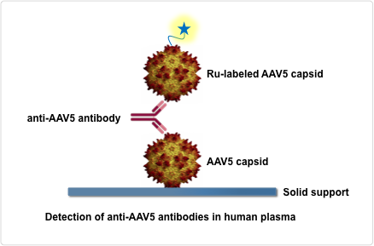
Figure 1: Schematic of the AAV5 DetectCDxTM ECL-based immunoassay.

- Patient specimens are run in the screening and confirmatory steps of the AAV5 DetectCDxTM in parallel, in separate wells of the 96-well plate (Figure 2).
- The confirmatory step methodology is identical to that of the screening step, except that patient specimens are pre-incubated with unlabeled capsid (referred to as AAV5 Confirmatory Reagent) to compete for any anti-AAV5 antibodies that are present, prior to addition to the 96-well plate. If AAV5-binding antibodies are present in the patient specimen, they will be bound by the unlabeled AAV5 capsid, resulting in a reduced ECL signal for the confirmatory step as compared to the screening step.
- Each 96-well plate includes a cut point control (CC), negative control (NEG), a low antibody positive control (LPC), and a high antibody positive control (HPC; Figure 2). For run/plate acceptance and for patient results to be reported, the NEG, CC, HPC, and LPC must meet the pre-established criteria for the between-well coefficient of variation (CV) for replicate wells. The HPC and LPC must screen and confirm positive, and the HPC, LPC, and NEG signals must fall within the established acceptance range.
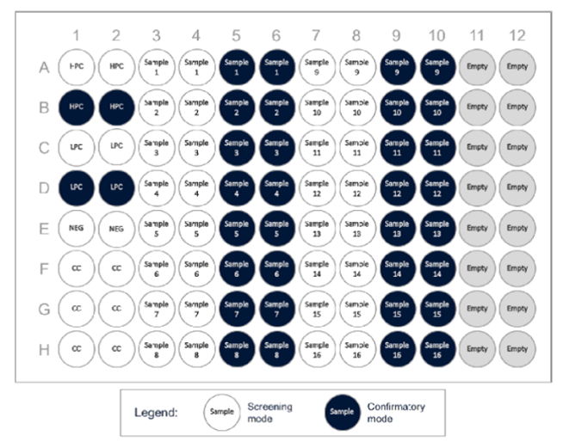
Figure 2: AAV5 DetectCDxTM Plate Map
Interpretation of results
- Results for the screening step are expressed as a Screen Index (SI). The SI is calculated by dividing the normalised screening result by the screening cut point.
- Results for the confirmatory step are expressed as a Confirm Index (CI). The CI is obtained by calculating the ratio of mean signals obtained for the confirmatory and screening steps and dividing this by the confirmatory cut point (CCP).
- The CI is not considered if anti-AAV5 antibodies are not detected in the screening step. Results are based on the values obtained for the SI and CI (Figure 3).
The screening cut point (SCP) is defined as the signal to noise (S/N) value at which a specimen will be considered negative if the specimen S/N is less than the calculated cut point value. The SCP was empirically determined to obtain a 5% false positive rate. The confirmatory cut point (CCP) was empirically determined to obtain a 1% false positive rate. Based on these analyses, when (S/N) = 1.14 for a sample, the SI = 1.0 (see Summary of Evidence Section for details regarding the establishment of screening and confirmatory cut-points).
- Specimens with SI < 1.00, or SI > 1.00 with a CI > 1.00, are reported as ‘not detected’ for anti-AAV5 antibodies.
- Specimens with SI ≥ 1.00 and CI ≤ 1.00 are reported as ‘detected’ for anti-AAV5 antibodies.
Patients evaluated with the AAV5 DetectCDx™ who are anti-AAV5 antibody negative (result of Not Detected) are eligible for treatment with valoctocogene roxaparvovec under the supervision of a physician.
- Detected: patient is not eligible for treatment with valoctocogene roxaparvovec
- Not Detected: patient is eligible for treatment with valoctocogene roxaparvovec

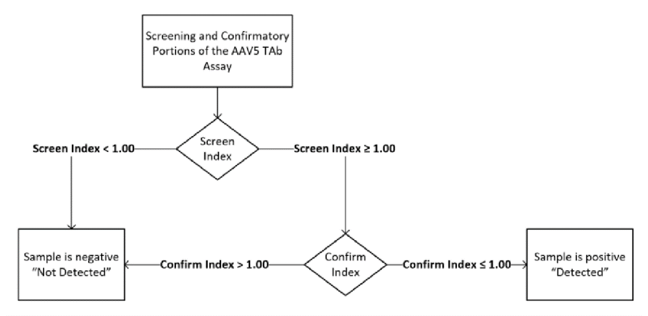
Figure 3: Summary of Resulting and Reporting for the two-step AAV5 DetectCDxTM

Clinical utility standard
The test used in the clinical trials of valoctocogene roxaparvovec, referred to as the clinical trial assay (CTA), differs from the proposed AAV5 DetectCDxTM test. Therefore, the CTA is the clinical utility standard for the purpose of the co-dependent assessment because it reflects the test used to inform the selection of patients upon whom the therapeutic outcomes are based, whereas the AAV5 DetectCDx™ test is the test that will be used in clinical practice.

The differences between the CTA and the AAV5 DetectCDxTM include a change in the capsid concentration in the AAV5 detection reagent and modification of the assay incubation time. All the analytical performance studies described in the Summary of Evidence Section (except concordance study), that were used to analytically validate the AAV5 DetectCDxTM, were performed using the final version of the assay (CDx).
The outcomes assessed in the analytical performance studies (see Summary of Evidence Section), that will be presented in the submission, include:
- Test reliability:
  - Intra-observer or intra-instrument variability/agreement (eg, repeatability of results conducted in a patient on multiple occasions, or repeatability of results conducted by single technician etc)
  - Inter-observer or inter-instrument variability/agreement (test results are reproducible across different patients / different technicians)

- Concordance:
  - Assessing the agreement between the CTA and the AAV5 DetectCDxTM that will be used in clinical practice.
Identify how the proposed technology achieves the intended patient outcomes:
The intended patient outcome is to determine if a patient is eligible for valoctocogene roxaparvovec. The AAV5 DetectCDx™ test does this by identifying patients that are anti-AAV5 antibody positive (result of ‘detected’ = not eligible) and anti-AAV5 antibody negative (result of ‘not detected’ = eligible).
Does the proposed health technology include a registered trademark component with characteristics that distinguishes it from other similar health components?
Yes, AAV5 DetectCDx™
Explain whether it is essential to have this trademark component or whether there would be other components that would be suitable:
It is essential to have this trademark component as there are no alternative AAV5 antibody tests available (noting that the test is not intended for listing on the MBS as detailed below).

Are there any proposed limitations on the provision of the proposed health technology delivered to the patient (For example: accessibility, dosage, quantity, duration or frequency)
No
Provide details and explain:
N/A

If applicable, advise which health professionals will be needed to provide the proposed health technology:
ARUP Medical Laboratory Trained Scientists.

If applicable, advise whether delivery of the proposed health technology can be delegated to another health professional:
At the time of implementation, the AAV5 DetectCDx™ test will solely be conducted by ARUP trained Medical Laboratory Scientists at a single site laboratory.
If applicable, advise if there are any limitations on which health professionals might provide a referral for the proposed health technology:
As discussed in the valoctocogene roxaparvovec PICO set, The AHCDO roadmap proposes a hub and spoke model of care for the administration of gene therapy in Australia. While it is the spoke centre’s responsibility to identify and screen patients for selection, the decision of which patients to treat is shared by the hub and spoke centres, and the hub being responsible for the administration of gene therapy.
Therefore, specialists at these spoke/hub Haemophilia Treatment Centres (HTCs) will provide a referral for the proposed test, in patients considered for treatment with valoctocogene roxaparvovec. It is not intended for patients to be referred for the AAV5 DetectCDx™ test outside of these centres.
Is there specific training or qualifications required to provide or deliver the proposed service, and/or any accreditation requirements to support delivery of the health technology?
The proposed service will be performed by ARUP Medical Laboratory Scientists who have been trained by ARUP to conduct the test.
Provide details and explain:
The ARUP Medical Laboratory Scientists are required to maintain medical laboratory scientist (MLS) certification through the American Society for Clinical Pathology (ASCP).
Indicate the proposed setting(s) in which the proposed health technology will be delivered:

Consulting rooms
Day surgery centre
Emergency Department
Inpatient private hospital
Inpatient public hospital
Laboratory
Outpatient clinic
Patient’s home
Point of care testing
Residential aged care facility
Other (please specify)

Is the proposed health technology intended to be entirely rendered inside Australia?
No
Please provide additional details on the proposed health technology to be rendered outside of Australia:
An AAV5 test is currently not available in Australia.
The AAV5 DetectCDx™ was developed by ARUP Laboratories’ PharmaDx Group in partnership with BioMarin to identify patients who are eligible for treatment with valoctocogene roxaparvovec, with the test conducted at ARUP Laboratories in the United States (single centre). It is not currently viable to set up testing of AAV5 in Australia given the small patient numbers and highly specialised nature of the test.
REDACTED

Summary of process:
The anticipated workflow for testing is as follows:
- Patient eligibility: The patient will be assessed for eligibility for valoctocogene roxaparvovec by the hub and/or spoke HTCs ahead of AAV5 testing.
- Test ordering: The haematologist at the hub and/or spoke HTC will order the test from ARUP via a secure web-based portal to ensure secure data transfer to ARUP lab.
- Sample collection: The blood sample will be collected by the hub and/or spoke HTC, spun down and plasma frozen within 2 hours (as described above).
- Sample shipping: The frozen sample will be shipped by World Courier, on dry ice, to ARUP laboratory REDACTED
- Analysis and reporting: ARUP laboratory will conduct the test and analysis and report AAV5 antibody results (‘detected’ or ‘not detected’) to the haematologist via the secure web-based portal.

More detailed implementation process information will be provided in the ADAR.

Comparator
Nominate the appropriate comparator(s) for the proposed medical service (i.e. how is the proposed population currently managed in the absence of the proposed medical service being available in the Australian health care system). This includes identifying health care resources that are needed to be delivered at the same time as the comparator service:

Please provide a name for your comparator:
There is currently no comparator to AAV5 DetectCDx™, and without this test, eligibility for valoctocogene roxaparvovec treatment cannot be determined and patients will continue with prophylactic treatment with FVIII therapy or emicizumab (as per the comparators in the valoctocogene roxaparvovec PICO set).
Please provide an identifying number for your comparator (if applicable):
N/A
Please provide a rationale for why this is a comparator:
There are no available alternative tests for detection of anti-AAV5 antibodies in human plasma for informing eligibility of haemophilia A patients for treatment with valoctocogene roxaparvovec, as such, a comparator to the proposed test does not exist.
Pattern of substitution – Will the proposed health technology wholly replace the proposed comparator, partially replace the proposed comparator, displace the proposed comparator or be used in combination with the proposed comparator?

None – used with the comparator
Displaced – comparator will likely be used following the proposed technology in some patients
Partial – in some cases, the proposed technology will replace the use of the comparator, but not all
Full – subjects who receive the proposed intervention will not receive the comparator

Please outline and explain the extent to which the current comparator is expected to be substituted:
The comparator is no test.

Outcomes
List the key health outcomes (major and minor – prioritising major key health outcomes first) that will need to be measured in assessing the clinical claim for the proposed medical service/technology (versus the comparator):
N/A – The test informs eligibility for treatment with valoctocogene roxaparvovec.
Outcome description – please include information about whether a change in patient management, or prognosis, occurs as a result of the test information:
The test informs eligibility for treatment with valoctocogene roxaparvovec.

Claims
In terms of health outcomes (comparative benefits and harms), is the proposed technology claimed to be superior, non-inferior or inferior to the comparator(s)?

Superior
Non-inferior
Inferior

Please state what the overall claim is, and provide a rationale:
Relative to the comparator: Compared with not testing, the AAV5 DetectCDx™ test is superior in detecting patients eligible for valoctocogene roxaparvovec.
In turn, treatment with valoctocogene roxaparvovec provides superior outcomes relative to its comparators (see valoctocogene roxaparvovec PICO set).
Relative to the clinical utility standard: The pre-clinical studies show that the AAV5 DetectCDx™ test is concordant with the clinical utility standard and is a reliable and reproducible test.

Why would the requestor seek to use the proposed investigative technology rather than the comparator(s)?
N/A

Identify how the proposed technology achieves the intended patient outcomes:
The AAV5 DetectCDx™ test detects pre-existing anti-AAV5 antibodies in patients with haemophilia A to inform patient eligibility for valoctocogene roxaparvovec, by ruling out those with pre-existing AAV5 antibodies.

For some people, compared with the comparator(s), does the test information result in:

A change in clinical management?
Yes, the test detects patients eligible for treatment with valoctocogene roxaparvovec that, without the test, would not have been detected.

A change in health outcome?
Yes, superior outcomes are achieved with valoctocogene roxaparvovec relative to prophylactic treatment with FVIII therapy or emicizumab.
Other benefits?
No, there are no other reasons to use this test other than to determine whether or not the patient has antibodies to AAV5 and is eligible for treatment with valoctocogene roxaparvovec

Please provide a rationale, and information on other benefits if relevant:
N/A

In terms of the immediate costs of the proposed technology (and immediate cost consequences, such as procedural costs, testing costs etc.), is the proposed technology claimed to be more costly, the same cost or less costly than the comparator?

More costly
Same cost
Less costly

Provide a brief rationale for the claim:
Compared with not testing, the test is more costly. REDACTED

Summary of Evidence
Provide one or more recent (published) high quality clinical studies that support use of the proposed health service/technology.
No published clinical studies are available for the AAV5 DetectCDx™ test. ARUP Laboratories has conducted pre-clinical studies on the reliability of the AAV5 DetectCDx™ test. The table below provides a short summary of the more pertinent precision studies conducted to date. Note that, all calculations were performed by the FDA in their assessment of the AAV5 DetectCDx™ test.

Summary of pre-clinical evidence for the AAV5 test
 | Study type | Method | Results
1 | Establishment of screening and confirmatory cut points | The screening and confirmatory cut points for the AAV5 DetectCDxTM were established prior to use of the investigational device in nonclinical studies and the 270-301 clinical study. Once established, the cut points for the device were locked and remain unchanged. | Disease-specific screening and confirmatory cut points were determined by analysis of plasma samples from eighty (80) previously unscreened haemophilia A patients. A balanced experimental design was utilised to diminish the variability associated with different analysts, runs and plates (Shankar et al., 2008). Two (2) analysts tested batches of five (5) plates, each plate containing a subgroup of 16 samples. For determination of both screening and confirmatory cut points, samples were run in duplicate in both the screening and confirmatory portions of the assay, for a total of four (4) wells on each plate. Each analyst tested each sample five (5) times on five (5) separate runs conducted on separate days, of which three (3) were non-consecutive days, resulting in each sample being tested a total of 10 times on 10 separate runs.  At the time of this study, no other method was currently available to detect infection or exposure to AAV5, therefore, it was not possible to know a priori which samples were negative or positive for anti-AAV5 antibodies. For this reason, a strategy was developed to identify samples containing pre-existing antibodies to AAV5, considered “true positives”, so that these samples could be removed from further statistical analysis of the screening cut point. This strategy involved the removal of samples that generated signals greater than the Low Positive Control (LPC), a known anti-AAV5 positive sample, as well as the removal of statistical outliers that were identified as additional true positives. The assay-specific, fixed Screening Cut Point (SCP) was thus established based on the statistical analysis of the set of samples identified as negative for anti-AAV5 antibodies, to generate a 5% false positive rate. The resultant analysis produced a SCP value of 1.14. The SCP is used as a normalization factor to calculate the Screen Index (SI). The SI = (S/N)/SCP, where S/N is the signal to noise. Thus when (S/N) = 1.14 for a sample, the SI = 1.0.  In order to calculate the Confirmatory Cut Point (CCP) for the assay, the Inhibition Ratio (IR) was calculated for each sample run in the screening and confirmatory steps of the assay (the IR = µconfirm / µscreen). Samples in which the mean IR was greater than or equal to the mean IR for the LPC were removed as true positives with pre-existing anti-AAV5 antibodies. The assay-specific, fixed CCP was thus established based on the statistical analysis of a set of samples negative for anti-AAV5 antibodies, to generate a 1% false positive rate. The resultant analysis produced a CCP of 0.707. The CCP is used as a normalization factor to calculate the Confirmatory Index (CI). For samples with SI > 1.00, a CI > 1.00 indicates the sample is negative for anti-AAV5 antibodies and samples with a CI ≤ 1.00 are deemed positive for anti-AAV5 antibodies.
2. | Bridging studies (clinical trial assay (CTA) and CDx) (concordance) | A bridging study was performed to demonstrate concordance of the CTA, used investigationally in the clinical studies, with the AAV5 DetectCDxTM, which was analytically validated in studies, and to bridge the safe and effective use of the AAV5 DetectCDx for its intended use as demonstrated with use of the CTA in the clinical studies, a bridging study was performed evaluating 106 clinical samples with both assays. | Concordance results for CTA/AAV5 DetectCDx bridging study  The study included 43 samples with an expected result of Detected and 63 samples with an expected result of Not Detected. Additionally, seven of the 43 Detected samples and seven of the 63 Not Detected samples evaluated in the study were within 20% of the assay cutoffs.  The results from this study indicated a 95% positive percent agreement (PPA), 94% negative percent agreement (NPA), and 94% overall percent agreement (OPA) for the AAV5 DetectCDxTM (see table).  CTA  Detected Not detected  AAV5 DetectCDx Detected 41 4  Not detected 2 59  It was noted that all six discordant samples had assay results near the SI/CI cutoffs for the assay. This study demonstrates that the CTA and AAV5 DetectCDxTM have a high degree of concordance with a 95% PPA for the AAV5 DetectCDxTM.
3 | Precision study  Within laboratory precision: repeatability, between-run, and between day components | The within-laboratory precision study was based on the single-site precision evaluation study, performed over 20 days, with two runs (plates) per day, and two true replicate measurements per sample type (a true replicate measurement is an average of two replicates of the same sample on the same plate). A single lot of critical reagents was used in the study, and the study was run on a single instrument system by a single operator. A total of 80 replicates were collected per sample (20 days x 2 runs/per day) x 2 replicates = 80 replicates per sample). | Repeatability, between-run, and between day results  20 day precision study – SI values  Repeatability Between-run Between-day  Sample type N Mean SD %CV SD %CV SD %CV  High Negative 80 0.88 0.029 3.3% 0.032 3.6% 0.010 1.2%  Cutoff 79** 1.05 0.032 3.0% 0.045 4.3% 0.018 1.7%  Low Positive 80 1.63 0.034 2.1% 0.069 4.2% 0.038 2.3%  Mid Positive 80 2.01 0.048 2.4% 0.084 4.2% 0.149 7.4%  High positive 79** 41.55 1.266 3.0% 3.182 7.7% 3.521 8.5%  High negative: SI < 1.00 and CI~1.20; Cut-off: SI >1.00 and CI~ 1.00; Low positive: SI >1.00 and CI~ 0.80; Mid positive SI ~1.80 and CI ~0.60; High positive SI > 10.0 and CI < 0.20  20 day precision study – CI values  Repeatability Between-run Between-day  Sample type N Mean SD %CV SD %CV SD %CV  High Negative 80 1.181 0.058 4.9% 0.039 3.3% 0.000 0.00%  Cutoff 79 1.005 0.031 3.1% 0.058 5.7% 0.033 3.2%  Low Positive 80 0.673 0.030 4.5% 0.025 3.7% 0.021 3.1%  Mid Positive 80 0.521 0.022 4.3% 0.015 7.0% 0.051 9.8%  High positive 79 0.027 0.001 4.3% 0.002 7.6% 0.003 10.2%
4 | Precision study: Repeatability | The repeatability study evaluated each of the five sample types in 16 true replicates on a single plate (run), using a single lot of reagents, and run on a single instrument system by a single operator. A true replicate is the mean of the measurements from two duplicate wells on the plate. | Repeatability – qualitative results  Sample type N Mean SI Mean CI % detected %not detected  High Negative 16 0.94 1.256 0/16 (100) 16/16 (100)  Cutoff 16 1.07 1.005 9/16 (56.25) 7/16 (43.75)  Low Positive 16 1.49 0.726 16/16 (100) 0/16 (100)  Mid Positive 16 1.80 0.638 16/16 (100) 0/16 (100)  High positive 16 35.91 0.031 16/16 (100) 0/16 (100)  Repeatability = SI and CI values  SI -repeatability CI -repeatability  Sample type N Mean SI SD %CV N Mean CI SD %CV  High Negative 16 0.94 0.052 5.6% 16 1.256 0.073 5.8%  Cutoff 16 1.07 0.051 4.8% 16 1.005 0.050 5.0%  Low Positive 16 1.49 0.035 2.4% 16 0.726 0.026 3.6%  Mid Positive 16 1.80 0.070 3.9% 16 0.638 0.051 8.0%  High positive 16 35.91 1.71 4.8% 16 0.031 0.002 6.8%
5 | Precision study:  Within-laboratory precision: operator-to-operator variability | Each sample type was evaluated by each of three operators, over five (non-consecutive) days, with one run (plate) per day, and with five true replicates on each plate. A true replicate is the mean of the measurements from two duplicate wells on the plate. Each operator evaluated performance of the sample types on different plates (different runs), and as such, operator imprecision is confounded by run (plate). The study was conducted using a single lot of critical reagents and was performed on a single instrument system. A total of 75 data points each were collected per sample analysed (5 days x 3 Operator runs (1 per day) x 5 replicates = 75 data points per sample). | Operator precision – qualitative results  Sample type N Mean SI Mean CI % detected overall % detected Operator 1 % detected Operator 2 % detected Operator 3  High Negative 75 0.86 1.191 0/75 (0) 0/25 (0) 0/25 (0) 0/25 (0)  Cutoff 73 1.03 1.008 25/73 (34.2) 4/24 (17) 11/24 (46) 10/25 (40)  Low Positive 75 1.54 0.706 75/75 (100) 25/25 (100) 25/25 (100) 25/25 (100)  Mid Positive 75 1.90 0.537 75/75 (100) 25/25 (100) 25/25 (100) 25/25 (100)  High positive 74 38.48 0.028 75/75 (100) 25/25 (100) 25/25 (100) 24/24 (100)  Operator precision – SI values  Repeatability Between operator/run Between day  Sample type N Mean SI SD % CV SD % CV SD % CV  High Negative 75 0.86 0.025 2.9 0.038 4.4 0.020 2.4  Cutoff 73 1.03 0.033 3.2 0.037 3.6 0.000 0.0  Low Positive 75 1.54 0.037 2.4 0.087 5.6 0.022 1.5  Mid Positive 75 1.90 0.048 2.5 0.161 8.5 0.000 0.0  High positive 74 38.48 1.864 4.8 3.974 10.3 0.000 0.0  Operator precision – CI values  Repeatability Between operator/run Between day  Sample type N Mean CI SD % CV SD % CV SD % CV  High Negative 75 1.191 0.0443 3.7 0.0153 1.3 0.0274 2.3  Cutoff 73 1.008 0.428 4.3 0.0311 3.1 0.0225 2.2  Low Positive 75 0.706 0.0311 4.4 0.0121 1.7 0.0086 1.25  Mid Positive 75 0.537 0.0214 4.0 0.0219 4.1 0.0215 4.0  High positive 74 0.028 0.0020 7.0 0.0016 5.6 0.0007 2.4
6 | Precision study  Within-laboratory precision: instrument-to-instrument variability | Each sample type was run on two instruments, over five (non-consecutive) days, with one run (plate) per day, and with five true replicates on each plate. A true replicate is the mean of the measurements from two duplicate wells on the plate. Samples were tested on each instrument on discrete plates, as independent runs. The study was conducted using a single lot of critical reagents and was performed on two instruments. A total of 50 replicates per sample were collected (5 days x 2 Instruments x 1 run/day x 5 replicates = 50 replicates per sample). | Instrument precision – qualitative results  Sample type N Mean SI Mean CI % detected overall % detected instrument 1 % detected instrument 2  High Negative 50 0.88 1.189 0/50 (0) 0/25 (0) 0/25 (0)  Cutoff 50 1.06 0.991 30/50 (60) 19/25 (76) 11/25 (44)  Low Positive 50 1.63 0.696 50/50 (100) 25/25 (100) 25/25 (100)  Mid Positive 50 2.06 0.512 50/50 (100) 25/25 (100) 25/25 (100)  High positive 50 42.55 0.027 50/50 (100) 25/25 (100) 25/25 (100)  Instrument precision – SI values  Repeatability Between operator/run Between day  Sample type N Mean SI SD % CV SD % CV SD % CV  High Negative 50 0.88 0.030 3.4% 0.000 0.0% 0.012 1.4%  Cutoff 50 1.06 0.041 3.8% 0.025 2.4% 0.000 0.0%  Low Positive 50 1.63 0.051 3.1% 0.080 4.9% 0.026 1.6%  Mid Positive 50 2.06 0.093 4.5% 0.080 3.9% 0.115 5.6%  High positive 50 42.55 3.149 7.4% 2.827 6.6% 2.310 23.0%  Instrument precision – CI values  Repeatability Between operator/run Between day  Sample type N Mean CI SD % CV SD % CV SD % CV  High Negative 50 1.189 0.0459 3.9% 0.0000 0.0% 0.0101 0.9%  Cutoff 50 0.991 0.0403 4.1% 0.0109 1.1% 0.286 2.9%  Low Positive 50 0.696 0.0289 4.1% 0.0092 1.3% 0.0186 2.7%  Mid Positive 50 0.512 0.0266 5.2% 0.0165 3.2% 0.231 4.5%  High positive 50 0.027 0.0023 8.6% 0.0008 3.2% 0.0008 3.1%
7 | Precision study  Within-laboratory precision: lot-to-lot variability | Each sample type was run with three unique reagent lots, over six (non-consecutive) days, with one run (plate) per day, and with four true replicates on each plate. A true replicate is the mean of the measurements from two duplicate wells on the plate. Samples were tested with each reagent lot with one run per day on discrete plates, as independent runs. The study was run on a single instrument system by a single operator. A total of 72 replicates per sample were collected (6 days x 3 lots x 1 run/day x 4 replicates = 72 replicates per sample). | Critical reagent lot precision – qualitative results  Sample type N Mean SI Mean CI % detected overall % detected lot 1 % detected lot 2 % detected lot 3  High Negative 72 0.85 1.195 0/72 (0) 0/24 (0) 0/24 (0) 0/24 (0)  Cutoff 71 1.42 0.713 71/71 (100) 24/24 (100) 23/23 (100) 24/24 (100)  Low Positive 72 6.21 0.162 72/72 (100) 24/24 (100) 24/24 (100) 24/24 (100)  Mid Positive 71 42.04 0.026 71/71 (100) 24/24 (100) 24/24 (100) 23/23 (100)  High positive 72 0.85 1.195 0/72 (0) 0/24 (0) 0/24 (0) 0/24 (0)  Critical reagent lot precision – SI values  Repeatability Between run/day Between lot  Sample type N Mean SI SD % CV SD % CV SD % CV  High Negative 72 0.85 0.022 2.6% 0.028 3.3% 0.000 0.0%  Cutoff 71 1.42 0.035 2.5% 0.034 2.4% 0.034 2.4%  Low Positive 72 6.21 0.192 3.1% 0.423 6.8% 0.409 6.6%  Mid Positive 71 42.04 1.087 2.6% 4.836 11.5% 3.074 7.3%  High positive 72 0.85 0.022 2.6% 0.028 3.3% 0.000 0.0%  Critical reagent lot precision – CI values  Repeatability Between run/day Between lot  Sample type N Mean CI SD % CV SD SD % CV SD  High Negative 72 1.195 0.042 3.5% 0.000 0.0% 0.044 3.7%  Cutoff 71 0.713 0.025 3.6% 0.010 1.3% 0.016 2.3%  Low Positive 72 0.162 0.009 5.5% 0.007 4.5% 0.012 7.4%  Mid Positive 71 0.026 0.001 4.9% 0.003 10.4% 0.002 7.9%  High positive 72 1.195 0.042 3.5% 0.000 0.0% 0.044 3.7%
CI, confirm index; CV, coefficient of variation; SI, screen index.
Note:
High negative: SI < 1.00 and CI~1.20;
Cut-off: SI >1.00 and CI~ 1.00;
Low positive: SI >1.00 and CI~ 0.80;
Mid positive SI ~1.80 and CI ~0.60;
High positive SI > 10.0 and CI < 0.20

Identify yet-to-be-published research that may have results available in the near future (that could be relevant to your application).
N/A

Algorithms

Preparation for using the health technology
Define and summarise the clinical management algorithm, including any required tests or healthcare resources, before patients would be eligible for the proposed health technology:
The clinical management algorithm, including any required tests or healthcare resources before patients are eligible for the AAV5 DetectCDxTM is provided in Figure 5.
The following will occur prior to testing of AAV5 DetectCDxTM:
- Diagnosis of haemophilia A is established based on clinical history, family history of bleeding and confirmed by a blood test for coagulant FVIII and genetic testing via the HTC.
- The severity of haemophilia A is determined.
- Patient assessed for history of inhibitors to FVIII.
- Patient are assessed for active hepatitis or severe liver status.
Following these assessments, patients diagnosed with severe haemophilia A, who do not have a history of inhibitors, who do not have active hepatitis or severe liver disease and who are otherwise considered suitable candidates for treatment with valoctocogene roxaparvovec by their treating physicians, will undergo the AAV5 antibody test to confirm eligibility.
Patients without detectable AAV5 antibodies will be eligible for treatment with valoctocogene roxaparvovec. It is expected that the majority of tested patients without AAV5 antibodies detected will receive valoctocogene roxaparvovec. Patients with AAV5 antibodies detected will continue prophylactic treatment with FVIII replacement therapy or emicizumab.
Is there any expectation that the clinical management algorithm before the health technology is used will change due to the introduction of the proposed health technology?)
Yes
The algorithm without the introduction of the test is provided in Figure 4. Diagnosis and assessment of inhibitors will take place regardless of the use of the proposed health technology. However, patients with active hepatitis or severe liver disease need to be ruled out prior to being eligible for the AAV5 DetectCDxTM, this is not a requirement for the current management of patients with haemophilia A.
Describe and explain any differences in the clinical management algorithm prior to the use of the proposed health technology vs. the comparator health technology:
N/A

Use of the health technology

Explain what other healthcare resources are used in conjunction with delivering the proposed health technology:
No other healthcare resources are used in conjunction with delivering the proposed health technology, other than the sample collection which will take place at the HTC, with no additional costs incurred (ie covered within the operation of the HTC).
Explain what other healthcare resources are used in conjunction with the comparator health technology:
N/A

Describe and explain any differences in the healthcare resources used in conjunction with the proposed health technology vs. the comparator health technology:
N/A

Clinical management after the use of health technology

Define and summarise the clinical management algorithm, including any required tests or healthcare resources, after the use of the proposed health technology:
After the AAV5 DetectCDx™ test has been performed, patients with AAV5 antibodies detected will not be eligible for valoctocogene roxaparvovec and will undergo current management; those without AAV5 antibodies detected will be eligible for treatment with valoctocogene roxaparvovec.

Define and summarise the clinical management algorithm, including any required tests or healthcare resources, after the use of the comparator health technology:
N/A

Describe and explain any differences in the healthcare resources used after the proposed health technology vs. the comparator health technology:
N/A

Algorithms
Insert diagrams demonstrating the clinical management algorithm with and without the proposed health technology:

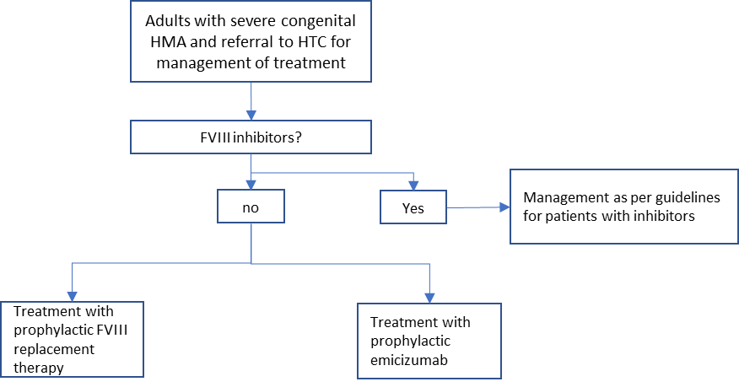
Figure 4 Current management algorithm (without the test)

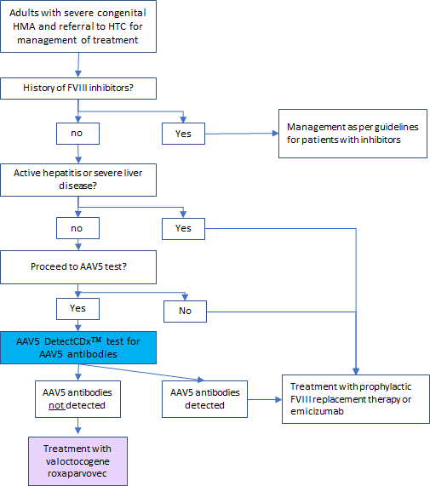
Figure 5 Proposed management algorithm (with the introduction of the test)

ARUP’s licensure certificates can be found here: https://www.aruplab.com/compliance/licensure-accreditations

