MSAC Application 1726

Testing of tumour tissue to determine a positive homologous recombination deficiency status in women newly diagnosed with advanced (FIGO stage III-IV) high grade epithelial ovarian, fallopian tube or primary peritoneal cancer, for access to PBS niraparib
This application form is to be completed for new and amended requests for public funding (including but not limited to the Medicare Benefits Schedule (MBS)). It describes the detailed information that the Australian Government Department of Health requires to determine whether a proposed medical service is suitable.
Please use this template, along with the associated Application Form Instructions to prepare your application. Please complete all questions that are applicable to the proposed service, providing relevant information only. Applications not completed in full will not be accepted. The separate MSAC Guidelines should be used to guide health technology assessment (HTA) content of the Application Form
Should you require any further assistance, departmental staff are available through the Health Technology Assessment Team (HTA Team) on the email below to discuss the application form, or any other component of the Medical Services Advisory Committee process.

Email: hta@health.gov.au
Website: www.msac.gov.au

PART 1 – APPLICANT DETAILS

Applicant details (primary and alternative contacts)
Corporation / partnership details (where relevant): N/A
Corporation name: GlaxoSmithKline Australia Pty Ltd
ABN: 47 100 162 481
Business trading name: GlaxoSmithKline Australia Pty Ltd

Primary contact name: REDACTED
Primary contact numbers
Business: REDACTED
Mobile: REDACTED
Email: REDACTED

Alternative contact name: REDACTED
Alternative contact numbers
Business: REDACTED
Mobile: REDACTED
Email: REDACTED

(a) Are you a consultant acting on behalf on an applicant?
Yes
No
(b) If yes what is the Applicant(s) name that you are acting on behalf of?

(a) Are you a lobbyist acting on behalf of an Applicant?
Yes
No

If yes, are you listed on the Register of Lobbyists?
Yes
No

Have you engaged a consultant on your behalf?
Yes
No

PART 2 – INFORMATION ABOUT THE PROPOSED MEDICAL SERVICE

Application title
Testing of tumour tissue to determine a positive homologous recombination deficiency (HRD) status in women with newly diagnosed, advanced (FIGO Stage III-IV) high-grade epithelial ovarian, fallopian tube or primary peritoneal cancer, for access to niraparib.

Provide a succinct description of the medical condition relevant to the proposed service (no more than 150 words – further information will be requested at Part F of the Application Form)
Ovarian cancer was the ninth most diagnosed and the sixth leading cause of cancer-related deaths among Australian females in 2017 (AIHW 2022). Most women are diagnosed at an advanced stage (81.8%, Lindemann 2018) with limited long-term survival prospects (7-years: 9-26%; Anuradha 2014). Despite high response rates (88.6%; Morgan 2020) to platinum-based chemotherapy, relapse occurs in most patients with diminishing outcomes and toxicities from subsequent treatment (Lindemann 2018, Fotopoulou 2014). There is a high clinical need for maintenance therapies to consolidate initial response, delay progression and increase the platinum free interval.
Approximately half of all HGEOCs exhibit functional defects in homologous recombination (HR) repair. While germline/somatic BRCA1 and BRCA2 mutations are the best characterised causes of homologous recombination deficiency (HRD), this can also arise from mutations or methylation of a wider set of genes (e.g. RAD51C, RAD51D or PALB2, promoter hypermethylation of the BRCA1 gene promotor; Miller 2020). It has been hypothesised that platinum induced DNA damage and PARP inhibition results in the accumulation of DNA damage and tumour cell death. With the identification of HRD, the clinical utility of PARPi has the potential to benefit patients in beyond those with a BRCA mutation.

Provide a succinct description of the proposed medical service (no more than 150 words – further information will be requested at Part 6 of the Application Form)
This application requests a medical service for the testing of tumour tissue to determine HRD status in women with NDA HGEOC to inform access to PBS niraparib. The HRD test involves the next generation sequencing (NGS) of DNA from a biopsy or archived FFPE block of tumour tissue. Assays to detect HRD status identify the genomic aberrations following repair of double strand breaks via the error prone non-homologous end joining pathway in HRD tumour cells. As per the evidentiary standard used in the pivotal trial (PRIMA), the quantitative assessment of genomic scarring was measured via a genomic instability status (GIS) score that evaluates the three DNA damage biomarkers across the entire genome: Loss of Heterozygosity (LOH). Telomeric Allelic Imbalance (TAI) and Large-Scale State Transitions (LST).

(a) Is this a request for MBS funding?
Yes
No

If yes, is the medical service(s) proposed to be covered under an existing MBS item number(s) or is a new MBS item(s) being sought altogether?
Amendment to existing MBS item(s)
New MBS item(s)

If an amendment to an existing item(s) is being sought, please list the relevant MBS item number(s) that are to be amended to include the proposed medical service/technology:
Not applicable

If an amendment to an existing item(s) is being sought, what is the nature of the amendment(s)?
Not applicable
- An amendment to the way the service is clinically delivered under the existing item(s)
- An amendment to the patient population under the existing item(s)
- An amendment to the schedule fee of the existing item(s)
- An amendment to the time and complexity of an existing item(s)
- Access to an existing item(s) by a different health practitioner group
- Minor amendments to the item descriptor that does not affect how the service is delivered
- An amendment to an existing specific single consultation item
- An amendment to an existing global consultation item(s)
- Other (please describe below):

If a new item(s) is being requested, what is the nature of the change to the MBS being sought?
- A new item which also seeks to allow access to the MBS for a specific health practitioner group
- A new item that is proposing a way of clinically delivering a service that is new to the MBS (in terms of new technology and / or population)
- A new item for a specific single consultation item
- A new item for a global consultation item(s)

Is the proposed service seeking public funding other than the MBS?
Yes
No

If yes, please advise:
Not applicable

What is the type of medical service/technology?
Therapeutic medical service
Investigative medical service
Single consultation medical service
Global consultation medical service
Allied health service
Co-dependent technology
Hybrid health technology

For investigative services, advise the specific purpose of performing the service (which could be one or more of the following):
- To be used as a screening tool in asymptomatic populations
- Assists in establishing a diagnosis in symptomatic patients
- Provides information about prognosis
- Identifies a patient as suitable for therapy by predicting a variation in the effect of the therapy
- Monitors a patient over time to assess treatment response and guide subsequent treatment decisions

Does your service rely on another medical product to achieve or to enhance its intended effect?
Pharmaceutical / Biological
Prosthesis or device
No

(a) If the proposed service has a pharmaceutical component to it, is it already covered under an existing Pharmaceutical Benefits Scheme (PBS) listing?
Yes
No

The PBAC have recommended niraparib at the March 2022 meeting for the maintenance treatment of HGSOC with a BRCA1 or BRCA2 pathogenic gene variant (somatic and germline)

If yes, please list the relevant PBS item code(s):
Not applicable

If no, is an application (submission) in the process of being considered by the Pharmaceutical Benefits Advisory Committee (PBAC)?
Yes (please provide PBAC submission item number below)
No

If you are seeking both MBS and PBS listing, what is the trade name and generic name of the pharmaceutical?
Trade name: Zejula®
Generic name: Niraparib

(a) If the proposed service is dependent on the use of a prosthesis, is it already included on the Prostheses List?
Yes
No

If yes, please provide the following information (where relevant):
Not applicable

If no, is an application in the process of being considered by a Clinical Advisory Group or the Prostheses List Advisory Committee (PLAC)?
Yes
No

Are there any other sponsor(s) and / or manufacturer(s) that have a similar prosthesis or device component in the Australian market place which this application is relevant to?
Yes
No

If yes, please provide the name(s) of the sponsor(s) and / or manufacturer(s):
Not applicable

Please identify any single and / or multi-use consumables delivered as part of the service?
Single or multi-use consumables for in-house developed IVD assays would be kits which may be used for
DNA extraction or quality assurance, or any kit for PCR amplification methods.

PART 3 – INFORMATION ABOUT REGULATORY REQUIREMENTS

(a) If the proposed medical service involves use of a medical device, in-vitro diagnostic test, pharmaceutical product, radioactive tracer, or any other type of therapeutic good, please provide details
Type of therapeutic good: Pharmaceutical Product: Zejula® (niraparib)
Manufacturer’s name: GSK
Sponsor’s name: GlaxoSmithKline Australia Pty Ltd

Type of therapeutic good: in vitro diagnostic test
Manufacturer’s name: REDACTED
Sponsor’s name: REDACTED

Has it been listed on the Australian Register of Therapeutic Goods (ARTG) by the Therapeutic Goods Administration (TGA)? If the therapeutic good has been listed on the ARTG, please state the ARTG identification numbers, TGA-approved indication(s), and TGA-approved purpose(s).
The co-dependent pharmaceutical product, Zejula® (niraparib) is currently registered on the ARTG:
ARTG ID: 305254
TGA approved indication(s):
- For the maintenance treatment of adult patients with advanced high-grade ovarian, fallopian tube or primary peritoneal cancer who are in response (complete or partial) following completion of first-line platinum-based chemotherapy.
- As monotherapy for the maintenance treatment of adult patients with platinum-sensitive relapsed high grade serous epithelial ovarian, fallopian tube, or primary peritoneal cancer who are in response (complete or partial) to platinum-based chemotherapy

If a medical device is involved, has the medical device been classified by TGA as a Class III OR Active Implantable Medical Device (AIMD) under the TGA regulatory scheme for devices?
Class III
AIMD
N/A

Is the therapeutic good classified by TGA for Research Use Only (RUO)?
Not applicable

(a) If not listed on the ARTG, is the therapeutic good to be used in the service exempt from the regulatory requirements of the Therapeutic Goods Act 1989?
Yes (If yes, please provide supporting documentation as an attachment to this application form)
No

If the therapeutic good is not ARTG listed, is the therapeutic good in the process of being considered by TGA?

Yes (if yes, please provide details below)
No
- If the therapeutic good is NOT in the process of being considered by TGA, is an application to TGA being prepared?
It is expected that the REDACTED HRD test will be available in Australia from August 2022. Completion of local validation, NATA accreditation for performing the REDACTED HRD Test is expected to occur at a number of Australian laboratories that are using the next-generation sequencing (NGS) REDACTED panel.

PART 4 – SUMMARY OF EVIDENCE

Provide one or more recent (published) high quality clinical studies that support use of the proposed health service/technology. At ‘Application Form lodgement’, please do not attach full text articles; just provide a summary.
 | Type of study design | Title of journal article or research project | Short description of research | Website link to journal article or research | Date of publication
1 | Randomised controlled trial | Niraparib in Patients with Newly Diagnosed Advanced Ovarian Cancer (PRIMA) | Randomised, double blind, phase 3 trial comparing niraparib (n=487) to placebo (n=246) in patients with NDA HGEOC in CR/PR to prior 1L PBC. The primary endpoint was PFS in patients who had tumours with HRD and in those in the overall population per hierarchical testing. Niraparib had significantly longer PFS compared to placebo, regardless of the presence or absence of HRD. | https://www.nejm.org/doi/full/10.1056/NEJMoa1910962 | December 2019
2 | Diagnostic study | Homologous Recombination Deficiency (HRD) Score Predicts Response to Platinum-Containing Neoadjuvant Chemotherapy in Patients with Triple-Negative Breast Cancer. | This study assessed a combined homologous recombination deficiency (HRD) score, an unweighted sum of LOH, TAI, and LST scores, in three neoadjuvant TNBC trials of platinum-containing therapy. The cohort was based on 497 Breast and 561 ovarian chemotherapy-naïve tumours with known BRCA1/2 status. The association of HR deficiency, defined as HRD score ≥42 or BRCA1/2 mutation, with response to platinum-based therapy was tested. HR deficiency identified TNBC tumors, including BRCA1/2 nonmutated tumours more likely to respond to platinum-containing therapy. | https://doi.org/10.1158/1078-0432.ccr-15-2477 | March 2016
3 | Diagnostic Study | Concordance of the FDA-Approved Companion Diagnostic and a Next-Generation Sequencing Assay Kit for Assessing Homologous Recombination Deficiency in Ovarian Cancer | This study evaluated the performance of an in-development next-generation sequencing assay, based on Illumina’s RUO TSO 500 content, that identifies variants in tumour tissue and HRD genomic scars (Illumina Test) vs the Myriad MyChoice Plus assay. Ovarian Cancer tissue samples were analysed with the Illumina (n=227, 40ng DNA) and Myriad tests (n=254, 200ng DNA). Agreement rates for BRCAm, GIS and HRD status were analysed. Illumina test and Myriad test HRD, BRCAm, and GIS detection results were in >91% agreement. | https://ijgc.bmj.com/content/31/Suppl_3/A375.1.info | October 2021
4 | Diagnostic Study | Assessing homologous recombination deficiency (HRD) in ovarian cancer: Optimizing  concordance of the regulatory-approved companion diagnostic and a next-generation  sequencing (NGS) assay kit. | This study evaluated the performance of an in-development NGS assay kit that identifies BRCA variants based on genomic content from Illumina’s TruSight™ Oncology 500 research assay, and, with additional genomic content, measures HRD GIS in tumor tissue (Illumina test) in parallel. Analytic concordance of the Illumina test versus the Myriad myChoiceVR PLUS assay (Myriad test) under improved algorithms for calculating GIS scores is reported. Ovarian cancer tissue samples were analyzed with the Illumina (40 ng DNA; N = 227) and Myriad (200 ng DNA; N = 254) tests. Comparison between the Illumina and Myriad tests showed that overall HRD status, BRCA analysis, and HRD GIS detection results were > 90% concordant | https://ascopubs.org/doi/abs/10.1200/JCO.2022.40.16_suppl.e17571 | June 2022

Identify yet-to-be-published research that may have results available in the near future (that could be relevant to your application). Do not attach full text articles; this is just a summary.
None identified

PART 5 – CLINICAL ENDORSEMENT AND CONSUMER INFORMATION

List all appropriate professional bodies/organisations representing the health professionals who provide the service. For MBS-related applications ONLY, please attach a brief ‘Statement of Clinical Relevance’ from the most relevant college/society.
The Royal College of Pathologists of Australasia (RCPA)
Australia New Zealand Gynaecological Oncology Group (ANZGOG)

List any professional bodies / organisations that may be impacted by this medical service (i.e. those who provide the comparator service):
As above

List the consumer organisations relevant to the proposed medical service (noting there is NO NEED to attach a support letter at the ‘Application Lodgement’ stage of the MSAC process):
Ovarian Cancer Australia

List the relevant sponsor(s) and / or manufacturer(s) who produce similar products relevant to the proposed medical service:
HRD testing is not currently reimbursed in Australia.
Tumour BRCA testing is established in Australia and is MBS funded (refer to Table 4).
- Nominate two experts that can be contacted about the proposed medical service, and current clinical management of the condition:
Name of expert 1: REDACTED
Telephone number(s): REDACTED
Email address: REDACTED
Justification of expertise: REDACTED

Name of expert 2: REDACTED
Telephone number(s): REDACTED
Email address: REDACTED
Justification of expertise: REDACTED

PART 6 – POPULATION (AND PRIOR TESTS), INTERVENTION, COMPARATOR, OUTCOME (PICO)
An overview of the PICO for the testing of tumour tissue to determine HRD status in patients with NDA HGEOC for access to maintenance niraparib is presented in the table below. Acknowledging the ratified PICO for Application 1658 (August 2021 PASC), the circumstances of niraparib have been applied to this framework:
- Population: the co-dependent application for niraparib will consider the test population circumstances proposed by the PASC (p9, Ratified PICO – Application 1658):
  - Population #1: NDA HGEOC patients at diagnosis (HRD testing for BRCA1/2 variant and GIS in parallel; constitutes population currently eligible for BRCA1/2 testing on MBS);
  - Population #2: NDA HGEOC non-BRCAm patients at diagnosis (Testing for GIS to occur sequentially following a negative BRCA1/2 test result);
  - Population #3: NDA HGEOC patients or NDA HGEOC non-BRCAm patients who receive a 1L platinum-based chemotherapy regimen (BRCA1/2 and GIS could be conducted in parallel or sequentially following a negative BRCA1/2 test result)
- Intervention and Comparator: with respect to the maintenance treatments, the key difference is that niraparib will be intended to be used following response to platinum-based chemotherapy (PBC), whereas Olaparib & bevacizumab combination would be used following PBC and bevacizumab as per patient populations of the pivotal evidence (PRIMA, PAOLA-1).
For non-BRCAm HRD patients, current standard of care is standard medical management following response to PBC only, whereas patients that received PBC + bevacizumab, would continue with bevacizumab as maintenance therapy.
- Outcomes: test and drug outcomes nominated in the ratified PICO (Application 1658) will be considered in a co-dependent application for niraparib.

Given the PICO from Application 1658 has been well defined and is directly applicable to the HRD testing circumstances to inform access to niraparib for NDA HGEOC, GSK requests that an expedited PASC bypass occurs in the MSAC assessment pathway.

Table 1: Overview of the PICO for the testing of tumour tissue to determine HRD status in patients with NDA HGEOC for access to niraparib
Population (NDA HGEOC) |  |  | Intervention | Comparator | Outcomes
Test | At diagnosis | Population #1 | Parallel: HRD testing to provide BRCA1 or BRCA2 result and GIS score | Parallel: Tumour BRCA1 or BRCA2 testing | - Comparison of concordance and discordance between evidentiary standard (Myriad MyChoice Assay) and local HRD test to determine HRD status  - Comparison of the analytical performance of the local HRD test compared with current tumour BRCA testing to determine BRCA pathogenic variant status (Applicable to parallel testing scenarios for Population #1 and Population #3)  - Clinical validity of the test: differential prognostic effect of HRD positive status in HGEOC, including an assessment of whether the prognostic effect varies further according to BRCA status  - Clinical utility of the test: treatment effect modification of niraparib by HRD positive status in patients with NDA HGEOC who are in response to PBC  - Other test related considerations: test failure rates and re-biopsy rates; test turnaround time  - Safety: adverse events associated with biopsy/re-biopsy for patients with inadequate tissue for tumour testing
 |  | Population #2 | Sequential: HRD testing to provide GIS score for non-BRCAm cohort only | Sequential: No Test
 | Receive 1L PBC | Population #3 | Parallel or Sequential | Parallel: Tumour BRCA1 or BRCA2 testing  Sequential: No Test
Primary Treatment (non-BRCAm HRD) | PBC |  | Niraparib maintenance | Standard Medical Management | - Progression Free Survival, Overall Survival, Objective Response Rate  - Health related quality of life  - Safety
 | PBC + Bevacizumab |  | Not applicable | Near market comparator: Olaparib & Bevacizumab maintenance (Application 1658)  Qualitative comparator: Bevacizumab maintenance
Abbreviations: GIS = genomic instability status; HGEOC = high grade epithelial ovrarian cancer; HRD = homologous recombination deficiency; NDA = newly diagnosed advanced; PBC = platinum based chemotherapy;
Note: Unshaded areas of the table indicate aspects of the ratified PICO that are consistent between the circumstances of Olaparib + Bevacizumab and Niraparib. Key differences are with respect to the place in therapy for the maintenance therapies (Orange: Olaparib & Bevacizumab maintenance following response to platinum-based chemotherapy & bevacizumab; Blue: niraparib maintenance following platinum based chemotherapy only).

PART 6a – INFORMATION ABOUT THE PROPOSED POPULATION

Define the medical condition, including providing information on the natural history of the condition and a high level summary of associated burden of disease (in terms of both morbidity and mortality):
Ovarian cancer (OC) was the ninth most diagnosed (11.1 age-standardised rate) and the sixth leading cause of cancer-related deaths (6.4 age-standardised rate) among Australian females in 2017. The Australian Institute of Health and Welfare (AIHW) has projected that by 2021, 1720 incident cases and 1042 deaths would be attributed to OC (AIHW 2021).
OC is a heterogeneous disease comprising different morphological subtypes that differ in natural history, response to treatment and prognosis (McCluggage 2011). Approximately 84% of OC are of epithelial origin (AIHW 2010), with the majority classified as high-grade tumours with serous histology (grade 2/3: 93.6%; serous: 70.8%; Alsop 2012). Early diagnosis of high-grade epithelial ovarian cancer (HGEOC) is challenging, as symptoms are often nonspecific (e.g. pelvic or abdominal discomfort, bloating, difficulty eating or feeling full and urinary urgency and frequency). Most HGEOC patients are therefore diagnosed at an advanced stage (Stage III and IV; 81.8%, Lindemann 2018) when prominent symptoms such as ascites and abdominal masses are evident and long-term survival prospects are limited (7-year survival: Stage III = 26%, 95% CI: 22%, 30%; Stage IV = 9%, 95% CI: 5%, 14%; Anuradha 2014).
First line treatment of HGEOC involves a combination of cytoreductive surgery and platinum-based chemotherapy. Despite high response rates (up to 88.6%; Morgan 2020), and sensitivity to first line platinum chemotherapy (platinum free interval, PFI > 6 months = 77.6%), relapse occurs for the majority of patients (81.2%, Lindemann 2018) within the first three years of diagnosis (Ledermann 2013, Lindemann 2018). Extended remission is an unlikely circumstance, with approximately 5% of patients high-grade serous OC being progression free at 10 years (Irodi 2020, Fig 2F). With each re-treatment course of platinum-based chemotherapy, there is diminished durability of response (PFI ≥ 6 months = 60.5% at the second line setting; Lindemann 2018) and associated toxicities and deficits in quality of life from prolonged chemotherapy treatment (hypersensitivity, renal toxicity, ototoxicity, neurotoxicity, myelosuppression; Fotopoulou 2014). Fear and anxiety associated with OC recurrence has a substantial impact on patient quality of life (Angle 2018, Ovarian Cancer Australia).
Prevalence of germline BRCA mutation (gBRCAm) has been reported in 22.6% of high grade serous ovarian cancer (Alsop 2012) with somatic mutations observed in a further 6.3% of cases (CGARN 2011). As a biomarker, gBRCAm holds both predictive and prognostic value in high-grade serous OC as well as increased sensitivity to PARP inhibitor (PARPi) maintenance therapy. The PBAC has recommended Olaparib (July 2020; PBS listed: November 2020) and Niraparib (March 2022, PBS listing pending) in the 1L BRCAm setting only. In the absence of a gBRCAm, patients are faced with reduced short to medium term survival outcomes after OC diagnosis (refer to Table 2 and Figure 1), highlighting the clinical need for maintenance therapy options to consolidate initial chemotherapy responses and delay disease progression.
Table 2: PFS and OS outcomes in according to gBRCAm status – AOCS (Alsop 2012)
Outcome |  | Non-gBRCAm (N=777) | gBRCAm (N=141)
OS, median, months (95% CI) |  | 55.5 (49.1, 61.8) | 62.4 (47.7, 77.0)
Primary treated population | N | 701 | 134
 | Time to progression <6months | 222 (31.7) | 20 (14.9)
 | Time to progression >6 months | 479 (68.3) | 114 (85.1)
Abbreviations: CI = confidence interval; gBRCAm = germline BRCA mutation; OS = overall survival; PFS = progression free survival. Source: Table 1, Figure 2 Alsop 2012

Figure 1: Kaplan-Meier plot for OS by gBRCAm status – AOCS (Alsop 2012)
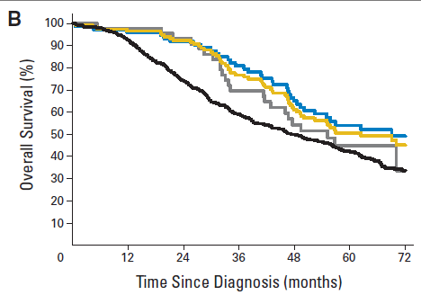
gBRCA1 mutation–positive (blue); gBRCA2 mutation–positive (gray); gBRCA1/2 mutation–positive (combined; gold); non-gBRCA mutation (black).
Source: Figure 1B, Alsop 2012.
Homologous recombination (HR) is an essential pathway for DNA double strand break (DSB) repair. Approximately half of all HGEOCs exhibit functional defects in homologous recombination repair (i.e. homologous recombination deficiency – HRD). While germline/somatic BRCA1 and BRCA2 mutations are the best characterised causes of HRD, HRD can arise through germline and somatic mutations or methylation of a wider set of genes involved in homologous recombination repair (e.g. BRCA1, BRCA2, RAD51C, RAD51D or PALB2, promoter hypermethylation of the BRCA1 gene promotor; Miller 2020). With HRD cells showing a greater reliance on PARP activity to maintain cell survival, the clinical utility of PARPis has the potential to extend beyond the BRCAm cohort. This has been confirmed in a recent trial of niraparib as monotherapy vs SMM, whereby treatment effects are enhanced in ovarian cancers displaying BRCAm and HRD (PRIMA). Noting that PBAC has previously considered that a more targeted population to identify patients most likely to benefit from niraparib would be reasonable (Paragraph 7.17, Item 7.07 - March 2022 PSD), GSK intend to submit a future co-dependent application requesting an expanded 1L listing for niraparib in patients with non-BRCAm, HRD status.

Table 3: Results for PFS according to BRCAm and HRD status – PARPi monotherapy: PRIMA
PFS |  | PRIMA
 |  | NIRA | PBO
Assessment Method |  | Per BICR
BRCAm | Events/N | 49/152 (32.2) | 40/71 (56.3)
 | Median, months | 22.1 | 10.9
 | HR (95% CI) | 0.40 (0.27, 0.62)
HRD | Events/N | 81/247 (32.8) | 73/126 (57.9)
 | Median, months | 21.9 | 10.4
 | HR (95% CI) | 0.43 (0.31, 0.59)
Non-BRCAm HRD | Events/N | 32/95 (33.7) | 33/55 (60.0)
 | Median, months | 19.6 | 8.2
 | HR (95% CI) | 0.50 (0.31, 0.83)
HRp | Events/N | 111/169 (65.7) | 56/80 (70.0)
 | Median, months | 8.1 | 5.4
 | HR (95% CI) | 0.68 (0.49, 0.94)
Abbreviations: BICR = blinded independent review committee; HRD = homologous recombinant deficient; HRp = homologous recombinant proficient INV = investigator; NIRA = niraparib; PBO = placebo; RUCA = rucaparib. Source: Gonzalez-Martin 2019,

Specify the characteristics of patients with (or suspected of having) the medical condition, who would be eligible for the proposed medical service/technology (including details on how a patient would be investigated, managed and referred within the Australian health care system, in the lead up to being eligible for the service):
The target population for the proposed medical service are women with newly diagnosed, advanced (NDA) a high-grade epithelial ovarian, fallopian tube or primary peritoneal cancer (HGEOC). At the August 2021 meeting, the PASC considered there were three populations that could be considered for HRD testing (note: population #3 has been adapted for the primary therapy circumstances associated with niraparib -received a platinum-based chemotherapy regimen only):
At diagnosis:
- Population #1: HRD testing for BRCA1/2 variant and GIS in parallel: encompasses the overall NDA HGEOC the population that is currently eligible for BRCA 1/2 testing on the MBS.
- Population #2: Testing for GIS to occur sequentially following a non-BRCAm test result: encompasses the NDA HGEOC population who have been established not to be carriers of BRCA 1/2 pathogenic or likely pathogenic variants.
At the time of primary therapy:
- Population #3: Testing for BRCA/HRD/GIS to occur for patients that have received a first line platinum-based chemotherapy regimen only: this population is consistent with the those enrolled in the pivotal trial, PRIMA. BRCA1/2 variant and GIS could be conducted in parallel or sequentially (following a negative BRCA1/2 test result)
An extended discussion of the current referral pathway from clinical presentation to BRCAm testing is presented below. Noting the non-specific symptoms associated with ovarian cancer (refer to Question 23), initial diagnosis comprises radiological imaging, investigative tests including those for tumour markers, with clinical staging and histology conducted at the time of surgery (NCCN 2022, Cancer Australia 2020, eVIQ 2022; refer to
Figure 2).

Figure 2: Overview of the current referral pathway from clinical presentation to BRCAm testing for the purposes of determining eligibility for PARPi maintenance therapy

Investigative tests to confirm diagnosis – workup:
Several tests may be performed to investigate the symptoms of ovarian cancer and confirm diagnosis. Commonly performed tests include:
- physical examination of the abdomen and pelvis, including rectal examination.
- imaging of the pelvis and abdomen using transvaginal ultrasound, abdominal ultrasound, computed tomography (CT) scans, magnetic resonance imaging (MRI) scans or positron emission tomography (PET) scans
- chest X-rays
- blood tests to check for tumour markers such as CA125, and to measure complete blood count and levels of chemicals in the blood
- use of scopes to see inside the gastrointestinal tract
- biopsy – where a small sample of tissue is removed to be examined under a microscope. This is usually done as part of the initial surgery, because the only way to confirm a diagnosis of ovarian cancer is through an operation. The surgeon will also take samples of any fluid in the abdomen
Clinical Staging of Ovarian cancer:
- Stage I: the cancer is in 1 or both ovaries and has not spread to other organs or tissues.
- Stage II: the cancer is in 1 or both ovaries and has spread to other organs in the pelvis, such as the uterus, fallopian tubes, bladder or colon.
- Stage III: the cancer is in 1 or both ovaries and has spread outside the pelvis to other parts of the abdomen or nearby lymph nodes.
- Stage IV: the cancer has spread to other parts of the body beyond the pelvis and abdomen, such as the lungs or liver.
Genetic Testing:
The eVIQ guidelines (ID 620, V.12) recommends that a woman with invasive epithelial ovarian cancer should consider genetic testing for a heritable pathogenic BRCA1 or BRCA2 gene variants in the following situations:
- individuals with a combined BRCA1 and BRCA2 pathogenic variant probability of ≥10% using the Manchester score (a validated pathogenic variant prediction tool).
- individuals with a combined BRCA1, BRCA2 and PALB2 pathogenic variant probability of ≥10% using CanRisk (a validated pathogenic variant prediction tool). This may include unaffected individuals and obligate carriers with ≥10% pathogenic variant probability as well as individuals from a population where a common founder pathogenic variant exists.
- individuals with high grade ovarian cancer diagnosed at any age.
- individual with advanced (FIGO III-IV), high-grade serous or high-grade epithelial ovarian, fallopian tube or primary peritoneal cancer to determine eligibility relating to BRCA status for access to Olaparib under the Pharmaceutical Benefits Scheme (PBS). The PBS listing for Niraparib in the 1L BRCAm setting was pending at the time of the submission of this application.
A medical oncologist or gynaecological oncologist would request or refer a patient on for BRCA testing. Funding arrangements for BRCA testing via the MBS are listed in Table 4 below. Tumour tissue specimens for the most patients in the target population will be available for testing following primary debulking surgery or via archived formalin-fixed paraffin embedded (FFPE) blocks. Retrieval and review of one or more archived FFPE blocks to determine the appropriate samples for the purpose of conducting genetic testing is funded under MBS item 72860. For a woman diagnosed with ovarian cancer, identification of a heritable mutation by genetic testing may inform the following (Cancer Australia 2022):
- Patient response to PBC and benefit from the use of PARP inhibitors as maintenance therapy is enhanced in women with BRCA1/2 mutations
- Increased risk of breast cancer has been associated with BRCA1/2 mutations. Risk reducing strategies for breast cancer may be considered, which may include bilateral prophylactic mastectomy and risk-reducing medications such as selective estrogen receptor modulators (e.g. tamoxifen, raloxifene) or aromatase inhibitor. Increased surveillance for breast cancer as appropriate, may include mammography, ultrasound or MRI.
- Family members of a women identified with a heritable BRCA1/2 mutation can be offered predictive genetic testing for the known mutation. Pre-test counselling by a genetic healthcare professional is needed for family members prior to predictive testing and should include discussion on implications for insurance. Informed consent should be obtained prior to testing.
While the PASC considered the feasibility in delaying BRCA testing to the point of primary chemotherapy (Attachment #1, Ratified PICO, August 2021), the informative value of BRCA testing result expands beyond the identification of patients that could benefit from the use if PARP inhibitors, including response to PBC, risk of breast cancer and potential need for risk reduction strategies, familial genetic testing.
Table 4: Funding arrangements for BRCA testing via the MBS
MBS Item | Description | Fee
73295 | Detection of germline BRCA1 or BRCA2 pathogenic or likely pathogenic gene variants, in a patient with advanced (FIGO III-IV) high-grade serous or high-grade epithelial ovarian, fallopian tube or primary peritoneal cancer for whom testing of tumour tissue is not feasible, requested by a specialist or consultant physician, to determine eligibility for olaparib under the PBS | $1200.00  Benefit:  75% = $900.00; 85% = $1,112.10
73296 | Characterisation of germline gene variants:  (a) including copy number variation in:  (i) BRCA1 genes; and (ii) BRCA2 genes; and (iii) one or more of the genes STK11, PTEN, CDH1, PALB2 and TP53; and  (b) in a patient:  (i) with breast, ovarian, fallopian tube or primary peritoneal cancer; and (ii) for whom clinical and family history criteria (as assessed, by the specialist or consultant physician who requests the service, using a quantitative algorithm) place the patient at greater than 10% risk of having a pathogenic or likely pathogenic gene variation identified in one or more of the genes specified in subparagraphs (a)(i), (ii) and (iii);  requested by a specialist or consultant physician | $1200.00  Benefit:  75% = $900.00; 85% = $1,112.10
73297 | Characterisation of germline gene variants, including copy number variation:  in one or more of the following genes:  BRCA1; BRCA2; STK11; PTEN; CDH1; PALB2; TP53; and  in a patient who:  is a biological relative of a patient who has had a pathogenic or likely pathogenic gene variant identified in one or more of the genes mentioned in paragraph (a); and has not previously received a service to which item 73295, 73296 or 73302 applies;  requested by a specialist or consultant physician | $400.00  Benefit:  75% = $300.00; 85% = $340.00
73301 | A test of tumour tissue from a patient with advanced (FIGO III-IV), high-grade serous or high-grade epithelial ovarian, fallopian tube or primary peritoneal cancer, requested by a specialist or consultant physician, to determine eligibility relating to BRCA status for access to olaparib under the PBS | $1200.00  Benefit:  75% = $900.00; 85% = $1,112.10
73302 | Characterisation of germline gene variants including copy number variants, in BRCA1 or BRCA2 genes, in a patient who has had a pathogenic or likely pathogenic variant identified in either gene by tumour testing and who has not previously received a service to which items 73295, 73296 or 73297 applies, requested by a specialist or consultant physician. | $400.00  Benefit:  75% = $300.00; 85% = $340.00

PART 6b – INFORMATION ABOUT THE INTERVENTION

Describe the key components and clinical steps involved in delivering the proposed medical service/technology:
Table 5 provides an overview of the intervention (medical service: HRD testing; maintenance therapy: Niraparib) and its applicability to the populations previously nominated by the PASC (Application 1658, August 2021). This application requests a medical service for the testing of tumour tissue to determine HRD status in women with newly diagnosed advanced (FIGO Stage III-IV) high grade epithelial ovarian, fallopian tube or primary peritoneal cancer to inform access to PBS niraparib. An application for HRD testing for access to combination Olaparib and bevacizumab is due for consideration by MSAC/PBAC at the July 2022 meeting (Application 1658)
Table 5: Overview of intervention and its applicability to the proposed population
Population circumstance (NDA HGEOC) |  |  | Intervention
Test | At diagnosis | Population #1 | Parallel: HRD testing to provide BRCA1 or BRCA2 result and GIS score
 |  | Population #2 | Sequential: HRD testing to provide GIS score for non-BRCAm cohort only
 | Receive platinum-based chemotherapy | Population #3 | #3a: Parallel: HRD testing to provide BRCA1 or BRCA2 result and GIS score  #3b: Sequential: HRD testing to provide GIS score for non-BRCAm cohort only
Primary Treatment: non-BRCAm HRD | Platinum based chemotherapy |  | Niraparib maintenance
 | Platinum based chemotherapy & Bevacizumab |  | Not applicable
The HRD test involves the next generation sequencing (NGS) of DNA from a biopsy or archived FFPE block of tumour tissue. Assays to detect HRD status identify the genomic aberrations following repair of double strand breaks (DSBs) via the error prone non-homologous end joining (NHEJ) pathway in HRD tumour cells. As per the evidentiary standard, the quantitative assessment of genomic scarring is measured via a genomic instability status (GIS) score that evaluates the following three DNA damage biomarkers across the entire genome:
- Loss of Heterozygosity (LOH): number of LOH regions longer than 15 Mb but shorter than the length of a whole chromosome.
- Telomeric Allelic Imbalance (TAI): number of regions with allelic imbalance which extend to the sub-telomere but do not cross the centromere
- Large Scale State Transitions (LST): number of chromosomal breaks between adjacent regions longer than 10 Mb after filtering out regions shorter than 3 Mb
The combined GIS score is the unweighted sum of LOH + TAI + LST, with a score range from 0 to 100, with a tumour’s HRD status being described by the following rules:
- HRd = HRD positive: any tumour with GIS score ≥42 or a suspected deleterious BRCA 1 or BRCA 2 mutation
- HRp = HRD negative: any tumour with GIS score <42 and without a suspected deleterious BRCA 1 or BRCA 2 mutation
- HRnd = HRD unknown: any tumour with inconclusive test results
At the time of application, the applicant was aware of the following HRD assay that is expected to be launched in REDACTED:
- REDACTED assay: future co-dependent application will be supported by the concordance studies of the REDACTED assay vs the trial standard used in PRIMA (Myriad Mychoice® CDx).
Patients with NDA HGEOC in response to 1L PBC that are identified as non-BRCAm HRD are proposed to be eligible to receive niraparib as maintenance therapy.

Does the proposed medical service include a registered trademark component with characteristics that distinguishes it from other similar health components?
Registered trademarks may be held by various components used across the stages of the HRD testing process (e.g. DNA extraction, quality assurance, quantification PCR amplification, NGS platform). The proposed item descriptor is agnostic to the type of HRD test, though would be subject to the demonstration of sufficient concordance from the associated laboratory.

If the proposed medical service has a prosthesis or device component to it, does it involve a new approach towards managing a particular sub-group of the population with the specific medical condition?
Not applicable – this application does not involve a prothesis or medical device. Potential changes to the clinical management of patients are addressed in Question 40

If applicable, are there any limitations on the provision of the proposed medical service delivered to the patient (i.e. accessibility, dosage, quantity, duration or frequency)?
HRD tumour testing is a new service to be provided by pathology laboratories in Australia. It is expected that NATA accreditation and verification processes would be undertaken prior to availability of the HRD test.

If applicable, identify any healthcare resources or other medical services that would need to be delivered at the same time as the proposed medical service:
Given the proximity of BRCA testing to the populations under consideration for HRD testing, genetic counselling is expected to be commenced prior to and following the availability of test results.

If applicable, advise which health professionals will primarily deliver the proposed service:
Testing to identify HRD status, results interpretation and reporting will be conducted molecular pathologists from specialist laboratories that are appropriately accredited and registered for this diagnostic testing procedure.

If applicable, advise whether the proposed medical service could be delegated or referred to another professional for delivery:
Once HRD testing is MBS funded, it is expected that multiple laboratories will have the capability to provide a timely service for patients.

If applicable, specify any proposed limitations on who might deliver the proposed medical service, or who might provide a referral for it:
Testing for HRD status in patients with advanced ovarian cancer will be based on referral request from a special medical/gynae-oncologist.

If applicable, advise what type of training or qualifications would be required to perform the proposed service, as well as any accreditation requirements to support service delivery:
Testing to identify HRD status, results interpretation and reporting will be conducted molecular pathologists from specialist laboratories that are appropriately accredited and registered for this diagnostic testing procedure.

(a) Indicate the proposed setting(s) in which the proposed medical service will be delivered (select ALL relevant settings):
Inpatient private hospital (admitted patient)
Inpatient public hospital (admitted patient)
Private outpatient clinic
Public outpatient clinic
Emergency Department
Private consulting rooms - GP
Private consulting rooms – specialist
Private consulting rooms – other health practitioner (nurse or allied health)
Private day surgery clinic (admitted patient)
Private day surgery clinic (non-admitted patient)
Public day surgery clinic (admitted patient)
Public day surgery clinic (non-admitted patient)
Residential aged care facility
Patient’s home
Laboratory
Other – please specify below
- Where the proposed medical service is provided in more than one setting, please describe the rationale related to each:
Not applicable

Is the proposed medical service intended to be entirely rendered in Australia?
Yes
No – please specify below

PART 6c – INFORMATION ABOUT THE COMPARATOR(S)

Nominate the appropriate comparator(s) for the proposed medical service (i.e. how is the proposed population currently managed in the absence of the proposed medical service being available in the Australian health care system). This includes identifying health care resources that are needed to be delivered at the same time as the comparator service):
The test and drug comparators nominated in this application are summarised in the Table 6. The comparators were informed by the PASC’s consideration from the August 2021 meeting (p24-26, Ratified PICO Confirmation - Application 1658) and adapted according to the circumstances applicable to niraparib (primary treatment pathway). An extended discussion regarding the comparators is presented below.
Table 6: Overview of comparators and applicability to the treatment algorithm
Population circumstance (NDA HGEOC) |  |  | Comparator
Test | At diagnosis | Population #1 | Parallel: Tumour BRCA1 or BRCA2 testing
 |  | Population #2 | Sequential: No Test
 | At time of primary chemotherapy | Population #3 | #3a: Parallel: Tumour BRCA1 or BRCA2 testing
 |  |  | #3b: Sequential: No Test
Primary Treatment: non-BRCAm HRD | Platinum Based Chemotherapy |  | Main comparator: Standard Medical Management
 | Platinum Based Chemotherapy & Bevacizumab |  | Near market comparator: Olaparib & Bevacizumab maintenance  Qualitative comparator: Bevacizumab maintenance
Test:
Testing of tumour tissue from a patient with advanced (FIGO III-IV), high-grade serous or high-grade epithelial ovarian, fallopian tube or primary peritoneal cancer, requested by a specialist or consultant physician, to determine eligibility relating to BRCA status for access to PARPi monotherapy on the PBS (i.e. olaparib, niraparib – PBS listing pending) is currently funded under MBS item 73301. As per the populations under consideration for HRD testing, the relevant comparators for testing are as follows:
- Population #1: Tumour BRCA or BRCA2 testing
- Population #2: No test: patients will continue to receive BRCA testing, but for those identified to be non-BRCAm, additional analyses will occur to determine GIS and HRD status.
- Population #3
  - 3a. Tumour BRCA 1 or BRCA2 testing: HRD testing to determine GIS and BRCA status at time of primary therapy
3b. No test: GIS testing at time of primary therapy for non-BRCAm identified patients at diagnosisMaintenance Therapy: Non-BRCAm cohort
The evidence base for PARPi monotherapy in 1L maintenance setting supports their use in a population that received chemotherapy as primary treatment only (without bevacizumab). With respect to niraparib, the pivotal trial (PRIMA) population consisted almost exclusively of patients (99%) pre-treated with chemotherapy only and utilisation is expected to be consistent with the clinical evidence. Consequently, the rationale for niraparib to substitute for bevacizumab pre-treated patients and therefore bevacizumab or combination Olaparib and bevacizumab as maintenance therapy is limited. Noting the above observations, the comparators are considered in the context of a 1L maintenance population distinguished on the basis of primary treatment received (chemotherapy or chemotherapy and bevacizumab) in the non-BRCAm cohort (proposed population: refer to Question 23).
CR/PR following primary treatment with chemotherapy only: Standard Medical Management
Current standard medical management is active surveillance, which involves ongoing follow-up primarily informed by thorough review of symptoms and physical examination (bimanual pelvic and rectovaginal examination) at frequent intervals (every 2-4 months for 2 years, then 3-6 months for 3 years, then annually thereafter). Radiographic imaging (PET/CT scan, MRI) and CA 125 testing is utilised if recurrence is suspected or clinically indicated (Salani 2017, NCCN 2022)
CR/PR following primary treatment with chemotherapy and bevacizumab: Bevacizumab, Olaparib and Bevacizumab
Bevacizumab is an anti-vascular epithelial growth factor (anti-VEGF) monoclonal antibody that has been listed on the PBS since August 2014 (March 2014 recommendation). While PBS listing was changed to an unrestricted listing in June 2021, the PBAC has previously considered that few HGEOC patients currently utilise bevacizumab (Niraparib March 2022 PSD, Paragraph 7.10), with the ESC citing poor tolerability and limited effectiveness (Niraparib March 2022 PSD, Paragraph 5.1). Noting major transitivity issues that prevented a reliable quantification of the comparative effectiveness between niraparib and bevacizumab, the ESC and PBAC considered that it was reasonable that this did not form the basis for an assessment of cost-effectiveness (Niraparib March 2022 PSD, paragraph 6.6, 7.10) with the clinical evaluation limited to a qualitative comparison.
Olaparib and bevacizumab is a near market comparator, being TGA approved on 10 March 2021 for the maintenance treatment of adult patients with advanced HGEOC who are in complete or partial response to PBC and whose cancer is associated with HRD positive status. Following two PASC considerations (April 2021, August 2021), the combination is being considered by the PBAC and MSAC at the July 2022 meeting as maintenance therapy for HGEOC in the non-BRCAm HRD population. The population representing the pivotal evidence for Olaparib and bevacizumab (PAOLA-1) was solely based on a bevacizumab pre-treated population, representing a separate treatment pathway to PARPi monotherapy (olaparib, niraparib) that derives from patients that had only received chemotherapy.

Does the medical service (that has been nominated as the comparator) have an existing MBS item number(s)?
Yes (please list all relevant MBS item numbers below) – note: applicable to Population #1 (test at diagnosis) and population #3b (test for patients that receive primary PBC) where parallel testing of BRCA and GIS via the HRD test will replace BRCA testing at diagnosis
No
MBS Item Numbers: 73295, 73296, 73301

(a) Will the proposed medical service/technology be used in addition to, or instead of, the nominated comparator(s)?
In addition to (i.e. it is an add-on service) - Testing for GIS to occur sequentially following a non-BRCAm test result (applicable to Population #2 and #3a)

Instead of (i.e. it is a replacement or alternative) - - HRD testing for BRCA1/2 variant and GIS in parallel (applicable to Population #1 and #3b)

If yes, please outline the extent to which the current service/comparator is expected to be substituted
With respect to Population #1 and #3a, of patients that can provide a tumour sample for testing (95%), HRD testing is expected to entirely substitute for BRCA testing. The remaining patients (5%) will continue to access germline BRCA testing.

PART 6c CONTINUED – INFORMATION ABOUT ALGORITHMS (CLINICAL MANAGEMENT PATHWAYS)s

Define and summarise the CURRENT clinical management pathway (algorithm) that patients follow when they receive the COMPARATOR service (i.e. the landscape before the proposed service is introduced). An easy-to-follow flowchart is preferred, depicting the current clinical management pathway), but dot-points would be acceptable. Please include health care resources used in the current landscape (e.g. pharmaceuticals, diagnostics and investigative services, etc.).
The current clinical management algorithm for the treatment of NDA HGEOC is presented in
Figure 3. In the absence of relevant updated Australian guidelines, the clinical management algorithm is modelled according to established international guidelines from the American Society of Clinical Oncology (ASCO, Tew 2020), National Comprehensive Cancer Network (NCCN 2022), the European Society of Medical Oncology (ESMO; Ledermann 2013; Updated July 2021) and the ESMO-European Society of Gynaecology (ESGO) 2019 consensus recommendations on ovarian cancer (Colombo 2019), acknowledging treatment circumstances applicable to the Australian setting (eviQ guidelines, MBS, PBS Schedule).

Figure 3: Clinical management algorithm for the treatment of NDA HGEOC adapted from ASCO, ESMO, NCCN Guidelines and the Australian setting (eviQ guidelines, MBS & PBS schedule)
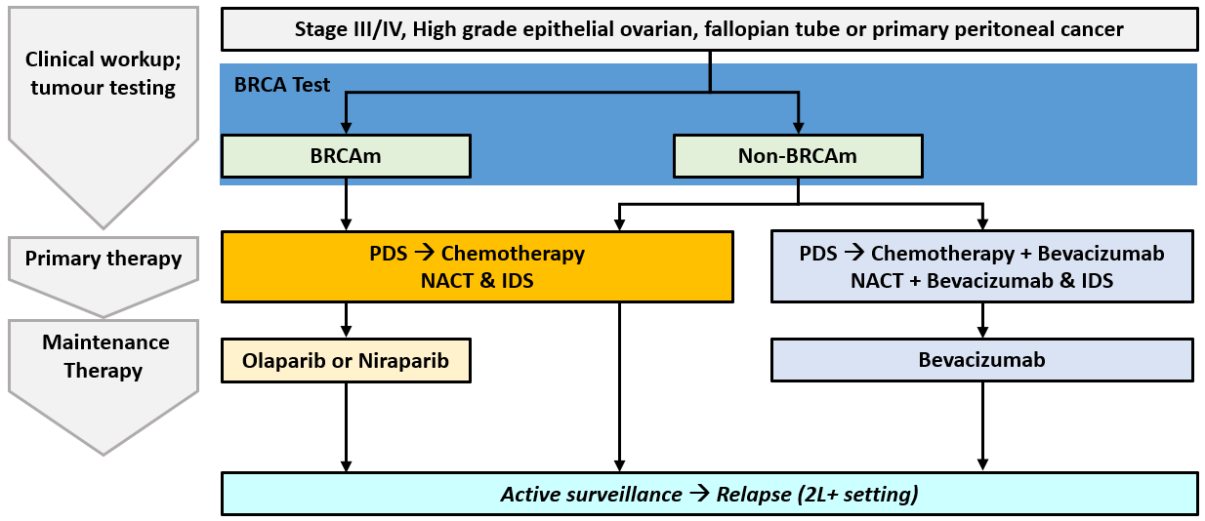
Note: Platinum-based chemotherapy is recommended as adjuvant therapy post-PDS and as neoadjuvant therapy prior to IDS and adjuvant therapy post-IDS. Following completion of platinum-based chemotherapy, patients are required to be in response (i.e. CR/PR) in order to transition to maintenance PARP inhibitors. Abbreviations: BRCAm = BRCA gene mutation; IDS = interval debulking surgery; PDS = primary debulking surgery.
Source: Tew 2020, NCCN 2022, Ledermann 2013; updated Jul 2021; Alsop 2012;
Primary treatment of NDA (Stage III/IV) high-grade serous/endometrioid OC involves a combination of debulking (cytoreductive) surgery and systemic chemotherapy:
Debulking surgery
The goal of debulking surgery is to achieve complete cytoreduction of all abdominal, pelvic, and retroperitoneal disease, as the extent of residual disease is an important prognostic factor for survival in advanced epithelial ovarian cancer (Chi 2009, NCCN 2021).
Primary debulking surgery (PDS) involving extensive upper abdominal surgical resection followed by chemotherapy is the standard approach for the initial treatment of advanced, high-grade serous/endometroid OC. More recently, neoadjuvant chemotherapy and subsequent interval debulking surgery (NACT-IDS) has been used as an alternative to PDS. Critical to the choice of surgical intervention is the pre-operative assessment of tumour spread, and patient condition which will determine the likelihood of achieving complete cytoreduction with PDS with an acceptable operative morbidity. Consequently, NACT-IDS is largely offered to patients with higher risk of perioperative morbidity or mortality (e.g. advanced age, co-morbidities, poor performance status) and those with extensive tumour dissemination, including large-volume ascites and/or large-volume pleural effusion (Colombo 2019, NCCN 2021, Hacker 2017). Overall, this has seen a gradual shift towards the predominant utilisation of NACT-IDS in Australian practice (Nicklin 2017).
Chemotherapy
For patients who receive PDS, adjuvant systemic chemotherapy with a platinum agent in conjunction with a taxane is recommended post PDS. The following chemotherapy regimens are recommended in the eviQ guidelines (v.10):
- 252: Paclitaxel 175 mg/m² IV, Carboplatin 5 AUC IV Q3W for 6 cycles
- 1016: Paclitaxel 80mg/m² IV on days 1, 8, and 15, Carboplatin 5 AUC Q3W for 6 cycles
- 1897: Paclitaxel 60mgm² IV, Carboplatin 2 AUC once weekly for 18 weeks
For patients receiving NACT-IDS, the NCCN 2022 guidelines indicate that the IV regimens recommended for adjuvant chemotherapy post PDS are also applicable for NACT-IDS. A minimum of 6 cycles of platinum-based chemotherapy is required, with 3 cycles given as adjuvant chemotherapy after IDS. Typically, this means 3 cycles 0f chemotherapy are given as NACT prior to IDS followed by 3 cycles of adjuvant chemotherapy.
Addition of bevacizumab
The PBAC has previously considered that few HGEOC patients currently utilise bevacizumab (Niraparib March 2022 PSD, Paragraph 7.10), with the ESC citing poor tolerability and limited effectiveness (Niraparib March 2022 PSD, Paragraph 5.1). The eviQ guidelines (v.10) recommends the following 1L platinum-based chemotherapy regimen involving the addition of bevacizumab in patients with NDA HGEOC that are suboptimally debulked (maximum diameter of any gross residual disease >1cm):
- 1601: Paclitaxel 175mg/m² IV, Carboplatin 5 AUC IV Q3W for 6 cycles. Bevacizumab (7.5mg/kg IV Q3W) to be administered in combination with paclitaxel and carboplatin from cycle 2 to cycle 6 and continued as a single agent from cycle 7 to cycle 19 (i.e. maximum of 18 cycles of bevacizumab in total).
Maintenance treatment:
The current maintenance management is influenced by MBS/PBS requirements and the evidentiary basis for use. Consideration of primary treatment received and BRCAm status informs the available maintenance therapies.
Primary treatment with chemotherapy only:
BRCAm population:
Olaparib is PBS listed for the first line maintenance treatment of patients with NDA Stage III/IV HGEOC associated with a class 4 or 6 BRCA1 or BRCA2 gene mutation who are in complete response or partial response to first line platinum-based chemotherapy. Current ovarian cancer guidelines recommend that patients with NDA HGEOC be referred for BRCA1/2 testing. BRCA1/2 testing is MBS funded under MBS item 73295 for germline testing or MBS Item 73301 for tumour testing to determine eligibility for Olaparib as maintenance treatment.

While the current olaparib PBS listing does not specify no prior bevacizumab as primary treatment, the pivotal evidence (SOLO-1) supporting the use of olaparib in the 1L maintenance setting is applicable to the population who received chemotherapy only (without bevacizumab) as primary treatment.

Non-BRCAm population:
No maintenance therapy options are available, with standard medical management being active surveillance. There is currently no evidence to support the use of bevacizumab as maintenance therapy only without prior combination treatment with chemotherapy.
Primary treatment with chemotherapy + bevacizumab:
As per the eVIQ guidelines the population most applicable for bevacizumab are patients with NDA HGEOC that are suboptimally debulked (maximum diameter of any gross residual disease >1cm). Bevacizumab use in this population is expected to remain aligned with the TGA indication, which requires bevacizumab to be continued as maintenance monotherapy following primary treatment with chemotherapy.

Bevacizumab use being limited to the treatment phase only (with nil intent on continuation as maintenance treatment) is not recommended by NCCN 2022 guidelines. Evidence from the GOG-0218 trial (Burger 2011) reported no significant difference in PFS between the group receiving carboplatin/paclitaxel/bevacizumab as primary treatment (without single-agent bevacizumab maintenance) vs. the control group receiving carboplatin/paclitaxel as primary treatment only (HR = 0.908; 95% CI: 0.795, 1.040; p=0.16).

Define and summarise the PROPOSED clinical management pathway (algorithm) that patients would follow after the proposed service/technology is introduced, including variation in health care resources.
At the August 2021 meeting, the PASC considered there were three test populations that could be considered for HRD testing, to reflect alternative approaches to the positioning of the HRD test in parallel (Population #1), sequential (Population #2) and testing for patients that receive primary platinum based chemotherapy (Population #3). Future clinical management algorithms based on these scenarios are presented below.
It is proposed that patients identified as non-BRCAm HRD will receive niraparib as maintenance therapy following CR/PR to primary platinum-based chemotherapy only, extending utilisation from the current BRCAm cohort. As per the pivotal evidence (PRIMA), in the non-BRCAm HRD cohort a clinically significant benefit for PFS was demonstrated for the comparison of niraparib vs SMM (HR = 0.50, 95% CI: 0.31, 0.83; 11.4 month median benefit; refer to
Table 3).
Patients that are HRp or HRnd will continue to receive current therapy: platinum-based chemotherapy followed by active surveillance (standard medical management) or platinum-based chemotherapy with bevacizumab followed by bevacizumab maintenance.
Population #1: HRD testing for BRCA1/2 variant and GIS in parallel:
The proposed future clinical management algorithm for population #1 is presented in
Figure 4. Population #1 considers a HRD test that evaluates BRCA1/2 and GIS status in parallel. Such a test will replace the tumour BRCA1/2 test (MBS item 73301) that is currently being performed at diagnosis as the one test will cover both GIS and BRCA1/2.

Figure 4: Clinical management algorithm for the treatment of NDA HGEOC – Population #1
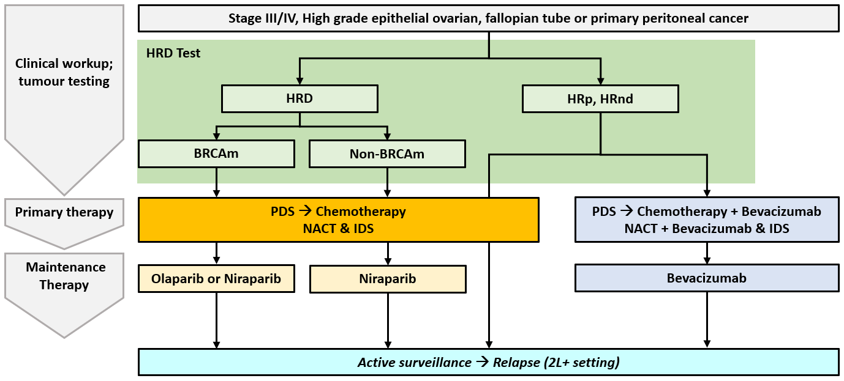

Population #2: Testing for GIS to occur sequentially following a non-BRCAm test result:
The proposed future clinical management algorithm for population #2 is presented in
Figure 5. Population #2 considers a HRD test that evaluates BRCA1/2 and GIS status sequentially. At diagnosis all patients with a viable tissue sample will receive BRCA testing. For those identified to be non-BRCAm, additional analyses will occur to determine GIS and confirm the patient’s HRD status.

Figure 5: Clinical management algorithm for the treatment of NDA HGEOC – Population #2
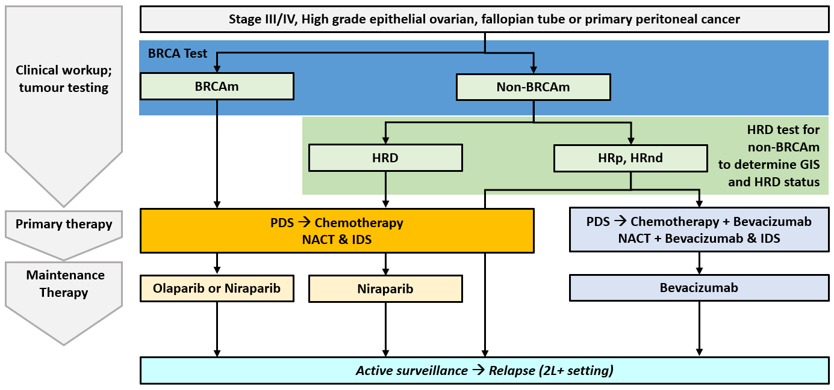
Note: BRCA test refers to MBS Item 73301

Population #3: Testing for BRCA/HRD/GIS to occur for patients that have received a first line platinum-based chemotherapy regimen only
The proposed treatment algorithm for Population #3a via parallel testing (
Figure 6) and #3b via sequential testing for patients that receive platinum based chemotherapy (Figure 7) is presented below.

Figure 6: Clinical management algorithm for the treatment of NDA HGEOC – Population #3a: Parallel HRD testing for patients that receive platinum-based chemotherapy
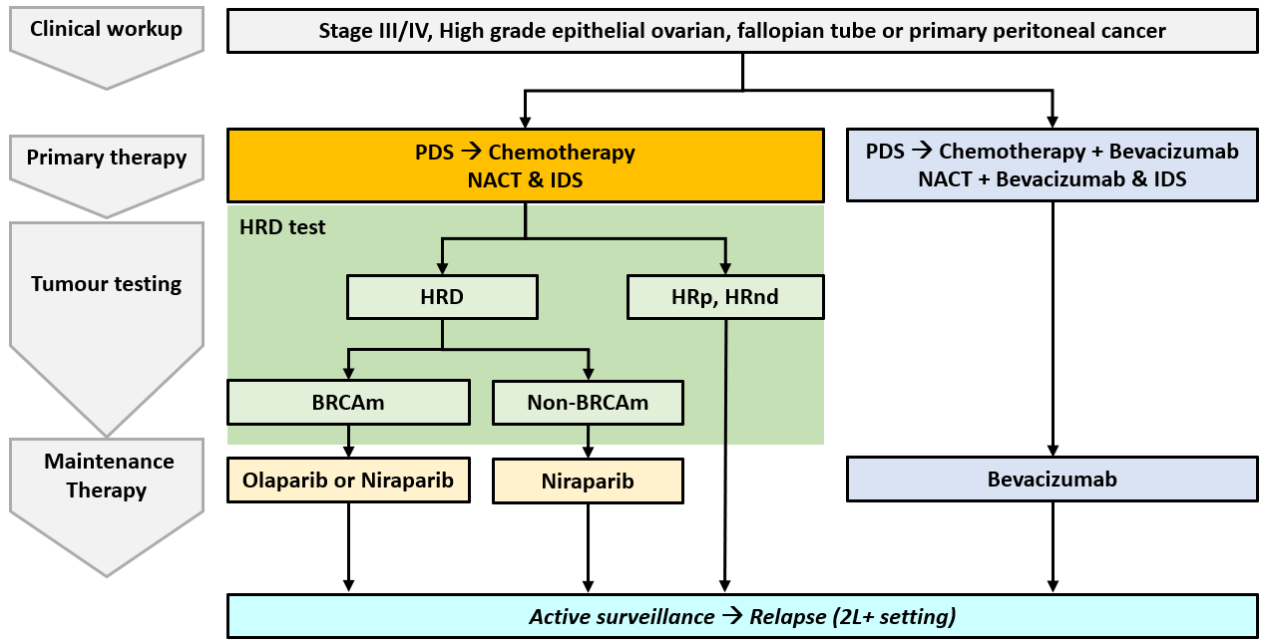

Figure 7: Clinical management algorithm for the treatment of NDA HGEOC – Population #3b: Sequential HRD testing for patients that receive platinum-based chemotherapy
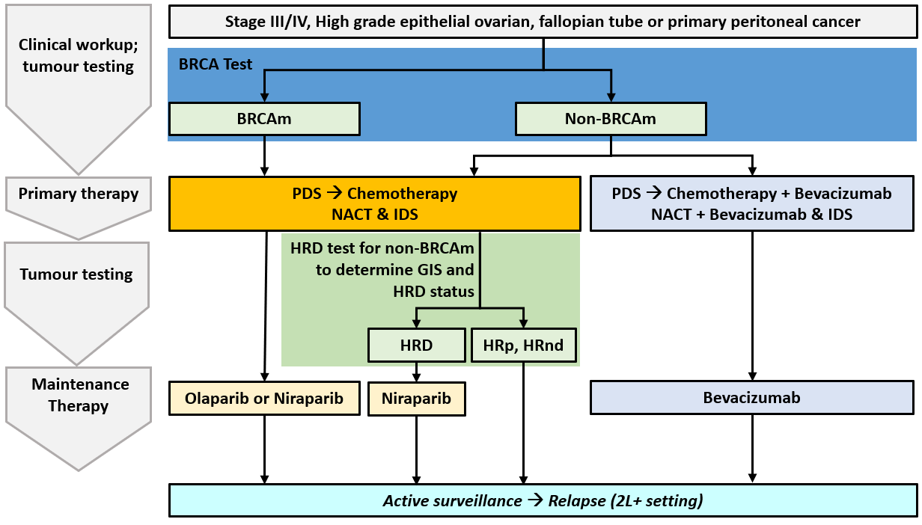
Note: BRCA test refers to MBS Item 73301

PART 6d – INFORMATION ABOUT CLINICAL OUTCOMES

Summarise the clinical claims for the proposed medical service against the appropriate comparator(s), in terms of consequences for health outcomes (comparative benefits and harms):
For patients with NDA (FIGO stage III-IV) HGEOC who are in response (CR/PR) to PBC, the co-dependent technologies of tumour testing to identify HRD status and treatment with niraparib as maintenance therapy in patients with HRD and no BRCA1/2 pathogenic variant is:
- Superior in terms of effectiveness compared to no HRD testing & SMM.
- Inferior to no HRD testing & SMM with respect to safety

Please state what the overall clinical claim is:
For patients with NDA (FIGO stage III-IV) HGEOC who are in response (CR/PR) to PBC, the co-dependent technologies of tumour testing to identify HRD status and treatment with niraparib as maintenance therapy in patients with HRD and no BRCA1/2 pathogenic variant is:
- Superior in terms of effectiveness compared to no HRD testing & SMM.
- Inferior to no HRD testing & SMM with respect to safety

List the key health outcomes (major and minor – prioritising major key health outcomes first) that will need to be measured in assessing the clinical claim for the proposed medical service/technology (versus the comparator):
Health outcomes that are relevant to the application are as follows:
Test
- Comparison of concordance and discordance between evidentiary standard (Myriad MyChoice Assay) and local HRD test to determine HRD status
- Comparison of the analytical performance of the local HRD test compared with current tumour BRCA testing to determine BRCA pathogenic variant status (Applicable to parallel testing scenarios for Population #1 and Population #3)
- Clinical validity of the test: differential prognostic effect of HRD positive status in HGEOC, including an assessment of whether the prognostic effect varies further according to BRCA status
- Clinical utility of the test: treatment effect modification of niraparib by HRD positive status in patients with NDA HGEOC who are in response to PBC
- Other test related considerations: test failure rates and re-biopsy rates; test turnaround time
- Safety: adverse events associated with biopsy/re-biopsy for patients with inadequate tissue for tumour testing
Maintenance Therapy
- Progression Free Survival
- Overall Survival
- Health related quality of life
- Safety

PART 7 – INFORMATION ABOUT ESTIMATED UTILISATION

Estimate the prevalence and/or incidence of the condition in the proposed population:
Based on the Australian Institute of Health and Welfare, ovarian cancer and serous carcinomas of the fallopian tube (C56, C57 and C58 with histologies 8441, 8460, 8461) were projected to have an incidence of 1720 in 2021. With respect to peritoneal cancer (C48), with the exclusion of cases in the retroperitoneum (MOH 2013), the incidence is estimated to be 117 in 2021.

Estimate the number of times the proposed medical service/technology would be delivered to a patient per year:
Testing to determine HRD status would be conducted only once per primary tumour diagnosis.

How many years would the proposed medical service/technology be required for the patient?
Testing to determine HRD status would be conducted only once per primary tumour diagnosis.

Estimate the projected number of patients who will utilise the proposed medical service(s) for the first full year:
The number of patients that would utilise HRD testing for the first year is summarised in Table 7 below. From the incident ovarian cancer population, patients with high grade (93.6%, Alsop 2012), epithelial (83.7%, AIHW 2010) and advanced disease (81.8%; Lindemann 2018) were estimated to be 1178 in 2021. It is assumed that 95% of these patients will have a tumour sample available for testing, of which all patients would receive HRD testing in Population #1 scenario (1119 patients). In a sequential testing situation (Population #2), patients identified as non-BRCAm (PBAC, 74.7%) would undergo subsequent GIS (836 patients). Most patients receive 1L PBC (Alsop 2012, 91.5%) and a chemotherapy only regimen (Niraparib March 2022 PSD, Paragraph 7.10 and 5.1; refer to Question 36), representing the HRD testing population that receive first line platinum based chemotherapy (Population #3a, 972 patients).
Table 7: Number of patients utilising HRD testing according to Population #1, #2 and #3
 | 2021 | Source
Ovarian cancer and serous carcinomas of the fallopian tube | 1720 | AIHW: C56, C57 and C58 with histologies 8441, 8460, 8461
Peritoneal cancer | 117 | AIHW: C48 (female only), exclude retroperitoneal (MOH 2013)
High grade | 93.6% | AOCS: Alsop 2012
Epithelial tumours | 83.7% | AIHW 2010
Advanced stage (FIGO III-IV) | 81.8% | AOCS: Lindemann 2018
Incidence of NDA HGEOC | 1178 | Calculated
Tumour sample available for testing | 95.0% | Assumption
Population #1 | 1119 | Calculated
Population #2 | 836 | PBAC - Non-BRCAm Cohort: 74.7%
Receive 1L PBC | 91.5% | Alsop 2012
Receive chemotherapy only regimen | 95.0% | Item 7.07 March 2022 PSD, Paragraph 7.10 & 5.2.
Population #3a | 972 | Calculated
Population #3b | 726 | PBAC - Non-BRCAm Cohort: 74.7%
Abbreviations: AIHW = Australian institute of health and welfare; AOCS = Australian Ovarian Cancer Study

Estimate the anticipated uptake of the proposed medical service/technology over the next three years, factoring in any constraints in the health system in meeting the needs of the proposed population (such as supply and demand factors), as well as provide commentary on risk of ‘leakage’ to populations not targeted by the service.
A detailed utilisation analysis will be presented in the co-dependent submission. The risk of leakage beyond the proposed population is low, given the proposed MBS item descriptor. It is not anticipated there will be constraints in the health system in meeting the needs of the proposed population, noting that it is expected that a number of pathology laboratories will undergo accreditation for HRD tests following the launch of the REDACTED assay in REDACTED.

PART 8 – COST INFORMATION

Indicate the likely cost of providing the proposed medical service. Where possible, please provide overall cost and breakdown:
The REDACTED test is expected to be launched in Australia from REDACTED. The pricing of the assay is expected to be available following the submission of this application in July 2022. Overall costs associated with providing the service to determine HRD status will be presented in a future co-dependent submission.

Specify how long the proposed medical service/technology typically takes to perform:
Tumour HRD testing is expected to take 4-6 weeks from request to reporting. This includes time for the request and time to transport the tumour specimen to a specialist laboratory where required (7-10 days). Testing in the laboratory may require several hours of activity to perform plus run time for automated processes depending on instrumentation and procedures being followed and could take up to 4 weeks. Reporting the results to the requesting specialist or consultant physician takes a further 1-2 days.

If public funding is sought through the MBS, please draft a proposed MBS item descriptor to define the population and usage characteristics that defines eligibility for the medical service/technology.
The proposed MBS item descriptor relevant to Population #1,#2, #3a and #3b is provided below. This acknowledges the PASC’s advice (August 2021) that the item descriptor should specify that the proposed test also uses a genomic instability score (GIS) to differentiate from germline testing of non-BRCA1/2 genes in the HRD pathway. GSK notes that with the consideration of HRD testing by the MSAC in July 2022 (#1658), there may be subsequent advice regarding the appropriate population for HRD testing and the wording for the proposed item descriptor (e.g. reference to GIS; reference to the primary chemotherapy regimen).
Population #1: HRD testing for BRCA1/2 variant and GIS in parallel
Category 6 – Pathology services
Proposed item descriptor:
A test of tumour tissue from a patient with advanced (FIGO III-IV), high grade serous or high grade epithelial ovarian, fallopian tube or primary peritoneal cancer, requested by a specialist or consultant physician, to determine eligibility with respect to homologous recombination deficiency (HRD) status for access to treatment with niraparib under the Pharmaceutical Benefits Scheme (PBS)
Evidence of homologous recombination deficiency must be derived through a validated test of tumour tissue to determine a genomic instability score.
Fee: $3000
Population #2: Testing for GIS to occur sequentially following a non-BRCAm test result
Category 6 – Pathology services
Proposed item descriptor:
A test of tumour tissue from a patient with advanced (FIGO III-IV), high grade serous or high grade epithelial ovarian, fallopian tube or primary peritoneal cancer, requested by a specialist or consultant physician, to determine eligibility with respect to homologous recombination deficiency (HRD) status in patients that do not express BRCA1 or BRCA2 pathogenic or likely pathogenic variants, for access to treatment with niraparib under the Pharmaceutical Benefits Scheme (PBS)
Evidence of homologous recombination deficiency must be derived through a validated test of tumour tissue to determine a genomic instability score.
Fee: $3000

Population #3a:
Category 6 – Pathology services
Proposed item descriptor:
A test of tumour tissue from a patient with advanced (FIGO III-IV), high grade serous or high grade epithelial ovarian, fallopian tube or primary peritoneal cancer who have received a first-line platinum based chemotherapy regimen, requested by a specialist or consultant physician, to determine eligibility with respect to homologous recombination deficiency (HRD) status for access to treatment with niraparib under the Pharmaceutical Benefits Scheme (PBS)
Evidence of homologous recombination deficiency must be derived through a validated test of tumour tissue to determine a genomic instability score.
A patient must not have received bevacizumab as part of their first-line platinum based chemotherapy regimen
Fee: $3000
Population #3b:
Category 6 – Pathology services
Proposed item descriptor:
A test of tumour tissue from a patient with advanced (FIGO III-IV), high grade serous or high grade epithelial ovarian, fallopian tube or primary peritoneal cancer who have received a first-line platinum based chemotherapy regimen, requested by a specialist or consultant physician, to determine eligibility with respect to homologous recombination deficiency (HRD) status in patients that do not express BRCA1 or BRCA2 pathogenic or likely pathogenic variants, for access to treatment with niraparib under the Pharmaceutical Benefits Scheme (PBS)
Evidence of homologous recombination deficiency must be derived through a validated test of tumour tissue to determine a genomic instability score.
A patient must not have received bevacizumab as part of their first-line platinum based chemotherapy regimen
Fee: $3000

If public funding is sought through an alternative (non-MBS) funding arrangement, please draft a service description to define the population and usage characteristics that defines eligibility for the service/technology.
Not applicable

