|  |
| --- |
| Protocol to guide the assessment of MR-guided biopsy procedures for diagnosis of prostate cancer |
| May 2016 |

Table of Contents

MSAC and PASC 3

Purpose of this document 3

Purpose of application 4

Intervention 4

Description 4

Estimated utilisation 6

Administration, dose, frequency of administration, duration of treatment 6

In-gantry MRGB 6

MRI-fusion TRUSGB and TPUSGB 6

Co-administered interventions 7

Background 7

Current arrangements for public reimbursement 7

Regulatory status 9

Patient population 9

Proposed MBS listing 9

Clinical place for proposed intervention 10

Clinical scenario 1: men who are suspected of having prostate cancer 10

Clinical scenario 2: men diagnosed with prostate cancer undertaking active surveillance 12

Comparator 14

Reference standard test 14

Clinical claim 14

Outcomes and health care resources affected by introduction of proposed intervention 15

Outcomes 15

Proposed structure of economic evaluation (decision-analytic) 16

References 17

Appendix 1 18

# MSAC and PASC

The Medical Services Advisory Committee (MSAC) is an independent expert committee appointed by the Minister for Health (the Minister) to strengthen the role of evidence in health financing decisions in Australia. MSAC advises the Minister on the evidence relating to the safety, effectiveness, and cost-effectiveness of new and existing medical technologies and procedures and under what circumstances public funding should be supported.

The Protocol Advisory Sub-Committee (PASC) is a standing sub-committee of MSAC. Its primary objective is the determination of protocols to guide clinical and economic assessments of medical interventions proposed for public funding.

## Purpose of this document

This document is intended to provide a draft decision analytic protocol that will be used to guide the assessment of an intervention for a particular population of patients. The draft protocol will be finalised after inviting relevant stakeholders to provide input to the protocol. The final protocol will provide the basis for the assessment of the intervention.

The protocol guiding the assessment of the health intervention has been developed using the widely accepted “PICO” approach. The PICO approach involves a clear articulation of the following aspects of the research question that the assessment is intended to answer:

**P**atients – specification of the characteristics of the patients in whom the intervention is to be considered for use;

**I**ntervention – specification of the proposed intervention

**C**omparator – specification of the therapy most likely to be replaced by the proposed intervention

**O**utcomes – specification of the health outcomes and the healthcare resources likely to be affected by the introduction of the proposed intervention

# Purpose of application

A proposal for an application requesting MBS listing of (1) multiparametric MRI (mpMRI) scans of the prostate, and (2) MR-guided prostate biopsy in men with a high or concerning Prostate Specific Antigen and under suspicion of harbouring prostate cancer, was received from the Australian and New Zealand Association of Urological Surgeons and the Australian Diagnostic Imaging Association by the Department of Health in August 2014.

Following the August 2015 meeting, PASC advised that Application 1397 should be spilt into two applications.

1. Intervention for Diagnostic mpMRI; and
2. Intervention for MR-guided biopsy.

This recommendation is intended to assist with the preparation and evaluation of the contracted assessments by the Economic Sub-Committee (ESC) and Medical Services Advisory Committee (MSAC).

# Intervention

## Description

In cancers, cells replicate in an abnormal, uncontrolled manner, forming a mass of cells called a tumour. Prostate cancer is the result of such abnormal replication in the prostate. While the cause(s) of prostate cancer are not yet completely understood, the following factors are thought to play a role: age, family history, ethnic background, lifestyle, and environmental factors. After heart disease, lung cancer, and cerebrovascular diseases, prostate cancer is the fourth leading cause of death amongst Australian men. In 2011, there were nearly 3300 deaths from prostate cancer, and the age-standardised mortality rate for prostate cancer was 31 per 100,000. It is projected that by 2020, the number of deaths will reach 3900 and the age-standardised mortality rate will decrease to 26 per 100,000 (AIHW 2013).

Currently in Australia, the signs of prostate cancer are detected with a prostate-specific antigen test (PSA test) and/or a digital rectal examination (DRE).

PSA is a protein that is made by the prostate to aid the fertilisation of eggs by spermatozoa. Prostate-specific antigen test is a blood test that quantifies PSA in the blood stream. The PSA may be present in the blood stream for many reasons – including infection or trauma to the prostate, benign prostatic enlargement (BPE), and prostate cancer. The most common reason for elevated PSA levels is BPE, and not all prostate cancers have elevated PSA levels. Consequently, the PSA test has a low specificity, in the order of 25-30% (Applicant advice). Overall, an elevated level of PSA may be indicative of an elevated risk of prostate cancer, but requires further investigation. (HealthPact 2014; Barentsz et al 2012).

Digital rectal examination (DRE) involves inserting a finger into the rectum to palpate the prostate; swellings, hardenings or lumps may be signs of prostate cancer. The Applicant advises that the DRE has a low sensitivity, although its positive predictive value is high – hard lumps detected by DRE are very likely to be prostate cancer, and while chronic inflammatory conditions can cause hard lumps, this is rare.

However, PSA and DRE tests are not diagnostic and patients will undergo additional imaging with mpMRI scans. Patients whose mpMRI results indicate a suspicion of prostate cancer will undergo a prostate biopsy to receive a diagnosis of prostate cancer. During a biopsy, a needle is inserted into the prostate under the guidance of ultrasound, and a set of random samples of tissue (using between 12-32 needles) are taken from the prostate. The samples are then analysed under the microscope, to see if cancer cells are present (Siddiqui et al 2015; AIHW 2013). Prostate cancers are graded using the Gleason system: Gleason score of 6 or less is considered low risk, a Gleason score of 7 is considered intermediate risk, and a score of 8 or above is considered to be high risk (HealthPact 2014). Another risk stratification measure in use is the TNM Classification of Malignant Tumours (TNM), where T describes the size of the tumour, N describes the affected lymph nodes, and M describes the metastases (Cancer Council Australia, 2015).

In magnetic resonance imaging, a magnet together with radio-waves is used to produce images of soft tissues. In multi-parametric MRI, three pulse sequences are used: T2 weighted (T2W), diffusion weighted (DWI) and dynamic-contrast enhanced (DCE). These are combined and analysed together. Both 1.5 and 3.0 Tesla MRI scanners are available in Australia; either one may be used to carry out multi-parametric scans (HealthPact 2014). However, the Applicant advises that although the new generation 1.5 Tesla MRI scanners may be adequate for mpMRI, the older generation machines are not, as they are unable to acquire the DWI.

This protocol includes two MRI-guided biopsy (MRGB) techniques:

1. in-gantry MRGB; and
2. Trans-rectal ultrasound-guided biopsy (TRUSGB) or trans-perineal ultrasound-guided biopsy (TPUSGB) using software fusion of previously acquired magnetic resonance images with ultrasound images (MRI/US fusion-guided biopsy).

In-gantry MRGB uses an MRI machine to guide the prostate biopsy in real-time, whereas MRI-fusion TRUSGB and TPUSGB uses existing (previously acquired) MR images which are fused with TRUS or TPUS images using image fusion software.

The Applicants advise that approximately 75% of prostate biopsies are currently performed trans-rectally, and 25% are performed trans-perineally. They note that the proportional use of the different approaches is changing rapidly in favour of trans-perineal biopsy due to its improved safety profile. PASC has recommended that any assumptions made about the proportion of biopsies that are performed trans-perineally should be tested in sensitivity analyses in the final assessment.

## Estimated utilisation

Between July 2014 and June 2015, there were 20,149 services claimed on the MBS for ultrasound-guided prostate biopsy (MBS item 37219). The population of men receiving these biopsies will include both men with suspected prostate cancer and men undergoing active surveillance for previously diagnosed prostate cancer.

If diagnostic mpMRI is listed on the MBS (Application 1397), the number of biopsies is expected to decrease, as diagnostic mpMRI allows more accurate selection of patients for biopsy. The extent of the expected reduction in biopsies is uncertain. The Applicant advises that the number of biopsies may be reduced by up to 50%, but the best source for an estimate of this parameter is likely to be the final assessment for diagnostic mpMRI. PASC noted that the availability of rebates for mpMRI prostate scans may also increase the number of men choosing to have regular testing for prostate cancer, and this may affect the expected utilisation of MRI-guided prostate biopsies.

It is expected that the majority of these ultrasound-guided prostate biopsies will be replaced by MRI-fusion TRUSGB and TPUSGB, with a minority of biopsies performed using in-gantry MRGB.

## Administration, dose, frequency of administration, duration of treatment

### In-gantry MRGB

Applicant advises that MRGB does not require anaesthesia or hospital admission, and a skilled operator can biopsy a single lesion in 20 minutes and two lesions in 30-40 minutes, depending on the position and relation to the first lesion. Most centres with sufficient training should be able to perform a biopsy of a single lesion in 30 minutes. If MRGB is positive, the cancer volume and grade, as well as the treatment options are discussed with the patient. If MRGB is negative, the needle position is validated by the radiologist using images taken at the time of biopsy – if the needle sampled the lesion, then the result is considered benign; if the needle missed the lesion, the biopsy is repeated with adjusted needle alignment. (Repeat rate is currently less than 5% and the repeat biopsy is conducted at no cost to patient).

### MRI-fusion TRUSGB and TPUSGB

In the case of fusion, fusion software superimposes the mpMRI data on the ultrasound data, fusing the two sets of images; this shows the operator where to aim the biopsy needle. The duration depends on whether the transrectal or transperineal approach is used, and whether both targeted and random biopsies are carried out. Applicant advises that theatre time for the transrectal approach is approximately 30 minutes, and the procedure is typically carried out under local anaesthesia. Transperineal biopsies are performed in a day theatre and require general anaesthesia. The transperineal biopsy takes approximately 60 minutes, which includes the time to anaesthetise and wake the patient. If fusion-based biopsy is positive, the cancer volume and grade, as well as the treatment options, are discussed with the patient. If the fusion-based biopsy is negative, the options are: to repeat the biopsy, to perform MRGB, or for the patient to be observed.

Both types of MR-guided biopsy can be performed by either a urologist or a radiologist. The Applicant advises that the Urological and Radiological College and Society agreed that specialist referral was required, and the patient had to be seen by a urologist, radiation oncologist or a medical oncologist first. The reporting radiologist must have MRI accreditation with RANZCR.

## Co-administered interventions

In-gantry MRGB involves the following co-administered interventions:

* MRI machine
* Needle guide with gadolinium inserts
* Antibiotic injection prior to the procedure
* Local anaesthetic
* Conscious sedation (optional)
* Pulse oximetry equipment (in patients who require sedation)
* Intravenous access and other disposables (titanium biopsy needles)

MRI-fusion TRUSGB and TPUSGB involves the following co-administered interventions:

* Theatre facilities
* MR images together with a fusion ultrasound machine
* MRI compatible biopsy gun
* Conscious sedation (e.g. Fentatyl) with local anaesthesia (TRUSGB); or general anaesthetic (TPUSGB)
* Intravenous antibiotic
* Antibiotics (at operator’s discretion)

Note that, depending on the jurisdiction, the use of conscious sedation may require the attendance of an anaesthetist.

# Background

## Current arrangements for public reimbursement

Current MBS item for ultrasound scans of the prostate, include:

Table 1: Current MBS item descriptors for scans of the prostate

| Subgroup 4 - Urological |
| --- |
| **MBS item 55600**  Prostate, bladder base and urethra, ultrasound scan of, if performed:  (a) personally by a medical practitioner (not being the medical practitioner who assessed the patient as specified in paragraph (c)) using one or more transducer probes that:  (i) have a nominal frequency of 7 to 7.5 MHz or a nominal frequency range that includes frequencies of 7 to 7.5 MHz; and  (ii) can obtain both axial and sagittal scans in 2 planes at right angles; and  (b) after a digital rectal examination of the prostate by that medical practitioner; and  (c) on a patient who has been assessed by a specialist in urology, radiation oncology or medical oncology, a consultant physician in medical oncology, who has:  (i) examined the patient in the 60 days before the scan; and  (ii) recommended the scan for the management of the patient’s current prostatic disease (R) (K)  *(See para DIQ of explanatory notes to this Category)*  **Fee:** $109.10 **Benefit:** 75% = $81.85 85% = $92.75 |
| **MBS item 55601**  PROSTATE, bladder base and urethra, ultrasound scan of, where performed:  (a) personally by a medical practitioner (not being the medical practitioner who assessed the patient as specified in (c)) using a transducer probe or probes that:  (i) have a nominal frequency of 7 to 7.5 megahertz or a nominal frequency range which includes frequencies of 7 to 7.5  megahertz; and  (ii) can obtain both axial and sagittal scans in 2 planes at right angles; and  (b) following a digital rectal examination of the prostate by that medical practitioner; and  (c) on a patient who has been assessed by a specialist in urology, radiation oncology or medical oncology or a consultant  physician in medical oncology who has:  (i) examined the patient in the 60 days prior to the scan; and  (ii) recommended the scan for the management of the patient's current prostatic disease (R) (NK)  *(See para DIQ of explanatory notes to this Category)*  **Fee:** $54.55 **Benefit:** 75% = $40.95 85% = $46.40 |
| **MBS item 55603**  PROSTATE, bladder base and urethra, ultrasound scan of, where performed:  (a) personally by a medical practitioner who undertook the assessment referred to in (c) using a transducer probe or probes that:  (i) have a nominal frequency of 7 to 7.5 megahertz or a nominal frequency range which includes frequencies of 7 to 7.5  megahertz; and  (ii) can obtain both axial and sagittal scans in 2 planes at right angles; and  (b) following a digital rectal examination of the prostate by that medical practitioner; and  (c) on a patient who has been assessed by a specialist in urology, radiation oncology or medical oncology or a consultant  physician in medical oncology who has:  (i)examined the patient in the 60 days prior to the scan; and  (ii)recommended the scan for the management of the patient's current prostatic disease (R) (K)  *(See para DIQ of explanatory notes to this Category)*  **Fee:** $109.10 **Benefit:** 75% = $81.85 85% = $92.75 |
| **MBS item 55604**  PROSTATE, bladder base and urethra, ultrasound scan of, where performed:  (a) personally by a medical practitioner who undertook the assessment referred to in (c) using a transducer probe or probes that:  (i) have a nominal frequency of 7 to 7.5 megahertz or a nominal frequency range which includes frequencies of 7 to 7.5  megahertz; and  (ii) can obtain both axial and sagittal scans in 2 planes at right angles; and  (b) following a digital rectal examination of the prostate by that medical practitioner; and  (c) on a patient who has been assessed by a specialist in urology, radiation oncology or medical oncology or a consultant physician  in medical oncology who has:  (i) examined the patient in the 60 days prior to the scan; and  (ii) recommended the scan for the management of the patient's current prostatic disease (R) (NK)  *(See para DIQ of explanatory notes to this Category)*  **Fee:** $54.55 **Benefit:** 75% = $40.95 85% = $46.40 |

The current MBS item for the biopsy portion of ultrasound-guided biopsy of the prostate is as follows:

Table 2: Current MBS item descriptor for item 37219

| Category 3 – Therapeutic Procedures |
| --- |
| MBS item 37219  PROSTATE, needle biopsy of, using prostatic ultrasound techniques and obtaining 1 or more prostatic specimens, being a service associated with a service to which item 55600 or 55603 applies  Multiple services rule.  (Anaes.) (Assist.)  **Fee:** $280.85 **Benefit:** 75% = $210.65 85% = $238.75 |

## Regulatory status

A number of MRI systems are TGA-approved for use in Australia. A recent horizon scan of MRI screening for prostate cancer in Australia has identified the following TGA-listed manufacturers of MRI full-body scanners: Emergo Asia Pacific Pty Ltd (ARTG # 136622); GE Healthcare Australia Pty Ltd (ARTG # 135096; 169744; 169036; 223115); Philips Electronics Australia Ltd (ARTG # 98887, 212690); Siemens Ltd (ARTG # 98319, 98485, 144221, 154128) and Toshiba Australia Pty Ltd (ARTG # 126911). (AIHW 2013)

# Patient population

The patient populations for this assessment are:

* men who are suspected of having prostate cancer on the basis of a PI-RADS 4 – 5 lesion on diagnostic mpMRI; and
* men undergoing active surveillance for prostate cancer who develop a PI-RADS 4 – 5 lesion on diagnostic mpMRI.

To determine PI-RADs score, patients would need an mpMRI scan. These patients would need to meet clinical criteria for suspicion of prostate cancer, as follows:

* PSA >3μg/L (or lower level is < 50 years of age) or
* Positive family history (including BRCA gene mutation) or
* Free/Total PSA ratio < 25%

Patients with a PI-RADS 1-3 lesion may also progress to a non-MRI guided template biopsy if they have other indications of increased risk such as positive family history/BRCA gene mutation, Free/Total PSA ratio < 12% or, PSA density > 0.15 . Please see the assessment of diagnostic mpMRI for more information on this patient population.

## Proposed MBS listing

Two MBS items are proposed, one for in-gantry MRGB, and one MRI-fusion TRUSGB/TPUSGB. PASC notes that if both modalities turn out to be equally effective, then MSAC could be silent on the image-guiding modality for biopsy (in-gantry MRI vs. US/MRI fused). However, if the modalities have differing effectiveness, then separate MBS items would be warranted.

Although feedback from the Urological Society of Australia and New Zealand (USANZ) advised that its members are currently using existing biopsy items for the above service, PASC recommend that a separate MBS item is required to separate MRI fusion-guided biopsy from US-guided biopsy without MRI.

Table 3: Proposed MBS item descriptors for Magnetic Resonance Imaging-guided prostate biopsy

| Category 3 – Therapeutic Procedures |
| --- |
| MBS [item number]  Magnetic Resonance Imaging-guided prostate biopsy, using an MRI machine in real time (MRGB) in men who are suspected of having prostate cancer on the basis of the mpMRI scan (PI-RADS 4 or PI-RADS 5).  Fee: Applicant advises that current fee charged for MRGB is $2300*  [Relevant explanatory notes]  A limit of one MRI-guided biopsy per patient per 12 month period, to be accessed by referral from a specialist (e.g. urologist, radiation oncologist or medical oncologist). |
| Category 3 – Therapeutic Procedures |
| MBS [item number]  Magnetic Resonance Imaging-guided prostate biopsy, using previously acquired magnetic resonance images which are fused using an ultrasound machine, in men who are suspected of having prostate cancer on the basis of the mpMRI scan (PI-RADS 4 or PI-RADS 5).  Fee: $280.85  (Anaes.)  [Relevant explanatory notes]  A limit of one MRI-guided biopsy per patient per 12 month period, to be accessed by referral from a specialist (e.g. urologist, radiation oncologist or medical oncologist). |

* the proposed for MRGB ($2300) consists of: MRI time ($800), disposables ($650), professional fee for a urologist or radiologist ($850)

Urologists have an exemption under subsection 16B (6) of the *Health Insurance Act 1973*, which allows consultant physicians and specialists (other than radiologists) to self-determine diagnostic imaging services within their area of speciality.  Consequently, if the biopsy is to be performed by a urologist, the service may be self-determined without requiring referral from another specialist. If the biopsy is to be performed by a radiologist, the patient must be referred by another specialist (e.g. urologist, radiation oncologist or medical oncologist).

## Clinical place for proposed intervention

### Clinical scenario 1: men who are suspected of having prostate cancer

Currently, prostate cancer is suspected following a prostate-specific antigen test (PSA) and/or a digital rectal examination (DRE). If these tests indicate a risk of prostate cancer, patients are evaluated using multi-parametric MRI (mpMRI). Patients with PI-RADS scores 1, 2, or 3 and low clinical suspicion, will return to primary care and may remain under observation. Patients with PI-RADS score 1, 2 or 3 and high clinical suspicion (positive family history/BRCA gene mutation, Free/Total PSA ratio <12%, or PSA density > 0.15) will have a template biopsy and patients with PI-RADS scores 4 and 5 will have an ultrasound-guided biopsy (either TRUSGB or TPUSGB). Based on the results of the biopsy, patients will either:

* return to primary care under observation, with a follow-up PSA test after six months; or
* undergo active surveillance; or
* have surgery or a radiotherapy/hormone therapy combination for their cancer.

Figure 1 contains the current clinical management algorithm for the biopsy portion of the investigation of potential prostate cancer. An algorithm showing all of the steps in the diagnostic process for prostate cancer has been provided for reference in Appendix 1.

Figure 1: Current clinical management algorithm for biopsy for suspected prostate cancer

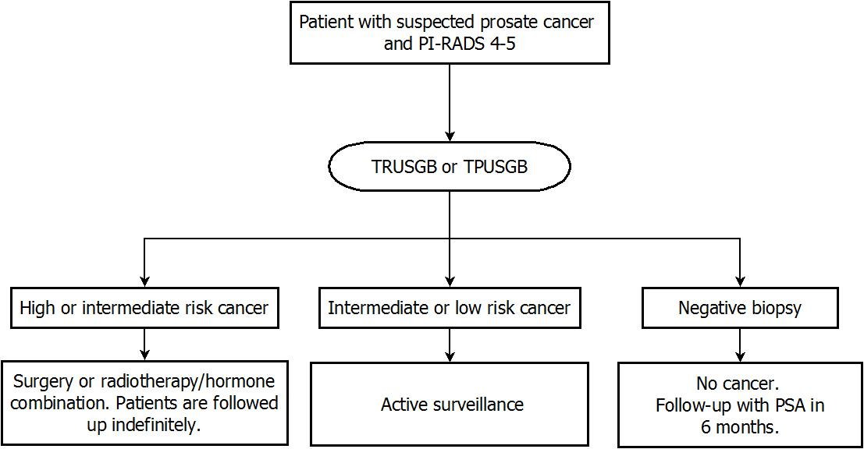

Abbreviations: PI-RADS=Prostate Imaging-Reporting and Data System; MR=magnetic resonance; TRUSGB=trans-rectal ultrasound-guided biopsy; TPUSGB=trans-perineal ultrasound-guided biopsy.

Under the proposed clinical management algorithm shown in Figure 2, patients with PI-RADS scores 4 and 5 will undergo a prostate biopsy with either in-gantry MRGB or MRI-fusion TRUSGB/TPUSGB. Based on the results of the biopsy, patients will be offered the same management options as under the current clinical management algorithm.

Figure 2: Proposed clinical management algorithm for MRGB for suspected prostate cancer

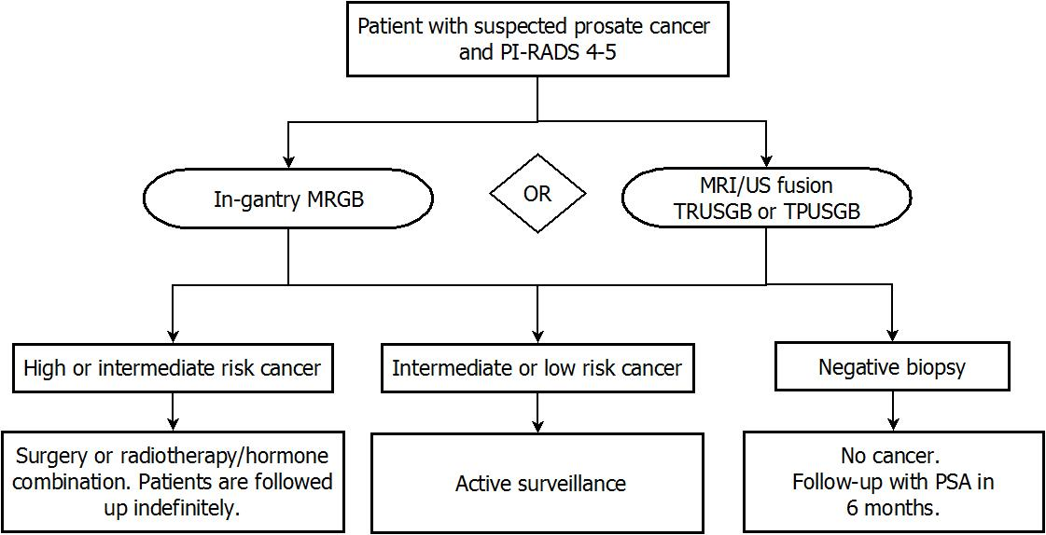

Abbreviations: PI-RADS=Prostate Imaging-Reporting and Data System; MR=magnetic resonance; MRGB=magnetic resonance guided biopsy; MRI=magnetic resonance imaging; TRUSGB=trans-rectal ultrasound-guided biopsy; TPUSGB=trans-perineal ultrasound-guided biopsy; US=ultrasound.

### Clinical scenario 2: men diagnosed with prostate cancer undertaking active surveillance

Men who have a diagnosis of intermediate or low risk cancer may choose to participate in Active Surveillance. During active surveillance men will undergo scheduled testing (PSA, PSA kinetics and DRE) over a period of five years or more. Men will also have scheduled mpMRI scans at 12 months, and then every three years thereafter. At any point in time, if there is concern about clinical or PSA/DRE changes, men can opt to have an additional mpMRI scan.

Men with PI-RADS scores 4 and 5 will undergo a prostate biopsy with either TRUSGB or TPUSGB. Based on the results of these biopsies, men will either continue on active surveillance or be offered surgery or a radiotherapy/hormone therapy combination for their cancer. Figure 3 below shows the current clinical management algorithm for the biopsy portion of the active surveillance protocol. An algorithm showing all of the steps in the active surveillance protocol for prostate cancer has been provided for reference in Appendix 1.

Figure 3: Current clinical management algorithm for biopsy for active surveillance of prostate cancer

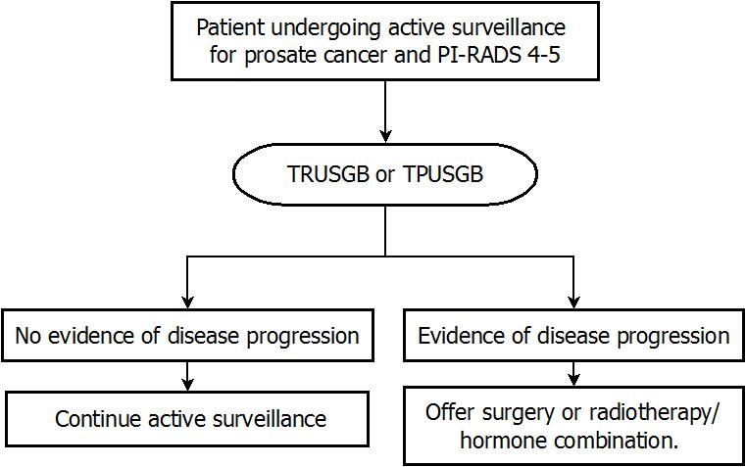

Abbreviations: PI-RADS=Prostate Imaging-Reporting and Data System; TRUSGB=trans-rectal ultrasound-guided biopsy; TPUSGB=trans-perineal ultrasound-guided biopsy.

Under the proposed clinical management algorithm, patients with PI-RADS scores 4 and 5 will undergo a prostate biopsy with either in-gantry MRGB or MRI-fusion TRUSGB/TPUSGB. Based on the results of the biopsy, patients will either continue on active surveillance or be offered surgery or a radiotherapy/hormone therapy combination for their cancer. The details of the proposed protocol for active surveillance are presented in Figure 4.

Figure 4: Proposed clinical management algorithm for MRGB for active surveillance prostate cancer

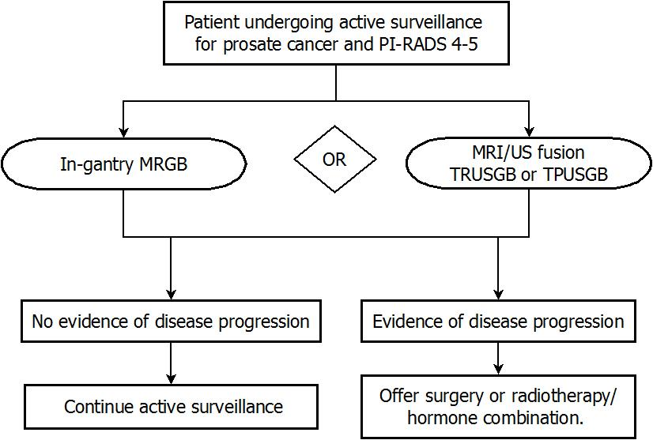

Abbreviations: PI-RADS=Prostate Imaging-Reporting and Data System; MR=magnetic resonance; MRGB=magnetic resonance guided biopsy; MRI=magnetic resonance imaging; TRUSGB=trans-rectal ultrasound-guided biopsy; TPUSGB=trans-perineal ultrasound-guided biopsy; US=ultrasound.

# Comparator

The comparators for each of the requested biopsy modalities are presented below.

**Comparators for in-gantry MRGB:**

1. TRUSGB/TPUSGB using software fusion of previously acquired magnetic resonance images with ultrasound images (MRI/US fusion-guided biopsy)
2. “Current” TRUSGB/TPUSGB (w/o MRI)

**Comparators for MR/US fusion-guided TRUSGB and TPUSGB:**

1. In-gantry MRGB
2. “Current” TRUSGB/TPUSGB (w/o MRI)

# Reference standard test

The reference standard is subsequent pathology (testing of the acquired samples).

# Clinical claim

MRI targeted biopsies can detect the most aggressive cancer using only 1 to 4 needles, compared to 12 to 50 needles used for transrectal or transperineal biopsy schemes (Pokorny 2014, Siddiqui 2014 and Walton 2015). Introducing only 4 needles as opposed to 12-50 means fewer punctures of the prostate, each of which has the potential to induce bleeding or seed bacteria into the bloodstream.

MRI guided biopsies have also been shown to find more significant cancers than standard biopsy techniques, and diagnose fewer insignificant cancers (Pokorny 2014). This is important as fewer men will have a delayed diagnosis of aggressive cancer, and fewer men will undergo treatment and the related harms of treatment for a cancer which was never a risk to them.

Because both modalities of MR-guided biopsy are considered to be more accurate and less invasive, the clinical claim is that they are more effective and safer than the comparator. In the event that claims of superior efficacy and safety are supported by the literature, either a cost-utility or a cost-effectiveness analysis would be appropriate.

Table 4: Classification of an intervention for determination of economic evaluation to be presented

|  |  |  |  |  |  |  |
| --- | --- | --- | --- | --- | --- | --- |
|  | | **Comparative effectiveness versus comparator** | | | | |
| Superior | | Non-inferior | Inferior | |
| **Comparative safety versus comparator** | Superior | CEA/CUA | | CEA/CUA | Net clinical benefit | CEA/CUA |
| Neutral benefit | CEA/CUA* |
| Net harms | None^ |
| Non-inferior | CEA/CUA | | CEA/CUA* | None^ | |
| Inferior | Net clinical benefit | CEA/CUA | None^ | None^ | |
| Neutral benefit | CEA/CUA* |
| Net harms | None^ |

Abbreviations: CEA = cost-effectiveness analysis; CUA = cost-utility analysis

* May be reduced to cost-minimisation analysis. Cost-minimisation analysis should only be presented when the proposed service has been indisputably demonstrated to be no worse than its main comparator(s) in terms of both effectiveness and safety, so the difference between the service and the appropriate comparator can be reduced to a comparison of costs. In most cases, there will be some uncertainty around such a conclusion (i.e., the conclusion is often not indisputable). Therefore, when an assessment concludes that an intervention was no worse than a comparator, an assessment of the uncertainty around this conclusion should be provided by presentation of cost-effectiveness and/or cost-utility analyses.

^ No economic evaluation needs to be presented; MSAC is unlikely to recommend government subsidy of this intervention

# Outcomes and health care resources affected by introduction of proposed intervention

## Outcomes

For the MR-guided biopsy, the assessment will consider:

* Effectiveness
  + Health outcomes: change in overall survival, changei n prostate cancer specific mortality, change in incontinence, change in impotence
  + Diagnostic accuracy: sensitivity, specificity, PPV, NPV
  + Change in management: changes in the biopsy rate, changes in the rate of men diagnosed with low risk cancer, change in the rates of surgery
  + Patient outcomes: quality of life, satisfaction, time from diagnosis to treatment
* Safety
  + Adverse events: Change in biopsy-induced trauma, change in biopsy-induced haemorrhage
* Cost-effectiveness or cost-utility

PASC noted feedback received from the Royal College of Pathologists of Australasia (RCPA) that it may not be feasible to measure change in overall survival and change in prostate cancer specific mortality due to the long natural history of prostate cancer (typically >10 years from diagnosis to death). The RCPA also advised that the savings in pathology costs are likely to be insignificant compared to the additional cost of mpMRI.

PASC noted feedback from the Urological Society of Australia and New Zealand (USANZ) and the Applicant that the adverse outcomes of biopsy are overstated here, as there is a growing trend to trans-perineal biopsies in Australia that have a close to 0% risk of sepsis. Adverse outcomes can include admission to an Intensive Care Unit (ICU) or hospital.

## Proposed structure of economic evaluation (decision-analytic)

Table 6: Summary of extended PICO to define research question that assessment will investigate

|  |  |  |  |  |
| --- | --- | --- | --- | --- |
| **Patients** | **Prior test** | **Intervention** | **Comparator** | **Outcomes to be assessed** |
| 1. Men who are suspected of having prostate cancer the basis of a PI-RADS 4 – 5 lesion on diagnostic mpMRI; and 2. Men undergoing active surveillance for prostate cancer who have a PI-RADS 4 – 5 lesion on diagnostic mpMRI. | mpMRI | 1. In-gantry MRGB 2. MRI/US fusion TRUSGB/TPUSBG | 1. MRI/US fusion  or  TRUS/TPUS GB w/o MRI-guidance 2. In-gantry MRGB  or  TRUS/TPUS GB w/o MRI-guidance | *Effectiveness*   * + Health outcomes: change in overall survival, changei n prostate cancer specific mortality, change in incontinence, change in impotence   + Diagnostic accuracy: sensitivity, specificity, PPV, NPV   + Change in management: changes in the biopsy rate, changes in the rate of men diagnosed with low risk cancer, change in the rates of surgery   + Patient outcomes: quality of life, satisfaction, time from diagnosis to treatment   *Safety*   * + Adverse events: Change in biopsy-induced trauma, change in biopsy-induced haemorrhage   *Economic:*   * + Cost-effectiveness or cost-utility |

# References

AIHW (2014). Australian Institute of Health and Welfare. Cancer in Australia: an overview 2014. Cancer series. No 90. Cat. no. CAN 88. Canberra: AIHW.

Barentsz, JO et al (2012). ESUR prostate MR guidelines 2012. *Eur Radiol* 22:746-757.

Cancer Council Australia (2015). TNM system.

HealthPACT (2014). *Technology Brief: MRI screening for prostate cancer*. State of Queensland (Queensland Dept of Health). Brisbane, QLD: Queensland Health.

NICE (2014) *Prostate Cancer: diagnosis and treatment. Clinical guideline. Full guideline January 2014.*

Pokorny MR, de Rooij M, Duncan E, Schroder FH, Parkinson R, Barentsz JO, et al. Prospective study of diagnostic accuracy comparing prostate cancer detection by transrectal ultrasound-guided biopsy versus magnetic resonance (MR) imaging with subsequent MR-guided biopsy in men without previous prostate biopsies*. Eur Urol*. [Research Support, Non-U.S. Gov't]. 2014 Jul;66(1):22-9.

Siddiqui, MM et al (2015) Comparison of MR/Ultrasound Fusion-Guided Biopsy with Ultrasound-Guided Biopsy for the Diagnosis of Prostate Cancer. *JAMA,* 313(4):390-7.

Walton Diaz A, Hoang AN, Turkbey B, Hong CW, Truong H, Sterling T, et al. Can magnetic resonance-ultrasound fusion biopsy improve cancer detection in enlarged prostates? *J Urol.* 2013 Dec;190(6):2020-5.

# Appendix 1

Clinical management algorithm for the diagnosis of prostate cancer.

Clinical management algorithm for the diagnosis of prostate cancer

Abbreviations: PSA=prostate specific antigen test; DRE=digital rectal examination; PI-RADS=Prostate Imaging-Reporting and Data System; MR=magnetic resonance; mpMRI=multi-parametric magnetic resonance imaging; MRGB=magnetic resonance guided biopsy; US=ultrasound.

*Indications of increased cancer risk may include patient’s age, positive family history, abnormal DRE, PSA doubling time < 2 years, PSA density > 0.15, free/total PSA ratio < 25%, Prostate Health Index > 25, known BRCA1 or BRCA2 mutation.

Clinical management algorithm for the active surveillance of prostate cancer.

Clinical management algorithm for the active surveillance of prostate cancer