1175:

Final Decision

Analytic Protocol (DAP) to guide the assessment of HER2 testing for access to lapatinib in metastatic breast cancer

May 2012

Table of Contents
MSAC and PASC 3
Purpose of this document 3
Purpose of the application 4
Background 4
Current arrangements for public reimbursement 4
Regulatory status 6
Intervention 8
Description 8
Delivery of the intervention 13
Prerequisites 15
Co-administered and associated interventions 16
Listing proposed and options for MSAC consideration 17
Proposed MBS listing 17
Clinical place for proposed intervention 18
Comparator 22
Outcomes for safety and effectiveness evaluation 23
Effectiveness 23
Safety 23
Summary of PICO to be used for assessment of evidence (systematic review) 23
Clinical claim 25
Outcomes and health care resources affected by introduction of proposed intervention 25
Outcomes for economic evaluation 25
Health care resources 26
Proposed structure of economic evaluation (decision analysis) 29
References 32

MSAC and PASC

The Medical Services Advisory Committee (MSAC) is an independent expert committee appointed by the Australian Government Health Minister to strengthen the role of evidence in health financing decisions in Australia. MSAC advises the Commonwealth Minister for Health and Ageing on the evidence relating to the safety, effectiveness, and cost- effectiveness of new and existing medical technologies and procedures and under what circumstances public funding should be supported.

The Protocol Advisory Sub-Committee (PASC) is a standing sub-committee of MSAC. Its primary objective is the determination of protocols to guide clinical and economic assessments of medical interventions proposed for public funding.

Purpose of this document

This document is the decision analytic protocol that will be used to guide the evidence- based assessment of human epidermal receptor–2 (HER2) testing of tissue samples from patients with breast cancer to determine suitability for targeted therapy with lapatinib (Tykerb®). This will inform the question for MSAC as to whether in-situ hybridisation (ISH) testing, listed on the Medicare Benefits Schedule (MBS) from 1st May 2012, should be extended to include reference to the proposed subsidy of lapatinib as well as trastuzumab. This protocol has been finalised after inviting relevant stakeholders to provide input and has been developed using the widely accepted “PICO” approach. This approach involves a clear articulation of the following aspects of the research question that the assessment is intended to answer:

Patients – specification of the characteristics of the population or patients in whom the intervention is intended to be used;
Intervention – specification of the proposed intervention;
Comparator – specification of the therapy most likely to be replaced, or added to, by the proposed intervention; and
Outcomes – specification of the health outcomes and the healthcare resources likely to be affected by the introduction of the proposed intervention.

Purpose of the application

An application from GlaxoSmithKline Australia Pty Ltd was received by the Department of Health and Ageing requesting a Medicare Benefits Schedule (MBS) listing for HER2 testing, in support of a PBAC application, to enable access to proposed Pharmaceutical Benefits Scheme (PBS) subsidised lapatinib treatment in patients with metastatic breast cancer who are able to tolerate paclitaxel (a taxane), but in whom trastuzumab is not appropriate. This application relates to two tests already funded on the MBS: immunohistochemistry to detect over-expression of HER2, and ISH for detection of HER2 gene amplification.

PASC has finalised this protocol to guide the assessment of the safety, effectiveness and cost-effectiveness of HER2 testing in order to inform MSAC’s decision-making regarding public funding of HER2 test/s which determine patient eligibility for access to lapatinib treatment.

Background

Current arrangements for public reimbursement

Immunohistochemistry (IHC) for the detection of oestrogen, progesterone and HER2 is currently listed on the MBS (see Table 1 for relevant item number and descriptor). This item number is currently not restricted by patient or clinical indication, so no change is proposed for the item descriptor for this medical service.

ISH for detection of HER2 gene amplification has been newly listed on the MBS (listed 1st May 2012; see Table 1 for relevant item number and descriptor). However, this item number is restricted to determining eligibility for treatment with trastuzumab under the PBS or through the ‘late-stage metastatic breast cancer’ Herceptin™ program, which is funded by the Australian Government but is not part of the PBS. The applicant therefore proposes an extension to the item descriptor for this medical service to include determining eligibility for treatment with lapatinib. Testing is provided by 28 laboratories certified to conduct ISH testing in Australia. The current MBS item description for ISH testing (see Table 1) does not restrict the stage at which the disease should be prior to testing. Lapatinib is being proposed as a treatment for metastatic (stage IV) breast cancer, and it is expected that the tested population will consist of patients diagnosed with metastatic breast cancer (stage IV) in whom treatment with trastuzumab is not appropriate.

Metastatic breast cancer patients are also generally treated with a taxane, such as docetaxel or paclitaxel, either in combination with trastuzumab (HER2+ patients) or alone (HER2- patients). Taxane treatments are reimbursed through the PBS.

Table 1 Current MBS item descriptors for IHC and ISH testing

Category 6 – Pathology services
MBS 72848

Immunohistochemical examination of biopsy material by immunofluorescence, immunoperoxidase or other labelled antibody techniques with multiple antigenic specificities per specimen - 1 to 3 of the following antibodies - oestrogen, progesterone and c-erb-B2 (HER2)

Fee: $75.00

(Item is subject to rule 13 – If more than 1 of the services mentioned in items 72846, 72847, 72848; 72849 and 72850 or
73059, 73060, 73061, 73064 and 73065 are performed in a single patient episode, a Medicare benefit is payable only for the item performed that has the highest scheduled fee.)
Category 6 – Pathology services
MBS 73332

An in situ hybridization (ISH) test of tumour tissue from a patient with breast cancer (other than in the neoadjuvant setting) requested by, or on behalf of, a specialist or consultant physician to determine if the requirements relating to human epidermal growth factor receptor 2 (HER2) gene mutation status for access to trastuzumab under the Pharmaceutical Benefits Scheme (PBS) or the Herceptin Program are fulfilled.

Fee: $317.50

The MBS items 72848 descriptor for IHC testing of HER2 also allows testing for oestrogen or progesterone receptors (Table 1). The utilisation of this item indicates that between July
2009 and June 2011 there were 13,373 services claimed (Table 2). The majority of these
are likely to be in women with breast cancer as suggested by the breakdown of item utilisation by sex. These data are reflective of IHC testing in the private healthcare setting and do not reflect the testing that occurs in the public healthcare system.

Table 2 Medicare utilisation of MBS item 72848 between July 2009 and June 2010

 | 2009/10 | 2010/11
Total  Women  Men | 6,438  6,278  160 | 6,935  6,796  139

In Australia, there were 12,567 cases of breast cancer in 2007, and it is estimated that this will increase to approximately 14,818 cases in 2011 and 15,409 cases by 2015 (Cancer Australia 2011). Based on data from the NSW Central Cancer Registry between 2004 and
2008, 51.2% of patients have localised disease at the time of diagnosis, while 36.5% have advanced disease with regional lymph node involvement, 5.4% have distant metastases, and the extent of disease in 6.9% is unknown (New South Wales Central Cancer Registry
2010). Thus, approximately 5.4% of patients (800 patients in 2011 and 832 in 2015) have metastatic disease.

Current usage of IHC testing suggests that most women with metastatic breast cancer are already being tested, and those with equivocal or negative IHC results were receiving privately funded HER2 ISH testing for inclusion in the ‘late-stage metastatic breast cancer’

Herceptin™ program through an agreement between the government and Roche Products
Pty Ltd. This agreement has now been replaced by MBS funding for HER2 ISH testing.

Regulatory status

In vitro diagnostic medical devices (IVDs) are, in general, pathology tests and related instrumentation used to carry out testing on human samples, where the results are intended to assist in clinical diagnosis or in making decisions concerning clinical management (Therapeutic Goods Administration 2009).

Manufacturers of Class 2, Class 3 and Class 4 commercial IVDs must hold certification from a regulatory body to show compliance with a suitable conformity assessment procedure (Therapeutic Goods Administration 2009). The Therapeutic Goods Administration (TGA) regulatory framework for IVDs changed in July 2010, such that in-house laboratory tests now also receive regulatory scrutiny. Laboratories that manufacture in-house Class 3 IVDs are required to notify the TGA of the types of IVDs manufactured in each laboratory for inclusion on a register. These laboratories must have National Association of Testing Authorities (NATA) accreditation, with demonstrated compliance with the suite of standards on the validation of in-house IVDs, as published by the National Pathology Accreditation Advisory Committee (NPAAC), for each test manufactured.

There are several kits available in Australia to determine HER2 status (Table 3), which have differing resource implications. The classification of these kits range between in vitro diagnostic class 2 and 3 medical devices (IVDs).

Class 2 IVDs are those that detect the presence of, or exposure to, infectious agents that are not easily propagated in the Australian population or that cause self-limiting diseases. Class 2 IVDs that present a moderate individual risk include those which provide results that are not intended to be used as the sole determinant in a diagnostic situation, or where an erroneous result rarely puts the individual in immediate danger (Therapeutic Goods Administration 2009).

Class 3 IVDs present a moderate public health risk, or a high individual risk, and include those used to target patients for selective therapy and management, or for disease staging, or in the diagnosis of cancer including cancer staging, where initial therapeutic decisions will be made based on the outcome of the test results, for example, personalised medicine (Therapeutic Goods Administration 2009).

In terms of using HER2 testing to selectively determine access to HER2 targeted therapies, these test kits and any in-house IVDs would be considered as Class 3 IVDs.

Table 3 Regulatory status of HER2 testing in Australia

Testing Test kit / antibody or DNA Sponsor ARTG Approved indication method probe number
IHC HercepTest™ Dako 76270 Not included on recorda
Roche Diagnostics Ventana Roche In N/A anti-Her-2/neu (4B5) primary Diagnostics Progress antibody Australia
Roche Diagnostics Confirm Roche Exempt N/A
anti-Her-2 neu Diagnostics
Australia
FISH HER2 FISH PharmDx™ Dako 76270 Not included on recorda
PathVysion kit Abbott 23280 Not included on recorda
Molecular
CISH SPOT-Light® HER2 CISH Invitrogen 132070 For in vitro diagnostic use only kit
SISH ultraView SISH detection kit Roche 174896 Class II IVD - intended to be used alone or in Diagnostics combination with other IVDs to perform various Australia tissue related histology and cytology-related
tests and procedures
INFORM HER2 DNA single Roche 180933 Class III IVD - DNA IVD probes intended to be probe Diagnostics used in genetic testing to provide information
Australia about acquired genetic alterations, which may include chromosomal alterations, mutations
and/or alterations in gene expression, and which may be used to characterise haematological or solid tumour malignancies and/or provide prognostic information.
ultraView Alk Phos Red ISH Roche 174896 Class II IVD - intended to be used alone or in
Detection kit Diagnostics combination with other IVDs to perform various
Australia tissue related histology and cytology-related tests and procedures
INFORM Chromosome 17 Roche 176103 Class II IVD - Various products intended to be single probe Diagnostics used alone or in combination with other IVDs to
Australia perform various human genetics-related tests
(e.g in-situ Hybridisation)
ultraView SISH DNP Roche 174896 Class II IVD - intended to be used alone or in detection kit Diagnostics combination with other IVDs to perform various
Australia tissue related histology and cytology-related tests and procedures
Ultraview Red ISH DIG Roche 174896 Class II IVD - intended to be used alone or in
Detection kit Diagnostics combination with other IVDs to perform various
Australia tissue related histology and cytology-related tests and procedures
INFORM HER2 Dual ISH Roche 180933 Class III IVD - DNA IVD probes intended to be
DNA probe cocktail Diagnostics used in genetic testing to provide information
Australia about acquired genetic alterations, which may include chromosomal alterations, mutations
and/or alterations in gene expression, and which may be used to characterise haematological or solid tumour malignancies and/or provide prognostic information.
a these devices were listed on the ARTG prior to the introduction of the regulatory framework for in-vitro diagnostic medical devices; IHC
= immunohistochemistry; N/A = not applicable; FISH = fluorescence in-situ hybridisation; CISH = chromogenic in-situ hybridisation; SISH
= silver in-situ hybridisation

Intervention

Description

Breast cancer is a disease in which abnormal cells, most commonly originating from the terminal duct lobular unit of the breast, transform and develop into an invasive tumour. These tumours can invade and damage the tissue around them, and spread to other parts of the body, such as the bones, liver, lung and brain, through the lymphatic or vascular systems (AIHW & NBOCC 2009).

Breast cancer is the most common cancer among Australian women, accounting for 27% of all cancer diagnoses and with an average age of first diagnosis of 60 years in 2007 (AIHW
& AACR 2010; AIHW & NBOCC 2009). Thus, one in nine women will be diagnosed with breast cancer before the age of 85. The BreastScreen Australia program screened
1,641,316 women (77.6% aged 50-69 years) for breast cancer in 2007-2008 (AIHW 2010).
There was an increase in the rate of detection of invasive breast cancer between 1996 and
2008, from 56.5 to 71.7 per 10,000 women screened for the first screening round, and from 35.3 to 47.5 per 10,000 women screened for subsequent screening rounds. However, nearly two-thirds of all invasive breast cancers detected by BreastScreen Australia were small, improving the chances of survival for these patients.

The relative five-year survival rate has been increasing steadily in the last few decades;
72.6% of women diagnosed with breast cancer in 1982-1987 survived, compared to 88.3% of women in 2000-2006. The 2006 five-year relative survival rate can be further divided into 96.5% for women with negative nodal status and 80.2% for women with positive nodal status in 2006 (AIHW & NBOCC 2009). Despite the high survival rates, breast cancer was the leading cancer cause of burden of disease for women, accounting for 40,600 years of life lost due to premature death and 20,500 years of healthy life lost due to disease, disability or injury in 2010 (AIHW & AACR 2010).

Lapatinib has shown promising results in the treatment of HER2 over-expressing advanced or metastatic breast cancer (Bilancia et al 2007; Di Cosimo & Baselga 2008). The applicant initially proposed that HER2 ISH testing be performed on tissue samples from patients with advanced or metastatic breast cancer (ie stage IIIA - IV), but later clarified its proposal as applying only to metastatic breast cancer patients for whom treatment with trastuzumab is not appropriate, but who can tolerate taxane therapy. The submission of evidence to support the veracity of the clinical claims should also clearly define the population for whom trastuzumab is “not appropriate”, and use this to support its estimates of the size of the eligible population. One possible definition of those patients who are not appropriate for trastuzumab are those with pre-existing heart problems, such as patients with a left ventricular ejection fraction (LVEF) of less than 45% and/or with symptomatic heart failure. Another definition might be patients with central nervous system metastases from HER2
positive breast cancer who would benefit more from a small molecule inhibitor, such as

lapatanib, that crosses the blood brain barrier unlike trastuzumab. Other relevant details defining the population in the evidence base that will support the use of lapatinib and a taxane in the first-line setting of HER2 positive patients with metastatic breast cancer are not fully known and should be clarified in the submission of this evidence. For example, details of the concurrent oestrogen receptor status and progesterone receptor status may have an important impact on the prevalence of the eligible patient population because most HER2 positive patients are hormone receptor negative (the closest current TGA-approved indication supports the first-line use of lapatinib and an aromatase inhibitor, and also requires that eligible patients must also be post menopausal and have hormone receptor positive tumours).

It is possible that patients for whom trastuzumab is not appropriate are currently not being tested as trastuzumab is the only first-line targeted treatment option. It is estimated that approximately 10% of patients with metastatic breast cancer would not be eligible for trastuzumab therapy (Breckenridge 2011). Table 4 provides definitions for the TNM staging categories used by the American Joint Committee on Cancer Staging (AJCC) and Table 5 describes the TNM categories that define breast cancer stages 0-IV. Stage IV, which would be eligible for HER2 ISH testing in order to identify those patients who will likely receive clinical benefit from HER2 targeted therapy with lapatinib (ie have metastatic disease), is highlighted.

Table 4 TNM staging of breast cancer

Primary tumour (T) | Regional lymph node (N) | Distant metastasis (M)
TX Primary tumour cannot be assessed  T0 No evidence of primary tumour  Tis Carcinoma in situ  (DCIS) Ductal carcinoma in situ  (LCIS) Lobular carcinoma in situ  (Paget’s) Paget’s disease of the nipple NOT associated with invasive carcinoma and/or carcinoma in situ  T1 Tumour ≤ 20 mm in greatest dimension  T2 Tumour > 20 mm but ≤ 50 mm in greatest dimension  T3 Tumour > 50 mm in greatest dimension  T4 Tumour of any size with direct extension to the chest wall and/or to the skin (ulceration or skin nodules)  T4a Tumour of any size with direct extension to the chest wall, not including only pectoralis muscle adherence/invasion  T4b Tumour of any size with ulceration and/or ipsilateral satellite nodules and/or edema (including peau d’orange) of the skin, which do not meet the criteria for inflammatory carcinoma  T4c Both T4a and T4b  T4d Inflammatory carcinoma | NX Regional lymph nodes cannot be assessed (for example, previously removed)  N0 No regional lymph node metastasis  N1 Metastases to movable ipsilateral level I, II axillary lymph node(s)  N2a Metastases in ipsilateral level I, II axillary lymph  nodes that are clinically fixed  or matted  N2b Metastases in clinically detected ipsilateral internal mammary nodes in the absence of clinically evident axillary lymph node metastases  N3a Metastases in ipsilateral infraclavicular (level III axillary) lymph node(s) with or without level I, II axillary lymph node involvement;  N3b Metastases in clinically detected ipsilateral internal mammary lymph node(s) with clinically evident level I, II axillary lymph node metastases;  N3c Metastases in ipsilateral supraclavicular lymph node(s) with or without axillary or internal mammary lymph node involvement | M0 No clinical or radiographic evidence of distant metastases  M0(i+) deposits of tumour cells in circulating blood, bone marrow, or other non- regional nodal tissue that are no larger than 0.2 mm  M1 Distant detectable metastases larger than 0.2 mm
Source: American Joint Committee on Cancer Staging resources [Accessed, September 2011]
http://www.cancerstaging.org/staging/index.html;

Table 5 American Joint Committee on breast cancer TNM stage grouping
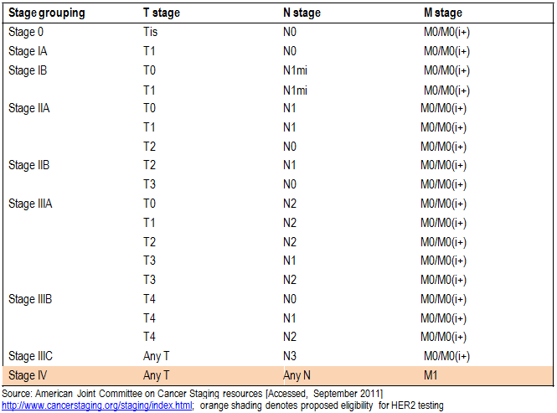
The HER2 gene is located on chromosome 17q 11.2-q12 and encodes the HER2 protein, one of four members of the epidermal growth factor receptor (EGFR) family which have an extracellular domain, a transmembrane region and an intracellular domain with tyrosine kinase activity (Di Cosimo & Baselga 2008). The receptors are activated by ligand-induced homo- and heterodimerisation. As HER2 has no known ligand, its main biological role is the formation of heterodimeric receptor complexes with the other three members of the EGFR family, inducing receptor autophosphorylation and interaction with downstream mediators (Bilancia et al 2007). The dimerisation partner is important because it impacts on the downstream effects in signal transduction to the nucleus, which ultimately leads to gene activation and cell division (Bilancia et al 2007; Di Cosimo & Baselga 2008; Yarden 2001). The EGFR family is important for normal growth and development; HER2 has been detected in the nervous system, developing bone, muscle, skin, heart, lungs and intestinal epithelium of human foetuses (Yarden 2001). The EGFR family is also involved in the regulation of normal breast growth and development, and disruption of the HER-mediated signal transduction pathways has been implicated in the pathogenesis of breast cancer (Bilancia et al 2007; Di Cosimo & Baselga 2008; Yarden 2001).

In particular, HER2 over-expression is associated with breast cancer, with HER2 gene amplification being the most common mechanism leading to increased levels of HER2 protein (Bilancia et al 2007; Di Cosimo & Baselga 2008; Yarden 2001). Although the exact mechanism of gene amplification has not been determined, two flexible sequences with the

strong potential to affect normal DNA replication and result in intra-chromosomal DNA amplification, have been identified at the location of amplified HER2 gene fragment boundaries (Kovalenko 2010).

Additionally, approximately one third of breast cancer patients have tumours with extra copies of chromosome 17 (polysomy 17). The copy number can vary from three to four copies (low ploidy - common), to five or more copies (high ploidy – much rarer) and results in an increased HER2 gene copy number, but it is mechanistically distinct from HER2 gene amplification. However, most polysomy 17 tumours do not over-express HER2 protein, and cannot be distinguished from HER2 negative tumours by standard pathologic criteria, such as hormone receptor status (Dal Lago et al 2006; Rosenberg 2008).

Over-expression of HER2 disrupts normal control mechanisms, leading to deregulation of cell growth and survival, tumour development, and resistance to chemotherapy (Bilancia et al 2007; Yarden 2001). Increased levels of HER2 are present in approximately 25% of human breast cancers and are associated with poor clinical outcomes such as significantly shortened survival times (Di Cosimo & Baselga 2008; Yarden 2001). However, the outcomes have improved with the development of anti-HER2 therapies, such as trastuzumab (Di Cosimo & Baselga 2008) and the therapy component of this co-dependent application, lapatanib. Over-expression and gene amplification can be detected by IHC and ISH, respectively.

IHC is performed on formalin-fixed, paraffin-embedded tumour samples and detects the presence of the HER2 receptor protein in the cellular membrane using a specific antibody for the HER2 protein. Antibodies which have bound to the receptor are then detected by another subsequent antigen-antibody reaction. Visualisation of these immunogenic reactions occurs as a result of labelling of the secondary antibody with either dyes or enzymes which are involved in chromogenic reactions. HER2 positivity is based on the staining patterns seen in the biopsy samples (Table 6).

Table 6 Scoring of IHC staining pattern in tumour biopsy samples

Staining intensity score | Staining pattern | HER2 over- expression assessment
0  1+  2+  3+ | No staining or membrane staining in fewer than 10% of tumour cells  Faint, barely perceptible membrane staining in more than 10% of tumour cells; the cells are stained only in part of their membrane  Weak to moderate complete membrane staining observed in more than 10% of tumour cells  Strong, complete membrane staining in more than 10% of tumour cells | Negative  Negative  Equivocal  Positive
Source: (Rhodes et al 2002); IHC = immunohistochemistry

Detection of amplification of the HER2 gene is performed with ISH which detects copies of the HER2 gene within the cells using specific labelled probes that are detectable with bright-field methodology (chromogenic in-situ hybridisation [CISH] or silver in-situ

hybridisation [SISH]) or by fluorescent microscopy (FISH). If amplification is occurring, there will be increased copies of the gene detected in the cells. ISH can be either a single probe or a double probe test. As a single probe test (directed at the HER2 gene), gene amplification is confirmed if the average number of copies of the HER2 gene, per nucleus, is ≥6. A copy number between 4 and 6 is considered equivocal (Wolff et al 2007).

A double probe test compares the number of HER2 gene copies to the number of chromosome 17 centromere (CEP17) copies to give an amplification ratio (Penault-Llorca et al 2009). Samples are considered positive for HER2 amplification when the number of copies of the HER2 gene per tumour cell, is ≥2.2-times the number of copies of chromosome 17 (Wolff et al 2007). It has also been recommended that borderline or equivocal results (ratio 1.8 to 2.2) be re-tested (Dendukuri et al 2007). There is generally greater than 85% concordance between FISH and CISH results, any discordance was usually seen in samples with low-level amplification by FISH (Penault-Llorca et al 2009).

ISH has been established as the most accurate method to predict HER2 gene amplification and response to monoclonal antibody-based therapy targeting HER2 in several clinical trials (Brügmann & Sorensen 2011), and is widely regarded as a superior diagnostic test to IHC in breast cancer.

Concerns about the accuracy of IHC testing have been raised on numerous occasions. The RCPA quality assurance program (QAP) performed a laboratory audit in 2005 and 2006 to evaluate in-house IHC HER2 testing results. They reported that while the results fall inside the established parameters overall, 49% of laboratories produced results that were rated as technically unsatisfactory (Francis et al 2007). This variation in results would impact on patient treatment decisions.

Delivery of the intervention

According to calculations based on data from 1998 to 2007, the incidence and mortality of breast cancer in Australia was estimated to be 13,600 and 2,900 persons in 2010 respectively (AIHW & AACR 2010).

There are no national data on the staging of breast cancer at the time of diagnosis available. However, Queensland collects some TNM staging information, and in 2002-2006
45% of cases were diagnosed at stages II to IV (AIHW & NBOCC 2009; Table 7). NSW uses a simpler breast cancer staging system, the Surveillance Epidemiology End Results (SEER) Summary Stage system, which is commonly used in reporting staging information to cancer registries. This system has three categories that indicate the extent of spread at diagnosis: local (when the tumour is confined to the breast), regional (the tumour has spread to surrounding tissue or nearby lymph nodes), and distant (the tumour has spread to distant organs). In the period from 1995 to 2004, 5.4% of breast cancers were diagnosed as distant (AIHW & NBOCC 2009; Table 7).

In the absence of combined data reporting on the proportion of those who are diagnosed with stage IV breast cancer, it is estimated that approximately 5.4% of breast cancer patients fall into this category (New South Wales Central Cancer Registry 2010). Of these,
10% (i.e. approximately 0.54% of all breast cancer patients) would not be appropriate for trastuzumab and would receive IHC with/without ISH testing for HER2 status to determine suitability for treatment with lapatinib. The expected utilisation of IHC and ISH testing to determine HER2 status for eligibility for lapatinib therapy for patients who would be not suited to trastuzumab treatment would be approximately 80 (10% of 800 patients diagnosed with metastatic disease) tests in 2011 and 83 (10% of 832) tests in 2015 (Cancer Australia 2011). It is unclear how many tumour samples would require retesting due to a sample that was not evaluable, or how many patients would be re-tested despite having previously determined HER2 status. Clinical advice suggests that many patients will be re-biopsied when presenting with a metastasis, even if they have already been HER2 tested on the primary tumour. Also relevant to estimating the number of additional HER2
ISH tests is the proportion of HER2 tests of metastatic breast cancer patients which is ordered before deciding whether treatment with trastuzumab is appropriate. For the submission of evidence, more accurate estimates of usage would require further insight into likely changes in clinical practice and further data on stage IV breast cancer incidence.

Table 7 Breast cancer by extent of disease at diagnosis
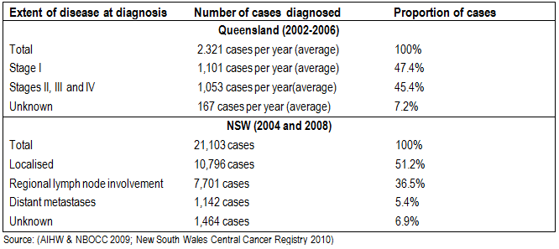

Biopsy samples are routinely taken as part of clinical practice in establishing a breast cancer diagnosis and for tumour staging. Assuming there is adequate tumour material, the original biopsy sample would also be used for HER2 testing.

The applicant has clarified that all patients with metastatic breast cancer (stage IV) should be tested with:

1) ISH testing alone (primary)
All eligible patients have their HER2 status determined through ISH testing alone.

OR

2) IHC followed by confirmation with ISH where necessary (triage/secondary)
All equivocal IHC results are retested using ISH to confirm HER2 gene amplification. Patients that have IHC 3+ or ISH + results are eligible for HER2 targeted treatment.

PASC disagreed with the applicant’s proposal that ISH testing without IHC testing would be a plausible option as IHC testing is used routinely as a prior test to examine the oestrogen, progesterone and HER2 status of all patients with breast cancer. Thus IHC testing would be used in all patients, either as a triage for ISH testing as for 2) above, or for all patients being tested using both IHC and ISH. Accordingly, PASC preferred 3) below in place of 1).

3) IHC and ISH testing for all patients (primary)
All eligible patients have their HER2 status determined through IHC and ISH testing. Patients that are HER2 positive using either the IHC or ISH test are eligible for HER2 targeted treatment.

The MBS item number for ISH testing does not pre-specify IHC testing to triage patients for the ISH test. Therefore, scenario 2 does not reflect the present MBS listing. In the clinical trials investigating the effectiveness of lapatinib in metastatic breast cancer, a HER2 positive status was determined by either IHC 3+ score or an ISH+ result, which is closest to scenario 3.

Biopsy and surgical samples are stored for a period of at least ten years for subsequent testing according to the National Guidelines for Tissues Storage; many centres and institutions would keep samples indefinitely. If repeat testing is necessary, due to initial results that are not evaluable, it is unlikely that additional biopsies would be required because stored samples would be sufficient to enable new material for testing.

Prerequisites

Biopsy or resection material for diagnostic testing is likely to be taken in the inpatient private hospital, inpatient public hospital, and day stay patient settings.

Ordering of HER2 testing should be restricted to oncologists, surgeons or pathologists, once a diagnosis of metastatic breast cancer has been established. Delivery of the intervention and reporting of the results would be provided by a pathologist in a NATA accredited pathology laboratory.

IHC and ISH testing should be performed in a NATA accredited laboratory that participates in the Royal College of Pathologists of Australasia (RCPA) quality assurance program to ensure test results do not vary between laboratories. The professionals associated with this process, and the setting in which this service will be delivered are the same as those currently involved with conducting publically reimbursed IHC testing or privately funded ISH testing in Australia.

As part of a quality use of medicines (QUM) initiative, prior to the Pharmaceutical Benefits Scheme (PBS) listing of trastuzumab for early breast cancer, reference laboratories were established to assist pathologists in performing HER2 testing and ensure reproducibility of results. Pathologists underwent ISH certification training resulting in certified ISH reference laboratories.

Now that ISH testing has been listed on MBS, any of the 28 laboratories certified to conduct ISH testing in Australia could perform the test, which would be available to all eligible patients in public and private practice. As ISH testing is already widely performed, no additional training, staff or accredited laboratories would be required under the proposed intervention.

Co-administered and associated interventions

HER2 testing is a co-dependent technology with the purpose of identifying patients with breast cancer over-expressing the HER2 receptor, who are likely to benefit from treatment with HER2 targeted therapies. Note, only those patients with metastatic disease would be eligible for treatment with lapatinib as proposed. This application relates to the use of the small molecule, reversible tyrosine kinase inhibitor, lapatinib, which inhibits the activity of HER2 and EGFR by binding to the ATP binding site on their intracellular tyrosine kinase domains (Bilancia et al 2007).

Trastuzumab is the current preferred treatment for patients with HER2 positive metastatic breast cancer and is subsidised for these patients through the Herceptin™ Program. It is also listed on the PBS for the adjuvant treatment of early breast cancer. However, trastuzumab should not be used in the 10% of HER2 test positive patients with a LVEF of less than 45% and/or with symptomatic heart failure (Breckenridge 2011). Furthermore, lapatinib has shown promising results in the treatment of HER2 over-expressing advanced or metastatic breast cancer, with potential benefit in patients with brain metastases (Bilancia et al 2007; Di Cosimo & Baselga 2008) indicating that lapatanib may be preferred over trastuzumab with patients with brain metastases. The small size of lapatinib allows it to cross the blood-brain barrier, which trastuzumab is not able to do. Thus, alternative treatments are required for this patient population. Hence, the sponsor seeks to gain PBS listing for lapatinib in this patient group.

Currently, the TGA restricts the patient population with metastatic breast cancer expressing HER2 that is eligible to use lapatinib in a first line setting (in combination with an aromatase inhibitor) to post menopausal women with hormone receptor positive tumours and in a second line setting (in combination with capecitabine) to those who have progressed after treatment with an anthracycline, a taxane and trastuzumab. The indicated drug combinations differ from that in this application; the applicant now seeks to combine lapatinib with a taxane for the treatment of metastatic breast cancer as a first-line treatment, for those patients for whom trastuzumab is not appropriate.

Even though lapatinib also has the potential for cardiotoxicity, the symptoms are much less severe than for trastuzumab. Approximately 3%–7% of patients undergoing trastuzumab therapy developed cardiac dysfunction with about three quarters being symptomatic (Widakowich et al 2007). Of the 1.6% of patients that experienced a decrease in left ventricular ejection fraction when treated with lapatinib, only 0.2% were symptomatic (Widakowich et al 2007). Therefore, it is recommended that patients should undergo an initial cardiac function assessment with continued monitoring every 8-12 weeks.

Listing proposed and options for MSAC consideration

Proposed MBS listing

It is proposed that the current MBS item descriptor for HER2 ISH testing of tumour tissue from patients with breast cancer be modified to include ISH testing for the purposes of determining eligibility for lapatinib as well as trastuzumab. The proposed amendments are shown in italics in Table 8.

Table 8 Proposed MBS item descriptor for HER2 testing in metastatic breast cancer
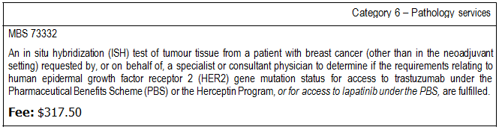

People with metastatic breast cancer who are eligible for treatment with lapatinib would be tested to determine HER2 status using:

1) IHC followed by confirmation with ISH where necessary (triage/secondary)

Patients with stage IV breast cancer would receive IHC testing on biopsy or resection samples, and these results would be confirmed by ISH studies, where IHC results are equivocal (2+).

OR

2) IHC and ISH testing for all patients (primary)

All eligible patients with stage IV breast cancer would have their HER2 status determined through IHC and ISH testing.

It is recommended that all ISH equivocal results (HER2 gene copy number of 4 – 6, or HER2 gene/chromosome 17 ratio of 1.8 – 2.2) should be retested by a central reference laboratory.

Clinical place for proposed intervention

In the current management of metastatic breast cancer, patients receive treatment with a taxane, either in combination with trastuzumab1 (HER2+ patients) or alone (HER2- patients and HER2+ patients not suitable for trastuzumab). The applicant proposes that patients with metastatic breast cancer for whom trastuzumab is not appropriate, but can tolerate taxane therapy, should be considered for lapatinib and so should be tested with ISH (with or without IHC) to determine their HER2 status.

For most clinical trials of HER2 targeted therapies, testing algorithms for HER2 were developed arbitrarily and the assays used to obtain data had not been standardized. Most algorithms consisted of either IHC testing with IHC 2+ triaged to FISH testing or reliance on ISH testing alone to detect gene amplification ratios of 2.0 or higher (Wolff et al 2007). Patients with tumours that had evidence of HER2 gene amplification by FISH or over- expression of the HER2 protein by IHC (3+) were considered suitable candidates for participation in these trials (Wolff et al 2007).

As a consequence of the uncertainties surrounding the accuracy of IHC testing, it could be argued that all patients with HER2 negative and equivocal (0, 1+, and 2+) results, not just those with equivocal (2+) results, should be retested using ISH. This could ensure that all patients that have HER2 positive breast cancer will be identified. However, it is still unknown whether or not HER2 targeted therapy is beneficial to patients who have an IHC 0 or 1+ and an ISH+ score (Dendukuri et al 2007).

An additional complication for HER2 IHC/ISH testing occurs in that approximately one third of breast cancer patients have tumours with extra copies of chromosome 17 (polysomy 17). These tumours mostly resemble HER2 negative tumours, rather than tumours with HER2 gene amplification (Rosenberg 2008). Thus, although polysomy tumours have an increased HER2 gene copy number, they do not often have a corresponding increase in HER2 protein expression (Dal Lago et al 2006). As a result, IHC 2+ expression is common in polysomy 17 tumours lacking HER2 gene amplification, but some IHC 3+ expression is associated with very high ploidy (>5 copies).

Patients with polysomy 17 metastatic breast cancer that does not over-express HER2 will not respond to targeted therapy (Hofmann et al 2008). In one study, polysomy was

1 Funded separately by a government program http://www.medicareaustralia.gov.au/provider/patients/late‐
breast‐cancer.jsp

observed in 26 patients and only six responded to trastuzumab treatment; the tumours from these six patients showed both HER2 over-expression (IHC 3+) and HER2 gene amplification (Downey et al 2010).

In rare cases, the IHC 3+ test result and over-expression of the HER2 protein is not due to either high ploidy or HER2 gene amplification but is a consequence of other genetic mutations; these mutations cause other changes, such as altered transcriptional regulation of the HER2 gene or altered HER2 protein stability, such that there is an increased expression of the HER2 protein on the cell surface (Kraus et al 1987). These tumours would be IHC 3+ and ISH-, and should benefit from HER2 targeted therapy.

Thus, the combination of an IHC test to detect over-expression of the HER2 protein and a double probe ISH test comparing the number of HER2 gene copies to the number of chromosome 17 centromere (CEP17) copies may provide the most accurate and complete profile for identifying which patients are likely to respond to HER2 targeted therapies. Patients that are either IHC 3+ (irrespective of ISH status) or ISH+ (irrespective of IHC status) would then be eligible for HER2 targeted therapy with either trastuzumab or lapatinib.

The current and proposed current and proposed clinical pathways that are presented in Figure 1 are each divided into a probability node for two different testing strategies; probabilities can be varied between zero and one such that all patients are subjected to either only one testing strategy or set to some “most likely” intermediate probability. This general structure of the model enables each of the two testing strategies of most interest to be assessed separately.

This scenario described above, where all patients are tested using both IHC and ISH, is reflected in the second test strategy of both the current and proposed clinical pathways that are presented in Figure 1. In the first test strategy, patients initially have an IHC test, which is used as a triage for the requirement for ISH testing, with equivocal (IHC 2+) test results undergoing ISH testing. This reflects standard clinical practice and is commonly used to determine HER2 status in clinical trials involving HER2 targeted therapies. These two test strategies were constructed based on advice from PASC.

The algorithm considers all metastatic breast cancer patients (Stage IV), which may include newly diagnosed patients, patients who have not had HER2 testing conducted for earlier diagnosed breast cancer and patients who are re-biopsied when presenting with a metastasis, even if they have already been HER2 tested on the primary tumour.

ISH testing is now funded by the MBS and is available to all patients with breast cancer (with or without prior IHC testing). It should be noted that the changes to the testing strategies between the current and proposed clinical pathways is simply a change in the triage of patients not suitable for trastuzumab treatment. As the proposed introduction of lapatinib as first-line for these patients is not expected to change the testing strategy, the

same probabilities for each test strategy should be used across both the current and proposed arms for each scenario. The probabilities can be varied to include the base case scenario, representing the best estimate of the current mix of the two strategies, and alternative scenarios where all patients are tested using a single testing strategy. This is important for the overall assessment of the co-dependent technologies because the different test strategies are likely to yield different health outcomes and different incremental cost-effectiveness ratios by varying the proportions of HER2 test negative and HER2 test positive patients and their identified treatment options.

Trastuzumab plus a taxane is not a comparator for the purposes of evaluating the safety and efficacy of lapatinib plus taxane treatment (given that the population eligible for lapatinib treatment will be those who are not suitable for trastuzumab). However, a comparison of ISH testing followed by targeted treatment with trastuzumab plus a taxane against ISH testing followed by targeted treatment with lapatinib plus a taxane should be presented to establish any differences in the co-dependency claim and any differences in the extent of treatment effects (outcomes) or extent of changes in subsequent use of affected healthcare resources. If these differences are shown to be negligible, then MSAC’s assessment of the test could be expedited.

Figure 1 Management algorithm for use of HER2 testing, with either IHC equivocal (2+) test results used to triage the requirement for ISH testing or IHC plus ISH
testing of tissue samples from all patients with metastatic breast cancer for treatment of those HER2+ve patients for whom trastuzumab is not appropriate

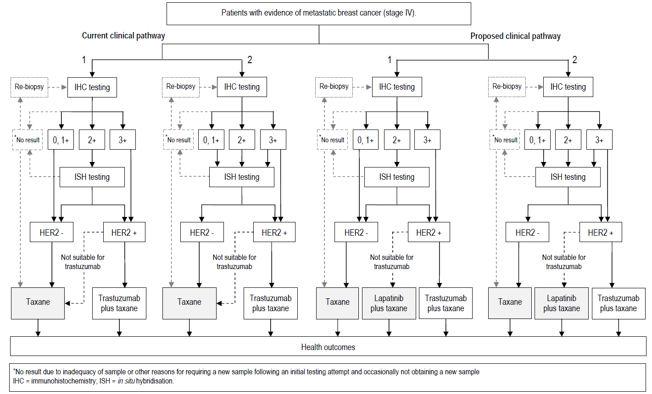

Comparator

The applicant suggested three current management algorithms according to different funding perspectives in Australia: the ‘real world’ funding perspective, a government funding perspective, and a MBS/PBS funding perspective. At the time of the initial application, HER2
ISH testing was not available on the MBS.

From a real world funding perspective, the comparator included privately funded ISH testing (with or without publicly funded IHC testing), and HER2 targeted therapy with trastuzumab plus a taxane through the government funded Herceptin™ program. The government funding perspective comparator included publicly funded IHC testing alone. The government funded Herceptin™ program was also included as a treatment option. The comparator for the PBS and MBS funding perspective included no HER2 testing as it was not required because no HER2 targeted therapies are available for metastatic breast cancer via the MBS and PBS.

However, now that HER2 ISH testing is available on the MBS, PASC recommended that the most appropriate comparator should include a decision node for two different testing strategies. The first strategy reflects current standard clinical practice as used in most clinical trials, where IHC is used to triage patients with a IHC 2+ result for ISH testing. Patients with either an IHC 3+ or an ISH+ result are then eligible for HER2 targeted therapy. The second strategy reflects current practice in Australia, where both IHC and ISH testing are available for all patients, and ISH testing is considered determinative for trastuzumab in early breast cancer. As the new MBS item for ISH testing to determine eligibility for targeted treatment with trastuzumab (see Table 1, page 4) does not specify that patients have a positive IHC result, all patients may currently obtain an ISH test.

There is no change in diagnostic practice between the current and proposed pathways. In the proposed pathway, treatment with lapatinib plus a taxane would replace taxane use alone, where it is deemed by the treating clinician that treatment with trastuzumab would not be suitable.

The various ISH test options (see pages 10 and 11 of the DAP) should all be compared against the reference standard (dual probe FISH). The costs of each test option should be assessed from the healthcare system perspective (i.e. the provision of each relevant healthcare resource with a material increment fully costed irrespective of the source of the payment(s) and also disaggregated across these sources as appropriate). The comparator for lapatinib plus a taxane is taxane treatment alone.

Outcomes for safety and effectiveness evaluation

A comparison of test outcomes across proposed test options and strategies is necessary, in each case including consideration of the adequacy of samples for laboratory assessment.

The health outcomes, upon which the comparative clinical performance of HER2 testing versus usual care (according to funding scenario) will be measured, are based on the impact of a change in management and subsequent treatment effectiveness. These outcomes are listed below:

Effectiveness

Primary outcomes: Overall survival; quality of life; progression free survival.

Secondary outcomes: Response rate; duration of response; rate of stable disease; rate of disease progression; time to progression.

Safety

Psychological and physical harms from testing. Any adverse events related to a change in treatment including tolerability; toxicity (particularly cardiovascular adverse events); and neutropaenia.

Summary of PICO to be used for assessment of evidence (systematic review)

Table 9 provides a summary of the PICO used to: (1) define the question for public funding,
(2) select the evidence to assess the safety and effectiveness of HER2 testing, and

(3) provide the evidence-based inputs for any decision-analytic modelling to determine the cost-effectiveness of HER2 testing,

for the proposed and current clinical pathways.

Table 9 Summary of PICO to define research questions for HER2 testing for triage for treatment using HER2 targeted therapies

Patients | Intervention | Comparator | Reference  Standard | Outcomes to be assessed
Diagnostic Patients with breast cancera | Diagnostic  Strategy 1  IHC testing with IHC 2+ triage for ISH testing  Strategy 2  IHC and ISH testing for all patients | Diagnostic  Strategy 1  IHC testing with IHC 2+ triage for ISH testing  Strategy 2  IHC and ISH testing for all patients | Dual probe  FISH test | Analytical validity  Adequacy of test samples according to test method  Re-testing rate according to test method  Inter- and intra-rater agreement regarding reading IHC and ISH test results  Concordance/agreement between IHC  and ISH HER2 tests  Comparative analytical validity and costs of the different ISH testing methods Safety  Psychological and physical harms from testing. Any adverse events related to a change in treatment including tolerability; toxicity; cardiovascular problems; and neutropaenia.  Effectiveness  Direct evidencecd  Primary outcomes: Overall survival; quality of life; progression free survival Secondary outcomes: Response rate; duration of response; rate of stable disease; rate of disease progression; time to progression.  Cost-effectiveness  Cost, cost per relevant health outcome  (eg LYG, QALY, DALY)
Therapeutic Metastatic (stage IV) breast cancer  patients for whom  trastuzumab is not appropriateb | Therapeutic lapatinib + a taxane | Therapeutic  a taxane
Research Question
Is HER2 testing with IHC ± ISH safe, effective and cost-effective when different IHC decision thresholds are used for confirmatory ISH testing?
Does HER2 testing using IHC (with IHC 2+ triaged for ISH testing) affect the health outcomes of patients with metastatic breast cancer due to a different ratio of HER2 test negative and HER2 test positive patients compared to using both IHC and ISH testing for all?
Is treatment with lapatinib plus a taxane safe, effective and cost-effective compared to treatment with a taxane alone in HER2 test (IHC ± ISH) positive patients diagnosed with metastatic breast cancer for whom trastuzumab is not appropriate?
a A broader population is proposed as the basis of the evidence to assess comparative test performance. Consideration will need to be
given as part of this submission as to how this broader evidence base will apply to the narrower population of patients with metastatic disease who would be additionally tested as proposed.
b The definition of the characteristics which mean that trastuzumab is “not appropriate” are required to be provided with the submission of evidence, but may include criteria such as a left ventricular ejection fraction (LVEF) of less than 45% and/or with symptomatic heart failure
or the presence of central nervous system metastases.
c Direct evidence, as described in the PICO table above, can be employed when there are trials available (on patients with metastatic breast cancer) that compare a management strategy that involves HER2 testing + targeted lapatinib therapy with a management strategy that involves HER2 testing + targeted trastuzumab therapy and the differential impact on patient-relevant clinical outcomes is measured. It can also be employed when there are trials available (on patients with metastatic breast cancer) that compare a management strategy
that involves HER2 testing with IHC ± ISH with a management strategy that involves HER2 testing with IHC ± ISH testing (at a different
IHC threshold), and the differential impact on patient-relevant clinical outcomes is measured. IHC = immunohistochemistry; ISH = in-situ hybridisation; N/A = not applicable.
d When this type of information is lacking, a linked evidence approach may be employed (ie linking evidence assessing diagnostic
accuracy of the HER2 test/s, to evidence of a change in management as a consequence of testing, and then to the effect of that change in management eg impact of trastuzumab or lapatinib therapy on patient health outcomes).

Clinical claim

There is no change in diagnostic practice between the current and proposed pathways. In terms of diagnostic performance, the testing methods are identical and would therefore be considered non-inferior in terms of safety and diagnostic accuracy. As such, they should attract the same reimbursement (ie. a cost-minimisation analysis). In the proposed pathway, treatment with lapatinib plus a taxane would replace a taxane alone where trastuzumab is not suitable. The applicant has not yet provided evidence to substantiate a claim regarding the effectiveness of lapatinib plus a taxane versus a taxane alone, but given that lapatinib will be an additional expense, health benefits, such as the rate of treatment response, progression free survival and overall survival, will need to be established in order for the use of lapatinib to be considered cost-effective. A cost-effectiveness or a cost-utility analysis is therefore required (see Table 10).

The applicant does not intend to make any claims about the comparative effectiveness of trastuzumab and lapatinib.

Table 10 Classification of an intervention for determination of economic evaluation from a real world funding perspective

 |  | Comparative effectiveness versus comparator
 |  | Superior |  | Non-inferior | Inferior
Comparative safety versus comparator | Superior | CEA/CUA |  | CEA/CUA | Net clinical benefit | CEA/CUA
 |  |  |  |  | Neutral benefit | CEA/CUA*
 |  |  |  |  | Net harms | None^
 | Non-inferior | CEA/CUA |  | CMA/CEA/CUA* | None^
 | Inferior | Net clinical benefit | CEA/CUA | None^ | None^
 |  | Neutral benefit | CEA/CUA*
 |  | Net harms | None^
Abbreviations: CEA = cost-effectiveness analysis; CMA = cost-minimisation approach; CUA = cost-utility analysis
* May be reduced to cost comparison analysis. Cost comparison analysis should only be presented when there is a lack of evidence indicating superiority and the proposed service has been indisputably demonstrated to be no worse than its main comparator(s) in terms of both effectiveness and safety, so the difference between the service and the appropriate comparator can be reduced to a comparison of costs. In most cases, there will be some uncertainty around such a conclusion (i.e., the conclusion is often not indisputable). Therefore, when an assessment concludes that an intervention was no worse than a comparator, an assessment of the uncertainty around this conclusion should be provided by presentation of cost-effectiveness and/or cost-utility analyses.
^ No economic evaluation needs to be presented; MSAC is unlikely to recommend government subsidy of this intervention

Outcomes and health care resources affected by introduction of proposed intervention

Outcomes for economic evaluation

If differences in health outcomes, such as the rate of treatment response, progression free survival and overall survival, can be determined, cost-effectiveness and cost-utility analyses

would be relevant, and health outcomes would need to be measured as life-years gained and quality-adjusted life-years gained.

Health care resources

As diagnosis and staging of metastatic breast cancer and the ascertainment of characteristics which will determine whether trastuzumab is not appropriate will occur for patients across both arms of the comparison, ie with or without HER2 testing, costs and resource use associated with these will not be needed in the economic evaluation of HER2 testing. Although the comparator for treatment with lapatinib and a taxane will be taxane use alone, the assessment of testing requires considerations of all downstream costs, including those incurred by patients who receive trastuzumab. However, the proportion of patients who are likely to receive trastuzumab in either arm (current or proposed testing strategies) are identical, therefore the healthcare resources associated with trastuzumab do not need to be considered in the economic evaluation.

As patients who are HER2 positive and are targeted for lapatinib therapy require cardiac monitoring but those treated with a taxane alone may not, the cost of cardiac monitoring for adverse events in patients receiving lapatinib therapy needs to be included in the economic evaluation. Costs of clinician management and other monitoring will also be need to be considered if these would change with the addition of lapatinib to a taxane.

A list of the resources that would need to be considered in the economic analysis for all three funding scenarios is provided in Table 11.

Table 11 List of resources to be considered in the economic analysis

 |  | Setting in which resource is provided | Proportion of patients receiving resource | Number of  units of resource  per relevant time  horizon per patient receiving resource | Disaggregated unit cost
 | Provider of resource |  |  |  | MBS/PBS Schedule Fee | Safety netsa | Other govt budget | Private health insurer | Patient | Total cost
Resources provided to identify eligible population: HER2 testing
Immunochemistry  (IHC)  Re-testing | Medical oncologist/ Pathologist | Outpatient | 100%  % to be based on trial evidence or clinical opinion | 1 | MBS item number  72848  $75.00 |  |  |  |  | $75.00  TBD
In-situ hybridisation (ISH)  Arm 2 | Medical oncologist/ Pathologist | Outpatient | 100% | 1 | MBS item number  73332  $317.50 |  |  |  |  | $317.50

 |  | Setting in which resource is provided | Proportion of patients receiving resource | Number of  units of resource  per relevant time  horizon per patient receiving resource | Disaggregated unit cost
 | Provider of resource |  |  |  | MBS/PBS Schedule Fee | Safety netsa | Other govt budget | Private health insurer | Patient | Total cost
Arm 1  Re-testing |  |  | % to be based on trial evidence or clinical opinion |  |  |  |  |  |  | TBD
Resources provided to deliver proposed intervention: Proposed drug (lapatinib) + co-administered (taxane)
Lapatinib  250mg tablet | Medical oncologist | Outpatient/  inpatient | HER2 positivity rate (patients eligible for lapatinib) | Number of tablets/ patientb | Cost/tablet c-in-c |  |  |  |  | TBD
DOCETAXEL Solution concentrate for IV infusion 20 mg in  1 mL | Medical oncologist | Outpatient/  inpatient | % to be based on trial evidence or clinical opinion | Number of infusions/ patientb | Cost/  infusion  $34.20 |  |  |  |  | TBD
PACLITAXEL Solution concentrate for IV infusion 150 mg in  25 mL | Medical oncologist | Outpatient/  inpatient | % to be based on trial evidence or clinical opinion | Number of infusions/ patientb | Cost/  infusion  $34.20 |  |  |  |  | TBD
Drug  administration cost for 1 to 6 hour infusion in outpatient setting | Medical oncologist | Day patient | % to be based on health service usage data or clinical opinion | Number of infusions/ patientc | Cost/  infusion  MBS item number  13918  $94.20 |  |  |  |  | TBD
Full day hospital admission for chemotherapy in a public hospital setting (excluding average pharmacy cost component)d | Medical oncologist | Day patient | % to be based on health service usage data or clinical opinion | Number of infusions/ patientc | Cost/  infusion  $516 |  |  |  |  | TBD
Full day hospital admission for chemotherapy in a private hospital setting (excluding average pharmacy cost component)d | Medical oncologist | Day patient | % to be based on health service usage data or clinical opinion | Number of infusions/ patientc | Cost/  infusion  $310 |  |  |  |  | TBD
Resources provided to deliver proposed intervention: Cardiac monitoring for patients receiving lapatinib
Echocardiogram |  | Outpatient | % to be based on trial evidence or clinical opinion | Number of procedures/ patient | Cost/  procedure  MBS item number |  |  |  |  | TBD

 |  | Setting in which resource is provided | Proportion of patients receiving resource | Number of  units of resource  per relevant time  horizon per patient receiving resource | Disaggregated unit cost
 | Provider of resource |  |  |  | MBS/PBS Schedule Fee | Safety netsa | Other govt budget | Private health insurer | Patient | Total cost
55113
$230.65
Multiple gated acquisition scans (MUGA) |  | Outpatient |  | Number of procedures/ patient | Cost/  procedure  MBS item number  61313  $303.35 |  |  |  |  | TBD
Twelve-lead electro- cardiography |  | Outpatient |  | Number of procedures/ patient | Cost/  procedure  MBS item number  11700  $30.05 |  |  |  |  | TBD
Resources provided in association with proposed intervention: Costs associated with treating adverse events (other than cardiac monitoring) for patients receiving lapatinib
Will depend on adverse events associated with lapatinib plus taxane usage |  |  |  |  |  |  |  |  |  | TBD
Resources provided to deliver comparator treatment: A taxane alone:
DOCETAXEL Solution concentrate for IV infusion 20 mg in  1 mL | Medical oncologist | Outpatient/  inpatient | % to be based on trial evidence or clinical opinion | Number of infusions/ patientb | Cost/  infusion  $34.20 |  |  |  |  | TBD
PACLITAXEL Solution concentrate for IV infusion 150 mg in  25 mL | Medical oncologist | Outpatient/  inpatient | % to be based on trial evidence or clinical opinion | Number of infusions/ patientb | Cost/  infusion  $34.20 |  |  |  |  | TBD
Drug  administration cost for 1 to 6 hour infusion in outpatient setting | Medical oncologist | Day patient | % to be based on health service usage data or clinical opinion | Number of infusions/ patientc | Cost/  infusion  MBS item number  13918  $94.20 |  |  |  |  | TBD
Full day hospital admission for chemotherapy in a public hospital setting (excluding average pharmacy cost component)d |  | Day patient | % to be based on health service usage data or clinical opinion | Number of infusions/ patientc | Cost/  infusion  $516 |  |  |  |  | TBD

 |  | Setting in which resource is provided | Proportion of patients receiving resource | Number of  units of resource  per relevant time  horizon per patient receiving resource | Disaggregated unit cost
 | Provider of resource |  |  |  | MBS/PBS Schedule Fee | Safety netsa | Other govt budget | Private health insurer | Patient | Total cost
Full day hospital admission for chemotherapy in a private hospital setting (excluding average pharmacy cost component)d |  | Day patient | % to be based on health service usage data or clinical opinion | Number of infusions/ patientc | Cost/  infusion  $310 |  |  |  |  | TBD
Resources provided in association with a taxane comparator: Costs associated with treating adverse events
Will depend on adverse events associated with taxane usage |  |  |  |  |  |  |  |  |  | TBD
a Include costs relating to both the standard and extended safety net.
b Estimate from the product or trial evidence of number of vials per infusion and number of infusions per patient.
c Estimate using the component drug with the highest number of infusions.
d Average cost from the National Hospital Cost Data Collection, AR-DRG version 5.3, Round 13 (2008-09)
TBD = to be determined based on the assumption provided regarding the proportion of patients receiving the resource; c-in-c =
commercial in confidence

Proposed structure of economic evaluation (decision analysis)

The decision analysis provided below (Figure 2) allows provision for the use of linked evidence, ie by breaking down the outcomes into true positives and false positives (the latter designated a ‘true positive’ on the basis of a gold standard), and true negatives and false negatives (the latter designated a ‘true negative’ on the basis of the same gold standard). However, in the event that there is acceptable direct evidence of the impact of HER2 testing and targeted treatment on health outcomes, these arms can be collapsed so that health outcomes from a positive test result are provided and health outcomes from a negative test result are provided (the effect of false positives and negatives will then be included in the health outcome measure). However, should the test method in the direct evidence differ from what is being proposed for use in Australia, then additional evidence would need to be provided regarding the test performance and costs of these other testing
methods, as well as their likely impact on health outcomes.

Figure 2 Decision tree representing the decision options of using IHC and ISH HER2 testing to guide treatment in metastatic breast cancer. (A) proposed clinical pathway vs (B) current clinicalpathway

A
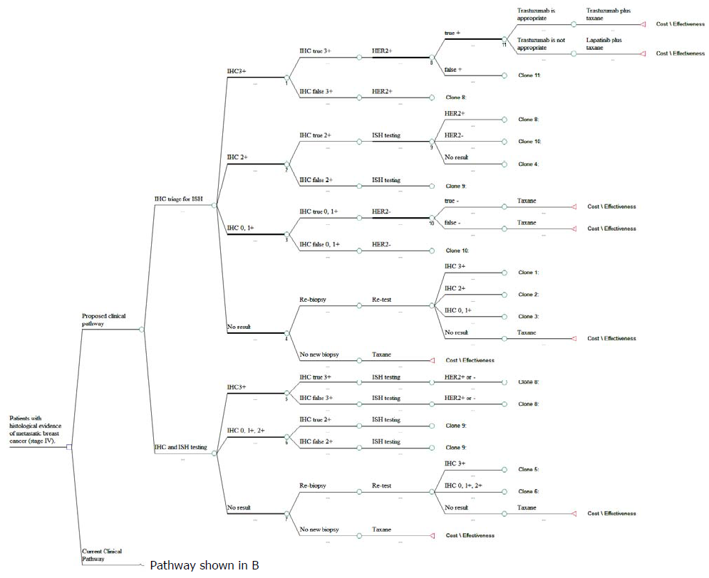

B

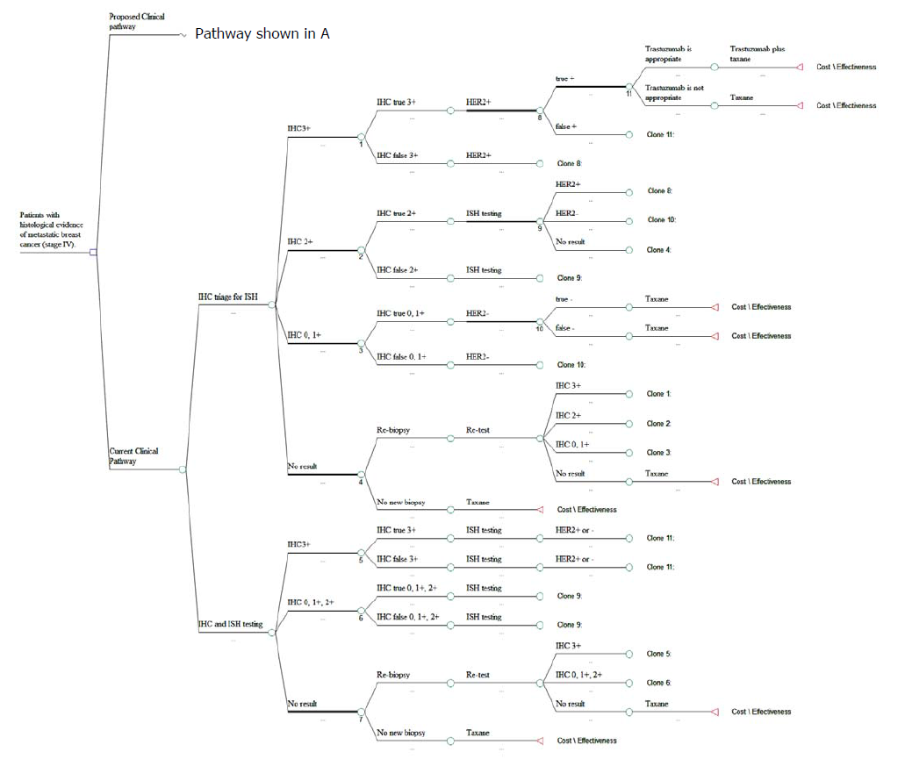

References

AIHW (2010). BreastScreen Australia monitoring report 2006-2007 and 2007-2008., Cancer series no. 55. Cat. no. CAN 51, Canberra: AIHW.

AIHW & AACR (2010). Cancer in Australia: an overview, 2010, Australian Institute of Health and Welfare, Canberra.

AIHW & NBOCC (2009). Breast cancer in Australia: an overview, 2009., Australian Institute of Health and Welfare, Canberra.

Bilancia, D., Rosati, G. et al (2007). 'Lapatinib in breast cancer', Annals of Oncology, 18 (suppl 6), vi26-vi30.

Breckenridge, A. (2011). 'Patient opinions and preferences in drug development and regulatory decision making', Drug Discovery Today: Technologies, 8 (1), e11-e14.

Brügmann, A. & Sorensen, B. S. (2011). 'Identifying responders to trastuzumab therapy in breast cancer', Future Oncology, 7 (6), 767-773.

Cancer Australia (2011). Breast cancer statistics [Internet]. Australian Government. Available from: http://canceraustralia.nbocc.org.au/breast-cancer/about-breast-cancer/breast-cancer- statistics [Accessed 19 September 2011].

Di Cosimo, S. & Baselga, J. (2008). 'Targeted therapies in breast cancer: Where are we now?', European Journal of Cancer, 44 (18), 2781-2790.

New South Wales Central Cancer Registry (2010). Top 20 cancer sites, Incidence, Persons, NSW, 2004-2008 [Internet]. NSW Health Department Available from: http://www.statistics.cancerinstitute.org.au/prodout/top20_extent/top20_extent_lhnres_inci d_2004-2008_NSW_P.htm [Accessed 21 September 2011].

Penault-Llorca, F., Bilous, M. et al (2009). 'Emerging technologies for assessing HER2 amplification', Am J Clin Pathol, 132 (4), 539-548.

Rhodes, A., Jasani, B. et al (2002). 'Evaluation of HER-2/neu Immunohistochemical Assay Sensitivity and Scoring on Formalin-Fixed and Paraffin-Processed Cell Lines and Breast Tumors', American Journal of Clinical Pathology, 118 (3), 408-417.

Therapeutic Goods Administration (2009). Overview of the new regulatory framework for in vitro diagnostic medical devices (IVDs), Commonwealth of Australia, Canberra.

Widakowich, C., de Castro, G. et al (2007). 'Review: Side Effects of Approved Molecular
Targeted Therapies in Solid Cancers', The Oncologist, 12 (12), 1443-1455.

Yarden, Y. (2001). 'Biology of HER2 and Its Importance in Breast Cancer', Oncology, 61 (Suppl. 2), 1-13.

