Public Summary Document

Report to the Medical Services Advisory Committee on real world outcomes of Reference 38 and Application 1230: Testing for HER2 positivity in patients diagnosed with breast cancer to determine eligibility for treatment with trastuzumab
Medicare Benefits Schedule (MBS) item considered: 73332
Dates of MSAC consideration: 6-7 April 2017
Context for decision: MSAC makes its advice in accordance with its Terms of Reference, see the MSAC Website.

Purpose
The purpose of the report presented to the Medical Services Advisory Committee (MSAC) was to inform MSAC of the real world impacts on the outcomes of Reference 38 and Application 1230. The MSAC then uses this information to ensure that the new item/s resulting from this application/s is being used as intended.
The report is not intended to be a review of the clinical information covered during the application process.

MSAC’s advice
MSAC considered actual utilisation data and compared it with the utilisation predicted prior to implementation of HER2 positivity testing in patients diagnosed with breast cancer to determine eligibility for treatment with trastuzumab. MSAC recommended no further action, but noted that the submission had underestimated the high uptake of the test, based on a large cost shift from the public sector to the private sector with MBS listing, and had also underestimated the rate of re-testing. MSAC recognised that future submissions of
co-dependent genetic tests to MSAC should account for this large cost shift from the public sector to the private sector following MBS listings and include a re-test rate of 10%.

Summary of consideration and rationale for MSAC’s advice
MSAC considered the real world impacts of the outcome of application 1230 for HER2 positivity testing in patients diagnosed with breast cancer to determine eligibility for treatment with trastuzumab (MBS item 73332) by examining the available data for this item and Australian Institute of Health and Welfare (AIHW) data on the number of women with breast cancer.
MSAC noted that actual utilisation is approximately 75% higher than predicted at 12,500 services per annum. This difference is despite accounting for the predicted increase in services associated with removal of the exclusion for neoadjuvant testing. MSAC noted that this higher utilisation is in part due to more patients claiming the service in the private sector than anticipated. MSAC noted that listing of MBS item 73332 appears to have resulted in a shift of testing from the public sector to the private sector. MSAC noted that based on AIHW data it appears that 73–83% of patients are being treated privately, compared with the estimate of 28–50% used in the assumptions.
MSAC noted that there was increased utilisation of core needle biopsies to determine HER2 status in this patient population. MSAC accepted that core needle biopsies are often performed in the surgery or outpatients clinic, which would account for increased billing to Medicare, even where patients are otherwise predominantly treated in a public hospital.
MSAC advised that shifting of billing practice from the public to the private sector as a result of MBS listing may be a relevant consideration for utilisation estimates in future submissions of co-dependent genetic tests. MSAC noted that predicted vs actual analyses can provide the basis for cost estimates of similar items, particularly in predicting the effects of cost-shifting between the sectors – public, private and privatised public.
MSAC noted it was assumed that 95% of women with breast cancer would be tested, but that clinical practice is now for all women with breast cancer to undergo HER2 testing. This would also slightly increase utilisation of MBS item 73332.
MSAC noted the rate of retesting (approximately 9%) appears high, given that HER2 status is unlikely to alter over the course of the disease. In 2015–16, 1,002 patients received two or more services of item 73332. The original submission (reference 38) did not account for re-testing in utilisation estimates. Re-testing may be the result of the HER2 assessment being uninterpretable or equivocal for a number of reasons. Information provided by the Royal College of Pathologists of Australasia (RCPA) confirmed that the non-diagnostic/equivocal rate is likely to be correct. RCPA also noted that:
  - A non-diagnostic or equivocal result may reflect technical issues with the specimen (tissue ischaemia/fixation issues or decalcification issues).
  - 11% of patients have multiple tumour deposits. Testing of each tumour is recommended where these tumours are different in appearance or immunophenotype.
  - Repeat testing between core and excision may occur if there is:
    - concern regarding heterogeneity in HER2 status not represented in the core (seen in approximately 1% of patients);
    - concern regarding changing HER2 status after neoadjuvant therapy; and/or
    - poor communication between physicians.
MSAC recommended that a re-testing rate of 10% be included in modelling costs for future submissions of co-dependent genetic tests to MSAC.
MSAC noted that the average fee charged for item 73332 has increased from $386 in 2012-13 to $404 in 2015-16. MSAC noted that the variation between states in bulk billing rates evident in 2012-13 has decreased. MSAC was concerned at the increasing out of pocket costs for patients and requested that the Department consider possible approaches to discourage excessive fees, particularly in this setting.
MSAC noted that it was assumed that the in/out of hospital split would be similar to item 72848 (60% in hospital) and actual utilisation has been close to this prediction, at 61-66% in hospital services.
In considering the provider breakdown of utilisation of item 73332 MSAC noted that approximately 40% of practitioners provide 95% of all services for item 73332.
MSAC noted that co-claiming patterns have changed since listing, although co-claiming appears appropriate. In 2012-13 the top co-claiming pattern for item 73332 was for it to be claimed by itself (15% of occasions). By 2015-16 this item was claimed by itself on only 5% of occasions. MSAC noted that the pattern of co-claiming with items 72838, 72847 and 73924 was persistent since listing and was the combination with the highest schedule fee of the top 10 claiming patterns for each year. MSAC noted that co-claiming patterns appear to be appropriate.
MSAC recommended that no specific action is required for this item. In considering this item MSAC noted the following:
- Future submissions of co-dependent genetic tests to MSAC should consider likely cost shifting within the public, private and privatised public sectors following MBS listing.
- Future submissions of co-dependent genetic tests to MSAC should include a 10% retesting rate as seen for this item.
- Out of pocket expenses continue to rise for patients. MSAC requested that the department consider mechanisms to discourage excessive fees, particularly in this setting.
PBS data on the use of trastuzumab should be linked with item 73332 to determine the rate of positive HER2 status.

Methodology
An application is selected for consideration if the resulting new item(s) or item amendment(s) have been on the MBS for approximately 24 months or longer or if there were particular concerns about utilisation such that MSAC requested to consider it earlier. The specific applications for each MSAC meeting are selected by the MSAC Executive which is composed of the Chairs of MSAC and its sub-committees.
A report on the utilisation is developed by the Department of Health (the department) with information on a number of metrics including state variation, patient demographics, services per patient, practitioner’s providing the service, data on fees and co-claiming of services. The number of metrics included in a report is dependent on the annual service volume for the MBS item(s) under consideration i.e. an item with very low utilisation will have less data to analyse. Where service volumes are too low, information is suppressed to protect patient privacy.
Where possible the report compares data on real world utilisation to the assumptions made during the MSAC assessment. Most of these assumptions are drawn from the assessment report.
Relevant stakeholders are provided an opportunity to comment on the findings in the report before it is presented to the MSAC. It is intended that stakeholders are given at least three weeks to consider the reports.
The stakeholder version of the report does not contain information on assumptions from the MSAC consideration if this information is not already publicly available. This is to protect the commercial in confidence of the original applicants. The same principle is applied to this document.
Once MSAC has considered the report its advice is made available online at the MSAC Website.

Results

Utilisation
Uptake of item 73332 has been higher than expected, even with the predicted expansion of the service accounted for (Table 1). Based on the AIHW data on the number of women with breast cancer it would appear that about 73-83% are claiming the test privately on Medicare rather than through the public sector (Table 1).
There is some degree of uncertainty as to the impact of expanding the listing of item 73332 in December 2012, given its proximity to the initial listing in May 2012. Utilisation did increase by approximately 2000 services from 2012-13 to 2013-14 before stabilising at about 12,500 services, however, this could also be attributed to more laboratories switching their billing practice from public to private setting over that time. There was a small increase in the number of practitioners between these years from 67 to 76, which could reflect this.
The actual re-testing rate also appears to be higher than expected (Table 4), with 962 patients receiving two or more services in 2014-15 and 1,002 patients receiving two or more services in 2015-16. The original application (reference 38) does not appear to account for repeat testing so it is unclear whether there are other reasons to re-test that may be resulting in the higher than expected numbers. It is possible that the higher re-testing rate is a reflection of the higher utilisation overall with an overall larger patient pool resulting in higher numbers.
There is a large spike in utilisation between June and September 2013 (Figure 2). Figure 2 is based on date of processing data whereas other tables are based on date of service. As such the spike is likely to be a processing issue rather than a reflection of unusual utilisation.
Utilisation is highest in NSW, VIC and QLD as would be expected and patients are predominantly female and aged 45-74 as expected.

Table 1: Predicted vs actual utilisation of MBS item 73332
 | Financial Year/ Year since listing | 2011-12 (Year 1) | 2012-13 (Year 2) | 2013-14 (Year 3) | 2014-15 (Year 4) | 2015-16 (Year 5)
A | Actual number of Services | 1,433 | 10,733 | 12,492 | 12,546 | 12,897
B | Total services projected (public and private) AIHW data | 14,357 | 14,662 | 14,963 | 15,260 | n/a
C | % of actual services to total services projected | n/a | 73% | 83% | 82% | n/a
Source: Department of Health, File: Q20659 Item 73332 66830 utilisation 16JAN17.xlsx and AIHW 2009Breast cancer incidence
NOTE: Item was listed 1 March 2012

Figure 1: Number of services for MBS item 73332 for 2011-12 to 2015-16.
Source: Department of Health, File: Q20659 Item 73332 66830 utilisation 16JAN17.xlsx

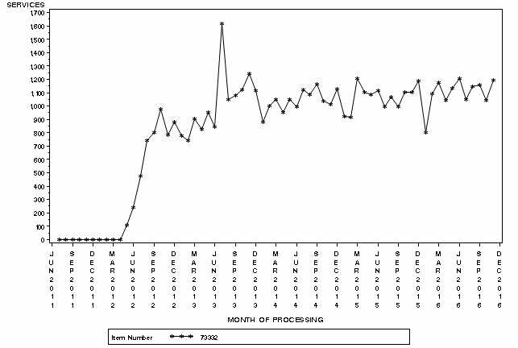
Figure 2: Month by month service volume for MBS item 73332 from March 2012 to November 2016.

(Blue line indicates 1 December 2012 expansion of listing)
Source: Medicare Statistics online

Table 2: Services and benefits paid per state for MBS item 73332 from 2012-13 to 2015-16
 |  | NSW/ACT | VIC/TAS | QLD | SA/NT | WA | Australia
2012-13 | Services | 3,875 | 3,325 | 1,653 | 875 | 1,005 | 10,733
 | Patients | 3,667 | 3,229 | 1,619 | 863 | 978 | 10,269
 | Benefits | $959,080 | $844,092 | $400,810 | $221,066 | $250,358 | $2,675,406
2013-14 | Services | 4,282 | 3,619 | 2,551 | 957 | 1,083 | 12,492
 | Patients | 4,080 | 3,468 | 2,321 | 936 | 1,036 | 11,735
 | Benefits | $1,050,897 | $913,298 | $628,556 | $242,109 | $262,736 | $3,097,597
2014-15 | Services | 4,301 | 3,073 | 2,702 | 1,038 | 1,432 | 12,546
 | Patients | 3,978 | 2,973 | 2,415 | 1,005 | 1,313 | 11,532
 | Benefits | $1,061,152 | $767,650 | $672,166 | $264,180 | $353,821 | $3,118,969
2015-16 | Services | 4,575 | 3,315 | 2,638 | 846 | 1,523 | 12,897
 | Patients | 4,209 | 3,192 | 2,351 | 830 | 1,379 | 11,828
 | Benefits | $1,134,767 | $830,972 | $659,959 | $212,764 | $378,333 | $3,216,794
Source for table 2: Department of Health, File: Q20659 Item 73332 66830 utilisation 16JAN17.xlsx

In and out of hospital
Utilisation is between 61-66% of services being provided in hospital from 2012-13 to 2015-16.

Table 3: Percentage of services provided in hospital for item 73332 in 2012-13 to 2015-16
 | NSW | VIC | QLD | SA | WA | TAS | NT | ACT | Australia
2012-13 | 69% | 52% | 85% | 53% | 77% | np | np | np | 65%
2013-14 | 73% | 56% | 70% | 49% | 84% | np | np | np | 66%
2014-15 | 69% | 67% | 64% | 45% | 72% | np | np | np | 65%
2015-16 | 65% | 61% | 58% | 54% | 67% | np | np | np | 61%
NP = not published
Source: Department of Health, File: Q20659 Item 73332 66830 utilisation 16JAN17.xlsx

Patient breakdown

Table 4: Number of services per patient in 2013-14 to 2015-16
 |  | Patients
Fin. Year | Services per patient | Count | Percentage
2012-13 | 1 | 9,824 | 96%
 | 2 | 427 | 4%
 | 3+ | 18 | 0%
 | Total | 9,519 | 100%
2013-14 | 1 | 11,011 | 94%
 | 2 | 692 | 6%
 | 3+ | 32 | 0%
 | Total | 11,735 | 100%
2014-15 | 1 | 10,558 | 92%
 | 2 | 936 | 8%
 | 3+ | 38 | 0%
 | Total | 11,482 | 100%
2015-16 | 1 | 10,826 | 92%
 | 2 | 944 | 8%
 | 3+ | 58 | 0%
 | Total | 11,828 | 100%

Table 5: Number of services per patient since service listed in March 2014 to June 2016
Number of Services | Number of Patients | Percentage of Patients
1 | 41,572 | 91%
2 | 3,730 | 8%
3 | 286 | 1%
4+ | 51 | 0%
Total | 45,639 | 100%
Source for tables 4-5: Department of Health, File: Q20659 Item 73332 66830 utilisation 16JAN17.xlsx

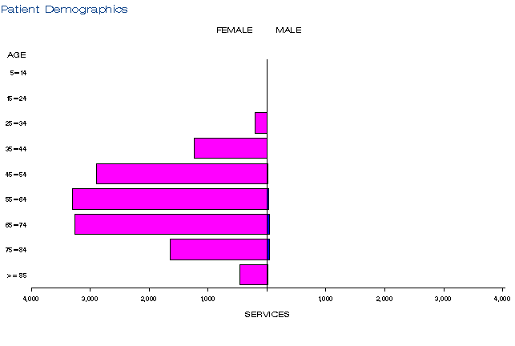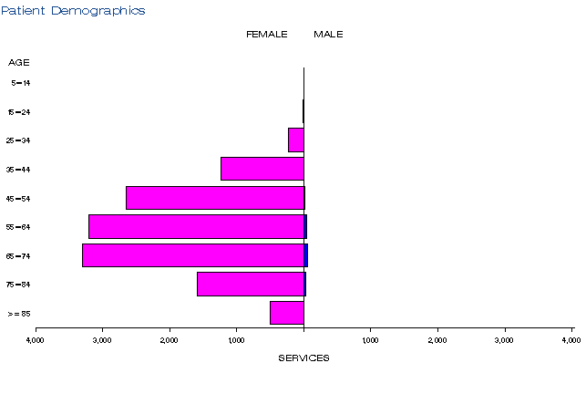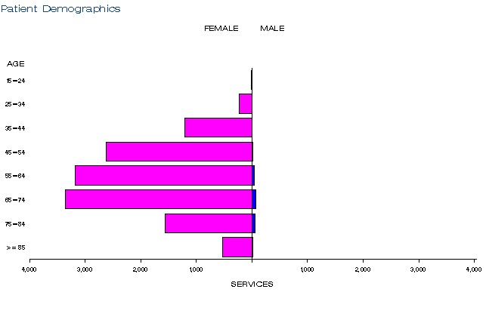
a)
b))
c)

Figure 3: Demographic profile for MBS item 73332 for 2013-14 (a), 2014-15 (b) and 2015-16 (c)
Source: Medicare Statistics Online

Provider breakdown
There were 75 practitioners providing this service in 2015-16. These practitioners specialised in haematology or pathology as expected. About 40% of practitioners provide 95% of all of these services.

Table 6: Number of practitioners providing this service in 2013-14 to 2015-16
Financial year | Australia
2012-13 | 67
2013-14 | 76
2014-15 | 76
2015-16 | 75

Table 7: Cumulative percentage of medical practitioners providing item 73332 for 2013-14 to 2015-16
 | 2012-13 | 2013-14 | 2014-15 | 2015-16
10% | 63% | 57% | 61% | 59%
20% | 80% | 77% | 80% | 75%
30% | 90% | 89% | 90% | 88%
40% | 95% | 95% | 95% | 93%
50% | 97% | 97% | 97% | 97%
60% | 99% | 99% | 99% | 99%
70% | 100% | 100% | 100% | 99%
80% | 100% | 100% | 100% | 100%
90% | 100% | 100% | 100% | 100%
100% | 100% | 100% | 100% | 100%
Source for tables 6-7: Department of Health, File: Q20659 Item 73332 66830 utilisation 16JAN17.xlsx

Co-claiming
Initially, the top claiming pattern for item 73332 was for it to be claimed by itself (15% of occasions in 2012-13 and 11% of occasions in 2013-14). By 2014-15, item 73332 was only claimed by itself on 5% of occasions and the most frequent co-claiming patterns were for it to be co-claimed with 73838, 72847 and 73924 together (10% of occasions, 11% in 2015-16) or with 73940 (10% of occasions in both financial years). The pattern of claiming 73332 with 72838, 72847 and 73924 was consistent across all financial years and notably was the combination with the highest schedule fee. The co-claiming patterns observed in the data do not appear to be inappropriate.

Table 8: Top 10 instances of co-claiming with MBS item 73332 in 2012-13
# | Items | Episodes | Number Services | Schedule Fee for Combination | % of total episodes | Cumulative %
1 | 73332 | 1,651 | 1,651 | $522,546 | 15% | 15%
2 | 73332, 73940 | 1,274 | 2,548 | $416,334 | 12% | 27%
3 | 73332, 72838,72847,73924 | 911 | 3,644 | $809,555 | 8% | 35%
4 | 73332, 73939 | 588 | 1,176 | $187,406 | 5% | 40%
5 | 73332, 72838,72848,73924 | 515 | 2,060 | $450,292 | 5% | 45%
6 | 73332, 72836,72848,73924 | 487 | 1,948 | $401,639 | 5% | 50%
7 | 73332, 72836,72847,73924 | 427 | 1,708 | $358,302 | 4% | 54%
8 | 73332, 73938 | 401 | 802 | $130,093 | 4% | 58%
9 | 73332, 72838,72847,72855,73924 | 252 | 1,260 | $270,567 | 2% | 60%
10 | 73332, 72838,72849,73924 | 234 | 936 | $211,480 | 2% | 62%

Table 9: Top 10 instances of co-claiming with MBS item 73332 in 2013-14
# | Items | Episodes | Number Services | Schedule Fee for Combination | % of total episodes | Cumulative %
1 | 73332 | 1,319 | 1,319 | $416,013 | 11% | 11%
2 | 73332, 72838,72847,73924 | 1,292 | 5,168 | $1,145,002 | 10% | 21%
3 | 73332, 73940 | 1,128 | 2,258 | $367,659 | 9% | 30%
4 | 73332, 72836,72847,73924 | 612 | 2,448 | $511,858 | 5% | 35%
5 | 73332, 72838,72849,73924 | 522 | 2,088 | $470,426 | 4% | 39%
6 | 73332, 73939 | 522 | 1,044 | $165,892 | 4% | 43%
7 | 73332, 72838,72847,72855,73924 | 365 | 1,825 | $390,787 | 3% | 46%
8 | 73332, 73938 | 363 | 726 | $117,376 | 3% | 49%
9 | 73332, 72836,72849,73924 | 337 | 1,348 | $286,972 | 3% | 52%
10 | 73332, 72838,72850,73924 | 324 | 1,296 | $296,816 | 3% | 55%

Table 10: Top 10 instances of co-claiming with MBS item 73332 in 2014-15
# | Items | Episodes | Number Services | Schedule Fee for Combination | % of total episodes | Cumulative %
1 | 73332, 72838,72847,73924 | 1,292 | 5,168 | $1,145,100 | 10% | 10%
2 | 73332, 73940 | 1,289 | 2,578 | $419,763 | 10% | 20%
3 | 73332 | 660 | 660 | $208,164 | 5% | 25%
4 | 73332, 73939 | 571 | 1,142 | $181,464 | 5% | 30%
5 | 73332, 72838,72849,73924 | 562 | 2,248 | $506,474 | 4% | 34%
6 | 73332, 72836,72847,73924 | 555 | 2,220 | $464,341 | 4% | 38%
7 | 73332, 72838,72850,73924 | 399 | 1,596 | $365,524 | 3% | 41%
8 | 73332, 73938 | 367 | 734 | $118,669 | 3% | 44%
9 | 73332, 72838,72848,73924 | 327 | 1,308 | $284,948 | 3% | 47%
10 | 73332, 72836,72849,73924 | 317 | 1,268 | $269,941 | 3% | 50%

Table 11: Top 10 instances of co-claiming with MBS item 73332 in 2015-16
# | Items | Episodes | Number Services | Schedule Fee for Combination | % of total episodes | Cumulative %
1 | 73332, 72838,72847,73924 | 1,368 | 5,472 | $1,212,458 | 11% | 11%
2 | 73332, 73940 | 1,277 | 2,558 | $416,506 | 10% | 21%
3 | 73332, 72838,72849,73924 | 725 | 2,904 | $654,271 | 6% | 27%
4 | 73332, 72836,72847,73924 | 601 | 2,404 | $502,827 | 5% | 32%
5 | 73332 | 590 | 590 | $186,086 | 5% | 37%
6 | 73332, 72838,72850,73924 | 527 | 2,108 | $482,785 | 4% | 41%
7 | 73332, 73938 | 485 | 972 | $157,148 | 4% | 45%
8 | 73332, 73939 | 371 | 744 | $118,222 | 3% | 48%
9 | 73332, 72836,72849,73924 | 298 | 1,192 | $253,665 | 2% | 50%
10 | 73332, 72838,72847,72855,73924 | 266 | 1,330 | $284,793 | 2% | 52%
Source for Tables 8-11: Department of Health, File:Q20659

Data on fee charged
The information provided on fees below is a snapshot of how the item is being claimed in practice. Data has not been printed for states and territories with relatively low service volumes.
The benefit for MBS item 73332 is $236.55 (75%) or $268.10 (85%).
The average fee charged for item 73332 has been increasing steadily from $386 in 2012-13 to $404 in 2015-16. This is likely related to the increase in the 95th percentile fee charged from $481 in 2012-13 to $516 in 2015-16. In 2015-16, the 95th percentile in WA is an outlier at $852. Given that this is significantly higher than the 95th percentile for WA in previous financial years, it’s possible this is an aberration. The bulk billing rate varies significantly between states in 2012-13 (12-50% range) but by 2015-16 the range has narrowed to 28-41% rate of bulk billing.

Table 12: Fees charged for MBS item 73332 for 2013-14 to 2015-16 by date of service
 |  |  | Provider State/Territory
 |  | NSW | VIC | QLD | SA | WA | TAS | NT | ACT | Australia
2012-13 | Average Fee Charged | $373 | $390 | $398 | $339 | $414 | np | np | np | $386
 | Std Deviation | $63 | $62 | $52 | $66 | $81 | np | np | np | $66
 | Median Fee Charged | $365 | $397 | $410 | $318 | $422 | np | np | np | $405
 | 75th Percentile | $410 | $413 | $413 | $353 | $441 | np | np | np | $420
 | 95th Percentile | $512 | $495 | $477 | $369 | $499 | np | np | np | $486
 | Bulk-billing Rate | 28% | 46% | 12% | 50% | 13% | np | np | np | 32%
2013-14 | Average Fee Charged | $377 | $403 | $400 | $351 | $417 | np | np | np | $392
 | Std Deviation | $66 | $99 | $57 | $29 | $70 | np | np | np | $74
 | Median Fee Charged | $373 | $408 | $408 | $353 | $423 | np | np | np | $408
 | 75th Percentile | $410 | $423 | $410 | $353 | $442 | np | np | np | $423
 | 95th Percentile | $514 | $495 | $480 | $370 | $481 | np | np | np | $480
 | Bulk-billing Rate | 25% | 43% | 26% | 48% | 10% | np | np | np | 32%
2014-15 | Average Fee Charged | $381 | $406 | $403 | $346 | $431 | np | np | np | $397
 | Std Deviation | $70 | $67 | $60 | $35 | $91 | np | np | np | $72
 | Median Fee Charged | $379 | $408 | $408 | $353 | $431 | np | np | np | $408
 | 75th Percentile | $410 | $431 | $410 | $353 | $442 | np | np | np | $426
 | 95th Percentile | $523 | $503 | $485 | $372 | $486 | np | np | np | $511
 | Bulk-billing Rate | 28% | 33% | 32% | 50% | 22% | np | np | np | 32%
2015-16 | Average Fee Charged | $378 | $420 | $404 | $378 | $459 | np | np | np | $404
 | Std Deviation | $67 | $85 | $61 | $47 | $163 | np | np | np | $92
 | Median Fee Charged | $379 | $410 | $408 | $383 | $431 | np | np | np | $408
 | 75th Percentile | $410 | $438 | $410 | $408 | $442 | np | np | np | $431
 | 95th Percentile | $516 | $508 | $489 | $460 | $852 | np | np | np | $516
 | Bulk-billing Rate | 31% | 38% | 39% | 41% | 28% | np | np | np | 35%
NP = not published
Source: Department of Health, File: Q20510b Item 73332 utilisation 20SEP16.xls
The Pharmaceutical Benefits Advisory Committee (PBAC) considered an application from Roche for the listing of trastuzumab (Herceptin) as a highly specialised drug for the treatment of early breast cancer at its 5-7 July 2006 meeting. The PBAC recommended that the Government should subsidise, the drug trastuzumab under the PBS for the treatment of patients with HER-2 positive early stage breast cancer following surgery, for a maximum period of 12 months to be commenced concurrently with adjuvant chemotherapy.
Herceptin was listed on the PBS on 1 October 2006 as a Section 100 special authority required benefit for the adjuvant treatment of early breast cancer in patients with HER-2 positive disease. Herceptin was also funded for late stage metastatic breast cancer outside the PBS via the Herceptin Program.
At the time, Roche fully funded the appropriate gene amplification testing for any patients with early breast cancer to determine eligibility for the therapy, pending consideration of gene amplification testing by the MSAC.
The MSAC assessed tests for HER2 gene amplification in breast cancer at its June 2008 meeting (reference 38). The aim was to identify the most effective test for HER2 gene amplification. The MSAC concluded that public funding be supported for ISH testing in breast cancer when used consequent to a positive immunochemistry test. In response to some concerns regarding this advice, in February 2009, the MSAC revised its advice to “ISH testing for women with breast cancer is a cost effective strategy for identifying women who are likely to respond to Herceptin.”
On 1 May 2012, an item for ISH testing of tumour tissue from breast cancer patients for human epidermal growth factor receptor 2 (HER2) gene amplification was listed on the MBS (item 73332). The listing specified that the testing was for “other than in the neo-adjuvant setting” in accordance with the MSAC/PBAC joint recommendation. The testing was to determine the patient’s eligibility for the PBS or Herceptin Program subsidised medicine trastuzumab (Herceptin®). The PBS listing was only for the adjuvant (following surgery) setting.
In March 2012, the department received an application (1230) from Roche Products Australia requesting an extension to the existing MBS listing for ISH testing of HER2 for patients diagnosed with breast cancer to enable consideration of neoadjuvant treatment with trastuzumab. On 2 August 2012 MSAC considered and supported this application. This was to support the PBAC recommended extension of the PBS listing of trastuzumab in the neo-adjuvant setting. It was also discussed and agreed by MSAC that the item should be pathologist-determinable. The expansion of the listing occurred on 1 December 2012.

Item descriptor
73332 | An in situ hybridization (ISH) test of tumour tissue from a patient with breast cancer requested by, or on the advice of, a specialist or consultant physician who manages the treatment of the patient to determine if the requirements relating to human epidermal growth factor receptor 2 (HER2) gene amplification for access to trastuzumab under the Pharmaceutical Benefits Scheme (PBS) or the Herceptin Program are fulfilled.  Fee: $315.40 Benefit: 75% = $236.55 85% = $268.10

Applicant’s comments on MSAC’s public summary document
The applicant had no comment

Further information on MSAC
MSAC Terms of Reference and other information are available on the MSAC Website.

The 95th percentile fee charged represents that 95% of the time the fee is below this amount but in 5% of cases, the fee is higher than this.

