MSAC Application 1773
Autologous Chondrocyte implantation for symptomatic articular cartilage defects greater than 2cm² of the knee
PICO Set Document

Population

Describe the population in which the proposed health technology is intended to be used:
Articular cartilage is the connective tissue covering the ends of the long bones such as the inferior surfaces of the femoral condyles in the hip joint, and the inner surface of the patella and the medial and lateral surfaces of the tibial plateau of the knee. It is composed of hyaline cartilage consisting of a dense extracellular matrix with a sparse distribution of chondrocyte (cartilage) cells. The function of articular cartilage is to decrease friction and distribute load so that complex joints such as the knee can progress through a range of movements smoothly while weight bearing.
Unlike other tissues, articular cartilage does not have blood vessels, nerves or lymphatics and is nourished by diffusion from the synovial fluid. Therefore, articular cartilage has a limited ability to repair itself when damaged (Yuze, 2022).
Cartilage damage is predominantly caused by injury, by various types of arthritis or other degenerative diseases such as osteochondritis dissecans (OCD). Cartilage damage can also occur from joint instability or abnormal loading of the joint from other musculoskeletal abnormalities (Meverkort, 2010; Yuze, 2022). Loss of articular cartilage is known as a chondral defect. Cartilage defects can be graded according to the International Cartilage Repair Society (ICRS) Grading System (below).
Grade 0 | Normal Cartilage
Grade 1 | Nearly normal (superficial lesion)
Grade 2 | Abnormal (lesion extends < 50% of cartilage depth)
Grade 3 | Severely abnormal (> 50% of cartilage depth)
Grade 4 | Severely abnormal (through the subchondral bone)
Patients with cartilage defects, particularly grade 3 and 4 lesions, suffer both pain and functional impairment. Symptoms include pain, effusion, locking of the joint or instability. This can significantly interfere with activities of daily living. Patients with knee articular defects commonly present with a history of precipitating trauma, such as a sporting injury. However sometimes a defect may be detected incidentally on MRI or arthroscopy. Functional impairment can be equivalent to that of patients eligible for knee arthroplasty (Heir, 2010).
It is difficult to determine exactly how many people in Australia may suffer from symptomatic cartilage lesions in Australia. It is estimated that between 5-11% of the general population have focal cartilage lesions (Bekkers, 2012). Widuchowski (2007), in a study of over 25,000 knee arthroscopies, noted that 7% of those patients under 40 and 9% of those under 50 were candidates for cartilage repair. The condition may be seen in conjunction with other common derangements of the knee including, ligamentous damage and mal-alignment of the patella-femoral joint.
Specify any characteristics of patients with the medical condition, or suspected of, who are proposed to be eligible for the proposed health technology, describing how a patient would be investigated, managed and referred within the Australian health care system in the lead up to being considered eligible for the technology:
- Patient characteristics
ACI is indicated for use in treatment of symptomatic cartilage damage caused by trauma, wear or degradation. Patient characteristics to be eligible for ACI treatment are as follows:
- aged between 18 and 55 years.
- have focal chondral defects ≥ 2 - <20cm² in an otherwise normal joint.
- chondral defects of ICRS grade 3 or 4 including those associated with chondromalacia patella or osteochondritis dissecans.
- defects should not be associated with rheumatoid and other inflammatory arthritic conditions.
- should not have unstable or mal-aligned joints unless being concurrently corrected.
Chondral injury occurs in many joints, although the knee joint is the most common requiring medical intervention. It should be noted that the statistics related to knee pain may underestimate the true size of the problem, because cartilage has no nerve supply and therefore chondral defects are not always associated with pain. These patients may not present for treatment until much later, after the chondral defect has progressed in severity or other symptoms develop. Other common symptoms include stiffness, clicking or locking of the knee in one position. A review of arthroscopy findings observed 53,569 articular cartilage lesions in 19,827 of 31,516 arthroscopy patients. (62.9%) (Curl, (1997), demonstrating that cartilage defects are often an incidental finding in patients presenting with knee problems.
- Investigations
A physical examination will evaluate factors that may predispose patient to the formation of articular defects such as joint laxity, mal-alignment, ligamentous instability and compartment overload. Imaging is likely to include x-rays to rule out arthritis and bony defects and to check the alignment of the knee joint. CT scans and MRI scans may also be performed with MRI considered the most sensitive to identifying and evaluating focal defects.
- Management
Conservative, non-invasive treatment is first line therapy when symptoms are mild, and includes rest, non-steroidal anti-inflammatories and physiotherapy. Other non-operative therapies for more severe symptoms may include corticosteroids, viscosupplementation (injection of a lubricating fluid into the knee joint), steroidal injections and an unloading brace. These interventions may address the symptoms but will not contribute to healing the underlying defect.
Surgery is considered when first line therapies have failed. Surgical procedures include lavage (injection of saline into the joint and removal of loose fragments by suction through injection cannula), or debridement/chondroplasty, where the goal is to remove any loose flaps of cartilage or chondral fragments to relieve mechanical symptoms. The arthroscopic procedure is also an opportunity to definitively diagnose the chondral defect. Often these techniques are performed together. Lavage and debridement are also interventions that address symptoms, but do not promote healing of the chondral defect.
Should debridement/chondroplasty be unsuccessful then repair procedures may be considered. These include mosaicplasty, microfracture and autologous chondrocyte implantation. Mosaicplasty is not commonly performed in Australia.
4. Referral Pathway
Patients often present with a history of precipitating trauma, such as a sporting injury, and the resultant pain or swelling will prompt them to seek medical treatment. Some patients, particularly those with chondral defects resulting from trauma, may present to an emergency department. The majority of patients, however, will experience gradual onset of symptoms associated with the degradation of articular cartilage and present to a general practitioner (GP).
The GP will either refer the patient on to an orthopaedic surgeon or will refer them for imaging. If the damage is minimal, the GP will advise conservative treatment (with additional input from other allied health professionals such as physiotherapists), or if indicated, will refer the patient on to the orthopaedic surgeon to continue treatment.

Provide a rationale for the specifics of the eligible population:
- aged between 18 and 55 years,
- have focal chondral defects ≥ 2 - <20cm² in an otherwise normal joint,
- chondral defects of ICRS grade 3 or 4 including those associated with chondromalacia patella or osteochondritis dissecans.
- defects should not be associated with rheumatoid and other inflammatory arthritic conditions.
- should not have unstable or mal-aligned joints unless being concurrently corrected.
The SUMMIT (Superiority of Matrix-induced autologous chondrocyte implant versus Microfracture for Treatment of symptomatic articular cartilage defects) was a prospective, open-label, parallel-group, multicentre (16 European sites) RCT comparing Genzyme MACI (Genzyme, Europe) against MF (Saris, 2014). The patients in this clinical study were aged between 18 and 55 years with one or more symptomatic cartilage defects, Outerbridge grade III or IV focal defects of size ≥ 3 cm² on medial or lateral femoral condyle and/or trochlea, and with a moderate to severe KOOS (Knee Injury and Osteoarthritis Outcome Score) (Brittberg, 2018).
Following a UK Cartilage Consensus meeting in March 2014, BASK (The British Association for Surgery of the Knee) produced a consensus document. The points most relevant to this appraisal are summarised below (Biant, 2015):
- Surgical treatment should be considered for symptomatic lesions of ICRS grade 3 or 4.
- MF leads to fibrocartilaginous scar tissue that has poorer biomechanical properties than normal hyaline cartilage, and this repair tissue degenerates. Short-term improvement in symptoms does not persist.
- Mosaicplasty can give good short-term results in small lesions, but longer-term results are poorer. It is not suitable for larger lesions or patellar defects.
- For lesions > 2 cm², cell therapy (ACI) is the most effective treatment based on current evidence.
- When ACI is considered appropriate, it should be first-line treatment because results are poorer if it is used after failure of other procedures.
Symptomatic articular cartilage lesions show a strong prognostic correlation with osteoarthritis (OA) in later life (Willers, 2007). It is estimated that 68% of individuals over 55 years of age have radiographic evidence of OA and focal cartilage lesions arising from wear and tear associated with aging. Joint replacement is the only treatment option available to these patients when symptom management ceases to be effective.

Are there any prerequisite tests?
Yes

Are the prerequisite tests MBS funded?
Yes

Please provide details to fund the prerequisite tests:
Cartilage defects are definitively identified via medical imaging or arthroscopy. The lesion(s) is measured, and the quality of the surrounding cartilage is assessed.
Item number 63515 is used to describe an MRI scan of the knee.
MBS 63328  MRI—scan of musculoskeletal system for derangement of knee or its supporting structures (R) (Anaes.) (Contrast)  Bulk bill incentive  (Anaes.)  Fee: $424.40 Benefit: 75% = $318.30 85% = $360.75 | No. of claims 2022-2023  95,005
Item number MBS 49570 is used to describe the biopsy and diagnosis of cartilage defects in the knee.
MBS 49570  Diagnosis of knee, by arthroscopic means, when the pre-procedure diagnosis is undetermined, including either or both of the following (if performed):  (a) biopsy;  (b) lavage  Fee: $295.95 Benefit: $75% = $224.25 | No. of claims  2022-2023  528

Intervention

Name of the proposed health technology:
Matrix-Induced Autologous Chondrocyte Implantation (ACI)

Describe the key components and clinical steps involved in delivering the proposed health technology:
- Identification of cartilage lesion
Cartilage defects are definitively identified via medical imaging or arthroscopy. The lesion(s) is measured, and the quality of the surrounding cartilage is assessed. Lesion identification and biopsy collection can occur in separate procedures or concurrently.
- Cartilage biopsy
At least one ~3mm² articular cartilage biopsy is acquired from healthy non-weight bearing cartilage by curette, generally arthroscopically. The biopsy is then transferred to the manufacturing laboratory together with a sample of the patient’s blood. The sample is conveyed to a certified laboratory in a validated sample collection kit. Collection of the patient biopsy and blood samples are usually carried out as a day procedure.
- Expansion of chondrocytes
At the manufacturing facility the chondrocytes are extracted from the patient cartilage biopsy with the use of enzymes which removes the non-cellular matrix surrounding the cells. The cells are propagated in the laboratory to achieve the desired cell concentration and quality characteristics required for the implant. These cells are then prepared for implant as a high concentration cell suspension. The process to extract and propagate the cells takes approximately five weeks.
- Implantation
Once the cells are ready, the patient is re-admitted to hospital for the implantation procedure. The site of the defect is accessed via a minimally invasive incision or via arthroscope (arthroscope is the more common approach). Any debris remaining at the implant site is removed and the edges of the defect are debrided. A template is made to replicate the size and shape of the defect and used to trim a collagen scaffold to the correct size. The chondrocytes are loaded onto the collagen scaffold, and the scaffold is placed over the defect, cell side down. It is then fixed in place, most commonly using fibrin glue. The joint is then articulated through its full range of motion. The procedure is completed after it is confirmed that the scaffold will not be dislodged during normal movement.

Identify how the proposed technology achieves the intended patient outcomes:
Matrix-induced ACI was developed to be safer and more efficient than ACI. The matrix, or scaffold, acts as a cell carrier. The chondrocytes are seeded onto the scaffold and placed cell-side down in the defect area. Because of the scaffold’s flexibility, it can conform to differently shaped defects and is easy to introduce into the joint via mini-arthrotomy or a transarthroscopic procedure to be fixed in the cartilage lesion with fibrin glue. After 48 hours, most of the cells have migrated away from the collagen scaffold and are spread throughout the fibrin glue matrix.
The SUMMIT trial showed the clinically better outcomes of matrix induced ACI versus microfracture for symptomatic cartilage knee defects 3 cm² or larger; the improvement in outcomes was statistically significant (P = .001), and structural repair tissue and safety were similar (Saris, 2014).

Does the proposed health technology include a registered trademark component with characteristics that distinguishes it from other similar health components?
Yes
Explain whether it is essential to have this trademark component or whether there would be other components that would be suitable:
OrthoACI® is a registered trademark in Australia. OrthoACI® is the only autologous chondrocyte product manufactured in Australia that is included on the ARTG. There are no similar products in Australia.

Are there any proposed limitations on the provision of the proposed health technology delivered to the patient (For example: accessibility, dosage, quantity, duration or frequency):
Yes

Provide details and explain:
The surgeon should be appropriately trained in performing the ACI procedure and this may initially limit accessibility at some sites. The availability of appropriately trained surgeons is likely to improve over time as more surgeons become familiar with the service. The service is only intended to be used once per lesion, but more than one lesion can be treated in a single procedure if the appropriate clinical criteria are met.
Additionally, there may be limitations to the surgery in remote areas possibly due to a lack of appropriately trained surgeons in these regions. This is the only limiting factor as the manufacturer provides ACI implants to a variety of other countries, therefore remoteness would not be a barrier to access, as eligible patients would be able to receive treatment through regional health facilities.
It is more likely that the procedure will be offered more frequently in private hospitals rather than public hospitals due to the cost of the implant, although it is currently offered in public hospitals.

If applicable, advise which health professionals will be needed to provide the proposed health technology:
The service is delivered by Orthopaedic surgeons.

If applicable, advise whether delivery of the proposed health technology can be delegated to another health professional:
The service cannot be delegated.

If applicable, advise if there are any limitations on which health professionals might provide a referral for the proposed health technology:
It is anticipated that that GPs will be the primary referral source but there are no limitations on which medical practitioners may refer for the procedure.

Is there specific training or qualifications required to provide or deliver the proposed service, and/or any accreditation requirements to support delivery of the health technology?
Yes

Provide details and explain:
The service must be provided by a Fellow of the Royal Australasian College of Surgeons who has completed the Orthopaedic Surgery Surgical Education Training program delivered by the Australian Orthopaedic Association or the New Zealand Orthopaedic Association, or else who is otherwise qualified to practice Orthopaedic Surgery in Australia. The surgeon must also undergo appropriate training to perform ACI.
Orthocell Ltd conducts mandatory training for their product OrthoACI® to ensure that surgeons understand the requirements for compliance with product usage instructions and patient selection in accordance with the indications and contraindications of the product. Training consists of a presentation delivered by Orthocell Ltd representatives to provide initial familiarisation with the product and processes. Representatives also provide and review documents associated with the product (including the product information for the medical practitioner, the consumer medicines information and documents required for supply of the sample to Orthocell (i.e., patient information and consent). The supply of OrthoACI® is restricted to relevant medical professionals who have completed the OrthoACI® training program.

Indicate the proposed setting(s) in which the proposed health technology will be delivered:
Consulting rooms
Day surgery centre
Emergency Department
Inpatient private hospital
Inpatient public hospital
Laboratory
Outpatient clinic
Patient’s home
Point of care testing
Residential aged care facility
Other
No patient contact takes place in the laboratory, but it is the site of the manufacture of the cell culture.

Is the proposed health technology intended to be entirely rendered inside Australia?
Yes
The service is delivered entirely in Australia. The Orthocell laboratory is located in Western Australia.

Comparator

Nominate the appropriate comparator(s) for the proposed medical service (i.e. how is the proposed population currently managed in the absence of the proposed medical service being available in the Australian health care system). This includes identifying health care resources that are needed to be delivered at the same time as the comparator service:
The comparator to matrix induced ACI is microfracture (MBS 49576).
Microfracture stimulates the growth of new cartilage by allowing mesenchymal cells, platelets and other growth factors from bone marrow to fill the defect area from small holes drilled in the subchondral bone in the area of the lesion. Microfracture is performed arthroscopically and can be done at the same time as debridement and lavage. In the financial year July 2022 to June 2023 microfracture (MBS 49576) was claimed 1581 times (Australian Government, Medicare Statistics 2023).
Health resources required for the delivery and follow-up of microfracture include:
- Surgery and associated costs
- Follow-up with surgeon
- Physiotherapy
- MRI scans

Clinical management of patients who are candidates to receive microfracture are the same as those who would be candidates to receive ACI. The referral pathways would be the same; patients would receive conservative management for mild symptoms and would be considered for microfracture if treatment response was poor or if symptoms worsened.

List any existing MBS item numbers that are relevant for the nominated comparators:
49576
Repair of chondral lesion of knee, by arthroscopic means, including either or both of the following (if performed):
(a) microfracture;
(b) microdrilling;
other than a service performed in combination with a service to which another item of this Schedule applies if the service described in the other item is for the purpose of performing chondral or osteochondral grafts (H)
Multiple Operation Rule
(Anaes.) (Assist.)
Fee: $727.50 Benefit: 75% = $545.65

Please provide a rationale for why this is a comparator:
Microfracture is the most commonly reported comparator treatment assessed in randomised controlled trials and systematic reviews of ACI (Mistry, 2017).
Patients enrolled in the SUMMIT (Demonstrate the superiority of MACI to Microfracture Treatment) trial were randomised to either MACI or microfracture treatment for symptomatic cartilage defects of the knee. This was a prospective randomised, open-label, multicentre study. Patient outcomes were measured with a change in KOOS pain and function sub score (Saris, 2014). The clinical safety and efficacy of MACI vs microfracture (SUMMIT) at 5 years post-treatment were reported in Brittberg, 2018.

Pattern of substitution – Will the proposed health technology wholly replace the proposed comparator, partially replace the proposed comparator, displace the proposed comparator or be used in combination with the proposed comparator?
It will be used instead of the comparator for lesions of 2-4cm² and will be an additional service for those patients with lesions greater than 4cm².
None – used with the comparator
Displaced – comparator will likely be used following the proposed technology in some patients
Partial – in some cases, the proposed technology will replace the use of the comparator, but not all
Full – subjects who receive the proposed intervention will not receive the comparator

Please outline and explain the extent to which the current comparator is expected to be substituted:
Approximately 40 ACI procedures are currently carried out in Australia annually. The cost of the implant must be paid for by the patient. The cost of providing the scaffold is XXXX and the cost of the cultured cells is XXXX. Therefore, the procedure is restricted to those patients who have the resources to pay, unless provided in the public sector.
Should the procedure be included on the MBS and the implant subsequently included on the Prostheses List then it is anticipated that a proportion of microfracture procedures will be displaced and ACI used instead. It is not anticipated that the comparator service will be replaced entirely by ACI, but ACI will become an additional choice for clinicians treating cartilage defects.

Outcomes

List the key health outcomes (major and minor – prioritising major key health outcomes first) that will need to be measured in assessing the clinical claim for the proposed medical service/technology (versus the comparator):
Knee Injury and Osteoarthritis Outcome Score (KOOS)
Health benefits
Health harms
Resources
Value of knowing

Outcome description – please include information about whether a change in patient management, or prognosis, occurs as a result of the test information:
The primary efficacy analysis in the SUMMIT trial was based on the co–primary endpoint of change from baseline to year 2 for the patient’s KOOS pain and function (sports and recreational activities) subscore (Saris, 2014). Five years after treatment, the improvement seen in MACI over microfracture with regard to the co-primary endpoint of KOOS Pain and Function was maintained and was clinically and statistically significant (P = .022) (Brittberg, 2018).
The clinical management pathway following service delivery of matrix induced ACI is the same as that for microfracture.

List the key health outcomes (major and minor – prioritising major key health outcomes first) that will need to be measured in assessing the clinical claim for the proposed medical service/technology (versus the comparator):
Activities of Daily Living (ADL)
Health benefits
Health harms
Resources
Value of knowing

Outcome description – please include information about whether a change in patient management, or prognosis, occurs as a result of the test information:
In the SUMMIT 5-year follow-up; improvement in activities of daily living remain significantly better (P = 0.007) in MACI versus microfracture patients (Brittberg, 2018).
Table 1 Changes from baseline to year 5 in all KOOS subscales (SUMMIT)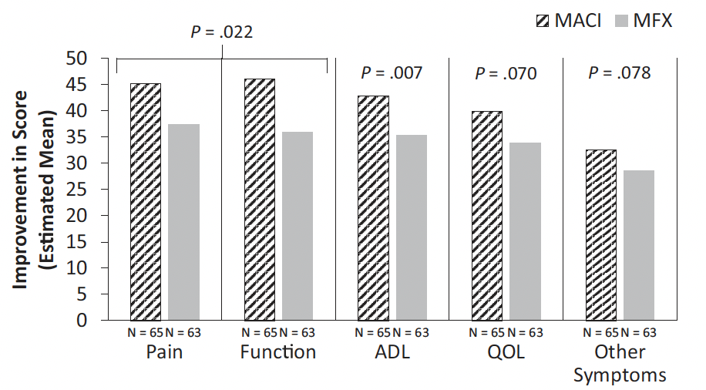

List the key health outcomes (major and minor – prioritising major key health outcomes first) that will need to be measured in assessing the clinical claim for the proposed medical service/technology (versus the comparator):
Treatment failure.
Health benefits
Health harms
Resources
Value of knowing

Outcome description – please include information about whether a change in patient management, or prognosis, occurs as a result of the test information:
In the SUMMIT study there were no analyses conducted for treatment failure rates between treatment groups because of the small number of treatment failures. Only 2 patients in the microfracture group were deemed treatment failures, and no patients in the MACI group.
Treatment failure was defined as; at any time after week 24, the patient and physician global assessment result was the same as or worse than at baseline, a <10% improvement in the KOOS pain subscale, physician-diagnosed failure ruling out all other potential causes, and the physician deciding that surgical retreatment was needed.

List the key health outcomes (major and minor – prioritising major key health outcomes first) that will need to be measured in assessing the clinical claim for the proposed medical service/technology (versus the comparator):
Adverse events
Health benefits
Health harms
Resources
Value of knowing

Outcome description – please include information about whether a change in patient management, or prognosis, occurs as a result of the test information:
No unexpected safety events were reported in the SUMMIT study (Saris, 2014).
The incidence of treatment emergent adverse events (TEAEs) considered to be related to the study treatment was comparable between treatments (MACI: 34.7% and microfracture: 38.9%). The most common related TEAEs were treatment failure, arthralgia, and joint swelling. In each group, 1 patient (1.4%) discontinued because of TEAEs.
Serious TEAEs were reported more frequently in the microfracture group (26.4%) than in the MACI group (15.3%), which were attributed to treatment failure, cartilage injury, and arthralgia in the microfracture group. No deaths occurred in this study.

List the key health outcomes (major and minor – prioritising major key health outcomes first) that will need to be measured in assessing the clinical claim for the proposed medical service/technology (versus the comparator):
Subsequent surgical events
Health benefits
Health harms
Resources
Value of knowing

Outcome description – please include information about whether a change in patient management, or prognosis, occurs as a result of the test information:
Subsequent surgery
The number of patients with at least 1 subsequent surgical procedure was not significantly different (P = .427) between the MACI group (8.3%) and the microfracture group (9.7%). Two subsequent surgical procedures were experienced by 2 patients in the microfracture group but by no patient in the MACI group (Saris, 2014).

Proposed MBS items

How is the technology/service funded at present? (for example: research funding; State-based funding; self-funded by patients; no funding or payments):
The procedure is provided in public hospitals, covered by worker’s compensation or self-funded by patients.

Please provide at least one proposed item with their descriptor and associated costs, for each population/Intervention:
HARVEST:
MBS item number | 49584
Category number | 3
Category description | Therapeutic Procedures
Proposed item descriptor | Harvesting of chondrocytes of knee for preparation of Autologous Chondrocytes Implantation- where patients - are aged between 15-55 years;  - have a focal chondral defect which is ≥ 2cm²;
Proposed MBS fee | Fee: $849.45 Benefit: 75% = $637.00
Indicate the overall cost per patient of providing the proposed health technology | REDACTED
Please specify any anticipated out of pocket expenses | $212.40
Provide any further details and explain | The out-of-pocket costs are related to gap payments and are dependent upon the fee charged by the medical practitioner
IMPLANT
MBS item number | 49503
Category number | 3
Category description | Therapeutic Procedures
Proposed item descriptor | Arthrotomy of knee, including  Implantation of autologous chondrocyte graft where patients - are aged between 15-55 years;  - have a focal chondral defect which is ≥ 2cm²
Proposed MBS fee | Fee: $536.20 Benefit: 75% = $402.15
Indicate the overall cost per patient of providing the proposed health technology | REDACTED
Please specify any anticipated out of pocket expenses | $134.05
Provide any further details and explain | The out-of-pocket costs are related to gap payments and are dependent upon the fee charged by the medical practitioner

Algorithms
Preparation for using the health technology

Define and summarise the clinical management algorithm, including any required tests or healthcare resources, before patients would be eligible for the proposed health technology:
Definitive diagnosis of a chondral defect is by medical imaging (most commonly MRI) or arthroscopy. Sometimes a lesion may be identified incidentally during MRI or arthroscopy intended to investigate a different clinical issue (e.g. ligament damage or joint misalignment). During diagnostic arthroscopy, debridement or lavage to remove loose cartilage may be performed concurrently.
If symptoms are ongoing despite conservative first line therapy, then surgical intervention will be considered. If debridement has not already been performed, the surgeon may perform this procedure first, otherwise patients will proceed to a surgical repair procedure. At this point the patient would be considered eligible for ACI. The decision on which procedure to use is based on a number of factors such as size of the defect, previous surgery, age, BMI and condition of the surrounding cartilage.

Is there any expectation that the clinical management algorithm before the health technology is used will change due to the introduction of the proposed health technology?
No

Describe and explain any differences in the clinical management algorithm prior to the use of the proposed health technology vs. the comparator health technology:
Use of the health technology

Explain what other healthcare resources are used in conjunction with delivering the proposed health technology:
Harvest
- Procedure 1 – arthroscopy and cartilage biopsy harvest
- Product (Orthocell) including courier services and development of cell culture.
- Anaesthesia
- Theatre assistant
- Hospital AR-DRG costs (Arthroscopy, Minor Complexity)
Implant
- Procedure 2 – arthroscopy (day case)
- Hospital AR-DRG costs (Arthroscopy, Minor Complexity)
- Scaffold costs
- Fibrin glue
- Anaesthesia
- Theatre assistant

Explain what other healthcare resources are used in conjunction with the comparator health technology:
- Procedure – arthroscopy
- Anaesthesia
- Theatre assistant
- Hospital AR-DRG costs (Arthroscopy, Minor Complexity)

Describe and explain any differences in the healthcare resources used in conjunction with the proposed health technology vs. the comparator health technology:
Matrix-induced ACI involves a two-step procedure where the patient undergoes an arthroscopy, to collect the cartilage biopsy, as per microfracture but then returns 4-6 weeks later for surgical implantation of the cultured cartilage cells. They both follow the same rehabilitation pathway and pre surgery management.
Clinical management after the use of health technology

Define and summarise the clinical management algorithm, including any required tests or healthcare resources, after the use of the proposed health technology:
The introduction of matrix induced ACI is not intended to change the current clinical pathway following treatment. The clinical management pathway following service delivery of matrix induced ACI is the same as that for microfracture. It is anticipated that matrix induced ACI be used only once in a lifetime per lesion, unless the procedure fails.

Define and summarise the clinical management algorithm, including any required tests or healthcare resources, after the use of the comparator health technology:
Following microfracture, patients will receive an intensive knee rehabilitation program designed to strengthen the musculature that supports the knee joint, maintain patella femoral tracking and increase range of motion and endurance so that the patient can return to their normal activities. Should the repair fail then a second repair may be attempted with a similar rehabilitation program. Eventually when patients reach the age of 55 years or older, a knee replacement may be required. This may be related to the original cartilage defect or may be due to unrelated osteoarthritic changes in the knee joint. Please see the attached ‘Clinical Pathway following Microfracture’.

Describe and explain any differences in the healthcare resources used after the proposed health technology vs. the comparator health technology:
The introduction of ACI is not intended to change the current clinical pathway following treatment. The clinical management pathway following service delivery of ACI is the same as that for microfracture. It is anticipated that ACI be used only once in a lifetime per lesion.

Algorithms

Insert diagrams demonstrating the clinical management algorithm with and without the proposed health technology:
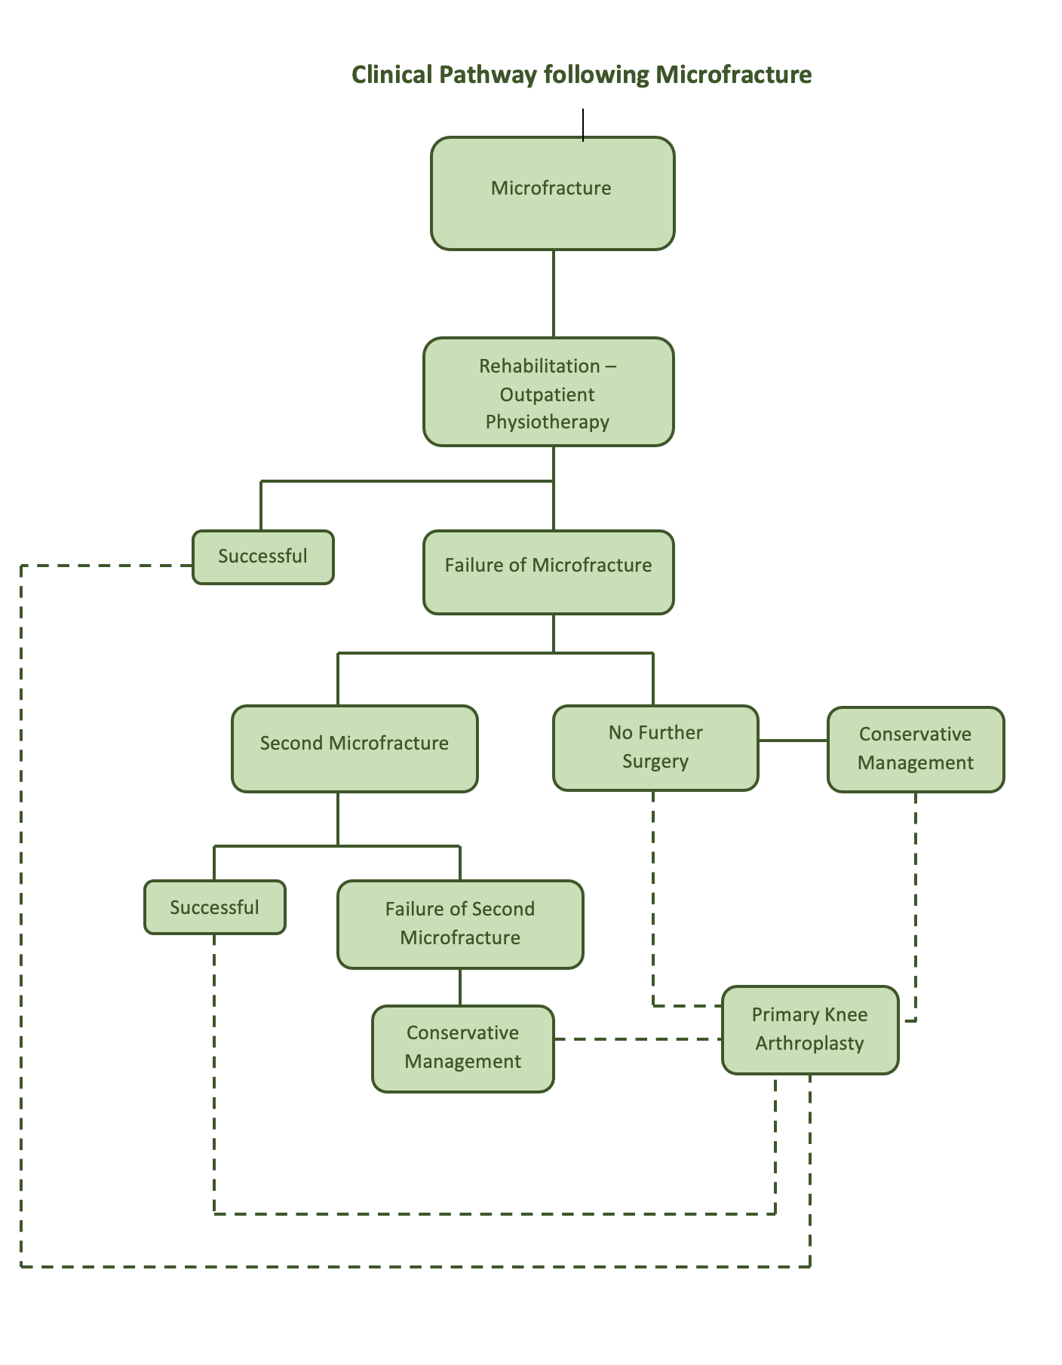

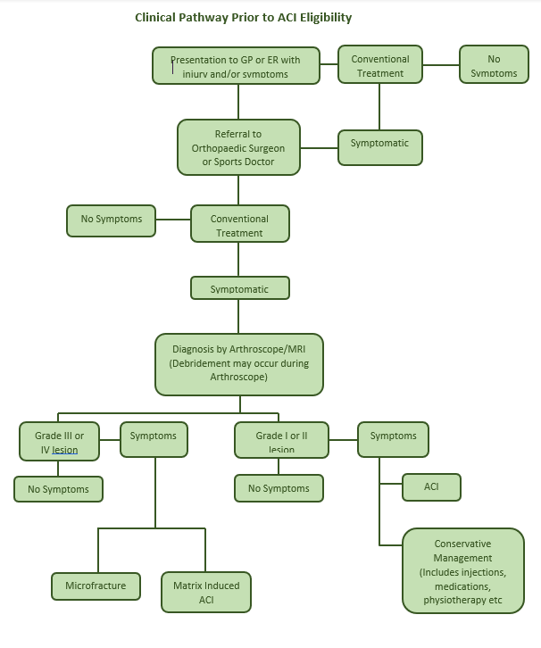

Claims
In terms of health outcomes (comparative benefits and harms), is the proposed technology claimed to be superior, non-inferior or inferior to the comparator(s)?
Superior
Non-inferior
Inferior

Please state what the overall claim is, and provide a rationale:
ACI is superior to microfracture (Brittberg, 2018)
Evidence of long-term durability of ACI procedures is demonstrated in the Nawaz (2014) single arm study.

Why would the requestor seek to use the proposed investigative technology rather than the comparator(s)?
The clinical trial outcomes favour matrix induced ACI over the comparator microfracture. Treatment failure rates are small with no unexpected safety events reported in the 5-year SUMMIT follow-up study.
Microfracture clinical outcomes are not always sustained (Knustsen, 2007; Kreuz, 2006; Mithoefer, 2009; Mithoefer, 2005). The generation of predominantly fibrocartilage from microfracture (, Di Bartola 2016) is less durable compared with more hyaline-like repair tissue reported with MACI (Brittberg, 2010). In addition, intralesional osteophytes may result from microfracture which could compromise any successful clinical outcomes (Minas, 2009).
In a systematic review Niemeyer (2019) considered reoperation rates within 36 months, 1 study showed that the need for subsequent surgery was less frequent in patients treated by ACI (3.9%) than in those treated by microfracture (11.5%).

Identify how the proposed technology achieves the intended patient outcomes:
ACI is a regenerative surgical procedure for isolated chondral defects, that involves culturing and re-implanting a patient’s own chondrocytes. First and second generations of the surgical technique required suturing of a periosteal or collagen cover to retain the cells within the chondral defect. Third-generation techniques (matrix-induced ACI) seed the cells onto a collagen membrane, which is then glued to the subchondral bone (Mistry, 2017). Progression to third-generation technology resulted in added benefits to patients including shorter procedure time, better surgical consistency, a smaller incision, more consistent cell seeding, less periosteal hypertrophy, and fewer adverse events (Saris, 2014).
In the SUMMIT study, the MACI implantation procedure was performed via mini-arthrotomy 4 to 8 weeks after baseline arthroscopic surgery. Briefly, the lesions were debrided to a vertical rim of stable healthy cartilage without breaching the subchondral bone. The shape and size of the lesion(s) were assessed, and a template for each lesion was created. The MACI implant was trimmed to the correct size and shape of the defect and placed down into the debrided base of the defect with the cells facing the subchondral bone. The implant was secured in place using a thin layer of fibrin sealant on the base and edges of the defect, and stability of the implant was checked while fully extending and flexing the knee several times (Saris, 2014).
The MACI procedure is consistent with positive clinical outcomes, superior KOOS sub scores, reduced treatment failures and good structural outcomes (Brittberg, 2018).

For some people, compared with the comparator(s), does the test information result in:

A change in clinical management?
No

A change in health outcome?
Yes

Other benefits?
No

Please provide a rationale, and information on other benefits if relevant:
-

In terms of the immediate costs of the proposed technology (and immediate cost consequences, such as procedural costs, testing costs etc.), is the proposed technology claimed to be more costly, the same cost or less costly than the comparator?
More costly
Same cost
Less costly

Provide a brief rationale for the claim:
ACI involves two procedures: the arthroscopic cell harvest and the re-implantation during arthrotomy. While it does not require an inpatient stay it may be assumed, given the two-step procedure, it will be more costly.

Summary of Evidence

Provide one or more recent (published) high quality clinical studies that support use of the proposed health service/technology.
Please note: ACI is a technology that has advanced rapidly and incrementally since the 1980’s. Therefore, relevant longer-term evidence is inevitably available only for earlier iterations. These longer-term studies are included below.
 | Type of study design | Title of journal article or research project | Short description of research | Website link to journal article or research | Date of publication
1. | Multicentre Prospective Randomised Controlled Trial | Vanlauwe J, Saris D.B.F, Victor. J, et al and TIG/ACT/01/2000&EXT Study Group ‘Five-Year Outcome of Characterized Chondrocyte Implantation Versus Microfracture for Symptomatic Cartilage Defects of the Knee: Early Treatment Matters’ Am J Sports Med 2011 39: 2566 | RCT comparing ACI-P with microfracture with 5 years follow up.  The main outcome measurement was change from baseline in overall Knee Injury and Osteoarthritis Outcome Score (KOOS). Time to failure and adverse events were recorded. Failure was defined as a reintervention affecting more than 20 percent of the index lesion. | http://journals.sagepub.com/doi/abs/10.1177/0363546511422220?url_ver=Z39.88-2003&rfr_id=ori:rid:crossref.org&rfr_dat=cr_pub%3dpubmed | September 9 2011
2. | Multicentre Prospective Randomised Controlled Trial | Saris, D et al on behalf of the SUMMIT study group ‘Matrix-Applied Characterized Autologous Chondrocytes versus Microfracture: Two-Year Follow-up of a Prospective Randomized Controlled Trial’ Am J Sports Med 2014 Jun;42(6):1384-94.  AND  Brittberg, M et al on behalf of the SUMMIT study group ‘Matrix-Applied Characterized Autologous Chondrocytes versus Microfracture: Five-Year Follow-up of a Prospective Randomized Controlled Trial’ Am J Sports Med. 2018 May;46(6):1343-1351. | Multicentre prospective randomised controlled trial comparing MACI to microfracture. Participants were followed for two years. Lesions included were ≥ 3cm². 72 participants were in each group.  The primary outcome was changes to KOOS for pain and function subscales from baseline to Year 2  SUMMIT participants were followed for five years. Lesions included were ≥ 3cm². Of the 144 patients enrolled in the original trial, 128 were followed up at 5 years (65 MACI, 63 MF).  The primary outcome was changes to KOOS for pain and function subscales from baseline to Year 5 | http://journals.sagepub.com/doi/abs/10.1177/0363546514528093  http://journals.sagepub.com/doi/abs/10.1177/0363546518756976?url_ver=Z39.88-2003&rfr_id=ori:rid:crossref.org&rfr_dat=cr_pub%3dpubmed | Published online April 8 2014  Published online March 22, 2018
3. | Single Arm Observational study | Nawaz S et al ‘Autologous Chondrocyte Implantation in the Knee: Mid-Term to Long-Term Results’ J Bone Joint Surg Am. 2014; 96:824-30 | 827 patients were followed for a mean duration of 6.2 years with a range of 2 to 12 years.  Main clinical outcome was survival | https://insights.ovid.com/pubmed?pmid=24875023 | May 21 2014
4. | Randomised Controlled Trial | G Bentley, L.C Biant, S Vijayan, S Macmull, J.A Skinner, R.W.J. Carrington ‘Minimum ten-year results of a prospective randomised study of autologous chondrocyte implantation versus mosaicplasty for symptomatic articular cartilage lesions of the knee’ J Bone Joint Surg Br 2012; 94-B; 504-9 | 100 patients were randomised to either ACI or mosaicplasty for symptomatic cartilage lesions of the knee.  Primary Outcome was time to failure and functional outcome scores. | http://bjj.boneandjoint.org.uk/content/94-B/4/504.long | March 20 2012
5. | Randomised Controlled Trial | Basad et al ‘Matrix-induced autologous chondrocyte implantation versus microfracture in the treatment of cartilage defects of the knee: a 2-year randomised study’ Knee Surg Sports Trauma Arthrosc (2010) 18:519-527 | RCT comparing MACI with microfracture with 2 years follow up. Outcome measures include Tegner, Lysholm and ICRS scores. | https://www.researchgate.net/publication/40900650_Matrix-induced_autologous_chondrocyte_implantation_versus_microfracture_in_the_treatment_of_cartilage_defects_of_the_knee_a_2-year_randomised_study_Knee_Surg_Sports_Traumatol_Arthrosc_18_519-527 | April 2010
6. | Cohort Study | Jungmann et al, ‘Autologous Chondrocyte Implantation for Treatment of Cartilage Defects of the Knee’ Am J Sports Med 2012 Jan;40(1):58-67 | Retrospective analysis of prospective database. 413 patients, 73.6% treated with ACI-C (collagen). Outcome measures include treatment failure and time to revision | http://journals.sagepub.com/doi/abs/10.1177/0363546511423522?url_ver=Z39.88-2003&rfr_id=ori:rid:crossref.org&rfr_dat=cr_pub%3dpubmed | Published online October 2011
7. | Multi-centre observational study | Moseley et al ‘Long-Term Durability of Autologous Chondrocyte Implantation: A Multicenter, Observational Study in US Patients”. XXXX | 72 patients treated with ACI-C were followed for 6-10 years. Outcome measures included treatment failure, VAS pain. | http://journals.sagepub.com/doi/abs/10.1177/0363546509348000 | February 2010
 | Cohort Study | Ebert JR, Smith A, Edwards PK, Hambly K, Wood DJ, Ackland TR. Factors predictive of outcome 5 years after matrix-induced autologous chondrocyte implantation in the tibiofemoral joint. Am J Sports Med. 2013 Jun;41(6):1245-54. doi: 10.1177/0363546513484696. Epub 2013 Apr 25. PMID: 23618699. | Cohort study to estimate the improvement in clinical and radiological outcomes and investigate the independent contribution of pertinent preoperative and postoperative patient, chondral defect, injury/surgery history, and rehabilitation factors to clinical and radiological outcomes, as well as patient satisfaction, 5 years after MACI. | https://pubmed.ncbi.nlm.nih.gov/23618699/ | June 2013
 | RCT | Ebert JR, Fallon M, Ackland TR, Janes GC, Wood DJ. Minimum 10-Year Clinical and Radiological Outcomes of a Randomized Controlled Trial Evaluating 2 Different Approaches to Full Weightbearing After Matrix-Induced Autologous Chondrocyte Implantation. Am J Sports Med. 2020 Jan;48(1):133-142. doi: 10.1177/0363546519886548. Epub 2019 Nov 25. PMID: 31765228. | RCT comparing clinical and radiological outcomes in patients who received matrix-induced ACI and two different approaches to full weight bearing with 10 year follow up. | https://pubmed.ncbi.nlm.nih.gov/31765228/ | Jan 2020
 | Case Series | Ebert JR, Fallon M, Wood DJ, Janes GC. Long-term Prospective Clinical and Magnetic Resonance Imaging-Based Evaluation of Matrix-Induced Autologous Chondrocyte Implantation. Am J Sports Med. 2021 Mar;49(3):579-587. doi: 10.1177/0363546520980109. Epub 2021 Jan 7. PMID: 33411565. | Clinical and radiological outcomes a minimum of 10 years after matrix induced ACI in a consecutive series of patients | https://pubmed.ncbi.nlm.nih.gov/33411565/ | March 2021

Yuze Zhang, Hao Lian, Yinghai Liu, "Deconstruction of Knee Cartilage Injury in Athletes Using MR Images Based on Artificial Intelligence Segmentation Algorithm", Contrast Media & Mol Imaging. 2022 Sep 27;2022:4165232. doi: 10.1155/2022/4165232. PMID: 36247846; PMCID: PMC9532134.
Meyerkort D One-stage vs two-stage cartilage repair: a current review. Orthop. Res. Rev. 2010: 2, 1-12
Heir S Focal cartilage defects in the knee impair quality of life as much as severe osteoarthritis: a comparison of knee injury and osteoarthritis outcome score in 4 patient categories scheduled for knee surgery.’ AM J Sports Med. 2010 Feb; 38 (2) 231-7
Bekkers J Cartilage Repair in Football (Soccer) Athletes What Evidence Leads to Which Treatment? A Critical Review of the Literature. Cartilage 2012; 31(1 Suppl):43S-49S
Widuchowski, W., Widuchowski, J. & Trzaska, T. Articular cartilage defects: study of 25,124 knee arthroscopies. Knee (2007) 14, 177–82.
Curl WW, Krome J, Gordon ES, Rushing J, Smith BP, Poehling GG. Cartilage injuries: a review of 31,516 knee arthroscopies. Arthroscopy. 1997 Aug;13(4):456-60. doi: 10.1016/s0749-8063(97)90124-9. PMID: 9276052.
Saris D, Price A, Widuchowski W, Bertrand-Marchand M, Caron J, Drogset JO, Emans P, Podskubka A, Tsuchida A, Kili S, Levine D, Brittberg M; SUMMIT study group. Matrix-Applied Characterized Autologous Cultured Chondrocytes Versus Microfracture: Two-Year Follow-up of a Prospective Randomized Trial. Am J Sports Med. 2014 Jun;42(6):1384-94. doi: 10.1177/0363546514528093. Epub 2014 Apr 8. PMID: 24714783.
Brittberg M, Recker D, Ilgenfritz J, Saris DBF; SUMMIT Extension Study Group. Matrix-Applied Characterized Autologous Cultured Chondrocytes Versus Microfracture: Five-Year Follow-up of a Prospective Randomized Trial. Am J Sports Med. 2018 May;46(6):1343-1351. doi: 10.1177/0363546518756976. Epub 2018 Mar 22. PMID: 29565642.
Biant LC, McNicholas MJ, Sprowson AP, Spalding T. The surgical management of symptomatic articular cartilage defects of the knee: Consensus statements from United Kingdom knee surgeons. Knee. 2015 Oct;22(5):446-9. doi: 10.1016/j.knee.2015.06.001. Epub 2015 Jun 23. PMID: 26116040.
Willers C et al Articular Cartilage Repair: procedures versus products. Expert Rev. Med. Devices 4(3), 373–392 (2007)
Mistry H, et al. Autologous chondrocyte implantation in the knee: systematic review and economic evaluation. Health Technol Assess (2017);21(6).
Brittberg M et al ‘Matrix-Applied Characterized Autologous Cultured Chondrocytes Versus Microfracture: Five-Year Follow-up of a Prospective Randomized Trial’ Am J Sports Med. 2018 May;46(6):1343-1351
Nawaz SZ et al ‘Autologous Chondrocyte Implantation in the Knee, Mid-Term to Long-Term Results’ J Bone Joint Surgery Am. 2014; 96:824-30
Knutsen G, Drogset JO, Engebretsen L, Grøntvedt T, Isaksen V, Ludvigsen TC, Roberts S, Solheim E, Strand T, Johansen O. A randomized trial comparing autologous chondrocyte implantation with microfracture. Findings at five years. J Bone Joint Surg Am. 2007 Oct;89(10):2105-12. doi: 10.2106/JBJS.G.00003. PMID: 17908884.
Kreuz PC, Steinwachs MR, Erggelet C, Krause SJ, Konrad G, Uhl M, Südkamp N. Results after microfracture of full-thickness chondral defects in different compartments in the knee. Osteoarthritis Cartilage. 2006 Nov;14(11):1119-25. doi: 10.1016/j.joca.2006.05.003. Epub 2006 Jul 11. PMID: 16815714.
Mithoefer K, McAdams T, Williams RJ, Kreuz PC, Mandelbaum BR. Clinical efficacy of the microfracture technique for articular cartilage repair in the knee: an evidence-based systematic analysis. Am J Sports Med. 2009 Oct;37(10):2053-63. doi: 10.1177/0363546508328414. Epub 2009 Feb 26. PMID: 19251676.
Mithoefer K, Williams RJ 3rd, Warren RF, Potter HG, Spock CR, Jones EC, Wickiewicz TL, Marx RG. The microfracture technique for the treatment of articular cartilage lesions in the knee. A prospective cohort study. J Bone Joint Surg Am. 2005 Sep;87(9):1911-20. doi: 10.2106/JBJS.D.02846. PMID: 16140804.
DiBartola AC, Everhart JS, Magnussen RA, Carey JL, Brophy RH, Schmitt LC, et al. Correlation between histological outcome and surgical cartilage repair technique in the knee: A meta-analysis. The Knee. 2016;23(3):344-9
Brittberg M. Cell carriers as the next generation of cell therapy for cartilage repair: a review of the matrix-induced autologous chondrocyte implantation procedure. Am J Sports Med. 2010;38(6):1259-1271.
Minas T, Gomoll AH, Rosenberger R, Royce RO, Bryant T. Increased failure rate of autologous chondrocyte implantation after previous treatment with marrow stimulation techniques. Am J Sports Med. 2009;37(5):902-908.
Niemeyer P, Schubert T, Grebe M, Hoburg A. Matrix-Associated Chondrocyte Implantation Is Associated With Fewer Reoperations Than Microfracture: Results of a Population-Representative, Matched-Pair Claims Data Analysis for Cartilage Defects of the Knee. Orthop J Sports Med. 2019 Oct 21;7(10):2325967119877847. doi: 10.1177/2325967119877847. PMID: 31673564; PMCID: PMC6804358.

