|  |
| --- |
| Application 1374  Final protocol to guide the assessment of subcutaneous implantable cardioverter defibrillator therapy |
| May 2014 |

Table of Contents

MSAC and PASC 3

Purpose of this document 3

Background 4

Purpose of application 4

Current arrangements for public reimbursement 5

Regulatory status 7

Intervention 8

Description 8

Delivery of the intervention 8

Prerequisites 8

Co-administered and associated interventions 9

Patient Selection for subcutaneous ICD 9

Medical condition and population eligible for the proposed intervention 10

Proposed MBS listing 12

Clinical place for proposed intervention 13

Comparator 14

Clinical claim 15

Outcomes and health care resources affected by introduction of proposed intervention 16

Outcomes 16

Health care resources 16

Proposed structure of economic evaluation 19

References 23

# MSAC and PASC

The Medical Services Advisory Committee (MSAC) is an independent expert committee appointed by the Australian Government Health Minister to strengthen the role of evidence in health financing decisions in Australia. MSAC advises the Commonwealth Minister for Health on the evidence relating to the safety, effectiveness, and cost-effectiveness of new and existing medical technologies and procedures and under what circumstances public funding should be supported.

The Protocol Advisory Sub-Committee (PASC) is a standing sub-committee of MSAC. Its primary objective is the determination of protocols to guide clinical and economic assessments of medical interventions proposed for public funding.

## Purpose of this document

This document is intended to provide a protocol that will be used to guide the assessment of an intervention for a particular population of patients. The draft protocol will be finalised after inviting relevant stakeholders to provide input to the protocol. The final protocol will provide the basis for the assessment of the intervention.

The protocol guiding the assessment of the health intervention has been developed using the widely accepted “PICO” approach. The PICO approach involves a clear articulation of the following aspects of the research question that the assessment is intended to answer:

**P**atients – specification of the characteristics of the patients in whom the intervention is to be considered for use;

**I**ntervention – specification of the proposed intervention

**C**omparator – specification of the therapy most likely to be replaced by the proposed intervention

**O**utcomes – specification of the health outcomes and the healthcare resources likely to be affected by the introduction of the proposed intervention

# Background

A proposal for an application requesting Medicare Benefits Schedule (MBS) listing for the insertion of a subcutaneous implantable cardioverter defibrillator (ICD) electrode[1] was received from Boston Scientific by the Department of Health and Ageing in September 2013.

Conventional (transvenous) ICD therapy consists of a generator, which is usually implanted in a pocket in the pectoral region below the left clavicle, and a transvenous right ventricular lead that contains the shock coils and pacing electrode (single-chamber ICD). Additional leads may also be connected to the right atrium (dual-chamber ICD) or left ventricle (cardiac resynchronisation therapy) for the purposes of pacing, sensing and defibrillation. Currently, transvenous ICD devices are able to provide cardiac pacing to treat dangerously low heart rates (bradycardia), if present. However, the majority of patients implanted with an ICD do not have a bradycardia pacing indication. Insertion of the subcutaneous ICD is clinically similar to the insertion of a transvenous ICD, yet the subcutaneous ICD leads do not need to be inserted into the vasculature of the heart. Rather, they are placed under the skin of the patients’ chest.

ICDs represent a highly effective therapy for primary and secondary prevention of sudden cardiac death (SCD), treatment of life threatening ventricular arrhythmias. The cost-effectiveness of ICDs in primary[2] and secondary[3] prevention is widely accepted (Charles & Gammage, 2007), and in Australia, their use is reimbursed through Medicare. However, implantation of endocardial leads using a transvenous approach can be associated with significant procedural and long term complications (DiMarco, 2003). The subcutaneous ICD system provides the same clinical benefits as transvenous ICDs while minimising the risk of some long-term complications associated with transvenous ICD lead failure. The subcutaneous ICD system is intended to provide defibrillation therapy for the treatment of life threatening ventricular arrhythmias in patients who do not have symptomatic bradycardia, incessant ventricular tachycardia (VT), or spontaneous, frequently occurring VT that is reliably terminated with anti-tachycardia pacing. There is an unmet clinical need and new line of therapy for those patients (particularly children and younger adults) with life threatening ventricular arrhythmias who may have difficult anatomy for transvenous lead insertion, and for whom a pacing lead is not needed.

# Purpose of application

The following protocol will outline the proposed approach to evaluate comparative effectiveness, safety and costs associated with insertion of a subcutaneous ICD lead compared to a transvenous ICD lead for patients indicated for subcutaneous ICD therapy. Specifically, subcutaneous ICD is only indicated for the treatment of life-threatening ventricular arrhythmias in patients who do not have symptomatic bradycardia, incessant VT, or spontaneous, frequently recurring VT that is reliably terminated with anti-tachycardia pacing. This patient group represents a subgroup of all patients currently receiving transvenous ICD systems.

## Current arrangements for public reimbursement

The application is seeking MBS listing for subcutaneous ICD therapy. The cost of the generator associated with subcutaneous ICD leads will separately require consideration for reimbursement through the Prostheses List. There are existing MBS items for insertion of transvenous ICD leads in primary prevention (item 38384; Table 1) and secondary prevention (item 38390; Table 2). The associated MBS items for the insertion or replacement of an automatic defibrillator generator are items 38387 and 38393.

*Subcutaneous ICD*

Subcutaneous ICD systems are not currently being used in Australia. This is the first MSAC application related to the use of the subcutaneous ICD devices. The S-ICD®, developed by Cameron Health, received a CE mark in 2009 (Lobodzinski, 2011) and US Food and Drug Administration (FDA) approval in 2012 (FDA, 2012). S-ICD® is currently available in the US, New Zealand, UK and several other European countries, including the Netherlands, Denmark, Germany, France and Italy. Over 2,000 procedures have been conducted worldwide.

*Transvenous ICD*

The 2006 MSAC assessment report of ICDs for prevention of SCD (MSAC Ref 32) recommended the listing of ICD implantation on the MBS for primary prevention for patients with a left ventricular ejection fraction (LVEF) of ≤ 30 per cent at least one month after a myocardial infarct (MI) when the patient has received optimal medical therapy (OMT); and patients with chronic heart failure (CHF) associated with mild to moderate symptoms (New York Heart Association (NYHA) II and III) and a LVEF ≤ 35 per cent when the patient has received OMT.

Evidence based US and European practice guidelines recommend traditional ICD therapy for primary and secondary prevention of SCD (Epstein et al., 2008; Zipes et al., 2006), and Medicare funding through the MBS is available for primary and secondary prevention of SCD.

Table 1 Current MBS item descriptor for insertion of transvenous ICD lead (primary prevention)

|  |
| --- |
| Category 3 – Therapeutic Procedures |
| MBS: 38384  AUTOMATIC DEFIBRILLATOR, insertion of patches for, or insertion of transvenous endocardial defibrillation electrodes for, primary prevention of sudden cardiac death in:  - patients with a left ventricular ejection fraction of less than or equal to 30% at least one month after a myocardial infarct when the patient has received optimised medical therapy; or  - patients with chronic heart failure associated with mild to moderate symptoms (NYHA II and III) and a left ventricular ejection fraction less than or equal to 35% when the patient has received optimised medical therapy.  Not being a service associated with a service to which item 38213 applies  Multiple Services Rule (Anaes.) (Assist.)  Fee: $1,052.65  Explanatory note:  T8.67 Implantable Cardioverter Defibrillator (Items 38384 and 38387)  Items 38384 and 38387 apply only to patients who meet the criteria listed in the item descriptor, and to patients who do not meet the criteria listed in the descriptor but have previously had an ICD device inserted and who prior to its insertion met the criteria and now need the device replaced. |

Table 2 Current MBS item descriptor for insertion of transvenous ICD lead (secondary prevention)

|  |
| --- |
| Category 3 – Therapeutic Procedures |
| MBS: 38390  AUTOMATIC DEFIBRILLATOR, insertion of patches for, or insertion of transvenous endocardial defibrillation electrodes for - not for patients with heart failure or as primary prevention for tachycardia arrhythmias. Not being a service associated with a service to which item 38213 applies  Multiple Services Rule (Anaes.) (Assist.)  Fee: $1,052.65  (No explanatory notes) |

A comparison between the processes for inserting a transvenous ICD and subcutaneous ICD is provided in Table 3. The implications of these differences for the economic evaluation will be considered in more detail in the submission based assessment and will be used to determine an appropriate fee for the service.

Table 3 Implant procedure comparison between subcutaneous ICD lead and transvenous ICD lead

| **Steps in the delivery of intervention** | **Proposed Service – Insertion of a subcutaneous ICD lead** | **Current Service (MBS items 38384, 38390)** |
| --- | --- | --- |
| Sedation Type | * Conscious or general sedation | * Conscious or general sedation |
| Imaging Technique | * X-ray may be used post-implant to validate optimal pulse generator to lead placement | * Fluoroscopy |
| Procedural Steps | * Prep time * Device pocket formation * Subcutaneous lead placement (additional incisions and suturing required) * Electrode terminal pin connection to device * Device programming & testing performed * Pocket closure | * Prep time * Device pocket formation * Transvenous lead placement under fluoroscopy * Electrode terminal pin connection to device * Device programming & testing performed * Pocket closure |
| Procedure Time | * Approx. 1 hour | * Approx. 1 hour |

Table 4 presents historical and current utilisation and expenditure data for the MBS services 38384 and 38390 between July 2008 and June 2013. These data indicate a slight trend towards growth for primary prevention of SCD since 2008, while services (and MBS expenditure) for secondary prevention have remained relatively stable over the same period. It is important to note that the proposed subcutaneous ICD system will only be used in a proportion of the patient population described in Table 4.

Table 4 Count and expenditure of MBS services for transvenous ICD lead insertion from July 2008- June 2013

|  |  |  |  |
| --- | --- | --- | --- |
| **MBS item number** | **Period** | **Services** | **MBS expenditure a** |
| 38384  (Primary prevention) | Jul 2008 – Jun 2009 | 775 | $305,140 |
| Jul 2009 – Jun 2010 | 852 | $322,988 |
| Jul 2010 – Jun 2011 | 961 | $381,122 |
| Jul 2011 – Jun 2012 | 1,085 | $453,463 |
| Jul 2012 – Jun 2013 | 1,014 | $450,798 |
| Total | 4,687 | $1,913,512 |
| 38390  (Secondary prevention) | Jul 2008 – Jun 2009 | 934 | $424,541 |
| Jul 2009 – Jun 2010 | 767 | $345,990 |
| Jul 2010 – Jun 2011 | 821 | $374,031 |
| Jul 2011 – Jun 2012 | 841 | $395,822 |
| Jul 2012 – Jun 2013 | 864 | $426,467 |
| Total | 4,227 | $1,966,851 |

**a** MBS items listed in Group T8 are subject to Multiple Operations Rule (see note T8.2 of MBS)

## Regulatory status

Boston Scientific’s Q-TRAK® S-ICD® lead and SQ-RX® Pulse Generator are currently listed in the Australian Register of Therapeutic Goods (ARTG).

Table 5 ARTG listings for subcutaneous ICD components

| **ARTG number** | **Start date** | **Product name** | **Intended purpose** |
| --- | --- | --- | --- |
| 219499 | 23/01/2014 | SQ-RX Pulse Generator | An active implantable component of the S-ICD System. The S-ICD System is intended to provide defibrillation therapy for the treatment of life-threatening ventricular tachyarrhythmias in patients who do not have symptomatic bradycardia, incessant ventricular tachycardia, or spontaneous, frequently recurring ventricular tachycardia that is reliably terminated with anti-tachycardia. pacing. |
| 219500 | 23/01/2014 | Q-TRAK Subcutaneous Lead, | A component of the S-ICD System, which is prescribed for patients when cardiac arrhythmia management is warranted. The S-ICD System detects cardiac activity and provides defibrillation therapy. |

# Intervention

## Description

The subcutaneous ICD system provides defibrillation therapy in the event of a life threatening ventricular arrhythmia. Insertion of the subcutaneous ICD is clinically similar to the insertion of a transvenous ICD, however the subcutaneous ICD lead does not need to be inserted into the vasculature of the heart. Rather, it is placed under the skin of the patients’ chest. Shock therapy is delivered from an electrode to the ICD generator, which are both implanted subcutaneously. An overview of Boston Scientific’s Q-TRAK® S-ICD® lead and SQ-RX® Pulse Generator is provided as an appendix to this protocol.

*Medicare funding for subcutaneous ICD therapy would allow clinicians and patients another treatment option for ventricular arrhythmia. The application is not intended to be limited to Boston Scientific’s technology or a specific trademark. ICD technology is not indicated for other conditions; therefore there is a low risk of use outside this patient population.*

## Delivery of the intervention

Boston Scientific’s S-ICD® is comprised of the SQ-RX® model pulse generator and connected Q-TRAK® model subcutaneous lead (3mm, bipolar parasternal lead, polycarbonate urethane 55D). The Q-GUIDE™ lead tunneling tool and Q-TECH™ programming device are used during implantation (Aydin et al., 2012; Dabiri Abkenari et al., 2011; Lobodzinski, 2011).

Lead placement is via anatomical incisions made at the mid-axillary line, xiphoid mid-line and superior parasternal area. The lead is then inserted subcutaneously via a tunnelling tool and sutured in place. An incision and pocket is created in the vicinity of the left 5th and 6th intercostal spaces at the mid-axillary line where the ICD generator is implanted. Once connected to the lead, it is placed in the pocket and sutured closed.

*A comparison of transvenous ICD and subcutaneous ICD insertion will be presented in the submission based assessment.*

## Prerequisites

Implantation of a subcutaneous ICD device is clinically similar to the insertion of a transvenous ICD in terms of staffing, procedure time and required infrastructure. As such, the necessary capabilities to perform subcutaneous ICD implantation are already established at the relevant clinics and institutions. Unlike transvenous ICD, subcutaneous ICD does not require fluoroscopy or other medical imaging systems found in an electrophysiology laboratory. Therefore, it is expected that this procedure will decrease the burden on current imaging infrastructure and associated costs to the MBS. As is the case for transvenous ICD lead insertion, all subcutaneous ICD lead insertions will take place in a hospital setting.

Furthermore, as those specialists involved in the insertion of a subcutaneous ICD lead would be the same with the expanded listing as currently required, the proposed listing is not expected to lead to any incremental resource requirements. Manufacturers of subcutaneous ICD technology provide training to hospital staff.

## Co-administered and associated interventions

The diagnostic tests required to establish whether a patient is indicated for subcutaneous ICD therapy are the same as for transvenous ICD. Optimal medical and pharmaceutical therapy for chronic heart failure would be provided in accordance with Australian clinical practice guidelines (Krum, Jelinek, Stewart, Sindone, & Atherton, 2011). In the majority of patients receiving ICD therapy, medications would remain unchanged after device implantation.

Subcutaneous ICD system implantation is commonly provided under conscious or general sedation, as is transvenous ICD. An anaesthetist may be required to provide the appropriate level of sedation. There is no need for fluoroscopy or other medical imaging systems found in an electrophysiology laboratory.

*Diagnosis and medication use for patients receiving a subcutaneous ICD is expected to be similar to transvenous ICD patients. Subcutaneous ICD may be associated with less imaging.*

Replacement procedures

The insertion of a subcutaneous ICD lead and associated generator is a once-off procedure and the therapy is for the lifetime of the patient. If the patient requires a new generator (in the event that the battery expires) then the new generator can be connected to the existing subcutaneous ICD lead i.e. there is no additional cost for technology or physician fee for replacement of a subcutaneous ICD lead. This is no different to insertion and replacement of a transvenous ICD generator.

*The insertion of a subcutaneous ICD lead is a once-off procedure. This is same as for a transvenous ICD lead. Any differences in lead and generator longevity will be evaluated in the submission based assessment.*

## Patient Selection for subcutaneous ICD

It is important to assess the clinical need of each individual ICD patient, in order to avoid exposure to potentially harmful surgery if it is unnecessary. Such a selection process is currently performed in clinical practice by the treating cardiologist or cardiac specialist when determining the appropriate transvenous ICD system (single-chamber, dual-chamber or CRT-D), and the necessary functions of that system (defibrillation, pacing, resynchronisation etc.). This process will continue should the subcutaneous ICD system be included on the MBS, as the treating clinician will determine which of their patients are clinically appropriate for subcutaneous ICD therapy.

The subcutaneous ICD system provides a reliable alternative for a large population of ICD patients, but may be more preferable for certain patient groups such as:

* Younger patients that will require decades of ICD therapy – expected to be patients with a life expectancy greater than 15 years
* In patients who are at high risk for infection – patients with diabetes, renal impairment, paediatric and small patients
* In patients with difficult venous anatomy – patients with left persistent superior vena cava (LPSVC), capped ICD leads, occluded veins and diseased or mechanical tricuspid valves

*The identification of these preferential patient sub-groups for subcutaneous ICD therapy is yet to be quantified in clinical trials. Therefore, the proposed submission does not intend to demonstrate differences in clinical outcomes for patients who may be preferable for subcutaneous ICD therapy. Rather, it will focus on all patients in need of defibrillation therapy for the treatment of life-threatening ventricular arrhythmias, in whom pacing is not required.*

# Medical condition and population eligible for the proposed intervention

Chronic heart failure

Heart failure is a complex syndrome resulting from any structural or functional cardiac abnormality that reduces the ability of the heart to function as a pump (Cowie & Zaphiriou, 2002), and is a major cause of morbidity and mortality in Western societies. The condition is characterised by dyspnoea, fatigue, and fluid retention (Cowie & Zaphiriou, 2002). Patients with heart failure have limited exercise capacity, frequent need for hospitalisation, high rates of mortality and an impaired quality of life (Hare, 2002).

The effectiveness of cardiac muscle contraction is represented by the measurement of LVEF. This is calculated as the percentage of blood present in the heart that is ejected with each contraction. The fraction is normally greater than 50%. The effect to which the symptoms of heart failure affect functional capacity can be assessed using the NYHA classification (Ahmed, 2003; Krum et al., 2011) (Table 6 ). Under this system, subjective symptoms are used to rank patients according to their functional capacity into four classes.

Table 6 NYHA classification of functional class for heart failure (NHF/CSANZ, 2011)

|  |  |
| --- | --- |
| Class I | No limitations. Ordinary physical activity does not cause undue fatigue, dyspnoea or palpitations (asymptomatic left ventricular dysfunction). |
| Class II | Slight limitation of physical activity. Ordinary physical activity results in fatigue, palpitation, dyspnoea or angina pectoris (mild chronic heart failure). |
| Class III | Marked limitation of physical activity. Less than ordinary physical activity leads to symptoms (moderate chronic heart failure). |
| Class IV | Unable to carry on any physical activity without discomfort. Symptoms of CHF present at rest (severe chronic heart failure). |

Sudden cardiac arrest and sudden cardiac death

SCD is an abrupt loss of consciousness and unexpected death due to cardiac causes. It is a terminal event in approximately 35-50 per cent of patients with chronic heart failure (Packer, 1992). Most SCDs are caused by acute, fatal ventricular arrhythmia; mostly VT and ventricular fibrillation (VF). Epidemiologic data indicate that structural coronary artery disease and their consequences are the cause of 80% of arrhythmias causing these SCD events (Huikuri, Castellanos, & Myerburg, 2001; Myerburg, Interian, Mitrani, Kessler, & Castellanos, 1997). Dilated and hypertrophic cardiomyopathies account for the second largest number of sudden deaths from cardiac causes (Zipes & Wellens, 1998). Other cardiac disorders, such as valvular or congenital heart diseases, acquired infiltrative disorders, and primary electrophysiological disorders account for only a small proportion of the sudden deaths that may occur in the general population (Huikuri et al., 2001).

Ventricular arrhythmias can occur in individuals with or without a cardiac disorder. There is a great deal of overlap between clinical presentations and the severity and type of heart disease. For example, stable and well-tolerated VT can occur in the individual with previous MI and impaired ventricular function. The prognosis and management are individualised according to symptom burden and severity of underlying heart disease, in addition to the clinical presentation (Zipes et al., 2006). Evidence based best practice guidelines recommend ICD therapy for primary and secondary prevention of SCD (Epstein et al., 2008; Zipes et al., 2006).

A patient with chronic heart failure is also susceptible to malignant ventricular arrhythmias. Further, the prevalence and complexity of ventricular arrhythmias such as premature depolarisations and non-sustained ventricular tachycardia (NSVT) increases as left ventricular function deteriorates. In patients with LVEF less than 40%, the prevalence of NSVT rises from 15-20% in patients with NYHA class I-II symptoms of heart failure to 40-55% in patients with NYHA class II-III symptoms, and 50-70% in patients with NYHA class III-IV symptoms (Packer, 1992). Therefore there is a complex interaction between electrical and mechanical performance of the heart, and it is impossible to determine which factor may play a primary factor in terminal heart failure (MSAC, 2006). The risk of sudden death is higher in patients with chronic heart failure than in any other identifiable subset of patients in cardiovascular medicine and five times higher than in the general population (Packer, 1992).

In summary, acute ventricular arrhythmias and chronic heart failure are common risk factors for sudden cardiac arrest (SCA) and SCD. Subcutaneous ICD therapy is indicated to treat ventricular arrhythmias and SCA, and prevent SCD.

Australian Pathway to Identify Patients at Risk of SCD

Individuals at the highest risk of ventricular arrhythmia and SCD are those with a history of myocardial infarction, coronary artery disease, left ventricular dysfunction and cardiomyopathies. Individuals with a family history of SCD or genetic defects such as long QT syndrome are also at a high risk of SCD (Lopshire & Zipes, 2006). Common clinical presentations of patients with ventricular arrhythmia and SCD are presented in Table 7.

Table 7 Clinical Presentations of Patients with Ventricular Arrhythmias and Sudden Cardiac Death

|  |
| --- |
| * Asymptomatic individuals with or without electrocardiographic * Abnormalities |
| * Persons with symptoms potentially attributable to ventricular arrhythmias * Palpitations * Dyspnea * Chest pain * Syncope and presyncope |
| * Ventricular tachycardia that is hemodynamically stable |
| * Ventricular tachycardia that is not hemodynamically stable |
| * Cardiac arrest * Asystolic (sinus arrest, atrioventricular block) * Ventricular tachycardia * Ventricular fibrillation * Pulseless electrical activity |

Source: Zipes, et al., 2006

Currently available treatment options for patients at risk of SCD

The most common methods for treating ventricular arrhythmia are antiarrhythmic medications, ICDs and cardiac ablation surgery. With the exception of beta blockers, the currently available antiarrhythmic drugs have not been shown in RCTs to be effective in the prevention of sudden cardiac death. More specifically, the overall long-term benefit from amiodarone does not appear to have a clear advantage over placebo (Epstein, et al., 2008).

Depending on the patient’s clinical need, commercially available transvenous ICDs include:

* Single chamber ICD: A single lead connected to a pulse generator is placed using a transvenous approach into the right ventricle at a site that can pace and also defibrillate the heart.
* Dual-chamber ICD: the defibrillation lead is placed using a transvenous approach in the right ventricle and a pacing lead is placed in the right atrium and is connected to a pulse generator. The defibrillation lead delivers an electrical shock to the heart.
* Cardiac resynchronisation therapy defibrillators (CRT-Ds): The CRT-D device operates very similarly to an ICD system, but it involves three leads with the purpose of the third lead when introduced into the left ventricle to coordinate or resynchronise, ventricular contractions.

Note that pacemakers (MBS item 38353) are generally designed to correct bradycardia and are not relevant to this protocol.

Cardiac Ablation Surgery: Evidence suggests that standard radiofrequency (RF) ablation carries a relatively low success rate and is recommended for patients who are not or cannot receive appropriate therapy from an ICD or antiarrhythmic drugs (Epstein et al., 2008).

## Proposed MBS listing

The proposed MBS item for the insertion, replacement or removal of subcutaneous ICD lead is presented in Table 8. The proposed item descriptor specifies that the use of subcutaneous ICD should be limited to patients who do not have symptomatic bradycardia, incessant ventricular tachycardia, or spontaneous, frequently occurring VT that is reliably terminated with anti-tachycardia pacing. The applicant estimates the time and skill required for extraction of a subcutaneous ICD lead is similar to the insertion of a subcutaneous ICD lead. Therefore, the proposed MBS item includes both insertion and removal/replacement of subcutaneous ICD leads. This is in contrast the current funding arrangement for transvenous ICD whereby a separate MBS item for lead removal (item 38358) is required due to the complexity of the procedure.

It should be noted that the applicant is not requesting reimbursement in a new population, but rather a subpopulation of patients already eligible for transvenous ICD. Subcutaneous electrode implantation is not indicated for other conditions; therefore there is a low risk of use of the proposed service outside this patient population.

Table 8 Proposed MBS item descriptor for insertion, removal or replacement of subcutaneous ICD lead

|  |
| --- |
| Category 3 – Therapeutic Procedures |
| SUBCUTANEOUS DEFIBRILLATOR LEAD, insertion, removal or replacement of, for prevention of sudden cardiac death in patients who do not have symptomatic bradycardia, incessant ventricular tachycardia, or spontaneous, frequently occurring ventricular tachycardia that is reliably terminated with anti-tachycardia pacing.  Multiple Services Rule (Anaes.) (Assist.)  Fee: $TBD |

A comparison of time and complexity for the two procedures will be undertaken in the submission based assessment e.g. appropriate lead placement to reduce over sensing, lead migration and local infection.

Patient Population

MSAC Assessment Report 32 (2006) assessed ICDs for the prevention of SCD. A review of cardiac services for implantable cardioverter defibrillators is currently in development. The purpose of the assessment for subcutaneous ICD therapy is to address whether the proposed service is safe, effective and cost-effective for patients currently indicated for a transvenous ICD who will be eligible for subcutaneous ICD in clinical practice.

*The applicant suggests that, as* *subcutaneous ICD is indicated for a sub-group of the current patient population receiving transvenous ICD technology, a description of epidemiology for the proposed service is not required.*

## Clinical place for proposed intervention

The subcutaneous ICD system cannot provide long-term bradycardia pacing or antitachycardia pacing (Aydin et al., 2012; Dabiri Abkenari et al., 2011; Lobodzinski, 2011). Rather, the subcutaneous ICD system is an alternative option for patients indicated for a single- or dual- chamber ICD who do not require pacing therapy i.e. patients indicated for ICD therapy that do not have symptomatic bradycardia or ventricular tachycardia that is reliably terminated with anti-tachycardia pacing. As such, subcutaneous ICD technology does not introduce a new patient population in addition to patients indicated for single or dual-chamber ICD.

*Subcutaneous ICD therapy is suitable for a subset of patients who are currently indicated for transvenous ICD: those that do not require pacing.* *Expert clinical opinion estimates that ~75-80% of patients receiving an ICD would not have a bradycardia pacing indication at the time of implantation and be eligible to receive a subcutaneous ICD instead of a transvenous ICD. Both the number of patients suitable for subcutaneous ICD and the number of those patients expected to develop a need for pacing overtime (expected to be small) will be investigated in the submission based assessment.* Subcutaneous ICD is a direct substitute for patients who have an indication for a transvenous ICD and do not require pacing therapy. The management algorithm for treatment of ventricular arrhythmia is presented in Figure 1.

Figure 1: Proposed clinical management pathway for patients with ventricular arrhythmia at risk of sudden cardiac death

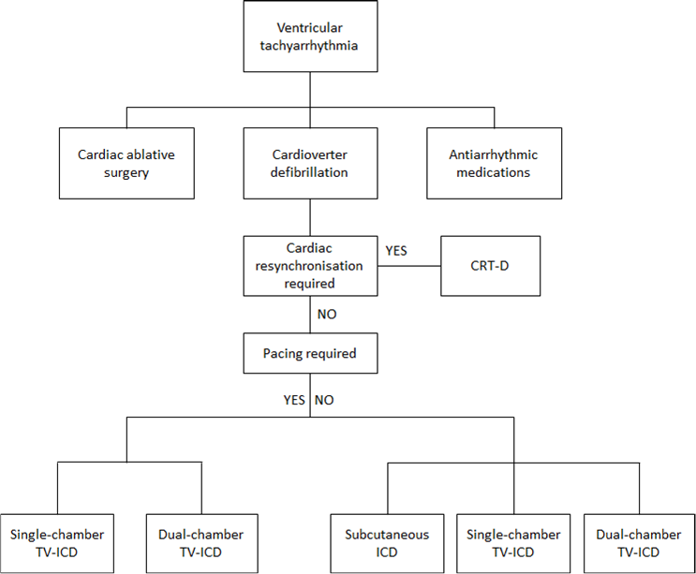

# Comparator

The proposed comparator for the subcutaneous ICD system is single and dual-chamber transvenous ICD in patients who do not have bradycardia pacing indications. ICD therapy is standard of care for patients at risk of SCD and is subject to a current MSAC Review. The proposed application will focus on establishing non-inferiority of subcutaneous ICD to transvenous ICD with respect to safety and effectiveness.

Subcutaneous ICD is proposed to be a direct substitute for transvenous ICD systems programmed for defibrillation only as the subcutaneous ICD is not suitable for patients with symptomatic bradycardia, incessant VT, or spontaneous, frequently recurring VT that is reliably terminated with anti-tachycardia pacing. The proportion of subcutaneous ICD systems that will be utilised in place of transvenous ICD systems will be provided in the submission based assessment.

A comparison of the physical characteristics and clinical capabilities of subcutaneous and transvenous ICD is provided in Table 9 below.

Table 9 Comparison of physical and clinical characteristics of subcutaneous and transvenous ICD devices

| **Device Characteristic** | **Subcutaneous ICD** | **Transvenous ICD**  **(based on typical single or dual chamber device)** |
| --- | --- | --- |
| **Physical**   * Size (HxWxD) * Mass * Volume * Positioning | * 78.2 × 65.5 × 15.7 mm * 145g * 69.9cc * Subcutaneous device and lead placement | * 61.7 x 6.90 x 9.9 mm* * 72g* * 30.5cc* * Subcutaneous device and transvenous lead placement |
| **Defibrillation capabilities**   * Rhythm discrimination * DFT testing energy * Delivered energy * Number of Shocks * Shock Zone * Sensing configuration * Polarity | * Yes; morphology template matching * 10-80 joules programmable * 80 joules; non programmable * 5 * Yes; programmable * Yes; manual and automatic * Selected based on history of successful shocks with ability to manually override. | * Yes; two available options – Onset and Stability & Morphology template matching*. * 1-37 joules; programmable* * 1-37 joules; programmable* * 5 to 8 * Yes; programmable * Yes; manual and automatic   Programmable; Initial or Reversed |
| **Pacing capabilities** | * Post-shock pacing; programmable ON or OFF only * No Antitachycardia pacing | * Post-shock pacing; programmable * Various device specific tachy and brady pacing capabilities |
| **Storing and analyzing data** | * Patient, hospital and treating physician details * Stores up to 24 treated and 20 untreated tachyarrythmia episodes (74 mins total) | * Patient, hospital and treating physician details * 17mins storage of event episodes* |
| **Communication** | * Wireless communication with programmer * No remote monitoring | * Wireless communication with programmer * Remote monitoring capability |
| **System Diagnostics**   * Shock electrode impedance * Device integrity check * Battery Performance * Internal warning system * Magnet Response | * Yes, weekly and post-shock delivery * Yes, daily and on connection with programmer * Ongoing battery status, Elective replacement indicator and end of life * Tone alerts patient if anything requires attention * Inhibits Tachy therapy | * Yes; manually, daily and post shock * Yes; manually, daily and post shock * Ongoing battery status, Elective replacement indicator and end of life * Tone alerts patient if anything requires attention * Off, Store EGM, Inhibit Therapy |

* Specifications for INCEPTA™ single-chamber ICD provided as an example

# Clinical claim

The application considers subcutaneous ICD is non-inferior to transvenous ICD and offers some important safety advantages because subcutaneous ICD does not require transvenous lead implantation. As such, it is proposed that Section D of the submission based assessment will take a cost-minimisation approach.

The submission based assessment will undertake a literature review to identify the best available clinical data for subcutaneous ICD and transvenous ICD.

# Outcomes and health care resources affected by introduction of proposed intervention

## Outcomes

The highest-quality clinical evidence available will be used to support the efficacy and safety of subcutaneous ICD. This will likely include data from both single arm trials (Bardy et al., 2010; Burke, 2012; Dabiri Abkenari et al., 2011; Olde Nordkamp et al., 2012; Weiss et al., 2013) and comparative studies (Gold et al., 2012; Kobe et al., 2013), as well as larger longer-term registry data (Boersma, 2012; Pedersen et al., 2012). Where available, the submission will report patient-relevant endpoints, such as all-cause mortality and SCD. Where such data are not reported, surrogate efficacy endpoints such as accurate ventricular arrhythmia detection and treatment will be presented. Studies of subcutaneous ICD are likely to be underpowered to detect differences between treatments in the rate of major clinical events. Therefore it is proposed that the assessment of non-inferiority is based on surrogate efficacy endpoints. The validity of these endpoints and the identification of appropriate non-inferiority margins will be key research questions in the submission. The submission will also present a detailed assessment of safety, including short term safety data from comparative studies and long term safety outcomes from single-arm trials. A list of relevant efficacy and safety endpoints is provided below.

Primary Efficacy Outcomes

* Sensitivity and Specificity of Induced Arrhythmia Detection
* Induced VF Conversion
* Spontaneous VF Detection and Conversion

Secondary Efficacy Outcomes

* All-cause mortality
* Sudden Cardiac Death

Safety Outcomes

* Peri-procedural Adverse Events
* Post-procedural Adverse Events
* Appropriate/Inappropriate Shocks
* Lead Failure
* Pneumothorax
* Major infection e.g. lead re-intervention, pneumothorax, cardiac perforation
* Minor infection i.e. only requiring antibiotics

## Health care resources

Patient identification costs

Subcutaneous ICD will provide physicians and patients with an alternative treatment option; the initial tests to establish if a patient is indicated for an ICD will remain unchanged. When deciding if a patient is suitable for subcutaneous ICD, physicians will need to ensure that patients with any need for pacing are excluded. Since pacing requirements are already taken into consideration by physicians when selecting and configuring a patient’s ICD, this will have no impact on the costs associated with patient identification.

Device and procedure costs

If MBS listing is recommended by MSAC, the applicant intends to seek a comparable price for subcutaneous ICD to a single chamber ICD device on the Prostheses List. Based on the clinical claim of non-inferiority (supported by clinical evidence presented in Section B of the submission) and the similarity in the procedure complexity and resources used, a cost-minimisation analysis is considered appropriate.

Since the reimbursement of subcutaneous ICD is unlikely to lead to any growth in the market for ICDs, the applicant considers subcutaneous ICD will be cost-neutral to the health system. It is more likely that the new service will be cost-saving as subcutaneous ICD is associated with a decreased need for fluoroscopic imaging, which is associated with its own MBS item fee and substantial infrastructure requirements. The duration and complexity of the procedure relative to the implantation of transvenous ICD will be evaluated in the SBA to determine an appropriate fee.

Subcutaneous ICD devices need replacing approximately every 5 years. Conventional transvenous ICD devices need replacing approximately every 5-8 years, and leads have a lifetime of approximately 10 years. The implications of any differences in battery-life on lifetime costs will be considered in the economic evaluation.

In terms of how the service is to be provided, the insertion of a subcutaneous ICD lead will need to be performed by a surgeon, cardiologist or electrophysiologist. The current listing for ICD lead insertion does not limit the insertion, removal, or replacement of the device to cardiologists. *The proposed listing is not expected to lead to any incremental training requirements. Manufacturers of subcutaneous ICD technology provide training to hospital staff.*

As stated in the MSAC Assessment Report 32, the average length of stay for implantation of an transvenous-ICD device in Australia is likely to be the same as for implantation of a standard cardiac pacemaker (National Hospital Cost Data Collection Cost Weights for AR-DRG Versions 5.1 [private] and 5.2 [public] 2008-09, AR-DRG F12Z estimate this to be 4.65 days in public hospitals and 3.9 days in private hospitals), except in cases where there are complications associated with implantation of the device. The length of stay for subcutaneous ICD lead and generator insertion is expected to be similar to insertion of transvenous ICD (Kobe, 2013).

The subcutaneous ICD System is designed to be implanted using anatomical landmarks only, with the pulse generator placed in the lateral thoracic region and the electrode placed in a subcutaneous sinus along the sternum. As the electrode and pulse generator are placed subcutaneously, there is no need for fluoroscopy or other medical imaging systems found in an electrophysiology laboratory. The patient is required to be admitted to hospital for access to a sterile environment, device programmer and resuscitation equipment. Similar to transvenous ICD insertion, an x-ray is often performed after implanting the subcutaneous ICD pulse generator and lead to confirm accurate placement.

Implantation of transvenous leads can be difficult for certain patients who have compromised or abnormal venous structures. In such cases, implanting physicians must firstly locate and access a suitable vein, then navigate through structures under fluoroscopy using a variety of single-use accessories with different shapes and sizes, until they can access the correct location where they wish to secure the lead. In contrast, there is less variability when tunnelling subcutaneously. While the time taken to make incisions, tunnel between them, draw the electrode through and close incisions may be similar to the time taken to perform a transvenous lead implant, the steps are predictable and require less equipment to perform the procedure. Comparing the insertion of transvenous and subcutaneous ICD leads is somewhat subjective, as the two procedures require a different set of skills to ensure appropriate lead placement to reduce over sensing, lead migration and local infection. The skill and time required for the implantation of subcutaneous ICD leads will be examined in the submission based assessment to determine an appropriate fee for the service.

A list of the resource items that will be considered in the cost-minimisation analysis is presented in Table 10.

Table 10 List of resources to be considered in the economic analysis

|  | **Provider of resource** | **Setting in which resource is provided** | **Proportion of patients receiving resource** | **Number of units of resource per relevant time horizon per patient receiving resource** | **Disaggregated unit cost** | | | | | |
| --- | --- | --- | --- | --- | --- | --- | --- | --- | --- | --- |
| **MBS** | **Safety nets\*** | **Other govt budget** | **Private health insurer** | **Patient** | **Total cost** |
| Resources provided to identify eligible population | | | | | | | | | | |
| No change |  |  |  |  |  |  |  |  |  |  |
|  |  |  |  |  |  |  |  |  |  |  |
| Resources provided to deliver proposed intervention | | | | | | | | | | |
| Insertion of generator | Surgeon/specialist | Private hospital | 100% | 1 | $287.85 |  |  |  |  |  |
| Acquisition of generator | Manufacturers | Private hospital | 100% | 1 |  |  |  | $42,640 |  |  |
| Insertion of leads | Surgeon/specialist | Private hospital | 100% | 1 | $TBD |  |  |  |  |  |
| Acquisition of leads | Manufacturers | Private hospital | 100% | 1 |  |  |  | $4,680 |  |  |
| Hospital stay / Operating rooms | Private hospital | Private hospital | 100% | 1 (65 days) | TBD |  |  |  |  |  |
| Anaesthetists | Private hospital | Private hospital | TBD | 1 | TBD |  |  |  |  |  |
| Imaging (fluoroscopy and X-ray) | Private hospital | Private hospital | TBD | 1 | TBD |  |  |  |  |  |
| Resources provided in association with proposed intervention | | | | | | | | | | |
| Optimal medical management | no change, not included |  |  |  |  |  |  |  |  |  |
| Resources provided to deliver main comparator | | | | | | | | | | |
| Insertion of generator | Surgeon/specialist | Private hospital | 100% | 1 | $287.85 |  |  |  |  |  |
| Acquisition of generator | Manufacturers | Private hospital | 100% | 1 |  |  |  | $42,640 (Billing Code BS208) |  |  |
| Insertion of leads | Surgeon/specialist | Private hospital | 100% | 1 | $1,052.6 |  |  |  |  |  |
| Acquisition of leads | Manufacturers | Private hospital | 100% | 1 |  |  |  | $4,680 (Billing Code MC251) |  |  |
| Hospital stay / Operating rooms | Private hospital | Private hospital | 100% | 1 (65 days) | TBD |  |  |  |  |  |
| Anaesthetists | Private hospital | Private hospital | TBD | 1 | TBD |  |  |  |  |  |
| Imaging (fluoroscopy and X-ray) | Private hospital | Private hospital | TBD | 1 | TBD |  |  |  |  |  |
| Resources provided in association with main comparator | | | | | | | | | | |
| Optimal medical management | no change, not included |  |  |  |  |  |  |  |  |  |

* Include costs relating to both the standard and extended safety net.

MBS: Medicare Benefits Schedule; ICD: implantable cardioverter defibrillator; RA: right atrial; RV: right ventricular; CRT-D: cardiac resynchronisation therapy device capable of defibrillation; LV: left ventricular.

Clinical advice has suggested that tests prior to subcutaneous ICD implantation are the same as those prior to transvenous ICD implant:

* Electrocardiogram and cardiac echocardiogram
* Possibly cardiac catheterisation, cardiac MRI, cardiac biopsy
* Patients with a cardiac device will require testing at least every 6 months
* In some cases testing may require echocardiographic optimisation of the ICD device

*Overall, resources for the population without a requirement for pacing and are eligible for subcutaneous ICD are expected to be similar to the patient population currently indicated for a transvenous ICD on the MBS. This will be assessed in the submission based assessment using a cost-minimisation analysis.*

# Proposed structure of economic evaluation

The clinical claim in this submission is likely to be non-inferiority compared to transvenous ICD in terms of clinical efficacy and safety. Therefore the most appropriate form of economic evaluation is a cost-minimisation analysis. A decision analytic economic evaluation is therefore not proposed for this assessment.

The PICO criteria for the cost-minimisation analysis are provided in Table 11.

Table 11 Summary of extended PICO to define research question that assessment will investigate

|  |  |  |  |  |
| --- | --- | --- | --- | --- |
| **Patients** | **Intervention** | **Comparator** | **Outcomes to be assessed** | **Healthcare resources to be considered** |
| Patients indicated for ICD for the treatment of life-threatening ventricular arrhythmia and who do not require pacing therapy i.e. do not have symptomatic bradycardia or ventricular tachycardia that is reliably terminated with anti-tachycardia pacing. | Subcutaneous ICD | Transvenous ICD | Primary Efficacy Outcomes  Sensitivity and Specificity of Induced Arrhythmia Detection  Induced VF Conversion  Spontaneous VF Detection and Conversion  Secondary Efficacy Outcomes  All-cause mortality  Sudden Cardiac Death  Safety Outcomes  Peri-procedural Adverse Events  Post-procedural Adverse Events  Appropriate/Inappropriate Shocks  Lead Failure  Pneumothorax  Major infection e.g. lead re-intervention, pneumothorax, cardiac perforation  Minor infection i.e. only requiring antibiotics | Insertion of generator  Acquisition of generator  Insertion of leads  Acquisition of leads  Hospital stay / Operating rooms  Anaesthetists  Imaging (fluoroscopy and X-ray)  Monitoring and follow up visits |

ICD: implantable cardioverter defibrillator

**Appendix A: Device Overview and Anatomical Landmarks for Lead Insertion**

The S-ICD® System includes the S-ICD® pulse generator, a subcutaneous electrode which requires an insertion tool for proper electrode placement and a programmer for device analysis and defibrillation testing. The S-ICD® System components are extremely similar to those of a single-chamber transvenous ICD system that includes a pulse generator, electrode, insertion tool, and programmer. 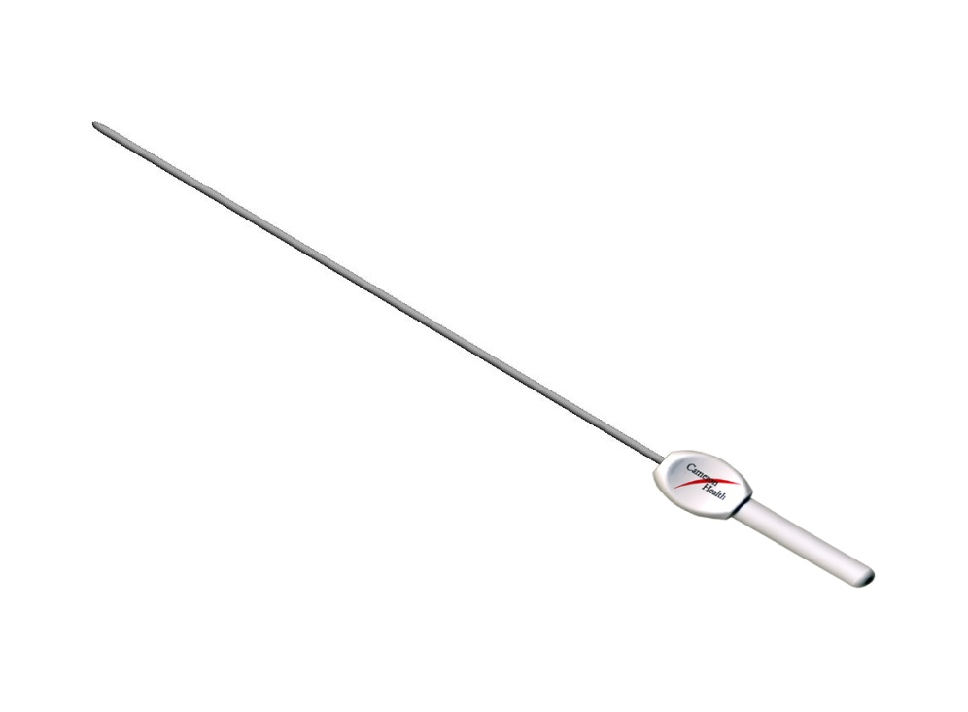

S-ICD Pulse Electrode Insertion Tool

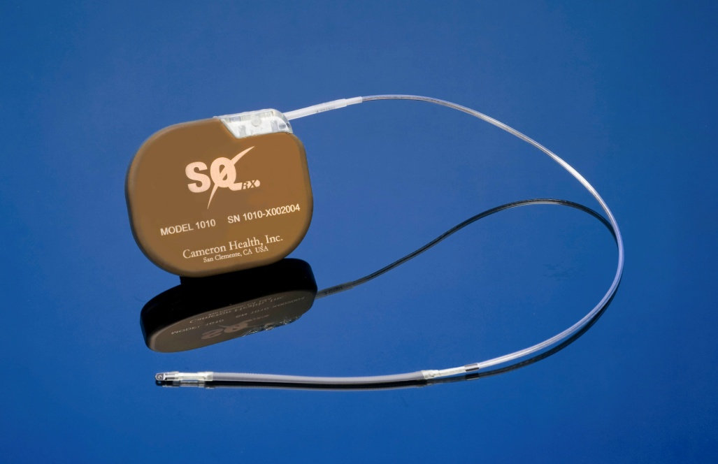

S-ICD Pulse Generator and Subcutaneous electrode

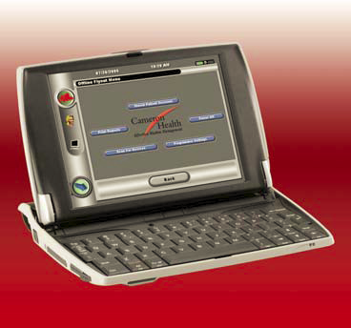

S-ICD Programmer

**Anatomical landmarks for lead insertion.**

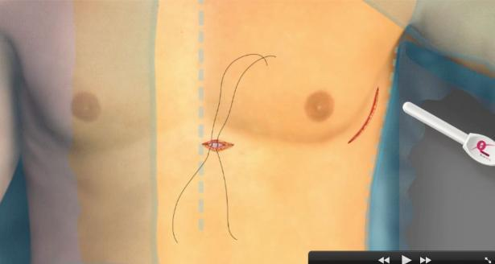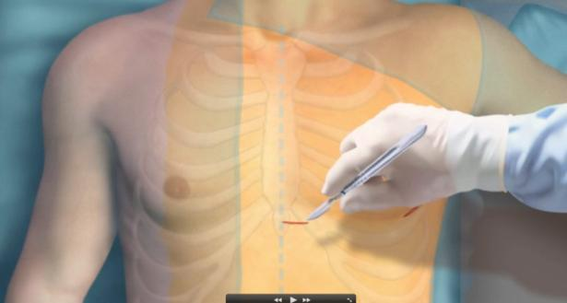

**Illustrative representation of**

**device and lead placement**

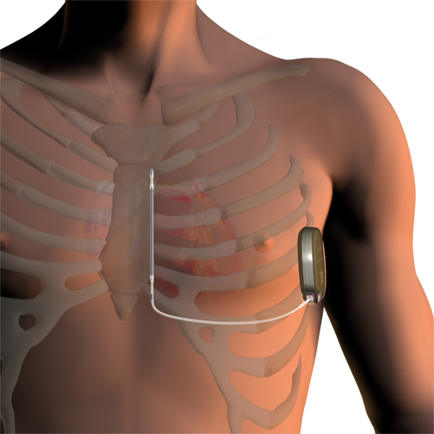 **Illustrative representation of device and lead placement**

**One month post operative**

**One month post operative**

# References

Ahmed, A. (2003). American College of Cardiology/American Heart Association Chronic Heart Failure Evaluation and Management guidelines: relevance to the geriatric practice. *J Am Geriatr Soc, 51*(1), 123-126.

Aydin, A., Hartel, F., Schluter, M., Butter, C., Kobe, J., Seifert, M., . . . Willems, S. (2012). Shock efficacy of subcutaneous implantable cardioverter-defibrillator for prevention of sudden cardiac death: initial multicenter experience. *Circ Arrhythm Electrophysiol, 5*(5), 913-919. doi: 10.1161/circep.112.973339

Bardy, G. H., Smith, W. M., Hood, M. A., Crozier, I. G., Melton, I. C., Jordaens, L., . . . Grace, A. A. (2010). An entirely subcutaneous implantable cardioverter-defibrillator. *N Engl J Med, 363*(1), 36-44. doi: 10.1056/NEJMoa0909545

Boersma, L. (2012). Long Term Outcome Of Patients Receiving The Subcutaneous ICD After Transvenous ICD Extraction.

Burke, M. C. (2012). Safety and Efficacy of a Subcutaneous Implantable Defibrillator (S-ICD). *Heart Rhythm Society Late Breaking Clinical Trials*.

Charles, R. D., & Gammage, M. D. (2007). Heart Rhythm Management Devices: Guidance for Commissioners. *National Heart Rhythm Management Device Taskforce*.

Cowie, M. R., & Zaphiriou, A. (2002). Management of chronic heart failure. *Bmj, 325*(7361), 422-425.

Dabiri Abkenari, L., Theuns, D. A., Valk, S. D., Van Belle, Y., de Groot, N. M., Haitsma, D., . . . Jordaens, L. (2011). Clinical experience with a novel subcutaneous implantable defibrillator system in a single center. *Clin Res Cardiol, 100*(9), 737-744. doi: 10.1007/s00392-011-0303-6

Dickstein, K., Vardas, P. E., Auricchio, A., Daubert, J. C., Linde, C., McMurray, J., . . . van Veldhuisen, D. J. (2010). 2010 Focused Update of ESC Guidelines on device therapy in heart failure: an update of the 2008 ESC Guidelines for the diagnosis and treatment of acute and chronic heart failure and the 2007 ESC Guidelines for cardiac and resynchronization therapy. Developed with the special contribution of the Heart Failure Association and the European Heart Rhythm Association. *Europace, 12*(11), 1526-1536. doi: 10.1093/europace/euq392

DiMarco, J. P. (2003). Implantable cardioverter-defibrillators. *N Engl J Med, 349*(19), 1836-1847. doi: 10.1056/NEJMra035432

Epstein, A. E., Dimarco, J. P., Ellenbogen, K. A., Estes, N. A., 3rd, Freedman, R. A., Gettes, L. S., . . . Sweeney, M. O. (2008). ACC/AHA/HRS 2008 guidelines for Device-Based Therapy of Cardiac Rhythm Abnormalities: executive summary. *Heart Rhythm, 5*(6), 934-955. doi: 10.1016/j.hrthm.2008.04.015

FDA. (2012). Device Approvals and Clearances: subcutaneous Implantable Defibrillator (S-ICD) - P110042.

Gold, M. R., Theuns, D. A., Knight, B. P., Sturdivant, J. L., Sanghera, R., Ellenbogen, K. A., . . . Burke, M. C. (2012). Head-to-head comparison of arrhythmia discrimination performance of subcutaneous and transvenous ICD arrhythmia detection algorithms: the START study. *J Cardiovasc Electrophysiol, 23*(4), 359-366. doi: 10.1111/j.1540-8167.2011.02199.x

Hare, J. M. (2002). Cardiac-resynchronization therapy for heart failure. *N Engl J Med, 346*(24), 1902-1905. doi: 10.1056/NEJMed020028

Huikuri, H. V., Castellanos, A., & Myerburg, R. J. (2001). Sudden death due to cardiac arrhythmias. *N Engl J Med, 345*(20), 1473-1482. doi: 10.1056/NEJMra000650

Kobe, J., Reinke, F., Meyer, C., Shin, D. I., Martens, E., Kaab, S., . . . Eckardt, L. (2013). Implantation and follow-up of totally subcutaneous versus conventional implantable cardioverter-defibrillators: a multicenter case-control study. *Heart Rhythm, 10*(1), 29-36. doi: 10.1016/j.hrthm.2012.09.126

Krum, H., Jelinek, M. V., Stewart, S., Sindone, A., & Atherton, J. J. (2011). 2011 update to National Heart Foundation of Australia and Cardiac Society of Australia and New Zealand Guidelines for the prevention, detection and management of chronic heart failure in Australia, 2006. *Med J Aust, 194*(8), 405-409.

Lobodzinski, S. S. (2011). Subcutaneous implantable cardioverter-defibrillator (S-ICD). *Cardiol J, 18*(3), 326-331.

Lopshire, J. C., & Zipes, D. P. (2006). Sudden cardiac death: better understanding of risks, mechanisms, and treatment. *Circulation, 114*(11), 1134-1136. doi: 10.1161/circulationaha.106.647933

MSAC. (2006). “Implantable cardiac defibrillators for prevention of sudden cardiac death, Reference 32”.

Myerburg, R. J., Interian, A., Jr., Mitrani, R. M., Kessler, K. M., & Castellanos, A. (1997). Frequency of sudden cardiac death and profiles of risk. *Am J Cardiol, 80*(5b), 10f-19f.

Olde Nordkamp, L. R., Dabiri Abkenari, L., Boersma, L. V., Maass, A. H., de Groot, J. R., van Oostrom, A. J., . . . Knops, R. E. (2012). The entirely subcutaneous implantable cardioverter-defibrillator: initial clinical experience in a large Dutch cohort. *J Am Coll Cardiol, 60*(19), 1933-1939. doi: 10.1016/j.jacc.2012.06.053

Packer, M. (1992). Lack of relation between ventricular arrhythmias and sudden death in patients with chronic heart failure. *Circulation, 85*(1 Suppl), I50-56.

Pedersen, S. S., Lambiase, P., Boersma, L. V., Murgatroyd, F., Johansen, J. B., Reeve, H., . . . Theuns, D. A. (2012). Evaluation oF FactORs ImpacTing CLinical Outcome and Cost EffectiveneSS of the S-ICD: design and rationale of the EFFORTLESS S-ICD Registry. *Pacing Clin Electrophysiol, 35*(5), 574-579. doi: 10.1111/j.1540-8159.2012.03337.x

Weiss, R., Knight, B. P., Gold, M. R., Leon, A. R., Herre, J. M., Hood, M., . . . Burke, M. C. (2013). Safety and efficacy of a totally subcutaneous implantable-cardioverter defibrillator. *Circulation, 128*(9), 944-953. doi: 10.1161/circulationaha.113.003042

Zipes, D. P., Camm, A. J., Borggrefe, M., Buxton, A. E., Chaitman, B., Fromer, M., . . . Zamorano, J. L. (2006). ACC/AHA/ESC 2006 guidelines for management of patients with ventricular arrhythmias and the prevention of sudden cardiac death: a report of the American College of Cardiology/American Heart Association Task Force and the European Society of Cardiology Committee for Practice Guidelines (Writing Committee to Develop Guidelines for Management of Patients With Ventricular Arrhythmias and the Prevention of Sudden Cardiac Death). *J Am Coll Cardiol, 48*(5), e247-346. doi: 10.1016/j.jacc.2006.07.010

Zipes, D. P., & Wellens, H. J. (1998). Sudden cardiac death. *Circulation, 98*(21), 2334-2351.

1. The terms electrode and lead are used interchangeably within this document
2. Primary Prevention refers to patients who have not had a cardiac arrest or sustained ventricular tachycardia
3. Secondary Prevention refers to intervention patients who have survived a prior cardiac arrest or sustained ventricular tachycardia