

**Public Summary Document**

***Application*** 1351 – Point of care tests to exclude pre-term labour: Quantitative Fetal Fibronectin (fFN) testing for predicting

pre-term labour

**Applicant: Hologic Australia Pty Ltd**

**Date of MSAC consideration: MSAC 62nd Meeting, 26-28 November 2014**

Context for decision: MSAC makes its advice in accordance with its Terms of Reference, see at [www.msac.gov.au](http://www.msac.gov.au/)

# Purpose of application and links to other applications

An application requesting the Medicare Benefits Schedule (MBS) listing of fetal fibronectin (fFn) tests for excluding false preterm labour was received from Hologic Australia Pty Ltd by the Department of Health in July 2013. The applicant proposed one MBS item descriptor and fee that could be used for either the quantitative version of the fFN test or the qualitative version of the fFN test.

A related application proposing MBS listing of the Phosphorylated Insulin-like Growth Factor Binding Protein (phIGFBP-1) test for excluding false preterm labour was received from Alere Pty Ltd (Inverness Medical Innovations Australia) (Application Number 1335) and considered by MSAC at the same meeting.

# MSAC’s advice to the Minister

After considering the available evidence in relation to safety, clinical effectiveness and cost-effectiveness of quantitative fFN testing for predicting pre-term labour, MSAC did not support public funding because of inadequate test performance and thus unacceptable overall clinical effectiveness and cost-effectiveness.

MSAC noted that the evidence demonstrated poor and variable accuracy of the test, no verification of additive value over existing methods of assessing the risk of pre-term labour, but also evidence that use of the test would not change current clinical practice.

# Summary of consideration and rationale for MSAC’s advice

MSAC noted the application requested MBS listing of point of care testing of fFN in cervicovaginal secretions of women presenting with symptoms of early labour for the purposes of excluding pre-term labour. Two presentations of the test were proposed: a dipstick qualitative test and an optical reader quantitative test.

The fFN test can be used to distinguish between false labour and true labour in women threatening pre-term labour. fFN is typically absent from cervicovaginal secretions between 24 and 36 weeks gestation, becoming detectable as full term approaches. Elevated levels of fFN between 24 and 36 weeks are associated with increased risk of pre-term labour. Identification of false labour can reduce the unnecessary use of therapies to delay premature labour (tocolytics) and to promote fetal lung development (corticosteroids), both of which have potential side effects. It can also reduce unnecessary referral to a tertiary level hospital with adequate neonatal care. MSAC noted that this was particularly important for women in rural and remote communities where hospital admission may mean considerable travel away from family.

MSAC noted the overlap between this application and Application 1335 for phosphorylated insulin-like growth factor binding protein (phIGFBP-1) testing for predicting pre-term labour. Therefore, both applications were considered simultaneously.

The proposed item descriptor requested MBS funding for pregnant women where gestation is greater than 24 weeks and less than 36 weeks who present with symptoms of threatened pre-term labour and are found to have intact amniotic membranes on sterile speculum examination of the cervix.

MSAC noted that the main comparator for this intervention was routine clinical care with or without transvaginal ultrasound for cervical length (TVCL). A second comparison between fFN and phIGFBP-1 was also considered.

MSAC noted that there were significant concerns with the appropriateness of studies that were included in the assessment in particular differences in patient population and the inclusion of women up to 37 weeks gestation and with multiple pregnancies.

There were no studies identified that investigated the safety of the fFN test in the diagnosis of pre-term labour. The test itself is considered safe so long as it is performed by a qualified health professional using a sterile speculum with a sterile swab after premature rupture of the amniotic membranes has been excluded.

MSAC considered the analytical validity of the fFN test, using pre-term delivery within seven days as the reference standard. The evidence presented suggested that the rate of false negatives is unacceptably high for its intended use as a triage test. A false negative, where a woman is incorrectly excluded from being at risk of pre-term labour, can have serious consequences. Across twelve studies of the qualitative version of the test, sensitivity values ranged between 0.33 and 0.95, with an overall sensitivity = 0.77; 95%CI: 0.69, 0.83 and specificity = 0.82; 95%CI: 0.81, 0.84. In two single studies of the quantitative version of the test, sensitivity and specificity values both ranged between 0.42 and 0.96 depending on the threshold set for the test between ≥10 ng/mL and ≥500 ng/mL, with increasing sensitivity associated with decreasing specificity. Although these results suggest the test performs better than chance, there remains unexplained clinically important heterogeneity in this test performance, which was likely to be affected by the low event rate of pre-term delivery, and clinically important rates of false negatives. Overall, MSAC concluded that these sensitivity results were not sufficient to achieve a reasonable threshold for concluding test negative results are clinically reliable. In other words, relying on the results from this test is likely to lead to an increased risk of harm compared with not relying on the test and managing threatened pre-term labour conservatively , because of the appreciable number of women with pre-term delivery classified as ‘false pre-term labour’ by the test.

MSAC noted that the comparative results were not provided from the three studies identified which directly comparing the analytical validity of fFN with phIGFBP-1. However, the results of the seven presented studies for phIGFBP-1 (overall sensitivity = 0.79; 95%CI: 0.71, 0.86 and specificity = 0.86; 95%CI: 0.83, 0.88, again using pre-term delivery within seven days as the reference standard) provided no basis to conclude that one test performs better or worse than the other.

No data were presented that compare the analytical validity of fFN with current clinical assessment without TVCL, which is more relevant to the wider range of clinical settings proposed for its use. Comparisons with TVCL were less relevant because this technology is less likely to be available in these settings. There were also no data presented to examine the extent to which adding fFN to clinical assessment might modify analytical validity, rather than assessing the fFN test result in isolation. It is probable that this test may improve accuracy compared with current clinical assessment, but with insufficient sensitivity to achieve acceptable thresholds to avoid misclassifying women and causing harm compared to a more risk-averse approach to clinical management.

MSAC considered the evidence presented for clinical effectiveness of the fFN test as measured by the extent to which the test improves patient outcomes or leads to a change in patient management. Data meta-analysed from six small randomised trials (total N=530) comparing management with and without fFN test results showed no significant differences in the:

* rates of admission to hospital (rate difference = 4% more admissions with fFN results known; 95%CI: 11% more admissions to 4% less admissions);
* use of tocolytics (rate difference = 2% fewer patients treated with fFN results known; 95%CI: 11% fewer patients treated to 7% more patients treated; N=192); or
* use of steroids (rate difference = 3% fewer patients treated with fFN results known; 95%CI: 13% fewer patients treated to 8% more patients treated; N=289).

MSAC considered that a possible explanation for the lack of any effect on hospitalisations might be explained by having many inputs to the clinical management decision in this situation, and the net information gain from adding a point of care test result therefore being relatively small. Given the lack of any demonstrated effect on clinical management, MSAC concluded that the test might improve patient outcomes.

The economic evaluation was modelled on a cost-minimisation to the phIGFBP-1 point of care test and to standard care with or without TVCL. This was performed using sensitivity and specificity values of each of the tests and using prevalence values to model the movement of women into true positive, false positive, true negative and false negative categories based on test performance. However, MSAC accepted advice from its ESC that this model may not be reasonable as there was little data available to inform the model’s assumptions. In particular, MSAC considered that the model was inconsistent with trial data regarding the consequences of testing on clinical management.

Based on the estimated proportions of women receiving fFN tests, the estimated cost to the MBS for one test per pregnancy in 2014 would be $2.93 million increasing to $2.99 million by 2018. However, there is uncertainty surrounding the extent of utilisation that may occur outside the target population (that is, in women at less than 24 or more than 34 weeks gestation) or amongst women at high risk of pre-term labour.

# Background

An application for listing of an earlier form of the fFN test was assessed by MSAC in November 2006. MSAC determined that the test is safe but that effectiveness had not been demonstrated and did not support public funding.

A separate application for another test for excluding preterm labour, the phIGFBP 1 test, was under consideration by MSAC at the same time as this application.

# Prerequisites to implementation of any funding advice

The application was for two fFN tests; a qualitative system and a quantitative system. These tests do not have individual listings and are included on the Therapeutic Goods Administration database as other therapeutic goods.

ESC suggested that the proposed items be restricted to practitioners trained in aseptic speculum techniques.

# Proposal for public funding

fFN is a glycoprotein promoting adhesion between the fetal chorion and maternal decidua. fFN is typically absent from cervicovaginal secretions between 24 and 36 weeks gestation, becoming detectable again as full term approaches. Elevated levels of fFN above 50 ng/mL in cervicovaginal secretions between 24 and 36 weeks gestation are associated with an increased risk of pre-term birth (Abbott et al, 2012).   
  
The fFN test is a two-step procedure. The first step requires obtaining a cervicovaginal sample from a patient during standard speculum examination. The second involves processing the sample to detect and quantify the level of fFN present in the sample. fFN quantification allows precise assessment of the patient’s risk of pre-term labour.

Most women who present with signs and symptoms of preterm delivery go on to deliver at term; however, a minority will experience preterm labour. Preterm birth is regarded as delivery of an infant before 37 weeks gestation. In 2010, preterm birth made up 8.3% of all deliveries in Australia, with 45% of these births occurring at or before Week 34 (AIHW, 2012). Infants born at 34 weeks or earlier often have life-threatening medical conditions. To prevent and delay preterm birth, many women in suspected preterm labour are hospitalised and treated, while others are advised bed rest at home for significant proportions of their pregnancy.

PASC recommended access to the intervention for pregnant women, between 24 and 33 weeks and 6 days gestation who present with the symptoms of threatened preterm labour and are found to have intact amniotic membranes on sterile speculum examination of the cervix.

The SBA proposed MBS descriptor is for pregnant women between 24 to 36 weeks gestation.

Proposed MBS item descriptor for fFN tests in women with threatened preterm labour

| Category 2 – Diagnostic Procedures and Investigations |
| --- |
| **MBS [item number]**  Preterm testing of a cervical secretion specimen, using a **fetal fibronectin** point-of-care test, in symptomatic women, for the assessment of threatened preterm labour where gestation is greater than 24 weeks and less than **36** weeks gestation and preterm rupture of membranes (PROM) has been excluded to a maximum of two services per pregnancy where the first test yields a negative result.  Fee: $104.00 Benefit 75%= $78.00 85%=$88.40 |

Abbreviations: MBS= Medicare Benefits Schedule

Source: Adapted from Decision Analytic Protocol (DAP) (2013)

ESC noted that the quantitative and qualitative tests were proposed to be alternative options at the same fee under this single item descriptor.

The SBA proposed that physicians, participating nurse practitioners or participating midwives, who are trained in sterile speculum examination, will perform the fFN tests. No additional specialised training or qualifications are required by these practitioners to perform this test.

The SBA also indicated that the fFN test can also be performed by all levels of healthcare providers but that some minimal training is required.

# Summary of Public Consultation Feedback/Consumer Issues

Consumers noted that use of the test could inform patients’ risk management decisions, particularly in remote communities/situations where people need to make significant arrangements/travel long distances to be admitted to an appropriate care facility.

It was noted the cost is already being met by the consumer (state budgets) and that some consumers might choose to pay a fee for this service to reassure them in certain circumstances, even when the service is not publicly funded.

# Proposed intervention’s place in clinical management

It was proposed that the fetal fibronectin test can be used by physicians to distinguish between: false labour where there may be contractions and other signs of labour but the women does not deliver in the next 7 days; and true labour where the women gives birth in the next 7 days.

Below is the proposed clinical management algorithm with a fFN test reimbursed on the MBS.

Figure 2: Proposed clinical management algorithm with a fFN test  reimbursed on MBS

# Comparator

The SBA nominated standard care with or without transvaginal ultrasound for cervical length (TVCL), dependent on clinical setting as the main comparator. TVCL can be conducted via three methods: transvaginal (TVU), transabdominal (TA), and transperineal (TP).

**Nominated comparator for the fFN test dependent on hospital setting**

| **Hospital setting** | **Comparator** | **Justification** |
| --- | --- | --- |
| Rural | Standard care (-TVCL) | TVCL not usually available |
| Metropolitan public hospital | Standard care (-TVCL) | TVCL usually conducted after admission, whereas fFN test conducted prior to admission |
| Metropolitan private hospital | Standard care (+TVCL) | TVCL is often used a part of the clinical decision making process |

PASC also anticipated a comparison across phIGFBP-1 and fFn as well as a comparison between the proposed test and current management without it (with or without TVUS).

# Comparative safety

The evaluation noted that potential risks to patients are expected to be minimal, because the cervicovaginal sample required for fetal fibronectin testing is obtained with a swab as part of a standard speculum examination. However, the consequences of minimal treatment of women who test negative, but deliver pre-term (false negatives) should be considered.

# Comparative effectiveness

**Diagnostic Accuracy**

The SBA included fourteen fFN studies (total number of subjects, N=3,213), four phIGFBP-1 studies (N=365), and one study with both fFN and phIGFBP-1 tests (N=94). Across the fifteen studies that included a fFN test, only one was confirmed as using the current version of the qualitative test (Diaz 2009), and only one was confirmed as using the current quantitative version of test (Abbott 2013). Of the remaining thirteen studies, seven studies used older versions of the fFN tests, six studies did not specify which version of the fFN test was used and ten of the fFN studies included in the SBA were non-comparative.

The Critique noted concerns with the particular studies included and excluded from the evidence base. The SBA included fFN studies that recruited women outside the target population defined by the DAP: one study included women with gestation age from 22 weeks, and seven studies included women up to 35, 36 or 37 weeks of gestation. The SBA excluded a number of studies that recruited women with either singleton or multiple child pregnancies, but included one with a ‘mixed’ population (Singer 2007).

Data from the identified studies was used in a meta-analysis. The outcomes of the meta-analysis included the proportion of true positive (TP), true negative (TN), false positive (FP) and false negative (FN) results, which informed the sensitivity, specificity and summary receiver operating curves (SROCs) for each test. Patient outcomes included delivery within 7 and 14 days of testing, and delivery before 34 weeks gestation.

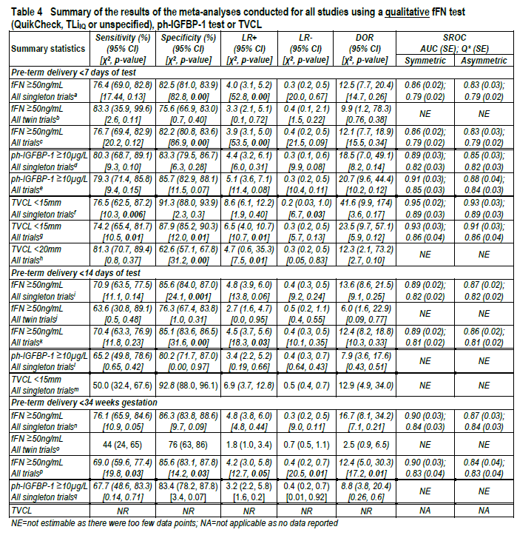

The table summarises the sensitivity, specificity, positive and negative likelihood ratios, diagnostic odds ratio and the area under the curve (AUC) and Q statistic estimated from the

SROC curves. The values reported for fFN, ph-IGFBP1- and TVCL were all fairly consistent and high in terms of the sensitivity and specificity of the tests, with the exception of fFN testing amongst women carrying twins to predict pre-term birth at <34 weeks gestation, but that was based on a relatively small sample size.

**Patient Management**

The SBA summarised patient management reported in six studies selected for inclusion for the assessment of diagnostic accuracy. However, the Critique noted the potential exclusion of additional relevant studies of patient management, and listed seven randomised controlled trials (RCTs) (identified during the evaluation) that compared ‘knowledge of fFN status’ versus ‘standard management’. Relevant results from six of these RCTs are shown in the

table 5 below.

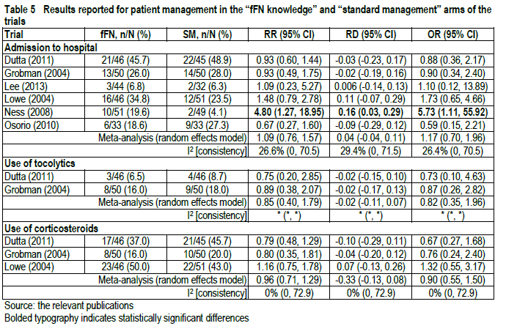

Whilst the results reported in the diagnostic accuracy studies included in the SBA indicated some changes to patient management, the RCTs identified by the Critique (which specifically assessed changes to patient management with or without the knowledge of the results of the fFN test) indicate that the results of the test do not significantly change patient management, despite the majority of patients having tested negative for fFN in the fFN arm. This suggests that knowledge of fFN status did not alter patient management.

# Economic evaluation

The SBA presented a cost-minimisation analysis, comparing fFN at various thresholds with ph-IGFBP-1 and with standard care (SC) rendered with or without TVCL. The sensitivity and specificity values for each of the tests are applied to the prevalence estimate for symptomatic women to move women into the TP, FN, FP and TN health states. The sensitivity and specificity for the tests was assumed equivalent in the analyses for 24-34 and 24-36 weeks, with the only difference being the prevalence estimate.

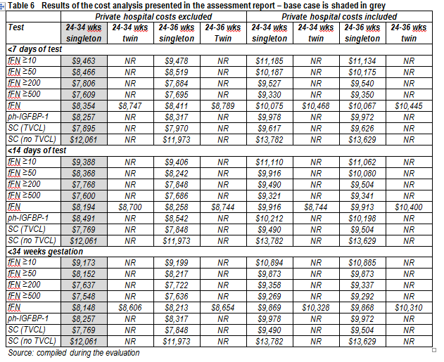

Where no actual data regarding the sensitivity or specificity of that strategy and a sensitivity of 1 and specificity of 0 have been assumed, only true and false positives are assumed to have been identified. This results in all women being admitted for symptoms of pre-term labour, which may not be reasonable.

# Financial/budgetary impacts

The estimated proportions of women receiving fFN tests and the applied unit costs appear reasonable. The key area of uncertainty noted in the Critique was the extent of utilisation that might occur outside the target population (ie, in women <24 or >34 weeks gestation) or amongst women at high risk of preterm delivery. This issue was addressed in the applicant’s pre-ESC response.

**Table 7 Estimated eligible population of patients and cost to the MBS**

| Description | | Method | 2014 | 2015 | 2016 | 2017 | 2018 |
| --- | --- | --- | --- | --- | --- | --- | --- |
| Australian population estimates | | | | | | | |
| A | Total births | AIHW, linear extrapolation | 301,537 | 303,014 | 304,491 | 305,969 | 307,446 |
| B | Singleton | A × *96.9%* | *292,189* | *293,621* | *295,052* | *296,484* | *297,915* |
| C | Multiple | A × *3.1%* | *9,348* | *9,393* | *9,439* | *9,485* | *9,531* |
| D | Total symptomatic patients who will be tested | E+F | *28,194* | *28,332* | *28,470* | *28,608* | *28,746* |
| E | Singleton | B × 6.45% | *18,846* | *18,939* | *19,031* | *19,123* | *19,216* |
| F | Multiple | C × 100% | *9,348* | *9,393* | *9,439* | *9,485* | *9,531* |
| G | Cost to MBS (one test/patient) | D × $104.00 | *$2,932,161* | *$2,946,524* | *$2,960,886* | *$2,975,258* | *$2,989,621* |

The estimated extent of financial implications did not extend to an analysis of patient out of pocket costs. These could be significant for women living in rural or remote areas, and many women living in such areas might have a high willingness-to-pay for a fFN test if it reassures them regarding a decision to avoid preterm hospital admission.

# 14. Key issues from ESC for MSAC

ESC noted that the submission diverged from the final protocol by nominating a broader population which would extend eligibility to 36 weeks gestation. No evidence was identified to justify the expanded population.

ESC suggested that, given the relative performance of the test compared with transvaginal ultrasound, MSAC may wish to consider whether eligibility should be restricted to situations where assessment by transvaginal ultrasound is either equivocal or not possible.

ESC noted that there was no reported adverse event evidence. ESC also noted that no evidence was provided to enable consideration of the side effects of steroids on a baby in the event that pre-term labour was incorrectly diagnosed, although it was acknowledged that this already occurs in current clinical practice if women are incorrectly diagnosed.

ESC advised that MSAC consider limiting any MBS listing for only one test for each episode of threatened preterm labour regardless of the type of test (ie, a phIGFBP test or a quantitative fFN or a qualitative fFN test) can be claimed. To achieve this, MSAC may wish to consider defining ‘an episode’ or alternatively specifying a timeframe (eg 2-3 days) during which multiple claiming cannot occur. ESC advised that each episode of threatened preterm labour could be managed as an independent event, rather than attempting to limit the number of tests per pregnancy.

ESC noted that no information had been provided on the relative value and risks of false positive and/or false negative results. In particular, ESC was concerned at the risk that a mother in pre-term labour to be sent home inappropriately based on false negative result.

ESC noted that the sensitivity and specificity of pathology tests to exclude pre-term labour is considerably less than 100%. This is expected to be a pivotal issue for MSAC consideration; particularly given the pervasive access to ultrasound in hospitals or by transfer to hospital from the outpatient setting. In the SBA, the applicant discusses a number of studies that suggest the sensitivity and specificity of fFN testing and TVCL.

ESC noted that whilst the SBA discussed whether TVCL improves the diagnoses of preterm labour in symptomatic women when fFN testing is available, the SBA did not address the questions of whether fFN testing improves the diagnosis of preterm labour in symptomatic women when TVCL is available. Indeed, the discussion in the SBA suggests that the tests can be considered to be interchangeable.

ESC noted a lack of clarity regarding the clinical setting of the service. In particular, ESC questioned whether it would be appropriate to deliver the service from a general practice, or a patient’s home by a trained midwife, compared with transfer to hospital. ESC noted there may be particular benefits to consumers who would otherwise have to travel long distances to be assessed at a hospital.

ESC noted that the main driver of the economic model is a presumed change in patient management based on fFN test results (ie, TN, FN, TP, FP), even though seven RCTs excluded from the SBA reported no statistically significant differences in patient management for settings where fFN was available. In its pre-ESC response, the applicant disagreed with this interpretation of the evidence and discusses issues with generalizability of the seven RCTs. The pre-ESC response provided further detail from an Australian study by Giles (2000) and a New Zealand study by Groom (2006), which the applicant claimed are consistent with changed patient management with the use of fFN testing.

ESC noted that concerns regarding modelling based on expert opinion affected the estimated overall financial impact. The level of risk associated with an incorrect decision would mean that practitioners would continue to err on the side of caution, and it is conceivable and potentially appropriate that treating practitioners will suggest transfer to hospital and precautionary use of steroids irrespective of the test result. If providers did not change behaviour based on the test result, hospitalisation would not be avoided.

The listing of the item on the MBS is not straightforward, as the test is a pathology service, but is neither sent to a laboratory nor performed by a pathologist. Given the types of services listed in Category 2 of the MBS, ESC did not consider the test to be diagnostic procedures. ESC noted that point-of-care tests in other therapeutic settings are the subject of other current MSAC applications, and decisions regarding the positioning of other PoC tests on the MBS might act as precedents for the current application.

ESC advised that, if the phIGFBP-1 and fFN tests are both supported and found to be clinically equivalent, they should be listed with the same MBS fee.

# Other significant factors

Nil.

# Applicant’s comments on MSAC’s Public Summary Document

Hologic disagrees with MSAC’s assessment of quantitative Fetal Fibronectin (fFN) testing for predicting pre-term labour. Hologic believes the fFN test does provide clinical utility when used as an adjunct to informed clinical decision making, and this is supported by an extensive body of evidence, the vast majority of which was not considered within the current assessment framework; and through the adoption of fFN testing in several current clinical guidelines in Australia. Hologic remains committed to ensuring clinicians have access to the fFN test to ensure limited resources are used appropriately and women and babies are not exposed to potentially harmful treatments.

# Further information on MSAC

MSAC Terms of Reference and other information are available on the MSAC Website at: [www.msac.gov.au](http://www.msac.gov.au/).