MSAC Application 1672

Transcatheter insertion of a leadless pacemaker
This application form is to be completed for new and amended requests for public funding (including but not limited to the Medicare Benefits Schedule (MBS)). It describes the detailed information that the Australian Government Department of Health requires to determine whether a proposed medical service is suitable.
Please use this template, along with the associated Application Form Guidelines to prepare your application. Please complete all questions that are applicable to the proposed service, providing relevant information only. Applications not completed in full will not be accepted.
Should you require any further assistance, departmental staff are available through the Health Technology Assessment Team (HTA Team) on the contact numbers and email below to discuss the application form, or any other component of the Medical Services Advisory Committee process.

Email: hta@health.gov.au
Website: www.msac.gov.au

PART 1 – APPLICANT DETAILS

Applicant details (primary and alternative contacts)
Corporation / partnership details (where relevant): Not applicable (N/A)
Corporation name: Medtronic Australasia Pty Ltd
ABN: 47 001 162 661
Business trading name: Medtronic Australasia Pty Ltd

Primary contact name: REDACTED
Primary contact numbers
Business: Medtronic Australasia
Mobile: REDACTED
Email: REDACTED

Alternative contact name: REDACTED
Alternative contact numbers
Business: REDACTED
Mobile: REDACTED
Email: REDACTED

(a) Are you a lobbyist acting on behalf of an Applicant?
Yes
No

If yes, are you listed on the Register of Lobbyists?
Yes
No

PART 2 – INFORMATION ABOUT THE PROPOSED MEDICAL SERVICE

Application title
Transcatheter insertion of a leadless pacemaker (LPM).

Provide a succinct description of the medical condition relevant to the proposed service (no more than 150 words – further information will be requested at Part F of the Application Form)
Bradycardia is defined as abnormally slow heart rhythm, as a consequence of the disturbance of the generation or conduction of cardiac electrical activity. Permanent pacing works by preventing the heart from beating slower than a predefined rate, by delivering an electrical stimulus to the myocardium when required.
Conventional single-chamber pacemakers have a long history of use and have essentially remained unchanged over time with reliance on a pulse generator which sits in a subcutaneous pocket (created at time of insertion), and a connecting transvenous lead system. Single-chamber ventricular pacemakers are typically used for those with chronic atrial fibrillation (AF) with atrioventricular (AV) block and persistent bradycardia or patients with sinus node dysfunction (SND) with bradycardia.

Provide a succinct description of the proposed medical service (no more than 150 words – further information will be requested at Part 6 of the Application Form)
The Micra Transcatheter Pacing System (TPS) is a single-chamber implantable transcatheter pacemaker inserted via the femoral vein and implanted directly into the right ventricular myocardium negating the need for transvenous wires. It is the only LPM currently available in Australia. All patients eligible for conventional single-chamber VVI pacemakers would be suitable for consideration of implantation with a LPM.
Due to the absence of leads and necessity of a subcutaneous pocket, the advantages of leadless pacing compared to conventional single-chamber pacing are based on eliminating lead and pocket complications therefore presenting advantages from a safety perspective. Other possible advantages include patient satisfaction due the absence of a scar and subcutaneous device location.

(a) Is this a request for MBS funding?
Yes
No

If yes, is the medical service(s) proposed to be covered under an existing MBS item number(s) or is a new MBS item(s) being sought altogether?
Amendment to existing MBS item(s)
New MBS item(s)

If an amendment to an existing item(s) is being sought, please list the relevant MBS item number(s) that are to be amended to include the proposed medical service:
N/A

If an amendment to an existing item(s) is being sought, what is the nature of the amendment(s)?
N/A

If a new item(s) is being requested, what is the nature of the change to the MBS being sought?
- A new item which also seeks to allow access to the MBS for a specific health practitioner group
- A new item that is proposing a way of clinically delivering a service that is new to the MBS (in terms of new technology and / or population)
- A new item for a specific single consultation item
- A new item for a global consultation item(s)

Is the proposed service seeking public funding other than the MBS?
Yes
No

If yes, please advise:
N/A

What is the type of service:
Therapeutic medical service
Investigative medical service
Single consultation medical service
Global consultation medical service
Allied health service
Co-dependent technology
Hybrid health technology

For investigative services, advise the specific purpose of performing the service (which could be one or more of the following):
N/A

Does your service rely on another medical product to achieve or to enhance its intended effect?
Pharmaceutical / Biological
Prosthesis or device
No

(a) If the proposed service has a pharmaceutical component to it, is it already covered under an existing Pharmaceutical Benefits Scheme (PBS) listing?
N/A

If yes, please list the relevant PBS item code(s):
N/A

If no, is an application (submission) in the process of being considered by the Pharmaceutical Benefits Advisory Committee (PBAC)?
N/A

If you are seeking both MBS and PBS listing, what is the trade name and generic name of the pharmaceutical?
Trade name: N/A
Generic name: N/A

(a) If the proposed service is dependent on the use of a prosthesis, is it already included on the Prostheses List?
Yes
No

If yes, please provide the following information (where relevant):
Billing code(s): N/A
Trade name of prostheses: N/A
Clinical name of prostheses: N/A
Other device components delivered as part of the service: N/A

If no, is an application in the process of being considered by a Clinical Advisory Group or the Prostheses List Advisory Committee (PLAC)?
Yes
No

Medtronic intends to submit an application in early 2022 for inclusion on the Prostheses List

Are there any other sponsor(s) and / or manufacturer(s) that have a similar prosthesis or device component in the Australian market place which this application is relevant to?
Yes
No

If yes, please provide the name(s) of the sponsor(s) and / or manufacturer(s):
Note that the St Jude’s (now Abbott) Medical Nanostim leadless pacemaker was recalled from the Australian market by the TGA in 2016 due to battery malfunction specific to the device, hence is no longer marketed in Australia. Other leadless pacemakers are in earlier stages of development and are expected to be several years away from readiness for market entry.

Please identify any single and / or multi-use consumables delivered as part of the service?
Single use consumables: Micra introducer (MI2355A)
Multi-use consumables: N/A

PART 3 – INFORMATION ABOUT REGULATORY REQUIREMENTS

(a) If the proposed medical service involves the use of a medical device, in-vitro diagnostic test, pharmaceutical product, radioactive tracer or any other type of therapeutic good, please provide the following details:
Type of therapeutic good: Micra single chamber transcatheter pacing system - Intracardiac pacemaker
Manufacturer’s name: Medtronic Inc
Sponsor’s name: Medtronic Australasia Pty Ltd

Is the medical device classified by the TGA as either a Class III or Active Implantable Medical Device (AIMD) against the TGA regulatory scheme for devices?
Class III
AIMD
N/A

(a) Is the therapeutic good to be used in the service exempt from the regulatory requirements of the Therapeutic Goods Act 1989?
Yes (If yes, please provide supporting documentation as an attachment to this application form)
No

If no, has it been listed or registered or included in the Australian Register of Therapeutic Goods (ARTG) by the Therapeutic Goods Administration (TGA)?
Yes (if yes, please provide details below)
No

ARTG listing, registration or inclusion number: 283235
TGA approved indication(s), if applicable:
Indicated for use in patients who have experienced one or more of the following conditions:
- symptomatic paroxysmal or permanent high-grade AV block in the presence of AF
- symptomatic paroxysmal or permanent high-grade AV block in the absence of AF, as an alternative to dual chamber pacing, when atrial lead placement is considered difficult, high risk, or not deemed necessary for effective therapy
- symptomatic bradycardia-tachycardia syndrome or sinus node dysfunction (sinus bradycardia or sinus pauses), as an alternative to atrial or dual chamber pacing, when atrial lead placement is considered difficult, high risk, or not deemed necessary for effective therapy.
Rate-responsive pacing is indicated to provide increased heart rate appropriate to increasing levels of activity.

If the therapeutic good has not been listed, registered or included in the ARTG, is the therapeutic good in the process of being considered for inclusion by the TGA?
N/A

If the therapeutic good is not in the process of being considered for listing, registration or inclusion by the TGA, is an application to the TGA being prepared?
N/A

PART 4 – SUMMARY OF EVIDENCE

Provide an overview of all key journal articles or research published in the public domain related to the proposed service that is for your application (limiting these to the English language only). Please do not attach full text articles, this is just intended to be a summary.
# | Type of study design* | Title of journal article or research project (including any trial identifier or study lead if relevant) | Short description of research (max 50 words)** | Website link to journal article or research (if available) | Date of publication***
1. | Observational study, longitudinal, prospective matched cohort study  Ongoing, post-market surveillance study# | MICRA CED  Piccini JP et al. Contemporaneous Comparison of Outcomes Among Patients Implanted with a Leadless versus Transvenous Single-Chamber Ventricular Pacemaker  Manuscript in press | REDACTED | Article in press, hence not available | Expected 2021
2. | MC, worldwide, single arm study with external comparator (retrospective, historical control) | Micra TP (Duray 2017)  Long-term performance of a transcatheter pacing system: 12-Month results from the Micra Transcatheter Pacing Study | The purpose of this study was to describe the prespecified long-term safety objective of LPM (Micra VR) at 12 months and electrical performance through 24 months. The external comparator, N=2667, comprised 5 dual chamber pre-market studies and one post-market study. Events related only to the right atrial lead were excluded to estimate complications with single lead pacing. The risk of major complications for patients with LPM (N=726) was 4% vs 7.6% for patients with TV-PM, equivalent to a relative risk reduction of 48% through 12 months postimplant (HR= 0.52; 95% CI 0.35–0.77; P = 0.001). The effect was observed across examined subgroups. Electrical performance was excellent through 24 months, with a projected battery longevity of 12.1 years. | https://pubmed.ncbi.nlm.nih.gov/28192207/ | Heart Rhythm 2017;14:702–709
3. | MC, worldwide, single arm study with external comparator (retrospective, historical control) | Micra PAR (El Chami 2018)  Updated performance of the Micra transcatheter pacemaker in the real-world setting: A comparison to the investigational study and a transvenous historical control | The purpose of the study was to report on the updated performance of LPM (Micra VR) from a worldwide Post-Approval Registry (PAR) and compare it with the Investigational Device Exemption (IDE) study as well as a TV-PM historical control. Through 12 months, the major complication rate with LPM was 2.7% versus 7.6% for patients with TV-PM, meaning the risk was 63% lower with LPM through 12 months post implantation (HR 0.37; 95% CI 0.27–0.52; p < 0.001). Pacing thresholds were low and stable through 12 months post implantation. | https://pubmed.ncbi.nlm.nih.gov/30103071/ | Heart Rhythm 2018;15:1800–1807
4. | SC, Italy, matched cohort study | Zuchelli (2020)  Comparison between leadless and transvenous single-chamber pacemaker therapy in a referral centre for lead extraction | The purpose of the study was to compare the long-term clinical and electrical performance of LMP (Micra) (n=100) with single-chamber TV-PM (n=100) in a high-volume centre for transvenous lead extraction (TLE). TV-PM patients were matched for age, sex, LVEF and pervious TLE during the same time period. After a median follow-up of 12 months there are no acute and chronic procedure-related complications in the LPM group whilst in the TV-PM group seven patients (7%) reported acute complications (p=0.02) and three patients (3%) reported long term complications (p=0.24) | https://link.springer.com/article/10.1007/s10840-020-00832-9 | Journal of Interventional Cardiac Electrophysiology. 2020
5. | MC, retrospective comparison | Garg (2020)  Morbidity and mortality in patients precluded for transvenous pacemaker implantation: experience with a leadless pacemaker | The purpose of the study was to compare safety and all-cause mortality in patients undergoing LPM (Micra) implantation (n=2817) with a historical cohort of patients who received a single-chamber TV-PM (n=2268). Patients were stratified by whether they were precluded for therapy with a TV-PM or not. Both acute mortality (2.75% vs 1.32%; P=0.022) and total mortality at 36 months (38.1% vs 20.6%; P<0.001) were significantly higher in the precluded group than in the non-precluded group. Mortality was similar among non-precluded patients and patients implanted with a TV-PM. The major complication rate through 36 months was similar between the two LPM groups (3.81% vs 4.30%; P=0.40). | https://www.heartrhythmjournal.com/article/S1547-5271(20)30749-9/fulltext | Heart Rhythm Society. 2020
6 | MC, retrospective cohort study | Pagan (2020)  Safety of leadless pacemaker implantation in the very elderly | The purpose of the study was to compare the safety of the LPM (Micra) (n=183) with single-chamber TV-PM in the very elderly (aged ≥ 85 years). There was no difference in procedure related complications between the LPM and TV-PM treatment groups (3.3% vs 5.9%; p=0.276). | https://www.heartrhythmjournal.com/article/S1547-5271(20)30456-2/pdf | Heart Rhythm 2020
7 | SC, consecutive, cohort study | Tachibana (2020)  The feasibility of leadless pacemaker implantation for super elderly patients | The purpose of the study was to compare the safety and efficacy of the LPM (Micra) (n=27) with single-chamber TV-PM (n=35) in elderly patients (aged ≥ 85 years). There was no significant difference in the complication-free rates in the Micra group compared with the TVP group (88.6% vs. 92.6%; p=0.68). | https://onlinelibrary.wiley.com/doi/abs/10.1111/pace.13894 | PACE. 2020;43(4):374-381
8 | SC, retrospective, cohort study | Sanchez 2020  Incidence of pacing induced cardiomyopathy in pacemaker dependent patients is lower with leadless pacemakers compared to transvenous pacemakers | The purpose of the study was to identify incidence, predictors and long-term outcomes of pacing-induced cardiomyopathy (PICM) in LPM (Micra) (n=131) and TV-PM (n=67) patients. The incidence of PICM was significantly lower in the LPM group compared with TV-PM (3% vs. 13.7%; p=0.02). Predictors for PICM included TV-PM as pacing modality (OR = 1.07) whilst age was a negative predictor (OR = 0.94). | https://onlinelibrary.wiley.com/doi/abs/10.1111/jce.14814?af=R | Journal of Cardiovascular Electrophysiology. 2020
9 | SC, prospective cohort study | Martinez-Sande 2020  Conventional single-chamber pacemakers versus transcatheter pacing systems in a “real world” cohort of patients: A comparative prospective single-center study | This is a prospective, observational, single-center study (Spain) that included all patients with an indication for a single-chamber pacemaker implant within a 4-year period. A matched comparison of complication rates between conventional TV-PM (N=245) vs LPM (N=198) was provided. In a multivariate analysis of data matched on age, LVEF, CHF anticoagulation status, and CKD, LPM was associated with a lower risk of complications than TV-PM (HR = 0.39 [0.15–0.98], p=0.013), but major complications were not different (3% vs 5.6% respectively, p=0.1761). There was no difference in the mortality between the groups in the adjusted analysis. | https://www.sciencedirect.com/science/article/pii/S0972629220301674 | 2020
10 | SC, prospective, consecutive, case series | Denman 2019  Leadless Permanent Pacing: A Single Centre Australian Experience | This prospective case series included all patients undergoing LPM implantation from November 2015 to April 2018 (N=79) at the Prince Charles Hospital in Queensland, Australia set out to describe the performance and clinical outcomes of LPMs. Successful implantation was achieved in 96% of patients. Over a median follow-up of 355 days, device electrical performance has remained stable, with all patients having thresholds of less than 1.2V at 0.24 ms at last follow-up. All patients had adequate R waves and impedances have remained stable. The authors report that early battery performance has been excellent. No patient has been re-admitted for a device related complication or the need for system revision. | https://pubmed.ncbi.nlm.nih.gov/30392985/ | 2019
* Categorise study design, for example meta-analysis, randomised trials, non-randomised trial or observational study, study of diagnostic accuracy, etc.
**Provide high level information including population numbers and whether patients are being recruited or in post-recruitment, including providing the trial registration number to allow for tracking purposes.
*** If the publication is a follow-up to an initial publication, please advise.
# The Medtronic Micra is approved for funding in the US with a Coverage with Evidence Development [CED] requirement in the form of this US Claims data study
$ At the time of lodging the ADAR, the CED evidence is expected to include: 2 year follow up of 1,729 Micra patients and 4,202 transvenous patients (N=5,931) & 1 year follow up of ~4300 Micra and ~10,000 transvenous patients (N=10,430). The CED study will provide pivotal evidence.
HRS, Heart Rhythm Society; MC, multicentre; SC, single centre.

Identify yet to be published research that may have results available in the near future that could be relevant in the consideration of your application by MSAC (limiting these to the English language only). Please do not attach full text articles, this is just intended to be a summary.
 | Type of study design* | Title of research (including any trial identifier if relevant) | Short description of research (max 50 words)** | Website link to research (if available) | Date***
1 | MC, prospective, cohort study | Longitudinal Coverage With Evidence Development Study on Micra Leadless Pacemakers (Micra CED) | The primary purpose of the study is to meet the CMS mandated Coverage with Evidence Development requirement in the National Coverage Determination for Leadless Pacemakers as they apply to Medtronic Micra devices. The study uses administrative claims data of the Medicare population implanted with single-chamber ventricular pacemakers vs single chamber TV pacemaker. | NCT03039712  Note, this is the pivotal evidence referred to in the table above, which is ongoing. | Active, not recruiting  Estimate study completion: June 2025  (interim results in press as per above table)
1. | MC, prospective, cohort study | The MICRA AV CED study  Longitudinal coverage with evidence development study on Micra AV leadless pacemakers (Micra AV CED) | The purpose of the study is to estimate the acute overall complication rate and the 2-year survival rate of Medicare beneficiary patients implanted with a Micra AV leadless pacemaker vs dual chamber TV pacemakers. Note the patients population is AV not VR pacing, hence not directly applicable of the population in this Application. | NCT04235491 | Estimate study completion: June 2024
* Categorise study design, for example meta-analysis, randomised trials, non-randomised trial or observational study, study of diagnostic accuracy, etc.
**Provide high level information including population numbers and whether patients are being recruited or in post-recruitment.
***Date of when results will be made available (to the best of your knowledge).

PART 5 – CLINICAL ENDORSEMENT AND CONSUMER INFORMATION

List all appropriate professional bodies / organisations representing the group(s) of health professionals who provide the service (please attach a statement of clinical relevance from each group nominated):
A letter of support of the clinical relevance of the proposed service will be provided by a relevant society when it becomes available.

List any professional bodies / organisations that may be impacted by this medical service (i.e. those who provide the comparator service):
Not applicable, because the same clinical experts perform the comparator service.

List the consumer organisations relevant to the proposed medical service (please attach a letter of support for each consumer organisation nominated):
A letter of support from the Hearts4Hearts consumer organisation will be provided when it becomes available.

List the relevant sponsor(s) and / or manufacturer(s) who produce similar products relevant to the proposed medical service:
There are no other sponsors and/or manufacturers who produce similar devices relevant to the proposed medical service.

Nominate two experts who could be approached about the proposed medical service and the current clinical management of the service(s):

Name of expert 1: REDACTED
Telephone number(s): REDACTED
Email address: REDACTED
Justification of expertise: REDACTED

Name of expert 2: REDACTED
Telephone number(s): REDACTED
Email address: REDACTED
Justification of expertise: REDACTED

Please note that the Department may also consult with other referrers, proceduralists and disease specialists to obtain their insight.

PART 6 – POPULATION (AND PRIOR TESTS), INTERVENTION, COMPARATOR, OUTCOME (PICO)

PART 6a – INFORMATION ABOUT THE PROPOSED POPULATION

Define the medical condition, including providing information on the natural history of the condition and a high level summary of associated burden of disease in terms of both morbidity and mortality:

Bradycardia
Bradycardia, or cardiac bradyarrhythmia, is defined as abnormally slow heart rhythm, as a consequence of the disturbance of the generation or conduction of cardiac electrical activity. A resting heart rate less than 60 beat per minutes in adults other than well trained athletes is considered bradycardia by the National Institutes of Health (NIH) (NIH 2017). However, to be classified as SND bradycardia, the sinus rate must be below 50 (Kusomoto 2019).
Within the heart there is a natural pacemaker, the sinoatrial (SA) node, located within the right atrium. The SA node sets the heart rate by spontaneously generating electrical activity which initiates depolarisation and contraction of the right atrium. The electrical signal is then propagated through the right atrium to the ventricles through the atrioventricular (AV) junction. The AV junction consists of the AV node and the bundle of His and is located at the base of the intra-atrial septum extending into the interventricular septum. In a normally functioning heart this is the only electrical connection between the atrium and the ventricles. Following electrical conduction through this system, there is resulting depolarisation and contraction of the ventricles (Sovari 2018).
There are several conditions that can cause disruption in this pathway. Such disruptions result in arrythmias of which bradycardia is the most common. Depending on the location of the conduction abnormality, or the presence of symptomatic bradycardia, the treatment of these conditions is usually permanent cardiac pacing. Bradycardia can be broadly categorised as stemming from sinus node dysfunction (SND) or AV block, with the clinical presentation, ranging from insidious symptoms to episodes of syncope, explained by the underlying electrophysiologic issue. Irrespective of whether the bradycardia is caused by SND or AV block, the term “symptomatic bradycardia” is used by the 2018 American College of Cardiology / American Heart Association/ Heart Rhythm Society (ACC/AHA/HRS) bradycardia guidelines and is defined as a “documented bradyarrhythmia that is directly responsible for development of the clinical manifestations of syncope or presyncope, transient dizziness or light headedness, heart failure symptoms, or confusional states resulting from cerebral hypoperfusion attributable to slow heart rate” (Kusumoto 2019 Bradycardia Guideline pg e391).
Whilst SND is often related to age-dependent, progressive, degenerative fibrosis of the sinus nodal tissue and surrounding atrial myocardium, which in turn can result in abnormalities of sinus node and atrial impulse formation, the leading cause of progressive AV block is the degenerative disease of the AV node. The ACC/AHA/HRS (2019) definitions of SND and AV block are provided in Table 1.

Table 1 Definitions or descriptions of SND and AV block
Term | Definition or description
SND with accompanying symptoms | Sinus bradycardia: Sinus rate <50 bpm
 | Ectopic atrial bradycardia: Atrial depolarisation attributable to an atrial pacemaker other than the sinus node with a rate <50 bpm
 | Sinoatrial exit block: Evidence that blocked conduction between the sinus node and adjacent atrial tissue is present. Multiple electrocardiographic manifestations including “group beating” of atrial depolarisation and sinus pauses.
 | Sinus pause: Sinus node depolarises >3 s after the last atrial depolarisation
 | Sinus node arrest: No evidence of sinus node depolarisation
 | Tachycardia-bradycardia (“tachy-brady”) syndrome: Sinus bradycardia, ectopic atrial bradycardia, or sinus pause alternating with periods of abnormal atrial tachycardia, atrial flutter, or AF.S2.1-1 The tachycardia may be associated with suppression of sinus node automaticity and a sinus pause of variable duration when the tachycardia terminates.
 | Chronotropic incompetence: Broadly defined as the inability of the heart to increase its rate commensurate with increased activity or demand, in many studies translates to failure to attain 80% of expected heart rate reserve during exercise.
 | Isorhythmic dissociation: Atrial depolarisation (from either the sinus node or ectopic atrial site) is slower than ventricular depolarisation (from an atrioventricular nodal, His bundle, or ventricular site).
AV block | First-degree atrioventricular block: P waves associated with 1:1 atrioventricular conduction and a PR interval >200 ms (this is more accurately defined as atrioventricular delay because no P waves are blocked)
 | Second-degree atrioventricular block: P waves with a constant rate (<100 bpm) where atrioventricular conduction is present but not 1:1
 | Mobitz type I: P waves with a constant rate (<100 bpm) with a periodic single nonconducted P wave associated with P waves before and after the nonconducted P wave with inconstant PR intervals
 | Mobitz type II: P waves with a constant rate (< 100 bpm) with a periodic single nonconducted P wave associated with other P waves before and after the nonconducted P wave with constant PR intervals (excluding 2:1 atrioventricular block)
 | 2:1 atrioventricular block: P waves with a constant rate (or near constant rate because of ventriculophasic sinus arrhythmia) rate (<100 bpm) where every other P wave conducts to the ventricles
 | Advanced, high-grade or high-degree atrioventricular block: ≥2 consecutive P waves at a constant physiologic rate that do not conduct to the ventricles with evidence for some atrioventricular conduction
 | Third-degree atrioventricular block (complete heart block): No evidence of atrioventricular conduction
 | Vagally mediated atrioventricular block: Any type of atrioventricular block mediated by heightened parasympathetic tone
 | Infranodal block: atrioventricular conduction block where clinical evidence or electrophysiologic evidence suggests that the conduction block occurs distal to the atrioventricular node
Source: Kusumoto (2019) table 3 pg d390.

Permanent pacing
Permanent pacing works by preventing the heart from beating slower than a predefined rate, by delivering an electrical stimulus to the myocardium when required. In conventional pacing this occurs via a transvenous lead which is in contact with the myocardium either in the atrium or ventricle depending on the lead location. The electrical impulse triggers localised depolarisation which is then propagated causing either atrial or ventricular contraction. This electrical impulse needs to deliver enough energy to cause depolarisation. The minimum energy required to “capture” the myocardium of the heart is known as the output threshold. The efficacy of pacemaker therapy is therefore measured by the ability of a pacemaker to deliver electrical impulse successfully. The efficacy of therapy is monitored regularly by clinicians, with device check-ups at regular intervals or if a patient presents with symptomatic bradycardia (Pacemaker Learning package 2016).
Currently available permanent pacemakers are available in two main forms: single-chamber (atrial or ventricular pacing only) or dual-chamber (paces both the atrium and ventricles). In addition, these pacemakers are available in various pacing modes. Selection of ideal pacing mode involves consideration of the patient’s overall physical condition, comorbidities, exercise capacity, left ventricular function, and chronotropic response to exercise in addition to the underlying rhythm disturbance (Hayes 2018). Patient preference must also be taken into account. Table 2 outlines cardiac pacing nomenclature as used in pacing mode descriptors.
Table 2 Cardiac pacing nomenclature: five position code¹
Position | Function described | Code | Code meaning
I | Chamber(s) paced | A | Atrium
 |  | V | Ventricle
 |  | D | Dual chamber²
II | Chamber(s) sensed | A | Atrium
 |  | V | Ventricle
 |  | D | Dual chamber²
 |  | O | Sensing absent
III | Response to a sensed event | I | Sensed event inhibits the output pulse and causes the pacemaker to recycle for one or more timing cycles
 |  | T | Sensed event triggers an output pulse
 |  | D | Dual modes of response³, an event sensed in the atrium inhibits the atrial output but triggers a ventricular output⁴
 |  | O | No response to sensed input
IV | Rate modulation⁵ | R | Rate modulation present with a sensor to adjust the programmed paced heart rate in response to patient activity
 |  | O | Rate modulation is either unavailable or disabled
V | Multisite pacing⁶ | O | No multisite pacing
 |  | A | Multisite pacing in the atrium or atria
 |  | V | Multisite pacing in the ventricle or ventricles
 |  | D | Dual multisite pacing in both atrium and ventricle
Source: adapted from Hayes 2018
1. Note that this code is generic and does not describe specific or unique functional characteristics for each pacing device. When a code includes only three or four characters it can be assumed that the positions not mentioned are “O” or absent
2. Both atrium and ventricle
3. Restricted to dual-chamber systems
4. There is a programmable delay between the sensed atrial event and the triggered ventricular output to mimic the normal PR interval. If the ventricular lead senses a native ventricular signal during the programmed delay, it will inhibit the ventricular output
5. Also referred to as rate-responsive or rate adaptive pacing
6. Defined as stimulation sites in both atria, both ventricles, more than one stimulation site in any single-chamber, or a combination of these (this position is rarely used)

Single chamber pacing
Single-chamber pacing is the process by which a single-chamber of the heart is sensed and paced. This can be either the atrium or the ventricle. In single-chamber ventricular pacing, the electrical activity in the ventricle is sensed, and the ventricle is paced as required. There are two approaches to single chamber pacing, either via the standard transvenous implanted pacemaker (TV-PM) or the LPM (Micra). At the time of writing this application, the Micra LPM registered for use in Australia is specifically for pacing to the right ventricle (Micra VR). [Note. The next generation Micra LPM device will be available in due course which will sense the electrical signals in the atrium to allow for synchronised AV pacing of the ventricle (Micra AV); however, this application is limited to the Micra LPM for pacing to the right ventricle].
Conventional single-chamber pacemakers have a long history of use and have essentially remained unchanged over time with reliance on a pulse generator which sits in a subcutaneous pocket (created at time of insertion), and a connecting transvenous lead system. A single lead is inserted percutaneously either via subclavian, cephalic or axillary veins, and guided transvenously via the tricuspid valve into the right ventricle. The position of the wire is checked using fluoroscopy. The lead can either be attached passively with tines (spikes at the end of the wire), which become fixed via granulation tissue formation, or can be actively fixed to the myocardium using a screw. The most commonly used mode in single-chamber ventricular pacing is VVI (Table 2). In this mode the right ventricle is sensed and paced, with an inhibitory function if intrinsic activity is detected. There is also a rate responsiveness function which allows the programmed rate to increase with increased physical activity, such as strenuous exercise, to allow for a compensatory increase in cardiac output.
Single-chamber TV-PM is typically used in patients with SND or atrial fibrillation (AF) with AV block and persistent bradycardia. Whilst an effective intervention, conventional TV-PM expose the patients to risk of lead and pocket complications. Furthermore, the subcutaneous device placement is cumbersome to some patients, leaving an unsightly scar, which may in turn compromise a patients quality of life. Given the limitations of the conventional TV-PM with respect to device and lead complications, there is a clinical need for an alternate treatment option in these patients, overcoming the safety concerns with the TV-PM.

Specify any characteristics of patients with the medical condition, or suspected of, who are proposed to be eligible for the proposed medical service, including any details of how a patient would be investigated, managed and referred within the Australian health care system in the lead up to being considered eligible for the service:
The proposed patient population for the insertion of a LPM for pacing of the ventricle include patients for whom permanent pacing with a conventional single chamber TV-PM is indicated.

The proposed patient population requested for LPM include the patients for whom permanent pacing with a conventional single chamber TV-PM is indicated. That is, patients with SND or AV block that require single chamber pacing to their right ventricle, consistent with the registered indications for the only available LPM in Australia (at the time of writing), Micra VR.
The service is performed by an interventional cardiologist, electrophysiologists or cardiac surgeon. Patients may initially present to the hospital or to a general practitioner, with subsequent referral to a specialist cardiologist.
In the lead up to being considered eligible for the service, evaluation of the patient’s history and physical examination constitutes a pivotal component of the medical evaluation (Kusumoto 2019).
Further non-invasive testing may include resting electrocardiography (ECG) monitoring to document rhythm, rate, and conduction as well as screening for structural heart disease or systemic illness; exercise ECG testing, ambulatory ECG, imaging, lab tests to investigate potential underlying causes (including thyroid function tests, Lyme titre, potassium, pH), genetic testing and sleep apnoea testing. Invasive testing may be required in some patients where non-invasive tests are non-diagnostic, such as implantable cardiac monitors and electrophysiology studies (Kusumoto 2019).
The ACC/AHA/HRS 2019 guidelines provides several work up algorithms that show the investigations performed on patients with bradycardia in the lead up to more specific diagnosis and subsequent consideration for permanent pacing. Figure 1 provides an algorithm of the evaluation of bradycardia and conduction disease, whilst Figure 2and Figure 3 provide the algorithm of the initial evaluation of suspected AV block and SND respectively.
Importantly, the work up and lead up to diagnosis of patients will not change as a consequence of the introduction of the proposed intervention.
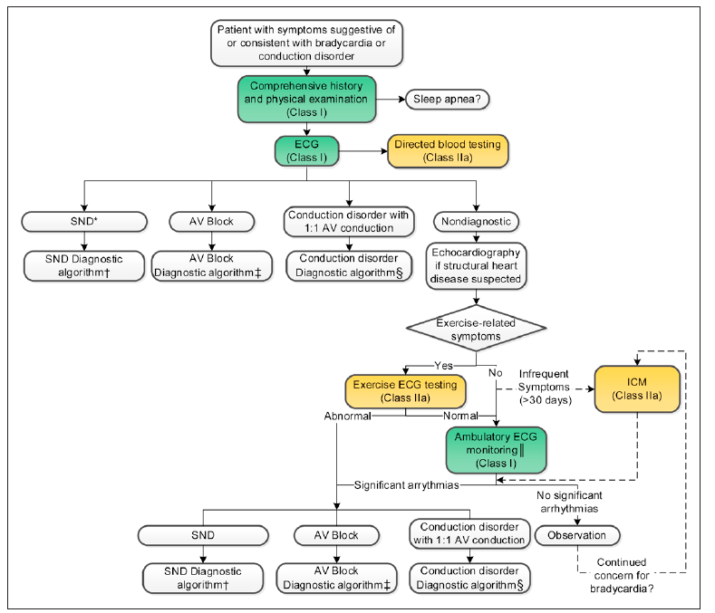
Figure 1 Evaluation of bradycardia and conduction disease algorithm
AV, atrioventricular; ECG, electrocardiogram/electrocardiographic.
Colours correspond to Class of Recommendation as per the Guidelines (Kusumoto 2019). Dashed lines indicate possible optional strategies based on the specific clinical situation. *Sinus bradycardia, ectopic atrial rhythm, junctional rhythm, sinus pause.
Source: Kusumoto (2019) Figure 1 pg e393.

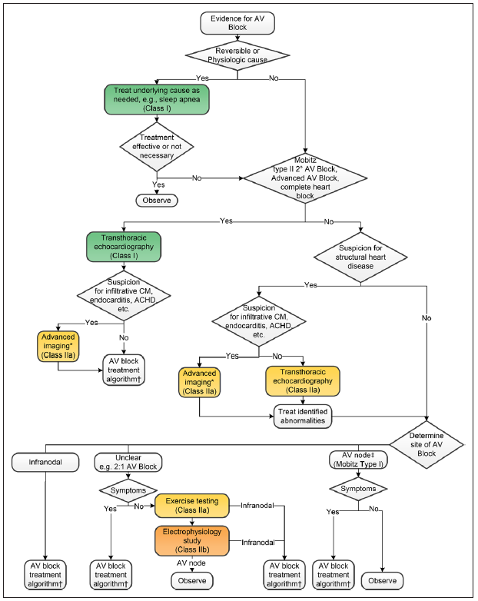
Figure 2 Initial evaluation of suspected AV block algorithm
Source: Kusumoto (2019) Figure 3 pg e395.
Colours correspond to Class of Recommendation in Kusumoto (2019). *Targeted Advanced Imaging—Magnetic Resonance Imaging (MRI): Amyloidosis, myocarditis, hemochromatosis, sarcoidosis, CHD, sinus of Valsalva aneurysm, aortic dissection, arrhythmogenic right ventricular cardiomyopathy; fluoro-deoxy-glucose (fludeoxyglucose)-positron emission tomography (FDG PET): sarcoidosis; 99m technetium pyrophosphate (Tc PYP) or 99m technetium 3,3-diphosphono-1,2-propanodicarboxylic acid (TC-DPD): Transthyretin (TTR) amyloidosis; cardiac computed tomography (CT): CHD, sinus of Valsalva aneurysm, aortic dissection, arrhythmogenic right ventricular cardiomyopathy; echo longitudinal strain: Amyloidosis; transesophageal echocardiogram (TEE): Endocarditis, sinus of Valsalva aneurysm, aortic dissection, CHD. ‡The atrioventricular node is more likely the site of block with second-degree Mobitz type I atrioventricular block and a narrow QRS complex or severe first-degree atrioventricular block (>0.30 s) with a narrow QRS complex.
AV, atrioventricular; ACHD, adult congenital heart disease; CHD, congenital heart disease; and CM, cardiomyopathy.

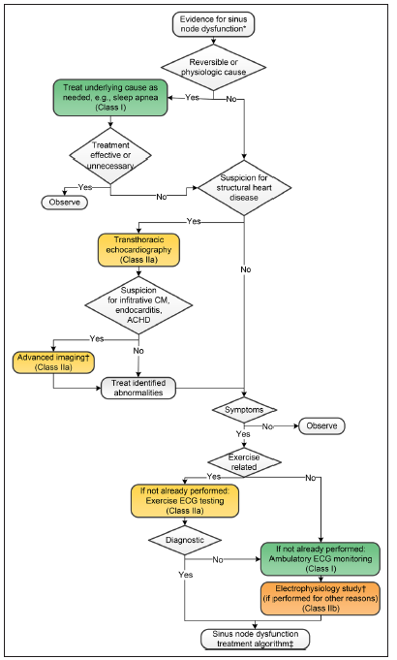
Figure 3 Initial evaluation of suspected or documented SND algorithm
Source: Kusomoto (2019) Figure 2 pg e394.
Colours correspond to Class of Recommendation Kusomoto (2019). *Sinus pauses, sinus bradycardia, junctional rhythm, ectopic atrial rhythm (all with heart rates <50 bpm) while awake. †The electrophysiology test should not be done primarily for sinus node dysfunction. If electrophysiology testing is being performed for another reason (eg, risk stratification for sudden cardiac death), evaluation of sinus node function may be useful to help inform whether an atrial lead for atrial pacing would have potential benefits.
CM, cardiomyopathy; ECG, electrocardiogram/electrocardiographic.

Define and summarise the current clinical management pathway before patients would be eligible for the proposed medical service (supplement this summary with an easy to follow flowchart [as an attachment to the Application Form] depicting the current clinical management pathway up to this point):
Whilst there are no Australian specific algorithms available for the management of patients with bradycardia, based on local expert advice, the Australian clinicians refer to the 2018 ACC/AHA/HRS guidelines on the management of patient with bradycardia (Kusomoto 2019). It should be noted that the European Society of Cardiology (ESC) also provided guidelines in 2013 on cardiac pacing (Brignole 2013). These guidelines, whilst broadly similar to the ACC/AHA/HRS guidelines are somewhat dated, noting that an update of these guidelines is expected in 2021. Hence for the purpose of this Application, the ACC/AHA/HRS 2018 guidelines are used to inform the management of patients with bradycardia (Kusomoto 2019).
Permanent cardiac pacing is indicated to lessen the symptoms of reduced blood flow to the cerebrum (ie, cerebral hypoperfusion), as a consequence of bradycardia after the elimination of other potential treatable or reversible causes. The most common indication for permanent pacing (dual and single chamber) is symptomatic SND followed closely by AV block. Typically, the best response to pacing therapy is observed when an indisputable correlation between symptoms and bradycardia has been established. The main benefit of pacing in SND is the improvement of a patients quality of life (Kusomoto 2019).
The presence or absence of symptoms is the major determinant in deciding whether permanent pacing is required in patients with bradycardia associated with AV block. There are three additional clinical considerations when deciding on the use of permanent pacing in patients with atrioventricular block, 1) the site of AV block, 2) significant amounts of right ventricular pacing are potentially deleterious and 3) co-existing, associated systemic disease may lead to progressive AV block or has additional risk for ventricular arrhythmias (Kusomoto 2019).
As discussed previously, in terms of permanent pacing, patients can either receive a single-chamber or a dual chamber pacemaker. Single-chamber ventricular pacing has the ability to protect a patient from bradyarrhythmia’s of any aetiology. It can be used in SND or AV disease when synchrony between the atrium and ventricle is not required, however the most common indication is chronic atrial fibrillation (AF) with a slow ventricular response (Epstein 2008).
This Application focus’s on the patient population for whom single-chamber pacing is indicated. In single-chamber pacing, as the name suggests, a single-chamber of the heart is sensed and paced. This can be either the atrium or the ventricle. There are two approaches to single chamber pacing, either via TV-PM (current standard of care) or the LPM (Micra, proposed service). The LPM registered for use in Australia, Micra VR, provides pacing to the right ventricle.
To this end, this Application has adapted the ACC/AHA/HRS guidelines (Kusomoto 2019) management algorithms for SND and AV block in Figure 4 and Figure 5 respectively, to include the proposed medical service, insertion of a LPM with pacing to the right ventricle. The clinical place in therapy for the LPM with pacing to the right ventricle is in those patients for whom a single chamber pacing to the right ventricle is considered appropriate. It should be noted that the insertion of the LPM using Micra VR has been performed in Australian public hospitals for several years (first implant 2006), in the proposed patient population.
The clinical place in therapy for LPM, as illustrated in Figure 4 and Figure 5, was confirmed with local experts and is consistent with the populations currently indicated for LPM based on the Micra device indications (ARTG 283235). Micra LPM is currently indicated for use in patients who have experienced one or more of the following conditions:
- symptomatic paroxysmal or permanent high-grade AV block in the presence of AF
- symptomatic paroxysmal or permanent high-grade AV block in the absence of AF, as an alternative to dual chamber pacing, when atrial lead placement is considered difficult, high risk, or not deemed necessary for effective therapy
- symptomatic bradycardia-tachycardia syndrome or sinus node dysfunction (sinus bradycardia or sinus pauses), as an alternative to atrial or dual chamber pacing, when atrial lead placement is considered difficult, high risk, or not deemed necessary for effective therapy.
The pacing performance of the Micra device is arguably the same irrespective of the indication for pacing, SND or AV block, as per the standard, single chamber, TV-PM. Based on local expert advice from three electrophysiologists, the overall majority of patients for whom LPM would be considered reflect patients with AV block, with only a minority of SND considered suitable for LPM. This is because there is a subset of patients with SND who may require atrial pacing support at a later point in time. Atrial pacing is not a function available in current LPM devices (Micra VR). For these patients, an upgrade to a dual chamber transvenous pacemaker system would be required; thus, requiring atrial lead placement.

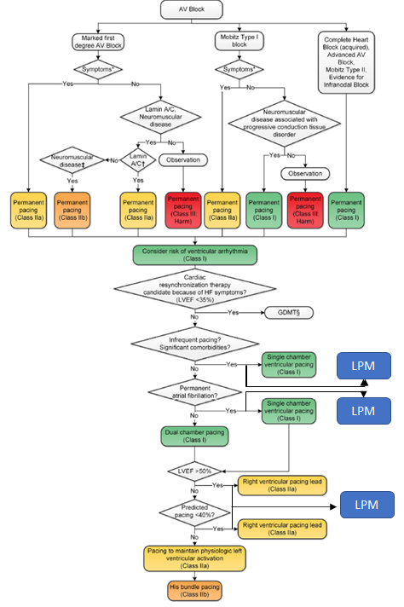
Figure 4 AV block management algorithm – including insertion of leadless pacemaker (LPM)
Source: Adapted from Figure 7 pg e170 (Kusomoto 2018)

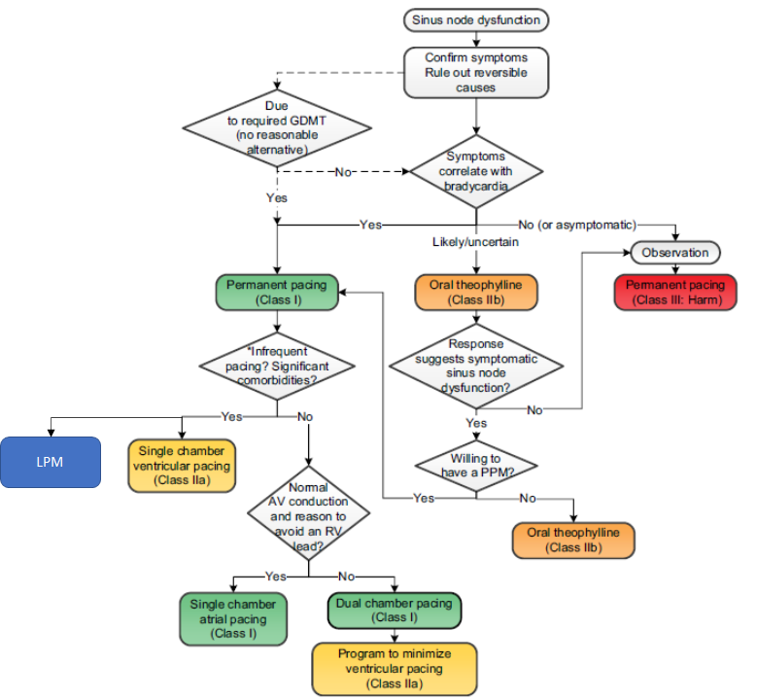
Figure 5 Sinus node dysfunction management algorithm – including insertion of leadless pacemaker (LPM)
Source: Adapted from Figure 6 pg e163 (Kusomoto 2018)

PART 6b – INFORMATION ABOUT THE INTERVENTION

Describe the key components and clinical steps involved in delivering the proposed medical service:
The proposed medical service is the transcatheter insertion of a LPM to the right ventricle. The only available single chamber implantable transcatheter pacing system in Australia is Medtronic’s Micra TPS (Model MC1VR01 referred to as Micra VR). The Micra VR is a programmable cardiac device that monitors and regulates the patient’s heart rate by providing rate-responsive bradycardia pacing to the right ventricle.
The miniaturised device, see Figure 6, senses the electrical activity of the patient’s heart, using the sensing and pacing electrodes enclosed in the titanium capsule of the device. It monitors the heart rhythm for bradycardia and responds to bradycardia by providing pacing therapy based on the pacing parameters programmed. The device provides rate response, controlled through an activity based sensor. It also provides diagnostic and monitoring information for guidance in the pacing system evaluation and in patient care. The device has an active fixation mechanism consisting of 4 electrically inactive tines designed to anchor it in the cardiac tissue at the implant location in the right ventricle. Figure 7 shows the Micra in situ.
Figure 6 The Micra TPS
Abbreviations: TPS, transcatheter pacing system

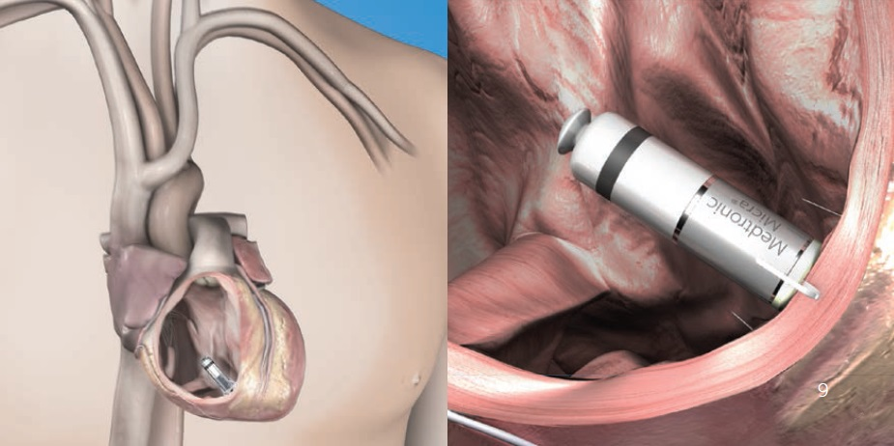
Figure 7 The Micra TPS in situ
Abbreviations: TPS, transcatheter pacing system

The components of the Micra Model MC1VR01 transcatheter pacing system include the LPM, the delivery catheter, the introducer and the Medtronic CareLink programmer, as shown in the Figure 8.
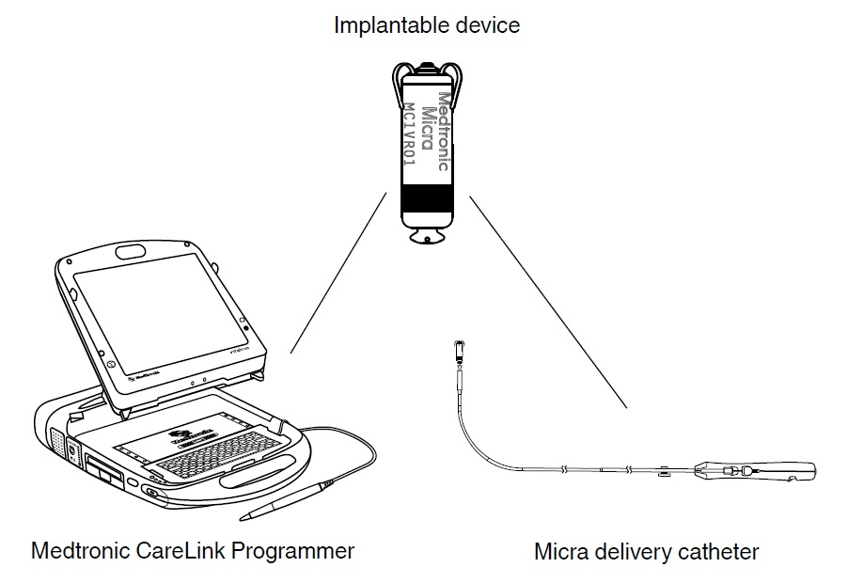
Figure 8 System Components

The four main steps, with associated tasks, of the implantation of the Micra TPS are as follows:
- Performing the implant procedure
- Preparing the delivery system and device for implant.
- Inserting a percutaneous introducer into the patient’s femoral vein. The use of a 7.8 mm (23 Fr) introducer sheath that is 56 cm long or longer is required.
- Navigating the delivery system and deploying the device in the right ventricle, whilst observing the fluoroscopic image for guidance. This requires insertion of the delivery system into the introducer, and the advancement of the delivery system through the introducer to the right atrium. Then the introducer is retracted out of the atrium and down into the inferior vena cava. Forming a curve in the delivery system, it is then deflected to cross the tricuspid valve. The deflection is then released and the system is navigated to the implant location in the right ventricle. The location of the delivery system is confirmed from different fluoroscopic views. Then the device is deployed and the delivery system is retracted.
- Assessing the device fixation
- Performing the pull and hold test to assess the adequacy of the device fixation in the patients cardiac tissue. This is performed by gently putting tension on the tether of the delivery system, whilst viewing the fluoroscopic image closely to examine the fixation of the device tines in the cardiac tissue.
- Initial electrical measurements are taken to help determine whether the sensing, electrode impedance, and pacing threshold values are acceptable for the device implant.
- Repositioning the device if necessary for proper fixation
- Completing the implant procedure
- Completing the device programming.
- Assessing the device performance

Does the proposed medical service include a registered trademark component with characteristics that distinguishes it from other similar health components?
No

If the proposed medical service has a prosthesis or device component to it, does it involve a new approach towards managing a particular sub-group of the population with the specific medical condition?
Yes, the medical service include the implantation of a LPM device, hence involves a new approach towards managing the proposed patient population. That is, the proposed population is currently receiving the implantation of a conventional, single-chamber TV-PM, which involves the implantation of the pacemaker generator itself, positioned in a subcutaneous pocket, and the implantation of the electrode leads into the heart. In contrast, the LPM is implanted directly into the right ventricle, via the femoral vein as discussed above.
Due to the absence of leads and necessity of a subcutaneous pocket, the advantages of LPM compared to conventional single-chamber pacemaker are based on eliminating lead and pocket complications therefore presenting advantages from a safety perspective. Other possible advantages include patient satisfaction due the absence of a scar and subcutaneous device location.

If applicable, are there any limitations on the provision of the proposed medical service delivered to the patient (i.e. accessibility, dosage, quantity, duration or frequency):
There are no expected limitations on the provision of the proposed medical service delivered to the patient.

If applicable, identify any healthcare resources or other medical services that would need to be delivered at the same time as the proposed medical service:
The health care resources delivered at the same time as the proposed medical service are similar to those delivered at the same time as the comparator procedure, insertion of a standard single chamber TV-PM, with the exception of the device itself. The procedures are performed by the cardiologist in the cardiac catheter laboratory. The healthcare resources required include:
- LPM device
- Cardiologist professional attendance time for insertion of the device
- Anaesthesia (general in 5% and local in 95%; Denman 2019)
- Hospitalisation – the patient generally stays overnight in hospital
Based on local expert advice, the duration of the proposed and comparator procedures are similar. According to an Australian conducted study by Denman (2019) the procedure time was 29 minutes (interquartile range [IQR]: 21–43 minutes) of which fluoroscopy time was 8 minutes (IQR: 5–13).

If applicable, advise which health professionals will primarily deliver the proposed service:
The health professionals that will primarily deliver the proposed service include specialist cardiologists (interventional cardiologist, cardiac electrophysiologist) or cardiac surgeons.

If applicable, advise whether the proposed medical service could be delegated or referred to another professional for delivery:
Not applicable.

If applicable, specify any proposed limitations on who might deliver the proposed medical service, or who might provide a referral for it:
The delivery of the service, as addressed in Q.32 is limited to interventional cardiologist, cardiac electrophysiologist or cardiac surgeon. The referring physicians are general practitioner or a non-interventional cardiologist.

If applicable, advise what type of training or qualifications would be required to perform the proposed service, as well as any accreditation requirements to support service delivery:
Cardiologists who intend to perform insertion of a LPM device undergo a comprehensive training program, which is provided by Medtronic. This robust program includes online as well as hands-on education designed to provide a performance-based, interactive procedural training to prepare physicians to start implanting Micra.
Prerequisites
The Micra system is placed in the heart via a 23 Fr Introducer after access is gained through the femoral vein. Proficiency in femoral venous access and large bore catheter manipulation are, therefore, recommended.
Upon satisfaction of the prerequisites, physicians are invited to complete the required Micra Academy educational components (see Implanter Training Pathway below).
Implanter Training Pathway
Physicians must complete two Micra procedural training components: online modules via Medtronic Academy and attend a Medtronic sponsored in-person training course. This in-person training includes didactic learning and hands-on procedural training (e.g.: implant simulator, cadaver and animal model, videos, and demonstration models).
Micra Technical Support
It is recommended that a minimum of the first 10 implants be supported by a Medtronic Micra Technical Expert representative. Additional support beyond the first 10 cases will be made available.

(a) Indicate the proposed setting(s) in which the proposed medical service will be delivered (select ALL relevant settings):
Inpatient private hospital (admitted patient)
Inpatient public hospital (admitted patient)
Private outpatient clinic
Public outpatient clinic
Emergency Department
Private consulting rooms – GP
Private consulting rooms – specialist
Private consulting rooms – other health practitioner (nurse or allied health)
Private day surgery clinic (admitted patient)
Private day surgery clinic (non-admitted patient)
Public day surgery clinic (admitted patient)
Public day surgery clinic (non-admitted patient)
Residential aged care facility
Patient’s home
Laboratory
Other – please specify below

- Where the proposed medical service is provided in more than one setting, please describe the rationale related to each:
The procedure is performed as an inpatient service, either in the public or private hospital setting. The first 24 hours after the procedure is critical in terms of monitoring the patient for adverse events and complications.

Is the proposed medical service intended to be entirely rendered in Australia?
Yes
No – please specify below

PART 6c – INFORMATION ABOUT THE COMPARATOR(S)

Nominate the appropriate comparator(s) for the proposed medical service, i.e. how is the proposed population currently managed in the absence of the proposed medical service being available in the Australian health care system (including identifying health care resources that are needed to be delivered at the same time as the comparator service):
The nominated comparator to the insertion of a LPM in the proposed patient population is the insertion of a standard, single chamber TV-PM. As discussed in Q.31, the health care resources that are needed to be delivered at the same time as the comparator service are similar to those delivered at the same time as the proposed intervention, and includes anaesthesia, the professional service itself and hospitalisation. The duration of stay is the same for both procedures with patients admitted overnight. Also as detailed in Q.31, the procedure time of the insertion of the LPM and a TV-PM is similar (around 30 minutes, Denman 2019).

Does the medical service (that has been nominated as the comparator) have an existing MBS item number(s)?
Yes (please list all relevant MBS item numbers below)
No

There are two item numbers listed on the MBS that are used to claim the single-chamber TV-PM procedure; one item relevant to the insertion of the PM device itself (MBS item 35353) and one item for the component of the service that relate to the insertion of the TV lead (MBS item 38350; Table 3). It should be noted that whilst item 38350 is specific to the insertion of the lead for a single-chamber PM, item 38353 can be used for the insertion of either a dual or single-chamber PM, hence is not limited to single-chamber PMs.

Table 3 MBS items used for the comparator service, implantation of a single-chamber TV-PM
MBS item number | Description | Fee and benefit
38350 | SINGLE CHAMBER PERMANENT TRANSVENOUS ELECTRODE, insertion, removal or replacement of, including cardiac electrophysiological services where used for pacemaker implantation  Multiple operation Rule  TN.8.60ª | Fee: $658.60 Benefit: 75% = $493.95
38353 | PERMANENT CARDIAC PACEMAKER, insertion, removal or replacement of, not for cardiac resynchronisation therapy, including cardiac electrophysiological services where used for pacemaker implantation  Multiple operation Rule  TN.8.60 ª | Fee: $263.45 Benefit: 75% = $197.60
a TN.8.60: The fees for the insertion of a pacemaker (Items 38350, 38353 and 38356) cover the testing of cardiac conduction or conduction threshold, etc related to the pacemaker and pacemaker function. Accordingly, additional benefits are not payable for such routine testing under Item 38209 or 38212 (Cardiac electrophysiological studies).
Source: MBS online, accessed 23 February 2021.

Define and summarise the current clinical management pathway/s that patients may follow after they receive the medical service that has been nominated as the comparator (supplement this summary with an easy to follow flowchart [as an attachment to the Application Form] depicting the current clinical management pathway that patients may follow from the point of receiving the comparator onwards, including health care resources):
The clinical management pathway that patients may follow after they receive the medical service that has been nominated as the comparator, insertion of single-chamber TV-PM is provided in Figure 9. The first 24 hours after the procedure are critical in terms of monitoring for adverse events. Patients receiving a single-chamber TV-PM may experience procedural or device related complications related to the pacemaker or to the leads.
A proportion of patients will experience lead and/or pocket infections. This complication typically results in the pacing system (device and leads) needing to be removed. The patient is admitted (or remains in hospital if occurring within 24 hours) and treated with antibiotic therapy to clear the infection. Temporary cardiac pacing will often be required during this time. Temporary cardiac pacing is achieved by the insertion of a temporary lead which is connected to an external pacing generator. After the infection has resolved a completely new system will be inserted including the PM generator and lead. The patient is hospitalised for the duration of the episode, which according to local experts typically lasts two weeks.
The frequency of monitoring of patients after the procedure may vary by treatment centres, however patients are generally followed up at 1 week, 3 months, 6 months and then every 6–12 months by specialist cardiologist or general practitioner.

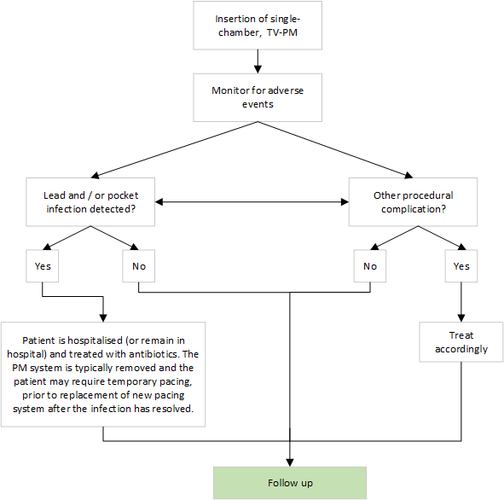
Figure 9 The clinical management pathway that patients may follow after they receive the medical service that has been nominated as the comparator

(a) Will the proposed medical service be used in addition to, or instead of, the nominated comparator(s)?
In addition to (i.e. it is an add-on service)
Instead of (i.e. it is a replacement or alternative)

If instead of (i.e. alternative service), please outline the extent to which the current service/comparator is expected to be substituted:
As per Part 7, it is anticipated that REDACTED % of single-chamber TV-PM services will be substituted for LPM in the first year, increasing to REDACTED % in year 5.

Define and summarise how current clinical management pathways (from the point of service delivery onwards) are expected to change as a consequence of introducing the proposed medical service, including variation in health care resources (Refer to Question 39 as baseline):
The current clinical management pathway from the point of service delivery onwards including LPM is provided in Figure 10. The main difference in the current clinical management from the point of service delivery, that is, the insertion of a LPM, is the reduction in procedure and device related complications compared with the insertion of a single-chamber TV-PM. In particular, given the lack of leads in the LPM procedure, LPM patients will not experience lead complications such as infections described above (as per Figure 9).
LPM patients may experience device or procedure related complications related to the LPM procedure. Such an event may include cardiac effusion or perforation. However, based on the CED study discussed in Part 4, the incidence of this event is low (REDACTED% with LMP and REDACTED% TV-PM) (Piccini – manuscript in press).
All other monitoring requirement post the LPM procedure is the same as per the comparator procedure.

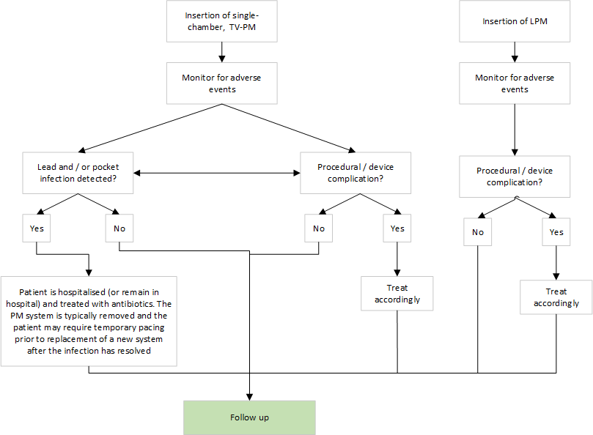
Figure 10 The clinical management pathway that patients may follow after they receive the medical service that has been nominated as the comparator, TV-PM and the proposed service, LPM

PART 6d – INFORMATION ABOUT THE CLINICAL OUTCOME

Summarise the clinical claims for the proposed medical service against the appropriate comparator(s), in terms of consequences for health outcomes (comparative benefits and harms):
Relative to the insertion of a single-chamber TV-PM, LPM is expected to have non-inferior efficacy, on the basis that LPM pacing thresholds are met, and superior on safety with respect to procedural / device related complications.

Please advise if the overall clinical claim is for:
Superiority
Non-inferiority

Below, list the key health outcomes (major and minor – prioritising major key health outcomes first) that will need to be specifically measured in assessing the clinical claim of the proposed medical service versus the comparator:
It should be noted that the efficacy of pacemaker therapy is the ability of the device to deliver electrical therapy to the patient as required by the mode the device is set to. In clinical practice a patient will have the device checked at regular intervals, to ensure correct electrical activity, or will report any abnormal symptoms which may be associated with device settings and function so that activity can be assessed. Hence, efficacy of LPM can be measured in clinical trials as the achievement of a low and stable threshold (ie, pacing performance). To this end, it is expected that the non-inferior effectiveness claim as per Q.43 of LPM versus TV-PM will be made indirectly, via the LPM device meeting the standard threshold levels.
Furthermore, efficacy of a pacemaker is reliant on battery performance, which is intrinsic to the device and battery depletion requires insertion of a new device. Therefore, estimates of battery life is considered to reflect device efficacy. Adaptability is a feature of pacemakers that allows rate responsiveness to increased exertion, it is therefore a feature of device efficacy.

Safety Outcomes:
– Procedural complications
– Device related complications
– Device dislodgments / device malfunction
– Reinterventions
– Deaths

Clinical Effectiveness Outcomes:
– Pacing performance,
– Battery life and
– Adaptability

PART 7 – INFORMATION ABOUT ESTIMATED UTILISATION

Estimate the prevalence and/or incidence of the proposed population:
The use of permanent pacemakers increases with age. Seventy to eighty percent (70-80%) of pacemakers are implanted in the over 65 age group (Gregoratos 1999), with aging associated with an increased risk of arrhythmias and conduction disorders (Wasmer 2017). With an increasingly aging population in Australia, it is expected the number of pacemakers inserted annually will continue to rise.
Estimates from a study in Western Australia showed prevalence rates of pacemaker insertion rose across their 15- year study period, from 186 per 100,000 in 1995 to 469 per 100,000 in 2009. These findings are similar to rates found in European studies (Bradshaw 2014).
In Bradshaw (2014), the indication for dual-chamber pacing was predominant from 1995 and was twice that of single-chamber TV-PM, although the study did not provide data to support that.
The Australian and New Zealand cardiac implantable electronic device survey for the 2017 calendar year collected sales data directly from companies providing pacemakers and other implantable cardioverter-defibrillators (ICDs) (Mond 2017). In 2017, there were a total of 141 Australian centres implanting PMs. The study found that in 2017, there were 17,971 new pacemakers (745 PMs per million population) and 3,462 replacements sold in Australia. Of the total number of pacemakers, new and replacements, 21% (4,464) were single-chamber PMs, reflecting services conducted in the private and public system. Applying the percentage single-chamber pacemakers to the number of new pacemakers, it is estimated that 3,774 single-chamber pacemakers were sold in 2017. Notably, this estimate also includes LPMs.

Estimate the number of times the proposed medical service(s) would be delivered to a patient per year:
It is expected that the proposed medical service be delivered once per patient. However, when the battery life of the LPM expires, a new LPM unit will be inserted into the right ventricle, whilst leaving the original unit in place. Hence, patients who outlive the battery life of the LPM unit will require another service. The longevity of the LPM battery is 12 years (Duray 2017).

How many years would the proposed medical service(s) be required for the patient?
See Q.47

Estimate the projected number of patients who will utilise the proposed medical service(s) for the first full year:
Three alternative approaches are taken in estimating the likely extent of LPM use on the MBS:
- Based on the number of PM devices sold in 2017, as reported in the aforementioned Australian and New Zealand cardiac implantable electronic device survey (Mond 2019).
- Based on the projected usage for MBS item 38350, the current MBS-funded service relating to the placement of transvenous electrode for single-chamber PMs.
- Based on the projected usage for MBS item 38353, the current MBS-funded service relating to the placement of PM devices (not exclusive to the single-chamber device).

Based on number of PM devices sold in 2017 as per Mond (2019)
Mond (2019) reported findings from a survey of cardiac implantable electronic device (CIED) manufacturers in Australia and New Zealand. The survey suggested a total of 3,774 single chamber PMs were reportedly sold in Australia in 2017 and its usage grew by 8.1% between 2013 and 2017 (see Table 4 below). The reported data were inclusive of private as well as public hospital use and no disaggregation between the two was provided in Mond (2019).
Table 4 Pulse generate type (new and replacement) sold in Australia in 2013 and 2017
Device type | SSI(R) | DDD(R) | VDD | BiVP | All combined
2013
Units | 4,131 | 13,995 | 79 | 661 | 18,866
% | 22% | 74% | <1% | 6% | 100%
2017
Units | 4,464 | 15,722 | 0 | 1,247 | 21,433
% | 21% | 73% | 0% | 6% | 100%
Growth % from 2013 to 2017 in terms of unit | 8.1% | 12.3% | - | 88.7% | 13.6%
Abbreviations: SSI(R), atrial or ventricular pacing and sensing (rate adaptive); DDD(R), dual chamber pacing and sensing (rate adaptive); VDD, single lead atrial sensing and pacing and ventricular sensing and pacing; BiVP, biventricular pacemaker.
Source: Mond 2019

The private insurance coverage among Australians aged 60 years and above are roughly 55%. Assuming this coverage rate is directly applicable in disaggregating the total usage between private and public patients, it can be estimated that 2,455 single-chamber devices were provided at private hospitals in 2017. Of note, some, but expected to be only a few, of these devices were LPMs. It is also uncertain whether the population-level data on private health insurance coverage can be generalisable in estimating the uptake of PM-related services in private hospital settings.
Notwithstanding the potential limitations of this estimation approach mentioned above, the number of single-chamber PMs sold in Australia can be projected, as shown in Table 5; the annualised growth rate of 1.6% is assumed to be applicable each year to 2016, calculated from the 5-year rate (8.1%) reported in the publication.
Table 5 Projected number of single-chamber PMs implanted at private centres in Australia – based on Mond (2019)
Year | 2017 | 2018 | 2019 | 2020 | 2021 | 2022 | 2023 | 2024 | 2025 | 2026
Single-chamber PM use | 4,464
% private | 55%
Annualised growth | 1.6%^
Projected single-chamber PM in private settings | 2,455 | 2,493 | 2,532 | 2,572 | 2,612 | 2,653 | 2,694 | 2,736 | 2,779 | 2,822
^ Annualised growth based on 8.1% reported for the 5-year period between 2013 and 2017 in Mond (2019)

Based on these projected numbers, the number of implantation procedures using LPM can be determined as shown in Table 6 below. If the uptake of LPM is assumed to be REDACTED% by Year 6 in the total single-chamber PM use on the MBS, there will be up to REDACTED implant procedures using LPM by Year 6.
Table 6 Projected number of single-chamber PM implantations (based on Mond 2019 under an assulption that 55% of the total implantations provided through the MBS) and predicted uptake of LPM
Year | 2021 | Year 1 | Year 2 | Year 3 | Year 4 | Year 5
Single-chamber PM implantations^, projected | 2,612 | 2,653 | 2,694 | 2,736 | 2,779 | 2,822
Uptake, market share vs single-chamber device with lead | – | REDACTED | REDACTED | REDACTED | REDACTED | REDACTED
Estimated LPM implantations | – | REDACTED | REDACTED | REDACTED | REDACTED | REDACTED

Based on the projected usage of MBS item 38350 (the existing MBS service relating to insertion, removal or replacement of permanent transvenous electrode for the single-chamber device)
The current number of single-chamber PM implantation procedures subsidised on the MBS can be estimated based on the MBS statistics for MBS item 38350 (“insertion, removal or replacement of single chamber permanent transvenous electrode”; see Question 39). The historical utilisation of MBS item 38350 is provided in Figure 11. In the past 2-3 years, around 3,000-3,200 services were provided under this MBS item.

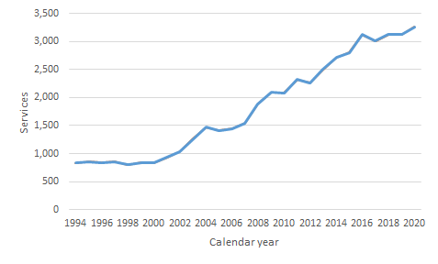
Figure 11 Number of services for MBS items 38350
Source: MBS Statistics (http://medicarestatistics.humanservices.gov.au/statistics/mbs_item.jsp)

Given that all single-chamber PM devices provided through the MBS require the lead, the usage data for MBS item 38350 is a reasonable representation of the number of implant procedures as well. However, some of the services provided under MBS item 38350 relate to lead complications including revisions. Revisions are expected to be lower with LPM than with single-chamber TV-PM (given lead complications do not occur with LPM), thus likely overestimating utilisation.
By assuming the linear trend observed in the previous 10 years to continue, the number of services for MBS item 38350 can be projected to Year 5 (with Year 1 in 2022); these estimates are taken as the overall use of single-chamber PMs on the MBS for the purpose of this analysis. This is shown in Figure 12 and Table 7.

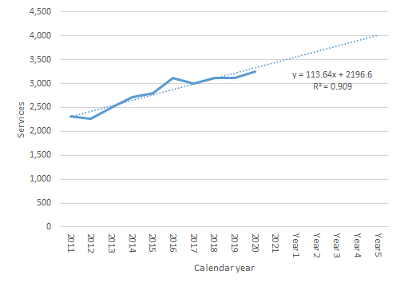
Figure 12 Projected number of services for MBS item 38350, linear trend applied to 2011-2020 data

Should an uptake rate of LPM be assumed to be REDACTED by Year 5, it can be estimated that there will be up to REDACTED implant procedures using LPMs by Year 5.

Table 7 Projected number of single-chamber PM implantations (based on MBS item 38350) and predicted uptake of LPM
Year | 2021 | Year 1 | Year 2 | Year 3 | Year 4 | Year 5
Single-chamber PM implantations^, projected | 3,333 | 3,447 | 3,560 | 3,674 | 3,788 | 3,901
Uptake, market share vs single-chamber device with lead | – | REDACTED | REDACTED | REDACTED | REDACTED | REDACTED
Estimated LPM implantations | – | REDACTED | REDACTED | REDACTED | REDACTED | REDACTED
^ Technically speaking, MBS item 38350 is inclusive of revisions (in addition to initial implantation); the risk of the revision is expected to be less with LPM, meaning this approach may be slight overestimation for the purpose of this analysis.

Based on the projected usage of MBS item 38353 (the existing MBS service relating to insertion, removal or replacement of PM devices)
Another relevant MBS item is 38353 (ie, insertion, removal or replacement of the PM device itself; see Question 39); the number of this service provided on the MBS is presented in Figure 13. It is shown that its service volume is currently four times more than that for MBS item 38350 (see Figure 11) because MBS item is 38353 is not specific to the single-chamber device and also encompass the insertion dual-chamber PMs.

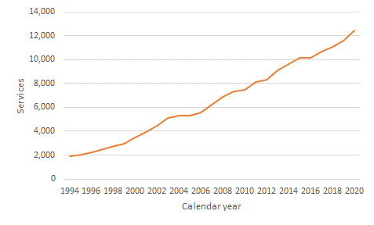
Figure 13 Number of services for MBS items 38353
Source: MBS Statistics (http://medicarestatistics.humanservices.gov.au/statistics/mbs_item.jsp)

By following the same method as that applied in the analysis of MBS item 38350 above, the number of PM implantations provided through the MBS can be estimated, as shown in Figure 14 and Table 8. Again, this MBS item is not specific to the single-chamber device utilisation; according to Mond (2019), however, 21% of all PMs sold in 2017 were single-chamber devices (see Table 4 above). Assuming this proportion is generalisable to the MBS setting, the number of implantation procedures using the single-chamber PM device can be estimated. This is shown in Table 8 below.

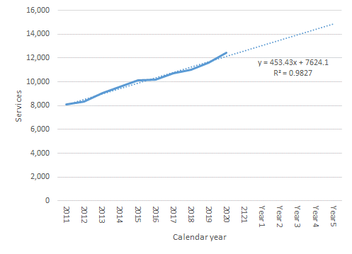
Figure 14 Projected number of services for MBS item 38352, linear trend applied to 2011-2020 data

Table 8 Projected number of single-chamber PM implantations (based on MBS item 38353, adjusted by the proportion of single-chamber devices reported in Mond 2019) and predicted uptake of LPM
Year | 2021 | Year 1 | Year 2 | Year 3 | Year 4 | Year 5
PM implantations, projected | 12,158 | 12,612 | 13,065 | 13,519 | 13,972 | 14,426
% with single-chamber devices |  |  | 21%
Number of single-chamber PM implantations, derived | 2,553 | 2,649 | 2,744 | 2,839 | 2,934 | 3,029
Uptake, market share vs single-chamber device with leaded | – | REDACTED | REDACTED | REDACTED | REDACTED | REDACTED
Estimated LPM implantations | – | REDACTED | REDACTED | REDACTED | REDACTED | REDACTED

Should an uptake rate of LMP be again assumed to be REDACTED% by Year 5, it can be estimated that there will be up to REDACTED implant procedures using LPM by Year 5.

Summary
The three alternative estimation methods explored returned the projected service volumes for the insertion of single-chamber TV-PMs that are not dissimilar to each other, as summarised in Error! Reference source not found.. Of the three approaches, it is felt that the approach based on Mond (2019) and the assumption that 55% of all PM devices are implanted through the MBS as informed by the private health insurance coverage, is somewhat uncertain. Given that this approach has returned estimates that are largely consistent with the third approach (based on MBS item 38353 and Mond 2019 for the share of single-chamber device), it is presented as a supportive evidence and not considered in producing usage and financial estimates for the forthcoming submission.
The utilisation estimates provided within this Application is expected to provide reasonable ballpark estimates of expected utilisation of LPM. These estimations will be confirmed in the applicant developed assessment report (ADAR).

PART 8 – COST INFORMATION

Indicate the likely cost of providing the proposed medical service. Where possible, please provide overall cost and breakdown:
An overview of the likely costs of providing the proposed medical service is provided In Table 9. According to an Australian observational study (Denman 2019), most procedures only require local anaesthetic while 5% required general anaesthetics (all of which involved extraction of a previously implanted transvenous device and re-implantation of an LPM as a single procedure). The current analysis assumes that the administration of local anaesthesia is to be absorbed within the included service fees for other services, eg, insertion procedure.
The procedural fee for the insertion of the LPM is informed by the combined fee of items 38350 and 38353, on the basis of the total procedure duration of the LPM and single-chamber TV-PM procedure assumed to be comparable. This was confirmed by local clinical experts.
Table 9 Cost structure of providing transcatheter insertion of a single-chamber, leadless pacemaker (LPM), without hospital accommodation cost for overnight stay (see discussion below)
Resource utilisation | Insertion of as LPM | Source
Transcatheter insertion
Pacemaker device and consumables | To be determined | To be justified and proposed in ADAR
Professional service, insertion of LPM | $790.33 | Estimated based on MBS items 38350 ($658.60) & 38353 ($263.45 x 50%)
Anaesthetics
Anaesthetist, pre-anaesthesia consultation | $45 | MBS item 17610
Initiation anaesthesia for insertion of TV pacemaker | $142.80 | MBS item 21941
Anaesthesia – time units (16-30 minutes) | $40.80 | MBS item 23025
Anaesthesia – time units (46-60 minutes) | $81.60 | MBS item 23045
% requiring anaesthesia | 5% | Denman 2019
Mean anaesthetic cost, per procedure | $15.51 | Calculated
Total, per procedure | $805.84 | Calculated, excluding device and consumables

The above table did not include any “hotel cost” – most patients after undergoing the procedure are expected to stay at hospital overnight for observation. This is also a common clinical practice with the existing pacemakers. According to the Department of Health & Human Services, State Government of Victoria, for example, the current guidance relating to nominal cost recovery rates for private patient accommodation suggests this cost is up to app. $1000 per procedure (see Table 10).
Table 10 Guidance relating to nominal cost recovery rates for private patient accommodation, the Department of Health & Human Services, State Government of Victoria
Patient classification | Commonwealth minimum benefit 2020-21 | Estimated cost for 2020-2021, median
Advanced surgery 1 (1–14 days), shared room | $448 | $890
Surgery/obstetric (1–14 days), shared room | $415 | $866
Advanced surgery 1 (1–14 days), single room | – | $987
Surgery/obstetric (1–14 days), single room | – | $1,057
Source: https://www2.health.vic.gov.au/hospitals-and-health-services/patient-fees-charges/admitted-patients/private-patients/overnight-stays

If public funding is sought through the MBS, please draft a proposed MBS item descriptor to define the population and medical service usage characteristics that would define eligibility for MBS funding.
Category 3 – Therapeutic procedures

Proposed item descriptor: LEADLESS PERMANENT CARDIAC PACEMAKER, insertion or removal of, including cardiac electrophysiological services
Fee: $790.33

References:
Bradshaw P, Stobie P, Knuiman M et al. Trends in the incidence and prevalence of cardiac pacemaker insertions in an aging population. Open heart 2014;1:e000177.
Brignole et al 2013. The Task Force on cardiac pacing and resynchronization therapy of the European Society of Cardiology (ESC). Developed in collaboration with the European Heart Rhythm Association (EHRA). 2013 ESC Guidelines on cardiac pacing and cardiac resynchronization therapy. European Heart Journal 34:2281–2329.
Denman et al 2019. Leadless Permanent Pacing: A Single Centre Australian Experience. Heart, Lung and Circulation (2019) 28, 1677–1682. https://doi.org/10.1016/j.hlc.2018.09.014
Epstein A, DiMarco J, Ellenbogen K, et al. ACC/AHA/HRS 2008 Guidelines for Device based therapy of cardiac rhythm abnormalities. Circulation 2008; 117:e350-e408.
Gregoratos G. Permanent pacemakers in older persons. J Am Geriatr Soc 1999;47(9):1125-35.
Hayes DL (2018) Modes of cardiac pacing: Nomenclature and selection [internet]. https://somepomed.org/articulos/contents/mobipreview.htm?28/60/29632?source=related_link#H15 (accessed 22 February 2021)
Kusomoto et al. 2018 ACC/AHA/HRS guideline on the evaluation and management of patients with bradycardia and cardiac conduction delay A Report of the American College of Cardiology/American Heart Association Task Force on Clinical Practice Guidelines and the Heart Rhythm Society. Circulation. 2019;140(8):e382–e482
National Institutes of Health. Pulse. Available at: https://medlineplus. gov/ency/article/003399.htm. Accessed December 18, 2017 (accessed 22 Feb 2021)
Pacemaker learning package. Liverpool hospital. 2016. URL: https://www.aci.health.nsw.gov.au/__data/assets/pdf_file/0003/306588/Pacemaker_Learning_Package.pdf. Accessed 22 Feb 2021.
Piccini et al (2021- article in press). Contemporaneous Comparison of Outcomes Among Patients Implanted with a Leadless versus Transvenous Single-Chamber Ventricular Pacemaker. JAMA Cardiology
Sovari A. Transvenous cardiac pacing. Medscape. Last updated: 6 March 2018. URL: https://emedicine.medscape.com/article/80659-overview. Accessed 29th October 2018.
Wasmer K, Eckardt L, Breithardt G. Predisposing factors for atrial fibrillation in the elderly. J of Geriatric Cardiology 2017;14:179-184.

https://www.escardio.org/Guidelines/Clinical-Practice-Guidelines/ESC-Guidelines-Publication-Schedule (accessed 26 February 2021)
https://www.aihw.gov.au/reports/australias-health/private-health-insurance

