MSAC Application 1763

Amendment of item 11512 to include the use of portable home spirometry via telehealth

Population
Describe the population in which the proposed health technology is intended to be used: As per item 11512, applicable to patients with chronic lung disease including obstructive and restrictive lung diseases. This would include children and adults capable of performing spirometry. Telehealth spirometry will be specifically performed to monitor lung function in a cohort of patients with existing respiratory diseases.

Spirometry testing will occur via a secure telehealth platform (decided by individual local health districts) under supervision of a respiratory scientist working in a respiratory laboratory-equipped to perform complex lung function testing.

Specify any characteristics of patients with, or suspected of having, the medical condition, who are proposed to be eligible for the proposed health technology, describing how a patient would be investigated, managed and referred within the Australian health care system in the lead up to being considered eligible for the technology:
Patients with existing lung disease who require ongoing monitoring of lung function and are assessed by their treating clinician as capable of performing spirometry via telehealth with the supervision of a Respiratory Laboratory Scientist.

Provide a rationale for the specifics of the eligible population:
Patients with lung disease who require regular monitoring of lung function as part of their routine clinic visits are now being offered the option of clinic visits via telehealth. These visits are reimbursed by Medicare. Accompanying spirometry assessments should also be made possible via Telehealth for these appointments.

Are there any prerequisite tests?
No

Are the prerequisite tests MBS funded?
N/A

Please provide details to fund the prerequisite tests:
N/A

Intervention

Name of the proposed health technology:
Home Spirometry Via Telehealth

Describe the key components and clinical steps involved in delivering the proposed health technology:
Spirometry service will be performed by the Respiratory Laboratory (with a qualified Scientist) online with the patient performing their pulmonary function test via Telehealth in real time.
Please see below Figure 1.

Figure 1: Clinic management workflow summary of Spirometry performed by the Respiratory Laboratory (with a qualified Scientist) online with the patient performing their pulmonary function test via Telehealth in real time.
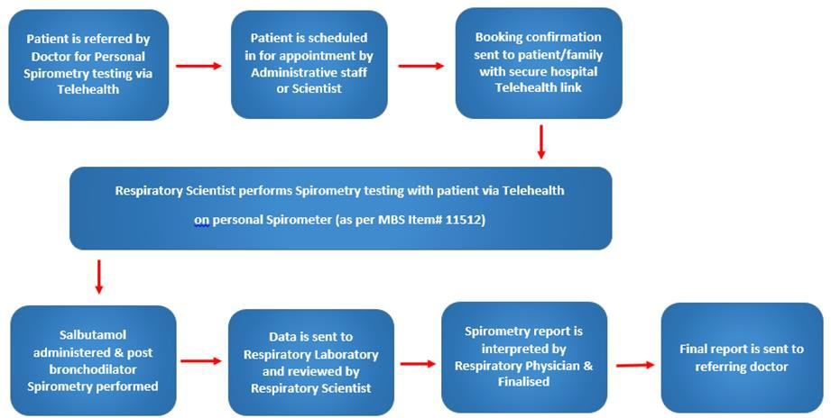

Identify how the proposed technology achieves the intended patient outcomes: Telehealth Spirometry is an essential tool utilized by Respiratory Laboratories. It enables high quality measurements performed via Telehealth with a Respiratory Laboratory Scientist in
continuous attendance. Spirometry via Telehealth with a Respiratory Scientist would benefit those patients with chronic respiratory disease. These patients will be able to continue to be appropriately monitored while being able to remain in their home environment. Diagnosis will not be made via Home Spirometry, its applications is designed to allow telehealth measurement for monitoring. The ability to undertake Spirometry via Telehealth improves consumer satisfaction for many patients significantly reducing the patient burdens of costs, travel time and social absenteeism. It also eliminates the risk of hospital communicable diseases or infection.

Does the proposed health technology include a registered trademark component with characteristics that distinguishes it from other similar health components?
No

Explain whether it is essential to have this trademark component or whether there would be other components that would be suitable:
N/A

Are there any proposed limitations on the provision of the proposed health technology delivered to the patient (For example: accessibility, dosage, quantity, duration or frequency):
We have not set any limitations other than that home spirometry via telehealth needs to accompany a clinical encounter (e.g. clinic visit) and be used for lung function monitoring.

Provide details and explain:
N/A

If applicable, advise which health professionals will be needed to provide the proposed health technology:
Respiratory Laboratory Scientist, Respiratory Physician as per current routine clinical care.

If applicable, advise whether delivery of the proposed health technology can be delegated to another health professional:
N/A

If applicable, advise if there are any limitations on which health professionals might provide a referral for the proposed health technology:
Referrals from the treating Respiratory Physician will be necessary.

Is there specific training or qualifications required to provide or deliver the proposed service, and/or any accreditation requirements to support delivery of the health technology?
As per item number 11512, Respiratory scientist at a respiratory laboratory equipped to perform complex lung function tests.

Provide details and explain:
As per existing Item number 11512, Respiratory scientist at a respiratory laboratory equipped to perform complex lung function testing, performed under the supervision of a consultant physician practising respiratory medicine who is responsible for staff training, supervision, quality assurance and the issuing of written reports.

Indicate the proposed setting(s) in which the proposed health technology will be delivered: (select all relevant settings)
Consulting rooms Day surgery centre
Emergency Department Inpatient private hospital Inpatient public hospital Laboratory
Outpatient clinic Patient’s home Point of care testing
Residential aged care facility Other (please specify)
The patient would be located remotely to the hospital laboratory. Only applicable to respiratory laboratories equipped to perform complex lung function tests with patients remotely.

Is the proposed health technology intended to be entirely rendered inside Australia?
Yes

Please provide additional details on the proposed health technology to be rendered outside of Australia:
N/A

Comparator

Nominate the appropriate comparator(s) for the proposed medical service (i.e. how is the proposed population currently managed in the absence of the proposed medical service being available in the Australian health care system). This includes identifying health care resources that are needed to be delivered at the same time as the comparator service: The comparator is the measurement of Spirometry within a Respiratory Laboratory.
List any existing MBS item numbers that are relevant for the nominated comparators:
MBS Item 11512

Please provide a rationale for why this is a comparator:
Patients with Chronic Respiratory diseases who are referred from a Respiratory Medicine Physician and have a personal spirometer would be eligible to perform Spirometry via telehealth with a Respiratory Scientist. No additional healthcare resources are required. See Figure 1 and Figure 2 attached of Comparative workflows.

GP Spirometry is generally of an insufficient standard when compared to Laboratory measurements performed by a Scientist. Please see References attached. Item number 11506 is used by GP’s. We are not proposing a change in this item number. Please see attached evidence file - Quality of Spirometry in primary care.

Pattern of substitution – Will the proposed health technology wholly replace the proposed comparator, partially replace the proposed comparator, displace the proposed comparator or be used in combination with the proposed comparator? (please select your response)
None (used with the comparator)
Displaced (comparator will likely be used following the proposed technology in some patients)
Partial (in some cases, the proposed technology will replace the use of the comparator, but not in all cases)
Full (subjects who receive the proposed intervention will not receive the comparator)

Please outline and explain the extent to which the current comparator is expected to be substituted:
Spirometry via Telehealth will only be performed when the accompanying clinical encounter (e.g. clinic visit) is also being performed via Telehealth. When patients attend face to face clinical encounters, standard face to face spirometry will be performed.

Outcomes

List the key health outcomes (major and minor – prioritising major key health outcomes first) that will need to be measured in assessing the clinical claim for the proposed medical service/technology (versus the comparator): (please select your response)
Health benefits Health harms Resources
Value of knowing

Outcome description – please include information about whether a change in patient management, or prognosis, occurs as a result of the test information:
Spirometry via Telehealth with a Respiratory Scientist would benefit those patients with chronic respiratory disease. These patients will be able to continue to be appropriately monitored while being able to remain in their home environment.

The ability to undertake Spirometry via Telehealth improves consumer satisfaction for many patients significantly reducing the patient burdens of costs, travel time and social absenteeism. Infection Control eliminates the risk of hospital communicable diseases or infection. In a multi- centre randomized controlled trial at 14 Cystic Fibrosis centres with subjects at least 14 years of old, intervention of home monitoring with telehealth spirometry among patients with CF was able to detect more exacerbations than usual care.

The onset of the COVID-19 pandemic was associated with restricted community movement and limited access to healthcare facilities, resulting in changed service delivery in several patient cohorts to telehealth including spirometry. In CF children and adults (3662 individuals), in the 12 months following the onset of the pandemic, there was improvement in clinical outcomes of people with CF when compared to the pre-pandemic period (outcomes included FEV1, number of hospitalizations, BMI). Virtual consultations increased from 8 to 47%.

Proposed MBS items

How is the technology/service funded at present? (for example: research funding; State- based funding; self-funded by patients; no funding or payments):
No funding
Please provide at least one proposed item with their descriptor and associated costs, for each population/Intervention: (please copy the below questions and complete for each proposed item)

MBS item number  (where used as a template for the proposed item) | 11512
Category number | Category 2
Category description | DIAGNOSTIC PROCEDURES AND INVESTIGATIONS
Proposed item descriptor | Measurement of spirometry:  - that includes continuous measurement of the relationship between flow and volume during expiration or during expiration and inspiration, performed before and after inhalation of a bronchodilator; and  - that is performed with a respiratory scientist in continuous attendance; and  - that is performed in a respiratory laboratory equipped to perform complex lung function tests; either face to face or via telehealth; and  - that is performed under the supervision of a specialist or consultant physician who is responsible for staff training, supervision, quality assurance and the issuing of written reports; and  - for which a permanently recorded tracing and written report is provided; and  - for which 3 or more spirometry recordings are performed; each occasion at which one or more such tests are performed  Not applicable for a service associated with a service to which item 11503 or 11507 applies  Fee: $67.65 Benefit: 75% = $50.75 85% = $57.55
Proposed MBS fee | $67.65
Indicate the overall cost per patient of providing the proposed health technology | $67.65
Please specify any anticipated out of pocket expenses | $600
Provide any further details and explain | Cost to the health service/respiratory function lab – No difference when compared to in person attendance.  Cost to the patient includes cost of spirometer and consumables. Spirometers cost approximately $600. Note however that the typical service life of spirometers is 5 years.

Algorithms
Preparation for using the health technology
Define and summarise the clinical management algorithm, including any required tests or healthcare resources, before patients would be eligible for the proposed health technology: Patients with existing lung disease who require ongoing monitoring of lung function and are assessed by their treating clinician as capable of performing spirometry via telehealth with the supervision of a Respiratory Laboratory Scientist.

Is there any expectation that the clinical management algorithm before the health technology is used will change due to the introduction of the proposed health technology?
The only change is the option to perform spirometry via telehealth when already partaking in a clinical encounter (e.g. Clinic visit) via telehealth.

Describe and explain any differences in the clinical management algorithm prior to the use of the proposed health technology vs. the comparator health technology:
Please see response above.
Use of the health technology

Explain what other healthcare resources are used in conjunction with delivering the proposed health technology:
No additional health care resources. Instead of performing spirometry in the laboratory face to face with a respiratory scientist, patients would now also have the option to perform spirometry via Telehealth supervised by a Respiratory Laboratory Scientist.

Explain what other healthcare resources are used in conjunction with the comparator health technology:
Please see response above.

Describe and explain any differences in the healthcare resources used in conjunction with the proposed health technology vs. the comparator health technology:
Please see response above.
Clinical management after the use of health technology

Define and summarise the clinical management algorithm, including any required tests or healthcare resources, after the use of the proposed health technology:
There will be no additional changes other than the option to perform spirometry via Telehealth as outlined above.

Define and summarise the clinical management algorithm, including any required tests or healthcare resources, after the use of the comparator health technology:
Please see response above.

Describe and explain any differences in the healthcare resources used after the proposed health technology vs. the comparator health technology:
Please see response above.

Insert diagrams demonstrating the clinical management algorithm with and without the proposed health technology:
Figure 1: Current clinic management workflow summary of Spirometry performed in Respiratory Laboratory; Item number 11512.

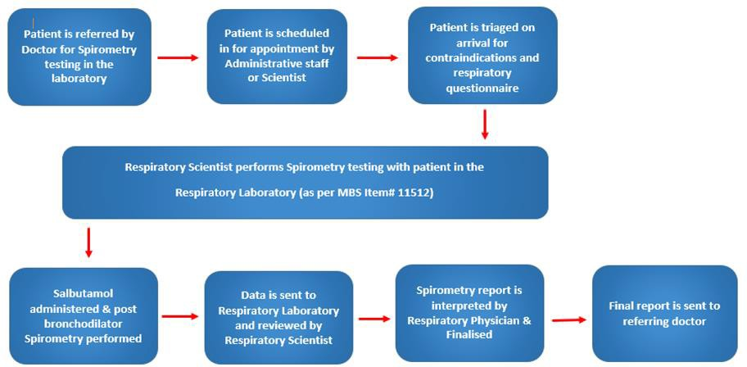

Figure 2: As per figure 1, except that Spirometry service will be performed by the Respiratory Laboratory (with a qualified Scientist) online with the patient performing their pulmonary function test via Telehealth in real time.

Claims

In terms of health outcomes (comparative benefits and harms), is the proposed technology claimed to be superior, non-inferior or inferior to the comparator(s)? (please select your response)
Superior Non-inferior Inferior

Please state what the overall claim is, and provide a rationale:
Published Data - see Summary of Evidence file attached.

Why would the requestor seek to use the proposed investigative technology rather than the comparator(s)?
This is the only objective option available for spirometry testing via Telehealth, to accompany clinical encounters (e.g. Clinic visit) via telehealth.

Identify how the proposed technology achieves the intended patient outcomes:
Spirometry via Telehealth provides objective information on lung function which is key for managing patients with a chronic lung disease. This would only be used when the accompanying clinical encounter (e.g. Clinic visit) is also performed via Telehealth.

For some people, compared with the comparator(s), does the test information result in:
A change in clinical management? Please see below A change in health outcome? Please see below Other benefits? Yes
Spirometry via Telehealth would be performed when patients have a virtual clinical visit with a respiratory physician. It would provide comparable information to spirometry testing performed in the laboratory, in-person.

Please provide a rationale, and information on other benefits if relevant:
The ability to undertake Spirometry via Telehealth improves consumer satisfaction for many patients significantly reducing the patient burdens of costs, travel time and social absenteeism. Infection Control eliminates the risk of hospital communicable diseases or infection. In a multi- centre randomized controlled trial at 14 Cystic Fibrosis centres with subjects at least 14 years of old, intervention of home monitoring with telehealth spirometry among patients with CF was able to detect more exacerbations than usual care.

In terms of the immediate costs of the proposed technology (and immediate cost consequences, such as procedural costs, testing costs etc.), is the proposed technology claimed to be more costly, the same cost or less costly than the comparator? (please select your response)
More costly Same cost Less costly

Provide a brief rationale for the claim:
While we do not anticipate any increased cost for the healthcare system, there may be an increased cost for the patient who has to purchase the home spirometer. However, as displayed below there may be significant societal cost savings for patients and families.

 | Metropolitan | Regional
 | Difference (95% CI) | Difference (95% CI) | Difference in Cost between Metropolitan and regional  patients
Travel time to clinic, minutes (S.D) | -70 | -237 | 167 mintues more for regional patients
 | (-98 to -42) | (-341 to -132)
Estimated total duration of time in cystic fibrosis clinic, minutes (S.D) | -71 | -42
 | (-91 to -50) | (-74 to -10)
Estimated travel cost, $AUD (S.D) | -9 | -77 | Regional patient cost is  $238 more than metropolitan patient per visit
 | (-14 to -4) | (-136 to -18)
Parking cost, $AUD (SD) | -7 | -10
 | (-12 to -2) | (-16 to -4)
Cost of Childcare, $AUD (S.D) | 0 | -8
 |  | (-22 to 7)
Accommodation cost, $AUD (SD) | 0 | -38
 |  | (-74 to -3)
Estimated loss in income,  $AUD (S.D) | -18 | -139
 | (-65 to 28) | (-337 to 59)

Societal cost savings for patients living in metropolitan versus regional settings (unpublished data from Royal Prince Alfred Hospital, Sydney, Australia 2022)

Summary of Evidence

Provide one or more recent (published) high quality clinical studies that support use of the proposed health service/technology. At
‘Application Form lodgement’,
Do not attach full text articles; just provide a summary (repeat columns as required).

 | Type of study design* | Title of journal article or research project (including any trial identifier or study lead if relevant) | Short description of research (max 50 words)** | Website link to journal article or research (if available) | Date of publication*  **
1 | Observational | Telehealth application of an ultrasonic home spirometer  PMID: 35277380 | This study demonstrates good reliability between the spirometry indices measured using a personal ultrasonic spirometer and conventional laboratory equipment in children. Supervised home use during telehealth resulted in a higher percentage (89%) of acceptable and reproduceable results compared with previous studies of unsupervised attempts at home spirometry. | https://adc.bmj  .com/content/ 107/8/752 | 2022
2 | RCT/  observational | Home Monitoring in Patients with Idiopathic Pulmonary Fibrosis  PMID: 32325005 | In Idiopathic Pulmonary Fibrosis (IPF), home spirometry yielded reliable FVC results similar to hospital-based spirometry, in line with other nonrandomized home spirometry studies. Home-based spirometry was highly correlated with hospital-based spirometry over time (r = 0.97, P<0.001 at baseline). Slopes of home- and hospital- based FVC over time were comparable. | https://pubme d.ncbi.nlm.nih. gov/32325005/ | 2020

 | Type of study design* | Title of journal article or research project (including any trial identifier or study lead if relevant) | Short description of research (max 50 words)** | Website link to journal article or research (if available) | Date of publication*  **
3 | RCT/  observational | Proactive Electronic Visits for Smoking Cessation and Chronic Obstructive Pulmonary Disease Screening in Primary Care: Randomized Controlled Trial of Feasibility, Acceptability, and Efficacy  PMID: 36040766 | In current smokers with no previous diagnosis of COPD, a good concordance was demonstrated between home and in-lab spirometry (FEV1). Twenty-one participants completed both home and in-lab PFTs. Among these participants, concordance between home and in-lab PFTs was higher for FEV1 (R2=0.75) compared to PEF (R2=0.49). | https://pubme d.ncbi.nlm.nih. gov/36040766/ | 2022
4 | Meta-analysis | Accuracy of portable spirometers in the diagnosis of chronic obstructive pulmonary disease A meta-analysis | In a meta-analysis including 31 publications, patients with COPD who have completed both portable and in-lab spirometry, demonstrated high accuracy with portable spirometry. The results show that the area under the SROC (AUC) of 0.91 indicate that the portable spirometer has high accuracy and can be used as an alternative for traditional pulmonary function tests in COPD screening, primary diagnosis and subsequent monitoring. | https://www.na ture.com/articl es/s41533- 022-00275-x | 2022

 | Type of study design* | Title of journal article or research project (including any trial identifier or study lead if relevant) | Short description of research (max 50 words)** | Website link to journal article or research (if available) | Date of publication*  **
5 | Prospective cohort study | Technical validity and usability of a novel smartphone-connected spirometry device for pediatric patients with asthma and cystic fibrosis | A paediatric asthma and CF cohort of fifty-eight subjects (6 – 16 years) performed spirometry once daily (after a training session) at home for 28 days on a mobile device. They performed spirometry on a conventional device and mobile device (during the same visit) at the hospital outpatient clinic at the beginning or end of the study period. The mobile device showed validity for the measurement of FEV1 and FVC with minimal interdevice variability. | https://onlineli brary.wiley.co m/doi/10.1002  /ppul.24932 | 2020
* Categorise study design, for example meta-analysis, randomised trials, non-randomised trial or observational study, study of diagnostic accuracy, etc.
**Provide high level information including population numbers and whether patients are being recruited or in post-recruitment, including providing the trial registration number to allow for tracking purposes. For yet to be published research, provide high level information including population numbers and whether patients are being recruited or in post-recruitment.
*** If the publication is a follow-up to an initial publication, please advise. For yet to be published research, include the date of when results will be made available (to the best of your knowledge).

Identify yet-to-be-published research that may have results available in the near future (that could be relevant to your application).
Do not attach full text articles; this is just a summary (repeat columns as required).

 | Type of study design* | Title of journal article or research project (including any trial identifier or study lead if relevant) | Short description of research (max 50 words)** | Website link to journal article or research (if available) | Date of publication*  **
1. | RCT/  observational | Comparisons between Spirohome and laboratory equipment in children | Investigation of the agreement between home spirometers and laboratory equipment during the same session face to face with a respiratory scientist. Forty three subjects from CF and asthma cohorts were recruited. Strong agreement was observedbetween the home and laboratory device. | https://onlinelibrary. wiley.com/doi/epdf/ 10.1111/resp.14215 | 2022
2. | RCT/  observational | The impact of technician- led virtual spirometry sessions on the availability and quality of home spirometry results in a virtual Cystic Fibrosis clinic. | In a CF cohort, after noticing a fall in the number and quality of spirometry reports done in home compared with previous face to face, a physiologist-led virtual clinic was implemented. In home spirometry prior to coaching achieved 37% tests with ATS A or B grade compared with 76% with the introduction of coaching by a respiratory physiologist. | https://thorax.bmj.co m/content/thoraxjnl/ 76/Suppl_2/A124.2.f ull.pdf | 2021
* Categorise study design, for example meta-analysis, randomised trials, non-randomised trial or observational study, study of diagnostic accuracy, etc.
**Provide high level information including population numbers and whether patients are being recruited or in post-recruitment, including providing the trial registration number to allow for tracking purposes. For yet to be published research, provide high level information including population numbers and whether patients are being recruited or in post-recruitment.
*** If the publication is a follow-up to an initial publication, please advise. For yet to be published research, include the date of when results will be made available (to the best of your knowledge).

