

MSAC Application 1659

Catheter-based renal denervation for uncontrolled elevated systolic blood pressure

This application form is to be completed for new and amended requests for public funding (including but not limited to the Medicare Benefits Schedule (MBS)). It describes the detailed information that the Australian Government Department of Health requires to determine whether a proposed medical service is suitable.

Please use this template, along with the associated Application Form Guidelines to prepare your application. Please complete all questions that are applicable to the proposed service, providing relevant information only. Applications not completed in full will not be accepted.

Should you require any further assistance, departmental staff are available through the Health Technology Assessment Team (HTA Team) on the contact numbers and email below to discuss the application form, or any other component of the Medical Services Advisory Committee process.

Email: [hta@health.gov.au](mailto:hta@health.gov.au)

Website: [www.msac.gov.au](http://www.msac.gov.au/)

PREFACE

Catheter-based renal denervation (RDN) is a minimally invasive procedure developed to treat patients with uncontrolled hypertension (HTN).

The Applicant (Medtronic Australia) first initiated the Medical Services Advisory Committee (MSAC) application process for the listing of RDN on the Medicare Benefits Schedule (MBS) in 2012.

Under the MSAC process contemporary to that time, a draft Decision Analytic Protocol (DAP) was finalised in September 2013 (*see 1338 Final Protocol to guide the assessment of catheter-based renal denervation for treatment-resistant hypertension [http://www.msac.gov.au/internet/msac/publishing.nsf/Content/1338-public]*).

In 2013, the application to MSAC for the reimbursement of RDN on the MBS was motivated by results from an early proof-of-concept single arm study (SYMPLICITY HTN-1; Krum 2009 & 2011) and an unblinded randomised controlled study (SYMPLICITY HTN-2; Esler 2010), in addition to other trials of RDN using radiofrequency ablation, conducted in a treatment-resistant hypertension study population. The trials collectively showed large blood pressure reductions in the patients who received the RDN procedure.

However, just after lodgement of the MSAC submission in October 2013, results from a single-blind, randomised, sham-controlled clinical trial (SYMPLICITY HTN-3 trial; Bhatt 2014; Kandarzi 2015) became available which failed to confirm a significant beneficial effect of RDN on blood pressure compared to the sham procedure.

As a consequence of the outcome of the HTN-3 trial, many programs for the development of various RDN devices were halted or suspended and the MSAC application for RDN was not evaluated.

However, subsequently a number of *post hoc* analyses revealed that the SYMPLICITY HTN-3 trial contained a number of important confounding factors which contributed to the poor results (discussed in Part 5). Importantly, insights into the failings of HTN-3 served to inform improvement to the design of subsequent clinical trials of RDN (Mahfoud 2015 & 2017; FDA 2018).

More recently, data from more robustly designed randomised sham controlled trials of RDN, including the Applicant’s SPYRAL HTN OFF-MED and SPYRAL HTN ON-MED proof of concept trials (Kandarzi 2018; Bohm 2020), involving the next generation Symplicity Spyral radiofrequency RDN system, have now provided strong support for RDN as an effective treatment for patients with uncontrolled hypertension.

On the basis of the positive data from the SPRYRAL HTN trials, the Applicant now wishes to recommence the MSAC application process to request the inclusion of catheter-based RDN as a funded item on the MBS.

Given the time elapsed since the finalisation of the DAP in 2013, changes in updated treatment guidelines for managing HTN, possible changes in defining the population targeted for RDN, changes in the number of interventions available and changes in the MSAC application process, the Applicant has assumed that a new updated PICO protocol will be required. Hence, this application form is submitted to inform the development of the PICO to be addressed by the Applicant Developed Assessment Report (ADAR).

# PART 1 – APPLICANT DETAILS

## Applicant details (primary and alternative contacts)

Corporation / partnership details (where relevant):

Corporation name: Medtronic Australasia Pty Ltd

ABN: 47 001 162 661

Business trading name: Medtronic Australasia Pty Ltd

**Primary contact name:** **REDACTED**

Primary contact numbers:

Business: REDACTED

Mobile: REDACTED

Email: REDACTED

**Alternative contact name: REDACTED**

Alternative contact numbers:

Business: REDACTED

Mobile: REDACTED

Email: REDACTED

## (a) Are you a consultant acting on behalf of an Applicant?

Yes

No

REDACTED

(b) If yes, what is the Applicant(s) name that you are acting on behalf of?

REDACTED

1. **(a) Are you a lobbyist acting on behalf of an Applicant?**

Yes

No

**(b) If yes, are you listed on the Register of Lobbyists?**

Yes

No

# PART 2 – INFORMATION ABOUT THE PROPOSED MEDICAL SERVICE

## Application title

Catheter-based renal denervation for uncontrolled elevated systolic blood pressure

***Generic consideration of catheter-based renal denervation devices***

*A number of catheter-based renal denervation (RDN) systems, using different ablation technologies, including radiofrequency (RF), ultrasound and pharmacological ablation, are in development but only the Simplicity Spyral catheter is currently used in the Australian market and the applicant is unaware of if and when the other devices will be available/used in Australia.*

*The applicant is open to advice from PASC on whether to propose the MBS item be inclusive of catheter-based RDN generically, or limited to RF ablation only, based on the current evidence and market use.*

## Provide a succinct description of the medical condition relevant to the proposed service (no more than 150 words – further information will be requested at Part F of the Application Form)

Hypertension (HTN) is a long-term medical condition in which the blood pressure in the arteries is persistently elevated. In most people, HTN typically does not cause symptoms. However, left uncontrolled, HTN is a major risk factor for coronary artery disease, stroke, heart failure, atrial fibrillation, peripheral arterial disease, vision loss, chronic kidney disease, and dementia. As such, HTN represents a major public health issue (NHFA 2016).

For many patients, HTN can be well managed with life-styles changes, and if these alone are not effective, the use of one or more anti-hypertensive medications. However, there is a subset of patients who have effectively exhausted therapy options, who remain with uncontrolled elevated systolic blood pressure ≥ 150 mmHg, despite optimised treatment with three or more antihypertensive drugs, or who are intolerant to antihypertensive medication.

The proposed service, catheter-based renal denervation, is intended as a one-time treatment in addition to existing standard of care, for HTN in these hard to treat patients, for whom additional medications are unlikely to be effective or tolerated.

## Provide a succinct description of the proposed medical service (no more than 150 words – further information will be requested at Part 6 of the Application Form)

The proposed service, catheter-based renal denervation (RDN), is a minimally invasive procedure intended as a one-time treatment adjunct to existing standard of care medication therapy, in patients with confirmed uncontrolled elevated systolic blood pressure ≥ 150 mmHg, despite optimised treatment with three or more antihypertensive drugs, or intolerant to antihypertensive medication, and who are at high risk of CVD based on one or more specified risk factor.

Based on the well-established role the sympathetic nervous system plays in HTN (Figure 1), RDN utilises an endovascular approach and ablative technology (e.g. RF, ultrasound, local alcohol microinjection) to selectively disrupt the renal sympathetic nervous system in a localised and minimally invasive manner at the level of the kidney (Sata 2018; Bolignano 2019) .

The RDN procedure is performed in the catheterisation laboratory, using standard endovascular intervention techniques similar to those used in renal angioplasty or stenting. The ablation catheter is localised via the femoral artery to the renal arteries. The efferent and afferent nerves adjacent to the artery are ablated through the arterial wall. During the procedure, both renal arteries are treated. The RDN procedure is considered to reduce blood pressure via reduction in total peripheral resistance, reduced renin release, and favourable alterations of water and salt handling.

Following this service, optimal medical management should be continued.

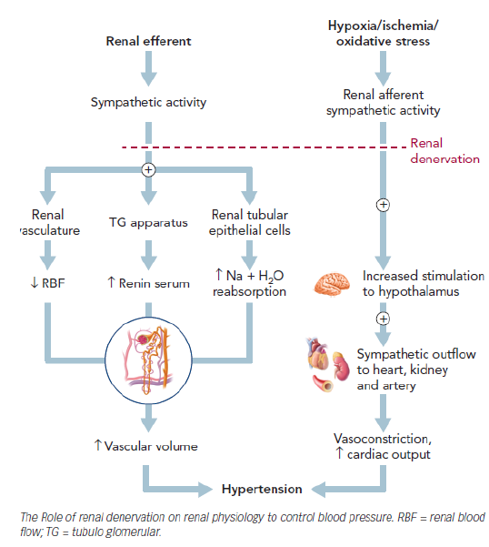

Figure Physiology of renal sympathetic control

Source: Padmanabhan 2018.

## ****(a) Is this a request for MBS funding?****

Yes

No

## ****If yes, is the medical service(s) proposed to be covered under an existing MBS item number(s) or is a new MBS item(s) being sought altogether?****

Amendment to existing MBS item(s)

New MBS item(s)

## ****If an amendment to an existing item(s) is being sought, please list the relevant MBS item number(s) that are to be amended to include the proposed medical service:****

Not applicable

## ****If an amendment to an existing item(s) is being sought, what is the nature of the amendment(s)?****

Not applicable

1. **An amendment to the way the service is clinically delivered under the existing item(s)**
2. **An amendment to the patient population under the existing item(s)**
3. **An amendment to the schedule fee of the existing item(s)**
4. **An amendment to the time and complexity of an existing item(s)**
5. **Access to an existing item(s) by a different health practitioner group**
6. **Minor amendments to the item descriptor that does not affect how the service is delivered**
7. **An amendment to an existing specific single consultation item**
8. **An amendment to an existing global consultation item(s)**
9. **Other (please describe below):**

## ****If a new item(s) is being requested, what is the nature of the change to the MBS being sought?****

1. **A new item which also seeks to allow access to the MBS for a specific health practitioner group**
2. **A new item that is proposing a way of clinically delivering a service that is new to the MBS (in terms of new technology and / or population)**
3. **A new item for a specific single consultation item**
4. **A new item for a global consultation item(s)**

## ****Is the proposed service seeking public funding other than the MBS?****

Yes

No

## ****If yes, please advise:****

Not applicable

## What is the type of service:

Therapeutic medical service

Investigative medical service

Single consultation medical service

Global consultation medical service

Allied health service

Co-dependent technology

Hybrid health technology

## For investigative services, advise the specific purpose of performing the service *(which could be one or more of the following)*:

Not applicable

1. To be used as a screening tool in asymptomatic populations
2. Assists in establishing a diagnosis in symptomatic patients
3. Provides information about prognosis
4. Identifies a patient as suitable for therapy by predicting a variation in the effect of the therapy
5. Monitors a patient over time to assess treatment response and guide subsequent treatment decisions

## Does your service rely on another medical product to achieve or to enhance its intended effect?

Pharmaceutical / Biological

Prosthesis or device

No

The service is a device-based therapy.

## (a) If the proposed service has a pharmaceutical component to it, is it already covered under an existing Pharmaceutical Benefits Scheme (PBS) listing?

Not applicable

Yes

No

If yes, please list the relevant PBS item code(s):

Not applicable

## If no, is an application (submission) in the process of being considered by the Pharmaceutical Benefits Advisory Committee (PBAC)?

Not applicable

Yes (please provide PBAC submission item number below)

No

## If you are seeking both MBS and PBS listing, what is the trade name and generic name of the pharmaceutical?

Not applicable

## (a) If the proposed service is dependent on the use of a prosthesis, is it already included on the Prostheses List?

Yes

No

If yes, please provide the following information (where relevant):

Not applicable

Yes

No

REDACTED

## If no, is an application in the process of being considered by a Clinical Advisory Group or the Prostheses List Advisory Committee (PLAC)?Dfadfas

Yes

No

REDACTED

## Are there any other sponsor(s) and / or manufacturer(s) that have a similar prosthesis or device component in the Australian marketplace which this application is relevant to?

Yes

No

## If yes, please provide the name(s) of the sponsor(s) and / or manufacturer(s):

Description: EnligHTN Ablation Catheter designed to deliver RF energy to the renal nerves to achieve targeted denervation

Sponsor: Abbott Medical Australia Pty Ltd

Manufacturer: St Jude Medical

Note: While registered on the ARTG, the EnligHTN catheter is not listed on the Prostheses List. **REDACTED**

## Please identify any single and / or multi-use consumables delivered as part of the service?

The list of consumables provided below is based upon the requirements for angiography and RDN using the Applicant’s Symplicity Spyral renal denervation system. However, the consumable requirements for other RDN devices are not expected to vary substantially.

**Single use consumables:**

* Single use ablation catheter
* General items used for angiography may include:

• Angiography pack

• 1% Lignocaine

• Heparin

• Glyceryl trinitrate

• Contrast agent

* General items used for many endovascular procedures may include:

• Introducer needle and sheath

• Disposable guide catheter

• Dispersive electrodes

• Tuohy-Borst adapter

• Stopcock sidearm

• Small Tegaderm (for groin dressing)

• Oxygen via Nasal prongs/Hudson mask

• Conscious sedation medication (e.g. Fentanyl or Midazolam).

• Other medications e.g.: Atropine, Maxalon & Aramine.

• Non-hydrophilic guide wire

• Angioseal or Perclose

• Extension tubing

• 3-way tap

• Pigtail catheters

• ACT syringes

• Radio opaque ruler (optional)

• Renal guide

• Grounding pad

**Multi-use consumables:**

Reusable RF ablation generator

# PART 3 – INFORMATION ABOUT REGULATORY REQUIREMENTS

## (a) If the proposed medical service involves the use of a medical device, in-vitro diagnostic test, pharmaceutical product, radioactive tracer or any other type of therapeutic good, please provide the following details:

**REDACTED**

Type of therapeutic good: Medical device Class IIb

Manufacturer’s name: Medtronic Inc

Sponsor’s name: Medtronic Australasia Pty Ltd

The proposed service involves the use of the Applicant’s Symplicity Catheter System, which comprises the Symplicity Spyral multi-electrode renal denervation catheter and the SymplicityG3 renal denervation RF generator.

## Is the medical device classified by the TGA as either a Class III or Active Implantable Medical Device (AIMD) against the TGA regulatory scheme for devices?

Class III

AIMD

N/A

## (a) Is the therapeutic good to be used in the service exempt from the regulatory requirements of the *Therapeutic Goods Act 1989*?

Yes (If yes, please provide supporting documentation as an attachment to this application form)

No

## If no, has it been listed or registered or included in the Australian Register of Therapeutic Goods (ARTG) by the Therapeutic Goods Administration (TGA)?

Yes (if yes, please provide details below)

No

ARTG listing, registration or inclusion number:

TGA approved indication(s), if applicable:

TGA approved purpose(s), if applicable:

Information regarding ARTG listing and TGA approval of the Symplicity Spyral system is provided in Table 1.

The Symplicity Spyral multi-electrode renal denervation catheter is indicated for the treatment of uncontrolled hypertension. The Symplicity Catheter System is intended to deliver low-level RF energy through the wall of the renal artery to denervate the human kidney. The generator, with power cord, a foot pedal and an extension cable, delivers controlled RF energy at specific power, temperature and time settings.

Please note that corresponding information for the EnligHTN system and ablation catheter which could be used to deliver the proposed service is provided in the response to Question 23.

Table Details of the ARTG listing of the catheter and generator making up the Applicant’s catheter-based RF renal denervation system

| **ARTG ID** | **Type of therapeutic good** | **Product name** | **Indication/Intended purpose** | **Manufacturer’s and/or Sponsor’s name** |
| --- | --- | --- | --- | --- |
| Catheter | | | | |
| 343930 | Medical Device Included Class IIb | Symplicity Spyral -  Radio-frequency ablation system renal denervation catheter | The Symplicity Spyral multi-electrode renal denervation catheter is indicated for the treatment of uncontrolled hypertension. | Medtronic Inc/  Medtronic Australasia Pty Ltd |
| Generator | | | | |
| 198986 | Medical Device Included Class IIb | Symplicity system - Generator, lesion, radio frequency | Symplicity Catheter System is intended to deliver low-level RF energy through the wall of the renal artery to denervate the human kidney.  The System may consist of a generator (to deliver the controlled RF energy at specific power, temperature and time settings) with its power cord, a foot pedal and an extension cable. | Medtronic Inc/  Medtronic Australasia Pty Ltd |

## If the therapeutic good has not been listed, registered or included in the ARTG, is the therapeutic good in the process of being considered for inclusion by the TGA?

Not applicable

Yes (please provide details below)

No

## If the therapeutic good is not in the process of being considered for listing, registration or inclusion by the TGA, is an application to the TGA being prepared?

Not applicable

Yes (please provide details below)

No

# PART 4 – SUMMARY OF EVIDENCE

## Provide an overview of all key journal articles or research published in the public domain related to the proposed service that is for your application (limiting these to the English language only). *Please do not attach full text articles, this is just intended to be a summary.*

|  | Type of study design* | Title of journal article or research project (including any trial identifier or study lead if relevant) | Short description of research (max 50 words)** | Website link to journal article or research (if available) | Date of publication*** |
| --- | --- | --- | --- | --- | --- |
| 1. | Protocols for two MC, MN, SB, PG sham-controlled randomised controlled trials of RDN (using the Symplicity Spyral RF system) | Rationale and design of two randomized sham-controlled trials of catheter-based renal denervation in subjects with uncontrolled hypertension in the absence (SPYRAL HTN-OFF MED Pivotal) and presence (SPYRAL HTN-ON MED Expansion) of antihypertensive medications: a novel approach using Bayesian design  **Clinicaltrial.gov identifier:** NCT02439749 & NCT01534299 | Describes the protocols for two multicentre, prospective, randomised, sham-controlled trials designed to evaluate the safety and efficacy of catheter-based renal denervation using RF ablation technology for the reduction of blood pressure in subjects with hypertension in the absence (SPYRAL HTN-OFF MED Pivotal) or presence (SPYRAL HTN-ON MED Expansion) of antihypertensive medications. | <https://pubmed.ncbi.nlm.nih.gov/32034481/> | April 2020 (Corrected May 2020) |
| 2. | MC, MN, SB, PG, Randomised sham- controlled trial of RDN (using the Symplicity Spyral RF system) | Efficacy of catheter-based renal denervation in the absence of antihypertensive medications (SPYRAL HTN OFF-MED Pivotal): a multicentre, randomised, sham-controlled trial  **Clinicaltrial.gov identifier:** NCT02439749. | Adult patients with mild to moderate HTN, off anti-hypertensive medication, were randomised (1:1) to catheter-based RDN (n=166) or sham procedure (n=165). The primary endpoint was the change in 24-h ABPM at 3 months. Patients were to remain off anti-hypertensive medications throughout the 3 months follow up.  Results at 3 months post procedure showed superiority of RDN compared to sham to safely lower blood pressure in the absence of anti-hypertensive medications (treatment difference for 24-h SBP = -3·9 mm Hg (95% BCI: -6·2 to -1·6 [p=0.0005]) and for OSBP = -6·5 mm Hg (-9·6 to -3·5 [p=0.0001]). | <https://pubmed.ncbi.nlm.nih.gov/32234534/> | March 2020 |
| 3. | MC, MN, SB, PG, Randomised sham- controlled trial of RDN (using the Symplicity Spyral RF system) – pilot /proof of concept study | Effect of renal denervation on blood pressure in the presence of antihypertensive drugs: 6-month efficacy and safety results from the SPYRAL HTN ON-MED proof-of-concept randomised trial  **Clinicaltrial.gov identifier:** NCT02439775 | Adult patients with mild to moderate HTN, on 1, 2 or 3 anti-hypertensive medications, were randomised (1:1) to catheter-based RDN or sham procedure. The primary endpoint was the change in 24-h ABPM at 6 months. Patients were to remain on anti-hypertensive medications throughout the 6 months follow up.  Results at 6 months post procedure for the first 80 patients showed significant reductions in BP in favour of RDN (n=38) compared to sham (n=42) (treatment difference for 24-h SBP = -7.0 mm Hg (95% BCI: --12.0 to -2.1 [p=0.0059]) and for OSBP = --6.6 mm Hg (-12.4 to -0.9 [p= 0.025]). | <https://pubmed.ncbi.nlm.nih.gov/29803589/> | May 2018 |
| 4. | RDN registry study design | Rationale and design of a large registry on renal denervation: the Global SYMPLICITY registry  **Clinicaltrial.gov identifier:** NCT01534299 | The Global SYMPLICITY registry is being conducted worldwide to evaluate the safety and efficacy of treatment with the Symplicity renal denervation system (Symplicity Spyral or Symplicity Flex) in real-world uncontrolled hypertensive patients, looking first at subjects with severe resistant hypertension to confirm the results of prior clinical trials, but then also subjects with a wider range of baseline blood pressure and coexisting comorbidities. | https://pubmed.ncbi.nlm.nih.gov/23965354/ | August 2013 |
| 5. | RDN registry study data | Effects of renal denervation on kidney function and long-term outcomes: 3-year follow-up from the Global SYMPLICITY Registry  **Clinicaltrial.gov identifier:** NCT01534299 | Among 2237 patients enrolled and treated with the Symplicity Flex catheter, 1742 were eligible for follow-up at 3 years. Baseline office and 24-h ambulatory systolic BP (SBP) were 166 ± 25 and 154 ± 18 mmHg, respectively. SBP reduction after RDN was sustained over 3 years, including decreases in both office (-16.5 ± 28.6 mmHg, P < 0.001) and 24-h ambulatory SBP (-8.0 ± 20.0 mmHg; P < 0.001). Twenty-one percent of patients had a baseline estimated glomerular filtration rate (eGFR) <60 mL/min/1.73 m2. Between baseline and 3 years, renal function declined by 7.1 mL/min/1.73 m2 in patients without chronic kidney disease (CKD; eGFR ≥60 mL/min/1.73 m2; baseline eGFR 87 ± 17 mL/min/1.73 m2) and by 3.7 mL/min/1.73 m2 in patients with CKD (eGFR <60 mL/min/1.73 m2; baseline eGFR 47 ± 11 mL/min/1.73 m2). No long-term safety concerns were observed following the RDN procedure. | https://pubmed.ncbi.nlm.nih.gov/30907413/ | November 2019 |
| 6. | RDN registry study data | Renal Denervation in High-Risk Patients With Hypertension  **Clinicaltrial.gov identifier:** NCT01534299 | BP reduction and adverse events over 3 years were evaluated for several high-risk subgroups in the GSR (an international registry of RDN in patients with uncontrolled hypertension (n = 2,652). Comparisons were made for patients age <65 years versus age ≥65 years, with versus without isolated systolic hypertension, with versus without atrial fibrillation, and with versus without diabetes mellitus. Baseline cardiovascular risk was estimated using the American Heart Association (AHA)/American College of Cardiology (ACC) atherosclerosis cardiovascular disease (ASCVD) risk score.  BP reduction after RDN was similar for patients with varying high-risk comorbidities and across the range of ASCVD risk scores: Reduction in 24-h systolic BP at 3 years was -8.9 ± 20.1 mm Hg for the overall cohort, and for high-risk subgroups, BP reduction was -10.4 ± 21.0 mm Hg for resistant hypertension, -8.7 ± 17.4 mm Hg in patients age ≥65 years, -10.2 ± 17.9 mm Hg in patients with diabetes, -8.6 ± 18.7 mm Hg in isolated systolic hypertension, -10.1 ± 20.3 mm Hg in chronic kidney disease, and -10.0 ± 19.1 mm Hg in atrial fibrillation (p < 0.0001 compared with baseline for all) | https://pubmed.ncbi.nlm.nih.gov/32527396/ | June 2020 |
| 7. | Systematic review | Device-based therapies for arterial hypertension | This review summarises the pathophysiological rationale and the clinical evidence for device-based therapies for hypertension (including randomised controlled trials not employing sham procedure, the early and the more recent, i*.e., more robustly designed*, randomised sham controlled trials[1], real world registries and non-randomised trials). | <https://pubmed.ncbi.nlm.nih.gov/32286512/> | October 2020 |
| 8. | Systematic review and meta-analysis | Sham-Controlled Randomized Trials of Catheter-Based Renal Denervation in Patients With Hypertension | The analysis included 977 patients from 6 sham controlled trials. The reduction in 24-h systolic ABPM was significantly greater for patients treated with RDN than sham procedure (WMD -3.65 mm Hg, 95% CI: -5.33 to -1.98; p < 0.001) as was the reduction in terms of office systolic BP (WMD -5.53 mm Hg, 95% CI: -8.18 to -2.87; p < 0.001).  Compared with the earlier sham controlled trials2, a significantly greater reduction in daytime systolic ABPM was observed with RDN in the more recent more robustly designed (i.e., post Simplicity HTN-3) sham controlled trials2 (6.12 mm Hg vs. 2.14 mm Hg; p interaction = 0.04); however, this interaction was not significant for 24-h systolic ABPM (4.85 mm Hg vs. 2.23 mm Hg; p interaction = 0.13). | <https://pubmed.ncbi.nlm.nih.gov/30947915/> | April 2019 |

ABPM, ambulatory blood pressure measurement; ACC, American College of Cardiology; AHA, American Heart Association; ASCVD, atherosclerotic cardiovascular disease; BP, blood pressure; CI, confidence interval; CKD, chronic kidney disease; CV, cardiovascular; eGFR, estimated glomerular filtration rate; GSR, Global Symplicity; HTN, hypertension; MC, multicentre; mmHg, millimetres of mercury; MN, multinational; PG, parallel group; RDN, renal denervation; SB, single blind; SD, standard deviation; WMD, weighted mean difference.

*\* Categorise study design, for example meta-analysis, randomised trials, non-randomised trial or observational study, study of diagnostic accuracy, etc.*

*\*\*Provide high level information including population numbers and whether patients are being recruited or in post-recruitment, including providing the trial registration number to allow for tracking purposes.*

*\**\*\* *If the publication is a follow-up to an initial publication, please advise.*

## Identify yet to be published research that may have results available in the near future that could be relevant in the consideration of your application by MSAC (limiting these to the English language only). *Please do not attach full text articles, this is just intended to be a summary.*

|  | Type of study design* | Title of research (including any trial identifier if relevant) | Short description of research (max 50 words)** | Website link to research (if available) | Status, and estimated primary completion date according to clinicaltrials.gov record |
| --- | --- | --- | --- | --- | --- |
| 1. | MC, MN, SB, PG, Randomised sham- controlled trial of RDN (using the Symplicity Spyral RF system) – | SPYRAL HTN ON-MED Expansion study  **Clinicaltrial.gov identifier:** NCT02439775  Global Clinical Study of Renal Denervation With the Symplicity Spyral Multi-electrode Renal Denervation System in Patients With Uncontrolled Hypertension on Standard Medical Therapy (SPYRAL HTN-ON MED) | Note: results for the SPYRAL ON-MED pilot “proof of concept” study have been reported (see table above).  Adult patients (~340 participants) with mild to moderate HTN, on 1, 2 or 3 anti-h medications, were randomised (1:1) to catheter-based RDN or sham procedure.  The primary endpoint was the change in 24-h ABPM at 6 months. Patients were to remain on off anti-h medications throughout the 6 months follow up. | https://clinicaltrials.gov/ct2/show/NCT02439775 | Recruiting; October 2021 |

ABPM, ambulatory blood pressure measurement; anti-h, antihypertensive; HTN. hypertension; MC, multicentre; MN, multinational; PG, parallel group; RDN, renal denervation; SB, single blind.

*\* Categorise study design, for example meta-analysis, randomised trials, non-randomised trial or observational study, study of diagnostic accuracy, etc.*

*\*\*Provide high level information including population numbers and whether patients are being recruited or in post-recruitment.*

*\**\*\**Date of when results will be made available (to the best of your knowledge).*

**Clinical trial history of catheter-based RDN using the Symplicity RF RDN device**

Introduction

The Symplicity Spyral RDN catheter is the second generation of the Symplicity family of RDN devices. It was designed off the platform of the Symplicity Flex catheter, with the goals of improving vessel access and reducing procedural variability and treatment time, while also maintaining the RF energy ablation profile and safety record of the Symplicity system. The first-generation Symplicity RF ablation system included a catheter (4 Fr) with a single electrode at the tip, a dispersive electrode, and the Symplicity G2 radiofrequency (RF) generator. The Spyral system features a flexible, 4-electrode array mounted on a 4 Fr catheter that is controlled by the Symplicity G3 RF generator. In contrast to the Flex catheter that can treat vessels down to a diameter of 4 mm, the Spyral catheter can treat vessels down to a diameter of 3 mm, and the catheter shape ensures a circumferential ablation pattern. Of note, the previous treatment approach with the Symplicity Flex device focused solely on the main body of the renal artery. Based on clinical research which demonstrated a statistically greater and more consistent treatment effect when both the main renal artery and its branches are ablated, the procedure in the SPYRAL HTN global clinical trial program treats both the main renal artery and the branches. Since four lesions are created simultaneously with 60 seconds of RF energy delivery, it reduces the overall procedure time required to perform multiple ablations in the main renal artery and branch arteries.

We present, as background information, the results of the earlier trials for the first generation Simplicity Flex device (Figure 2; Figure 3; and Figure 4). Collectively these studies demonstrate a decrease in SBP when undergoing RDN with Symplicity Flex catheter.

The Applicant therefore proposes the pivotal clinical evidence to be presented in the ADAR will comprise the recent Spyral ON-MED and OFF-MED sham controlled randomised clinical trials and data from the Global Simplicity Registry (see above tables for an overview of proposed studies). The applicant seeks advice on whether or not to include the studies of the first generation Symplicity Flex device.

Brief presentation of trial results for Simplicity RF device: from single arm studies through to the most recent robustly designed sham controlled trials

As outlined in the preface to this application, the early proof-of-concept SYMPLICITY HTN-1 single arm study and the open randomised controlled SYMPLICITY HTN-2 trials reported substantial BP reductions following RDN using the Symplicity RF RDN system in the treatment of patients with uncontrolled HTN (Krum 2009 & 2011; Esler 2010). Other single arm and open randomised controlled studies using the Symplicity RF system reported similar findings (Figure 2 and Figure 3).

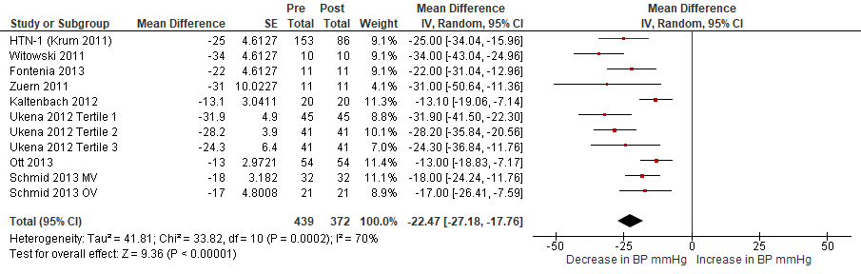

Figure Data from single arm studies of catheter-based RDN using a Simplicity RF device - Change from baseline in office SBP

Follow up was 6 months post RDN

In Schmid 2013, patients were stratified according to renal artery supply into one vessel (OV) (both sides) and at least multiple vessels (MV) (one side); In Ukena 2012, patients were grouped into tertiles according to baseline heart rate in beats per minute (bpm): Tertile 1 (≤60 bpm); Tertile 2 (61–70 bpm); and Tertile 3 (≥71 bpm).

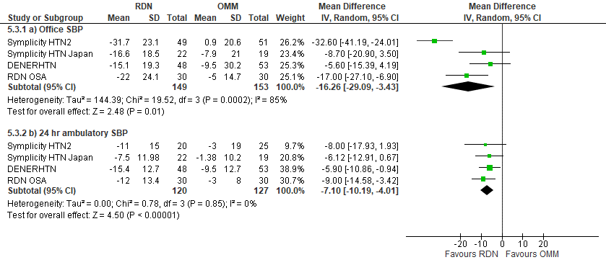

Figure Data from **open label randomised controlled studies** of catheter-based RDN using a Simplicity RF device - Change from baseline in in a) office SBP and b) 24 hr ambulatory SBP

Follow up was 6 months post RDN, with the exception of the RDN OSA study, where follow-up was 3 months.

Subsequently, however, the results of the sham-controlled SYMPLICITY HTN-3 and other early sham-controlled studies (Figure 4) failed to confirm a BP reduction compared to the sham procedure, and essentially led to the stalling of further development of RDN.

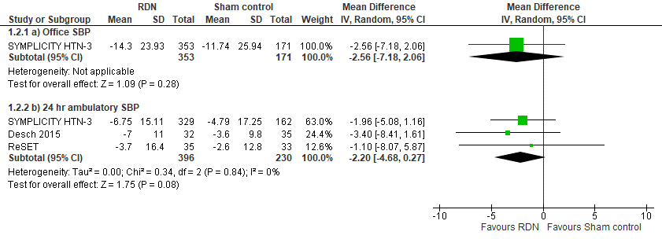

Figure Available data from **earlier** sham-controlled catheter-based RDN studies using a Simplicity RF device- Change from baseline in a) office SBP and b) 24 hr ambulatory SBP

Follow up was 6 months

*Post hoc* analysis of SYMPLICITY HTN-3 identified several confounding factors that may have caused the unexpected neutral results, especially the significant decrease in BP seen in the sham-control group (Kandarzi 2015).

1. the use of medications to treat hypertension and patient noncompliance with treatment were not adequately addressed.
   1. Prescribed medication changes were documented in 39% of patients during the study period, despite the protocol mandating no medication changes.
   2. Adherence to prescribed medications was not objectively monitored by blood or urine testing as part of the study protocol. Therefore, the actual rates of drug adherence and potential changes in drug adherence are unknown in HTN-3 and could have been different between groups.
2. The study population was predominantly North American with a significant proportion of Afro-Americans. Blood pressure reduction in the sham group was much larger in the subset of African Americans (26%) as compared to the non-African American subgroup. The explanation for this observation is uncertain but may also be tied to socioeconomic and other non-racial population demographic factors differentially impacting drug adherence between subgroups.
3. Substantial procedural variability may have occurred due to inexperience among study investigators.

Insights into the failings of the SYMPLICITY HTN-3 study served to inform discussions on the design of new and improved clinical trials of RDN (Mahfoud 2015 & 2017; FDA 2018).

Since then, data from two carefully designed, rigorously conducted, sham-controlled studies, utilising the upgraded Simplicity Spyral RF RDN system – the SPYRAL HTN-OFF MED and SPYRAL HTN-ON MED studies - have been published (Townsend 2017; Kandarzi, 2018). These studies took into consideration the pitfalls of SYMPLICITY HTN-3 and implemented a more robust design and vigorous follow-up.

The two studies included patients with early but well-established combined systolic/diastolic hypertension and high likelihood of response and excluded patients with end-stage renal disease, advanced hypertension, or isolated systolic hypertension. The SPYRAL HTN-OFF MED trial was a proof of concept study, designed to assess the efficacy of RDN in patients with HTN, in the absence of antihypertensive medications. The SPYRAL HTN-ON MED trial included patients with uncontrolled HTN on one, two or three antihypertensive medications and was designed to address the application of renal denervation in a setting representative of clinical practice for which integrating drug and procedural strategies might be anticipated. Both studies followed strict procedures to determine compliance with off-drug or on-drug designs. All in all, these trials were well designed and well run, utilising the best information available at the time.

Both studies provided remarkably consistent results confirming that RDN works and provides a clinical benefit (Figure 5). The results from these trials robustly support a benefit of the RDN concept.

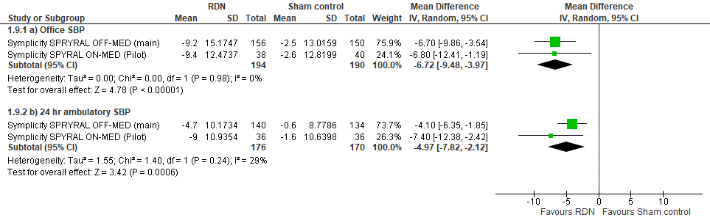

Figure Available data from **the newer- more robustly- designed** sham-controlled catheter-based RDN studies using a Simplicity RF device- Change from baseline in a) office SBP and b) 24 hr ambulatory SBP

Follow up was 6 months, with the exception of the SPYRAL OFF MED trial where follow up was 3 months.

**Long term data/Real world data for RDN using a Symplicity RF RDN device**

Real-world data supporting the benefit of RDN for the treatment of HTN, including longer term follow-up, is provided by the prospectively enrolling Global SYMPLICITY registry. The registry includes patients from 196 active sites worldwide with uncontrolled HTN and/or conditions associated with sympathetic nervous system activation who have been treated with the radiofrequency-based, single-electrode Symplicity Flex or multielectrode helical Spyral renal denervation systems.

An analysis of the registry data based on patients treated with the Symplicity Flex system followed up prospectively for 3-years were published recently by Mahfoud 2019. Out of a total of 2,237 patients in the database, 1,742 patients were eligible for 3-year follow-up. Baseline office and 24-h ambulatory systolic BP (SBP) were 166±25 and 154±18 mmHg, respectively. At 6 months after RDN, office SBP decreased by an average of -12.8±26.2 mmHg (n= 1691, P< 0.0001 vs. baseline) and 24-h ambulatory SBP by -7.2±17.8 mmHg (n=966, P<0.0001 vs. baseline). SBP reduction after RDN was sustained over 3 years, including decreases in both office (-16.5±28.6 mmHg, P < 0.001) and 24-h ambulatory SBP (-8.0±20.0 mmHg; P<0.001) (Figure 6).The 6-month change in office SBP was -21.7±24.0 (n=228, P<0.0001) specifically in patients with severe treatment-resistant hypertension, and -15.3±19.5 (n=55, P<0.0001) in patients with less severe hypertension. BP reductions were sustained to 3 years in both sets of patients (Figure 7).

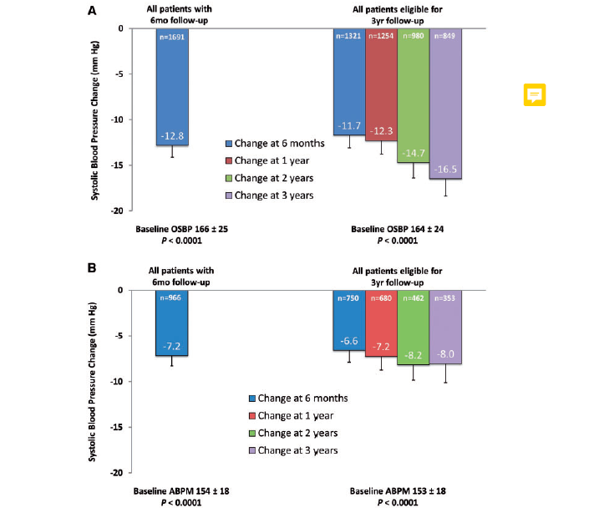

Figure Global Symplicity Registry analysis- 3 year follow-up: Change in (A) office SBP and (B) 24 hr ambulatory SBP  
Source: Mahfoud 2019

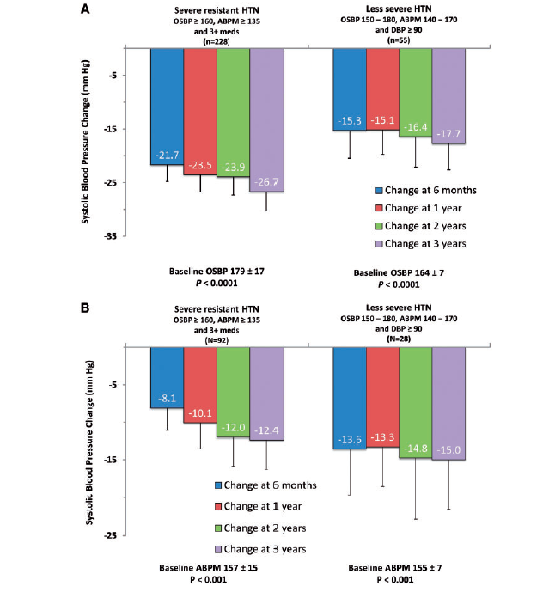

Figure Global Symplicity Registry analysis- 3 year follow-up: Change in (A) office SBP and (B) 24 hr ambulatory SBP stratified by patients with and without severe resistant hypertension

In the study, severe resistant hypertension was defined as office SBP ≥160 mmHg and 24-h ambulatory BP ≥135 mmHg, despite prescription of ≥3 antihypertensive medications; ‘less severe hypertension’ was defined as office SBP and diastolic BP 150–180mmHg and ≥90mmHg, respectively, and 24-h ambulatory SBP 140–170 mmHg.

Source: Mahfoud 2019

# PART 5 – CLINICAL ENDORSEMENT AND CONSUMER INFORMATION

## List all appropriate professional bodies / organisations representing the group(s) of health professionals who provide the service (please attach a statement of clinical relevance from each group nominated):

Statement to follow

## List any professional bodies / organisations that may be impacted by this medical service (i.e. those who provide the comparator service):

Not applicable

## List the consumer organisations relevant to the proposed medical service (please attach a letter of support for each consumer organisation nominated):

Not applicable

## List the relevant sponsor(s) and / or manufacturer(s) who produce similar products relevant to the proposed medical service:

Two renal denervation (RDN) systems are currently listed on the ARTG (including the Applicant’s product), both of which are catheter-based and use RF ablation technology (Table 2).

**REDACTED**

The Applicant is aware that there are other devices for catheter-based renal denervation, using RF or ablative technologies, for example: ultrasound, and local alcohol microinjection. **REDACTED**. At this point in time, to the applicant’s knowledge, there is only one ARTG device currently used in the Australian market (Symplicity Spyral). Therefore, the applicant proposes presenting only the evidence for this device. However, the applicant is open to recommendations from PASC regarding the scope of interventions and the evidence base they would like to see included in the application.

| ***Consideration of clinical evidence for catheter-based renal denervation using devices not currently listed on the ARTG***  *The Applicant seeks advice on whether presentation of data from clinical trials of catheter-based renal denervation involving devices previously listed but now removed from the ARTG, is required or appropriate in the Applicant Developed Assessment Report (ADAR).*  *The Applicant seeks advice on whether presentation of data from clinical trials of catheter-based renal denervation involving new devices in development, not listed on the ARTG, and which utilise radio frequency ablation, is required or appropriate in the ADAR.*  *The Applicant seeks advice on whether the presentation of data from clinical trials involving catheter-based renal denervation devices using ablation technologies other than radio frequency is required or appropriate in the ADAR (noting these devices are not listed on the ARTG).* |
| --- |

Table Catheter-based renal denervation device systems, catheters and generators which are currently listed on the ARTG

| **ARTG ID** | **Type of therapeutic good** | **Product name** | **Indication/Intended purpose** | **Manufacturer’s and/or Sponsor’s name** |
| --- | --- | --- | --- | --- |
| Catheters | | | | |
| 343930 | Medical Device Included Class IIb | Symplicity Spyral -  Radio-frequency ablation system renal denervation catheter | The Symplicity Spyral multi-electrode renal denervation catheter is indicated for the treatment of uncontrolled hypertension. | Medtronic Inc/  Medtronic Australasia Pty Ltd |
| 221818 | Medical Device Included Class IIb | EnligHTN -Radio-frequency ablation system renal denervation catheter | The Ablation Catheter is designed to deliver radiofrequency (RF) energy to the renal nerves to achieve targeted denervation. | St Jude Medical/  Abbott Medical Australia Pty Ltd |
| Generators | | | | |
| 198986 | Medical Device Included Class IIb | Symplicity system - generator, lesion, radio frequency | Symplicity Catheter System is intended to deliver low-level radiofrequency energy through the wall of the renal artery to denervate the human kidney.  The System may consist of a generator (to deliver the controlled radiofrequency energy at specific power, temperature and time settings) with its power cord, a foot pedal and an extension cable. | Medtronic Inc/  Medtronic Australasia Pty Ltd |
| 198878 | Medical Device Included Class IIb | EnligHTN system Generator, lesion, radio frequency | The EnlightN system RF ablation generator is intended to deliver RF energy to the Renal Artery Ablation Catheter | St Jude Medical/  Abbott Medical Australia Pty Ltd |

## Nominate two experts who could be approached about the proposed medical service and the current clinical management of the service(s):

REDACTED

*Please note that the Department may also consult with other referrers, proceduralists and disease specialists to obtain their insight.*

# PART 6 – POPULATION (AND PRIOR TESTS), INTERVENTION, COMPARATOR, OUTCOME (PICO)

PART 6a – INFORMATION ABOUT THE PROPOSED POPULATION

## Define the medical condition, including providing information on the natural history of the condition and a high level summary of associated burden of disease in terms of both morbidity and mortality:

**Medical condition**

HTN is a long-term medical condition in which BP in the arteries is persistently elevated. Left uncontrolled, HTN is a major risk factor for coronary artery disease, stroke, heart failure, atrial fibrillation, peripheral arterial disease, vision loss, chronic kidney disease, and dementia. As such, HTN represents a major public health issue (NHFA 2016).

*Clinical definition*

The practice guidelines of the National Heart Foundation Australia (NHFA 2016), the European Society of Cardiology and the European Society of Hypertension (ESC/ESH 2018 [Williams 2018]) define HTN as an average office systolic blood pressure ≥140 mmHg or an average diastolic blood pressure ≥90 mmHg (Table 3). The American Heart Association and American College of Cardiology (AHA/ACC) guideline (Welton 2017) has a stricter definition of HTN (≥130/80 mm Hg) (Table 3). Note, thresholds for diagnosis based on diagnosis ambulatory blood pressure measurement (ABPM) or home blood pressure measurement (HBPM) differ from those for office blood pressure measurement (OBPM) (Table 4).

Table 3 Classification of clinic/office blood pressure level in adults

| **NHFA 20161 and ESH/ESC2** | | | | **AHA/ACC 20173** | | | |
| --- | --- | --- | --- | --- | --- | --- | --- |
| Diagnostic category | **Systolic**  **mm Hg** |  | **Diastolic**  **mm Hg** | **BP category** | **Systolic**  **mm Hg** |  | **Diastolic**  **mm Hg** |
| Optimal | < 120 | and | < 80 | Normal | < 120 | and | < 80 |
| Normal | 120 - 129 | and/or | 80 – 84 | Elevated | 120 - 129 | and | < 80 |
| High normal | 130 – 139 | and/or | 85 -89 | Stage 1 hypertension | 130 -139 | or | 80 - 89 |
| Grade 1 (mild) hypertension | 140 – 159 | and/or | 90 -99 | Stage 2 hypertension | ≥140 | or | ≥90 |
| Grade 2 (moderate) hypertension | 160 - 179 | and/or | 100 – 109 |
| Grade 3 (severe) hypertension | ≥180 | and/or | ≥110 |
| Isolated systolic hypertension | >140 | And | > 90 |

American College of Cardiology; ACC, AHA, American Heart Association; ESC, European Society of Cardiology, ESH, European Society of Hypertension; NHFA, National Heart Foundation of Australia.

1. NHFA 2016
2. Williams 2018
3. \Welton 2017

Table Criteria for diagnosis of HTN using different methods of BP measurement

| **Method of BP measurement** | **Systolic BP mmHg** |  | **Diastolic BP mmHg** |
| --- | --- | --- | --- |
| Clinic/office | ≥ 140 | and/or | ≥ 90 |
| ABPM daytime (away) | ≥ 135 | and/or | ≥ 85 |
| ABPM night-time (sleeping) | ≥ 120 | and/or | ≥ 70 |
| ABPM 24 hrs | ≥ 130 | and/or | ≥ 80 |
| HBPM | ≥ 135 | and/or | ≥ 85 |

ABPM, ambulatory blood pressure measurement; BP, blood pressure; HBPM, home blood pressure measurement, mmHg millimetres of mercury

Source NHFA 2016

**Aetiology**

Essential or primary HTN (that is, high blood pressure that does not have a known secondary cause) may be attributed to multiple factors, including genetic predisposition, activation of neurohormonal systems and environmental risk factors (sodium and potassium intake, smoking; alcohol intake, body mass index, physical fitness, stress), that may interact to produce hypertension (Carretero 2000; Bolivar 2013). It has also become apparent that an inflammatory process often accompanies hypertension. Activated immune cells infiltrate and alter the function and structure of various organs, including the vasculature and the kidney. The inflammatory process is not thought to cause hypertension on its own, but rather to intensify dysfunction of the kidney and the vasculature. That is, it promotes BP elevation as well as the end-organ damage associated with hypertension (Trott, 2014; Chan 2015).

**Pathophysiology**

Blood pressure (BP) is controlled by a complex interaction of electrical, mechanical, and hormonal forces in the body (Figure 8). The main electrical component of blood pressure control is the sympathetic nervous system (SNS), which is part of the body’s autonomic nervous system (ANS), and operates without conscious control. The SNS connects the brain, heart, blood vessels, and kidneys, each of which plays an important role in the regulation of the body’s BP. The SNS supplies catabolic signals to all parts of the body. Its functions are directed toward energy use, and it prepares the body for combat or escape, known as the “fight or flight” response (Gordan 2015).

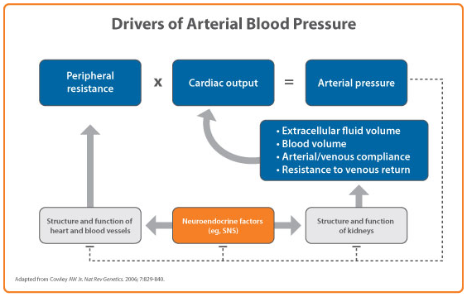

Figure Factors impacting on blood pressure

Source: Al-Saffar 2014, Figure 1.

The renal sympathetic nervous system plays a key role in BP regulation and in hypertension (Figure 9) (Sata 2019). The system comprises two parts: the efferent arm and the afferent arm.

The renal afferent sympathetic nerves, which terminate at the blood vessels, the juxtaglomerular apparatus, and the renal tubules, bring sympathetic signals from the central nervous system (CNS) to the kidneys. These signals cause increased renin release, sodium retention, and reduction of renal blood flow. In hypertensive patients, efferent sympathetic signalling is increased, causing over-stimulation of these components and contributing to the rise in BP.

From the other direction, the renal efferent nerves carry signals from the kidney to the CNS, thereby influencing sympathetic outflow to the kidneys and other organs involved in cardiovascular control (e.g., heart, peripheral blood vessels). Thus, elevated sympathetic drive creates positive feedback adversely impacting vasculature, the heart, and kidneys, which play a critical role in hypertension.

The involvement of the renal afferent and efferent sympathetic nerves at the interface of blood pressure regulation, and the well acknowledged concept that renal sympathetic overactivity leads to the development and progression of HTN provides the rational for renal nerve ablation as an approach to poorly manageable cases of HTN (Figure 9).

Picture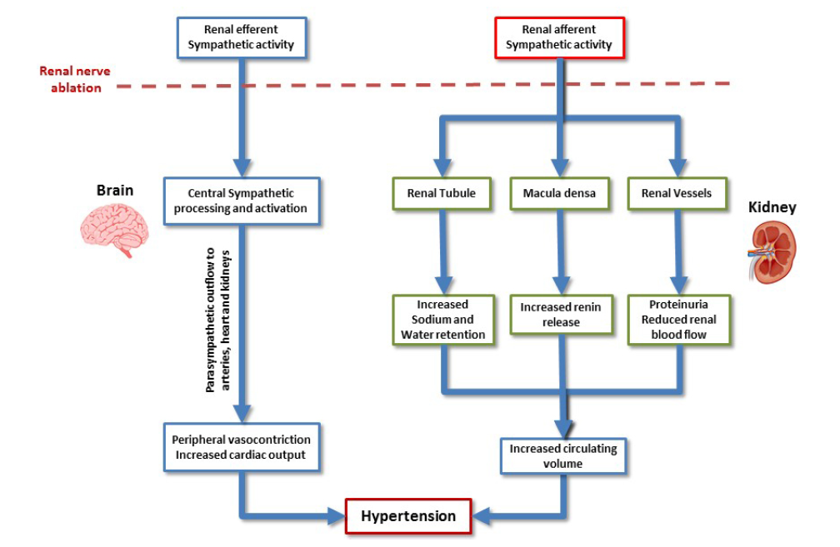

Figure Contribution of the renal sympathetic system to the genesis of hypertension

Afferent fibres originating from the central nervous system targets the kidney at different tissue levels enhancing sodium and water retention, increasing renin release and decreasing renal blood flow which ultimately lead to an increased circulating volume. Efferent fibres arising from the renal pelvis conveys, in turn, sympatho-excitatory stimuli to autonomic regulatory nuclei in the midbrain leading to peripheral vasoconstriction and increased cardiac rate and output.

Source: Bolignano 2019

**Burden of HTN disease**

HTN is the worldwide leading preventable cause of death, primarily due to its strong association with increased risk for heart attack, stroke, heart failure, and kidney disease.

It has been established that the risk of cardiovascular mortality rises linearly with increases above age-related targets in blood pressure - doubling for every 20 mm Hg (systolic) and 10 mm Hg (diastolic) increase above 115/75 mm Hg (Lewington et al 2002).

HTN remains an ineffectively treated pandemic with a global prevalence of roughly 35%, with about 65% of cases uncontrolled (Figure 10).

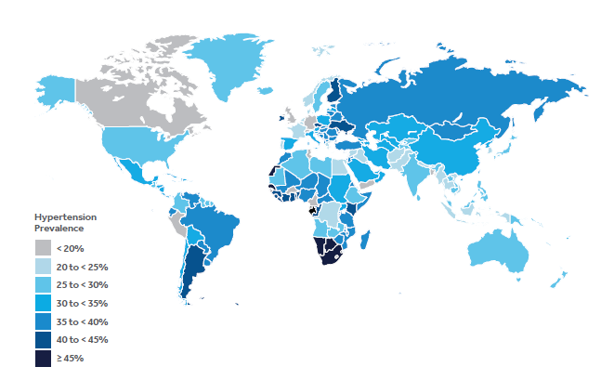

Figure Global rates of hypertension

Source: Mills 2016

The treatment of HTN remains an ongoing health priority for the Australian government. Based on measured data from the 2017–18 Australian Bureau of Statistics National Health Survey (AIHW, 2019a):

* About 1 in 3 people aged 18 and over (34%) were found to have high blood pressure, as defined by a BP ≥140/90 mmHg. This comprised 23% with uncontrolled high blood pressure; and 11% whose blood pressure was controlled using medication(s).
* Men were found to be more likely to have uncontrolled high blood pressure than women - 1 in 4 men (25%) had uncontrolled high blood pressure compared with 1 in 5 (20%) women.
* The proportion of adults with uncontrolled high blood pressure increased with age - from 10% or less among 18–34 year-olds (10% for men and 4.9% for women) to a peak of 47% at age 85 and over (51% for men and 48% for women).
* Uncontrolled high blood pressure was found to be significantly more common in the lowest socioeconomic areas where 1 in 4 people (24%) have uncontrolled high blood pressure, compared with 1 in 5 (19%) people in the highest socioeconomic areas.

Based on data for 2015, 5.8% of the total burden of disease in Australia was due to high blood pressure (AIHW 2019b) and about 21% of high blood pressure burden in Australia was attributed to a diet high in sodium—higher for men (23%) than women (17%)—based on unpublished estimates from the Australian Burden of Disease Study (ABDS).

In 2018, CVD was the underlying cause of death in 41,800 deaths in 2018 (26% of all deaths) according to the Australian Institute of Health and Welfare (AIHW 2020a) National Mortality Database. Over 60% of these deaths were due to coronary heart disease (CHD) or stroke- both linked to hypertension as a major causative risk factor. In terms of contributing causes of death, hypertensive diseases were ranked for both men and women (AIHW 2020b).

Vascular events associated with HTN represent a significant burden to the Australian healthcare system. During 2015-16, CVD alone was responsible for the second highest level of healthcare expenditure of any disease group, costing $10.4 billion (AIHW, 2019c).

Hypertension, and in particular uncontrolled HTN, therefore represent a substantial health burden in Australia. It is noteworthy that while approximately one third of Australians have been told by a doctor that they have high BP, only half are reported to be taking their prescribed medication (NHFA, 2016). As such it is important that improvements are made in managing individuals with HTN in order to reduce the costly burden of CVD.

## Specify any characteristics of patients with the medical condition, or suspected of, who are proposed to be eligible for the proposed medical service, including any details of how a patient would be investigated, managed and referred within the Australian health care system in the lead up to being considered eligible for the service:

The proposed medical service is intended as a one-time treatment, in addition to standard of care antihypertensive medication, in patients with uncontrolled HTN for whom the use of additional medication is unlikely to be more than minimally effective or tolerated.

Specifically, it is proposed that patients eligible for the proposed service are those with **confirmed uncontrolled elevated systolic blood pressure ≥ 150 mmHg, despite optimised treatment with** **three or more antihypertensive drugs, or who are intolerant to antihypertensive medication**.

Prior to considering the patient as a potential candidate for the proposed medical service , the GP or HTN specialist or general cardiologist treating the patient would need to have ruled out the presence of white coat HTN[2], and any secondary causes of HTN; and ensured that the patient’s antihypertensive regimen was optimised for effectiveness and tolerability.

Local expert clinical opinion on the proposed patient population also suggests RDN be **further limited to the patient population with the greatest clinical need based on CVD risk, on the basis of the presence of one or more or the following CVD high risk factors:**

* **Systolic BP > 180mm Hg**
* **Previous myocardial infarction or stroke**
* **Type II Diabetes**
* **Chronic kidney disease**
* **Atrial fibrillation**
* **Heart failure**

*The proposed eligibility criteria have been developed in consultation with local expert clinicians and are considered relevant to the Australian patient population and applicable in clinical practice.*

It is proposed that eligibility for the proposed service does not have an absolute requirement to rule out poor adherence to antihypertensive medication, although adherence should of course be strongly encouraged and facilitated as far as is possible (see Box below).

| ***Note on medication adherence***  It has been widely acknowledged that adherence to antihypertensive medication is generally poor, (Burnier 2019) and may be particularly so in heavily treated patients.  Barriers to adherence to antihypertensive medication may include the asymptomatic nature of hypertension; depression; comorbidities; low health literacy; medication complexity, cost, and concerns; use of alternative medicine; poor health care system perceptions; perceived discrimination; poor communication or provider-patient interaction; medication side effects; forgetfulness; inadequate social support or coping; caring for dependents; and lack of motivation for self-care (Peacock 2017). Strategies to maximized adherence include communication, tailoring advice and maintaining motivation (NHFA 2016) but these may not be effective, especially in the longer term.  Even in the setting of clinical trials, high rates of non-adherence to antihypertensive medications have been reported, despite protocols to discourage this (such as objective monitoring of drug use). For example: the DENERHTN trial of renal denervation added to a standardized stepped-care antihypertensive treatment for resistant hypertension and reported around 50% patients were non-adherent to their medications (Azizi 2016); in the SPYRAL HTN ON-MED pilot, approximately 40% of patients were found to be non-adherent (Kandzari 2018).  It is noteworthy that the 2013 finalised DAP for RDN documents that “*PASC acknowledges that it may be impossible to rule out non-compliance to specific aspects of previous treatment……In addition, PASC recognises that patients who are unable to adhere to medication due to intolerance or cognitive difficulties could also benefit from the proposed service.”.*  *[Source: http://www.msac.gov.au/internet/msac/publishing.nsf/Content/60408107686574D0CA25801000123BD2/$File/1338-FinalDAP.pdf]* |
| --- |

## How a patient would be investigated, managed, and referred within the Australian health care system in the lead up to being considered eligible for the service:

The diagnosis and onward management of patients with HTN mainly takes place in the primary health care setting. The pathway from diagnosis of HTN to the point of being considered eligible for the service is summarised in the flow charts provided in Attachment 1, Attachment 2 and Attachment 3.

Where HTN is suspected through routine office blood pressure (OBP) assessment, confirmation of a diagnosis of HTN and treatment decision making require a comprehensive BP measurement, medical history, physical examination and assessment of absolute CVD risk (where appropriate)(NHFA 2016).

Comprehensive assessment of BP should be based on multiple OBP measurements taken on several separate occasions, at least twice, one or more weeks apart, or sooner if the BP elevation is severe. While a modest predictor of CVD, OBPM remains the only BP measure to be validated when measuring CVD risk using available CVD risk calculators. OBPM is, however, subject to considerable error and variation, including white coat HTN. ABPM or HBPM provide different but complementary information which can help to build an accurate blood pressure profile on which to base diagnosis and treatment.

The current clinical management algorithm for patients with newly diagnosed hypertension, according to NHFA 2016 guidelines, is outlined in Attachment 1. Based on current NHFA, AHA/ACC and ESC/ESH guidelines, a cardiovascular disease (CVD) risk-based approach is considered best for determining when to begin treatment for lowering blood pressure and what the treatment target should be (Table 5).The Australian and European guidelines are similar on when to start therapy, but Australia has lower treatment targets. Commensurate with the stricter definition of hypertension, the AHA/ACC guidance recommends commencing treatment at a lower threshold and recommends stricter targets.

Life-style advice, including not smoking, eating a nutritious diet and regular adequate exercise is recommended for all patients. The initiation of antihypertensive therapy takes into consideration the patient’s baseline 5-year risk of CVD.

Antihypertensive therapy should be initiated in patients with low absolute CVD risk (<10% 5-year risk) with persistent BP ≥160/100 mmHg or moderate absolute CVD risk (10% -15% 5-year risk) and persistent SBP≥140 with DBP ≥90 mmHg. All patients with high absolute CVD risk (>15% 5-year risk) should be started on drug treatment immediately.

| ***Note on patient eligibility for absolute CVD risk assessment on the MBS***  *On 1 April 2019, two new interim items were introduced onto the Medicare Benefits Schedule (MBS) to support the delivery of Heart Health Checks in primary care: Items 699 (for general practitioners (GPs) and 177 (for other medical practitioners working in general practice). These items support the ongoing assessment and management of absolute CVD risk in primary care for eligible patients 45 years and over (30 years and over for Aboriginal and Torres Strait Islander patients).* |
| --- |

*Table 5 Comparison of international guidelines for the treatment of hypertension*

|  | **Australia: NHFA 20161** | | **Europe: ESC/ESH 20172** | | **US: AHA/ACC 20173** | |
| --- | --- | --- | --- | --- | --- | --- |
| **HTN definition mmHg** | ≥140/90 | | ≥140/90 | | ≥130/80 | |
|  | **Start treatment** | **Treatment target** | **Start treatment** | **Treatment target** | **Start treatment** | **Treatment target** |
| General population | ≥160/100a | <140/90 | ≥160/90a | <130/80 | ≥140/90 | <130/80 |
| High CV risk | ≥140/90 | <120/- | ≥140/90b | <130/80 | ≥130/80 | <130/80 |
| Older agec | ≥ | <120/- | ≥140/90  Age≥80 yrs: 160/90 | <130/80 | ≥130/- | <130/- |
| Diabetes | ≥140/90 | <120/90 | ≥140/90 | <130/80 | ≥130/80 | <130/80 |
| Kidney disease | ≥140/90 | <120/90 | ≥140/90 | <140/90 | ≥130/80 | <130/80 |

1. For those with a SBP of 140-159 mmHg treatment may begin after a period of lifestyle advice
2. Treatment may be considered in those with coronary disease or stroke with an SBP of 130-140 mmHg
3. Older people are: ≥75 years in Australian guidelines; ≥65 years in European and US guidelines

1. NHFA 2016

2. Williams 2018

3. Whelton 2017

Source: Atkins 2019

There are a number of different classes of antihypertensive drugs available. The major classes include angiotensin-converting enzyme (ACE) inhibitors, angiotensin receptor blockers (ARBs), calcium channel blockers (CCBs), beta-blockers (BBs), diuretics. The class or classes of drug selected for a patient depends on the patient’s age, presence of associated clinical conditions or end organ damage, potential interaction with other drugs and implications for adherence, cost and patient choice. Despite differences in mechanism, single drug therapy with first line classes of thiazide diuretics, CCB, ACE inhibitors, or ARBs are considered similar in terms of efficacy. However, an ACE inhibitor plus CCB combination is superior to an ACE inhibitor plus diuretic combination or beta-blocker and diuretic combination. Drug treatment strategy as recommended by the NHFA 2016 guidelines is outlined in Attachment 2.

Essentially patients are initiated with a low-moderate recommended dose of a first line drug, which if not tolerated, should be exchanged for a low-moderate dose of an antihypertensive drug of a different pharmacological class. If the target BP is not achieved after 3 months, a second drug of a low-moderate dose of a different pharmacological class is added on to the first therapy.

Adding on the second drug is preferential to increasing the dose of the first in order to avoid side effects. If the target BP is not achieved after 3 months and antihypertensive drugs have been well-tolerated by the patient, it is recommended that the dose of one of the drugs is increased incrementally to the maximum tolerated dose (MTD) (excluding thiazide diuretics) before increasing the dose of the other drug. If the target BP is not achieved after 3 months, despite maximum tolerated doses (MTDs) of at least two drugs, a third class of drug may be initiated, at a low-moderate dose.

At this stage it is recommended the patient is investigated, either by the GP or after referral to a specialist (HTN specialist or a general cardiologist) to identify and then manage possible causes of suboptimal blood pressure control. Possible causes could include: pseudo-hypertension as a result of poor-adherence to therapy or hypertension only in a clinical setting; suboptimal drug therapy; secondary hypertension resulting from an undiagnosed underlying condition (e.g., sleep apnoea; kidney disease, diabetes); hypertensive effects arising from other medications the patient may be taking; poor lifestyle (e.g., diet, exercise, smoking; undisclosed alcohol use, recreational drug use or high salt intake). Investigations could include a physical examination, urine and blood analysis, electrocardiogram (ECG), echocardiogram, ankle-brachial index (ABI), carotid Doppler and renal artery duplex ultrasound, renal nuclear medicine imaging, and/or CT angiography.

If blood pressure remains elevated above target after the addition of a third medication, then, consistent with the NHFA 2016 guidelines, and if not already done so, a GP should consider referring patients on to seek the advice of a specialist. If not already performed under the care of the GP, the HTN specialist or general cardiologist will investigate the patient for white coat and secondary causes of HTN and instigate optimal medical management of the patient.

Currently, continued optimal medical management, usually involving care advice from a HTN specialist or general cardiologist, remains the only option for these patients. The NHFA 2016 guidelines provide no specific recommendations regarding the onward management of patients at this stage, noting only that, under specialist advice, spironolactone many be used as an add-on drug in some patients. The European and US guidelines also suggest spironolactone may be considered as a fourth medication (Carey 2018; Williams 2018). However, while spironolactone has been shown in several clinical trials to be effective as an add-on hypertensive therapy, it has also been associated with high discontinuation rates (Williams 2015; Zhao 2017; Wang 2016; Rosa 2016; de Souza 2010) and, as such, its use in clinical practice as a fourth drug is limited by tolerability issues in some patients, including the development of hyperkalaemia in patients with CKD with an eGFR <45 mL/min/1.73m2 or baseline serum potassium >4.5 mEq/L (Lazich, 2014). Furthermore, prolonged use at higher doses can cause gynecomastia and erectile dysfunction in men and menstrual irregularities in women (Patibandla 2020). *It should be noted that, at the time of the publication of the NHFA Guidelines, spironolactone was not TGA registered as a BP lowering agent. However, it is now registered in the indication of essential hypertension and is available unrestricted on the PBS.*

It is proposed that where a patient has confirmed uncontrolled elevated systolic blood pressure ≥ 150 mmHg, despite optimal medical management AND, at high risk for CVD, based on having one or more of the following: SBP > 180 mmHg; previous myocardial infarction or stroke; diabetes; chronic kidney disease atrial fibrillation or heart failure, **this is** **the point at which they would be considered a potential candidate for the proposed service and would be referred to an interventional cardiologist (Orange Box, Attachment 3).**

Once the patient has been considered by the interventionist as provisionally being suitable for RDN, and the patient preference is to be treated by RDN, they would be booked in to receive the procedure. However, only after an aortogram and selective renal angiography is performed, immediately prior to the RDN procedure, can the patient’s renal anatomy be confirmed as eligible for RDN[3]. **Confirmation of suitable renal anatomy is the point at which the patient can be considered eligible for the proposed medical service (Blue Box, Attachment 3).**

## Define and summarise the current clinical management pathway *before* patients would be eligible for the proposed medical service (supplement this summary with an easy to follow flowchart [as an attachment to the Application Form] depicting the current clinical management pathway up to this point):

The clinical management pathway before patients would be eligible for the proposed medical service has already been described in the response to Question 26.

Where a patient has confirmed uncontrolled elevated systolic blood pressure ≥ 150 mmHg, despite optimal medical management (including optimised medication with three or more antihypertensive drugs unless intolerant) AND at high risk for CVD (based on having one or more of the following: SBP > 180 mmHg; previous myocardial infarction or stroke; diabetes; chronic kidney disease atrial fibrillation or heart failure) then they could be considered a potential candidate for the proposed service and be referred to an intervention cardiologist (Orange Box, Attachment 3).

The patient would then be scheduled in for the RDN procedure. However, a patient would be considered ineligible to complete the service if the aortogram/selective renal angiogram, which are required immediately prior to the RDN procedure, shows that the renal anatomy is not suitable for RDN.

A series of flow charts depicting the current clinical management pathway up to this point is provided in Attachment 1, Attachment 2 and Attachment 3.

PART 6b – INFORMATION ABOUT THE INTERVENTION

## Describe the key components and clinical steps involved in delivering the proposed medical service:

The proposed medical service is catheter-based renal denervation. Renal denervation (RDN) utilises ablative technology to selectively disrupt the renal sympathetic nervous system in a localised and minimally invasive manner at the level of the kidney using an endovascular approach.

There are a number of catheter-based systems currently available in overseas markets or in development that use different ablation technologies including radiofrequency, ultrasound and tissue directed pharmacological ablation systems.

As the only device currently in the market in Australia uses radiofrequency ablation, the procedure described here relates to this group of devices. However, the broad procedural steps involved for the delivery of the service (assessment of suitability and catheter insertion and ablation) and resource requirements are applicable across all catheter-based modalities of RDN.

The proposed medical service is to be undertaken in an appropriate catheterisation laboratory with the patient being admitted as an inpatient in hospital. Typically, a patient admitted early in the morning for their procedure would be permitted to go home in the afternoon. A patient admitted later in the day would generally be required to stay overnight. The procedure is typically performed under conscious sedation by a suitably qualified interventionist (interventional cardiologists, interventional radiologists, vascular surgeons and interventional nephrologists) with adequate experience in catheterisation and angioplasty of renal arteries as well as the necessary technical resources available for the management of any immediate complications that may occur. The total procedure, including denervation of both kidneys, is estimated to take approximately 1.5-2 hours to complete.

The service comprises an initial aortogram/selective renal angiogram to determine patient suitability (including vessel calibre, length, diameter, angle of origin and the presence of atherosclerotic plaque) and subsequent RDN procedure, if eligible, as described below.

**Patient preparation and assessment of suitability**

1. Prior to starting the procedure, administer appropriate systemic anticoagulation (such as heparin) to the patient.
2. A grounding pad is attached to left thigh (shaved for improved contact if required)
3. A local anaesthetic is applied prior to sheath introduction, and repeated as required throughout procedure.
4. Patient is prepared for catheter placement using standard interventional techniques.
5. Under fluoroscopy, a full renal angiogram is performed to trace the route to the renal arteries, assess anatomy and identify any potential obstacles or contraindications to renal denervation.

Note: based on the clinical trials, it is estimated that approximately 5% of patients would not proceed past the renal angiogram to receive the renal ablation procedure due to anatomical contraindications such as the presence of potential obstacles, aneurysms, severe stenosis, reference diameter < 4 mm, and excessive tortuosity. In clinical practice, this is expected to be lower (2-5%).

In these instances, the medical service fee charged would total $937.05 comprising both MBS item 60027 (Digital subtraction angiography, examination of abdomen, Fee=$839.50; Expert opinion describes 4-6 DSA runs as typical, one for each artery before and after) and MBS item 60075 (Selective arteriography or selective venography by digital subtraction angiography technique—2 vessels, Fee=$97.55).

**Catheter Insertion and ablation**

1. Once suitability for RDN is confirmed, sedation or analgesia is administered.
2. As shown in Figure 11, the catheter is percutaneously introduced via the femoral artery and positioned to the distal region of the renal artery (close to the renal hilum) under angiographic guidance using a 6F or larger calibre guide.
3. Under fluoroscopic guidance, the catheter is advanced until the distal electrode is located in the renal artery at the established treatment zone.
4. Adequate wall contact is assessed. Strict contact between the ablation device and renal artery wall is required to ensure maximal efficacy prior to balloon expansion, release of a self-expanding shape memory polymer cage, or by the 3D-structure of some renal ablation devices that take on a helicoidal or spiral shape after removal of the guidewire.
5. The generator is then activated, and radiofrequency energy is delivered to the artery wall. The number of ablations required per renal artery is dependent on the device used (number and distribution of electrodes) and renal anatomy[4].
6. After ablative treatment ends (whether by RF, US or pharmacological ablation) the procedure can be repeated in distal segments of the same renal artery with sufficient diameter to accommodate the device or in the contralateral renal artery.
7. At the end of the procedure, an angiogram of the renal arteries is performed to check for the presence of renal artery dissection or infarct.

The patients are observed for 2 hours post-procedure.

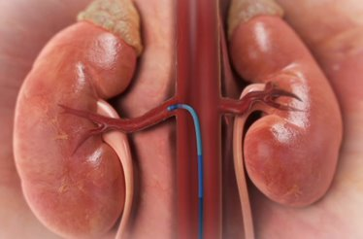

**Figure 11 Guide in the Renal Artery**

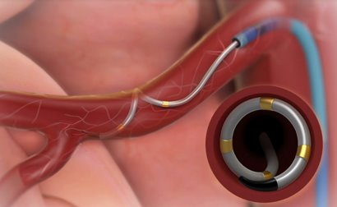

**Figure 12 Positioning of Catheter in the Artery**

## Does the proposed medical service include a registered trademark component with characteristics that distinguishes it from other similar health components?

No, the proposed medical service does not include a registered trademark.

## If the proposed medical service has a prosthesis or device component to it, does it involve a new approach towards managing a particular sub-group of the population with the specific medical condition?

RDN offers a new one-time treatment approach, in addition to standard of care antihypertensive medication, in patients with confirmed HTN who remain with uncontrolled elevated blood pressure ≥ 150 mmHg despite optimised treatment with three or more antihypertensive drugs, , or who are intolerant to antihypertensive medication, AND are at high risk of CVD based on the presence of one or more specified risk factors.

## If applicable, are there any limitations on the provision of the proposed medical service delivered to the patient (i.e. accessibility, dosage, quantity, duration or frequency):

The proposed medical service is to be undertaken in specialist centres with appropriate catheterisation laboratory and emergency stenting facilities.

It is not anticipated that a repeat treatment would be of clinical value. Subsequently, the procedure is limited to once per patient per lifetime.

## If applicable, identify any healthcare resources or other medical services that would need to be delivered at the same time as the proposed medical service:

As suitability for the procedure can be assessed using an aortogram and selective renal angiogram included as part of the procedure (see response to Question 28), no other imaging services are required prior to the proposed medical service.

Multiple angiographic imaging of the renal arteries is required to guide the renal denervation procedure and document the position of the catheter with digital subtraction angiography often used to minimise contrast usage. Angiography is also performed at the end of each procedure to confirm the absence of damage to the renal artery. Consistent with the DAP for RDN in 2013 (DAP-1338, p14), the costs of angiography required throughout the procedure are included as part of the proposed fee.

All patients should continue to receive optimal medical management for HTN including optimised pharmacological therapy.

## If applicable, advise which health professionals will primarily deliver the proposed service:

The procedure will be primarily performed by suitably qualified interventional cardiologists who have adequate experience in catheterisation and angioplasty of renal arteries as well as the necessary technical resources available for the management of any immediate complications that may occur.

## If applicable, advise whether the proposed medical service could be delegated or referred to another professional for delivery:

The medical service could be performed by interventional radiologists and interventional nephrologists who have undergone the appropriate training.

## If applicable, specify any proposed limitations on who might deliver the proposed medical service, or who might provide a referral for it:

The applicant proposes that there should not be any limitations on who will be able to deliver the proposed service only that they should be suitably qualified as described in response to Question 33 and Question 34.

## If applicable, advise what type of training or qualifications would be required to perform the proposed service, as well as any accreditation requirements to support service delivery:

With respect to the use of the Symplicity Spyral, all operating healthcare professionals will need to undergo training through the manufacturer.

The RDN procedure is performed according to the Symplicity Spyral catheter Instructions for Use, Symplicity G3 generator User Manual, and associated training provided by the sponsor, including online training, web-based workshops and remote or onsite proctoring.

Advice received from local clinical experts suggests most interventionist cardiologists should be proficient in the procedure following training in 5-10 cases.

## (a) Indicate the proposed setting(s) in which the proposed medical service will be delivered (select ALL relevant settings):

Inpatient private hospital (admitted patient)

Inpatient public hospital (admitted patient)

Private outpatient clinic

Public outpatient clinic

Emergency Department

Private consulting rooms - GP

Private consulting rooms – specialist

Private consulting rooms – other health practitioner (nurse or allied health)

Private day surgery clinic (admitted patient)

Private day surgery clinic (non-admitted patient)

Public day surgery clinic (admitted patient)

Public day surgery clinic (non-admitted patient)

Residential aged care facility

Patient’s home

Laboratory

Other – please specify below

1. **Where the proposed medical service is provided in more than one setting, please describe the rationale related to each:**

It is anticipated that catheter-based RDN will be provided in hospitals with available catheterisation laboratory facilities, in either Public or Private settings. Patients undergoing RDN would be admitted as inpatients. A patient admitted in the early morning would usually be sent home within the same day. A patient admitted in the afternoon would require an overnight stay.

## Is the proposed medical service intended to be entirely rendered in Australia?

Yes

No – please specify below

PART 6c – INFORMATION ABOUT THE COMPARATOR(S)

## Nominate the appropriate comparator(s) for the proposed medical service, i.e. how is the proposed population currently managed in the absence of the proposed medical service being available in the Australian health care system (including identifying health care resources that are needed to be delivered at the same time as the comparator service):

The proposed medical service is intended for patients with uncontrolled hypertension, who have exhausted therapy options and who are at an increased cardiovascular risk. Continued optimal medical management is currently the only treatment option for these patients. The proposed medical service, RDN, is intended as a one-time treatment to be used in addition to optimal medical management.

As such, in the target patient population, “no RDN treatment” is nominated as the comparator to RDN in the “real world” setting; sham procedure is nominated as comparator to RDN in the clinical trial setting.

The appropriate clinical comparison to be presented in the ADAR is therefore:

“**RDN procedure in addition to optimal medical management**

**vs**

**Sham procedure in addition to optimal medical management”**

## Does the medical service (that has been nominated as the comparator) have an existing MBS item number(s)?

Yes (please list all relevant MBS item numbers below)

No

Not applicable

## Define and summarise the current clinical management pathway/s that patients may follow *after* they receive the medical service that has been nominated as the comparator (supplement this summary with an easy to follow flowchart [as an attachment to the Application Form] depicting the current clinical management pathway that patients may follow from the point of receiving the comparator onwards, including health care resources):

As mentioned earlier, the nominated comparator to RDN in addition to optimal medical management is optimal medical management alone.

A flow chart depicting the current clinical management pathway is provided in Attachment 3.

## (a) Will the proposed medical service be used in addition to, or instead of, the nominated comparator(s)?

In addition to (i.e. it is an add-on service)

Instead of (i.e. it is a replacement or alternative)

## If instead of (i.e. alternative service), please outline the extent to which the current service/comparator is expected to be substituted:

Not applicable

## Define and summarise how current clinical management pathways (from the point of service delivery onwards) are expected to change as a consequence of introducing the proposed medical service, including variation in health care resources (Refer to Question 39 as baseline):

RDN is intended as a one-time treatment to be used in addition to ongoing optimal medical management. As such, patients receiving RDN would be expected to continue with their medications post procedure and be monitored as usual, with adjustments made as necessary to maintain optimal BP control and tolerability. In this respect, there would be minimal change in health care resources regarding BP management.

Patients receiving RDN benefit from a clinically significant and “always on” reduction in BP, which is not dependent on medication adherence, and has a greater reduction in SBP compared to medical management alone. These patients would be expected to have a lower risk of experiencing cardiovascular events and other negative health outcomes attributed to poorly controlled HTN. As such, RDN would be expected to result in an overall reduction in healthcare resource utilisation associated with treating the long-term consequences of uncontrolled HTN.

**A flow chart showing current and proposed clinical management pathways is provided in Attachment 3.**

PART 6d – INFORMATION ABOUT THE CLINICAL OUTCOME

## Summarise the clinical claims for the proposed medical service against the appropriate comparator(s), in terms of consequences for health outcomes (comparative benefits and harms):

It is proposed that RDN, used as a one-time treatment in addition to optimal medical management, has superior efficacy (as measured by SBP) and acceptable (inferior but manageable) safety, compared to ongoing optimal medical management alone.

## Please advise if the overall clinical claim is for:

Superiority

Non-inferiority

## Below, list the key health outcomes (major and minor – prioritising major key health outcomes first) that will need to be specifically measured in assessing the clinical claim of the proposed medical service versus the comparator:

Health outcomes to be included in the evaluation of RDN in addition to ongoing optimal medical management vs sham in addition to ongoing optimal medical management are summarised below.

**Safety Outcomes:**

Adverse events related to undergoing RDN: the risk of adverse events is expected to be low.

Safety outcomes will include, but not necessarily limited to: Pseudoaneurysm; Backpain; Renal artery perforation; Renal artery dissection; End-stage renal disease; Vascular complications; Hypotension; Hospitalisation for hypertensive crisis not related to non-adherence with medications; Mortality.

**Clinical Effectiveness Outcomes:**

Change in Systolic and diastolic blood pressure (24 hr ABPM; OBPM)

Incidence of achieving target office systolic blood pressure

Clinical outcomes of cardiovascular or renal disease (e.g. stroke; heart failure)

Quality of life

Mortality

*Due to insufficient sample size and duration of follow up, clinical outcomes, mortality and quality of life will likely be derived via economic modelling using SBP as a surrogate.*

Abbreviations: ABPM, ambulatory blood pressure measurement; OBPM, office blood pressure measurement.

# PART 7 – INFORMATION ABOUT ESTIMATED UTILISATION

## Estimate the prevalence and/or incidence of the proposed population:

As previously described in response to Question 25, the prevalence of HTN in Australia is estimated to be approximately 34% of the total adult population of whom 23% have had uncontrolled high blood pressure and 11% have blood pressure controlled using medication (Australian national health survey 2017-2018).

The proposed population targeted for the proposed medical service is defined as having confirmed uncontrolled elevated systolic blood pressure ≥ 150 mm Hg, despite optimised treatment with three or more antihypertensive medications, unless intolerant. The proportion of the HTN population meeting these criteria are discussed below and summarised in Table 6.

A recent analysis of a 10% PBS sample of adult patients prescribed antihypertensive medications during the period from July 2012 to December 2018 (Falster 2020) demonstrated that approximately 4.25 million Australians were on antihypertensive medications in 2018 (scaled up to represent the total Australian population), of whom, approximately 53% of patients were receiving one antihypertensive medication, 33% receiving two medications;12% receiving three medications; and 3% receiving four or more medications; indicating 15% (over 620,000 patients) were taking at least three medications (Figure 12).

The proportion of patients on three or more medications whose HTN remains uncontrolled is estimated to be approximately 72.2% based on a large cross sectional survey of the US population conducted by the National Center for Health Statistics of the Center for Disease Control and Prevention which aimed to determine the prevalence of treatment resistant HTN, where treatment resistant HTN is defined as failure to achieve recommended blood pressure (BP) treatment targets on 3 antihypertensive medications or require ≥4 medications to achieve their targets (Carey 2019). In this study, patients were considered “apparent treatment resistant HTN” on the basis that pseudo-HTN (due to incorrect medication dose, poor adherence, or white coat HTN) could not be excluded. Applying the estimate of 72.2% to the Falster 2018 data, the Australian population with uncontrolled HTN despite three or more medications is estimated to be approximately 450,000. Of note, uncontrolled HTN in this study was defined as ≥130 mm Hg, consistent with the 2017 American College of Cardiology (ACC)/AHA BP clinical practice guidelines. Based on the proposed eligibility requirement for RDN in this application of ≥150 mm Hg, the estimated eligible population size in Australia based on the US data reported in Carey 2019 is likely to be over-estimated.

Further to this, it has been suggested that pseudo-resistant hypertension including white-coat hypertension (excluded from the proposed population in this Application form) likely makes up to half of all uncontrolled resistant hypertensive individuals (Judd 2014; de la Sierra 2011), thus suggesting that approximately 225,000 patients would meet the proposed primary eligibility criteria for RDN in Australia.

Acknowledging the sizable proposed population, consultation with clinical experts has suggested that additional eligibility criteria should be applied to limit treatment with RDN to patients with the greatest clinical need based on the additional presence of one or more of the following CVD risk factors and/or comorbidities:

• Systolic BP > 180mm Hg

• Previous myocardial infarction or stroke

• Type II Diabetes

• Chronic kidney disease

• Atrial fibrillation

• Heart failure

There are limited data from which to inform the prevalence of these comorbidities in patients with uncontrolled HTN. A study describing the clinical features of a large cohort of 8,295 patients with resistant hypertension (de la Sierra 2011) reported a prevalence of diabetes and previous cardiovascular disease in 35.1% and 19.1% of patients when white coat HTN was excluded. The clinical characteristics of patients with treatment resistant HTN in a large multi-country sample (N=1,555) of specialist tertiary centres (the survey of patients with treatment resistant hypertension; SPIRIT study; Carcel 2019) reported similar high rates of comorbidities including diabetes (40.7%), chronic kidney disease (25.3%), stroke (10%), atrial fibrillation (9.9%), myocardial infarction (8.5%). On the basis that some patients would likely have more than one comorbidity, the proportion of patients meeting this criterion is assumed to be approximately 50%.

It is important to acknowledge that not all patients who meet these criteria for RDN will want to undergo the procedure. A retrospective analysis by Schmeider and colleagues (2020) reported results of 19 surveys conducted in Western Europe and the US which included 1666 patients diagnosed with hypertension, either treated or untreated with antihypertensive medications. Most patients interviewed had high BP despite taking multiple medications. Among those taking 3 or more antihypertensive medications, between 48% and 51% would consider undergoing RDN.

Finally, the utilisation of the proposed service considered relevant to MBS assumes 50% of services will be limited to patients with private health insurance.

While the estimates of the hypertensive population in Australia are derived from a directly applicable data set, it is acknowledged that there is greater uncertainty in estimating the proportion of patients meeting subsequent eligibility criteria. The estimates provided in Table 6 are indicative only and will be explored further in the ADAR.

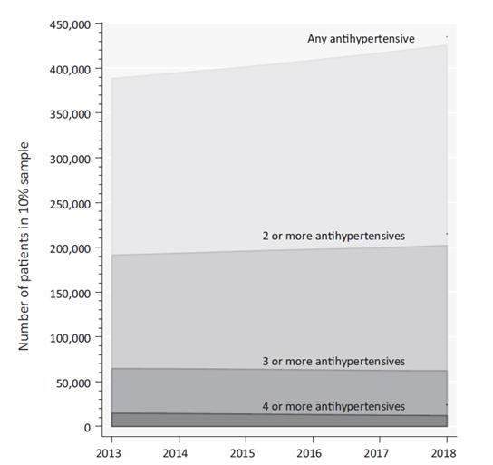

Figure 12 Trends in the number of people in 10% sample who dispensed an antihypertensive medicine within each calendar-year, or had concomitant exposure (≥40 days overlap) to two, three, or four or more antihypertensive medicines.

[Multiply x10 to scale up numbers to reflect the total Australian population

Source: Falster 2020

Table Estimation of patient numbers

| **Filter** | **Number of individuals** | **Comment** |
| --- | --- | --- |
| Population Australia | ~25.5 million | ABS, March 2020 |
| Adults | ~20 million | ABS, March 2020 |
| Elevated BP (SBP/DBP ≥140/90 mmHg) | ~6.7 million | ~ One third (34%) of adults have elevated BP  ABS 2017-18 Health Survey |
| Treated with one or more antihypertensive agent | ~4.25 million | PBS data 2018 - Falser 2020 |
| Treated with three or more antihypertensive agents | ~620,000 | ~15% of all patients treated  PBS data 2018 - Falster 2020 |
| Uncontrolled HTN despite three or more antihypertensive agents | ~450,000 | ~72.2% of all patients on 3 or more medications - Carey 2019 |
| Uncontrolled HTN despite three or more antihypertensive agents and excluding pseudo-resistant HTN | ~225,000 | 50% - Judd 2014 |
| Patients with 1 or more comorbidities other than hypertension | ~113,000 | 50% - Assumption based on Carcel 2019 |
| Patients potentially seeking RDN treatment | ~56,000 | 50% - Schmeider 2020 |
| Patients with private health insurance | ~28,000 | 50% - APRA, Private Health Insurance Annual Coverage Survey 2019 |

ABS, Australian Bureau of Statistic, blood pressure; HTN, hypertension; mm Hg, millimetres of mercury; PBS, Pharmaceutical Benefits Schedule.

## Estimate the number of times the proposed medical service(s) would be delivered to a patient per year:

Catheter-based is intended as a **one-time only** procedure.

## How many years would the proposed medical service(s) be required for the patient?

See answer to Question 48

## Estimate the projected number of patients who will utilise the proposed medical service(s) for the first full year:

REDACTED

## Estimate the anticipated uptake of the proposed medical service over the next three years factoring in any constraints in the health system in meeting the needs of the proposed population (such as supply and demand factors) as well as provide commentary on risk of ‘leakage’ to populations not targeted by the service:

REDACTED

# PART 8 – COST INFORMATION

## Indicate the likely cost of providing the proposed medical service. Where possible, please provide overall cost and breakdown:

The estimated RDN procedure cost is presented in Table 8. The RDN procedure cost includes the cost of theatre/admission, capital equipment, ablation catheter and other consumables, surgery time, angiography, and anaesthetist services. A total cost of REDACTED applies for each RDN procedure.

REDACTED

All MBS item fees used in Table 8 are exclusive of any multiple service rules which may apply in conjunction with the proposed listing for the RDN procedure. That is, all applicable MBS fees are simply added together. This approach overestimates the total cost of the RDN procedure and is conservative.

Table RDN procedure cost

|  |  |  |
| --- | --- | --- |
| Item | Cost | Reference |
| Theatre/Admission (overnight stay) | $2,827.02 | Private Health Data Bureau - 2018-19 (charges, benefits & gaps for AR-DRG version 6.0 - National Private Hospital (AR-DRG F21B) a |
| Capital equipment (includes depreciation) | REDACTED | Medtronic b |
| Symplicity ablation catheter | REDACTED | Medtronic |
| Other consumables | $0 | Assumption c |
| Professional services (surgery time) time | $2,164.05 | Proposed MBS Item fee |
| Anaesthetist services | $204.00 | MBS item 21942 d |
| Total | REDACTED |  |

a. Based on AR-DRG F21B, consists of accommodation costs of $3,175 (distributed across average length of stay of 5.7 days), and theatre costs of $2,270 (assumed to incurred on first day). Calculation: $3,175 / 5.7 + $2,270 = $2,827.02  
b. REDACTED  
c. Included with the cost of Theatre/Admission  
d. Radio frequency ablation used as a proxy for determining appropriate cost

## How many years would the proposed medical service(s) be required for the patient?

See answer to Question 48

## Specify how long the proposed medical service typically takes to perform:

The proposed medical service is undertaken in a cardiac catheterisation laboratory. The service comprises an aortogram/selective renal angiogram- to confirm the patient has the appropriate renal anatomy to undergo the RDN procedure - and, if the patient is confirmed as suitable, the RDN procedure itself.

The RDN procedure is performed under heavy sedation (but does not usually require general anaesthesia) and takes about 1.5-2 hrs in total for denervation in both kidneys.

The patient is observed for 2 hours post-procedure.

A patient admitted in the early morning would usually be sent home in the afternoon. A patient admitted in the afternoon would require an overnight stay.

## If public funding is sought through the MBS, please draft a proposed MBS item descriptor to define the population and medical service usage characteristics that would define eligibility for MBS funding.

Proposed wording for the proposed MBS item descriptors for catheter-based RDN is provided below:

The cost of catheter-based RDN is guided by the MBS item 38287 [ABLATION OF ARRHYTHMIA CIRCUIT OR FOCUS or isolation procedure involving 1 atrial chamber -Fee $2164.05]. This procedure is considered a reasonable benchmark for procedure type (catheter-based ablation) and time taken.

Category 3 – THERAPEUTIC PROCEDURES

MBS ###

Endovascular ablation of renal sympathetic nerves under image guidance (angiography) in a patient with hypertension with confirmed uncontrolled elevated systolic blood pressure of at least 150 mmHg, despite optimised treatment with three or more antihypertensive drugs, or intolerant to antihypertensive medication, with one or more of following conditions:

• Systolic BP > 180mm Hg

• Previous myocardial infarction or stroke

• Diabetes

• Chronic kidney disease

• Atrial fibrillation

• Heart failure

Includes angiography. One service only. (Anaes.)

Fee: $### Benefit: 75% = $### 85% = $###

References

Australian Institute of Health and Welfare (AIHW 2019a). High blood pressure. Available at: https://www.aihw.gov.au/reports/risk-factors/high-blood-pressure/contents/high-blood-pressure (Accessed 04 November 2020)

Australian Institute of Health and Welfare (AIHW 2019b). Australian Burden of Disease Study: impact and causes of illness and death in Australia 2015. Australian Burden of Disease series no. 19. Cat. no. BOD 22. Canberra: AIHW. Available at: https://www.aihw.gov.au/reports/burden-of-disease/burden-disease-study-illness-death-2015/contents/table-of-contents (Accessed 04 November 2020)

Australian Institute of Health and Welfare (AIHW 2019c). Disease expenditure in Australia. https://www.aihw.gov.au/reports/health-welfare-expenditure/disease-expenditure-australia/contents/summary (Accessed 04 November 2020

Australian Institute of Health and Welfare (AIHW 2020a) Cardiovascular disease https://www.aihw.gov.au/reports/heart-stroke-vascular-diseases/cardiovascular-health-compendium/contents/deaths-from-cardiovascular-disease (Accessed 04 November 2020)

Australian Institute of Health and Welfare (AIHW 2020b). Deaths in Australia. https://www.aihw.gov.au/reports/life-expectancy-death/deaths-in-australia/contents/leading-causes-of-death. (Accessed 04 November 2020)

Atkins ER, Perkovic V. Blood pressure: at what level is treatment worthwhile? Aust Prescr 2019;42:127-30. 10.18773/austprescr.2019.038

Azizi M, Schmieder RE, Mahfoud F, et al.; RADIANCE-HTN Investigators. Endovascular ultrasound renal denervation to treat hypertension (RADIANCE-HTN SOLO): a multicentre, international, single-blind, randomised, sham-controlled trial.Lancet. 2018; 391:2335–2345.

Azizi M, Pereira H, Hamdidouche I, et al. Adherence to Antihypertensive Treatment and the Blood Pressure-Lowering Effects of Renal Denervation in the Renal Denervation for Hypertension (DENERHTN) Trial. Circulation. 2016 Sep 20;134(12):847-57.

Bolignano D, Coppolino G. Renal nerve ablation for resistant hypertension: facts, fictions and future directions. Rev Cardiovasc Med. 2019 Mar 30;20(1):9-18.

Bolívar JJ. Essential hypertension: an approach to its etiology and neurogenic pathophysiology. Int J Hypertens. 2013;2013:547809.

Burnier M, Egan BM. Adherence in Hypertension. A Review of Prevalence, Risk Factors, Impact, and Management . Circ Res. 2019 Mar 29;124(7):1124-1140

Caraterro OA, Oparil S. Essential Hypertension. Part I: Definition and Etiology.Circulation.2000;101:329–335

Carcel C, Neal B, Oparil S, et al. Clinical characteristics, antihypertensive medication use and blood pressure control among patients with treatment-resistant hypertension: the Survey of PatIents with treatment ResIstant hyperTension study. J Hypertens. 2019 Nov;37(11):2216-2224.

Carey RM, Calhoun DA, Bakris GL et al. Resistant Hypertension: Detection, Evaluation, and Management: A Scientific Statement From the American Heart Association. Hypertension. 2018 Nov;72(5):e53-e90. doi: 10.1161/HYP.0000000000000084. PMID: 30354828; PMCID: PMC6530990.

Carey RM, Sakhuja S, Calhoun DA, Whelton PK, Muntner P. Prevalence of Apparent Treatment-Resistant Hypertension in the United States. Hypertension. 2019 Feb;73(2):424-431.

Chan CT, Sobey CG, Lieu M, et al. Obligatory role for B cells in the development of angiotensin II-dependent hypertension. Hypertension. 2015 Nov. 66 (5):1023-33.

Cowley AW Jr. The genetic dissection of essential hypertension. Nat Rev Genet. 2006 Nov;7(11):829-40. doi: 10.1038/nrg1967. Epub 2006 Oct 10. PMID: 17033627.

de la Sierra A, Segura J, Banegas JR, et al. Clinical features of 8295 patients with resistant hypertension classified on the basis of ambulatory blood pressure monitoring. Hypertension. 2011 May;57(5):898-902.

de Souza F, Muxfeldt E, Fiszman R, Salles G. Efficacy of spironolactone therapy in patients with true resistant hypertension. Hypertension. 2010;55:147–152.

Esler MD, Krum H, Sobotka PA, Schlaich MP, Schmieder RE, Bohm M. Renal sympathetic denervation in patients with treatment-resistant hypertension (The Symplicity HTN-2 Trial): a randomised controlled trial.Lancet. 2010; 376:1903–1909

Falster MO, Buckley NA, Brieger D, Pearson SA. Antihypertensive polytherapy in Australia: prevalence of inappropriate combinations, 2013-2018. J Hypertens. 2020 Aug;38(8):1586-1592.

FDA. Circulatory system devices panel meeting: clinical evaluation of antihypertensive devices. 2018. <https://www.fda.gov/advisory-committees/advisory-committee-calendar/december-4-5-2018-circulatory-system-devices-panel-medical-devices-advisory-committee-meeting>

Gordan R, Gwathmey JK, Xie LH. Autonomic and endocrine control of cardiovascular function. World J Cardiol. 2015;7(4):204-214.

Henegar JR, Zhang Y, Hata C, Narciso I, Hall ME, Hall JE. Catheter-based radiofrequency renal denervation: location effects on renal norepinephrine.Am J Hypertens. 2015; 28:909–914.

Judd E, Calhoun DA. Apparent and true resistant hypertension: definition, prevalence and outcomes. J Hum Hypertens. 2014 Aug;28(8):463-8.

Kandzari, DE, Bhatt, DL, Brar, S, Devireddy, CM, Esler, M, Fahy, M, Flack, JM, Katzen, BT, Lea, J, Lee, DP, et al. Predictors of blood pressure response in the SYMPLICITY HTN-3 trial. Eur Heart J. 2015;36:219–227.

Kandzari DE, Böhm M, Mahfoud F, et al. SPYRAL HTN-ON MED Trial Investigators. Effect of renal denervation on blood pressure in the presence of antihypertensive drugs: 6-month efficacy and safety results from the SPYRAL HTN-ON MED proof-of-concept randomised trial. Lancet. 2018 Jun 9;391(10137):2346-2355.

Krum H, Schlaich M, Whitbourn R, Sobotka PA, Sadowski J, Bartus K, Kapelak B, Walton A, Sievert H, Thambar S, et al.. Catheter-based renal sympathetic denervation for resistant hypertension: a multicentre safety and proof-of-principle cohort study.Lancet. 2009; 373:1275–1281

Krum H, Barman N, Schaich M et al (SYMPLICITY HTN-1 Investigators). Catheter based renal sympathetic denervation for resistant HTN: durability of blood pressure reduction out to 24 months. Hypertension 2011;57:911–7.

Lazich I, Bakris GL. Prediction and management of hyperkalemia across the spectrum of chronic kidney disease. Semin Nephrol. 2014;34:333-339. doi: 10.1016/j.semnephrol.2014.04.008

Lewington S, Clarke R, Qizilbash N, Peto R, Collins R; Prospective Studies Collaboration. Age-specific relevance of usual blood pressure to vascular mortality: a meta-analysis of individual data for one million adults in 61 prospective studies. Lancet. 2002 Dec 14;360(9349):1903-13.

Lobo MD, Sharp ASP, Kapil V, Davies J, de Belder MA, Cleveland T, Bent C, Chapman N, Dasgupta I, Levy T, Mathur A, Matson M, Saxena M, Cappuccio FP; British & Irish Hypertension Society, the British Cardiovascular Society, the British Cardiovascular Intervention Society, the British Society of Interventional Radiology and the Renal Association. Joint UK societies' 2019 consensus statement on renal denervation. Heart. 2019 Oct;105(19):1456-1463. doi: 10.1136/heartjnl-2019-315098. Epub 2019 Jul 10. PMID: 31292190; PMCID: PMC6817707.

Mahfoud F, Böhm M, Azizi M, et al. Proceedings from the European clinical consensus conference for renal denervation: considerations on future clinical trial design. Eur Heart J. 2015 Sep 1;36(33):2219-27.

Mahfoud F, Böhm M, Schmieder R, et al. Effects of renal denervation on kidney function and long-term outcomes: 3-year follow-up from the Global SYMPLICITY Registry. Eur Heart J. 2019 Nov 1;40(42):3474-3482.

Mahfoud F, Schmieder RE, Azizi M, et al. Proceedings from the 2nd European Clinical Consensus Conference for device-based therapies for hypertension: state of the art and considerations for the future. Eur Heart J. 2017;38:3272–3281

Mills KT, Bundy JD, Kelly TN, et al. Global Disparities of Hypertension Prevalence and Control: A Systematic Analysis of Population-Based Studies From 90 Countries. Circulation. August 9, 2016;134(6):441-450.

NHFA. Guideline for the diagnosis and management of hypertension in adults - 2016. Melbourne: National Heart Foundation of Australia, 2016.

Padmanabhan D, Isath A, Gersh BJ. Renal Denervation: Paradise Lost? Paradise Regained? US Cardiology Review 2018;12(2):78–86.

Patibandla S, Heaton J, Kyaw H. Spironolactone. [Updated 2020 Jul 9]. In: StatPearls [Internet]. Treasure Island (FL): StatPearls Publishing; 2020 Jan-. Available from: <https://www.ncbi.nlm.nih.gov/books/NBK554421/>

Peacock E, Krousel-Wood M. Adherence to Antihypertensive Therapy. Med Clin North Am. 2017;101(1):229-245. doi:10.1016/j.mcna.2016.08.005

Rosa J, Widimsky P, Waldauf P, et al. Role of adding spironolactone and renal denervation in true resistant hypertension: one-year outcomes of randomized PRAGUE-15 study. Hypertension. 2016;67:397–403.

Sardar P, Bhatt DL, Kirtane AJ, Kennedy KF, Chatterjee S, Giri J, Soukas PA, White WB, Parikh SA, Aronow HD. Sham-Controlled Randomized Trials of Catheter-Based Renal Denervation in Patients With Hypertension. J Am Coll Cardiol. 2019 Apr 9;73(13):1633-1642. doi: 10.1016/j.jacc.2018.12.082. PMID: 30947915.

Sata Y, Head GA, Denton K, May CN, Schlaich MP. Role of the Sympathetic Nervous System and Its Modulation in Renal Hypertension. Front Med (Lausanne). 2018;5:82.

Schmieder RE, Kandzari DE, Wang TD, Lee YH, Lazarus G, Pathak A. Differences in patient and physician perspectives on pharmaceutical therapy and renal denervation for the management of hypertension. J Hypertens. 2020 Aug 6. Ahead of print.

Townsend RR, Mahfoud F, Kandzari DE, et al.; SPYRAL HTN-OFF MEDTrialInvestigators*. Catheter-based renal denervation in patients with uncontrolled hypertension in the absence of antihypertensive medications (SPYRAL HTN-OFF MED): a randomised, sham-controlled, proof-of-concept trial.Lancet. 2017; 390:2160–2170.

Trott DW, Thabet SR, Kirabo A, et al. Oligoclonal CD8+ T cells play a critical role in the development of hypertension. Hypertension. 2014 Nov. 64 (5):1108-15.

Wang C, Xiong B, Huang J. Efficacy and safety of spironolactone in patients with resistant hypertension: a meta-analysis of randomised controlled trials. Heart Lung Circ. 2016;25:1021–1030.

Whelton PK, Carey RM, Aronow WS et al. 2017 ACC/AHA/AAPA/ABC/ACPM/AGS/APhA/ASH/ASPC/NMA/  
PCNA Guideline for the Prevention, Detection, Evaluation, and Management of High Blood Pressure in Adults: A Report of the American College of Cardiology/American Heart Association Task Force on Clinical Practice Guidelines. HypertensionVolume 71, Issue 6, June 2018, Pages e13-e115.

Williams B, Mancia G, Spiering W et al. 2018 ESC/ESH Guidelines for the management of arterial hypertension: The Task Force for the management of arterial hypertension of the European Society of Cardiology (ESC) and the European Society of Hypertension (ESH), European Heart Journal, Volume 39, Issue 33, 01 September 2018, Pages 3021–3104.

Williams B, MacDonald TM, Morant S, et al; British Hypertension Society’s PATHWAY Studies Group. Spironolactone versus placebo, bisoprolol, and doxazosin to determine the optimal treatment for drug-resistant hypertension (PATHWAY-2): a randomised, double-blind, crossover trial. Lancet. 2015;386:2059–2068.

Zhao D, Liu H, Dong P, Zhao J. A meta-analysis of add-on use of spironolactone in patients with resistant hypertension. Int J Cardiol. 2017;233:113–117.

# Attachments

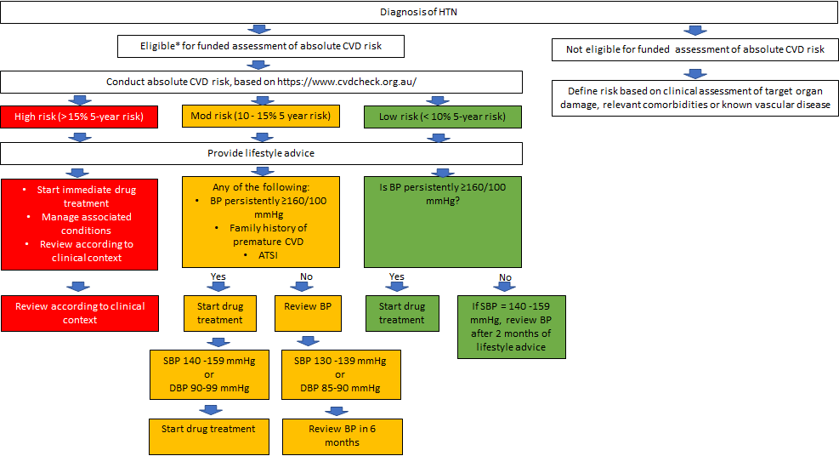

Attachment Management algorithm for patients with newly diagnosed hypertension

Source: NHFA 2016

ATSI Aboriginal and Torres Strait Islander; BP, blood pressure; CVD, cardiovascular disease; mmHg, millimetres of mercury.

*\* On 1 April 2019, two new interim items were introduced onto the Medicare Benefits Schedule (MBS) to support the delivery of Heart Health Checks in primary care: Items 699 (for GPs) and 177 (for other medical practitioners working in general practice). These items support the ongoing assessment and management of absolute CVD risk in primary care for eligible patients 45 years and over (30 years and over for Aboriginal and Torres Strait Islander patients).*

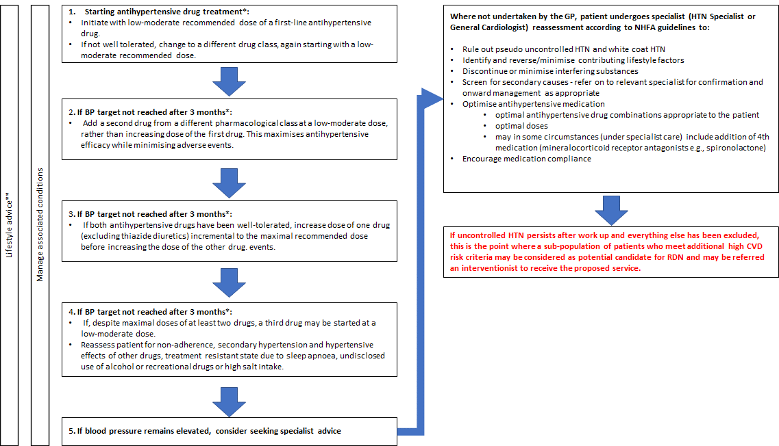

Attachment 2 Drug treatment strategy to reach blood pressure target

BP, blood pressure; CVD, cardiovascular disease; GP, general practitioner; HTN, hypertension; NHFA, National Heart Foundation Australia; RDN, renal denervation.

*Maximum effect of drug likely to be seen in 4-6 weeks. If baseline BP is severely elevated earlier reviews may be considered. For steps 1-4, review every 4-6 weeks for tolerance, efficacy and adverse effects.

**All patients should receive lifestyle advice with follow-up based on clinical context.

Source: NHFA 2016

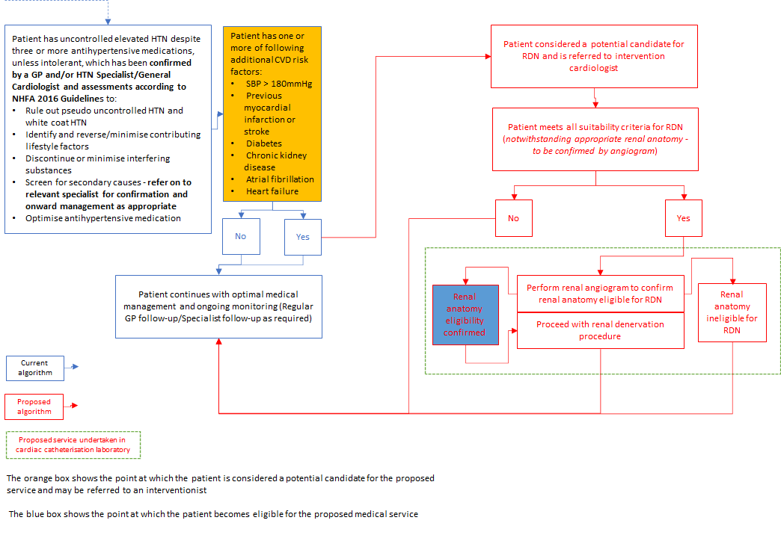

Attachment Proposed treatment management algorithm including RDN in selected patients

Orange box indicates shows the point at which patients may be considered a potential candidate for the proposed medical service;   
Blue box indicates shows the point at which patient becomes eligible for the proposed medical service

BP, blood pressure; CVD, cardiovascular disease; GP, general practitioner; HTN, hypertension; mmHg, millimetres of mercury; NHFA, National Heart Foundation Australia; RDN, renal denervation; SBP, systolic blood pressure.

1. More recent (post-SYMPLICITY HTN-3) sham controlled trials of RDN are distinguished from earlier sham controlled trials of RDN in regard to the patients enrolled, procedural technique employed, antihypertensive drug regimens prescribed, and endpoint ascertainment. The changes in trial design were necessary based on preclinical and clinical data from other studies, including post hoc analysis of the earlier trials, including the SYMPLICITY HTN-3 trial. As such, the newer RDN trials have excluded participants with isolated systolic hypertension, included procedures performed by highly experienced operators, employed advanced radiofrequency ablation techniques (e.g., using multipolar catheter to provide more complete ablation with extension beyond the main renal artery into renal-artery branch vessels) or novel denervation techniques such as endovascular ultrasound. Additionally the newer trials used modified medical treatment regimens and incorporated objective measurement of medical adherence, which had been found to be a significant confounding factor in the earlier trials. Finally, the newer trials incorporated 24 hour ambulatory measurements of blood pressure as primary outcome measures as they are regarded as superior to office measurements at predicting cardiovascular events (FDA 2018; Sarder 2018; Lobo 2019).
2. White coat HTN is when BP readings at a doctor’s clinic are higher than that in the home.
3. Renal anatomical characteristics that would preclude patients from RDN include arteries with a diameter less than 3 mm or greater than 8 mm; arteries with significant disease or with flow-limiting obstructions.
4. The average total number of ablations used per procedure in the SPYRAL clinical trials was 47 (SD 16) and 46 (SD 14) in the OFF-MED and ON-MED trials, respectively.