Application 1595.1
Closed-loop upper airway stimulation for moderate to severe obstructive sleep apnoea, for patients who have failed or are intolerant of continuous positive airway pressure

Ratified
PICO Confirmation

Summary of PICO/PPICO criteria to define the question(s) to be addressed in an Assessment Report to the Medical Services Advisory Committee (MSAC)
Table 1 PICO for closed-loop upper airway stimulation (UAS) for moderate to severe obstructive sleep apnoea (OSA), for patients who have failed or are intolerant of continuous positive airway pressure (CPAP)
Component | Description
Patients | Patients aged ≥ 18 years with a BMI < 32 kg/m² and moderate to severe obstructive sleep apnoea (OSA), defined as having an Apnoea Hypopnea Index (AHIª) ≥ 15 and ≤ 65, and who have been confirmed to have failed or cannot tolerate continuous positive airway pressure (CPAP) therapy or bi-level positive airway pressure (BIPAP) therapy. Patients with total concentric collapse at the soft palate level are not eligible. Patients are receiving no active treatment, have trialed or are not suitable for all other treatment options.
Prior tests | Drug induced sleep endoscopy and multi-disciplinary meeting, recent sleep study
Intervention | Implantation of an Upper Airway Stimulator System, including a respiratory sensing lead that senses breathing patterns, which is linked to an implantable pulse generator that delivers mild stimulation to the hypoglossal nerve via a stimulation lead.
Comparator | Usual care in the last line of therapy, i.e. no active treatment.
Outcomes | Efficacy/effectiveness  - Apnoea Hypopnoea Index (AHI)  - Oxygen Desaturation Index (ODI)  - Cardiovascular outcomes  - Quality of Life  - Epworth Sleepiness Scale (ESS)  - Functional Outcomes of Sleep Questionnaire (FOSQ)  Safety  - Procedure related adverse events  - Device related adverse events  - Other adverse events  Healthcare resources  - Cost to deliver intervention.  - Subcutaneous placement of electrical pulse generator  - Surgical placement of lead and connection to hypoglossal nerve  - Surgical placement of respiratory sensing lead  - Surgical repositioning or removal of electrical pulse generator  - Case conferences  Total Australian Government Healthcare costs  - Total cost to the Medicare Benefits Schedule (MBS)  - Total cost to other healthcare services
ª Apnoea Hypopnea Index measures the number of apnoea episodes per hour of sleep
PICO or PPICO rationale for therapeutic and investigative medical services only

Application background
An applicant-developed assessment report (ADAR) for closed loop upper airway stimulation (UAS) for the treatment of moderate to severe obstructive sleep apnoea (OSA) was considered by MSAC in November 2020 (Application 1595). The PICO Confirmation and the public summary document (PSD) for Application 1595 can be sourced here. MSAC did not support the creation of a new MBS item for closed loop UAS. A related application, MSAC Application 1630, was also received by the Department, although there is no PICO Confirmation or public summary document (PSD) available for this application.
The key issues raised by MSAC in regard to Application 1595 are summarised in the table below, along with how these issues have been addressed during development of the PICO for 1595.1.
Table 2: Summary of MSAC consideration of 1595
Component | MSAC consideration (November 2020) | Resubmission application 1595.1
Item descriptor | p29 of the PSD: ESC considered that for the MBS item descriptor:  - CPAP failure and lack of tolerance to CPAP should be defined.  - ‘Once per lifetime per patient’ was appropriate for surgical repositioning or removal of the device, but not for replacement of the device.  - Unnecessary patient descriptions should be removed from the descriptors for repositioning or removal, and replacement. | A definition of CPAP failure and intolerance was provided. The wording of ‘only once per lifetime’ was applied for repositioning or removal of the device.  The patient descriptions were removed.
Use of DISE as a prior test | p25 of the PSD: The ESC advice to MSAC stated that ESC noted that DISE is not a well-described test, and current funding for, and utilisation of, DISE are uncertain.  Table 1 of the PSD: MSAC advised that the uncertainty regarding the use of DISE as raised by ESC should be addressed in a resubmission. | The resubmission application stated (p17) that the applicant intends to more thoroughly describe the current use of DISE in Australia and will incorporate this in any resubmission.
Population and clinical place | Table 1 of the PSD: MSAC advised there may be a subpopulation of patients who have failed all other medical management options where UAS therapy may be appropriate. The resubmission would need to define this subpopulation using the appropriate eligibility criteria. | The proposed population are those that remain untreated following failed CPAP or are intolerant of CPAP.
Main comparator | p2 of the PSD: MSAC considered the main comparator, conservative medical management, i.e. medical management strategies (MMS) to be appropriate. These strategies included weight and alcohol reduction, sleep positioning therapy, sleep hygiene education, and use of mandibular advancement appliances. | The resubmission application has changed the comparator to usual care, which was defined at the pre-PASC meeting as no active treatment.
Clinical evidence | p1 of the PSD: MSAC considered that the evidence did not demonstrate that the safety and effectiveness of UAS in the proposed MBS population had been established.  Table 1 of the PSD: The resubmission was required to provide evidence to support the use of UAS in a subpopulation of patients who have failed all other medical management options and where UAS therapy may be appropriate. MSAC indicated the resubmission would need to define this subpopulation using the appropriate eligibility criteria. | There are two new randomised trials that will be available in 2021. The EFFECT trial has recently been published and it is anticipated that the CARDIOSA-12 trial is likely to be published later this year, which will be used to support superiority of Inspire over usual care (i.e. no active treatment).
Economic evaluation | Table 1 of the PSD: Improve the economic model to address the uncertainties regarding the model structure, time horizon and effect size as raised by ESC.  The resubmission should also reduce the cost of the device in order to ensure cost-effectiveness. | A cost utility evaluation will be conducted taking into account the MSAC’s advice.  The cost of the device was reduced to REDACTED from REDACTED used in Application 1595.
Financial estimates | Table 1 of the PSD: Update to address the subpopulation of patients who have failed all other medical management options. | The estimated patient numbers for treated patients remain the same as those estimated for 1595.
Source: November 2020 PSD for Application 1595 and the resubmission application.
CPAP=continuous positive airway pressure; DISE=drug-induced sleep endoscopy; PSD=public summary document; UAS=upper airway stimulation

PICO criteria

Population
PASC noted MSAC application 1595.1 is a resubmission and noted the reasons that MSAC did not previously support MBS listing of UAS for the treatment of OSA (MSAC application 1595), one of which was that the population needed to be refined.
The proposed population for the Inspire® Upper Airway Stimulation (UAS) System is adult patients (aged ≥18 years) who are confirmed as having moderate to severe OSA and who are also confirmed as having failed or cannot tolerate CPAP therapy or bi-level positive airway pressure (BIPAP) therapy, do not have concentric collapse at the soft palate level, and are currently untreated.
PASC noted the resubmitted application proposed a similar population as the previous submission and that in the pre-PASC response the applicant proposed adding ‘patients who are unsuitable for, or else have unsuccessfully attempted all other appropriate interventions and who are currently untreated’ along with definitions for CPAP failure and intolerance. PASC noted the applicant’s clinical expert advice that in clinical practice UAS is a niche therapy considered as a last resort for patients after excluding more common therapies for OSA, involves multidisciplinary team assessment of individual patient eligibility including CPAP failure, which should be demonstrated in an expert centre where the proposed intervention would be appropriate.
PASC considered that the population description should include ‘Patients are receiving no active care, have trialled or are not suitable for all other treatment options’ and that active care will need to be clearly defined.

Background
OSA is a disorder of sleep, characterised by repeated upper airway obstructions during the night, with resultant oxygen desaturations and arousals. OSA occurs when breathing is repetitively interrupted during sleep because of collapse of the upper airway. An apnoea is defined as a complete cessation of breathing that lasts 10 seconds or longer. Approximately 10% of middle-aged men and 5% of middle-aged women in the general population are likely to have OSA, defined as > 10 obstructed breathing events/hour of sleep (Young 2002).
Moderate to severe OSA is defined as having an Apnoea Hypopnea Index (AHI) ≥15 and ≤65. AHI measures the number of apnoea episodes per hour of sleep.
Failure of CPAP therapy is defined as continued AHI >20 despite appropriate CPAP usage. CPAP intolerance is defined as
- Inability to use CPAP (>5 nights per week of usage: usage defined as >4 hours of use per night), or
- Unwillingness to use CPAP (for example, a patient returns the CPAP system after attempting to use it).
Cross sectional and longitudinal studies have suggested that moderate to severe OSA is independently associated with greater risk of all-cause mortality after adjustment for age, gender, mean arterial pressure, total cholesterol, high density lipo-protein cholesterol, body mass, diabetes, angina and smoking status (Marshall 2008) and a higher incidence of fatal and non-fatal cardiovascular events in patients with severe disease (Marin 2005). OSA is also associated with daytime sleepiness and an increased incidence of road accidents (Tregear 2005). Overall OSA that is unable to be treated by CPAP represents a significant societal burden.
The resubmission application stated (p19-20) that while OSA is associated with a high body mass index (BMI), the majority of clinical evidence relates to patients with a BMI <32 kg/m².

Work-up of patients with suspected OSA
Patients are likely to initially present to a general practitioner (GP) with one or more of a variety of symptoms. These may include: excessive daytime sleepiness; loud snoring; observed episodes of stopped breathing during sleep; abrupt waking with gasping or choking; waking with a dry mouth or sore throat; morning headache; difficulty in concentration; mood changes, depression or irritability; night-time sweating; or decreased libido. The patient may then be referred to a sleep specialist, or the GP may refer the patient directly for a diagnostic sleep study (when validated screening questionnaires suggest a high pre-test probability for diagnosis of moderate to severe OSA).
The patient is then likely to undergo a Level 1 sleep investigation (MBS item 12203) or a Level 2 investigation (MBS item 12250). If the result of the investigation determines the patient has OSA, a trial of CPAP is instigated.
If the trial of CPAP is unsuccessful in treating OSA, or the patient is unable to tolerate CPAP (due to claustrophobia or a similar reason), the patient may be considered for UAS. The pre-PASC response added a further criterion that patients will ‘have unsuccessfully attempted all other appropriate interventions and are currently untreated’.
Prior to surgery, an endoscopy under sedation must be performed so that the patient’s upper airway anatomy maybe observed in a sleep-like state. The otolaryngologist is looking for the absence of a complete concentric collapse at the level of the soft palate. Patients with a complete collapse of the soft palate are not suitable for UAS. Further discussion of DISE is provided in the ‘Intervention’ section below.

Prevalence of OSA and size of population eligible for intervention
The resubmission application noted that the Sleep Health Survey of Australian Adults (Adams 2016) estimated that doctor-diagnosed sleep apnoea was 8.3% overall (12.9% for men and 3.7% for women).
The resubmission application noted (p26) that as CPAP therapy does not have an MBS item number, or is its use recorded in a publicly available source, it is difficult to determine the number of patients in Australia currently being treated by CPAP and therefore difficult to calculate how many may have failed CPAP therapy. As in the ADAR for application 1595, the resubmission application assumes that 50% of patients fail CPAP, sourced from the Australasian Sleep Association.
OSA is more likely to occur in men than women, with a variety of prevalence studies consistently finding the disorder is more common in men. An Australian study, of men only (Senaratna 2016), found OSA was associated with older age, obesity, chronic obstructive airway disease, diabetes, asthma, hypercholesterolemia and hypertension, and other lifestyle-related disorders.
The pre-PASC response indicated that the most reliable source of the number of diagnosed patients is the number of sleep studies conducted in Australia. The resubmission application used MBS item numbers 12203 and 12250 in 2019 to determine the number of sleep studies, a literature-based source to determine the proportion likely to be diagnosed with moderate to severe OSA, data from the Australasian Sleep Association for the proportion who will fail CPAP (as discussed above), a literature based source for the proportion with BMI <30kg/m², an adjustment for those with BMI ≥30kg/m² and <32kg/m², and a literature-based source for the proportion with complete concentric collapse. The numbers of eligible patients presented in the resubmission application are provided in the table below, and for reference, the numbers presented in the 1595 application and PICO, along with the numbers presented in the ADAR for 1595 are also provided in the table.

Table 3: Estimated size of eligible population
 | Application 1595 |  |  | Resubmission
Description | Source | Estimated population | Description | Source | Estimated population
ADAR |  |  | Application
Annual sleep studies | AIHW and MBS item 12250 | 158,252 | Annual sleep studies | MBS items 12203 and 12250 (2019) | 135,148
55.8% with diagnosis of moderate to severe OSA | Gray 2017 | 88,305 | 65% with diagnosis of moderate to severe OSA | Escourrou 2015 | 87,846
50% failure of CPAP | Australasian Sleep Association | 44,152 | 50% failure of CPAP | Australasian Sleep Association | 43,923
99.7% >18 years | Medicare Australia statistics | 44,020 | 98.5% or 99.7% >18 years | Medicare Australia statistics | Not used
45.1% BMI <30 kg/m² | Gray 2017 | 19,853 | 45.1% BMI <30 kg/m² | Gray 2017 | 19,809
10% adjustment for patients with BMI ≥30 and <32 kg/m² | Assumption | 21,838 | 10% adjustment for patients with BMI ≥30 and <32 kg/m² | Assumption | 21,790
Exclude 8% of patients with complete concentric collapse | Strollo 2014 | 20,091 | Exclude 8% of patients with complete concentric collapse | Strollo 2014 | 20,047
Source: Table 6, p27 of the resubmission application; Table 46, p95 of the application 1595 commentary.
ADAR=applicant-developed assessment report; BMI=body mass index; CPAP=continuous positive airway pressure; OSA=obstructive sleep apnoea
The table above shows that the estimated eligible population in the resubmission application (20,047) is very similar to the estimated eligible population in the ADAR for 1595 (20,091). During the pre-PASC meeting the applicant stated that in the resubmission, Australian Institute of Health and Welfare (AIHW) and MBS item 12250 will be used to estimate the number of annual sleep studies, instead of the two MBS item numbers.
PASC noted that the estimated eligible population was similar to the previous submission (MSAC 1595) but was unclear whether these estimates accounted for the additional criteria ‘no active treatment/care’. PASC considered that as well as the incident population, there is likely to be an even larger prevalent population. The eligible population is very large relative to the estimated number of patients to be treated with UAS. PASC noted the estimated number of treated patients is based on international experience and that the applicant claimed the ability to supply UAS in Australia provided a mechanism to restrict the usage. PASC noted if the vast majority (>99%) of patients in the proposed eligible population cannot access the service, this leads to substantial equity issues, in addition to rural and remote access issues.
PASC was uncertain whether the large estimated eligible population represents those who would benefit from UAS. PASC noted that a significant proportion of patients are diagnosed and treated for OSA outside of a clinical setting (e.g. CPAP management in Australia does not require a consultation with a GP) and questioned whether these patients would meet the threshold for initial diagnosis and/or treatment failure if they were reassessed in a clinical setting, including by a multidisciplinary team. As such, the estimated eligible population may include a proportion of patients who are unlikely to benefit from UAS.
PASC acknowledged the difficulty in confidently and precisely estimating the population size and therefore, the uncertainty over the population size needs to be characterised and assessed in the resubmission assessment report.

Number of patients treated
The resubmission application claims that a limited population will be able to access the service, given the need to use centres which integrate surgical and sleep medicine teams. The estimated number of patients treated is the same in the resubmission application as that estimated in the ADAR, with 8 to 10 patients treated per year, across 3 centres in Year 1, increasing to 15 centres in Year 5. The estimated centre numbers and patient numbers are provided in the table below.

Table 4 Estimated centre numbers and patient numbers for use of closed loop UAS
 | Year 1 | Year 2 | Year 3 | Year 4 | Year 5
Number of centres | 3 | 5 | 7 | 10 | 15
Number of patients per year | 8 | 8 | 8 | 10 | 10
Estimated usage (centres × patients) | 24 | 40 | 56 | 100 | 150
Source: Table 7, p28 of the resubmission application
UAS=upper airway stimulation.
The pre-PASC response indicated that the utilisation estimates were based on commercial-in-confidence data detailing the first 5 years of use of UAS in the USA, Germany and Japan, and according to the applicant these data are the most reliable evidence available to support the estimated utilisation in Australia.
The implantation rate (implants/population/million) in year 1 in these countries varied from 0.13 to 0.14 which would equate to between 4-13 implants in Australia and in year 6, the implants had risen to between 2.25 – 8.56, which would equate to between 59-223 implants in Australia in year 6. The applicant stated that it is more relevant to report actual proposed implantation numbers in any financial or utilisation estimates, rather than growth rates which could bias the interpretation of exactly how many implants will be achieved.
The applicant reiterated that utilisation or implantation numbers will also be dependent on the number of Ear, Nose and, Throat Specialists (ENTs) in Australia and that the surgeons will have fulfilled the requirements of the Australian Society of Otolaryngology Head and Neck Surgery (ASOHNS) or be otherwise qualified to practice this specialty in Australia. Extensive training, provided by the applicant, is required before ENTs may deliver this therapy. Training includes off-site classroom training and cadaver training. The first 3-5 cases conducted by an ENT are proctored, and the applicant is likely to provide continued theatre support for ENTs. The applicant did not indicate what may happen if this continued theatre support for ENTs is not provided.
The applicant indicated that in addition to specific surgical training for ENTs, training is provided to operating room staff, sleep physicians and sleep laboratory staff and additional training is provided to sleep physicians and other sleep or ENT clinic staff, so that activation and programming of the device is appropriate and controlled.
The applicant also noted there is a natural ceiling to the capacity of ENTs to meet any increasing demand. In 2016 there were 460 ENTs. Thus, the eligible population will always far exceed the capacity of the Australian healthcare system to provide UAS. The applicant concluded it is conservative to assume that all patients who have failed or are intolerant of CPAP may remain untreated and therefore be eligible for UAS.

Intervention
PASC noted that the proposed medical service remains the same as that presented for MSAC application 1595.
The intervention for the proposed medical service is implantation of an upper airway stimulator system. Prior to surgery, a DISE must be performed to observe the patient’s upper airway anatomy in a sleep-like state. The otolaryngologist is looking for absence of a complete concentric collapse at the level of the soft palate. Patients with a complete collapse of the soft palate are not suitable for UAS.
PASC noted that in MSAC’s consideration of MSAC application 1595, MSAC advised that any resubmission would need to address the uncertainty regarding the use of DISE as a prior test. PASC noted that the pre-PASC response indicated clinicians are currently claiming DISE under MBS item numbers 41855, 41816 and 41764 along with MBS items 20320 and 23035 for initiation and time of anaesthesia, and that the applicant intends to more thoroughly describe the current use of DISE in Australia in the resubmission assessment report.
PASC queried whether another sleep study is required as prior test. Advice from the applicant’s clinical expert indicated that in clinical practice a sleep study within the last 2 years is preferred. PASC considered a recent sleep study (i.e. within 2 years) should be captured as a prior test as well.
PASC also noted that the applicant intends to provide new evidence for UAS from the EFFECT and CARDIOSA-12 clinical trials in the resubmission assessment report.
The components of the proposed medical service are described below.

Surgical procedure
The Inspire® System consists of three components, an implantable pulse generator (IPG), a respiratory sensing lead and a stimulation lead. The leads connect to the IPG via two connection ports (Figure 1).

Figure 1: Inspire IPG and connector ports
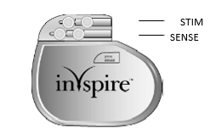
Source: Figure 1, p18 of the resubmission application form
The respiratory sensing lead detects respiratory effort. The lead has a pressure-sensitive membrane that converts the mechanical energy of respiration into an electronic signal. The stimulation lead delivers stimulation to the hypoglossal nerve via a self-sizing cuff electrode that encircles the median division of the nerve (Figures 2 and 3).

Figure 2: Respiratory sensing lead
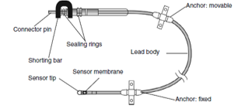
Source: Figure 2, p18 of the resubmission application form

Figure 3: Stimulation lead
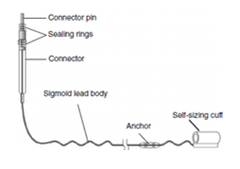
Figure 3, p19 of the resubmission application form
The Inspire system is implanted under general anaesthetic via three small incisions. The stimulation electrode is placed on the median division of the hypoglossal nerve to recruit the tongue protrusion function. The sensing lead is placed via an incision in the fifth intercostal space and placed between the internal and external intercostal muscles to detect ventilatory effort. The IPG is placed in the right ipsilateral mid-infra-clavicular region (Figure 4).

Figure 4: Inspire system in situ
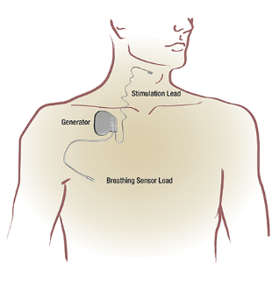
Figure 4, p19 of the resubmission application form
To allow for healing, activating the device is delayed until approximately one month after surgery. The device is switched on and the patient begins therapy. The Inspire device continuously monitors the patient’s breathing patterns and delivers mild hypoglossal nerve stimulation during inspiration to prevent airway collapse. The device is activated by the patient using a hand-held remote control. Therapy is adjusted by the specialist at a follow up monitoring visit(s). Patients are likely to have at least one sleep study following the procedure.

Setting
The service is delivered by ear, nose and throat surgeons (ENTs). The service must be performed in an appropriate operating theatre, under general anaesthetic. A proportion of patients may be appropriate for same day discharge, where others may have an overnight stay.
Surgeons will have fulfilled the requirements of the Australian Society of Otolaryngology Head and Neck Surgery (ASOHNS) or be otherwise qualified to practice this specialty in Australia.
Extensive training, provided by Inspire® Medical Systems, is required before ENTs may deliver this therapy. Training includes off-site classroom training and cadaver training. The first 3-5 cases conducted by an ENT are proctored, and Inspire® Medical Systems is likely to provide continued theatre support for ENTs.
In addition to specific surgical training for ENTs, training is provided to operating room staff, sleep physicians and sleep laboratory staff. Additional training is provided to sleep physicians and other sleep or ENT clinic staff, so that activation and programming of the device is appropriate.
There may be limitations in access to qualified specialists who have trained in the proper use and surgical procedure associated with Inspire® therapy. Should the new medical service be recommended, and the Inspire® System subsequently included on the Prostheses List, it is more likely the procedure would be carried out in private hospitals, on patients who have private health insurance. There may be budget constraints in the public hospital system.
A majority of ENTs practice in major cities, so patients who live in rural or remote areas may have difficulty accessing the service.
The device battery is conservatively estimated to last 10 years, so the initial procedure is likely to be carried out only once. Once the battery has depleted, the IPG may be removed and a new IPG would be attached to existing leads (which remain in situ).
In regard to further detail on duration of treatment, the pre-PASC response indicated the technical specification of the battery longevity is 10.9 years with 0.6 years standard deviation.

Prosthesis
The pre-PASC response indicated that a submission to the Prostheses List Advisory Group (PLAC) will be made only if MSAC can recommend an appropriate MBS item descriptor and the procedure to implant the device is included on the MBS. The response concluded that an application will be made to PLAC to include the device on the Prostheses List at the appropriate time.

Main comparator
The main comparator in MSAC application 1595 was conservative medical management which MSAC indicated was appropriate (p2, November 2020 PSD).
In the resubmission 1595.1, the applicant changed the comparator to ‘usual care’ which the applicant considered to be ‘no treatment’. The claim that patients who are intolerant of CPAP and are suitable for UAS are unlikely to receive any active intervention was based on Mehra 2020 which stated that for patients denied insurance coverage for UAS, 86% did not pursue any further therapy, 7% re-attempted CPAP, 3% were using an oral appliance, 3% underwent additional OSA surgery and 1% used CPAP and an oral appliance. Mehra 2020 is a non-randomised cohort study comparing patients treated with UAS who received insurance coverage (N=230) to another group of patients who were denied insurance coverage for UAS (N=100). Patients in the study were sourced from six academic medical centres in the United States (US) and three centres in Germany. Treatment decisions once insurance coverage was denied in these patients may not be applicable to Australian patients, where insurance coverage is not a determinant of MBS-funded therapy. Further, the final visit for patients denied insurance coverage was 175 days (5.75 months) with an interquartile range of 87 to 350 days, while those who received UAS had a final visit at 358 days (just less than a year), with a range of 261 to 400 days. The Mehra 2020 paper stated (p1618) that after being denied access to UAS, consideration of other therapy options may have driven the observation of the shorter follow-up time for the final visit.
PASC noted that the comparator had changed from conservative medical management (previous submission) to usual care and no active treatment in the resubmission. This change was claimed to be based on clinical advice and clinical treatment patterns in a US study by Mehra (2020). PASC noted the Mehra (2020) study had external validity and missing data issues. PASC considered it was reasonable to change the comparator to ‘no active treatment’ to be more clear that UAS is to be positioned as last line of therapy, i.e. after every other applicable therapy has been exhausted. PASC queried whether the last line of therapy has been consistently represented, i.e. ‘no active treatment’ versus ‘exhausted all options’. PASC considered that ‘last line of therapy’, ‘usual care’ and ‘no active treatment’ need to be clearly defined and consistently applied, along with explicit clarification of the differences between no active treatment versus conservative medical management.

Supplementary comparator
The applicant confirmed that the supplementary comparator in 1595, upper airways surgery, represented by uvulopalatopharyngoplasty (UPPP), would no longer be used as a supplementary comparator, due to the lack of comparative evidence.
PASC considered that it was reasonable to remove surgery as a comparator if surgery would be considered earlier in the algorithm or if surgery is not a substitute for UAS (i.e. completely different populations). PASC indicated this would need to be articulated and justified in the resubmission assessment report. PASC also noted that the justification for surgery (or another intervention) not being a comparator should not be based on these being an uncommon treatment for OSA, as the proposed usage of UAS means it will also be an uncommon treatment for OSA.

Outcomes
The outcomes included in the ratified PICO for 1595 are listed below.
Safety
- Procedure related adverse events
- Device related adverse events
- Other adverse events
Efficacy/effectiveness
- Apnoea Hypopnoea Index (AHI)
- Oxygen Desaturation Index (ODI)
- Quality of Life
  - Epworth Sleepiness Scale (ESS)
  - Functional Outcomes of Sleep Questionnaire (FOSQ)
Healthcare resources
- Cost to deliver intervention.
  - Subcutaneous placement of electrical pulse generator
  - Surgical placement of lead and connection to hypoglossal nerve
  - Surgical placement of respiratory sensing lead
  - Surgical repositioning or removal of electrical pulse generator
  - Case conferences
Total Australian Government Healthcare costs
- Total cost to the Medicare Benefits Schedule (MBS)
- Total cost to other healthcare services
PASC questioned whether cardiovascular outcomes should be included as an efficacy outcome. PASC noted that the outcomes for the EFFECT trial are consistent with the proposed outcomes but the CARDIOSA-12 trial aims to assess the impact of hypoglossal nerve stimulation on blood pressure and other cardiovascular endpoints (e.g. the primary study outcome is change in mean 24-HOUR systolic ambulatory blood pressure values). PASC also noted that there are over 30 ongoing trials, in differing populations (including comparison to CPAP in first line), with differing primary outcomes such as AHI, ODI, cardiovascular and patient reported outcomes. PASC also noted advice from the applicant’s clinical expert that there doesn’t appear to be evidence that the gold standard CPAP improves cardiovascular outcomes. After deliberating, PASC considered that as the applicant intends to present evidence of cardiovascular outcomes from the CARDIOSA-12 trial in the resubmission assessment report then cardiovascular outcomes (such as change in 24 hr systolic ambulatory blood pressure values as for trial for NCT03359096) should be included and appropriately justified.
PASC also noted that the cost to deliver the intervention should include the cost of case conferences.

Current and Proposed Clinical Management Algorithms
PASC noted that revised current and proposed clinical management algorithms were provided in the pre-PASC response which depicted only the clinical pathway for those with moderate to severe OSA who have failed or are intolerant of CPAP.

Current clinical management algorithm for identified population
The revised current clinical management algorithm is provided below.
Figure 5. Current clinical management algorithm for patients with moderate to severe OSA who have failed or are intolerant of CPAP
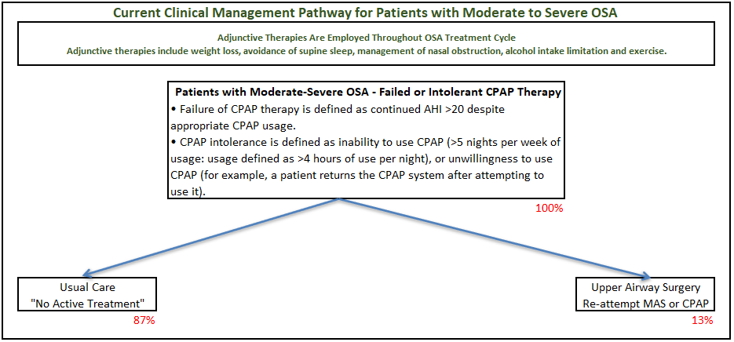
Source: Figure 7, p33 of 1595.1 Final Pre-PASC PICO – Applicant Comments.
AHI= apnoea hypopnoea index; CPAP=continuous positive airways pressure; MAS=mandibular advancement splint; OSA=obstructive sleep apnoea
Note: percentages are approximate based on Mehra 2020.

Proposed clinical management algorithm for identified population
The revised proposed clinical management algorithm is provided below.
Figure 6. Proposed clinical management algorithm for patients with moderate to severe OSA who have failed or are intolerant of CPAP
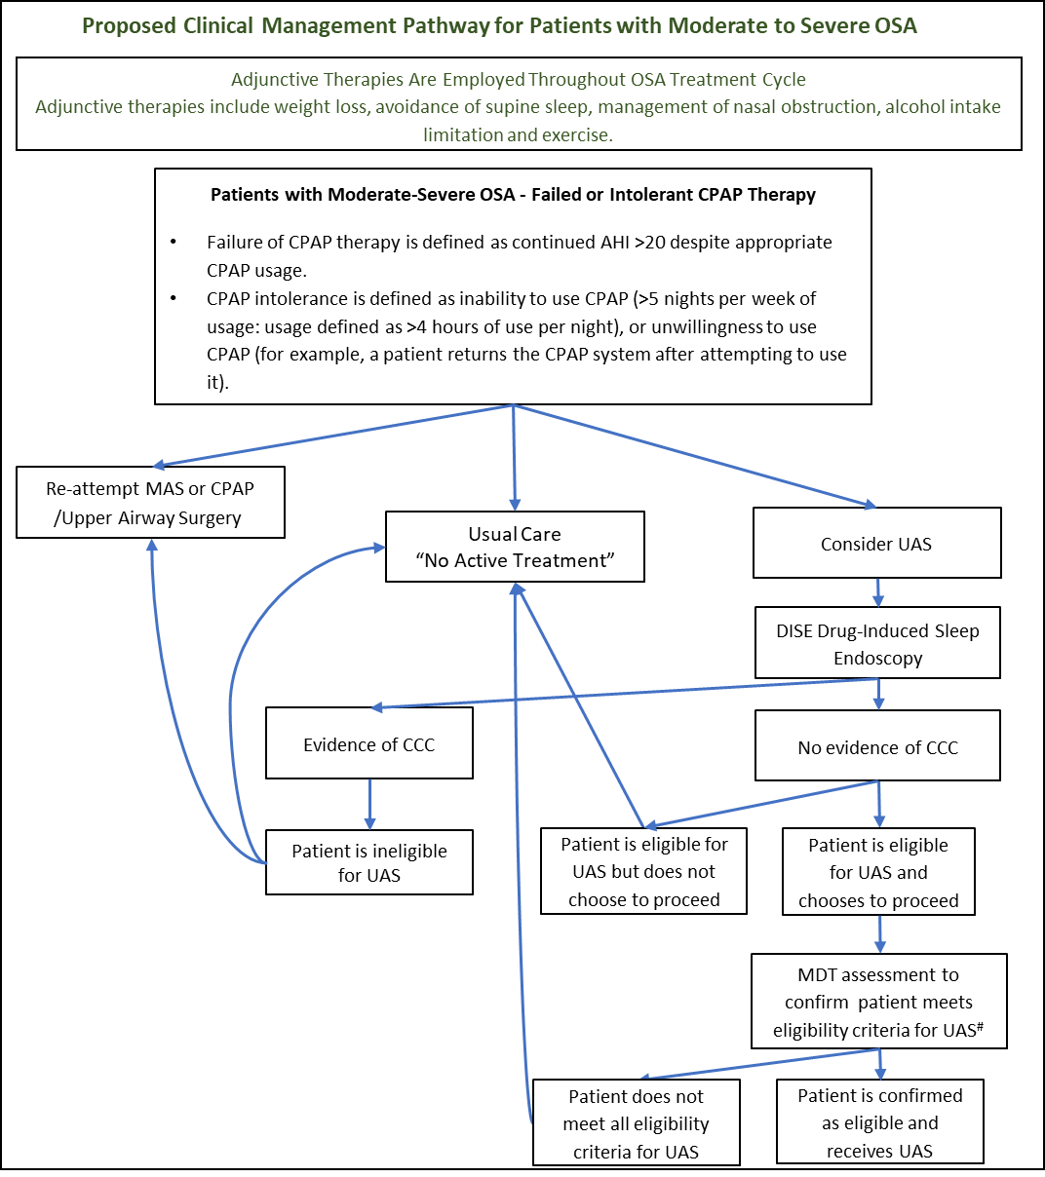
Source: Figure 8, p33 of 1595.1 Final Pre-PASC PICO – Applicant Comments revised post-PASC.
AHI=apnoea hypopnoea index; CCC=complete concentric collapse at the level of the soft palate; CPAP=continuous positive airways pressure; MAS=mandibular advancement splint; OSA=obstructive sleep apnoea; UAS=upper airway stimulation
# A sleep study may be required as an additional prior (if results from a recent sleep study, i.e. within 2 years are not available) to inform MDT assessment.

In considering whether the clinical algorithms capture UAS as a last line of therapy, PASC noted the algorithms depict the vast majority of patients as receiving no active care based on Mehra (2020).
PASC noted that the algorithms should include MDT case conference along with options for where patients are or are not assessed as meeting the eligibility criteria (e.g. CPAP failure, have exhausted all other treatment options and are receiving no active treatment).
PASC also queried if the DISE showed CCC, then would surgery be an option for those patients?

Proposed economic evaluation
PASC noted the resubmission claimed that UAS is superior to usual care for patients with moderate to severe OSA and who have failed or unable to tolerate CPAP. PASC noted that given UAS is a surgical intervention indicated for a population who would not otherwise have an intervention, a claim of inferior safety would likely be more appropriate. PASC confirmed the economic evaluation should be a cost-utility analysis.
PASC noted the pre-PASC response indicated that a cost-utility analysis will be conducted taking into account the advice MSAC provided for MSAC application 1595.
The pre-PASC response indicated the economic model will address:
- A revised economic model structure;
- A revised and justified time horizon;
- Justification and explanation of effect size issues as raised by ESC;
- Including longer term cardiac mortality;
- Including benefits from less traffic accidents; and
- External validation with published economic models.

Proposed MBS item descriptor/s and MBS fees (if relevant)
The PSD for 1595 indicated (p29) that for the MBS item descriptors, ESC considered that:
- CPAP failure and lack of tolerance to CPAP should be defined.
- ‘Once per patient per lifetime’ was appropriate for surgical repositioning or removal of the device, but not for replacement of the device.
- Unnecessary patient descriptions should be removed from the descriptors for repositioning or removal, and replacement.
PASC noted that the resubmission presented item descriptors for the insertion of the UAS, repositioning/removal of the UAS and replacement of the UAS along with a proposal for two case conference items (not previously included in MSAC 1595). PASC also noted that the pre-PASC response presented a revised proposed item descriptor for the insertion of the UAS that include definitions for CPAP failure/intolerance and an additional criterion ‘vi. have unsuccessfully attempted all other appropriate interventions and who are currently untreated’.
The applicant provided the following revised proposed item descriptor. As recommended in the ratified PICO for 1595, the item descriptors are agnostic to brand and refer only to a generic closed loop system.

Category 3 – Therapeutic Procedures

XXXXX
Proposed item descriptor: Unilateral closed-loop hypoglossal nerve stimulation therapy through stimulation of the hypoglossal nerve, including:
- subcutaneous placement of electrical pulse generator,
- surgical placement of lead including connection of the lead to the hypoglossal nerve and intra-operative test stimulation
- surgical placement of respiratory lead and intra-operative test stimulation for management of moderate to severe obstructive sleep apnoea in a patient who:
a) has an Apnoea Hypopnoea Index of greater than or equal to 15 and less than or equal to 65; and
b) is aged 18 and over; and
c) has failed or is intolerant of continuous positive airway pressure or bilevel airway pressure; and
d) has a BMI less than or equal to 32 kg/m²; and
e) does not have complete concentric collapse of the upper airway
- who have failed CPAP where CPAP failure is defined as continued AHI> 20 despite appropriate CPAP usage or
- who are intolerant of CPAP where CPAP intolerance is defined as inability to use CPAP (> 5 nights per week of usage: usage defined as > 4 hours of use per night or unwillingness to use CPAP or Patients who are unsuitable for, or
- have unsuccessfully attempted all other appropriate interventions and who are currently untreated.

Once per lifetime
Multiple Operation Rule
(Anaes.)
PASC noted that there may be unwillingness to undergo CPAP, and the threshold for unwillingness could be low as cost is entirely born by patients, and the market is unchecked with care not always delivered by health practitioners. PASC also noted that out of pocket costs may be substantial for UAS.
PASC confirmed that item (vi) should be prefaced with an ‘or’. PASC suggested that surgical repositioning or removal be only once per lifetime, instead of once per patient as stated in the proposed item descriptor.
Below are the item descriptors for repositioning or removal of the device, and replacement of the device.

Category 3 – Therapeutic Procedures

YYYYY
Proposed item descriptor: Unilateral closed-loop hypoglossal nerve stimulation therapy through stimulation of the hypoglossal nerve, surgical repositioning or removal of electrical pulse generator for management of moderate to severe obstructive sleep apnoea
Only once per patient lifetime
Multiple Operation Rule
(Anaes.)
MBS Fee: $161.95 Benefit 75% = $121.50 (in-hospital/admitted patient only)

Category 3 – Therapeutic Procedures

ZZZZZ
Proposed item descriptor: Unilateral closed loop hypoglossal nerve stimulation therapy through stimulation of the hypoglossal nerve, surgical replacement of electrical pulse generator
Multiple Operation Rule
MBS Fee: $346.05 Benefit 75% = $259.55 (in-hospital/admitted patient only)
The resubmission application proposed (p13) the inclusion of item numbers for a case conference to determine eligibility for closed loop UAS, similar to those available for transcatheter aortic valve implantation (TAVI), MBS items 6080 and 6081. The resubmission application indicated that at a minimum, the team would include an ENT surgeon and a sleep specialist. The proposed item numbers are provided below.

Category 1 – Professional Attendances

AAAAA
Proposed item descriptor: Coordination of a closed loop UAS Case Conference by a closed loop upper airways stimulation (UAS) practitioner where the closed loop UAS Case Conference has a duration of 10 minutes or more.
Fee: $52.50 Benefit: 75% = $39.40 85% = $44.65

Category 1 – Professional Attendances

BBBBB
Proposed item descriptor: Attendance at a closed loop UAS Case Conference by a specialist or consultant physician who does not also perform the service described in XXXX for the same Case Conference where the closed loop UAS Case Conference has a duration of 10 minutes or more.
Fee: $39.15 Benefit: 75% = $29.40 85% = $33.30
Regarding the proposed case conference items, PASC noted Department advice that specific case conference items for UAS should not be created as alternative appropriate case conference items are already available on the MBS. Therefore, PASC considered that the item descriptors for UAS should specify the requirement for a case conference and that there needs to be clarification and agreement of the multidisciplinary clinical expertise required for the case conference. It was noted that multidisciplinary expertise required for the case conference could be specified in an explanatory note.
The resubmission application also provided a tabled summary of the costs of closed loop UAS. The table is reproduced below.

Table 5: Costs of Closed Loop UAS
Service | Source | Fee/Cost | Benefit | Frequency | Cost
Presurgical services
DISE | MBS Item 41764 | $127.80 | $93.60 | 1 | $106.10
 | MBS Item 41889 | $180.90 | $135.70 | 1 | $135.70
Case conference - coordination | Proposed fee | $52.50 | $44.65 | 1 | $89.30
Attendance case conference | Proposed fee  Or MBS 236/237/238/239/240 | $39.15 | $33.30 | 2 | $66.60
Surgical services
Subcutaneous placement of IPG | Proposed fee | $346.05 | $259.55 | 1 | $259.55
Implantation of hypoglossal nerve lead | Proposed fee | $684.95 | $513.75 | 1 | $513.75
Implantation of respiratory sensing lead | Proposed fee | $684.95 | $513.65 | 1 | $513.65
Surgical repositioning or removal of IPG | Proposed fee | $161.95 | $121.50 | 0.016 | $1.95
Anaesthesia | MBS Item 20320 | $120.60 | $90.45 | 1 | $90.45
 | MBS Item 23091 | $180.90 | $135.70 | 1 | $135.70
Post-op chest x-ray | MBS Item 58500 | $35.35 | $26.55 | 1 | $26.55
Post-op neck x-ray | MBS 57945 | $43.40 | $32.85 | 1 | $32.85
Hospitalisation | AR-DRG D12B | $4,778 | $4,778 | 1 | $4,778
Follow up
Programming Inspire device | MBS item 105 | $44.35 | $37.70 | 2 | $75.40
DISE | MBS Item 41764 | $124.80 | $93.60 | 1 | $106.10
Source: Table 8, p29 of the resubmission application (MSAC 1595.1).
DISE=drug-induced sleep endoscopy; IPG=implantable pulse generator
The applicant indicated that consultation with local clinicians provided advice that item numbers 41855, 41816 or 41764 are currently used for DISE. Item 20320 may be used for initiation of anaesthesia and 23035 for anaesthesia time units.

Consultation feedback
Input was received from the following three (3) organisations and one (1) individual:
- the Sleep Health Foundation
- Australian Society of Otolaryngology Head & Neck Surgery (ASOHNS)
- Australia and New Zealand Sleep Science Association (ANZSSA)
It should be noted that ASOHNS wished to remain impartial with regards to medical device companies.
Feedback was broadly supportive of the application. The following advantages were suggested:
- Clinical claims are justified.
- Without the service, the proposed population would likely go untreated.
- Provides treatment choice for patients.
- UAS is a potentially useful alternative treatment for patients who are intolerant of CPAP.
The following disadvantages were stated:
- UAS is invasive surgery, thus has associated costs and risks.
- A higher efficacy would be desirable.
- Implantable device recommendations currently preclude MRI scanning.
Other comments raised in feedback are:
- Nasal endoscopy under anaesthesia should be considered.
PASC noted the consultation feedback which highlighted the need for an alternative therapy to CPAP and the benefits for UAS to treat OSA in a population of patients with no treatment alternatives. PASC noted the feedback raised concern that the proposed population was very inclusive and may represent the majority of patients, that there is potential for poor efficacy in some patients and that once implanted patients are precluded for undergoing an MRI.

Next steps
Upon ratification of PICO 1595.1, the application can proceed to the pre-Evaluation Sub-Committee (ESC) stage.
PASC noted that the applicant has elected to prepare an ADAR (applicant-developed assessment report).

Applicant comment on the PICO Confirmation
Population
The applicant anticipates that Inspire® Medical Systems Inc would provide theatre support for ENTS indefinitely, or for as long as implanting ENTs desired the support. It is common practice in Australia for device companies to supply theatre support for implantable devices.
Intervention
The applicant stated that while the EFFECT trial has been published, the CARDIOSA-12 trial has not been published as yet. Further, the applicant stated that Inspire is not a sponsor of this trial and has no involvement in the conduct of the trial. The applicant has no knowledge of when the results will be published. The results will be included if available.
Comparator
The applicant believes that the proposed wording of the item number adequately addresses PASC’s concerns. The phrase ‘patients who are unsuitable for, or else have unsuccessfully attempted all other appropriate interventions and who are currently untreated’ is equivalent to ‘exhausted all options’. The applicant stated that usual care for these patients is to remain untreated as stated in the consultation feedback.
The applicant disagrees that insurance coverage is not a determinant to access to an MBS-funded therapy and that patients who do not have private health insurance and must access the public sector for care are unlikely to have equivalent access to the therapy as those with private health insurance. The applicant also stated that private health insurance includes exclusions for some therapies (e.g. Bronze, silver and gold levels of cover) so insurance status will be a determinant of access in Australia.
Proposed economic evaluation
The applicant agrees that UAS is likely to be inferior in safety to usual care.
Proposed MBS item descriptor/s and MBS fees (if relevant)
The applicant advised that they will get expert advice on time required to coordinate and attend a case conference for UAS.
The applicant acknowledges the MBS Item fees in Table 5 will need to be updated.
Consultation Feedback
The applicant appreciates the feedback and believe that it is supportive of the proposed population.
Next Steps
The applicant states that the sponsor will submit ADAR to the 9th February 2022 lodgement deadline.

References

Heiser C, Steffen A, Hofauer B, Mehra R, Strollo PJ, Vanderceken OM, Maurer JT ‘Effect of Upper Airway Stimulation in Patients with Obstructive Sleep Apnea (EFFECT): A Randomized Controlled Crossover Trial’ J of Clinical Medicine 2021, 10
NCT0335906
Young T, Shahar E, Nieto FJ, Redline S, et al. Predictors of sleep-disordered breathing in community-dwelling adults: the Sleep Heart Health Study. Arch Intern Med 2002;162(8):893-900.
Marshall NS, Wong KK, Liu PY, Cullen SR, Knuiman MW, Grunstein RR. Sleep apnea as an independent risk factor for all-cause mortality: the Busselton Health Study. Sleep 2008;31(8):1079-85.
Marin JM, Carrizo SJ, Vicente E, Agusti AG. Long-term cardiovascular outcomes in men with obstructive sleep apnoea-hypopnoea with or without treatment with continuous positive airway pressure: an observational study. Lancet 2005;365(9464):1046-53.
Tregear S, Reston J, Schoelles K, Phillips B. Obstructive sleep apnea and risk of motor vehicle crash: systematic review and meta-analysis. J Clin Sleep Med 2009;5(6):573-81.
Adams R. Report to the Sleep Health Foundation 2016 Sleep Health Survey of Australian Adults. Available at: https://www.sleephealthfoundation.org.au/pdfs/surveys/SleepHealthFoundation-Survey.pdf
Australasian Sleep Association ‘Australasian Sleep Association submission re: Adult Sleep Apnea Surgery’ 2013. Available at: https://sleep.org.au/common/Uploaded%20files/Public%20Files/Professional%20resources/Sleep%20Documents/ENT%20MSAC.pdf
Senaratna CV, English DR, Currier D, Perret JL, et al. Sleep apnoea in Australian men: disease burden, co-morbidities, and correlates from the Australian longitudinal study on male health. BMC Public Health 2016;16(Suppl 3):1029.
Escourrou P, Grote L, Penzel T, McNicholas WT et al. The diagnostic method has a strong influence on classification of obstructive sleep apnea. J Sleep Res 2015; 24:730-738.
NCT03760328 - Effect of Upper Airway Stimulation in Patients With Obstructive Sleep Apnea (EFFECT)
NCT03359096 - Cardiovascular Endpoints for Obstructive Sleep Apnea With Twelfth Nerve Stimulation (CARDIOSA-12)
Inspire System Implant Manual. Inspire IV Implantable Pulse Generator Model 3028. Stimulation Lead Model 4603. Respiratory Sensing Lead Model 4340

