Ratified
PICO Confirmation
Application 1666:
Exclusion of the left atrial appendage via surgical epicardial clip implantation concomitant to open cardiac surgery for patients with atrial fibrillation

Summary of PICO criteria to define question(s) to be addressed in an Assessment Report to the Medical Services Advisory Committee (MSAC)
Table 1 PICO for epicardial clip implantation to exclude the left atrial appendage in patients with atrial fibrillation undergoing open cardiac surgery with a CHA₂DS₂-VASc* score of ≥ 2
Component | Description
Population | Patients with a documented history of atrial fibrillation (AF) undergoing open cardiac surgery, at risk of stroke based on a CHA₂DS₂-VASc* score of ≥ 2.
Intervention | Left atrial appendage (LAA) exclusion using an epicardial clip device implanted during concomitant open cardiac surgery
Comparators | LAA exclusion during concomitant open cardiac surgery using either:  - Staple occlusion  - Suture ligation  - amputation of the LAA and closure (cut and sew)  - double layer linear closure from within the atrium
Outcomes | Effectiveness  Primary  - Major stroke  - Ischemic stroke  - Haemorrhagic stroke  - Systemic embolism  - Cardiovascular and all-cause mortality  - LAA exclusion confirmed by transoesophageal echocardiography (TOE)  Secondary  - Health-related quality of life and disability  - Operative time, ease of use/learning curve  Safety  - Major bleeding events: short-term (post-operative <30 days) e.g. procedural and post-procedural events; and long term  - Re-admission rate: short-term (post-operative <30 days); and long term  - Reintervention rate: short-term (post-operative <30 days); and long term  - Failure of exclusion/occlusion requiring reintervention  - Intraoperative complications  - Postoperative complications: short-term (<30 days); and long term  Healthcare resources  - Cost to deliver the intervention, including follow-up  Total Government Healthcare costs  - Total cost to the Medicare Benefits Schedule (MBS)  - Total cost to other healthcare budgets including device costs
Assessment questions | What is the safety, effectiveness, and cost-effectiveness of epicardial clip devices versus sutures/staples in patients undergoing open cardiac surgery with a documented history of atrial fibrillation and at risk of stroke (CHA₂DS₂-VASc* score of ≥ 2)?
*Congestive heart failure, hypertension, age ≥ 75 years, diabetes mellitus, stroke or transient ischemic attack (TIA), vascular disease, age 65 to 74 years, sex category

Purpose of application
An application requesting listing of the AtriClip device on the Prostheses List (PL) with a benefit of $2,450 for patients undergoing open cardiac surgery with a documented history of atrial fibrillation (AF) was received from AtriCure by the Department of Health.
The AtriClip device for the exclusion of the left atrial appendage (LAA) was first listed on the PL in March 2021. It was grouped within 09.08.02 – Surgical Closure Devices (Atrial Appendage) at a benefit of $1,097. The Department advised that a new MBS item for the implantation of the device concomitant to open cardiac surgery is not required as the short time to implant the device (5-7 minutes) does not substantially impact the total duration of surgery.
A related assessment – MSAC Application 1615 - Transcatheter occlusion of the left atrial appendage for patients with non-valvular atrial fibrillation – was assessed by MSAC at their meeting on 31 March – 1 April 2021 (MSAC Application 1615, 2021). Application 1615 related to percutaneous (i.e. stand-alone) occlusion of the LAA rather than LAA exclusion concomitant to open cardiac surgery.
The use of an epicardial clip aims to replace other open surgical LAA exclusion methods, namely stapling and suture ligation, and is claimed to have superior effectiveness and superior safety compared with the comparators.

PICO criteria

Population
The proposed population is patients with a documented history of AF, who are undergoing open cardiac surgery for the treatment of coronary artery disease, structural heart disease or, most commonly, valvular disease and are at risk of stroke based on a CHA₂DS₂-VASc score of ≥ 2.
Patients would not undergo any additional investigations other than the standard of care work up prior to open cardiac surgery. LAA exclusion would be performed by the cardiac surgeon during the open cardiac surgery. Traditionally, stroke risk in AF is assessed using CHA₂DS₂-VASc scores to determine eligibility for oral anticoagulation (OAC) therapy (National Heart Foundation of Australia and the Cardiac Society of Australia and New Zealand [NHFA/CSANZ] 2018). The population who are suitable for the epicardial clip require a documented history of AF and an indication for open cardiac surgery, with a CHA₂DS₂-VASc score of ≥ 2.
PASC noted that in the pivotal LAAOS III trial (Whitlock et al 2021), patient inclusion criteria included ‘a documented history of AF’ and risk of stroke determined by a CHA₂DS₂-VASc score of ≥2.
PASC advised that the appropriate treatment population was patients with a documented history of AF who are at risk of stroke as demonstrated with a CHA₂DS₂-VASc score of ≥2, consistent with the LAAOS III trial.
PASC noted the advice from the applicant’s clinical expert that 30-50% of patients go into perioperative AF in the first six weeks post-surgery and, if these patients do not respond to antiarrhythmic drugs, they require cardioversion performed under a general anaesthetic with transoesophageal echocardiography (TOE). The clinical expert noted that use of an epicardial clip would obviate the need for TOE or cardioversion under general anaesthesia. The clinical expert considered that despite the limited clinical evidence, some surgeons may use the epicardial clip routinely, thus expanding the population beyond those specified. PASC considered that that an extension of the population would be difficult to justify.

Background

Stroke
Stroke occurs when a blood vessel supplying blood to the brain suddenly becomes blocked (arterial embolic ischaemic stroke), uncommonly the venous drainage becomes blocked (venous thrombotic stroke) and/or begins to bleed (haemorrhagic stroke). All may result in part of the brain dying, leading to sudden impairment that can affect several functions. Stroke often causes paralysis of parts of the body normally controlled by the area of the brain affected by the thromboembolism. Speech problems and other symptoms, such as difficulties with swallowing, vision and thinking, can also be caused by stroke.
Relevant for this application is the occurrence of arterial embolic stroke with the origin of the embolus being the left atrial appendage.
In 2018, an estimated 387,000 people—214,000 males and 173,000 females—had a stroke at some time in their lives, based on self-reported data from the Australian Bureau of Statistics 2018 Survey of Disability, Ageing and Carers. Stroke was also recorded as the underlying cause of 8,400 deaths, accounting for 5.3% of all deaths in Australia in 2018 (AIHW 2020).

Atrial fibrillation
AF is a common cardiac arrythmia and is a strong independent predictor of stroke incidence. The diagnosis of AF requires rhythm documentation with an electrocardiogram (ECG) tracing showing AF (Hindricks, 2020). AF is characterised by structural alteration of the myocardium, disrupting the electrical conduction system of the heart and cardiac muscle contractility. Irregularities in contraction patterns cause turbulent flow, resulting in the accumulation of blood and a higher risk of thromboembolism formation (NHFA/CSANZ 2018).
AF is traditionally categorised into four main clinical pattern types (Table 2). It is also frequently characterised as either valvular or non-valvular, although recent European Guidelines recommend abandoning this terminology (Hindricks, 2020).
Table 2 Clinical patterns of AF
Paroxysmal AF | Episodes that terminate spontaneously or are cardioverted within 7 days; may recur with variable frequency
Persistent AF | Episodes of continuous AF that last >7 days and do not self-terminate, including episodes that are cardioverted after 7 days or more
Long-standing persistent AF | Continuous AF lasting for ≥1 year when it is decided to adopt a rhythm control strategy
Permanent AF | Applies when a decision has been made jointly by the physician and patient to accept the presence of AF and stop further attempts to restore or maintain sinus rhythm. This represents clinical acceptance rather than an inherent pathophysiological attribute of AF and, should a rhythm-control strategy be adopted, the arrhythmia should be re-classified as ‘long-standing persistent AF’.
Source: Table derived from NHFA/CSANZ 2018, p.1220.
The symptoms of AF include palpitations, dizziness, chest pain and shortness of breath, often noticed as an inability to tolerate exercise. Approximately 10–30% of people with AF have no symptoms (Department of Health and Ageing (DoHA), 2012).
The AIHW reports that AF affects approximately 2% of the general population. Increasing age is a major risk factor along with other modifiable comorbidities including diabetes, hypertension, coronary artery disease, chronic kidney disease and obesity (Hindricks, 2020). The risk of developing a thromboembolism leading to stroke is greatly increased in patients with AF. In 2017-18, 15.5% of acute hospitalisations with the principal diagnosis of stroke had AF listed as an additional diagnosis (AIHW 2020).
AF management focusses on:
- stroke risk reduction with the use of oral anticoagulants
- management of symptoms with the use of pharmacological agents or, as a second-line option, catheter ablation, and
- reduction of cardiovascular and other risk factors (Hindricks, 2020; NHFA/CSANZ 2018).
Surgical ablation of AF concomitant to open cardiac surgery (i.e., coronary artery bypass grafting (CABG) or valve repair/replacement) is a common procedure performed on patients with persistent AF. The NHFA/CSANZ 2018 Guidelines recommend that patients with an increased risk of stroke should continue OAC therapy indefinitely, despite success of ablation procedures (NHFA/CSANZ 2018).

The left atrial appendage
Patients with AF have an increase in the risk of arterial ischaemic stroke, with the LAA being the primary anatomical source of the embolism. The LAA is a pocket-like extension of the left atrium and actively contracts to maintain blood flow in the left atrium.
Endothelial dysfunction, abnormal blood stasis and hypercoagulability dysregulate the pattern of blood flow in the LAA, promoting the formation of a mural thrombus (Bukowska et al. 2018). If this thrombus embolises in the systemic circulation upstream of the cerebral vasculature, it may migrate through the arterial system to the cerebral circulation and cause ischaemic stroke via occlusion of a cerebral artery, or alternatively may enter the systemic arterial system and occlude other organs.
The aim of LAA exclusion surgeries in patients with AF and high risk of stroke is to prevent the formation of a mural thrombus. Effective exclusion of the LAA from the systemic circulation is dependent on maintaining a smooth endocardial surface during surgery. Unsuccessful exclusion can lead to residual gap formation facilitating blood flow between the LAA and left atrium, increasing risk for bleeding complications at the site of ligation (Caliskan et al. 2018).
In addition, the LAA can be electrically isolated from the left atrium in an effort to introduce rhythm control management to target AF, therefore surgical exclusion may also improve symptom management due to electrical isolation of the LAA via exclusion surgery (Nishimura et al. 2019).

Patient eligibility and estimated population
Patients undergoing open cardiac surgery, primarily for CABG procedures or valvular repair/replacement, with a documented history of AF and a stroke risk based on a CHA₂DS₂-VASc score ≥ 2 would be eligible for an epicardial clip placement. Once a patient has been scheduled for open cardiac surgery, they are assessed for history of AF and risk of stroke. The applicant advised post PASC that contraindications of size and orientation of the LAA and presence of a clot are determined intra-operatively through measuring the LAA directly, and no additional pre-operative work-up is required, such as TOE or CT scan.
The use of an epicardial clip does not entail additional pre-surgical investigations as a patient referred to a cardiac surgeon for open cardiac surgery will have an extensive history of cardiac investigations, which will include at least an ECG. The referring physician, almost always a cardiologist, documents the history of AF as part of standard cardiac work up.
Over the period 2010-2020, there were approximately 9,000 CABG and valvular procedures claimed per year on the MBS (Figure 1). The applicant has estimated that approximately 70-75% of these are performed using an open surgical technique. The Application estimates that ~60% of patients undergoing mitral valve surgery (Jessurun et al. 2000; Arora et al. 2019) and ~5% of patients undergoing CABG (Saxena et al. 2015) have pre-operative AF. Based on these estimates, approximately 1,800 patients undergoing mitral valve surgery and 540 patients undergoing CABG would be eligible to undergo placement of an epicardial clip per year. The uptake is likely to be smaller and is dependent on clinical assessment of stroke risk and choice of LAA exclusion method. The applicant estimates 50% uptake.
In a large analysis of US hospital data, 7% of patients who underwent isolated CABG and had a history of AF also underwent LAA exclusion, however the use of LAA exclusion increased steadily over the study period (2010-14) (Mahmood et al, 2020).
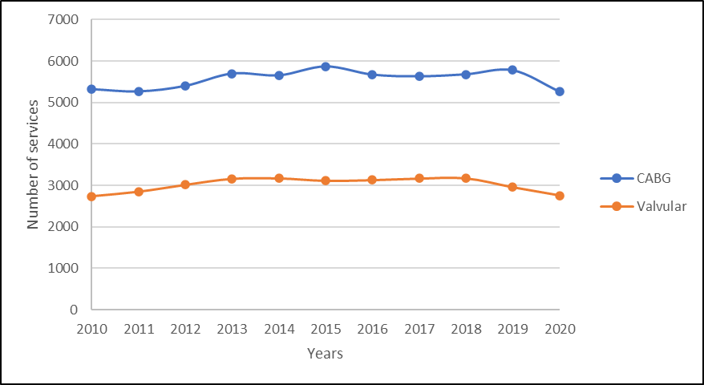
Figure 1 Number of services per year for MBS Items for CABG (38497, 38498, 38500, 38501, 38503, 38504) and valvular repair/replacement (38488, 38489,38490)
Source: Information derived from MBS Item Statistics Reports (http://medicarestatistics.humanservices.gov.au/statistics/mbs_item.jsp)
According to the NHFA/CSANZ 2018 guidelines, LAA occlusion concomitant to open cardiac surgery may be considered for stroke prevention in patients with AF, however the differences in safety and efficacy between various methods (i.e., stapling, epicardial clips) are unknown and “surgeons should perform the LAA occlusion technique with which they have most experience”. Additionally, it is recommended that OAC therapy is continued post-closure “unless complete occlusion is confirmed, generally by transoesophageal echo (TOE)” (NHFA/CSANZ 2018).
The more recent European Society of Cardiology guidelines (2020) recommend that surgical occlusion or exclusion of the LAA may be considered for stroke prevention in patients with AF undergoing cardiac surgery (Level of evidence IIB; Strength of recommendation C). Neither guideline was developed before publication of the large LAAOS III RCT, which reported a significantly lower incidence of ischaemic stroke or systemic embolism after surgical occlusion compared with no occlusion (Whitlock, 2021).

Intervention
The intervention is the exclusion of the LAA during open cardiac surgery using an epicardial clip. Only one epicardial clip, AtriClip, is currently available on the Australian market.

AtriClip device
The AtriClip FLEX device is a self-closing, sterile, implantable clip that is made of two parallel rigid titanium tubes with elastic nitinol springs and covered with a knit-braided polyester sheath (Figure 2). The AtriClip kit includes a single use, disposable applier and a permanently implanted clip that is indicated for use during open cardiac surgery.
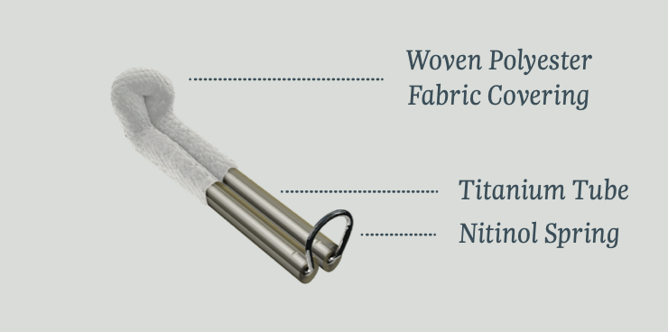
Figure 2 Image of AtriClip FLEX device
Source: AtriCure’s AtriClip FLEX product brochure: https://www.atricure.com/sites/default/files/brochure/PM-US-0110A-1020-G_AtriClip_FLEX_Brochure.pdf
The AtriClip device comes in several models that are indicated for use either concomitant to open cardiac surgery or as stand-alone minimally invasive surgery (excluded from this assessment). The AtriClip FLEX model is currently marketed in Australia and has been listed on the PL since March 2021 (Billing Code ZZ066). The applicant has advised that earlier models of the AtriClip are being discontinued. Table 3 details the various AtriClip models and their regulatory status in Australia. Only AtriClip FLEX is currently listed on the PL.
No other devices are currently included on the ARTG for the closure of the LAA during open cardiac surgery. The TigerPaw II system was previously included but was recalled in 2015 due to safety concerns.
Table 3 Regulatory status of all AtriClip devices
Concomitant | ARTG | Date included on ARTG | GMDN | Device
Open cardiac surgery | 175070 | 25/08/2010 | 35649 | AtriClip LAA Exclusion System (ACH1)
 | 308862 | 31/08/2018 | 35649 | AtriClip FLEX (ACH2)
 | 354171 | 03/02/2021 | 35649 | AtriClip FLEX V (FLEXV)
 | Not listed | N/A | N/A | AtriClip Long
Minimally invasive cardiac surgery | 308863 | 31/08/2018 | 35649 | AtriClip PRO (PRO)
 | 308864 | 31/08/2018 | 35649 | AtriClip PRO 2 (PRO2)
 | 354170 | 03/02/2021 | 35649 | AtriClip PRO V (PROV)
Sources: AtriClip webpage, ARTG public summary documents.

Proposed place in clinical care
The AtriClip device is intended to exclude the LAA to reduce the risk of stroke in patients with AF. The base of the LAA is clipped using the AtriClip device to stop blood flow and prevent the formation of thrombi.
Implantation of the AtriClip is concomitant to open cardiac surgery, most commonly valvular replacement/repair surgery and CABG. In eligible patients, the LAA is sized via direct measurement and the AtriClip device is placed under direct visualisation at the base of the LAA, resulting in electrical and haemodynamic isolation from the left atrium. The implantation procedure, assuming open access with direct visualisation in normal circumstances will take five to seven minutes to complete in addition to the procedure time for the index surgical procedure.

Comparators
Surgical methods of LAA exclusion include the use of surgical exclusion devices (AtriClip is the only such device marketed in Australia), stapling, and different approaches using sutures. The appropriate comparators are therefore stapling or suturing techniques for exclusion of the LAA during concomitant open cardiac surgery.
Table 4 shows the stapling devices and percutaneous LAA occluders currently listed on the PL. Percutaneous LAA occluders are intended to occlude the LAA as a stand-alone procedure and are not in scope for the assessment of epicardial clips used during open cardiac surgery.
Table 4 LAA occlusion devices listed on the Prostheses List
Type of LAA occlusion | Billing Code and Device name | Manufacturer | Prostheses List product subgroup | Benefit
Stapling | JJ903 Echelon disposable stapling device | Johnson & Johnson Medical Pty Ltd | Staplers | $357
 | MN215 Echelon disposable powered stapling device | Johnson & Johnson Medical Pty Ltd | Staplers | $447
 | AS046 Endo GIA stapling system | Medtronic Australasia Pty Ltd | Staplers | $357
 | MI227 Signia™ Powered Intelligent Stapling System | Medtronic Australasia Pty Ltd | Staplers | $447
 | MN219 Echelon staple reload | Johnson & Johnson Medical Pty Ltd | Staples, non-bone (reload) | $323
 | AS186 Endo GIA™ Reload with Tristaple™ Technology | Medtronic Australasia Pty Ltd | Staples, non-bone (reload) | $323
 | AS209 Endo GIA Reinforced Reload with Tri-Staple Technology | Medtronic Australasia Pty Ltd | Staples, reinforcer | $521
 | MI287 Tri-Staple 2.0 Reinforced reloads | Medtronic Australasia Pty Ltd | Staples, reinforcer | $521
Percutaneous | BS332 WATCHMAN | Boston Scientific Australia Pty Ltd | Left atrial appendage closure | $11,400
 | SJ395 Amplatzer Left Atrial Appendage Closure Device | Abbott Medical Australia Pty Ltd | Left atrial appendage closure | $11,400
 | BS384 WATCHMAN FLX | Boston Scientific Australia Pty Ltd | Left atrial appendage closure | $11,400
Source: Prostheses List (July 2021).

Stapling
Closure of the LAA can be performed using stapling devices that occlude the base of the structure. The main aim of stapled occlusion of the LAA is to disrupt the flow between the left atrium and LAA, reducing the likelihood of thrombus formation to decrease stroke risk.
The estimated total PL benefit of using a stapling device and staples to close the LAA is $1,020. This estimate is based on calculating the benefit of the stapling system (MI227) and a single reload (MI287), plus a second reload in 10% of patients ($447 + $521 + $52 = $1,020).

Suture ligation
Suture ligation of the LAA can be completed using various epicardial and endocardial techniques. In the LAAOS III trial, amputation followed by suture closure was the preferred approach. Double-layer linear closure from within the atrium was permitted for patients undergoing mini-thoracotomy and required TOE confirmation. Purse-string closure was not permitted. Incomplete closure of the LAA may not be effective as a partially open LAA can result in recanalisation (Noelck et al. 2016). Sutures are not included in the Prostheses List.
PASC confirmed that the comparators for the intervention are surgical amputation or stapling of the LAA.
PASC noted the clinical expert advice on safety risks associated with suturing or stapling the LAA, including significant post-operative bleeding and LAA closure could be suboptimal as it may not be flush or could lead to recanalisation. PASC noted that in the LAAOS III trial, all allowed LAA closure techniques were considered to be equivalent for the purposes of the study (see Outcomes).
PASC noted that percutaneous devices are not comparators.

Outcomes
The epicardial clip is proposed to replace other surgical LAA exclusion methods, such as stapling and sutures, used during open cardiac surgery for patients with AF. The epicardial clip is claimed to have superior effectiveness due to a higher rate of LAA closure, however differences in the primary clinical outcomes (major stroke, systemic embolism, cardiovascular and all-cause mortality) are unlikely to be established. For these long-term primary outcomes, the clinical claim is that the epicardial clip is non-inferior to the comparators.
The epicardial clip is claimed to have superior safety attributed to reduced adverse events in the post-operative period. The applicant claimed that epicardial clip implantation will reduce the short-term risks of bleeding, reoperation and major post-operative complications. This safety claim would be the major justification for the reimbursement request.

Effectiveness

Primary
- Major stroke
o Ischemic stroke
o Haemorrhagic stroke
- Systemic embolism
- Cardiovascular and all-cause mortality
- LAA exclusion confirmed by transoesophageal echocardiography (TOE)

Secondary
- Health-related quality of life and disability
- Operative time, ease of use/learning curve

Safety
- Major bleeding events: short-term (post-operative <30 days) e.g. procedural and post-procedural events; and long term
- Re-admission rate: short-term (post-operative <30 days); and long term
- Reintervention rate: short-term (post-operative <30 days); and long term
  - Failure of exclusion/occlusion requiring reintervention
- Intraoperative complications
- Postoperative complications: short-term (<30 days); and long term

Healthcare resources
- Cost to deliver the intervention, including follow-up

Total Government Healthcare costs
- Total cost to the Medicare Benefits Schedule (MBS)
- Total cost to other healthcare budgets including device costs
The applicant noted that once the LAA is closed, regardless of method, long-term stroke risk is low and it would not be possible to demonstrate differences between different methods of LAA closure. The applicant pointed out that LAA closure with sutures and staples are more likely to result in significant bleeding in the early post-operative period compared to using an epicardial clip.
PASC noted that in the LAAOS III trial no difference in complications with respect to perioperative bleeding and other post procedural problems was observed between the trial groups (occlusion vs. no occlusion). Approximately two-thirds of the occlusions were done with stapling and suturing, and this did not increase the frequency of perioperative complications in the occlusion group compared to the non-occlusion group. The low event rate will make differences in these short-term post-procedural outcomes difficult to demonstrate with sufficient power.
PASC confirmed stroke, systemic embolism, mortality and QoL as outcomes for this application, noting there may not be demonstrable differences between epicardial clip and its comparators. PASC noted that QoL may differ over the short and long term.
PASC confirmed that LAA exclusion confirmed by transoesophageal echocardiography (TOE) is a surrogate outcome.
PASC considered the impact of LAA closure on downstream therapy important, and noted that in the LAAOS III trial, LAA closure did not result in changes to OAC use; this is consistent with NHFA/CSANZ Guidelines.
PASC noted that the applicant’s advice that the major difference between the epicardial clip and the comparators relates to post-operative safety, particularly bleeding and the need for reoperation. PASC advised that short-term outcomes and long-term outcomes are included the PICO Confirmation as two separate endpoints (see Proposed Economic Evaluation).
PASC considered that direct comparative evidence is unlikely to be sufficiently powered to address the primary effectiveness outcomes. PASC noted that if all LAA closure techniques would be considered equivalent in terms of long-term outcomes, then a linked evidence approach (to translate the surrogate outcome to the long-term clinical outcomes) may not be helpful. However, such an approach is necessary to claim superior effectiveness for these outcomes (stroke risk).

Clinical management algorithms
The epicardial clip is proposed to directly replace stapled or sutured exclusion of the LAA during open cardiac surgery. The proposed management algorithms are presented in Figure 3 and Figure 4. There are no changes to the pre-surgical management or screening of patients, nor to post-surgical care. The algorithms therefore include both the intervention and the comparator. The clinical claim is that epicardial clip closure of the LAA will reduce the risk of post-operative bleeding and increase the rate of successful LAA exclusion. The applicant confirmed post PASC that there was no requirement for post-operative assessment of LAA closure via an epicardial clip closure, but noted that an LAA closure assessment is often performed concomitant to valve and/or ventricular function assessment TOE. The applicant advised that TOE may be performed if there is evidence of cardiac tamponade to assess for tearing of the LAA suture/staple closure line.

Current and proposed treatment management algorithm

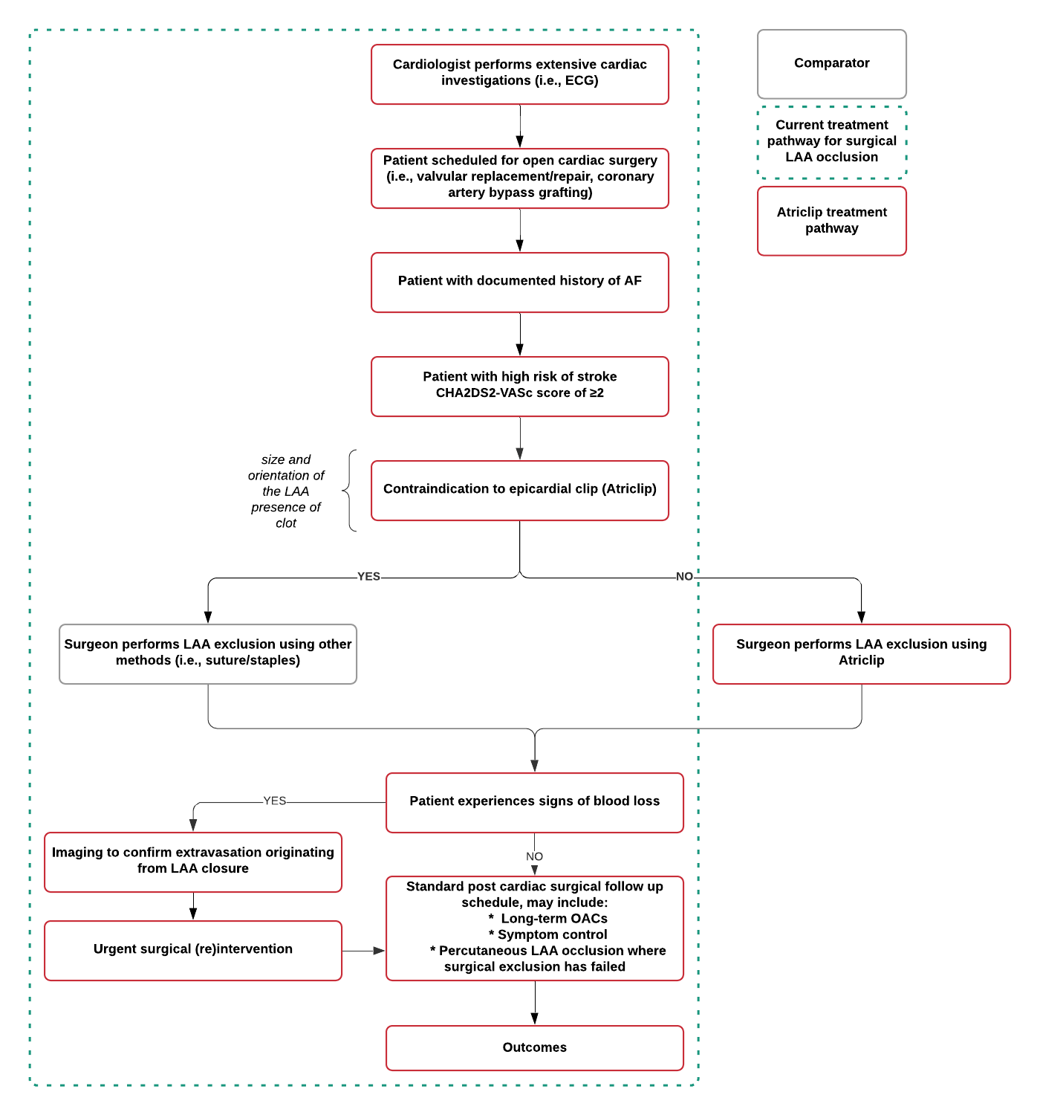Figure 3 Current and proposed treatment management pathway for LAA exclusion using an epicardial clip or alternative methods: sutures or staples
Abbreviations: ECG, electrocardiogram; AF, atrial fibrillation; LAA, left atrial appendage; OACs, oral anticoagulants.

PASC agreed with the proposed clinical management algorithms, noting the eligibility criteria for stroke risk was updated with a CHA₂DS₂-VASc score of ≥ 2 to align with PASC advice.

Proposed economic evaluation
On the basis of the clinical claim that the use of an epicardial clip is superior to stapling or suturing for exclusion of the LAA concomitant to open cardiac surgery, the appropriate economic evaluation is a cost-effective analysis or a cost-utility analysis.
PASC noted that the applicant’s claim is of superior comparative safety and considered a cost effectiveness analysis or cost utility analysis to be appropriate.
PASC noted that the economic evaluation would need to model both short-term and long-term outcomes.

Proposal for public funding
The Department has confirmed that a new MBS item is not required for implantation of an epicardial clip because the impact on the total duration of open cardiac surgery is insubstantial (the device only takes five to seven minutes to implant).
PASC agreed that no new MBS item is required for the LAA closure with an epicardial clip due to the insubstantial impact on the total duration of open cardiac surgery.
Cardiac MBS item numbers underwent substantial changes on 1st July 2021 in accordance with the MBS Review Taskforce (Medicare Benefits Schedule 2021). The CABG and valvular repair/replacement surgery MBS items (Table 5 and Table 6) may be used in conjunction with implantation of the epicardial clip. These MBS item numbers differ from those claimed historically (and represented in the utilisation estimates in Figure 1).
CABG items have been consolidated into a single MBS item (38502). Four additional MBS items can be claimed with the primary procedure when additional procedures are required (38510, 38511, 38513 and 38637).
There are two valve replacement MBS items (38484 and 38499) and two valve repair items (38516 and 38517). A stand-alone item for annuloplasty is available (38477). Two MBS items (38519 and 38490) can be claimed as add-on items with valve repair or replacement.
Table 5 MBS item for coronary artery bypass
Category 3 – THERAPEUTIC PROCEDURES
MBS 38502
Coronary artery bypass, including cardiopulmonary bypass, with or without retrograde cardioplegia, with or without vein grafts, and including at least one of the following:
(a) harvesting of left internal mammary artery and vein graft material;
(b) harvesting of left internal mammary artery;
(c) harvesting of vein graft material;
other than a service associated with a service to which item 11704, 11705, 11707, 11714, 18260, 33824, 38418, 38806 or 45503 applies (H).
(Anaes.) (Assist.)
Fee: $2,451.55 Benefit: 75% = $1,838.70

Table 6 MBS items for valve repair or replacement
Category 3 – THERAPEUTIC PROCEDURES
MBS 38484
Aortic or pulmonary valve replacement with bioprosthesis or mechanical prosthesis, including retrograde cardioplegia (if performed), other than a service associated with a service to which item 11704, 11705, 11707, 11714, 18260, 33824, 38418, 38806 or 45503 applies (H).
(Anaes.) (Assist.)
Fee: $2,112.20 Benefit: 75% = $1,584.15
MBS 38499
Mitral or tricuspid valve replacement with bioprothesis or mechanical prosthesis, including retrograde cardioplegia (if performed), other than a service associated with a service to which item 11704, 11705, 11707, 11714, 18260, 33824, 38418, 38806 or 45503 applies (H).
(Anaes.) (Assist.)
Fee: $2,112.20 Benefit: 75% = $1,584.15
MBS 38516
Simple valve repair:
(a) with or without annuloplasty; and
(b) including quadrangular resection, cleft closure or alfieri; and
(c) including retrograde cardioplegia (if performed);
other than a service associated with a service to which item 11704, 11705, 11707, 11714, 18260, 33824, 38418, 38806 or 45503 applies (H) (Anaes.) (Assist.)
Fee: $2,509.25 Benefit: 75% = $1,881.95
MBS 38517
Complex valve repair:
(a) with or without annuloplasty; and
(b) including retrograde cardioplegia (if performed); and
(c) including one of the following:
(i) neochords;
(ii) chordal transfer;
(iii) patch augmentation;
(iv) multiple leaflets;
other than a service associated with a service to which item 11704, 11705, 11707, 11714, 18260, 33824, 38418, 38806 or 45503 applies (H) (Anaes.) (Assist.)
Fee: $3,055.85 Benefit: 75% = $2,291.90
MBS 38477
Valve annuloplasty with insertion of ring, other than:
(a) a service to which item 38516 or 38517 applies; or
(b) a service associated with a service to which item 11704, 11705, 11707, 11714, 18260, 33824, 38418, 38806 or 45503 applies
(H) (Anaes.) (Assist.)
Fee: $2,084.55 Benefit: 75% = $1,563.45

Private health insurance
AtriClip is currently grouped on the PL within 09.08.02 – Surgical Closure Devices (Atrial Appendage), and is the only device in this grouping. The current PL benefit (at July 2021) is $1,097. MSAC Application 1666 is seeking a higher benefit of $2,450.
The application is requesting a $1,400 premium above the existing price on the Protheses List. PASC advised that the assessment report would need to provide justification for a price increase compared to its comparators, rather than to show that the epicardial clip is effective in LAA closure.

Summary of public consultation input
The Department received a response to the targeted consultation from Hearts4heart, a consumer peak body. The organisation was supportive of the application and considered that occlusion of the left atrial appendage could provide an alternative therapy and improve health outcomes for patients with persistent and permanent AF, where catheter ablation had not been successful.
PASC noted the consultation feedback.

Next steps
PASC advised that, upon ratification of the PICO Confirmation, the application can progress to the Evaluation Sub-Committee (ESC) stage of the MSAC process.
PASC noted that the applicant has elected to progress its applications as an ADAR (applicant developed assessment report).

Applicant comments on PICO Confirmation
The applicant provided Nil comments on the PICO Confirmation

References
Arora, S., Vemulapalli, S., Stebbins, A., Ramm, C. J., Kosinski, A. S., Sorajja, P., Piccini, J. P., Cavender, M. A., & Vavalle, J. P. (2019). The prevalence and impact of atrial fibrillation on 1-year outcomes in patients undergoing transcatheter mitral valve repair: results from the Society of Thoracic Surgeons/American College of Cardiology Transcatheter Valve Therapy Registry. Cardiovascular Interventions, 12(6), 569-578.
Australian Institute of Health and Welfare (AIHW 2020a). Atrial fibrillation in Australia. Retrieved 8 June 2021 from https://www.aihw.gov.au/reports/heart-stroke-vascular-diseases/atrial-fibrillation-in-australia/contents/stroke-and-atrial-fibrillation
Australian Institute of Health and Welfare (AIHW 2020b). Stroke. Retrieved 4th June 2021 from https://www.aihw.gov.au/reports/australias-health/stroke
Brieger, D., Amerena, J., Attia, J., Bajorek, B., Chan, K., & Connell, C. (2018). NHFA CSANZ Atrial Fibrillation Guideline Working Group National Heart Foundation of Australia and the Cardiac Society of Australia and New Zealand: Australian clinical guidelines for the diagnosis and management of atrial fibrillation 2018. Heart Lung Circ, 27, 1209-1266.
Bukowska, A., Hammwöhner, M., Corradi, D., Mahardhika, W., & Goette, A. (2018). Atrial thrombogenesis in atrial fibrillation. Herzschrittmachertherapie+ Elektrophysiologie, 29(1), 76-83.
Caliskan, E., & Emmert, M. Y. (2018). Surgical occlusion of the left atrial appendage: it is time to adopt newer techniques! European heart journal, 39(45), 3987-3998.
Department of Health (DoH 2021). Guidelines for preparing assessments for the Medical Services Advisory Committee. Accessed 20 July 2021 from http://www.msac.gov.au/internet/msac/publishing.nsf/Content/E0D4E4EDDE91EAC8CA2586E0007AFC75/$File/MSAC%20Guidelines-complete-16-FINAL(18May21).pdf
Department of Health and Ageing (DoHA 2012). Review of anticoagulation therapies in atrial fibrillation. Accessed 7 July 2021 from https://www.pbs.gov.au/reviews/atrial-fibrillation-files/report-anticoagulation.pdf;
Hanke, T. (2018). Surgical management of the left atrial appendage: a must or a myth? European Journal of Cardio-Thoracic Surgery, 53(suppl_1), i33-i38.
Hindricks, G., Potpara, T., Dagres, N., Arbelo, E., Bax, J. J., Blomström-Lundqvist, C., Boriani, G., Castella, M., Dan, G.-A., & Dilaveris, P. E. (2021). 2020 ESC Guidelines for the diagnosis and management of atrial fibrillation developed in collaboration with the European Association for Cardio-Thoracic Surgery (EACTS) The Task Force for the diagnosis and management of atrial fibrillation of the European Society of Cardiology (ESC) Developed with the special contribution of the European Heart Rhythm Association (EHRA) of the ESC. European heart journal, 42(5), 373-498.
Jessurun, E. R., van Hemel, N. M., Kelder, J. C., Elbers, S., de la Rivière, A. B., Defauw, J. J., & Ernst, J. M. (2000). Mitral valve surgery and atrial fibrillation: is atrial fibrillation surgery also needed? European Journal of Cardio-Thoracic Surgery, 17(5), 530-537.
Mahmood, E., Matyal, R., Mahmood, F., Xu, X., Sharkey, A., Chaudhary, O., Karani, S. and Khabbaz, K., 2020. Impact of left atrial appendage exclusion on short-term outcomes in isolated coronary artery bypass graft surgery. Circulation, 142(1), pp.20-28.
Medical Services Advisory Committee (2021). 1615 – Transcatheter occlusion of the left atrial appendage for patients with non-valvular atrial fibrillation. Retrieved 30 June 2021 from http://www.msac.gov.au/internet/msac/publishing.nsf/Content/1615-public
Medicare Benefits Schedule (2021). Modernising cardiac surgical services. Retrieved 5 July 2021 from http://www.mbsonline.gov.au/internet/mbsonline/publishing.nsf/Content/Factsheet-Modernising-Cardiac-Services
Nishimura, M., Lupercio-Lopez, F., & Hsu, J. C. (2019). Left atrial appendage electrical isolation as a target in atrial fibrillation. JACC: Clinical Electrophysiology, 5(4), 407-416.
Noelck, N., Papak, J., Freeman, M., Paynter, R., Low, A., Motu’apuaka, M., Kondo, K., & Kansagara, D. (2016). Effectiveness of left atrial appendage exclusion procedures to reduce the risk of stroke: a systematic review of the evidence. Circulation: Cardiovascular Quality and Outcomes, 9(4), 395-405.
Saxena, A., Kapoor, J., Dinh, D. T., Smith, J. A., Shardey, G. C., & Newcomb, A. E. (2015). Preoperative atrial fibrillation is an independent predictor of worse early and late outcomes after isolated coronary artery bypass graft surgery. Journal of cardiology, 65(3), 224-229.
Whitlock, R. P., Belley-Cote, E. P., Paparella, D., Healey, J. S., Brady, K., Sharma, M., Reents, W., Budera, P., Baddour, A. J., & Fila, P. (2021). Left atrial appendage occlusion during cardiac surgery to prevent stroke. New England Journal of Medicine, 384(22), 2081-2091.
Yaghi, S., Song, C., Gray, W. A., Furie, K. L., Elkind, M. S., & Kamel, H. (2015). Left atrial appendage function and stroke risk. Stroke, 46(12), 3554-3559.

LAA occlusion was performed during cardiac surgery with the use of any of the following techniques: amputation and closure (preferred), stapler closure, double-layer linear closure from within the atrium in participants undergoing minithoracotomy (with TOE confirmation of the occlusion), or closure with an approved surgical occlusion device.

