MSAC Application 1666

Exclusion of the left atrial appendage via implantation of epicardial clip concomitant to open cardiac surgery for patients with atrial fibrillation
This application form is to be completed for new and amended requests for public funding (including but not limited to the Medicare Benefits Schedule (MBS)). It describes the detailed information that the Australian Government Department of Health requires to determine whether a proposed medical service is suitable.
Please use this template, along with the associated Application Form Guidelines to prepare your application. Please complete all questions that are applicable to the proposed service, providing relevant information only. Applications not completed in full will not be accepted.
Should you require any further assistance, departmental staff are available through the Health Technology Assessment Team (HTA Team) on the contact numbers and email below to discuss the application form, or any other component of the Medical Services Advisory Committee process.

Email: hta@health.gov.au
Website: www.msac.gov.au

PART 1 – APPLICANT DETAILS

Applicant details (primary and alternative contacts)
Corporation name: Atricure
ABN: -
Business trading name: Atricure

Primary contact name: REDACTED
Primary contact numbers
Business: REDACTED
Mobile: REDACTED
Email: REDACTED

Alternative contact name: REDACTED
Alternative contact numbers
Business: REDACTED
Mobile: REDACTED
Email: REDACTED

(a) Are you a lobbyist acting on behalf of an Applicant?
Yes
No

If yes, are you listed on the Register of Lobbyists?
N/A

PART 2 – INFORMATION ABOUT THE PROPOSED MEDICAL SERVICE

Application title
Exclusion of the left atrial appendage via surgical epicardial clip implantation concomitant to open cardiac surgery for patients with atrial fibrillation

Provide a succinct description of the medical condition relevant to the proposed service (no more than 150 words – further information will be requested at Part F of the Application Form)
Atrial Fibrillation (AF) is recognized as a key risk factor for ischaemic strokes. It is the most common sustained cardiac arrhythmia. Thrombus may form when blood becomes trapped in the left atrial appendage (LAA) due to the fibrillation, effectively causing intermittent stasis of the blood. As the thrombus is in the systemic circulation downstream of the cerebral vasculature, it may migrate the arterial system to the cerebral circulation and cause ischaemic stroke via occlusion of a cerebral artery. Ischaemic strokes are often devastating to the patient suffering them, with sequalae including hemi-paralysis, speech deficits, dysphasia, and death. Recent guidelines from the Society Thoracic Surgeons and American College of Cardiology recommend managing the LAA in AF patients during open cardiac procedures in an effort to reduce stroke risk.

Provide a succinct description of the proposed medical service (no more than 150 words – further information will be requested at Part 6 of the Application Form)
The medical service is implantation of an epicardial clip producing exclusion of the left atrial appendage, concomitant to open cardiac surgery. The left atrial appendage is sized via direct measurement, then the Atriclip ACH2 device is placed under direct visualization at the base of the LAA, resulting in electrical and haemodynamic isolation from the left atrium. Atriclip ACH2 implantation will occur concomitant to open cardiac surgery, most commonly valvular replacement/repair surgery and Coronary artery bypass grafting (CABG). The implantation procedure, assuming open access with direct visualization, will in normal circumstances take 5-7 minutes to complete, this being in addition to the procedure time for the index surgical procedure.

(a) Is this a request for MBS funding?
Yes
No

If yes, is the medical service(s) proposed to be covered under an existing MBS item number(s) or is a new MBS item(s) being sought altogether?
N/A

If an amendment to an existing item(s) is being sought, please list the relevant MBS item number(s) that are to be amended to include the proposed medical service:
N/A

If an amendment to an existing item(s) is being sought, what is the nature of the amendment(s)?
- An amendment to the way the service is clinically delivered under the existing item(s)
- An amendment to the patient population under the existing item(s)
- An amendment to the schedule fee of the existing item(s)
- An amendment to the time and complexity of an existing item(s)
- Access to an existing item(s) by a different health practitioner group
- Minor amendments to the item descriptor that does not affect how the service is delivered
- An amendment to an existing specific single consultation item
- An amendment to an existing global consultation item(s)
- Other (please describe below):

If a new item(s) is being requested, what is the nature of the change to the MBS being sought?
- A new item which also seeks to allow access to the MBS for a specific health practitioner group
- A new item that is proposing a way of clinically delivering a service that is new to the MBS (in terms of new technology and / or population)
- A new item for a specific single consultation item
- A new item for a global consultation item(s)

Is the proposed service seeking public funding other than the MBS?
Yes

If yes, please advise:
Prothesis listing advisory committee (PLAC) assessment for inclusion on the prosthesis list

What is the type of service:
Therapeutic medical service

For investigative services, advise the specific purpose of performing the service (which could be one or more of the following):
- To be used as a screening tool in asymptomatic populations
- Assists in establishing a diagnosis in symptomatic patients
- Provides information about prognosis
- Identifies a patient as suitable for therapy by predicting a variation in the effect of the therapy
- Monitors a patient over time to assess treatment response and guide subsequent treatment decisions

Does your service rely on another medical product to achieve or to enhance its intended effect?
Pharmaceutical / Biological
Prosthesis or device
No

(a) If the proposed service has a pharmaceutical component to it, is it already covered under an existing Pharmaceutical Benefits Scheme (PBS) listing?
N/A

If yes, please list the relevant PBS item code(s):
N/A

If no, is an application (submission) in the process of being considered by the Pharmaceutical Benefits Advisory Committee (PBAC)?
N/A

If you are seeking both MBS and PBS listing, what is the trade name and generic name of the pharmaceutical?
N/A

(a) If the proposed service is dependent on the use of a prosthesis, is it already included on the Prostheses List?
Yes
No

If yes, please provide the following information (where relevant):
Billing code(s): ZZ066
Trade name of prostheses: Atriclip left atrial appendage exclusion system
Clinical name of prostheses: Gillinov-Cosgrove LAA Clip

If no, is an application in the process of being considered by a Clinical Advisory Group or the Prostheses List Advisory Committee (PLAC)?
Yes
No

Are there any other sponsor(s) and / or manufacturer(s) that have a similar prosthesis or device component in the Australian market place which this application is relevant to?
Yes
No

If yes, please provide the name(s) of the sponsor(s) and / or manufacturer(s):
N/A

Please identify any single and / or multi-use consumables delivered as part of the service?
Single use consumables: Atriclip left atrial appendage exclusion
Multi-use consumables: None

PART 3 – INFORMATION ABOUT REGULATORY REQUIREMENTS

(a) If the proposed medical service involves the use of a medical device, in-vitro diagnostic test, pharmaceutical product, radioactive tracer or any other type of therapeutic good, please provide the following details:
Type of therapeutic good: Implantable medical device
Manufacturer’s name: Atricure
Sponsor’s name: AAMed

Is the medical device classified by the TGA as either a Class III or Active Implantable Medical Device (AIMD) against the TGA regulatory scheme for devices?
Class III
AIMD
N/A

(a) Is the therapeutic good to be used in the service exempt from the regulatory requirements of the Therapeutic Goods Act 1989?

No

If no, has it been listed or registered or included in the Australian Register of Therapeutic Goods (ARTG) by the Therapeutic Goods Administration (TGA)?
Yes (if yes, please provide details below)

ARTG listing, registration or inclusion number: 175070
TGA approved indication(s), if applicable: The AtriClip LAA Exclusion System is used for open occlusion of the heart's left atrial appendage.
TGA approved purpose(s), if applicable: The AtriClip LAA Exclusion System is used for open occlusion of the heart's left atrial appendage.

If the therapeutic good has not been listed, registered or included in the ARTG, is the therapeutic good in the process of being considered for inclusion by the TGA?
N/A

If the therapeutic good is not in the process of being considered for listing, registration or inclusion by the TGA, is an application to the TGA being prepared?
N/A

PART 4 – SUMMARY OF EVIDENCE

Provide an overview of all key journal articles or research published in the public domain related to the proposed service that is for your application (limiting these to the English language only). Please do not attach full text articles, this is just intended to be a summary.
Type of study design | Title of journal article or research project | Short description of research | Website link to journal article or research (if available) | Date of publication
Systematic Review | Outcomes of left atrial appendage occlusion using the AtriClip device: a systematic review | A systematic review encompassing 11 studies/ 922 patients which showed a 97.8% closure rate, No device-related adverse events were reported across the studies. The reported incidence of stroke or transient ischaemic attack post-clip placement ranged from 0.2 to 1.5/100 patient-years. The AtriClip device is safe and effective in the management of patients with atrial fibrillation, as an adjunct in patients undergoing cardiac surgery. | https://pubmed.ncbi.nlm.nih.gov/31292605/ | Nov 2019
Single arm prospective registry | Exclusion of the left atrial appendage with a novel device: Early results of a multicenter trial | 71 patients undergoing open cardiac surgery had their LAA excluded via Atriclip implantation. 3 month imaging follow up showed a 98.4% closure rate. | https://www.jtcvs.org/article/S0022-5223(11)00828-2/fulltext | Sep 2011
Single arm prospective registry | Epicardial left atrial appendage AtriClip occlusion reduces the incidence of stroke in patients with atrial fibrillation undergoing cardiac surgery | 40 patients from a first in man trial and 251 consecutive patients undergoing heart surgery underwent Atriclip implantation. A 36 ± 23months follow up showed closure of the LAA in 100% of patients. Study conclusion was that LAA occlusion with the AtriClip in patients with AF undergoing cardiac surgery is safe and durable. | https://pubmed.ncbi.nlm.nih.gov/29016813/ | 2018
Case series report | Left Atrial Appendage Exclusion Using the AtriClip Device: A Case Series | The results of the study demonstrated that the LAA exclusion during open cardiac surgery with the AtriClip device is safe, has a 100% success rate, and appears to be stable over time. | https://pubmed.ncbi.nlm.nih.gov/29402693/ | March
Single arm prospective | Safe, effective and durable epicardial left atrial appendage clip occlusion in patients with atrial fibrillation undergoing cardiac surgery: first long-term results from a prospective device trial | 40 patients with AF who were undergoing elective cardiac surgery concomitantly had their LAAs excluded with Atriclip, Imaging investigations at 3.5 +-0.5 years showed a 100% closure rate. | https://doi.org/10.1093/ejcts/ezt204 | 2014
Retrospective single arm | Success of Surgical Left Atrial Appendage Closure: Assessment by Transesophageal Echocardiography | 137 patients underwent TOE imaging post surgical closure of their LAAs by suturing or stapling. 40% of closures were successful. | https://www.jacc.org/doi/full/10.1016/j.jacc.2008.03.067 | 2008
Prospective RCT | Left Atrial Appendage Occlusion Study (LAAOS): Results of a randomized controlled pilot study of left atrial appendage occlusion during coronary bypass surgery in patients at risk for stroke | 77 patients were randomized to the either LAA exclusion or the control group. Complete occlusion of the LAA was achieved in 45% (5/11) of cases using sutures and in 72% (24/33) using a stapler | https://www.sciencedirect.com/science/article/abs/pii/S0002870305000219 | 2005

Identify yet to be published research that may have results available in the near future that could be relevant in the consideration of your application by MSAC (limiting these to the English language only). Please do not attach full text articles, this is just intended to be a summary.
 | Type of study design | Title of research | Short description of research (max 50 words)** | Website link to research (if available) | Date***
1. | Retrospective comparative cohort analysis | Improved Outcomes in CABG Patients with Atrial Fibrillation Associated with Surgical Left Atrial Appendage Exclusion | Determine the impact of left atrial appendage clip exclusion  (LAACE) on coronary artery bypass grafting (CABG) outcomes. 3269 CABG alone patients, 930 CABG + epicardial clip | Abstract from US AHA Meeting: https://www.ahajournals.org/doi/10.1161/circ.140.suppl_1.13971  Article in press at journal | March 2021

PART 5 – CLINICAL ENDORSEMENT AND CONSUMER INFORMATION

List all appropriate professional bodies / organisations representing the group(s) of health professionals who provide the service (please attach a statement of clinical relevance from each group nominated):
The Australian and New Zealand Society of Cardiac and Thoracic Surgeons

List any professional bodies / organisations that may be impacted by this medical service (i.e. those who provide the comparator service):

The Australian and New Zealand Society of Cardiac and Thoracic Surgeons
Cardiac Society of Australia and New Zealand – Referral group
Australia and New Zealand Association of Neurologists - Referral group

List the consumer organisations relevant to the proposed medical service (please attach a letter of support for each consumer organisation nominated):
hearts4heart letter attached

List the relevant sponsor(s) and / or manufacturer(s) who produce similar products relevant to the proposed medical service:
N/A

Nominate two experts who could be approached about the proposed medical service and the current clinical management of the service(s):
REDACTED

Please note that the Department may also consult with other referrers, proceduralists and disease specialists to obtain their insight.

PART 6 – POPULATION (AND PRIOR TESTS), INTERVENTION, COMPARATOR, OUTCOME (PICO)

PART 6a – INFORMATION ABOUT THE PROPOSED POPULATION

Define the medical condition, including providing information on the natural history of the condition and a high level summary of associated burden of disease in terms of both morbidity and mortality:
Stroke occurs when a blood vessel supplying blood to the brain either suddenly becomes blocked (ischaemic stroke) or ruptures and begins to bleed (haemorrhagic stroke). Either may result in part of the brain dying, leading to sudden impairment that can affect a number of functions. Stroke often causes paralysis of parts of the body normally controlled by the area of the brain affected by the stroke, or speech problems and other symptoms, such as difficulties with swallowing, vision and thinking.

In 2018, an estimated 387,000 people—214,000 males and 173,000 females—had had a stroke at some time in their lives, based on self-reported data from the Australian Bureau of Statistics 2018 Survey of Disability, Ageing and Carers (ABS 2019). In the same year stroke was recorded as the underlying cause of 8,400 deaths, accounting for 5.3% of all deaths in Australia. https://www.aihw.gov.au/reports/australias-health/stroke

In 2016 there were 26 211 separations reported in Australian hospitals for the treatment of stroke of vary degrees of severity¹⁸.

Though the mortality rate from stroke has been and continues to improve; between 1980 and 2018, overall death rates for stroke have fallen by three-quarters (75%), or 3.5% a year, the impact is stroke on Australian society is still profound.

People disabled by stroke are more likely to need ongoing assistance with activities of daily living compared with people disabled by other diseases. For example, those disabled by stroke were twice as likely to need ongoing assistance with these activities as those whose disability was caused by coronary heart disease (42.1% compared with 21.6%) (AIHW: Heart, stroke and vascular diseases 2004).

The presence of atrial fibrillation is a strong independent predictor of stroke incidence, the 1991 Framingham study showed the risk of ischaemic stroke to be near fivefold when atrial fibrillation was present (p<0.001).² The Framingham study also concluded attributable risk of stroke for all cardiovascular contributors decreased with age except for atrial fibrillation, for which the attributable risk increased significantly (p<0.001), with stroke risk for those aged 85 years and older being ~23% in the presence of atrial fibrillation.

In most cases of stroke in the presence of AF, the LAA is the anatomical source of the embolism². Closure of the LAA, for the prevention of stroke, of patients undergoing cardiac surgery a Class IIb recommendation in the 2016 EACTS guidelines¹.

A study by Gillonov et al, which at the time of application is an accepted manuscript, showed that concomitant LAA exclusion via an epicardial closure device is associated with
reduced CABG mortality, thromboembolic events, and readmissions in patients with pre-existing atrial fibrillation.

It is estimated that ~60% of patients undergoing mitral valve surgery^{,15}, and ~5-22% of patients undergoing CABG ¹⁶ are in AF¹⁴.

Specify any characteristics of patients with the medical condition, or suspected of, who are proposed to be eligible for the proposed medical service, including any details of how a patient would be investigated, managed and referred within the Australian health care system in the lead up to being considered eligible for the service:
To be eligible for the proposed medical service the patient would be indicated for open cardiac surgery for treatment of coronary artery, structural disease, or most commonly; valvular disease and have a documented history of persistent atrial fibrillation.

The symptoms of AF include palpitations, dizziness, chest pain and shortness of breath, often noticed as an inability to tolerate exercise. Approximately 10–30 per cent of people with AF have no symptoms; many of these people are not diagnosed and thus do not receive appropriate treatment for stroke risk (Department of Health and ageing (DoHA): review of anticoagulation therapies in atrial fibrillation 2012).

The patient would not undergo any addition investigations than the standard of care work up of open cardiac surgery.

Define and summarise the current clinical management pathway before patients would be eligible for the proposed medical service (supplement this summary with an easy to follow flowchart [as an attachment to the Application Form] depicting the current clinical management pathway up to this point):
A patient diagnosed with a condition requiring open cardiac surgery and a documented history of AF is indicated for LAA exclusion¹⁹, a request of the surgeon for the LAA to be excluded at the time of the open cardiac surgery may also be made from the referring cardiologist. Currently there is no specific service covering exclusion of the LAA concomitant open cardiac surgery, hence the treating surgeon performs the LAA exclusion via an option of methods including Atriclip ACH2 implantation in limited cases (due to lack of reimbursement).

A patient referred to a cardiac surgeon for cardiac surgery will have an extensive cardiac investigations history which will include at least ECG. The referring physician, almost always a cardiologist, documents the history of atrial fibrillation as part of standard cardiac work up.

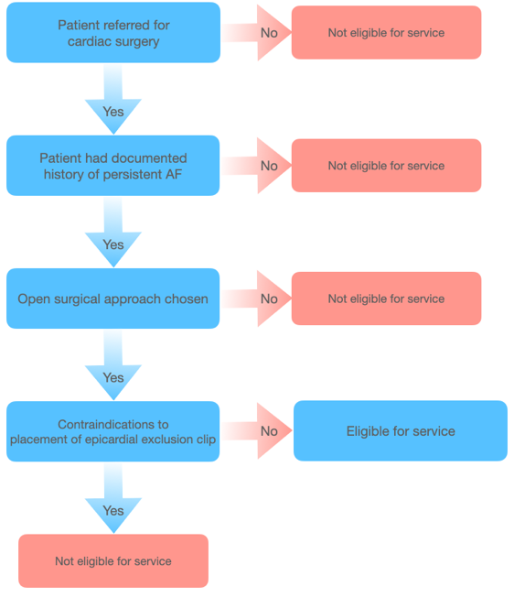
Figure 1.1 – Clinical pathway leading to
provision of service

PART 6b – INFORMATION ABOUT THE INTERVENTION

Describe the key components and clinical steps involved in delivering the proposed medical service:
The LAA is directly visualized then measured with the Atriclip sizing device to determine if which, if any, size Atriclip device is indicated for the patients LAA anatomy.

The AtriClip device is placed on the epicardial surface at the base of the LAA. Consistent /atraumatic force is equalized over tissue variations and trabeculation of the LAA via parallel titanium crossbars which apply pressure without crushing or damaging tissue.

The Atriclip device is then deployed leaving the LAA permanently occluded and electrically isolated from the left atrium.

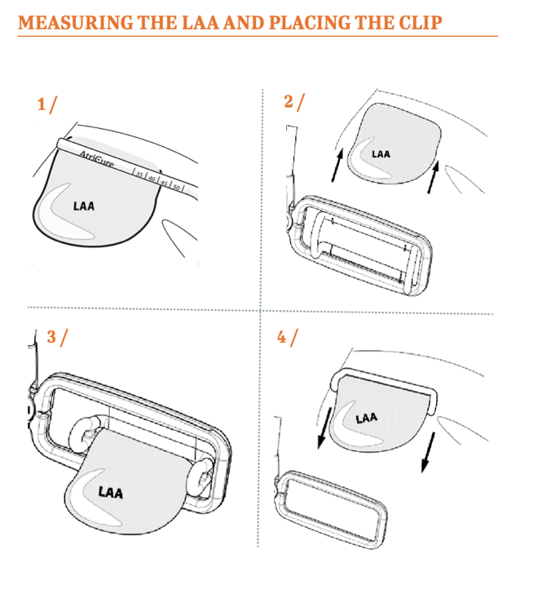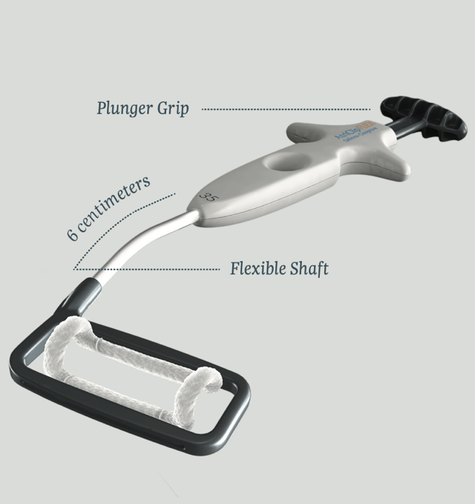
https://www.atricure.com/download-asset-file/8163
https://www.atricure.com/AtriClip-FLEX-Device

Does the proposed medical service include a registered trademark component with characteristics that distinguishes it from other similar health components?

The AtriClip® is a self-closing, sterile, implantable clip that is made of two parallel rigid titanium tubes with elastic nitinol springs and covered with a knit-braided polyester sheath. It comes in four clip sizes: 35 mm, 40 mm, 45 mm, and 50 mm.

The Atriclip is only device approved in Australia for surgical isolation of the LAA.

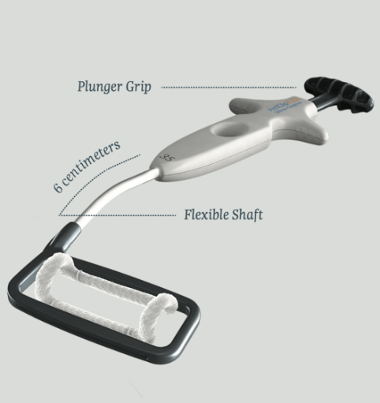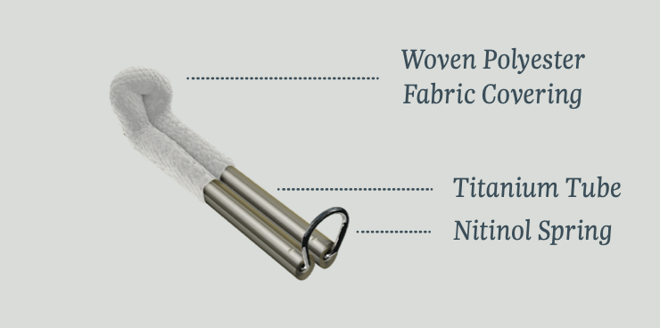

If the proposed medical service has a prosthesis or device component to it, does it involve a new approach towards managing a particular sub-group of the population with the specific medical condition?
No, the prosthesis simply makes safer and more effective the current intervention paradigm of isolating the LAA.

If applicable, are there any limitations on the provision of the proposed medical service delivered to the patient (i.e. accessibility, dosage, quantity, duration or frequency):
The size and orientation of the LAA, as well as the presence of clot, may preclude safe implantation, as per the Atriclip ACH2 contraindications.

If applicable, identify any healthcare resources or other medical services that would need to be delivered at the same time as the proposed medical service:
NA. As previously stated, it is simply a safe and effective method to execute the current treatment paradigm

If applicable, advise which health professionals will primarily deliver the proposed service:
Cardiac Surgeons with operating theatre privileges in an Australian private hospital

If applicable, advise whether the proposed medical service could be delegated or referred to another professional for delivery:
NA

If applicable, specify any proposed limitations on who might deliver the proposed medical service, or who might provide a referral for it:
As the implantation of Atriclip ACH2 can only occur concomitant to open heart surgery, its usage is limited to qualified and accredited cardiac surgeons, with cardiologists being the group most likely to refer.

If applicable, advise what type of training or qualifications would be required to perform the proposed service, as well as any accreditation requirements to support service delivery:
No additional qualifications will be required for a qualified cardiac surgeon to implant Atriclip ACH2. If the surgeon has not been exposed to and therefore not trained on usage of Atriclip, training can be completed by accessing manufacturer training material.

(a) Indicate the proposed setting(s) in which the proposed medical service will be delivered (select ALL relevant settings):
Inpatient private hospital (admitted patient)
Inpatient public hospital (admitted patient)
Private outpatient clinic
Public outpatient clinic
Emergency Department
Private consulting rooms - GP
Private consulting rooms – specialist
Private consulting rooms – other health practitioner (nurse or allied health)
Private day surgery clinic (admitted patient)
Private day surgery clinic (non-admitted patient)
Public day surgery clinic (admitted patient)
Public day surgery clinic (non-admitted patient)
Residential aged care facility
Patient’s home
Laboratory
Other – please specify below
Specify further details here
- Where the proposed medical service is provided in more than one setting, please describe the rationale related to each:
Patients will be treated in an Inpatient setting in both the public and private system.

Is the proposed medical service intended to be entirely rendered in Australia?
Yes

PART 6c – INFORMATION ABOUT THE COMPARATOR(S)

Nominate the appropriate comparator(s) for the proposed medical service, i.e. how is the proposed population currently managed in the absence of the proposed medical service being available in the Australian health care system (including identifying health care resources that are needed to be delivered at the same time as the comparator service):
Patients undergoing open chest heart surgery who have a pre operative history of AF currently have their LAA excluded by internal ligation, surgical suturing or stapler exclusion. This is confirmed by a recent survey (Results attached)showing 4/9 surgeons currently exclude the LAA using surgical staplers with remaining using various suture techniques, all 9 of the surgeons stated this choice is driven by the lack of funding for the Atriclip prosthesis implantation.

Resource | Provider of resource | Price per unit of resource | Quantity | Source
Prosthesis Cost
Stapling device | Prosthesis | REDACTED | 1 | Prosthesis listed item -
Total cost of LAA occlusion | REDACTED
Table 1.1 cost of comparator service

Does the medical service (that has been nominated as the comparator) have an existing MBS item number(s)?
Yes (please list all relevant MBS item numbers below)
No
Specify item number/s here

Define and summarise the current clinical management pathway/s that patients may follow after they receive the medical service that has been nominated as the comparator (supplement this summary with an easy to follow flowchart [as an attachment to the Application Form] depicting the current clinical management pathway that patients may follow from the point of receiving the comparator onwards, including health care resources):

If the patient is exhibits signs of blood loss in the period immediately post the comparator therapy, further ultrasound imaging may be performed to confirm no extravasation originating from the LAA suture/staple closure. Evidence of LAA communication from suture/stapler line failure or by tears in the friable LAA tissue which result in communication with extracardiac space most likely would require immediate surgical reintervention.

Post surgical LAA exclusion via a stapling or suturing, the patient will undergo cardiac ultrasound imaging to confirm the there is no communication with the LAA. If there is evidence of communication with the LAA when the patient is still in AF, a decision must be made on how to mitigate the embolic stroke risk, as a partially closed LAA is considered a high risk of developing and then introducing a thromboembolism into the systemic circulation and hence potentially cerebral circulation. The options to mitigate this increased risk being placement of a transcatheter closure LAA exclusion device (watchmen/amulet) if anatomically possible or placing the patient long term on anti-coagulation medication. If the patient is exhibits signs of blood loss in the period immediately post the comparator therapy, ultrasound imaging is performed to confirm no extravasation originating from the LAA suture/staple closure. Evidence of significant LAA communication with extracardiac space from suture/stapler line failure or by tears in the friable LAA tissue requires immediate/urgent surgical reintervention.

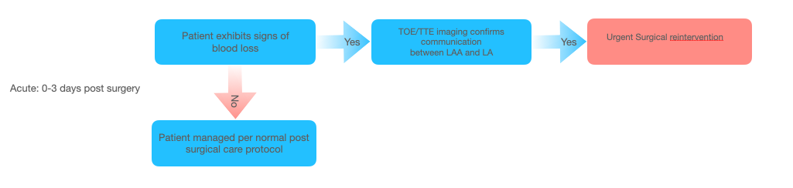

Figure 2.1 – Current Short term Clinical Pathway post stapling/suture closure

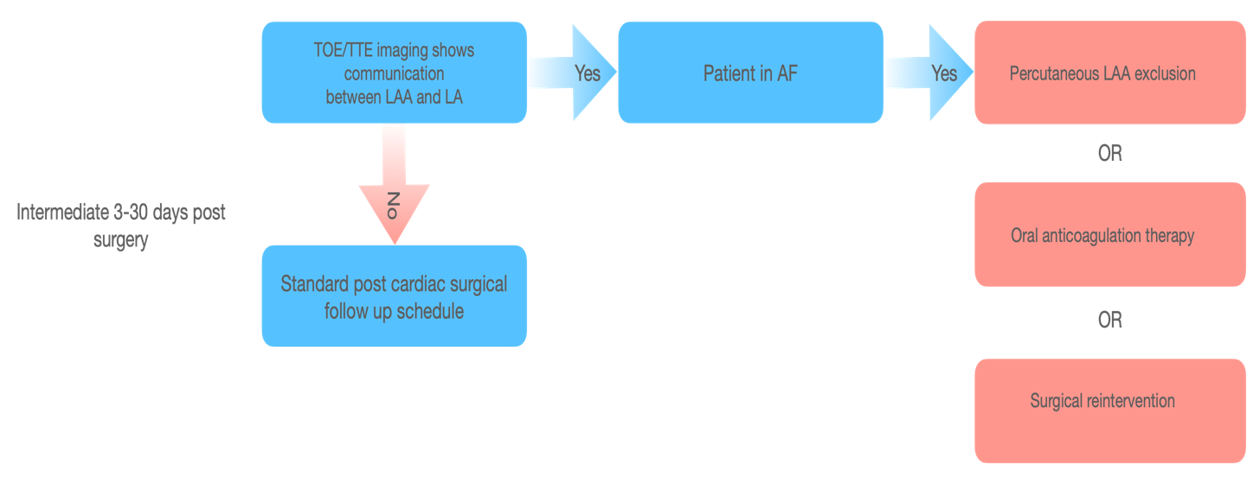
Figure 2.2 – Current intermediate term Clinical Pathway post stapling/suture closure

Urgent Surgical reintervention
Resource | Provider of resource | Price per unit of resource | Quantity | Source
Medical Services – Intervention
Hospital procedure costs (Direct costs only) | Hospital | $10,226.00 | 1 | AR-DRG: 2016-2017 V8
Intra-operative transesophageal echocardiography | Anaesthetist | $180.90 |  | MBS Item 22051
Intra-arterial cannulation when performed in association with the administration of anaesthesia | Anaesthetist | $80.40 | 1 | MBS Item 23043
Blood pressure monitoring | Anaesthetist | $60.30 | 1 | MBS Item 22012

RE-OPERATION via median sternotomy, for any procedure, including any divisions of adhesions where the time taken to divide the adhesions is 45 minutes or less | Cardiac Surgeon | $988.35 | 1 | MBS Item  38640
Total cost of urgent surgical reintervention | $12,794.95

Table 1.2 Cost of urgent surgical reintervention

Oral Anti coagulation therapy – 1 year

Given the narrow therapeutic window of warfarin, regular monitoring of INR is required to ensure adequate anticoagulation whilst minimising the risk of bleeding. According the to the warfarin product information (PI) (Coumadin), the therapeutic range is considered INR 2-3, with bleeding risk increasing significantly with an INR of 4. The bleeding risk of INR 2-3 is 1.3% (De Caterina et al 2007). Thus, regular INR measurement is required for the
POC devices using finger-prick capillary blood sampling allows for convenient and efficient INR measurement in the clinical practice setting and for self-management in the patient’s home.

POC devices, ie coagulometers, and required consumables, e.g. test strips are not reimbursed via MBS and as such comes at a cost to the practice or patient. The healthcare resources required for INR measurement of patients treated with warfarin depends on the model of care used (as described above). There are several coagulometers registered for use in Australia. POC testing is generally most relevant in the on-going monitoring of patients who are stable.
Costs associated with INR monitoring when warfarin is prescribed includes pathology collection and testing, and general practitioner consultations as reimbursed. It is estimated that the annual cost of monitoring INR to ensure therapeutic targets range is $445 per patient per year. Alternatively, POC monitoring by the patient would mean purchasing of the coagulometer, such as CoaguChek (estimated at $700/device) and test strips (estimated at $150 per 24 strips) as these devices and consumables are not reimbursed on the MBS.

Oral Anticoagulation Therapy
Resource | Price per unit | Quantity | Source
Patient episode initiation: Initiation of a patient episode by collection of a specimen for 1 or more services | $5.95 |  | MBS item 73928
Prothrombin time (including INR): pathology services | $13.70 |  | MBS item 65120
Number of INR test required per year | 20 |  | Deloitte Access Economics 2011
Number of GP visits required per year | 3 |  | MSAC application 1071; every 6th test
GP professional attendance | $17.50 |  | MBS item 3 $445.5 (A+B)×C+(D×E)
Total cost for 1 year of OAT | $445.5 (A+B)×C+(D×E)

Table 1.3 Cost of ongoing Oral anticoagulation therapy

(a) Will the proposed medical service be used in addition to, or instead of, the nominated comparator(s)?
In addition to (i.e. it is an add-on service)
Instead of (i.e. it is a replacement or alternative)

If instead of (i.e. alternative service), please outline the extent to which the current service/comparator is expected to be substituted:
Outline service/comparator substitution here

Define and summarise how current clinical management pathways (from the point of service delivery onwards) are expected to change as a consequence of introducing the proposed medical service, including variation in health care resources (Refer to Question 39 as baseline):
There is little to no change in the management pathway post the proposed service, with the difference being the expected reduced rates of LAA appendage exclusion failure meaning there will be far less instances of urgent surgical reintervention and reduced need for long term OAC.

PART 6d – INFORMATION ABOUT THE CLINICAL OUTCOME

Summarise the clinical claims for the proposed medical service against the appropriate comparator(s), in terms of consequences for health outcomes (comparative benefits and harms):
Atriclip is currently the only device indicated for surgical exclusion of the LAA. The proposed service results in a higher LAA closure rate with decreased risk of adverse events. Closure of the LAA in patients with AF undergoing concomitant cardiac surgery is associated with lower risk of admission of thromboembolism event^{24.} Incomplete closure is associated with an increased risk of stroke in patients with AF, with suture and stapling techniques reporting closure rates of ~50%^{6,7,} compared with closure via epicardial clip which conisistently shows close to >98% closure success with 0% device related adverse events^{1,2,3,4,5}. Closure with stapling devices has been associated with life threatening bleed events that require urgent surgical correction in 3-6% of cases^{20,21,22}, and published case reports of fatal complications²⁵.

Please advise if the overall clinical claim is for:
Superiority
Non-inferiority

Below, list the key health outcomes (major and minor – prioritising major key health outcomes first) that will need to be specifically measured in assessing the clinical claim of the proposed medical service versus the comparator:
Safety Outcomes: Major bleeding events, failure of suture/staple line requiring reintervention.

Clinical Effectiveness Outcomes: Exclusion of the LAA demonstrated by ultrasound imaging, 28 day readmission rate, Reintervention rate

PART 7 – INFORMATION ABOUT ESTIMATED UTILISATION

Estimate the prevalence and/or incidence of the proposed population:
Medicare statistics indicate there was a combined total of 9452 valvular and CABG cardiac surgery procedures in 2018-2019, these numbers are for services that qualify for medicare benefit and do not included public patients in public hospitals. As the reported statistics do not specify whether the cardiac surgery was open access or otherwise, a physician survey was conducted to determine the approximate proportion of open access cases. The results of this survey from Australian cardiac surgeons working in both private and public practice. it is estimated that 70% of cardiac surgery procedures are performed via and open surgical approach.
http://medicarestatistics.humanservices.gov.au/statistics/do.jsp?_PROGRAM=%2Fstatistics%2Fmbs_item_standard_report&DRILL=ag&group=38497%2C+38498%2C+38499%2C+38500%2C+38501%2C+38502%2C+38503%2C+38504&VAR=services&STAT=count&RPT_FMT=by+state&PTYPE=finyear&S

Table: Number of patients per year in private undergoing open CABG, MVR * prevalence of AF in these patients.

Metric | Source | Mean | CI 95%
Combined number of cardiac surgical procedures eligible for Medicare benefit | Medicare statistics | 9452 | -
% of procedures performed using open access | Informal Surgeon Survey | 75% | ±4.5%  70.5%, 79.5%
Prevalence of pre-operative AF | Medicare USA - 28.4 %  STS database – 13.4% | 20.9% | ±10.5%  10.4%, 31.4%
Prevalence of proposed population (per year eligible for service) |  | 1481 | 693-2359

Estimate the number of times the proposed medical service(s) would be delivered to a patient per year:
The service is delivered once per lifetime of the patient.

How many years would the proposed medical service(s) be required for the patient?
As per Q48, the service is delivered once per lifetime of the patient.

Estimate the projected number of patients who will utilise the proposed medical service(s) for the first full year:
Based on feedback from the Australian cardiac surgeons, it is estimated that 50% of indicated patients will utilize the medical service in the first year. This number being constrained by access to the prosthesis.

Estimate the anticipated uptake of the proposed medical service over the next three years factoring in any constraints in the health system in meeting the needs of the proposed population (such as supply and demand factors) as well as provide commentary on risk of ‘leakage’ to populations not targeted by the service:
As the medical service is concomitant to open heart surgery it is not feasible that leakage into broader populations will occur.

It is very unlikely that the treating cardiac surgeon will choose to exclude the LAA of a patient not in AF, the analogy would be the likelihood of while preforming a CABG, a cardiac surgeon replaces a healthy functioning valve with no documented history of valvular pathology.

PART 8 – COST INFORMATION

Indicate the likely cost of providing the proposed medical service. Where possible, please provide overall cost and breakdown:

Resource | Provider of resource | Price per unit of resource | Quantity | Source
Prosthesis Cost
Epicardial Clip | Prosthesis | $2450 | 1 | MSAC Application
Total cost of epicardial LAA occlusion concomitant to open cardiac surgery per patient |  | $2450

Specify how long the proposed medical service typically takes to perform:
Intra service component: 5-7minutes assuming open access to the heart, service is usually performed post the core cardiac surgery procedure while the patient is still on cardiopulmonary bypass. Cardiac imaging via TOE is performed on the table post all open cardiac surgical procedures, and assessment of the LAA is standard for this already performed imaging. There is not requirement for further imaging.

Post-service component: Maximum 3 minutes. This may include procedures notes.

If public funding is sought through the MBS, please draft a proposed MBS item descriptor to define the population and medical service usage characteristics that would define eligibility for MBS funding.
N/A

References

- Kirchhof, P., Benussi, S., Kotecha, D., Ahlsson, A., Atar, D., Casadei, B., ... & Hindricks, G. (2016). 2016 ESC Guidelines for the management of atrial fibrillation developed in collaboration with EACTS. European journal of cardio-thoracic surgery, 50(5), e1-e88.
- Yaghi, S., Song, C., Gray, W. A., Furie, K. L., Elkind, M. S., & Kamel, H. (2015). Left atrial appendage function and stroke risk. Stroke, 46(12), 3554-3559.
- Blackshear JL, Odell JA . Appendage obliteration to reduce stroke in cardiac surgical patients with atrial fibrillation. Ann Thorac Surg. 1996;61:755-9.
- https://www.aihw.gov.au/reports/australias-health/stroke
- Toale, C., Fitzmaurice, G. J., Eaton, D., Lyne, J., & Redmond, K. C. (2019). Outcomes of left atrial appendage occlusion using the AtriClip device: a systematic review. Interactive cardiovascular and thoracic surgery, 29(5), 655–662. https://doi.org/10.1093/icvts/ivz156
- Caliskan, E., Sahin, A., Yilmaz, M., Seifert, B., Hinzpeter, R., Alkadhi, H., Cox, J. L., Holubec, T., Reser, D., Falk, V., Grünenfelder, J., Genoni, M., Maisano, F., Salzberg, S. P., & Emmert, M. Y. (2018). Epicardial left atrial appendage AtriClip occlusion reduces the incidence of stroke in patients with atrial fibrillation undergoing cardiac surgery. Europace : European pacing, arrhythmias, and cardiac electrophysiology : journal of the working groups on cardiac pacing, arrhythmias, and cardiac cellular electrophysiology of the European Society of Cardiology, 20(7), e105–e114. https://doi.org/10.1093/europace/eux211
- Ailawadi, G., Gerdisch, M. W., Harvey, R. L., Hooker, R. L., Damiano Jr, R. J., Salamon, T., & Mack, M. J. (2011). Exclusion of the left atrial appendage with a novel device: early results of a multicenter trial. The Journal of thoracic and cardiovascular surgery, 142(5), 1002-1009.
- Atrial fibrillation as an independent risk factor for stroke: the Framingham Study. P A Wolf, R D Abbott and W B Kannel Stroke. 1991;22:983-988
- Alqaqa, A., Martin, S., Hamdan, A., Shamoon, F., & Asgarian, K. T. (2016). Concomitant Left Atrial Appendage Clipping During Minimally Invasive Mitral Valve Surgery: Technically Feasible and Safe. Journal of atrial fibrillation, 9(1), 1407. https://doi.org/10.4022/jafib.1407
- Hanke, T., Sievers, H.H., Doll, N. and Weimar, T., 2013. Surgical closure of the left atrial appendage in patients with atrial fibrillation. Indications, techniques and results. Herzschrittmachertherapie & Elektrophysiologie, 24(1), pp.53-57.
- Kanderian, A. S., Gillinov, A. M., Pettersson, G. B., Blackstone, E., & Klein, A. L. (2008). Success of surgical left atrial appendage closure: assessment by transesophageal echocardiography. Journal of the American College of Cardiology, 52(11), 924-929.
- Viles-Gonzalez JF, Kar S, Douglas P, Dukkipati S, Feldman T, Horton R et al. The clinical impact of incomplete left atrial appendage closure with the watchman device in patients with atrial fibrillation: a PROTECT AF (Percutaneous closure of the left atrial appendage versus warfarin ther- apy for prevention of stroke in patients with atrial fibrillation) substudy. J Am Coll Cardiol 2012;59:923–9.
- Maximilian Y. Emmert, Gilbert Puippe, Stephan Baumüller, Hatem Alkadhi, Ulf Landmesser, Andre Plass, Dominique Bettex, Jacques Scherman, Jürg Grünenfelder, Michele Genoni, Volkmar Falk, Sacha P. Salzberg, Safe, effective and durable epicardial left atrial appendage clip occlusion in patients with atrial fibrillation undergoing cardiac surgery: first long-term results from a prospective device trial, European Journal of Cardio-Thoracic Surgery, Volume 45, Issue 1, January 2014, Pages 126–131,
- Healey, J. S., Crystal, E., Lamy, A., Teoh, K., Semelhago, L., Hohnloser, S. H., ... & Morillo, C. (2005). Left Atrial Appendage Occlusion Study (LAAOS): results of a randomized controlled pilot study of left atrial appendage occlusion during coronary bypass surgery in patients at risk for stroke. American heart journal, 150(2), 288-293.
- Emile R. Jessurun, Norbert M. van Hemel, Johannes C. Kelder, Suzanne Elbers, Aart Brutel de la Rivière, Jo J.A.M. Defauw, Jef M.P.G. Ernst, Mitral valve surgery and atrial fibrillation: is atrial fibrillation surgery also needed?, European Journal of Cardio-Thoracic Surgery, Volume 17, Issue 5, May 2000, Pages 530–537
- Arora S, Vemulapalli S, Stebbins A, Ramm CJ, Kosinski AS, Sorajja P, Piccini JP, Cavender MA, Vavalle JP. The Prevalence and Impact of Atrial Fibrillation on 1-Year Outcomes in Patients Undergoing Transcatheter Mitral Valve Repair: Results From the Society of Thoracic Surgeons/American College of Cardiology Transcatheter Valve Therapy Registry. JACC Cardiovasc Interv. 2019 Mar 25;12(6):569-578. doi: 10.1016/j.jcin.2018.12.012. PMID: 30898255.
- Akshat Saxena, Jada Kapoor, Diem T. Dinh, Julian A. Smith, Gilbert C. Shardey, Andrew E. Newcomb,Preoperative atrial fibrillation is an independent predictor of worse early and late outcomes after isolated coronary artery bypass graft surgery,Journal of Cardiology,Volume 65, Issue 3,2015,Pages 224-229,
- https://www.ihpa.gov.au/publications/national-hospital-cost-data-collection-ar-drg-cost-weight-tables-v80x-round-21
- Badhwar V, Rankin JS, Damiano RJJr, Gillinov AM, Bakaeen FG, Edgerton JR et al. The Society of Thoracic Surgeons 2017 Clinical Practice Guidelines for the Surgical Treatment of Atrial Fibrillation. Ann Thorac Surg 2017;103:329–41
- Pruitt JC, Lazzara RR, and Ebra G. (2007) Minimally invasive surgical ablation of atrial fibrillation: The thoracoscopic box lesion approach. Journal of Interventional Cardiac Electrophysiology 20:83–7.
- Blackshear JL, Johnson WD, Odell JA et al. (2003) Thoracoscopic extracardiac obliteration of the left atrial appendage for stroke risk reduction in atrial fibrillation. Journal of the American College of Cardiology 42:1249–52.
- Whitlock RP, Vincent J, Blackall MH, Hirsh J, Fremes S, Novick R, Devereaux PJ, Teoh K, Lamy A, Connolly SJ, Yusuf S, Carrier M, Healey JS. Left Atrial Appendage Occlusion Study II (LAAOS II). Can J Cardiol. 2013;29:1443–1447. doi: 10.1016/j.cjca.2013.06.015.
- McCarthy PM, Davidson CJ, Kruse J, Lerner DJ, Braid-Forbes MJ, McCrea MM, Elmouelhi AM, Ferguson MA. Prevalence of atrial fibrillation before cardiac surgery and factors associated with concomitant ablation. J Thorac Cardiovasc Surg. 2020 Jun;159(6):2245-2253.e15. doi: 10.1016/j.jtcvs.2019.06.062. Epub 2019 Jul 10. PMID: 31444073.
- Ferraris VA. Left Atrial Appendage Occlusion During Cardiac Operations for Prevention of Thromboembolic Events. JAMA. 2018;319(4):345–347. doi:10.1001/jama.2017.20361
- Edward G. Soltesz, MD MPH , Krish C. Dewan, MD , Louise H. Anderson PhD , Michael A Ferguson, PhD , A. Marc Gillinov, MD. Improved Outcomes in CABG Patients with Atrial Fibrillation Associated with Surgical Left Atrial Appendage Exclusion. Accepted manuscript Journal of Cardiac Surgery
- Wehbe, M.S., Doll, N. and Merk, D.R., 2018. Fatal complications associated with surgical left atrial appendage exclusion. The Journal of Thoracic and Cardiovascular Surgery, 156(6), pp.e207-e20

