1192:

Final Decision Analytic Protocol (DAP) to guide the assessment of reduction of mitral regurgitation through tissue approximation using transvenous/transseptal techniques

May 2012

Table of Contents
Questions raised during public consultation phase 3
MSAC and PASC 4
Purpose of this document 4
Purpose of application 5
Intervention 5
Indication for intervention 5
Description of intervention 6
Administration and duration of treatment 6
Co-administered interventions 8
Background 8
Current arrangements for public reimbursement 9
Regulatory status 10
Patient population 10
Clinical place for proposed intervention 11
Proposed MBS listing 14
Comparator 15
Mitral valve repair or replacement surgery 15
Medical management 15
Clinical claim 16
Outcomes and health care resources affected by introduction of proposed intervention 17
Outcomes 17
Health care resources 17
Proposed structure of economic evaluation (decision-analytic) 20
Clinical research questions for public funding 21
Decision analytic diagram 21
References 26

Questions raised during public consultation phase

The following questions were presented in the Consultation DAP, when the document was available for public review and comment:

- It has been proposed that consideration of this device for public funding may be premature at this stage; based on the adequacy or inadequacy of available clinical evidence (considering issues such as available length of follow-up and patient populations examined), should this assessment proceed?

  - If not, what additional evidence (e.g. longer follow-up of safety and/or effectiveness outcomes, evaluation of specific patient populations) may be required?

  - If so, is it reasonable to restrict the population group to those patients meeting eligibility criteria for available clinical studies?

- Is any detailed information available regarding the MitraClip training program, or any specific accreditation required for practitioners to perform this procedure?

No comments on these specific questions or on the Consultation DAP in general were received during the public consultation phase.

MSAC and PASC

The Medical Services Advisory Committee (MSAC) is an independent expert committee appointed by the Australian Government Health Minister to strengthen the role of evidence in health financing decisions in Australia. MSAC advises the Commonwealth Minister for Health on the evidence relating to the safety, effectiveness, and cost-effectiveness of new and existing medical technologies and procedures and under what circumstances public funding should be supported.

The Protocol Advisory Sub-Committee (PASC) is a standing sub-committee of MSAC. Its primary objective is the determination of protocols to guide clinical and economic assessments of medical interventions proposed for public funding.

Purpose of this document

This document is intended to provide a draft decision analytic protocol that will be used to guide the assessment of an intervention for a particular population of patients. The draft protocol will be finalised after inviting relevant stakeholders to provide input to the protocol. The final protocol will provide the basis for the assessment of the intervention.

The protocol guiding the assessment of the health intervention has been developed using the widely accepted “PICO” approach. The PICO approach involves a clear articulation of the following aspects of the research question that the assessment is intended to answer:

Patients – specification of the characteristics of the patients in whom the intervention is to be considered for use;

Intervention – specification of the proposed intervention

Comparator – specification of the therapy most likely to be replaced by the proposed intervention

Outcomes – specification of the health outcomes and the healthcare resources likely to be affected by the introduction of the proposed intervention

Purpose of application

A proposal for an application requesting Medicare Benefits Schedule (MBS) listing of percutaneous reconstruction of an insufficient mitral valve through tissue approximation using transvenous/transseptal techniques for patients with mitral regurgitation was received from Abbott Vascular by the Department of Health and Ageing in August 2011.

Intervention

Indication for intervention
The mitral valve is one of four valves in the heart which function to ensure that blood flows unidirectionally. Proper functioning of the mitral valve is dependent on a complex interaction between the valve leaflets, valve annulus, sub-valvular apparatus, comprised of the chordae tendineae and papillary muscles, and the left atrium and left ventricle. Mitral regurgitation (MR) occurs when the mitral valve leaflets do not coapt or close properly, allowing backward flow of blood from the left ventricle into the left atrium during systole. As a consequence there is decreased forward flow into the aorta and systemic circulation, requiring the heart to work harder to maintain an adequate forward stroke volume. MR is a progressive condition; over time, left ventricular (LV) dilatation occurs in an attempt to accommodate the increased volume load and maintain cardiac output. Often, the result is a pure left ventricular volume overload which, if prolonged, can lead to left ventricular remodelling and progressive left ventricular dysfunction (Olson et al 1987).

MR is a complex and heterogeneous condition, and can be classified as primary or secondary depending on the underlying pathophysiology. The two categories have differing aetiology, natural history, treatment options and outcomes. Primary MR, also referred to as Degenerative MR (DMR), refers to MR caused by a structural abnormality of the valve apparatus which results in poor leaflet coaptation. Common aetiologies of DMR include myxomatous degeneration and fibroelastic deficiency. In patients with degenerative MR the left ventricle is usually normal in size and function initially. With the onset of MR, LV contractility increases to cope with the increased volume load, but over time LV dilatation and systolic impairment occur. In the case of severe degenerative MR there may be a prolonged asymptomatic phase, followed by substantial morbidity and mortality due to heart failure and arrhythmia. In secondary MR, also referred to as functional MR (FMR), the mitral valve is generally structurally normal. Poor leaflet coaptation occurs due to an abnormality of the left ventricle or papillary muscles associated with either localised (e.g. ischaemia or infarction) or global (e.g. cardiomyopathy) causes (Rosen et al 1994). In general, patients with FMR have a poorer LV contractile reserve and as such are less able to increase LV stroke volume in response to MR. FMR is more common than DMR, and is associated with a poorer prognosis.

While a small proportion of patients present with acute severe MR, the majority present with chronic progressive disease which may or may not be symptomatic. Prognosis for patients with moderate or severe MR can be poor in both symptomatic and asymptomatic patients. If left untreated, MR can lead to pulmonary oedema, congestive heart failure, irreversible LV systolic dysfunction, thromboembolism resulting from atrial fibrillation, and in some cases sudden death (Hanson and Alfonso 2011), and should be considered a significant cardiovascular disease.

Description of intervention

The MitraClip system is based on the principle of edge-to-edge repair (also known as the ‘Alfieri technique) – an existing surgical technique for mitral valve repair in which a suture is placed through the middle scallops of the mitral leaflets to form a double orifice valve. The double orifice structure reduces MR but still enables adequate blood flow through the valve during diastole. The MitraClip system is a catheter-based device which enables physicians to perform percutaneous mitral valve repair for the treatment of MR, providing an alternative to ongoing medical management and conventional open chest, arrested heart surgery. In place of a suture as used in conventional edge- to-edge surgical repair, a mechanical clip holds the middle portion of the valve leaflets together to form a double orifice valve for MR reduction.

The MitraClip system consists of three major technological components:
• MitraClip device (implant): a 4 mm-wide cobalt-chromium implant with two arms that are opened and closed by a mechanism on the handle of the clip delivery system. Adjacent to each arm is a ‘gripper’ to secure the leaflets as they are captured during closure of the arms. Each leaflet is independently secured between an arm and a gripper. The clip has a locking mechanism to maintain closure and is covered with a polyester fabric to promote tissue ingrowth.
• Clip delivery system.
• Steerable guide catheter: a tri-axial catheter that together with the clip delivery system enables placement of the clip on the mitral valve leaflets. Dials on the clip delivery system and catheter handle allow deflection in multiple planes.

Administration and duration of treatment

A patient will generally be referred by a general practitioner to a cardiologist if the presence of MR is suspected, who in turn refers the patient to either an interventional cardiologist or a cardiothoracic surgeon. It is proposed that a ‘heart team ’ will jointly recommend a patient receive treatment with MitraClip. While further details on the exact professional composition of this heart team are required, expert opinion suggests this should include cardiothoracic surgeons and both an interventional and non-interventional cardiologist. Having a recommendation from both cardiologists and cardiothoracic surgeons helps facilitate an appropriate and optimal approach towards patient selection and therapy delivery. Further detail is required as to whether a heart team would be reimbursed under a "case- conferencing" item rather than individual consultation items.

The MitraClip procedure is performed while the heart is beating, which better allows the identification of the origin of MR. The guide catheter and clip delivery system are introduced through the femoral vein and into the left atrium via transseptal puncture. The clip is advanced into the left atrium and steered until positioned over the origin of the regurgitant jet. The clip arms are opened, the clip advanced into the left ventricle and then retracted until both leaflets are grasped. Closure of the clip draws the mitral leaflets together. The MitraClip system is designed to enable the physician to assess leaflet coaptation and MR reduction prior to final deployment of the MitraClip device by intraoperative transoesophageal echocardiography. If the physician is not satisfied with MR reduction upon initial placement of the MitraClip device after the mitral valve leaflets have been grasped and approximated, the clip can be reopened, leaflets released, and the clip repositioned. When adequate reduction of MR has been achieved, the clip is deployed. If, during deployment of one MitraClip device, it is determined that a second MitraClip device would result in further reduction of the patient’s MR, the physician may place a second device. Following clip deployment the delivery system and catheter are withdrawn and the venous puncture site is closed. The average length of a MitraClip procedure, as measured from the time of transseptal puncture to removal of the steerable guide catheter, is under 2 hours.

A number of scenarios exist with respect to treatment failure. If MR is unable to be satisfactorily reduced during the procedure, the physician is able to remove the MitraClip device completely, leaving the patient with the same therapeutic options as prior to the procedure, including surgical intervention. However, it is important to note that the MitraClip device and deployment system is single-use, and cannot be reused in subsequent procedures. If MR recurs subsequent to an initially successful MitraClip procedure, a further intervention with a second device is one possible treatment option if a single device was implanted in the initial procedure. Surgical repair may also be an option after MitraClip failure; however, the likelihood of successful surgical repair may be reduced due to changes in the mitral valve tissue resulting from Mitraclip placement. Expert opinion suggests that valve tissue is often found to be substantially torn or fibrotic after MitraClip failure and its subsequent removal. In this case, replacement of the mitral valve would be the only surgical option available to the patient or the patient may return to medical management if further surgery is contraindicated.

Physicians and hospital staff are required to complete a training program for MitraClip prior to use of the system. The main training program generally includes didactic coursework (e.g. lectures and presentations) and ‘hands on’ use of a demonstration system which includes a heart model, and is delivered over five days. Further detail on the training program, such as whether it could be incorporated into a larger heart valve treatment training program, would be informative. In order to be eligible for the training program the physician must meet the following requirements:

- Be either an interventional cardiologist or cardiac surgeon.
- Have experience in transseptal technique and have an understanding or experience in structural heart disease (patent foramen ovale, atrial septal defect, aortic valve, etc.).
- Have a multidisciplinary team to support the procedure, including:
  - A dedicated echocardiologist for patient screening and to be present during the procedure.
  - If the physician is an interventional cardiologist, a cardiac surgeon to provide supportand assist with the process.
- Identify five suitable patients prior to training.
- Be able to continue to have a reasonable volume of patients so as to maintain minimum skills levels and optimal patient outcomes.

The procedure should be delivered only in centres and facilities that provide interventional cardiac services via the catheterisation or hybrid laboratory and also provide a cardiothoracic surgical service. Both the catheterisation and hybrid laboratory are suitable for the delivery of therapy, and do not require major staffing changes. The procedure should only be rebated if it is delivered by an appropriately trained medical practitioner.

Co-administered interventions

Under normal circumstances, a patient suffering from suspected MR will be referred for a consultation with a cardiologist., During this consultation a range of investigational procedures may be performed to diagnose or identify severity of MR. These may include:
• electrocardiography (ECG; MBS Item 11700, 11701 and 11702)
• chest x-ray (MBS Item 58503)
• transthoracic echocardiography (TTE; MBS Item 55113, 55114 and 55115)
• transesophageal echocardiography (TEE; MBS Item 55118)
• cardiac catheterisation (MBS Item 38203 and 38206)
• CT coronary angiography
• exercise tests (MBS item 11712)
If the patient is found to meet eligibility for treatment with MitraClip, the patient would be referred to a treating physician – either an interventional cardiologist or a cardiothoracic surgeon – with whom a pre-procedural consultation would be required. Another TEE examination is likely to be performed shortly before the procedure to determine the patient’s final eligibility for treatment.

The MitraClip procedure itself is performed under general anaesthesia with intra-operative TEE (MBS Item 55130 and 55135) and fluoroscopic guidance of device delivery (MBS item 61109). Guidance, confirmation of clip positioning, and assessment of leaflet coaptation and MR reduction prior to final MitraClip deployment are all done primarily through use of intra-operative TEE.

TEE is used to confirm a patient’s suitability to be discharged following the procedure, as well as during patient follow-up. Post-treatment follow-up would also involve blood-thinning medications, as well as laboratory testing and further clinical consultation.

Background

International estimates reveal that mitral valve disease is the second most common valvular lesion, preceded only by aortic stenosis, with MR affecting approximately 5 in 10,000 people within the United States (Hanson and Alfonso 2011). The only definitive treatment for MR is surgery; however, due to potential morbidity and mortality associated with the procedure, the actual number of patients who have surgery is only approximately 20 to 30 per cent of newly diagnosed annual cases. Thus, there are many individuals with significant MR who do not undergo surgery each year. Nonetheless, approximately 50,000 mitral valve operations are performed in the United States each year (Dang et al 2005). Concomitant with an aging population, MR has also been found to be increasing in prevalence in the United States (Thom et al 2006).

An estimate of the prevalence of MR and demand for treatment within Australia is not readily available. According to Australian Institute of Health and Welfare (AIHW) data, there were 3,066 hospital separations for the principal diagnosis of non-rheumatic mitral valve disorders (which includes mitral insufficiency, mitral prolapse and mitral stenosis) in 2009-10 (Australian Institute of Health and Welfare 2011). Given the relatively low proportion of patients who receive surgical treatment, this is a conservative estimate of the prevalence of MR within the Australian population; based on the available AIHW data and the prevalence rate reported by Hanson and Alfonso (2011) this is estimated to be in the range of 10,000 to 15,000 people.

Current arrangements for public reimbursement

The MBS listing and reimbursement fees for procedures relating to MR are listed in Table 1 (Medicare Australia 2011b). From usage data, there were 3,814 MBS claims made in 2010-11 for surgical procedures relating to MR (Medicare Australia 2011a). It is important to note, however, that only a proportion of these procedures would have been performed for mitral valve treatment, as many would have been claimed for treatment of the aortic or tricuspid valve. There is no way to determine from these figures the frequency with which treatment of the mitral valve was performed.

Table 1: Current MBS Items related to the surgical treatment of mitral regurgitation

MBS Item  Number | MBS Listing | Benefit  (AU$) | Number of Claims  (Jul 2010 - Jun 2011)
38480 | Valve repair, 1leaflet | 1,966.00 | 559
38481 | Valve repair, 2 or more leaflets | 2,238.15 | 331
38485 | Mitral annulus, reconstruction of, after decalcification, when performed in association with valve surgery | 801.85 | 153
38488 | Valve replacement with bioprosthesis or mechanical prosthesis | 1,874.00 | 2,469
38489 | Valve replacement with allograft (subcoronary or cylindrical implant), or unstented xenograft | 2,228.70 | 57
38490 | Sub-valvular structures, reconstruction and re-implantation of, associated with mitral and tricuspid valve replacement | 544.20 | 245
51303 | Assistance at any operation identified by the word "assist" for which the fee exceeds $547 94 or at a series of operations identified by the word "assist" which the aggregate fee exceeds $547.90 file save | Derived fee: *
MBS: Medicare Benefits Schedule

*derived fee is based on one fifth of the established fee for the operation or combination of operations.

The MitraClip system was introduced into Australian practice at Sir Charles Gairdner Hospital, Perth, in early 2011. Due primarily to the novelty of the technology, MitraClip does not currently have MBS listing for either permanent or interim funding, nor has it been previously considered by MSAC. Abbott Vascular is providing support to a post-approval clinical trial to track the initial clinical experience of MitraClip in Australia and New Zealand (http://clinicaltrials.gov/show/NCT01301625).

Regulatory status
Regulatory approval for the MitraClip system was received from the Therapeutic Goods Administration (TGA) on 18 November 2010. Details regarding its listing on the Australian Register of Therapeutic Goods(ARTG) are provided in Table 2.
Table 2: ARTG listings forMitraClip system

ARTG  number | Sponsor name | ARTG label name | Functional description | Intended purpose
177709 | Abbott Vascular Division of Abbott Australasia Pty Ltd | MSK02ST MitraClip System – Mitral valve tissue repair system | The steerable guide catheter and clip delivery system are typically steered and actuated through the use of control knobs, levers and torque translation techniques and guided by echocardiographic and fluoroscopic imaging. The clip is positioned and the mitral valve leaflets are coapted to reduce mitral regurgitation. The system includes a reusable non-sterile stabilizer (which is sterilized before use), support plate and lift which provide a working platform during the procedure. | A system of devices intended for the percutaneous reconstruction of an insufficient mitral valve through tissue approximation using transvenous/transseptal techniques.
ARTG: Australian Register of Therapeutic oods
It should also be noted that at present MitraClip has yet to receive approval from the United States Food and Drug Administration.

Patient population
As part of the clinical assessment, all patients should be echocardiographically screened for suitability by the physician. Both transthoracic (TTE) and transoesophageal (TOE) echocardiography are used to evaluate the clinical considerations for each patient. In order to be considered for treatment with MitraClip, a patient should meet all of the following clinical requirements:
• Present with clinically significant mitral valve regurgitation, classified using echocardiography and a number of objective and subjective measures. An MR grading of 3+ (regarded as
‘moderate’ to ‘severe’) or 4+ (regarded as ‘severe’) is generally considered to be clinically significant (Bonowet al 2006).
• Present with symptoms, or be asymptomatic with evidence of left ventricular dysfunction or dilatation.
• The primary regurgitant jet originates from malcoaptation of the mitral valve in a location accessible with the MitraClip implant. If a secondary jet exists, it should be considered clinically insignificant.
• Transseptal catheterisation is determined to be feasible by the treating physician.

Assessment of the mitral valve anatomy is an important consideration when determining the suitability of the patient for MitraClip therapy. Patients who are most likely to be treated successfully are those in whom the jet of MR originates from the A2/P2 mitral valve leaflets and is relatively discrete. If a flail leaflet is present, the gap between the two leaflets should not be too great (i.e. flail segment width greater than 15mm, or a flail gap greater than 10mm). MitraClip is less likely to be successful in patients with evidence of calcification or cleft of the grasping area, severe bileaflet flail or prolapse, lack of both primary and secondary chordal support, or a mitral valve orifice area of≥4cm2. MitraClip should not be implanted in patients with active endocarditis or other clinically significant infection, or in patients in whom MR is resulting from rheumatic heart disease.
As mentioned, surgical mitral valve repair or replacement is delayed or not an option in many patients due to its inherent risk of mortality and morbidity, including cardiac, neurological, respiratory and renal complications, some of which are related to the use of cardiopulmonary bypass. Risks related to surgery increase with specific comorbidities such as prior cardiothoracic surgery and advanced age
(Sundt 2011). It is proposed that MitraClip may be of greatest utility for the treatment of particular patient groups who may otherwise be at a high risk of adverse outcomes from surgical mitral valve treatment. Further detail is required as to the specific comorbidities that lead to a patient being classified as ‘high-risk’ for surgery. However, these groups may potentially include:
• Patients with functional MR
• Patients at high risk of compliations from cardiopulmonary bypass
• Elderly patients
• Younger patients as a bridge to cardiac surgery later in life (e.g. patients for whom life-long anticoagulant use would be an unacceptable consequence of mechanical mitral valve replacement, such as young women prior to childbearing though anticoagulant treatment is not required after mitral valve repair or mitral valve bioprosthesis)
Any reported outcomes related to the treatment of these patient groups would be of particular interest for this assessment.
It should be noted that expert opinion is that the number of patients unsuitable for surgical mitral valve repair is decreasing as advancements in surgical valve treatment, such as minimally-invasive approaches, are made. Expert opinion also suggests that as MitraClip does not utilise an annuloplasty ring, it does not satisfactorily address dilatation of the mitral valve annulus. As such, it may be of limited benefit in patients with substantial annular dilatation due to ischaemic or non-ischaemic heart damage, as is the case with many elderly patients.

Clinical place for proposed intervention
Management of MR currently varies based on the onset and severity of symptoms, the severity of MR, and the degree of LV dysfunction. The majority of patients present with chronic progressive MR and may or may not be symptomatic, while a small proportion of patients present with severe acute MR. The 2006 American College of Cardiology/American Heart Association guidelines for the management of patients with valvular heart disease (Bonow et al 2006) recommend that clinical evaluation and echocardiography should be performed at regular intervals to assess the degree of MR, LV function, and clinical symptoms.
There is no generally accepted effective pharmacologic regimen for patients with MR (Bonow et al
2006). Medical management is regarded as palliative at best, and no pharmacologic study has definitively demonstrated improved haemodynamics, a delay in time to surgery, or a reduction in mortality with chronic MR. Medical management is generally instituted for patients presenting with mild to moderate MR, primarily to mitigate preload, afterload, and hypertension. In the small proportion of patients with acute severe MR, medical management is employed to stabilize the patient haemodynamically in preparation for emergency surgery (Bonow et al 2006). Medical management may also be an acceptable treatment option for patients who are unfit for surgery due to feasibility or safety concerns.
Whenever possible, patients with symptomatic severe MR or asymptomatic severe MR with evidence of LV dysfunction or dilatation are generally considered for surgery (Bonow et al 2006). The primary treatment for significant MR is mitral valve repair or replacement surgery, which is beneficial for most patients who receive treatment. Although minimally invasive mitral valve surgery is evolving, both mitral valve repair and replacement generally occur through open chest, arrested heart surgery,

performed under general anaesthetic and requiring cardiopulmonary bypass. To repair the mitral valve, the surgeon may insert a cloth-covered ring around the valve to bring the leaflets into contact with each other (annuloplasty), reshape the valve by removing redundant or loose segments of the leaflets (quadrangular resection), or resuspend the leaflets with artificial chords or “switching” and reinsertion of the native chordae (chordal transposition). In comparison, mitral valve replacement involves the surgical removal of the damaged valve, which is replaced with a mechanical (metal or plastic) or biological (tissue) valve.

The decision between repairing and replacing the valve depends on the type and extent of damage to the mitral valve. Repair is more successful if there is limited damage to certain areas of the mitral valve leaflets or chordae tendineae. Mitral valve repair is considered to be the surgical procedure of choice for most patients, since the native valve tissue and sub-valvular apparatus are spared, resulting in superior hemodynamics and left ventricular function. Replacement is usually preferred for patients who are not good candidates for mitral valve repair, such as those who have a hard, calcified mitral annulus or widespread damage to the valve and surrounding tissue.

The current clinical management algorithm for diagnosing and treating patients with MR at is illustrated in Figure 1.

Figure 1: Clinical management algorithm for diagnosis and treatment of mitral regurgitation at present
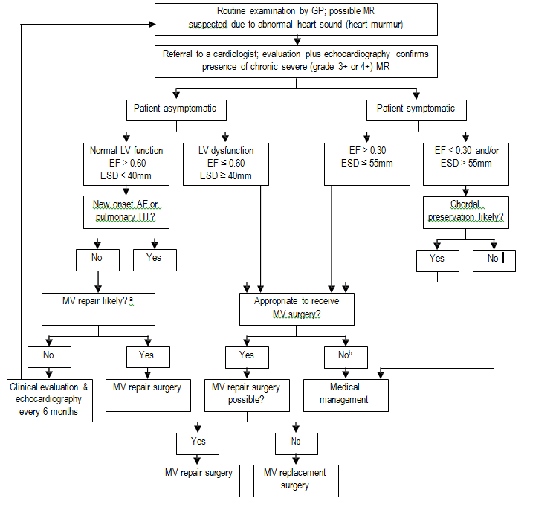
AF: atrial fibrillation; EF: ejection fraction; ESD: end-systolic dimension; GP: general practitioner; HT: hypertension; LV: left ventricular; MR: mitral regurgitation; MV: mitral valve
a MV repair may be performed in asymptomatic patientswith normal LV function if performed by an experienced surgical team and if the likelihood of successful MV repair is greater than 90%.
b Potential contraindications to MV surgery with cardiopulmonary bypass include: existing damage to the heart; high risk of complication from cardiopulmonary bypass; advanced age; unacceptable risk of life-long anticoagulant requirement
Adapted from:Bonow et al (2006).

Figure 2 illustrates the clinical management algorithm for diagnosing and treating patients with MR, with the availability of the MitraClip system as proposed. The MitraClip system is designed to be a direct substitute (i.e. provides patients with a new treatment alternative) for the currently subsidised intervention of surgical mitral valve repair or replacement. In the case of patients who would otherwise be deemed unfit to undergo surgical treatment, it may act as a direct substitute for medical management of MR.

Figure 2: Proposed clinical management algorithm for diagnosis and treatment of mitral regurgitation with availability of percutaneous mitral valve reconstruction (MitraClip)

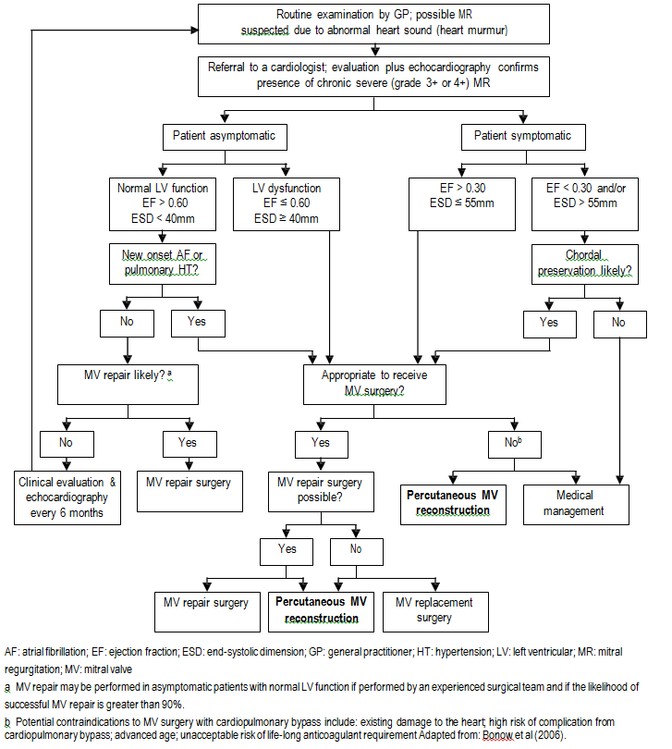

Proposed MBS listing

After expert input and PASC consideration, the term ‘tissue approximation’ as originally proposed was amended to ‘permanent coaptation of mitral valve leaflets’ to more specifically reflect the intended effect of the MitraClip procedure. At the suggestion of the sponsor and expert input, a potential explanatory note was added requiring the provision of a joint recommendation from a ‘heart team’, comprising at least two cardiologists (including one non-interventional cardiologist) and two cardiothoracic surgeons, for a patient to be deemed appropriate to receive treatment. The potential descriptor has been further amended to reflect the requirements for the provision of the service and is provided in Table 3.

Proposed MBS Item descriptor for MitraClip system
Category3 – Therapeutic Procedures
MBS 38xxx
Percutaneous reconstruction of an insufficient mitral valve using transvenous/transseptal techniques for :

- permanent placement of up to two tissue approximation devices or

- subsequent removal of up to two tissue approximation devices as a result of post percutaneous reconstruction recurrent mitral regurgitation requiring further surgical or medical management. (Anaes.) (Assist.)
Explanatory notes
It is recommended that a ‘heart team’, comprising two cardiologists (including one non-interventional cardiologist) and two cardiothoracic surgeons, provide approval regarding the patient’s suitability for treatment.

This item may not be claimed if this device cannot be placed satisfactorily in the patient; and abandon surgery item may be claimed in this case.

Fee: $895.30 Benefit: 75% = $671.50 85% = $821.60

The fee proposed by the applicant was based on the surgical repair of two leaflets (MBS Item 38481). However, after PASC consideration it was determined that repair of an atrial septal defect via transcatheter approach (MBS Item 38272) provides a more comparable basis for the item fee in terms of time and complexity; the fee is shown in Table 3.
Given that the cost of each single-use MitraClip device is approximately $35,000, the potential for two devices to be used in many procedures, and that the device cannot be reused even when it is not deployed, further detail and justification regarding procedural, equipment, and aftercare costs is required for economic modelling purposes and to verify the appropriateness of the proposed fee. Consideration should also be given to the descriptor and the economic model to provide for instances where the Mitraclip cannot be placed successfully at the primary intervention, a second Mitraclip is inserted at a second intervention and instances where one or two MitraClips are removed due to failure or for recurrent MR where the patient is to be medically managed or to facilitate further surgery.

Comparator

Mitral valve repair or replacement surgery
As highlighted in the clinical management algorithm (Figure 1), the most appropriate comparator to MitraClip for the treatment of MR is generally mitral valve repair or replacement surgery. The anatomical considerations for determining the suitability of a patient for surgical treatment are similar to those for MitraClip.
In general, MitraClip is a system for repair of the mitral valve. Accordingly, the referral pathway, clinical algorithm for patient selection, and the healthcare resources and diagnostic tests used to identify appropriate patients for treatment and used in patient follow-up are the same for both MitraClip and mitral valve repair or replacement surgery. The primary differences in the procedures exist in the delivery of the therapy. While MitraClip therapy is provided by interventional cardiologists and/or cardiothoracic surgeons in a catheterisation or hybrid lab, mitral valve repair or replacement surgery is delivered by cardiac surgeons in an operating theatre and requires the presence of a perfusionist to facilitate cardiopulmonary bypass. Requirements for echocardiography and anaesthesia are the same for the two therapies. However anaesthetic time is significantly less for the insertion of MitraClip than for valve repair or replacement surgery and this should be considered in the economic model.

Medical management
As previously mentioned, surgical treatment of MR may not be appropriate for a small proportion of patients due to feasibility or safety concerns (e.g. existing damage to the heart, cardiopulmonary bypass risk, advanced age, need for avoidance of anticoagulant use). In such patients, medical management is an appropriate comparator to MitraClip. Note that there is no generally accepted effective pharmacologic regimen for patients with MR.

Clinical claim
As the MitraClip device is deployed percutaneously and is fitted in the beating heart, chest incisions, cardiopulmonary bypass, and cardiac arrest are not required, decreasing the risk of adverse outcomes in patients with comorbidities and avoiding the long recovery time associated with mitral valve repair or replacement surgery. As such, it is proposed that treatment with MitraClip may:
- Lead to fewer procedural and early adverse events than mitral valve repair surgery;
- Reduce the procedural length of stay, with fewer days in coronary care and intensive care compared to mitral valve repair surgery;
- Significantly reduce hospitalisation rate in the 12 months after the procedure compared to the previous 12 months; and
- Lead to significant improvements in the symptomatic status (e.g. New York Heart Association Functional Classification), and quality of life (physical and mental scores) of patients.

The overall clinical claim for treatment with MitraClip is that it has superior safety with non-inferior effectiveness and cost-effectiveness when compared to the currently MBS-funded procedure of mitral valve repair or replacement surgery. As such, the economic evaluation will be based on a cost- effectiveness or cost-utility analysis (see Table 4 for details).
Table 4: Classification of an intervention for determination of economic evaluation to be presented

 |  | Comparative effectiveness versus comparator
 |  | Superior |  | Non-inferior | Inferior
Comparative safety versus comparator | Superior | CEA/CUA |  | CEA/CUA | Net clinical benefit | CEA/CUA
 |  |  |  |  | Neutral benefit | CEA/CUA*
 |  |  |  |  | Net harms | None^
 | Non-inferior | CEA/CUA |  | CEA/CUA* | None^
 | Inferior | Net clinical benefit | CEA/CUA | None^ | None^
 |  | Neutral benefit | CEA/CUA*
 |  | Net harms | None^
Abbreviations: CEA = cost-effectiveness analysis; CUA = cost-utility analysis
* May be reduced to cost-minimisation analysis. Cost-minimisation analysis should only be presented when the proposed service has been indisputably demonstrated to be no worse than its main comparator(s) in terms of both effectiveness and safety, so the difference between the service and the appropriate comparator can be reduced to a comparison of costs. In most cases, there will be some uncertainty around such a conclusion (i.e., the conclusion is often not indisputable). Therefore, when an assessment concludes that an intervention was no worse than a comparator, an assessment of the uncertainty around this conclusion should be provided by presentation of cost-effectiveness and/or cost-utility analyses.
^No economic evaluation needs to be presented; MSAC is unlikely to recommend government subsidy of this intervention

It should be noted that the sponsor provided no clinical claim relating to the use of MitraClip in comparison to medical management.

Outcomes and health care resources affected by introduction of proposed intervention

Outcomes
Potential outcomes of interest for the comparison of the relative clinical effectiveness and safety of MitraClip and mitral valve repair or replacement surgery are provided in Table 5. Please note that this is not necessarily a comprehensive list of potential outcomes.
Table 5: Potential effectiveness and safety outcomes of interest

Effectiveness outcomes | Safety outcomes
Severity of post-treatment mitral regurgitationa  Technical success (i.e. clip placement and success of the clip in permanently reducing MR)  Patient survival  Freedom from surgery for valve dysfunctionb  Freedom from further surgery post Mitraclip  Patient quality of life  Post-procedural hospitalisation duration Post-procedural patient recovery time Time taken to resume normal activities Procedure time | Patient mortality (e.g. procedure-related, 30-day mortality) Myocardial infarction  Reoperation for failed surgical treatment  Migration of device  Non-elective cardiovascular surgery for adverse events  Stroke  Renal failure  Deep wound infection  Ventilation required for >48 hours Gastrointestinal complication requiring surgery New onset of permanent atrial fibrillation Septicaemia  Transfusion of two or more units of blood
a To be considered equally effective, MitraClip should show parity with surgical treatment with regards to post-treatment mitral regurgitation.
b Proportion of patients requiring valve replacement surgery due to damaged valve tissue after MitraClip failure/removal should also be evaluated.
It is essential to note that in studies assessing surgical mitral valve repair or replacement, treatment success is generally defined as a post-treatment MR grading of≤1+. This is considerably more stringent than the definition used in studies assessing MitraClip, which commonly regard a post- treatment MR of ≤2+ to be treatment success. Expert opinion suggests that the condition of a patient with post-treatment MR of 2+ is almost certain to worsen and require follow-up treatment. As such, comparison of MitraClip to surgical treatment must take this discrepancy into account, and assess the clinical outcomes of both treatments as uniformly as possible. However, in studies that examine the treatment of patients deemed unfit for surgery (e.g. MitraClip compared to medical management), it is accepted that a post-treatment MR grading of ≤2+ may be considered an acceptable outcome.

Any outcomes related specifically to the treatment of patient subgroups deemed to be a high risk for surgery (e.g. patients with existing damage to the heart, elderly patients, patients for whom life-long anticoagulant use would be an unacceptable consequence of surgery) are of particular interest to this assessment, and should be reported in detail.
As the development of mitral regurgitation is often a degenerative condition, with the disease and underlying aetiologies worsening over time, long-term outcomes are of particular importance to this assessment. Given the nature of the condition, expert opinion recommends five years to be the minimum follow-up period necessary for an informed determination of the effectiveness of a treatment such as MitraClip. However, the required time horizon may vary between patient groups (e.g. young patients, elderly patients, patients receiving MitraClip as a bridge to surgery).

Health care resources
Details on the health care resources whose utilisation is likely to be impacted should MitraClip be made available as requested are listed below in Table 6.

Table 6: List of resources to be considered in the economic analysis
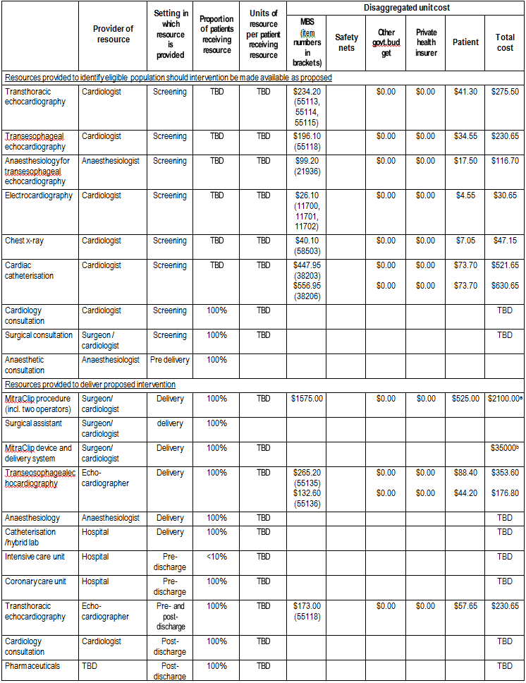
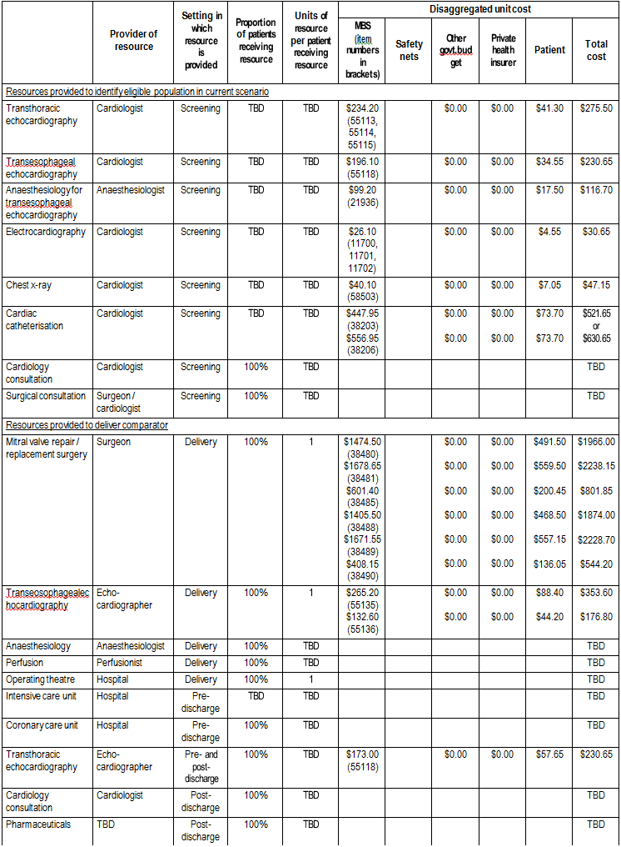

MBS: Medicare Benefits Schedule; PBS: Pharmaceutical Benefits Scheme; TBD: to be determined a Proposed fee.
 | Provider of resource | Setting in which resource is provided | Proportion of patients receiving resource | Units of resource per patient receiving resource | Disaggregated unit cost
 |  |  |  |  | MBS  numbers in brackets) | Safety nets | Other govt.bud get | Private health insurer | Patient | Total cost
Resources provided in association with comparator
Blood bank | TBD |  | TBD | TBD |  |  |  |  |  | TBD

b Approximate cost per MitraClip device(including single-use delivery system).

Proposed structure of economic evaluation (decision-analytic)

The PICO criteria proposed for the evaluation is provided in Table 7.

Table 7: Summary of extended PICO to define research question that assessment will investigate

Patients | Intervention | Comparator | Outcomes to be assessed
Patients with clinically significant MR,as determined by echocardiography and objective and subjective measures (i.e. MR grading of 3+ (moderate-severe) or  4+ (severe)) who are medically fit for mitral valve surgery | Percutaneous reconstruction of an insufficient mitral valve through permanent coaptation of mitral valve leaflets using transvenous/transseptal techniques | Mitral valve repair or replacement surgery | Effectiveness (including but not limited to):  - Severity of MR  - Technical success (i.e. clip placement - 1 or  2 clips placed or removed and failure to place successfully)  - Patient mortality  - Freedom from surgery for valve dysfunction  - Patient quality of life  - Post-procedural hospitalisation duration  - Post-procedural patient recovery time  - Procedure time  Safety (including but not limited to):  - Patient mortality  - Myocardial infarction  - Reoperation for failed surgical treatment  - Non-elective cardiovascular surgery for adverse events  - Stroke  - Renal failure  - Deep wound infection  - Ventilation required for >48 hours  - Gastrointestinal complications  - New onset of permanent atrial fibrillation  - Septicaemia  - Transfusion of two or more units of blood
Patients with clinically significant MR,as determined by echocardiography and objective and subjective measures (i.e. MR grading of 3+ (moderate-severe) or  4+ (severe)) who are medically unfit for mitral valve surgery |  | Medical managementa
Patients with clinically significant MR,as determined by echocardiography and objective and subjective measures (i.e. MR grading of 3+ (moderate-severe) or
4+ (severe)):
who have existing heart damage or
are elderly patients or
where long term anticoagulation therapy is unacceptable (bridge to surgery patients)
MR: mitral regurgitation
a There is no generally-accepted pharmacologic regimen for treatment of mitral regurgitation.

Clinical research questions for public funding

1. In the treatment of patients with clinically significant mitral valve regurgitation for whom mitral valve surgery is indicated, what is the safety, effectiveness and cost-effectiveness of percutaneous mitral valve repair through permanent coaptation of mitral valve leaflets using transvenous/transseptal techniques, compared to mitral valve repair or replacement surgery?

2. In the treatment of patients with clinically significant mitral valve regurgitation for whom mitral valve surgery is contraindicated, what is the safety, effectiveness and cost- effectiveness of percutaneous mitral valve repair through permanent coaptation of mitral valve leaflets using transvenous/transseptal techniques, compared to medical management?

Decision analytic diagram

Three proposed decision analytic pathways for this assessment are presented below. The pathway for patients with clinically significant MR who are unsuitable to receive any form of mitral valve surgery (including patients receiving treatment as a bridge to surgery) is shown in Figure 3. The pathway for patients with clinically significant MR who are unsuitable to receive mitral valve repair surgery is shown in Figure 4. The pathway for patients with clinically significant MR who are suitable to receive both mitral valve repair and replacement surgery is shown in Figure 5.

Figure 3: Decision analytic pathway for diagnosis and treatment of mitral regurgitation in patients unsuitable for mitral valve surgery
LV: left ventricle; MR: mitral regurgitation; MV: mitral valve

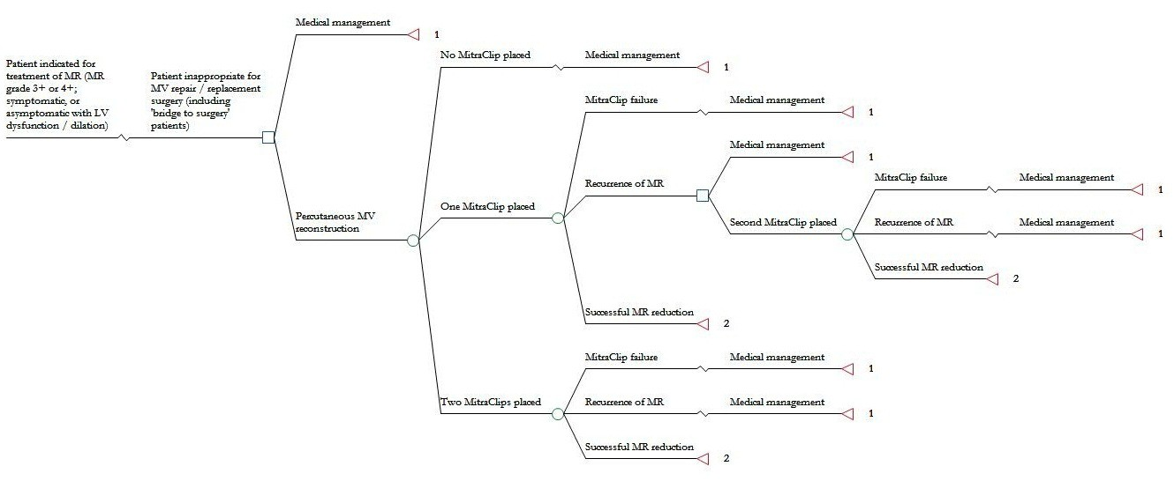
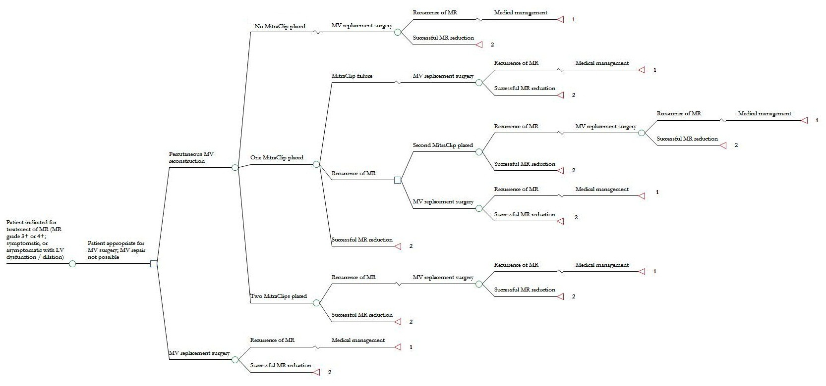

References

Australian Institute of Health and Welfare 2011. Principal diagnosis data cubes. Last updated 2011. http://www.aihw.gov.au/principal-diagnosis-data-cubes [accessed 26 October 2011].

Bonow RO, Carabello BA, Chatterjee K, de Leon Jr. AC, Faxon DP, Freed MD, Gaasch WH, et al (2006). ACC/AHA 2006 guidelines for the management of patients with valvular heart disease.Circulation, 114:e84-e231.

Dang NC, Aboodi MS, Sakaguchi T, Wasserman HS, Argenziano M, Cosgrove DM, Rosengart TK, et al (2005). Surgical revision after percutaneous mitral valve repair with a clip: Initial multicenter experience. Annals of Thoracic Surgery, 80(6):2338-2342.

Hanson I& Alfonso LC.Mitral Regurgitaton. Last updated 7 October 2011. http://www.emedicine.com/med/topic1485.htm [accessed 26 October 2011].

Medicare Australia 2011a.Medicare Australia statistics – item reports. Last updated 2011. https://www.medicareaustralia.gov.au/statistics/mbs_item.shtml [accessed 26 October 2011].

Medicare Australia 2011b. MBS online – Medicare Benefits Schedule. Last updated 2011. http://www.health.gov.au/internet/mbsonline/publishing.nsf/Content/Medicare-Benefits-Schedule-
MBS-1 [accessed 26 October 2011].

Olson LJ, Subramanian R, Ackermann DM, Orszulak TA, Edwards WD (1987). Surgical pathology of the mitral valve: a study of 712 cases spanning 21 years.Mayo ClinProc, 62(1):22-34.

Owings MF & Lawrence L (1999).Detailed diagnoses and procedures, National Hospital Discharge
Survey, 1997.Vital Health Stat, 13(145):1-157.

Rosen SE, Borer JS, Hochreiter C, Supino P, Roman MJ, Devereux RB, Kligfield P, et al (1994). Natural history of the asymptomatic/minimally symptomatic patient with severe mitral regurgitation secondary to mitral valve prolapse and normal right and left ventricular performance.Am J Cardiol, 74(4):374-
380.

Sundt TM 3rd. Mitral valve replacement. Last updated 2011. http://www.sts.org/patient- information/valve-repair/replacement-surgery/mitral-valve-replacement [accessed 7 November 2011].

Thom T, Haase N, Rosamond W, Howard VJ, Rumsfeld J, Manolio T, Zheng ZJ, et al (2006). Heart disease and stroke statistics – 2006 update: a report from the American Heart Association Statistics Committee and Stroke Statistics Subcommittee. Circulation, 113(6):e85-151.

