Application 1176r
– Assessment of application for joint injection items

Sponsor: Australian Rheumatology Association (ARA) Date of MSAC consideration: 52nd MSAC meeting, 27 April 2011
54th MSAC meeting, 29 November 2011

1. Purpose of Application

An application was submitted through the MBS Quality Framework in April 2010 by the Australian Rheumatology Association (ARA) seeking two new consultation items involving joint injection/aspiration procedures for patients suffering osteoarthritis or inflammatory arthritis.

This assessment relates to the treatment of “complex” patients with osteoarthritis and inflammatory arthritis by consultant physicians. The purpose of the assessment is to ascertain, via a rapid review process, what evidence exists in the literature to support the claims made within the application.

Medical practitioners are able to provide joint injections under existing consultation items, but this assessment focussed on injection by consultant physicians as the claims and evidence for other services, such as an image guided joint injection, need to be separately assessed.

Joint aspiration, or arthrocentesis, is the process of draining the synovial fluid from a joint. When arthrocentesis is used for diagnostic purposes in patients with arthritis, the synovial fluid is sent to a laboratory for analysis of leukocyte counts, measurement of glucose and protein levels, Gram stain, bacterial culture and other tests as indicated. Synovial fluid analysis is used to broadly characterise the type of arthritis and to establish a diagnosis of septic arthritis, gout or pseudogout.

Intra-articular (IA) corticosteroid injection involves injecting steroid solution directly into the joint space. It is used as a short-term treatment for suppressing joint inflammation in patients with osteoarthritis or inflammatory arthritis whose symptoms are otherwise well controlled. The potential side effects of IA steroid injection include local skin atrophy and depigmentation, tendonitis or tendon rupture, haemarthrosis and, very rarely, septic arthritis.

Clinical Pathway diagrams on page 16 and 17 of the MBS Quality Framework Assessment Protocol, Diagnostic joint aspiration and intra-articular steroid injection for osteoarthritis and inflammatory arthritis, QF 2010-001, December 2010 are based on information contained in the MBS Quality Framework application from the Australian Rheumatology Association. The aim of the flowcharts is to help define the place of the proposed service in clinical management.
This application is for a new item number for an existing intervention that is not publicly funded. The application was assessed by an external evaluator throughout 2010 using elements of the MBS
Quality Framework new listing process as agreed by the Minister of Health and Ageing in March
2010.

The application relates to the use of diagnostic joint aspiration and intra-articular steroid infection by rheumatologists in patients with osteoarthritis and inflammatory arthritis.

2. Background

As part of the 2009 Budget, the Australian Government announced that joint injection items 50124 and 50125 would be removed from the Medicare Benefits Schedule (MBS) on 1 November 2009 as they were considered, in most cases, minor and routine in nature, and could be delivered as part of
a standard consultation. From 1 November 2009, any practitioner administering the service could continue to perform the service under the relevant attendance item for the relevant medical speciality, or the relevant imaging items for diagnostic imaging specialists. Practitioners with previously rendering this service under MBS arrangements included consultant physicians (including rheumatologists), general practitioners and radiologists undertaking image guided joint injections on referral.

At present, the consultant physician attendance items are not time-based. Rheumatologists argued that they do not render other procedural services that may compensate for the longer time required to perform more complex joint aspirations or injections. General Practitioners who undertake joint injections may be remunerated for the time taken by moving from a Level B consultation item to a Level C or D, provided that all requirements of the relevant item are met. Radiologists also undertake image guided joint injections on referral from a medical practitioner. The higher MBS fee for radiological items provides for the additional time, complexity and equipment associated with administering the service.

The department met with the ARA on several occasions to discuss the impact of the removal of these two items from the MBS on people suffering from severe arthritis. The ARA also advised
that the procedure is not necessarily simple or routine in all patient groups, as rheumatologists often deal with more complex joint aspirations and injections, such as for small joints.

In March 2010, the Minister of Health and Ageing agreed that the MBS Quality Framework new listing process be used as a way of analysing the merits of claims made by the ARA. This was the first application to be assessed under the MBS Quality Framework new listing process.

The MBS Quality Framework trialled methodologies for the assessment of services that had not historically been evaluated by MSAC (i.e. consultation, consultation-related and allied health services). In December 2010 the Minister for Health and Ageing decided to seek MSAC’s advice on the outcomes of assessments conducted under the MBS Quality Framework. In many instances these types of services do not have the level of published peer-reviewed evidence that MSAC would expect to appraise under its terms of reference. Applicants were therefore asked to provide published scientific/academic literature where possible, and where there was an absence of such documentation, applicants were encouraged to provide other sources of evidence, such as grey literature, websites of specialty organisations or projects related to the application, clinical expert opinion and research reports.

The assessment of the evidence base with respect to the safety, effectiveness and cost-effectiveness for this application was through a “rapid review” and not a formal systematic review.
Modifications were made to the methodology with respect to the search strategy, inclusion criteria, assessment of study quality and data analysis. This rapid review was an evidence-based assessment derived from a simple systematic search of studies published in the peer reviewed literature.

3. Listing proposed and options for MSAC consideration

Joint or other synovial cavity, diagnostic aspiration of, corticosteroid injection into, or both of these procedures (performed by a consultant physician where the patient is referred by another medical practitioner), for the diagnosis or treatment of one or more of the following conditions:
- osteoarthritis; or
- inflammatory arthritis.

To be used in conjunction with Items 110 and 116.
Fee: $38.75

Although the proposal was for services to be remunerated only where rendered by ‘Consultant physicians where the patient is referred by another medical practitioner.’, and the rapid review evidence identified that special training and skills are required, MSAC considered that any new items would most likely be used by practitioners who have appropriate training in intra-articular aspiration and injection techniques.

Although the applicant sought a new MBS item for consultant physicians, MSAC considered whether the introduction of a separate item for this group of practitioners would provide an incentive for the other specialities to request their own joint injection items.

This application was considered by the Protocol Advisory Sub Committee (PASC) in
February 2011. Specific issues raised by PASC were:

• The flowcharts (see Figures 1 and 2) did not demonstrate how clinical management would differ with and without the capacity to have the two interventions (i.e. diagnostic joint aspiration and intra-articular steroid injection) and so did not clarify the comparisons to be undertaken. PASC also noted that the flowcharts did not reflect other failed therapies or address the two identified disease groups.

• For each type of arthritis there are different comparators and different clinical places for the proposed interventions but these were not clearly articulated in the protocol.

• PASC considered whether withdrawing the items may have led to an increase in the procedures being done in hospital (i.e. a shift from office to hospital setting), but not the overall rate of healthcare resource usage. For example, the removal of the option to perform these procedures as office-based interventions (at $27/intervention) may have resulted in a shift to more expensive image-guided interventions (at $90/intervention).

The protocol required clarity around defining the specific population(s) for whom the intervention is intended. In addition, PASC raised concern that the clinical questions were not clearly articulated and were hard to understand.

MSAC agreed with ESC that there was not adequate information included on the potential impacts of the intervention and the potential flow-on effect the intervention may have on other services which could potentially be more expensive to the patient.

Figure 1 Clinical flow chart for diagnostic joint aspiration and IA steroid injection in patients with a swollen joint who are referred to a rheumatologist by a general practitioner (GP)

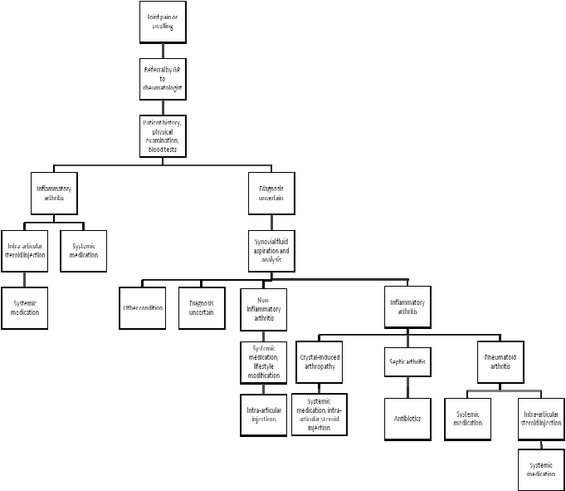

Figure 2 Clinical flow chart for diagnostic joint aspiration and IA steroid injection in patients with a swollen joint who receive a follow-up consultation with a rheumatologist
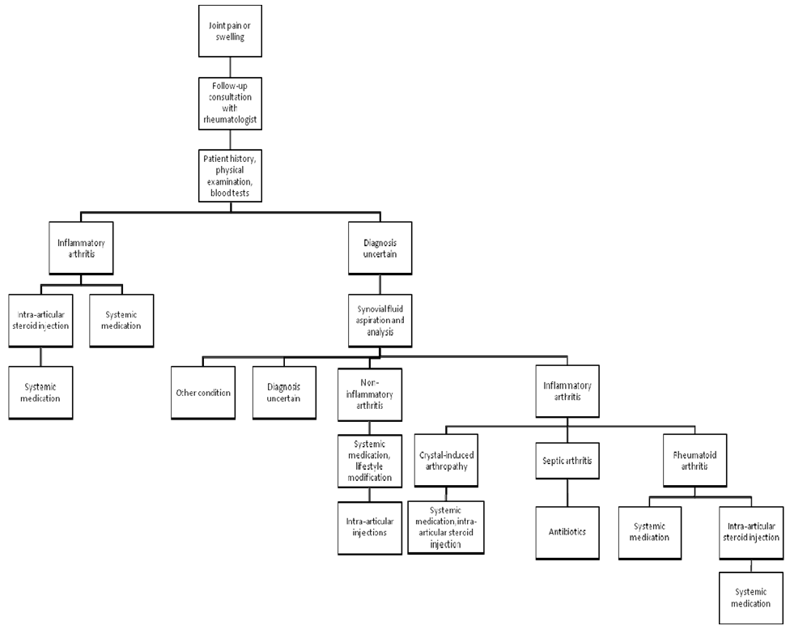
The PICO (Population, Intervention, Comparator, Outcomes) criteria were used to develop
well-defined clinical questions (Richardson et al 1995). This involved focusing the question on the following four elements:
• the patients or problem to be addressed
• the intervention or treatment being considered
• the comparison service, if necessary
• the claimed clinical outcomes of interest.

Outlined below are the PICO criteria and clinical questions formulated according to the information provided in the ARA application and garnered from discussion with the Department at the preliminary meeting and stakeholder input.

Table 1 PICO criteria and clinical questions for diagnostic joint aspiration

Population Intervention Comparator Outcomes

Patients of any age with osteoarthritis or inflammatory arthritis

Diagnostic aspiration of synovial fluid, conducted independently of the reference test

Patient history and clinical examination
Blood tests
Diagnostic imaging
(either alone or in combination)

Sensitivity Specificity Likelihood ratios
Diagnostic odds ratios
Positive and negative predictive values
Technical failures
Adverse effects

Table 2 PICO criteria and clinical questions for IA injection of corticosteroids

Population Intervention Comparator Outcomes

Patients of any age with osteoarthritis or inflammatory arthritis

Intra-articular injection of corticosteroids, either alone or in combination with
therapeutic joint aspiration

No treatment
Placebo or sham therapy
Intra-articular injection of drugs other than corticosteroids
Systemic medication
Surgical intervention

Efficacy
Primary: swollen or tender joint counts, pain, functional status, global estimate of status, return to work, blood inflammatory markers
Secondary: imaging study results
Safety - including infection, tendon rupture or weakening, post-injection flare, local nerve or soft tissue damage, haemarthrosis, joint instability

4. Comparator to the Intervention

PASC identified:

• that the protocol needed clarity around defining the specific population(s) for whom the intervention is intended; and

• that for each type of arthritis there are different comparators and different clinical places for the proposed interventions which were not clearly articulated in the protocol.

For diagnostic joint aspiration, the comparators used in the report were patient history and clinical examination, blood tests and diagnostic imaging (alone or in combination). For intra-articular steroid injection the comparators were no treatment, placebo or sham therapy, intra-articular of drugs other than corticosteroids, systemic medication and surgical intervention.

MSAC and ESC agreed that for each type of arthritis there are different comparators and different clinical places for the proposed interventions which were not clearly articulated in the protocol.

The proposal was for the intervention to be claimed in conjunction with existing consultant physician attendance Items 110 and 116. A separate MBS item is being sought for the joint injection/aspiration procedure.

The ARA is seeking MBS funding for the proposed new item.

5. Scientific basis of comparison

This rapid review is an evidence-based assessment derived from a simple systematic search of studies published in the peer reviewed literature. Systematic reviews, cross-sectional analytic studies, randomised controlled trials and grey literature were searched to identify relevant studies and reviews for the period between 2000 – August 2010.

6. Comparative Safety

Comparative safety and effectiveness profiles indicate that for:

• Diagnostic joint aspiration
o No available evidence for crystal induced arthritis, inflammatory arthritis or Osteoarthritis.
o Insufficient evidence to make an informed decision for septic arthritis.

• Intra-articular steroid injection

o No available evidence for Juvenile idiopathic arthritis, IA steroid injection in children with osteoarthritis or inflammatory arthritis, Osteoarthritis of joints other than the hand and knee, or frequency and number of IA steroid injections.
o Some evidence for inflammatory arthritis - in the elbow, wrist, knee and ankle for patients with rheumatoid arthritis.
o Evidence - Osteoarthritis of the hand and knee
MSAC at its 52nd meeting of 27 April 2011 accepted that there were no safety issues around diagnostic joint aspiration and intra-articular steroid injections.

7. Comparative effectiveness

MSAC at its April 2011 meeting accepted that there were no effectiveness issues around diagnostic joint aspiration and intra-articular steroid injections.

8. Economic evaluation

MSAC at its April 2011 meeting, noted that there was no available evidence on cost effectiveness possibly because of the time limited nature of the rapid review (ie only reviewed papers back to
2000 and as it is a long established procedure cost effectiveness analyses may have been conducted prior to this). MSAC concluded that there was uncertainty around the lack of evidence in respect to cost-effectiveness.

Cost of service and cost-offsets:
• No cost offsets were identified. The proposed item would be a separate new item to be provided in conjunction with an existing consultant physician consultation item (110 or 116);
• No estimate was provided by reviewer.

The ARA proposed a fee of $41.70, revised by the reviewer to $38.75 based on MBS Quality Framework input based fee methodology. The fee assumes an average 8.5 minutes per service. The fee for removed item 50124 was $29.35. There were no restrictions around provider access for this item. However, there was a restriction on the number of times the service could be claimed in a given year. Co-payment/out of pocket for proposed intervention are not known. Implications for the Medicare Safety Net are not known or discussed in this report. There is no intention to cap the proposed intervention.

9. Financial/budgetary impacts

The ARA estimated that around 54,000 services per year would be utilised. However, MSAC noted ESC advice that the utilisation numbers were not detailed and lacked the differentiation between each patient group and lacks clarity as to whether the utilisation numbers were for new or existing patients or both, and that the application lacked specific utilisation data since the removal of items
50124 and 50125. In light of the discussion around utilisation, MSAC agreed with ESC that the ARA’s case for a new item was not particularly strong. MSAC also noted ESC’s advice that there was no evidence of the number of recommended treatments patients can have per year; noting that items 50124 and 50125 had such restrictions.

Despite the applicant’s claim that the evidence suggested that recent guidelines recommended limiting the frequency and number of intra-articular injection treatments; there was no evidence identified in systematic reviews or randomised controlled trials to support or refute these claims.

Detailed analysis of the expected patient numbers in any given year was not undertaken.

Arthritis affects approximately 3.1 million Australians (15%), of whom two out of every three are between 15 and 60 years of age. Over 1.6 million Australians have osteoarthritis. Around 429,000 have rheumatoid arthritis, making these the two most common forms of arthritis in Australia. The overall prevalence of juvenile arthritis in Australia in the 2004-05 period was estimated to be 103 per 100,000 persons.

10. MSAC key issues

• Main issues around the evidence for safety?

MSAC agreed with ESC that there were limited studies for both safety and effectiveness for joint injections and aspiration of a joint.

• Main issues around the evidence for clinical effectiveness?

MSAC agreed with ESC that in certain circumstances there were some significant clinical improvements from steroid injections (refer to section 8 for more detail).

• Main clinical issues and areas of uncertainty

MSAC agreed with ESC that the measure and magnitude of clinical benefit was not available in the review.

MSAC also agreed with ESC advice that:

• the applicant has clarified that the rheumatologists serve more complex patients and provide more skilled services rather than providing more complex injections. Members felt that a defensible definition for complex injections was required rather than stating that rheumatologists see complex patients as this runs the risk of putting all patients into the complex category. Members agreed that if the activity itself is not complex then there is no supporting case that a new item be created;

• there is no evidence to support the assertion that the rheumatologists by virtue of training and experience are more skilled in injection/aspiration than others such as orthopaedic surgeons or radiologists; and

• aspirations and injections are safe and effective (for appropriate patients) but consume time and resources.

• Main economic issues and areas of uncertainty

MSAC noted ESC advice that assuming the 2008 provider usage data, where rheumatologists provided a total of 10% of the services for 50124, the costs will grow slowly. There is no incentive for physicians to undertake more services than previously, and numbers of rheumatologists are not thought to be growing rapidly, although numbers of people with arthritis are growing.

MSAC agreed that the core question is whether it is appropriate to provide a separate item for this service or whether it should be covered by an existing consultation item as is currently the case for other specialty groups. The average time for this service is approximately 8.5 minutes. The ARA indicated that services will continue to be provided but patients will have significant out-of-pocket costs.

MSAC also agreed with ESC that there is no evidence available on whether gap payments have increased; and as the argument focuses on payment, it relates to what should be considered part of a “consultation” and what a separate activity is, and whether these could or should be different for different specialty groups.

11. Other significant factors

MSAC agreed with ESC that it was not proven whether it was reasonable to agree to public funding through the MBS for an intervention that took only 8.5 minutes. MSAC noted the assessment
report did not address whether a joint injection could be absorbed as part of an existing attendance item; and all other specialty groups accept that minor procedures are to be conducted as part of the existing attendance items.

MSAC and ESC also agreed it was a policy matter for Government to determine whether the intervention is defined as ‘minor’ and ‘should form part of an existing attendance item’. MSAC also noted that if the intervention were to be introduced as a separate item, this may be an incentive for consultant physicians to provide more services or other specialties to ask for similar items.

MSAC and ESC also noted limitations in the report due to the lack of cost-effectiveness data and limited identified studies for both safety and effectiveness for joint injections and aspiration of a joint.

MSAC and ESC agreed that if the intervention were to be considered in isolation from a consultation, then within the limits of the available data the intervention appears to be safe, effective and reasonably priced. However, MSAC noted that the intervention is not normally performed separately from a consultation. MSAC agreed with the ESC suggestion that the department might consider developing criteria to help determine when an intervention should be considered a separate procedure or form part of a consultation, and such criteria should incorporate risk, safety implications and flow on effects.

MSAC and ESC noted that claims for diagnostic imaging items have increased since the removal of the previous joint injection items, but the rate of growth in such claims has been relatively
consistent in the period before and after the removal of the joint injection items. It was noted that there was a slight increase in referrals from rheumatologists but most referrals were from GPs and specialists. The Department advised that the interpretation of the diagnostic imaging data provided to ESC was limited because the diagnostic imaging items were not specific to joint injections and could be used for other conditions. MSAC and ESC also noted that there is little evidence that rheumatologists are referring more patients to radiologists for this service, so it seems likely they are continuing to undertake the procedures; but that the potential for a transfer to radiology still exists.

MSAC and ESC agreed that there is no evidence to suggest that patients are missing out on joint injections or aspirations since the removal of items 50124 and 50125.

Taking into consideration the applicant’s response to specific issues raised at the April meeting, MSAC agreed that there was insufficient evidence to identify the characteristics of patients or providers for whom the procedure would be more time consuming or complex and could not be performed as part of an attendance, nor was there any proven indications that patients were missing out.

MSAC noted there remains an underlying policy question of how such procedures should be funded within the Medicare arrangements.

12. Summary of consideration and rationale for MSAC’s advice

At its 52nd meeting, held on 27 April 2011, MSAC considered the assessment report for the use of diagnostic joint aspiration and intra-articular steroid infection by rheumatologists in patients with osteoarthritis and inflammatory arthritis. MSAC concluded then that there were no safety or effectiveness issues around diagnostic joint aspiration (DJA) and intra-articular steroid injection (IASI) and that both are clinically relevant and well established procedures performed by a range of providers. However, MSAC deferred its decision on the application until further advice was provided by the applicant in respect to the lack of evidence around:

- distinguishing between complex versus standard joint injections
- what joint locations and/or extent of joint deformity are considered complex
- special training requirements for particular circumstances
- number of joints to be treated in proposed initial versus follow up consultations
- utilisation of MBS items 50124 and 50125 before they were removed from MBS
- evidence of changing referral pathways following removal of these items( particularly additional referrals to diagnostic imaging services).
- restriction of some procedures to be performed by consultant physicians only

MSAC was reminded that this application arose from a 2009-10 Budget decision by government to remove MBS item numbers 50124 and 50125 for joint aspirations and injections on the basis that these services were deemed “minor and routine in nature and could be delivered as part of a standard consultation”.

MSAC again noted that this application was submitted by the Australian Rheumatology Association (ARA) and was managed as a review through the MBS Quality Framework. The ARA sought reimbursement for new items as follows:

Joint or other synovial cavity, diagnostic aspiration of, corticosteroid injection into, or both of these procedures (performed by a consultant physician where the patient is referred by another medical practitioner), for the diagnosis or treatment of one or more of the following conditions:
- Osteoarthritis; or
- Inflammatory arthritis.
To be used in conjunction with items 110 and 116. Fee: $38.75

MSAC noted that the applicant suggested there is no distinction between “complex” joint injections or joint aspirations versus standard procedures. Instead the applicant suggested that it is patient characteristics that make the consultation complex such as the presence of co-morbidities and the need to make accurate diagnoses and customise treatment. Given this assertion that there was no group of patients who required joint injections of additional complexity, but rather that some patients were more complex to manage in general, MSAC did not support the applicant’s request to provide reimbursement based on complexity of the procedure.

MSAC noted that additional evidence has not been produced which supports the claim that there is a select group of patients in whom the procedure is more time consuming and not able to be performed as part of a normal consultation.

MSAC agreed that there was also no evidence provided as to why these procedures should be limited to specific providers rather than be defined according to the characteristics of the patient. MSAC noted the applicant’s assertion that rheumatologists (by virtue of training or experience) are more skilled in injection/aspiration than other providers, but noted no evidence was presented to support this claim.

MSAC noted the outcomes of a small clinical audit of four providers which claimed that rheumatologists mostly inject large joints particularly knees and shoulders, inject no more than 3 joints in one attendance, usually inject only one joint), but on average inject 1.7 joints per attendance. MSAC agreed the audit did not support an assertion that rheumatologists injected more complex joints compared to other providers, or in doing so delivered better outcomes. No evidence was presented that demonstrated that rheumatologists had superior training relative to other providers rendering this service (such as orthopaedic surgeons, radiologists, or sports medicine physicians). MSAC noted the ARA submission that all joints should be accessible by a rheumatologist but noted that subtalar, hip and metatarsal joints may be difficult to localise without imaging.

MSAC noted that the utilisation of diagnostic imaging items known to be strongly associated with
(but not limited to) joint injections (items 55848 and 55850) has continued to rise after November
2009, when items 50124 and 50125 were removed. However, the rate of growth in that period was not significantly different from the growth over the preceding time period. As well, MSAC acknowledged that evidence of a change in referral patterns favouring image guided procedures would be relevant, but noted that MBS data do not indicate that referrals by rheumatologists for image guided services has changed since the removal of the joint injection items. MSAC accepted that from the limited available evidence, the outcome of ultrasound guided procedures versus those performed by rheumatologist without ultrasound was equivalent.

MSAC noted that no data were available regarding patient co-payments for rheumatology services that could be attributed to withdrawal of items 51024 and 50125.

Finally MSAC noted that there was no evidence that removal of items 51024 and 51025 had impacted adversely on patient access to these services.

13. MSAC’s advice to the Minister

After considering the strength of the available evidence in relation to the application for a new MBS item for diagnostic joint aspiration and intra articular steroid injection by consultant physicians, MSAC agreed that there was insufficient evidence to identify the characteristics of patients or providers for whom the procedure would be more time consuming or complex and could not be performed as part of an attendance. If evidence supporting the need for specific MBS items were to become available, MSAC considered that such services should be defined in terms of
patient characteristics rather than provider type.

