Application 1544:
Genome-wide microarray testing for haematological malignancies
Ratified PICO Confirmation

Summary of PICO/PPICO criteria to define the question(s) to be addressed in an Assessment Report to the Medical Services Advisory Committee (MSAC)
Component | Description
Patients | Patients with a confirmed clinical diagnosis of:  - chronic lymphocytic leukaemia (CLL), or  - multiple myeloma (MM)
Prior tests | Biopsy/surgical resection sample for tissue. Pathological or haematological investigation of cancer cells including: complete blood count; bone marrow aspiration and trephine biopsy; physical examination by palpation of lymph node zones (in CLL), and possible computed tomography.
Intervention | Genome-wide microarray as an:  1. adjunct or  2. alternative testing method to current investigations.
Comparator | Karyotyping and fluorescence in situ hybridisation (FISH).
Outcomes | - Effectiveness: impact on clinical management, disease-free and/or overall survival, disease progression, incidence of metastases, health-related quality of life.  - Safety: unexpected prognosis, adverse events related to chemotherapy or targeted treatment  - Clinical validity¹: Clinical sensitivity and specificity, positive and negative predictive values, prognostic value  - Healthcare resources: cost of genome-wide microarray, cost of clinical genetic evaluation, cost of treatments  - Cost-effectiveness: Cost per quality-adjusted life year  - Total Australian Government healthcare costs: cost of genome-wide microarray cost partially offset by reduction in use of other tests, change in use of, and cost of, cancer treatments
Abbreviations: CLL, chronic lymphocytic leukaemia; FISH, fluorescence in situ hybridisation; MM, multiple myeloma
- Clinical validity: measures the test’s ability to predict the presence or absence of disease, that is, the sensitivity, specificity and positive and negative predictive values, in this case, to accurately predict the risk of distant recurrence.
PICO or PPICO rationale for therapeutic and investigative medical services only
Population
The proposed population are patients with confirmed clinical diagnosis of Chronic Lymphocytic Leukaemia (CLL) or Multiple Myeloma (MM).
Chronic lymphocytic leukaemia
CLL is a type of slow-growing leukaemia in the blood that affects developing B-lymphocytes, which are specialised white blood cells. Under normal conditions they produce immunoglobulins or antibodies that help protect against infection and disease. In people with CLL, lymphocytes undergo a malignant change and become leukemic cells¹, accumulating in parts of the body such as the bone marrow, blood, lymph nodes, spleen or liver. As these cells do not function properly, their presence interferes with normal blood cell production.
In Australia there were 1,259 new cases of CLL in 2013², and it is estimated that this will increase to approximately 1,451 new cases in 2018. The median age at diagnosis is 72 years and life expectancy is 6.5 to over 10 years³ depending on severity of disease. CLL is twice as likely to occur in men than in women and is very rare in children⁴.
Treatment for CLL is based on clinical risk staging which is determined using the Binet clinical system. For patients with inactive disease or in the lowest risk category, observation is recommended. Previous studies have shown that early chemotherapy treatment for these patients does not translate into a survival gain³. For patients with either active disease or in the higher risk categories, first-line treatment includes chemotherapy, monoclonal antibodies or tyrosine kinase inhibitors.
For many patients, CLL remains stable for months or years, with little impact on their health. Around 30-50% of people diagnosed with CLL never require treatment for their disease.
Testing prior to treatment
Prior tests for diagnosis and risk assessment of CLL include³: history and physical examination, including palpation of all lymph node areas; complete blood and differential count in addition to serum chemistry; bone marrow aspirate testing and trephine biopsy (BMAT); fluorescence in situ hybridisation (FISH) testing for the detection of del 17p; additional molecular genetic testing to detect other cytogenetic abnormalities, such as del 11q or trisomy 12, immunoglobulin heavy chain variable mutation status; and imaging studies by computed tomography (CT).
The frequency of cytogenetic abnormalities which inform prognosis and treatment in CLL patients vary when identified using FISH. In CLL, del(17p) has a frequency of 3-8%, del(11q) 5-20%, trisomy 12, 10-20% and del(13q) 50%⁵.
Multiple Myeloma (MM)
MM is a cancer of the plasma cells in the blood that affects mature lymphocytes which are specialised white blood cells. Under normal conditions they produce immunoglobulins or antibodies that help protect against infection and disease. In people with MM, lymphocytes undergo a malignant change and become myeloma cells⁶. MM is an incurable and very heterogenous disease group where some patients have severe disease with rapid progression and short survival, while others are less severely affected⁷.
In Australia there were 1,637 new cases of MM in 2013, and it is estimated this will increase to approximately 1,876 new cases in 2018⁶. MM accounts for 15% of blood cancers and 1% of all cancers generally. MM is rare in people under the age of 40, with the disease often found in people over 60. It is slightly more common in men than in women⁸.
There are three stages of disease: an initial premalignant stage termed monoclonal gammopathy of uncertain significance (MGUS), followed by smouldering (or asymptomatic) MM and symptomatic MM⁹. MM is almost always preceded by MGUS.
If a clinical trial is not available for a person to enter, autologous stem cell transplant (ASCT) is recommended (pending the person’s suitability) followed by chemotherapy. Treatment for MM, depends on a patient’s eligibility for ASCT and high dose therapy, which is reliant on a person’s age, comorbidities and functional status. Currently, chemotherapy includes immunomodulatory and proteasome inhibitor-based treatments. Treatment is determined by the presence of MM defining events, manifested by either hypercalcemia, renal impairment, anaemia or bone disease (so-called CRAB criteria)⁹.
Testing prior to treatment
Prior tests conducted for the diagnosis and risk assessment of MM include: blood tests to measure the levels of paraprotein, lactate dehydrogenase, serum levels of ß₂-microglobulin and albumin; x-ray of bone; CT or magnetic resonance imaging (MRI) scan; BMAT; urine protein electrophoresis; urine immunofixation electrophoresis; and genetic testing for various abnormalities which lead to poor prognosis. Testing for these abnormalities is endorsed by local societies such as Myeloma Australia⁹ and HSANZ¹⁰.
The frequency of high-risk cytogenetic abnormalities in MM patients vary when identified using FISH. In MM, t(4;14) has a frequency of 15%, del(17/17p) 7%, t(14;16) 4%, t(14;20) 1%, nonhyperploidy 50% and gain (1q) 40%^{11, 12}. Favourable/neutral cytogenetic abnormalities such as t(11;14), t(6;14) and trisomy of odd numbered chromosomes (3, 7, 9, 11, 15 or 17) have 16%, 4% and 57% prevalence rates, respectively^{12, 13}.
Rationale:
The use of array comparative genomic hybridisation (CGH) in CLL is to detect genetic changes which inform prognosis and treatment. Current studies focus on four main genetic mutations¹⁴:
- Deletions of part of the short arm of chromosome 17 (del 17p), are particularly harmful. The abnormality occurs infrequently (5-10% of patients with CLL) but results in significantly shorter interval before they require therapy and a shorter survival as a result.
- Deletions of the long arm on chromosome 11 (del 11q) are also unfavourable although not to the degree seen with del 17p. The abnormality occurs infrequently in CLL (5–10%).
- Trisomy 12 is a relatively frequent finding occurring in 20–25% of patients and imparts an intermediate prognosis.
- Deletion of the long arm of chromosome 13 (del 13q) is the most common abnormality in CLL with roughly 50% of patients with cells containing this defect. These patients have the best prognosis and most live for many years.
The most important of these for this application is del 17p, as this mutation is used to guide treatment, not merely for prognosis.
The impact of copy number variants (CNVs, i.e. genetic abnormalities) on a patient’s prognosis in MM is included in Kim and colleagues (2015)¹⁵. Thirty-five newly diagnosed MM patients commencing bortezomib + melphalan + prednisone (VMP) treatment had their cytogenetic samples analysed with FISH and single nucleotide polymorphism (SNP) arrays. It was demonstrated that cytogenetic abnormalities had an impact on a patient’s chances of obtaining greater than very good partial response (VGPR) to VMP treatment. The number of detected abnormalities by SNP array was significantly higher in patients who did not achieve VGPR compared to those with VGPR (P=0.032) and was also higher in patients with progressive disease (PD) compared to those without PD (P=0.011).
Intervention
Genome-wide microarray is a method of measuring gains and losses of DNA throughout the human genome. The technology works by collecting DNA from two groups of participants: people with the disease and similar people without the disease. Both sets of DNA are then labelled with fluorescent dyes and attached to glass slides. The microarray scanner then measures the fluorescent signals, which are coloured differently depending on whether the gene is strongly expressed, strongly repressed, or neither. Finally, computer software analyses the data and generates a plot which can be interpreted by a trained technician. Several types of genome-wide microarray exist, such as SNP array, CGH, oligonucleotide microarray, and gene expression profiling.
The technology identifies extra or deleted genome chromosomal segments called CNVs¹⁶. A CNV is when the number of copies of a particular gene varies from one individual to the next. It has long been recognised that some cancers are associated with elevated copy numbers of particular genes¹⁷.
Genome-wide microarrays have two significant limitations. The first is that many of the CNVs detected by microarray are of uncertain clinical significance, meaning that the impact of the CNV on patient prognosis is unknown and there is no treatment targeting these CNVs. The second limitation is that genome-wide microarray cannot detect certain chromosome rearrangements, such as balanced translocation and inversions, because although there has been an exchange of DNA, there is no net gain or loss.
These tests are able to measure for greater than a single gene mutation (low complexity test) but less than a higher complexity test such as full gene sequencing¹⁸; the nominated tests stated above, would qualify as medium complexity tests.
Currently there is only one item on the MBS for genome-wide microarrays (MBS item 73292,
Table 1). It is currently listed for targeted assessment of a person with developmental delay, intellectual disability, autism, or at least two congenital abnormalities.

Table 1 MBS approved genome-wide microarrays
MBS Item Number | Description | Cost
73292 | Analysis of chromosomes by genome-wide microarray including targeted assessment of specific regions for constitutional genetic abnormalities in diagnostic studies of a person with developmental delay, intellectual disability, autism, or at least two congenital abnormalities (including a service in items 73287, 73289 or 73291, if performed)– 1 or more tests. | Fee: $589.90  Benefit: 75% = $442.45 85% = $508.20
Source: MBS online (accessed Jun 2018)
Abbreviations: MBS, Medicare benefits schedule
Rationale:
The ability of the genome-wide microarray to detect abnormalities in CLL patients has been the subject of much research. The use of genome-wide microarray alone (rather than in combination with FISH and karyotyping) has been investigated.
One study found that array CGH was able to detect abnormalities in 81% of cases, compared to 65% using FISH, and 28% using karyotyping¹⁹. In the detection of del 17p, array CGH detected the abnormality in 11% of cases, while FISH detected it in 12%. In the subpopulation which was tested using both techniques, there was no discordance in findings. Other studies have found discordance between the results of genome-wide microarray testing and FISH but have confirmed that the rate of detection of del 17p using genome-wide microarray is approximately 11%^{20, 21}.
In a prospective population-based study of 123 patients with newly diagnosed MM with their samples undergoing karyotyping, FISH and oligonucleotide-array comparative genomic hybridisation (oaCGH). Clonal abnormalities were identified in 27%, 83% and 99% of cases when conducting karyotyping, FISH and oaCGH, respectively. However, oaCGH is unable to detect gene arrangements, multiple clones, low level clonal aberrations and balanced translocations⁷. Furthermore, a caveat of CGH, array CGH and SNP microarray are their inability to identify triploidy or tetraploidy²².
Comparator
The main comparators for genome-wide microarray are FISH testing and karyotyping. Genome-wide microarray would likely be employed with FISH testing but is likely to replace standard karyotyping in diagnostic assessments of MM and CLL.
Karyotyping
Chromosome analysis or karyotyping is a test that evaluates the number and structure of a person’s chromosomes in order to detect abnormalities. Karyotyping reveals cytogenetic abnormalities in 20% to 30% of patients, those being mainly numerical abnormalities (seen with chromosomes). Several translocations such as t(4;14) are not detected¹¹. Karyotyping is able to detect trisomy, monosomy, deletions, duplications, translocations and genetic rearrangement²³. Of note, cytogenetic analysis with karyotyping in MM is often only possible in patients with >15% plasma cells in the aspirate as the yield of metaphases is low with a lesser plasma cell burden.⁹ Due to this limitation, karyotyping is prone to failure²⁴.
Currently karyotyping for haematological malignancy is available under the current MBS item: 73290 (Table 2). The test has a cost of $394.55, with a rebate for all or part of the cost but has a Medicare rebate of $335.40, subject to the requirements of the Medicare descriptor being met. Test turnaround is 18 working days for karyotyping²⁵. Karyotyping qualifies as a low complexity test¹⁸.
Table 2 MBS approved cytogenetic tests for haematological conditions
MBS Item Number | Description | Cost
73290 | The study of the whole of each chromosome by cytogenetic or other techniques, performed on blood or bone marrow, in the diagnosis and monitoring of haematological malignancy (including a service in items 73287 or 73289, if performed). – 1 or more tests. | Fee: $394.55  Benefit: 75% = $295.95 85% = $335.40
Source: MBS online (accessed Jun 2018)
Abbreviations: MBS, Medicare benefits schedule
Medicare statistics indicated that a total of 8,579 and 8,890 services were undertaken for the MBS item number from July 2016 to June 2017 and July 2017 to June 2018, respective (Table 3).
Table 3. Number of MBS services undertaken between July 2015 and June 2017
MBS Item Number | Number of Services Jul 2016 to Jun 2017 | Number of Services Jul 2017 to Jun 2018
73290 | 8579 | 8890
Source: MBS online (Accessed Jun 2018)
Abbreviations: MBS, Medicare benefits schedule
The Australian Institute of Health and Welfare estimated that the incidence of CLL and MM in 2018 was 1,451 and 1,876 cases, respectively. Using the Medicare statistics data from July 2017 to July 2018, it can be determined that CLL and MM patients account for ~37% (~16% for CLL and ~21% for MM) of uses for MBS item 73290. Therefore, if the new proposed MBS item descriptor for microarrays is introduced, this is likely to result in a large reduction in the usage of MBS item 73290.
Rationale:
FISH is a diagnostic test which looks for a few common chromosomal abnormalities. FISH is usually performed with the same genetic material gathered from BMAT. The advantage of FISH testing is that results are often available within a couple of days²⁶. Furthermore, FISH provides a rapid result for confirmation or to determine whether a patient has high risk disease which can lead to a poorer prognosis. Unlike karyotyping, FISH only looks at a small number of chromosome changes²⁷. Given this limitation, FISH is often used in tandem with conventional karyotyping or with microarrays.
Currently, there are no FISH tests reimbursed on the MBS for MM. In CLL, FISH testing is currently reimbursed on the MBS to test for del 17p in a patient with relapsed or refractory CLL (Table 4). However, various studies^{20, 21, 28} have detected discordance between the ability of genome-wide microarray and FISH to detect del 17p. Therefore, genome-wide microarray is recommended for use alongside FISH, rather than in replacement. The MBS item description and fees of the FISH test are included below.
Table 4 MBS approved FISH tests in CLL
MBS Item Number | Description | Cost
73343 | Detection of 17p chromosomal deletions by fluorescence in situ hybridisation, in a patient with relapsed or refractory chronic lymphocytic leukaemia or small lymphocytic lymphoma, on a peripheral blood or bone marrow sample, requested by a specialist or consultant physician, to determine if the requirements for access to idelalisib or ibrutinib on the Pharmaceutical Benefits Scheme are fulfilled. | Fee: $230.95 Benefit: 75% = $173.25 85% = $196.35
Source: MBS online (accessed Jun 2018)
Abbreviations: MBS, Medicare benefits schedule

Outcomes
Patient relevant
From a patient perspective, the important outcomes of genome-wide microarrays are: improved prognostic assessment and avoiding less efficacious treatments. Furthermore, in CLL, the detection of del 17p by genome-wide microarray will enable specialists to prescribe treatments on the PBS that require the demonstration of 17p chromosomal deletions.
From a clinical perspective, an accurate assignment of genomic mutations is important because of prognostic and therapeutic implications for the patients. Accurate determination of cytogenetic abnormalities present in haematological malignancies would provide prognostic information that may lead to a more accurate progression free survival (PFS) and overall survival (OS) prediction.
However, in MM, according to the International Melanoma Working Group consensus (2016)¹¹, bortezomib and carfilzomib treatment appear to improve complete response, PFS, and OS in t(4;14) and del(17/17p). While lenalidomide may be associated with improved PFS in t(4;14) and del(17/17p). Both bortezomib and lenalidomide are already used in the first to third line treatment of symptomatic MM patients (Figure 1). Thus, the impact of cytogenetic abnormalities on treatment paradigms are minimal, yet their impact on patient prognosis is significant⁹. While, cytogenetic abnormalities can segregate patients into standard or high-risk disease, it is still yet to be established in routine practice²⁹.
Genome-wide microarray is currently more expensive than standard karyotype, however it would be considered more cost-effective in the haematological population because of greater sensitivity to detect chromosomal abnormalities. Furthermore, karyotyping has a higher culture failure rate in conducting a successful cytogenetic analysis than microarray^{19, 24}. Additionally, it requires more time to conduct due to the need to culture more cells⁷. Consequently, microarray appears to offer a more efficient and accurate form of cytogenetic analysis testing that is less prone to failure than karyotyping and quicker to conduct.
Effectiveness:
- Impact on clinical management
- Disease-free and/or overall survival
- Disease progression
- Incidence of metastases
- Health-related quality of life
- Length of hospitals stays
Safety:
- Adverse effects of chemotherapy – short and long term (e.g. neutropenic sepsis)
- Adverse effects of immunotherapy
- Repeated biopsies
- Hospital stays for serious adverse effects during/following treatment
- Improvement in function
- Potential drug interactions
Clinical validity
- Clinical sensitivity and specificity
- Positive and negative predictive values
- Prognostic value
Healthcare system
The availability of genome microarrays for patients with CLL and MM whose pathological and biopsy results meets the defined histological criteria will have implications for the Australian health care system.
Repeated pathology request forms will not be required for microarrays as one BMAT should be sufficient. Microarray testing is to be used in addition to FISH analysis, where no additional biopsies need to be conducted. However, it is possible for repeated biopsies to occur as the amount of material retrieved may be insufficient for cytogenetic analyses (FISH and genome-wide microarrays). The associated risks (although rare) and costs of repeated biopsies can be a concern not only for the patient³⁰ but also for the health system in terms of additional costs and associated health complications.
The proposed genome-wide microarray is able to provide cytogenetic abnormality results in addition to FISH, in approximately the same amount of time (two days), rather than the 18 working days required for karyotyping results²⁵. This would lead to a quicker determination of whether a patient has high or low risk disease, thereby impacting patient prognosis and treatment. Moreover, the applicant believes the uptake of genome-wide microarray testing will lead to the decreased use of karyotyping and will likely be used with FISH.
Microarrays will see more use when newer medications for MM targeting specific cytogenetic abnormalities are listed on the PBS. Currently, it provides prognostic information for a patient with MM. Whereas, in CLL it can cause the shift of patients on chemotherapy treatment to targeted immunotherapies which will incur additional costs to the PBS.
The improved allocation to chemotherapy regimens will result in lower resultant costs of care such as hospitalisations and specialist visits, however the overall impact on the government health budget is expected to be positive.
Healthcare resources:
- Number of chemotherapy treatment sessions
- Hospitalisation (same day and overnight) associated with delivery of chemotherapy treatment sessions
- Hospitalisation (same day and overnight) associated with delivery of immunotherapy treatment sessions
- Hospitalisation/treatment associated with chemotherapy/immunotherapy therapy side-effects
- Monitoring of patients while on therapy and months afterwards, including liver and renal function tests
- Specialist visits
- Requirements for subsequent therapy
- Costs of genome-wide microarray
- Costs of conventional karyotyping
- Cost of surgery, chemotherapy, radiotherapy, immunotherapy
- Palliative care costs
- Reduction in repeat testing

Cost-effectiveness:
- Cost per quality-adjusted life year

Total Australian Government healthcare costs:
- Cost of genome-wide micro-array cost partially offset by reduction in other tests
- Change in use of, and cost of, cancer treatments

Current clinical management algorithm for identified population
Chronic lymphocytic leukaemia (CLL)
For CLL, a patient’s disease is most likely first detected in a routine blood test. The patient will then be referred to a haematologist for a complete blood count, bone marrow aspiration, cytogenetics and other testing. In the current environment, cytogenetic testing is performed using karyotyping and FISH. Based on the result of these tests, the patient is stratified into risk categories, which will determine treatment.
All patients, regardless of risk category, can be tested for genetic abnormalities; this will be at the discretion of the clinician. Patients with early stage or inactive disease are monitored for the progression of their disease and receive regular blood tests to determine if their disease has become active. For those with active or advanced stage disease, del 17p status and fitness levels are used to determine suitability of treatment with chemotherapy agents such as fludarabine or chlorambucil, immunotherapy agents such as rituximab or ibrutinib, or allogenic haematopoietic stem cell transplant.
Multiple Myeloma
Under the current clinical management pathway (Figure 1), a patient’s pathology/urine/bone marrow sample is tested once (assuming the patient has symptomatic MM) before a specialist can determine the most appropriate course of treatment. Should a patient have symptomatic MM, for younger patients (under 65 years of age) or fit patients under 70 years of age in good clinical condition, an ASCT with high-dose therapy (HDT) is recommended. However, not all patients suffice these criteria and are initiated on induction therapy.
Although rare, repeat testing will be highly variable and possibly undertaken in cases of early relapse/refractoriness which may occur in younger patients (under 65-70 years).
As part of the Revised International Staging System (R-ISS) criteria (which is a prognostic staging system for MM), in addition to conventional karyotyping, FISH is also incorporated to determine whether the patient has high risk MM, thus leading to a poorer prognosis.
ESMO 2017 guidelines²⁹ state that clinical trials for high-risk smouldering MM patients are strongly encouraged. Cytogenetic abnormalities such as t(4;14) or del 17p or 1q gain are sufficient to define a high risk smouldering MM patient³¹.

Figure 1 Current clinical management algorithm
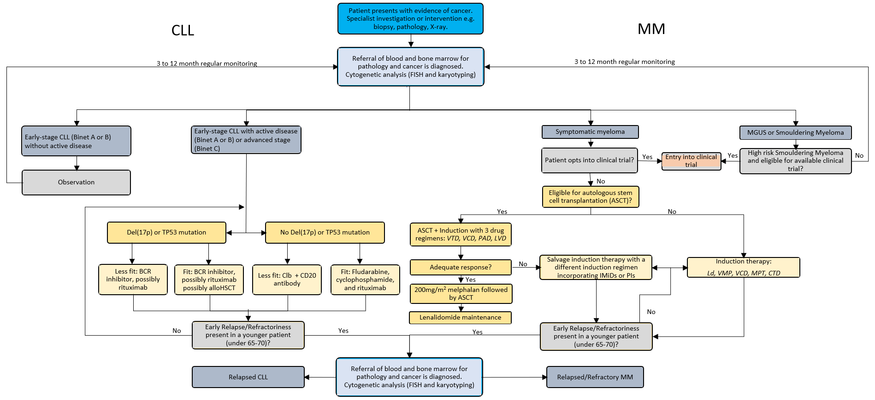
Source: Adapted from Myeloma Australia 2017 and European Society of Medical Oncology (ESMO) 2017 guidelines
Abbreviations: AlloHSCT; allogenic haematopoietic stem cell transplant; ASCT, autologous stem cell transplantation; BCR, B-cell receptor; Clb; chlorambucil; CLL, chronic lymphocytic leukaemia; CTD, cyclophosphamide + thalidomide + dexamethasone; FISH, Fluorescence in situ Hybridisation; IMiDs; immunomodulatory imide drug; LVD, lenalidomide, bortezomib, dexamethasone; MGUS, monoclonal gammopathy of uncertain significance; MM, multiple myeloma; MPT, melphalan + prednisone + thalidomide; PAD, bortezomib, doxorubicin, dexamethasone; PI; proteasome inhibitor; VCD; bortezomib + cyclophosphamide + dexamethasone; VMP, bortezomib + melphalan + prednisone; VTD, bortezomib + thalidomide + dexamethasone

Proposed clinical management algorithm for identified population
The proposed clinical management algorithm for CLL and MM is presented in Figure 2. Genome-wide microarray testing would be required in addition to bone marrow aspirate and/or haematological investigations but without further healthcare resources for obtaining the tumour sample (i.e. on the same specimen).
In CLL, genome-wide microarray will replace FISH testing. This is the clinical experience in South Australia, which has transitioned to the genome-wide microarray for CLL and no longer performs FISH analysis.
In MM, genome-wide microarray will be used alongside FISH. FISH is still required to detect cryptic translocations, which are not necessarily detected by microarray. The reason that FISH is still required in MM, but not in CLL is because in CLL, the most significant mutations are not translocations, whereas in MM several translocations are significant.
Although rare, repeat testing will be highly variable and possibly undertaken in cases of early relapse/refractoriness which may occur in younger patients (under 65-70 years).
It is important to note that when FISH would be used alongside genome-wide microarray before the commencement of any treatment, it is not funded under the MBS. FISH testing is funded under MBS item number 73343, but only for patients with relapsed or refractory CLL. Therefore the use of FISH testing for patients not meeting these requirements in the proposed clinical management algorithm is privately funded.
As new targeted therapies become available, more cytogenetic abnormalities can be tested for with microarrays for all CLL and MM patients, especially with a new MBS item description to be provided for testing. Consequently, this may influence the course of treatment for CLL and MM.
For patients with CLL, the inclusion of genome-wide microarray testing may enable more accurate determination of del 17p status, which will allow patients to be directed to the most effective current therapies. In MM, current clinical practice supports findings by the International Melanoma Working Group regarding cytogenetic testing of high-risk patients¹¹. Subsequently, genomic testing may segregate patients with standard or high-risk disease²⁹, but the impact of profiling patients is yet to be seen in clinical guidelines. It is possible that treatments which target certain mutations will be developed in the future, however at the present time genome-wide microarray test results will not alter the treatment pathway for patients with MM.

Figure 2 Proposed clinical management algorithm
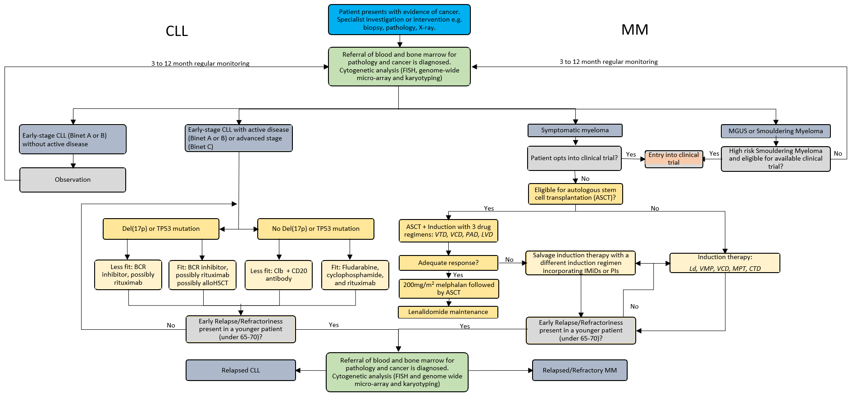
Source: Adapted from Myeloma Australia 2017 and European Society of Medical Oncology (ESMO) 2017 guidelines
Abbreviations: AlloHSCT; allogenic haematopoietic stem cell transplant; ASCT, autologous stem cell transplantation; BCR, B-cell receptor; Clb; chlorambucil; CLL, chronic lymphocytic leukaemia; CTD, cyclophosphamide + thalidomide + dexamethasone; FISH, Fluorescence in situ Hybridisation; IMiDs; immunomodulatory imide drug; LVD, lenalidomide, bortezomib, dexamethasone; MGUS, monoclonal gammopathy of uncertain significance; MM, multiple myeloma; MPT, melphalan + prednisone + thalidomide; PAD, bortezomib, doxorubicin, dexamethasone; PI; proteasome inhibitor; VCD; bortezomib + cyclophosphamide + dexamethasone; VMP, bortezomib + melphalan + prednisone; VTD, bortezomib + thalidomide + dexamethasone

Proposed economic evaluation
The clinical claim is that genome-wide microarray, in addition to FISH analysis provided to patients diagnosed with CLL and MM is non-inferior in terms of safety yet superior in terms of comparative effectiveness to FISH analysis and conventional karyotyping for the detection of genetic abnormalities. This is because genome-wide microarrays are able to detect more CNVs than conventional karyotyping and may have better accuracy in detecting some important CNVs.
According to the Technical Guidelines for preparing assessment reports for the Medical Services Advisory Committee: Investigative, the required economic analysis is therefore a cost utility analysis for CLL and a cost effectiveness analysis for MM.
Chronic Lymphocytic Leukaemia
The use of genome-wide microarray in testing CLL patients is to detect deletions of the short arm of chromosome 17 (i.e. del 17p), thereby allowing patients access to the most effective treatments. The benefits of increased life-years gained and improved health-related quality-of-life will be realised due to the improved accuracy of genome-wide microarray in detecting del 17p, compared to karyotyping.
A diagram of the proposed economic evaluation is presented in Figure 3.
Figure 3 Basic structure of the economic evaluation for CLL
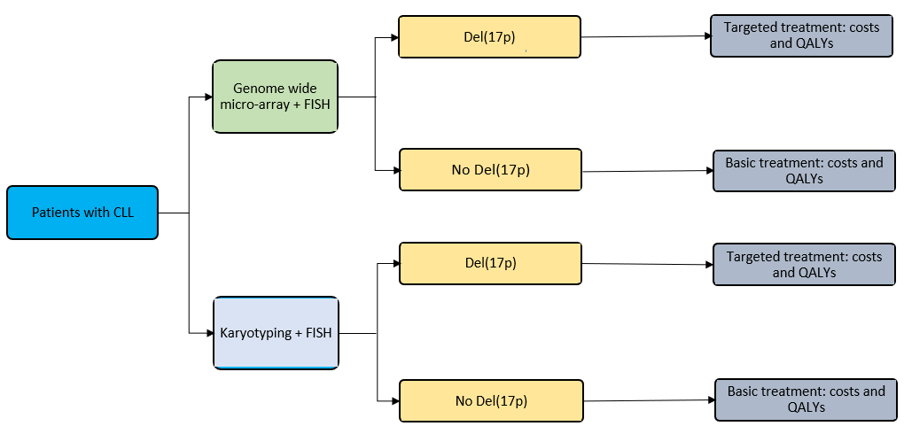
Abbreviations: CLL; chronic lymphocytic leukaemia; del, deletion; FISH, fluorescence in situ hybridisation; QALY, quality adjusted life year
Multiple Myeloma
The basic structure of the inclusion of genome-wide microarray is based on the service listing requested. For the economic evaluation, changes in the use of conventional karyotyping will be measured alongside the uptake of genome-wide microarrays.
The proposed economic evaluation does not include any difference in treatment pathways because the mutations detected by genome-wide microarrays currently have no selective treatments, even though arrays provide prognostic significance. Therefore, the funding of genome-wide microarray testing to the MM population should be seen as an effort to accommodate future developments in treatments of MM, rather than yielding immediate benefits.
A diagram of the proposed economic evaluation is presented in Figure 4.
Figure 4 Basic structure of the economic evaluation for MM
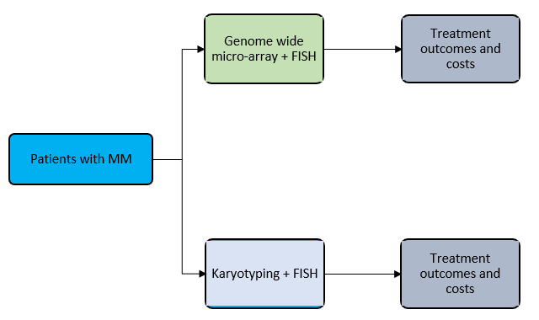
Abbreviations: CLL; chronic lymphocytic leukaemia; FISH, fluorescence in situ hybridisation; MM, multiple myeloma

Proposed item descriptor
Category 6 (Pathology Services) – Group P7 Genetics
Item number: XXXXX

Analysis of chromosomes by genome-wide microarray in diagnostic studies of a patient with chronic lymphocytic leukaemia or multiple myeloma (including a service in item 73290, if performed) - 1 or more tests,

Fee: $589.90 Benefit: 75% = $442.45 85% = $508.20
The fee proposed by the applicant includes the cost of the microarray, testing, sequencing and labour (medical and scientific) and bioinformatics for interpretation (as required for MBS service item 73292). It also includes the development, validation, maintenance, quality control and overhead costs from the laboratories providing the clinical testing.
Several array technologies are available for genome-wide microarray and all require single use consumables such as chips. This application does not endorse any one specific commercial product/brand of consumables.
The language used in the item descriptor is intentionally method-agnostic, allowing for multiple types of technology to be employed. Based on correspondence with the Department of Health, the methods available under the proposed item are limited to medium complexity processes. Therefore high complexity processes such as massively parallel sequencing and next generation sequencing are beyond the scope of this application.

References
1. Leukaemia Foundation, Chronic lymphocytic leukaemia (CLL), in What is chronic lymphocytic leukaemia? Accessed 30 May 2018.
2. Australian Institute of Health and Welfare AIHW, Cancer in Australia 2017. 2017. p. Canberra: AIHW.
3. Eichhorst, B., et al., Chronic lymphocytic leukaemia: ESMO Clinical Practice Guidelines for diagnosis, treatment and follow-up. Annals of Oncology, 2015. 26(suppl_5): p. v78-v84.
4. Cancer Council NSW. Chronic lymphocytic leukaemia (CLL). Who gets CLL? Accessed 30 May 2018; Available from: https://www.cancercouncil.com.au/chronic-lymphocytic-leukaemia/.
5. Puiggros, A., G. Blanco, and B. Espinet, Genetic abnormalities in chronic lymphocytic leukemia: where we are and where we go. BioMed research international, 2014. 2014.
6. Leukaemia Foundation. What is Myeloma? 12 June 2018]; Available from: https://www.leukaemia.org.au/disease-information/myeloma/.
7. Kjeldsen, E., Identification of prognostically relevant chromosomal abnormalities in routine diagnostics of multiple myeloma using genomic profiling. Cancer Genomics-Proteomics, 2016. 13(2): p. 91-127.
8. Cancer Council, Understanding Myeloma. 2014.
9. Australia, M., Clinical Practice Guideline MULTIPLE MYELOMA. 2017.
10. Haematology Society of Australia and New Zealand (HSANZ) Nurses Group, TESTS AND INVESTIGATIONS FOR MULTIPLE MYELOMA A guide for patients and caregivers. 2017.
11. Sonneveld, P., et al., Treatment of multiple myeloma with high-risk cytogenetics: a consensus of the International Myeloma Working Group. Blood, 2016. 127(24): p. 2955-2962.
12. Kalff, A. and A. Spencer, The t (4; 14) translocation and FGFR3 overexpression in multiple myeloma: prognostic implications and current clinical strategies. Blood cancer journal, 2012. 2(9): p. e89.
13. Kumar, S., et al., Trisomies in multiple myeloma: impact on survival in patients with high-risk cytogenetics. Blood, 2012. 119(9): p. 2100-2105.
14. Hallek, M., Chronic lymphocytic leukemia: 2017 update on diagnosis, risk stratification, and treatment. American journal of hematology, 2017. 92(9): p. 946-965.
15. Kim, M., et al., Copy number variations could predict the outcome of bortezomib plus melphalan and prednisone for initial treatment of multiple myeloma. Genes, Chromosomes and Cancer, 2015. 54(1): p. 20-27.
16. Theisen, A., Microarray-based comparative genomic hybridization (aCGH). Nature Education, 2008. 1(1): p. 45.
17. Institute, N.H.G.R. Genome-Wide Association Studies. Genome-Wide Association Studies Accessed 12 June Fact Sheets:[Available from: https://www.genome.gov/20019523/.
18. Australian Law Reform Comisssion (ALRC). 10. Genetic Testing. 12 July 2018]; Available from: https://www.alrc.gov.au/publications/10-genetic-testing/access-genetic-testing.
19. O’MALLEY, D.P., et al., Comparison of array comparative genomic hybridization (aCGH) to FISH and cytogenetics in prognostic evaluation of chronic lymphocytic leukemia. International Journal of Laboratory Hematology, 2011. 33(3): p. 238-244.
20. Stevens-Kroef, M.J., et al., Identification of prognostic relevant chromosomal abnormalities in chronic lymphocytic leukemia using microarray-based genomic profiling. Molecular cytogenetics, 2014. 7(1): p. 3.
21. Salaverria, I., et al., Detection of chromothripsis‐like patterns with a custom array platform for chronic lymphocytic leukemia. Genes, Chromosomes & Cancer, 2015. 54(11): p. 668-680.
22. Agnelli, L., et al., A SNP microarray and FISH‐based procedure to detect allelic imbalances in multiple myeloma: An integrated genomics approach reveals a wide gene dosage effect. Genes, Chromosomes and Cancer, 2009. 48(7): p. 603-614.
23. Lab tests online. Chromosome Analysis (Karyotyping). Accessed 25 May 2018; Available from: https://www.labtestsonline.org.au/learning/test-index/chromosome-analysis-karyotyping. .
24. Stevens‐Kroef, M.J., et al., Genomic array as compared to karyotyping in myelodysplastic syndromes in a prospective clinical trial. Genes, Chromosomes and Cancer, 2017. 56(7): p. 524-534.
25. Sonic Genetics. Karyotype(blood). 2017 19 June 2018]; Available from: https://www.sonicgenetics.com.au/tests/karyotype-blood/.
26. Myeloma Crowd. Myeloma 101: FISH testing in Myeloma. 2018; Available from: https://myelomacrowd.org/myeloma-101-fish-testing-in-myeloma/.
27. Biomnis, E., Constitutional cyto- and molecular genetics: Karyotyping, FISH and CGH array. 2016.
28. Hagenkord, J.M., et al., Array-Based Karyotyping for Prognostic Assessment in Chronic Lymphocytic Leukemia: Performance Comparison of Affymetrix 10K2.0, 250K Nsp, and SNP6.0 Arrays. The Journal of Molecular Diagnostics : JMD, 2010. 12(2): p. 184-196.
29. Moreau, P., et al., Multiple myeloma: ESMO Clinical Practice Guidelines for diagnosis, treatment and follow-up†. Annals of Oncology, 2017. 28(suppl_4): p. iv52-iv61.
30. Clinic, M. Bone marrow biopsy and aspiration. 2018 18 June 2018]; Available from: https://www.mayoclinic.org/tests-procedures/bone-marrow-biopsy/about/pac-20393117
31. Rajkumar, S.V., et al., International Myeloma Working Group updated criteria for the diagnosis of multiple myeloma. The lancet oncology, 2014. 15(12): p. e538-e548.

Clinical validity: measures the test’s ability to predict the presence or absence of disease, that is, the sensitivity, specificity and positive and negative predictive values, in this case, to accurately predict the risk of distant recurrence.

