Attachment 1 – Clinical Management Pathway

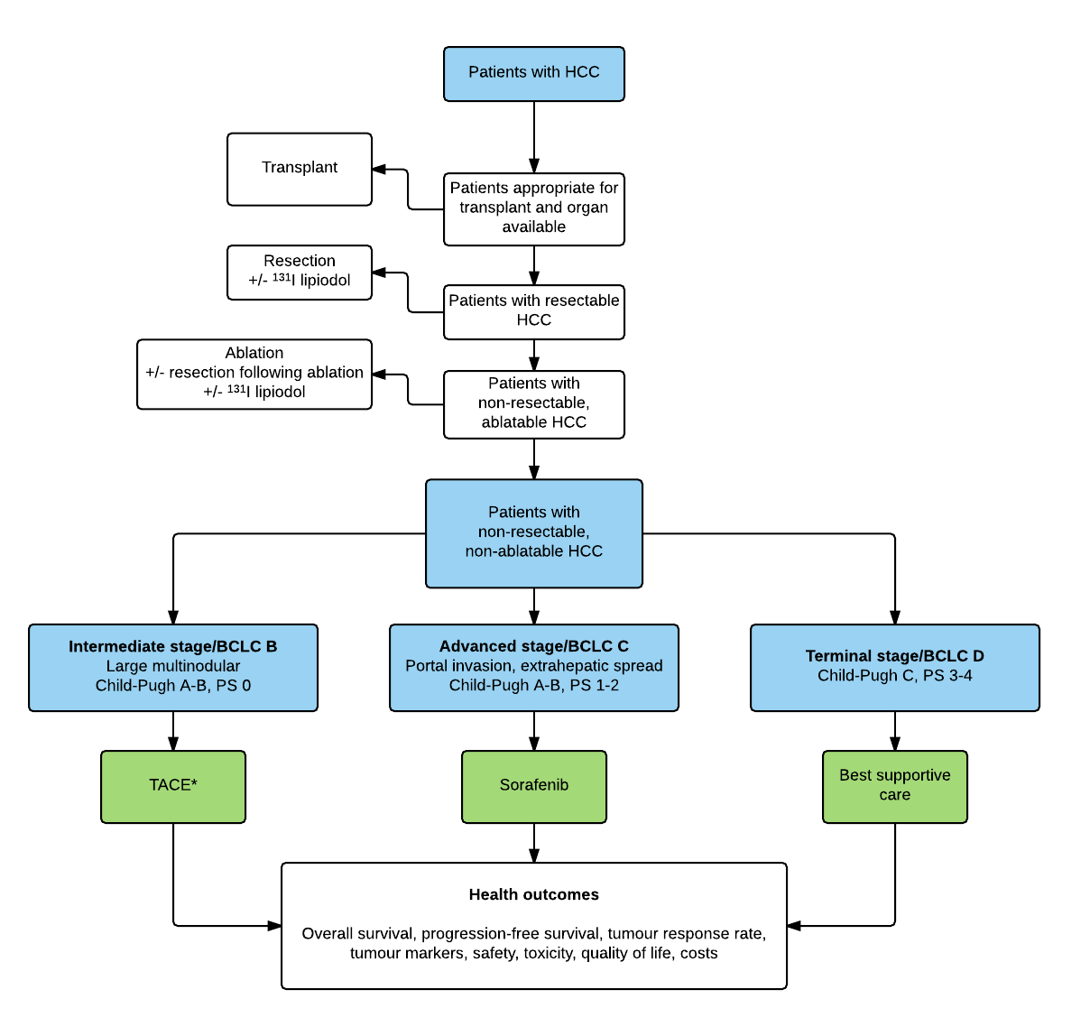
Abbreviations: BCLC, Barcelona Clinic Liver Cancer; HCC, hepatocellular carcinoma; PS, performance status; TACE, transarterial chemoembolisation.
* If the proposed first-line treatment is contraindicated owing to a patient's clinical status, the treatment approach recommended for the subsequent disease stage should be considered. For example, a patient with early stage HCC (BCLC stage A) might benefit from TACE.
Lucidchart - Diagrams Done Right

