Application 1493:
Transarterial radioembolisation with yttrium-90 (TARE-Y) for the treatment of unresectable hepatocellular carcinoma
PICO Confirmation
(To guide a new application to MSAC)
(Version 1.0)

This PICO Confirmation Template is to be completed to guide a new request for public funding for new or amended medical service(s) (including, but not limited to the Medicare Benefits Schedule (MBS)). It is relevant to proposals for both therapeutic and investigative medical services.
Please complete all questions that are applicable to the proposed service, providing relevant information only.
Should you require any further assistance, departmental staff are available through the Health Technology Assessment (HTA Team) on the contact number and email below to discuss the application form, or any other component of the Medical Services Advisory Committee process.
Phone: +61 2 6289 7550
Email: hta@health.gov.au
Website: http://www.msac.gov.au

Version Control
Document History
Version Number | Date Changed | Author | Reason for Change
0.1 | 10 March 2016 | MSAC Reforms | Final template for publication
0.2 | 19 May 2016 | MSAC WEB | Accessibility compliance

Document Approval
Version Number | Date Changed | Author | Reason for Change
1.0 | 19 May 2016 | MSAC Web | Template released for online publication

Summary of PICO criteria
Table 1 describes the PICO criteria to define the question(s) to be addressed in an Assessment Report to the Medical Services Advisory Committee (MSAC).
Table 1 Summary of PICO/PPICO criteria
Component | Description
Patients | Patients with unresectable hepatocellular carcinoma (HCC), including  - Population one: Patients with advanced HCC (BCLC stage C) as an alternative to sorafenib or for patients contraindicated for sorafenib (first-line indication)  - Population two: Patients with intermediate HCC (BCLC stage B) who have failed treatment with transarterial chemoembolisation (TACE) or are contraindicated for TACE (second-line indication)  - Population three: Patients with advanced HCC (BCLC stage C) who have failed first-line treatment with sorafenib (second-line indication)
Intervention | Transarterial radioembolisation with yttrium-90 containing microspheres of 20-60 μm, which are infused through femoral artery catheter
Comparator | - Population one: sorafenib or best supportive care  - Population two: TACE or best supportive care  - Population three: best supportive care
Outcomes | Efficacy/effectiveness  - Overall survival  - Progression-free survival  - Time to progression  - Recurrence-free survival  - Time to recurrence  - Tumour response rate  - Quality of life  - Downstaging to curative treatment (resection/ablation/transplant)  - Rate of liver transplantation (due to change from palliative to curative treatment)  Safety  - Frequency of adverse reactions (e.g. liver toxicity, lung toxicity)  - Patient-reported adverse events  Cost-effectiveness  - Cost per life year gained  - Cost per QALY gained  Healthcare resources  - Pre-surgery costs (pathology, radiology, angiography, lung shunting study)  - Surgery costs (catheterisation, dosimetry, injection of microspheres)  - Post-surgery costs (follow-up investigations, including radiology)  Total Australian Government Healthcare costs  - Total cost to the Medical Benefits Schedule (MBS)  - Total cost to the Pharmaceutical Benefits Scheme (PBS)  - Total cost to other healthcare services

PICO or PPICO rationale for therapeutic and investigative medical services only

Population
The patient population for whom public funding of the proposed medical service is intended includes:
- patients with advanced hepatocellular carcinoma (BCLC stage C), particularly those with portal vein invasion/thrombosis (PVI/PVT) (first-line indication);
- patients with intermediate hepatocellular carcinoma (BCLC stage B), who have failed or are contraindicated to transarterial chemoembolisation (TACE) (second-line indication);
- patients with advanced hepatocellular carcinoma (BCLC stage C), who have failed sorafenib (second-line indication).
Hepatocellular carcinoma is a type of primary liver cancer arising from hepatocytes, the main cell type found in the liver. HCC is one of the most common types of cancers seen worldwide, being the fifth most common in men and the ninth most common in women, and is the third largest contributor to cancer mortality overall. Liver cancer has a very poor prognosis – the mortality to incidence ratio of liver cancer is 0.95 (Ferlay, Soerjomataram et al. 2015).
The most commonly used staging system for HCC is the Barcelona Clinic Liver Cancer (BCLC) algorithm, shown in Table 2. Classification into stages 0 (very early stage), A (early stage), B (intermediate stage), C (advanced stage) and D (terminal stage) is dependent on (i) the number, size and extent of spread of the tumour/s, (ii) the Child-Pugh score (which measures the extent of liver disease) and (iii) and the patient’s performance status. When the patient with HCC has decompensated liver disease and poor performance status, this is considered to be the terminal stage and treatment is palliative only. In BCLC 0 and A HCC, the patient has few tumours, reasonable liver function and good performance status; as such potentially curative treatment such as ablation, resection or transplant are indicated.
The population of interest in this application comprises patients with intermediate and advanced HCC (BCLC-B and C). These stages are characterised by multinodular tumours, portal invasion or extrahepatic spread, and may include moderately reduced liver function and performance status. First-line treatments for BCLC stage B and C are TACE and sorafenib, respectively. While treatments with survival benefit are available, these tumours are considered unresectable and the primary aim of treatment in these patients is palliative. Patients with unresectable disease (stage B and C disease) would be eligible for treatment with TARE-Y.
Table 2 also summarises the prognosis of untreated and treated patients with HCC for each of the BCLC stages, and shows that the earlier HCC is detected, the better the prognosis. Unfortunately, most HCCs are diagnosed at stage B or higher (Park, Chen et al. 2015).
Table 2 Prognosis of HCC by BCLC staging system
BCLC Stage | Description | Tumour burden and invasiveness | Child-Pugh score | Performance status | Natural history | Recommended therapy | Expected survival with recommended therapy
 | Potentially | curative
0 | Very early | Single < 2 cm | A | 0 | > 36 months | Ablation  Resection  Transplant | 70–90% 5-year survival with ablation, transplant, resection
A | Early | Single < 5 cm or 3 nodules < 3 cm each | A and B | 0 | 36 months | Ablation  Resection  Transplant  TACE in some | 50–70% 5-year survival with ablation, transplant, resection
 | Palliative
B | Intermediate | Large/  multinodular | A and B | 0 | 16 months | TACE | 20 months median survival
C | Advanced | Vascular invasion and/or extrahepatic spread | A and B | 1-2 | 4-8 months | Sorafenib | 6–11 months median survival
D | End stage | Any of the above | C | 3-4 | < 3  months | Best supportive care | -
Source: Adapted from Lau et al. (Lau, Teoh et al. 2016). The populations of interest to this application are shown in bold.
Abbreviations: BCLC, Barcelona Clinic Staging System; HCC, hepatocellular carcinoma; TACE, transarterial chemoembolisation.

There are a number of risk factors associated with the development of HCC. Most notably these include alcohol abuse, and hepatitis B (HBV) or C (HCV) infection. The causes of HCC vary across countries, with HBV being the main cause in regions where infection is endemic, and cirrhosis due to alcohol abuse, hepatitis C or obesity being the main cause in regions where HBV in not endemic. The results of the BRIDGE study, a large retrospective chart review of more than 18,000 HCC patients at 42 sites in 14 countries, show that there are a number of differences in the characteristics of patients and disease seen at diagnosis between Asian countries, and compared with Western regions (Park, Chen et al. 2015).
The prevalence of HBV in patients diagnosed with HCC is substantially higher in China, Taiwan and South Korea (63-77%) compared with North America, Europe and Japan (10-23%), while HCV is most prevalent in this population in North America, Europe, Taiwan and Japan (31-64%), and least prevalent in China and South Korea (3-10%). Alcoholic liver disease and non-alcoholic steatohepatitis is most prevalent in this population in North America (21% and 12%, respectively) and Europe (37% and 10%, respectively) compared with Asia (4-13% and 1-6%, respectively). A recent study by Choo and colleagues investigated in detail the differences in epidemiology, genetics, treatment approaches and clinical outcomes for Asian and non-Asian patients, and concludes that there are inherent differences between HCCs from Eastern and Western populations, and that this creates challenges in terms of devising a standard treatment approach (Choo, Tan et al. 2016). This is of particular relevance to Australia where there is substantial immigration from parts of Asia where HBV is endemic (China and India currently provide the highest number of permanent migrants to Australia), and liver cancer has the highest rate of increasing mortality of all cancers – from 2.3 per 100,000 persons in 1982 to 6.0 per 100,000 in 2014, and the second highest rate of increasing incidence of all cancers (behind thyroid cancer) – 1.8 per 100,000 persons in 1982 to 6.4 per 100,000 in 2014 (AIHW, 2014).

Rationale
Currently, the majority of patients with BCLC stage C disease receive best supportive care rather than sorafenib, so TARE-Y would provide an option for patients not considered suitable for sorafenib. In addition, there is some evidence that TARE-Y is more effective and safer as a first-line treatment than sorafenib in these patients (Vilgrain, Abdel-Rehim et al. 2014).
Although the BCLC algorithm recommends sorafenib as a second-line treatment in BCLC stage B disease if first-line TACE fails, sorafenib is not reimbursed or registered for this indication in Australia, and the majority of patients receive TACE again as second-line therapy. A large proportion of these patients also only get best supportive care. Having TARE-Y as a second-line treatment option following TACE failure, and for those contraindicated to TACE, may be of benefit to patients.
Similarly, it is proposed that second-line TARE-Y for BCLC stage C disease should be offered as an option for patients who receive sorafenib first-line and fail, and who want active treatment rather than best supportive care.
There appear to be some differences in how Asian and Western patients respond to treatment, which may be related to the underlying cause and subsequent features of their disease (eg, more HBV-related disease in Asia compared with HCV- and alcohol-related disease in Western countries). This will have to be explored in detail, and any potential impact on the clinical pathway will need to be discussed and incorporated.

Intervention
TARE-Y (also known as selective internal radiation therapy; SIRT) is a medical procedure for the treatment of unresectable HCC. TARE-Y utilises the differential blood supply of the healthy and tumorous liver (80% of the blood supply to the liver is via the portal vein and almost all the blood supply to liver tumours is via the hepatic artery), and involves the delivery of yttrium-90-containing microspheres of 20-60 μm diameter.
Two types of microspheres are available: resin (SIR-Spheres/Sirtex Medical Products) and glass (TheraSphere/BTG International Asia). The yttrium-90 (Y-90) emits high energy beta radiation with a mean tissue penetration of 2.5 mm (maximum 11 mm). Thus, the microspheres deliver a cytocidal dose of beta radiation to the cancer cells with minimal irradiation of normal healthy liver tissue. Because of the small size of the microspheres, tumour necrosis is largely caused by radiation, with only a minor contribution from embolisation due to the particles.

Pre-treatment
The following tests would be required for all patients undergoing TARE-Y:
- History, physical examination, assessment of performance status;
- Clinical laboratory tests (complete blood count with differential, blood urea nitrogen, serum creatinine, serum electrolytes, liver function, albumin, lactate dehydrogenase, prothrombin time);
- Chest X-ray, tumour marker assay (carcinoembryonic antigen [CEA], α-fetoprotein);
- Computed tomography (CT)/magnetic resonance imaging (MRI) scan of the abdomen and pelvis with assessment of portal vein patency, and;
- Arteriography/lung shunting study.

Treatment
If a patient meets the treatment requirements, and treatment occurs, a catheter is inserted into the femoral artery and then guided to the hepatic artery. The radioactive microspheres (glass or resin, see below) are then infused, a procedure that takes several minutes. Once infused, the microspheres lodge in the blood vessels near the tumour, where they give small amounts of radiation to the tumour site for several days (half-life of yttrium-90 is 64.2 hours). Tissue penetration of radiation ranges from 2.5 to 11 mm, so its effects are limited mainly to the tumour. The microspheres become permanently implanted in the capillary bed of the tumour. The entire procedure takes 1-1.5 hours. Following infusion, the patient remains in the recovery area or Nuclear Medicine Department for 2-6 hours. The patient may be required to remain in hospital overnight.
Medications the patient may receive on the day of treatment include:
• A sedative and pain medication (in preparation for the procedure)
• A low-dose steroid to help combat fatigue
• An anti-ulcer medication to help protect the stomach
• An antibiotic to reduce potential for infection.

Follow-up
Follow-up imaging to determine treatment response is conducted using CT or MRI. There is no standard protocol for timing of imaging; however, the first scan should be approximately 1-2 months’ post-treatment, with follow-up at 3-6 months thereafter. During follow-up visits patients are also assessed for treatment-related adverse events including abdominal pain, nausea, vomiting and fatigue, as well as specific rare side effects including hepatic abscess, perihepatic ascites, pleural effusion, radiation cholecystitis and radiation pneumonitis.

Rationale
There are currently interim MBS item numbers relating to the use of resin microspheres (SIR-Spheres) in patients with “hepatic metastases which are secondary to colorectal cancer and are not suitable for resection or ablation, used in combination with systemic chemotherapy using 5-fluorouracil (5FU) and leucovorin”. The item numbers are:
- 35404 – Dosimetry, handling and injection of SIR-Spheres
- 35406 – Transfemoral catheterisation of the hepatic artery to administer SIR-Spheres
- 35408 – Catheterisation of the hepatic artery via a permanently implanted hepatic artery port to administer SIR-Spheres.
This application is proposing two new MBS item numbers relating to the use of TARE-Y. The two proposed item numbers are similar to MBS 35404 and 35406; the differences being that (i) they are for treatment using resin or glass microspheres and (ii) the indication is for patients with unresectable HCC.
This application is for TARE-Y the procedure, and not limited to a specific microsphere type. TARE-Y can be delivered using either of the two currently commercially available Y-90 emitting microsphere products – TheraSphere (glass microspheres) or SIR-Spheres (resin microspheres) – both of which have registered trademarks. The main characteristic that distinguishes these microspheres from others is the fact they contain Y-90. There are some differences between the glass and resin Y-90 microspheres as summarised in Table 3, with the main difference being the lower density of Y-90 per sphere for resin compared with glass microspheres. This means that more resin spheres are required to administer a given dose, thus resulting in a higher embolic effect.
If the item descriptor specifies the use of Y-90 emitting microspheres, then any new Y-90-emitting microspheres, should they become available, would also be able to be used.

Table 3 Characteristics of commercially available Y-90 microspheres
Characteristic | TheraSphere  (BTG International) | SIR-Spheres  (Sirtex Medical)
Isotope | Yttrium-90 | Yttrium-90
Half-life; h | 64.2 | 64.2
Material | Glass with yttrium in matrix | Resin bound with yttrium
Diameter; mean μm (range) | 25 (20-30) | 35 (20-60)
Activity per particle; Bq | 2500 | 50
Spheres per 3 Bq | 1.2 million | 40-80 million
Spheres per dose | 4 million | 30-60 million
Specific gravity; g/mL | 3.2 | 1.6
Embolic effect | Negligible | Mild
Contrast injection | No | During infusion
FDA approved indication | HCC | CLM with intrahepatic floxuridine
Australian approved indication | Not yet registered | Inoperable liver cancer
Source: adapted from (Mahnken 2016)
Abbreviations: CLM, colorectal liver metastases; HCC, hepatocellular carcinoma.

Comparator
According to the BCLC management pathway, and the interim results of a clinician survey, the most commonly used treatments for unresectable HCC are TACE and sorafenib, with drug-eluting bead-TACE (DEB-TACE) also used (although substantially less than conventional TACE). If TARE-Y is limited to use in patients who cannot tolerate or have failed first-line treatment with TACE or sorafenib for unresectable HCC, then no therapy (or best supportive care), is the most appropriate comparator.

Rationale
While the main comparison will be no therapy/best supportive care, comparisons of TARE-Y against the first-line treatments TACE and sorafenib will also be included to provide assurance of its comparative efficacy and safety.

Outcomes

Patient relevant
It is claimed that TARE-Y improves patient health outcomes in patients with unresectable HCC, particularly as a first-line treatment in patients with advanced (BCLC stage C) HCC, as a second-line treatment in patients with BCLC stage C disease in whom sorafenib failed, and as a second-line treatment in patients with intermediate stage (BCLC stage B) HCC in whom first-line TACE failed.
TARE-Y is proposed to improve overall survival, progression-free survival, recurrence-free survival, tumour response rates, and quality of life. In addition, treatment with TARE-Y in stages BCLC B and C (where treatment is generally considered palliative only) may result in downstaging to potentially curative treatment.
Safety outcomes to be considered include the frequency of adverse reactions (e.g. liver toxicity, lung toxicity) and patient-reported adverse events.

Healthcare system
Introduction of TARE-Y will likely lead to increased health care costs. Based on an interim survey analysis by the applicant, the estimated number of patients who could potentially receive TARE-Y treatment (assuming an uptake of 70%) ranges from 76-86 per year over the projected time period (2018-2022), including both first-line and second-line indications. Patients receive on average 1.8 TARE-Y treatments per lifetime. It is not expected that there would be leakage to another population. TARE-Y is only appropriate for the treatment of liver cancers, the most common of which are HCC and colorectal liver metastases. TARE-Y using SIR-Spheres is already reimbursed on the MBS for colorectal liver metastases.
The likely per-patient cost to the MBS of providing the proposed medical procedure as a first-line treatment is approximately $5,151.65. There will likely be a proportion of patients who undergo pre-surgery work-up (attendances, pathology and radiology) who are unsuitable for delivery of the microspheres due to significant lung shunting; this proportion is estimated to be approximately 25%. Weighting the workup costs to account for these patients increases the average cost per patient for the first treatment to $5,777.58.
Subsequent treatments (on average an additional 0.8 per patient) are expected to increase the cost (assuming the work-up does not need to be repeated) to $7,764.36. The management of adverse events has not been included in the costings. Note that the costs reported here are the total costs of the procedure including prior testing, professional attendances and follow up, which go beyond the cost of the requested MBS items.

Rationale
TARE-Y represents a new approach to treating patients with unresectable HCC. While pharmacological agents are currently available for this patient group (chemotherapy delivered transarterially [TACE] and sorafenib), this localised radiotherapy technique offers an alternative mode of treatment for these patients, as well as providing a new treatment option for patients who fail or are contraindicated for treatment with TACE or sorafenib, but who are still eligible for further treatment.
The evidence provided in the application reports the following results:
Randomised controlled trials (both completed and ongoing) and observational study evidence is available for the comparison between TARE-Y, and TACE/DEB-TACE and sorafenib.
A number of published meta-analyses were also identified by the literature search; however, these are considered to be of poor methodological quality due to inappropriate pooling of studies, and would not be used as the basis of a clinical argument. There is, however, one ongoing prospective, individual patient meta-analysis currently underway; this would be very informative for a comparison between TARE-Y and sorafenib.

TARE-Y versus TACE/DEB-TACE
Several randomised controlled trials and observational studies suggest that TARE-Y may be more effective than TACE. A phase 2 RCT of patients with HCC of BCLC stages A or B found TARE-Y to provide significantly longer time to progression than TACE. TARE-Y appeared to provide better tumour control and could reduce drop-out from transplant waitlists (Salem, Gordon et al. 2016).
Single-session TARE-Y appeared to be as safe and had a similar impact on health-related quality of life as multiple sessions of TACE, suggesting that TARE-Y might be an alternative option for patients eligible for TACE (Kolligs, Bilbao et al 2015).
No significant differences between TARE-Y and DEB-TACE were found in median progression-free survival, overall survival and time to progression. The lower rate of tumour progression in the TARE-Y group was nullified by a greater incidence of liver failure (Pitton, Kloeckner et al. 2015).

TARE-Y versus sorafenib
Two ongoing RCTs investigate the overall survival, progression-free survival, tumour response and quality of life (Vilgrain, Abdel-Rehim et al. 2014) and adverse events (Vilgrain, Abdel-Rehim et al. 2014, Ricke, Bulla et al. 2015). Preliminary evidence suggests that TARE-Y followed by sorafenib appears to be as well tolerated as sorafenib alone (Ricke, Bulla et al. 2015).
According to an observational propensity score analysis, HCC patients with portal vein thrombosis who underwent TARE-Y achieved comparable survival to patients who received sorafenib. The TARE-Y group also experienced fewer severe adverse effects (Cho, Lee et al. 2016).

Current clinical management algorithm for identified population
Figure 1 Clinical management algorithm for patients with unresectable HCC
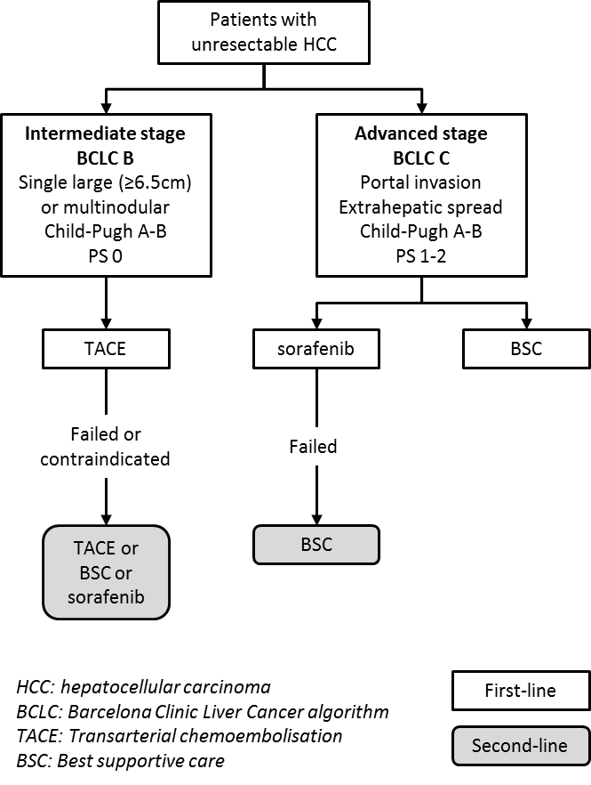

Proposed clinical management algorithm for identified population
Figure 2 Proposed clinical management algorithm for patients with unresectable HCC
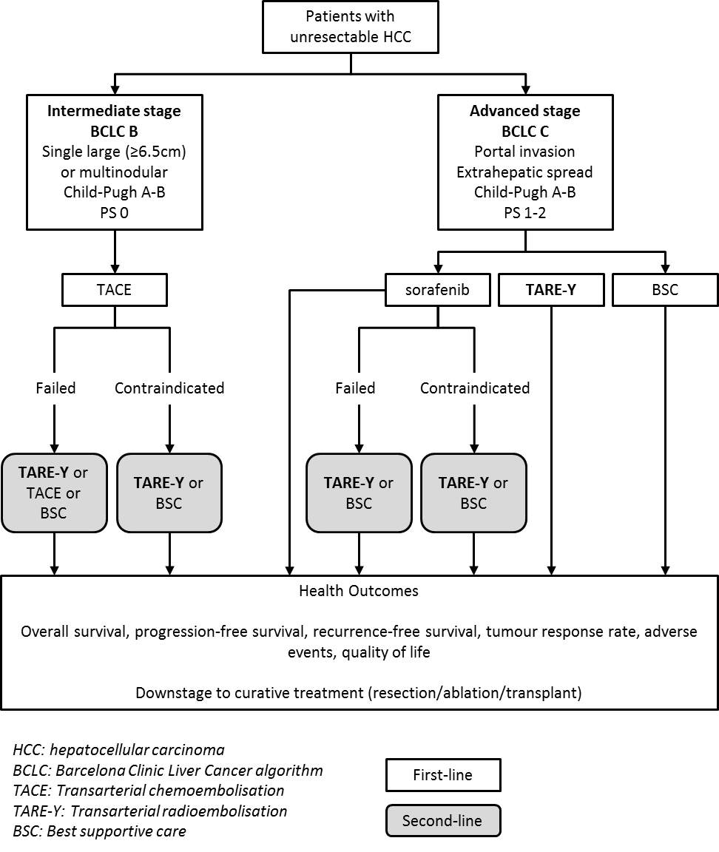

Proposed economic evaluation
The clinical claim is that TARE-Y is non-inferior in safety, and superior in clinical effectiveness, compared to best supportive care. It is suggested there may be efficacy and/or safety benefits of TARE-Y over sorafenib and TACE. According to the Technical Guidelines for preparing assessment reports for the Medical Services Advisory Committee: Investigative, the required economic analysis is therefore a cost-utility or cost-effectiveness analysis.

Proposed item descriptor
The proposed MBS item descriptors are based on the existing descriptors for Selective Internal Radiation Therapy (SIRT) using SIR-Spheres in patients with hepatic metastases that are secondary to colorectal cancer and are not suitable for resection or ablation, used in combination with systemic chemotherapy using 5-fluorouracil (5FU) and leucovorin (Table 4). Note that an item based on MBS 35408 (catheterisation of the hepatic artery via a permanently implanted hepatic artery port to administer SIR-Spheres) has not been requested as this procedure is no longer used.
These proposed descriptors may be refined depending on the outcome of discussions with the Department, feedback from PASC, and availability of clinical evidence.
Table 4 Proposed MBS Item descriptor
Category 3 – THERAPEUTIC PROCEDURES
Group T8 – SURGICAL OPERATIONS
Subgroup 3 – VASCULAR
Subheading 13 – INTERVENTIONAL RADIOLOGY PROCEDURES

DOSIMETRY, HANDLING AND INJECTION OF yttrium-90-emitting microspheres for selective internal radiation therapy of hepatocellular carcinoma that is not suitable for resection or ablation [specific population groups to be added as appropriate], not being a service to which item 35317, 35319, 35320 or 35321 applies

The procedure must be performed by a specialist or consultant physician recognised in the specialties of nuclear medicine or radiation oncology on an admitted patient in a hospital.

Fee: $346.60 Benefit: 75% = $259.95

Category 3 – THERAPEUTIC PROCEDURES
Group T8 – SURGICAL OPERATIONS
Subgroup 3 – VASCULAR
Subheading 13 – INTERVENTIONAL RADIOLOGY PROCEDURES

Trans-femoral catheterisation of the hepatic artery to administer yttrium-90-emitting microspheres to embolise the microvasculature of hepatocellular carcinoma that is not suitable for resection or ablation [specific population groups to be added as appropriate], for selective internal radiation therapy, not being a service to which item 35317, 35319, 35320 or 35321 applies

Excluding associated radiological services or preparation, and excluding aftercare

Fee: $813.30 Benefit: 75% = $610.00

References
Cho, Y. Y., M. Lee, H. C. Kim, J. W. Chung, Y. H. Kim, G. Y. Gwak, S. H. Bae, Y. Kim do, J. Heo and Y. J. Kim (2016). "Radioembolization Is a Safe and Effective Treatment for Hepatocellular Carcinoma with Portal Vein Thrombosis: A Propensity Score Analysis." PLoS One 11(5): e0154986.
Choo, S. P., W. L. Tan, B. K. Goh, W. M. Tai and A. X. Zhu (2016). "Comparison of hepatocellular carcinoma in Eastern versus Western populations." Cancer.
Ferlay, J., I. Soerjomataram, R. Dikshit, S. Eser, C. Mathers, M. Rebelo, D. M. Parkin, D. Forman and F. Bray (2015). "Cancer incidence and mortality worldwide: sources, methods and major patterns in GLOBOCAN 2012." Int J Cancer 136(5): E359-386.
Kolligs, F. T., J. I. Bilbao, T. Jakobs, M. Inarrairaegui, J. M. Nagel, M. Rodriguez, A. Haug, D. D'Avola, M. op den Winkel, A. Martinez-Cuesta, C. Trumm, A. Benito, K. Tatsch, C. J. Zech, R. T. Hoffmann and B. Sangro (2015). "Pilot randomized trial of selective internal radiation therapy vs. chemoembolization in unresectable hepatocellular carcinoma." Liver Int 35(6): 1715-1721.
Mahnken, A. H. (2016). "Current status of transarterial radioembolization." World J Radiol 8(5): 449-459.
Park, J. W., M. Chen, M. Colombo, L. R. Roberts, M. Schwartz, P. J. Chen, M. Kudo, P. Johnson, S. Wagner, L. S. Orsini and M. Sherman (2015). "Global patterns of hepatocellular carcinoma management from diagnosis to death: the BRIDGE Study." Liver Int 35(9): 2155-2166.
Pitton, M. B., R. Kloeckner, C. Ruckes, G. M. Wirth, W. Eichhorn, M. A. Worns, A. Weinmann, M. Schreckenberger, P. R. Galle, G. Otto and C. Dueber (2015). "Randomized comparison of selective internal radiotherapy (SIRT) versus drug-eluting bead transarterial chemoembolization (DEB-TACE) for the treatment of hepatocellular carcinoma." Cardiovasc Intervent Radiol 38(2): 352-360.
Ricke, J., K. Bulla, F. Kolligs, M. Peck-Radosavljevic, P. Reimer, B. Sangro, E. Schott, K. Schutte, C. Verslype, J. Walecki, P. Malfertheiner and S. s. group (2015). "Safety and toxicity of radioembolization plus Sorafenib in advanced hepatocellular carcinoma: analysis of the European multicentre trial SORAMIC." Liver Int 35(2): 620-626.
Salem, R., A. C. Gordon, S. Mouli, R. Hickey, J. Kallini, A. Gabr, M. F. Mulcahy, T. Baker, M. Abecassis, F. H. Miller, V. Yaghmai, K. Sato, K. Desai, B. Thornburg, A. B. Benson, A. Rademaker, D. Ganger, L. Kulik and R. J. Lewandowski (2016). "Y90 Radioembolization Significantly Prolongs Time to Progression Compared With Chemoembolization in Patients With Hepatocellular Carcinoma." Gastroenterology 151(6): 1155-1163 e1152.
Vilgrain, V., M. Abdel-Rehim, A. Sibert, M. Ronot, R. Lebtahi, L. Castera, G. Chatellier and S. T. Group (2014). "Radioembolisation with yttrium90 microspheres versus sorafenib for treatment of advanced hepatocellular carcinoma (SARAH): study protocol for a randomised controlled trial." Trials 15: 474.

