MSAC Application 1728
Etranacogene dezaparvovec for the treatment of Haemophilia B
This application form is to be completed for new and amended requests for public funding (including but not limited to the Medicare Benefits Schedule (MBS)). It describes the detailed information that the Australian Government Department of Health requires to determine whether a proposed medical service is suitable.
Please use this template, along with the associated Application Form Instructions to prepare your application. Please complete all questions that are applicable to the proposed service, providing relevant information only. Applications not completed in full will not be accepted. The separate MSAC Guidelines should be used to guide health technology assessment (HTA) content of the Application Form
Should you require any further assistance, departmental staff are available through the Health Technology Assessment Team (HTA Team) on the email below to discuss the application form, or any other component of the Medical Services Advisory Committee process.

Email: hta@health.gov.au
Website: www.msac.gov.au

PART 1 – APPLICANT DETAILS

Applicant details (primary and alternative contacts)
Corporation / partnership details (where relevant):
Corporation name: CSL Behring (Australia) Pty Ltd
ABN: 48 160 734 761
Business trading name: CSL Behring (Australia) Pty Ltd
Primary contact name: REDACTED
Primary contact numbers
Business: REDACTED
Mobile: REDACTED
Email: REDACTED

Alternative contact name: REDACTED
Alternative contact numbers
Business: REDACTED
Mobile: REDACTED
Email: REDACTED

(a) Are you a consultant acting on behalf on an applicant?
Yes
No

(b) If yes what is the Applicant(s) name that you are acting on behalf of?
Not relevant

(a) Are you a lobbyist acting on behalf of an Applicant?
Yes
No

Have you engaged a consultant on your behalf?
No

PART 2 – INFORMATION ABOUT THE PROPOSED MEDICAL SERVICE

Application title
Etranacogene dezaparvovec for the treatment of haemophilia B

Provide a succinct description of the medical condition relevant to the proposed service (no more than 150 words – further information will be requested at Part F of the Application Form)
Haemophilia is a rare congenital bleeding disorder caused by deficiencies in coagulation factors as a result of mutations in clotting factor genes. There are two main types of haemophilia, with type A (HMA) accounting for 80-85% and type B (HMB) around 15% of the total prevalent population. HMB is characterised by congenital underproduction or dysfunction of coagulation factor IX (FIX), an essential protein involved in promoting clot formation. The FIX gene is found on the X chromosome and because the genetic defect is expressed in an X-linked recessive manner the vast majority of people living with the disease are male. A family history is present in about two-thirds of patients and the remaining cases are caused by spontaneous mutations. HMB is a lifelong condition typically causing bleeding tendency. Serious bleeds can result in disabling sequelae and may even be fatal in some circumstances.

Provide a succinct description of the proposed medical service (no more than 150 words – further information will be requested at Part 6 of the Application Form)
Etranacogene dezaparvovec (also known as AMT-061 and CSL222) is a gene therapy designed to introduce a copy of the human FIX gene to address the lack of functional FIX protein expression in a haemophila B patient. Etranacogene dezaparvovec (EtranaDez) is an infusion of recombinant adeno-associated virus 5 (AAV5) vector including a gene cassette containing the FIX Padua variant under the control of a liver-specific promoter. After infusion, EtranaDez preferentially targets liver cells, where vector DNA is released into the nucleus instructing the cell to produce FIX. Following transduction, functional FIX is produced at near normal to normal levels and circulates in the body, reducing the risk of bleeding.
REDACTED

(a) Is this a request for MBS funding?
Yes
No

Is the proposed service seeking public funding other than the MBS?
Yes
No

If yes, please advise:
Public funding is sought under the national blood agreement, managed by the National Blood Authority (NBA). Funding is implemented by the blood or blood-related product being listed on the National Products Price List. REDACTED
It is usual practice for the Jurisdictional Blood Committee (JBC) to review new blood and blood-related products. Part of this review can include referral to MSAC for an evidence-based, health technology assessment of clinical effectiveness, cost-effectiveness, and safety.
REDACTED

What is the type of medical service/technology?
Therapeutic medical service
Investigative medical service
Single consultation medical service
Global consultation medical service
Allied health service
Co-dependent technology
Hybrid health technology
- For investigative services, advise the specific purpose of performing the service
N/A

Does your service rely on another medical product to achieve or to enhance its intended effect?
Pharmaceutical / Biological
Prosthesis or device
No

(a) If the proposed service has a pharmaceutical component to it, is it already covered under an existing Pharmaceutical Benefits Scheme (PBS) listing?
Yes
No
- If yes, please list the relevant PBS item code(s):
N/A

If no, is an application (submission) in the process of being considered by the Pharmaceutical Benefits Advisory Committee (PBAC)?
Yes
No – However if such a submission is deemed more appropriate by the Department, please advise the sponsor at the earliest opportunity.
- If you are seeking both MBS and PBS listing, what is the trade name and generic name of the pharmaceutical?
N/A

- (a) If the proposed service is dependent on the use of a prosthesis, is it already included on the Prostheses List?
Yes
No
- If yes, please provide the following information (where relevant):
N/A
- If no, is an application in the process of being considered by a Clinical Advisory Group or the Prostheses List Advisory Committee (PLAC)?
Yes
No

Are there any other sponsor(s) and / or manufacturer(s) that have a similar pharmaceutical product in the Australian marketplace which this application is relevant to?
Yes
No

Please identify any single and / or multi-use consumables delivered as part of the service?
The only consumables routinely required are those associated with administration via a 1–2-hour IV infusion.

PART 3 – INFORMATION ABOUT REGULATORY REQUIREMENTS

(a) If the proposed medical service involves use of a medical device, in-vitro diagnostic test, pharmaceutical product, radioactive tracer, or any other type of therapeutic good, please provide details
Type of therapeutic good: Gene therapy
Manufacturer’s name: CSL Behring (Australia) Pty Ltd
Sponsor’s name: CSL Behring (Australia) Pty Ltd

Has it been listed on the Australian Register of Therapeutic Goods (ARTG) by the Therapeutic Goods Administration (TGA)? If the therapeutic good has been listed on the ARTG, please state the ARTG identification numbers, TGA-approved indication(s), and TGA-approved purpose(s).
ARTG ID: Not listed

If a medical device is involved, has the medical device been classified by TGA as a Class III OR Active Implantable Medical Device (AIMD) under the TGA regulatory scheme for devices?
Class III
AIMD
N/A

Is the therapeutic good classified by TGA for Research Use Only (RUO)?
No

(a) If not listed on the ARTG, is the therapeutic good to be used in the service exempt from the regulatory requirements of the Therapeutic Goods Act 1989?
Yes (If yes, please provide supporting documentation as an attachment to this application form)
No

If the therapeutic good is not ARTG listed, is the therapeutic good in the process of being considered by TGA?
Yes
No
- If the therapeutic good is NOT in the process of being considered by TGA, is an application to TGA being prepared?
REDACTED

PART 4 – SUMMARY OF EVIDENCE

Provide one or more recent (published) high quality clinical studies that support use of the proposed health service/technology. At ‘Application Form lodgement’, please do not attach full text articles; just provide a summary.
 | Type of study design | Title of journal article or research project | Short description of research | Website link to journal article or research | Date of publication
1. | Phase I/II, open-label, parallel group, dose escalation study of precursor formulation AMT-060 (n=10) | Gene therapy with adeno-associated virus vector 5-human factor IX in adults with hemophilia B. NCT02396342 | This was an initial safety, efficacy and dose ranging study assessing the therapeutic potential of an early formulation of the proposed intervention (AMT-061) in a small cohort of patients with moderate to severe haemophilia B. Long term follow up is ongoing and further publications are planned. | pubmed.ncbi.nlm.nih.gov/29246900/  pubmed.ncbi.nlm.nih.gov/31276009/ | 2018  2019
2. | Phase IIb, open-label, single-dose, confirmatory study with commercial formulation AMT-061 (n=3) | Etranacogene dezaparvovec (AMT-061 phase 2b): normal or near normal FIX activity and bleed cessation in hemophilia B.  NCT03489291 | This small pragmatic was proposed by the sponsor and supported by the US FDA and EMEA to address a change of transgene construct (from AMT-060 to AMT-061) and inform the dose selection for the Phase III study (see below). The primary aim was to confirm that a single dose of 2 × 1013 gc/kg of etranacogene dezaparvovec would result in FIX activity levels ≥5% by 6 weeks of follow up. | pubmed.ncbi.nlm.nih.gov/31698454/ | 2019

Identify yet-to-be-published research that may have results available in the near future (that could be relevant to your application). Do not attach full text articles; this is just a summary.
 | Type of study design | Title of research (including any trial identifier if relevant) | Short description of research | Website link to research | Date
1. | Phase III open-label, single dose, before and after study investigating the safety and efficacy of etranacogene dezaparvovec in patients with haemophilia B (n=56) | Phase III, open-label, single-dose, multicentre, multinational trial investigating a serotype 5 adeno-associated viral vector containing the Padua variant of a codon-optimized Human Factor IX gene (AAV5-hFIXco-Padua, AMT-061) administered to adult subjects with severe or moderately severe hemophilia B.  NCT03569891 | Pivotal study to demonstrate the efficacy and safety of etranacogene dezaparvovec in the target patient population, as measured by annualised bleed rates, FIX activity levels, use of FIX replacement therapy and treatment emergent adverse events. The primary analysis was conducted after 52 weeks, with longer term follow up planned and ongoing. | clinicaltrials.gov/ct2/show/NCT03569891 | 2022
2. | Phase I/IIb, open-label, parallel group, extension study (n=10) | A Phase I/IIb extension study assessing the long-term safety and efficacy of an adeno-associated viral vector containing a codon-optimized human factor IX gene (AAV5-hFIX) previously administered to adult patients with severe or moderately severe haemophilia B during the CT-AMT-060-01 Phase I/II study. EudraCT Number: 2020-000739-28. | Extension study to assess the long-term safety and efficacy (6-10 years after dosing) of AMT-060 on patients with moderately severe and severe haemophilia B as measured by long-term safety, including frequency and incidence of AEs, levels of FIX inhibitors, ALT/AST levels, liver pathology and AFP.  Secondary endpoints are FIX activity level, FIX consumption, bleeding events requiring FIX, procedures, quality of life and Haemophilia Joint Health Score. | n/a | 2023+

PART 5 – CLINICAL ENDORSEMENT AND CONSUMER INFORMATION

List all appropriate professional bodies/organisations representing the health professionals who provide the service.
Royal Australasian College of Physicians (RACP);
Royal College of Pathologists of Australia (RCPA); and
Australian Haemophilia Centre Directors’ Organisation (AHCDO)

List any professional bodies / organisations that may be impacted by this medical service (i.e., those who provide the comparator service):
State and Territory Haemophilia Treatment Centres (HTCs);
Australian Red Cross Lifeblood;
Australasian Society of Thrombosis and Haemostasis (ASTH);
Australian Centre for Blood Diseases (ACBD);
Australian Haemophilia Nurses’ Group (AHNG);
Australia/New Zealand Haemophilia Social Workers’ and Counsellors’ Group (ANZHSWCG); and
Australian and New Zealand Physiotherapy Haemophilia Group (ANZPHG).

List the consumer organisations relevant to the proposed medical service (noting there is NO NEED to attach a support letter at the ‘Application Lodgement’ stage of the MSAC process):
Haemophilia Foundation Australia (HFA)

List the relevant sponsor(s) and / or manufacturer(s) who produce similar products relevant to the proposed medical service:
Not relevant
- Nominate two experts that can be contacted about the proposed medical service, and current clinical management of the condition:
Name of expert 1: REDACTED
Telephone number(s): REDACTED
Email address: REDACTED
Justification of expertise: REDACTED

Name of expert 2: REDACTED
Telephone number(s): REDACTED
Email address: REDACTED
Justification of expertise: REDACTED

Name of expert 3: REDACTED
Telephone number(s): REDACTED
Email address: REDACTED
Justification of expertise: REDACTED

Please note that the Department may also consult with other referrers, proceduralists and disease specialists to obtain their insight.

PART 6 – POPULATION (AND PRIOR TESTS), INTERVENTION, COMPARATOR, OUTCOME (PICO)

PART 6a – INFORMATION ABOUT THE PROPOSED POPULATION

Define the medical condition, including providing information on the natural history of the condition and a high-level summary of associated burden of disease (in terms of both morbidity and mortality):
Haemophilia is a rare congenital bleeding disorder caused by deficiencies in coagulation factors as a result of mutations in clotting factor genes. There are two main types of haemophilia, with type A (HMA) accounting for 80-85% and type B (HMB) around 15% of the total prevalent population. A much rarer form known as type C (HMC) is estimated to occur in less than 5% of cases. Haemophilia B is characterised by a partial or complete deficiency in the activity of the essential coagulation factor IX (FIX), and occurs primarily in males, with females typically carriers with a mild or absent phenotype.
Haemophilia B remains a serious and life-threatening condition in which breakthrough bleeds and repeated bleeding in the joints in prophylactic treatment settings lead to major sequelae, including permanent joint disease and reduced quality of life. Severe and moderate phenotypes are associated with a lifetime risk of spontaneous and trauma-related bleeding, hypertension, cardiovascular disease (CVD), low bone density, joint morbidity, and obesity (Jiménez‐Yuste et al. 2019). If left untreated, haemophilia B leads to significant morbidity and reduced life expectancy.
Most bleeding occurs internally, with intra-articular, intramuscular and mucocutaneous bleeds considered severe. Repeated bleeding, in particular joint bleeds (haemarthrosis), is a major cause of significant morbidity and decreased quality of life in people living with haemophilia B. Although infrequent, intracranial and gastrointestinal bleeding, and bleeding into the neck and throat, can be life-threatening. The typical phenotype of HMB is the tendency to bleed, which is correlated with the level of FIX. Therefore, the severity of (and bleeding risk associated with) HMB is classified according to patients’ endogenous FIX activity in their plasma. Those patients with FIX activity levels less than 1% are classified as having severe disease; between 1% and 5%, moderate disease; and between 5% and 40%, mild disease. However, individuals may exhibit severe bleeding irrespective of their FIX level or with current use of factor IX continuous prophylaxis.
Based on the Australian Bleeding Disorders Registry (ABDR) in 2019-2020 the national prevalence of HMB was estimated at around 590 persons, approximately 80% of whom were male, 75% adults ≥ 18 years, and 45% with moderate to severe disease (NBA Australia 2021). Current unmet needs in haemophilia B include treatments that provide long-term bleeding control without the risk of inhibitor development, eliminate the burden of frequent injections, and improve quality of life (QoL). Patients with severe or moderately severe haemophilia B experience chronic pain with most reporting an impact of haemophilia on their daily lives. Physical limitations caused by haemophilia B can make it difficult for patients to participate in social activities, leading to substantial effects on mental well-being, particularly among younger people living with the condition.
The mainstay of treatment for HMB consists of IV FIX replacement therapy, using either plasma-derived or recombinant factor concentrates, administered either on demand (when bleeds occur) or prophylactically (as regular ongoing infusions). Optimal management is highly nuanced and patient specific, specialised and multidisciplinary in nature. Various detailed clinical guidelines are available both locally and internationally, which summarise a constantly evolving treatment landscape and evidence base. In Australia most people living with haemophilia B receive care through a dedicated Haemophilia Treatment Centre (HTC).
Guidelines recommended that patients with severe HMB, or moderate HMB with a severe phenotype should receive routine prophylaxis with recombinant FIX concentrate, preferably using an extended half-life (EHL) formulation. Over the last 30 years, plasma derived FIX replacement products (e.g., MonoFIX) have been largely replaced by recombinant products (e.g., BeneFIX) with use of extended half-life (EHL) formulations (e.g., ALPROLIX) becoming increasingly common in the last 5 years, especially for regular prophylaxis.
Although the introduction of EHL products has decreased the number of injections, FIX replacement injections are still frequent and lifelong. Frequent injections can lead to poor venous access, blood clots, inflammation, and secondary infections. Treatment complexity and pain associated with FIX injections can lead to poor adherence, leading to poor clinical outcomes (Srivastava et al. 2020) and it is estimated more than a quarter of people living with haemophilia B in Australia are currently not optimally adherent to treatment (Brennan, Parikh, McRae, & Tran 2020). Although EHL products extend the time until patients reach the minimum trough levels required to avoid spontaneous bleeds, there is significant interpatient variability related to age, body mass, blood group, von Willebrand factor (VWF) level, bleeding phenotype, physical activity level, joint status, and adherence.
Poor adherence to prophylaxis may be especially dangerous as missing an infusion can cause clotting factor levels to fall below the individual protective trough level, causing an increase of bleeding risk. Patients are at high risk of breakthrough, spontaneous bleeding in-between infusion periods. Long term, the negative effects of haemophilia on patients’ lives as well as treatment burden can interfere with their education, employment, and productivity at work. Haemophilia B is also associated with a substantial use of non-FIX treatment healthcare resources including physician visits, outpatient visits, emergency room visits, and hospitalisations for spontaneous bleeds, and for traumatic bleeds from surgery.
Current treatments cannot deliver sufficiently high and sustained factor IX activity levels to provide protection from bleeds and resolve these issues. The peak and trough nature of these treatments, and the need for regular intravenous infusion are major limitations of current therapy. New treatments are needed to improve patient and clinical outcomes and to slow down or completely stop the progression of the disease; ultimately improving humanistic and economic burdens resulting from haemophilia B.

Specify the characteristics of patients with the medical condition, who would be eligible for the proposed medicine (including details on how a patient would be investigated, managed and referred within the Australian health care system, in the lead up to being eligible for the medicine):
Based on the characteristics of the proposed medicine, draft regulatory indication, and respective eligibility criteria and results of the key clinical trials, the optimal clinical place for etranacogene dezaparvovec in Australian practice will likely be as a single (once in a lifetime) treatment, of curative intent, for some adult patients (≥18 years), with at least moderately severe to severe (≤2% FIX) HMB and anti-AAV5 neutralising antibody (NAb) titres <1:700, who have been receiving a stable dose of regular FIX prophylaxis and whom do not have inhibitors.
Classification of moderately severe and severe haemophilia B patients
Clinical severity | FIX clotting activity | Symptoms | Usual age of diagnosis
Severe | <1%  (<0.01 IU/mL) | Frequent spontaneous bleeding  Excessive and/or prolonged bleeding after minor injuries, surgery, or tooth extractions  Used in the HOPE-B trial* | Age ≤2 years
Moderately severe | 1-≤2%  (<0.02 IU/mL)
Moderate | 1-5%  (0.01-0.05 IU/mL) | Rare spontaneous bleeding  Excessive/or prolonged bleeding after minor injuries, surgery, or tooth extractions | Age <5-6 years
Mild | 5­<40% (0.05-0.4IU/mL) | No spontaneous bleeding  Excessive and/or prolonged bleeding after major injuries, surgery, or tooth extractions | Often later in life, depending on hemostasis challenges
FIX: Factor IX; IU: International units; mL: Milliliters
*Not part of historical haemophilia categorisation but was used as an inclusion criterion in the HOPE-B trial.
Sources: (Konkle, Huston, & Fletcher 1993) (C. et al. 2001)
These patients would all currently be receiving care through one of 18 specialist Australian Haemophilia Treatment Centres (HTCs) although the investigative, management and referral pathways leading to these treatment destinations are likely heterogeneous. It is anticipated the assessment of suitability for etranacogene dezaparvovec, administration of the therapy and subsequent follow up, would be exclusively conducted within an established HTC setting.

PART 6b – INFORMATION ABOUT THE INTERVENTION

Describe the key components and clinical steps involved in delivering the proposed medical technology:
People living with HMB are managed by Australia’s network of specialist HTCs. These centres deliver a comprehensive care model to ensure the complex care needs of haemophilia patients spanning prevention and treatment are provided in a co-ordinated way by a multi-disciplinary team with specialised expertise.
The first step in delivering the medicine is to establish patients’ eligibility and suitability for treatment. This will involve a combination of clinical and laboratory assessments. Of these, only the assessment of anti-AAV5 neutralising antibodies would be an addition to current clinical care for this patient population. Patients may be referred to an HTC of expertise if their local HTC does not have etranacogene dezaparvovec dosing capabilities. Patients will receive counselling and education ahead of making a shared decision under a multidisciplinary care model. REDACTED
For eligible and suitable patients, etranacogene dezaparvovec would be administered by IV infusion at a dose of 2 x 10¹³ gc/kg over approximately 1 - 2 hours, in an outpatient setting under the care of a specialised HTC. Patients would be closely monitored for tolerance and detection of immediate adverse events for approximately 3 hours after administration. Longer term follow-up for assessment of safety and treatment response would be determined by the treating specialist haematologist, consistent with regulatory advice. Under no circumstances, would patients receive a second course of treatment.

Does the proposed medical service include a registered trademark component with characteristics that distinguishes it from other similar health components?
Yes, the proposed intervention is a proprietary product.

If the proposed medical service has a prosthesis or device component to it, does it involve a new approach towards managing a particular sub-group of the population with the specific medical condition?
Not applicable.

If applicable, are there any limitations on the provision of the proposed medical service delivered to the patient (i.e., accessibility, dosage, quantity, duration or frequency)?
Yes, the proposed medicine would be provided only once in a patient’s lifetime.

If applicable, identify any healthcare resources or other medical services that would need to be delivered at the same time as the proposed medical service:
Not applicable.

If applicable, advise which health professionals will primarily deliver the proposed service:
Specialist medical professionals working within a HTC setting.

If applicable, advise whether the proposed medical service could be delegated or referred to another professional for delivery:
Precise arrangements for administration of the gene therapy will be at the discretion of each HTC.

If applicable, specify any proposed limitations on who might deliver the proposed medical service, or who might provide a referral for it:
The intervention would only be provided within an established HTC.

If applicable, advise what type of training or qualifications would be required to perform the proposed service, as well as any accreditation requirements to support service delivery:
CSL Behring will work with the HTCs to provide appropriate education and training in the administration of etranacogene dezaparvovec both prior to and beyond the product launch. The Office of the Gene Technology Regulator (OGTR) has the specific responsibility to protect the health and safety of people, and to protect the environment from any risks posed by gene technology. REDACTED

(a) Indicate the proposed setting(s) in which the proposed medical service will be delivered (select ALL relevant settings):
Inpatient private hospital (admitted patient)
Inpatient public hospital (admitted patient)
Private outpatient clinic
Public outpatient clinic
Emergency Department
Private consulting rooms - GP
Private consulting rooms – specialist
Private consulting rooms – other health practitioner (nurse or allied health)
Private day surgery clinic
Public day surgery clinic
Residential aged care facility
Patient’s home
Laboratory
Other – please specify below
Specialist Haemophilia Treatment Centre

Is the proposed medical service intended to be entirely rendered in Australia?
Yes

REDACTED

PART 6c – INFORMATION ABOUT THE COMPARATOR(S)

Nominate the appropriate comparator(s) for the proposed medical service (i.e., how is the proposed population currently managed in the absence of the proposed medical service being available in the Australian health care system). This includes identifying health care resources that are needed to be delivered at the same time as the comparator service):
The proposed comparator is no gene therapy (or other treatment of curative intent, against a background standard of care comprising both routine and on demand use of FIX replacement therapy). This standard of care is not itself the relevant comparator, as some patients who receive etranacogene dezaparvovec may continue to have either a short- or longer-term requirement for FIX replacement therapy. Although this would typically be greatly reduced as a result of treatment with etranacogene dezaparvovec.

Does the medical service (that has been nominated as the comparator) have an existing MBS item number(s)?
No, however various FIX replacement therapies used in the background standard of care are currently funded for certain HMB patients through the National Blood Authority.

(a) Will the proposed medical service/technology be used in addition to, or instead of, the nominated comparator(s)?
Instead of (i.e., it is a replacement or alternative)

If yes, please outline the extent to which the current service/comparator is expected to be substituted
The proposed therapy will (by definition) completely substitute the proposed comparator in all treated patients. The extent to which the current standard of care will be reduced as a result of this one-time treatment of curative intent, is a more complex question than cannot be addressed in this application form.

PART 6c CONTINUED – INFORMATION ABOUT ALGORITHMS (CLINICAL MANAGEMENT PATHWAYS)

Define and summarise the CURRENT clinical management pathway (algorithm) that patients follow when they receive the COMPARATOR service (i.e., the landscape before the proposed service is introduced). An easy-to-follow flowchart is preferred, depicting the current clinical management pathway), but dot-points would be acceptable. Please include health care resources used in the current landscape (e.g., pharmaceuticals, diagnostics and investigative services, etc.).
A summarised version of the current clinical management algorithm for HMB in Australia is presented in the diagram below. Briefly, treatment approaches are guided by disease severity (as measured by residual FIX activity) although bleeding phenotype, individual patient circumstances and preferences also play an important role. Patients with more severe disease typically receive routine FIX prophylaxis, usually with a recombinant EHL product. Short-term prophylactic therapy is recommended for all patients prior to surgical or dental procedures or other foreseeable occasional events for which there is an elevated bleeding risk. Irrespective of prophylaxis, most patients will require at least occasional on-demand treatment for a bleeding event.
Current Australian clinical management algorithm for treatment of haemophilia
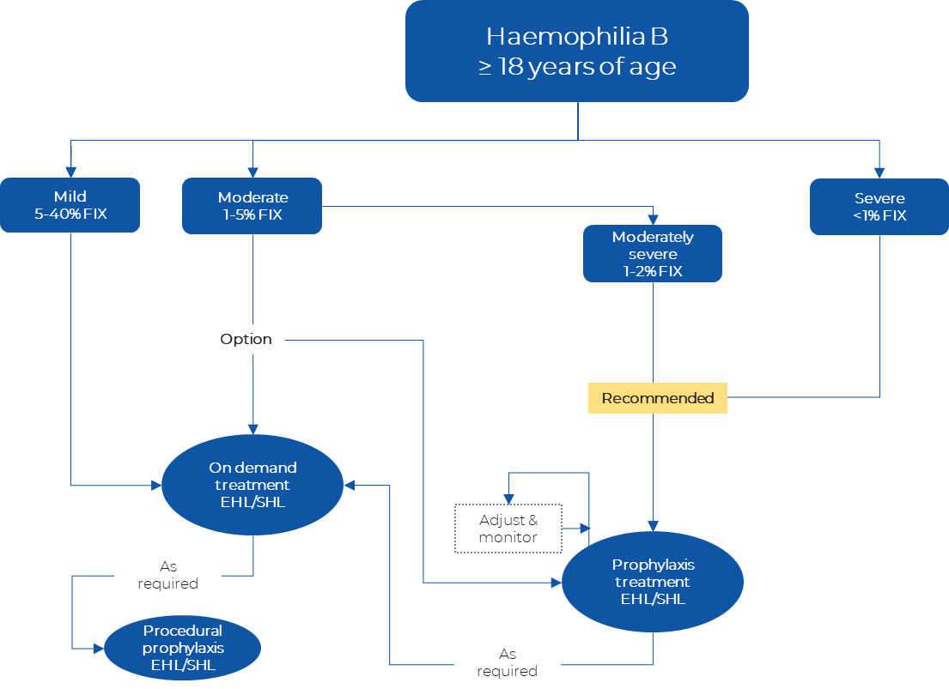
Abbreviations: FIX = factor IX expression; EHL = extended half-life recombinant FIX replacement therapy; SHL = standard half-life recombinant FIX replacement therapy
Sources: Developed using (AHCDO 2016; Dolan et al. 2018; MSAC 2018)

Define and summarise the PROPOSED clinical management pathway (algorithm) that patients would follow after the proposed service/technology is introduced, including variation in health care resources.
The proposed intervention would not so much change the current clinical management pathway, but rapidly and permanently shift the majority of eligible HMB patients to a mild or normal phenotype where only occasional procedural prophylactic or on-demand replacement may be required, and the risk of developing inhibitors is greatly reduced. The use of etranacogene dezaparvovec will not completely eliminate the need for FIX replacement therapy or change the circumstances under which it would be required, but significantly reduce both the extent and frequency of its use.
As described previously, the indicative clinical place for etranacogene dezaparvovec is for adult patients with moderately severe or severe HMB (≤2% FIX), without inhibitors, who are currently receiving FIX prophylaxis at a stable dose, and who have pre-existing neutralising anti-AAV5 antibody titers below 1:700 (yellow shaded oval). A minor change to the clinical management of moderately severe and severe patients will be the addition of a simple anti-AAV5 NAb test. Those who have anti-AAV5 NAbs ≥1:700 will remain on their individualised FIX prophylaxis treatment regime.
Proposed Australian clinical management algorithm for treatment of haemophilia
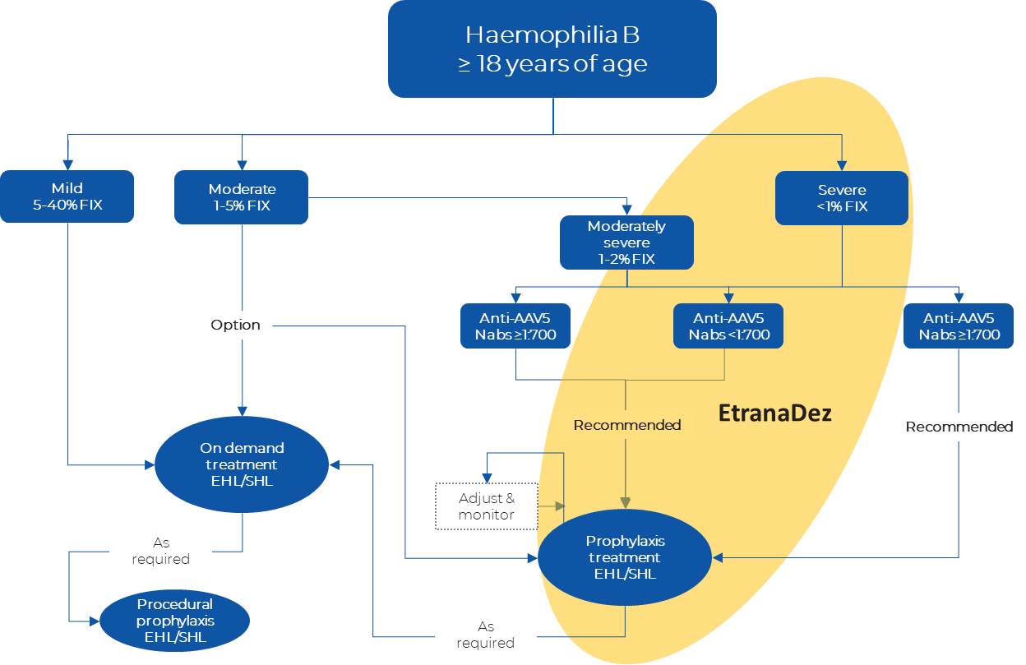 Abbreviations: FIX = factor IX expression; EHL = extended half-life recombinant FIX replacement therapy; SHL = standard half-life recombinant FIX replacement therapy
Sources: Developed using (AHCDO 2016; Dolan et al. 2018; MSAC 2018)

PART 6d – INFORMATION ABOUT CLINICAL OUTCOMES

Summarise the clinical claims for the proposed medical service against the appropriate comparator(s), in terms of consequences for health outcomes (comparative benefits and harms):
The proposed intervention is an easily administered and well tolerated single dose (IV) treatment that permanently attenuates a rare genetic condition which otherwise causes chronic deficiency in a key protein required in the process of blood clotting (i.e., FIX). As a result, patients can significantly reduce, or even completely discontinue, an intensive and difficult regimen of FIX replacement therapy, which has many established limitations, including the potential for development of inhibitors and issue of suboptimal adherence. Available clinical evidence also demonstrates that, in comparison to the current standard of care, the proposed intervention leads to significant reductions in bleeding events, which are associated with both short and long term morbidity and (rarely) mortality.
Improvements in some short-term measures of health-related quality of life (HRQoL) have also been reported, with greater effects anticipated over longer follow up. The intervention is well tolerated, with an acceptable and reasonably predictable short to medium term safety profile. As such, the balance of known and potential risks and benefits are both strongly positive.

Please state what the overall clinical claim is:
Significantly and importantly superior efficacy with non-inferior and acceptable safety, over the proposed comparator of no gene therapy (or other treatment of curative intent).
Adverse events for etranacogene dezaparvovec are largely focused on the period immediately after infusion, while a lifetime of potential adverse events accrue with current prophylactic standard of care.
From a longer-term perspective, improving disease severity of haemophilia B from severe to the mild-to-normal range, reduces the need for regular prophylaxis therapy and its associated adverse events (such as infusion site pain), and therefore constitutes an incremental safety benefit, outweighing initial infusion-related adverse events of etranacogene dezaparvovec. This safety benefit will be increasingly evident over time as patients remain off prophylaxis due to sustained mild-to-normal FIX levels.

List the key health outcomes (major and minor – prioritising major key health outcomes first) that will need to be measured in assessing the clinical claim for the proposed medical service/technology (versus the comparator):
Annualised bleed rates (overall and site/type specific)
Endogenous FIX activity levels and trough FIX activity
Utilisation of FIX replacement therapy
Discontinuation of routine FIX prophylaxis
Occurrence and resolution of target joints
Patient reported outcomes and overall HRQoL
Adverse events and laboratory indicators of safety
Formation of FIX inhibitors or anti-AAV5 antibodies

PART 7 – INFORMATION ABOUT ESTIMATED UTILISATION

Estimate the prevalence and/or incidence of the condition in the proposed population:
REDACTED

Estimate the number of times the proposed medical service/technology would be delivered to a patient per year:
Strictly once per lifetime.

How many years would the proposed medical service/technology be required for the patient?
Etranacogene Dezaparvovec is a one-time single dose therapy with projected lifelong treatment effect.

Estimate the projected number of patients who will utilise the proposed medical service(s) for the first full year:
Utilisation analyses informed by research and consultation with key stakeholders will be presented in full at the time of submission.

Estimate the anticipated uptake of the proposed medical service/technology over the next three years, factoring in any constraints in the health system in meeting the needs of the proposed population (such as supply and demand factors), as well as provide commentary on risk of ‘leakage’ to populations not targeted by the service.
Leakage outside of the highly defined patient population and specialised treatment setting is highly unlikely to occur. Furthermore, patients will be managed by a very small number of specialised haematologists under well-established governance frameworks ensuring appropriate and quality use.

PART 8 – COST INFORMATION

Indicate the likely cost of providing the proposed medical service. Where possible, please provide overall cost and breakdown:
Etranacogene dezaparvovec will substantially reduce healthcare resource utilisation due to the elimination or significant reduction in the need for FIX prophylaxis therapy in most patients, reducing the overall resourcing pressure on the healthcare system over time.
As a one-time infusion, etranacogene dezaparvovec will incur a high upfront treatment cost compared to the way current standard of care is procured, which realises on-going high costs spread out over regular intervals over the lifetime.
Over the long run, EtranaDez is expected to compound cost-savings ultimately relieving direct budget pressure on the NBA through the reduction in FIX clotting factor usage for adults living with severe and moderately severe haemophilia B.
A price and overall budget impact model will be provided at the time of full submission for consideration by MSAC.

Specify how long the proposed medical service/technology typically takes to perform:
Approximately 1-2 hours infusion time and 3 hours of close monitoring.

If public funding is sought through an alternative (non-MBS) funding arrangement, please draft a service description to define the population and usage characteristics that defines eligibility for the service/technology.
Not applicable

References
AHCDO, 2016, “Guidelines for the management on haemophilia in Australia, Australian Haemophilia Centre Directors’ Organisation and National Blood Authority,” Retrieved from https://www.blood.gov.au/system/files/HaemophiliaGuidelines-interactive-updated-260317v2.pdf.
Australia, NBA, 2021, Australian Bleeding Disorders Registry - Annual Report 2019-2020, , https://www.blood.gov.au/sites/default/files/ABDR-Annual-Report-2019-20-FINAL.pdf.
Brennan, Y, Parikh, S, McRae, S, & Tran, H, 2020, “The Australian experience with switching to extended half‐life factor VIII and IX concentrates: On behalf of the Australian Haemophilia Centre Directors’ Organisation,” Haemophilia, vol. 26, no. 3, pp. 529–535, doi: 10.1111/hae.13970.
C., 2nd White, G, Rosendaal, F, Aledort, LM, Lusher, JM, Rothschild, C, Ingerslev, J, Factor, V, & Factor, IXS, 2001, “Definitions in hemophilia. Recommendation of the scientific subcommittee on factor VIII and factor IX of the scientific and standardization committee of the International Society on Thrombosis and Haemostasis,” Thromb Haemost, vol. 85, p. 560, Retrieved from https://www.ncbi.nlm.nih.gov/pubmed/11307831.
Dolan, G, Benson, G, Duffy, A, Hermans, C, Jiménez-Yuste, V, Lambert, T, Ljung, R, Morfini, M, & Šalek, SZ, 2018, “Haemophilia B: Where are we now and what does the future hold?,” Blood Reviews, vol. 32, no. 1, pp. 52–60, doi: 10.1016/j.blre.2017.08.007.
Jiménez‐Yuste, V, Álvarez‐Román, MT, Martín‐Salces, M, Corte‐Rodríguez, HD la, Altisent, C, Parra, R, Núñez, R, Pérez, R, García‐Candel, F, Bonanad, S, Querol, F, Alonso, N, Fernández‐Mosteirín, N, López‐Ansoar, E, García‐Frade, LJ, Bermejo, N, Pérez‐González, N, Gutiérrez‐Pimentel, MJ, Martinoli, C, Fernández‐Arias, I, & Kim, HK, 2019, “Joint status in Spanish haemophilia B patients assessed using the Haemophilia Early Arthropathy Detection with Ultrasound (HEAD‐US) score,” Haemophilia, vol. 25, no. 1, pp. 144–153, doi: 10.1111/hae.13628.
Konkle, BA, Huston, H, & Fletcher, SN, 1993, “Hemophilia B,” Retrieved from https://www.ncbi.nlm.nih.gov/pubmed/20301668.
MSAC, 2018, 1511 - Extended half-life (EHL) blood clotting factors VIII + IX, , http://www.msac.gov.au/internet/msac/publishing.nsf/Content/1511-public.
Srivastava, A, Santagostino, E, Dougall, A, Kitchen, S, Sutherland, M, Pipe, SW, Carcao, M, Mahlangu, J, Ragni, MV, Windyga, J, Llinas, A, Goddard, NJ, Mohan, R, Poonnoose, PM, Feldman, BM, Lewis, SZ, Berg, HM van den, Pierce, GF, panelists, WFHG for the M of H, & co, authors, 2020, “WFH Guidelines for the Management of Hemophilia, 3rd edition,” Haemophilia, vol. 26 Suppl 6, no. S6, pp. 1–158, doi: 10.1111/hae.14046.

