Protocol Advisory Subcommittee Report

Protocol to guide the assessment of processing and cryopreservation of male and female gonadal tissue and gametes prior to gonadotoxic treatment to preserve fertility for the future
May 2016

Developed by:
Dr. Antoinette Anazodo, Chief Investigator Future Fertility Study. Paediatric and Adolescent Oncologist, Sydney Children’s and Prince of Wales Hospital, Director of The Sydney Youth Cancer Service. Churchill Fellow 2015
Mrs. Brigitte Gerstl, National Project Manager Future Fertility Program, Sydney Children’s Hospital
Associate Professor Catharyn Stern, Head of the Endocrine and Metabolic Service at the Royal Women’s Hospital, Melbourne and Head of Clinical Research at Melbourne IVF
Professor David Molloy, Clinical Director of Queensland Fertility Group, Director of the Queensland Gynaecological Endosurgery Group, Director of the Endometriosis Clinic of Queensland, Deputy Chairman of the IVF Directors Group of Australia and New Zealand
Professor David Handelsman, Director of the ANZAC Research Institute at the Concord Repatriation General Hospital
Mr. Chris Nicholls Christopher Nicol, Lab Manager SEALS Andrology, Scientific Director Department of Reproductive Medicine

This initiative has been funded by the FUTuRE Fertility research study team and CanTeen Australia.

Table of Contents
Table of Contents 3
Executive Summary 8
Canteen Australia Summary 10
Summary of the purpose of this document 11
Population 11
New Item Numbers 11
Frequency of procedure 11
Restriction 11
Glossary and Definitions 12
Background 15
Fertility preservation and oncofertility care 15
Population at risk of infertility 16
Gonadotoxic treatments in cancer patients 16
Gonadotoxic treatments in non-cancer patients 16
Gonadotoxic therapy and male infertility 17
Gonadotoxic therapy and female infertility 17
Fertility preservation options in males 18
Options for fertility preservation in post-pubertal males 18
Options for fertility preservation in pre pubertal males 18
Fertility preservation options for females 18
Options for fertility preservation in post-pubertal females 19
Current options for fertility preservation in pre-pubertal females 20
Fertility related psychological distress 21
Current barriers for uptake of Fertility Preservation 21
Available Clinical Information 21
Available Patient Information 22
Barriers for rural patients and non-English speaking patients 22
Referral pathways 22
Specialist advice 23
Timing…………………………………………………………………………………………………………………..23
Costs…………………………………………………………………………………………………………………….23
Handling cryopreservation and storage of ovarian tissue 24
Handling, cryopreservation and storage of ovarian tissue summary box 24
Prepubertal Tissue (≤ 15 years) 25
Adult Tissue 25
Storage…………………………………………………………………………………………………………………25
Freezer Program 26
Handling and storage of testicular tissue 27
Handling, cryopreservation and storage of male testicular tissue and summary box 27
Testicular tissue collection 27
Cryopreservation of testicular tissue and sperm 27
Controlled slow freezing 28
Thawing 28
Vitrification 28
Thawing 29
Tissue Histology 29
Regulatory Information 30
Reproductive Technology Accreditation Committee (RTAC) Certification 30
National Association of Testing Authorities (NATA) 30
Table 1: Accreditation 31
Recommendation to PASC 32
New MBS item numbers 32
Population 32
Frequency of procedure 32
Restriction 32
Clinical Indications for testing in patients who will or have received gonadotoxic treatment 33
Health Outcomes 34
Fertility preservation and reproductive health 34
Miscarriage 34
Pregnancy 34
Premature and still birth 34
Increased Quality of life 34
Improved relationships and family life 34
Summary of costs 36
Table 3: Summary of Patient Information Comparator Outcomes (PICO) 38
Proposed structure of economic evaluation 39
Consultation 40
FUTuRE Fertility chief investigators and lead investigators 40
Australasian Oncofertility Consumer Group 40
Fertility Society of Australia Medical Fertility Preservation Group 40
Access Australia's National Infertility Network Ltd 40
CanTeen Youth Advisory Group 41
CanTeen Leadership Group 41
Youth Cancer Services Strategic Advisory Group 41
Andrology 41
IVF Directors 41
Medical Oncology Group of Australia (MOGA) 41
Cancer Nurse Society of Australia (CNSA) 41
South Australian Oncofertility Group 42
Queensland Oncofertility Group 42
Victorian Fertility Preservation Taskforce 42
References 43
Appendix 1 57
Australasian Oncofertility Consortium Charter 57
Figure 1a 58
Algorithm for fertility preservation in new and relapsed paediatric female patients prior to receiving gonadotoxic treatment 58
Figure: 1b Algorithm for the assessment of female paediatric patient’s reproductive potential following gonadotoxic treatment 59
Figure 2b: Algorithm for the assessment of reproductive potential for adolescent and young adult (AYA) female patient’s following gonadotoxic treatment 61
Figure 3a: Algorithm for fertility preservation in new and relapsed adult female patients prior to receiving gonadotoxic treatment 62
Figure 3b: Algorithm for the assessment of reproductive potential for adult female patient’s following gonadotoxic treatment 63
Figure 4a: Algorithm for fertility preservation in new and relapsed paediatric male patients prior to receiving gonadotoxic treatment 64
Figure 4b: Algorithm for the assessment of male paediatric patient’s reproductive potential following gonadotoxic treatment 65
Figure 5a: Algorithm for fertility preservation in new and relapsed adolescent young adult and adult male patients prior to receiving gonadotoxic treatment 66
Figure 5b: Algorithm for the assessment of male adolescent young adult and adult patient’s reproductive potential following gonadotoxic treatment 67

Executive Summary
The loss of reproductive function due to cancer or non-malignant diseases, treated with gonadotoxic treatment (chemotherapy, radiotherapy and bone marrow transplantation or surgery to the gonadal tissue or neuroendocrine axis), is a significant survivorship consideration for many patients. The use of gonadotoxic treatment can impact the future fertility of men, women, and children and the late effects consequences of infertility are irrefutable on a patient’s physical and psychological wellbeing.

The sub-specialty of oncofertility has been established to ensure that the reproductive health of all cancer and non-malignant patients receiving gonadotoxic treatment, is considered and if possible preserved prior to starting treatment. Advances in fertility preservation options have allowed fertility to be addressed at earlier stages in cancer care. Increased rates of survival have encouraged clinicians and patients to explore the options available for fertility preservation, allowing the potential for patients to have a biological family in the future with substantial improvements in their satisfaction and quality of life.

This report will discuss all aspects associated with cancer and non-malignant diagnoses which require gonadotoxic treatment that may cause infertility and advancements in fertility preservation options. The report details recommendations focusing on the establishment of three new oncofertility Medicare item numbers:

- Processing and cryopreservation of ovarian tissue for fertility preservation treatment for female patients.
- Processing and cryopreservation of semen for fertility preservation treatment.
- Processing and cryopreservation of testicular tissue for fertility preservation treatment.

The FUTuRE Fertility Research Study Group, CanTeen Australia, and our collaborators believe that fertility preservation should be available to all cancer patients and patients with non-malignant disease receiving gonadotoxic chemotherapeutic agents, as a ‘duty of care’ as supported by the Australasian Oncofertility Charter (Appendix 1). The availability of Medicare item numbers will allow equitable access for all Australians of reproductive age, who are diagnosed with a condition requiring gonadotoxic treatment. Appropriate item numbers willensure that patients have access to consistent oncofertility referral pathways, consultation with a reproductive specialist and the opportunity to undertake fertility preservation, as well as receiving oncofertility follow-up in the survivorship period.

We look forward to hearing about a favorable outcome.

Dr Antoinette Anazodo
Paediatric and Adolescent Oncologist
Director of the Sydney Youth Cancer Service
Sydney Children’s Hospital and Prince of Wales Hospital
Chief Investigator FUTuRE Fertility study
Churchill Fellow 2015

Canteen Australia Summary

For 30 years, CanTeen Australia has supported young people when cancer has turned their world upside down and helped them cope with the physical, emotional and practical impact of living with cancer.

Working with 12-24 year olds, CanTeen supports young people at every stage of their cancer journey, whether they’re dealing with their own cancer or the diagnosis or death of a parent or sibling. Individually tailored support is provided to help every young person deal with the impact that cancer is having on their life, through peer support programs or specialist hospital and community-based services that offer medical care, information and psychosocial support. Monitoring and tracking our programs and services through research and evaluation means CanTeen continually strives to meet the needs of young people affected by the dramatic impact of a cancer diagnosis.

CanTeen is transforming the way young cancer patients are treated through the Youth Cancer Services, which are funded until 2017 by the Federal Government, in partnership with State/Territory health departments. Five Youth Cancer Services across Australia deliver world-class treatment and psychosocial support, ensuring that 15 to 25 year old cancer patients have access to a specialist multidisciplinary team comprising of medical, nursing and allied health support. More than 1,200 young cancer patients were treated and supported during 2014-15. Complementing local service delivery are national strategic priorities in research, data, professional development and advocacy to ensure continuous system improvement and national consistency in models of care, survivorship and other key focus areas.

Summary of the purpose of this document

The applicant has requested the addition of three new MBS item numbers for the discipline of oncofertility in the following populations:

Population
1. Male and female patients with any cancer irrespective of stage, who will receive or have received gonadotoxic treatment in three categories: paediatric, adolescent/ young adult (AYA) and adult populations; and
2. Male and female patients with non-malignant disease who will receive or have received gonadotoxic treatment in three categories paediatric, adolescent/ young adult (AYA) and adult populations.

New Item Numbers
- Processing and cryopreservation of ovarian tissue for fertility preservation treatment for female patients.
- Processing and cryopreservation of semen for fertility preservation treatment.
- Processing and cryopreservation of testicular tissue for fertility preservation treatment.

Frequency of procedure
Maximum of one procedure (which may include semen being collected more than once) prior to or after receiving gonadotoxic treatment. Some patients may need to have fertility preservation before and after cancer treatment to ensure an adequate collection.

Restriction
Female and male patients who have fertility preservation for nonmedical indication or infertility treatment and who have not received gonadotoxic treatment.

Glossary and Definitions

Alkylating agents - activity that inhibits cell division and growth and is used to treat some cancers.
AMH - Anti-Müllerian hormone.
AOFR - Australasian Oncofertility Registry.
Andrology - a branch of medicine concerned with male diseases and especially with those affecting the male reproductive system
Anti-Mullerian Hormone (AMH) - This is a protein released by small pre-antral follicles in the ovary and reflects the follicle pool. Blood tests to check AMH levels may be done as part of fertility testing.
Assisted Reproductive Technology (ART) - Methods used to achieve pregnancy by artificial or partially artificial means.
AYA – adolescents and young adults, usually aged between 15-25 years old.
Azoospermia - absence of sperm in the semen.
Cancer - any type of malignant growth or tumor caused by abnormal and uncontrolled cell division.
Chemoradiation – chemotherapy followed by radiation to treat cancer
Egg - also known as an ovum, is the female reproductive cell or gamete.
Embryo – when an egg and sperm come together (fertilization) they form an embryo, which is the early stage of development of an animal.
Embryo cryopreservation – Eggs are collected from a female patient’s ovaries and sperm is inserted into the egg (fertilization). The embryos are then frozen and stored.
Fertility - the ability to conceive a baby.
Fertility preservation – this is a way to help cancer patients keep their fertility after cancer treatment, in order to have their own biological children.
Fertilization – This is the fusion of an egg with a sperm, which leads to the development of an embryo.
FSH - Follicle stimulating hormone.
GnRHGnRH analogues - hormone protection.
GnRH analogues (GnRHa)–) – peptide analogs of gonadotrophin-releasing hormone (GnRH).
Gonadal organs - defined as testes or ovaries.
Gonadal tissue or gonads – Glands that make sex hormones and reproductive cells; testes in the male, ovaries in the female.
Gynaecology - The medical practice dealing with the health of the female reproductive system (uterus, vagina, and ovaries).
Infertility - the inability to conceive after 1 year of intercourse without contraception.
Intracytoplasmic sperm injection (ICSI) - this is an in vitro fertilization procedure in which a single sperm is injected directly into an egg.
In Vitro Maturation (IVM) – This is a method of letting immature ovarian follicles mature in vitro (in a test tube). This method is new and used in a very small number of centres but babies have been born using this method.
IVF - In vitro Fertilization techniques.
MBS - Medicare Benefits Schedule.
MSAC - Medical Services Advisory Committee (MSAC).
Neuroendocrine axis - the interaction between the nervous and endocrine systems mainly involving the hypothalamus, pituitary and gonads.
Obstetrics - The medical practice of looking after pregnant women during pregnancy and childbirth.
Oocyte cryopreservation - egg collection and frozen storage.
Oncofertility - Oncofertility bridges the disciplines of oncology and reproductive medicine in order to discover and apply new fertility preservation options for young patients facing fertility-threatening diseases or treatments.
Ovarian cryopreservation - the collection and frozen storage of tissue from the ovary.
Ovarian follicle count - Ovarian follicles are part of the female reproductive system, and are found in the ovary and decrease through reproductive life to zero at menopause. Each follicle contains a single egg. These eggs are developed only once every menstrual cycle (i.e. once a month in females) until menopause.
Ovarian tissue cryopreservation - A whole ovary or tissue from part of the ovary is collected frozen and then stored.
Ovarian transposition - surgical movement of the ovaries.
Ovary - The ovary is one of a pair of female reproductive organs that produce eggs and release hormones, including estradiol.
PASC - Protocol Advisory Sub-Committee.
POF - premature ovarian failure.
Pre-pubertal testicular biopsy - the collection of immature testicular tissue in pre-pubertal male children, currently experimental.
Pelvic ultrasound - This is a type of scan where a probe is rubbed over the lower part of the abdomen (trans-abdominal scan) or inserted into the vagina (trans-vaginal) to look at the ovaries. The probe sends out harmless, high frequency sound waves into the pelvis and an image is formed.
Psychology - The study of the mind and of thought, feeling and behaviour.
Psychologist - This is a health professional that studies and treats psychological distress.
Psychological Distress - This is a term used to describe a range of symptoms and experiences that are commonly held to be troubling, confusing or out of the ordinary.
Quality of life - Fertility related well-being.
Reproductive health - The health of the reproductive system in its ability to produce gametes (eggs, sperm) and circulating steroid hormones (estradiol, testosterone) to ensure fertility and systemic effects of reproductive hormones.
Semen - This is a fluid produced by males that comes out of the penis by ejaculation. The semen contains sperm which can fertilize female eggs.
Seminoma - a malignant tumour of the testis.
Sperm - The male reproductive cells that combine with female egg cells during fertilization.
Semen analysis - To examine semen to measure variables that impact on fertility like semen volume, sperm number, morphology (shape) and viability (motility or swimming speed and directionality)).
Sperm retrieval - the collection of sperm in post-pubertal men by epididymal or testicular biopsy when semen contains no or too few sperm or sperm cannot be collected by masturbation.
Sperm cryopreservation/banking - To collect sperm and then freeze and store for later use.
Spermatogonia - a cell produced at an early stage in the formation of spermatozoa.
Spermatozoa - male reproductive cells.
Successful cryopreservation of sperm - defined as viable sperm recovered after thawing a frozen collection of sperm or semen.
Trachelectomy – excision of the uterine cervix.
Testicular sperm extraction (TESE) - This is the process of removing a small portion of tissue (biopsy) from the testicle under local anesthesia and extracting the viable sperm present in that tissue.

Background

Fertility preservation and oncofertility care
Improvements in the cancer diagnosis and treatment of children, adolescents and young adults, and adult cancer patients of reproductive age (0-44 years) has led to significant improvements in survival rates.^{[1, 2]} As survival rates improve, there is an expectation by clinicians and patients to preserve the reproductive health potential of cancer patients whenever possible.^{[3-5]} A patient’s fertility can be affected by both a cancer diagnosis and cancer treatment (chemotherapy, radiotherapy, bone marrow transplant and surgery).^{[4, 6-10]} which can cause damage to the gonadal organs (testes or ovaries) or the neuroendocrine axis (by inhibiting pituitary hormone secretion that drives gamete production).

A number of studiesstudies have shown that infertility following gonadotoxic treatment is a major concern. Potential and actual infertility affects the future quality of life of patients and leads to psychological distress as well as being a predictor of stress in present and future relationships.^{[3, 11, 12]}

Fertility preservation is the overarching term used for medical and surgical treatment to minimise the impact of cancer treatment on a patient’s future fertility by preserving tissue and gametes and protecting fertility during gonadotoxic therapy .^{[4, 5]} There are a number of fertility preservation techniques, which are standard practice and recommended by the 13 international guidance documents on fertility preservation. Currently the fertility preservation options available include:
- Oocyte cryopreservation (egg collection and storage);
- Embryo cryopreservation (fertilization of an egg with either a partner’s or donor sperm);
- Ovarian cryopreservation (the collection and storage of tissue from the ovary – standard of care for adult cancer patients however experimental in children);
- Sperm banking (the collection of sperm or semen via masturbation or testicular biopsy in post-pubertal men);
- Pre-pubertal testicular biopsy (the collection of immature testicular tissue in pre-pubertal male children, currently experimental).
- Gonadal protection during chemotherapy

With the development of fertility preservation strategies and oncofertility care, ^{[13, 14]} an increasing number of patients of reproductive age are being referred for fertility preservation and may be able to plan for a biological parentage after cancer treatment.^{[15]}

In 2006, the term ‘‘oncofertility’’ was introduced to describe a new subspecialty focused on the reproductive future for cancer survivors, who may face infertility (as a result of chemotherapy, radiation, or surgery).^{[16, 17]} Oncofertility encompasses: (1) the science needed to develop new fertility preservation options for patients prior to the onset of cancer treatment; (2) the clinical specialties to integrate fertility preservation such as family planning, and hormonal management and (3) advances in oncofertility communication, education and service provisions.^{[17]}

Population at risk of infertility
1. Male and female patients with any cancer irrespective of stage, who will receive or have received gonadotoxic treatment in three categories paediatric, adolescent/ young adult and adult populations; and
2. Male and female patients with non-malignant disease who will receive or have received gonadotoxic treatment in three categories paediatric, adolescent/ young adult and adult populations.

Gonadotoxic treatments in cancer patients
Cohort | Age | Number patients diagnosed with cancer annually^{[18] [19]}
Australian population | 0-45 years | 9,700
Paediatric | 0-14 years | 600 (6%)
Adolescent young adult | 15-24 years | 900 (9%)
Adult | 25-45 year | 8200 (85%)

Gonadotoxic treatments in non-cancer patients
Gonadotoxic treatments are sometimes utilised for many non-malignant conditions which pose a major risk of gonadal damage^{[20]}

Examples of these conditions include:
- gastrointestinal diseases^{[21-23]}- Inflammatory bowel diseases (IBDs), consists of diseases such as ulcerative colitis (incidence rates are 17.4 per 10,000)^{[24]} and Crohn's disease (incidence rates are 29.3 per 10,000).^{[24]}
- rheumatologic disorders – 6,000 Australian patients of a reproductive age 15-44 years are affected by arthritis and some are treated with gonadotoxic agents.^{[25]}
- non-malignant hematologic conditions – the most common condition treated with gonadotoxic agents is aplastic anemia with incidence rate of 3-5 persons per million in western populations.^{[26]}
- autoimmune/vasculitis/glomerular disorders – 1 per 50,000 Australian patients are affected by vasculitis and 20-150 persons per 100,000 are affected by systemic lupus erythematosus (SLE)^{[27-30]} most typically diagnosed in females of child-bearing age. Other glomerular disorders including: anti-neutrophilic cytoplasmic antibodies (ANCA) vasculitis and steroid resistant nephrotic syndrome may occasionally require treatment with gonadotoxic agents.
- gynaecologic conditions – there are a number of non-malignant surgical conditions eg severe endometriosis, in which surgery may render a patient infertile and fertility preservation at the time of operation will give these women and children an opportunity for a biological family in the future with or without the use of a surrogate gestational carrier.
- metabolic diseases^{[31-33]} – there are a number of metabolic conditions which are treated by the use of bone marrow transplantation and these patients although cured of their metabolic condition are likely to all be infertile.

Gonadotoxic therapy and male infertility

In male cancer patients, testicular damage primarily impacts the rapidly proliferating germ cells but at higher doses can also damage and affect the somatic cells of the testis (Sertoli and Lleydig cells) ^{[34]} The germinal epithelium of the mature adult testis, where spermatogenesis occurs, is the most rapidly proliferating epithelium in the body, rendering it highly sensitive to gonadotoxic treatments, especially anti-mitotic drugs or irradiation. This germinal epithelium actively produces mature spermatozoa (male reproductive cells), which are susceptible to damage as a result of gonadotoxic treatment.

Cancer treatment at any age can lead to subsequent infertility,^{[35, 36]} as the testis can be highly susceptible to damage even before as well as, during, and after puberty. Cytotoxic treatment targets rapidly dividing cells, and as a result spermatogenesis can be disrupted during and after treatment. Recovery of spermatogenesis depends on restoration from germinal stem cells which are also susceptible to cytotoxic damage. The mechanism of this damage is uncertain, but seems to be associated with depletion of the proliferating germ-cell pool, cells at the stage of differentiating spermatogonia.^{[37]}

High dose chemotherapy associated with bone marrow or stem cell transplantation causes severe and often permanent male sterility in most cases.^{[38]} The testis is also highly sensitive to irradiation such that a dose as low as 0.15 Gray causes reduced sperm production and doses of 0.5 Gray or above can cause azoospermia (complete elimination of sperm in the semen). Partial recovery from irradiation-induced azoospermia may occur ; however, the time to recovery is proportional to the testicular dose, and may take several years.^{[39]}

Gonadotoxic therapy and female infertility

The human ovary has a fixed number of primordial follicles, which is at a maximum at 5 months of gestational age.^{[7]} These follicles are progressively lost with increasing age in an exponential trend, culminating in menopause which on average occurs at around 50 years of age. The rate of oocyte attrition (decline) accelerates rises at around age 35 years.
Both chemotherapy, radiotherapy and bone marrow transplantation may lead to an increase in oocyte depletion, leading to premature menopause.^{[40, 41]}

Cancer-related infertility, predominantly causing ovarian follicle depletion, is multifactorial and is dependent on a number of factors including, the nature of treatment required but also other intervening variables such as gender, age, pubertal status, gynaecological and reproductive health history, underlying medical conditions, (including genetic or endocrine conditions) and cancer type, and importantly the nature of treatment required.^{[42, 43]}

Other factors that may impair fertility or contribute to sub-optimal fertility include damage to the hypothalamic-pituitary-gonadal axis^{[45, 46]}, immunological and cytological responses to cancer,^{[47, 48]} systemic processes (fever, malnutrition and immunosuppression) ^{[37, 49, 50]} and psychological effects of cancer that may affect patient’s sexuality,libido and sexual performance, thereby causing infertility.^{[51]}

Fertility preservation options in males

Options for fertility preservation in post-pubertal males
- Semen (masturbation/electroejaculation)
Cryopreservation (freezing) of semen following masturbation, prior to cancer treatment for male patients, is acceptable and easy to facilitate with minimal or acceptable delay in cancer treatment^{[53-74]} Currently, cryopreservation of spermatozoa is the most reliable^{[75]} and the only well-endorsed method of fertility preservation in post-pubertal males.^{[76]} This typically involves collecting up to 3 semen samples on alternate days producing up to 50 cryopreserved straws of frozen sperm. Successful cryopreservation of sperm (defined as motile sperm observed after freezing and thawing) is achieved for between 85–100% of male patients; however this is dependent on age (minimum age 14–15+ years depending on pubertal maturity) and diagnosis (including testicular cancer, lymphomas, leukemias, bone cancer and other cancers).^{[74]}

- Mature sperm extracted from testicular tissue (open or closed needle testicular biopsy)
For sperm collection in male patients unable to produce an ejaculate, microsurgical testicular sperm extraction (TESE) is a proven method of sperm collection for cryopreservation.^{[61, 77-81]}

Future use of sperm can be in the form of intrauterine insemination, IVF-ICSI and possibly testicular tissue grafting. When sperm quantity or quality is limited, intracytoplasmic sperm injection (ICSI) (where an individual sperm cell is injected into an egg cell) is an effective technique to achieve pregnancy.^{[75]}

Options for fertility preservation in pre pubertal males

1 Freezing of testicular tissue containing mature and/or immature sperm/spermatogonia

The pre-pubertal testis does not produce mature spermatozoa. Maturation of spermatogonia from testicular tissue biopsy in prepubescent boys for later clinical use remains in the early phases of experimental research^{[7, 82, 83]} Recent studies have demonstrated that this is feasible in mice and clinical application is likely to be successful in the near future.^{[84-86]} Paediatric fertility preservation should be undertaken under stringent governance at specialised centres.

Fertility preservation options for females

Fertility preservation options for female cancer patients vary depending on the age and gender of the patient, the type and stage of the cancer, urgency of cancer treatment, and whether the patient has a (permanent) partner at the time of diagnosis.^{[5, 6]} Increasing uptake of fertility preservation options has allowed more patients to preserve their fertility prior to commencing cancer treatment.^{[52]}

Options for fertility preservation in post-pubertal females
A number of fertility preservation options are available for post-pubertal women:

- Ovarian cryopreservation
Ovarian cortical tissue, which contains the majority of the ovarian pool of follicles, can be harvested in an attempt to preserve fertility prior to toxic damage from gonadotoxic treatment.^{[87]}

Ovarian cryopreservation is utilised in post-pubertal women for multiple indications (1. where there is a high risk of ovarian damage or sterility,
2. prior to conditioning therapy and bone-marrow transplant, 3. when there is not enough time for a cycle of ovarian stimulation, 4. where ovarian stimulation is contraindicated, 5. prior to pelvic surgery, 6. prior to pelvic irradiation).^{[88]}

In adults, either 1/3 of an ovary or a whole ovary is removed and then processed with slicing into very fine pieces (1 x 3 x 10mm) and cryopreservation. Tissue samples are tested by histology and molecular biological techniques for cancer cells.^{[89-91]} When a woman has completed cancer treatment, and has recovered, but has ovarian failure, the thawed tissue can be transplanted back into the pelvis, to restore ovarian function and normalise levels of gonadotrophins .on average it takes 4-5 months for the graft to begin functioning after surgery., Restoration of ovarian activity was observed in 93% of patients at between 3.5 months and 6.5 months after grafting.^{[89-92]}

To date, there have been over 100 live births (verbal communication, ISFP 2015 international meeting) worldwide reported after cryopreservation of ovarian tissue in adult patients.^{[91, 95-110].}

- Oocyte and embryo cryopreservation
Oocyte and embryo cryopreservation are well-established and highly endorsed procedures for fertility preservation in female cancer patients.^{[76, 111, 112]} Ovarian stimulation with storage of the oocytes or embryos that have been created is considered the most reliable fertility preservation technique for post-pubertal women. It requires a woman to undergo stimulation for 8-12 days with regular monitoring and then collection of oocytes under sedation or a general anaesthetic with subsequent cryopreservation of gametes or embryos.^{[111]} There are many reasons to which women may prefer to freeze oocytes instead of embryo including: lack of relationship, relationship uncertainty, maintaining complete autonomy regarding future use of gametes, and potential ethical as well as religious concerns. For patients who have a partner, embryos can be created using in vitro fertilization techniques and then frozen.^{[17, 113, 114]} The term cryopreservation refers to the storage of viable cells at low temperatures (normally at −196°C).^{[115]} The ultra-rapid cooling method also known as vitrification^{[115]} has resulted in an increase in the success rate of both oocyte and embryo cryopreservation.

Additional considerations have to be made by patients, families and specialists before patients undergo oocyte stimulation, such as the potential effects of any delay in oncological treatment and decisions about the best stimulation protocols that limit exposure to increased estrogen levels induced by ovarian stimulation.

- Gonadrotrophin releasing hormone (GnRH analogues)
GnRH analogues (hormone protection) have been utilised during chemotherapy to suppress ovarian cyclicity and reduce the accelerated recruitment and atresia which occur in response to the chemotherapy. GnRH analogues induce a temporary medical menopause in an attempt to protect the ovaries from the gonadotoxic effects of chemotherapy.^{[7, 116-118]}

One class of GnRH analogues (GnRH agonists) induce an initial supraphysiological release of gonadotropins and within several days they desensitize the GnRH receptors on the pituitary gonadotropes, preventing the endogenous pulsatile GnRH to exert its physiological action, resulting in a hypogonadotropic state which aims to replicate the pre-pubertal state of the neuroendocrine axis phenomenon.^{[118]} However, the hypoestrogenic state may induce menopausal symptoms, such as hot flushes, vaginal dryness and sleep disturbance, more common in older and infrequent in younger patients. By contrast, GnRH antagonists directly induce the down regulated hypogonadotrophic state without any initial release.

Over 20 studies (including five prospective randomized controlled trials) have reported on patients treated with GnRHa during chemotherapy, mostly but not universally showing a significant decrease in premature ovarian failure (POF) rate in survivors.^{[116, 119-129]} Studies have reported that > 90% of patients treated with GnRHa during chemotherapy maintained ovarian function, with a pregnancy rate of approximately 19%,^{[123]} 22% suggesting that the use of GnRHa co-treatment can help to preserve not only ovarian function but also fertility in the medium term.^{[123]}

- Ovarian transposition
Ovarian transposition (surgical movement of the ovaries) also known as ovarian suspension, oophoropexy, or ovariopexy)^{[130, 131]} may be used for fertility preservation in women receiving pelvic radiation.^{[130, 131]} Ovarian transposition is a surgical technique used to protect ovarian function before a patient receives radiation. This procedure aims to move the ovary out of the irradiation field, protecting it from direct radiation and irreversible damage thereby preserving its function. Laparoscopic ovarian transposition in women <40 years of age is associated with preservation of ovarian function in 88.6% of cases.^{[132]} Studies have reported that 90% of patients who had ovarian transposition before radiotherapy resume normal levels of follicle-stimulating hormone and estradiol.^{[133]}

Current options for fertility preservation in pre-pubertal females
- Ovarian cryopreservation
The only method of fertility preservation in pre-pubertal female children is ovarian tissue cryopreservation. The same method is used for children as for adults but the procedure is technically more challenging because of the size of the patient’s ovaries. The main aim of this strategy is to ultimately re-implant cortical ovarian tissue into the pelvis once treatment is completed and the patient is disease-free.^{[91, 95, 96, 134-141]} For children undergoing this procedure, small slices of (4 x 5 x1 mm) are frozen in individual vials and stored in liquid nitrogen (cryopreserved).^{[142]} The added advantage of re-implanting ovarian tissue in children is induction of puberty. Frozen ovarian tissue not only retains reproductive potential, but also the functional unit of the ovary, the follicle. Follicles in the transplanted tissue possesses the capacity to produce estradiol and other sex hormones that maintain regular menstrual cycles.^{[142]} Sex hormones exert a plethora of different functions in the female body and maintained female steroid producing capacity opens new possibilities.^{[142]}

Internationally a number of centres offer ovarian tissue storage for pre-pubertal girls, within ethical frameworks. . To date there has only been one birth^{[108]} from a child who had ovarian tissue stored at 13 years of age prior to bone marrow transplant but numbers are expected to rise imminently. Institutional ethics committee approved protocols are required for paediatric fertility preservation, which should only be undertaken under stringent governance at specialised centres.

Fertility related psychological distress
The loss of reproductive function is one of the most troubling adverse consequences of successful curative cancer treatment, causing psychological distress and diminishing the quality of life of cancer survivors.^{[143-145]}
Cancer patients have a strong desire to be informed about the available options and strategies associated with fertility preservation,^{[146, 147]} but research shows that many patients are not provided with information about fertility preservation options and strategies.^{[148]}
Infertility can have long lasting psychological ramifications on the quality of life for cancer patients, who have not yet started or completed their family at the time of their cancer diagnosis^{[149, 150]} Cancer survivors whose^{[149, 150]} fertility has been compromised by their treatment, experience heightened psychosocial and emotional distress and have more difficulties in adjusting to life after cancer than those who do not lose their reproductive capacity.^{[3, 146, 151-158]}

Current barriers for uptake of Fertility Preservation
Despite promising advances in technology in the past decade and an increasing number of patients seeking fertility preservation, several clinician and patient barriers exist in providing fertility preservation:

Available Clinical Information
There is not yet good quality data on the short and long term effects on fertility of for the new novel chemotherapy agents or combinations of chemotherapy or multimodality treatment.^{[159]} A lack of current ^{[159]} and relevant information can be a potential barrier for patients receiving the specialty care they require.

Provision of written as well as verbal information about the possible effects on fertility of cancer treatment at the time of a cancer diagnosis is required because at that time a patient’s focus is on processing information associated with their cancer diagnosis.^{[146, 160, 161]} However, various studies demonstrate that not being given the opportunity to discuss fertility preservation at any stage throughout the cancer trajectory causes heightened psychological distress.^{[3, 11, 12]}

Available Patient Information
Unfortunately, less than 50% of cancer patients^{[146, 158, 162-166]} report being informed about potential risks to fertility associated with their cancer diagnosis, and less than 35% of cancer survivors recall discussing the possible risks of pregnancy during or after cancer treatment, or available fertility preservation options ,with a health care provider.^{[3, 4]}

Some cancer specialists feel uncomfortable broaching the topic of sexual health, particularly if sexual and reproductive health is outside their realm of expertise.^{[150]} Other studies have reported oncologists’ non-referral relates to a deviation from their primary objective, which is to treat the patient’s malignancy.^{[167]} Concerns regarding delaying a patient’s cancer treatment have also been documented as a concern and potential barrier for referral from cancer to reproductive specialist. ^{[168]} Health care professionals also report lack of knowledge, skills and training associated with discussing fertility preservation, as well as a lack of standardised guidelines available in Australia for referral.

Conversely, some cancer patients and their families may be focused solely on survival and may not consider the future impact of the cancer treatment on the patient’s fertility. However, current studies report that parents, family members^{[169, 170]} and young cancer patients^{[3, 146]} would like to have discussions regarding their cancer and its implications on their reproductive health.

Health care professionals also report lack of knowledge, skills and training associated with discussing fertility preservation, as well as a lack of standardised guidelines for referral in Australia.^{[171-173]}

Barriers for rural patients and non-English speaking patients
Non-English speaking patients face additional barriers; fertility preservation information is mostly not discussed at the point of consultation by the cancer specialist. ^{[165, 169, 174]} Uptake for Assisted Reproductive Technology services are predominately utilised by affluent English speaking patients.^{[175-177]}

Patients who are treated in rural cancer centres have additional barriers in accessing fertility preservation, as fertility and andrology centres are usually based in metropolitan or regional locations.^{[178-181]}

Referral pathways
In Australia there are nationally agreed guidelines for fertility preservation, however we do not have state or national referral pathways and this results in some patients missing out on the opportunity for fertility preservation.^{[164, 182, 183]} Referral pathways between clinics exist but they are often ad hoc between certain clinicians. Unfortunately, many cancer specialists indicate that they are unaware of whom or where to refer a patient for fertility preservation services and this is a barrier for referral.^{[169, 174, 184]} This is especially relevant for patients residing in rural and regional areas, where access to fertility preservation services is limited.

Specialist advice
Most cancer patients receive information about fertility preservation by cancer experts and not fertility and andrology specialists but unfortunately not all cancer doctors inform patients about the potential of losing their fertility ^{[148, 185, 186]} or do so on an ad hoc basis, even though they recognise the importance of providing this information.

In 2005 the ethics committee of the American Society for Reproductive Medicine extended physicians’ duty to ‘inform patients about options for fertility preservation and future reproduction prior to treatment.’^{[76, 170]}

Regrettably in some areas, there is still suboptimal communication between cancer and fertility specialists.^{[187]}Given the competing demands of providing complicated and detailed information about fertility potential and the risk to fertility, based on cancer treatment, there is a role for cancer specialists to work collaboratively with reproductive and andrology specialists to achieve the best outcome for patients.^{[80, 188]}

Timing
Timely referral and uptake of fertility preservation is important and so is early commencement of treatment with gonadotoxic agents. Delays in referral to fertility preservation services and the length of fertility preservation treatment, are often reasons for why patients choose to start treatment prior to referral to fertility preservation experts. In one study only 20% of parents and 30% of adolescent patients indicated they would delay treatment to undergo fertility preservation methods ^{[148, 189]} but it is^{[148, 189]} unclear to what extent clinicians views influence decisions.

Costs
Fertility preservation treatments are expensive; the upfront cost and the lack of Medicare and insurance coverage for some aspects of oncofertility care is often a reason for clinicians’ lack of referrals and for patients not taking up referrals to a fertility or andrology specialist. The cost of processing, cryopreservation and storage are not included in the current Medicare Schedule and are a significant barrier for patients.

The American Medical Association (AMA) adopted a new policy (resolution 6) in 2012 supporting financial cover of fertility preservation when iatrogenic infertility may be caused, directly or indirectly by medical treatment necessitated for cancer therapy.

The guidelines from the National Comprehensive Cancer Network^{[190]}, American Society of Clinical Oncology, the guidelines from the National Comprehensive Cancer Network^{[190]}, American Society of Clinical Oncology^{[170]} and Clinical Oncological Society of Australasia ^{[191]} agree that potential fertility side effects of treatment must be discussed, and fertility preservation should be offered. Without Medicare and insurance coverage, these guidelines are an unattainable recommendation for many patients.

Handling cryopreservation and storage of ovarian tissue

Handling, cryopreservation and storage of ovarian tissue summary box

Preparation of the cortical ovarian tissue
The ovarian tissue is prepared prior to freezing by dissecting apart the surface (cortical) tissue containing the follicles and the inner part mainly circulation and support tissue. The surface tissue is subsequently dissected into 1mm thick slices to facilitated movement of the cryoprotectants (anti-freeze solutions). This is a manual procedure. This takes several hours.

Freezing of the cortical ovarian tissue
The slices of ovarian cortical tissue are exposed to cryoprotectants to remove water from the cells and placed in vials in an automated freezing machine which gradually reduces temperature at a controlled rate over time to -150 °C. The vials are then stored in a large tank containing liquid nitrogen at a temperature below -150 °C. This takes several hours

Storage
The vials must be maintained at a temperature of -150 C to preserve the cellular integrity, and this is achieved by replenishing the liquid nitrogen reservoir in the storage tank.

Ovarian tissue can be obtained during laparoscopy or laparotomy under general anesthetic. Once the tissue is removed, it will be analysed for detection of gametes and also evaluated by histological and molecular biological techniques to exclude malignant cells. If any mature eggs are present they will be removed and frozen in liquid nitrogen. Ovarian tissue can be frozen using three different approaches: most commonly tissue is prepared as fragments of ovarian cortex, since there are still technical challenges (relating to cryoprotectant dissemination in tissue) precluding the widespread practice of freezing of a whole ovary and its vascular pedicle. Isolated follicles can also be cryopreserved. Following ovarian tissue retrieval, the tissue is processed, placed in straw like tubes, which are then placed in a cryopreservant (an antifreeze solution) and stored at subzero temperatures, until they are required for use.
The procedure includes the following:
- Before collecting tissue remove freezing solutions from fridge and equilibrate to room temp.
- Place tissue in large petri dish containing Hepes (20 ml). Examine and record information; size, surface; appearance, colour, presence of blood on surface, density, follicles, CL, medulla, appearance, density, abnormalities, follicles.
- Puncture with fine needle any follicles, expel follicular fluid by applying pressure search for oocyte cumulus mass. Transfer oocytes to Nunc well, containing Fert medium. These will be cultured in maturation medium prior to freezing.
- Before trimming remove small area of tissue for histology (1/10). Preference; take poorer area i.e. bloody area, area containing corpus luteum, irregular surface, odd looking. Place in labelled container in 10% formalin. For query ovarian cancer or endometriosis take piece from each end and area abutting tissue which will be frozen ie middle (place only one piece in each path pot and number same as pieces). Track the piece of origin against slices in vials (record).

Prepubertal Tissue (≤ 15 years)
- All of the medulla is to be frozen for the patient. Remove medulla in one piece, slice this into roughly 1-2 mm slices treat in similar way to cortex slices.
- Only prepare cortex in slices, no blocks are to be cut. Record which vials contain cortex (5 slices/vial) and medulla (2 pieces of medulla /vial).
1 vial is to contain 1 piece of medulla for testing another to contain 2 slices of cortex for testing. Include these in patient total. 1 slice of cortex for fixing.

Adult Tissue
- Cut away medulla using scissors and forceps (aim 1 mm thick), remove all corpus luteum and any bloody areas. In tissue from leukemia /lymphoma patients remove completely all blood containing areas.
Retain two large blobs of medulla to be frozen for later assessment of malignant contamination of tissue (freeze in 1 vial).
- Cut cortex into 4 –5 rectangular pieces (~5mm wide). Working with one piece at a time. Cut into ~1mm slices using double sided razor blade. Use grid under scope to check size. For whole ovary cut some into small blocks 5x5 mm again check size with grid. At completion of each piece, transfer slices to sieve sitting in 8 mls Fert Medium (CO₂ ) in small petri dish.
Record number of slices in each sieve (~ 15 slices per sieve, 2 blocks per sieve). For smaller amount of tissue (<50 slices) put 10 slices per sieve.
1-2 slices of cortex to be given to Kelly/Renee for fixing and any small irregular pieces.
- Check dishes for oocytes, move to Fert medium. These will be cultured in maturation medium prior to freezing.
- Using 6 well plates label and aliquot freezing solutions (8ml). Left side PBS +alb, right side 1.5M PROH +0.1M Sucrose +alb. Dehydration procedure conducted at room temperature.
- Remove sieve from medium with forceps touch side of sieve on dish lid to remove excess medium. Dip sieve in PBS well, remove from PBS (<30sec) drain on side of well, transfer sieve to 1.5 MPROH +0.1Sucrose +alb, lift to remove any bubbles trapped under sieve. 2 bloody areas of medulla are also dehydrated in solutions. Periodically swirl sieve and using forceps move slices around in sieve (tend to clump together and move to side of sieve). Leave in 1.5 PROH+0.1 Sucrose +alb for 90 minutes.
- During this time label vials with UR, Surname, Freeze Date, Vial number and put coloured plugs in lids with number on top. Place 0.5 ml of 1.5 M PROH +0.1 M Sucrose +alb in each vial. See above for number of slices /vial. 1 vial to contain 2-3 slices of cortex for testing if required later (record in patient total).
- At about 80 min start to load slices into vials. Load vials onto canes start freeze program at 90 min. Use Embryo 1.5 PROH program. Seed at -7 °C using jumbo swabs, check for ice nucleation.
- Record all information in red book and ovarian tissue sheet.
Complete letter, make 3 copies; 1 to each of following original to patient, referring doctor, Kate, one to be file with ovarian tissue sheet.

Storage
- Large Vapour Tank. Fill lowest level boxes first.
- Record position, cap colour, number vials.
- Mark off position on rack box sheet.

Freezer Program
- Planner Freezing Machine
- Embryo Freezing 1.5 PROH Program
- Pause 16 °C
- Ramp 1: -2 °C /min to –7 °C
- Ramp 2: Hold at –7 °C for 10 min
manual seed with giant swabs, watch ice formation
- Ramp 3: -0.3 °C /min to –30 °C
- Ramp 4: -50 °C /min to –150 °C
- Ramp 5: Hold at –150 °C for 2 hours

Cryostorage refers to the process of freezing the ovarian tissue with a view to thawing the tissue for use in assisted reproduction treatments when the patient is ready for family planning. There are two methods of cryopreservation: slow freezing and vitrification. Slow freezing refers to the exposure of the tissue to cryoprotectant and cooling the tissue slowly in approximately -140ºC, after which time the tissue is put into liquid nitrogen at -196ºC for storage. Vitrification of ovarian tissue is a rapid method of cryopreservation developed to eliminate the risk of ice crystal formation in ovarian tissue. Vitrification differs from the slow-freezing method in the concentration of the cryoprotectant (high) and the rate of cooling (fast, within minutes).^{[192-199]}

Handling and storage of testicular tissue

Handling, cryopreservation and storage of male testicular tissue and summary box

Preparation of the testicular tissue
Testicular tissue is collected during a short surgical procedure performed under general anaesthetic. The testicular tissue is then prepared for cryopreservation in the laboratory by an Andrologist where it will be processed and then frozen

Cryopreservation of testicular tissue and sperm
Tissue pieces are placed in 1.8ml cryovials containing 1.5 ml of cryopro- tectant medium, which consisted of 5% DMSO and 5% human serum albumin (HSA) solution diluted in HBSS. Equilibration is then performed at +4^{O}C for 30 min. The samples are then cooled in a programmable CL863 freezer.
Testicular tissue freezing can be done by either slow freezing or vitrification (rapid freezing) of immature testicular tissue

Storage
Samples are placed on a vitrification block or plate precooled to -196ºC with liquid nitrogen. The sample will instantly freeze on contact with the surface.
The vitrified samples are then transferred to a liquid nitrogen-cooled cryovial before storage in a liquid nitrogen tank. For DCV, the fragments are immediately put in a cryovial and directly exposed to liquid nitrogen.
Testicular tissue freezing can be done by either slow freezing or vitrification (rapid freezing) of immature testicular tissue

Testicular tissue collection
Testicular tissue is collected during a short surgical procedure performed under general anaesthetic. During the operation, a urologist collects a wedge-shaped section (biopsy) from one of the testes. The size of the biopsied tissue is usually about 1-2 × 2-7 × 9-10 mm. The testicular tissue is then prepared for cryopreservation in the laboratory by an Andrologist where it will be processed and then frozen.

The Andrology scientist will collect the sample directly from the surgeon as soon the tissue is removed. The biopsy is placed directly into a physiological buffered collection media containing HEPES and 5% human serum albumin (HSA) or equivalent solution in a MEA toxicity tested specimen container. The vessel is then labelled with the patient’s addresso, displaying a minimum of three patient identifiers. The testicular tissue is then transported for cryopreservation in the laboratory where it will be processed and frozen (a chain of custody must be maintained at all times for such samples; from the time of collection in the theatre, during transport, cryopreservation and cryostorage).

Cryopreservation of testicular tissue and sperm
Tissue pieces are placed in 1.8ml cryovials (NUNC, Life Technologies, Roskilde, Denmark) containing 1.5 ml of cryoprotectant medium, which consisted of 5% DMSO (Sigma-Aldrich, Sweden AB) and 5% human serum albumin (HSA) solution (Vitrolife, Goteborg, Sweden) diluted in HBSS. Equilibration is then performed at +4^{O}C for 30 min. The samples are then cooled in a programmable CL863 freezer.
Testicular tissue freezing can be done by either slow freezing or vitrification (rapid freezing) of immature testicular tissue.^{[256]}

Controlled slow freezing
Using aseptic techniques at all times the tissue is removed from the transport medium and the segment dissected into smaller fragments, increasing the surface area of the tissue to ensure sufficient contact and penetration of the cryoprotectant reagent. A number slow freeze cryopreservatives and methods have been identified.
- Tissue segments are placed in 1.8ml cryovials (NUNC, Life Technologies, Roskilde, Denmark) containing 1.5 ml of cryoprotectant medium, which consisted of 5% DMSO (Sigma-Aldrich, Sweden AB) containing 5% HSA solution (Vitrolife, Goteborg, Sweden) diluted in HBSS.

- Tissue pieces in cryovial filled with sterile Hank's balanced saline solution (HBSS; 14175-129; Life Technologies, Merelbeke, Belgium), containing 0.7 M DMSO (D2650; Sigma-Aldrich, Bornem, Belgium) without sucrose and 5 mg/ml human serum albumin (HSA; 10046; Vitrolife, Göteborg, Sweden) or with 0.1 M sucrose (+S; 10274-5c; VWR, Leuven, Belgium) and 10 mg/ml HSA.
- Alternatively, the tissue can be loaded into a series of 0.3ml CBS high security cryostraws (Cryo Bio Systems, Groupe IMV Technologies, L’Aigle, France), in 1.5M Propanediol, 0.5M Sucrose, 1% human serum albumin (ART-8014, SAGE media, Trumbull, USA), with no DMSO and heat sealed.
Cryoprotectant equilibration is then performed at +4OC for 30 min.
Using a programmable freezer, vials are cooled at 1°C/min with holding at 0°C for 5 min, followed by cooling at 0.5°C/min until −8°C. At this temperature, the program is put on hold for 10 min to allow manual seeding. The program continues at a rate of 0.5°C/min until −40°C, held for 10 min, and continues to −70°C at 7°C/min, with subsequent plunging to liquid nitrogen.

Thawing
The samples are thawed in a water bath at 37°C until the ice melts (2 min) and then washed twice for 5 min in sterile HBSS on ice or, when applicable, in a reversed sucrose gradient solution (0.1, 0.05 and 0 M sucrose).

Vitrification
Using aseptic techniques at all times the tissue is removed from the transport medium and the segment of tissue dissected into smaller fragments, increasing the surface area of the tissue to ensure sufficient contact and penetration of the cryoprotectant reagent.
The testicular fragments are exposed to a DMEM/F12-based vitrification solution containing 1.05 M DMSO and 1.35 M ethylene glycol (EG; E-9129; Sigma-Aldrich) for 10 minutes and 2.1 M DMSO and 2.7 M EG for 5 min each. At the second step, the vitrification solution is supplemented with 20% HSA.
Tissue fragments are then removed from the last step media and placed one at a time in direct the vitrification block or plate precooled to -196ºC with liquid nitrogen. The tissue fragment will instantly freeze on contact with the surface.
The vitrified tissue samples are then transferred to a liquid nitrogen-cooled cryovial before storage in a liquid nitrogen tank. For DCV, the fragments were immediately put in a cryovial and directly exposed to liquid nitrogen.

Thawing
Samples are warmed by adding a pre-warmed solution (37°C, DMEM/F12 + 0.5 M sucrose + 20% HSA) to the cryovials and by keeping the samples at 37°C for 2 min. Samples are then washed in DMEM/F12 with 20% HSA for 2 min at 37°C and finally immersed in a fixative for light or electron microscopy.^{[257]}

Tissue Histology
Small fragments of the biopsied tissue must be sent for histopathology to check the nature and quality of the tissue and to ensure that the frozen material is free of any disease. This must be completed before any attempts of propagation and/or autotransplantation of spermatogonial stem cells.

Regulatory Information

Reproductive Technology Accreditation Committee (RTAC) Certification
All fertility and andrology centres are licensed by the Reproductive Technology Accreditation Committee (RTAC) Certification Scheme, developed by the Fertility Society of Australia and independently audited by JAS-ANZ (see Table 1). This is an independent body which is responsible for ensuring certain minimum standards are met by all fertility and andrology clinics in Australia.
RTAC is an independent body responsible for ensuring standards are met by all fertility and andrology clinics in Australia. All processes, from clinics to laboratories and day hospitals, will have ISO 9001:2008 accreditation.

National Association of Testing Authorities (NATA)
NATA is a technical accreditation provider to laboratories, and is formally recognised by the Federal Government as the national authority for accreditation of laboratories conducting tests and measurements in all technical fields. All diagnostic laboratories and pathology services will be rigorously assessed and accredited by the National Association of Testing Authorities (NATA), the independent authority for technical best practice and a requirement for Medicare Pathology billing (see Table 1). Currently, semen analysis and related testing (like sperm antibodies etc) are covered by Medicare but sperm cryostorage is not specified in the NATA accreditation and as such is not covered by Medicare.

Table 1: Accreditation
Andrology | Accrediting Body | Standard | On-going accreditation
Diagnostic Testing  (for example semen analyses and anti-sperm antibody testing) | NATA  Field of Testing – Medical Testing  (Medicare rebates for eligible tests are only available to facilities holding NATA accreditation) | ISO 15189 | Audited over a 4 year cycle involving online assessment activities, at least one Surveillance visit by a NATA lead assessor and at least one Reassessment visit involving an on-site visit by NATA lead assessor and technical assessor
Clinical Preparations  (for example preparation of IUI samples and freezing of semen for future use) | RTAC  (When laboratory is part of an Assisted Reproductive Technology facility) | Code of Practice for Assisted Reproductive Technology Units | Audited by JAS-ANZ accredited certification bodies over a 3 year cycle, with minimum of yearly surveillance visits for auditing of Critical Criteria (including identification/traceability processes), whilst Good Practice Criteria auditing occurs at least once per 3 year cycle

Recommendation to PASC
Following national consultation with patients, parents, partners and health care professionals (doctors, nurses, psychologists, and counselors) and fertility laboratory staff, we are seeking three new oncofertility Medicare item numbers.

The new oncofertility Medicare item numbers will allow the development of evidence-based internationally recognised oncofertility practice in Australia as well as allowing equitable access to all patients requiring fertility preservation.

Following the creation of oncofertility Medicare item numbers, insurance agencies supported by the Federal Government, will be encouraged to incorporate oncofertility care into insurance item numbers. This will mean that patients receiving gonadotoxic treatment with medical insurance will have policies, which may cover some or all of the costs of oncofertility care.

New MBS item numbers
- Processing and cryopreservation of ovarian tissue for fertility preservation treatment for female patients.
- Processing and cryopreservation of semen for fertility preservation treatment.
- Processing and cryopreservation of testicular tissue for fertility preservation treatment.

Population
1. Male and female patients with any cancer irrespective of stage, who will receive or have received gonadotoxic treatment in three categories paediatric, adolescent young adult and adult populations; and
2. Male and female patients with non-malignant disease who will receive or have received gonadotoxic treatment in three categories paediatric, adolescent young adult and adult populations.

Frequency of procedure
Maximum of one procedure (which may include semen being collected more than once) prior to and/or after receiving gonadotoxic treatment. Some patients may need to have fertility preservation before and after cancer treatment to ensure an adequate collection.

Restriction
Female and male patients who have fertility preservation for nonmedical indication or infertility treatment and who have not received gonadotoxic treatment.

Clinical Indications for testing in patients who will or have received gonadotoxic treatment

Newly diagnosed or relapsed patients receiving gonadotoxic treatment should have an assessment of gonadotoxic risk and need for fertility preservation prior to the start of treatment. A detailed history is required by either a physician, cancer or fertility doctor to determine the reproductive risk of the patient.

- For pre-pubertal female paediatric patients see algorithm 1a: algorithm for fertility preservation in new and relapsed paediatric female patients prior to receiving gonadotoxic treatment and 1b - algorithm for the assessment of female paediatric patient’s reproductive potential following gonadotoxic treatment
- For Adolescent Young Adult Patients (AYA) female patients (15 to 25 year old) see Algorithm 2a; algorithm for fertility preservation in new and relapsed adolescent and young adult (AYA) female patients prior to receiving gonadotoxic treatment and 2b: algorithm for the assessment of reproductive potential for adolescent young adult (AYA) female patient’s following gonadotoxic treatment
- For adult female patients see Algorithm 3a: Algorithm for fertility preservation in new and relapsed paediatric female adult patients prior to receiving gonadotoxic treatment and 3b: Algorithm for the assessment of female adult patient’s reproductive potential following gonadotoxic treatment
- For pre-pubertal male paediatric patients see 4a: Algorithm for fertility preservation in new and relapsed paediatric male patients prior to receiving gonadotoxic treatment 4b: Algorithm for the assessment of male paediatric patient’s reproductive potential following gonadotoxic treatment
- For adolescent and young adult (AYA) and adult male patients see 5a: Algorithm for fertility preservation in new and relapsed adolescent and young adult (AYA) and adult male patients prior to receiving gonadotoxic treatment and 5b: Algorithm for the assessment of male adolescent young adult and adult patient’s reproductive potential following gonadotoxic treatment.

Health Outcomes

Fertility preservation and reproductive health
This is the key patient-relevant outcome, for which ‘pregnancy’ is one outcome measure. AMH is also a surrogate measure for fertility following treatment with gonadotoxic therapy. Other outcomes may include the age of mother at conception (with different associated risk profiles), willingness to attempt conception.

Miscarriage
Treatment with gonadotoxic therapy may result in a patient becoming sub-fertile or infertile and this may have an effect on the opportunity for a woman to have a future biological pregnancy; and the late effects of gonadotoxic treatment may: (i) have a direct effect on a female patient’s egg quality, ii)ability to hold a pregnancy; (iii) have an effect on the position of implantation of the embryo and therefore increase the chance of malposition/malpresentation, miscarriage if a female falls pregnant naturally.
Pregnancy
Literature supports that patients who have received treatment with gonadotoxic treatment, who have conceived naturally, tend to experience more clinical complications during their pregnancy placing them at greater risk for pregnancy and birth complications compared with women who have undergone treatment with IVF.^{[200, 201]} Women who undergo fertility preservation prior to starting treatment with gonadotoxic therapy and then undergo assisted reproductive technologies have better pregnancy outcomes and experience less complications throughout their pregnancy compared with women who have assisted reproductive pregnancy using gonadal tissue or ametes collected following cancer treatment.

Premature and still birth
Babies of survivors who have natural pregnancies are reported to experience significantly elevated risks of preterm delivery, low birth weight and neonatal morbidities (including admission to a special care unit) compared to those born to women who have had undergone ART and are managed cautiously throughout the duration of pregnancy through to delivery.^{[202-205]}
Increased Quality of life
The ability to have a biological family following treatment with gonadotoxic therapy, as a result of storing gametes and gonadal tissue prior to treatment has immeasurable benefits to both a patient and their partner. Patients who are given the opportunity to store their own gametes and gonadal tissue experience less psychological distress on completion of treatment compared with patients who were not given the opportunity to undergo fertility preservation.
Improved relationships and family life
Loss of reproductive potential after receiving gonadotoxic treatment can negatively impact relationships and family quality of life (QOL) in survivors.^{[161, 206]} Recent studies have indicated that the potential iatrogenic loss of fertility, the loss of a potential child, has a profound impact on recipients of gonadotoxic treatment and, at times, may be more stressful than the diagnosis itself.^{[207]} The literature reports that patients who are given the opportunity to store their own gametes and gonadal tissue experience less psychological distress and therefore do not have the pressures of potentially becoming childless on completion of treatment as compared with patients who are not given the opportunity to undergo fertility preservation and may be rendered childless as a consequence of treatment. This can place added stresses on a relationship where the survivor would like to have a child but is unable to do so because of the detrimental effects of treatment received.

Summary of costs
MBS Item Number | Description | Cost
MBS ONC1 | Processing and cryopreservation of ovarian tissue for fertility preservation treatment for female patients.  Preparation of the cortical ovarian tissue  The ovarian tissue is prepared prior to freezing by dissecting apart the surface (cortical) tissue containing the follicles and the inner part mainly circulation and support tissue. The surface tissue is subsequently dissected into 1mm thick slices to facilitated movement of the cryoprotectants (anti-freeze solutions). This is a manual procedure.  Freezing of the cortical ovarian tissue  The slices of ovarian cortical tissue are exposed to cryoprotectants to remove water from the cells and placed in vials in an automated freezing machine which gradually reduces temperature at a controlled rate over time to -150 °C. The vials are then stored in a large tank containing liquid nitrogen at a temperature below -150 °C. | Fee proposal:  Cost $684 partial ovarian tissue cryopreservation.  $1250 whole ovary ovarian tissue cryopreservation  Benefit:  Nil
MBS ONC2 | Processing and cryopreservation of semen for fertility preservation treatment. | Fee proposal:  $ 495  Benefit:
MBS ON3 | Processing and cryopreservation of testicular tissue for fertility preservation treatment. | Fee proposal:  $ 675  Benefit:

Table 3: Summary of Patient Information Comparator Outcomes (PICO)
Population | Intervention | Comparator | Outcomes
Female patients receiving gonadotoxic treatment | MBS ONC1  Processing and cryopreservation of ovarian tissue for fertility preservation treatment for female patients. | - Infertility post- gonadotoxic treatment  - Natural pregnancy following treatment with gonadotoxic treatment | Health Outcomes  - Fertility preserved  - Miscarriage  - Pregnancy  - Premature/live/still births  - Increased quality of life  - Improved relationship and family life  Cost-effectiveness  - Cost  - Cost per quality adjusted life year or disability adjusted life year  - Incremental cost-effectiveness ratio
Male patients receiving gonadotoxic treatment | MBS ONC2  Processing and cryopreservation of semen for fertility preservation treatment. | - Infertility post- gonadotoxic treatment  - Natural pregnancy following treatment with gonadotoxic treatment | Health Outcomes  - Fertility Preserved  - Miscarriage in partner  - Pregnancy in partner  - Premature/live/still births  - Increased quality of life  - Improved relationship and family life  Cost-effectiveness  - Cost  - Cost per quality adjusted life year or disability adjusted life year  - Incremental cost-effectiveness ratio
Male patients receiving gonadotoxic treatment | MBS ONC3  Processing and cryopreservation of testicular tissue for fertility preservation treatment. | - Infertility post- gonadotoxic treatment  - Natural pregnancy following treatment with gonadotoxic treatment | Health Outcomes  - Fertility Preserved  - Miscarriage in partner  - Pregnancy in partner  - Premature/live/still births  - Increased quality of life  - Improved relationship and family life  Cost-effectiveness  - Cost  - Cost per quality adjusted life year or disability adjusted life year  - Incremental cost-effectiveness ratio

Proposed structure of economic evaluation
A full economic evaluation will be submitted following approval of this stage.

Consultation
The application for the Protocol Advisory Sub Committee Report on Oncofertility Item Numbers has had widespread consultation and support from consumers representing patients, parents and partners, advocacy groups and a range of health care providers as detailed in the list provided below:

FUTuRE Fertility chief investigators and lead investigators
NSW Dr Antoinette Anazodo (CI)
NSW Ms Brigitte Gerstl (AI)
NSW Professor William Ledger (CI)
NSW Professor Elizabeth Sullivan (CI)
NSW Professor Michael Chapman (CI)
NSW Associate Professor Claire Wakefield (CI)
NSW Professor Richard Cohn (CI)
NSW Dr Rebecca Deans (CI)
NSW Professor Rosalie Viney (AI)
VIC Professor Kate Stern (CI)
VIC Professor Rob Mclachlan (CI)
VIC Dr Yasmin Jayasinghe (CI)
VIC Dr Lisa Orme (CI)
VIC Ms Franca Agresta (AI)
QLD Dr Wayne Nicholls
QLD Associate Professor Anusch Yasdani
QLD Dr Ben Kroon
WA Dr Marianne Phillips
SA Professor Bogda Koczwara
SA Dr Michael Osborne
SA Dr Fiona Young
TAS Dr Rosemary Harrop

Australasian Oncofertility Consumer Group
NSW Ms Heather Minnich- patient representative
NSW Mr Marcus Ehrlich – patient representative
NSW Ms Rikki Hickey – partner representative
NSW Ms Jo Pedgrift – support person to consumer
QLD Dr Alex Powell - patient representative
SA Mr Mark Haseloff – patient representative
VIC Mrs Sophia HO – parent representative
WA Miss Bronwyn Kilby - patient representative

Fertility Society of Australia Medical Fertility Preservation Group

Access Australia's National Infertility Network Ltd
Dr Sandra Dill Managing Director Access Australia's National Infertility Network

CanTeen Youth Advisory Group
Miss Xenia Alexander, co-Chair
Mark Haseloff, co-Chair
Mr Keifer King
Mr Byron Walker
Mr Jarrod Eggins,
Miss Jenna Moloney
Miss Bronwyn Kilby
Mr Thomas Binns
Miss Jasmine Gailer
Miss Elodie Nadon
Mr Nikhil Autar

CanTeen Leadership Group
Dr Antoinette Anazodo
Dr Hera Dimitriadis
Dr Lisa Orme
Ms Kate Thompson
Dr Michael Osborn
Mr Allan Hayward
Dr Rachel Hughes
Dr Po Inglis
Ms Roslyn Henney

Youth Cancer Services Strategic Advisory Group

Andrology
Professor David Handelsman
Mr Christopher Nicolls
Professor Robert Mclachlan

IVF Directors
Professor David Molloy, Chair

Medical Oncology Group of Australia (MOGA)
Professor Rosemary Harrop, Chair

Cancer Nurse Society of Australia (CNSA)
Ms Deborah Hoberg, Chair SA
Ms Marie Condon, Chair WA
Ms Robyn Wilson, Chair VIC
Ms Lyndal Moore, Chair NSW Hunter
Ms Meredith Cummins, Chair NSW Central

South Australian Oncofertility Group

Queensland Oncofertility Group

Victorian Fertility Preservation Taskforce

References
1. Australian Institue of Health Welfare (2012) Cancer in Australia An overview 2012.Cat no. 56.AIHW 2012.
2. De Bree, E., et al., Pregnancy after breast cancer. A comprehensive review. Journal of surgical oncology, 2010. 101(6): p. 534-542.
3. Zebrack, B.J., et al., Fertility issues for young adult survivors of childhood cancer. Psychoty issues for you13(10): p. 689-699.
4. Anderson, R.A., et al., Do doctors discuss fertility issues before they treat young patients with cancer? Human reproduction, 2008. 23(10): p. 2246-2251.
5. Hyman, J.H. and T. Tulandi, Fertility preservation options after gonadotoxic chemotherapy. Clinical medicine insights. Reproductive health, 2013. 7: p. 61.
6. Sonmezer, M. and K. Oktay, Fertility preservation in female patients. Human Reproduction Update, 2004. 10(3): p. 251-266.
7. Wallace, W.H.B., R.A. Anderson, and D.S. Irvine, Fertility preservation for young patients with cancer: who is at risk and what can be offered? The lancet oncology, 2005. 6(4): p. 209-218.
8. Meirow, D., et al., Toxicity of chemotherapy and radiation on female reproduction. Clinical obstetrics and gynecology, 2010. 53(4): p. 727-739.
9. Gracia, C.R., et al., Impact of cancer therapies on ovarian reserve. Fertility and sterility, 2012. 97(1): p. 134-140. e1.
10. Fleischer, R.T., B.J. Vollenhoven, and G.C. Weston, The effects of chemotherapy and radiotherapy on fertility in premenopausal women. Obstetrical & gynecological survey, 2011. 66(4): p. 248-254.
11. Oeffinger, K.C., et al., Chronic Health Conditions in Adult Survivors of Childhood Cancer. New England Journal of Medicine, 2006. 355(15): p. 1572-1582.
12. Rosen, A., K.A. Rodriguez-Wallberg, and L. Rosenzweig. Psychosocial distress in young cancer survivors. in Seminars in oncology nursing. 2009. Elsevier.
13. Klock, S.C., J.X. Zhang, and R.R. Kazer, Fertility preservation for female cancer patients: early clinical experience. Fertility and sterility, 2010. 94(1): p. 149-155.
14. Redig, A.J., et al., Incorporating fertility preservation into the care of young oncology patients. Cancer, 2011. 117(1): p. 4-10.
15. Kondapalli, L.A., Oncofertility: a new medical discipline and the emerging scholar, in Oncofertility Fertility Preservation for Cancer Survivors. 2007, Springer. p. 221-234.
16. Klonoff-Cohen, H., Establishing a fertility preservation database: no time like the present. Expert Review of Obstetrics & Gynecology, 2012. 7(3): p. 213-225.
17. Waimey, K.E., et al., Future directions in oncofertility and fertility preservation: a report from the 2011 oncofertility consortium conference. Journal of adolescent and young adult oncology, 2013. 2(1): p. 25-30.
18. Woodruff, T.K. and K.A. Snyder, Oncofertility: fertility preservation for cancer survivors. Vol. 138. 2007: Springer Science & Business Media.
19. Maltaris, T., et al., The effect of cancer treatment on female fertility and strategies for preserving fertility. European Journal of Obstetrics & Gynecology and Reproductive Biology, 2007. 130(2): p. 148-155.
20. Yee, S., et al., A national study of the provision of oncofertility services to female patients in Canada. J Obstet Gynaecol Can, 2012. 34(9): p. 849-58.
21. Clinical Oncological Society of Australia. Fertility preservation for AYAs diagnosed with cancer: guidance for health professionals 2011 Available at: Clinical Oncological Society of Australia. Fertility preservation for AYAs diagnosed with cancer: guidance for health professionals 2011. Accessed on April 17, 2012.
22. Lee, S.J., et al., American Society of Clinical Oncology recommendations on fertility preservation in cancer patients. Journal of clinical oncology, 2006. 24(18): p. 2917-2931.
23. Australian Institute of Health and Welfare (AIHW). Australian Cancer Incidence and Mortality (ACIM) books: Canberra. AIHW.
24. Cancer in Australia An overview 2012. Australian Institute of Health Welfare 2012.
25. McConnell, R., M. Stankiewicz, and B. Koczwara, Access to assisted reproductive technology for cancer patients in Australia. Asias to assisted reproductive technology for can7(2): p. 123-128.
26. Zebrack, B.J., et al., Fertility issues for young adult survivors of childhood cancer. Psycho-Oncology, 2004. 13(10): p. 689-99.
27. Rosen, A., K.A. Rodriguez-Wallberg, and L. Rosenzweig, Psychosocial distress in young cancer survivors. Seminars in Oncology Nursing, 2009. 25(4): p. 268-77.
28. Loscalzo MJ and Clark KL, eds. The Psychosocial Context of Cancer-Related Infertility. ed. T.P.C.o.C.-R. Infertility. 2007, T.K. Woodruff and K.A. Snyder (eds.) Oncofertility: USA.
29. Gorman, J.R., et al., How do you feel about fertility and parenthood? The voices of young female cancer survivors. J Cancer Surviv, 2012. 6(2): p. 200-9.
30. Wallace, W.H.B., R.A. Anderson, and D.S. Irvine, Fertility preservation for young patients with cancer: who is at risk and what can be offered? Lancet Oncology, 2005. 6(4): p. 209-18.
31. Whitehead, E., et al., Gonadal function after combination chemotherapy for Hodgkin's disease in childhood. Archives of disease in childhood, 1982. 57(4): p. 287-291.
32. Relander, T., et al., Gonadal and sexual function in men treated for childhood cancer. Medical and pediatric oncology, 2000. 35(1): p. 52-63.
33. Meistrich, M.L., et al., Damaging effects of fourteen chemotherapeutic drugs on mouse testis cells. Cancer research, 1982. 42(1): p. 122-131.
34. Chatterjee, R. and A. Goldstone, Gonadal damage and effects on fertility in adult patients with haematological malignancy undergoing stem cell transplantation. Bone marrow transplantation, 1996. 17(1): p. 5-11.
35. Meistrich, M., Effects of chemotherapy and radiotherapy on spermatogenesis. European urology, 1992. 23(1): p. 136-41; discussion 142.
36. Whitehead, E., et al., The effect of combination chemotherapy on ovarian function in women treated for Hodgkin's disease. Cancer, 1983. 52(6): p. 988-993.
37. Wallace, W.H.B., et al., Ovarian failure following abdominal irradiation in childhood: natural history and prognosis. Clinical Oncology, 1989. 1(2): p. 75-79.
38. Cruz, M.R.S., et al., Fertility preservation in women with breast cancer undergoing adjuvant chemotherapy: a systematic review. Fertility and sterility, 2010. 94(1): p. 138-143.
39. Kim, S.S., Fertility preservation in female cancer patients: current developments and future directions. Fertility and sterility, 2006. 85(1): p. 1-11.
40. Ramos, E.J., et al., Cancer anorexia-cachexia syndrome: cytokines and neuropeptides. Current Opinion in Clinical Nutrition & Metabolic Care, 2004. 7(4): p. 427-434.
41. Rival, C., et al., Interleukin-6 and IL-6 receptor cell expression in testis of rats with autoimmune orchitis. Journal of reproductive immunology, 2006. 70(1): p. 43-58.
42. Theas, M., et al., Death receptor and mitochondrial pathways are involved in germ cell apoptosis in an experimental model of autoimmune orchitis. Human Reproduction, 2006. 21(7): p. 1734-1742.
43. Martínez, P., F. Proverbio, and M. Camejo, Sperm lipid peroxidation and pro-inflammatory cytokines. Journal of Reproductive Immunology, 2006. 71(2): p. 169-170.
44. Heyns, C.F. and M. Fisher, The urological management of the patient with acquired immunodeficiency syndrome. BJU international, 2005. 95(5): p. 709-716.
45. Marmor, D., et al., Semen analysis in Hodgkin's disease before the onset of treatment. Cancer, 1986. 57(10).
46. Arai, Y., et al., Sexuality and fertility in long-term survivors of testicular cancer. Journal of clinical oncology, 1997. 15(4): p. 1444-1448.
47. Wallace, W.H., R.A. Anderson, and D.S. Irvine, Fertility preservation for young patients with cancer: who is at risk and what can be offered? The lancet oncology, 2005. 6(4): p. 209-218.
48. Stern, C., et al., Reproductive concerns of children and adolescents with cancer: challenges and potential solutions. Clinical Oncology in Adolescents and Young Adults, 2013. 3: p. 63-78.
49. Levine, J. and C.J. Stern, Fertility preservation in adolescents and young adults with cancer. Journal of clinical oncology, 2010. 28(32): p. 4831-4841.
50. Jeruss, J.S. and T.K. Woodruff, Preservation of fertility in patients with cancer. New England Journal of Medicine, 2009. 360(9): p. 902-911.
51. Hovatta, O., Cryopreservation of testicular tissue in young cancer patients. Human reproduction update, 2001. 7(4): p. 378-383.
52. Fertility HOPE, Women / Risk of Amenorrhea. 2007, Fertility HOPE.
53. Rautonen, J., A.I. Koskimies, and M.A. Siimes, Vincristine is associated with the risk of azoospermia in adult male survivors of childhood malignancies. European Journal of Cancer, 1992. 28(11): p. 1837-1841.
54. Jadoul, P., M.M. Dolmans, and J. Donnez, Fertility preservation in girls during childhood: is it feasible, efficient and safe and to whom should it be proposed? Hum Reprod Update, 2010. 16(6): p. 617-30.
55. Lambert, S.M. and H. Fisch, Infertility and testis cancer. Urologic Clinics of North America, 2007. 34(2): p. 269-277.
56. Wallace, W.H.B., A.B. Thomson, and T.W. Kelsey, The radiosensitivity of the human oocyte. Human Reproduction, 2003. 18(1): p. 117-121.
57. Wallace, W.H.B., et al., Predicting age of ovarian failure after radiation to a field that includes the ovaries. International Journal of Radiation Oncology* Biology* Physics, 2005. 62(3): p. 738-744.
58. Sanders, J.E., et al., Pregnancies following high-dose cyclophosphamide with or without high-dose busulfan or total-body irradiation and bone marrow transplantation. Blood, 1996. 87(7): p. 3045-3052.
59. Byrne, J., et al., Early menopause in long-term survivors of cancer during adolescence. American journal of obstetrics and gynecology, 1992. 166(3): p. 788-793.
60. Shalet, S.M., Effect of irradiation treatment on gonadal function in men treated for germ cell cancer. European urology, 1992. 23(1): p. 148-51.
61. Gordon, W., et al., A study of reproductive function in patients with seminoma treated with radiotherapy and orchidectomy:(SWOG-8711). International Journal of Radiation Oncology* Biology* Physics, 1997. 38(1): p. 83-94.
62. Byrne, J., et al., Effects of treatment on fertility in long-term survivors of childhood or adolescent cancer. New England Journal of Medicine, 1987. 317(21): p. 1315-1321.
63. Dargent, D., Pregnancies following radical trachelectomy for invasive cervical cancer. Gyn Onc, 1994. 54: p. 105.
64. Rob, L., et al., Advances in fertility-sparing surgery for cervical cancer. Expert Rev Anticancer Ther, 2010. 10(7): p. 1101-14.
65. Gershenson, D., Article fertility-sparing surgery for malignancies in women. J Natl Cancer Inst Monogr, 2005. 34: p. 43-7.
66. Hourvitz, A., et al., Intracytoplasmic sperm injection (ICSI) using cryopreserved sperm from men with malignant neoplasm yields high pregnancy rates. Fertility and sterility, 2008. 90(3): p. 557-563.
67. Romerius, P., et al., Sperm DNA integrity in men treated for childhood cancer. Clinical Cancer Research, 2010. 16(15): p. 3843-3850.
68. Oktay, K., Fertility preservation: an emerging discipline in the care of young patients with cancer. The lancet oncology, 2005. 6(4): p. 192-193.
69. Chen, S.-U., et al., Andrology: Pregnancy achieved by intracytoplasmic sperm injection using cryopreserved semen from a man with testicular cancer. Human reproduction, 1996. 11(12): p. 2645-2647.
70. Davis, O., et al., Pregnancy achieved through in vitro fertilization with cryopreserved semen from a man with Hodgkin's lymphoma. Fertility and sterility, 1990. 53(2): p. 377-378.
71. Levron, J., et al., Pregnancy after subzonal insertion of cryopreserved spermatozoa from a patient with testicular seminoma. Fertility and sterility, 1992. 58(4): p. 839-840.
72. Rowland, G.F., et al., Pregnancy following in vitro fertilization using cryopreserved semen from a man with testicular teratoma. Urology, 1985. 26(1): p. 33-36.
73. Schill, W.B. and S. Trotnow, Use of frozen sperm for in vitro fertilization. A case report. Hautarzt, 1984. 35: p. 313-315.
74. Tournaye, H., et al., Are there any predictive factors for successful testicular sperm recovery in azoospermic patients? Human Reproduction, 1997. 12(1): p. 80-86.
75. Agarwal, A., et al., Fertility after cancer: a prospective review of assisted reproductive outcome with banked semen specimens. Fertility and sterility, 2004. 81(2): p. 342-348.
76. Tournaye, H., et al., In vitro fertilization techniques with frozen-thawed sperm: a method for preserving the progenitive potential of Hodgkin patients. Fertility and sterility, 1991. 55(2): p. 443-445.
77. Audrins, P., et al., Semen storage for special purposes at Monash IVF from 1977 to 1997. Fertility and sterility, 1999. 72(1): p. 179-181.
78. HALLAK, J., et al., Investigation of fertilizing capacity of cryopreserved spermatozoa from patients with cancer. The Journal of urology, 1998. 159(4): p. 1217-1220.
79. Lass, A., et al., A programme of semen cryopreservation for patients with malignant disease in a tertiary infertility centre: lessons from 8 years' experience. Human Reproduction, 1998. 13(11): p. 3256-3261.
80. Magelssen, H., et al., Twenty years experience with semen cryopreservation in testicular cancer patients: who needs it? European urology, 2005. 48(5): p. 779-785.
81. Revel, A., et al., In vitro fertilization-intracytoplasmic sperm injection success rates with cryopreserved sperm from patients with malignant disease. Fertility and sterility, 2005. 84(1): p. 118-122.
82. Rosenlund, B., et al., In-vitro fertilization and intracytoplasmic sperm injection in the treatment of infertility after testicular cancer. Human Reproduction, 1998. 13(2): p. 414-418.
83. Schmidt, K.L.T., et al., Assisted reproduction in male cancer survivors: fertility treatment and outcome in 67 couples. Human Reproduction, 2004. 19(12): p. 2806-2810.
84. Kelleher, S., et al., Long-term outcomes of elective human sperm cryostorage. Human Reproduction, 2001. 16(12): p. 2632-2639.
85. Hallak, J., et al., Sperm cryopreservation in patients with testicular cancer. Urology, 1999. 54(5): p. 894-899.
86. Padron, O.F., et al., Effects of cancer on spermatozoa quality after cryopreservation: a 12-year experience. Fertility and sterility, 1997. 67(2): p. 326-331.
87. Kamischke, A., et al., Cryopreservation of sperm from adolescents and adults with malignancies. Journal of andrology, 2004. 25(4): p. 586-592.
88. Holoch, P. and M. Wald, Current options for preservation of fertility in the male. Fertility and sterility, 2011. 96(2): p. 286-290.
89. Ethics Committee of the American Society for Reproductive, M., Fertility preservation and reproduction in cancer patients. Fertility and Sterility, 2005. 83(6): p. 1622-1628.
90. Meseguer, M., et al., Testicular sperm extraction (TESE) and ICSI in patients with permanent azoospermia after chemotherapy*. Human Reproduction, 2003. 18(6): p. 1281-1285.
91. Devroey, P., et al., Pregnancies after testicular sperm extraction and intracytoplasmic sperm injection in non-obstructive azoospermia. Human Reproduction, 1995. 10(6): p. 1457-1460.
92. GIL-SALOM, M., et al., Testicular sperm extraction and intracytoplasmic sperm injection: a chance of fertility in nonobstructive azoospermia. The Journal of urology, 1998. 160(6): p. 2063-2067.
93. Rodriguez-Wallberg, K.A. and K. Oktay, Fertility preservation in women with breast cancer. Clinical obstetrics and gynecology, 2010. 53(4): p. 753.
94. Bahadur, G., R. Chatterjee, and D. Ralph, Testicular tissue cryopreservation in boys. Ethical and legal issues: case report. Human Reproduction, 2000. 15(6): p. 1416-1420.
95. Schlatt, S., S.S. Kim, and R. Gosden, Spermatogenesis and steroidogenesis in mouse, hamster and monkey testicular tissue after cryopreservation and heterotopic grafting to castrated hosts. Reproduction, 2002. 124(3): p. 339-346.
96. Yokonishi, T., et al., Offspring production with sperm grown in vitro from cryopreserved testis tissues. Nat Commun, 2014. 5: p. 4320.
97. Picton, H.M., et al., A European perspective on testicular tissue cryopreservation for fertility preservation in prepubertal and adolescent boysdagger. Hum Reprod, 2015. 30(11): p. 2463-75.
98. Pukazhenthi, B.S., et al., Slow freezing, but not vitrification supports complete spermatogenesis in cryopreserved, neonatal sheep testicular xenografts. PLoS One, 2015. 10(4): p. e0123957.
99. Lee, S.J., et al., American Society of Clinical Oncology recommendations on fertility preservation in cancer patients. J Clin Oncol, 2006. 24(18): p. 2917-31.
100. Multidisciplinary Working, G., A strategy for fertility services for survivors of childhood cancer. Human Fertility: an international, multidisciplinary journal dedicated to furthering research and promoting good practice, 2003. 6(2).
101. Ata, B., et al., Cryopreservation of oocytes and embryos for fertility preservation for female cancer patients. Best practice & research Clinical obstetrics & gynaecology, 2010. 24(1): p. 101-112.
102. Duncan, F.E., et al., The gynecologist has a unique role in providing oncofertility care to young cancer patients. US obstetrics & gynaecology, 2011. 6(1): p. 24.
103. Ata, B., R.-C. Chian, and S.L. Tan, Cryopreservation of oocytes and embryos for fertility preservation for female cancer patients. Best Practice & Research Clinical Obstetrics & Gynaecology, 2010. 24(1): p. 101-112.
104. Blumenfeld, Z., G. Katz, and A. Evron, ‘An ounce of prevention is worth a pound of cure’: the case for and against GnRH-agonist for fertility preservation. Annals of Oncology, 2014: p. mdu036.
105. Blumenfeld, Z. and T. Zuckerman, Repeated spontaneous pregnancies and successful deliveries after repeated autologous stem cell transplantation and GnRH-agonist treatment. The oncologist, 2010. 15(1): p. 59-60.
106. Blumenfeld, Z. and A. Evron, Preserving fertility when choosing chemotherapy regimens-the role of gonadotropin-releasing hormone agonists. Expert opinion on pharmacotherapy, 2015. 16(7): p. 1009-1020.
107. Blumenfeld, Z., How to preserve fertility in young women exposed to chemotherapy? The role of GnRH agonist cotreatment in addition to cryopreservation of embrya, oocytes, or ovaries. The Oncologist, 2007. 12(9): p. 1044-1054.
108. Blumenfeld, Z. and M. von Wolff, GnRH-analogues and oral contraceptives for fertility preservation in women during chemotherapy. Human Reproduction Update, 2008. 14(6): p. 543-552.
109. Del Mastro, L., et al., Luteinising hormone releasing hormone agonists (LH-RHa) in premenopausal early breast cancer patients: current role and future perspectives. Cancer treatment reviews, 2011. 37(3): p. 208-211.
110. Del Mastro, L., et al., Medical approaches to preservation of fertility in female cancer patients. Expert opinion on pharmacotherapy, 2011. 12(3): p. 387-396.
111. Clowse, M.E.B., et al., Ovarian preservation by GnRH agonists during chemotherapy: a meta-analysis. Journal of women's health, 2009. 18(3): p. 311-319.
112. Wong, M., et al., Goserelin with chemotherapy to preserve ovarian function in pre-menopausal women with early breast cancer: menstruation and pregnancy outcomes. Annals of oncology, 2013. 24(1): p. 133-138.
113. Kim, S.S., et al., Use of hormonal protection for chemotherapy-induced gonadotoxicity. Clinical obstetrics and gynecology, 2010. 53(4): p. 740-752.
114. Bedaiwy, M.A., et al., Gonadotropin-releasing hormone analog cotreatment for preservation of ovarian function during gonadotoxic chemotherapy: a systematic review and meta-analysis. Fertility and sterility, 2011. 95(3): p. 906-914.
115. Chen, H., et al., Adjuvant gonadotropin-releasing hormone analogues for the prevention of chemotherapy induced premature ovarian failure in premenopausal women. Cochrane Database Syst Rev, 2011. 11.
116. Yang, B., et al., Concurrent treatment with gonadotropin-releasing hormone agonists for chemotherapy-induced ovarian damage in premenopausal women with breast cancer: a meta-analysis of randomized controlled trials. The Breast, 2013. 22(2): p. 150-157.
117. Wang, C., et al., Gonadotropin-releasing hormone analog cotreatment for the preservation of ovarian function during gonadotoxic chemotherapy for breast cancer: a meta-analysis. 2013.
118. Andersen, C.Y., et al., Two successful pregnancies following autotransplantation of frozen/thawed ovarian tissue. Human reproduction, 2008. 23(10): p. 2266-2272.
119. Donnez, J. and M.-M. Dolmans, Fertility preservation in women. Nature Reviews Endocrinology, 2013. 9(12): p. 735-749.
120. Donnez, J., et al., Ovarian tissue cryopreservation and transplantation: a review. Human Reproduction Update, 2006. 12(5): p. 519-535.
121. Donnez, J., et al., Ovarian tissue cryopreservation and transplantation in cancer patients. Best Pract Res Clin Obstet Gynaecol, 2010. 24(1): p. 87-100.
122. Donnez, J., et al., Restoration of ovarian activity and pregnancy after transplantation of cryopreserved ovarian tissue: a review of 60 cases of reimplantation. Fertil Steril, 2013. 99(6): p. 1503-13.
123. Donnez, J., et al., Restoration of ovarian function in orthotopically transplanted cryopreserved ovarian tissue: a pilot experience. Reproductive biomedicine online, 2008. 16(5): p. 694-704.
124. Oktay, K., et al., Embryo development after heterotopic transplantation of cryopreserved ovarian tissue. The Lancet, 2004. 363(9412): p. 837-840.
125. Schmidt, K., et al., Follow-up of ovarian function post-chemotherapy following ovarian cryopreservation and transplantation. Human Reproduction, 2005. 20(12): p. 3539-3546.
126. Demeestere, I., et al., Ovarian function and spontaneous pregnancy after combined heterotopic and orthotopic cryopreserved ovarian tissue transplantation in a patient previously treated with bone marrow transplantation: case report. Human Reproduction, 2006. 21(8): p. 2010-2014.
127. Rosendahl, M., et al., Biochemical pregnancy after fertilization of an oocyte aspirated from a heterotopic autotransplant of cryopreserved ovarian tissue: case report. Human Reproduction, 2006. 21(8).
128. Schmidt, K.L.T., et al., Follow-up of ovarian function post-chemotherapy following ovarian cryopreservation and transplantation. Human Reproduction, 2005. 20(12): p. 3539-3546.
129. Dittrich, R., et al., Pregnancies and live births after 20 transplantations of cryopreserved ovarian tissue in a single center. Fertil Steril, 2015. 103(2): p. 462-8.
130. Donnez, J., et al., Livebirth after orthotopic transplantation of cryopreserved ovarian tissue. The Lancet, 2004. 364(9443): p. 1405-1410.
131. Meirow, D., et al., Pregnancy after transplantation of cryopreserved ovarian tissue in a patient with ovarian failure after chemotherapy. New England Journal of Medicine, 2005. 353(3): p. 318-321.
132. Demeestere, I., et al., Fertility preservation: successful transplantation of cryopreserved ovarian tissue in a young patient previously treated for Hodgkin's disease. The oncologist, 2007. 12(12): p. 1437-1442.
133. Barton, S.E., et al., Female cancer survivors are low responders and have reduced success compared with other patients undergoing assisted reproductive technologies. Fertility and sterility, 2012. 97(2): p. 381-386.
134. Halter, J., et al., Severe events in donors after allogeneic hematopoietic stem cell donation. haematologica, 2009. 94(1): p. 94-101.
135. Oktay, K., A.P. Cil, and H. Bang, Efficiency of oocyte cryopreservation: a meta-analysis. Fertility and sterility, 2006. 86(1): p. 70-80.
136. Donnez, J., et al., Pregnancy and live birth after autotransplantation of frozen-thawed ovarian tissue in a patient with metastatic disease undergoing chemotherapy and hematopoietic stem cell transplantation. Fertility and sterility, 2011. 95(5): p. 1787. e1-1787. e4.
137. Kim, M.K., et al., Live birth with vitrified-warmed oocytes of a chronic myeloid leukemia patient nine years after allogenic bone marrow transplantation. Journal of assisted reproduction and genetics, 2011. 28(12): p. 1167-1170.
138. Isachenko, V., et al., First live birth in germany after re-transplantation of cryopreserved ovarian tissue: original device for initiation of ice formation. Clinical laboratory, 2011. 58(9-10): p. 933-938.
139. Dittrich, R., et al., Live birth after ovarian tissue autotransplantation following overnight transportation before cryopreservation. Fertility and sterility, 2012. 97(2): p. 387-390.
140. Andersen, C.Y., et al., Long-term duration of function of ovarian tissue transplants: case reports. Reproductive biomedicine online, 2012. 25(2): p. 128-132.
141. Oktay, K., I. Türkçüoğlu, and K.A. Rodriguez-Wallberg, Four spontaneous pregnancies and three live births following subcutaneous transplantation of frozen banked ovarian tissue: what is the explanation? Fertility and sterility, 2011. 95(2): p. 804. e7-804. e10.
142. Lucena, E., et al., Successful ongoing pregnancies after vitrification of oocytes. Fertility and sterility, 2006. 85(1): p. 108-111.
143. Demeestere, I., et al., Live birth after autograft of ovarian tissue cryopreserved during childhood. Human Reproduction, 2015: p. dev128.
144. Callejo, J., et al., Live birth in a woman without ovaries after autograft of frozen-thawed ovarian tissue combined with growth factors. J Ovarian Res, 2013. 6(1): p. 33.
145. Meirow, D., et al. Results of one center indicate that transplantation of thawed ovarian tissue is effective. Repeated IVF reveals good egg quality and high pregnancy rate. OXFORD UNIV PRESS GREAT CLARENDON ST, OXFORD OX2 6DP, ENGLAND.
146. Ronn, R. and H.E.G. Holzer, Oncofertility in Canada: cryopreservation and alternative options for future parenthood. Current Oncology, 2014. 21(1): p. e137.
147. Cao, Y.-X. and R.-C. Chian. Fertility preservation with immature and in vitro matured oocytes.
148. Oktay, K., et al., In vitro maturation of germinal vesicle oocytes recovered after premature luteinizing hormone surge: description of a novel approach to fertility preservation. Fertility and sterility, 2008. 89(1): p. 228-e19.
149. Noyes, N., et al., Oocyte cryopreservation as a fertility preservation measure for cancer patients. Reproductive biomedicine online, 2011. 23(3): p. 323-333.
150. Revel, A., et al., At what age can human oocytes be obtained? Fertility and sterility, 2009. 92(2): p. 458-463.
151. Al-Talib, A., F. Nezhat, and T. Tulandi, Fertility Preservation in Women with Gynecologic Cancer. 2009.
152. Tulandi, T., J.Y.J. Huang, and S.L. Tan, Preservation of female fertility: an essential progress. Obstetrics & Gynecology, 2008. 112(5): p. 1160-1172.
153. Bisharah, M. and T. Tulandi, Laparoscopic preservation of ovarian function: an underused procedure. American journal of obstetrics and gynecology, 2003. 188(2): p. 367-370.
154. Barahmeh, S., et al., Ovarian transposition before pelvic irradiation: indications and functional outcome. Journal of Obstetrics and Gynaecology Research, 2013. 39(11): p. 1533-1537.
155. Donnez, J. and S. Bassil, Indications for cryopreservation of ovarian tissue. Human Reproduction Update, 1998. 4(3): p. 248-259.
156. Oktay, K., et al., Cryopreservation of immature human oocytes and ovarian tissue: an emerging technology? Fertility and sterility, 1998. 69(1): p. 1-7.
157. Oktay, K. and G. Karlikaya, Ovarian function after transplantation of frozen, banked autologous ovarian tissue. New England Journal of Medicine, 2000. 342(25): p. 1919-1919.
158. Radford, J.A., et al., Orthotopic reimplantation of cryopreserved ovarian cortical strips after high-dose chemotherapy for Hodgkin's lymphoma. The Lancet, 2001. 357(9263): p. 1172-1175.
159. Donnez, J., et al., The role of cryopreservation for women prior to treatment of malignancy. Current Opinion in Obstetrics and Gynecology, 2005. 17(4): p. 333-338.
160. Kim, S.S., I.-T. Hwang, and H.-C. Lee, Heterotopic autotransplantation of cryobanked human ovarian tissue as a strategy to restore ovarian function. Fertility and sterility, 2004. 82(4): p. 930-932.
161. Ernst, E., et al., Case report: stimulation of puberty in a girl with chemo-and radiation therapy induced ovarian failure by transplantation of a small part of her frozen/thawed ovarian tissue. European Journal of Cancer, 2013. 49(4): p. 911-914.
162. Hirshfeld-Cytron, J., C. Gracia, and T.K. Woodruff, Nonmalignant diseases and treatments associated with primary ovarian failure: an expanded role for fertility preservation. Journal of Women's Health, 2011. 20(10): p. 1467-1477.
163. Cima, R.R. and J.H. Pemberton, Medical and surgical management of chronic ulcerative colitis. Archives of surgery, 2005. 140(3): p. 300-310.
164. Waljee, A., et al., Threefold increased risk of infertility: a meta-analysis of infertility after ileal pouch anal anastomosis in ulcerative colitis. Gut, 2006. 55(11): p. 1575-1580.
165. Shayya, R. and R.J. Chang, Reproductive endocrinology of adolescent polycystic ovary syndrome. BJOG: An International Journal of Obstetrics & Gynaecology, 2010. 117(2): p. 150-155.
166. Wilson, J., et al., High incidence of inflammatory bowel disease in Australia: A prospective population‐based Australian incidence study. Inflammatory bowel diseases, 2010. 16(9): p. 1550-1556.
167. Elizur, S.E., et al., Fertility preservation treatment for young women with autoimmune diseases facing treatment with gonadotoxic agents. Rheumatology, 2008. 47(10): p. 1506-1509.
168. Transfusion Outcomes Research Collaborative - Aplastic Anaemic (AA) Registry
169. Maidhof, W. and O. Hilas, Lupus: an overview of the disease and management options. Pharmacy and Therapeutics, 2012. 37(4): p. 240.
170. Askanase, A., K. Shum, and H. Mitnick, Systemic lupus erythematosus: an overview. Soc Work Health Care, 2012. 51(7): p. 576-86.
171. Lawrence, R.C., et al., Estimates of the prevalence of arthritis and selected musculoskeletal disorders in the United States. Arthritis & Rheumatism, 1998. 41(5): p. 778-799.
172. Pons-Estel, G.J., et al. Understanding the epidemiology and progression of systemic lupus erythematosus. Elsevier.
173. Hirschberg, A.L., Polycystic ovary syndrome, obesity and reproductive implications. Women's Health, 2009. 5(5): p. 529-542.
174. Livshits, A. and D.S. Seidman, Fertility issues in women with diabetes. Women's Health, 2009. 5(6): p. 701-707.
175. Nader, S., Reproductive endocrinology: Live birth prediction in polycystic ovary syndrome. Nature Reviews Endocrinology, 2010. 6(2): p. 64-66.
176. Weenen, C., et al., Antinen, C., et al., l., logy, 2010. h prediction in polycystic ovary syndrome. in the United States.otoxic agents.y.ive colitis. Molecular human reproduction, 2004. 10(2): p. 77-83.
177. Hansen, K.R., et al., Correlation of ovarian reserve tests with histologically determined primordial follicle number. Fertility and sterility, 2011. 95(1): p. 170-175.
178. La Marca, A., et al., Anti-Müllerian hormone (AMH) as a predictive marker in assisted reproductive technology (ART). Human reproduction update, 2010. 16(2): p. 113-130.
179. Su, H., Measuring ovarian function in young cancer survivors. Minerva endocrinologica, 2010. 35(4): p. 259-270.
180. Baird, D.D. and A.Z. Steiner, Anti-Müllerian hormone: a potential new tool in epidemiologic studies of female fecundability. American journal of epidemiology, 2012: p. kwr439.
181. Fauser, B.C.J.M. and A.M. van Heusden, Manipulation of Human Ovarian Function: Physiological Concepts and Clinical Consequences 1. Endocrine reviews, 1997. 18(1): p. 71-106.
182. Broer, S.L., et al., Anti-Müllerian hormone: ovarian reserve testing and its potential clinical implications. Human reproduction update, 2014: p. dmu020.
183. de Vet, A., et al., Antimüllerian hormone serum levels: a putative marker for ovarian aging. Fertility and sterility, 2002. 77(2): p. 357-362.
184. Van Rooij, I.A.J., et al., Serum anti-Müllerian hormone levels: a novel measure of ovarian reserve. Human Reproduction, 2002. 17(12): p. 3065-3071.
185. Fong, S.L., et al., Assessment of ovarian reserve in adult childhood cancer survivors using anti-Müllerian hormone. Human Reproduction, 2009. 24(4): p. 982-990.
186. Borgmann-Staudt, A., et al., Fertility after allogeneic haematopoietic stem cell transplantation in childhood and adolescence. Bone marrow transplantation, 2012. 47(2): p. 271-276.
187. Singh, K.L., M. Davies, and R. Chatterjee, Fertility in female cancer survivors: pathophysiology, preservation and the role of ovarian reserve testing. Human Reproduction Update, 2005. 11(1): p. 69-89.
188. Green, D.M., et al., Ovarian failure and reproductive outcomes after childhood cancer treatment: results from the Childhood Cancer Survivor Study. Journal of Clinical Oncology, 2009. 27(14): p. 2374-2381.
189. Kelsey, T.W., et al., A validated model of serum anti-Müllerian hormone from conception to menopause. PloS one, 2011. 6(7): p. e22024.
190. Nelson, S.M., et al., Nomogram for the decline in serum antimüllerian hormone: a population study of 9,601 infertility patients. Fertility and Sterility, 2011. 95(2): p. 736-741.
191. Nelson, S.M., et al., External validation of nomogram for the decline in serum anti-Müllerian hormone in women: a population study of 15,834 infertility patients. Reproductive biomedicine online, 2011. 23(2): p. 204-206.
192. Krawczuk-Rybak, M., et al., Anti-Müllerian hormone as a sensitive marker of ovarian function in young cancer survivors. International journal of endocrinology, 2013. 2013.
193. Nielsen, S.N., et al., A 10-year follow up of reproductive function in women treated for childhood cancer. Reproductive biomedicine online, 2013. 27(2): p. 192-200.
194. Anderson, R.A. and W.H.B. Wallace, Antimüllerian hormone, the assessment of the ovarian reserve, and the reproductive outcome of the young patient with cancer. Fertility and sterility, 2013. 99(6): p. 1469-1475.
195. Anderson, R.A., P.C. Hindmarsh, and W.H.B. Wallace, Induction of puberty by autograft of cryopreserved ovarian tissue in a patient previously treated for Ewing sarcoma. European Journal of Cancer, 2013. 13(49): p. 2960-2961.
196. van Beek, R.D., et al., Anti-Mullerian hormone is a sensitive serum marker for gonadal function in women treated for Hodgkin’s lymphoma during childhood. The Journal of Clinical Endocrinology & Metabolism, 2007. 92(10): p. 3869-3874.
197. Brougham, M.F.H., et al., Anti-Müllerian hormone is a marker of gonadotoxicity in pre-and postpubertal girls treated for cancer: a prospective study. The Journal of Clinical Endocrinology & Metabolism, 2012. 97(6): p. 2059-2067.
198. Zebrack, B.J., et al., Fertility issues for young adult survivors of childhood cancer. Psychooncology, 2004. 13(10): p. 689-99.
199. Rosen, A., K.A. Rodriguez-Wallberg, and L. Rosenzweig, Psychosocial distress in young cancer survivors. Semin Oncol Nurs, 2009. 25(4): p. 268-77.
200. Klock, S.C., J.X. Zhang, and R.R. Kazer, Fertility preservation for female cancer patients: early clinical experience. Fertil Steril, 2010. 94(1): p. 149-55.
201. Schover, L.R., et al., Knowledge and experience regarding cancer, infertility, and sperm banking in younger male survivors. Journal of clinical oncology, 2002. 20(7): p. 1880-1889.
202. Carter, J., et al., Cancer-related infertility in survivorship. International Journal of Gynecological Cancer, 2010. 20(1): p. 2-8.
203. Quinn, G.P., et al., Who decides? Decision making and Fertility Preservation in Teens with Cancer: A Review of the literature. Journal of Adolescent Health, 2011. 49(4): p. 337-346.
204. Domar, A.D., P. Zuttermeister, and R. Friedman, The psychological impact of infertility: a comparison with patients with other medical conditions. Journal of psychosomatic obstetrics and gynaecology, 1993. 14: p. 45-45.
205. Schover, L.R., Psychosocial aspects of infertility and decisions about reproduction in young cancer survivors: a review. Medical and pediatric oncology, 1999. 33(1): p. 53-59.
206. Partridge, A.H., et al., Web-based survey of fertility issues in young women with breast cancer. Journal of Clinical Oncology, 2004. 22(20): p. 4174-4183.
207. Thewes, B., et al., The fertilityet al., l., logy, 2004. in young women with breast cancer. young cancer survivors: a review.prospective study.dho Psychotilityet al., l.,12(5): p. 500-511.
208. Patel, A., et al., Reproductive health assessment for women with cancer: a pilot study. American journal of obstetrics and gynecology, 2009. 201(2): p. 191. e1-191. e4.
209. Crandall, C., et al., Association of breast cancer and its therapy with menopause-related symptoms. Menopause, 2004. 11(5): p. 519-530.
210. Gupta, P., et al., Menopausal symptoms in women treated for breast cancer: the prevalence and severity of symptoms and their perceived effects on quality of life. Climacteric, 2006. 9(1): p. 49-58.
211. Hartmann, J., et al., Long-term effects on sexual function and fertility after treatment of testicular cancer. British journal of cancer, 1999. 80(5-6): p. 801.
212. Rieker, P.P., E.M. Fitzgerald, and L.A. Kalish, Adaptive behavioral responses to potential infertility among survivors of testis cancer. Journal of clinical oncology, 1990. 8(2): p. 347-355.
213. Schover, L.R., et al., Having children after cancer. Cancer, 1999. 86(4): p. 697-709.
214. Barton, S.E., et al., Infertility, infertility treatment, and achievement of pregnancy in female survivors of childhood cancer: a report from the Childhood Cancer Survivor Study cohort. The Lancet Oncology, 2013. 14(9): p. 873-881.
215. Ussher, J.M., et al., Talking about fertility in the context of cancer: health care professional perspectives. European Journal of Cancer Care, 2015.
216. Tschudin, S. and J. Bitzer, Psychological aspects of fertility preservation in men and women affected by cancer and other life-threatening diseases. Human Reproduction Update, 2009. 15(5): p. 587-597.
217. Wenzel, L., et al., Defining and measuring reproductive concerns of female cancer survivors. J Natl Cancer Inst Monogr, 2005(34): p. 94-8.
218. Smith JL. Medicare and assisted reproductive technologies. [document on the internet] Australian Health Policy Institute; 2006 May 1 [cited 5 August 2008]. Available from:ahpi.health.usyd.edu.au/research/publish/ivfbrief.pdf
219. Quinn, G.P., et al., Patient–physician communication barriers regarding fertility preservation among newly diagnosed cancer patients. Social science & medicine, 2008. 66(3): p. 784-789.
220. Achille, M.A., et al., Facilitators and obstacles to sperm banking in young men receiving gonadotoxic chemotherapy for cancer: the perspective of survivors and health care professionals. Human reproduction, 2006. 21(12): p. 3206-3216.
221. PALMER, S., et al., Unmet needs among adolescent cancer patients: a pilot study. Palliative & supportive care, 2007. 5(02): p. 127-134.
222. Patrizio, P., S. Butts, and A. Caplan, Article Ovarian Tissue Preservation and Future Fertility: Emerging Technologies and Ethical Considerations. 2005.
223. Vadaparampil, S.T., et al., Pediatric oncology nurses' attitudes related to discussing fertility preservation with pediatric cancer patients and their families. Journal of Pediatric Oncology Nursing, 2007. 24(5): p. 255-263.
224. Goodwin, T., et al., Attitudes and practices of pediatric oncology providers regarding fertility issues. Pediatric blood & cancer, 2007. 48(1): p. 80-85.
225. King, L., et al., Oncology nurses’ perceptions of barriers to discussion of fertility preservation with patients with cancer. Clin J Oncol Nurs, 2008. 12(3): p. 467-476.
226. Quinn, G.P., S.T. Vadaparampil, and G. Fertility Preservation Research, Fertility preservation and adolescent/young adult cancer patients: physician communication challenges. Journal of Adolescent Health, 2009. 44(4): p. 394-400.
227. Thompson, K., et al., An exploratory study of oncology specialists' understanding of the preferences of young people living with cancer. Social work in health care, 2013. 52(2-3): p. 166-190.
228. Quinn, G.P., et al., Discussion of fertility preservation with newly diagnosed patients: oncologists’ views. Journal of cancer survivorship, 2007. 1(2): p. 146-155.
229. Inhorn, M.C., Global infertility and the globalization of new reproductive technologies: illustrations from Egypt. Social science & medicine, 2003. 56(9): p. 1837-1851.
230. Schroeder, P., Infertility and the world outside. Fertility and sterility, 1988. 49(5): p. 765-767.
231. Steinberg, D.L. A most selective practice: The eugenic logics of IVF. Elsevier.
232. McCabe, M.P., et al., Ecological Model of Australian Indigenous Men's Health. Am J Mens Health, 2015.
233. Holden, C.A., et al., Men in Australia Telephone Survey (MATeS): a national survey of the reproductive health and concerns of middle-aged and older Australian men. The Lancet, 2005. 366(9481): p. 218-224.
234. Warr, D. and L. Hillier, ‘THAT'S THE PROBLEM WITH LIVING IN A SMALL TOWN’: PRIVACY AND SEXUAL HEALTH ISSUES FOR YOUNG RURAL PEOPLE. Australian Journal of Rural Health, 1997. 5(3): p. 132-139.
235. O'Kane, G., P. Craig, and D. Sutherland, Riverina men's study: An exploration of rural men's attitudes to health and body image. Nutrition & Dietetics, 2008. 65(1): p. 66-71.
236. Blumenfeld, Z., et al., Preservation of fertility and ovarian function and minimizing chemotherapy-induced gonadotoxicity in young women. Journal of the Society for Gynecologic Investigation, 1999. 6(5): p. 229-239.
237. Knapp, C.A. and G.P. Quinn, Healthcare provider perspectives on fertility preservation for cancer patients, in Oncofertility. 2010, Springer. p. 391-401.
238. Achille, M.A., et al., Facilitators and obstacles to sperm banking in young men receiving gonadotoxic chemotherapy for cancer: the perspective of survivors and health care professionals. Human reproduction, 2006. 21(12): p. 3206-3216.
239. Oktay, K. and M. Sonmezer, Ovarian tissue banking for cancer patients Fertility preservation, not just ovarian cryopreservation. Human reproduction, 2004. 19(3): p. 477-480.
240. Quinn, G.P., et al., Physician referral for fertility preservation in oncology patients: a national study of practice behaviors. Journal of clinical oncology, 2009. 27(35): p. 5952-5957.
241. Abrams, A.N., E.P. Hazen, and R.T. Penson, Psychosocial issues in adolescents with cancer. Cancer treatment reviews, 2007. 33(7): p. 622-630.
242. Stern, C., et al., Reproductive concerns of children and adolescents with cancer: challenges and potential solutions. Clinical Oncology in Adolescents & Young Adults, 2013. 3.
243. Goossens, J., et al., Cancer patients’ and professional caregivers’ needs, preferences and factors associated with receiving and providing fertility-related information: A mixed-methods systematic review. International journal of nursing studies, 2014. 51(2): p. 300-319.
244. Burns, K.C., C. Boudreau, and J.A. Panepinto, Attitudes regarding fertility preservation in female adolescent cancer patients. Journal of Pediatric Hematology Oncology, 2006. 28(6): p. 350-354.
245. NCCN. NCCN Guidelines for Patients. 2013 [cited 2014 29 Jan 2014]; Available from: http://www.nccn.org/patients/guidelines/aya/index.html#1/z.
246. COSA. Fertility Preservation for AYA's diagnosed with cancer: Guidance for health professionals. 2012 [cited 2014 29 Jan]; Available from: COSA. Fertility Preservation for AYA's diagnosed with cancer: Guidance for health professionals. 2012.
247. Anazodo, A., et al., A Study Protocol for the Australasian Oncofertility Registry: Monitoring referral patterns and the uptake, quality and complications of fertility preservation strategies in Australia and New Zealand. Journal of Adolescent and Young Adult Oncology. Accepted (4th November 2015). .
248. Silber, S.J., Ovary cryopreservation and transplantation for fertility preservation. Molecular human reproduction, 2012. 18(2): p. 59-67.
249. Silber, S.J. and N. Barbey, Scientific molecular basis for treatment of reproductive failure in the human: an insight into the future. Biochimica et Biophysica Acta (BBA)-Molecular Basis of Disease, 2012. 1822(12): p. 1981-1996.
250. Gandolfi, F., et al., Efficiency of equilibrium cooling and vitrification procedures for the cryopreservation of ovarian tissue: comparative analysis between human and animal models. Fertility and sterility, 2006. 85: p. 1150-1156.
251. Isachenko, E., et al., Cryopreservation of human ovarian tissue by direct plunging into liquid nitrogen. European journal of obstetrics & gynecology and reproductive biology, 2003. 108(2): p. 186-193.
252. Keros, V., et al., Vitrification versus controlled-rate freezing in cryopreservation of human ovarian tissue. Human reproduction, 2009. 24(7): p. 1670-1683.
253. Fahy, G.M., et al., Vitrification as an approach to cryopreservation. Cryobiology, 1984. 21(4): p. 407-426.
254. Amorim, C.A., et al., Vitrification of human ovarian tissue: effect of different solutions and procedures. Fertility and sterility, 2011. 95(3): p. 1094-1097.
255. Kagawa, N., S. Silber, and M. Kuwayama, Successful vitrification of bovine and human ovarian tissue. Reproductive biomedicine online, 2009. 18(4): p. 568-577.
256. Wyns, C., et al., Options for fertility preservation in prepubertal boys. Human reproduction update, 2010. 16(3): p. 312-328.
257. Baert, Y., et al., What is the best cryopreservation protocol for human testicular tissue banking? Hum Reprod, 2013. 28(7): p. 1816-26.
258. Hudson, M.M., Reproductive outcomes for survivors of childhood cancer. Obstet Gynecol, 2010. 116(5): p. 1171-83.
259. Dalberg, K., J. Eriksson, and L. Holmberg, Birth outcome in women with previously treated breast cancer--a population-based cohort study from Sweden. PLoS Med, 2006. 3(9): p. e336.
260. Haggar, F.A., et al., Adverse obstetric and perinatal outcomes following treatment of adolescent and young adult cancer: a population-based cohort study. PLoS One, 2014. 9(12): p. e113292.
261. Madanat-Harjuoja, L.M., et al., Preterm delivery among female survivors of childhood, adolescent and young adulthood cancer. International Journal of Cancer, 2010. 127(7): p. 1669-79.
262. Clark, H., et al., Obstetric outcomes in cancer survivors. Obstet Gynecol, 2007. 110(4): p. 849-54.
263. Stensheim, H., et al., Birth outcomes among offspring of adult cancer survivors: a population-based study. Int J Cancer, 2013. 133(11): p. 2696-705.
264. Loprinzi, C.L., et al., Symptom management in premenopausal patients with breast cancer. Lancet Oncol, 2008. 9(10): p. 993-1001.
265. Schover, L.R., Patient attitudes toward fertility preservation. Pediatr Blood Cancer, 2009. 53(2): p. 281-4.

Appendix 1

Australasian Oncofertility Consortium Charter
- All cancer clinicians should discuss the possible effects of cancer treatment on a patient’s fertility before the start of treatment, irrespective of age, diagnosis and prognosis of the patient.

- Cancer clinicians should give patients an opportunity to discuss a patient’s future fertility by offering referral to specialists who can discuss fertility preservation strategies and the fertility and reproductive health follow-up following cancer treatment.

- Cancer centres should have a clear referral pathway between cancer and fertility and/or andrology services to ensure that a fertility preservation consultation and appropriate treatment can be organised in a timely manner when it is deemed appropriate to do so before the onset of cancer treatment.

- National oncofertility data should be collected to enable the development and implementation of national standardised guidelines and governance structure, which takes into consideration the age of a patient.

- Oncofertility care should be incorporated into the training curriculum for cancer and fertility multi-disciplinary health professionals at both graduate and postgraduate levels to ensure that oncofertility care becomes standard practice in Australasia.

- Fertility preservation strategies and storage of gonadal tissue and embryos should be affordable and equitable for all cancer patients irrespective of age, ethnicity, sexual orientation or socioeconomic factors.

- Fertility related psychosocial support should be available to all cancer patients during and after cancer therapy, irrespective of whether they pursued fertility preservation strategies.

- Health care professionals should give all patients reproductive health information and support. This will enable patients to initiate or maintain personal relationships following a cancer diagnosis and maintain safe sexual health practices.

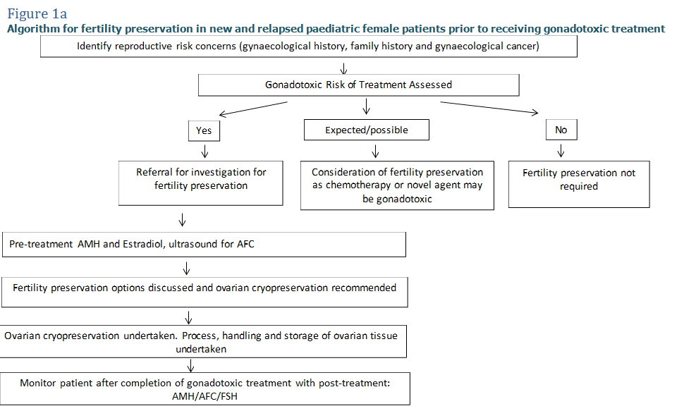

Figure: 1b Algorithm for the assessment of female paediatric patient’s reproductive potential following gonadotoxic treatment
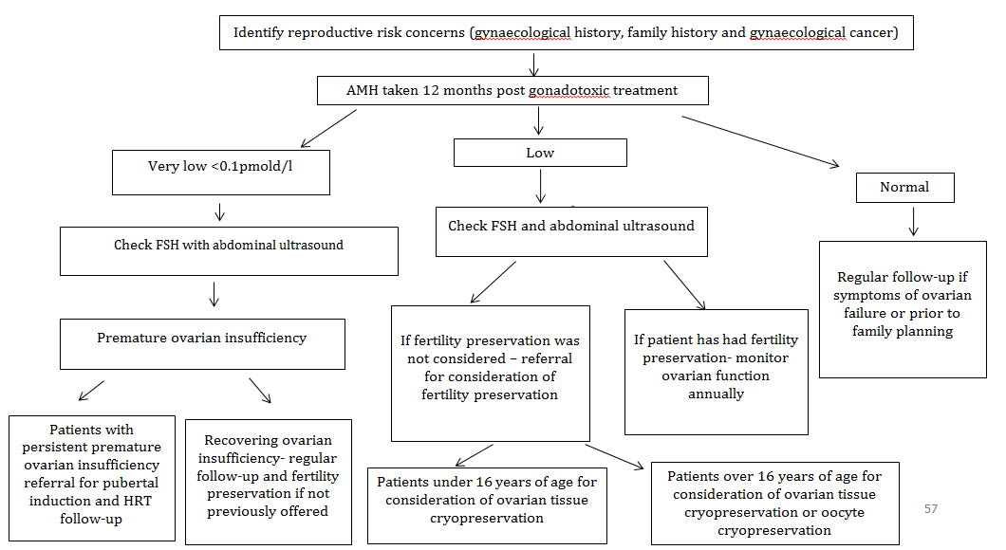
Figure 2a: Algorithm for fertility preservation in new and relapsed adolescent and young adult (AYA) female patients prior to receiving gonadotoxic treatment
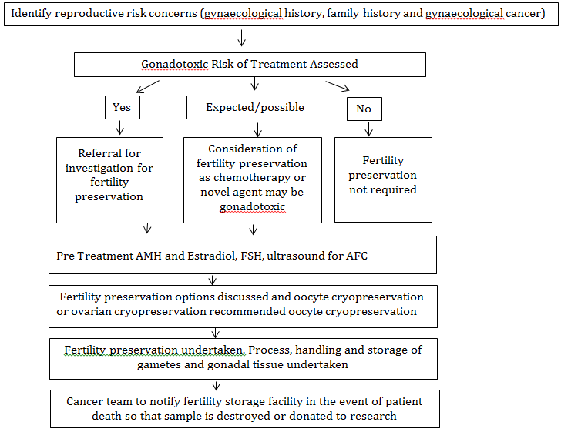

Figure 2b: Algorithm for the assessment of reproductive potential for adolescent and young adult (AYA) female patient’s following gonadotoxic treatment
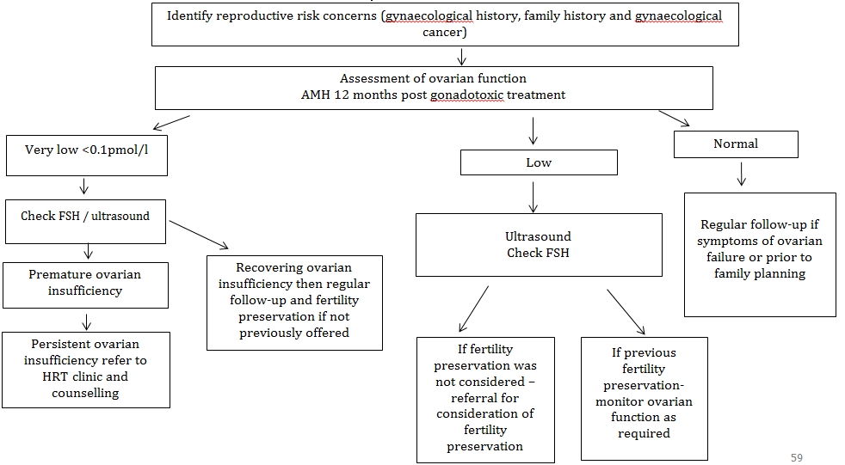

Figure 3a: Algorithm for fertility preservation in new and relapsed adult female patients prior to receiving gonadotoxic treatment

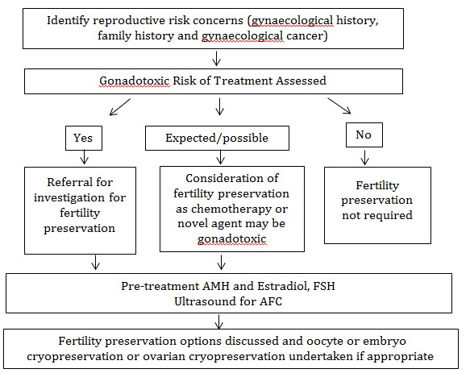

Figure 3b: Algorithm for the assessment of reproductive potential for adult female patient’s following gonadotoxic treatment

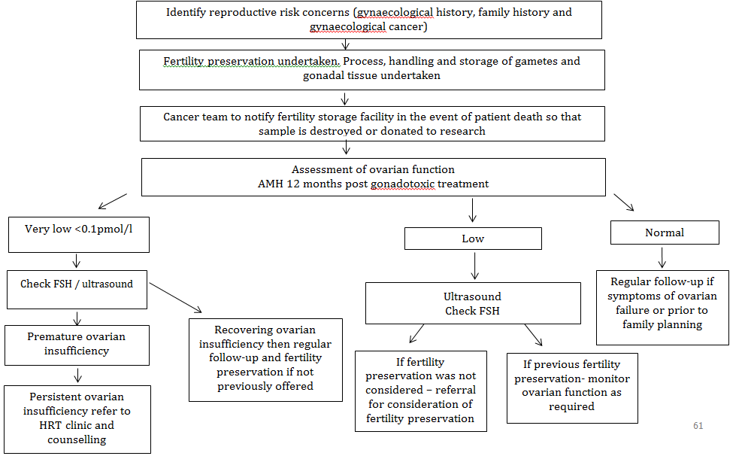

Figure 4a: Algorithm for fertility preservation in new and relapsed paediatric male patients prior to receiving gonadotoxic treatment
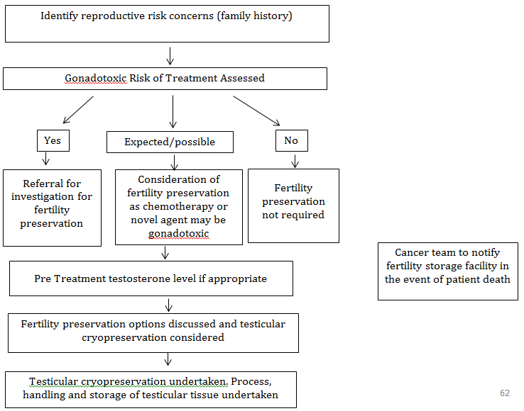

Figure 4b: Algorithm for the assessment of male paediatric patient’s reproductive potential following gonadotoxic treatment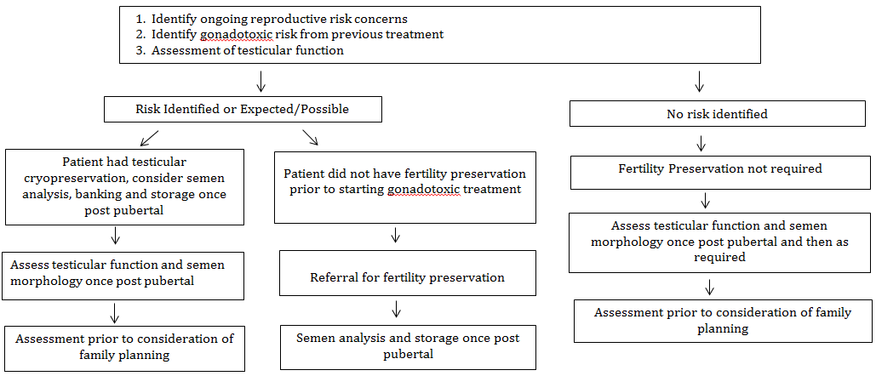

Figure 5a: Algorithm for fertility preservation in new and relapsed adolescent young adult and adult male patients prior to receiving gonadotoxic treatment
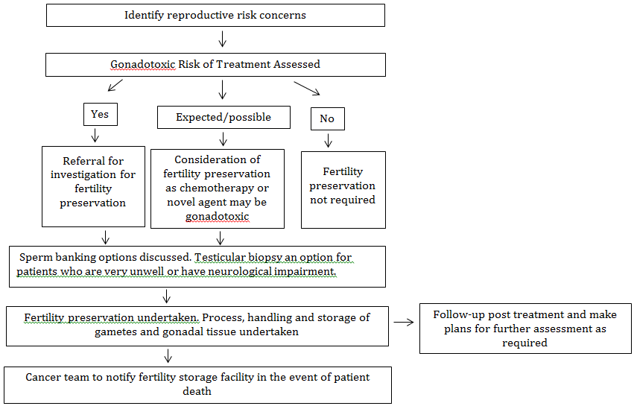

Figure 5b: Algorithm for the assessment of male adolescent young adult and adult patient’s reproductive potential following gonadotoxic treatment
