Public Summary Document
Application No. 1699 – National Lung Cancer Screening Program
Applicant: Cancer Australia
Date of MSAC consideration: 28-29 July 2022
Context for decision: MSAC makes its advice in accordance with its Terms of Reference, visit the MSAC website

1. Purpose of application
This application sought MSAC’s advice in relation to a proposed national lung cancer screening program (the Program) for Australia. The application was deferred by MSAC at its 31 March – 1 April 2022 meeting to seek the following information expeditiously:
- clarification regarding the validity of the Australian modelled economic evaluation
- an investigation of whether a lower ICER is achievable with adjustments to the definition of the population eligible for screening and/or screening intervals
- associated with and contingent on this, a more complete financial analysis of the proposed Program.
The requested additional information was provided in time for MSAC reconsideration of the application in July 2022.

2. MSAC’s advice to the Minister
After considering the strength of the available evidence in relation to comparative safety, clinical effectiveness, cost-effectiveness and total cost, MSAC supported the introduction of a National Lung Cancer Screening Program, including the creation of a new Medicare Benefits Schedule (MBS) item for low-dose computed tomography (LDCT) scans, to support the early detection of lung cancer in asymptomatic high-risk individuals. MSAC considered that its previous uncertainties regarding the economic and financial analyses of the proposed Program had been resolved. MSAC advised that the proposed screening should be on a biennial basis, with individuals eligible for the program being aged 50 to 70 years who have a history of cigarette smoking of at least 30 pack-years, and, if former smokers, had quit within the previous 10 years. MSAC advised that there was high certainty clinical evidence that the proposed Program would lead to a reduction in lung cancer mortality. MSAC also advised that the defined eligibility criteria produced an acceptable and robust incremental cost-effectiveness ratio (ICER) per quality-adjusted life-year (QALY) gained of approximately $65,000 as well as optimising the consequences for lung cancer deaths avoided, overdiagnoses, false positive diagnoses and total net cost to the Australian Government health budget.
MSAC supported the following new MBS item as part of the new Program:
Category 5 – DIAGNOSTIC IMAGING SERVICES
MBS item *56XXX
Computed tomography, low dose for lung cancer screening, without contrast material(s):
- Where the patient:
  - Is aged 50 to 70 years; and
  - Is asymptomatic (no signs or symptoms of lung cancer); and
  - Has a history of cigarette smoking of at least 30 pack-years; and
  - If a former smoker, has quit within the past 10 years.
- Where the service is reported by a specialist in the specialty of diagnostic radiology who:
  - Is available to monitor and influence the conduct and diagnostic quality of the examination; and
  - Is available, if necessary, to attend on the patient personally; and
  - Is involved in the ongoing supervision and interpretation of chest computed tomography acquisitions in the past 3 years.
- Where the service is performed at a comprehensive practice and the CT:
  - Performs LDCT with a volumetric CT dose index (CTDIvol) of ≤3.0 mGy (milligray) for a standard size patient (defined to be 170 cm and approximately 70 kg) with appropriate reductions in CTDIvol for smaller patients and appropriate increases in CTDIvol for larger patients; and
  - Utilises a standardised lung nodule identification, classification, and reporting system.
- Where information on the service must be submitted to a Department of Health approved register for each LDCT lung cancer screening performed with details on the patient (noting the register is still under development).
- (R) (Anaes.)
Eligible for screening every 2 years.
Fee: $302.10 Benefit: 75% = $226.60 85% = $256.80

Consumer summary
This application was from Cancer Australia to implement a national lung cancer screening program targeted to people who are at high risk of developing lung cancer. The screening component would be provided primarily through the Medicare Benefits Schedule (MBS).
The 31 March–1 April 2022 MSAC meeting deferred a decision pending more information from the applicant.
In its reconsideration, MSAC remained confident that the available evidence showed that the proposed Program would lead to a reduction in the number of deaths caused by lung cancer. Based on the further information supplied, MSAC was confident to rely on the results of the revised economic and financial analyses. MSAC used these analyses to judge the value for money and total net cost of the proposed Program to the Commonwealth government.
MSAC examined many options for defining the proposed Program. MSAC supported the proposal for biennial (every two years) screening and recommended that individuals eligible for the program be aged 50 to 70 years who have a history of cigarette smoking of at least 30 pack-years, and, if former smokers, had quit within the previous 10 years. MSAC advised that its recommendations for the Program would lead to acceptable value for money while also minimising the risk and costs of unnecessary further diagnostic tests and treatments.
MSAC also advised that its proposed eligibility criteria would be simpler to implement as well as better aligned with lung cancer screening programs in other countries and the key lung cancer screening trials provided as evidence for the effectiveness of lung cancer screening.
MSAC’s advice to the Commonwealth Minister for Health and Aged Care
MSAC supported the creation of a National Lung Cancer Screening Program, including a new item on the MBS to fund the LDCT scan. MSAC advised that the Program would be effective, safe and good value for money for individuals meeting MSAC’s proposed eligibility criteria.

3. Summary of consideration and rationale for MSAC’s advice
MSAC noted that this application was to re-consider an application for the proposed National Lung Cancer Screening Program in light of additional clarifying information, and to advise on its safety, effectiveness, cost-effectiveness and sustainable implementation if funded by the Australian Government.
The Program would support the early detection of lung cancer through the MBS listing of LDCT scans using existing radiology facilities. MSAC noted the proposed MBS item included a proposed fee of $302.10 based on the current MBS item for a CT chest scan. MSAC noted the application was for biennial screening of a population of current or former smokers aged 55–74 years (or 50–74 years for Aboriginal/Torres Strait Islander people) with a 6-year risk ≥1.51% based on the PLCOm2012 risk prediction tool. MSAC again supported the proposed specifications of LDCT service delivery, the proposed MBS fee, and the proposed nodule management system (PanCan for baseline nodule management and LungRADS for subsequent nodule management) associated with the Program.
MSAC recalled from its March–April 2022 meeting that the proposed Program demonstrated clinical effectiveness based on nine randomised controlled trials (RCTs) (including the large National Lung Screening Trial [NLST] started in 2002 and NELSON trial started in 2003), comprising a total of 90,000 participants. These studies showed that lung cancer screening reduces lung cancer mortality. A summary of the key effectiveness outcomes of these trials is provided in Table 1. Although the trials also showed that lung cancer screening does not decrease all-cause mortality, MSAC accepted as reasonable that the modelled economic evaluation does estimate a net increase in overall life-years gained (LYG).
Table 1: Comparative effectiveness outcomes of randomised controlled trials of LDCT-based lung cancer screening programs
Trial ID | Lung cancer deaths | Overall deaths | Lung cancers detected
AME 2013 |  |  | LDCT: 1.5% (51/3512)  Control: 0.3% (10/3145)
DANTE 2001 | LDCT: 4.7% (59/1264)  Control: 4.6% (55/1186)  HR: 0.99  95% CI: 0.69 to 1.43 | LDCT: 14.2% (180/1264)  Control: 14.8% (176/1186)  HR: 0.95  95% CI: 0.77 to 1.16 | LDCT: 8.23% (104/1264)  Control: 6.07% (72/1186)  p = 0.0418
DLCST 2004 | LDCT: 1.9% (39/2052)  Control: 1.9% (38/2052)  HR: 1.03  95% CI: 0.66 to 1.60 | LDCT: 8.0% (165/2052)  Control: 7.9% (163/2052)  HR: 1.02  95% CI: 0.82 to 1.27
ITALUNG 2004 | LDCT: 43 (29.3 per 10,000 person-years)  Control: 60 (42.1 per 10,000 person-years)  RR: 0.70  95% CI: 0.47 to 1.03 | LDCT: 154 (105.1 per 10,000 person-years)  Control: 181 (127.0 per 10,000 person-years)  RR: 0.83  95% CI: 0.67 to 1.03 | LDCT: 7 (49.9 per 10,000 person-years)  No screening: 1 (53.7 per 10,000 person-years)  RR: 0.93  95% CI: 0.67 to 1.30
LUSI 2007 | LDCT: 1.4% (29/2029)  Control: 2.0% (40/2023)  RR: 0.72  95% CI: 0.45 to 1.16 | LDCT: 7.3% (148/2029)  Control: 7.4% (150/2023)  RR: 0.98  95% CI: 0.79 to 1.22 | LDCT: 4.2% (85/2029)  Control: 3.3% (67/2023)  p = 0.16
MILD 2005 | LDCT: 2.3% (40/1723)  Control: 1.7% (40/2376)  p = 0.14 | LDCT: 6.2% (106/1723)  Control: 5.8% (137/2376)  p = 0.61 | LDCT: 3.5% (60/1723)  Control: 4.1% (98/2376)  p = 0.29
NELSON 2003 | LDCT: 156 (2.5 per 1000 person-years)  Control: 206 (3.3 per 1000 person-years)  RR: 0.76  95% CI: 0.61 to 0.94 |  | 5.2% (341 of 6583*)  *NELSON male cohort
NLST 2002 | LDCT: 247 deaths per 100,000 person-years  CXR: 309 deaths per 100,000 person-years  RRR: 20.0%  95% CI: 6.8% to 26.7% | LDCT: 1877  CXR: 2000  RRR: 6.7%  95% CI: 1.2% to 13.6% | LDCT: 645 lung cancers per 100,000 person-years  CXR: 572 lung cancers per 100,000 person-years  RR: 1.13  95% CI: 1.03 to 1.23
UKLS 2011 | LDCT: 1.5% (30/1987)  Control: 2.3% (46/1981)  RR: 0.65  95% CI: 0.41 to 1.02 | LDCT: 12.4% (246/1987)  Control: 13.4% (266/1981)  RR: 0.91  95% CI: 0.77 to 1.09 | LDCT: 4.3% (86/1987)  Control: 3.8% (75/1981)  RR: 1.15  95% CI: 0.84 to 1.57
Abbreviations: CXR = chest x-ray; HR = hazard ratio; LDCT = low dose computed tomography; RR = relative risk; RRR = relative risk reduction
Source: Table 3, Attachment 2, Attachments to the March-April 2022 Public Summary Document for MSAC Application 1699
MSAC also noted that all these RCTs enrolled participants with reference to age ranges that overlapped with those examined for the proposed Program and, except for one smaller RCT, all enrolled participants with reference to smoker history defined by pack-years and years since smoking cessation.
MSAC considered that the applicant had satisfied its previous concerns on the validity of the MISCAN modelled economic evaluation with respect to the U-shaped relationship between the risk threshold and the ICER per QALY. MSAC agreed with the applicant’s response, that this relationship was due to the effects of:
- the fixed Program costs which would not reduce with smaller high-risk populations being screened and thus contributing a greater proportion to incremental costs
- the fact that the PLCOm2012 risk prediction tool includes age, which means that, after reaching an optimal point as the inflection in this U-shaped relationship, the potential for overdiagnosis increases with increasing risk thresholds. This is because older people are more likely to meet these higher risk thresholds but are also more likely to be overdiagnosed as they face higher additional non-cancer mortality risks. The consequence of these factors is additional costs incurred and reduced QALYs gained from screening.
MSAC noted the applicant had therefore retained the structure of its economic MISCAN model but had appropriately respecified key parameter inputs in order to address MSAC’s remaining queries. These respecifications included:
- adopting a more realistic uptake assumption (reduced from 100% to 65%)
- taking into account the costs and consequences (including survival improvements) of contemporary treatment with immunotherapies and targeted therapies by stage of diagnosis using the most up to date MBS and Pharmaceutical Benefits Scheme (PBS) cost data and the application of hazard ratios to capture immunotherapy effects on overall survival
- adjusting fixed program costs for the first two years (limited period costs) to take into account additional information provided in the commentary on the initial application, resulting in increases in these limited period costs.
MSAC therefore had greater confidence in relying on this revision of the MISCAN model for its decision-making. MSAC also noted that the revised results were broadly consistent with those of other economic evaluations of lung cancer screening in the Australian context provided by the applicant as part of its additional information. MSAC noted that the results of the MISCAN model were also concordant with those from three other microsimulation models of lung cancer screening namely the Massachusetts General Hospital–Harvard Medical School model, the Lung Cancer Outcomes Simulation model from Stanford University, and the University of Michigan model.
MSAC noted that the additional information from the applicant included the results of this respecified MISCAN model as applied to a comprehensive set of screening scenarios by varying parameters of:
- the PLCOm2012 risk assessment tool
- eligibility criteria based on pack-years smoked and years since smoking cessation (hitherto known as NLST-like criteria as they adopted the structure of the criteria specified in the NLST trial but varied the numerical parameters defined for the NLST trial)
- alternative combinations of starting and stopping ages
- annual and biennial screening frequency.
The results of these modelled scenarios were relied on by MSAC to select the most appropriate specifications for a screening strategy for the proposed Program which ultimately led to MSAC supporting a differently specified target population from what was proposed in the application.
MSAC observed that in choosing the most appropriate scenario for the Program, some key trade-offs should be taken into account:
- higher risk thresholds are more efficient resulting in reduced costs, reduced false positive screens, reduced number of overdiagnoses (to a point), and reduced the incremental cost per QALY and the incremental cost per LYG. They also result in increased LYG per death prevented, increased QALYs gained per death prevented and increased deaths avoided per overdiagnosis
- on the other hand, although lower risk thresholds for screening are less efficient than higher risk thresholds, they result in increased numbers of extra lung cancer deaths avoided and increased numbers of extra LYG.
In explicitly basing its decision making on multiple factors, MSAC acknowledged that some of these factors were being considered more than once. For example, false positive screens are also accounted for in the ICER insofar as the costs associated with false positives were taken into account in estimating the ICER. The reason the MISCAN model did not attribute a utility or quality of life decrement to a false positive screening result was because the quality of life data in the NLST trial did not detect a statistically significant difference in those with false positive screening results. MSAC therefore acknowledged that separately taking the number of false positives into account necessarily involved an extra weighting of the cost and quality of life implications of false positives independently of their impacts on ICER per QALY, but considered that such extra weighting may be appropriate given the clinical context.
MSAC therefore relied on the respecified model to compare the various reported scenarios, referring to the additional information which separately reported results for each of these identified relevant factors. From these comparisons, MSAC sought to discern the optimal balance of Program performance across all the trade-off choices. It was on this basis that MSAC’s advice was formulated.
In particular, MSAC considered that several of these trade-offs can be discerned in the shape of the curves depicted in Figure 1. The blue curve and the orange curve represent the ‘efficient frontier’ for all scenarios and for biennial scenarios only, respectively. The efficient frontier contains only those scenarios which are ‘non dominated’ in the sense of providing the highest returns (in this case extra QALYs gained as represented on the vertical axis) for defined levels of incremental cost over no screening (as represented by the horizontal axis). The higher up on each curve a scenario is, the greater the extra QALY gained; the further to the left on each curve a scenario is, the smaller the incremental cost. The most efficient scenario is the one associated with the steepest line from the origin of the figure (where the vertical and horizontal axes meet) giving the most favourable ICER per QALY (the value on the horizontal axis divided by the value on the vertical axis). From this point the curves concave down from left to right and bottom to top because the gain in the QALY (movement up the vertical axis) is proportionately less than the increase in costs (movement to the right on the horizontal axis). The shape of these curves also demonstrates that more QALYs can be gained with other scenarios on the efficient frontier, but with less efficiency because the proportional increase in costs is greater for these other scenarios. As a result, there is lower marginal QALY gain with decreasing risk of individuals identified for screening.
Because the orange curve in Figure 1 (representing the efficient frontier for biennial screening scenarios only) is lower than the blue curve (representing the efficient frontier for all scenarios, which happens to contain only annual screening scenarios), Figure 1 also shows that annual screening scenarios are more efficient (in terms of ICER) than the corresponding biennial screening scenarios, though at higher risk thresholds these differences become smaller (i.e. the gap between the curves gets smaller when following them downwards and towards the left).

Figure 1: Screening scenarios on the efficient frontier for the analysis of all scenarios and the analysis of biennial scenarios only, assuming a 65% uptake rate; contemporary costs
MSAC considered that, in choosing the most appropriate scenario for the Program based on these results, there were five different modifiable elements of the intervention to consider defining:
- whether to have separate eligibility criteria for Aboriginal or Torres Strait Islander individuals compared to the general population
- whether to use inclusion criteria based on NLST-like criteria (i.e. pack-years smoked and years since smoking cessation if non-smoker) or PLCOm2012 criteria
- whether the frequency of screening should be annual or biennial
- if the decision is taken to adopt NLST-like criteria, what should be the minimum thresholds of number of pack-years and, if an ex-smoker, the number of years since smoking cessation
- what should be the minimum and maximum screening age thresholds.
MSAC advised against separate eligibility criteria for Aboriginal or Torres Strait Islander individuals, recalling that the ICER results for this subgroup were much less favourable than those for the general population. As these differences are mostly due to the reduced life expectancy in this population resulting in much greater proportions of overdiagnoses, MSAC considered that this reality should not be used to discriminate against this subgroup. MSAC also noted that its supported minimum screening age of 50 years for the general population (see below) matched that proposed in the application for this subgroup.
In relation to the most appropriate inclusion criteria, MSAC advised that adopting the approach of the NLST-like inclusion criteria be preferred over the approach of the PLCOm2012 criteria for the following reasons:
- they align with nearly all trials included in the evidence base
- they define the eligible patient population without reintroducing age as a factor in calculating the PLCOm2012 criteria and thus reduce the effect of the U-shaped relationship between the risk threshold and the ICER per QALY
- they are simpler for health practitioners to use, similar to the intent of definitions in existing Australian cancer screening programs, thus are more likely to improve screening feasibility and uptake
- they reflect the approach adopted in the US and Canadian lung cancer screening programs.
MSAC noted that adopting the NLST-like criteria would require the exercise of judgement because the type and volume of smoking varies over time, and smokers may attempt to quit several times. However, MSAC considered that these judgements were also implicit in completing the questionnaire to determine the PLCOm2012 criteria, so making them explicit was not a disadvantage for the NLST-like criteria.
MSAC noted that the approach of the NLST inclusion criteria generated similar efficiency results. For example, scenario NLST#11 (one of the two NLST-like criteria on the efficient frontier) had the lowest ICER per QALY gained of $60,606 (Table 2). This NLST scenario also had the lowest number of false positive screens (63,308) and overdiagnosed cancers (2464) and yet at the same time had the highest number of lung cancer deaths prevented per overdiagnosed case (2.54) and highest LYG per lung cancer death prevented (9.55) (Table 3). MSAC considered that these comparisons demonstrated that scenarios using NLST-like criteria were capable of at least comparable (and in this case superior) performance to scenarios using PLCOm2012 criteria on efficiency and clinical considerations.
Table 2: Characteristics of risk based (PLCO) and NLST-like screening scenarios on the efficient frontier assuming a 65% uptake rate; contemporary costs
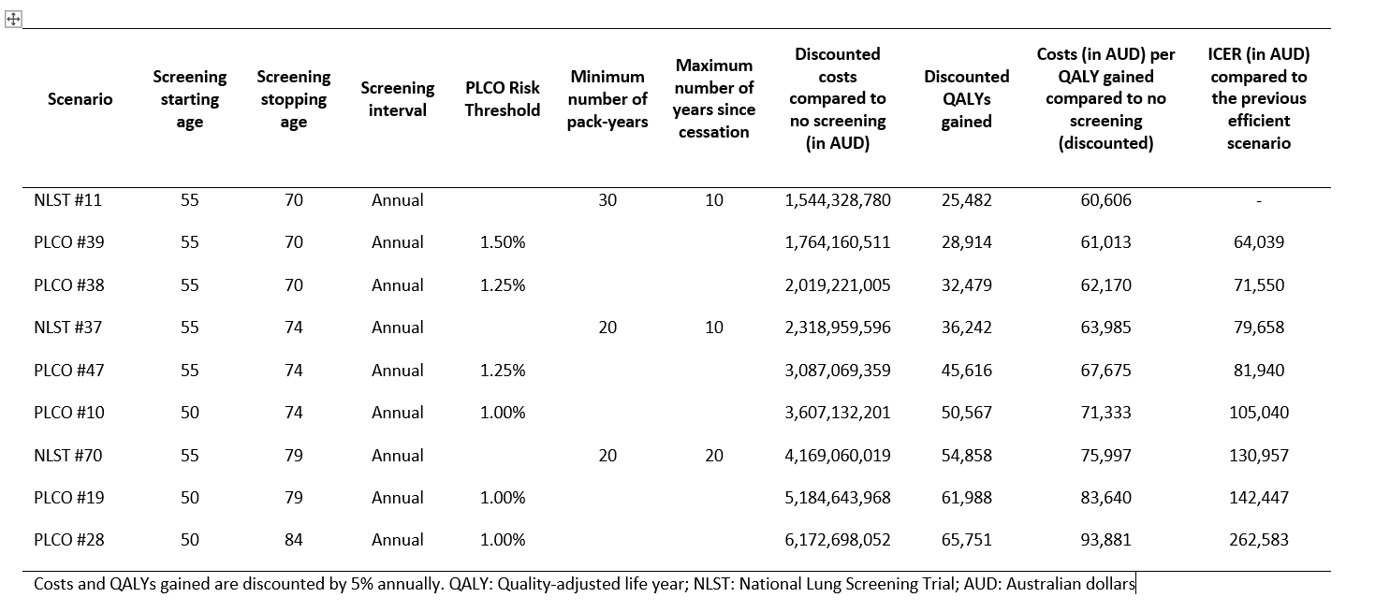

Table 3: Overview of selected outcomes of the risk based (PLCO) and NLST-like screening scenarios on the efficient frontier assuming a 65% uptake rate; contemporary costs
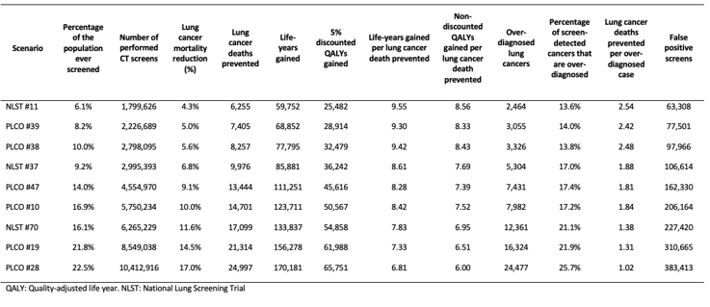
MSAC noted that, if its decision on which set of screening criteria to select were to be based solely on ICER per QALY, then the scenario NLST#11 depicted in Table 2 would have been the most appropriate and that would have concluded the basis for its advice. Under this scenario, current and former smokers (who quit ≤10 years ago) between ages 55 and 70 who smoked ≥30 pack-years would be screened annually.
In relation to the choice between annual screening and biennial screening, MSAC advised that adopting biennial screening be preferred for the following reasons:
- it aligns with the breast and colorectal cancer screening programs in Australia
- it is consistent with the design of the NELSON trial
- it is a more feasible and acceptable expectation for the screened population than annual screening.
Acknowledging that this screening frequency differs from those in the Canadian and US screening programs, and does not provide the most efficient scenarios, MSAC examined the consequences for the other identified relevant factors by comparing these outcomes of NLST#11 (annual screening) as seen in Table 2 against those of NLST#122, which is one of the non-dominated biennial screening scenarios modelled in Table 4 at MSAC’s request to focus the model on NLST-like screening scenarios only. This comparison was selected on the basis of having broadly similar coverage of the population (6.1% of the population for NLST#11 vs 6.2% for NLST#122). Further, with the exception of the maximum years since cessation criteria (NLST#122 specifies 15 years since cessation compared to 10 years for NLST#11), these two scenarios are well matched in terms of other eligibility criteria unrelated to screening frequency (i.e. similar starting and stopping screening ages, and similar numbers of pack years smoked). Compared to the annual scenario (NLST#11), the biennial scenario (NLST#122):
- was associated with two thirds the 6-year total net cost ($740 million vs $1.2 billion)
- had a slightly higher ICER per QALY ($65,728 vs $60,606)
- resulted in fewer lung cancer deaths prevented (4095 vs 6255)
- had fewer overdiagnoses (1563 vs 2464)
- had fewer false positives (34,790 vs 63,308)
- had more lung cancer deaths prevented per overdiagnosis (2.62 vs 2.54)
- had fewer false positives per lung cancer death prevented (8.5 vs 10.1).
MSAC noted from these findings that, while annual screening resulted in a lower ICER than biennial screening, biennial screening was associated with significantly lower total costs despite covering approximately a similar share of the population and was also associated with some improvements on a range of non-ICER related outcomes relating to false positives and overdiagnoses. This is also despite the fact that the biennial strategy had a lower risk threshold than the annual strategy it was being compared against (15 years since smoking cessation vs 10 years since smoking cessation). MSAC considered that these results demonstrated that scenarios based on biennial screening are at least comparable overall to scenarios based on annual screening in terms of economic, clinical and total cost outcomes.
Given MSAC’s choice of NLST-like criteria and a biennial screening frequency. MSAC next considered how the recommended NLST-like inclusion criteria should be specified. In selecting from the options, MSAC considered that the best approach was to start with the most cost-effective scenario in Table 4 (in this case NLST#116 which has an ICER per QALY of $65,584) which lists all the non-dominated biennial screening scenarios and examine how increases in risk thresholds affect the ICER and non-ICER outcomes.
Table 4: Characteristics of NLST-like biennial screening scenarios (simple non-dominated)
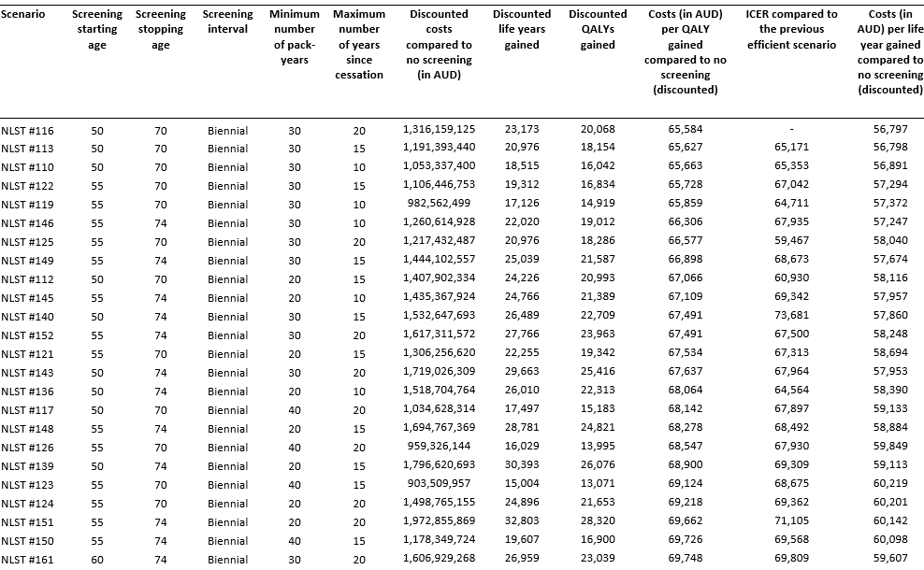
MSAC noted that the ‘top three’ scenarios in Table 4 in terms of lowest ICERs per QALY, namely NLST#116, NLST#113 and NLST#110, all had the same starting and stopping ages (50 and 70 years) but there was an increase in the risk thresholds in moving down the list:
- NLST#116 specifies 30 pack years and a maximum of 20 years since smoking cessation
- NLST#113 specifies 30 pack years and a maximum of 15 years since smoking cessation
- NLST#110 specifies 30 pack years and a maximum of 10 years since smoking cessation.
MSAC noted that based on these comparisons, increasing the risk threshold from 20 years since smoking cessation to 10 years since smoking cessation resulted in substantial reductions in the number of LDCT screens (from almost 1.5 million to around 900,000), false positives (from 47,134 to 28,914) and overdiagnoses (from 2057 to 1644) but only resulted in a small reduction in the number of lung cancer deaths prevented (from 5112 to 4080) – see Table 5. Discounted incremental costs associated with these three scenarios in Table 4 were also similar.
Table 5: Overview of selected outcomes of NLST-like biennial screening scenarios (simple non-dominated)
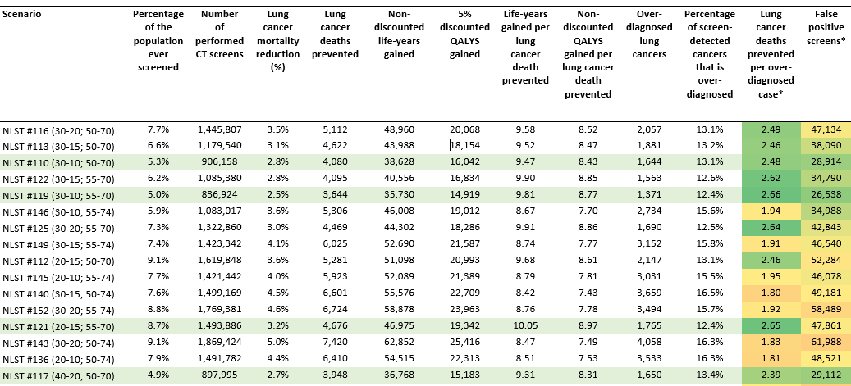
Accordingly MSAC advised that the NLST-like criteria be specified as a smoking history of 30 pack-years and if former smokers, 10 years or less since smoking cessation because scenarios using this specification relative to specifications based on lower risk thresholds yielded similar ICERs and discounted incremental costs, but more efficient outcomes in terms of measures of false positives, overdiagnoses and numbers of LDCT screens.
As a final step, MSAC considered the choice of the most appropriate starting and stopping ages. Starting the analysis by identifying the most cost-effective scenarios in terms of ICERs in Table 4 reduced this choice to two options: (a) a starting and stopping age of 50 and 70 years versus (b) a starting and stopping age of 55 and 70 years. This was because scenarios with a stopping age of 74 years on average tended to have higher total costs and higher ICERs, with the best scenario, NLST#146, having a stopping age of 74. MSAC therefore confined this aspect of its consideration to comparing NLST#110 against NLST#119 because:
- #110 has a starting and stopping age of 50 and 70 years and is the NLST scenario which would have been chosen based on the other specifications already recommended (biennial screening with inclusion criteria of 30 pack years and a maximum 10 years since smoking cessation)
- #119 has directly comparable inclusion criteria (30 pack years and a maximum 10 years since smoking cessation) but a different starting age of 55 and the same stopping age of 70 as well as being the biennial version of NLST#11 which was the annual screening scenario with the lowest ICER per QALY.
MSAC noted that although NLST#119 performed better than NLST#110 on the number of false positives (26,538 vs 28,914) and overdiagnoses (1371 vs 1644) and resulted in small savings in terms of the 6-year total net costs ($786M vs $799M), it resulted in a similar ICER ($65,859 vs $65,663) and performed worse on number of lung cancer deaths prevented (3644 vs 4080). Overall, MSAC considered that the performance advantages of the later starting age of 55 on these non-ICER based outcomes and the small savings in financial cost did not outweigh other advantages associated with a lower commencing age of 50 (given similar ICERs).
In addition, MSAC advised that the starting age of 50 years was preferable because it aligned with the starting age of the breast and colorectal cancer screening programs. MSAC also considered that, although its specification involved a lower stopping age of 70 (compared to 74 years in these other programs) this could also be justified given that the scenarios with a stopping age of 74 produced higher ICERs and higher total costs as already noted. The lower stopping age was also clinically justified given the competing risks and co-morbidities of the screened population (these competing risks and co-morbidities mean that a higher stopping age would be associated with a greater number of overdiagnoses which is also evident from Table 5).
MSAC noted that using the above parameters in combination would screen 5.3% of the population and yield the optimal combination of clinical, economic and total cost results. While increasing this percentage of the population screened (by changing the parameters) would result in more cancers being detected, it would also result in more overdiagnoses and more false positive results.
Combining all these steps, MSAC decided that the definitions for the overall optimal performance of the proposed Program were best represented by scenario NLST#110, with its specifications as defined in Table 4. To further scrutinise the specifications it had chosen, in Table 6 MSAC compared selected performance measures based on these parameters against performance measures for the available non-dominated scenarios which MSAC considered most resembled the existing US and Canadian lung cancer screening programs, namely PLCO#19 and PLCO#47, respectively (thus the values reported for the various performance measures in this table are for how these programs would perform if implemented in Australia rather than their actual outcomes in the US and Canada). MSAC considered that its supported NLST#110 compared favourably with lung cancer screening programs in these two other countries in terms of overdiagnoses, false positives and ICER.
Table 6: Comparison of consequences for an Australian Program of adopting other country definitions
Country | Frequency | Age  (years) | Smoking history (pack-years, cessation) | % of population covered, #CTs,  6-year cost | ICER/  QALY  (‘000s) | Deaths avoided  (‘000s) | Overdiagnosis/  False positives (‘000s)
Canada* | Annual**** | 55-74 | 30, <15 years | 14%, 4.6M, $4.0B | 68 | 13 | 7.4/162
US** | Annual | 50-80 | 20, <15 years | 22%, 8.5M, $7.5B | 84 | 21 | 16/311
Australia*** | Biennial | 50-70 | 30, <10 years | 5.3%, 0.9M, $0.8B | 66 | 4 | 1.6/29
* Values are estimated by PLCO#47 from The economic evaluation of targeted lung cancer screening in Australia: Response to request for additional analyses by MSAC. ICER value is from Table 12, % of population covered, numbers of CTs, deaths avoided, overdiagnosis and false positives are from Table 13, 6-year total net cost is estimated as the Australian cost divided by the Australian number of CTs multiplied by the Canadian estimated number of CTs
** Values are estimated by PLCO#19 from The economic evaluation of targeted lung cancer screening in Australia: Response to request for additional analyses by MSAC. ICER value is from Table 12, % of population covered, numbers of CTs, deaths avoided, overdiagnosis and false positives are from Table 13, 6-year total net cost is estimate as the Australian cost divided by the Australian number of CTs multiplied by the US estimated number of CTs
*** Values are for NLST#110 from The economic evaluation of targeted lung cancer screening in Australia: Additional analyses requested for NLST-like biennial scenarios only. ICER value is from Table 1, % of population covered, numbers of CTs, deaths avoided, overdiagnosis and false positives is from Table 2, 6-year total net cost is from Table 8.
**** The frequency of screening was assumed to be on an annual basis as per PLCO#19 and so does not fully reflect the reality of the Canadian approach, which recommends screening with three consecutive annual scans only.
To further contextualise the parameters it had chosen, in Table 7 MSAC compared its proposed program with other Australian cancer screening programs. these comparisons were obtained by translating the outcomes from the proposed Program into an annualised basis whereas the outcomes from the other programs were derived from Lew et al (2019). MSAC considered that this shows that lung cancer screening compares favourably or is similar to most of the other screening programs, especially in terms of deaths prevented (except with cervical before HPV and colorectal cancer screening), cost (lower than the others), and number needed to screen per death avoided (lower than the others).
Table 7: Comparison (annualised) of Australian cancer screening programs
Program | Cervical | Cervical post HPV | Breast | Colorectal | Lung
Number screened (M) | 2.47 | 1.34 | 0.89 | 1.44 | 0.11
Deaths prevented | 1185 | 153 | 580 | 2519 | 504
Cost ($M) | 223 | 126 | 316 | 1410 | 80 (Y6)
Number needed to screen per death avoided | 2085 | 8776 | 1528 | 572 | 85
Incremental cost per life-year gained ($) | 23,244 | 102,897 | 40,279** | 3,380 | 56,891
Cervical from Lew et al (2019) – 5 yearly HPV/cytology 25-74 years of age
Breast from Lew et al (2019) – biennial mammography 50-74 years of age, **underestimate, only includes BreastScreen costs, not costs for breast cancer treatment including to states/territories via the National Healthcare Reform Agreement
Colorectal from Lew et al (2019) – biennial iFOBT 50-74 years of age
MSAC recalled that it had deferred its consideration of the application to seek further information from the applicant including on whether a lower ICER closer to $20,000 was achievable by redefining population criteria and screening intervals. MSAC noted that it was now clear from the comprehensive modelling undertaken by the applicant that an ICER closer to $20,000 was not feasible for a lung cancer screening program. MSAC considered that while it had not accepted ICERs of $51,501/QALY to $83,545/QALY in the initial application, these previous ICERs were subject to considerable uncertainty. By contrast, MSAC considered that the base case ICER for MSAC’s supported scenario NLST#110 of $65,663/QALY associated with its chosen specifications, although in the same range, was based on a greater level of confidence than the initial consideration because it more plausibly included all the expected substantial cost and QALY consequences. MSAC therefore advised that this ICER was acceptable on the grounds of being comprehensively scrutinised and also contextualised in terms of other trade-offs across clinical benefits and health outcomes not fully captured in this ratio. MSAC considered that the more fully reported results (particularly for non-ICER outcomes) across all the potential candidate scenarios enabled it to make these trade-offs transparently when nominating the optimal scenario.
MSAC also advised that a higher but more robust base case ICER was acceptable in the context of related equity issues – in particular there is a higher risk of lung cancer in rural and remote settings, Australians of lower socioeconomic status and Aboriginal and Torres Strait Islander people. MSAC considered that an ICER of this magnitude was acceptable as a screening program that encompassed these groups. As noted in Table 7, the outcomes of the proposed Program are similar to, and in the case of some outcomes, superior to those of other Australian cancer screening programs. MSAC also noted the context of unavoidably high total costs and opportunity costs associated with screening programs and that there are also opportunity costs associated with not supporting this Program, e.g. it is more cost-effective to screen for and treat earlier-stage lung cancer than late-stage lung cancer. MSAC also queried whether economies of scale in CT scans may allow the MBS fee to be reduced at a later point in the Program’s delivery, which may result in a lower ICER in the future.
MSAC further advised that its acceptance of the base case ICER was influenced by the updated sensitivity analyses involving less conservative assumptions against the proposed Program. For example, that assuming an annual discount rate of 3% instead of 5%, a decrease in initial phase of care costs for stage I and II cancers of 20% and a life expectancy threshold of 5 years (i.e. assuming that people with a life-expectancy of less than 5 years would not uptake screening) the ICER decreased to as low as $39,059/QALY for NLST#110. In relation to the annual discount rate and other relevant factors, MSAC noted that the November 2019 Pharmaceutical Benefits Advisory Committee meeting had previously considered a 3.5% annual discount rate and other consequences beyond those captured in an ICER to be informative when considering a population-based intervention (a vaccine for meningococcal group B). However, MSAC also considered that it would not rely exclusively on an ICER based on a lower annual discount rate of 3% as it was more appropriate to compare the current base case ICER with the base case ICER from the initial application and with all other MSAC and PBAC applications relying on an ICER using the same annual discount rate of 5%.
MSAC considered from an equity perspective that it was appropriate that the ICER was agnostic of whether smoking induced lung cancer could be described as a self-inflicted disease. MSAC considered that the ethical issues raised by this description needed to be balanced against the addictive nature of smoking and that the timing of a decision to start smoking is far removed from the later negative consequences.
MSAC noted that the revised financial analyses were more comprehensive than those presented in the initial application. MSAC considered that these analyses were more plausible as they appropriately included downstream cost consequences including contemporary treatment costs. MSAC accepted that, for consistency with the economic evaluation, these analyses did not estimate the financial implications of a phased implementation of the proposed Program. MSAC noted that treatment costs decrease over the 6-year time horizon, due to an increase in earlier-stage detection enhancing the cost-effectiveness of treatment. MSAC also noted that the Program costs, including the relatively large upfront costs in years 1 and 2, would not change if the Program eligibility criteria changed.
MSAC considered that the cumulative net costs for the Commonwealth budget, which were $800 million over 6 years ($255 million in year 1 to $80 million in year 6 – see Table 8) represented a substantial opportunity cost for the government.
Table 8: MBS/PBS costs and program costs per year and category for the first 6 years (2023-2028) of a national lung cancer screening program for MSAC-supported screening scenario NLST#110: PY 30-10; 50-70 (non-discounted)
NLST#110: PY 30-10; 50-70 | Year 1 | Year 2 | Year 3 | Year 4 | Year 5 | Year 6 | Total
Additional treatment costs (MBS/PBS) | 30,472,378 | 48,803,023 | 36,585,782 | 27,863,446 | 19,796,900 | 12,647,954 | 176,169,483
False positive costs (MBS/PBS) | 1,932,026 | 1,664,694 | 3,385,061 | 3,010,902 | 3,329,703 | 2,884,823 | 16,207,210
LDCT screen costs (MBS/PBS) | 34,718,868 | 29,963,887 | 33,411,796 | 29,754,985 | 31,361,771 | 27,063,895 | 186,275,201
Follow-up LDCT costs (MBS/PBS) | 1,949,194 | 1,679,486 | 1,502,726 | 1,338,013 | 1,338,818 | 1,150,594 | 8,958,831
True positive diagnostic costs (MBS/PBS) | 2,274,070 | 2,192,416 | 2,006,975 | 1,864,438 | 1,820,409 | 1,694,325 | 11,852,632
First risk assessment costs (MBS/PBS) | 103,086,922 | - | - | - | - | - | 103,086,922
Re-risk assessment costs (MBS/PBS) | 5,212,529 | 4,498,638 | 5,016,291 | 4,467,274 | 4,708,510 | 4,063,247 | 27,966,488
Incidental findings costs (MBS/PBS) | 5,281,245 | 4,550,485 | 5,088,309 | 4,528,908 | 4,778,168 | 4,119,354 | 28,346,469
Total costs (MBS/PBS) | 184,927,231 | 93,352,628 | 86,996,940 | 72,827,967 | 67,134,278 | 53,624,192 | 558,863,236
Program costs | 70,298,654 | 70,298,654 | 23,682,794 | 24,998,504 | 25,145,554 | 25,310,986 | 239,735,146
Total costs | 255,225,885 | 163,651,282 | 110,679,734 | 97,826,471 | 92,279,832 | 78,935,178 | 798,598,382
MSAC was satisfied from the applicant’s modelling that moving from annual to biennial screening would not result in a significant reduction in total costs because:
- there would be fixed costs that would be incurred regardless of screening frequency
- annual screening would be associated with a greater magnitude of stage shift which would lead to greater uptake of cost-effective treatment.
MSAC recommended that the Program be reviewed in 5 years to ensure clinical effectiveness, safety and cost-effectiveness are realised, preferably with collection of relevant data in a registry, such as actual screening rates, to update the relevant factors considered by MSAC where possible. This review should therefore include a refresh of the modelled economic evaluation using relevant registry data and updated smoking rates, given that these are declining in Australia and may alter the related parameters of this Program in the future.

4. Further information on MSAC
MSAC Terms of Reference and other information are available on the MSAC Website: visit the MSAC website

Aberle DR, Adams AM, Berg CD, et al. Reduced lung-cancer mortality with low-dose computed tomographic screening. N Engl J Med. 2011 Aug 4;365(5):395-409.
De Koning H, Van Der Aalst C, Ten Haaf K, Oudkerk M. PL02.05 Effects of Volume CT Lung Cancer Screening: Mortality Results of the NELSON Randomised-Controlled Population Based Trial. Journal of Thoracic Oncology. 2018;13(10):S185.
Meza R, Jeon J, Toumazis I, et al. Evaluation of the Benefits and Harms of Lung Cancer Screening With Low-Dose Computed Tomography: Modelling Study for the US Preventive Services Task Force. JAMA. 2021 Mar 9;325(10):988-997.
Two provincial screening programs in Canada now use a two-stage approach with PLCOm2012 as the second stage assessment of risk.
All these values can be read off Tables 2, 3, 4 and 5 (false positives per lung cancer death prevented can be calculated from the values provided for each of these scenarios) except the 6-year total net costs, which were obtained from Table 22 of The economic evaluation of targeted lung cancer screening in Australia: Response to request for additional analyses by MSAC (for NLST#11), or calculated as the NLST#11 cost divided by the NLST#11 number of CTs multiplied by the NLST#122 number of CTs (for NLST#122).
All of these figures are from Tables 4 and 5 with the exception of the 6-year total net costs which are from Tables 7 and 8 of The economic evaluation of targeted lung cancer screening in Australia: Additional analyses requested for NLST-like biennial scenarios only.
Lew JB, Feletto E, Wade S, et al. Benefits, harms and cost-effectiveness of cancer screening in Australia: an overview of modelling estimates. Public Health Res Pract. 2019 Jul 31;29(2):e2921913.
The number of screens per year was estimated by dividing the total number of screens for birth cohorts born in 1945 to 1969 (906,158) by the number of years of screening per person (8.1). The first value (906,158) was an output of the MISCAN model. The second value was estimated by first estimating the total number of screening rounds each individual within the birth cohort would undertake over their lifetime (81) and dividing this by the number of cohorts that would be screened in a year (10).
The annual number of deaths prevented was estimated by dividing the number of lung cancer deaths prevented across birth cohorts (4080) by the number of years of screening (8.1). The first value is a direct output of the model and is also reported in Table 5 and the second value was estimated as per the previous footnote.
The cost is as reported in Table 8 (rounded up to the nearest $10m).
The NNS per death avoided was estimated by dividing the total number of people screened over their lifetime (346,500) by the number of lung cancer deaths prevented. The first value was estimated by the product of the percentage of people ever screened (5.25% which is a direct output of the model and can also be read off Table 5 where it has been rounded up) by the total number of births between 1945 and 1969 which is the MISCAN model population (6,600,000 which is a direct output of the model).
The ICER per LYG was a direct output of the model and is from the corrected Table 1 of The economic evaluation of targeted lung cancer screening in Australia: Additional analyses requested for NLST-like biennial scenarios only.
Table 4 of The economic evaluation of targeted lung cancer screening in Australia: Additional analyses requested for NLST-like biennial scenarios only.

