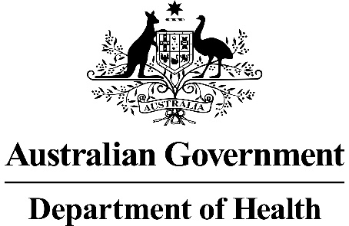

Application 1551:
Aspiration therapy via insertion of a customised percutaneous endoscopic gastrostomy tube into the stomach for weight loss management in obese patients with a BMI ≥ 35 kg/m²

Ratified PICO Confirmation

Summary of PICO/PPICO criteria to define the question(s) to be addressed in an Assessment Report to the Medical Services Advisory Committee (MSAC)
Component | Description
Patients | Obese patients with a body mass index (BMI) ≥35 kg/m² and comorbidities. Patients would have failed to achieve or maintain adequate weight loss with lifestyle modifications or intensive interventions such as very low-energy diets and/or pharmacotherapy. Patients must undergo psychological support and/or counselling prior to commencing aspiration therapy.
Intervention | Placement, removal and adjustment of a percutaneous endoscopic gastronomy tube (A-Tube™) required as part of aspiration therapy for weight loss in obese patients.  Aspiration therapy is a method for managing food portion control by the removal of ingested food from the stomach.
Comparators | PASC outlined two comparators as being relevant to the primary assessment of aspiration therapy:  - Laparoscopic adjustable gastric band (LAGB).  - Sleeve gastrectomy  PASC further outlined that if patients with a high BMI (>55 kg/m²) seek to become eligible for placement, removal and adjustment of a percutaneous endoscopic gastronomy tube through the MBS, a separate comparator will be needed.
Outcomes | Key patient-relevant outcomes include:  - Excess weight loss (%EWL) from use of aspiration therapy at 52-weeks  - Absolute weight loss from use of aspiration therapy at 52-weeks  - Weight loss at follow-up of 5 years to assess durability of benefit of aspiration therapy  - Incidence of device-related, procedure-related and therapy-related adverse events from the use of aspiration therapy.  Key healthcare system outcomes include:  - Proportion of patients who discontinue treatment and have the A-Tube™ removed over time  - Proportion of patients requiring A-Tube™ replacement over time  Further outcomes applicable to the assessment of the efficacy and safety of aspiration therapy are outlined in the ‘Outcomes’ section.
PICO or PPICO rationale for therapeutic and investigative medical services only
Population
The applicant is seeking an MBS item for the placement of a percutaneous gastrostomy tube (A-Tube™) in obese patients with a body mass index (BMI) ≥35 kg/m² and comorbidities.
A key determinant of patient eligibility for the placement of the A-Tube™ funded through the MBS is having a BMI ≥35 kg/m². BMI is a weight-for-height index used to classify weight in adults. The thresholds defining whether a patient is underweight, healthy weight, overweight or obese defined in the WHO classifications (WHO, 2000) are presented in Table 1. Based on the WHO thresholds, the placement of an A-Tube™ funded through the MBS would be limited to patients with obesity class II and III.
Table 1: Body mass index classification in adults
BMI (kg/m2) | Classification
< 18.5 | Underweight
18.5–24.9 | Healthy weight range
25.0–29.9 | Overweight
30.0–34.9 | Obesity I
35.0–39.9 | Obesity II
≥ 40.0 | Obesity III
Source: Table 4.1 (p. 52) of (NHMRC, 2013) from (WHO, 2000)
Based on 2014-15 data reporting on the prevalence of obesity in Australia, 28% of Australian adults were obese (BMI ≥30 kg/m²). Further disaggregation of the prevalence of obesity reports that: 18% of adults were classified as obesity class I; 6% as obesity class II; and 3% as obesity class III (AIHW, 2017).
The distribution of BMI between men and women shows that despite a higher proportion of Australian men (71%) being classified as overweight or obese than women (56%), there is a modest increase in the proportion of women with a BMI ≥35 kg/m² and eligible to have placement of an A-Tube™ funded through the MBS as requested (Figure 1).
Figure 1: Distribution of body mass index in Australian adults by sex 2014-15
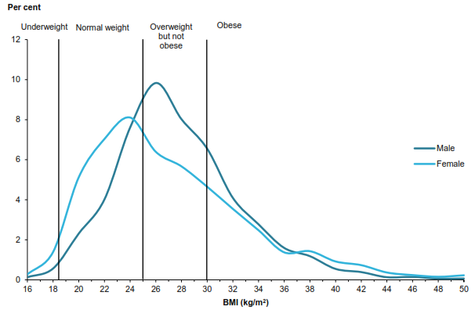Source: Figure 4.2 (p.16) of (AIHW, 2017)
The 2014-15 prevalence data for obesity in Australia shows that approximately 9% of the Australian adult population would have a BMI ≥ 35 kg/m². Based on a 2018 adult population (age ≥ 18 years) of 19,529,153 (ABS, 2013), it is estimated that 1,757,624 Australian adults would have a BMI ≥35 kg/m².
Rationale for patient population
Under the proposed MBS item descriptor, the placement of the A-Tube™ could be funded through the MBS regardless of a patient’s age. Not restricting access to the procedure based on patient age is consistent with existing MBS items for weight loss surgery (31569 – 31581). However, the completed clinical studies assessing the efficacy and safety of aspiration therapy have been undertaken in a patient population aged 21 years or over. A clinical study of aspiration therapy in adolescents (aged 16 to 21 years) is ongoing, with an anticipated end date of March 2019.
The applicant has nominated that aspiration therapy (facilitated via placement of the A-Tube™) is for patients “over 18 years of age, who are obese and have a BMI between 35 and 65, and who have failed to achieve and maintain weight loss with non-surgical weight loss therapy” (p. 12 of MSAC Application Form). This context of use is broadly consistent with key inclusion criteria for patients to enrol in a randomised controlled trial of aspiration therapy, reported in the supplement to (Thompson et al., 2017) of:
- Measured BMI of 35 - 55 kg/m² at time of screening
- 21 – 65 years of age at time of screening
- Failed attempt at weight loss for a duration equal to 3-months, by alternative approaches (e.g. supervised or unsupervised diets, exercise, behavioural modification programs).
Data from a single-arm pilot study of aspiration therapy in super-obese (BMI >55 kg/m²) adults has also been reported (MacHytka et al., 2017).
PASC has requested that the submission include a definition and overview of non-surgical weight loss methods which may be attempted prior to being considered for aspiration therapy, as well the role of psychological support and counselling in the management of patients, before aspiration therapy.
Current approach to patient management within patient population
Obesity is a multi-factorial condition requiring the involvement of a variety of experts in a multidisciplinary care team. As outlined in the Australian clinical practice guidelines for the management of obesity (NHMRC, 2013), the usual initial healthcare provider is a GP or practice nurse. Dietitians, psychologists, exercise physiologists and diabetes educators may be involved in supporting patients with obesity depending on a patient’s clinical characteristics.
When a patient expresses readiness for behavioural change, lifestyle modifications incorporating reduced energy intake and increased physical activity are recommended as the initial management approach for patients with obesity (NHMRC, 2013). Lifestyle modifications are suited for delivery in the primary healthcare setting and may be augmented by measures designed to support the behavioural changes such as goal setting and cognitive restructuring techniques.
For patients who do not achieve sustained weight loss through lifestyle modification, intensive interventions include very low-energy diets, weight loss medications (pharmacotherapy), and bariatric surgery. Intensive interventions are considered as an adjunct to lifestyle interventions of reduced energy intake and increased physical activity. The Australian clinical practice guidelines for the management of obesity outline that intensive interventions are likely to be used sequentially, starting with a very low-energy diet to achieve weight loss before using medications to help counter the hormone changes and increased hunger that follows weight loss.
Very low-energy diets involve replacing one or more meals a day with foods or formulas providing a specific number of kilojoules and are associated with rapid weight loss and onset of ketosis which may supress hunger. Due to the potential for rapid change in nutritional intake, careful monitoring of patients on very low-energy diets is required, including the conduct of liver function tests, lipid profile measurements, full blood count and iron studies, along with levels of electrolytes, creatinine and uric acid prior to starting. Electrolyte and creatinine levels are also recommended to be checked about 6 weeks after starting the diet, or earlier if more careful monitoring is required (e.g. in people who have renal impairment or are using diuretics) (NHMRC, 2013). Due to the monitoring and testing requirements associated with very low-energy diets, this intervention should be applied under the supervision of a patient’s GP.
Pharmacological treatments for patients with obesity include orlistat and phentermine. Orlistat is available as a pharmacy only medicine without prescription or via prescription through the RPBS (available to holders of Veterans’ health cards only). Phentermine is a prescription only medicine and is not listed on the PBS. The indications for orlistat and phentermine as outlined in the TGA Product Information is given in Table 2.
Table 2: TGA-approved indications for weight loss medications
Treatment (Brands) | Indication
Phentermine (Duromine, Ionamin, Phentermine Resin) | Indicated in the management of obesity as a short-term adjunct in a medically monitored comprehensive regimen of weight reduction based, for example, on exercise, diet (caloric/kilojoule restriction) and behaviour modification in obese patients with a body mass index (BMI) of 30 kg/m² or greater. The treatment with phentermine can be initiated in overweight patients with a lower BMI (25 to 29.9 kg/m²), which increases the risk of morbidity from a number of disorders. Secondary organic causes of obesity should be excluded by diagnosis before prescribing this agent.
Orlistat (Xenical, Xenistat, Orlistat GPPL, Prolistat, ALLI) | Indicated for the treatment of obese patients with a body mass index (BMI) ≥ 30, and overweight patients with a BMI ≥ 27 in the presence of other risk factors, in conjunction with a mildly hypocaloric diet.

Bariatric surgery is not outlined as being an immediate consideration unless other interventions have been unsuccessful or are contraindicated, or a patient’s BMI is >50 kg/m². Bariatric surgery is a form of weight loss surgery which aims to reduce the intake of food by reducing gastric capacity and/or reducing uptake of energy by reducing exposure to the small bowel absorptive area. Bariatric procedures described in the Australian clinical practice guidelines for the management of obesity (NHMRC, 2013) are:
- Laparoscopic adjustable gastric banding (LAGB): Involves placing a band around the stomach near its upper end to create a small pouch. This restricts intake of food. The band can be tightened or loosened over time to change the extent of restriction.
- Sleeve gastrectomy: Involves removing the greater portion of the fundus and body of the stomach, reducing its volume from up to 2.5 L to about 200 mL. This procedure provides fixed restriction and does not require adjustment like LAGB.
- Roux-en-Y gastric bypass (RYGB): A combination procedure in which a small stomach pouch is created to restrict food intake and the lower stomach, duodenum and first portion of the jejunum are bypassed to produce modest malabsorption of nutrients and thereby kilojoule intake.
- Biliopancreatic diversion: A combination procedure that involves removing the lower part of the stomach, and bypassing the duodenum and jejunum to produce significant malabsorption.
To achieve and maintain weight loss patients undergoing bariatric surgery should also apply lifestyle modifications including reduced energy intake and increased physical activity. Psychological support and counselling may also play an important role in the management of patients prior to and following bariatric surgery.
Whilst bariatric surgery would be undertaken by a surgeon as part of an hospital inpatient episode, primary healthcare professions have a role in the ongoing care of patients through the monitoring and treatment of any co-morbidities, assessing nutritional status (including micronutrient and vitamin testing), and continuing to promote the benefits of reduced energy intake and increased physical activity.
Intervention
Aspiration therapy is a treatment for obesity providing patients with a method for managing food portion control at the level of the stomach. Portion control is achieved by the removal of ingested food from the stomach thereby preventing its delivery into the small intestine for absorption.
This application relates to the use of the AspireAssist™ system (Aspire Bariatrics) as part of the management of a patient with obesity with aspiration therapy. The AspireAssist™ system is comprised of two key components (Figure 2):
- A modified percutaneous endoscopic gastronomy (PEG) tube (A-Tube™)
  - The A-Tube™ must be placed in a patient via an endoscopic procedure.
  - One end of the A-Tube™ is placed in the patient’s stomach allowing aspiration of the stomach contents.
  - The other end of the A-Tube™ has a specifically designed adapter (Skin-Port™) containing a valve which is normally closed to prevent leakage.
- The AspireAssist device used to aspirate the contents of the stomach out via a connector which attaches to the Skin-Port.
  - Aspiration is recommended approximately 20 minutes after each meal. Aspiration is initiated by attaching the connector to the Skin-Port, opening the closed Skin-Port valve. Stomach contents flow out of the stomach through the drain tube into the toilet bowl. Remaining food may be flushed out through the A-Tube™ by flipping a lever on the Companion allowing water to be infused into the stomach from the water reservoir and then reversing the flow allowing stomach contents to drain out of the A-Tube™.
Figure 2: Components of the AspireAssist system used in aspiration therapy
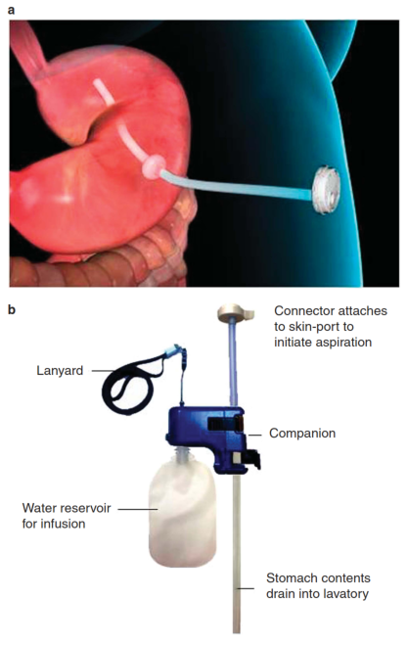
Source: Figure 1 (p. 449) of (Thompson et al., 2017)
a: AspireAssist A-Tube™ with Skin-Port; b: AspireAssist device used to aspirate stomach contents
The applicant has advised that a decision to have the ApsireAssist system included on the Prostheses List has been put ‘on hold’ by the Prostheses List Advisory Committee (PLAC) pending the availability of an MBS item associated with the endoscopic placement of the A-Tube™. As such, this application relates specifically to the creation of an MBS item for the insertion of a customised percutaneous endoscopic gastrostomy tube into the stomach for weight loss management in obese patients.
The placement of a percutaneous endoscopic gastrostomy tube (A-Tube™) can be undertaken by a gastroenterologist or endoscopically-trained surgeon in an endoscopy suite (outpatient procedure).
The process for placing the A-Tube™ for patients enrolled in a randomised controlled trial of aspiration therapy (PATHWAY study) is outlined below.
“A routine upper endoscopy, which includes examination of the esophagus, stomach and the proximal duodenum, is performed. The tip of the endoscope is then positioned in the gastric body or antrum of the stomach, and the A-Tube™ exit site is prepped and draped in sterile fashion. The site for A-Tube™ placement should be identified by both transillumination and finger indentation. The skin and subcutaneous tissue at the exit site area is injected with an anesthetic, and a small (<1-cm) horizontal skin incision is made by using a scalpel. The safe tract technique (no air bubbles observed after inserting a needle with syringe containing several ml of saline or anesthetic until the needle is visualized in the gastric lumen) should be used to ensure no intervening loop of bowel is present between the stomach and the anterior abdominal wall. A metal stylet with a plastic sheath is passed through the abdominal wall into the gastric lumen. After removing the inner stylet, a wire is passed through the plastic sheath into the stomach lumen. The wire is grasped with a snare, and both the endoscope and wire are removed through the mouth. The A-Tube™ delivery system is attached to the oral portion of the wire and pulled through the abdominal wall exit site. The endoscope is passed into the stomach again to confirm proper placement of the tube and internal bumper. Endoscopic photographic imaging will be performed at the end of the procedure to document proper A-Tube™ placement.
After endoscopic A-Tube™ placement is completed, subjects are observed in the recovery area of the endoscopy suite or admitted to the hospital for up to 24 h, at the discretion of the physician performing the procedure.” (pp. 24-25 of PATHWAY study protocol provided as a supplement to Thompson et al., 2017).
Placement of a percutaneous endoscopic gastrostomy tube (A-Tube™) takes approximately 20 minutes and may occur under sedation. As per the protocol for the placement of the A-Tube™ in the PATHWAY trial, the choice of specific sedative and decision whether an anaesthetist should be present during the procedure is left to the discretion of the endoscopist based on the patient’s risk of apnoea and other complications.
Upon completion of the placement of the percutaneous endoscopic gastrostomy tube patients would wait approximately 14 days before having a follow-up visit where: the Skin-Port is attached; patients receive training on the use of the AspireAssist device; and patients are instructed to commence aspiration of the stomach contents following meals. This follow-up visit would take place in the treating physician’s consulting rooms.
The placement of the percutaneous endoscopic gastrostomy tube (A-Tube™) is procedurally consistent with the conduct of a percutaneous gastrostomy under MBS items 30481 (initial procedure) and 30482 (repeat procedure). However, as MBS items 30481 and 30482 exclude the insertion of a device for the purposes of facilitating weight loss the placement of an A-Tube™ associated with aspiration therapy is not permitted under existing item numbers. The descriptor and fee associated with MBS item 30481 is outlined in Table 3 for reference.
Table 3: MBS item 30481 descriptor for percutaneous gastrostomy
MBS item 30481
PERCUTANEOUS GASTROSTOMY (initial procedure):

(a) including any associated imaging services; and
(b) excluding the insertion of a device for the purpose of facilitating weight loss (Anaes.)

(See para TN.8.17 of explanatory notes to this Category)
Fee: $357.00 Benefit: 75% = $267.75 85% = $303.45

The placement of the A-Tube™ is fully reversible, and patients may require the A-Tube™ to be removed in several circumstances, such as: achieving goal weight loss and ceasing aspiration therapy; not achieving goal weight loss and deciding to cease aspiration therapy and pursue alternative treatments (e.g. bariatric surgery); or experiencing an infection/blockage of the A-Tube™. The removal of the A-Tube™ would be undertaken by a gastroenterologist or endoscopically-trained surgeon in an endoscopy suite (outpatient procedure) under sedation or general anaesthesia.
Whilst a patient is being managed with aspiration therapy and achieving weight loss, they are likely to require intermittent shortening of the A-Tube™ to ensure the Skin-Port™ is sitting flush with the body. Shortening of the A-Tube™ can be undertaken by the managing clinician in their consulting rooms, as part of routine follow-up and monitoring of patients being managed with aspiration therapy. No sedation or anaesthesia is required for the shortening of the A-Tube™.
Comparator
The applicant proposed that aspiration therapy will most likely be used for a group of patients who have not achieved sustained weight loss, after lifestyle interventions, very low-energy diets and pharmacotherapy. The characteristics of these patients is consistent with characteristics of patients for whom treatment with bariatric surgery would be considered. Several bariatric surgical procedures are currently listed on the MBS for weight loss. Utilisation statistics on bariatric procedures funded through the MBS in the last full calendar year are presented in Table 4.
Table 4: Bariatric procedures processed through the MBS: January 2017-December 2017
MBS Item # | Procedure | Total services | % Total
31569 | Laparoscopic adjustable gastric band | 1,348 | 6%
31572 | Gastric bypass by Roux-en-Y | 2,915 | 13%
31575 | Sleeve gastrectomy | 18,493 | 79%
31578 | Gastroplasty | 381 | 2%
31581 | Gastric bypass by biliopancreatic diversion | 157 | 1%
Total | - | 23,294 | 100%
Note: These MBS items may be claimed when undertaking the initial procedure as well as the reversal/revision of the procedure (when co-claimed with MBS Item 31584).
The utilisation of MBS items associated with bariatric procedures funded through the MBS in the last full calendar year are presented in Table 5.
Table 5: Items associated with bariatric procedures processed through the MBS: January 2017-December 2017
MBS Item # | Procedure | Total Services
20791 | Initiation of anaesthesia for bariatric surgery | 24,189
31584 | Surgical reversal of laparoscopic adjustable gastric band, gastric bypass, gastroplasty or biliopancreatic diversion | 3,842
31587 | Adjustment of gastric band | 61,675
31590 | Adjustment of gastric band reservoir | 422
Total | - | 90,128

The applicant outlined that aspiration therapy would be used somewhere between pharmacotherapy and use of a laparoscopic adjustable gastric band (LAGB). The reversible nature of aspiration therapy (via removal of the A-Tube™) and LAGB (via removal of the gastric band) is specified as the rationale for nominating LAGB as the only possible comparator. If a patient elects to undergo aspiration therapy, it is likely this would replace the use of LAGB (or other bariatric procedures) in most patients. At the December 2018 meeting, PASC considered that aspiration therapy would be an add-on to current bariatric procedures, rather than a replacement, as it is designed as a temporary measure.
The applicant also outlined a potential role for aspiration therapy in a subgroup of patients who are morbidly obese, making the use of a general anaesthetic (which is necessary for bariatric surgery) too high risk. In these patients, the placement of the A-Tube™ under sedation and use of aspiration therapy would be in the context of facilitating weight loss, in order to then become suitable for bariatric surgery. In this scenario, aspiration therapy would be used in addition to other bariatric procedures. PASC noted that, if patients with high BMI are included, a separate comparator will be required.
Rationale
Based on the number of MBS items claimed in 2017, the use of LAGB as a bariatric procedure (6% of total services) is substantially lower than sleeve gastrectomy (79% of total services). Noting that a key difference between aspiration therapy and sleeve gastrectomy is that aspiration is fully reversible (and does not involve making significant changes to the patient’s anatomy), it is likely that, in broader clinical practice, some patients would consider aspiration therapy an alternative to sleeve gastrectomy. In this context, sleeve gastrectomy (as a bariatric comparator) may represent an appropriate comparator on the basis of it being the procedure most likely to be replaced with aspiration therapy in Australian clinical practice.
At its December 2018 meeting, PASC accepted the proposed comparator of LAGB. PASC also identified sleeve gastrectomy as an additional appropriate comparator, given this is the most common bariatric procedure in Australia.
Separate applications seeking MBS listing of alternate weight loss surgeries are currently being considered through the MSAC assessment process:
- MSAC Application 1515: Endoscopic placement and removal of an intra-gastric balloon (IGB) for the management of overweight and obesity in a high-risk patient (considered at August 2018 PASC meeting).
- MSAC Application 1555: Endoscopic Sleeve Gastroplasty (ESG) for the treatment of patients with Class I and Class II obesity with comorbidities who have failed first-line treatments (scheduled for assessment at same PASC meeting as aspiration therapy).
The MSAC application webpage for the placement and removal of an IGB (MSAC Application 1515) states that the application is focussed on patients with a BMI ≥30 and <35 kg/m² with complications, such as high blood pressure and diabetes.
The MSAC application for endoscopic sleeve gastroplasty is seeking MBS listing for patients with a BMI of 30.0-39.9 mg/kg² with comorbidities is also under MSAC assessment (MSAC Application 1555).
The patient populations proposed to be eligible for aspiration therapy, intra-gastric balloon and endoscopic sleeve gastroplasty are not entirely consistent. However, there is a degree of overlap with regards to the proposed patient populations proposed for each of these treatments as well as existing bariatric procedures listed on the MBS (Table 6)
Table 6: Patient population characteristics of weight loss surgeries available on the MBS and under MSAC assessment
- | Bariatric procedures listed on the MBS | Aspiration therapy | Intra-gastric balloon | Endoscopic sleeve gastroplasty
BMI criteria | Noneª | ≥35 kg/m² | ≥30 and <35 kg/m² | ≥30.0 and <40.0 mg/kg²
Comorbidity criteria | Noneª | Yes | Yes | Yes
a: Note on suitability for bariatric procedures listed on the MBS: Items 31569 to 31581 and item 20791 provide for surgical treatment of clinically severe obesity and the accompanying anaesthesia service (or similar). The term clinically severe obesity generally refers to a patient with a Body Mass Index (BMI) of 40kg/m² or more, or a patient with a BMI of 35kg/m² or more with other major medical co-morbidities (such as diabetes, cardiovascular disease, cancer). The BMI values in different population groups may vary due, in part, to different body proportions which affect the percentage of body fat and body fat distribution. Consequently, different ethnic groups may experience major health risks at a BMI that is below the 35- 40 kg/m² provided for in the definition. The decision to undertake obesity surgery remains a matter for the clinical judgment of the surgeon (p. 382 of Medicare Benefits Schedule Book operating from 1 September 2018).
At its December 2018 meeting, PASC recommended that the assessment report should identify the comorbidity criteria that should apply to the patient population eligible for aspiration therapy.
Outcomes
Patient relevant
Key patient-relevant outcomes for patients with obesity are weight loss and improvements in measures of comorbidities that are associated with overweight and obese patients (such as blood pressure, blood lipids and blood sugars).
Australian clinical practice guidelines for the management of obesity outline that a realistic estimate for weight loss is 5-10% of the patient’s initial weight, noting that even modest amounts of weight loss can improve health, and increased health benefits will be gained from further weight loss (NHMRC, 2013).
Patient-relevant outcomes included in the head-to-head trial of aspiration therapy (plus lifestyle modifications) versus lifestyle modifications alone, are outlined in Table 7. Each of these outcomes is relevant to assessing the efficacy of aspiration therapy in achieving the objectives of weight loss surgery.
Table 7: Patient-relevant efficacy and safety outcomes for the assessment of aspiration therapy
 | Aspiration therapy and control arms | Aspiration therapy arm only
Primary efficacy endpoints | Mean percent excess weight loss (%EWL) at 52-weeks.  At least 50% of aspiration therapy patients achieve %EWL ≥25% at 52-weeks | -
Secondary efficacy endpoints | Mean percent absolute weight loss  Proportion of patients who achieve ≥10% absolute weight loss  Percent change in serum lipids  Percent change systolic and diastolic blood pressures  Percent change in haemoglobin A1C (only in patients with type 2 diabetes at baseline)  Percent change in Impact of Weight on Quality of Life (IWQOL) questionnaire | -
Safety outcomes | Incidence of device-related, procedure-related and therapy- related adverse events  Incidence of device-related or unrelated serious adverse events, including unanticipated adverse device effects  Development of adverse eating behaviours as measured by eating disorders examination and Questionnaire on Eating and Weight Patterns | -
Procedural outcomes | - | Procedural success defined as successful endoscopic placement of the A-Tube™

Additional outcome measures suitable for the assessment of the long-term efficacy and safety of aspiration therapy are:
- Weight loss at follow-up of 5 year to assess durability of benefit of aspiration therapy
- Improvement in comorbidities (e.g. reversal of diabetes, non-alcoholic steatohepatitis, hypertension, osteoarthritis, and mental health)
- Electrolyte and other markers of metabolic disturbance for patients on aspiration therapy
- Assessment of eating disorder development for patients on aspiration therapy
- Changes in health-related quality of life beyond 52-weeks, with outcomes measured using obesity-specific scales and validated tools to 5 years nominated by PASC as being indicative of a meaningful change
- Weight loss reported in patients who discontinue treatment
- Proportion of patients experiencing complications associated with the replacement and/or removal of the A-Tube™
Healthcare system
Outcomes relevant to the assessment of the broader healthcare system consequences of listing the placement of a percutaneous gastrostomy tube (A-Tube™) and use of aspiration therapy are:
- Proportion of patients who discontinue treatment and have the A-Tube™ removed over time
- Proportion of patients requiring A-Tube™ replacement over time
- Proportion of patients who discontinue aspiration therapy and receive subsequent bariatric procedures for weight loss
- Estimate of cost to government for additional services related to the removal/replacement of the A-Tube™ or subsequent bariatric procedures for weight loss
- Estimate of patient out-of-pocket expenses for additional services related to the removal/replacement of the A-Tube™ or subsequent bariatric procedures for weight loss
- Estimate of additional costs to government and/or patients for additional relevant services such as anaesthetist fees, allied health and dietitian intervention, clinical review for malabsorption and electrolyte imbalance, and training for use

Current clinical management algorithm for identified population
The clinical management algorithms for overweight and obese patients based on the bariatric procedures currently listed on the MBS is represented in Figure 3. This algorithm is based on that presented in the Public Summary Document for MSAC Application 1180r – Review of items for the surgical treatment of obesity considered by MSAC in November 2011.
Figure 3: Current clinical management algorithm for overweight and obese patients
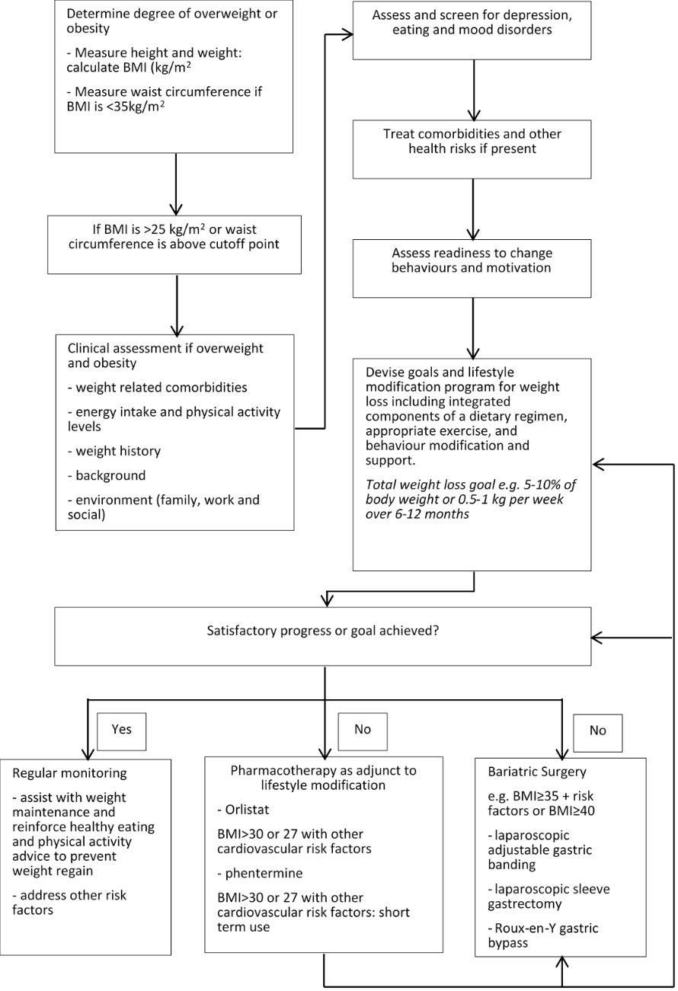

Proposed clinical management algorithm for identified population
The clinical management algorithms for overweight and obese patients with the availability of aspiration therapy provided by the applicant in provided in Figure 4.
Figure 4: Proposed clinical management algorithm for overweight and obese patients
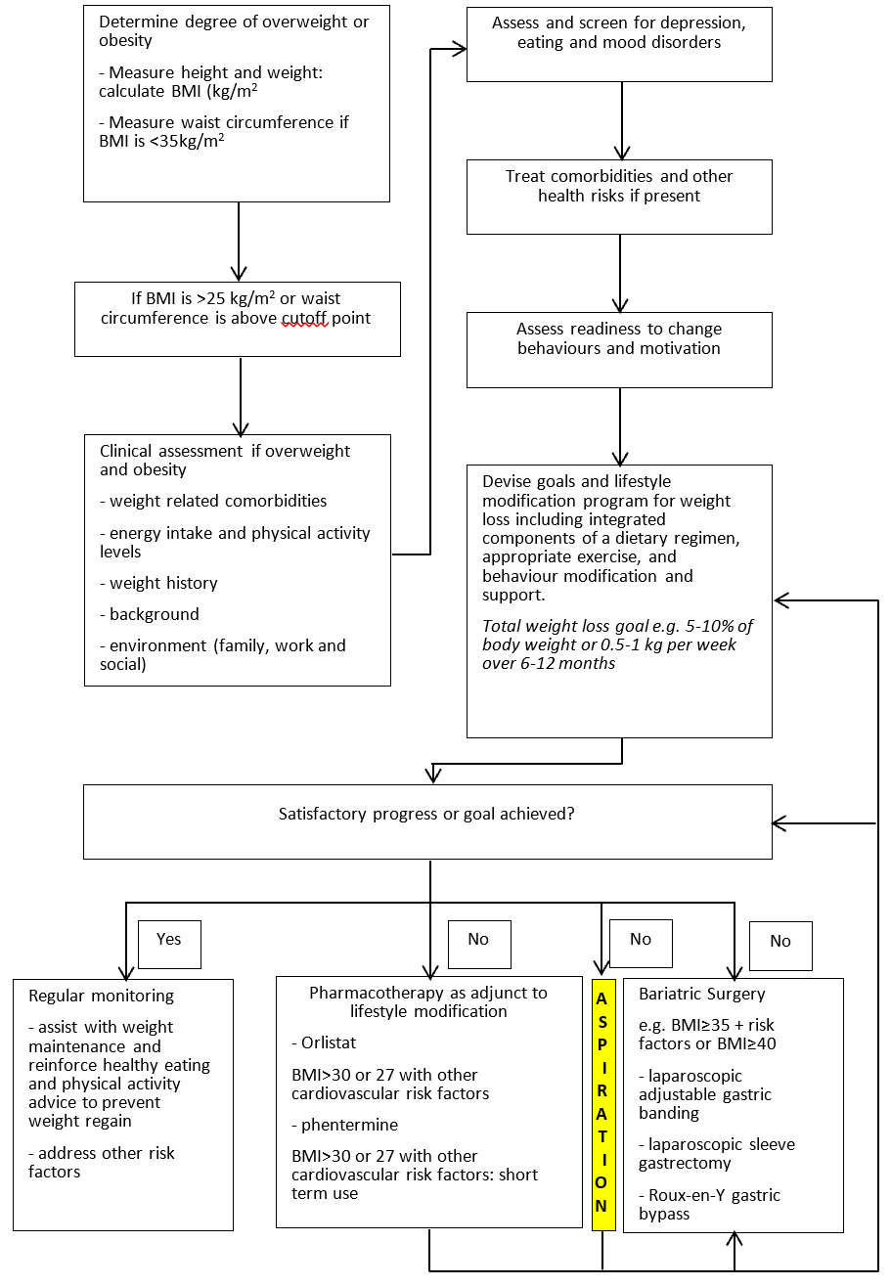
Note that for bariatric surgeries currently funded through the MBS outlined in the algorithm, services relating to the adjustment (laparoscopic adjustable gastric band) and reversal of the procedures is also funded through the MBS.

Proposed economic evaluation
The applicant has outlined that a clinical claim of superiority of aspiration therapy over lifestyle modifications is anticipated. Key patient-relevant health outcomes reported in a head-to-head of aspiration therapy (plus lifestyle modifications) versus lifestyle modifications alone (Thompson et al., 2017), are presented in Table 8. Given LAGB and sleeve gastrectomy are nominated comparators, these should be included in the economic analysis. PASC noted the lack of trials that directly compare aspiration therapy with any other endoscopic or bariatric techniques, meaning that all comparisons in the submission will be indirect.

Table 8: Patient-relevant health outcomes for aspiration therapy plus lifestyle adjustments vs. lifestyle adjustments alone
- | Aspiration therapy plus lifestyle adjustments | Lifestyle adjustments
% excess weight loss at 52-weeks, mean (SD). | 31.5 (26.7) | 9.8 (15.5)
Difference in %EWL | 21.7 (95% CI 15.3, 28.1), P=0.008
% body weight loss at 52-weeks, Mean (SD) | 12.1 (9.6) | 3.5 (6.0)
Weight loss (kg) at 52-weeks, Mean (SD) | 14.2 (11.3) | 4.1 (7.2)
Change from baseline IWQOL score at 52-weeks, Mean (SD) | 6.2 (13.4) | 3.3 (10.0)
Difference in IWQOL | 2.9 (12.5), P=0.03

In consideration of the outcomes presented in Table 8 showing increased weight loss for patients treated using aspiration therapy, as well as the guidance for selecting the appropriate form of economic evaluation outlined in the Technical Guidelines for preparing assessment reports for the Medical Services Advisory Committee – Medical Service Type: Therapeutic (Version 2.0), a cost-utility analysis (CUA) would be an appropriate form of economic evaluation. A cost-utility analysis would allow the economic evaluation to incorporate differences in efficacy (e.g. weight loss parameters), safety (e.g. complications arising from placement of the percutaneous gastrostomy tube and use of aspiration therapy) and quality-of-life (IWQOL score) reported in the head-to-head trial of aspiration therapy plus lifestyle modifications versus lifestyle modifications alone.
Table 9: Classification of the clinical claims and guide to the suitable type of economic evaluation for MSAC assessment reports
 | Comparative effectiveness
Comparative safety | Inferior | Uncertain ª | Non- | Superior
Inferior | Health forgone: need other supportive factors | Health foregone possible: need other supportive factors | Health foregone: need other supportive factors | ? Likely CUA
Uncertain ª | Health foregone possible: need other supportive factors | ? | ? | ? Likely CEA/CUA
Non- | Health forgone: need other supportive factors | ? | CMA | CEA/CUA
Superior | ? Likely CUA | ? Likely CUA | ? Likely CEA/CUA | CEA/CUA
CEA = cost-effectiveness analysis; CMA = cost-minimisation analysis; CUA = cost-utility analysis
? = reflects uncertainties and any identified health trade-offs in the economic evaluation, as a minimum in a cost-consequences analysis

Proposed item descriptor
The MBS item descriptor proposed by the applicant is outlined below.
T8. SURGICAL OPERATIONS – 1.GENERAL
PERCUTANEOUS GASTROSTOMY (initial procedure):
(a) including any associated imaging services; and
(b) including the insertion of a device for the purpose of facilitating weight loss for patients with a BMI ≥ 35.
Multiple Services Rule
(Anaes.)
(See para TN.8.17 of explanatory notes to this Category)

Fee: $357.00 Benefit: 75% = $267.75 85% = $303.45

PASC noted that the applicant only requested an MBS item associated with the initial placement of the percutaneous endoscopic gastrostomy tube (A-Tube™) that is required for aspiration therapy. At the December 2019 meeting, PASC noted that separate MBS items would be required for:
- Removal of the percutaneous endoscopic gastrostomy tube (A-Tube™) as this is temporary intervention
- Tube replacement as tube failure may occur over time
- Tube shortenings required when patients are losing weight whilst on aspiration therapy.
Details of the additional MBS items required when a patient is being managed with aspiration therapy should be provided in the submission.

References
ABS 2013. 3222.0 - Population Projections, Australia, 2012 (base) to 2101. Australian Bureau of Statistics.
AIHW 2017. A picture of overweight and obesity in Australia. Australian Institute for Health and Welfare
Machytka, E., Buzga, M., Turro, R., et al. 2017. Aspiration therapy in super obese patients-pilot trial, 3-years data endoscopic and percutaneous interventional procedures. Obesity Surgery, Conference, 22nd World Congress of the International Federation for the Surgery of Obesity and Metabolic Disorders, IFSO 2017. United Kingdom. 27 (1 Supplement 1) (pp 487).
NHMRC 2013. Clinical practice guidelines for the management of overweight and obesity in adults, adolescents and children in Australia. National Health Medical Research Council, Department of Health Ageing.
Thompson, C. C., Abu Dayyeh, B. K., Kushner, R., et al. 2017. Percutaneous Gastrostomy Device for the Treatment of Class II and Class III Obesity: Results of a Randomized Controlled Trial. American Journal of Gastroenterology, 112, 447-457.
WHO 2000. Obesity: preventing and managing the global epidemic, World Health Organization.

http://www.isrctn.com/ISRCTN36495438

