Public Summary Document

Application No. 1216 – Cystic fibrosis transmembrane regulator (CFTR) testing

Applicant: Royal College of Pathologists of Australasia

Date of MSAC consideration: MSAC 64th Meeting, 30-31 July 2015

Context for decision: MSAC makes its advice in accordance with its Terms of Reference, see at www.msac.gov.au

Purpose of application and links to other applications

An application requesting Medicare Benefits Schedule (MBS) listing of diagnostic testing for hereditary mutations in the cystic fibrosis transmembrane conductance regulator (CFTR) gene was received from the genetics subcommittee of the Pathology Services Table Committee (PSTC).
However, as the PSTC no longer exists the Royal College of Pathologists of Australasia (RCPA) agreed to sponsor the referral originally made by the PSTC and submitted an updated application. The evidence for assessment of this application was submitted in May 2015.

MSAC’s advice to the Minister

After considering the available evidence presented in relation to safety, clinical effectiveness and cost-effectiveness of Cystic fibrosis transmembrane conductance regulator (CFTR) testing, MSAC deferred the application to seek better definitions and prevalence estimates of the intended populations and re-evaluation of the clinical and cost effectiveness in the intended populations to be tested.

MSAC noted that the application mainly focused on evaluation of safety, effectiveness and cost effectiveness for prenatal diagnosis only and not for the other intended populations.

MSAC considered that the following issues should be addressed in any fit-for-purpose resubmission:
- better definitions and prevalence estimates of the intended populations
- more accurate data relating to the expected number of patients tested for each purpose;
- more accurate data relating to diagnostic yield for each class of test in each intended population
- cost effectiveness analysis for each of the intended populations;
- clearer MBS item descriptors including restrictions on eligibility and genetic counselling requirements;
- consider including cascade testing and routine antenatal screening for reproductive planning purposes;
- consider impact of next-generation sequencing(NGS), non-invasive prenatal testing (NIPT) and preimplantation genetic diagnosis (PGD – Application 1165).

MSAC considered that the updated information should be provided via ESC.

Summary of consideration and rationale for MSAC’s advice

MSAC noted that currently CFTR testing is performed in Australia under two separate arrangements. The new born screening (NBS) program run by State and Territory health systems accounts for 66% of the tests performed in Australia. The remainder of the tests were performed for diagnosis (20%), to determine carrier status (8%), or as prenatal testing of a fetus (5%).

MSAC considered that the proposed item descriptors could lead to considerable leakage and extend past testing of high risk pregnancies only to pregnancies where no risk has been identified. MSAC also noted pre-MSAC feedback from the applicant that there is currently no provision for identification of carrier status in the MBS, nor is there provision for cascade testing. MSAC considered that this could be an additional risk for leakage to low-risk pregnancies. In addition, the current testing rates quoted in the application suggest considerable testing outside the indicated populations. This would have further financial implications to the MBS.

MSAC considered the safety and effectiveness of the CFTR testing and noted that the evaluation of diagnostic accuracy focused mainly on analytical validity rather than clinical validity. Since the sequencing technology used is highly accurate the greater concern is the diagnostic yield of the test in identifying new cases of cystic fibrosis or carriers in each of the intended patient populations (ie number of tests performed versus number of new cases/carriers identified). The number of reported tests in each category appears to greatly exceed the projected number of new cases, suggesting widespread use of CFTR diagnostic testing for screening purposes in low risk populations with consequent low diagnostic yields and poor cost effectiveness. The safety of prenatal diagnosis was assessed through assessment of adverse effects associated with collection of fetal material for testing (amniocentesis and CVS compared to non-invasive testing) as well as adverse events arising from change in management (termination of pregnancy). MSAC noted there was no assessment of safety in other intended test populations. MSAC noted that there was limited evidence presented on the psychological impact of pregnancy termination or of raising a child with cystic fibrosis. Overall, MSAC agreed that compared to no testing, pre-natal testing has inferior safety due to risk of adverse events associated with sampling and termination of pregnancy.

Nine studies were presented to assess the impact of prenatal testing on the management of patients. The results demonstrated that a positive CFTR test result would change patient management and a positive result predicts termination of pregnancy. MSAC noted that compared to no genetic testing, CFTR prenatal mutation testing is likely to correctly identify most CFTR mutations and result in termination of the majority of affected pregnancies reducing the frequency of babies being born with CF.

MSAC noted the economic analysis was based on prenatal genetic testing of CFTR in pregnancies assessed as being high risk for CF compared to no genetic testing and newborn screening after birth. MSAC noted there was considerable uncertainty in the costs of the panels. The costs were dependent on the number of mutations included in the panel from the minimum of 10 mutations (Sensitivity 80%, cost $135) to 32 mutations (sensitivity 92%, $200) or $1000 for whole gene sequencing. MSAC noted that the economic analysis was highly sensitive to uptake of termination of pregnancy and incidence of CF in fetuses with echogenic bowel.

This attracted a range of costs from $135 for a panel of 10 common mutations to $1000 for whole gene sequencing. The application did not present any consensus on what represented an ideal case for initial testing in the populations indicated. MSAC considered that a low price for panels may create a perverse incentive to use small panels to maximize reflex testing by whole gene sequencing and that a cost of $250 may be more appropriate to increase use of large NGS panels (estimated cost $168 - $500 for panels with 11-145 mutations) and reduce use of whole gene sequencing. MSAC requested that the applicant look at an algorithm to assess the most efficient minimum panel or some defined percentage of mutations and base proposed descriptor texts and economic and financial analysis on this algorithm.

MSAC considered that the financial and budgetary impact of CFTR testing was highly uncertain as the data were based on a projected tripling of test volume in between 2011 and 2019 which could not be explained by population expansion, or by current prevalence of CF in the Australian population. MSAC requested that the number of tests estimated in Australia be reviewed.

Background

CFTR testing has not previously been considered by MSAC.

Prerequisites to implementation of any funding advice

CFTR mutation testing is currently undertaken in all States and Territories, diagnostic laboratories should be National Association of Testing Authorities (NATA) accredited to perform CFTR mutation tests.

Proposal for public funding

Cystic Fibrosis (CF) and other CFTR related disorders are one of the most common autosomal recessive disorders in Caucasians, with a frequency of about 1 in 2,500 – 2,800 live births worldwide and a carrier frequency of 1 in 25 in Australia. The major cause of morbidity and mortality among young people with CF is progressive respiratory disease. Cystic fibrosis is usually clinically diagnosed with supporting evidence of a CFTR abnormality, either by sweat chloride measurement or through identification of mutations in the CFTR gene known to cause CF.

The applicant noted that genetic testing occurs in three groups:
- Individuals suspected of having CF or presenting with classic or non-classic CF symptoms (including men with congenital bilateral absence of the vas deferens (CBAVD));
- Couples seeking prenatal diagnosis as a consequence of having had a previous child with CF or a CFTR related disorder, or having been identified by other means to both be carriers of a CFTR mutation, or having a fetus with an echogenic bowel; and
- A partner of someone with at least one known CFTR mutation, to provide information for reproductive planning.
Most CF patients in Australia are currently diagnosed through national newborn screening programs; all infants with elevated immunoreactive trypsinogen levels would be suspected of CF and tested. These infants would theoretically fall within the first group mentioned above. However, as this testing of newborns is already considered standard practice and funded by the States and Territories (parents would not be paying for the test themselves), it was considered by PASC that testing of newborns would not need to be examined further in this assessment.

According to the application, different types of genetic tests are currently performed in Australia. Common mutation analyses are conducted in patients/parents/partners for whom familial mutations are not known, whereas whole gene sequencing is undertaken if the clinical situation demands and the common mutation analysis is unable to identify both CFTR mutations. In prenatal testing, if a mutation is known in both parents, a mutation analysis would be performed on a sample from the fetus, specifically targeting the parents’ mutations. If the parents both carry the most common mutation (F508del) a single mutation test would be performed. If one of the parental variants is not known, a broader panel would be performed.

The applicant claimed that the MBS listing of CFTR testing in the target population and setting would create additional diagnostic surety for a lifelong, expensive and complex condition, affecting family planning options, and the selection of treatment.

Five new MBS item descriptors for identifying the presence of the CFTR gene in the key patient groups were proposed.

Note: Costs associated with CFTR mutation testing in Australia were provided in the assessment report, and vary between $135 and $500 for a mutation panel (10 – 145 mutations), between $50 and $160 for a single mutation test and around $1000 for the whole gene sequencing depending on the laboratory, testing method used and number of mutations tested. The proposed laboratory costs would not include counselling and other fees.

Genetic counselling would be required if the tests were listed, as they meet criteria for either level 1 or level 2 DNA testing, as per the Requirements for Medical Testing of Human Nucleic Acids (NPAAC, 2013). Currently, there is no genetic counselling item on the MBS, however the assessment report assumes genetic counselling will be provided for by specialists, attracting the specialist consultation fees. Access to genetic counselling has previously been identified as a gap, for genetic tests listed on the MBS, due to the limited workforce and no specific MBS listing.

Summary of Public Consultation Feedback/Consumer Issues

Consumer feedback noted that the intervention was worthwhile as it would provide wider access to testing for the Australian population and better information for decision making, especially in prenatal testing. It would allow for better planning from social, financial and support perspectives.

However, there may be access/equity issues based on the current availability of genetic services in Australia. For example, genetic counselling is usually provided in genetic services units, usually located in metropolitan hospitals, with some regional services, and some outreach services provided to regional/rural areas.

Proposed intervention’s place in clinical management

The clinical management algorithms below illustrate how the tests would be used in the three different population groups as shown in Figure 2, Figure 3 and Figure 4.

The blue boxes show the pathway related to intervention (which is current clinical practice), whereas the grey boxes show clinical practice in the absence of the intervention, which is the comparator pathway or the historical clinical pathway.

Figure 1 Clinical pathway for use of a genetic CFTR test to identify mutations in people with a high clinical suspicion of CF
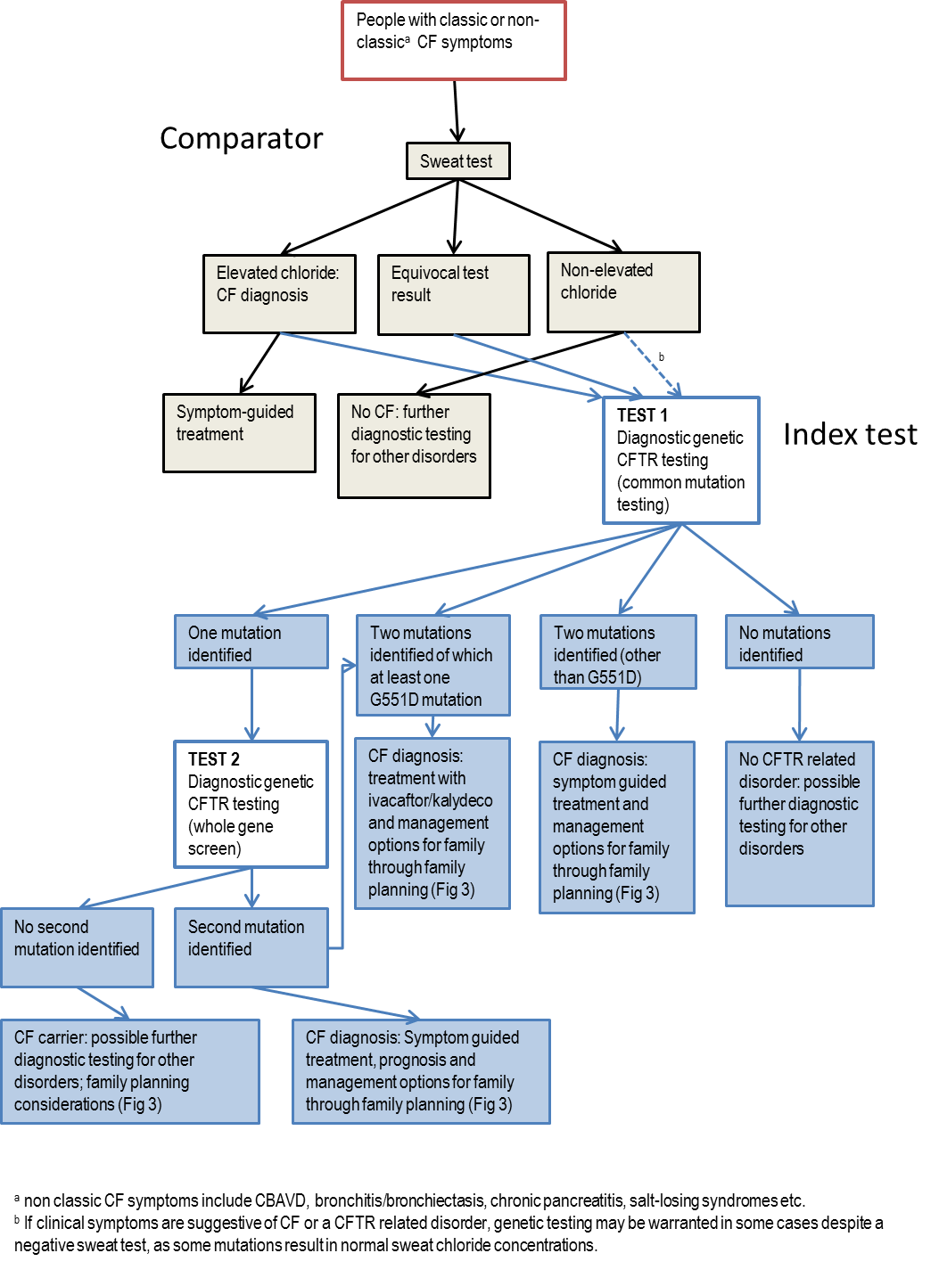

Figure 2 Clinical pathway for use of a genetic CFTR test in pregnant couples to determine the CF status of the fetus

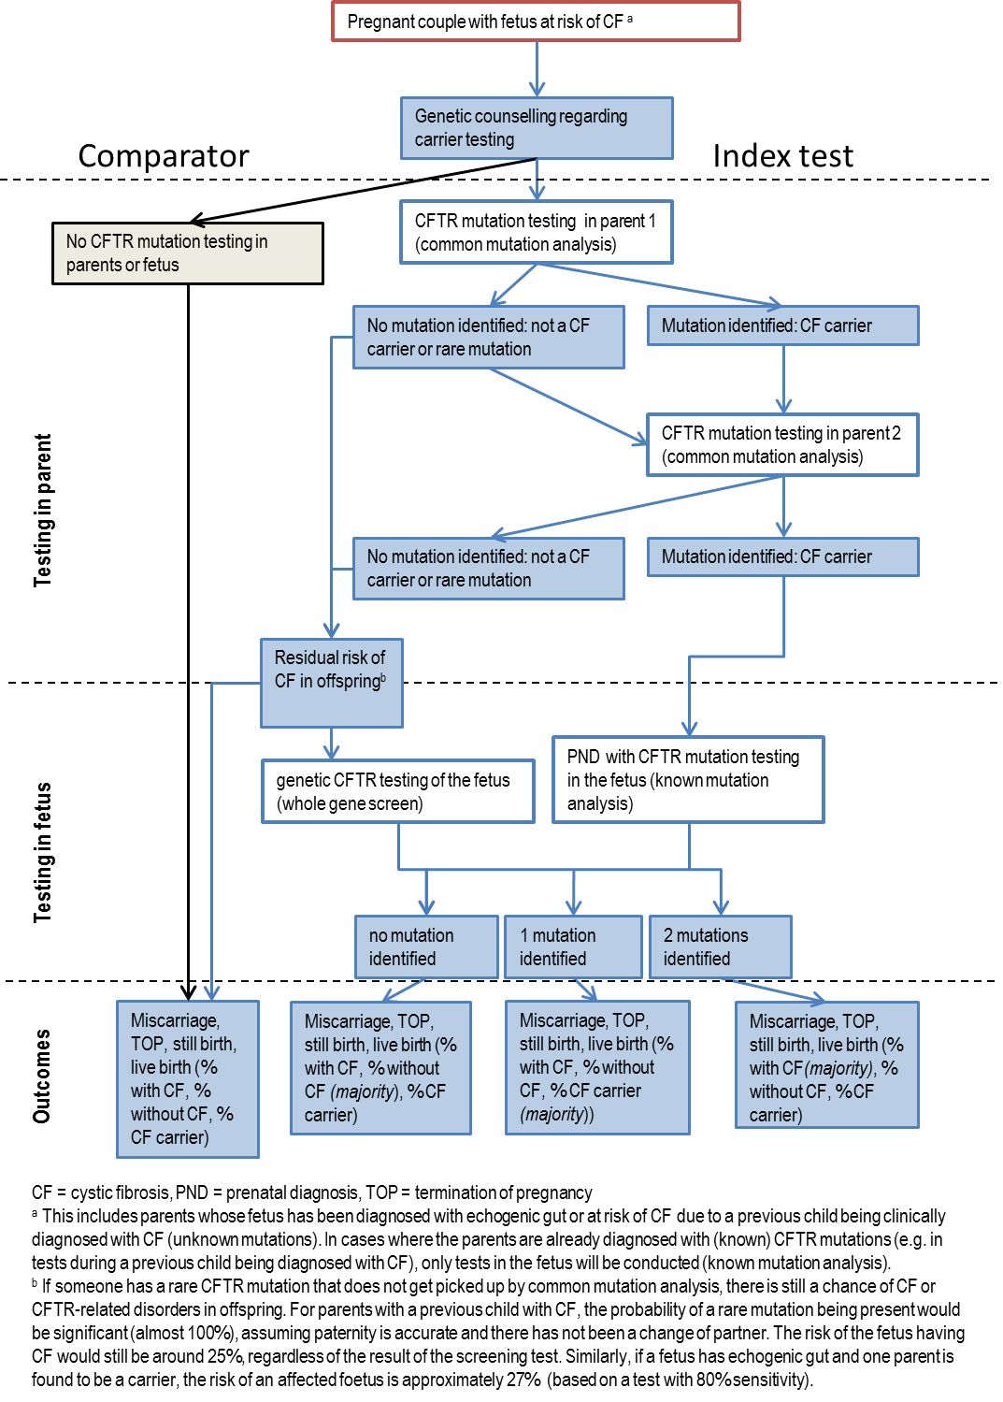

Figure 3 Clinical pathway for use of a genetic CFTR test to inform reproductive planning, prior to conception (plus PGD or pre-natal CFTR testing) versus pre-natal CFTR testing

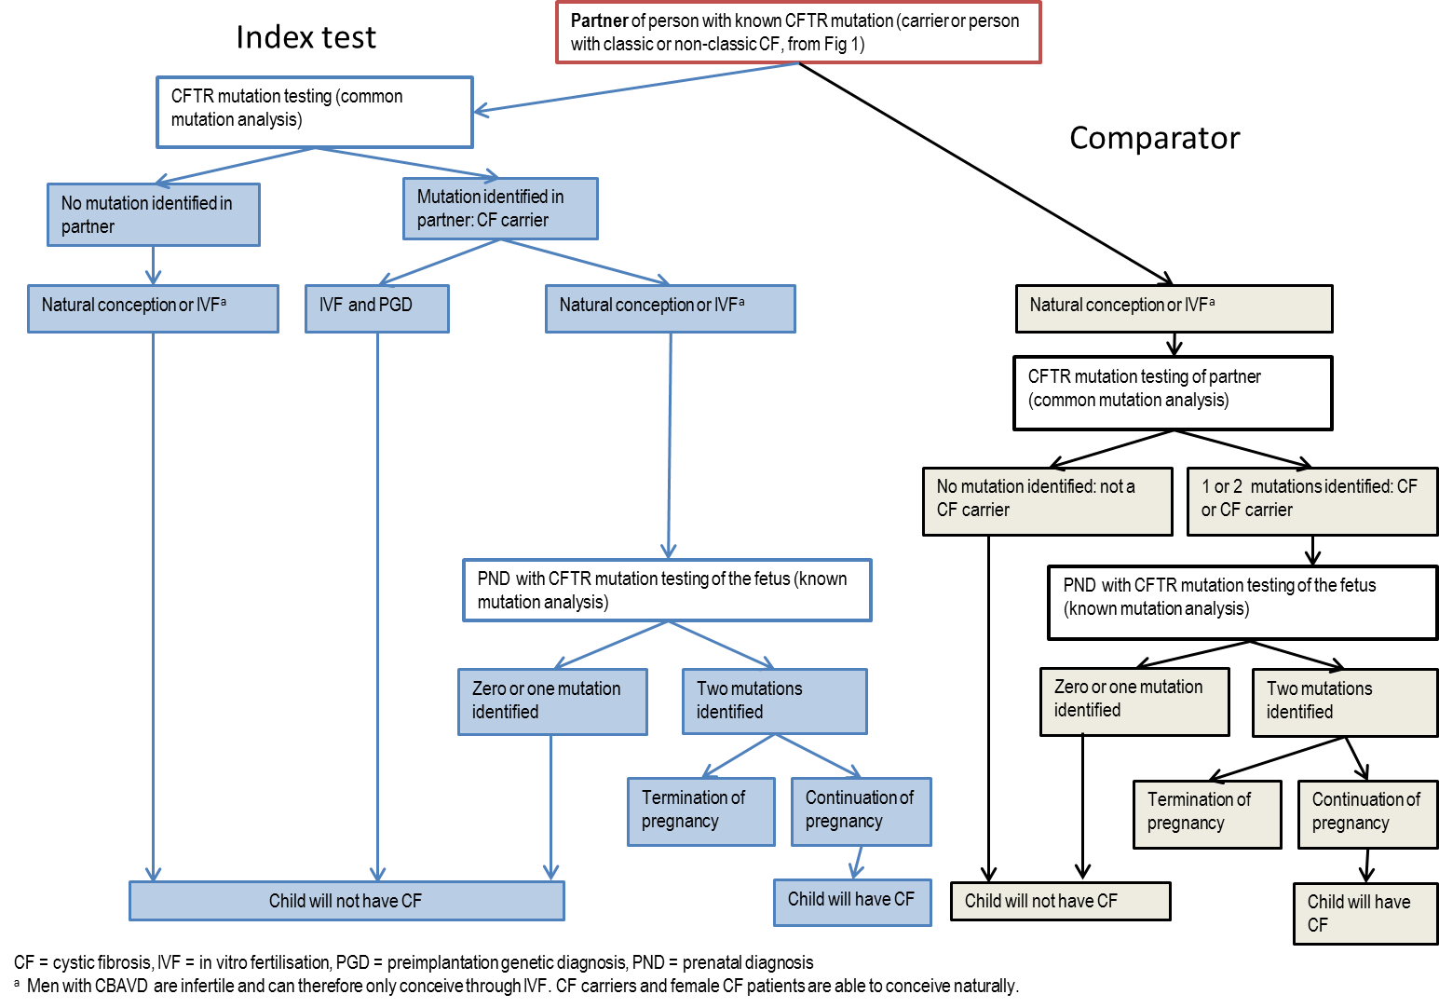

Comparator

The comparator was no prenatal CFTR mutation testing and diagnosis of the child after the birth.

The application noted that currently, parents receiving the test for prenatal diagnostic purposes would have to pay for CFTR mutation testing themselves (in the private system). If the test was not affordable, then there would be no prenatal genetic testing and the diagnosis would be made after the child’s birth through existing neonatal programs.

Comparative safety

No studies were identified that directly assessed the PICO criteria for clinical effectiveness or safety of (prenatal) CFTR mutation testing. The assessment report used a linked evidence approach to estimate the clinical effectiveness of CFTR mutation testing.

Test Adverse Events
No studies on the safety of prenatal CFTR testing were identified. A separate search was conducted to investigate the safety of amniocentesis and chorionic villus sampling (CVS), both of which are used to retrieve fetal DNA for prenatal testing (discussed in section B.8.1). Evidence from systematic reviews was identified, comparing the foetal loss rates associated with amniocentesis and CVS with no invasive testing. The attributable risk of fetal loss due to amniocentesis was 0.1% according to the most recent systematic review (2015; k=7, each study N>1000), whereas the only randomised controlled trial available, published in 1986, showed an increase of 1% in total fetal loss. For CVS, a 2015 systematic review estimated an attributable risk of fetal loss of 0.22% (95%CI, -0.71, 1.16%, k=3, p=0.64).

Adverse events from change in management
There are a number of methods for TOP (both pharmaceutical and surgical), and the method selected often depends on the gestational age of the fetus, availability of these options and physician or patient preference. Surgical TOP in the first trimester can lead to complications such as infection, cervical laceration (rare), incomplete evacuation, uterine perforation (rare), haemorrhage and problems with anaesthesia. Side effects and complications from pharmaceutical TOPs in the first trimester are bleeding (moderate to heavy), pain, nausea, vomiting, and diarrhoea. No maternal deaths were reported from surgical or pharmaceutical TOP.

Second trimester TOP can also be conducted by drug regimen or surgically. The incidence of combined major and minor complications was lower with the surgical method, and fewer adverse events were reported (compared to pharmaceutical TOP). However, side effects reported from pharmaceutical TOP were usually mild, except the need for surgical evacuation due to retained products of the placenta and heavy vaginal bleeding. It was concluded that there are safe and effective TOP methods available for use in first and second trimester.

Comparative effectiveness

No studies were identified that directly assessed the PICO criteria for clinical effectiveness of (prenatal) CFTR mutation testing. The assessment report used a linked evidence approach.

Diagnostic accuracy
DNA sequencing and clinical diagnosis were used as reference standards. Diagnostic accuracy was investigated for all population groups: patients suspected of CF (including men with CBAVD), parents of a fetus suspected of CF and fetuses suspected of CF. No accuracy studies on partners of people with at least one known CFTR mutation were identified.

CFTR testing in patients with a high clinical suspicion of CF
The median sensitivity of CFTR mutation testing in CF patients, compared with DNA sequencing, was 85% (range 71-97; k=4) when all known mutations were included in the analysis, and 97% (range 90-100) when only those mutations designed to be detected by each test were included. This means that only 3% of samples were falsely negative, and the tests are highly accurate when compared to gene sequencing. Due to the reduced number of CFTR mutations detected by panel-based tests, the median sensitivity of panel-based CFTR tests compared with clinical diagnosis was only 80% (range 52-91; k=5), compared with 91% (range 86-100; k=4) for DNA sequencing compared with clinical diagnosis. Meta-analysis could not be conducted to determine the accuracy of CFTR mutation testing in patients with a high clinical suspicion of CF. Only one study met the a priori inclusion criteria, and the studies that met the broadened criteria compared CFTR mutation testing with either DNA sequencing methods in patients with known CFTR mutations, or with clinical diagnosis in patients definitively diagnosed with CF or CBVAD. As a consequence, only the sensitivity and false negative rate could be reported.

Panel-based CFTR mutation testing was compared with exon scanning CFTR mutation testing plus DNA sequencing and multiplex ligation-dependent probe amplification (MLPA) deletion/insertion detection in men with CBAVD in one study. The sensitivity to detect all mutations was 94% (95%CI 81-99) when compared with DNA sequencing and 89% (95%CI 75-97) when compared with DNA sequencing plus MPLA. There were no false positive results. Panel based testing compared with clinical diagnosis only had a sensitivity of 52% (range 45-72, k=4), due to the large proportion of patients and chromosomes for which a CFTR mutation could not be identified. Exon-scanning CFTR mutation testing plus DNA sequencing had a slightly higher sensitivity when compared with clinical diagnosis (64%, range 47-88, k=5).

CFTR testing in parents with a fetus suspected of CF
Only one study met the inclusion criteria to assess test performance in parents of a fetus suspected of having CF. The study compared the accuracy of four different panel-based tests to DGGE exon-scanning CFTR mutation testing plus DNA sequencing in 25 CFTR mutation carriers. The panel-based tests had a sensitivity of 100% for the mutations they were designed to detect, and 92% when all mutations were included in the analysis.

CFTR testing in fetuses
Four studies were included that reported on the accuracy of CFTR mutation tests in fetuses from carrier parents as compared to clinical diagnosis after birth (samples collected through various methods, e.g. CVS or amniocentesis). No false negative results were reported in two of the studies (sensitivity = 100%); the other studies only reported diagnostic yield (8-22% with CF, 38-55% carriers, 24-33% normal). Of the fetuses with two identified CFTR mutations (from carrier parents), 95% are aborted (see ‘change in patient management’). The false positives of the test could not be determined as the presence of CF could not be clinically determined in those that were aborted.

The accuracy of CFTR mutation testing in fetuses with a fetal echogenic bowel (FEB) was only identified in one study. As no clinical outcomes were reported, the accuracy compared to clinical diagnosis could not be determined.

Test failure rates
The failure rates of seven different panel-based CFTR tests were reported in five studies (median 4.5%, range 0.0001-9), which suggests that around 4.5% of tests would need to be repeated (in diagnostic laboratories).

Overall, the sensitivity of CFTR mutation tests is high when detecting mutations included in the mutation panel. Both panel-based and exon-scanning CFTR mutation tests, as well as DNA sequencing-based tests cannot detect large deletion or insertion mutations, which occur in about 2% of CF patients worldwide. In the case of a negative test result, it is important for the diagnostic laboratory to explain the scope of the mutation testing undertaken and the likelihood of the person being truly negative, particularly when one of the consequences of testing may be TOP.

Change in patient management (prenatal testing group only)
Nine studies were included to assess the impact of prenatal testing on the management of patients. None of the studies included a comparison with pregnancy management when there was no prenatal CFTR testing; therefore all nine studies were non-comparative. Six studies reported on the rate of TOP in pregnancies affected by FEB and reported that TOP occurred in 65% (50/77) of the pregnancies where CFTR mutations were identified (range 0% - 100%). In prospective parents who are known carriers, a positive CFTR test in the fetus led to TOP in 155/163 cases (95%, k=4). This shows that CFTR mutation testing does change management and that a positive test result predicts TOP. It is assumed that no TOP would occur in the absence of prenatal testing.

Treatment effectiveness
As outlined above, one key result is that the parents are presented with an opportunity for choice of outcome based on this information. Although some may elect for TOP, alternatives may include PGD or artificial reproductive therapy (donor egg or sperm) or proceed with the pregnancy but with the knowledge to plan and prepare for a CF-affected child.

No studies were identified on parental psychological health after proceeding with TOP, as a consequence of a CF-affected fetus, compared to the psychological health associated with proceeding with the pregnancy and raising a child with CF. A separate (non-systematic) search was conducted to identify studies investigating psychological outcomes after TOP was instigated following identification of various fetal anomalies (not specific to CF). Posttraumatic stress, grief, anger, guilt and depression were prevalent in this population. In the first few months after TOP, rates of posttraumatic stress (45.8 – 67%), grief (36 – 78%) and depression (around 30%) were high, however, these rates decreased over time.

Depression and anxiety rates reported in the first couple of months after TOP were similar to the rates among mothers of children suffering from CF, with 20-34% and 48% of these women scoring above the threshold for depression and anxiety, respectively. Psychological health improved over time in women who underwent TOP, but it is not fully known whether this is also the case for women with children suffering from CF. One study indicated that in this group, severe depression and anxiety was associated with a younger age of the child. Women showed more (psychological) symptoms than men, both in the post-TOP group and the group with CF affected children.

In summary, relative to no genetic testing (and clinical diagnosis after birth), prenatal CFTR mutation testing is likely to correctly identify most CFTR mutations (if the appropriate test is used) and may result in some terminations of affected pregnancies. CFTR mutation testing may reduce the frequency of people being born with CF. The test has inferior safety compared to clinical diagnosis after birth, due to the risk of miscarriage associated with prenatal sampling procedures and the adverse events associated with termination of pregnancy. There was insufficient evidence to make a direct comparison regarding the psychological impact of termination of pregnancy and the impact of raising a child with CF, although in the short term there appear to be similar rates of depression.

Economic evaluation

The application presented an analysis which investigated the cost-effectiveness of prenatal genetic CFTR testing in pregnancies where fetuses were assessed as high risk of having CF (populations 2a and 2b) compared with the current situation of no prenatal genetic testing and CF diagnosis through newborn screening after birth.

The application presented two economic models for populations 2a and 2b:
- Model 1 (population 2a): Fetus at 1:4 risk of CF due to parents being carriers (known carriers or have previous child being clinically diagnosed with CF)
- Model 2 (population 2b): Fetus at risk of CF due to diagnosis of echogenic bowel on the second trimester ultrasound

Key structural assumptions of the models were:
- Prenatal diagnostic CFTR testing is done within a valid timeframe to allow for termination of pregnancy if CF is diagnosed.
- The parents accepting the test are prepared to take the risk of invasive testing.
- Consistent with the limited available evidence base, mutation tests for this population group are assumed to be 100% sensitive and it is assumed that the tests used are appropriate for the mutations being identified. In the absence of any evidence, the tests are also assumed to be 100% specific. Analytical validity of the diagnostic tests is, therefore, considered 100%, ie. mutation tests are assumed to accurately detect the presence or absence of specific mutations. Impact of varying the test accuracy was not assessed in the sensitivity analyses.
- Parenting partnerships are considered stable and transparent (ie. parents with a previous CF child between them are both assumed to be carriers).

The application noted that the proposed MBS listing for the common mutation test suggested the inclusion of a minimum of ten mutations in the panel. However the applicant believed that this does not appear to reflect current clinical practice as a larger number of mutations are generally included in the common mutation panel. As a consequence, four scenarios were considered in the economic evaluation, and these varied according to the number of mutations included in the panel and by the clinical sensitivity of the common mutation test. A summary of the scenario analyses is presented in Table 2 below.

Table 1 Scenarios analysed in economic evaluation
Number of common mutations included in the panel | Clinical sensitivity | Cost | Model usage
10 (PASC recommended minimum) | 80% | $135 | Base case analysis
17 (HGSA recommended) | 83.5% | $150 | Additional scenario 1
23 (ACOG recommended) | 88% | $170 | Additional scenario 2
32 (Clinical evidence see section B.6) | 92% | $200 | Additional scenario 3
PASC= Protocol Advisory Sub-Committee; ACOG = American College of Obstetricians and Gynaecologists; HGSA = Human Genetics Society of Australasia
The application estimated that under baseline assumptions (10 mutation panel with 80% test sensitivity and cost of $135), the incremental costs per CF birth averted were $1,898 and $23,254 for Model 1 and Model 2 respectively. Although the mutation panels (additional scenarios) with higher sensitivity result in higher effectiveness, this is offset by the higher costs of the mutation test. The incremental costs per CF birth averted were observed to be driven largely by the cost of the diagnostic tests (common mutation test and whole gene sequencing).

The application provided a summary of the results of the economic evaluation in the table below. An alternative presentation of the economic model calculating benefits and harms resulting from a given expenditure associated with the proposed testing was presented.

Table 2 The incremental cost-effectiveness of prenatal CFTR mutation testing for all scenarios explored in the economic evaluation.
Strategy | Base case scenario  10 mutation panel | Alternate scenario 1  17 mutation panel | Alternate scenario 2  23 mutation panel | Alternate scenario 3  32 mutation panel
Model 1 – Parents are known CF carriers.
Incremental cost per prenatal CF diagnosed | $1,804 | $1,816 | $1,840 | $1,977
Incremental cost per CF birth averted | $1,898 | $1,910 | $1,935 | $2,079
Model 2 – Fetus has FEB
Incremental cost per prenatal CF diagnosed | $15,182 | $15,331 | $15,537 | $16,304
Incremental cost per CF birth averted | $23,254 | $23,480 | $23,794 | $24,972
FEB= fetal echogenic bowel; CF = cystic fibrosis; CFTR = cystic fibrosis transmembrane conductance regulator; ICER = incremental cost-effectiveness ratio
The application noted that in Model 1 (both parents are known CF carriers) the results were most sensitive to the uptake rate of terminations of CF-affected pregnancies, the cost of newborn screening in infants tested prenatally, the sensitivity of the common mutation panel and the cost of whole gene sequencing. In Model 2, the ICER were most sensitive to changes in the incidence of CF in fetuses with FEB, as well as TOP uptake rates in the tested population (

Table 3).

Table 3 Key drivers of the economic models
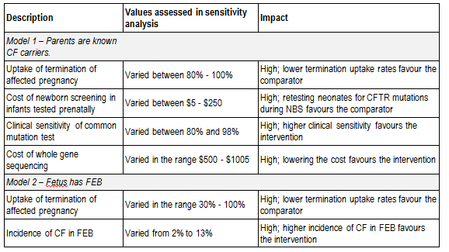
NBS = newborn screening; CF = cystic fibrosis; FEB = fetal echogenic bowel.
Note: intervention is CFTR mutation common panel test (base case scenario) and comparator is no genetic testing.

Financial/budgetary impacts

The application used a market-based approach to estimate the financial implications of listing CFTR mutation testing on the MBS. The estimate was based on extrapolations from data collected in the RCPA Genetic Testing Survey conducted in 2012 on data for the 2011 calendar year. While the survey recorded the number of CFTR tests by broad reason, data could not be distinguished by patient indication. As the proposed descriptor for the MBS item did not include all current indications for testing (eg. newborn or general population screening are not proposed), the proportion of current CFTR tests that would be eligible for use with the MBS item was sought from the literature and expert opinion.

The application considered that this did not include the impact of termination of pregnancy of a CF-affected pregnancy which would avoid the downstream cost of life-long care of a CF-affected child, with all three of medical, hospital and pharmaceutical costs.

The financial implications to the MBS resulting from the proposed listing of CFTR mutation testing in the table below.

Table 4 Total costs to the MBS associated with CFTR mutation testing
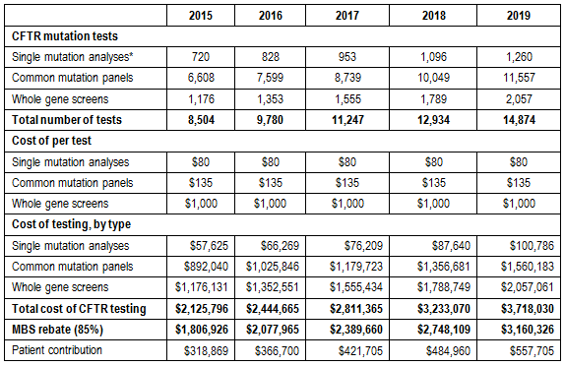
CFTR = Cystic Fibrosis Transmembrane conductance Regulator; MBS = Medicare Benefits Schedule
*Single mutation analyses are performed to identify one or two F508del mutations

As the proposed listing does not attempt to change existing clinical practice, the net cost to the Australian health system should be zero for a MBS listing for CFTR mutation testing. If, however, there is growth in the market the net overall cost of CFTR mutation testing will be positive, but the effect may be small as it is likely that the majority of patients eligible for MBS funding would continue to receive testing funded by the States/Territories.

The analyses were most sensitive to changes that increased the number of common mutation screening tests, such as increasing the proportion of current screening tests that are eligible, which increased the cost implication to the MBS by up to 25%. Reducing the market growth rate, improving the clinical sensitivity of the common mutation panel and reducing the cost of the whole gene screen would result in a substantial reduction in costs to the MBS (25 – 50%).

Key issues from ESC for MSAC

ESC advised that this application should be considered in the context of work currently underway to develop a clinical utility card to inform consideration of genetic testing, and application 1165 for Pre-implantation genetic diagnosis.

ESC noted that two economic models were presented for different populations which resulted in ICERs of $1898 and $23,254 for each model respectively.

However, ESC noted that the models were based on the prenatal population only and that results were sensitive to several assumptions of uncertain validity. In particular, ESC did not consider that the assumption of 100% diagnostic accuracy was reasonable.

ESC noted that the key financial impact is a shift of costs from State payers and patients to the MBS. ESC also noted that there was a potential cost increment of between 25% and 50% depending on uncertainties in growth, usage and testing rates. The financial impact on the MBS was most sensitive to changes that increased the number of common mutation screening tests.

ESC considered that the confidentiality, ethical and legal considerations of this application are significant.

ESC considered that, if the application was supported, the issues with the proposed descriptor raised by the applicant in their pre-ESC response should be considered.

ESC also noted that genetic counselling would be required for the tests, but there is no genetic counselling item on the MBS, and there is a limited workforce. The assessment report assumes genetic counselling will be provided by specialists, attracting the specialist consultation fees. ESC also noted that genetic counselling is currently provided by States.

Other significant factors

The assessment report provided additional commentary covering a range of ethical and legal issues which, whilst not falling specifically within the MSAC terms of reference, are likely to be important in informing the Minister’s decision.

Applicant’s comments on MSAC’s Public Summary Document

Nil.

Further information on MSAC

MSAC Terms of Reference and other information are available on the MSAC Website at: www.msac.gov.au.

