1207:

Final Decision
Analytical Protocol
(DAP) to guide the assessment of BRAF V600 mutation testing in patients with locally advanced or metastatic melanoma for eligibility for dabrafenib treatment
May 2012

Table of Contents
MSAC and PASC 3
Purpose of this document 3
Purpose of application 4
Background 4
Current arrangements for public reimbursement 4
Regulatory status 5
Intervention 7
Description 7
Delivery of the intervention 10
Prerequisites 12
Co-administered and associated interventions 13
Listing proposed and options for MSAC consideration 14
Proposed MBS listing 14
Clinical place for proposed intervention 16
Comparator 20
Outcomes and health care resources affected by introduction of proposed intervention 20
Outcomes 20
Summary of PICO to be used for assessment of evidence (systematic review) 21
Clinical claim 23
Health care resources 24
Proposed structure of economic evaluation 28
References 33

MSAC and PASC
The Medical Services Advisory Committee (MSAC) is an independent expert committee appointed by the Australian Government Health Minister to strengthen the role of evidence in health financing decisions in Australia. MSAC advises the Commonwealth Minister for Health and Ageing on the evidence relating to the safety, effectiveness, and cost-effectiveness of new and existing medical technologies and procedures and under what circumstances public funding should be supported.
The Protocol Advisory Sub-Committee (PASC) is a standing sub-committee of MSAC. Its primary objective is the determination of protocols to guide clinical and economic assessments of medical interventions proposed for public funding.

Purpose of this document
This document is intended to provide a draft decision analytic protocol that will be used to guide the assessment of an intervention for a particular population of patients. This protocol has been finalised after inviting relevant stakeholders to provide input and will provide the basis for the assessment of the intervention.
The protocol guiding the assessment of the health intervention has been developed using the widely accepted “PICO” approach. The PICO approach involves a clear articulation of the following aspects of the research question that the assessment is intended to answer:
Patients – specification of the characteristics of the patients in whom the intervention is to be considered for use;
Intervention – specification of the proposed intervention
Comparator – specification of the therapy most likely to be replaced by the proposed intervention
Outcomes – specification of the health outcomes and the healthcare resources likely to be affected by the introduction of the proposed intervention

Purpose of application
An application requesting MBS listing of BRAF V600 mutation testing for locally advanced unresectable stage III or IV melanoma was received from GlaxoSmithKline Australia (GSK) by the Department of Health and Ageing in August 2011. The proposed co-dependent BRAF V600 test is for eligibility for the proprietary BRAF targeted therapy dabrafenib. GSK does not own, nor sponsor any mutation test proposed in this application. The application relates to a new test that is not currently available on the MBS, although a previous application for BRAF V600 mutation testing for eligibility for vemurafenib therapy by Roche Diagnostics Australia Pty Ltd is currently under consideration by MSAC (Application 1172).
This DAP is also applicable to testing for trametinib, a MEK inhibitor which is for another new targeted therapy. GSK is expected to place an application for assessment with MSAC for BRAF testing for trametinib eligibility in the near future. Trametinib therapy will rely on the same (or similar) biomarker testing strategy to determine PBS eligibility as dabrafenib, as it is designed to treat a similar population of melanoma patients.
PASC has finalised this decision analytic protocol to guide the assessment of the safety, effectiveness and cost-effectiveness of BRAF V600 mutation testing in order to inform MSAC’s decision-making regarding public funding of the intervention.

Background

Current arrangements for public reimbursement
Currently there is no MBS reimbursement for BRAF V600 mutation testing, however testing is currently conducted by 11 Australian laboratories.
BRAF V600 mutation testing is a co-dependent service, relating to eligibility for therapy with dabrafenib in patients with unresectable stage III or IV melanoma. Dabrafenib is a small molecule serine-threonine kinase inhibitor targeted towards BRAF kinase. BRAF is a member of the NRAS-BRAF-MEK-ERK pathway which plays an important role in cell signalling. Vemurafenib is another BRAF kinase inhibitor which has shown evidence of extending the progression free survival (PFS) compared with dacarbazine (p<0.001) in melanoma patients harbouring a BRAF V600E mutation (Chapman et al. 2011). A separate application for public funding of BRAF V600 mutation testing for vemurafenib eligibility is currently under consideration by MSAC. Roche will be launching a BRAF V600 mutation testing program on June 1st 2012 for accessing vemurafenib.
As BRAF V600 mutation testing is not MBS listed there is no Medicare data available as to its utilisation. The incidence rates of cutaneous melanoma in 2007 were 57 cases per 100,000 for males and 38 cases per 100,000 for females. Both male and female incidence rates increased between 1982 and 2007, with the male rate more than doubling in that time (AIHW & AACR 2010). Data from the 2011 NSW cancer registry regarding the proportion of incident melanoma cases at stages I to IV indicate that 12.3% of cases in that state are stage III or IV (see Table 1). A study published in 2011 which included 667 melanoma patients, found that 47% carried a BRAF mutation, 20% had an NRAS mutation and 33% were wild type (Jakob JA 2011).
Table 1: Proportion of incident melanoma cases by cancer stage in NSW (NSW Central Cancer Registry 2011)
AJCC melanoma stage¹ | Proportion of incident cases in NSW
Localised cancer (stage I and II) | 84%
Regional cancer (stage III) | 7.7%
Distant cancer (stage IV) | 4.6%

Regulatory status
In vitro diagnostic medical devices (IVDs) are, in general, pathology tests and related instrumentation used to carry out testing on human samples, where the results are intended to assist in clinical diagnosis or in making decisions concerning clinical management (Therapeutic Goods Administration 2009).
The Therapeutic Goods Administration (TGA) regulatory framework for IVDs changed in July 2010, such that all IVDs now require premarket approval by the TGA (unless they were offered prior to July 1 2010 in Australia whereby a transition period up to 2014 applies). As testing for BRAF mutations is currently only provided as an in-house IVD, it would be classified as a Class 3 in-house IVD (see Figure 1). Any commercially available BRAF testing kits for the purposes of guiding therapy would, similarly, be classified as Class 3 IVDs.
Figure 1: Classification of Class 3 In Vitro Diagnostic (IVD) medical devices
Source: http://www.tga.gov.au/industry/ivd-framework-overview.htm [accessed 2nd August 2011]
Therapeutic Goods (Medical Devices) Regulations 2002 –Schedule 2A
1.3 Detection of transmissible agents or biological characteristics posing a moderate public health risk or high personal risk
- An IVD is classified as Class 3 IVD medical devices or a Class 3 in-house IVD if it is intended for any of the following uses:
  - detecting the presence of, or exposure to, a sexually transmitted agent;
  - detecting the presence in cerebrospinal fluid or blood of an infectious agent with a risk of limited propagation;
  - detecting the presence of an infectious agent where there is a significant risk that an erroneous result would cause death or severe disability to the individual or foetus being tested;
  - pre-natal screening of women in order to determine their immune status towards transmissible agents;
  - determining infective disease status or immune status where there is a risk that an erroneous result will lead to a patient management decision resulting in an imminent life-threatening situation for the patient;
  - the selection of patients for selective therapy and management, or for disease staging, or in the diagnosis of cancer;
  - human genetic testing;
  - to monitor levels of medicines, substances or biological components, when there is a risk that an erroneous result will lead to a patient management decision resulting in an immediate life-threatening situation for the patient;
  - the management of patients suffering from a life-threatening infectious disease;
  - screening for congenital disorders in the foetus.
Note: For paragraph (f) An IVD medical device would fall into Class 2 under clause 1.5 if:
  - a therapy decisions would usually be made only after further investigation; or
  - the device is used for monitoring.
- Despite subsection (1) an IVD is classified as a Class 3 IVD medical device or a Class 3 in-house IVD if it is used to test for transmissible agents included in the Australian National Notifiable Diseases Surveillance System (NNDSS) list as published from time to time by the Australian government.
Laboratories that manufacture in-house Class 3 IVDs are required to notify the TGA of the types of IVDs manufactured in each laboratory for inclusion on a register. These laboratories must have National Association of Testing Authorities (NATA) accreditation, with demonstrated compliance with the suite of standards on the validation of in-house IVDs, as published by the National Pathology Accreditation Advisory Committee (NPAAC), for each test manufactured. The laboratory itself must meet the standard published by the International Organization for Standardization known as ISO 15189, Medical laboratories — Particular requirements for quality and competence. Commercially available Class 3 IVDs must hold certification from a regulatory body to show compliance with a suitable conformity assessment procedure (Therapeutic Goods Administration 2011).
GSK does not own or sponsor any proprietary BRAF V600 mutations tests but lists the following tests as available in their application (see Table 2). The tests use methods such as DNA (Sanger) sequencing, SNaPshot, high resolution melting, pyrosequencing, mass spectrometry and Next Generation Sequencing. Roche Diagnostics Australia Pty Ltd has applied to the TGA for approval of the cobas® 4800BRAF V600 Mutation Test.
Table 2: Currently available proprietary BRAF V600 mutation tests (GlaxoSmithKline Australia, 2011)
Sponsor/manufacturer | Name of BRAF V600 mutation test
Roche | cobas® 4800 BRAF V600 Mutation Test
Sequenon | OncoCarta™ Panels and MelaCarta™ Panel

Other in-house IVDs may also have been developed and be in use for BRAF testing; however, since laboratory developed assays are not required to be entered on the Australian Register of Therapeutic Goods (ARTG) until 2014, their existence and supply is largely unknown.

Intervention

Description
Melanoma
Cutaneous melanoma is increasing in incidence in Australia and globally, accounting for more than 80% of skin cancer deaths (Vultur, Villanueva & Herlyn 2011). It occurs when mutations accumulate in the melanocytes of the skin, mainly as a result of exposure to ultra violet radiation from sunlight. When mutations accumulate they can eventually deregulate growth and cell cycle control genes, and lead to tumour formation through proliferation and metastasis of cells. In 2007 melanoma was the third most frequently diagnosed cancer in Australian men and women accounting for 10% (5,980 out of 62,019 cases) and 9% (4,362 out of 46,349 cases) of all cancer cases diagnosed in men and women respectively (AIHW & AACR 2010).

Melanoma in its advanced form has a poor prognosis. Stage IV (metastatic) melanoma has an estimated survival time of six to nine months, and a three year survival rate of 10 to 15% (Eggermont & Robert 2011). While overall survival time for melanoma patients has increased slightly over the last 40 years, this has been mainly due to an increased proportion of cases being diagnosed at earlier stages (Eggermont & Robert 2011). NRAS-BRAF-MEK-ERK pathway in melanoma
In a majority of melanomas the mitogen-activated protein kinase (MAPK) pathway, also known as the NRAS-BRAF-ERK-MEK pathway, becomes activated as a result of mutations. Normally the MAPK pathway is regulated by expression control of ligands which bind to cell membrane-bound receptors linked to the pathway. The binding of extracellular ligands triggers a cascade of signalling events beginning with the recruitment of the small G-protein NRAS, which then goes on to activate the serine-threonine BRAF protein. Activated BRAF continues the pathway by phosphorylating and activating the kinase MEK, which is followed by phosphorylation of ERK. Active MEK allows translocation of ERK to the nucleus where it regulates gene expression leading to cellular events such as metabolism or division (see Figure 2).

In melanomas with altered function of the MAPK pathway, mutation of either the membrane receptor or one of the pathway protein genes renders the MAPK pathway constitutively active by altering the configuration or binding ability of that protein. Recent studies have found that NRAS mutations are present in approximately 20% and BRAF mutations in 50% of melanoma cases, however MEK and ERK mutations are much less frequent (Eggermont & Robert 2011; Vultur, Villanueva & Herlyn 2011).

Figure 2: Genetic lesions in melanoma – targeting BRAF gain of function mutations (Huang PH 2009)
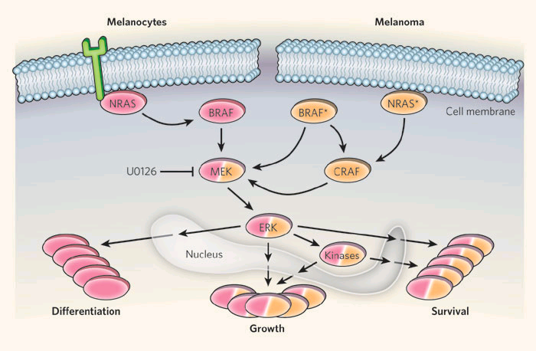
In healthy melanocytes, the NRAS-BRAF-MEK-ERK signalling cascade (pink) tightly regulates cellular functions such as differentiation, growth and survival. In melanoma (orange), BRAF mutations (BRAF*) bypass activation by NRAS, leading to cancer-associated signalling through the MEK-ERK pathway that favours growth and survival over differentiation. BRAF* can also activate this pathway through direct activation of CRAF. Mutant NRAS (NRAS*), however, activates MEK-ERK independently of BRAF, through CRAF (Huang & Marais 2009). Source: (Huang & Marais 2009)

BRAF mutations associated with melanoma
In a study of 197 Australian metastatic melanoma patients, 48% harboured a BRAF mutation, 74% of whom carried a valine to glutamic acid substitution at position 600 (V600E) on the amino acid chain of the protein, 20% carried a valine to lysine substitution (V600K) at the same position and 6% had other genotypes (Long et al. 2011). Both V600E and V600K mutations are able to constitutively activate the MAPK pathway downstream of BRAF and result in oncogenic transformation of the cell early in the establishment of the melanoma. Redundancy of the MAPK pathway (activation of expression of cell proliferation, differentiation and survival genes can also occur through the P13K pathway) often incurs dual dependency of the tumour later in disease progression on mutations in two pathways.

Since melanoma mutations are most frequently found in BRAF, various BRAF inhibitors have been developed for treatment trials. Dabrafenib and vemurafenib are two recently developed selective inhibitors which have been shown to give significant benefit in early trials (Chapman et al. 2011; Kefford R 2010). Dabrafenib is claimed to be a selective ATP competitive BRAF inhibitor with > 100-fold selectivity for mutant BRAF over wild type cell lines (Kefford R 2010).

BRAF V600 mutation testing
By testing tumours in melanoma patients for a BRAF V600 mutation, a population can be identified for whom treatment with the TKI dabrafenib would likely be most effective. Techniques used for identifying BRAF mutation status include, high resolution melt (HRM) analysis, pyrosequencing, SNaPshot and Sanger sequencing. Sanger sequencing, also called dideoxy sequencing uses single stranded DNA as a template for synthesis of new DNA strands by the addition of dinucleotides and dideoxynucleotides (ddNTPs) from solution. The incorporation of a ddNTP prevents further addition of nucleotides and so terminates the new DNA strand synthesis. Separation by electrophoresis of the synthesised strands on the basis of the size enables determination of the sequence of the template DNA.
HRM analysis is performed on double stranded DNA samples and is generally used in conjunction with polymerase chain reaction (PCR) which initially amplifies the DNA region of interest. The amplified DNA or amplicon is subjected to a heating process which causes the DNA strands to ‘melt’ or separate. The temperature at which melting occurs is precise and enables identification of a variation in genetic sequence when compared to a standard. When a mutation is detected, HRM is often followed by sequencing of the sample to confirm its sequence and mutation type.
Pyrosequencing uses single stranded DNA as a template for synthesis of a new complimentary strand into which nucleotides are incorporated as for Sanger sequencing. As nucleotides are added, the activity of the enzyme involved, DNA polymerase, is detected using another chemiluminescent enzyme. When the nucleotide solution complements the first unpaired base of the template, corresponding chemiluminescent light is produced, detection of which allows sequencing of the template.
Additional in-house methods for BRAF V600 mutation detection may also be used in research environments.

Delivery of the intervention
Under the proposed base case testing scenario BRAF V600 mutation testing would be performed on patients diagnosed with unresectable stage IIIA, IIIB or IIIC, resectable stage IIIB or IIIC, or metastatic (stage IV) cutaneous melanoma patients (the base case as defined by the Protocol Advisory Sub-Committee; PASC, as per the base case outlined in the DAP for vemurafenib). The population eligible for testing under the base case scenario will be broader than the population eligible for dabrafenib as those testing positive will have to meet further eligibility criteria (i.e. progression of disease to unresectable stage IIIB or IIIC, or stage IV). Diagnosis and tumour staging are made from biopsy samples which are expected to provide sufficient tumour material to also carry out BRAF V600 mutation testing. Biopsy samples are generally archived as formalin-fixed paraffin-embedded (FFPE) tissue blocks. If diagnosis of unresectable stage IIIA, IIIB or IIIC, resectable stage IIIB or IIIC or metastatic (stage IV) melanoma is made at the time of biopsy, then it will be followed by a request for the BRAF V600 mutation test. For patients initially diagnosed at an earlier stage of disease, the test will be requested once the disease is diagnosed as having progressed to unresectable stage IIIA, IIIB or IIIC, resectable IIIB or IIIC or metastatic (stage IV), in which case, retrieval of the archived biopsy sample will be necessary to allow mutation testing to be performed. Treatment may then occur if and when patients have or develop unresectable stage IIIB, IIIC or stage IV melanoma.
As an alternative scenario PASC suggested that a wider population consisting of those patients diagnosed with stage IIC, IIIA, IIIB, IIIC or stage IV melanoma could be considered for BRAF V600 mutation testing. This model includes testing those with either resectable or unresectable stage IIC, III or stage IV disease. In this scenario there is a less than 50% likelihood of patients with stage III disease progressing to disease for which dabrafenib would be eligible if they tested positive, whereas in the base case, there is a greater than 50% likelihood of patients progressing to the point of dabrafenib eligibility.
In a second alternative scenario the tested population is more restricted than the base case, including only patients with unresectable stage IIIC or stage IV metastatic disease (i.e. excluding those with stage IIIB and those with resectable stage IIIC disease). In this scenario the tested population is the same as the population eligible for vemurafenib, and would be immediately be eligible for dabrafenib treatment if found to be mutation positive.
A third alternative scenario is suggested in which the tested population corresponds with the eligible populations for the current randomised dabrafenib trials: unresectable stage IIIB or IIIC, or metastatic (stage IV) melanoma. In this scenario, patients with unresectable stage IIIB, IIIC and stage IV disease would be tested for dabrafenib eligibility. In this scenario, the population eligible for BRAF V600 mutation testing is the same as those eligible to receive dabrafenib treatment.
Table 3 summarises the different populations proposed by PASC (the base case and first two alternative scenarios) and by the applicant (alternative scenario 3).
Table 3 Scenarios outlining population eligible for BRAF mutation testing
Base case | Alternative scenario I | Alternative scenario 2 | Alternative scenario 3
Unresectable stage IIIA, IIIB or IIIC or resectable stage IIIB or IIIC or stage IV melanoma (based on base case in vemurafenib DAP) | Stage IIC, IIIA, IIIB, IIIC or IV melanoma | Unresectable stage IIIC or IV melanoma  (based on vemurafenib trial population) | Unresectable stage IIIB, IIIC or IV melanoma  (based on dabrafenib trial populations)
The majority of patients will only require one BRAF V600 mutation test in their lifetime. Re-testing may be necessary if insufficient DNA is retrievable from the biopsy cells, if the biopsy sample is not considered satisfactory (due to deterioration or formalin associated artefacts), or if DNA testing is inconclusive. Furthermore, re-biopsy may be required to provide additional material for retesting or if an oncologist requests testing of additional tumours (e.g. new melanomas arising in the same patient), however circumstances for re-testing or re-biopsy are likely to arise infrequently. Only patients whose performance status is of an acceptable level for treatment (i.e. patients whose health status is considered sufficient to tolerate treatment) with dabrafenib would be considered eligible for BRAF V600 mutation testing.
As there is little incidence or prevalence data available for locally advanced or metastatic melanoma, it is difficult to estimate the number of patients who may require BRAF V600 mutation testing. The incidence of melanoma for 2010 was estimated from 1982 to 2007 data by AIHW to be 11,900 persons, with an age adjusted incidence rate of 50 per 100,000. Mortality was estimated at 1,500 persons for 2010 with an age adjusted rate of 6 per 100,000 (AIHW & AACR 2010). Mortality can be considered a reasonable estimate of the prevalence of non-resectable melanoma as the life expectancy for this group is less than one year. While approximately 10% of these patients would not have previously been suitable candidates to receive chemotherapy due to their poor performance status, they may be offered the oral therapy dabrafenib if found positive for a BRAF V600 mutation. It could be estimated therefore that 1,500 (100%) of patients may have been eligible for BRAF V600 mutation testing in 2010, with a likelihood of higher numbers eligible for testing in 2013 due to an increasing incidence of melanoma.

Prerequisites
BRAF V600 mutation testing would ordinarily be ordered by the patient’s oncologist once a diagnosis of advanced or metastatic melanoma is made, however in some cases reflex testing by the pathologist at the time of diagnosis may be considered. A surgeon, oncologist or dermatologist would be responsible for the collection of a biopsy or cytological sample from the patient. Tissue samples are normally processed into FFPE tissue blocks which are then sectioned, stained and mounted onto glass slides. Following mounting, samples would be examined by a suitably qualified pathologist.
Once the tissue sample has been retrieved by the testing laboratory, an anatomical pathologist would mark the tumour, following which a scientist would perform a dissection of the tumour cells (sample enrichment) so that an appropriate sample is available for DNA extraction. DNA extraction and assay would be performed by a molecular scientist or technician, under the supervision of a senior scientist or pathologist according to NPAAC laboratory supervision standards. Supervising senior scientists are required by the NPAAC to have a PhD or Fellowship in the appropriate discipline, 10 years experience and a minimum of two years as a supervisor in a clinical laboratory. Pathologists require a medical degree followed by five years of specialist training in pathology and examination by the Fellow of the Royal College of Pathologists of Australasia (FRCPA).
All BRAF V600 mutation tests must be performed in NATA accredited laboratories. To gain NATA accreditation a laboratory must satisfy standards set by NPAAC. Competence to perform the test will be monitored through the RCPA Quality Assurance Program (QAP). While it is not proposed that a specific method for BRAF V600 mutation testing should be included in the MBS item listing (unless relative performance analysis indicates MBS item listing should limit the range of suitable tests), the choice of technique may depend on factors such as available equipment, skill and experience of staff, case load and case mix. Where laboratories in Australia are already conducting BRAF V600 testing it could be expected that no further investment in equipment or staff would be required, although upgrades driven by technology changes may be necessary. Laboratories wishing to establish BRAF V600 testing would need to outlay for the testing platform of their choice, and additional outlays to seek NATA accreditation and staff training will be required.
Due to the complexity of the testing and the need for NATA accreditation it is likely that the majority of BRAF V600 testing will be performed in specialist referral laboratories, located in the major metropolitan areas of Australia (although it is possible that testing will be more widely provided if it is MBS listed). Currently patients are usually required to attend a metropolitan or large regional facility to have a biopsy taken (although occasionally a GP will take a biopsy sample from a patient). If BRAF V600 testing is not available at the laboratory where the diagnostic analysis is performed, the biopsy sample would be retrieved by the testing laboratory and prepared for DNA analysis. Patients would not be further inconvenienced by this process. Where the initial laboratory is unable to provide the test and it is referred on, the second laboratory may be able to claim a separate MBS item, incurring additional cost to MBS.

Co-administered and associated interventions
BRAF V600 mutation testing is a co-dependent service and is required to determine eligibility for treatment with the dabrafenib for mutation positive patients with unresectable stage III or metastatic (stage IV) melanoma. The recommended course of dabrafenib for mutation positive patients is 150 mg twice daily until there is further disease progression or until toxicity prevents further use.
Patients testing positive for a BRAF V600 mutation could be eligible for vemurafenib or dabrafenib therapy, or other new therapies targeted at BRAF activating mutations (eg. Trametinib). Should these therapies become PBS listed, their usage is likely to increase, while at the same time, utilisation of standard chemotherapy (dacarbazine) is likely to decrease for these patients.

Listing proposed and options for MSAC consideration

Proposed MBS listing
The details of the proposed MBS listing for BRAF V600 mutation testing are shown in Table 4 (wording is based on item descriptor for MSAC Application 1172).
Table 4: Proposed MBS item descriptor for BRAF V600 testing in advanced or metastatic melanoma
Category 6 – Pathology Services
MBS [proposed item number]
A test of tumour tissue from a patient with unresectable stage IIIA, stage IIIB, or stage IIIC, or resectable stage IIIB or IIIC, or metastatic (stage IV) cutaneous melanoma to determine if the requirements relating to BRAF activating mutation status for access to dabrafenib under the Pharmaceutical Benefits Scheme (PBS) are fulfilled.
Fee: $285 - $325
Explanatory notes:
The test will, ordinarily, be initiated by a pathologist, medical oncologist or surgeon. Samples with low quality DNA or low tumour cell content relevant to the sample size available and chosen testing method may require tumour cell enrichment or the use of a method more sensitive than Sanger sequencing.

Note: The item descriptor reflects the base case scenario with regard to population and V600 mutation status.
Under the base case proposal, patients diagnosed with unresectable stage IIIA, IIIB, or IIIC, or resectable stage IIIB or IIIC, or metastatic (stage IV) melanoma would be eligible for BRAF V600 mutation testing. The patient population eligible for BRAF V600 mutation testing under the MBS is likely to be broader than that eligible for dabrafenib treatment supported by the MBS (under the base case testing scenario). Stage III and IV melanoma are defined by the TNM staging criteria. Table 5 outlines the TNM staging criteria defining the different stages in cutaneous melanoma. Table 6 shows the clinical and pathological staging classifications with regard to cutaneous melanoma. The blue shading shows the population likely eligible for dabrafenib treatment if listed on the PBS.
Table 5: TNM staging categories for cutaneous melanoma
T stage | Thickness (mm) | Ulceration status/mitoses
Tis | N/A | N/A
T1 | ≤ 1.00 | a: without ulceration and mitosis < 1/mm²  b: with ulceration or mitosis ≥ 1/mm²
T2 | 1.01–2.00 | a: without ulceration  b: with ulceration
T3 | 2.01–4.00 | a: without ulceration  b: with ulceration
T4 | > 4.00 | a: without ulceration  b: with ulceration
N stage | No of metastatic nodes | Nodal metastatic burden
N0 | 0 | N/A
N1 | 1 | a: micrometastasis¹  b: macrometastasis²
N2 | 2–3 | a: micrometastasis¹  b: macrometastasis²  c: in transit metastases / satellites without metastatic nodes
N3 | Pathologic: 4+ metastatic nodes, or matted nodes, or in transit metastases / satellites with metastatic nodes  Clinical: ≥ 1 node with in transit metastases / satellite(s)
M stage | Site | Serum LDH
M0 | No distant metastases | N/A
M1a | Distant skin, subcutaneous, or nodal metastases | Normal
M1b | Lung metastases | Normal
M1c | All other visceral metastases  Any distant metastasis | Normal  Elevated
Source: (American Joint Committee on Cancer 2010; Balch et al. 2009)
N/A = not applicable; LDH = lactate dehydrogenase.
¹ = micrometastases are diagnosed after sentinel lymph node biopsy
² = macrometastases are defined as clinically detectable nodal metastases confirmed pathologically.
Table 6: Anatomic stage groupings for cutaneous melanoma
 | Clinical staging¹ |  |  |  | Pathologic staging²
 | T | N | M |  | T | N | M
0 | Tis | N0 | M0 | 0 | Tis | N0 | M0
IA | T1a | N0 | M0 | IA | T1a | N0 | M0
IB | T1b  T2a | N0  N0 | M0  M0 | IB | T1b  T2a | N0  N0 | M0  N0
IIA | T2b  T3a | N0  N0 | M0  M0 | IIA | T2b  T3a | N0  N0 | M0  M0
IIB | T3b  T4a | N0  N0 | M0  M0 | IIB | T3b  T4a | N0  N0 | M0  M0
IIC | T4b | N0 | M0 | IIC | T4b | N0 | M0
III | Any T | N > N1 | M0 | IIIA | T1-4a  T1-4a | N1a  N2a | M0  M0
 |  |  |  | IIIB | T1-4b  T1-4b  T1-4a  T1-4a  T1-4a | N1a  N2a  N1b  N2b  N2c | M0  M0  M0  M0  M0
 |  |  |  | IIIC | T1-4b  T1-4b  T1-4b  Any T | N1b  N2b  N2c  N3 | M0  M0  M0  M0
IV | Any T | Any N | M1 | IV | Any T | Any N | M1
Source: (American Joint Committee on Cancer 2010)
¹ Clinical staging includes microstaging of the primary melanoma and clinical/radiologic evaluation for metastases. By convention, it should be used after complete excision of the primary melanoma with clinical assessment for regional and distant metastases.
² Pathologic staging includes microstaging of the primary melanoma and pathologic information about the regional lymph nodes after partial (ie sentinel node biopsy) or complete lymphadenectomy. Pathologic stage 0 or stage IA patients are the exception; they do not require pathologic evaluation of their lymph nodes.

Clinical place for proposed intervention
Current and proposed clinical management
The current and proposed scenarios for clinical management of locally advanced or metastatic melanoma are illustrated in Figure 3. In the current scenario there is no BRAF V600 mutation testing or dabrafenib treatment for patients with locally advanced or metastatic melanoma. Treatment with dacarbazine is generally offered to these patients (fotemustine is another option) as a first line therapy. In the event of failure of first line therapy, the immunomodulator ipilimumab may be offered as a second line therapy. Dacarbazine and ipilimumab require intravenous administration every three weeks, and in addition ipilimumab requires liver and thyroid functions tests to be carried out prior to each dose.

Under the proposed base case scenario all patients diagnosed with unresectable stage IIIA, IIIB or IIIC, or resectable stage IIIB or IIIC, or metastatic (stage IV) melanoma would undergo BRAF V600 mutation testing. Only patients testing positive for V600E or V600K and with disease which has progressed to unresectable stage IIIC or metastatic (stage IV) will be eligible to receive the targeted BRAF therapy dabrafenib (or vemurafenib) in the base case scenario. The FDA approved and TGA pending Cobas BRAF assay only detects the presence or absence of a V600E or V600K mutation but does not identify which V600 mutation (ie E or K) is present. Patients testing negative for a V600 mutation and those who test positive for a V600 mutation other than V600E or K, would be eligible to receive dacarbazine (or fotemustine) as a first line therapy followed by ipilimumab as a second line therapy (chemotherapy is offered on the basis that the patient’s health status is considered satisfactory to receive that treatment). As BRAF V600 testing follows diagnosis of unresectable stage IIIA, IIIB or IIIC, or resectable stage IIIB or IIIC, or metastatic (stage IV) melanoma, retrieval of the stored biopsy will be necessary for those initially diagnosed at earlier stages. Patients testing positive would then be eligible to receive dabrafenib if/when their disease progresses to advanced, unresectable stage IIIB or IIIC, or metastatic (stage IV) disease. Clinical studies with dabrafenib have enrolled subjects with V600E and V600K mutations.

In the first alternative BRAF testing scenario, patients testing positive for any V600 mutation would be eligible to receive dabrafenib therapy. Almost 100% of patients with BRAF mutations would be detected in this scenario, compared with 94% in the base case scenario (Long et al, 2011). Those testing positive for any V600 mutation would be offered dabrafenib (or vemurafenib) if their disease progresses to unresectable stage IIIB or IIIC (or stage IIIC for vemurafenib) or metastatic (stage IV) melanoma and those found negative for any V600 mutations would be offered chemotherapy as described in the base case scenario.

In a second alternative scenario for BRAF mutation testing, only patients testing positive for a V600E mutation would be eligible for treatment with dabrafenib. Other patients will be offered chemotherapy as described in the base case and first alternative scenario.

The proposed management algorithm would satisfy a previously unmet clinical need, as there is currently no Commonwealth Government funding for BRAF V600 mutation testing of patients with melanoma. It should be noted that patients considered not suitable for chemotherapy due to poor health status under the current scenario (approximately 10% of patients) could be offered the oral treatments dabrafenib or vemurafenib if they tested positive under the proposed scenarios.BRAF V600 mutation testing has not previously been used to identify eligible patients for targeted BRAF therapies under Australian clinical guidelines. Patients found to be M+ for BRAF V600E or K may benefit from other BRAF targeted therapies if they were to be PBS listed for treatment of melanoma. Vemurafenib is another BRAF inhibitor currently under review by PBAC. Figure 3 illustrates the current and proposed clinical algorithms for treatment according to V600 mutation status.

The MEK inhibitor trametinib may be another possible alternative for future targeted treatment of advanced melanoma, and will rely on the same (or similar) biomarker and testing strategy to determine PBS eligibility if approved.
All eligible and available test options for testing against the biomarker (BRAF V600E or K, BRAF V600E only or any BRAF V600 mutation) should be included in the submission of evidence and compared to the evidentiary standard (i.e. the test and testing procedure used to generate evidence to support the effectiveness of dabrafenib). MSAC assessment of the three defined biomarker scenarios would be assisted by the inclusion of evidence of the change of prevalence across each of the definitions.
Figure 3: Management algorithm for use of BRAF V600 mutation testing in locally advanced or metastatic cutaneous melanoma
Chemotherapy: dacarbazine or fotemustine
Health outcomes
Health outcomes
Chemotherapy: dacarbazine or fotemustine

M-⁴

BRAF V600 M+⁴
Dabrafenib, trametinib or
vemurafenib

Current clinical pathways
¹ Testing will occur on biopsies from primary cutaneous tumour or on specimens (eg fine needle aspiration) from metastatic tumour. Repeat testing or re-biopsying may be required if there is insufficient tumour material to provide a result.
² This pathway is applicable to the base case and all 3 alternative scenarios
³ This pathway is applicable to the base case (stage IIIB only) and alternative scenarios 1 and 3 only
⁴ BRAF M+ and M- status defined by the mutations tested in the scenario
BRAF V600 mutation testing¹
Dacarbazine or fotemustine
Dacarbazine or fotemustine
Ipilimumab

Ipilimumab

Ipilimumab

Patients suitable for chemotherapy
Patients unsuitable for chemotherapy
Palliative care
90%
10%
At or progressed to unresectable stage IIIC or stage IV disease²

Alternate Scenario 1,
Base case
Dacarbazine or fotemustine
90%
10%
Patients who have progressed to unresectable stage IIIB, IIIC or metastatic stage IV disease
Palliative care
Unresectable stage IIIA, IIIB, IIIC, or resectable stage IIIB, IIIC, or stage IV melanoma
Stage IIC, IIIA, IIIB, IIIC or IV melanoma
Unresectable stage IIIC or stage IV melanoma (based on vemurafenib trial population)
Unresectable stage IIIB, IIIC or IV melanoma (based on dabrafenib trial populations)
No progression to treatment stage for any scenario
At or progressed to unresectable stage IIIB disease³

Dabrafenib or trametinib

Dacarbazine or fotemustine
Ipilimumab

Alternate Scenario 2,
Alternate Scenario 3,
BRAF V600 M+⁴
Palliative care
1st line therapies
2nd line therapies
Proposed clinical pathways

Comparator
The first comparator for this assessment is ‘no testing with usual care’ for melanoma patients. Usual care consists of standard chemotherapy (dacarbazine, or less commonly fotemustine) as a first line therapy, and ipilimumab, may be offered as a second line treatment. The comparator is described in the current management algorithm, where patients with unresectable stage IIIA, IIIB or IIIC, resectable stage IIIB or IIIC, or metastatic (stage IV) melanoma would not be tested for BRAF mutation status, but would be offered standard chemotherapy (usual care). Patients considered to have a poor performance status and therefore not offered chemotherapy (estimated at 10%) will be eligible for treatment with the oral therapy dabrafenib under the proposed clinical pathway. There are no MBS item descriptors for ‘usual care’, however there are MBS items which cover the provision of chemotherapy, although these would also be relevant to those who are mutation negative in the intervention arm.
An alternative comparator would be BRAF V600 mutation testing with vemurafenib therapy or usual care. This comparator could be used for the assessment should data become available for the comparison of BRAF mutation testing followed by either vemurafenib with usual care or dabrafenib or usual care in melanoma patients.
A second alternative comparator could be BRAF V600 mutation testing with trametinib treatment or usual care, should GSK submit an application to MSAC for assessment of that drug and data becomes available for comparison of BRAF mutation testing followed by dabrafenib or usual care with trametinib or usual care.

Outcomes and health care resources affected by introduction of proposed intervention

Outcomes
The health outcomes, upon which the comparative clinical performance of BRAF V600 mutation testing plus dabrafenib or usual care versus the comparators of 1) no BRAF testing plus usual care or 2) BRAF mutation testing plus vemurafenib or usual care or 3) BRAF mutation testing plus trametinib or usual care will be measured, are:
Effectiveness
- Progression free survival
- Overall survival
- Quality of life
- Response rate (complete or partial)
- Duration of response
- Rate of stable disease
- Rate of disease progression
- Time to progression

Analytic validity
- Analytic accuracy (ie sensitivity, specificity, rate of false positives and false negatives)
- Test-retest reliability
- Equivocal test results

Safety
- Toxic effects from subsequent treatment (including skin rash, neutropenia, diarrhoea, QT prolongation, additional cancers, fever, fatigue, headache, nausea, vomiting)
- Adverse events associated with biopsy
- Rate of re-biopsy
- Impact on patients of false positive and false negative test results

Note: The applicant has indicated that a test strategy adopted in the major randomised trial generating evidence for dabrafenib is currently being examined, and is not able to disclose any details publicly at this point.

Summary of PICO to be used for assessment of evidence (systematic review)
Table 7 provides a summary of the PICO used to:
- define the question for public funding,
- select the evidence to assess the safety and effectiveness of BRAF V600 mutation testing in unresectable stage IIIA, IIIB or IIIC, or resectable stage IIIB or IIIC, or metastatic (stage IV) cutaneous melanoma (base case scenario), and
- provide the evidence-based inputs for any decision-analytic modelling to determine the cost-effectiveness of BRAF V600 mutation testing in unresectable stage IIIA, IIIB, or IIIC, or resectable stage IIIB or IIIC), or metastatic (stage IV) cutaneous melanoma.
Table 7: Summary of PICO to define research questions that assessment will investigate
Patients | Intervention | Comparator | Reference Standard | Outcomes to be assessed
Base case  Patients with unresectable stage IIIA, IIIB, or IIIC, or resectable stage IIIB or IIIC, or metastatic (stage IV)ª cutaneous melanoma^{b}  Alternative 1  Patients with stage IIC, IIIA, IIIB or IIIC, or metastatic (stage IV) cutaneous melanoma^{b}  Alternative 2  Patients with unresectable stage IIIC or metastatic (stage IV) cutaneous melanoma  Alternative 3  Patients with unresectable stage IIIB or IIIC, or metastatic (stage IV) cutaneous melanoma | BRAF V600E/K (or V600 or V600E) mutation testing and use of dabrafenib in patients with a BRAF V600E/K (or V600 or V600E) mutation or current usual care* in patients without these mutations  *Current usual care is defined as dacarbazine or fotemustine as first line treatment and ipilimumab as a second line treatment, or palliation in those who are unsuitable for chemotherapy | No BRAF V600E/K (or V600 or V600E) mutation testing and current usual care*  *Current usual care is defined as dacarbazine or fotemustine as first line treatment and ipilimumab as a second line treatment, or palliation in those who are unsuitable for chemotherapy. | No agreed reference standard currently available, but comparisons should be made against the specific tests used to generate the evidence to support the effectiveness of dabrafenib compared with current usual care. | Safety  - Toxic effects from subsequent treatment (including skin rash, neutropenia, diarrhoea, QT prolongation, additional cancers, fever, fatigue, nausea, headache, vomiting)  - Adverse events associated with biopsy  - Rate of re-biopsy  - Impact on patients of false positive and false negative test results  Effectiveness^{c}  Direct evidence  Primary outcomes:  - Overall survival  - Quality of life  - Progression-free survival  Secondary outcomes:  - Response rate (complete or partial)  - Duration of response  - Rate of stable disease  - Rate of disease progression  - Time to progression  Analytical validity  - Accuracy (sensitivity, specificity, positive predictive values, negative predictive values)  - Test retest reliability  - Equivocal test results  Cost-effectiveness  - Cost  - Cost per relevant health outcome (eg LYG, QALY, DALY)
 |  | BRAF V600E/K (or V600) mutation testing and use of vemurafenib in patients with a BRAF V600E/K (or V600) mutation or current usual care* in patients without these V600 mutations  *Current usual care is defined as dacarbazine or fotemustine as first line treatment and ipilimumab as a second line treatment, or palliation in those who are unsuitable for chemotherapy. | No agreed reference standard currently available, but comparisons should be made against the specific tests used to generate the evidence to support the effectiveness of vemurafenib compared with current usual care or dabrafenib.
 |  | BRAF V600E/K (or V600) mutation testing and use of trametinib in patients with a BRAF V600E/K (or V600) mutation or current usual care* in patients without these V600 mutations  *Current usual care is defined as dacarbazine or fotemustine as first line treatment and ipilimumab as a second line treatment, or palliation in those who are unsuitable for chemotherapy. | No agreed reference standard currently available, but comparisons should be made against the specific tests used to generate the evidence to support the effectiveness of trametinib compared with current usual care or dabrafenib.
Research Questions
- Base case: Is BRAF V600E/K mutation testing in patients with unresectable stage IIIA, IIIB or IIIC, or resectable stage IIIB or IIIC, or metastatic (stage IV) cutaneous melanoma to guide targeted treatment with dabrafenib in those BRAF test positive patients who have or develop unresectable stage IIIB or IIIC of metastatic (Stage IV) disease, safe, effective and cost-effective compared to usual care alone without BRAF testing?
  - Compared to the base case, are the alternative test population scenarios of i. patients with stage IIC, IIIA, IIIB, IIIC or metastatic (stage IV) cutaneous melanoma; ii. patients with unresectable stage IIIC or metastatic (stage IV) melanoma; or iii. patients with unresectable stage IIIB or IIIC, or metastatic (stage IV) melanoma, safe, effective and cost-effective compared to usual care alone without BRAF testing?
  - Compared to the base case, are the alternative biomarker definition scenarios of i. BRAF V600 (any mutation); ii. BRAF V600E only mutation testing, safe, effective and cost-effective compared to usual care alone without BRAF testing?
- Compared to the base case proposal, is the alternative targeted treatment with vemurafenib, safe, effective and cost-effective?
- Compared to the base case proposal, is the alternative targeted treatment with trametinib, safe, effective and cost-effective?

ª According to the 2009 American Joint Committee on Cancer (American Joint Committee on Cancer 2010)
^{b} This proposal allows wider BRAF V600 mutation testing than was conducted in the trials to develop evidence for dabrafenib although patients would only be eligible for treatment with dabrafenib at advanced unresectable stage IIIB or IIIC, or metastatic (stage IV) cutaneous melanoma.
^{c} Section B of the “Information requests for co-dependent technologies” table (http://www.health.gov.au/internet/hta/publishing.nsf/Content/whats-new) outlines some strategies for linking evidence in the absence of direct trial evidence of the co-dependent package of technologies (ie biomarker/test/drug). In this case this might include systematically reviewing data on the accuracy of BRAF V600 mutation testing – using various testing modalities - in stage III or stage IV cutaneous melanoma relative to Sanger sequencing (or another proposed reference standard if it can be justified), and linking that to data on observed changes in management associated with BRAF testing, as well as trial data on the effectiveness of dabrafenib (relative to usual care) in the proposed population. The PICO to address each type of evidence linkage would need to be pre-specified and a research question constructed.
N/A = not applicable; RECIST = Response Evaluation Criteria in Solid Tumours; FNA = fine needle aspiration; LYG = life-year gained; QALY = quality adjusted life-year; DALY = disability adjusted life-year.

Clinical claim
The applicant has indicated that while Phase III trials generating evidence for BRAF V600 testing followed by dabrafenib are currently underway, it is unable to disclose any details or make any clinical claims at this point. If the results of these trials support a clinically relevant and statistically significant improvement in progression-free survival and response rates compared to dacarbazine, the use of these co-dependent technologies may have a large impact on the treatment of BRAF V600 mutation-positive melanoma patients.
For patients who are found to be BRAF V600 negative, BRAF mutation testing will have minimal impact and patients would not be required to undergo further biopsy (assuming that mutation status between the primary tumour and metastases is stable).
The proposed BRAF V600 mutation testing would replace no testing. While BRAF V600 mutation testing and targeted treatment may be superior in efficacy to no testing and usual care there is likely to be increased costs associated with test performance and with the codependent dabrafenib treatment when compared to chemotherapy (dacarbazine). Relative to the dacarbazine, BRAF V600 mutation testing and treatment with dabrafenib may be non-inferior in terms of safety and may be superior in terms of effectiveness. As such, the type of economic evaluation required would be a cost-effectiveness analysis or cost-utility analysis (orange shading in Table 8). In addition, exploration of uncertainty should be conducted around the estimates of effectiveness and safety.
A second comparator to BRAF testing and dabrafenib treatment is BRAF testing and vemurafenib treatment in those who are BRAF mutation positive. Phase III trial data comparing dabrafenib with dacarbazine chemotherapy may allow indirect comparison of efficacy and safety outcomes with vemurafenib. If dabrafenib and vemurafenib are demonstrated to be non-inferior to each other in terms of safety and effectiveness, a cost-minimisation analysis would be performed.
A third possible comparator to BRAF testing and dabrafenib treatment is BRAF testing and trametinib treatment in those who are BRAF mutation positive if trials were to provide data on this comparison. Indirect comparison may be made with data from comparisons of BRAF testing and darafenib treatment or usual care, and BRAF testing and trametinib treatment or usual care. If dabrafenib and trametinib are shown to be non-inferior to each other for safety and effectiveness, a cost-minimisation analysis should be performed.
Table 8: Classification of an intervention for determination of economic evaluation to be presented
 |  | Comparative effectiveness versus comparator
 |  | Superior |  | Non-inferior | Inferior
Comparative safety versus comparator | Superior | CEA/CUA |  | CEA/CUA | Net clinical benefit | CEA/CUA
 |  |  |  |  | Neutral benefit | CEA/CUA*
 |  |  |  |  | Net harms | None^
 | Non-inferior | CEA/CUA |  | CEA/CUA* | None^
 | Inferior | Net clinical benefit | CEA/CUA | None^ | None^
 |  | Neutral benefit | CEA/CUA*
 |  | Net harms | None^
Abbreviations: CEA = cost-effectiveness analysis; CUA = cost-utility analysis
* May be reduced to cost-minimisation analysis. Cost-minimisation analysis should only be presented when the proposed service has been indisputably demonstrated to be no worse than its main comparator(s) in terms of both effectiveness and safety, so the difference between the service and the appropriate comparator can be reduced to a comparison of costs. In most cases, there will be some uncertainty around such a conclusion (i.e., the conclusion is often not indisputable). Therefore, when an assessment concludes that an intervention was no worse than a comparator, an assessment of the uncertainty around this conclusion should be provided by presentation of cost-effectiveness and/or cost-utility analyses.
^ No economic evaluation needs to be presented; MSAC is unlikely to recommend government subsidy of this intervention

Health care resources
Health care resources utilised in the current management scenario, and those whose utilisation is expected to be impacted should the proposed intervention be made available, are listed in Table 9.

Table 9: List of resources to be considered in the economic analysis
 | Provider of resource | Setting in which resource is provided | Proportion of patients receiving resource | Number of units of resource per relevant time horizon per patient receiving resource | Disaggregated unit cost
 |  |  |  |  | MBS | Safety nets* | Other govt budget | Private health insurer | Patient | Total cost
Resources provided to deliver BRAF V600 mutation testing – proposed scenario
Block retrieval of stored sample from tissue archive (from most recent biopsy) | Pathologist |  | TBD (not all samples will need to be retrieved if biopsy performed at diagnosis of metastatic disease) | 1 |  |  |  |  |  | TBD
Preparation of tissue sample | Pathologist |  | 100% | 1 |  |  |  |  |  | TBD
BRAF V600 mutation molecular test | Molecular pathologist |  | 100% | 1 | $285 - $325 |  |  |  |  | TBD
Retesting if BRAF V600 status inconclusive | Molecular pathologist |  | Will differ according to each specific test method used | 1 | $285 - $385 |  |  |  |  | TBD
Resources provided to deliver drug therapy – proposed scenario
Specialist consultation  for initiation of dabrafenib (oral) and Regular follow-up in BRAF V600 mutation positive patients  MBS 110  MBS 116 | Medical oncologist | Outpatient | 47%ª | TBD | $145.20  $72.65 |  |  |  |  | TBD
Dabrafenib | Medical oncologist | Outpatient/  inpatient | 47%ª | 150 mg twice daily orally^{b} until disease progression |  |  |  |  |  | TBD
Specialist consultation for initiation of dacarbazine ( or fotemustine) as first-line chemotherapy, with or without a T cell immunostimulant (ipilimumab) or fotemustine as a second line treatment and regular follow-up  MBS 110  MBS 116 | Medical oncologist | Outpatient | 53% (BRAF negative patients) |  | $145.20  $72.65 |  |  |  |  | TBD
Dacarbazine (first line treatment) | Medical oncologist | Day patient | TBD (BRAF negative patients) |  |  |  |  |  |  | TBD
Fotemustine (first or second line treatment) | Medical oncologist | Day patient | TBD (BRAF negative patients) |  | $1206.86/vial |  |  |  |  | TBD
Ipilimumab (second line treatment) | Medical oncologist | Day patient | TBD (BRAF negative patients) |  |  |  |  |  |  | TBD
Drug administration for < 1 hr infusion (MBS 13915) | Medical oncologist | Day patient | 53% (BRAF negative patients) |  |  |  |  |  |  | TBD
Public hospital outpatient admission for drug administration | Medical oncologist | Day patient | 53% (BRAF negative patients) |  |  |  |  |  |  | TBD
Resources provided in association with proposed intervention – to manage adverse events from dabrafenib
Cutaneous squamous cell carcinoma monitoring | Medical oncologist | Outpatient | 12%^{b} | TBD |  |  |  |  |  | TBD
Cutaneous squamous cell carcinoma excision  MBS 31280  MBS 31285  MBS 31290 | Dermatologist | Outpatient | 12%^{b} | TBD | $149.95  $201.90  $236.55 |  |  |  |  | TBD
Monitoring for QT prolongation, 12 lead electrocardiography (MBS 11700) | Medical oncologist | Outpatient | 47%ª | TBD | $30.05 |  |  |  |  | TBD
Resources provided to deliver drug therapy - current scenario
Specialist consultation for initiation of dacarbazine - or less commonly fotemustine - as first-line chemotherapy, with or without a T cell immunostimulant (ie ipilimumab) or fotemustine as a second line treatment and regular follow-up (MBS 116) | Medical oncologist | Outpatient | 100% |  |  |  |  |  |  | TBD
Dacarbazine (first line teatment) | Medical oncologist | Day patient | TBD |  |  |  |  |  |  | TBD
Fotemustine (first or second line treatment) | Medical oncologist | Day patient | TBD |  | $1206.86/vial |  |  |  |  | TBD
Ipilimumab (second line treatment) | Medical oncologist | Day patient | TBD |  |  |  |  |  |  | TBD
Drug administration for < 1 hr infusion (MBS 13915) | Medical oncologist | Day patient | 100% |  |  |  |  |  |  | TBD
Public hospital outpatient admission for drug administration | Medical oncologist | Day patient | 100% |  |  |  |  |  |  | TBD
Resources provided in association with delivering drug therapy - current scenario
Cutaneous squamous cell carcinoma monitoring | Medical oncologist | Outpatient | 12%^{b} | TBD |  |  |  |  |  | TBD
Cutaneous squamous cell carcinoma excision  MBS 31280  MBS 31285  MBS 31290 | Dermatologist | Outpatient | 12%^{b} | TBD | $149.95  $201.90  $236.55 |  |  |  |  | TBD
Monitoring for QT prolongation, 12 lead electrocardiography (MBS 11700) | Medical oncologist | Outpatient | 47%ª | TBD | $30.05 |  |  |  |  | TBD
TBD = to be determined
* Include costs relating to both the standard and extended safety net.
ªPercentage of BRAF mutation positive patients in a study of 677 melanoma patients (Jakob JA 2011)
^{b}Percentage of cutaneous squamous cell carcinoma in a study of 675 BRAF V600E positive melanoma patients randomised to vemurafenib or dacarbazine (Chapman et al. 2011)

Proposed structure of economic evaluation
Figure 4 outlines the proposed base case decision analysis as a means of summarising the comparisons the assessment report should investigate and present for those patients with unresectable stage IIIA, IIIB or IIIC, or resectable stage IIIB or IIIC, , or metastatic (stage IV) cutaneous melanoma. Figure 5 outlines the decision analysis with BRAF mutation testing occurring in the alternative population of resectable or unresectable stage IIC, IIIA, IIIB or IIIC or IV melanoma. Figure 6 displays the decision analysis for alternative population 2 (unresectable stage IIIC or IV) and Figure 7 displays the decision analysis for the alternative population 3 (unresectable stage IIIB, IIIC or stage IV).
The additional scenarios corresponding to different mutation tests used would not alter the basic structure of the following decision analyses.

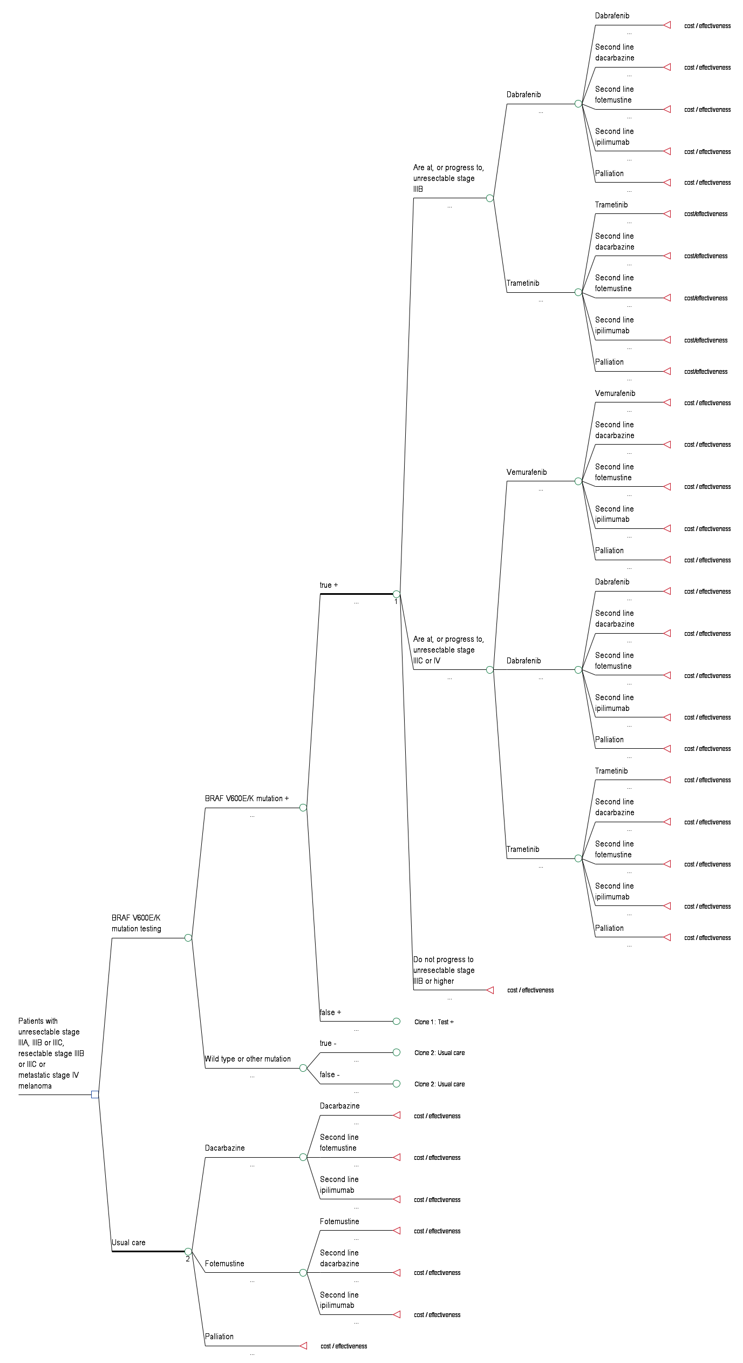Figure 4: Decision tree representing the decision options of using BRAF V600 E/K mutation testing to guide treatment in unresectable stage IIIA, IIIB or IIIC, or resectable stage IIIB or IIIC, or metastatic (stage IV) melanoma (base case)

Figure 5 Decision tree representing the decision options of using BRAF V600 E/K mutation testing to guide treatment in stage IIC, IIIA, IIIB or IIIC, or metastatic stage IV melanoma (alternative 1)
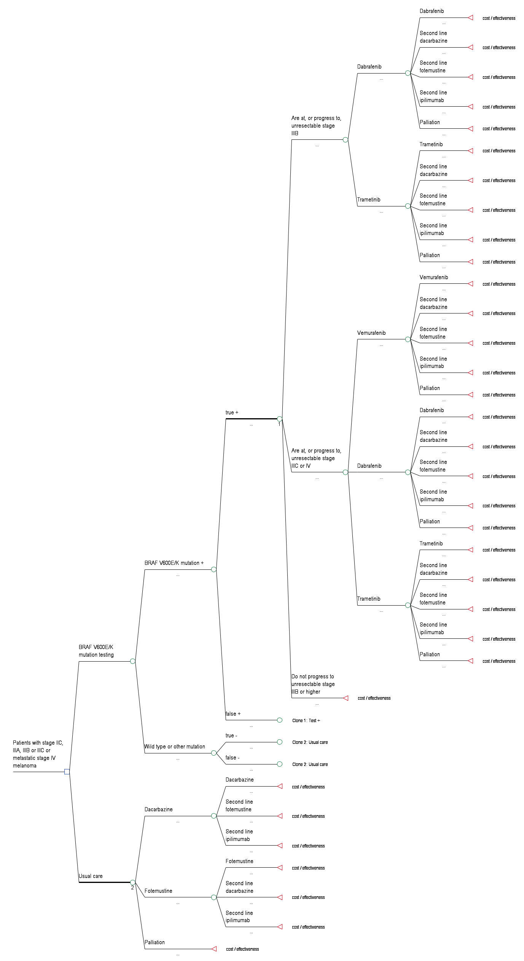
Figure 6 Decision tree representing the decision options of using BRAF V600 E/K mutation testing to guide treatment in unresectable stage IIIC or metastatic stage IV melanoma (alternative 2)
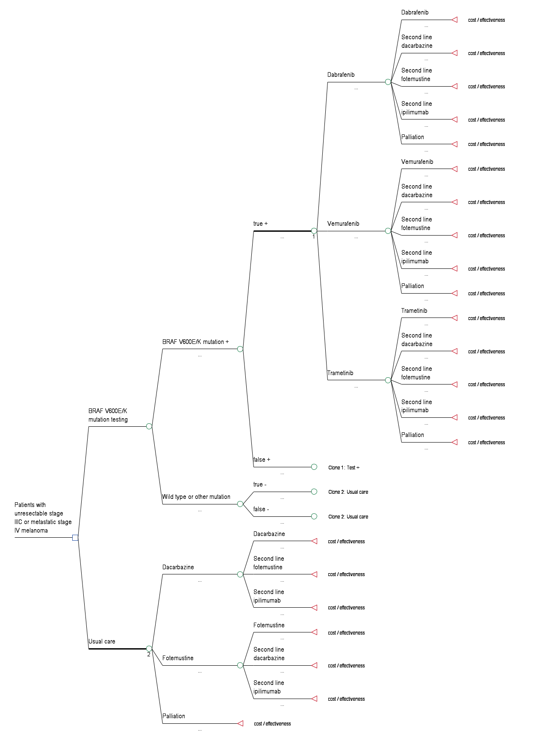
Figure 7 Decision tree representing the decision options of using BRAF V600 E/K mutation testing to guide treatment in unresectable stage IIIB or IIIC, or metastatic stage IV melanoma (alternative 3)
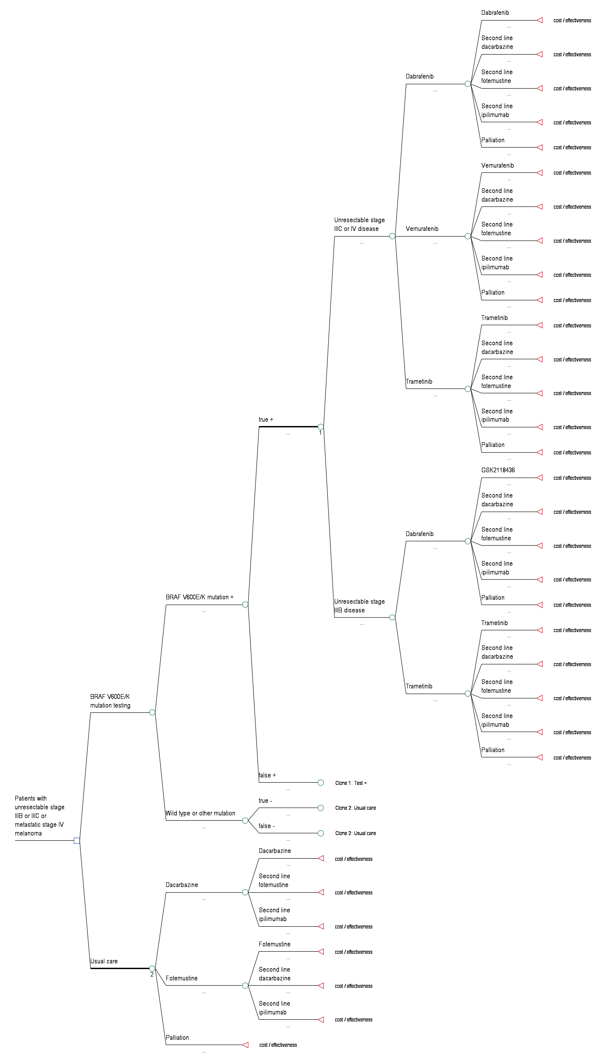

References
AIHW & AACR 2010, Cancer in Australia: an overview, 2010, Cancer series, Canberra.

American Joint Committee on Cancer 2010, Cancer staging manual, 7th edition edn, Springer.

Balch, CM, Gershenwald, JE, Soong, SJ, Thompson, JF, Atkins, MB, Byrd, DR, Buzaid, AC, Cochran, AJ, Coit, DG, Ding, S, Eggermont, AM, Flaherty, KT, Gimotty, PA, Kirkwood, JM, McMasters, KM, Mihm, MC, Jr., Morton, DL, Ross, MI, Sober, AJ & Sondak, VK 2009, 'Final version of 2009 AJCC melanoma staging and classification', J Clin Oncol, vol. 27, no. 36, Dec 20, pp. 6199-6206.

Chapman, PB, Hauschild, A, Robert, C, Haanen, JB, Ascierto, P, Larkin, J, Dummer, R, Garbe, C, Testori, A, Maio, M, Hogg, D, Lorigan, P, Lebbe, C, Jouary, T, Schadendorf, D, Ribas, A, O'Day, SJ, Sosman, JA, Kirkwood, JM, Eggermont, AM, Dreno, B, Nolop, K, Li, J, Nelson, B, Hou, J, Lee, RJ, Flaherty, KT & McArthur, AG 2011, 'Improved survival with vemurafenib in melanoma with BRAF V600E mutation', N Engl J Med, vol. 364, no. 26, Jun 30, pp. 2507-2516.

Eggermont, AMM & Robert, C 2011, 'New drugs in melanoma: It’s a whole new world', European Journal of Cancer, vol. 47, no. 14, pp. 2150-2157.

Huang, PH & Marais, R 2009, 'Cancer: Melanoma troops massed', Nature, vol. 459, no. 7245, May 21, pp. 336-337.

Huang PH, MR 2009, 'Cancer: Melanoma troops massed', Nature, vol. 459, no. 7245, pp. 336-337.

Jakob JA, BR, NgCS, Lazar AJF, Alvarado GC, Rohlfs ML, Richard J, Gershenwald JE, Hwu O, Kim KB, Davies MA, 2011, 'Clinical characteristics and outcomes associated with BRAF and NRAS mutations in metastatic melanoma. ', Journal of Clinical Oncology, vol. 2011 ASCO Annual Meeting proceedings Vol 29; No 15 (May 20 supplement), no. Abstract presentation from the 2011 ASCO Annual Meeting.

Kefford R, AH, Brown MP, et al 2010, 'Phase I/II study of dabrafenib, a selective inhibitor of oncogenic mutant BRAF kinase, in patients with metastatic melanoma and other solid tumours.', J Clin Oncol, vol. 28 [suppl.; abstr. 8503].

Long, GV, Menzies, AM, Nagrial, AM, Haydu, LE, Hamilton, AL, Mann, GJ, Hughes, TM, Thompson, JF, Scolyer, RA & Kefford, RF 2011, 'Prognostic and Clinicopathologic Associations of Oncogenic BRAF in Metastatic Melanoma', Journal of Clinical Oncology, vol. 29, no. 10, April 1, 2011, pp. 1239-1246.

NSW Central Cancer Registry 2011, Top 20 Cancer sites, incidence, persons NSW 2004-2008, viewed 19th August 2011, <http://www.statistics.cancerinstitute.org.au/prodout/top20_extent/top20_extent_lhnres_incid_2004-2008_NSW_P.htm>.

Therapeutic Goods Administration 2009, Overview of the new regulatory framework for in vitro diagnostic medical devices (IVDs), Commonwealth of Australia, Canberra.

—— 2011, Overview of the new regulatory framework for in vitro diagnostic medical devices (IVDs). Commonwealth of Australia, Canberra.

Vultur, A, Villanueva, J & Herlyn, M 2011, 'Targeting BRAF in advanced melanoma: a first step toward manageable disease', Clin Cancer Res, vol. 17, no. 7, Apr 1, pp. 1658-1663.

Therapeutic Goods (Medical Devices) Amendment Regulations 2010 (No. 1) - F2010L00469. Available at: http://www.comlaw.gov.au/Details/F2010L00469
The assumption is made that the population eligible for dabrafenib will be the same as used in the current trials, i.e. unresectable stage III or IV melanoma.
In some cases general practitioners also perform biopsies on melanoma patients; however, this is not recommended (Expert advice from MESP member, pathologist, personal communication, email received 3/11/11).
Expert opinion, PASC member, PASC meeting 2/12/11

