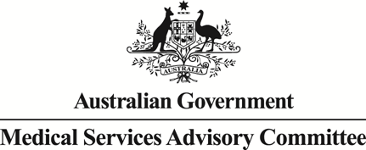
Public Summary Document

Report to the Medical Services Advisory Committee on utilisation of MBS item 37245 following Application 1149: Holmium:YAG laser enucleation of the prostate (HoLEP) with or without tissue morcellation for the treatment of benign prostatic hyperplasia (BPH)
Medicare Benefits Schedule (MBS) item considered: 37245
Date of MSAC consideration: 28-29 March 2018
Context for decision: MSAC makes its advice in accordance with its Terms of Reference, see the MSAC Website.

Purpose
The purpose of the report presented to the Medical Services Advisory Committee (MSAC) was to inform MSAC of the real world impacts on the outcomes of Application 1149. The MSAC uses this information to ensure that the new item/s resulting from this application/s is being used as intended.
The report is not intended to be a review of the clinical information covered during the application process.

MSAC’s advice
After consideration of the real world data for Medicare Benefits Scheme (MBS) item 37245 – holmium-YAG laser enucleation of the prostate (HoLEP) with or without tissue morcellation for the treatment of benign prostatic hyperplasia (BPH) - MSAC Application 1149, MSAC recommended no further action. MSAC noted that utilisation of services of HoLEP (MBS item 37245) were low and co-claiming incidences were clinically appropriate and of no concern.

Summary of consideration and rationale for MSAC’s advice
MSAC considered the real world impacts of the outcome of MSAC Application 1149 for holmium-YAG laser enucleation of the prostate (HoLEP) with or without tissue morcellation for the treatment of benign prostatic hyperplasia (BPH) by examining five years of real world data (financial years 2012–2017). This service is listed under Medicare Benefits Scheme (MBS) item 37245.
Before the listing of HoLEP, treatment for BPH involved transurethral resection of the prostate (TURP) and/or open prostatectomy (OP). MSAC recalled that HoLEP was expected to substitute a portion of the existing procedures for TURP and OP.
MSAC recalled that the initial first year uptake of HoLEP (financial year 2012–13) was predicted to be 1% of the total volume of TURP procedures due to the natural delay in the learning curve and adoption of holmium:YAG laser technology. This rate of replacement was predicted to rise to 10% of TURP procedures by the fifth year after implementation (financial year 2016–17). In conjunction, 5% of OP procedures were predicted to be replaced by HoLEP over the five year review period (financial years 2013–2017). From these rates of replacement, MSAC recalled that there were a predicted 133 services for HoLEP in the first year of implementation (partial financial year 2012–13) rising to 1258 services of HoLEP in year five (financial year 2016–17).
MSAC noted that there were 550 actual services for HoLEP in the second year of implementation (2013-14), which was higher than the predicted 383 services. However, the actual volume of services in year 5 was less than the predicted volume of services for HoLEP, at 855 actual services versus 1258 predicted services.
MSAC recalled that the services for HoLEP had been predicted to cost the MBS an additional $201,465 over the combined cost of TURP and OP procedures at year 3 (financial year 2014–15), increasing to $398,589 by year 5.
MSAC noted that New South Wales (NSW), South Australia (SA) and the Australian Capital Territory (ACT) were the states with the highest uptake of actual services of HoLEP. However, NSW had the greatest utilisation at 1351 HoLEP services, accounting for approximately 46% of nationwide services in the review period.
MSAC noted the median fee charged for HoLEP services was $2406 for financial year 2016–17, but that the fee was above $4100 in 5% of services. MSAC noted that the national average fee charged for HoLEP services has remained relatively stable over the 2014–2017 period. However, there had been an average increase in fee of $46.69, $804.35 and $134.28 in Victoria, Western Australia and the ACT respectively over the period. MSAC noted that there was considerable price variation between states and territories; NSW had the biggest difference in the 25th and 95th percentile for fees charged ($1934.55 and $4380.05, respectively) in the financial year 2016–17, whereas the 95th percentile fee charged in SA was less than $2500.
MSAC noted that the services for HoLEP were primarily claimed by male patients in the 65-74 year age group. This group made up 43% of all claims from 2013–2017.
MSAC noted that the number of practitioners providing services for HoLEP increased from 14 to 33 during the review period, with approximately 20% of practitioners providing almost 60% of services. MSAC noted that 99% of services for HoLEP were provided by urologists.
MSAC noted that 0.1% of HoLEP services were bulk billed.
MSAC noted that, for the review period, 39% of services for HoLEP were claimed alone while the most commonly co-claimed service was MBS item 105 (consultation item) at 33% of episodes. MSAC considered that items that were co-claimed with MBS item 37245 were likely to be clinically appropriate. MSAC noted that, as of 1st November 2017, MBS items 105, 116 and 119 can no longer be claimed on the same day as a group T8 item with a schedule fee of $300 or more.
MSAC noted that there were significant out-of-pocket expenses to the patient at approximately $1500 per service.
MSAC recommended no further action as utilisation of HoLEP services were less than predicted, were only provided by a small number of practitioners and co-claiming incidences were clinically appropriate and of no concern.

Methodology
An application is selected for consideration if the resulting new item(s) and/or item amendment(s) have been on the MBS for approximately 24 months or longer or if there were particular concerns about utilisation such that MSAC requested to consider it earlier. The specific applications for each MSAC meeting are selected by the MSAC Executive which is composed of the chairs of MSAC and its sub-committees.
A report on the utilisation is developed by the department with information on a number of metrics including; state variation, patient demographics, services per patient, practitioner’s providing the service, data on fees and co-claiming of services. The number of metrics included in a report is dependent on the annual service volume for the MBS item(s) under consideration i.e. an item with very low utilisation will have less data to analyse. Where service volumes are too low, information is suppressed to protect patient privacy.
Where possible the report compares data on real world utilisation to the assumptions made during the MSAC assessment. Most of these assumptions are drawn from the assessment report.
Relevant stakeholders are provided an opportunity to comment on the findings in the report before it is presented to the MSAC. It is intended that stakeholders are given at least three weeks to consider the reports.
The stakeholder version of the report does not contain information on assumptions from the MSAC consideration if this information is not already publicly available. This is to protect the commercial in confidence of the original applicants. The same principle is applied to this document.
Once MSAC has considered the report, its advice is made available online at the MSAC Website.

Results

Utilisation
Although actual utilisation of item 37245 was greater than the estimated number of services in the initial years following implementation, by 2016-17 the actual utilisation was significantly lower than predicted (Figure 1). There were 383 predicted services compared to 550 actual services in 2013-14, and 1,258 predicted services compared to 855 actual services in 2016-17 (Figure 1).
From 1 March 2013 to 31 March 2017, New South Wales had the highest utilisation with 1,351 services, which constitutes approximately half of total services billed to the item.

Figure 1: Predicted verses actual services of MBS item 37245 from 1 March 2013 to
30 June 2017 by date of service.
° Predicted services in 2012-13 adjusted to reflect a partial Financial Year
Source: MBS Costing, MBS Analytics Section; Department of Health, File: Q20994_1149 Item 37245 utilisation 07NOV17.xls
Table 1: Service volume of MBS item 37245 between 2012-13 and 2016-17 (date of service)
 | State/Territory |  |  |  |  |  |  |  | Total
 | NSW | VIC | QLD | SA | WA | TAS | NT | ACT
2012-2013° | 44 | np | np | 49 | np | np | np | np | 110
2013-2014 | 316 | 49 | np | 142 | 34 | np | np | np | 550
2014-2015 | 331 | 97 | np | 151 | 34 | np | np | 49 | 662
2015-2016 | 334 | 127 | np | 166 | 49 | np | np | 49 | 725
2016-2017 | 370 | 143 | 47 | 172 | 53 | np | np | 70 | 855
All years | 1,351 | 416 | 83 | 680 | 170 | np | np | 176 | 2,902
°Item implemented 1 March 2013
NP = not printed
Source: Department of Health, File: Q20994_1149 Item 37245 utilisation 07NOV17.xls

Patient breakdown
There were 851 patients who claimed item 37245 in 2016-17. Of these, 841 were new patients and 10 were continuing from the previous financial year (Table 3).
The service is most commonly claimed by male patients aged 65-74 at 43% of the total services since implementation (Table 4).
Table 2: Number of new and continuing patients who received MBS item 37245 by financial year
Financial Year | New Patients | Continuing Patients | Total Patients
2015-16 | 716 | 8 | 724
2016-17 | 841 | 10 | 851
Source: Department of Health, File:Q20994_1149 Item 37245 utilisation 07NOV17.xls
Table 3: Percentage of patients receiving MBS item 37245 per age group by financial year
Age range | Financial Year |  |  |  |  | Total
 | 2012-13 | 2013-14 | 2014-15 | 2015-16 | 2016-17
0-34 | 0% | 0% | 0% | 0% | 0% | 0%
35-44 | 0% | 0% | 0% | >1% | 0% | >1%
45-54 | 1% | 3% | 4% | 1% | 3% | 3%
55-64 | 25% | 28% | 21% | 21% | 22% | 23%
65-74 | 42% | 41% | 41% | 44% | 45% | 43%
75-84 | 31% | 23% | 28% | 30% | 25% | 26%
85+ | 1% | 5% | 6% | 4% | 5% | 5%
Source: Medicare Statistics Online, accessed 15th January 2018
a)
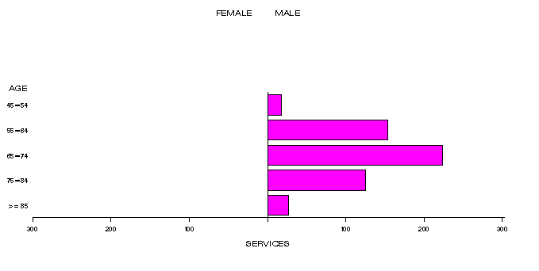
b)
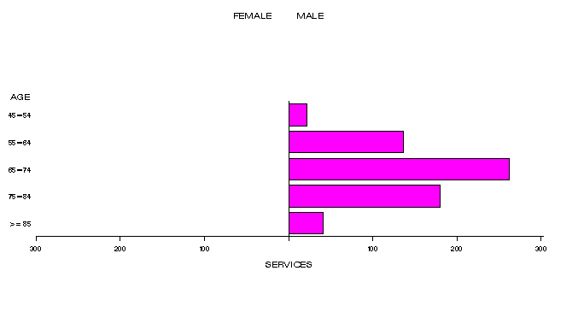
c)
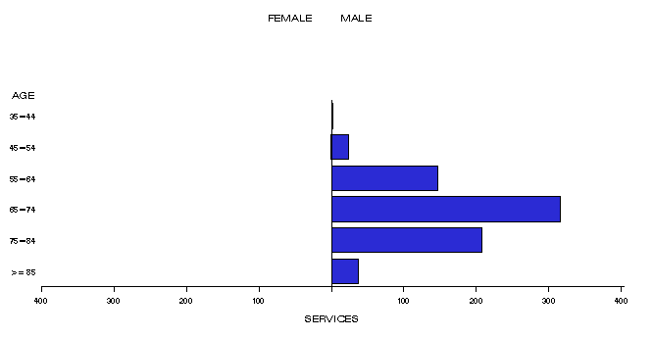
d)
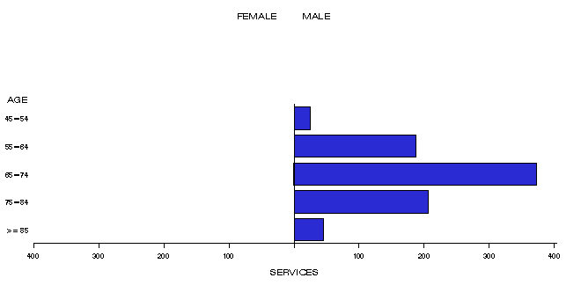
Figure 2: Demographic profile for MBS item 37245 for (a) 2013-14, (b) 2014-15, (c) 2015-16 and (d) 2016-17.
Source: Medicare Statistics Online, accessed 9th January 2018

Practitioner breakdown
There has been a gradual increase in the number of practitioners providing services under item 37245. There were 14 practitioners in 2012-13, increasing to 33 practitioners in 2016-17 (Table 5). About 20% of practitioners have provided close to 60% of all services (Table 6).
Data indicates that 99% of services were provided by Urologists. The remaining 1% of services are being provided by specialists in Obstetrics and Gynaecology, Anaesthesia and Vascular Surgery. Given the data is based on provider billing behaviour (i.e. derived specialty as opposed to registered specialty), it is possible that these services were provided by Urologists, but not classified as such in the data.
Table 4: Number of practitioners providing services under item 37245 in 2012-13 to 2016-17
Financial year | Practitioners | Services | Average
2012-13 | 14 | 110 | 7.9
2013-14 | 26 | 550 | 21.2
2014-15 | 28 | 662 | 23.6
2015-16 | 29 | 725 | 25.0
2016-17 | 33 | 855 | 25.9
All Years | 130 | 2,902 | 22.3
Table 5: Cumulative percentage of medical practitioners providing item 37245 and how many services each percentile accounts for in 2012-13 to 2016-17
Provider Cumulative % | 2012-13 | 2013-14 | 2014-15 | 2015-16 | 2016-17
10% | 40% | 45% | 44% | 41% | 39%
20% | 55% | 66% | 60% | 62% | 62%
30% | 63% | 80% | 74% | 74% | 73%
40% | 77% | 86% | 85% | 85% | 81%
50% | 84% | 92% | 91% | 91% | 89%
60% | 95% | 95% | 95% | 96% | 95%
70% | 96% | 98% | 97% | 98% | 98%
80% | 97% | 99% | 99% | 99% | 99%
90% | 99% | 100% | 100% | 100% | 100%
100% | 100% | 100% | 100% | 100% | 100%
Source for tables 5-6: Department of Health, File: Q20994_1149 Item 37245 utilisation 07NOV17.xls

Co-claiming
In approximately 39% of episodes between 2013-14 and 2016-17, item 37245 was not claimed with any other item. In the same period, item 37245 was co-claimed with specialist attendance item 105 in 33% of episodes. The rate of co-claiming with item 105 only has increased from 22% in 2013-14 to 40% in 2016-17 (Tables 7-10).
As of 1 November 2017, medical practitioners were no longer be able to claim MBS benefits for subsequent attendance items 105, 116, and 119 if they are claiming any Group T8 items with a schedule fee of equal to or greater than $300 on the same day. Three new consultation items have been implemented (111, 117 and 120). These do not replace any current MBS items. They are additional items to be used in extenuating circumstances whereby a consultation takes place and is followed by a T8 surgical procedure on the same day, with a schedule fee $300 or more. The procedure must be unscheduled and otherwise unpredicted prior to the consultation.
With regards to this change and item 37245, medical practitioners who are not claiming subsequent attendance items will not be affected. However, practitioners who are co-claiming item 37245 with subsequent consultation item 105 will no longer be able to do so. Therefore, an increased rate of item 37245 being claimed on its own is anticipated. The new attendance items are not expected to be co-claimed with item 37245.
Five of the remaining eight co-claimed items are for the purposes of Cystoscopy (36811, 36824, 36827, 36840 and 37011). The remaining two are for the purposes of biopsy and ultrasound of the bladder or prostate.
Departmental medical advice stated that these co-claimed items are all clinically appropriate.
Table 6: Instances of co-claiming with MBS item 37245 in 2013-14
# | Items | Episodes | Services | Schedule Fee for combination | Number of patients | % of episodes
1 | 37245 | 275 | 275 | $347,091 | 275 | 50%
2 | 37245, 105 | 119 | 238 | $155,313 | 119 | 22%
3 | 37245, 36827 | 42 | 84 | $57,838 | 42 | 8%
4 | 37245, 55603 | 30 | 60 | $40,988 | 30 | 5%
5 | 37245, 36863 | 15 | 30 | $22,430 | 15 | 3%
6 | 37245, 105,36863 | 6 | 18 | $9,230 | 6 | 1%
7 | 37245, 36840 | 5 | 10 | $7,119 | 5 | >1%
8 | 37245, 37011 | 5 | 10 | $6,544 | 5 | >1%
9 | 37245, 37219,55603 | 5 | 15 | $7,533 | 5 | >1%
Table 7: Instances of co-claiming with MBS item 37245 in 2014-15
# | Items | Episodes | Services | Schedule Fee for combination | Number of patients | % of episodes
1 | 37245 | 264 | 264 | $333,208 | 264 | 40%
2 | 37245, 105 | 213 | 426 | $277,997 | 213 | 32%
3 | 37245, 36827 | 41 | 82 | $56,461 | 41 | 6%
4 | 37245, 55603 | 32 | 64 | $43,720 | 32 | 5%
5 | 37245, 36863 | 26 | 52 | $38,879 | 26 | 4%
6 | 37245, 37011 | 14 | 28 | $18,324 | 14 | 2%
7 | 37245, 105, 36863 | 9 | 27 | $13,845 | 9 | 1%
Table 8: Instances of co-claiming with MBS item 37245 in 2015-16
# | Items | Episodes | Services | Schedule Fee for combination | Number of patients | % of episodes
1 | 37245, 105 | 267 | 534 | $348,475 | 266 | 37%
2 | 37245 | 238 | 238 | $300,392 | 238 | 33%
3 | 37245, 36827 | 43 | 86 | $59,215 | 43 | 6%
4 | 37245, 55603 | 37 | 74 | $50,551 | 37 | 5%
5 | 37245, 37011 | 13 | 26 | $17,015 | 13 | 2%
6 | 37245, 36824, 37011 | 12 | 36 | $16,705 | 12 | 2%
7 | 37245, 105, 36863 | 9 | 27 | $14,078 | 9 | 1%
8 | 37245, 36824 | 8 | 16 | $10,950 | 8 | 1%

Table 9: Instances of co-claiming with MBS item 37245 in 2016-17
# | Items | Episodes | Services | Schedule Fee for combination | Number of patients | % of episodes
1 | 37245, 105 | 343 | 686 | $447,666 | 341 | 40%
2 | 37245 | 275 | 275 | $347,091 | 275 | 32%
3 | 37245, 55603 | 45 | 90 | $61,481 | 45 | 5%
4 | 37245, 36827 | 41 | 82 | $56,461 | 41 | 5%
5 | 37245, 37011 | 20 | 40 | $26,177 | 20 | 2%
6 | 37245, 36863 | 16 | 32 | $23,926 | 16 | 2%
7 | 37245, 36811 | 9 | 18 | $12,815 | 9 | 1%
8 | 37245, 105, 36863 | 8 | 24 | $12,307 | 8 | 1%
Source for Tables 7-10: Department of Health, Medical Benefits Division, Primary Care and Diagnostics Branch, MBS Analytics Section

Data on fee charged
The information provided on fees below is a snapshot of how the item is being claimed in practice. Data has not been printed for states and territories with low service volumes.
The 75% benefit for item 37245 is $946.65.
The national average fee charged for item 37245 has remained relatively stable (Table 4). In 2016-17 ACT was the state/territory with the highest average fee charged of $3043.65. NSW is the state/territory with the greatest disparity between 25th and 95th percentile fees charged (Table 2), as well as highest volume of claims (Table 1).
The states/territories which have seen an increased average fee over 3 years since 2014-15 are Vic by $49.69, WA with by $804.35 and ACT by $134.28.
Services are rarely bulk billed.
Table 10: Statistics on fees charged for MBS item 37245 for 2014-15 to 2016-17 by date of service
 |  | Provider State/Territory
 |  | NSW | Vic | Qld | SA | WA | ACT | AUS
2014-15 | Average Fee | $2,869.49 | $2,544.24 | $0.00 | $1,897.80 | $2,181.36 | $2,909.37 | $2,567.35
 | Standard Deviation | $942.79 | $550.41 | $0.00 | $249.57 | $163.46 | $337.08 | $821.92
 | 25th Percentile fee | $1,991.30 | $1,991.00 | $0.00 | $1,797.35 | $2,200.00 | $3,000.00 | $1,912.00
 | Median | $2,698.55 | $3,000.00 | n/a (4) | $1,911.10 | $2,200.00 | $3,000.00 | $2,200.00
 | 95th Percentile fee* | $4,600.00 | $3,000.00 | n/a (4) | $2,297.35 | $2,200.00 | $3,065.00 | $4,400.00
 | Bulk Billed rate | 0.3% | 0.0% | 0.0% | 0.0% | 0.0% | 0.0% | 0.2%
2015-16 | Average Fee | $2,910.80 | $2,557.53 | $0.00 | $1,870.95 | $2,508.39 | $2,882.07 | $2,581.72
 | Standard Deviation | $927.44 | $665.86 | $0.00 | $301.21 | $393.33 | $483.46 | $831.81
 | 25th Percentile Fee | $1,990.63 | $1,911.1 | $0.00 | $1,803.25 | $2,200.00 | $2386.50 | $1911.1
 | Median | $2,800.00 | $3,000.00 | $0.00 | $1,803.25 | $2,200.00 | $3,065.00 | $2,303.25
 | 95th Percentile fee* | $4,400.00 | $3,617.75 | $0.00 | $2303.25 | $3,065.00 | $3,125.00 | $4,183.40
 | Bulk Billed rate | 0.0% | 0.8% | 0.0% | 0.0% | 0.0% | 0.0% | 0.1%
2016-17 | Average Fee | $2,729.58 | $2,594.13 | $2,556.04 | $1,841.55 | $2,985.71 | $3,043.65 | $2,560.14
 | Standard deviation | $906.71 | $801.03 | $434.95 | $381.37 | $287.84 | $412.06 | $816.59
 | 25th Percentile Fee | $1,934.55 | $1,911.10 | $2,049.25 | $1,559.60 | $3,065.00 | $3,125.00 | $1918.45
 | Median | $2,406.00 | $3,000.00 | $2,549.25 | $1,803.25 | $3,065.00 | $3,200.00 | $2,406.00
 | 95th Percentile fee* | $4,380.05 | $3,617.75 | $3,065.00 | $2,411.10 | $3,065.00 | $3,281.25 | $4,100.00
 | Bulk Billed rate | 0.3% | 0.0% | 0.0% | 0.0% | 0.0% | 0.0% | 0.1%
* The 95th percentile fee charged represents that 95% of the time the fee is below this amount but in 5% of cases, the fee is higher than this.
(4) Descriptive statistics for Fees Charged are only calculated when there are sufficient services for a valid result
NP = not printed
Source: Department of Health, File: Q20994_1149 Item 37245 utilisation 07NOV17.xls

Figure 3: Average fee charged and range between 25th percentile and 95th percentile fee charged by state for MBS item 37245 between 2014-15 and 2016-17
Source: Department of Health, File: Q20994_1149 Item 37245 utilisation 07NOV17.xls

Background
In October 2010, the Department of Health and Ageing In May 2012, the Department of Health and Ageing received an application from MD Solutions Pty Ltd requesting Medical Benefits Schedule (MBS) listing of holmium:YAG laser enucleation of the prostate (HoLEP) with or without tissue morcellation for the treatment of benign prostatic hyperplasia (BPH). HoLEP was a relatively new surgical treatment option for men with BPH in whom surgery is indicated. Light from holmium:YAG lasers – which contain a crystal of yttrium, aluminium and garnet (YAG), doped with holmium – has a defined wavelength which can be used to produce unique effects on targeted tissue. In this instance, these lasers serve as a precise cutting instrument for the dissection of prostatic lobes into a number of sections. Dissected lobes are then pushed into the bladder, where they can be cut into smaller pieces and removed–using a morcellator.
MSAC’s role was to assess the safety, effectiveness and cost-effectiveness of HoLEP for men with BHP. MSAC would also consider the wording of the MBS item descriptor, the MBS fee and the financial implications of publicly funding the surgical procedure.
On 29-30 November 2012, MSAC supported the listing of a new MBS item of holmium:YAG laser enucleation of the prostate (HoLEP) with or without tissue morcellation for the treatment of benign prostatic hyperplasia (BPH) (item 37245).
The 2012 MSAC Public Summary document noted that MSAC agreed with the applicants request to leave the descriptor as using holmium:YAG but did not agree with the need for it to specify laser equipment with power greater than or equal to 100 watts. MSAC noted the applicant requested a 20% premium for training. However, MSAC agreed this is not applicable for funding under Medicare policy and therefore was to be removed from the final proposed fees.
Item descriptor
37245 | Prostate, endoscopic enucleation of, using high powered Holmium:YAG laser and an end-firing, non-contact fibre, with or without tissue morcellation, cystoscopy or urethroscopy, for the treatment of benign prostatic hyperplasia, and other than a service associated with a service to which item 36854, 37201, 37202, 37203, 37206, 37207, 37208, 37303, 37321, or 37324 applies.  Multiple Services Rule  (Anaes.  Fee: $1,262.15 Benefit: 75% = $946.64

Applicant’s comments on MSAC’s public summary document
The applicant had no comment

Further information on MSAC
MSAC Terms of Reference and other information are available on the MSAC Website at: www.msac.gov.au.

