

Public Summary Document

Application No. 1358.1 – Vagus Nerve Stimulation (VNS) Therapy

**Applicant: LivaNova Australia Pty Ltd**

**Date of MSAC consideration: MSAC 68th Meeting, 24-25 November 2016**

Context for decision: MSAC makes its advice in accordance with its Terms of Reference, [visit the MSAC website](http://www.msac.gov.au/)

# Purpose of application and links to other applications

A resubmission for new Medicare Benefits Schedule (MBS) listings for vagus nerve stimulation (VNS) therapy in patients with refractory epilepsy was received from LivaNova Australia Pty Ltd by the Department of Health.

MSAC considered Application 1358 in July 2015 and identified concerns regarding the use of trial data in the economic modelling. The resubmission attempted to address these concerns and did not involve further changes to application 1358.

# MSAC’s advice to the Minister

After considering the evidence presented in relation to the comparative safety, clinical effectiveness and cost-effectiveness, MSAC supported MBS funding of VNS therapy for a small patient population with refractory epilepsy and a high unmet clinical need. In this context, MSAC accepted the high cost-effectiveness ratio.

# Summary of consideration and rationale for MSAC’s advice

MSAC considered applications for MBS listing of VNS therapy for epilepsy in June 2008, and July 2015 but it did not support public funding due to uncertain cost-effectiveness. MSAC accepted, however, the population, proposed treatment algorithm and comparator as appropriate.

In reviewing the resubmission, MSAC considered that the revised model reasonably addressed the issues raised at the July 2015 MSAC consideration. Although some residual uncertainty remained regarding the extrapolation of response rates in the model MSAC considered that this was adequately addressed in the sensitivity analyses provided by the applicant in the pre-MSAC response. MSAC noted the low cost per seizure avoided, due to the high baseline rate of seizures in this population. MSAC considered that the base case ICER was high at approximately $60,000 but in the context of high unmet clinical need agreed that this was reasonable.

MSAC noted that implantation of the device made up a small proportion of the total cost of VNS therapy compared to the prostheses costs. MSAC considered that the costs of the electric pulse generator and lead (about $12,600 and $3,400 respectively) were high and that, given the high ICER, the Prostheses List Advisory Committee (PLAC) should be advised that the costs were at the upper limit of cost-effectiveness. MSAC strongly encouraged consideration of a reduction in the costs of the device and battery.

MSAC acknowledged that the financial impact of the proposed service was likely to be small.

MSAC advised that the item descriptor should be amended to specify stimulation via the left vagal nerve and that there should be a separate item for battery replacement.

# Background

Application 1358 was considered at the July 2015 MSAC meeting. MSAC did not support public funding because of uncertain cost‑effectiveness. MSAC accepted there was some clinical benefit in a small patient population with a high unmet clinical need, albeit supported by limited data.

MSAC considered that any reapplication should address the issues identified with the economic evaluation by:

* providing a simple economic model with a cost-utility analysis;
* including time horizon over 5 years, with sensitivity analyses for time horizons between 1 and 10 years;
* including disutility for side effects; and
* providing cost per seizure avoided.

The PSD for this previous application can be viewed on the MSAC website.

# Prerequisites to implementation of any funding advice

VNS therapy was approved by the Therapeutic Goods Administration (TGA) for “use as an adjunctive therapy in reducing the frequency of seizures in patients whose epileptic disorder is dominated by partial seizures (with or without secondary generalisation) or generalised seizures that are refractory to antiepileptic medications”.

# Proposal for public funding

The proposed item descriptors for VNS therapy are shown in Table 1.

**Table 1 Proposed MBS item descriptors, specifically for use with VNS therapy**

| Surgical placement of electrical pulse generator |
| --- |
| TBC  VNS therapy ELECTRICAL PULSE GENERATOR, subcutaneous placement of, for the management of refractory generalised epilepsy, or treating refractory focal epilepsy that is not suitable for resective epilepsy surgery through stimulation of the vagus nerve  Multiple Services Rule  (Anaes.) (Assist.)  Fee: $340.60 Benefit: 75% = $255.45 |
| Surgical repositioning or removal of electrical pulse generator |
| TBC  VNS therapy ELECTRICAL PULSE GENERATOR, that was inserted for the management of refractory generalised epilepsy, or treating refractory focal epilepsy that is not suitable for resective epilepsy surgery, surgical repositioning or removal of  Multiple Services Rule  (Anaes.)  Fee: $159.40 Benefit: 75% = $119.55 |
| Surgical placement of lead |
| TBC  VNS therapy LEAD, surgical placement of, lead including connection to vagus nerve, including intraoperative test stimulation, for the management of refractory generalised epilepsy, or treating refractory focal epilepsy that is not suitable for epilepsy surgery through stimulation of the vagus nerve  Multiple Services Rule  (Anaes.) (Assist.)  Fee: $674.15 Benefit: 75% = $505.61 |
| Surgical repositioning or removal of lead |
| TBC  VNS therapy LEAD, that was inserted and attached to the vagal nerve for the management of refractory generalised epilepsy, or treating refractory focal epilepsy that is not suitable for resective epilepsy surgery, surgical repositioning or removal of  Multiple Services Rule  (Anaes)  Fee: $605.35 Benefit: 75% = $454.01 |
| Electrical analysis and programming of electrical pulse generator |
| TBC  VNS therapy ELECTRICAL PULSE GENERATOR, electrical analysis and programming of, VNS therapy device using an external wand, for the management of refractory generalised epilepsy, or treating refractory focal epilepsy that is not suitable for resective epilepsy surgery.  Fee: $189.70 Benefit:75% = $142.58 |

The text “performed in the operating theatre of a hospital” was omitted from the proposed MBS descriptors based on advice in the Public Summary Document -Application No. 1358

MSAC advised that item descriptors should reference stimulation via the left vagal nerve and that in addition to the items proposed in the resubmission a separate item for battery replacement was required too.

# Summary of Public Consultation Feedback/Consumer Issues

Overall, consumers supported the proposed intervention and noted that the low prevalence/very high impact life circumstances warrants consumer impact tests for effectiveness and efficiency.

# Proposed intervention’s place in clinical management

The patient population eligible for VNS therapy is ‘patients with epilepsy who are refractory to anti-epileptic drugs (AEDs), suffering ongoing severe and frequent seizures, and unsuitable for, unwilling or have failed surgery’. The population and the proposed clinical algorithm are unchanged from Application 1358.

# Comparator

The nominated comparator was “no active intervention” consistent with the original application.

# Comparative safety

The resubmission identified no new clinical evidence assessing the safety of VNS.

The critique noted that the resubmission made no claim regarding the comparative safety of VNS therapy, nor does it present any additional safety data. Infection rates associated with the implantation of the VNS therapy device have been reported at rates of 2%-11.7%. The following adverse events were also commonly associated with VNS therapy stimulation: cough; dyspnoea; hoarseness/voice change; pain; paraesthesia; and pharyngitis. In the clinical trial reporting on ‘High Level’ versus ‘Low Level’ stimulation, the only adverse events reported as having a statistically significant difference between treatment arms were dyspnoea and hoarseness/voice change.

The critique stated that given the implantation of the VNS therapy device is associated with risk of infection, and that VNS therapy stimulation is associated with several adverse events, the use of VNS therapy as an adjunct to AEDs is likely to have an inferior safety profile compared to ‘no active intervention’.

# Comparative effectiveness

The resubmission identified no new clinical evidence assessing the efficacy of VNS. For the clinical evaluation of VNS, the resubmission relies on the randomised control trial (RCT) evidence presented in the original application, of which, E03 and E05 are considered to represent the pivotal evidence with supportive evidence from non-randomised comparative trials. Key efficacy outcomes are summarised in Table 2 and Table 3.

The resubmission noted that MSAC had agreed that low stimulation was equivalent to sham at the July 2015 meeting.

**Table 2 Summary of clinical effectiveness of VNS therapy in randomised controlled trials: VNS high setting stimulation vs. VNS low setting stimulation and VNS therapy vs. no active intervention**

| Trial ID | Treatment duration | Seizure frequency | Seizure frequency | Seizure frequency | Seizure frequency |
| --- | --- | --- | --- | --- | --- |
| Trial ID | Treatment duration | >50% reduction | >75% reduction | 100% reduction | Mean percentage change |
| Trials of VNS therapy: High vs. Low stimulation | | Trials of VNS therapy: High vs. Low stimulation | | | Trials of VNS therapy: High vs. Low stimulation |
| - | | Relative risk (95% CI) *Result >1 favours VNS high stim* | | | Mean difference (95% CI) *Result <0 favours VNS high stim* |
| E03 | 14 weeks | 2.36  (1.11 to 5.03) | 4.44  (0.51 to 38.55) | Not estimable | -18.4  (-32.62 to -4.18) |
| E05 | 3 months | 1.49  (0.84 to 2.66) | 5.43  (1.22 to 24.12) | 3.25  (0.13 to 78.88) | -12.70  (-22.99 to -2.41) |
| Klinkenberg 2012 | 20 weeks | 0.75  (0.19 to 2.91) | NA | NA | NA |
| Meta-analysis | | 1.61  (1.00 to 2.60)  P=0.05 | 5.09  (1.49 to 17.36)  P=0.009 | 3.25  (0.13 to 78.88)  P=0.47 | -14.66  (-23.00 to -6.32)  P<0.01 |
| Trials of VNS therapy vs No active intervention | | | | | |
| - | | Relative risk (95% CI) *Result >1 favours VNS therapy* | | | Mean difference (95% CI) *Result <0 favours VNS therapy* |
| Ryvlin 2014a | 52 weeks | 1.34  (0.59 to 3.04) | NA | NA | NA |
| E06 | 52 weeks | 1.19  (0.65 to 2.16) | NA | NA | 12.70  (-29.78 to 55.18) |
| Metal-analysis | | 1.24  (0.76 to 2.01)  P=0.39 | NA | NA | 12.70  (-29.78 to 55.18)  P=0.56 |
| Metal-analysis | |

The data shows that High Stimulation VNS therapy is associated with a reduction in seizure frequency compared to both Low Stimulation VNS therapy and ‘no active intervention’. Data for the outcome of >50% reduction in seizure frequency was reported across all trials. Pooled analysis of the outcome of achieving a >50% reduction in seizure frequency demonstrated:

* A relative risk of 1.61 (95% CI: 1.00-2.60, P=0.05) for High Stimulation VNS therapy compared to Low Stimulation VNS therapy.
* A relative risk of 1.24 (95% CI: 0.76-2.01, P=0.39) for High Stimulation VNS therapy compared to no active intervention.

Table 3 Summary of clinical effectiveness of VNS therapy in comparative observational studies of VNS therapy vs. no active intervention

| Trial ID | Treatment duration | Seizure frequency | | |
| --- | --- | --- | --- | --- |
| >50% reduction | >75% reduction | 100% reduction |
| Comparative observational studies: VNS therapy vs. No active intervention | | | | |
|  | | Relative risk (95% CI) *Result >1 favours VNS High stimulation* | | |
| Marrosu 2003 | 12 months | 6.55 (0.41 to 105.1) | NA | NA |
| Boon 2002a, | Up to 26 months | 2.16 (1.17 to 4.00) | NA | NA |
| Harden 2000 | 3 months | 2.20 (0.93 to 5.18) | 3.33 (1.08 to 10.34) | NA |
| Hoppe 2013 | Up to 6.8 years | 1.09 (0.64 to 1.86) | 3.50 (0.83 to 14.83) | NA |
| Meta-analysis | | 1.72 (1.04 to 2.84); P=0.04 | 3.40 (1.39 to 8.2); P=0.01 | NA |

Source: Cyberonics Systematic Review Appendices: Table J.12; Table J16

The efficacy claim for VNS in the resubmission remains the same as in the original application, i.e., one of superior effectiveness compared to ‘no active intervention’.

The resubmission noted that MSAC has already accepted there is clinical benefit of VNS in patients with a high unmet clinical need: “After considering the strength of the available evidence presented in relation to safety, clinical effectiveness…. MSAC accepted there was some clinical benefit in a small patient population with a high unmet clinical need, albeit supported by limited data.” [Source: MSAC PSD – Appl. 1358 VNS].

The critique noted that the clinical claim of superior efficacy is marginally supported by the evidence base, noting that there was no additional efficacy data presented to address MSAC’s observation that there is limited data available.

# Economic evaluation

The resubmission presents three new pre-modelling studies which sought to address issues of translation of the RCT data to the economic modelling.

The economic evaluation assessed VNS therapy relative to no VNS therapy in an Australian population with drug-resistant epilepsy.

The economic model consisted of a Markov model comprised four core health states with a cohort of patients transiting between these health states according to the effectiveness over time of the therapy being received. Modifications to the model included:

* a base case model duration of 5 years
* the definition of the four core health states is based on absolute seizure frequency (as opposed to percent reduction in seizure frequency)
* movement between health states for VNS patients and No VNS patients is based on extrapolation from short-term results from the pivotal trials (E03 and E05) out to the long-term
* patients in the VNS arm accrue VNS implant specific AE disutilities.

Key aspects of the economic evaluation are summarised in Table 4.

**Table 4 Summary of the economic evaluation**

|  |  |
| --- | --- |
| Perspective | Not explicitly stated. Based on inputs used a health care provider perspective was taken. |
| Comparator | No active intervention |
| Type of economic evaluation | Cost-utility analysis (cost per QALY). Cost-consequence (cost per seizure avoided) presented as a supplementary analysis. |
| Sources of evidence | Randomised controlled trials (E03 and E05)  Efficacy and safety data at 3 months  Systematic review long-term (beyond 3 months) efficacy data  Utility values |
| Time horizon | 5 years in the MSAC-specified base case. An alternate base case of 7 years presented as a supplementary analysis |
| Outcomes | QALYs and number of seizures |
| Methods used to generate results | Markov model |
| Health states | ≥10 seizures per month (non-responder)  2 to 9 seizures per month (responder)  >0 to 1 seizure per month (responder)  0 seizures per months (responder, seizure free)  Dead |
| Cycle length | 3 months (half-cycle correction applied) |
| Discount rate | Costs and consequences discounted at 5% per annum |
| Software packages used | TreeAge Pro 2009 |

Figure 1 shows how the model follows the key extrapolation assumptions over time. First patients respond to VNS or no VNS over three months (data derived from the randomised trials), then there was a gradual improvement in the VNS arm of the model for a further 24 months (based on the longer-term single-arm studies), at which point the effect of VNS stabilised until the end of the model. Similarly, the proportion becoming seizure-free following VNS increased up to month 27, at which point the effect of VNS stabilised until the end of the model.

Figure 1 Proportion of patients with a response and being seizure free over time in the economic model

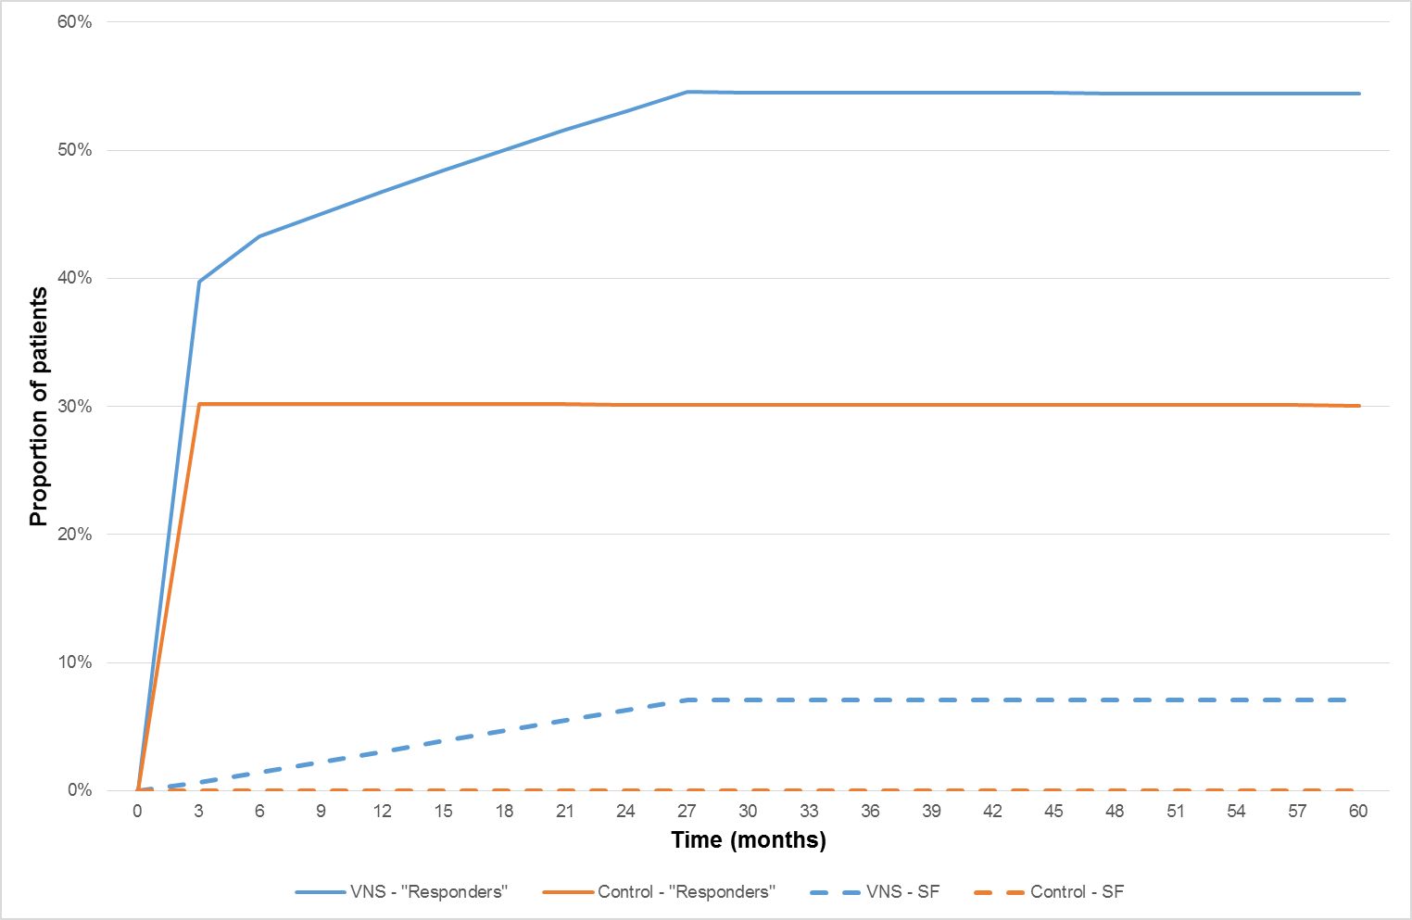

“Responders” are those patients not in the worst health state, ie: all patients with 9 or fewer seizures per month

SF = seiazure-free

The incremental cost per QALY gained of VNS therapy estimated over the five-year period of the economic model was $59,741. The incremental cost per seizure avoided was $21 (Table 5).

Table 5 Base case model results – 5-year period: incremental cost-effectiveness of VNS therapy estimated by the economic model

|  |  |  |  |
| --- | --- | --- | --- |
| Item | VNS | No VNS | Difference |
| Cost | $65,180 | $55,288 | $9,893 |
| Seizures | 1,214 | 1,689 | -475 |
| QALYs | 3.2610 | 3.0954 | 0.1656 |
| Incremental cost per seizure avoided | | | $21 |
| Incremental cost per QALY gained | | | $59,741 |

The resubmission stated that the incremental cost-effectiveness ratio (ICER) should be interpreted in the context of the conservative assumptions which underlay the economic model. Most importantly, the model duration of 5 years was particularly biased against VNS because all the up-front costs of VNS were captured but 2 years of the benefits of the 7-year life time of the therapy were not.

An alternative base case model reflecting the battery life of VNS (7 years) was provided by the resubmission for comparison. This demonstrates the cost-effectiveness of VNS therapy improves (to $28,889 per QALY) with only a relatively short increase in the duration of the model, reflecting the continued outcomes of VNS therapy from full utilisation of battery life.

The resubmission stated that the sensitivity analysis demonstrates the validity of the base case outcomes. The cost per QALY outcomes relative to the base case of $59,741 per QALY for 10-year model duration ($23,885) and efficacy based health states ($41,855).

As requested by ESC, the applicant provided additional sensitivity analyses for both the 5-year (in adherence to advice from MSAC), and 7-year models (the applicants preferred base case because it aligns with the 7-year battery life of VNS).

MSAC noted that the economic evaluation did not consider any disutility associated with surgical site infection and the subsequent explantation of the VNS therapy device as part of a separate surgical procedure. As such, the results of the economic evaluation may not be an accurate estimation of the overall cost-effectiveness of VNS therapy. Disutility associated with explantation of the VNS therapy device would be experienced as a one-off event applied to the same 3-month cycle where explantation occurred. As such, the inclusion of explantation-associated disutility in the economic evaluation was likely to have only a modest impact on the overall results.

The modelled results were most sensitive to: changes in the proportion of VNS therapy non-responders at three months (end of trial) that gained a response over the first two years; health care costs associated with each health state; and the time horizon.

# Financial/budgetary impacts

The resubmission stated that while a sizable proportion of epileptic cases may become refractory to AEDs (approximately 30%; e.g., Platt and Sperling 2002); the uptake of VNS would be limited to a very small subgroup of the overall refractory patient population. The resubmission estimated that between 60-150 patients per year would undergo the implantation procedure in Australia: totalling 500 procedures in the first 5 years, with 25% of these cases being private patients.

The financial implications to the MBS resulting from the proposed listing of VNS therapy are summarised in Table 6.

**Table 6 Total estimated costs to the MBS associated with VNS therapy: all procedures**

|  | Year 1 | Year 2 | Year 3 | Year 4 | Year 5 | Sum (Year 1-5) |
| --- | --- | --- | --- | --- | --- | --- |
| VNS therapy related MBS items as requested | $22,949 | $30,194 | $38,853 | $49,455 | $63,415 | $204,866 |
| Co-administered services currently MBS listed | $9,885 | $13,181 | $17,077 | $21,872 | $28,165 | $90,180 |
| **Overall total: full benefits** | **$32,833** | **$43,375** | **$55,930** | **$71,327** | **$91,580** | **$295,045** |
| **Overall total: 75% benefits** | **$24,625** | **$32,531** | **$41,947** | **$53,495** | **$68,685** | **$221,284** |

Source: compiled during the evaluation

The overall estimated per patient cost to the MBS associated with the implantation of the VNS therapy device was $2,012.44. Over the first five years of listing, the overall cost for all VNS therapy procedures (including costs associated with patient consultation, anaesthetics and assistance at the operation) was estimated as $295,045 (full benefits) and $221,284 (75% benefits).

# Key issues from ESC for MSAC

ESC noted that although no additional primary data on efficacy or safety was provided, the resubmission sought to address the issues raised by MSAC in the 2015 PSD regarding the economic model. The resubmission provides a cost-utility analysis over a 5-year time horizon; based on a structurally changed economic model with health states and disutility adjustments for adverse events; and results presented as an ICER per seizure avoided.

However, ESC considered that the extrapolation of the randomised trial evidence (based on data from other sources, see Figure 2) to determine the comparative proportions of patients with a response and being seizure-free over time (see Figure 3) in the economic model was uncertain. Figure 3 presents a modelled synthesis of the 3-month randomised controlled trial and the longer-term single-arm observational studies to show a further incremental effect in the VNS arm. However, ESC also noted there were no sensitivity analyses provided for this approach in the economic modelling. ESC requested the applicant to provide MSAC sensitivity analyses around this approach for the proportions of patients with a response and being seizure-free in order to examine how important to the ICER was the extra treatment effect generated over 3-24 months and then maintained for the remaining three years. The applicant was also asked to consider providing MSAC further justification for its approach.

**Figure 2 Summary of the data used to justify extrapolating the VNS treatment effect**

| Figure 2 - diagram: Source-Englot et al. Registry data (n=5554); Figure 3 of the SBA | Figure 2: diagram-Source Englot et al. (2015) Systematic review of 78 studies (n=2869); Figure 4 of the SBA | SFigure 2:diagram- Source: E01 to E05 trial. Morris et al. Figure 5 of the SBA |
| --- | --- | --- |
| Source: Englot et al. Registry data (n=5554); Figure 3 of the SBA | Source: Englot et al. (2015) Systematic review of 78 studies (n=2869); Figure 4 of the SBA | Source: E01 to E05 trial. Morris et al. Figure 5 of the SBA |

Source: Figure 1, page 2, pre-ESC response

Figure 3 Proportion of patients with a response and being seizure free over time in the economic model

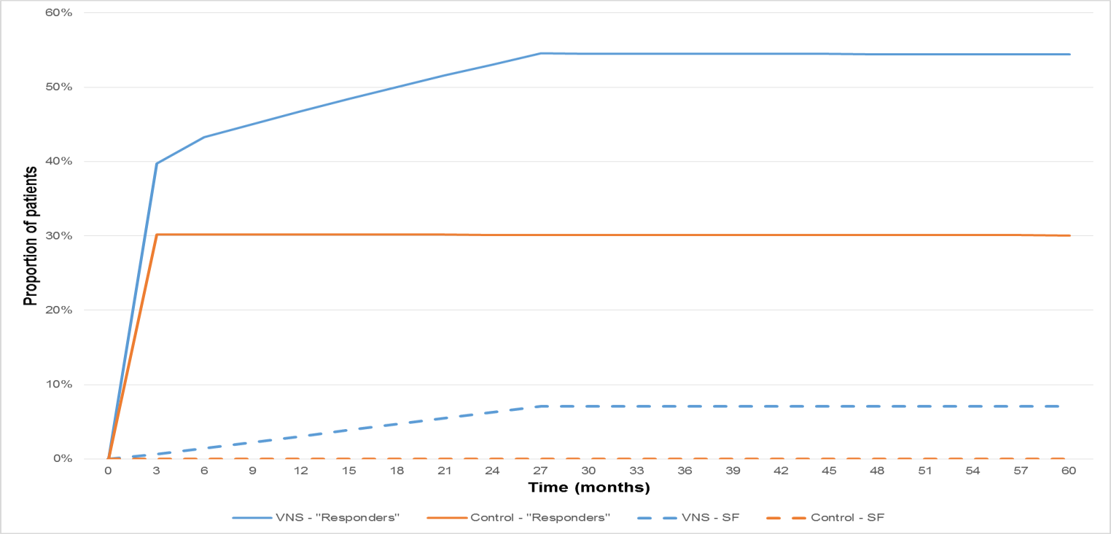

“Responders” are those patients not in the worst health state, ie: all patients with 9 or fewer seizures per month

SF = seizure-free

ESC advised that the other key driver of the model was cost-offsets in other areas of the health system caused by reduced seizure frequency due to VNS therapy.

ESC noted that the adverse events in the resubmission associated with VNS implantation and stimulation were reported at a rate of 22%; with greater frequency of dyspnoea and hoarseness/voice change. ESC agreed that VNS therapy as an adjunct to medicines was likely to have inferior safety compared to “no active intervention”.

ESC considered that not including a disutility for infection rates associated with implanting the VNS device, reported between 2-11.7%, would have minimal impact on the model results.

ESC noted that there was no proposed MBS item for battery replacement and considered whether the proposed item descriptors should be amended to account for this.

ESC considered that the MBS item descriptors should clearly define both types of refractory epilepsy (generalised epilepsy, or focal epilepsy.

ESC noted that VNS implantation only on the left vagus nerve had been trialled for refractory epilepsy and considered that the MBS item descriptors should clearly state that.

# Other significant factors

Nil.

# Applicant’s comments on MSAC’s Public Summary Document

LivaNova welcomes the MSAC decision to recommend MBS funding of VNS therapy in patients with refractory epilepsy.

# Further information on MSAC

MSAC Terms of Reference and other information are available on the MSAC Website:   
[visit the MSAC website](http://www.msac.gov.au/)