1190

Final Decision Analytic Protocol to guide the assessment of Magnetic Resonance Imaging (MRI) for:

- Small bowel Crohn’s disease
- Fistulising perianal Crohn’s disease
September 2012

Table of Contents
MSAC and PASC 3
Purpose of this document 3
Purpose of application 4
Background 4
Current arrangements for public reimbursement 4
Regulatory status 4
Intervention 4
Description of patient population 4
Description of technology 5
Co-administered interventions 6
Listing proposed and options for MSAC consideration 6
Proposed MBS listing 6
Clinical place for proposed intervention 7
Comparator 17
Clinical claim 18
Outcomes and health care resources affected by introduction of proposed intervention 20
Outcomes 20
Health care resources 21
Proposed structure of economic evaluation (decision-analytic) 23
Reference List 30

MSAC and PASC
The Medical Services Advisory Committee (MSAC) is an independent expert committee appointed by the Minister for Health and Ageing (the Minister) to strengthen the role of evidence in health financing decisions in Australia. MSAC advises the Minister on the evidence relating to the safety, effectiveness, and cost-effectiveness of new and existing medical technologies and procedures and under what circumstances public funding should be supported.
The Protocol Advisory Sub-Committee (PASC) is a standing sub-committee of MSAC. Its primary objective is the determination of protocols to guide clinical and economic assessments of medical interventions proposed for public funding.

Purpose of this document
This document is intended to provide a draft decision analytic protocol that will be used to guide the assessment of an intervention for a particular population of patients. The draft protocol that will be finalised after inviting relevant stakeholders to provide input to the protocol. The final protocol will provide the basis for the assessment of the intervention.
The protocol guiding the assessment of the health intervention has been developed using the widely accepted “PICO” approach. The PICO approach involves a clear articulation of the following aspects of the research question that the assessment is intended to answer:
Patients – specification of the characteristics of the patients in whom the intervention is to be considered for use;
Intervention – specification of the proposed intervention
Comparator – specification of the therapy most likely to be replaced by the proposed intervention
Outcomes – specification of the health outcomes and the healthcare resources likely to be affected by the introduction of the proposed intervention

Purpose of application
A proposal for an application requesting MBS listing of MRI for patients with Crohn’s disease was received from the Gastroenterology Society of Australia by the Department of Health and Ageing in July 2011. This Decision Analytic Protocol specifically looks at two populations:
- MRI small bowel in patients with small bowel Crohn’s disease and
- MRI pelvis for patients with fistulising perianal Crohn’s disease
The applicant notes that in the future it is intended that a separate application be made seeking MBS listing for MRI pelvis in patients with non-Crohn’s disease related perianal fistulae.

Background

Current arrangements for public reimbursement
MRI for Crohn’s disease is not currently funded under the MBS. For patients to access MRI for this condition it would have to be on a self-pay basis. While the cost of MRI pelvis should be similar to other MBS MRI items (around $400), the long patient preparation, scan duration and specialist expertise required to perform an MRI small bowel means that an MRI in this patient population is likely to cost more than an MRI for other conditions.

Regulatory status
MRI is currently available in public and private facilities in major centres in each state and territory. One hundred and thirty sites have been licensed by the Department of Health and Ageing to provide services that are eligible for funding under the MBS. From 1 November 2012 a further thirty sites will be fully licensed to provide eligible services in rural areas and 161 will have partial licenses.

Intervention

Description of patient population
Crohn’s Disease
Crohn's disease is a chronic inflammatory disorder that can affect any part of the gastrointestinal tract from the mouth to the anus, but most commonly causes inflammation and ulceration of the ileum and the colon. It may cause the intestine to develop fistulae to the bowel or skin, or strictures causing narrowing of the bowel. Symptoms of Crohn's disease include diarrhoea, weight loss, rectal bleeding and fever. Complications may include rectal abscesses and fistulisation. Perianal fistulas are a frequent manifestation of Crohn’s disease and may arise from inflamed or infected anal glands and/or penetration of fissures or ulcers of the rectum or anal canal (Schwartz & Herdman 2004). Consequences of perianal fistulas include perianal drainage, pain, dyspareunia and faecal incontinence.
Crohn’s disease is most common in adolescents and young adults, but can occur at any age. Diagnosis is based on a composite of endoscopy, radiography and pathological findings. Management depends on the disease location, disease severity, and disease-associated complications (Lichtenstein et al 2008). Since there is no cure for Crohn's disease, the goals of treatment are to induce remissions, maintain remissions, minimise side effects of treatment, and improve quality of life. Non-surgical treatment for Crohn’s disease includes dietary measures and drug therapy. Corticosteroids, antibiotics and anti TNF agents are used to induce remission, and immunosuppressive agents or maintenance anti TNF therapy to maintain remission. Surgical removal of the affected bowel is sometimes necessary but this is not curative as the disease can recur in other sites. Some people with Crohn's disease however have long periods of symptom-free remission.

Description of technology
MRI
MRI is an imaging technique that allows accurate visualisation of the entire gastrointestinal tract through the acquisition of multiplanar images with high-contrast resolution of the tissue. Bowel distension is needed to obtain optimal visualisation and is achieved through the use of a enteric contrast material. This may be administered orally (enterography) or through an enteric (nasojejunal tube). These techniques are referred to as MR enterography and MR enteroclysis respectively, with the term ‘MRE’ representing an abbreviation used to describe all small bowel MR techniques.
Improvements in MRI technology such as fast scanning techniques and the use of bowel antiperistaltic agents have permitted more accurate diagnosis of complications of Crohn’s disease, including abscess, fistula and stenosis. MRI is also useful when ionising radiation is contraindicated such as in children and pregnant women or when patients are at risk of accumulating significant exposure from multiple diagnostic procedures, such as may occur in chronic, remitting and relapsing condition such as Crohn’s disease.
Crohn’s disease is a lifelong condition which often requires repeat diagnostic investigations to evaluate and assess disease; patients may undergo MRI as frequently as several times a year or not at all depending on their progress and disease severity.
Small bowel MRI is used in conjunction with enteric contrast material to achieve bowel distention (the exception to this is in pregnant women where the use of the contrast agent may not be used). As such small bowel MRI may involve preparatory drinking or enteral tube intubation about one hour before the test as well as insertion of an intravenous cannula for intravenous contrast. Similarly an MRI of the pelvis generally requires insertion of intravenous cannula and IV contrast. The actual MRI takes around 30 to 40 minutes depending on whether it is for the small bowel or for pelvis.
To perform a MRI in patients with Crohn’s disease, a specialist radiologist with expertise in interpreting MRI scanning and familiarity with Crohn’s disease would be needed. The scan, in order to attract a rebate, must also be requested by a specialist medical practitioner or consultant physician and be performed on a Medicare-eligible MRI unit by a Medicare-eligible provider, and be an MRI service listed in the MBS.
Co-administered interventions
There is no single diagnostic test in the evaluation of patients with Crohn’s disease. As such patients undergo a combination of clinical, laboratory, histological, endoscopic and imaging assessments including colonoscopy (MBS item 32090), gastroscopy (MBS item 30473), CT with or without enterography (MBS item 56507), small bowel radiology (MBS item 58915) and blood tests (MBS 66512). For patients with perianal disease surgical examination may also be undertaken (G44C – ARTG)
Other related procedures
Capsule endoscopy may also be used for the diagnosis of suspected uncomplicated small bowel Crohn’s disease. It is however contraindicated in patients with complicated small bowel disease since the capsule may become lodged thereby requiring surgical removal. It is also contraindicated in pregnant women. Capsule endoscopy is therefore not listed as a comparator in this review since its application is in relation to different circumstances from which this submission is based.

Listing proposed and options for MSAC consideration

Proposed MBS listing
MRI is proposed for patients with small bowel Crohn’s and fistulising perinanal disease in the following indications:
- Evaluation of disease extent at time of initial diagnosis of Crohn’s disease
- Evaluation of exacerbation/suspected complications of known Crohn’s disease
- Evaluation of known or suspected Crohn’s disease in pregnancy
- Assessment of change to therapy in patients with Crohn’s disease
At the April PSAC meeting it was noted that the descriptor and the fee would need further discussion and that separate descriptors and fees would be needed to distinguish between MR enterography and MR enteroclysis. In response to these comments the RANZCR recommended that a separate fee of $265.25 be established for the MRI enteroclysis procedure; comprising $130 for the naso-jejunal tube and $135.25 for the procedure (which is the same procedure fee that applies to the Double Contrast Barium Enema procedure item 58921). These comments were presented at the August PASC meeting and are reflected in Table 1.
A fee of $627.50 was suggested for the MRI small bowel procedure which is considered equivalent in complexity to MRI item 63473 (staging of cervical cancer).
It was also noted in the RANZCR response that the current MRI Schedule includes a separate modifying item (MBS item 63491) to be claimed when contrast is used which attracts a fee of $44.80.

Table 1: Proposed MBS item descriptor for MRI for small bowel Crohn’s disease with and without contrast agent
Category 5 – Diagnostic Imaging Services
MRI to evaluate small bowel Crohn’s disease. Medicare benefits are only payable for this item if the service is provided to patients for :
- Evaluation of disease extent at time of initial diagnosis of Crohn’s disease
- Evaluation of exacerbation/suspected complications of known Crohn’s disease
(c) Evaluation of known or suspected Crohn’s disease in pregnancy
- Assessment of change to therapy in patients with small bowel Crohn’s disease

NOTE 1: Assessment of change to therapy can only be claimed once in a 12 month period.

Fee: $627.50 Benefit: 75% = $470.63 85% = $533.38

MRI enteroclysis for Crohn’s disease. Medicare benefits are only payable for this item if the service is related to item XXXX :
Fee: $265.25 Benefit: 75% = $198.94 85% = $225.46

For patients with fistulising perinanal Crohn’s disease the following indications are proposed:
- Evaluation of pelvic sepsis and fistulas associated with established or suspected Crohn’s disease
- Assessment of change to therapy to treatment of pelvis sepsis and fistulas from Crohn’s disease

A scheduled fee of $403.20 has been proposed by the applicant given that MRI Pelvis is similar in complexity and time to MBS item 63482 MRI of pancreas and biliary tree. Similarly to the above item(s) the MRI Schedule includes a separate modifying item to be claimed when contrast is used (MBS item 63491), rather than having separate items with and without contrast agent.
Table 2 Proposed MBS item descriptor for MRI for fistulising perianal Crohn’s disease
Category 5 – Diagnostic Imaging Services
MRI for fistulising perianal Crohn’s disease. Medicare benefits are only payable for this item if the service is provided to patients for:
- Evaluation of pelvic sepsis and fistulas associated with established or suspected Crohn’s disease
- Assessment of change to therapy of pelvis sepsis and fistulas from Crohn’s disease

NOTE 1: Assessment of change to therapy can only be claimed once in a 12 month period.

Fee: $403.20 75% = $302.40 85% = $342.72

Clinical place for proposed intervention
Most cases of Crohn’s disease can be diagnosed by ileocolonoscopy which permits examination of the inner lining of the anus, rectum, large bowel and terminal ileum. However ileocolonoscopy cannot always be completed and there are several disadvantages including the invasiveness of the test, the risk of bowel perforation as well as the relative poor patient acceptance of the test. It also cannot effectively assess perinanal fistulae and cannot examine the small bowel apart from the last few centimetres. Consequently ileocolonoscopy is largely used to make a diagnosis of Crohn’s disease, but not often utilised in assessing patients or evaluating for complications of Crohn’s disease. As such other imaging techniques including CT, ultrasonography and MRI have been increasingly used for evaluation of patients with Crohn’s disease. The choice between imaging techniques is usually determined by local preference and patient’s preparedness to pay for MRI.
MRI for patients with small bowel Crohn’s disease
Currently CT scan or small bowel barium follow through (SBFT) are performed to evaluate small bowel Crohn’s disease, usually in the clinical context where there is a suspicion of complicated small bowel Crohn’s disease (e.g. intestinal stricture or obstruction; intra-abdominal perforation, abscess or fistula). The use of SBFT is now mostly used when CT or MRI services are not available.
Evaluation of disease extent at time of initial diagnosis of Crohn’s diagnosis
In this indication MRI is proposed as a replacement to CT and SBFT in patients with newly diagnosed Crohn’s disease (e.g. on the basis of endoscopy or surgery) and where small bowel involvement is clinically suspected. The main purpose is to inform clinicians about the extent of disease, and whether intestinal complications are already present.
Evaluation of exacerbation/suspected complications of known Crohn’s disease
In this indication MRI is proposed as a replacement to abdominal CT and SBFT that are currently used to investigate patients with suspected complications from small bowel Crohn’s disease. MRI is reported to be much more accurate than SBFT but similar in sensitivity and specificity to CT and avoids the radiation risk associated with these tests (American College of Radiology 2011). A further advantage of MRI over CT is that it can distinguish inflammatory Crohn’s disease of the small bowel from complicated small bowel Crohn’s disease (fibrotic or fistulising disease). This distinction is clinically important since treatment options differ for the two circumstances (medical treatment for inflammatory disease; surgery for some intestinal complications) and the findings could help determine which therapeutic approach is taken or lead clinicians to an early surgical approach if medical management fails. According to the applicant however there will still be a requirement for abdominal CT scanning to be listed for this indication. This is because in a significant minority of cases (approx 10%) patients present in emergency circumstances and CT scanning is more readily available at most centres when imaging is required emergently. For the remainder of patients in whom the semi-elective evaluation of suspected complications is required, MRI would be a replacement to abdominal CT or small bowel follow through.
Evaluation of known or suspected Crohn’s disease in pregnancy
In this indication however MRI is proposed as a replacement to ultrasound since alternative radiological options such as CT scan or SBFT are generally avoided due to the foetal radiation risk. Endoscopy which is invasive and associated with a need for vigorous bowel preparation and intravenous sedation is also generally contra-indicated. Abdominal ultrasound is the current comparator that is used in clinical practice for this indication, but its sensitivity is low. In this population MRI is expected to be able to provide information on confirmation on diagnosis, assessment of extent of small bowel involvement and identification or the presence of small bowel complications. It would be anticipated that a requirement for MRI small bowel investigation would be highly exceptional.
Assessment of change to therapy in patients with Crohn’s disease
In clinical practice, assessing therapeutic response is generally done by measuring change in symptoms or blood or faecal markers of inflammation. Endoscopic or imaging (CT or SBFT) is indicated when patients symptoms have not resolved or getting worse in spite of treatment; there is a discrepancy between symptoms and blood or faecal tests (or a decision has to be made as to whether to proceed with different medical management or to pursue surgery. This type of investigation may be required on more than one occasion during a patient’s life, and MRI offers a non-invasive accurate alternative without the risk of ionising radiation
MRI for patients with fistulising perianal Crohn’s disease
Currently there is no satisfactory non-invasive radiological option for evaluating perianal fistulisling Crohn’s disease. Surgical examination is considered the gold standard in acute deterioration of perianal sepsis, but is invasive. Expertise with endoscopic (endoanal) ultrasound in Australia is limited, and CT scanning is not sufficiently sensitive for this purpose( Horsthuis et al 2005).
Evaluation of pelvis sepsis and fistulas associated with established or suspected Crohn’s disease
In this indication MRI is proposed as a replacement to surgical assessment or endoanal ultrasound. MRI pelvis is able to define the anatomical configuration of a fistulous track thereby providing information to determine whether or not surgery is necessary and to assist with surgical planning. Knowing in advance the anatomy of a complex fistula greatly assists the surgeons make informed decisions. In current practice, surgical assessment [examination under anaesthesia (EUA)] and exploration is often undertaken to evaluate pelvic fistulising Crohn’s disease. However surgical assessment is expensive, limited in availability, and carries the risk of damaging the anal sphincter leading to incontinence. Definitive surgery is required in certain circumstances when a perianal abscess or fistula track needs to be drained. Endoanal ultrasound is operator dependent, and expertise with this investigation in Australia is very limited. In any case it has limited capacity to examine distances beyond the bowel wall, and cannot delineate major complex fistulas that run several centimetres away from the intestinal lumen (e.g. ischiorectal abscesses). This is a crucial deficiency of endoanal ultrasound, since exclusion of a pelvic collection is mandatory before intensive medical therapy can be started. MRI is the only non-invasive means able to accurately direct treatment.
Assessment of change to treatment in patients with pelvis sepsis and fistulas from Crohn’s disease
Assessment of treatment response is based currently on clinical groups (mainly symptoms including pain and draining), and if indicated, EUA. MRI pelvis will assist in deciding whether or not medical treatment should be continued, including alternative medical treatment and whether or not surgery is an option (Gligorijevic et al 2010).
MRI for patients with small bowel Crohn’s disease
Figure 1 Evaluation of disease extent at time of initial diagnosis of Crohn’s diagnosis*
No small bowel
disease
No change to treatment

Legend:

Current management
Proposed management
Common pathway

Patients with initial suspected diagnosis of Crohn’s disease based on symptoms of small bowel involvement and positive inflammatory markers (blood tests and/or fecal calprotectin) but with abnormal or normal terminal ileum on colonoscopy – this includes pregnant women with known Crohn’s disease.

Outcomes: Impact of treatment on symptoms, activity of disease, development of complications, Crohn’s disease progression, treatment morbidity, quality of life

Suspected small bowel disease
MRI Small bowel

No small bowel
disease

Small bowel disease confirmed

CT or Small bowel radiology

S
T

No change to treatment

Small bowel disease confirmed
Change treatment (medical or surgery)

Change treatment (medical or surgery)
*Medical treatment may include corticosteroids, anti-inflammatories and biological agents or nutritional therapy. For patients undergoing medical treatment, response to treatment would be evaluated (see Figure 4)
MRI for patients with small bowel Crohn’s disease

Figure 2 Evaluation of exacerbation/suspected complications of known Crohn’s disease*

No complications
Evaluation of patients with exacerbation/suspected complications of known Crohn’s disease -including pregnant women
(for example intestinal stricture or obstruction;
intra-abdominal perforation, abscess or fistula)
Subacute or chronic
CT or
SBFT

MRI Small bowel

No complications
Outcomes: Impact of treatment on symptoms, activity of disease, development of complications, Crohn’s disease progression, treatment morbidity, quality of life

Acute
No change to treatment
CT
No complications
No change to treatment
Complication
Complication

Complication
Legend:

Current management
Proposed management
Common pathway

Change treatment (medical or surgical)
No change to treatment
Change treatment (medical or surgical)

Change treatment (medical or surgical)

*Medical treatment may include corticosteroids, anti-inflammatories and biological agents. For patients undergoing medical treatment, response to treatment would be evaluated (see Figure 4)

MRI for patients with small bowel Crohn’s disease
Figure 3 Evaluation of suspected Crohn’s disease in pregnancy
This flowchart is adapted from the MSAC review of Capsule endoscopy for the diagnosis of suspected small bowel Crohn’s disease MSAC Application 1146(MSAC 2011) where MRI was considered as a comparator. The assumption is that the clinical management of pregnant women should be the same as for all symptomatic patients but the choice of test is guided by safety concerns.
Treatment:
Medical treatment or surgery

Pregnant women with suspected Crohn’s disease based on clinical, serologic assessment
MRI small bowel
No treatment
Outcomes: Impact of treatment on symptoms, activity of disease, development of complications, Crohn’s disease progression, treatment morbidity, quality of life

Definitive diagnosis

Possible diagnosis

Normal findings

Ultrasound CT or SBFT

Definitive diagnosis

Possible diagnosis
Normal findings

No treatment
Possible repeat/ additional tests

Treatment:
Medical treatment or surgery

Possible repeat/ additional tests

Legend:

Current management
Proposed management
Common pathway

It should be noted that this algorithm only addresses suspected disease – the populations in Figure 1 and 2 incorporate pregnant women and address issues around known disease.
MRI for patients with small bowel Crohn’s disease
Figure 4 Assessment of change to therapy in patients with Crohn’s disease
No change to treatment
Change treatment
(patients may discontinue treatment; change drugs or proceed to surgery)
Assessment of change to therapy in patients with small bowel Crohn’s disease

MR small bowel

Response
No response or poor clinical response

Outcomes: Impact of treatment on symptoms, activity of disease, development of complications, Crohn’s disease progression, treatment morbidity, quality of life

Additional imaging (CT, SBFT), endoscopic assessment
T

Response
No change to treatment

No response or poor clinical response
Change treatment (patients may discontinue treatment; change drugs or proceed to surgery)

Discontinue/
change treatment
Discontinue/
change treatment

No response or poor clinical response based on clinical, serological assessment
T

Legend:
Current management
Proposed management
Common pathway

MRI for patients with fistulising perianal Crohn’s disease
Figure 5 Evaluation of pelvic sepsis and fistulas associated with established or suspected Crohn’s disease*

Legend:
Current management
Proposed management
Common pathway

Complex abscess or fistula

Directed surgical draining (+/- Seton) and long term medical therapy
Response–continue medical treatment
No response – consider

Simple abscess
Evaluation of patients with pelvic sepsis and fistulas associated with established or suspected Crohn’s disease*
MRI pelvis
Simple abscess

Outcomes: Impact of treatment on symptoms, activity of disease, development of complications, impact of treatment on disease progression (fistula drainage assessment measure, treatment morbidity, quality of life

Surgical assessment or
Endoanal ultrasound
Complex abscess or fistula
Repeated surgical assessments, recurrent drainage procedures +/- medical therapy
Antibiotics +/- drainage

Antibiotics +/- drainage

Monitor
Monitor

Response–continue medical treatment
No response – consider
* This excludes emergency/urgent circumstances where MRI would not be considered.
Medical therapy includes immunosuppressive biological therapy. CT is not included in the above algorithm as it is insensitive for fistulising perianal disease and not used in clinical practice
MRI for patients with fistulising perianal Crohn’s disease -
Figure 6 Assessment of change to therapy in patients with pelvis sepsis and fistulas from Crohn’s disease
Comparator
Endoanal ultrasound is not really an available option in Australia. Surgical assessment cannot accurately define fistula anatomy, and is not useful to assess treatment. Clinical observation provides directive information to the surgeon, thereby limiting extent of surgery. Medical options depend in MRI findings.
Legend:
Current management
Proposed management
Common pathway

No response or poor clinical response

Intensify medical treatment, consider surgical drainage, consider procectomy and ileostomy

Assessment of change to therapy in patients with pelvis sepsis and fistulas from Crohn’s disease based on prior tests

MRI pelvis

Response
Outcomes: Impact of treatment on symptoms, activity of disease, development of complications, impact of treatment on disease progression (fistula drainage assessment measure, treatment morbidity, quality of life

Clinical observation, surgical assessment(s) or endoanal ultrasound
Response
Monitor
No response or poor clinical response

Intensify medical treatment, consider surgical drainage, consider procectomy and ileostomy

Continue treatment, or consider reducing treatment if fistula completely healed
Monitor
Response–continue medical treatment
No response – consider
Response–continue medical treatment
No response – consider

CT
Abdominal CT is a radiological technique used in the diagnosis of small bowel Crohn’s disease. This test provides multiplanar images of the lumen, wall and mesentery of the small bowel. These images have a high degree of spatial resolution and are generated via the use of multidetector CT technology following intravenous contrast and the ingestion of a contrast agent by the patient either orally or via a naso-jejunal tube (CT enteroclysis CTE).
Small bowel follow through (SBFT)
SBFT is a radiological technique for imaging the small bowel. Barium is either ingested by the patient or administered by enteroclysis and then x-ray images are taken of the abdomen. In some Australia settings, SBFT has been superseded by abdomen CT/CTE however clinical practice varies across settings. Moreover, its use is limited by high radiation exposure.
Endoanal Ultrasound
To perform endoanal ultrasound a dedicated probe is required, which can be attached to some standard ultrasound machines. Endoanal ultrasound is only used for perianal disease, as opposed to standard ultrasound which is used for gynaecological evaluation of the pelvis, renal tract or hepatobiliary-pancreatic tree. Expertise in Australia with endoanal ultrasound is limited as there is no formal training and the investigation is usually carried out by interested clinicians who may not specific radiological training in ultrasound (Rieger et al 2004).The main disadvantage with this endoanal ultrasound is its ability to assess deep, complex fistulas accurately.

Surgical Examination
In practice, surgical assessment [examination under anaesthesia (EUA)]and exploration is undertaken to evaluate fistulising Crohn’s disease. This consists of visual inspection, palpation and the passage of metal probes into fistula tracks under general anaesthesia. EUA is the gold standard in the evaluation and classification of acute deterioration of perianal sepsis in Crohn’s disease. It is expensive however and carries the risk of damage to the anal sphincter during the procedure leading to incontinence.

Clinical claim
The clinical claims for MRI (small bowel and pelvis) relative to its comparator(s) are listed below:
Potential benefits:
MRI has advantages over other radiological imaging techniques and methods of examination such as EUA in terms of both safety and effectiveness.
In terms of safety the main benefit of MRI is the lack of ionising radiation particularly given that many patients are young and may have multiple follow-up scans to assess disease activity.
It also offers a non-invasive method of evaluating perianal disease, (in comparison to surgical examination) reducing the risk of complications associated with anaesthesia and surgical evaluation.
In terms of effectiveness it is claimed that MRI may have similar sensitivity and specificity to CT in adults with known Crohn’s disease (American College of Radiology 2011; Panes et al 2011) and may in fact be more accurate in areas such as
- distinguishing between inflammation and fibrosis
- demonstrating the transmural nature and severity of bowel wall inflammation,
Potential harms (disadvantages):
The main disadvantages in the literature relate to the availability of MRI, the cost of the test and the acceptance by patients (due to the length of time to undertake the test)(Zimmermann & Al-Hawary 2011).
MRI is contraindicated in a small proportion of patients, such as those with pacemakers, internal defibrillators and aneurysm clips. These circumstances are most unusual in the patient population with Crohn’s disease who are usually young.

On the basis of this, the clinical claim for MRI in small bowel and pelvis is that it has both superior (or at the very least, comparable) effectiveness and superior safety compared to other options including CT, SBFT, endoanal ultrasound and EUA. As such on the basis of Table 3 below a cost effectiveness or cost utility analysis would seem to be most appropriate. This however is dependent on the evidence; other approaches may be considered once the evidence has been reviewed however these would need to be justified in the report.

Table 3: Classification of an intervention for determination of economic evaluation to be presented
 |  | Comparative effectiveness versus comparator
 |  | Superior |  | Non-inferior | Inferior
Comparative safety versus comparator | Superior | CEA/CUA |  | CEA/CUA | Net clinical benefit | CEA/CUA
 |  |  |  |  | Neutral benefit | CEA/CUA*
 |  |  |  |  | Net harms | None^
 | Non-inferior | CEA/CUA |  | CEA/CUA* | None^
 | Inferior | Net clinical benefit | CEA/CUA | None^ | None^
 |  | Neutral benefit | CEA/CUA*
 |  | Net harms | None^
Abbreviations: CEA = cost-effectiveness analysis; CUA = cost-utility analysis
* May be reduced to cost-minimisation analysis. Cost-minimisation analysis should only be presented when the proposed service has been indisputably demonstrated to be no worse than its main comparator(s) in terms of both effectiveness and safety, so the difference between the service and the appropriate comparator can be reduced to a comparison of costs. In most cases, there will be some uncertainty around such a conclusion (i.e., the conclusion is often not in disputable). Therefore, when an assessment concludes that an intervention was no worse than a comparator, an assessment of the uncertainty around this conclusion should be provided by presentation of cost-effectiveness and/or cost-utility analyses.
^ No economic evaluation needs to be presented; MSAC is unlikely to recommend government subsidy of this intervention
The key uncertainties surrounding the selection and implementation of the economic analysis include the following:
- Obtaining comparative effectiveness data to populate a CEA/CUA model. The use of MRI in Crohn’s disease is relatively new and there is likely to be limited evidence relating to its comparative effectiveness particularly in relation to the evaluation of response. While accuracy information may be available, data on change of management and impact on health outcomes may be limited.
- Sub group analysis of use of MRI in the evaluation of known or suspected Crohn’s disease in pregnancy. The lower radiation dose of MRI relative to CT, and hence its superior safety, is the key clinical claim of MRI in this population. The proposed population is also likely to be very small and it is possible that a discussion of the costs and consequences of funding MRI in this group may be more appropriate than a decision analytic model aimed at estimating cost effectiveness.

Outcomes and health care resources affected by introduction of proposed intervention

Outcomes
MRI for patients with small bowel Crohn’s disease
Diagnostic performance
Sensitivity
Specificity
Additional TP and FP
Diagnostic yield

Therapeutic impact
% change in management plans (e.g. avoidance of surgical procedures)

Patient outcomes
Impact of treatment on symptoms
Activity of disease
Development of complications
Crohn’s disease progression
Treatment morbidity
Quality of life

MRI for patients with fistulising perianal Crohn’s disease
Diagnostic performance
Sensitivity
Specificity
Additional TP and FP
Diagnostic yield

Therapeutic impact
% change in management plans (e.g. avoidance of surgical procedures)

Patient outcomes
Impact of treatment on symptoms
Activity of disease
Development of complications
Fistula Drainage Assessment Measure
Treatment morbidity
Quality of life

Health care resources
Consequences:
The main potential consequence of using MRI in the clinical management of patients with Crohn’s disease is a reduced risk to the patient by avoiding ionising radiation association with alternative imaging tests. Given that it may be a more accurate diagnostic test in terms of assessing the location, extent and severity of disease it may also lead to changes in patient management such as avoidance of surgery, and may ultimately result in improved patient outcomes.
Costs:
Small bowel: If publically funded MRI will replace CT or SBFT (which is no longer used regularly in the investigation of Crohn’s patients) currently performed in the patient population. Therefore some of the costs of MRI will be offset by a reduction in reimbursement costs for these tests. Costs associated with treatment (or delayed treatment) may also be reduced should MRI result in earlier or more appropriate treatment, particularly in the setting of proposed assessment of treatment response in patients with Crohn’s disease.
In terms of perianal disease MRI would reduce the need for repeated surgical examinations. MRI is less costly than surgical examination. Costs associated with treatment may also be reduced should MRI result in more appropriate interventions or cessation of expensive drug treatment in the situation where assessing treatment with MRI shows no improvement or conversely where MRI should the fistula has fully healed.
Estimating utilisation
The applicant provides an estimation of potential utilisation of MRI in small bowel Crohn’s disease based on published data regarding the natural history of Crohn’s disease. Using a cohort of 100 newly diagnosed patients with Crohn’s disease, it is estimated that the requirement for MRI small bowel would be 20 in the first year, and 3 per annum thereafter. Repeat investigations may also be required. This figure does not take into account patients with known disease (prevalence) which is the target population for this test. It is estimated that in Australia the prevalence of Crohn’s disease is about 50 per 100 000 population.
MRI of the pelvis is required for most patients with perianal fistulas. Using a cohort of 100 newly diagnosed patients with Crohn’s disease, - the applicant estimates that 5% may have a perianal fistula at presentation and another 7% by the end of the year (12% in total). The rate of new fistulas thereafter is about 1% per annum and patients would probably require repeat investigations. The demand for MRI in patients with perianal fistulas would be higher once taking into account prevalent cases, it is estimated that around 20% of all Crohn’s disease patients will experience a fistula at some stage.
Table 4: List of resources to be considered in the economic analysis (not exhaustive)
 | Provider of resource | Setting in which resource is provided | Proportion of patients receiving resource | Number of units of resource per relevant time horizon per patient receiving resource | Disaggregated unit cost
 |  |  |  |  | MBS | Safety nets* | Other govt budget | Private health insurer | Patient | Total cost
Resources provided to identify eligible population (comparators)
- MRI | Radiologists | Outpatient
- CT/CTE | Radiologist | Outpatient
- SBFT | Radiologist | Outpatient
- Surgical Examination | Specialist | Outpatient/  Inpatient
Resources provided to prior or in conjunction with comparators
- Colonoscopy | Specialist | Outpatient/  Inpatient
- Consultant/  - Specialist | Specialist | Outpatient/  Inpatient
 | Specialist | Outpatient/  Inpatient
Resources provided in association with medical therapy
- Prednisone | Specialist | Outpatient/  Inpatient
- Azathioprine | Specialist | Outpatient/  Inpatient
- Mesalazine | Specialist | Outpatient/  Inpatient
- Infliximab | Specialist | Outpatient/  Inpatient
- Administration costs | Specialist | Outpatient/  Inpatient
- Adalimumab | Specialist | Outpatient/  Inpatient
Resources provided to deliver surgery therapy
- Consultant surgeon | Specialist | Outpatient/  Inpatient
- Hospitalisation | Specialist | Inpatient
- General practitioner | GP | Outpatient/  Inpatient
    - MRI costs for contrast agent and nastogastic tube also need to be taken into account.

Proposed structure of economic evaluation (decision-analytic)
For patients with small bowel Crohn’s the following indications are proposed:
- Evaluation of disease extent at the time of initial diagnosis of Crohn’s disease (including pregnant women)
- Evaluation of exacerbation/suspected complications of known Crohn’s disease(including pregnant women)
- Evaluation of suspected Crohn’s disease in pregnancy
- Assessment of change to therapy in patients with Crohn’s disease
For patients with fistulising perianal Crohn’s disease the following indications are proposed:
- Evaluation of pelvic sepsis and fistulas associated with established or suspected Crohn’s disease
- Assessment of change to therapy in patients with pelvic sepsis and fistulas from Crohn’s disease

Table 5 PICO to define the research question for the evaluation of disease extent at time of initial diagnosis of Crohn’s disease
Patients | Intervention | Comparator | Outcomes to be assessed | Healthcare resources to be considered
Patients with initial suspected diagnosis of Crohn’s disease with symptoms of small bowel involvement but abnormal or normal terminal ileum on colonoscopy | MRI small bowel | CT  SBFT | Diagnostic performance  Sensitivity  Specificity  Additional TP and FP  Diagnostic yield  Therapeutic impact  % change in management plans (for example from medical to surgery)  Patient outcomes  Impact of treatment on symptoms  Activity of disease  Development of complications  Crohn’s disease progression  Treatment morbidity  Quality of life | See table 4
What is the safety and effectiveness and cost-effectiveness of MRI small bowel in comparison to CT and SBFT for the evaluation of disease extent in patients initially diagnosed with Crohn’s disease with suspected small bowel involvement?

Figure 7 Simplified decision tree structure for the evaluation of disease extent at the time of initial diagnosis of Crohn’s disease
The difference in health resources (surgery vs. medical treatment) will be determined by the proportions in each branch – which will be driven by the discordant results between the imaging tests. While the below tree does not outline paths for true/false negative and true/false positive results this will be incorporated in the cost-effectiveness model for the final assessment.

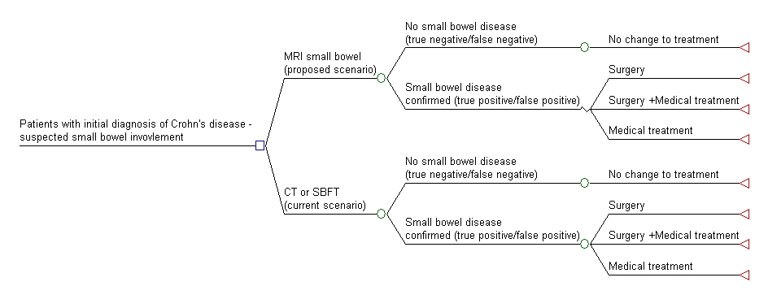

Table 6: PICO to define the research question for the evaluation of patients with exacerbation/suspected complications of known Crohn’s disease
Patients | Intervention | Comparator | Outcomes to be assessed | Healthcare resources to be considered
Patients with exacerbation/suspected complications of known Crohn’s disease | MRI small bowel | CT  SBFT | Diagnostic performance  Sensitivity  Specificity  Additional TP and FP  Diagnostic yield  Therapeutic impact  % change in management plans (for example from medical to surgery)  Patient outcomes  Impact of treatment on symptoms  Activity of disease  Development of complications  Crohn’s disease progression  Treatment morbidity  Quality of life | See Table 4
What is the safety and effectiveness and cost-effectiveness of MRI small bowel in comparison to CT and SBFT for the evaluation of patients with exacerbation/suspected complications of known Crohn’s disease?

Figure 8 Simplified decision tree structure for the evaluation of patients with exacerbation/suspected complications of known Crohn’s disease
The difference in health resources will be determined by the proportions in each branch – which will be driven by the discordant results between the imaging tests. While the below tree does not outline paths for true/false negative and true/false positive results this will be incorporated in the cost-effectiveness model for the final assessment.

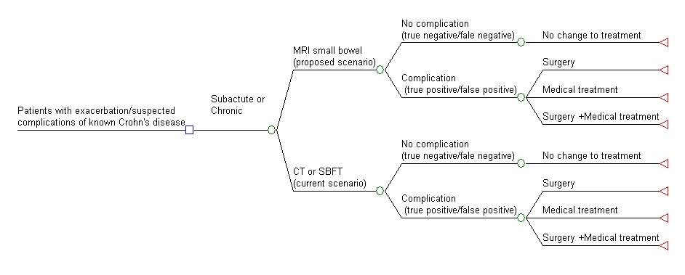

Table 7 PICO to define the research question for the evaluation of pregnant women with suspected small bowel Crohn’s disease based on positive
Patients | Intervention | Comparator | Outcomes to be assessed | Healthcare resources to be considered
Pregnant women with suspected small bowel Crohn’s disease based on clinical assessment | MRI small bowel | Abdominal Ultrasound (US) | Diagnostic performance  Sensitivity  Specificity  Additional TP and FP  Diagnostic yield  Therapeutic impact  % change in management plans  Patient outcomes  Impact of treatment on symptoms  Activity of disease  Development of complications  Crohn’s disease progression  Treatment morbidity  Quality of life | See Table 4
What is the safety and effectiveness and cost-effectiveness of MRI in comparison to US in pregnant women with suspected small bowel Crohn’s disease?

Figure 9 Simplified decision tree structure for the evaluation of patients with exacerbation/suspected complications of known Crohn’s disease

The difference in health resources will be determined by the proportions in each branch – which will be driven by the discordant results between the imaging tests.
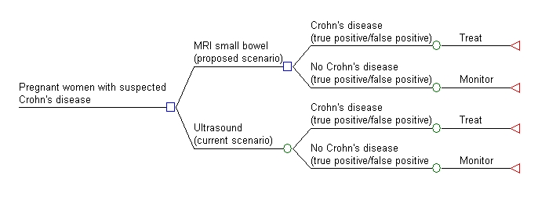

Table 8 PICO to define the research question for the assessment of change to therapy in patients with small bowel Crohn’s disease
Patients | Intervention | Comparator | Outcomes to be assessed | Healthcare resources to be considered
Assessment of change to therapy in patients with small bowel Crohn’s disease | MRI small bowel | CT  SBFT  Endoscopic assessment | Diagnostic performance  Sensitivity  Specificity  Additional TP and FP  Diagnostic yield  Therapeutic impact  % change in management plans  Patient outcomes  Impact of treatment on symptoms  Activity of disease  Development of complications  Crohn’s disease progression  Treatment morbidity  Quality of life | See Table 4
What is the safety and effectiveness and cost-effectiveness of MRI in comparison to CT, SBFT or endoscopic assessment in the assessment of change to therapy in patients with small bowel Crohn’s disease?

Figure 10 Simplified decision tree structure for the assessment of change to therapy in patients with small bowel Crohn’s disease
The difference in health resources will be determined by the proportions in each branch – which will be driven by the discordant results between the imaging tests.

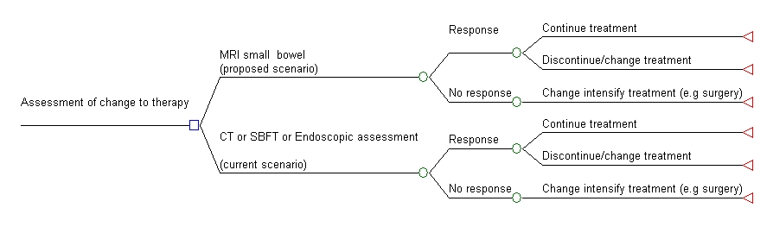

Table 9 PICO to define the research question for the evaluation of patients with pelvic sepsis and fistulas associated with established or suspected Crohn’s disease
Patients | Intervention | Comparator | Outcomes to be assessed | Healthcare resources to be considered
Patients with pelvic sepsis and fistulas associated with established or suspected Crohn’s disease | MRI pelvis | Surgical assessment or  Endoanal ultrasound (EUS) | Diagnostic performance  Sensitivity  Specificity  Additional TP and FP  Diagnostic yield  Therapeutic impact  % change in management plans  Patient outcomes  Impact of treatment on symptoms  Activity of disease  Development of complications  Fistula Drainage Assessment Measure  Treatment morbidity  Quality of life
What is the safety and effectiveness and cost-effectiveness of MRI in comparison to CT, surgical assessment and endoanal ultrasound in patients with pelvic sepsis and fistulas associated with established or suspected Crohn’s disease?

Figure 11Simplified decision tree structure for the evaluation of patients with pelvic sepsis and fistulas associated with established or suspected Crohn’s disease

The difference in health resources will be determined by the proportions in each branch – which will be driven by the discordant results between the imaging tests.

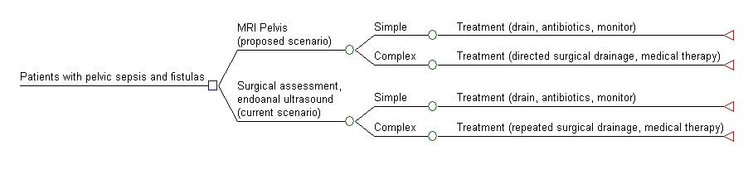

Table 10 PICO to define the research question for the assessment of change to therapy in patients with pelvic sepsis and fistulas from Crohn’s disease
Patients | Intervention | Comparator | Outcomes to be assessed | Healthcare resources to be considered
Assessment of change to therapy in patients with pelvic sepsis and fistulas from Crohn’s disease | MRI pelvis | Clinical observation, surgical assessment(s)  Endoanal ultrasound (EUS) | Diagnostic performance  Sensitivity  Specificity  Additional TP and FP  Diagnostic yield  Therapeutic impact  % change in management plans  Patient outcomes  Impact of treatment on symptoms  Activity of disease  Development of complications  Fistula Drainage Assessment Measure  Treatment morbidity  Quality of life | See Table 4
What is the safety and effectiveness and cost-effectiveness of MRI in comparison to CT, surgical assessment and endoanal ultrasound in assessment of change to therapy in patients with pelvis sepsis and fistulas from Crohn’s disease?

Figure 12 Simplified decision tree structure for the assessment of change to therapy in patients with pelvic sepsis and fistulas from Crohn’s disease

The difference in health resources between the intervention and the comparator will be determined by the proportions in each branch – which will be driven by the true/false positive and true/false negative results.
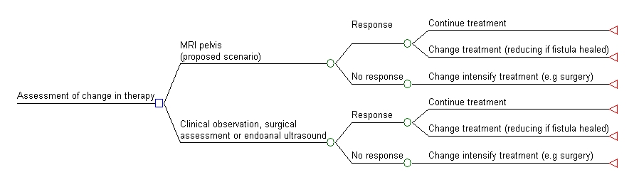

Reference List

1. American College of Radiology 2011, ACR Appropriateness Criteria® Crohn's disease [Internet]. Available from: http://www.acr.org/SecondaryMainMenuCategories/quality_safety/app_criteria/pdf/ExpertPanelonGastrointestinalimaging/CrohnsDiseaseDoc5.aspx [Accessed
2. Gligorijevic, V, Spasic, N et al 2010. The role of pelvic MRI in assesment of combined surgical and infliximab treatment for perianal Crohn's disease, Acta Chirurgica Iugoslavica, 57 (3), 89-95.
3. Horsthuis, K, Lavini, C et al 2005. MRI in Crohn's disease. [Review] [87 refs], Journal of Magnetic Resonance Imaging, 22 (1), 1-12.
4. Lichtenstein, GR, Hanauer, SB et al 2008. Management of Crohn's disease in adults, The American Journla of Gastroenterology1-19.
5. MSAC 2011, Capsule endoscopy for the diagnosis of suspected small bowel Crohn's disease. Application 1146.
6. Panes, J, Bouzas, R et al 2011. Systematic Review: the use of ultrasonography, computed tomography and magnetic resonance imaging for the diagnosis, assessment of activity and abdominal complications of Crohns disease, Alimentary Pharmacology and Therapeutics, 34 (2), 125-145.
7. Rieger, N, Tjandra, J et al 2004. Endoanal and endorectal ultrasound: applications in colorectal surgery, ANJ Surgery, 74 (671-675.
8. Schwartz, DA and Herdman, CR 2004. The Medical Treatment of Crohn's Perianal Fistulas, Alimentary Pharmacology and Therapeutics, 19 (9),
9. Zimmermann, EM and Al-Hawary, MM 2011. MRI of the small bowel in patients with Crohn's disease. [Review], Current Opinion in Gastroenterology, 27 (2), 132-138.

